Parliamentary Joint Committee on the Australian Crime Commission

Inquiry into trafficking in women for sexual servitude

Submission No:20
Received 25 September 2003
Mrs Peg McEntee OAM
National President
Catholic Women's League Australia Inc.
Favier House
1 Ballumbir Street
BRADDON ACT 2612
02 6201 9825 02 6230 6070
E-mail: cwlanational@ozemail.com.au

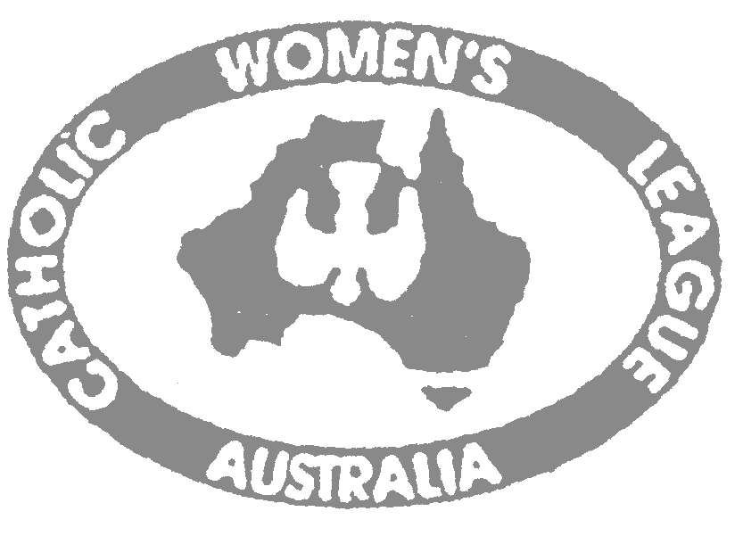
Catholic Women's League Australia Inc.
Affiliated with World Union of Catholic Women's Organizations Paris
NGO in Consultative (Roster) Status with the Economic and Social Council of the United Nations

CWLA National Secretariat
Favier House,
National President: Mrs P McEntee OAM 1 Ballumbir Street,
National Secretary: Mrs G Meaney-Budd BRADDON ACT 2612
National Treasurer: Mrs R Goldie Ph: 02 6201 9825
Fax: 02 6230 6070
E: cwlanational@ozemail.com.au
Date: 18th September, 2003 Web: www.cwla.org.au

SUBMISSION TO: The Secretary
Parliamentary Joint Committee on the Australian Crime Commission
Suite S1.107
Parliament House
CANBERRA ACT 2600

SUBMISSION FROM: Catholic Women's League Australia Inc. (CWLA)

Authorised by PEG McENTEE OAM
National President, CWLA Inc.

About CWLA

CWLA (est. in the early 1900's) is an organisation of some 8000 female members across Australia in regional, rural and remote areas. In our objectives we advocate the promotion of spiritual, cultural, intellectual and social development of women and support the family unit. We also aim to uphold the dignity of women and to encourage their participation in social and public life

CWLA thanks the Parliamentary Joint Committee on the Australian Crime Commission, for the opportunity to comment on the Australian Crime Commission's response to trafficking in women for sexual servitude.

Terms of References addressed in this Submission:

- The Australian Crime Commission's work in establishing the extent of people trafficking in Australia for the purposes of sexual servitude.
- The Australian Crime Commission’s relationship with the relevant State and other Commonwealth agencies.
- The adequacy of the current legislative framework

Catholic Women's League Australia Inc.
Affiliated with World Union of Catholic Women's Organizations Paris
NGO in Consultative Status with the Economic and Social Council of the United Nations

INQUIRY INTO TRAFFICKING IN WOMEN FOR SEXUAL SERVITUDE

INTRODUCTION

According to Project Respect, an organisation that advocates the rights of trafficked sex workers, approximately 1000 women are trafficked into Australia each year. In addition there are over 260 million pornographic websites, currently operating on the internet. The sexual exploitation of women and young girls is a severe adversity that is representative of an expanding ‘demand’ for sexual servitude, aided by a profitable and legalised prostitution industry. To address this demand there is an urgent need for the ACC in conjunction with the government, and other commonwealth and state agencies, to evaluate current work undertaken within this area and consider reforms to the present legislative framework. CWLA acknowledges the persistent effort of the ACC in establishing the extent of women and children, trafficked into Australia for the purposes of sexual servitude, and offers additional considerations for possible reforms.

- The Australian Crime Commission's work in establishing the extent of people trafficking in Australia for the purposes of sexual servitude.

PERCEPTIONS

While the ACC has notably undertaken a consistent effort to identify the pimps, traffickers and buyers of women and young girls trafficked for sexual servitude, they have not addressed the fundamental factors which contribute to, and ensure, a ‘demand’ for the industry. Pro-prostitute groups argue for the rights of women to "prostitute themselves” and many Australians accept that not all forms of violence against women - pornography, trafficking and prostitution - are harmful. It is from these initial perceptions that the commission should begin its work in order to eliminate this growing industry.

The ACC’s role therefore, in conjunction with law enforcement agencies and the state and federal governments, should be expanded into educating the Australian community to recognise that all forms of violence against women are serious violations of human rights. Women are often forced into sexual servitude either by trafficking, slavery, or socio-economic reasons. While some undoubtedly have chosen to enter into such practices, usually these are the women with the least alternatives available to them. Education is therefore fundamental in order to ensure the Australian community realises that it is the perpetual cycle of oppression, acts of violence and torture, which causes these women to undertake duties they wouldn’t normally ‘choose’ to do. While actions of these women may appear to be voluntary, they often stem from a self-perception of worth, measured only in terms of their ability to service their buyers. Constant abuse breaks down their resistance and escape becomes impossible. Until this grave reality of trafficked women for sexual servitude is acknowledged collectively within the Australian community, women and young girls will continue to be perceived as commodities, and the demand for trafficking will continue to exist.

- The Australian Crime Commission’s relationship with the relevant State and other Commonwealth agencies.

ELIMINATING THE ‘DEMAND’

The prerequisite for the trafficking in women for sexual servitude is a profitable prostitution industry, aided through its legalisation. Perceptions that some forms of violence against women are acceptable, will never change, whilst prostitution and pornography continue to be legally practiced in many Australian states/territories. Efforts to legalise prostitution must be understood as inhibitors to the prosecution of those running illegal brothels, and trafficking women. Providing a shield to pimps, traffickers and buyers to escape or lessen penalties, such legislation functions to perpetuate this vicious cycle.

Catholic Women's League Australia Inc.
Affiliated with World Union of Catholic Women's Organizations Paris
NGO in Consultative Status with the Economic and Social Council of the United Nations

INQUIRY INTO TRAFFICKING IN WOMEN FOR SEXUAL SERVITUDE

CWLA therefore requests that the ACC facilitate further dialogue with the Federal and State Governments and the COAG, to ensure the collective acknowledgment that the legalisation of prostitution and pornography aids and abets the trafficking of women. Work undertaken by the ACC to identify those responsible for people trafficking is performed in ignorance if simultaneously legislation is functioning to protect and provide a loop hole for offenders. The demand side of the industry urgently needs to become criminalised while the supply side of the industry - the victims - should be decriminalised.

PROTECTING THE VICTIMS

While those responsible for identifying the traffickers have had a few successes of late (due mostly to pressure from Project Respect and journalists from The Australian Newspaper) the total cooperation from all agencies, including NGO’s, and all levels of government is needed to ensure that paramount importance is placed upon protecting the victims. The ACC should subsequently establish a strong relationship with the relevant State and Commonwealth agencies, to promote the reality that sexual exploitation through prostitution, pornography and contemporary forms of slavery are serious violations of human rights. A department within the ACC, dealing specifically with victims, could be established as well as training manuals ensuring a consistent protocol is implemented in all situations, with protection being of paramount concern.

- The adequacy of the current legislative framework
Inadequacy of the current legislative framework is evident due to the growing market for women and children being trafficked and exploited for sexual servitude. CWLA believes that the first step in eliminating this inadequacy would involve the Australian Government ratifying the UN Protocol to Prevent, Suppress and Punish Trafficking in Persons, Especially Women and Children. CWLA also offers the following suggestions for consideration:

CRIMINAL CODE AMEDMENT (SLAVERY AND SEXUAL SERVITUTE ACT) 1999 (CWLTH)

According to section 270.4 of the Criminal Code Amendment (Slavery and Sexual Servitude) Act 1999 (Cwth), sexual servitude is defined as,
The condition of a person who provides sexual services and who, because of the use of force or threats:
(a) is not free to cease providing sexual services; or
(b) is not free to leave the place or area where the person provides sexual services.
CWLA requests that amendments be made to s 270.4 to additionally confer protection upon women who have consented to sexual servitude but were deceived about the conditions of the work.

MODEL FOR REFORM: SWEDEN

CWLA identifies the effort undertaken by the Swedish government to eliminate the trafficking in women for sexual servitude as a model for possible legislative reform. Swedish law, prohibiting the purchase of sexual services, enacted into domestic law in 1999, criminalised the ‘demand’ side of the industry. In addition, 2002 amendments have also linked the trafficking in women for sexual servitude to such criminal offences. The ‘supply side’ of the industry has been decriminalised and services and financial support have been implemented to assist rehabilitation.

According to Sister Lynda Dearlove RSM (Institute GB) in her Report on the Commission on the Status of Women 3-14 March 2003, this legislative framework, that provides both an incentive to leave and the support to escape, has ensured that 60% of women in Sweden have left the prostitution industry. In addition 80% of the population supports the legislation, ensuring a united stance against

Catholic Women's League Australia Inc.
Affiliated with World Union of Catholic Women's Organizations Paris
NGO in Consultative Status with the Economic and Social Council of the United Nations

INQUIRY INTO TRAFFICKING IN WOMEN FOR SEXUAL SERVITUDE

sexual servitude across Sweden. Notably, the number of trafficked women has not increased since the implementation of the legislation!

REHABILITATION CENTRES

CWLA calls for all agencies and levels of government, to recognise that sexual servitude exposes women to multiple traumas, including rape, torture and violence, as well as forced imprisonment and slavery. As a result, the women and young girls suffer additional humiliation, shame and guilt as well as complex forms of PTSS. In recognition of this, CWLA requests that the COAG establish and financially support rehabilitation centres in each state/territory to assist women (including those trafficked into Australia illegally) in leaving the industry. Centres should be equipped to provide necessary treatment including accommodation, counselling, and comprehensive programs that provide job training, legal assistance, confidential health care and psychological care.

In addition, CWLA requests that amendments be made to the Migration Act, to allow trafficked women, who are also illegal citizens, to remain in Australia in order to seek protection and rehabilitation. CWLA also calls for more aid to be distributed overseas, directed towards addressing the factors that contribute to the vulnerability of trafficked women and ensure that victims returning to their own countries are linked with support agencies.

CONCLUSION

The persistent demand for trafficking in women for the purposes of sexual servitude correlates with an inadequate legislative framework, which functions to perpetuate this cycle through the legalisation of prostitution. Such inadequacy is additionally evident in that no protection is conferred upon women consenting to sexual servitude, in reliance upon misrepresentations surrounding the conditions of work. Support is also limited where women are ‘illegal’ citizens, - a group encompassing many of the ‘trafficked’ women. Misconceptions surrounding prostitution and pornography also prevent a collective acknowledgement across the Australian community that sexual exploitation through sexual servitude is both a serious violation of human rights and a prevalent industry within Australia.

CWLA identifies the efforts of the Swedish government, as an example of possible reform, in their endeavor to criminalise the buyers of sexual services, whilst protecting the victims. We also acknowledge the need for victims to be provided with an opportunity to escape sexual exploitation and seek rehabilitation within specialised support centres. Additionally, CWLA encourages a collective effort among the ACC, the governments, law enforcements, and other commonwealth and state agencies, to eliminate the industry of trafficked women and children for sexual servitude.

