Parliamentary Joint Committee on the Australian Crime Commission

Inquiry Into Cybercrime

Submission No:12A
Received 18 July 2003
Mr Scott Pobihun
Manager
Investigations & Forensic Services
PricewaterhouseCoopers
53 Blakall Street
BARTON ACT 2607
02 6271 9342 
E-mail: scott.pobihun@au.pwcglobal.com



Submission to the
Cybercrime Inquiry
of the
Parliamentary Joint Committee on the

Australian Crime Committee

May 2003

Contents

Introduction 5
Who Are PricewaterhouseCoopers Investigative & Forensic Services? 6
Outline of our Submission 7
Section 1: Cybercrime Techniques 9
(i) Anonymous User Activity 9
(ii) Social Engineering and Deception 11
(iii) IT System Exploits 15
Section 2: The importance of an appropriate investigative response 16
Section 3: Global Economic Crime Survey 20
Section 4: Our Investigations Experience 21
Child Pornography Investigations 21
Banking, Credit Card and Online Fraud 23
Conclusions 25

Introduction
This submission is provided by PricewaterhouseCoopers (PwC) in response to an invitation by the Parliamentary Joint Committee for all interested parties to make submissions regarding recent trends in practices and methods of cybercrime. PwC is the world’s largest professional services organisation. Drawing on the knowledge and skills of more than 125,000 people in 142 countries, we build relationships by providing services based on quality and integrity. PwC has regular dealings with all facets of industry across many sectors both public and private. We regularly provide hi-tech investigative services to both federal and state law enforcement agencies and departments as well as to private sector corporate clients from banking and finance to legal, manufacturing, retail and others.

This submission seeks to assist the inquiry by identifying recent developments in cybercrime. We provide you with results of our Global Survey on Economic Crime and comment upon the information technology investigations for which we have been engaged in the Asia Pacific region.

We are pleased to provide this submission and hope it provides the appropriate assistance and adequate information. If you have any queries relating to our submission then please do not hesitate to contact us.

Your faithfully



Graham Henley Scott Pobihun
Director Manager
Investigations & Forensic Services Investigations & Forensic Services
Sydney, NSW Canberra, ACT

Who are PricewaterhouseCoopers Investigative & Forensic Services?
This submission has been developed by PricewaterhouseCoopers Australian Investigations and Forensic Services (IFS) team. The IFS is a national team with members in capital cities across Australia and the Asia Pacific region. The nature of our services facilitates multi-disciplined investigations, often combining members from diverse employment and academic backgrounds. Given the nature of investigative work and the global economy, the IFS team has a national and international response capacity

IFS attends to a diverse client base including public and private sector clients such as banks, international corporations and law enforcement agencies. Our IFS specialists provide for a variety of services including:
- Fraud Investigation
- Computer Forensics and Electronic Investigations
- Fraud Prevention and Control
- Forensic Accounting
- Suspicious Transaction Analysis

In the region our Computer Forensics and Electronic Investigations team comprises of members in Sydney, Melbourne, Brisbane, Canberra, Hong Kong Jakarta and New Zealand. The team also regularly communicates with it’s colleagues outside of the Asia Pacific region including specialists in the United Kingdom, the United States and South Africa. Like all of the IFS team, the Computer Forensic team often is called upon to quickly respond to incidents which can involve extra-territory travel.

Some of our Computer Forensic specialists have come from a law enforcement background but we also employ specialist individuals with Legal and Accounting backgrounds. The team often undertake investigations into incidents which involve the use of computers, including Corporations law infringement and Corporate disputes, Employment Law, Piracy and Criminal law including Cybercrime offences covered by the terms of this Inquiry

Our team is well known for its capacity to quickly react to the demands of our clients anywhere within the region.

Outline of our Submission

We have broken our submission down into the following sections to facilitate ease of use:

Section 1: Trends & Techniques in Cybercrime

We understand the Inquiry wishes to develop an understanding of recent trends in cybercrime. We therefore provide the Inquiry with recent developments which we have been made aware of through our own research and through our experience in investigating cybercrime. We break them down into four broad areas which we discuss in detail. We provide a more in depth description of each of these methods through Appendix A which is attached to this submission.

Section 2: The Investigative Response To Cybercrime

In this section we discuss briefly the legislative framework affecting our investigations and we provide suggestions as to the effective investigation of cybercrime and the importance of proper investigative techniques.

Section 3: Our Research

PricewaterhouseCoopers has recently released the results of its 2003 Global Economic Crime Survey. We identify the key results as they relate to cybercrime in the Asia Pacific region.

Section 4: Experience Gained From Our Investigations

We then provide the Inquiry with information relating to our experience in investigating cybercrime, particularly relating to access or distribution of child pornography as well as investigations into online fraud.

Section 1: Cybercrime Techniques

A number of factors assist the commission of unlawful conduct upon the Internet and also influence the ability to positively identify an offender. Broadly speaking, these methods and techniques can be categorised into four broad areas:
(i) Anonymous User Activity
(ii) Social Engineering and Deception
(iii) System Exploits

(i) Anonymous User Activity

Anonymous Internet Use

With the rapid population of the online environment has come the increased demand by those who inhabit it to protect their privacy. This demand has arisen from the Internet’s very nature. TCP/IP technology, the method which computers communicate within the Internet, presently provides for an unsecured path which can permit an individual user’s activities being observed and recorded. Whilst this is very useful in investigations, the common user who is simply traversing the Internet may be left exposed to malicious attacks.

There are a variety of techniques which both the skilled and inexperienced computer user has at their disposal to protect their identity on-line. These range from advanced techniques of accessing the on-line environment through virtual private networks to the use of Internet cafes and web based Internet email facilities such as “hotmail”. There are many legitimate reasons why an individual may be interested in doing this, including:
- the protection of their privacy
- the protection of their method of accessing the on-line environment to reduce the chances of their computer being maliciously attacked, and
- to prevent personal information from being accessed by spammers or those seeking to undertake identity theft.
There are also a variety of reasons why an individual may want to utilise such facilities to carry out unlawful conduct upon the web including:
- surf the Internet to access or disseminate inappropriate material such as paedophilic pornography or illegal software such as credit card key generators or pirated software
- use malicious tools against other computers with the reduced likelihood of being caught
- dissemination of slanderous or misleading material, and
- promoting other techniques for social engineering purposes.
Internet technology allows perpetrators to hide their identity relatively easily. This therefore reduces the capability of investigators to adequately obtain evidence to connect an individual’s conduct to an unlawful event. Eventually, before either a civil or criminal Court, it will be the task of the investigator to tie the fingers of the offender to the unlawful activity on the computer keyboard.

Anonymous Payment Systems

In recent investigations we have seen the use of private secure offshore payment systems (such as www.evocash.com) to facilitate transactions for unlawful purposes and also to launder ill-gotten gains. Such companies operate entirely out of Australian jurisdiction and control.

Anonymous Computer Use, Data Wiping & Encryption

In our investigations we have seen a steady increase in the use by suspects of Data Wiping tools to permanently erase evidence. The regular operation of computers causes information to be left on the computer’s hard drive. For example, information remains even after a document is placed in the ‘Recycler’ or if a file is deleted. Data can only be considered destroyed once it is physically over-written by other data.

A common way in which data is recovered in a forensic examination of a computer is by analysing the ‘unallocated’ space upon a hard drive. If data is deleted by the operating system, be it by a user’s instruction or otherwise, it is identified as no longer being required by the system and the space which this data occupies returns to an ‘unallocated’ state. Whilst the data remains in that space, the computer considers that space available for writing to in the future. Drive-wiping software permits the writing of either random data or a particular character or string of characters to a certain area of the hard drive or the entire hard drive. This way a user can effectively erase the contents of a drive. A simpler form may be used by individuals to remove information relating to their Internet activity. This complicates forensic examination as it increases the chances of destroying evidence of a user’s inappropriate activity on the Internet.

In addition to this we have seen an increase in the use of strong file encryption. Whilst a vital tool for legitimate business purposes, the strong and cost effective encryption software available to individuals makes it an attractive tool for cyber criminals. We appreciate that recent legislation in the Cybercrime Act moves to address this issue in regard to police powers of search.

(ii) Social Engineering and Deception

Cybercrime is not necessarily ‘new’ crime. Cybercrime may be old style scams which make use of the Internet as a marketing and contact tool. Typical Internet related frauds include investment frauds, secret market frauds and ‘pyramid schemes’ where the Internet is used as a new medium to attract a victim, and that hapless victim is persuaded to part with money or credit card details. Many of the frauds that are prevalent on the Internet involve the offering of unrealistically high returns on investment. Secret market frauds are a variation on this theme. Victims are persuaded that there is a confidential and exclusive market for a particular kind of fictitious financial instrument, such as a “prime bank guarantee”, which offers high rates of return. Pyramid schemes again offer high returns for small contributions and invariably collapse leaving the last to join without prospect of recovering any funds.

The Internet exhibits some characteristics which make it attractive to someone wishing to exploit other people:
- it is largely unregulated in so far as who may set up a site. No licence fees are payable to any central authority and no form of vetting is, or in practical terms ever could be, carried out on those persons or entities setting up sites
- an Internet site can be set up anywhere in the world at very low cost and can reach anywhere else in the world at low cost. This means that fraudsters now have "global reach" and can access a far larger market of potential victims than ever before. As fraudsters are always looking for new victims, this is a very attractive feature
- an impressive site with links to established companies or financial institutions may be no more than an empty shell designed to attract and trap the unwary. There is often no easy way of separating the genuine from the false
- the glamour and novelty of the Internet and the spurious credibility claimed by a web site may cause otherwise prudent investors to become involved in fraudulent schemes, and
- a site may, and probably will, operate outside the legal jurisdiction of the country in which the victim of the fraud resides. In some circumstances, a company may give the impression that it is an Australian company through it’s Internet website but may have absolutely no legal or commercial connection with our jurisdiction. In many cases law enforcement agencies will not investigate cross jurisdictional matters due to these difficulties.
The above factors make it extremely difficult to discover, in sufficient time to effect recovery or at all, the identity of a fraudulent web site operator.

Internet related fraud can go as far as the establishment of ‘phoney’ banks in tax havens such as the British Virgin Islands and Cayman Islands. These banks can have very sophisticated marketing campaigns, web sites and so on, which attract depositors with promises of very high rates of return. Such scams reflect the old style “Ponzi” scheme fraud, where initial investors returns are paid from new investors funds, attracting further investment, until such time as the scam operators disappear with depositors funds.

These types of Internet related scams reflect one of the main differences between Internet fraud and traditional fraud – the success of Internet fraud, and the difficulty associated with its ultimate investigation, is reliant upon the anonymity of the fraudster. Traditional fraud relies upon the fraudster’s success in covering up his activities. Internet fraud is far more brazen, however its success lies in the relative anonymity of its perpetrators.

More often than not, our investigations relating to cybercrime indicate that individuals have undertaken social-engineering using the Internet. There are a variety of techniques which one can implement to obtain unlawful gains via the Internet. These include:
- SPAM e-mail such as the original Nigerian Letter technique
- Bulletin Board or Chat postings of misleading information to influence capital markets
- Web Page diverting.
These scamming techniques are very much old techniques dressed up in new electronic guises.

Spam Scams & Phoney Websites

Recently the Sydney Morning Herald reported that a US based group had sent spam email to individuals requesting they access the Commonwealth Bank’s Netbank website asking them to update their account details.

In such circumstances individuals can be deceived by being requested to access a seemingly legitimate website. In most cases such activity can only be investigated on a reactive basis as it is virtually impossible to identify these websites prior to the relevant authorities being notified of its existence due to the vastness of the Internet.

Web-page diversion – hijacking

It is possible for users to be inadvertently diverted to another website should that website be modified. Whilst it is common practice in the corporate environment where a company may own multiple domain names (for example www.pwcglobal.com.au will divert you to www.pwcglobal.com through www.pwcglobal.com/au where the Australian information will be displayed to you.). There are circumstances though where websites are ‘hijacked’ – techniques are available whereby individuals may enter an authentic URL (such as www.pwcglobal.com) but will be diverted to an illegitimate website instead. This may be consequential and may not damage the user in the instance significantly if they were attempting to enter the PricewaterhouseCoopers website, however if they intended to enter their bank’s online services and were misled into thinking they were doing so then that user will have exposed their personal banking details to the individuals who administer the fake website.

Cookie Exploits

Individuals may also have their personal information accessed through the accessing of websites. Often websites use a small piece of information called a cookie to identify users and to set viewing preferences accordingly. Often cookies are used in an appropriate manner however cookies can be used to enable foreign systems to obtain information about a user so as to put them on spam mailing lists or track their activity across a broad range of topics including banking activity which could lead to identity theft.

(iii) IT System Exploits

As our community demands more and more from technology, the operating systems which drive them become more and more complex. Unfortunately, this does not necessarily equate to a more secure electronic environment and may even provide new opportunities for things such as:
- identity theft
- Trojans and Backdoors accessing user’s computers destroying material upon the computer, information being stolen or information being placed upon user’s computers without them being aware
- Virus infections which spread rapidly to deliver their payload.

Section 2: The importance of an appropriate investigative response

Of utmost importance in any investigation, be it into cybercrime or otherwise, is the awareness of all as to what to do immediately upon its discovery. Organisations who have infrastructure affected by any kind of cybercrime should be aware of how to respond to it from the outset. They should be aware that it is vital to the investigation that whilst being considerate of business needs, evidence must be collected and preserved. We applaud the recent development by Standards Australia of a handbook outlining the guidelines for the preservation of electronic evidence which we feel will be a valuable resource in the private and public sectors.

For persons involved in computer forensics and cybercrime investigations we believe a national standard of accreditation should be implemented to promote core skills. Individuals who undertake these investigations must be appropriately skilled in:
- investigative techniques
- information technology, and
- Legal Issues relating to evidence, information technology and litigation both civil and criminal.

Identification of the Cyber Criminal

The process of identifying a criminal who is determined to maintain his or her anonymity can present many challenges. Computers connected to the Internet are identified by an unique number called an IP (Internet Protocol ) address. IP addresses are either Dynamic or Permanent:
- Dynamic IP addresses are given to Internet users using a normal dial up connection. When the user ‘dials in’ to an ISP, a unique IP address is allocated from a pool of available IP addresses to the users machine. The user is allocated this address for as long as he is connected to the Internet. When the user terminates the connection that IP address is returned to the ISP and will be allocated to the next user that ‘dials in’
- Permanent IP addresses are usually given to users that are permanently connected to the Internet.
IP address ranges are unique to each ISP. This makes it easier to locate the specific ISP that the criminal uses to access the Internet. From then, a users identity can be ascertained with the co-operation of the ISP by checking the logs and finding out who was assigned a specific IP address at that point in time.

Many cyber crime investigations concern email, the primary form of communication on the Internet. Email can and often is sent anonymously however information related to the source of the email can often be discovered through careful scrutiny of the e-mail’s message header. The message header contains an audit trail of each server the e-mail was routed through to get to the specified email address. Assistance in positively identifying the suspect must invariably be obtained from the ISP. This can be complicated when technology is used to remove or fabricate the audit trail.

The successful investigation of cybercrime involves a heavy reliance upon the assistance of Internet Service Providers. (It is our experience that certain Internet Service Providers limit record keeping for the purpose providing anonymity to their customers. Some parties use this anonymity to engage in dubious activities).

In Australia the private sector investigations firm has a limited civil mechanism by which effective access can be obtained to information held by an Internet Service Provider. Such access may be required in a matter in which there is at that time insufficient evidence for investigation by the police. We have successfully sort such information by court subpoena in the past. However, the lack of an identified respondent requires a civil application for ‘preliminary discovery’. Generally such applications are time consuming (weeks) and expensive.

Computer Based Evidence Recovery

Traditionally the collection of evidence in a fraud investigation has relied upon the presence of a physical paper trail. In today’s corporate environment, the paper trail largely originates from, and in many cases has been replaced by, personal computer records. In response to this trend, a field known as computer forensics has developed. Put simply, computer forensics is the seizure and analysis of electronic data using a methodology which ensures its future admissibility as evidence in a court of law. As the evidence related to a cybercrime is likely to be in electronic form, computer forensics is an integral part of modern cybercrime investigation.

The fundamental principle of computer forensics is that original data is never altered. For this reason, purpose written ‘forensic image’ software is used to take an exact copy of a ‘target’ computer system. From this image the original system can be recreated at any time. It is essential that trained and experienced specialists are assigned to this task. This ensures both the integrity of the target system (it is difficult to put a monetary value on the accidental loss of commercial information), and the integrity of seized evidence. A computer forensic technician must be able to justify their actions in future court proceedings.

Forensic computer images have been accepted by Australian Courts to be ‘original’ evidence. It is not necessary (in most cases) to seize physical computer hardware. Indeed, in situations where target computer systems contain critical data, such as in a doctor’s surgery, physical seizure is never a viable option. Once an image has been taken, hardware that may otherwise have been required to be secured for evidence continuity may be put back into use.

Forensic imaging is also well suited to covert investigations. Much information can be drawn from a suspect’s personal computer without alerting him/her to an investigation.

In the analysis phase, computer forensics is concerned with more than existing files. A computer forensic technician will examine the entire structure of a hard disk, looking to collect all possible evidence. During normal PC operation, data additional to that which the user intends to save is ‘written’ to the surface of the hard disk. On examination this information can be collected and analysed.

On many occasions valuable evidence from these areas has been collected from computer systems which were previously believed to be ‘clean’.

In investigations where the suspect is computer literate, these ‘hidden’ areas are sometimes used to hide information. It is common that the actions of a suspect in removing or hiding evidence from a computer system can have the opposite effect, and strengthen the evidence. This is often the case with deleted files, or the non destructive ‘format’ of the computer hard drive.

In common operating systems such as Windows 2000 and Windows XP, there are a variety of ‘cache files’, ‘swap space’, ‘audit logs’, and ‘registry entries’ which all contain information about the actions of the user. An experienced computer forensic technician can quickly put together a profile of computer use, and identify potential evidence.

Computer forensics has proved a reliable, successful, and cost effective tool for the investigator. In cybercrime investigations it is an essential tool.

Section 3: Global Economic Crime Survey

PricewaterhouseCoopers recently released its 2003 global and Asia Pacific economic crime surveys which discussed cybercrime. Key points to come out of this survey were:
- although only 16% of organisations in the survey reported suffering from cybercrime in the last 2 years, increasingly all incidences of economic crime depend on an element of technology
- in the Asia Pacific, 38% of organisations perceive cybercrime as their chief concern over the next 5 years
- globally, the biggest concerns for the future are asset misappropriation and Cybercrime
- over two thirds of corporate cybercrime victims could not quantify the direct monetary costs.
The full Economic Crime Survey reports are attached to our submission as Appendix B & C.

Section 4: Our Investigations Experience

The PricewaterhouseCoopers Computer Forensic team performs a wide variety of investigative work for corporate and government clients. In recent times the most prominent type of investigation has been the theft of commercially sensitive intellectual property. These activities have usually been carried out by, or with the involvement of, persons internal to the victim organisation.

As per the terms of your enquiry, we provide you with a breakdown of our investigations which have involved child pornography and online fraud.

Child Pornography Investigations

Our major client base of Large corporates were found to be the dominant group engaging us in investigations resulting in the discovery of paedophilic material. Diagram 1 below suggests that there is no one particular client base which provides for any particular significance in child pornography Investigations.

Approximately half of the subjects attempted to remove evidence of their activities by deleting the material (placing it in the recycle bin) or by use of wiping software. Generally these attempts were ineffective.

The most common way in which child pornography was accessed involved the use of free or subscription based websites. We have not identified groups of like minded individuals communicating on this subject.

In accordance with relevant state legislation dealing with possession of child pornography, the investigations in which we identify child pornography usually necessitate the immediate referral of the matter to the relevant state law enforcement agencies. This can influence our continued involvement in the investigation.

Banking, Credit Card and Online Fraud

Who engage us in Online Fraud Investigations?
Our online fraud investigations are well distributed between the Police, other law enforcement and the private sector. Most of our private sector online fraud investigations are for large corporate clients.

Fraud Perpetration Breakdown
Approximately 95% of the fraud cybercrime we have investigated involved conduct of an employee or former employee. The remaining 5% involved groups of employees or former employees.

Diagram 4 describes cybercrime of a fraudulent nature undertaken by Employees.

Much of the unlawful conduct by employees still falls into the ‘trusted person’ category where perpetrators gained access to account details.

Sector break down of Investigations

We have found that the finance sector is the dominant sector affected by cyber-fraud. Approximately 10% of all cyber-fraud investigations involved government.

Diagram 5 below describes the sectors of our economy which we have been involved in investigating cyber-crime.

Conclusions

In August 2001 the Parliamentary Joint Senate Committee on the National Crime Authority published its report on the Implications of New Technology on Law Enforcement. The report encompassed the effect of new technology on current legislation, existing law enforcement bodies and the interaction between the two in an effort to combat crime. Particular importance was given to the adequacy of current responses and the implications of developing technology on such responses with regard to the sufficiency/capability of the law. The report culminates an extensive process of investigation and research by a variety of bodies with submissions made predominantly by the public sector. The Committee made nine recommendations, in which . Emphasis was given to:
- nationally consistent approach to multi-jurisdictional investigations
- the ability to address issue of money laundering
- the ability of legislation to keep pace with change.
We consider that these remain the primary issue to be addressed in the investigations of Cybercrime.

In our private sector investigations we have identified a recent increase in cases which involve the theft of commercial intellectual property. We have also observed a steady increase in the use by suspects of technology to erase or secure data, including Internet anonymising software, disk wiping and encryption tools.

We consider that the private sector investigations teams play an important role in the identification and investigation of cybercrime. In many instances it will be such teams that act as the intermediary between the victim and law enforcement. A major hurdle in our efforts to investigate cybercrime in the private sector is the lack of an efficient civil mechanism to obtain timely access to information from Internet Service Providers for investigative purposes.
It is also our investigations experience that there is uncertainty in the private sector about the use of investigations techniques, such as key stroke logging or packet capturing devices and their use in regard to the Telecommunications Interception Act.

A way forward for such issues may be to follow legislation similar to the NSW Work Place Surveillance Act in which private sector organisation can apply to the court to utilise such techniques.

We look forward in Australia to the development of training and accreditation standards for both corporate and government agencies specifically applicable to the investigation of cybercrime.
Appendix A – Methods Facilitating Cybercrime

Internet Mail

One of the simplest ways which unlawful conduct upon the Internet can be undertaken is by using Internet Mail. Examples of such include Hotmail and Yahoo! Mail. On setting up an Internet Mail account, a user may choose whatever name they desire so long as it has not been chosen by someone else. No form of identity verification is required and thus users are free of the constraints caused by their real life experiences.

This way, a user ie John Smith from Canberra may chose say John_Smith@hotmail.com if he wishes to be able identifiable as John Smith in correspondence. Alternatively John may wish to hide his identity and be known as Canberra_Man@hotmail.com. John may then believe he is in a position to communicate more freely with individuals upon the Internet, free of any concern about being tracked down in real life.

Say John dislikes Bill Jones, John may create an account Bill_Jones@hotmail.com and send malicious e-mails in Bill’s name.

Having said that though, skilled investigators can in many circumstance review header information within the contents of an email to trace an email back to the computer which was used to send the e-mail.

Fake Email

Software has been created to allow the creation of email without the need to have an email account or access to a particular email account.

In our example above you will recall that John Smith used an Internet account Bill_Jones@hotmail.com to disseminate malicious e-mail. Let’s say Bill found this out and knew that John possessed the John_Smith@hotmail.com email account.

Using such software, Bill could create the impression that John smith sent an email using the John_Smith@hotmail.com address. He could therefore send an email that is even more damaging to John than the message sent by John in Bill’s name.

The drawback from a malicious user’s perspective is that in using this technique the culprit will unlikely receive any response to the ‘fake email’ sent as it is unlikely the culprit will have access to the real e-mail account.

From an investigator’s perspective fake email can in many circumstances be identified as such since the fake email will not provide the appropriate information relating to the originating computer.

Simpler fake e-mail software will use the computer’s information as its originating point enabling investigators to discover the originating computer the malicious user operated in their actions.

More advanced fake email software will permit the user to cover their tracks, therefore reducing their chance of capture.

Paging Software

Another form of communication is the use of Paging software. Examples of paging software include Lotus’ Sametime Connect, Yahoo! Pager, ICQ. These programs allow for one on one real time communication between users, regardless of their physical location. Many paging programs such as those provided as examples provide advanced utilities including file transfers as well as voice and video software.

In our experience, Paging software is frequently identified on computers used to undertake a variety of inappropriate or unlawful activities including:
- software piracy
- pornography including paedophilic
- commercial fraud

The problem faced by lawful users of the Internet in utilising Paging software is that often it is insecure. The ICQ product, in the past, was an example of a product that had security gaps permitting remote processes to directly access the contents of a user’s computer.

Internet Relay Chat (IRC)

IRC is a type of online chat forum where individuals can communicate in real-time. More advanced systems may also provide users with the ability to transfer files. Our experience indicates that there is significant discussion about many kinds of unsavoury behaviour.

In our cyber investigations training, we recommend students utilise this tool (whilst maintaining anonymity) to identify potential cybercriminals.

Web Chat

Like IRC on-line chat environments, Web Chat environments permit users to communicate in real time. The more advanced systems such as that found at chat.yahoo.com.au provides for voice and video communication between users. A user accesses such an environment by means of a Web-browser by means of a previously created account. In the case of the Yahoo! Web-chat, accounts used for chat services also provide other services including email.

Anonymisers Re-director and Diverters

A computer user communicates with another over the Internet not by communicating directly with it but by taking several steps, known as hops, over the network. This way any computer that can find a path to another can do so with the assistance of infrastructure configured to route traffic between separate parts of the network.

Basically, routing hardware is provided with information to permit it to identify where it is itself within the network.

When a computer sends information across the Internet it does so in packets. This is so as to permit the free flow of data across the Internet. Aside from the data transmitted TCP/IP packets contain information including the source and destination computers’ location as well as where the particular packet fits in the data to be transmitted. Once the packets are received by the destination computer they are put back together in the required order.

When a Router receive data it analyses it to identify whether it is capable of transmitting the data along the path towards its destination by means of routing tables. This process continues until either the data gets to its final destination or is incapable of being sent to its final destination . As such, packets may not necessarily traverse the same path to reach its destination. Thus if say a computer sent data across the Internet within 30 packets, the destination computer may receive the 3rd packet before the 1st. The destination computer will piece together the packets in the correct order though given that it can verify each and every packet was correctly received.

Anonymisers cause a user’s computer to transmit its information via an intermediary proxy server. This intermediary system can replace packet information relating to the source of the data. That way a user going through an anonymizer service will be identified by the replaced source information within the packets received by the destination computer.

Basically this means anonymizers give observers at the destination computer the impression that the data was sent from the intermediary proxy server rather than the true source location.

SPAM

Spam (unwanted email) databases are created through the exploitation of cookie capabilities. Another method which SPAM databases develop is through the accessing of online public directories. One such directory is the WHOIS service which now suffers as a result of SPAM exploitation from bogus or inaccurate information.

Spam filters are available for most email services however they are often ineffective in preventing all Spam mail coming through. It is not uncommon for such mail to contain malicious code.

Spy-Ware

Spy-ware is often bundled with popular free-ware and permits system and user activities to be reported to a remote process. Some of the biggest names in the industry have been accused of including spy-ware within their products.

In Australian Personal Computer’s February 2003 edition, the magazine stated that the four main spyware packages were:
- Blackstone Data Transponder
- Cydoor
- Brilliant Door
- Xupiter/Lap.com
- Gator
- Cytron

The most common products affected are the peer-to-peer technologies such as KaZaA, the next generation of products replacing the now defunct Napster.

The magazine also stated that big corporate names such as RealNetworks, Audiogalaxy and Netscape have also been accused of utilising Spyware.

Drive Wipers

The regular operation of computers these days causes information to be left on the computer’s hard drive even after it is no longer need. For example, such information remains even after say a document is placed in the ‘Recycler’ or if a file is deleted. Data is only destroyed once it is physically over-written by other data.

A common way in which data is recovered in a forensic examination of a computer is by analysing the ‘unallocated’ space upon a hard drive. If data is deleted by the operating system, be it by a user’s instruction or otherwise, it is identified as no longer being required by the system and the space which this data occupies returns to an ‘unallocated’ state. Whilst the data remains in that space, the computer considers that space available for writing to in the future.

Drive-wiping software permits the writing of either garbage or a particular character or string of characters to a certain area of the hard drive or the entire hard drive. This way a user can effectively erase the contents of a drive. In doing so, they may be removing vital evidence necessary in the investigation of a user’s unlawful activity.

Steganography

Steganography has recently received media attention as the next weapon which cyberterrorists use to communicate with one another. Stegangraphy, or Steg for short, is the science of embedding data within other, larger data often cryptographically. Discussions regarding Steg often lead to the belief that it is a tool used by those dealing with paedophilic material.

Steganography is notoriously difficult to discover. PricewaterhouseCoopers has yet to undertake an investigation where this technique has been used to assist in the commission of a crime.
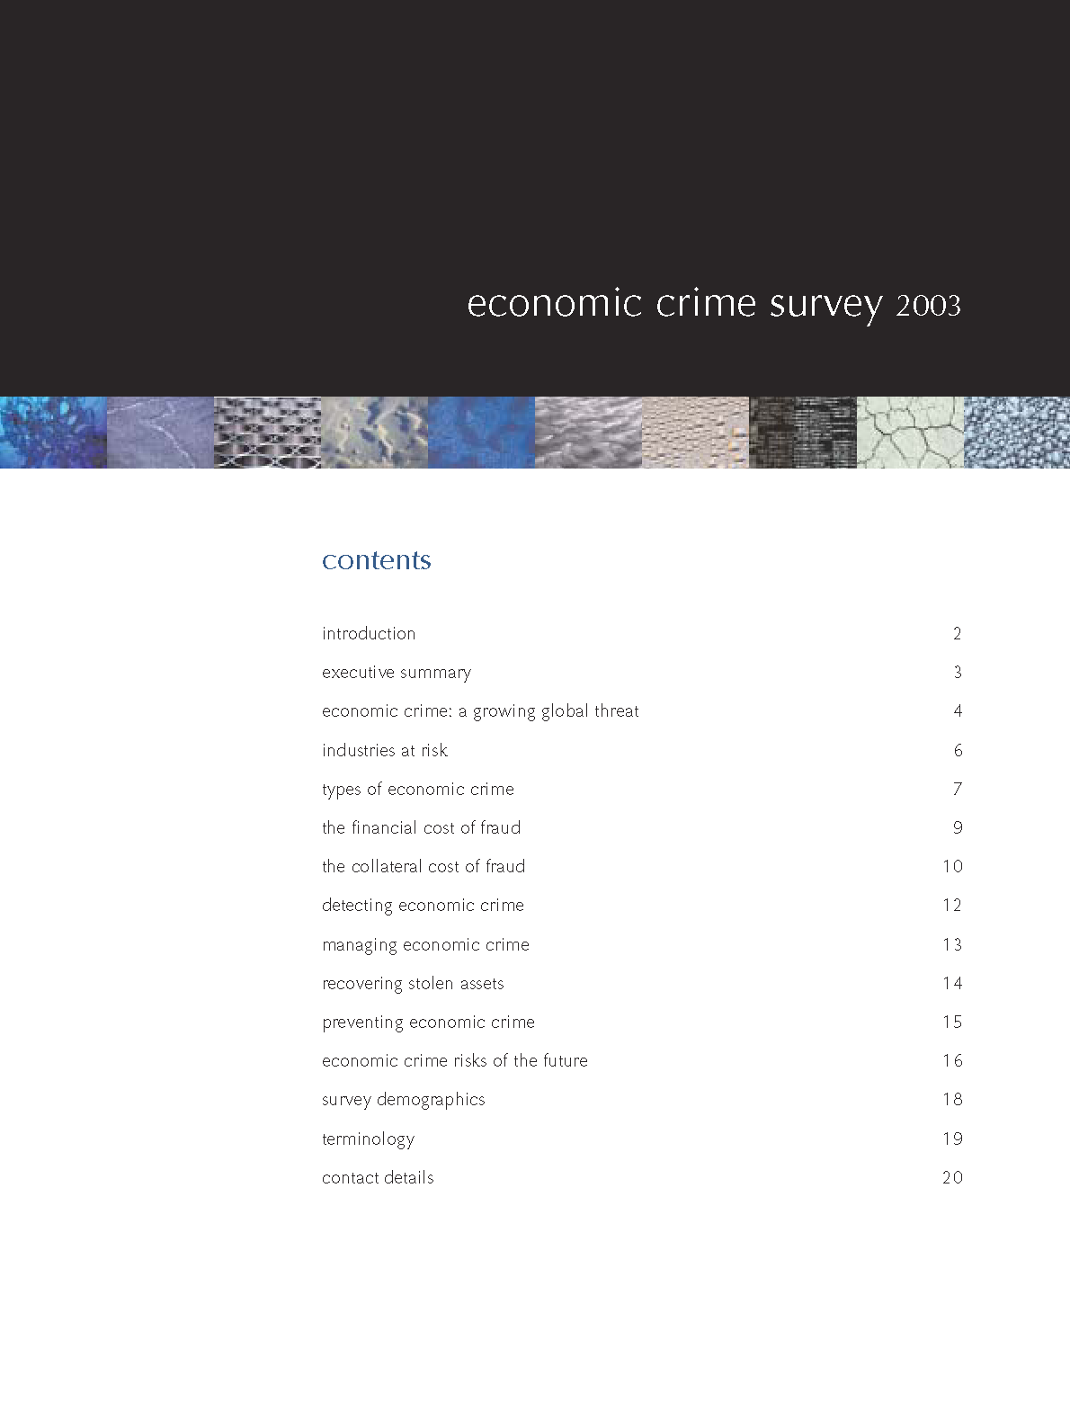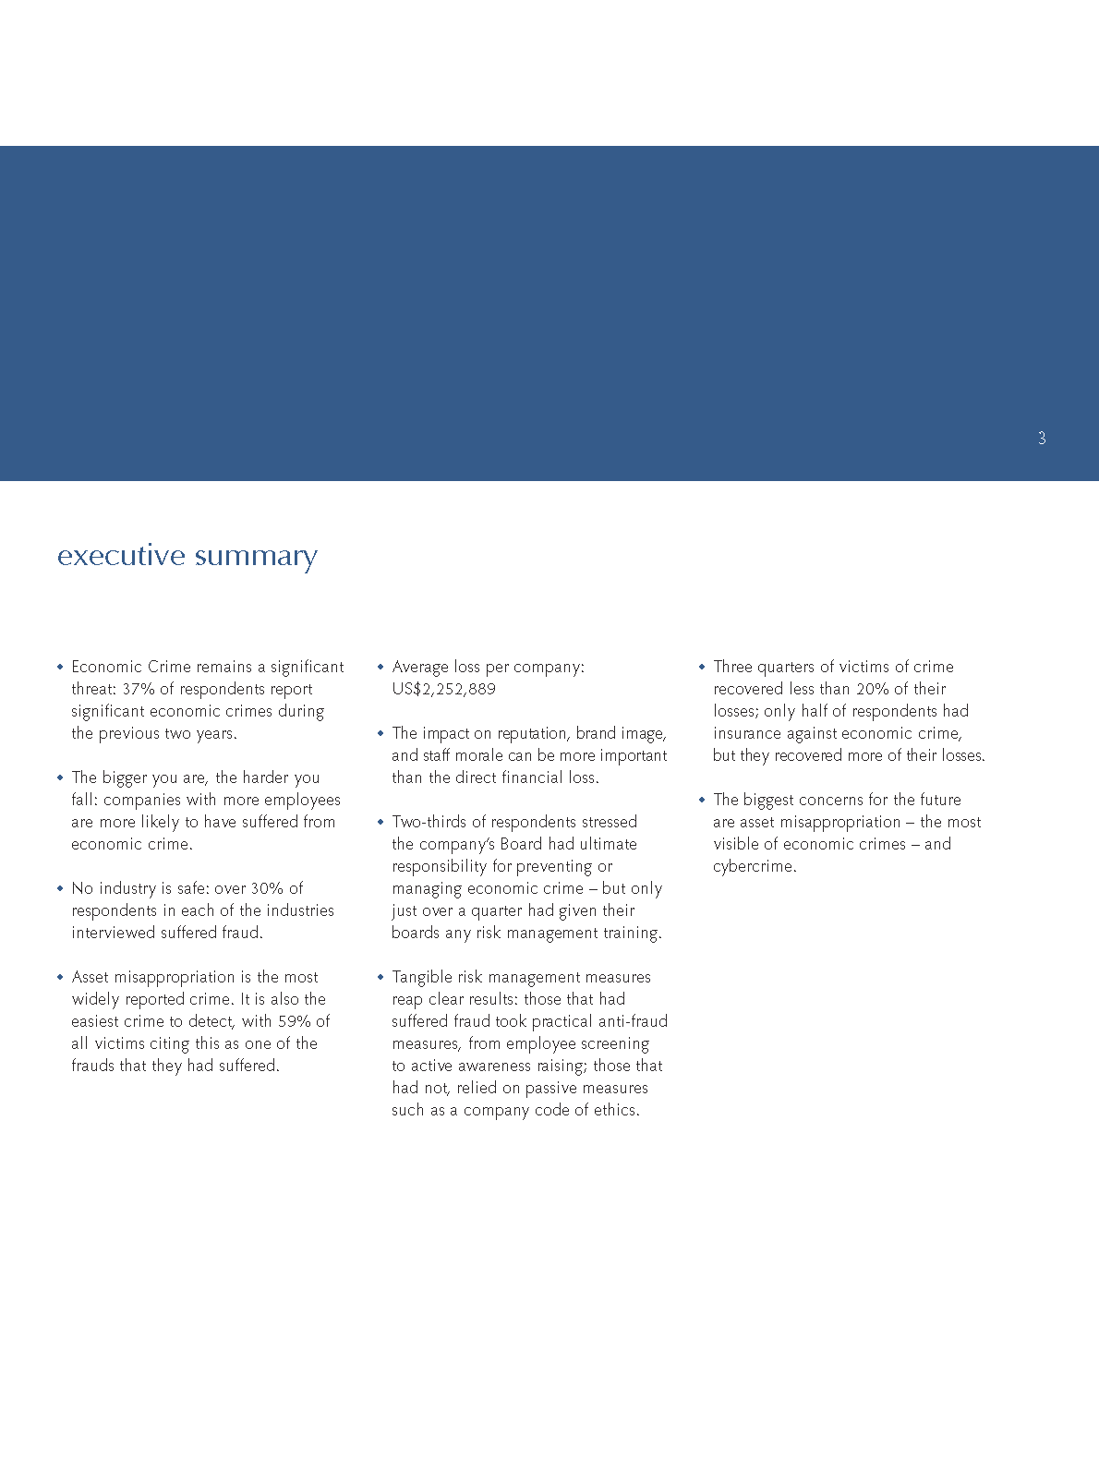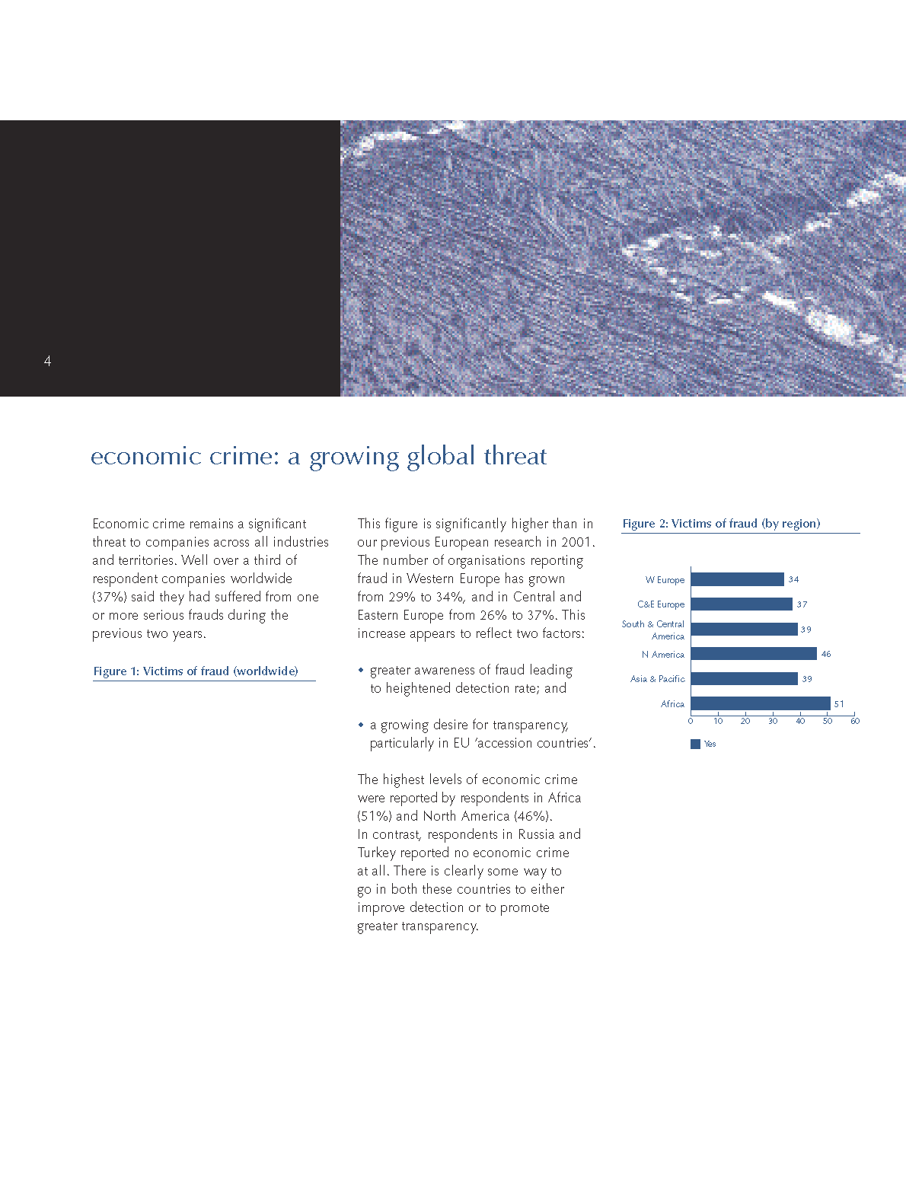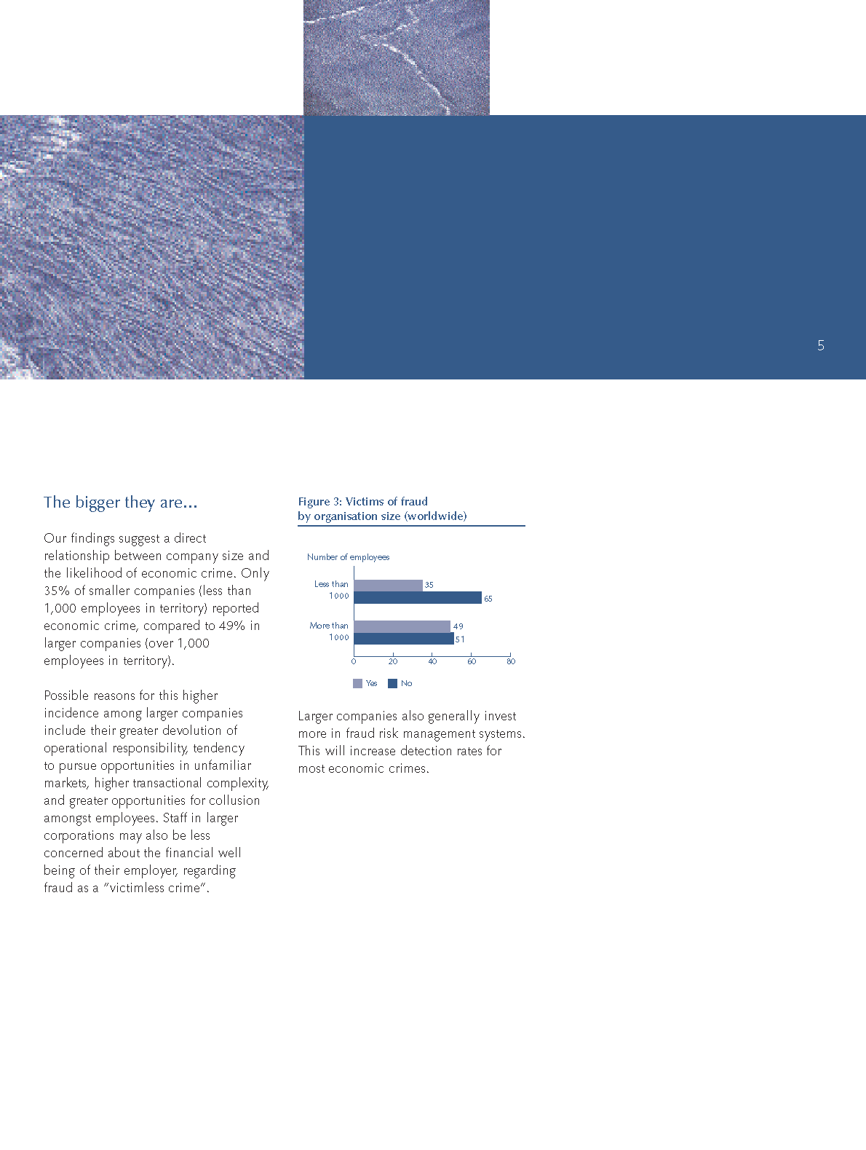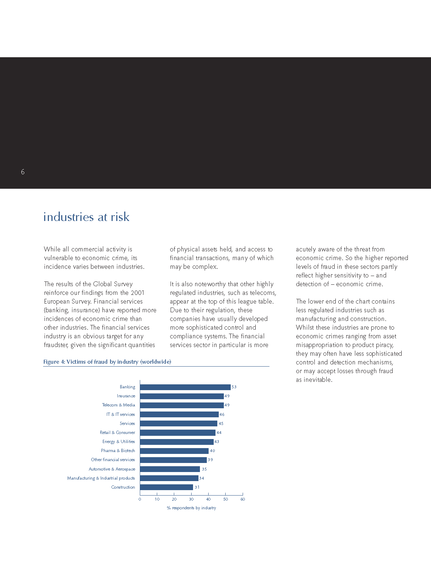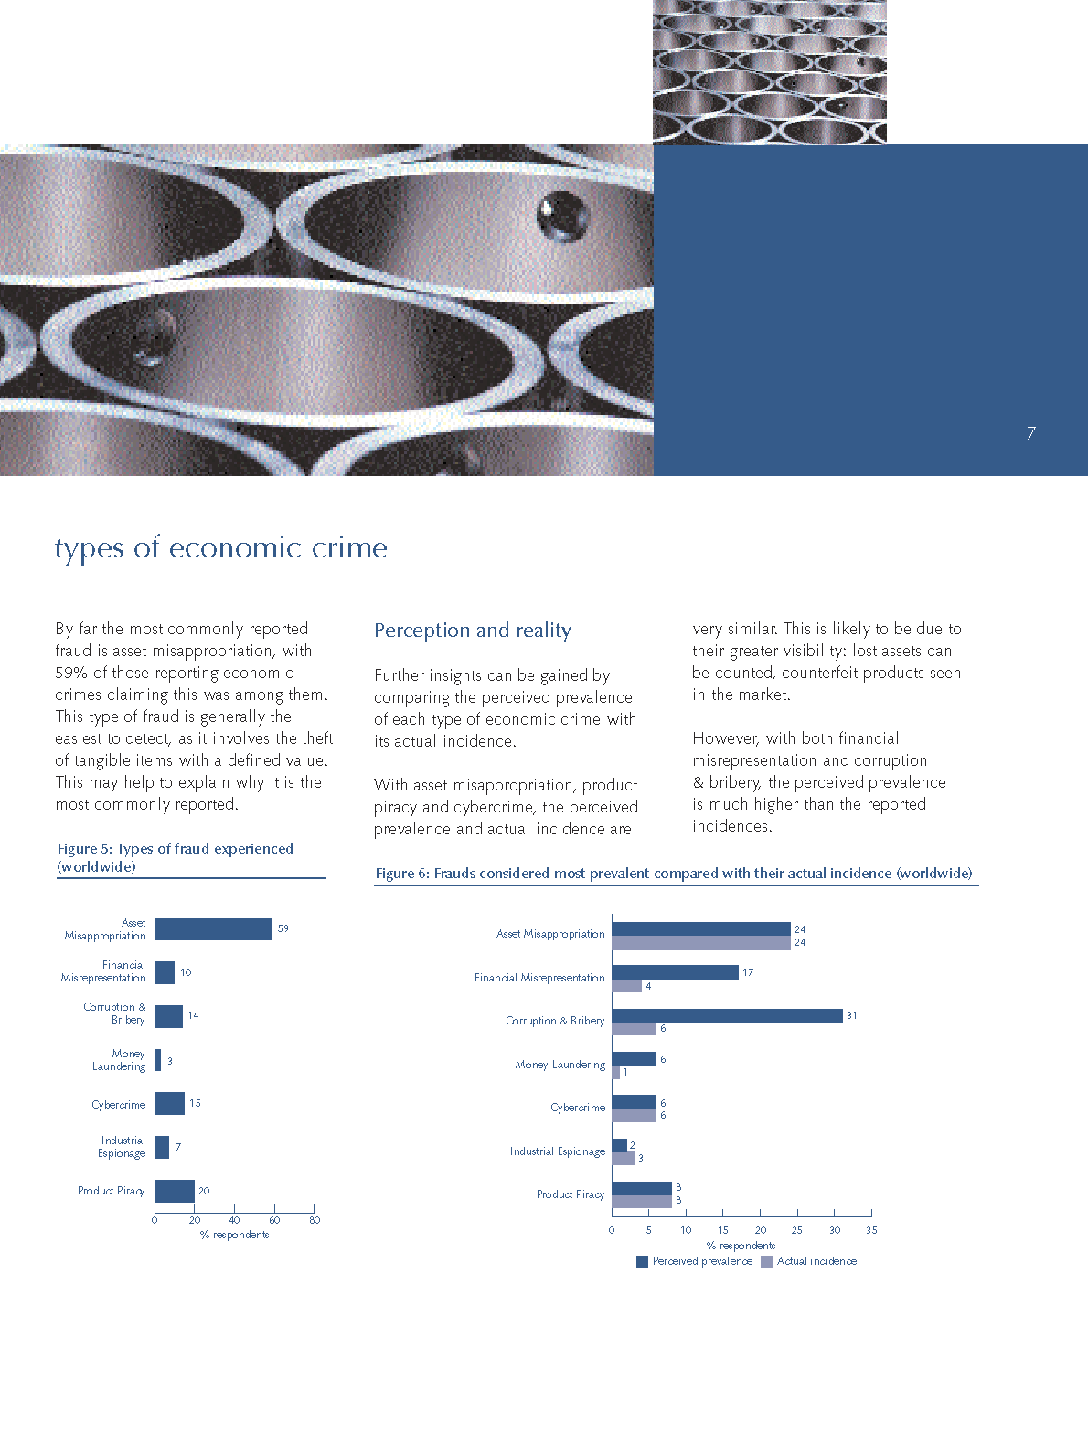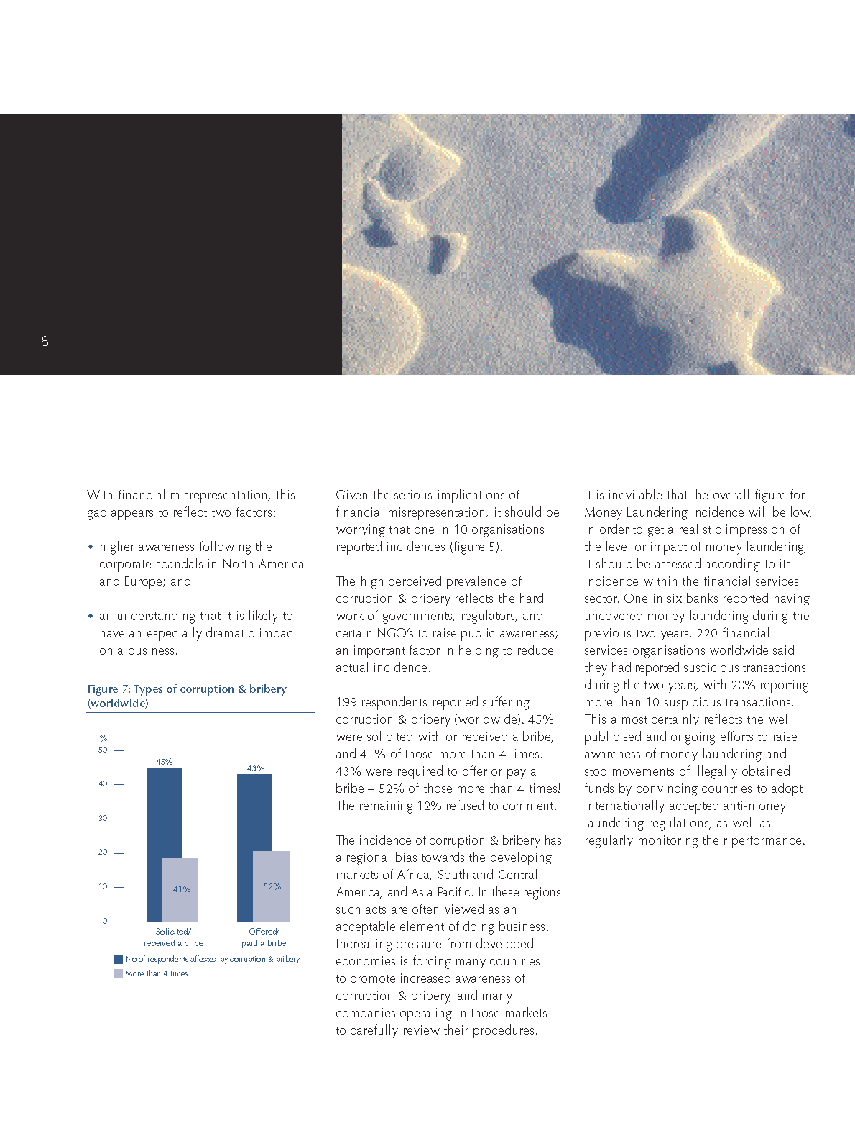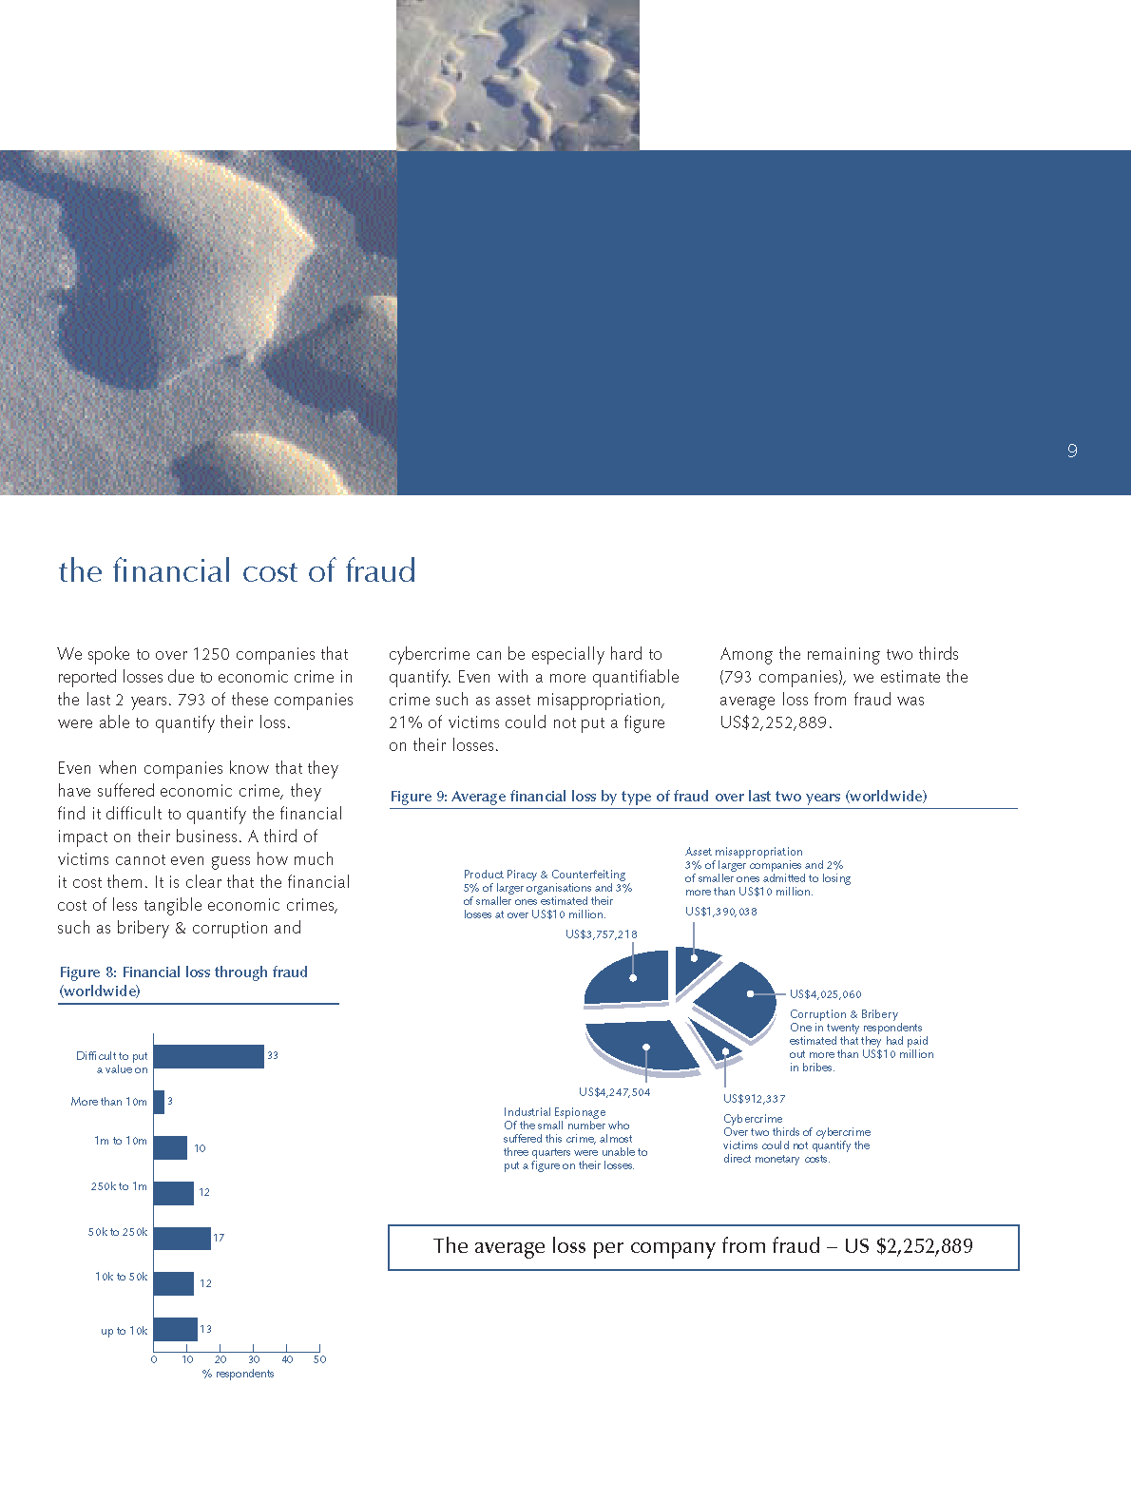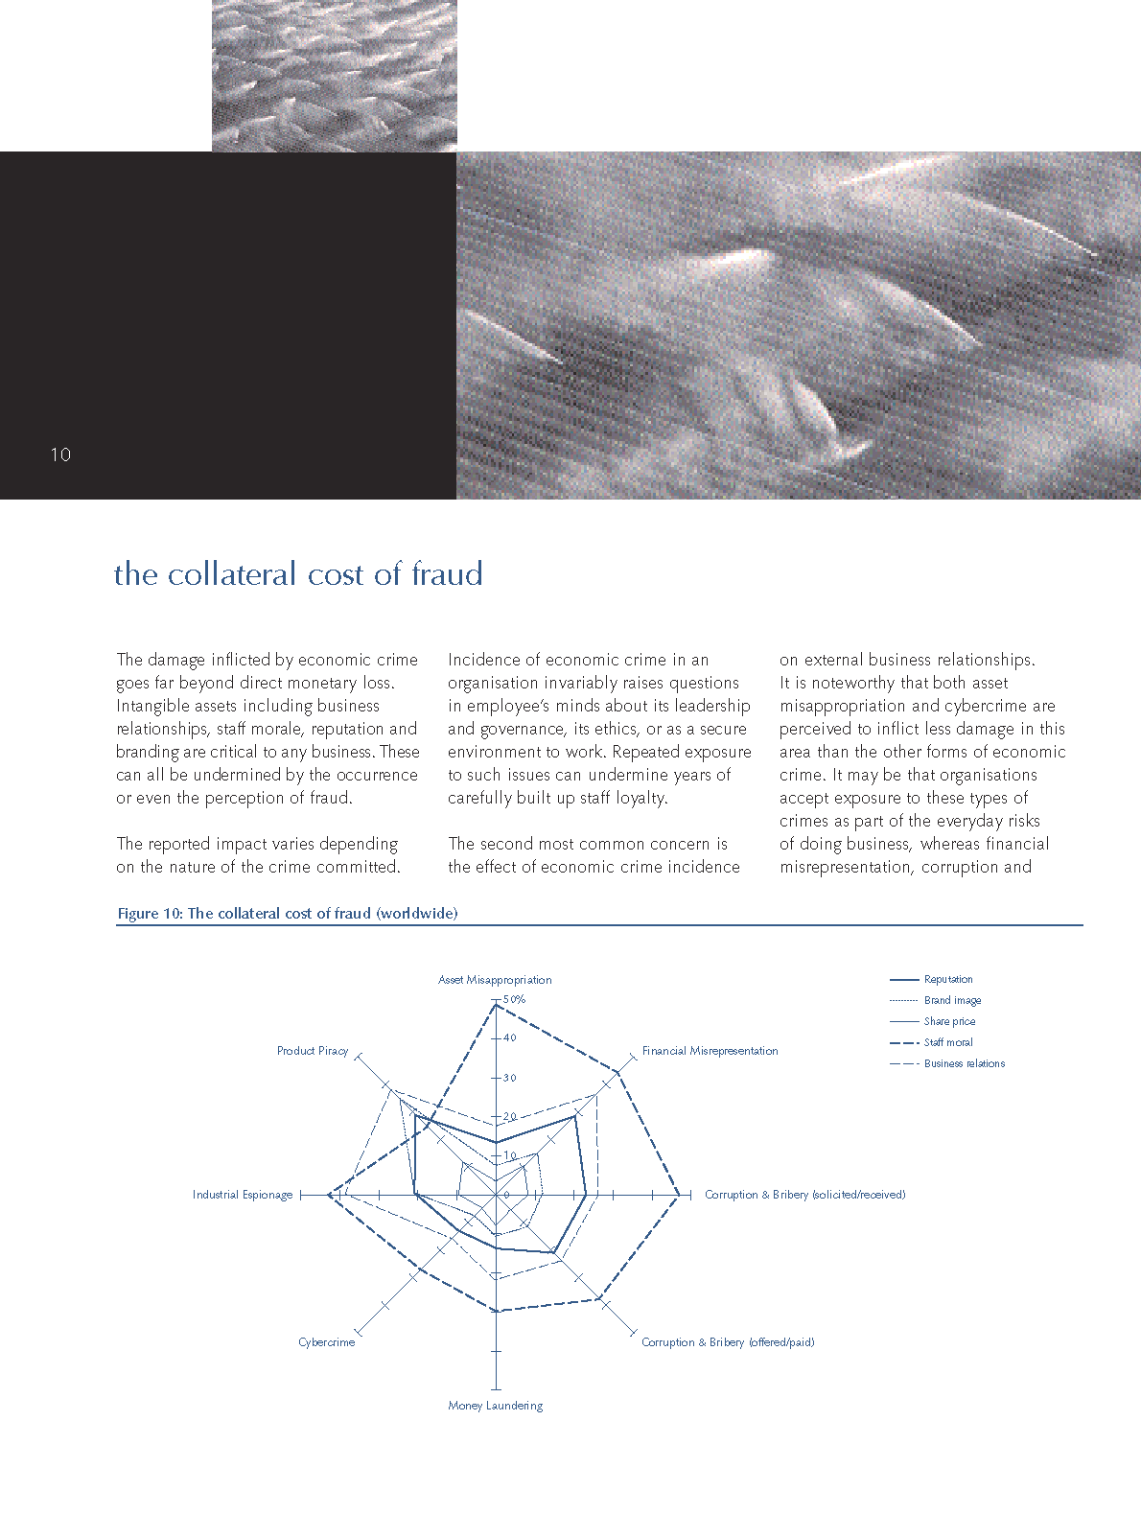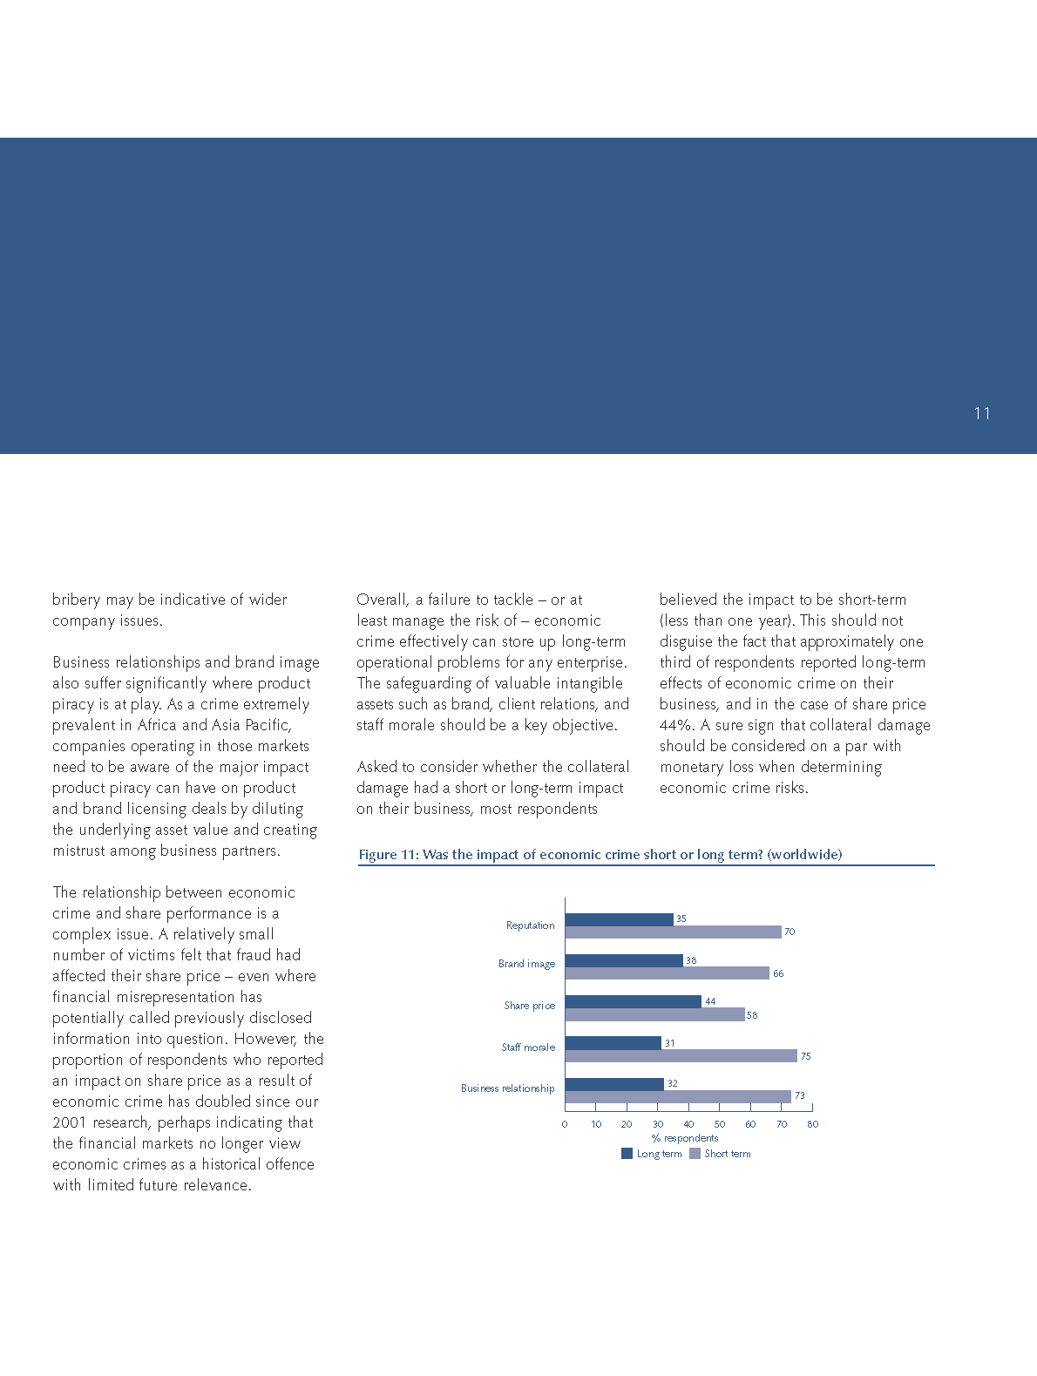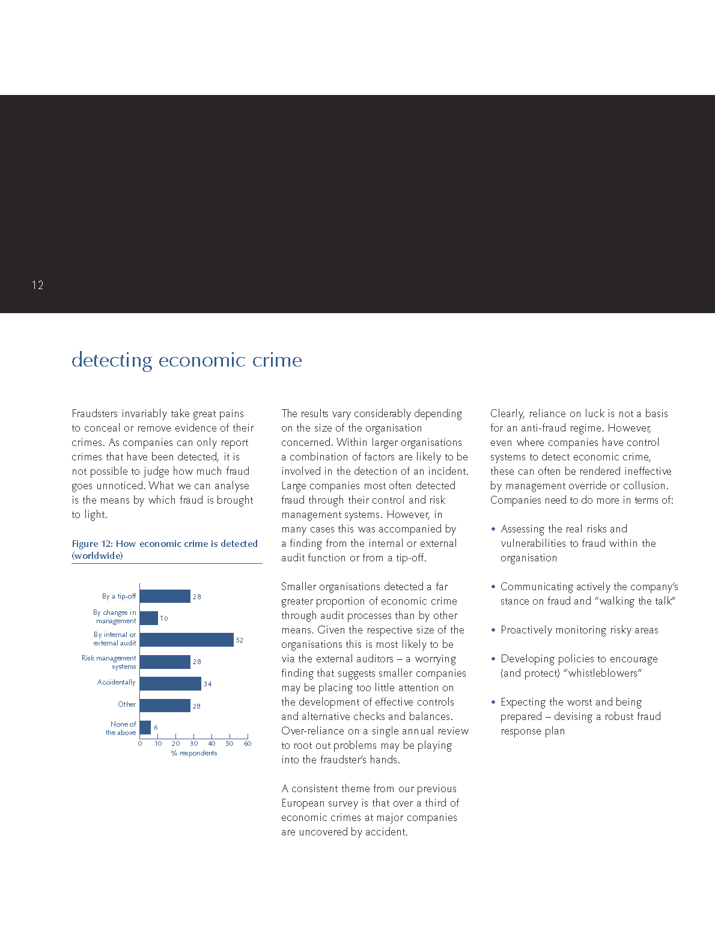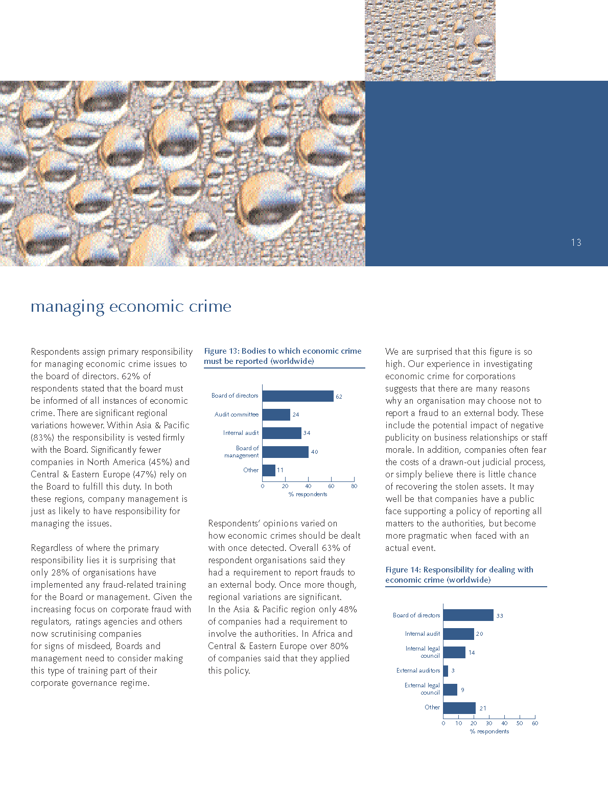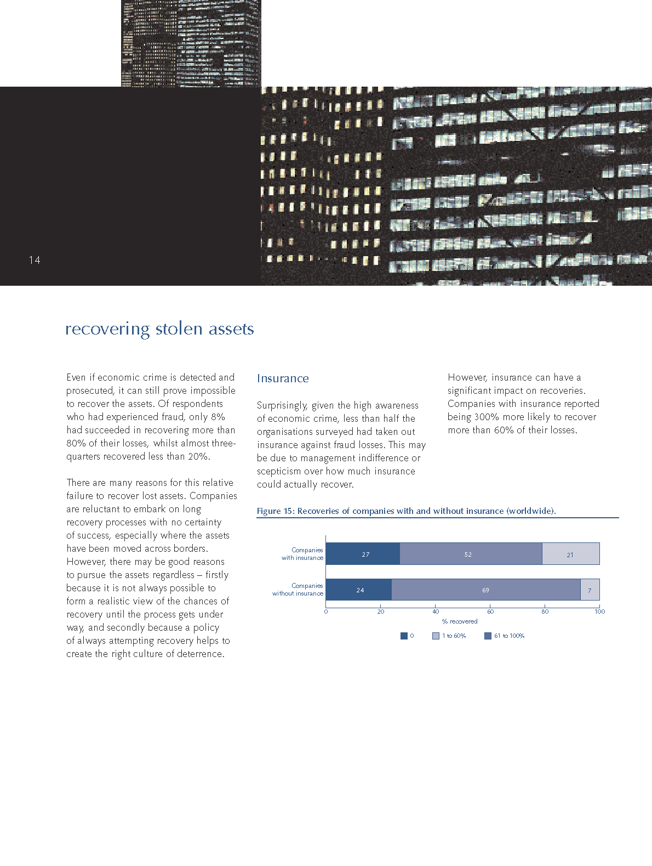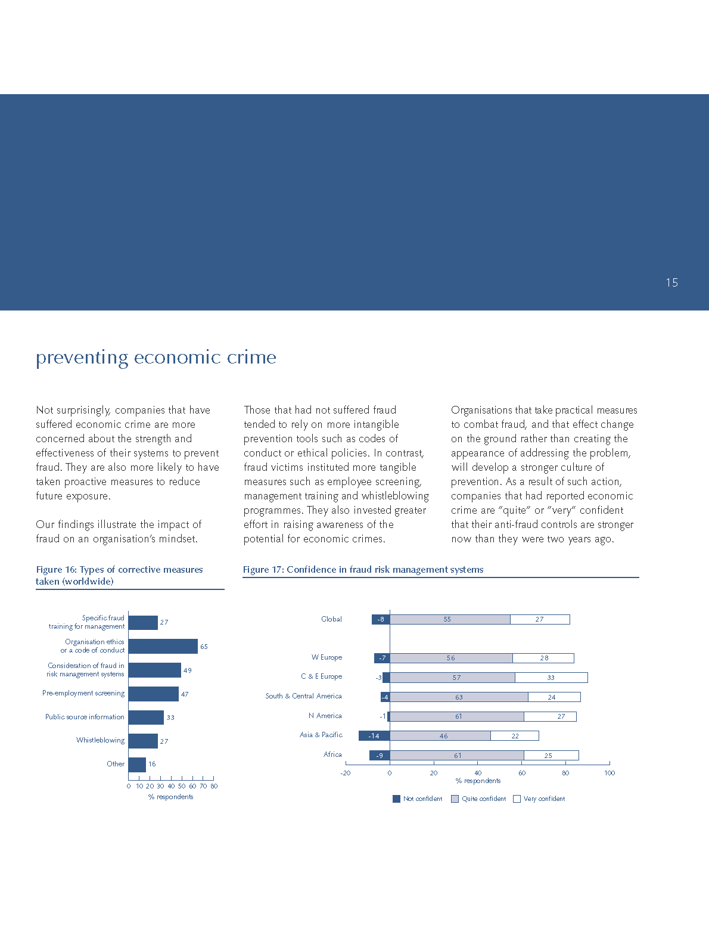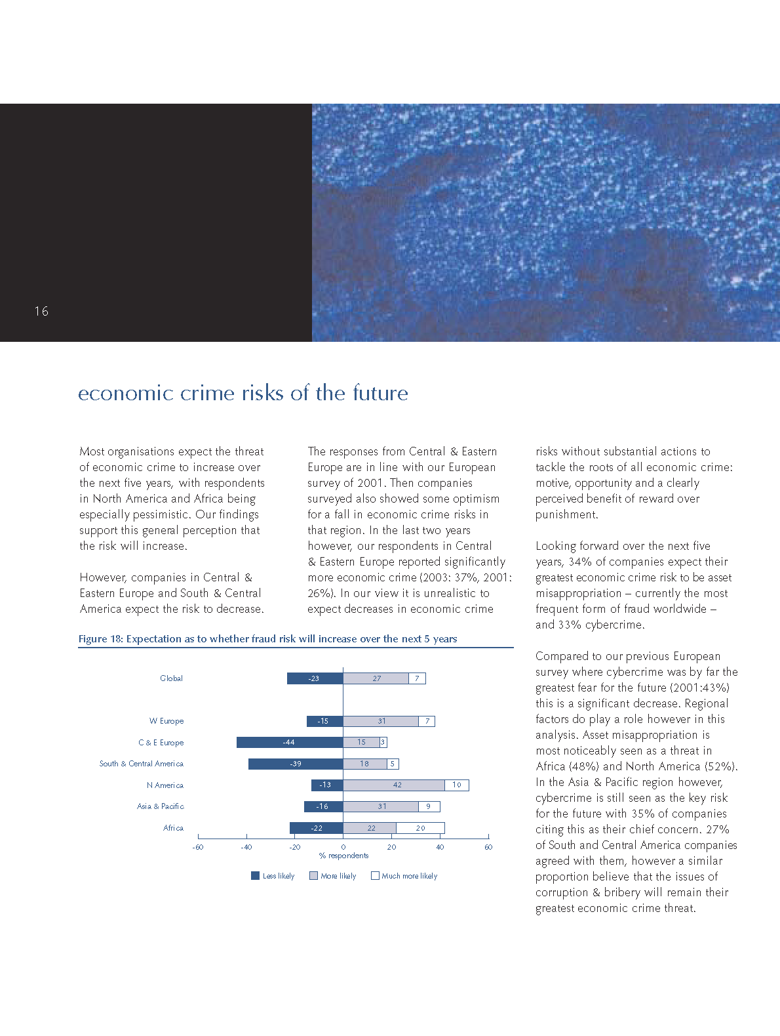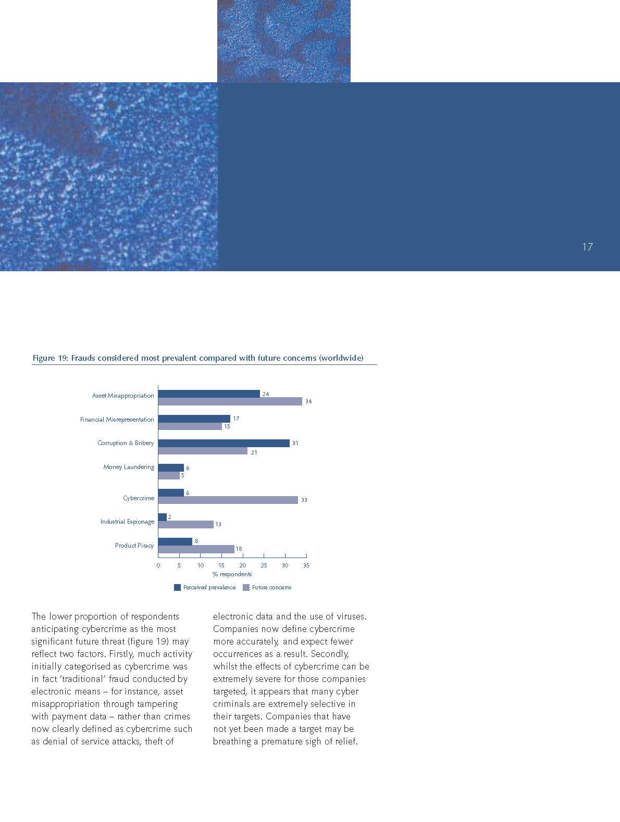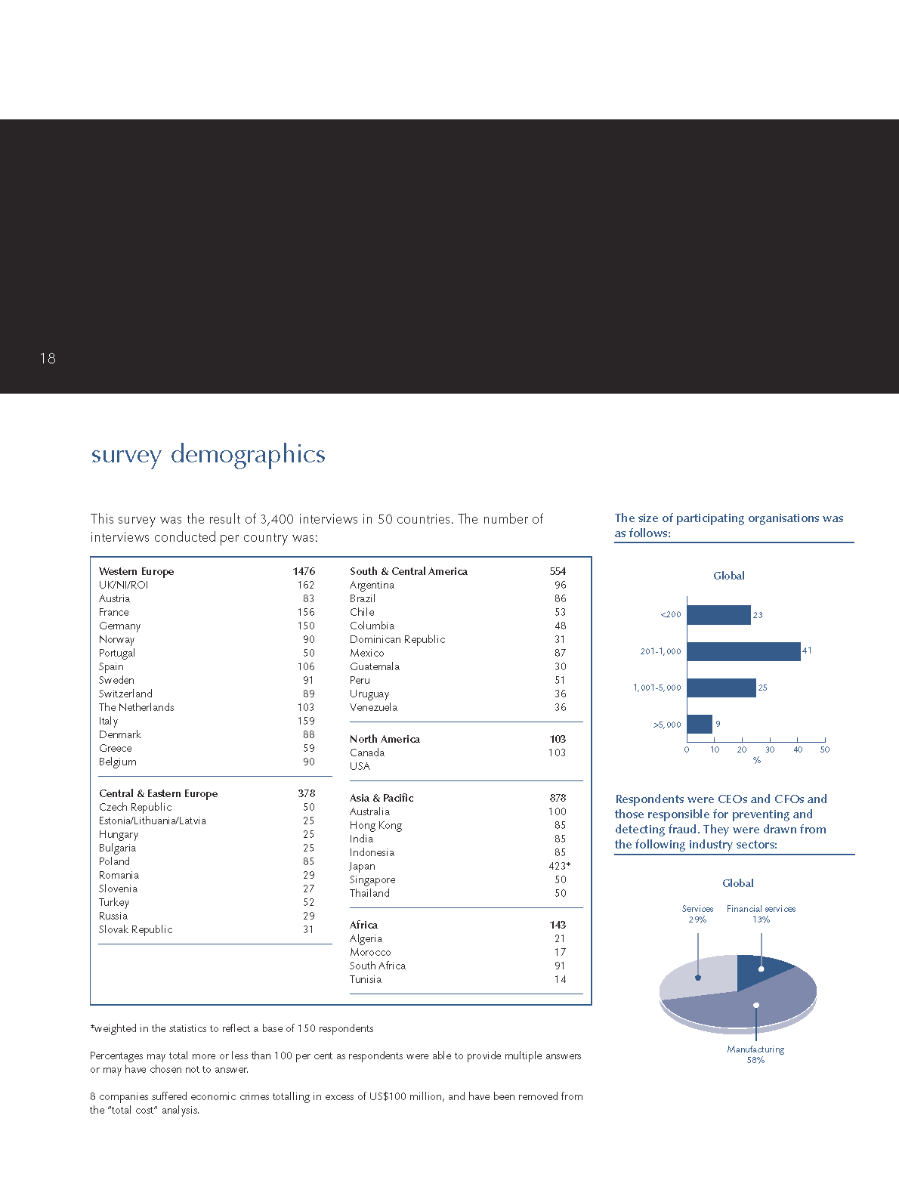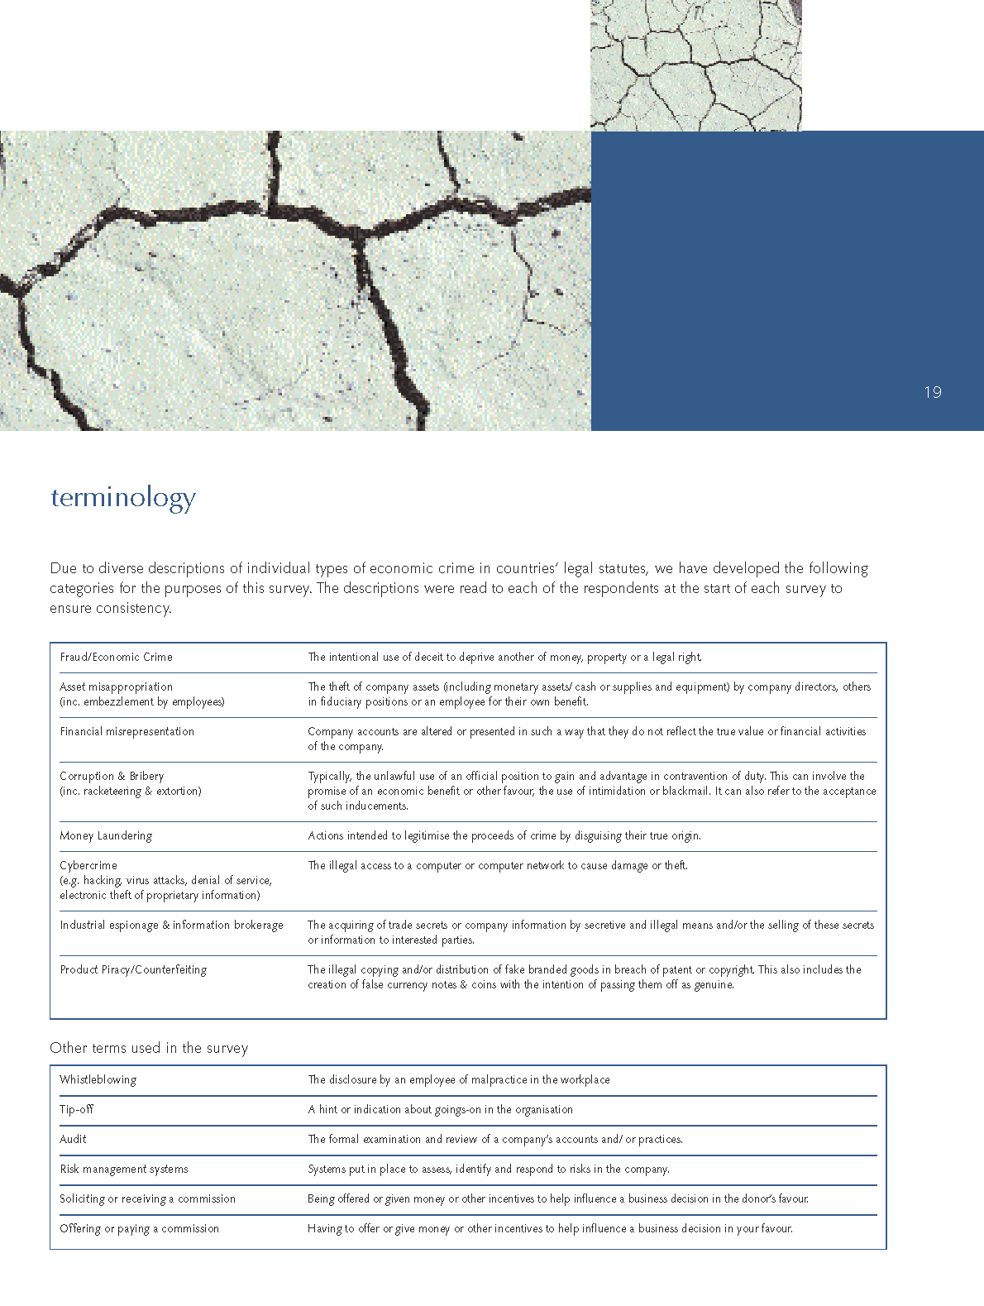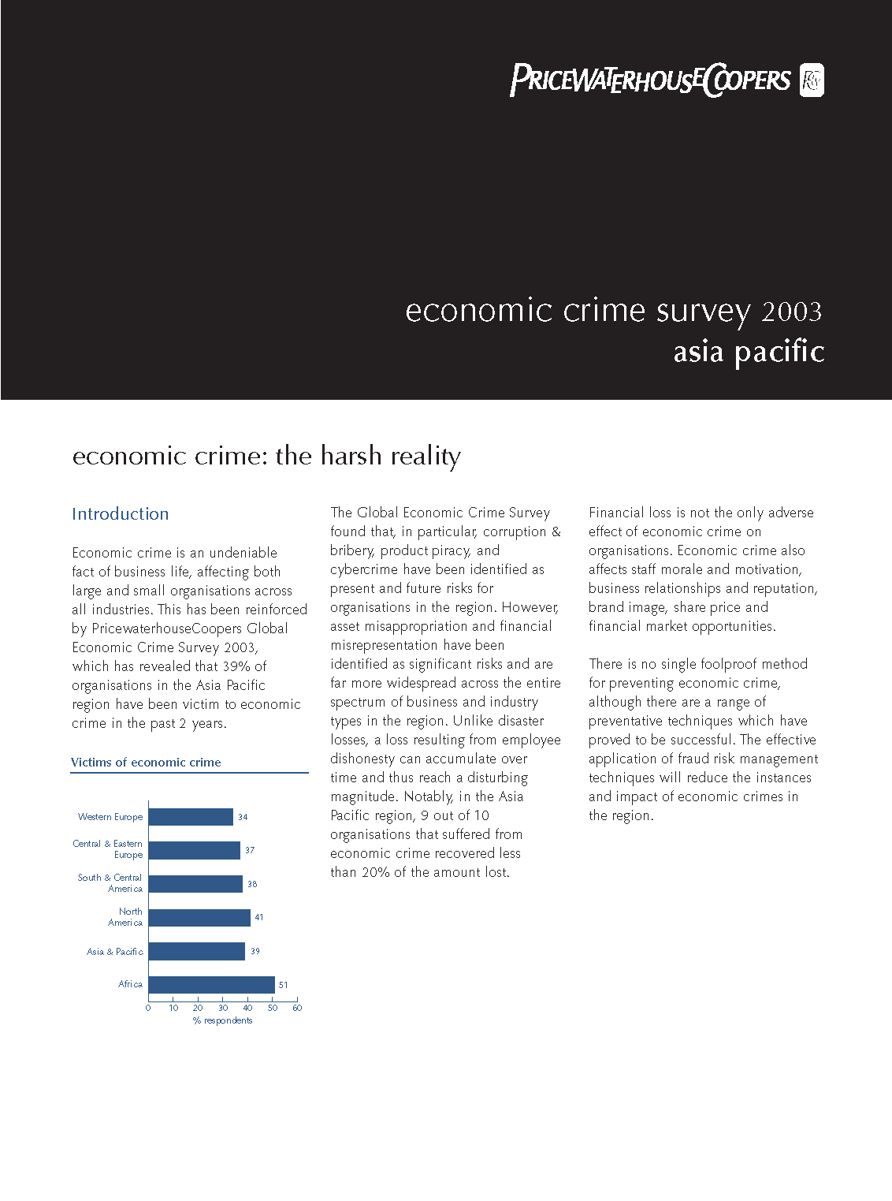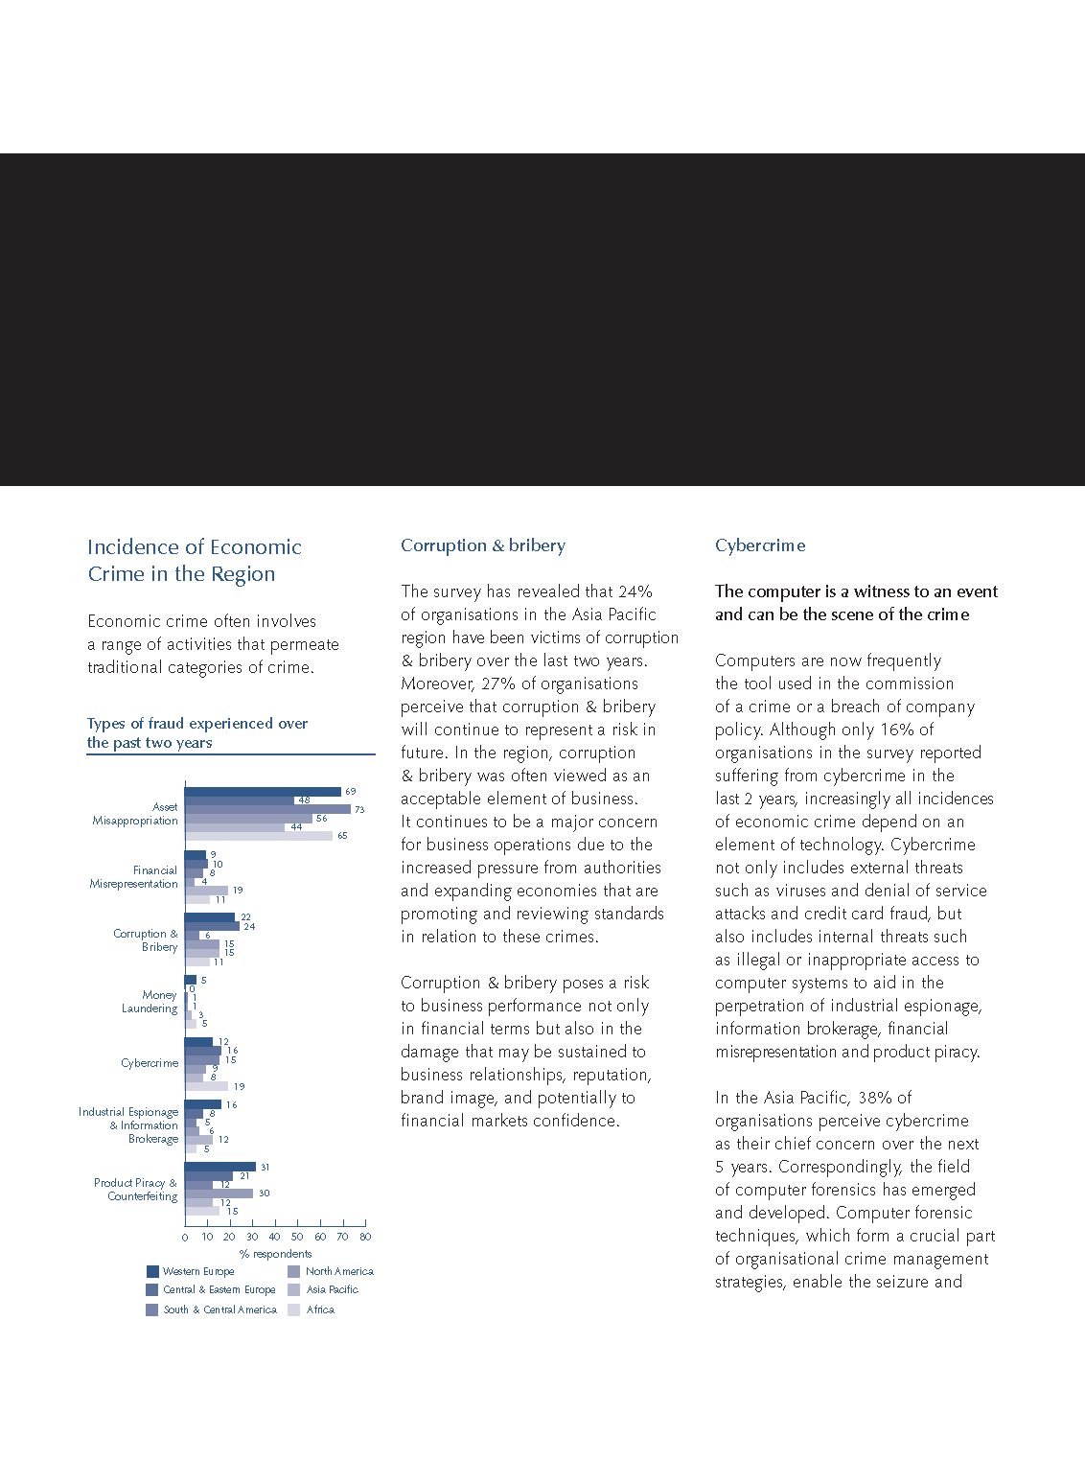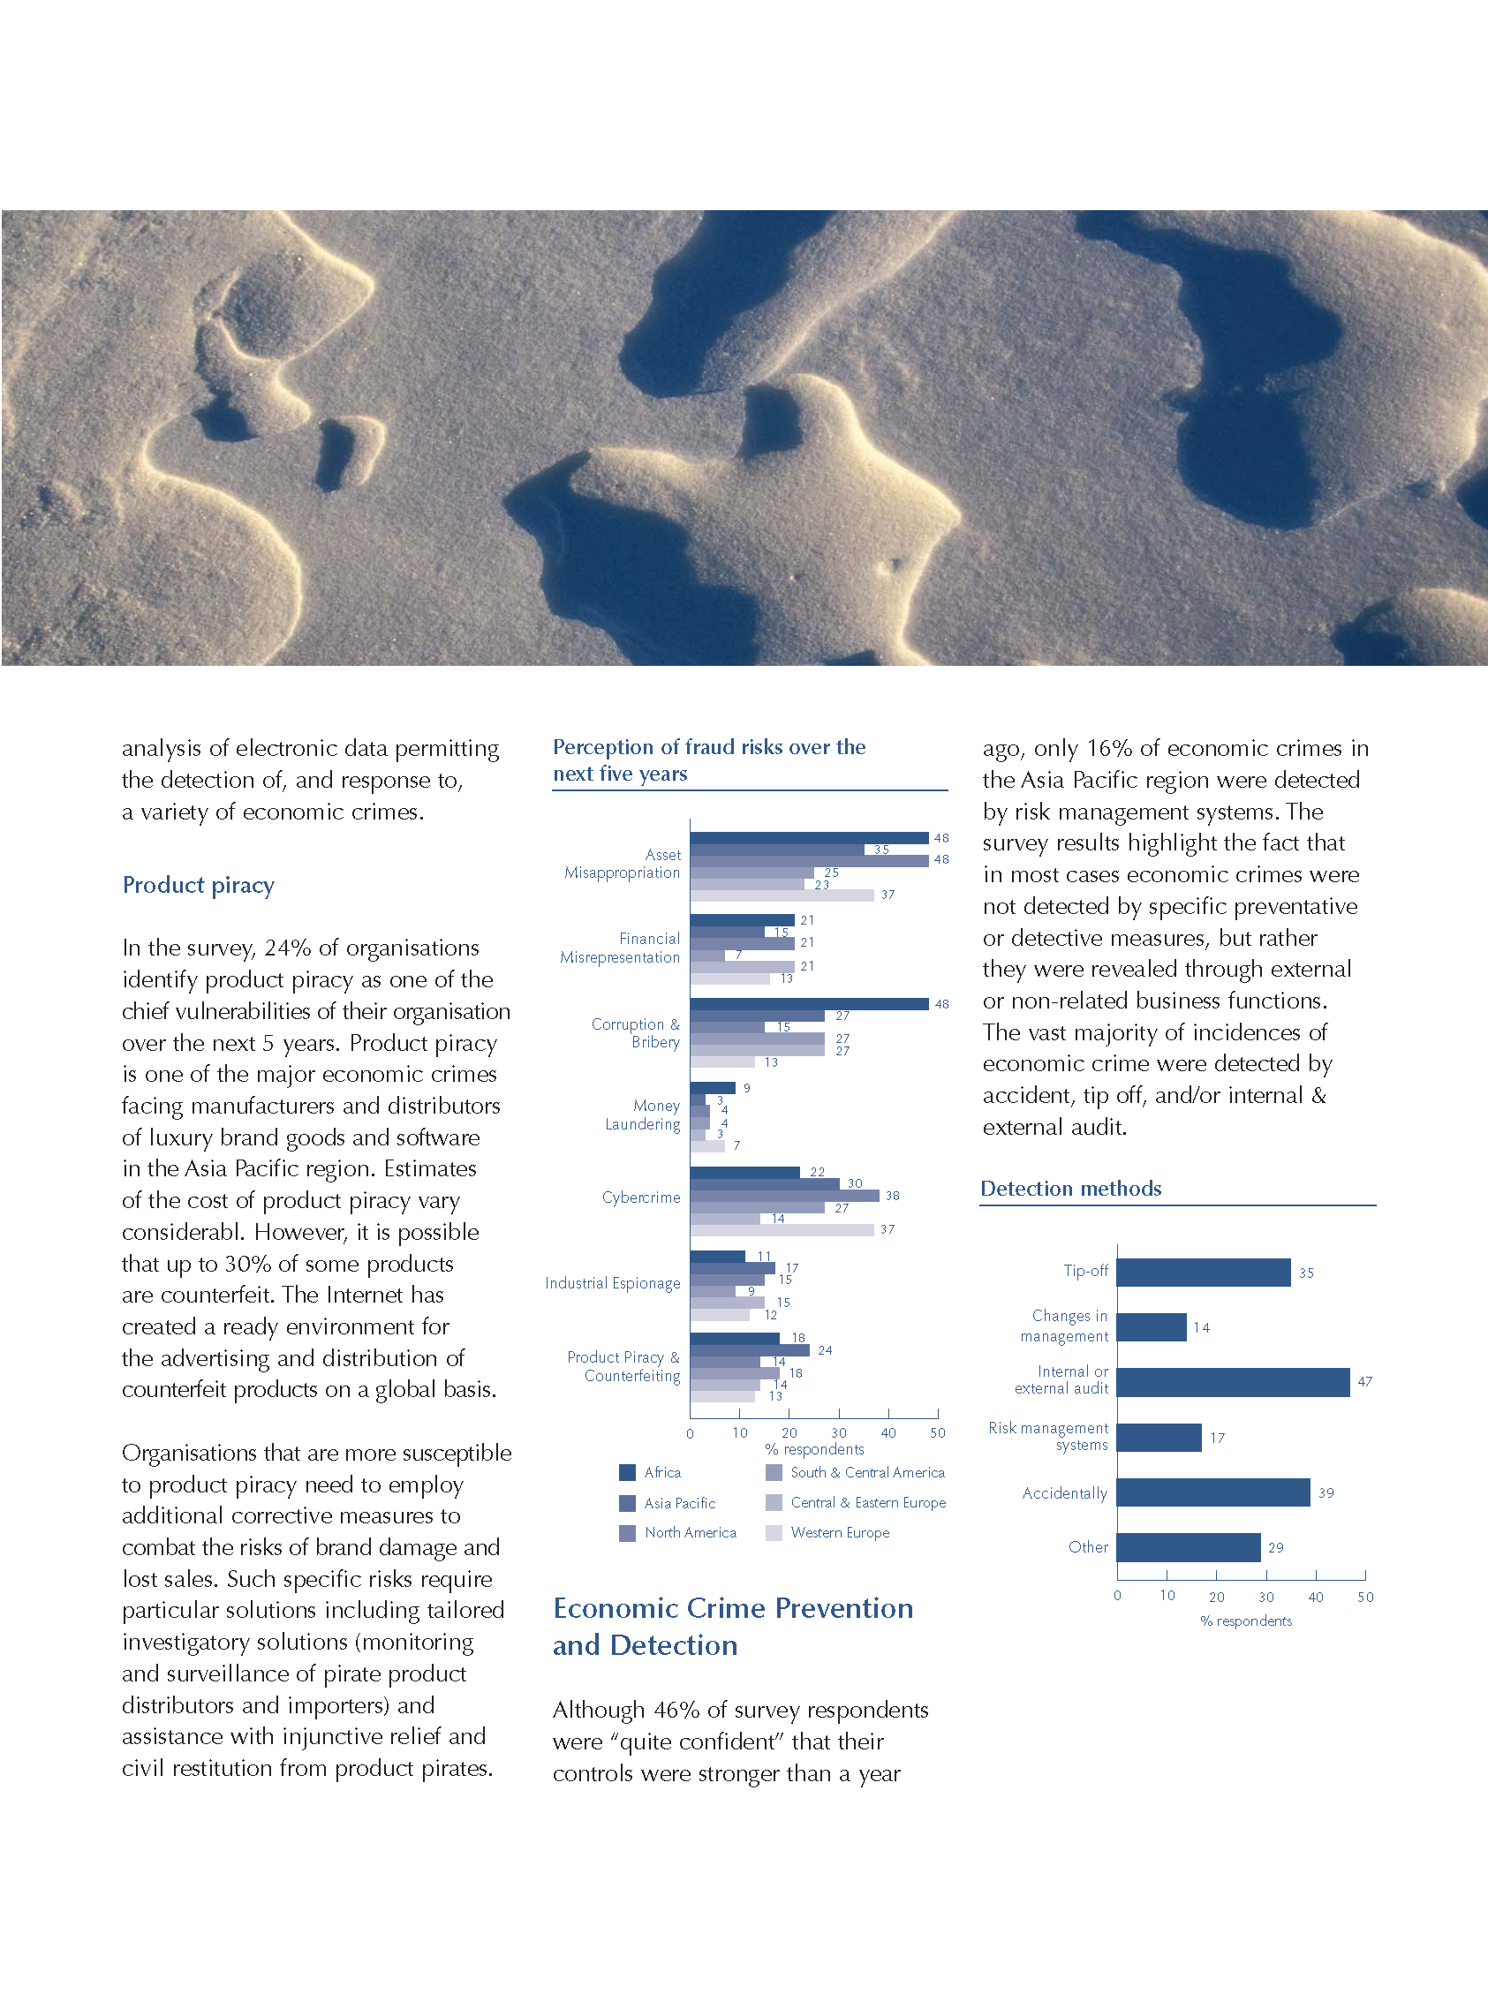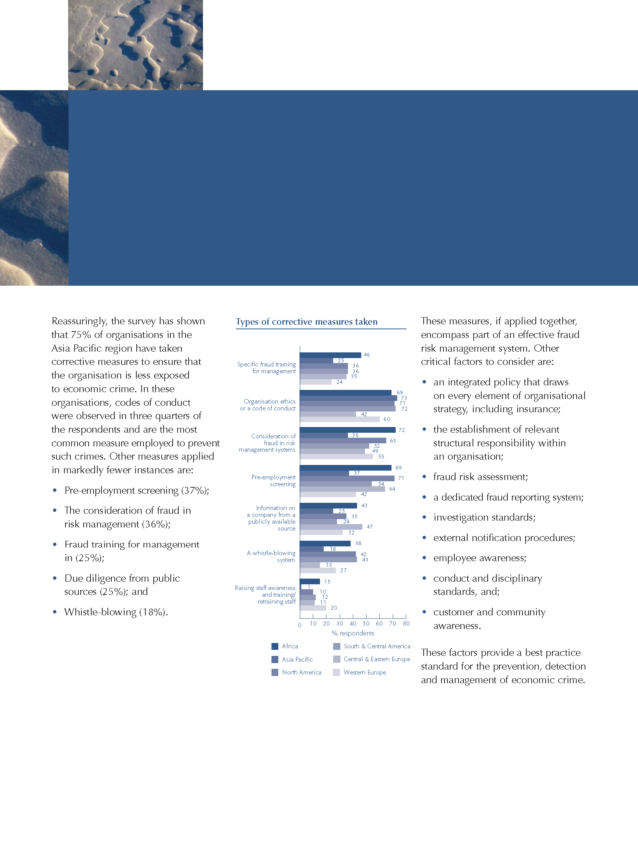
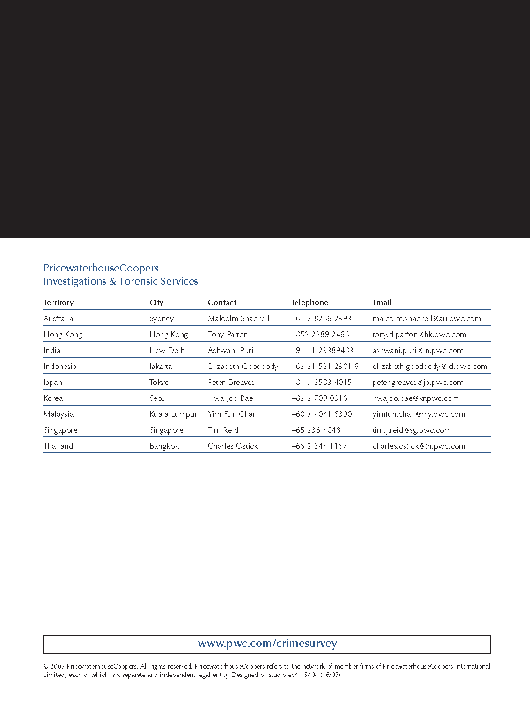

This is a summary of the Parliamentary Joint Senate Committee on the National Crime Authority Report into “Law Enforcement Implications of New Technology”, August 2001. Department of the Senate Printing Unit, Parliament House, Canberra.

