Department of Parliamentary Reporting Staff

December – February 2002

Taking the Pulse
a small piece of research around the question,
“Is DPRS living its values?”

Suzanne (Suzi) Ross MAPsS, FAISA

Director of Consulting, Counselling, & Training
St James Ethics Centre

suzi.ross@ethics.org.au
02 9221 9801

Introduction

Meg Hart, former Director of Consulting at the St James Ethics Centre (SJEC), was helping DPRS in the exploration of their values. Due to illness Meg was unable to continue this work and the executive group at the St James Ethics Centre furnished the department with some questions to further their explorations and reflections. Following this, Suzanne Ross met with the Secretary and Group Manager of Strategic Development and it was agreed to conduct two days research to “take the pulse” of the organisation in relation to living their values.

The following report is a result of an agreement that the SJEC would do a very short and limited (in numbers) piece of research around the topic of “Is DPRS Living its Values?”

On December 3 and 13, 2001, a number of small groups involving 45 DPRS employees were interviewed. On December 3 Brian Cheetham also attended those interviews. We agreed that Brian would not be present on the second day. The numbers for this piece of research are of course very small, and no strong conclusions can ever be formed on this limited data group. The findings expressed in this report are simply mild indications for consideration, further dialogue and possible direction for future activity.

Does the Department live by its values?

In The Way We Work it is stated that ‘we are ethical’. What do DPRS employees understand ‘ethical’ to mean? It is extremely common in organisational life to use words in the ethical arena, assuming everybody understands its meaning, and shares the same understanding with how it informs their actions.

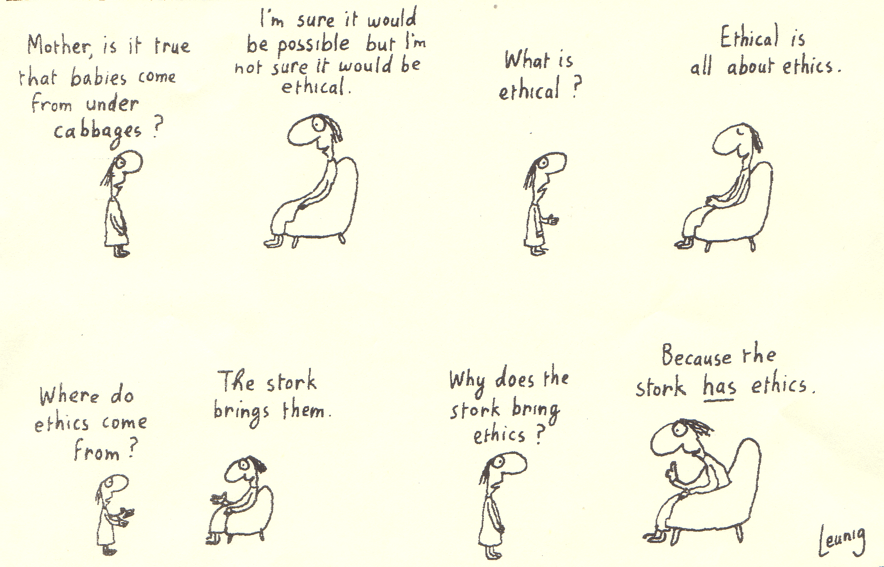
What is ethics?
reprinted with permission

At the beginning of each session, the participants were asked to give a definition of what they thought ethics was. They were clearly working with differing conceptions. Ethics was defined under the following clusters.

Ethics is simple, straightforward and socially common, eg. it’s commonsense, doing what is right, social mores.
- Ethics is complex and moving, eg. it’s in the eye of the beholder, it changes according to role, function and situation.

Ethics is about principles, eg. The Golden Rule (do unto others as you would have them do unto you), principles that drive us.

Ethics is about values and virtues, eg. honesty, respect, tolerance, professionalism.
- Ethics is about following one’s conscience, eg. doing the right thing, morality.

Ethics is about following the law, eg. avoiding legal implications, compliance.

Ethics is about following rules and codes, eg. standards of behaviour, codes of conduct.

Ethics is about understanding different viewpoint and values, eg. seeing both sides of the story.

Ethics is about having integrity, eg. being honest to oneself, act according to one’s set of values.

Ethics is about relationships, eg. stakeholders.

Value One – Professionalism

DPRS definition:

We are ethical, committed and use initiative in providing our services.

DPRS staff review definition:

This includes accuracy, quality of work, ability to manage personal resources, ability and willingness to accept responsibility, initiation and completion of tasks.
DPRS staff review criteria for success regarding this value
Outstanding
    - Has a thorough knowledge of a topic / issue before making a decision including taking into consideration how other areas / staff will be affected.
    - Is able to see things from more than one angle when making comments / decisions.
    - Work is of the highest possible quality and encompasses more than that initially requested.
    - Is well presented; observes guidelines on standard dress.
    - Coaches others with time management due to outstanding skills in this area themselves. Recognises that this assists with individual development and unit output.
    - Has an outlook extremely focussed on service delivery.
    - Is recognised throughout the organisation for their skill levels.
    - Is utilised to represent the workplace / department at internal / external forums.

DPRS Staff Newsletter opinion of the links between its values and the Parliamentary Services values

Parliamentary Service Value 1

The parliamentary Service provides professional advice and support for the Parliament independently of the Executive Government of the Commonwealth.

Parliamentary Service Value 2

The Parliamentary Service provides non-partisan and impartial advice and services to each House of the Parliament, to committees of each House, to joint committees of both Houses and to Senators and Members of the House of Representatives.

Parliamentary Service Value 3

The Parliamentary Service has the highest ethical standards.

Parliamentary Service Value 4

The Parliamentary Service performs its functions with probity and is openly accountable for its actions to the Parliament.

Parliamentary Service Value 6

Employment decisions in the Parliamentary Services are based on merit.

Pulse-taking Focus Group Findings
Professionalism was defined in a variety of ways, with a strong core difference in many cases.
- It is purely related to the quality of the product – i.e. a professional product.
- It is the means of achieving the product – i.e. a professional approach.
- It is the corporate image, dress and speech – i.e. a professional look.
- It is how others see our performance – i.e. a professional perception.
- It is a constant attempt to do your best – i.e. a diligent professional.
- It is about the way in which we deal with people – i.e. relating professionally.
- It is about behaviour – i.e. acting professionally.
- It is about work being a vocation, rather than just a job – i.e. it is a profession.
- It is defined within a section or department, eg. broadcasting versus Hansard – i.e. professionalism is culturally defined.
- It is about managing within limitations and constraints – i.e. the grace under pressure professional.
- It is about providing a high input of knowledge and skills – i.e. the skilled professional.
Does DPRS live the stated value of professionalism?
The groups were asked to score their section and DPRS as a whole, out of a score of ten.
Section – 8 out of 10
In nearly all cases, people considered that their section (regardless of the definition that they individually used for ‘professionalism’) scored quite highly, i.e. they were quite professional. Whilst the range was between 5 and 10, over 85% of the group gave a professional score of 8.
Organisation – 7 out of 10
In ranking DPRS as a whole on professionalism, the range was much less, being 5 to 8, with over 70% ranking as 7.
Living the value
            - DPRS does seem to live its value of professionalism
Ethical issues to ponder
- Should we judge a book by its cover? When is casual too casual?
There was strong discussion about professionalism and its connection to dress. Broadcasting staff argued that professionalism to them was their quality of work, and not their dress code. They argued that the culture of their profession had an identifiable dress code like other professions, eg. boiler-makers wear blue overalls, doctors wear white coats, Hansard staff wear ties, and radio / TV staff wear jeans and T-shirts. This is an interesting ethical issue. Being employed as a public servant in DPRS requires one code of dress, whilst all of their industry colleagues who work outside of the public service will be wearing jeans and T-shirts. So, what rights does the individual have? What rights does the employing body have? Is this change to culture fully explained during recruitment? How is the discomfort of an individual who feels they are doing a professional job, and is considered unprofessional because of their dress, to be managed? How does the culture of an employing body cope with a group that is counter-culture dress wise? When does dress reflect badly on the employer?
There was quite a degree of emotion around this area, particularly as they perceived
- Some compromises were considered to have been made by both parties.
- Some senior personnel were imposing dress codes that they themselves did not always adhere to.
- The issue of dress is firmly tagged to one’s staff review, eg. under the heading, “Not Meeting Job Requirements” regarding professionalism, “Dress and grooming are frequently below standards set in the workplace.”
Competing values and principles
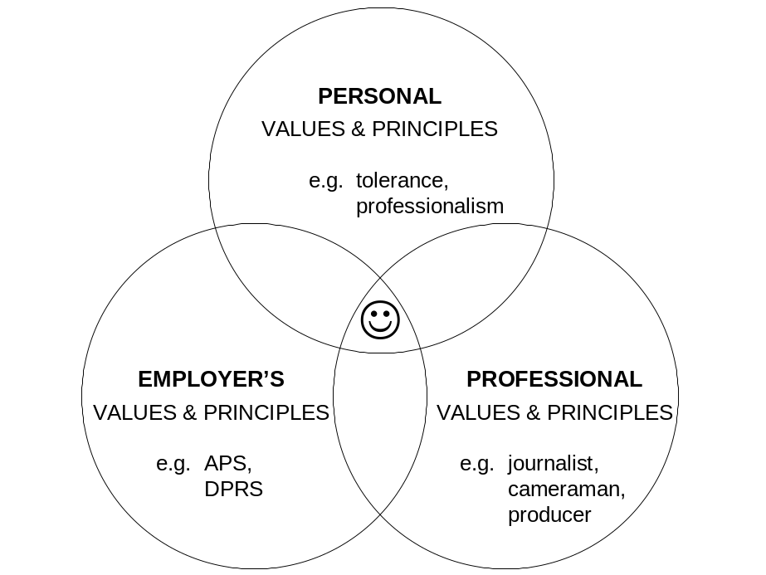

Value Two – Partnerships with Clients

DPRS definition:

We work with clients to find the best way of meeting their needs.

DPRS staff review definition:

This includes identification of clients, awareness of clients’ needs, two-way relationships with clients including negotiations as appropriate, changes made to better client’s needs.
DPRS staff review criteria for success regarding this value
Outstanding
    - Is used by other groups / agencies as a reference point for various issues.
    - Is quite fluent in knowledge of other groups
    - Always “gets behind the question” to identify any unstated needs.
    - Develops processes to lift service to the next level.
    - Understands the relationship between own duties and other areas of the department.
    - Constantly receives positive feedback from clients.
    - Consistently seeks out all of the client’s needs in order to provide improved services. Looks for feedback on how to improve for next time.
    - Follows through to ensure all commitments made to clients are met.

DPRS Staff Newsletter opinion of the links between its values and the Parliamentary Services values

Parliamentary Service Value 10

The parliamentary Service focuses on achieving results and managing performance.

Pulse-taking Focus Group Findings
Partnership with clients was defined as follows:
- Find out what the client wants and needs and give it to them.
- Working together in a consultative process.
- Quick response when our clients tell us that we’ve got it wrong.
- Finding the best way to meet the needs of our clients.

Does DPRS live the stated value of partnerships with clients?
Partnerships with external clients was considered to be very good. Partnerships between internal groups, however, was in some cases considered to be very poor. It was universally agreed that despite these poor relationships the product standard was not affected. It is interesting to note that the inter-group difficulty would have required greater attention if the product was affected – it is unclear whether good partnerships were valued in their own right.
External partnerships – 8 out of 10
The range for these were 7 to 9.
Internal partnerships – varied
I wouldn’t even like to put an average figure on this, as it ranged between 2 and 10.
Quotes of interest
“Between-group relations, very poor.”
“Our internal culture is very political, there is a spirit of gamesmanship which interferes with our duty to truly work as partners.”
“Our external clients have extremely high expectations of us and they act like gods.”
“Senators and Members are to be treated like gods.”
“We deal with four other departments that have conflicting objectives and goals.”
“In sitting week, we are often not professional in our dealings with others as gods’ work must be done.”
“There is a them and us situation; workers and managers.”
Ethical issues to ponder
- Is it right to serve the gods?
It would seem from reading DPRS literature that it is quite clear that the first priority must be to the Senators and Members.
From Corporate Governance within DPRS: “our direct clients are 224 Senators and Members of the House of Representatives who make up the Australian Parliament, their support and the Parliamentary administration which helps the Parliament to function. Priority is given to services to Senators and Members.”
- Do internal relationships have to be so painful?
It appears that a major focus for DPRS to live its values is in the area of its internal partnerships. A high quality product for a high priority group may not have to mean that the “lesser mortals” squabble between themselves. Ethics is about relationships and the quality of the character of the relationships, both internal and external.
Corporate Support Group
Financial Services
Personnel Services
Technical Services Group
Projects
Infrastructure Facilities
Standards and Security
Client Services Group
Client Liaison
Hansard
Broadcasting
Business Management
Staffing
Strategic Development Group
Emerging Technology
Corporate Improvement
Secretary and Executive

DPRS
224 Senators & Members of the House of Representatives
Senators’ & Members’ support staff and administration
individuals and organisations within federal, state and local government
universities
public and private companies
professional practices
schools
libraries
not-for-profit groups
media
Living the value?
            - DPRS lives its value of partnership with clients with high priority external clients (Senators and Members).
            - DPRS does not well live this value between a number of the internal groups, and also within some of the internal groups.

Value Three – Continuous Improvement

DPRS definition:

We seek ways to improve quality, value for money and personal effectiveness.

DPRS staff review definition:

This includes awareness of cost of services, understanding of current work practices and systems, ability to critically review same, staff development activities both for a staff member and any of their staff.
DPRS staff review criteria for success regarding this value
Outstanding
    - Develops systems for improving individual and workplace efficiency without being requested.
    - Undertakes self-development activities on own initiative.
    - Is able to motivate the team / peers to take up self-development opportunities and see the benefits of such.
    - Understands cost-effectiveness in own area, and the consequences for other groups. Looks for opportunities to improve where necessary.
    - Actively seeks feedback from supervisors.
    - Always thinks about how all elements of work can be improved.

DPRS Staff Newsletter opinion of the links between its values and the Parliamentary Services values

Parliamentary Service Value 11

The Parliamentary Service uses Commonwealth resources properly and cost-effectively.

Parliamentary Service Value 13

The Parliamentary Service provides a reasonable opportunity to all members of the community to apply for Parliamentary Service employment.

Parliamentary Service Value 14

The Parliamentary Service is a career-based service to enhance the effectiveness and cohesion of Australia’s democratic system of government.

Parliamentary Service Value 15

The Parliamentary Service provides a fair system of review of decisions taken in respect of Parliamentary Service employees.
Quotes of interest
“We try not to rest.”
“We try to improve process and service.”
“At times cost limits the perfect product and the possibility of improvement.”
“Improvement suffers at times when people don’t take initiative.”
“Some people don’t own the change.”
“People are inwardly focused, which affects some improvements.”
“We have a lot of change but not all is improvement.”
“Having managers in acting positions or changing managers isn’t in the interest of improvement.”
“Some managers are over cautious and don’t speak their mind, they say what they think that people above them want to hear. They are ruled by fear.” (The implication of this is that it affects improvements, as superiors don’t get reliable information.)
“Some people whinge rather than getting things changed.”
“The communication chain and frameworks are in existence, but there are no checks – a lot doesn’t get through to the executive and we can have uninformed decision-making.”
“There is a real fear thing that if you rock the boat you won’t get the reward.”
“They stress open management, but if you express your view and they don’t like it, god help you.”
“We have a culture of suspicion.”
“The culture of fear means that people give good reports to the secretary.”
“We need to be proactive not just reactive.”
Does DPRS live the stated value of continuous improvement?
The groups were asked to score their section and DPRS as a whole, out of a score of ten. The range was between 5 and 8, with most respondents equally spread across those scores.
Ethical issues to ponder
- How does one manage the complexity of right versus right, when the values of efficiency and improvement (quality) compete?
- How does one manage the complexity of right versus right, when the values of desirable staff roles and security / stability compete?
- Is it true that there is uninformed decision-making, due to real or perceived fears?
- Where does the virtue of courage and the value of honesty fit with this real or perceived culture?
Living the value?
            - In general DPRS lives this value, however finance, staff changes, internal relations, fear and “silo” mentality still impair this potential.

Value Four – Personal Respect

DPRS definition

We value and support each other and share ideas.

DPRS staff review definition:

This includes communication skills both oral and written, sharing knowledge and experience, contribution to teamwork and communication, recognition of others’ contribution.
DPRS staff review criteria for success regarding this value
Outstanding
    - Contributes to team meetings effectively and ensures relevant outcomes are apparent.
    - Recognises learning styles and modifies approach accordingly to ensure maximum outcome.
    - Coaches other peers / staff members both individually and in group.
    - Supports the implementation of staff member’s suggestions or discusses how they can be modified for maximum use.
    - Has the respect of peers, supervisors and subordinates.
    - Regularly assists in other areas in times of heavy workload.
    - Articulate verbal communicator who makes a positive impact in group situations and meetings.
    - Well developed, mature skills in various forms of written communication (as applicable to staff member’s level), eg. Submissions, letters, memos.
    - Builds confidence in others.

DPRS Staff Newsletter opinion of the links between its values and the Parliamentary Services values

Parliamentary Service Value 5

The parliamentary Service has leadership of the highest quality.

Parliamentary Service Value 7

The Parliamentary Service provides a workplace that is free from discrimination and recognises and utilises the diversity of the Australian community.

Parliamentary Service Value 8

The Parliamentary Service establishes workplace relations that value communication, consultation, cooperation and input from employees on matters that affect their workplace.

Parliamentary Service Value 9

The Parliamentary Service provides a fair, flexible, safe and rewarding workplace.

Parliamentary Service Value 12

The Parliamentary Service promotes equity in employment.

Pulse-taking Focus Group Findings
People defined this in much the same ways as is defined above.
Quotes of interest
“We don’t feel respected. When Parliament sits we are on–site at 2:00 a.m. with no extra pay – something our superiors don’t have to do”
“We’re not respected for what we wear.” (broadcasting)
“We need to be able to tolerate more self-criticism. We are far too precious.” (The implication of this being that constructive feedback can be seen as disrespect.)
“There is a dual responsibility to get our messages through in a way that can be heard and responded to. We need to listen to the message even if it’s delivered in a way that is difficult to hear.”
“There is a lack of tolerance for difference.”
“There is a lack of tolerance and respect between groups.”
“There’s conflict between what is good for the section and what is good for the department.”
“Respect would be increased if we could raise the awareness of what other areas are doing. We might see the big picture and cooperate more.”
Does DPRS live the stated value of partnerships with clients?
The groups were asked to score their department within section and between work units, and DPRS as a whole, out of a score of ten. The range was between 5 and 8, with most respondents equally spread across those scores.
DPRS as a whole – 6 out of 10
The range for this was 5 to 7, with most people scoring 6.
Within section – 8.5 out of 10
The range for this was 7 to 9, with most people scoring 8 or 9.

Between work units – highs and lows
This task caused a split scoring. The range was from 2 to 9. For example a score of 9/3 meant that between themselves and one work unit they gave a nine, and another a three. This happened in most cases.
Recommendation – living the value
            - It would seem that the first focus for the DPRS would be to improve the low between-group scores. There are a variety of ways of approaching this, using either external or internal resources. For example,
              - Work with group managers as a whole to improve the between-group situation.
              - Focus on one pair of working units, set up a workgroup comprising of representatives of each unit to address the task.
              - Survey approach to one work unit pair – it could be possible to do a combined survey from SJEC with Michael Brookes from ARTD (SR & MB).

Additional Focus Group Finding
1. In a number of groups on the second day (where I ran the groups without Brian Cheetham present) I was told that the DPRS Staff Survey for 2001 was linked to Christmas bonuses. A number of people were not surprised that various areas improved!!!!! If this is true, then neither am I.
As part of this research I met with Michael Brookes and found him to be a man of integrity who is a highly competent and skilled professional. If there was any truth at all in internal DPRS structures biasing his survey, I think that this is a pity for all concerned.
2. In the Way We Work brochure, the following is linked to living the values. From the quotes in the above report, regardless of small numbers interviewed, it could be suggested that a few of these might be in danger.

we will not

- ‘Do as I say’
- Control and blame
- Take others for granted
- Mistrust others
- ‘Just work’
- Be negative
- Follow ‘hidden agendas’
- Act defensively
- Use ‘but’, ‘can’t’ or ‘if only’
- Pass the buck
- Just spend
- Pursue perfection for its own sake
- Let rules drive us
- Focus on process
- Work hierarchically
- Work bureaucratically

