Question: F1
Outcome 1, Output 1.1.1
Topic: Costing of alternative policies that contained references to Labor policies

Hansard Page: F&PA 247 and 248

Senator Conroy asked:

Mr Bowen, when did you receive a request to cost Labor’s policies? How many?

Answer:

The Department of Finance and Administration received requests to cost alternative policies which contained references to nine Labor policies. The requests to cost the alternative policies which included references to Labor policies were received on 6, 10 and 13 July 2001.

Question: F2
Outcome 1, Output 1.1.1
Topic: Costing of Labor policies

Hansard Page: F&PA 249

Senator Conroy asked:

Would you be able to tell us how many Labor policies were asked be costed within
that? If possible, could that include which of Labor’s policies you were costing?

Answer:

As outlined in answer to Question F1, the Department of Finance and Administration received requests to cost policy alternatives which included references to nine Labor policies. The Labor policies were:

- Buprenorphine as a treatment for addiction;
- Education Priority Zones;
- a Medicare Alliance;
- a National Benchmark of Care;
- a National Workforce Forecasting Council;
- maintaining the Four Pillars Policy;
- deepwater surveillance of the Southern Ocean;
- increased Budget information; and
- a National Strategy to Combat Salinity.

Question: F3
Outcome 1, Output 1.1.1
Topic: Absorbing the cost of deployments to the Middle East

Hansard Page: F&PA 255

Senator Conroy asked:

On 17-18 October, the Treasurer and the PM were asked about what it would cost and they maintained that all costs would be absorbed—that it was a zero cost. Was DOFA aware of the Prime Minister’s announcement about deployments to the Middle East before it was made on 17 October 2001?

Answer:

Finance was aware from the Prime Minister’s press conference in Sydney on 2 October 2001 that the Government had indicated that Australia was prepared to support Australia’s involvement with US led coalition forces. No further details were known until the announcement on 17 October 2001.

Question: F4
Outcome 1, Output 1.1.1
Topic: Finance’s role in the costing of deployments to the Middle East

Hansard Page: F&PA 255

Senator Conroy asked:

Was it involved in any process to cost this announcement before it was made?

Answer:

No. Finance was not involved in any costing process before the announcement was made on 17 October 2001.

Question: F5
Outcome 1, Output 1.1.1
Topic: Finance’s role in the costing of deployments to the Middle East

Hansard Page: F&PA 255

Senator Conroy asked:

Was DOFA involved prior to the announcement and, if it was not, then, subsequent to the Prime Minister’s announcement, did you do some costings?

Answer:

Finance was requested to undertake the costing of election commitments on 2 November 2001 in a letter from the Prime Minister to the then Secretary of the Department of Finance and Administration under the Charter of Budget Honesty Act 1998.

Question: F6
Outcome 1, Output 1.1.1
Topic: Finance’s role in the costing of the coalition’s defence policy

Hansard Page: F&PA 255

Senator Conroy asked:

Did you cost that request—the coalition’s defence policy released on 9
November?

Answer:

During the Election campaign, Finance provided costings to the Prime Minister under the Charter of Budget Honesty Act 1998. Finance received a request from the Prime Minister to cost the policy “Defence Policy: Strengthening Australia’s Defences” on 2 November 2001.

Finance, in costing the Prime Minister’s request, sought additional information from the Prime Minister on the costings on 5 and 7 November 2001, including whether these costs could be absorbed. The Prime Minister’s response provided on 8 November 2001 stated that, in relation to Australia’s counter terrorism efforts “in the short term that money will be absorbed, in the longer term there could be some additional expenditure” and “the same principle will apply to the ongoing costs of Australia’s joint participation in the Coalition Against Terrorism”.

It was reasonable to accept the assumptions that the costs would be capable of being absorbed in Defence in the short-term and that consideration would be given to additional supplementation beyond the short-term. The Defence Budget has grown significantly, by 7.4 percent over the period 2000-01 to 2002-03. On a base of $14 billion, including funding provided under the Defence White Paper, defence spending in 2002-2003 will be over $1.3 billion higher than in 2000-2001. In the short-term, it contains scope to re-order priorities, for example from training to operations, and to re-order acquisitions, for example by reducing inventory consumption in non-operational areas. Ensuring that Defence resources reflect changing strategic circumstances and are prioritised accordingly before considering the case for additional funding is consistent with sound financial practice.

Finance published its costing report on 9 November 2001. Estimates were $0 in 2001-2002 and a range of $0 to $500 million in 2002-2003. These costs were clearly based on the assumption that Defence would absorb all costs in 2001-02, and on the recognition that uncertainties about the length of the deployment and the capacity of Defence to absorb additional pressures in 2002-03 made it difficult to estimate costs reliably at that stage.

Question: F7
Outcome 1, Output 1.1.1
Topic: Costing deployments to the Middle East

Hansard Page: F&PA 257

Senator Conroy asked:

This is a document sent to us under the Charter of Budget Honesty. It is my understanding that there would have been consultations in the bureaucracy. We can check that.
So you would have spoken to Defence at least?
We will see whether we can confirm that shortly.

Answer:

Finance contacted the Department of Defence and was advised that Defence had not estimated the costs of deployment.

Question: F8
Outcome 1, Output 1.1.1
Topic: Costing of deployments to the Middle East

Hansard Page: F&PA 258

Senator Conroy asked:

What information, if you can, was provided by Defence on the costs of these deployments? Did Defence clearly indicate that they would be able to absorb the full costs of the deployments?

Answer:

No such information was provided by Defence. Refer to answer to Question F7 above.

Question: F9
Outcome 1, Output 1.1.1
Topic: Costing deployments to the Middle East

Hansard Page: F&PA 259

Senator Conroy asked:

I appreciate that the government would have looked at it, but the point is that you, your department, costed this as zero. What parameters did Defence give you? Did Defence come to you and say, ‘Look, we are going to be spending $300-odd million, so here is $300-odd million in offsets as a reprioritising within our budget’? Is that what they did?

Answer:

Refer to answers in Questions F7 and F8 above.

Question: F10
Outcome 1, Output 1.1.1
Topic: Costing of deployments to the Middle East

Hansard Page: F&PA 262

Senator Conroy asked:

Did the defence department, when you iterated it to them, agree with the zero
costing in the short term?

Answer:

Refer to answer to Question F8 above.

Question: F11
Outcome 1, Output 1.1.1
Topic: Net cash flow from investments in financial assets (pages 2-18 and 11-7 of Budget Paper No 1)

Hansard Page: F&PA 273

Senator Conroy asked:

I am also interested in what that loss is and whether or not it would impact on the budget. Could you give that some thought as well?

Answer:

The negative net cash flow of $626 million from investments in financial assets for policy purposes in 2001-02 comprises receipts from assets sales (+$567 million) and net advances for HECS and other student loans (-$1,192 million). Consistent with GFS standards, financial assets are excluded from the calculation of the underlying cash and fiscal balances.

Question: F12
Outcome 1, Output 1.1.1
Topic: Contingency Reserve

Hansard Page: F&PA 275

Senator Conroy asked:

Can you give me a breakdown of the contingency reserve—and I presume they are decisions in previous years—so I am able to get a breakdown of what the money was used for in previous years. It was $900 million last year and there might have been $100 million left over, but there is $800 million that is therefore tagged to a decision or an expenditure. Would I be able to get a copy of the contingency reserves for the last few years?

Answer:

Of the $919 million Contingency Reserve estimate for 2001-02 (published in the 2001-02 Budget Papers), $453 million related to the provision for late parameter adjustments (primarily relating to prices and wages and unemployment beneficiary recipient numbers) and $172 million related to late decisions.

The provision for late decisions primarily related to measures included in the Acknowledging Older Australians package (see pages 109-111, Budget Paper 2 (BP2) 2001-02), affecting the Family and Community Services and Health and Aged Care portfolios.

Other late decisions were:
- Alcohol Education and Rehabilitation Foundation (BP2, pg 140)
- Australia’s response to foot and mouth disease and other quarantine risks – Department of Transport and Regional Services component (BP2 pg 65)
- Construction of a new Scoresby Freeway (BP2 pg 190)
- Australian Securities and Investments Commission – supplementary funding for HIH investigation (BP2 pg 195)

The remaining amount related to commercial-in-confidence or national security items.

The Contingency Reserve estimate for 2000-01 published in the 2000-01 Budget Papers was $274 million. There were no late decisions included in that total.

Question: F13
Outcome 1, Output 1.1.1
Topic: Decline of $580 million in 2002-03 in ‘Other economic revaluations’

Hansard Page: F&PA 278

Senator Conroy asked:

In Budget Paper No.1, page 10 to 14, can you explain what is contained in the '2001-02 minus $4.1 billion net write-down of assets, bad and doubtful debts'? In the same table—and you can take this on notice for after lunch—could you also explain what is contained in ‘Other economic revaluations’ and what accounts for the decline of $580 million in 2002-03? Could I just get a breakdown of what that figure represents?

Answer:

The break-up of the figure for the ‘net writedown of assets/bad and doubtful debts’ of $4.1 billion is: Snowy Mountains Hydro-Electric Authority, $2.3 billion; tax office bad debts, $1 billion; defence specialised military equipment, $0.4 billion; family and community services and education debts, $0.2 billion.

“Other economic revaluations” declined by $457 million between 2001-02 and
2002-03.

The $457 million decline consists of two components: premiums on the repurchase of debt of $123 million and the change in accounting for multi-year grants in the Department of Health and Ageing’s grants to the states of $334 million.

Question: F14
Outcome 1, Output 1.1.1
Topic: R&D Start programme – correspondence between Ministers

Hansard Page: F&PA 279

Senator Conroy asked:

Could I find out the date of those? I am happy for you to not try and answer that
question right now.
Could you let us know when you received information from them? That is within
your portfolio. (In relation to corro between Ministers about the R&D Start Programme)

Answer:

The Minister for Industry, Tourism and Resources first indicated that demand for the R&D Start Programme was likely to be greater than initially projected, in correspondence to the Minister for Finance and Administration dated 23 January 2002.

Question: F15
Outcome 1, Output 1.1.1
Topic: Net write-down of assets

Hansard Page: F&PA 281

Senator Conroy asked:

You have given me a breakdown of the $4.1 billion. Last year’s budget projection
was for $1.7 billion. Mr Bowen—We do not have last year’s with us but we certainly would not have had a write down on the Snowy Mountains Hydro-Electric Authority. If you have add 1.7 to 2.3 you get around four. So that is my guess. If you double-check that, I would appreciate it.

Answer:

The write down on the Snowy Mountains Hydro-Electric Authority of $2,333 million in the 2002-03 Budget was not included in last year’s (2001-02) budget projection.

Question: F16
Outcome 1, Output 1.1.1
Topic: Advance from the Finance Minister

Hansard Page: F&PA 289

Senator Conroy asked:

Provide a breakdown of the total amount of advances that have been made since estimates hearings in February.

Answer:

Since the last documents were tabled in Parliament on 20 March 2002, a further 10 requests for AFM have been approved. Details are:

Dept of Prime Minister and Cabinet | CHOGM  Approved 1 March 2002 | $22,000,000
Dept of Foreign Affairs and Trade | Contributions to international organisations -UN Interim Force in Lebanon  - UN Observer Mission in Georgia  - UN Transitional Admin in East Timor  - APEC International Secretariat  Approved 19 March 2002 | $1,659,746
Dept of Foreign Affairs and Trade | Contributions to international organisations  - North American Pension Scheme  - APEC Business Advisory Council  - UN Peacekeeping Operations  - International Peace Monitoring Team  Approved 23 April 2002 | $2,927,069
Australian Maritime Safety Authority | Costs of search and rescue operations  - driven by number of incidents  Approved 25 March 2002 | $1,000,000
Dept of Employment and Workplace Relations | Payments under the General Employee Entitlements and Redundancy Scheme  - driven by business insolvency, number and remuneration of employees  Approved 24 April 2002 | $15,036,036
Stevedoring Industry Finance Committee | Compensation claims and legal costs  - asbestos-related claims  Approved 12 April 2002 | $6,265,759
Dept of the Treasury | Payments to the States and Territories for the First Home Owners' Scheme  Approved 24 April 2002 | $52,459,532
Migration Review Tribunal | Costs attributable to an increase in the number of cases  Approved 1 May 2002 | $2,983,000
Dept of Industry, Tourism and Resources | Grants to companies under the Industry Innovation Programme Approved 14 May 2002 | $35,000,000
Dept of Foreign Affairs and Trade | Contributions to international organisations  - OECD Contribution  - UN Peacekeeping Operations  - International Peace Monitoring Team  Approved 17 May 2002 | $11,087,244

Question: F17
Outcome 2, Output 2.2.2
Topic: Superannuation

Hansard Page: F&PA 293

Senator Sherry asked:

Could the Minister explain why the Government does not intend to offer the same claimed attractions in respect of the military superannuation funds.

Answer:

The Minister Assisting the Minister for Defence has portfolio responsibility for the legislation governing the relevant superannuation schemes for military personnel. Accordingly, I have referred your enquiry to the Minister.

Question: F18
Outcome 2, Output 2.2.2
Topic: Superannuation

Hansard Page: F&PA 293

Senator Sherry asked:

Are you able to tell me the proportion of the costs that relate to the closure of the PSS to new members? What proportion relates to so-called choice for existing CSS and PSS members?

Answer:

The costing is based on an assumption that choice for existing CSS and PSS members will result in $200 million a year from 2003-04 being paid into non-Commonwealth superannuation funds in respect of CSS and PSS members who exercise choice. The costing assumes that the closure of the PSS will result in payments to non-Commonwealth superannuation funds of $20 million in 2003-04, $60 million in 2004-05 and $100 million in 2005-06.

Question: F19
Outcome 2, Output 2.2.2
Topic: Superannuation

Hansard Page: F&PA 293

Senator Sherry asked:

Of the cost relating to so-called choice, what proportion relates to CSS and PSS members?

Answer:

The assumed split is 40 per cent in relation to the CSS and 60 per cent in relation to the PSS.

Question: F20
Outcome 2, Output 2.2.2
Topic: Superannuation

Hansard Page: F&PA 293

Senator Sherry asked:

What assumption has the department made regarding the number of CSS and PSS members expected to exercise so-called choice?

Answer:

The costing is based on an assumption of around 20 per cent of accruing benefits for civilian employees being paid to non-Commonwealth schemes as a result of choice, rather than an assumption about a specific number of employees exercising choice.

Translating this assumption into numbers of CSS and PSS members would require additional assumptions about the characteristics of employees who would exercise choice.

Question: F21
Outcome 2, Output Public Sector Superannuation Advice
Topic: Superannuation

Hansard Page: F&PA 296

Senator Sherry asked:

What will be allowed to be offered by each individual department, what will the parameters be? Would you double-check that and perhaps give us some advice on notice?

Answer:

Legislation to facilitate choice of superannuation fund for Commonwealth civilian employees has not yet been re-introduced into the Parliament. The parameters that would apply to individual departments would be determined by the general choice of fund legislation as well as that legislation.

Question: F22
Outcome 1, Output 1.1.1
Topic: Intergenerational Report

Hansard Page: F&PA 298

Senator Sherry asked:

What areas did Finance make a contribution in?

Answer:

Finance participated as a member of the Inter Departmental Committee on the preparation of the Intergenerational Report. Finance’s participation was general in nature: conceptual development of the document and coverage of issues, commentary on the macroeconomic assumptions, input to the drafting of the Report, advising on updated forward estimates as new information became available. The Inter-Departmental Committee was chaired by Treasury.

Question: F23
Outcome 1, Output 1.1.1
Topic: Intergenerational Report

Hansard Page: F&PA 298 & 299

Senator Sherry asked:

Let us just take a couple of examples. The projections with respect to age and service
pension: would you have had an input into that, or would that be Treasury? What about disability support pension? What about the Pharmaceutical Benefits Scheme?

Answer:

Finance provided the forward estimates of expenses and were consulted, along with other agencies, on the projections of major expenditure programmes including age and service pensions, disability support pension and the Pharmaceutical Benefits Scheme. The projections were based on Treasury’s economic and fiscal models, and the data bank for those projections were developed by Treasury in consultation with relevant Government agencies.

Question: F24
Outcome 2, Output 2.2.2
Topic: Superannuation

Hansard Page: F&PA 299

Senator Sherry asked:

Can you recall the day that the conversation [with Treasury] took place?

Answer:

The date and details of the conversation were not recorded.

Question: F25
Outcome 2, Output 2.3.1
Topic: Sale of the R G Casey Building to Motor Traders Association

Hansard Page: 312

Senator Ray asked:

When was the R G Casey Building sold to the Motor Traders Association?

Answer:

The R G Casey building was sold to MTAA Superannuation Fund Property Pty Ltd and Sparad (No 24) Pty Ltd in the 1997/1998 financial year.

The sale was settled on 24 April 1998.

Question: F26
Outcome 2, Output 2.1
Topic: Dasfleet Dispute

Hansard Page: F&PA 314

Senator Sherry asked:

What was the Macquarie Bank seeking? Provide details of the figure changes during the dispute

Answer:

The dispute related to both a dispute with the Office of Asset Sales and Information Technology Outsourcing (OASITO) under the Sale Agreement, and the Tied Contract. Whilst it was a complex commercial dispute with numerous interrelated issues, there were several significant core issues. The more significant issues being disputed by Macquarie Bank Limited (MBL), together with the Commonwealth’s estimation of their value, were in the order of:

- a payment of $28 million relating to MBL’s interpretation of the purchase price adjustment provisions under the Sale Agreement;
- the allocation of the premium paid on purchase of the Dasfleet business across the entire fleet, including a potential to “double dip” on this recovery. This amount was difficult to determine but was claimed by MBL to be as high as $46 million; and
- the amount necessary to ensure that MBL had a minimal exposure to losses on disposal of vehicles still on lease after the conclusion of the Tied Contract. This was estimated to be as high as $20 million.

As best as can be determined, MBL’s original claims were in the order of
$100 million payable by the Commonwealth.
In many instances, the quantification, and even existence, of various claims only became evident during the course of the dispute, and were subject to double counting, interpretational disputes or were interrelated to other areas of dispute. Various claims were conceded, often before anything other than a high level estimation of the potential claim was determined.

By way of arbitration and negotiation the Commonwealth reduced MBL's claims in the order of $80 million. Approximately $43 million of which was conceded by MBL in various forms during the arbitration process. Some of the significant issues where a monetary value could be attributed were:

- MBL agreed it was not entitled to claim tax on Residual Risk Fees (RRFs) via the reserve account (December 1999) - value $3 million (approx.);
- MBL agreed to drop its claim to double recovery (under both the provisions of the Sale Agreement and the Tied Contract) of a portion of the loss on the Tombstone Fleet (April 2000) - value $19 million (approx.);
- MBL provided a cheque for $1.64 million to compensate the Commonwealth for errors in invoices delivered to CPA customers (May 2000);
- Further errors were uncovered in the calculation of the Reserve Account (July 2000) - value $3 million (approx.);
- MBL agreed the CPA fleet was 600 cars smaller than it had previously asserted (July 2000) - value $2-3 million; and
- MBL agreed to reduce its purchase price of the Tombstone Fleet vehicles (August 2000) - value $13 million (approx.).
In addition to the above items, the parties also agreed the following significant items, for which no specific monetary estimates were determined:

- MBL provided details of its methodology for calculating the balance of the Reserve Account and RRFs (May 2000);
- MBL effectively agreed with the conclusions of the November 1999 Audit of MBL's reporting under the Tied Contract commissioned by Finance (May 2000); and
- MBL agreed it had not calculated RRFs in accordance with the Tied Contract and agreed to adopt a more 'open book' methodology (June 2000).
The points listed above and other minor concessions made by MBL make up the difference between the original amount claimed by MBL and the final amount agreed at settlement.

Question: F27
Outcome 2, Output 2.1

Topic: Dasfleet Dispute

Hansard Page: F&PA 314

Senator Sherry asked:

How much was Sir Daryl Dawson paid? Was he paid by the department?

Answer:

Sir Daryl Dawson's costs were shared fifty-fifty between the Commonwealth and MFL Leasing Pty Ltd. The Commonwealth paid $84,175 for Sir Daryl Dawson's services. This amount was shared equally between the then Office of Asset Sales and Information Technology Outsourcing and the Department of Finance and Administration.

Question: F28
Outcome 2, Output 2.1
Topic: Dasfleet Dispute

Hansard Page: F&PA 315

Senator Sherry asked:

How much were the legal costs incurred by the department?

Answer:

The Commonwealth incurred legal costs of $4.085 million between July 1999 and 31 October 2001 related to ongoing contract management and the resolution of the DASFLEET dispute. No break-up is available between dispute-related and normal contract management legal costs.

In the same period, the Commonwealth also incurred expenditure relating to probity advice ($0.092 million), expert witnesses ($1.192 million) and legal counsel ($0.730 million).

Question: F29
Outcome 2, Output 2.1.1 (Asset Sales)
Topic: Asset Sales Activities

Hansard Page: F&PA 318

Senator Conroy asked:

The department has allocated $12.3 million in 2002-03 to continue asset sales activities. Can you please provide the breakdown of expenditure between costs associated with the sale of Sydney Basin airport and scoping studies on Medibank Private, the Defence Housing Authority and ComLand?

Answer:

It is not customary to publicly breakdown asset sales expenditure. To do so could prejudice the Commonwealth’s negotiating position when appointing specialist advisers.

Question: F30
Outcome 2, Output 2.1.1 (Asset Sales)
Topic: Asset Sales Scoping Studies

Hansard Page: F&PA 319

Senator Conroy asked:

Could you take on notice whether we can have a copy of the terms of reference? (for the scoping studies)

Answer:

It is not customary to release the terms of reference for the scoping studies and it is accordingly not proposed to release them.

Question: F31
Outcome 2, Output 2.1.1 (Asset Sales)
Topic: Medibank Private Limited Scoping Study

Hansard Page: F&PA 320

Senator Conroy asked:

Minister, is it possible to get a copy of the opinion of the Solicitor-General?

Answer:

The Department of Finance and Administration has not received an opinion from the Solicitor-General on the Government’s position with regard to the sale of Medibank Private. However, Medibank Private has informed the Department that Dennis Rose QC (a former Chief General Counsel and from time to time Acting Solicitor-General), in his capacity as consultant to Blake Dawson Waldron, has provided advice to both the Health Insurance Commission (prior to the establishment of Medibank Private Limited as a corporation) and to Medibank Private Limited directly, on a range of legal issues. The Department has also been informed by Medibank Private that the relevant legal advice is proprietary and commercially sensitive and, therefore, is unable to be provided.

Question: F32
Outcome 2, Output 2.3.1
Topic: Environmental assessment and Planning study prepared for
Property Group

Hansard Page: 325

Senator Conroy asked:

Will you make these reports available? Can I have a copy?

Answer:

A report entitled “West Menai, Sandy Point - Planning Advisory Services” was prepared for the Department of Finance and Administration Property Group in March 2002 by Planning Workshop Australia in association with Gunninah Environmental Consultants. It is the considered opinion that it not would not be in the public interest to release the report at this time, for the following reasons that are consistent with the public interest tests applied in the context of the Commonwealth’s Freedom of Information Act. The report canvasses a range of alternative planning options. No decision has yet been made by the Commonwealth on the future ownership, management and use of the property, and so some of these options will not be taken. To release the options on this partially-considered matter at this time would be premature and could mislead the public and encourage ill-informed speculation. The release of such potentially misleading or confusing material would not make a valuable contribution to the public debate. Premature release of this information could also prejudice ongoing negotiations between the Commonwealth and the New South Wales Government on the future of the land.

Question: F33
Outcome 1, Output 1.1.1
Topic: Treatment of property sale proceeds in the GFS framework

Hansard Page: F&PA 325

Senator Conroy asked:

Are the proceeds from property sales shown in the GFS framework? If you are able to point to a table where you think it should be, that would be great.

Answer:

The proceeds from property sales are not separately disclosed in the GFS cash flow statement. The total proceeds from the sale of non-financial assets are $853 million for 2001-02 and $1,353 million for 2002-03. (Please refer to Table 3, Statement 11, page 7).

Question: F34
Outcome 1, Output 1.1.1
Topic: Property sales

Hansard Page: F&PA 326

Senator Conroy asked:

What was the initial projection for property sales in 2001-02, and how much was eventually sold?

Answer:

The estimated proceeds from the sale of land and buildings at the 2001-02 Budget were $1,187 million. While details of total actual proceeds will not be available until the end of the 2001-02 financial year, actual proceeds from the sale of land and buildings to 31 May 2002 is $409 million. The variance between estimated proceeds and the year to date amount largely reflects slippage in the sale of properties controlled by the Department of Defence and the Defence Housing Authority.

Question: F35
Outcome 1, Output 1.1.1
Topic: Property sales

Hansard Page: F&PA 326

Senator Conroy asked:

I was just asking about which properties, and you were going to check which properties—whether they were DOFA controlled—

Answer:

Of the total estimated proceeds from the sale of land and buildings at the 2001-02 Budget of $1,187 million, $1,041 million relates to properties controlled by the Department of Defence and the Defence Housing Authority. Department of Finance and Administration-controlled properties contributed $94.4 million to the above total estimated proceeds.

Question: F36
Outcome 1, Output 1.1.1
Topic: Property sales

Hansard Page: F&PA 326

Senator Conroy asked:

Excluding plant and equipment, what are the proceeds from property sales in
2002-03?

Answer:

The estimated proceeds from the sale of property are not separately identified in the Budget papers, however the estimated property sales proceeds for 2002-03 are $1,201 million.

Question: F37
Outcome 1, Output 1.1.1
Topic: Property sales

Hansard Page: F&PA 326

Senator Conroy asked:
As an obvious follow-up to that one, how confident are you that you will reach your target?

Answer:

NOT REQUIRED. - The Committee Secretariat have agreed that this was answered on p326 of the Hansard

Question: F38
Outcome 2, Output 2.1.1 (Asset Sales)
Topic: Kingsford Smith Airport

Hansard Page: F&PA 329

Senator Conroy asked:

What was the loss of traffic at KSA as a result of September 11 and Ansett’s collapse? You are saying it is getting back, but it is not quite there. Has there been a recovery? To what level?

Answer:

Demand for international travel has recovered to the extent that May 2002 passenger numbers are down 2.0% on the corresponding period last year. Domestic passenger numbers are recovering at a lower rate against the historic highs achieved last year. The broader investment community expects that the long term financial prospects of the airport industry will remain relatively unchanged by the events of September 11 and the demise of Ansett.

Question: F39
Outcome 2, Output 2.1.1 (Asset Sales)
Topic: Sydney Airports Corporation Limited Sale

Hansard Page: F&PA 333

Senator Conroy asked:

What SACL assets are included in the sale, other than the physical airport site? Please include liabilities.

Answer:

The Commonwealth’s 100% shareholding in SACL is being sold. The assets and liabilities represented by that shareholding are recorded on SACL’s balance sheet. As at 31 December 2001 total assets were reported to be $3,207,571 and total liabilities were reported as $1,355,759. Total assets includes all physical assets, land and buildings, investments and cash at that date as set out in the SACL annual report.

Question: F40
Outcome 2, Output 2.1.1 (Asset Sales)
Topic: Sale of Bankstown Airport

Hansard Page: F&PA 334

Senator Conroy asked:

[Bankstown Airport – re caveats of conditions of sale] “Are there any others similar to the extension one? Is that the only one?”

Answer:

In December 2000 the Minister for Transport and Regional Services announced the Government’s plans with respect to Sydney’s future airport needs including the proposed role for Bankstown airport.

In March 2001 the Minister for Transport and Regional Services and the Minister for Finance and Administration announced the Government’s plans in respect of the sale of Bankstown, Hoxton Park and Camden airports.

These announcements referred to, among other matters, foreign, airline and cross ownership issues and in relation to Bankstown airport, the need to encourage the new owners to upgrade the airport so that it is capable of acting as an overflow airport for Sydney airport.

As part of the sale process the Government will detail all the requirements to be met by bidders including any sale conditions or restrictions.

Question: F41
Outcome 2, Output 2.1.1 (Asset Sales)
Topic: Sydney Airports Corporation Limited Sale

Hansard Page: F&PA 334

Senator Conroy asked:

So you have that first right of refusal. Is it only a first right of refusal? You do not have last right of refusal? Okay. How about this as a sort of middle ground: you take it on notice and, if you find that you are not able to discuss anything, you say, ‘Other issues are confidential.’ If there is anything else that you feel does not quite cross that line, perhaps you could let us know.

Answer:

The new owner of Sydney Airport will be given the first right of refusal by the Commonwealth to build and operate any second major airport within 100 kilometres of the Sydney CBD. The Federal Government does not believe that a second airport will be necessary within the next ten years, and will review Sydney’s airport needs again in 2005.
The relevant clauses in the sale agreement will be agreed with the purchaser of Sydney Airports Corporation Limited.

Question: F42
Outcome 1, Output 1.1.1
Topic: Legal advice on the use of Section 31 agreements

Hansard Page: F&PA 348

Senator Conroy asked:

Is it available to the committee to be tabled? (legal advice from the AGS)

Answer:

Attached is the legal advice from the Australian Government Solicitor regarding the transfer from the Official Public Account to agencies of interest revenue under the Agency Banking Incentive Scheme.

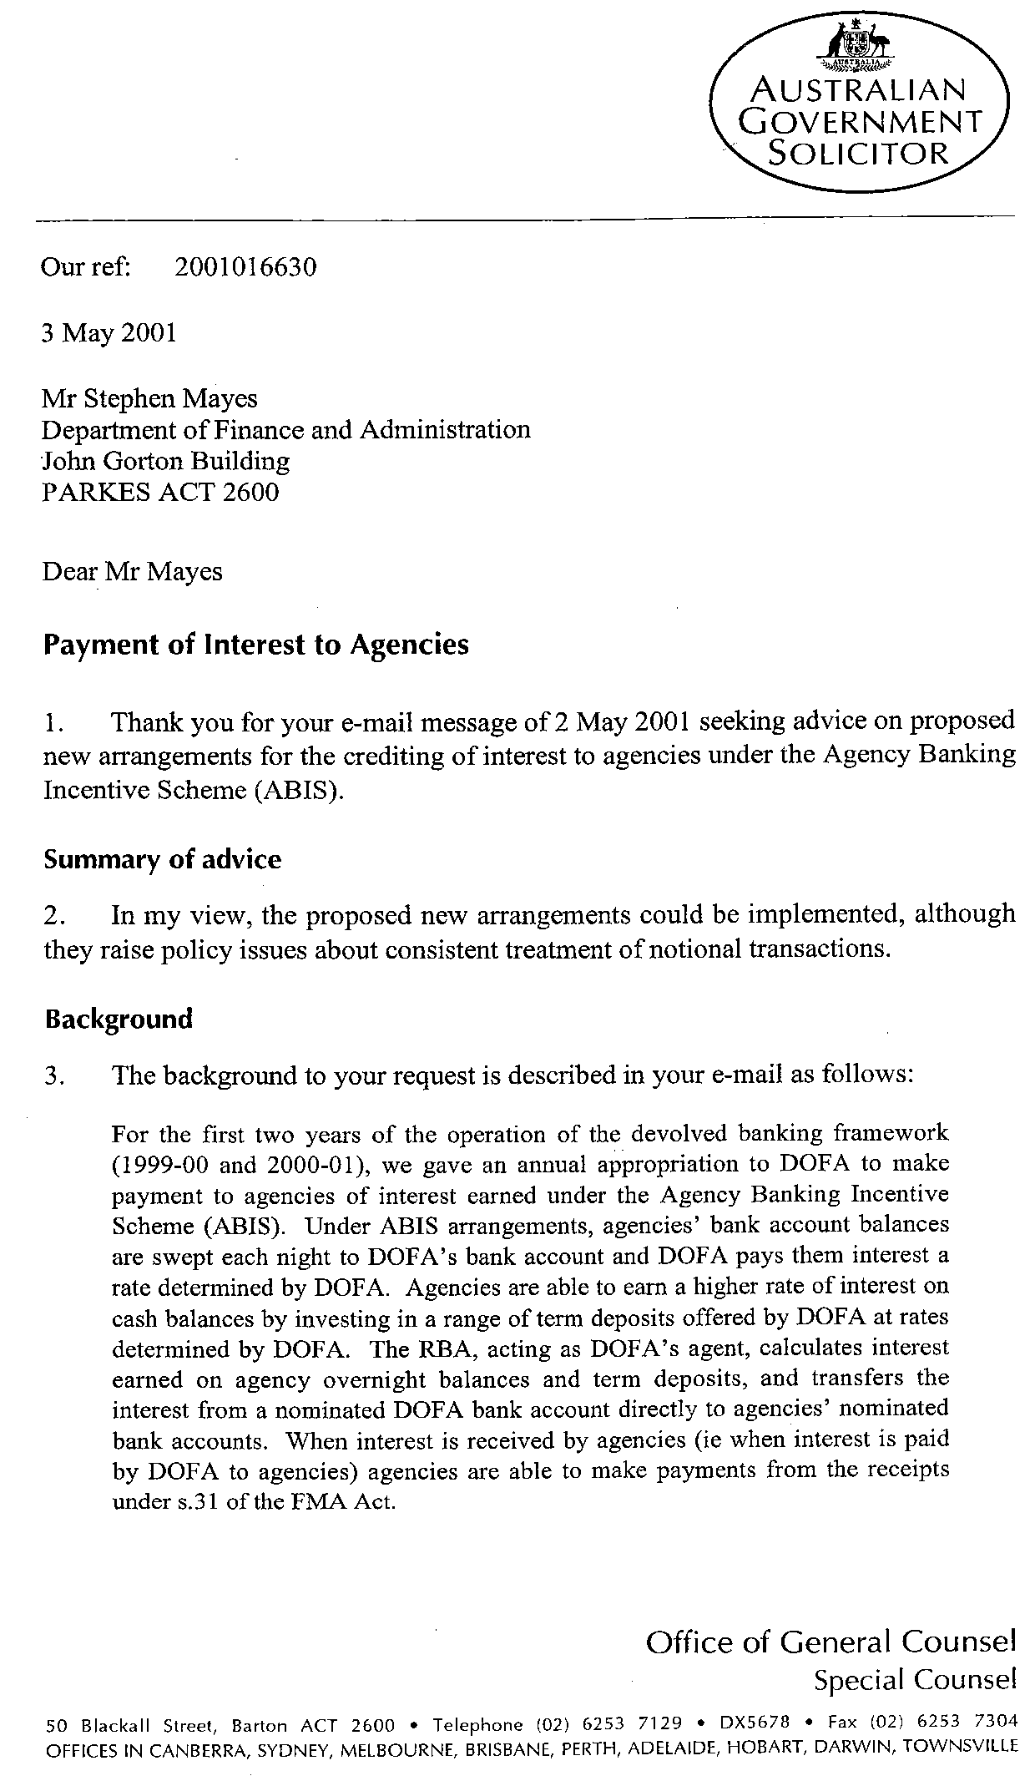
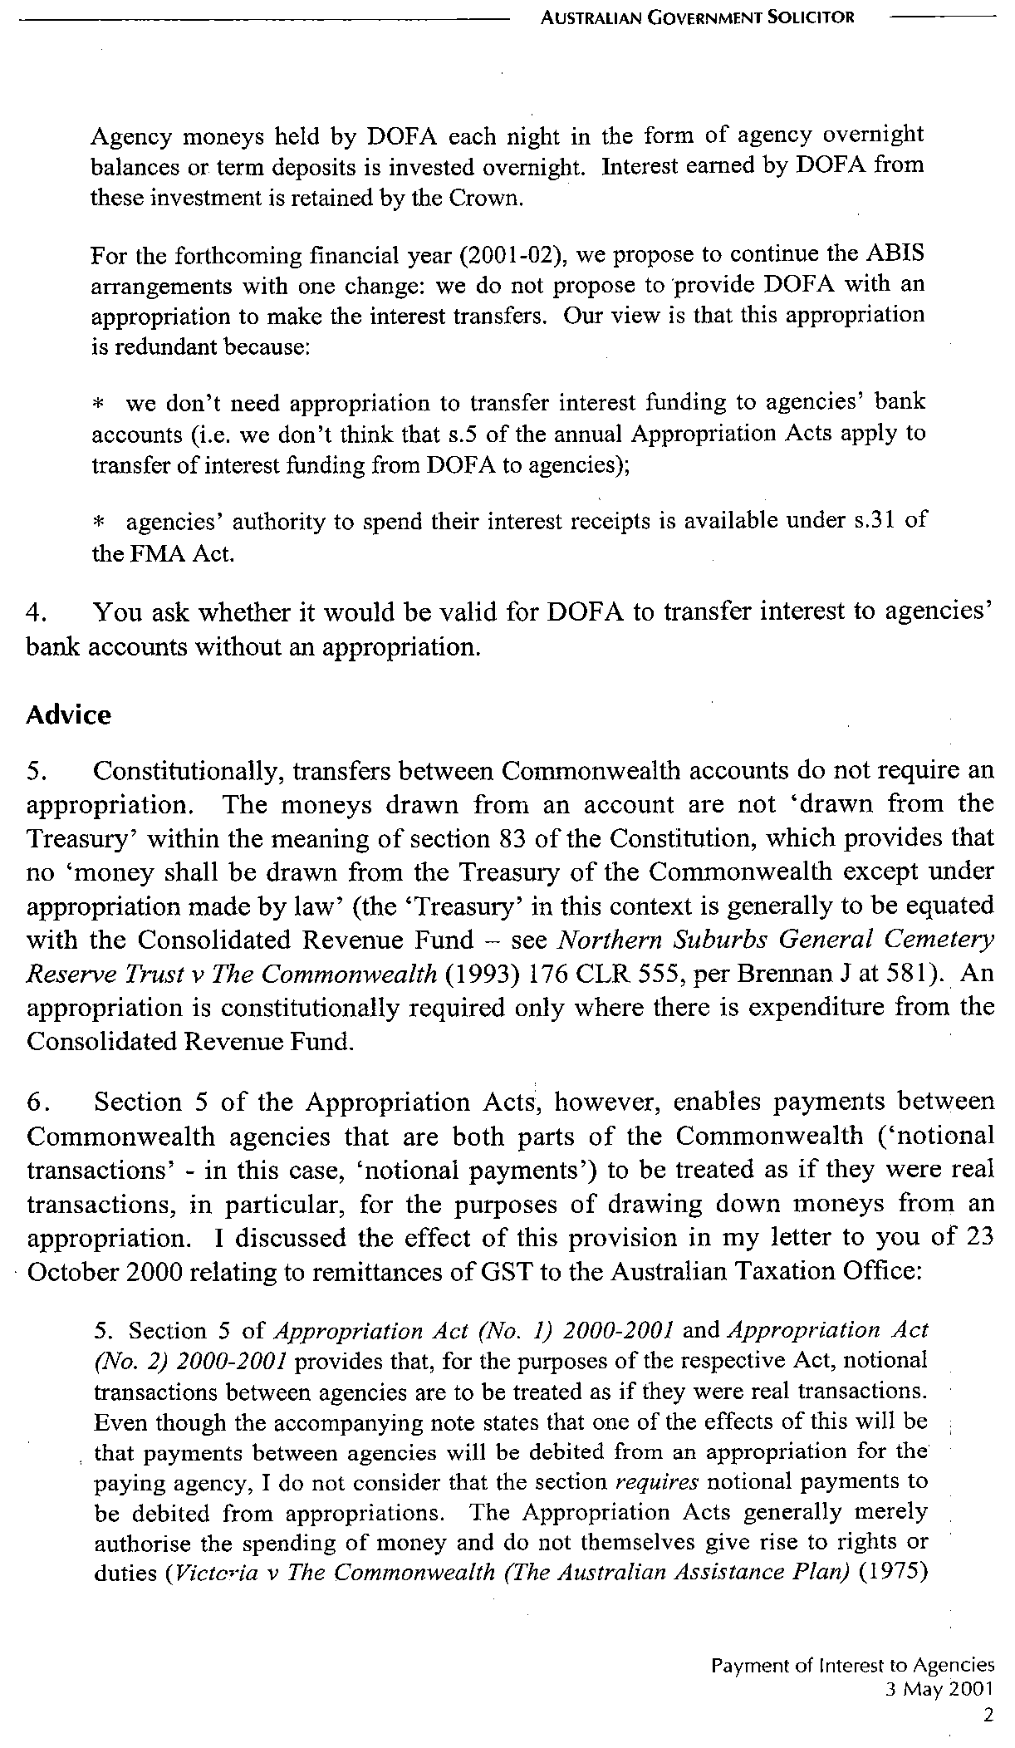
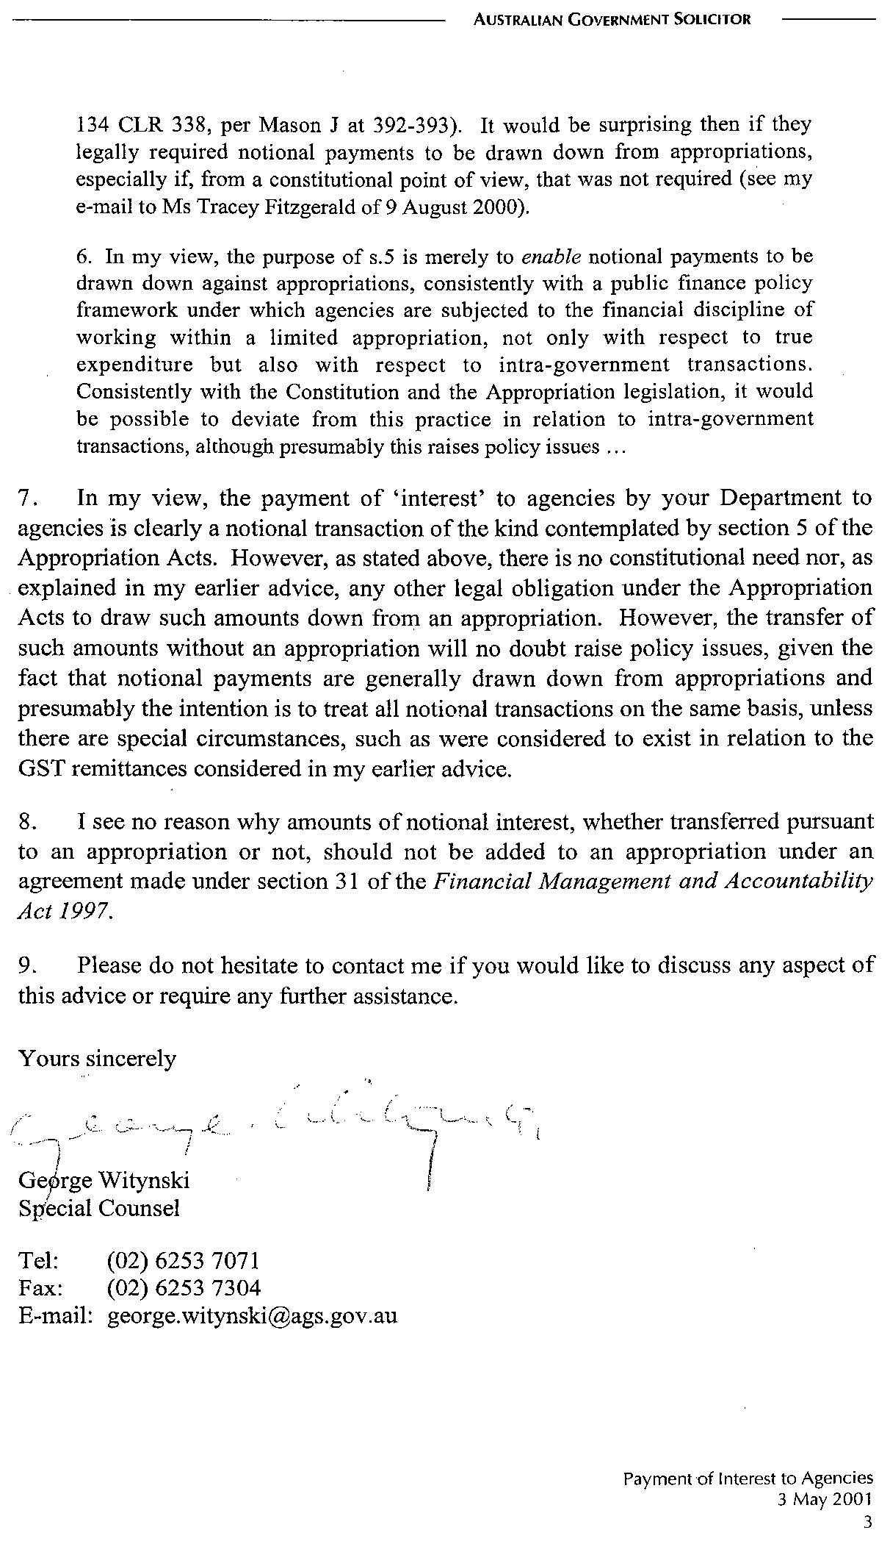

Question: F43
Outcome 1, Output 1.1.1
Topic: Section 31

Hansard Page: F&PA 348

Senator Conroy asked:

Dr Watt—This might not be the moment for it, but we would be quite happy to provide you with a detailed briefing on the way section 31 works. —I am happy to receive that;

Answer:

On 19 June 2002 Senator Conroy received a personal briefing from Finance officials.

Question: F44
Outcome 1, Output 1.1.1
Topic: Section 31 of the FMA Act

Hansard Page: F&PA 349

Senator Conroy asked:

If the amendment [to section 31] had not been made, would you still have thought you could do it?
That is what I am interested in.
It has been put to me that it was the 1999 amendment that allowed you to go down this path – potentially.

Answer:

Section 31 of the FMA Act authorises the Minister for Finance and Administration to enter into agreements with other Ministers that specify the types of receipts (such as user charging) an agency may retain and spend in addition to funding received through their normal annual departmental appropriations. This section of the FMA Act has not been amended since the Act was initially passed in 1997.

The 1999 amendments to the FMA Act dealt with the removal of requirements to account for public moneys through various cash based funds, and had no impact on the Agency Banking Incentive Scheme.

Question: F45
Outcome 1, Output 1.1.1
Topic: Reporting of bank interest

Hansard Page: F&PA 350

Senator Conroy asked:

Can you please explain to me what the Crown is? There are not many places you will find the word anywhere in the 100-year history of PBS statements or their forerunners.

Which creative genius came up with the word ‘Crown’?

Answer:

The term ‘Crown’ is not formally part of the Commonwealth’s financial management framework. It is a term that has been used informally to denote the Commonwealth and, in particular, financial transactions of the Commonwealth through the Official Public Account (eg payments to or from the ‘Crown’). It was used in this context in Finance’s 2001-02 Portfolio Budget Statement document. The term ‘Crown’ has not been used in the 2002-03 Budget documents.

Question: F46 & F47
Outcome 2, Output 2.2.1
Topic: The Government’s foreign currency revenues and liabilities.

Hansard Page: F&PA 357

Senator Conroy asked:

I would like to ask about the press release from the Minister for Finance and Administration put out yesterday in response to the Auditor-General’s report, two years after the Auditor-General’s report was issued. So there was a two-year gap before the government responded. Are the government’s foreign currency revenues approximately equal to its foreign currency liabilities?

Answer:

The Government’s foreign currency affected spending is only a very small proportion of total spending. In addition, revenues which are directly affected by changes in the exchange rate are minor.

In terms of managing foreign exchange risks, special circumstances relate to the Commonwealth. The first is that the Commonwealth is able to take a long-term view of foreign exchange fluctuations. That is, gains and losses due to foreign exchange fluctuations have a tendency to balance out over the long term. In taking a long-term view the Commonwealth will not incur transaction and other costs associated with hedging. This policy is consistent with the Commonwealth not commenting on the exchange rate. If the Commonwealth hedged its exchange rate risks it may be perceived by the markets as a signal as to the direction that the Government thought that the exchange rate was going to move, with potential flow on effects to confidence in the currency.

The Commonwealth is a large organisation that has some natural offsets to the effect of foreign exchange movements on expenses. For example, an exchange rate depreciation would directly impact on the amount of taxation revenue collected from customs duty, luxury car tax (LCT) and petroleum resource rent tax (PRRT). An exchange rate depreciation raises the price of imports in $A terms. As customs duty and LCT are taxed on the import prices in $A, a depreciation will boost customs duty and LCT revenue. PRRT is levied on the world price of oil in $A terms. As a depreciation will increase the world price of oil in $A terms, such a depreciation will increase PRRT revenue.

However, the most significant impacts on revenue from an exchange rate depreciation occur indirectly through variables such as GDP, CPI and wages. For example, a lower exchange rate increases the incomes of exporters and thus tax revenue. The assets of the RBA also give rise to a natural hedge. All of these effects are difficult to quantify precisely, but together they are likely to be substantial.

Question: F48
Outcome 2, Output 2.2.1
Topic: Government revenues linked to the value of the Australian dollar.

Hansard Page: F&PA 358

Senator Conroy asked:

You [Dr Watt] mentioned a couple of examples [of Government revenues linked to the value of the Australian dollar]. Can you give me an expanded version?

Answer:

See answer to question F46.

The Government’s foreign currency affected spending is only a very small proportion of total spending. In addition, revenues which are directly affected by changes in the exchange rate are minor.

In terms of managing foreign exchange risks, special circumstances relate to the Commonwealth. The first is that the Commonwealth is able to take a long-term view of foreign exchange fluctuations. That is, gains and losses due to foreign exchange fluctuations have a tendency to balance out over the long term. In taking a long-term view the Commonwealth will not incur transaction and other costs associated with hedging. This policy is consistent with the Commonwealth not commenting on the exchange rate. If the Commonwealth hedged its exchange rate risks it may be perceived by the markets as a signal as to the direction that the Government thought that the exchange rate was going to move, with potential flow on effects to confidence in the currency.

The Commonwealth is a large organisation that has some natural offsets to the effect of foreign exchange movements on expenses. For example, an exchange rate depreciation would directly impact on the amount of taxation revenue collected from customs duty, luxury car tax (LCT) and petroleum resource rent tax (PRRT). An exchange rate depreciation raises the price of imports in $A terms. As customs duty and LCT are taxed on the import prices in $A, a depreciation will boost customs duty and LCT revenue. PRRT is levied on the world price of oil in $A terms. As a depreciation will increase the world price of oil in $A terms, such a depreciation will increase PRRT revenue.

However, the most significant impacts on revenue from an exchange rate depreciation occur indirectly through variables such as GDP, CPI and wages. For example, a lower exchange rate increases the incomes of exporters and thus tax revenue. The assets of the RBA also give rise to a natural hedge. All of these effects are difficult to quantify precisely, but together they are likely to be substantial.

Question: F49
Outcome 2, Output 2.2.1
Topic: Foreign currency assets

Hansard Page: F&PA 360

Senator Conroy asked:

At the end of 2000-01, government foreign liabilities comprised 20 per cent of the government’s debt portfolio of $64 billion, which roughly works out at $13 billion. Does the government have any other foreign currency assets?

Answer:

Apart from foreign currency holdings and assets held by various Commonwealth Departments for operational purposes, the Government’s foreign currency assets are predominantly held by the Reserve Bank of Australia.

The June 2002 Reserve Bank Bulletin quotes the RBA as holding “Gold and Foreign exchange assets of $38.3 billion” as at close of business 12 June 2002.

Question: F50, F51
Outcome 2, Output 2.3.1
Topic: Spike in GST – Affecting Building Owners

Hansard Page: 468

Senator Conroy asked:

With regard to agreements adjusted by the CPI, would increases have reflected the spike in the CPI following the introduction of the GST? Did you negotiate that? I am talking about with the actual new building owners. What I am asking is: did you deliver that outcome for the leases for these buildings you used to own?

Answer:

In negotiating leases with the tenants of buildings owned by the Commonwealth, detailed negotiations were undertaken on all aspects of the lease, including clauses relating to CPI increases. The lease clause relating to CPI increases is based on industry standards. All future tenants were actively encouraged to seek professional advice on the terms of the lease. The final terms of the lease were agreed with the future tenants.

