The following is an example of a pathology claim which, in the “paper world”, would require both a pathology voucher and a request / referral voucher to be completed for the claim.

DVA Pathology Voucher (D1218):

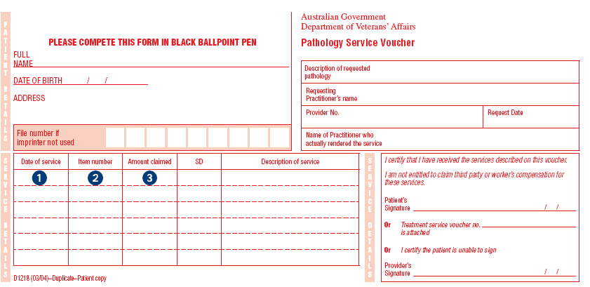
‘On Line Form’ example showing DVA Pathology Data Elements

Note:
In the M / C / O Column below,
M = Mandatory
C = Conditional
O = Optional

Field Name in Paperless | M/C/O
AccessionDateTime | C
AccountReferenceNum | O
BenefitAssignmentAuthorisedCde | M
BenefitAssignmentAuthorisedText | C
ChargeAmount | C
ClinicalConditionTreatedRsnCde | M
ClinicalConditionWhiteCardInd | M
ClinicalConditionTreatedText | C
ClinicalIndicationsForServiceText | C
ClinicalReportIssuedInd | C
ClinicalRequestReferralOverrideText | C
ClinicalRequestReferralText | C
ClinicalRequestReferralVoucherNum | C
ClinicalResultsFromServiceText | C
CollectionDateTime | C
DateOfService | M
DistanceKms | C
ItemNum | M
MalignancyConfirmedInd | O
PatientAddressLocality | C
PatientAddressPostcode | C
PatientAliasFirstName | O
PatientAliasFamilyName | O
PatientDateOfBirth | M
PatientFamilyName | M
PatientFirstName | M
PatientSecondInitial | O
RequestingProviderNum | C
RequestIssueDate | C
RequestOverrideTypeCde | C
Rule3ExemptInd | O
ServiceText | O
ServiceTypeCde | M
ServicingProviderNum | M
SizeOfGrowthMm | O
SCPId | M
SupportingConfidentialDetailsSentInd | O
S4b3ExemptInd | O
DateOfService | C
VeteranFileNum | O

DVA Request/Referral (D904):
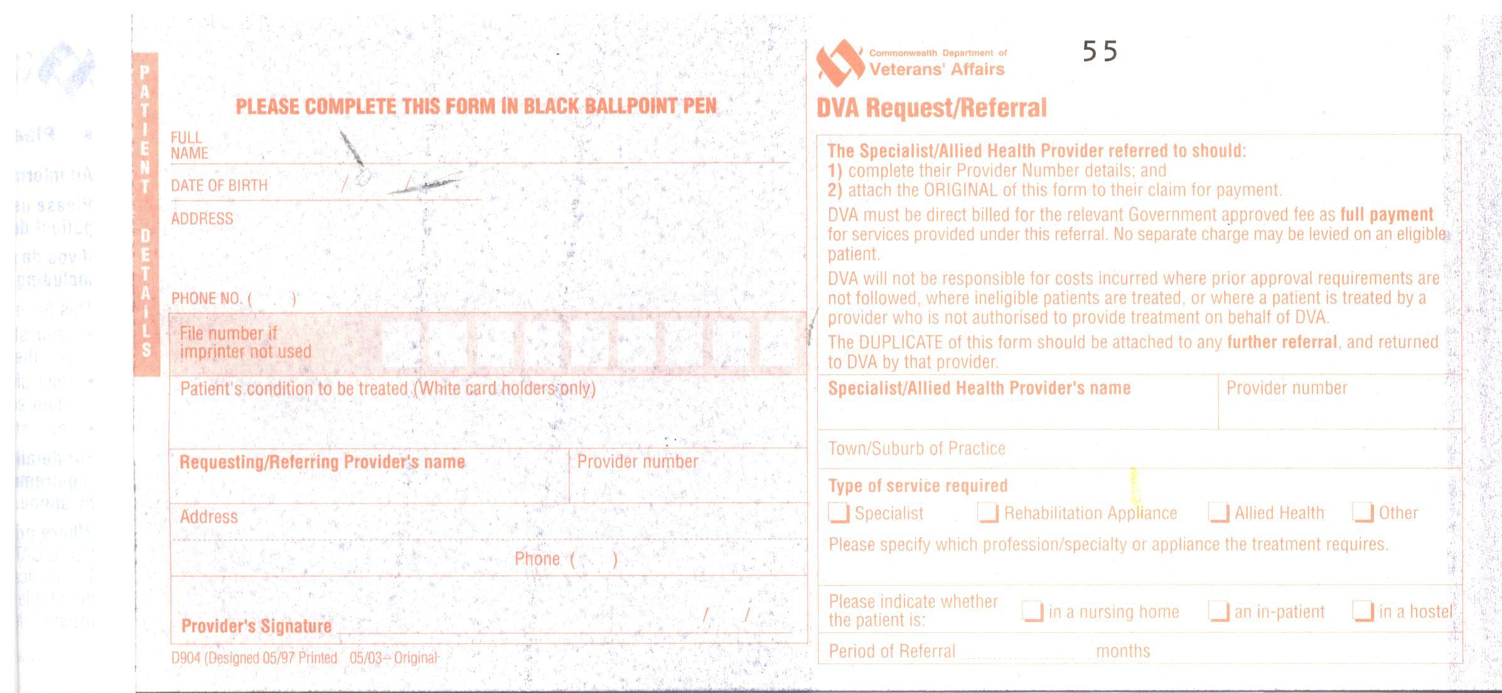

‘On Line Form’ example showing DVA Request/Referral Data Elements

Note:
In the M / C / O Column below,
M = Mandatory
C = Conditional
O = Optional

Field Name in Paperless for Request/Referral Data Elements | M/C/O
PatientAddressLocality | C
PatientAddressPostcode | C
PatientAliasFirstName | O
PatientAliasFamilyName | O
PatientDateOfBirth | M
PatientFamilyName | M
PatientFirstName | M
PatientPhoneNumber | O
PatientSecondInitial | O
VeteranFileNum | O
ClinicalConditionWhiteCardInd | M
ClinicalConditionTreatedText | C
RequestingProviderNam | C
RequestingProviderNum | C
RequestingProviderAdd | C
RequestingProviderPostcode | C
RequestingProviderPhnumber | C
RequestIssueDate | C
ReferralPeriod | M
ReferralProviderNam | M
ReferralProviderNum | M
ReferralProviderTown/suburb | M
ServiceTypeRequired | M
ServiceText | M
PaitentLocation | M

