Question 2

Outcome 1 (Corporate)
Topic: DFISA

Hansard page 95

Senator Mark Bishop asked:
What were the figures for those costings done on Centrelink and FaCS administering the arrangement?

Answer:
Costings for alternative administrative arrangements comprise policy advice to Government and the Department is therefore not able to provide details.

Question 11

Outcome 1 (Compensation and Resources)

Topic: DFISA

Senator Mark Bishop asked:
- Were costings done on the administrative costs of alternative models for the exemption of disability pensions from the SSA means test, and if so what were the costings for each model.

- What is the precise break up of the 19 000 beneficiaries of DFISA by SSA payment type, and VEA payment type.

- What are the projected levels of allowance by disability pension levels for each Centrelink benefit, including tax as currently provided in the Bill, and according to the proposed amendments assuming assessable income at the lowest marginal rate.

Answer:
- Please see response to question 2.

(b) See response to question 3.

(c) The amount of DFISA a person receives will depend on many factors, including the amount of disability pension they receive, the type of social security pension or benefit they receive, their marital status, any amount of other income they receive and whether they are a home–owner or renting privately.

As at 22 October there were 21019 DFISA recipients, with an average DFISA rate of $44.23 across the entire population.

Following is a list of DFISA recipients by social security payment type. This list gives the number of people receiving DFISA in each category and the average payment as at 22 October 2004.

SSA income support payment | Data | Total
AUSTUDY PAYMENT | Number | 11
 | Average Benefit | $60.71
CARER PAYMENT NON-TAXABLE | Number | 409
 | Average Benefit | $83.75
CARER PAYMENT TAXABLE | Number | 93
 | Average Benefit | $51.30
AGE PENSION (Centrelink) | Number | 12885
 | Average Benefit | $36.36
DSP NON-TAXABLE | Number | 1590
 | Average Benefit | $71.61
DSP TAXABLE | Number | 9
 | Average Benefit | $39.25
MATURE AGE ALLOWCE | Number | 22
 | Average Benefit | $61.94
NEWSTART | Number | 342
 | Average Benefit | $55.71
PARENTING PAYMENT | Number | 269
 | Average Benefit | $67.81
PARTNER ALLOWANCE | Number | 168
 | Average Benefit | $55.46
SICKNESS ALLOWANCE | Number | 9
 | Average Benefit | $12.36
SPECIAL BENEFIT | Number | 1
 | Average Benefit | $29.64
WIDOW ALLOWANCE | Number | 2
 | Average Benefit | $1.10
WIFE PEN NON-TAXBLE | Number | 77
 | Average Benefit | $73.80
WIFE PENSION TAXBLE | Number | 71
 | Average Benefit | $33.81
YOUTH ALLOWANCE | Number | 1
 | Average Benefit | $59.39
AGE PENSION (DVA) | Number | 5060
 | Average Benefit | $53.78
Total Number |  | 21019
Total Average Benefit |  | $45.23
Note: Where the social security payment is taxable the corresponding DFISA payment is also taxable.
Where the social security payment is non-taxable the DFISA payment is non-taxable.

Some payments may be either taxable or non-taxable depending on circumstances, such as the age of the recipient. These are identified in the above table.
All other payments listed in the table are taxable payments.

The net indicative fortnightly benefits from DFISA based on the current rates for single disability support pensioners with no other income and not renting is as follows, based on rates as at 20 September 2004:

- $266.88 for special rate
- $168.56 for intermediate rate
- $129.96 for extreme disablement adjustment
- $69.76 for 100 per cent general rate
- $63.83 for 95 per cent general rate
- $57.90 for 90 per cent general rate
- $51.98 for 85 per cent general rate
- $46.05 for 80 per cent general rate
- $40.12 for 75 per cent general rate
- $34.19 for 70 per cent general rate
- $28.26 for 65 per cent general rate
- $22.34 for 60 per cent general rate
- $16.41 for 55 per cent general rate
- $10.48 for 50 per cent general rate
- $4.55 for 45 per cent general rate
- $0.00 for 0 to 40 per cent general rate

Due to the complex interplay of a number of variables, it is not possible for DVA to determine the impact on an individual’s income tax situation. However, the majority of DFISA recipients are over pension age and will therefore receive the senior Australians’ tax offset (SATO). Where this applies the individual will pay minimal, if any, additional tax. Nobody will be financially worse off as a result of receiving the payment.
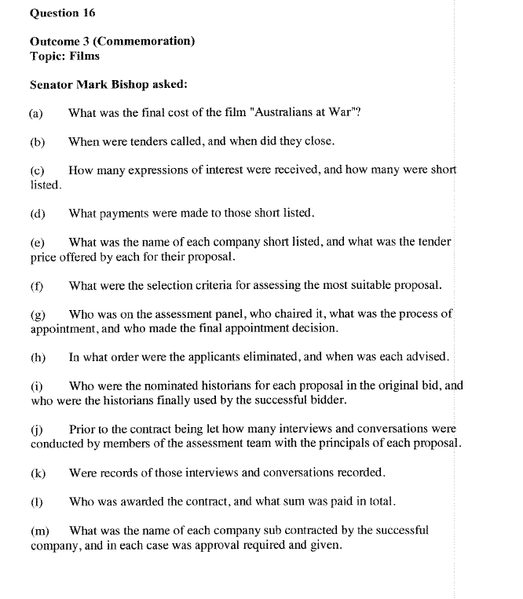
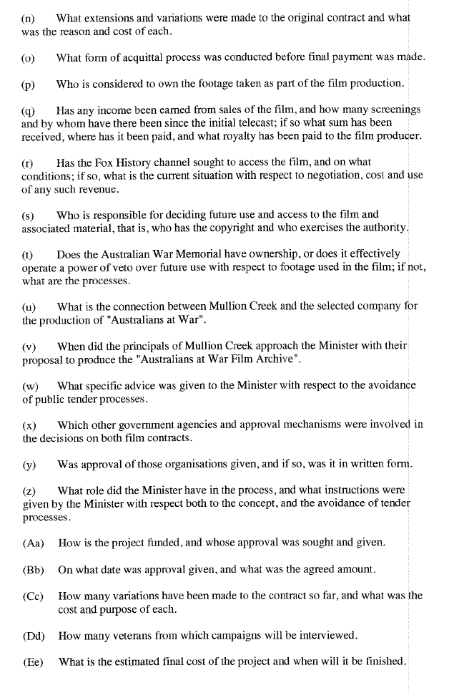
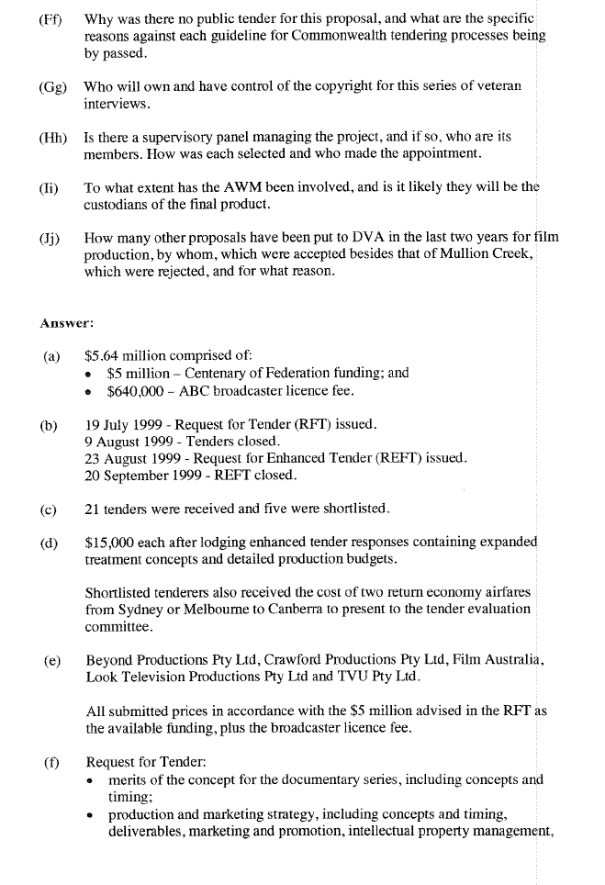
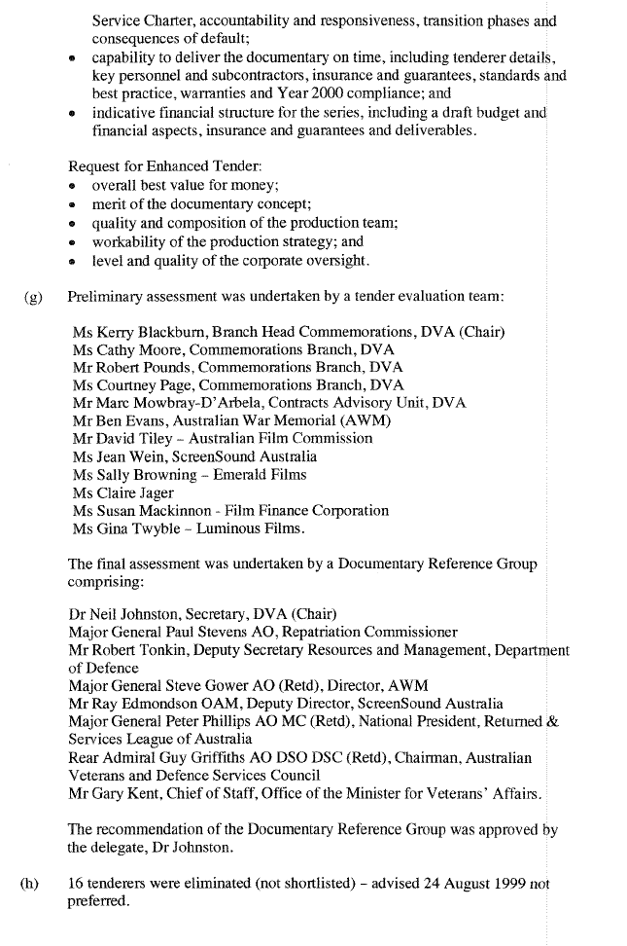
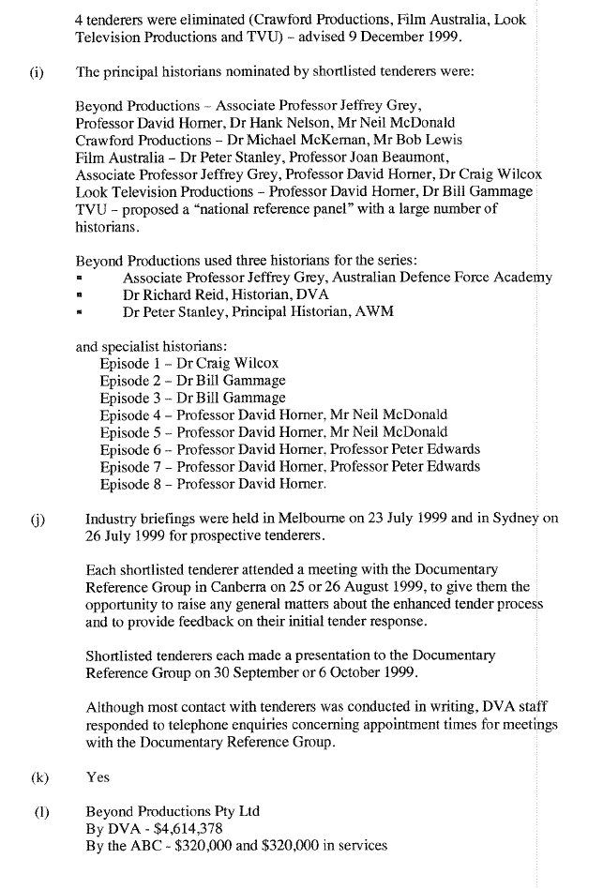
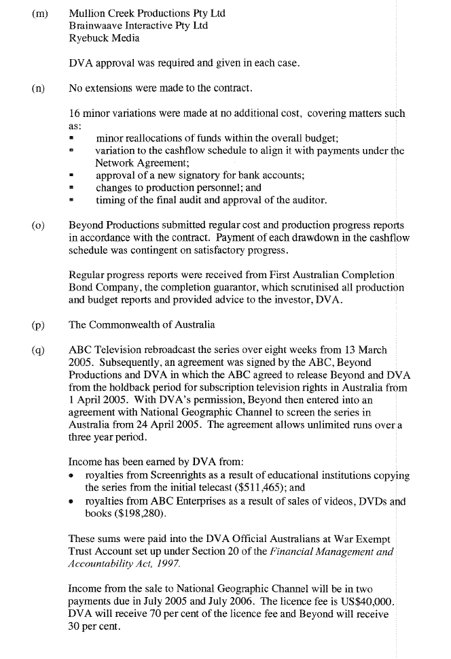
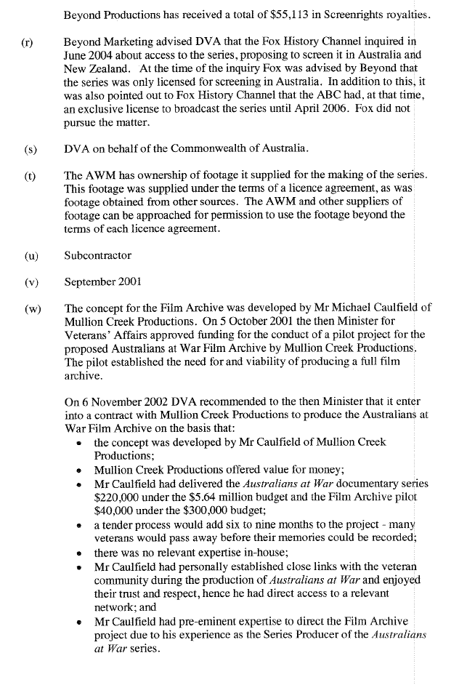
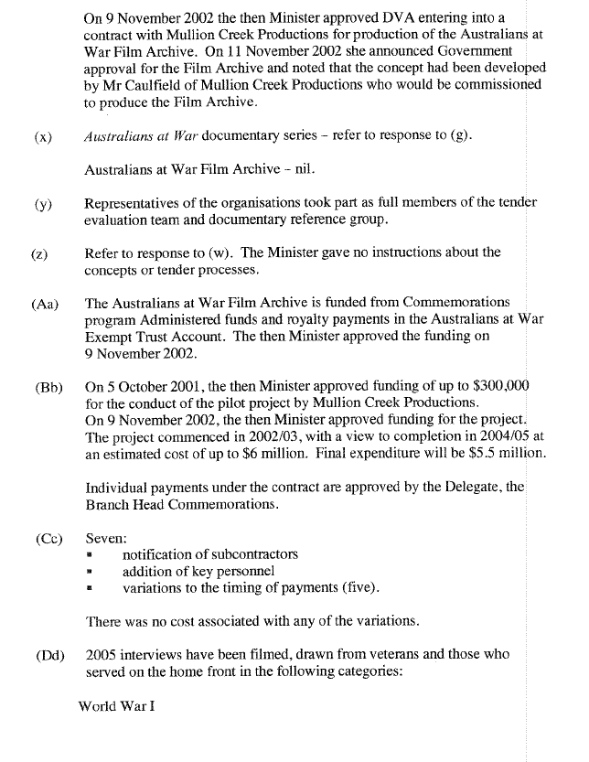
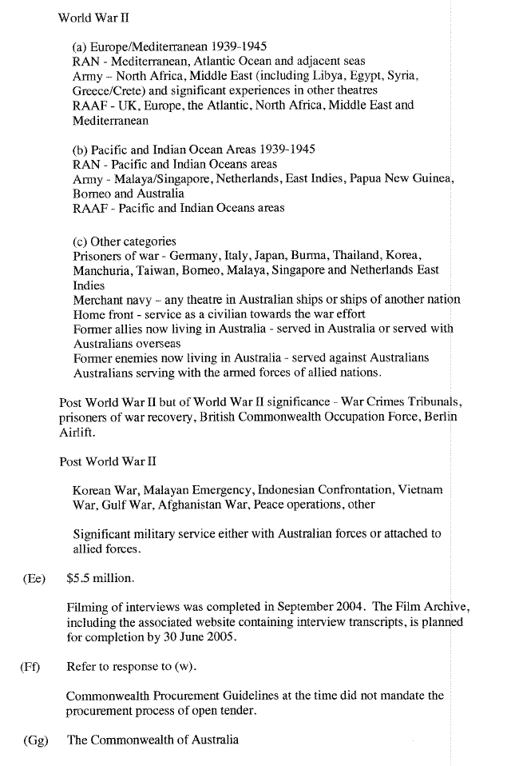
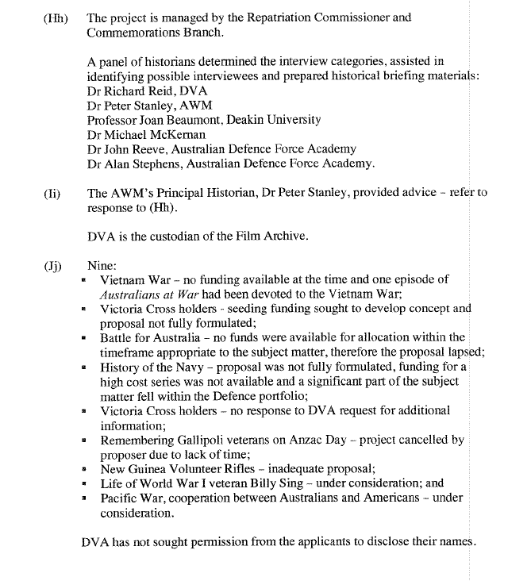
Question 1

Outcome: All Outcomes
Topic: Advertising or public information projects

Written question on notice 18 May 2004

Senator Andrew Murray

Please provide a list of all advertising or public information projects currently being undertaken or expected to be undertaken by the department or agency in the course of 2004 where the cost of the project is estimated or contracted to be $100 000 or more, indicating:

- the purpose and nature of the project;
- the intended recipients of the information to be communicated by the project;
(c) who authorised or is to authorise the project;
(d) the manner in which the project is to be carried out;
(e) who is to carry out the project;
(f) whether the project is to be carried out under a contract;
(g) whether such contract was let by tender;
(h) the estimated or contracted cost of the project.

Answer:
Both the Department of Veterans’ Affairs and the Australian War Memorial have a nil response to this question.

