Senate Foreign Affairs, Defence and Trade Legislation Committee
Budget estimates 2004–2005; June 2004
Answer to a question on notice from Department of Defence

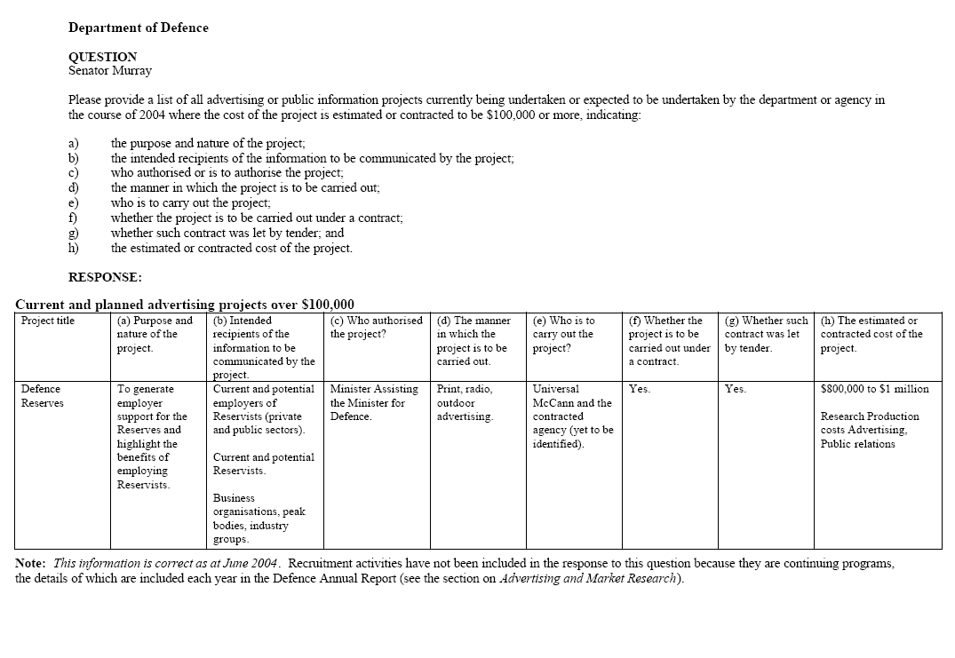
1

