Question 3

Outcome 1
Topic: The number of civilian nurses employed in Vietnam

Hansard page 231

Senator Schacht asked:
What were the number of nurses involved? [Employed by the Department of External Affairs in Vietnam].

Answer:
The number is not precisely known. The Nominal Roll of those who served in Vietnam contains the names of 441 members of SEATO medical and surgical teams. Of that number 172 personnel were doctors and it is assumed that the balance (269) was mostly made up of nurses.

Question 4

Outcome 1
Topic: The number of people employed by the Department of External Affairs in Thailand

Hansard page 232

Senator Schacht asked:

How many were involved? [The other small allotment of service people in Thailand.]

Answer:

This is not known to the Department of Veterans’ Affairs.

Question 10

Outcome 1
Topic: GST expenditure

Hansard page 241

Senator Schacht asked:
Just describe to me—in last year's budget and this year's budget, which totalled $6.6 million—what the implementation money has been spent on, just so I get the difference clear from promotion.

Answer:
In the 1999/2000 Budget there was a measure that provided $3.605m in 1999/2000, $3.089m in 2000/2001 and $0.042m ongoing in departmental expenses. These funds have been spent across all programs on a range of activities:

- Project management and coordination by GST implementation team (salary and administrative costs);
- System analysis, specification, development, testing and implementation;
- System support;
- Preparation of information booklets for veteran organisations and, on request, made available to individual veterans and members of parliament;
- Provision of information through seminars;
- Staff training;
- Query/problem resolution;
- Postage and distribution costs in respect of claims that were sent to veterans for the purposes of savings bonuses;
- Data collection;
- Bonus processing;
- Review and appeals activity;
- Processing costs with external agencies;
- Call centre costs;
- Travel;
- Hire of tax consultants.

Question 12

Outcome 1 and Output Group 6
Topic: The GST and aged person's savings bonus letter

Hansard page 242

Senator Schacht asked:
Will you take it on notice how much that [the 268,000 letters] cost? The same for you Mr Mackrell, how much your 55,000 [62,000] letters cost.

Answer:
The estimate of the direct cost of the production of the aged person’s savings bonus letters is as follows:

Market testing:

The forms and information sheets were
market tested in conjunction with
Centrelink and the ATO.
DVA's contribution $ 15,731

Printing:
Postage and Reply paid postage $251,488
Printing costs $ 28,577
Scanning and processing charges $ 41,520

Total $337,316

Total cost of the mailout (Mr Mackrell's letter), including printing and postal charges was $55,456.

Question 13

Outcome 1 and Output Group 6
Topic: GST implementation letters

Hansard page 242

Senator Schacht asked:
Dr Johnston, are there any other sections we have not here at the table who have written letters to the veterans community? …

Mr Hay, would you provide a copy of the letter [the GST and aged person's savings bonus letter]?

Answer:
The DVA letter differs from the Centrelink letter in that it asks two additional but optional questions. Veterans with income below the income free area are not obliged to advise DVA of changes to their income or investments and so for low income earners DVA records may be out of date. The DVA letter thus gives the veteran the opportunity to update information about their income levels, but if they decline to do so, the veteran can elect to have the bonus calculated from data already held by DVA. Because a pensioner's financial circumstances may fluctuate widely and because DVA has historical information about their income levels, the bonus will be calculated to produce the highest bonus based on the information provided by the veteran on their claim form or the DVA records.

A copy of the DVA letter is attached below.

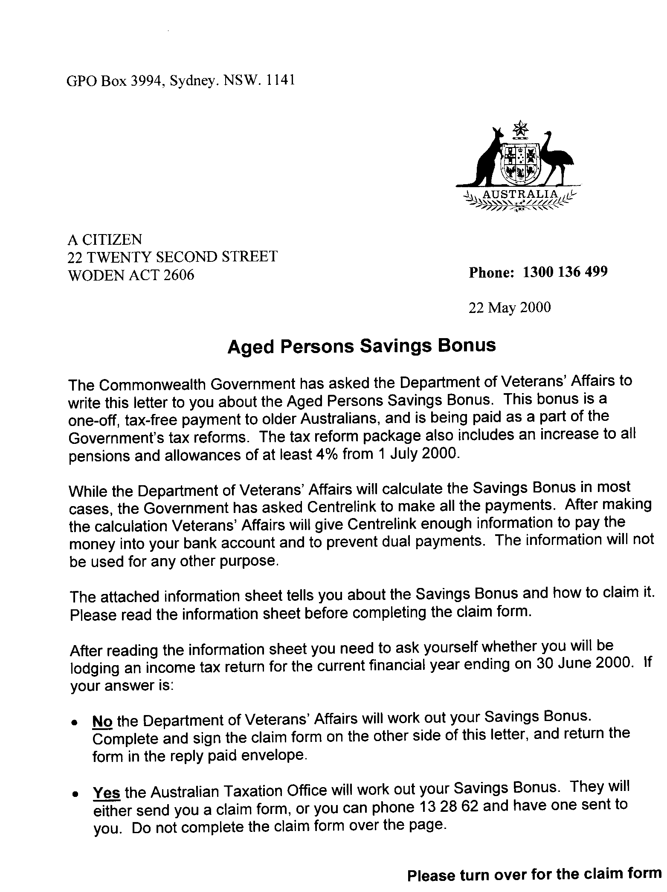
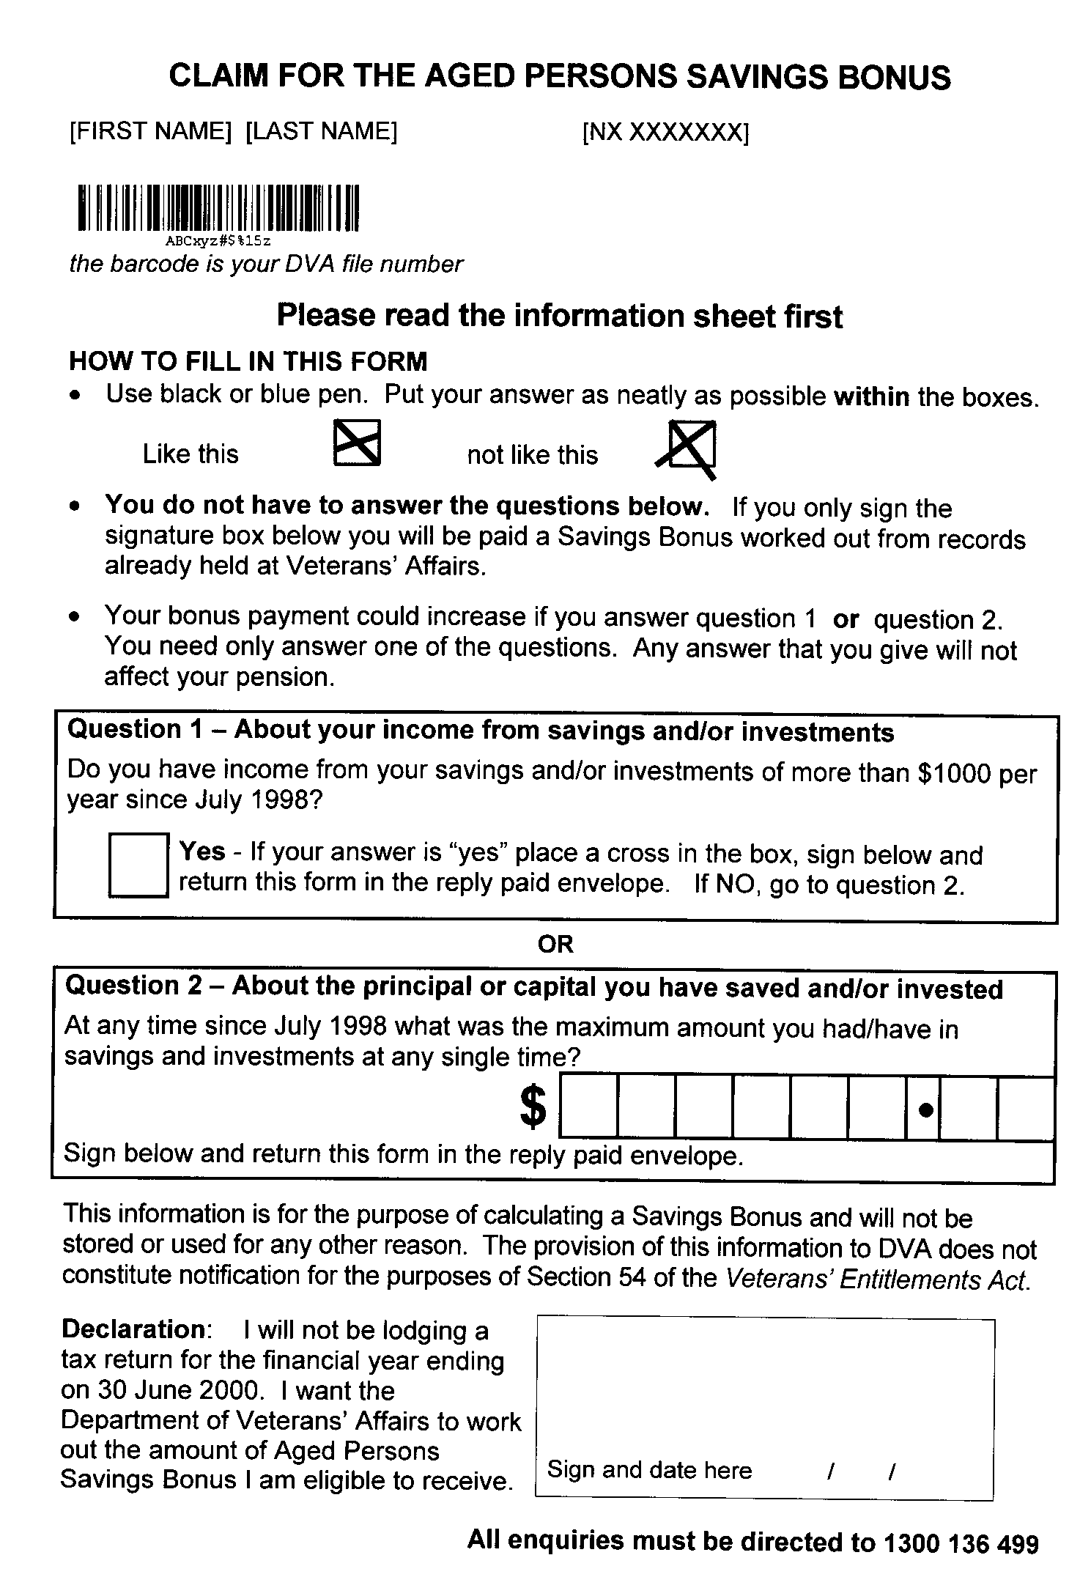
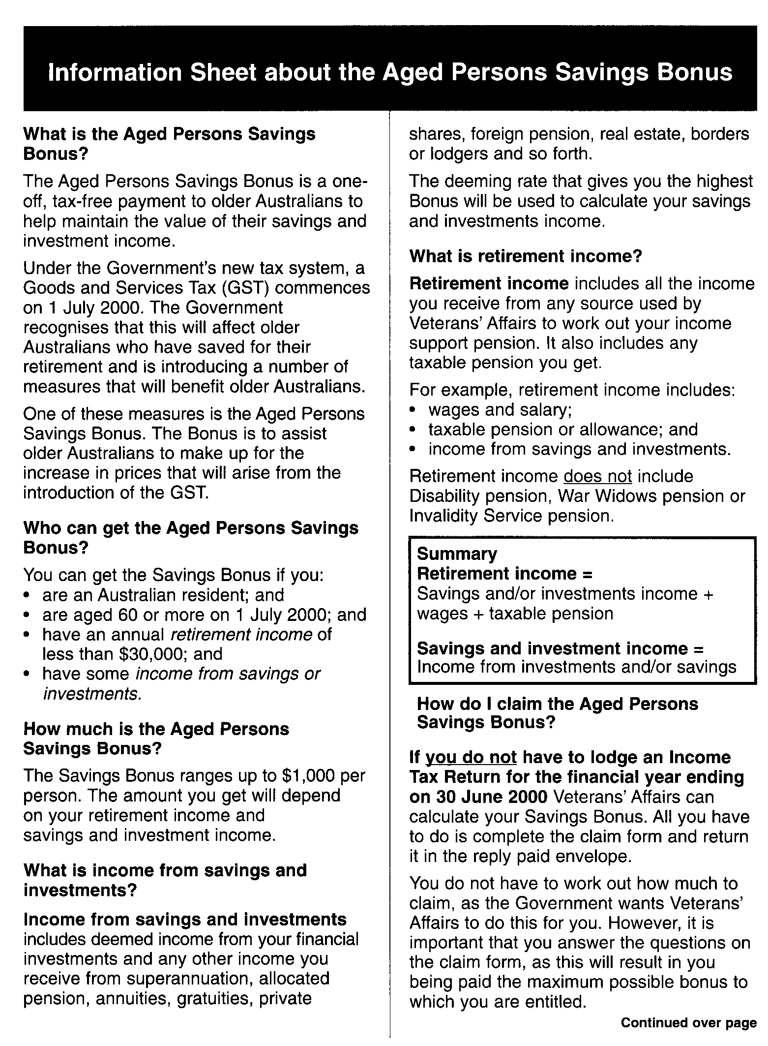
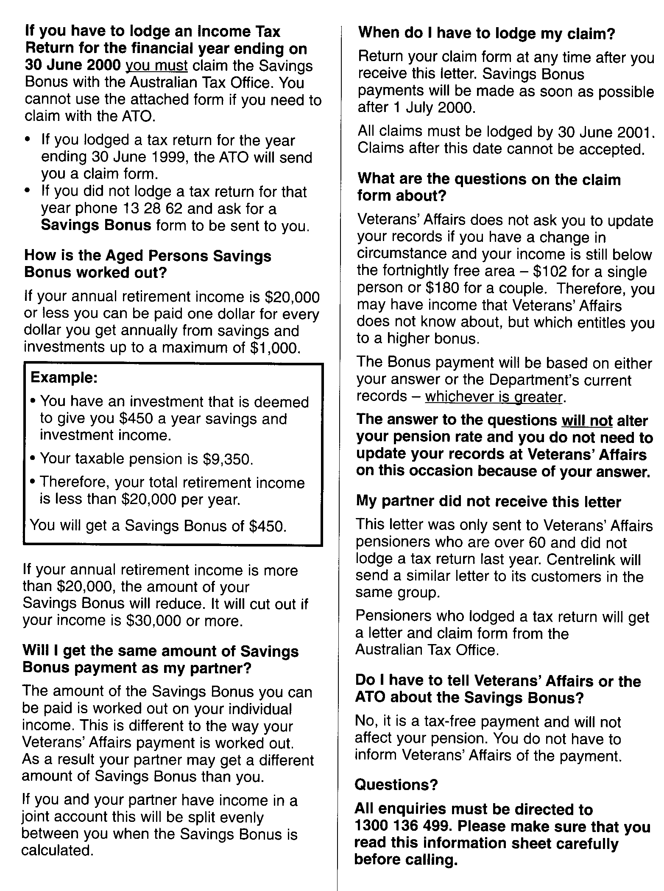
Question 19

Outcome 1, Output 1.1 and 1.2
Topic: Recognition of veterans who served in South-East Asia between 1955–1975

(Written questions on notice)

Senator Harradine asked:
1) Why do veterans who served in South-East Asia between 1955-1975 have to wait 7 months until 1 January 2001 for their final recognition?

2) What effect does this decision have on the income of those who now receive or may be eligible to receive an Aged Pension from DSS and a DVA Disability pension?

3) What would be the cost of backdating final recognition to the day of the announcement of “eligibility for qualifying service” ie Budget Day 2000, 9 May 2000?

4) Will the government consider backdating final recognition as has happened with disability pensions in 1997? If not, why not?

Answer:
- Timing was a decision by the Government to coincide with the likely completion of the legislation process and enhancement of compensation systems.
- Veterans with newly recognised qualifying service will be able to transfer to the Department of Veterans’ Affairs to receive service pension instead of age pension. Once in receipt of a service pension their disability pension will no longer be counted as income for the purpose of this pension. They will therefore, receive an increase in their pension.
- Approximately $6.8m.
- No. See(1) above.
Question 20

Outcome 1
Topic: Recognition of veterans who served in South-East Asia between 1955–1975

(Written questions on notice)

Senator Harradine asked:
5) Will casualties [among those veterans who served in South-East Asia between 1955–1975] be added to the Roll of Honour at the Australian War Memorial before next Anzac Day?

Answer:

The Australian War Memorial (AWM) uses the Department of Defence definitions of types of service and categorisations of particular campaigns or periods of service under those definitions to determine the eligibility of deceased persons for inclusion on the Roll of Honour.

To be eligible for inclusion on the Roll of Honour, a deceased person must have been a member of the Australian Defence Force at the time of death, and died on warlike service, or as a result of such service, and within the prescribed period.

As far as the AWM is aware, all eligible persons are included on the Roll of Honour for these conflicts.

In the light of the outcomes of the Review of Service Entitlement Anomalies in respect of South-East Asian Service 1955-75, the AWM has commenced a review to determine if additional names for the South-East Asian conflicts should be added to the Roll of Honour.

The outcome of this review will be advised to the Council of the Australian War Memorial who has the responsibility for decisions on inclusions on the Roll of Honour. Because of this, and special panel casting requirements that may be involved, it is not possible to state whether any work would be completed by ANZAC Day 2001.

Question 2

Outcome 2
Topic: Vietnam Veterans' Health Study recommendations

Hansard page 231

Senator Schacht asked:
How many of these recommendations being accepted by the government will now require amendment to the Veterans' Entitlements Act?

Answer:
The response to the Vietnam Veterans Morbidity (Health) Study contains over 20 separate but integrated initiatives that address the physical, mental and social health conditions reported, and in some cases subsequently validated, as affecting the Vietnam veteran community.

The following initiatives require legislative amendments before benefits can be provided:

- provision of psychiatric assessments to partners and children up to their 36th birthday;
- provision of counselling through the Vietnam Veterans Counselling Service to ex-partners and children up to their 36th birthday; and
- extending access to the Veteran Children’s Education Assistance Scheme to children of Vietnam veterans who are vulnerable to self harm as a result of their familial circumstances.

These initiatives only affect a small proportion of the total beneficiaries of the package. There are additional important measures, not requiring change to the Veterans’ Entitlements Act, that the government is implementing which substantially increase the number and range of programs directed at improving the health of the Vietnam veterans and their families. These include:

- the fast tracking of treatment for severe anxiety disorders and clinical depression in Vietnam veterans;
- if validation confirms a higher than expected incidence of multiple sclerosis and motor neurone disease in Vietnam veterans, fast tracking of treatment of these conditions;
- the provision of assistance with treatment costs for children with spina bifida and cleft lip/palate (administered by the Department of Health and Aged Care);
- health promotion and other preventive strategies to address lifestyle illnesses including heart disease and alcohol abuse in veterans;
- bursaries to assist children to enter tertiary study;
- additional Vietnam Veterans Counselling Service group programs will address the needs of family groups, veterans’ partners and their children;
- crisis relief will be provided to distressed families;
- the expansion of the role of the National Centre for War-Related Post-traumatic Stress Disorder to address the mental health needs of veterans more generally than has been the case until now;
- a location register of female Vietnam veterans will be completed; and
- the implementation of training initiatives for health professionals specific to the health problems identified in the Health Study.

Question 5

Outcome 2
Topic: Issues arising out of the ANAO report

Hansard page 233

Senator Schacht asked:
In view of the time, could you [Ms Hohnke] provide that to us on notice? [examples of initiatives to supplement rural services]

Answer:
The following are examples where DVA has taken action to supplement the provision of health services to the veteran community:

- A joint initiative involving DVA and the Manilla Area Health Service (part of the New England region) combined resources to establish a podiatry clinic in Manilla. The Health Service provided the premises and DVA funded the equipment required for the clinic. The Clinic has been operating successfully for a number of months providing a fortnightly Clinic for DVA's clients and the general community. Another monthly clinic has now been established at Barraba, which is even more isolated than Manilla.

- A similar initiative following the same model is being developed to recruit podiatrists for the South Coast Sector incorporating the Eurobodalla and Bega Valley Shires.

- As a result of the local podiatrist in Swan Hill retiring, the veteran community was going to have to travel two hours to Cohuna to receive a podiatry service. The local hospital was approached to arrange access to their State funded podiatrist. It was found there was a waiting list of 67 days that DVA considered unacceptable for veterans and war widow/ers. The second and more desirable option was to assist a private podiatrist from outside the district to provide podiatry services to the veteran community in Swan Hill. Monetary assistance went towards rental, travel and a small amount towards administration expenses. This gap was addressed in order to ensure veteran access to appropriate and timely services in their local area.

- In Mallacoota, a designated remote area in Victoria, special arrangements apply for the provision of podiatry services to the veteran community. The visiting public podiatrist now stays overnight and treats veterans at a special session, under a fee for service arrangement. The veteran community in Mallacoota was very appreciative of this initiative, as it has substantially reduced the waiting time to see the public podiatrist.
- DVA was involved in a special project with Queensland State Health that eventually led to the establishment of Podiatry services in the Torres Strait Region.

- DVA's Victorian State Office recently entered into a contractual arrangement with the Chief Executive Officer (CEO) of the Boort Dental Clinic. The CEO maintains the facility and is responsible to ensure compliance with DVA's dental arrangements. The Boort Clinic relies on Victoria's Dental Job Search (DJS) group for sessional dental practitioners. The DJS provides opportunities for newly trained or mobile dental practitioners to practice in otherwise poorly serviced areas. The agreement provides for more complex and long term work to be referred to the main centre for treatment. Prior to this arrangement veterans in the area were either financing their own treatment or travelling to main centres for treatment.

- A Brisbane based psychiatrist visits Rockhampton on a monthly basis to provide services to the central Queensland region. This action was a response to the lack of suitable and available services in the area. To assist with the cost of this service, special financial arrangements apply.

- In far North Queensland, DVA has been involved in a mental health study with the Queensland State Government Mental Health Service and the Royal Flying Doctor Service. The results of this study are being analysed with a view to improving access and availability of services.

- DVA has a program of visiting contracted country private hospitals to raise their awareness of the DVA arrangement including Discharge Planning policy and procedures. This project seeks to ensure that patients upon discharge are aware of the range of DVA services and the network of local community based services available on discharge.

- In February this year DVA participated in a workshop for the ‘Doctors for the Bush’ program run by the Queensland Rural Medical Support Agency (QRMSA). Part of the focus of the workshop was management and care of veterans in rural Queensland.

- Under Departmental legislation, veterans are provided with transport or reimbursed their costs to attend the nearest available services to meet their clinical needs.

Question 9

Outcome 2, Output Group 2.1
Topic: The outcome of the talks with DHAC regarding the death of the veteran in Alchera

Hansard page 239

Senator Schacht asked:
If you are going to talk to them, [DHAC] I would ask you then to take on notice and give me a response of what the outcome of the talks was.

Answer:
As indicated in the response to Senator Schacht in the Senate Estimates Hearing, the Department of Veterans’ Affairs and the Department of Health and Aged Care (DH&AC) are working closely in following up matters in relation to these issues. Following the Estimates Hearing DH&AC has written again to the Commissioner of Police seeking further advice on their investigations.

Question 18

Outcome 2
Topic: The Home Care proposal savings

Hansard page 247

Senator Schacht asked:
One last question I wanted to put on notice is to ensure that when you come back to me on the aged veterans' home care you will try to explain to me that the saving of $80 million a year flows through, as Mr Stonehouse explained, those steps, what that actual figure was and what the savings are in the other areas of programs to get you to the total of $80 million a year.

Answer:
The Veterans’ Home Care Program is expected to produce savings to the veterans’ health budget by reducing unnecessary and avoidable illness and injury through improvements in Government services.

Veterans’ Home Care will not and indeed cannot directly reduce health services for veterans. Access to such services is based on entitlement and clinical need. Veterans will therefore continue to have access to health and medical services to which they are currently entitled under the Veterans’ Entitlements Act 1986.

The Veterans’ Home Care budget estimates reflect an estimated gross saving of around $80m per annum against a total average health outlay of $3.1b per annum in the forward estimate period. This amounts to a reduction of around 2.6% in treatment costs and hospital expenditure, including a reduction in unplanned admissions. This is based on veterans requiring less services, not on denying access to them.

The Department’s hospital costs are expected to be reduced by 4.5%, or around $51 million in a full year against the forward estimates, because veterans will not need such frequent hospitalisation. Treatment costs (health services other than hospital services) are estimated to be reduced by 1.7%, or around $33 million on average in a full year, as veterans reduce their call on LMO services because of better home help and personal care. These reductions will be achieved by reducing demand for services through preventing illness and injury, not through cuts to services. The rationale for the estimated reductions in health expenditure is based on a substantial body of Departmental and independent research.

There are no projected savings to other programs as a result of Veterans’ Home Care.
Question 21

Outcome 2
Topic: Tendering and nursing home services

(Written questions on notice)

Senator Schacht asked:

Could the department provide answers to the following eleven (11) questions.

Question:
1) Can the department describe the process for tendering or allocating out its home nursing services?

Answer:
Appointment of community nursing providers
The Department does not currently tender for the provision of community nursing services. It sets rates for various community nursing services and publicises them to the community nursing market. In brief, those agencies that wish to provide services for veterans and war widows then agree to observe those rates and ancillary conditions. A contractual arrangement is arrived at and the provider appointed to a list. The Department has developed standards and requirements for the provision of community nursing services. The Department’s State Offices assess providers against these standards and requirements and the Department only enters into a contractual arrangement with a provider who has been determined as having the capacity to meet these.

Referral arrangements
The referral of veterans and war widow(er)s to community nursing services is done without reference to the Department on referral by a Local Medical Officer (the individual patient’s general practitioner). A Local Medical Officer, a treating doctor in hospital or the hospital discharge planner identifies the patient’s clinical need for community nursing services and refers him or her to a Departmental contracted community nursing provider. The Department requests that the choice of contracted community nursing provider is done in consultation with the individual veteran or war widow(er).

Exception
The only exception to this process is where a provider ends its contractual arrangement with the Department and veterans and widow(er)s need to be transferred to other contracted community nursing providers in a defined period. This process is outlined under Question 6.
Question:
2) In terms of that process does the department have any guidance on whether employees of the department can participate in applying or tendering for and providing these services?

Answer:
The Department contracts independent professional Advisers from the various health care professions to provide advice on the provision of health care services for veterans and war widow(er)s. These Advisers are not employees of the Department and do not have the formal delegation to make decisions about the provision of services by individual contracted providers.

The Department has taken the position that for Advisers to provide advice which is clinically appropriate, they must have the opportunity to continue to work in the wider profession whether in the public or private sector. Advisers may be contracted separately as service providers by the Department to deliver health care services to members of the veteran community. They are required to meet the same standards and requirements as all other providers.

Question:
3) Can the department confirm that recently a nursing agency on the NSW central coast ceased providing home nursing services to approximately 80 veterans?

Answer:
Yes. Vesgrove, a contracted community nursing provider run by Ms Christine Smith and her husband Mr Terry Smith, made a business decision to cease operation on 28 April 2000. The veterans and war widow(er)s under the care of this provider had to be transferred to alternative contracted community nursing providers at very short notice over the Easter period.

Originally, Ms Smith provided the Department with a list of 74 veterans and war widow(er)s who were being provided with community nursing services. This list was reduced by 16 veterans and war widow(er)s who were discharged from Vesgrove after being assessed by Vesgrove staff as no longer requiring community nursing services, admitted to hospital or discharged from hospital to another contracted community nursing provider. Please note that on admission to hospital, a veteran or war widow(er) is usually discharged from the community nursing provider who has been providing their care.

At the time of its closure, Vesgrove was providing services to 58 veterans and war widow(er)s.
Question:
4) Can the department confirm that the nursing agency that now provides those nursing services to the majority of those 80 veterans, Fahey's Nursing Agency, is run by Tina Fahey (?) who is an employee of DVA?

Answer:
Faheys Nursing Service provides services to 13 of the 58 patients formerly dealt with by Vesgrove.

Ms Tina Fahey is not an employee of the Department. She is contracted to the Department as a professional Adviser for community nursing.

Mr Malcolm Fahey, Ms Fahey’s husband, is a proprietor of Fahey’s Nursing Pty Limited trading as Faheys Nursing Service. While Ms Fahey is a Director of the company, she is not involved in the day to day running of the business. She does, however, provide community nursing services to patients on the weekend.

Initially, Faheys Nursing Service was offered 8 veterans and war widow(er)s by the Department, the same number as the three other larger (see Answer 9) contracted community nursing providers in the area. One of these providers, Sue Mann’s Nursing Service, rejected five of the patients that were offered because they required both morning and afternoon visits and that nursing service does not provide afternoon visits. All five of these patients were offered to Faheys Nursing Service because of their location and the organisation’s capacity to provide the level of care required. Faheys Nursing Service accepted all five patients, making their total allocation at the time of transfer 13 of Vesgroves’ 58 patients.

If, after transfer, a veteran or war widow(er) is unhappy with their new community nursing provider, for whatever reason, they should discuss their concerns with their Local Medical Officer, who can refer them to another contracted community nursing provider. This, like all referrals, is done without reference to the Department. The Department understands that some veterans and war widow(er)s may have been referred by their Local Medical Officer to other contracted community nursing providers since their transfer at Easter. However, because the referral is made without reference to the Department, the Department is unaware at this time of the actual numbers of veterans or war widow(er)s who have changed providers, including those that may have gone to Faheys Nursing Service, since the date of transfer.
Question:
5) Can the department confirm that Tina Fahey is employed in the department in its community nursing area?

Answer:
Ms Fahey is not an employee of the Department. Ms Fahey is an independent contractor to the Department giving professional advice on community nursing matters. She provides professional advice on community nursing issues to the Department’s employees who manage the community nursing program. Ms Fahey also educates contracted community nursing providers on the Department’s community nursing arrangements and monitors the provision of services by providers under these arrangements. The answer to Question 2 provides information on the approach the Department takes to the engagement of Advisers.

Question:
6) Was the recent allocations of these nursing services in the NSW central coast area consistent with department guidelines?

Answer:
When a community nursing provider ends its contractual arrangement with the Department, the Department’s policy is for the Local Medical Officer of each affected veteran or war widow(er) to be contacted and asked which alternative contracted community nursing provider they would like the veteran or war widow(er) to be transferred to. When there is insufficient time available to undertake this process as the transfer has to be done urgently, such as occurred in the case of Vesgrove, the Department’s policy is for employees of the Department to identify the alternative contracted community nursing providers in the area and determine their capacity to take on additional veterans and war widow(er)s. The patients are then distributed as equally as possible amongst the identified contracted community nursing providers, taking into account the individual provider’s willingness to accept new patients and the actual number of veterans and war widow(er)s in the area.

The transfer itself is done with great care, to minimise stress and disruption and maintain needed services. Wherever possible, each affected veteran or war widow(er) is visited personally by employees of the Department or an employee of the Department with a professional Adviser for community nursing who explain the reason for the transfer and answer any questions that they may have. If a veteran or war widow(er) has any concerns with their new contracted community nursing provider, they are advised to discuss them with their Local Medical Officer. All Local Medical Officers are informed in writing of the change of provider, to ensure that they have the appropriate information to discuss any concerns raised by the affected veterans and war widow(er)s.

The transfer of veterans and war widow(er)s from Vesgrove to alternative contracted community nursing providers was consistent with Departmental policy.
Question:
7) Is the department satisfied that there was no conflict of interest in the allocations of these nursing services?

Answer:

The Department considers there was no conflict of interest in this case.

Ms Fahey was not involved in any part of the transfer of veterans and war widow(er)s from Vesgrove to alternative community nursing providers. The decision to transfer veterans and war widow(er)s to Faheys Nursing Service, the same as the decision to transfer veterans and war widow(er)s to the other alternative contracted community nursing providers, was made exclusively by employees of the Department.

Question:
8) Can the department provide details on why Fahey's Nursing agency was chosen to deliver these services?

Answer:
Faheys Nursing Service is a contracted community nursing provider on the central coast of New South Wales. All contracted community nursing providers on the central coast were offered veterans and war widow(er)s from Vesgrove. As a larger organisation with a greater capacity to accept additional patients and to manage high needs patients, Faheys Nursing Service, along with the other larger organisations, was offered a higher number of the veterans and war widow(er)s requiring transfer.

Question:
9) Can the department provide details on which other nursing agencies in the region were approached to provide these nursing services and why they were chosen?

Answer:
Ten contracted community nursing providers were contacted by the Department and asked if they would be willing to accept additional veterans and war widow(er)s.

They are as follows:
- Central Coast Nursing Service
- Woy Woy District Nursing Service
- Sue Mann’s Nursing Service
- Faheys Nursing Service
- Marcella Hannagans Nursing Service
- Coastal Home Nursing Service
- SOS Nursing Service
- Allcare Nursing Service
- Terrigal Home Nursing Service
- Lakes & District Nursing Service

The four larger organisations, Central Coast Nursing Service, Woy Woy District Nursing Service, Sue Mann’s Nursing Service and Faheys Nursing Service were each (due to their size and capacity to take additional patients) offered eight patients. The number of patients offered to the smaller providers was based on the number of veterans and war widow(er)s in the area. The lowest number of patients offered to one provider was two. All other providers were offered four or more patients.

Question:
10) Can the department confirm that Tina Fahey played no part in that decision and gained no advantage in that process through her position in the department?

Answer:

Yes. Contracted professional Advisers like Ms Fahey, have no role in the decision-making processes of the Department. Accordingly, Ms Fahey played no part in the transfer of Vesgroves’ patients. Moreover, in all of the Department’s dealings with Faheys Nursing Service, it dealt with Mr Fahey and not Ms Fahey.

Question:
11) Can the department provide details on any other of its employees that run agencies that provide home nursing services to veterans?

Answer:
No employee of the Department runs a community nursing organisation which has a contractual arrangement with the Department to provide community nursing services to veterans and war widow(er)s.

The contracted professional Adviser for community nursing in Tasmania has her own private community nursing organisation. The Department’s Tasmania State Office has protocols in place to ensure that no conflict of interest occurs between her role as an Adviser and her role as a provider of community nursing services to veterans and war widow(er)s.

None of the other contracted professional Advisers for community nursing, in any State or Territory, owns community nursing organisations which are contracted to provide services to veterans and war widow(er)s.

Question 1

Output Group 6
Topic: Budget total appropriation compared with last year.

Hansard pages 209 and 210

Senator Schacht asked:
In the overview of the budget for the PBS, the total appropriation on page 17 is $8.4 billion. Can you show me where we can compare that with what you had last year?

I think it is not unreasonable for a simple column to be added, on page 17, to show the total expenditure in all aspects of the department--just a simple line to find out whether you have actually gone up or gone down. Has the Government given you more money, the same money or less money? …

Can you tell me whether you have got more money this coming financial year than you had for the year just about to end?

Answer:
Dr Johnston stated that DVA would confirm that there were no conceptual differences between the total appropriations figure of $7,497,853 in portfolio budget statements for last year compared with $8,446,257 this year.

The attached table provides a comparison between the department’s Total Appropriations of $7,497,853,000 in PBS 1999–2000 (p16) and of $8,446,257,000 in PBS 2000-2001 (p17). See Columns 2 and 11 respectively.

An explanation of the movement from PBS 99–00 to PBS 00–01 is included in the table at Columns 3 to 9. The movement is totalled in Column 10.

The department intends to include such a table in its future Portfolio Additional Estimates and Portfolio Budget Statements to assist the Senate and other readers, subject to central agency approval.

Revised Table 1 (forwarded to the Committee 17 July 2000)

TABLE 1: COMPARISON OF 99/00 and 00/01 APPROPRIATIONS
ADMINISTERED APPROPRIATIONS
1 | 2 | 3 | 4 | 5 | 6 | 7 | 8 | 9 | 10 | 11
OUTCOME TOTALS | Budget Estimate as per 1999-2000 PBS | Indexation/ AWE adjustments | Fees/Rates Variations | Growth in numbers and/or useage rates | Movement between high and low cost services | Previous Budget Measures | 2000-01 Budget Measures | Other | Total Variations | Budget Estimate as per 2000-01 PBS
 | $,000 | $,000 | $,000 | $,000 | $,000 | $,000 | $,000 | $,000 | $,000 | $,000
Outcome 1 | 4,629,401 | 176,379 | 61,890 | 12,975 | 0 | 447,628 | 13,957 | -11,208 | 701,621 | 5,331,022
Outcome 2 | 2,616,059 | -112 | 22,548 | 190,966 | 28,466 | -21,715 | -4,057 | 2,266 | 218,362 | 2,834,421
Outcome 3 | 16,620 | 206 | 0 | 0 | 0 | -4,081 | 5,440 | -67 | 1,498 | 18,118
Outcome 4 | 7,577 | 13 | 0 | 0 | 0 | -2,628 | 6,000 | 0 | 3,385 | 10,962
 | 7,269,657 | 176,486 | 84,438 | 203,941 | 28,466 | 419,204 | 21,340 | -9,009 | 924,866 | 8,194,523

DEPARTMENTAL APPROPRIATIONS
Outcome 1 | 93,968 | -83 | 0 | 0 | 0 | -908 | 5,629 | 12,487 | 17,125 | 111,093
Outcome 2 | 72,922 | -65 | 0 | 0 | 0 | 0 | 14,639 | -20,306 | -5,732 | 67,190
Outcome 3 | 10,296 | -9 | 0 | 0 | 0 | 0 | 657 | -2,817 | -2,169 | 8,127
Outcome 4 | 42,010 | -37 | 0 | 0 | 0 | 0 | 776 | 12,213 | 12,952 | 54,962
Outcome 5 | 0 | 0 | 0 | 0 | 0 | 0 | 0 | 0 | 0 | 0
 | 219,196 | -194 | 0 | 0 | 0 | -908 | 21,701 | 1,577 | 22,176 | 241,372
Capital/Equity | 9,000 |  |  |  |  |  | 7,962 | -6,600 | 1,362 | 10,362
TOTAL | 7,497,853 | 176,292 | 84,438 | 203,941 | 28,466 | 418,296 | 51,003 | -14,032 | 948,404 | 8,446,257

Question 1–Table 1 was received by the Committee as part of the initial package of answers.
It has been superseded by ‘Revised Table 1’

TABLE 1: COMPARISON OF 99/00 and 00/01 APPROPRIATIONS
ADMINISTERED APPROPRIATIONS
1 | 2 | 3 | 4 | 5 | 6 | 7 | 8 | 9 | 10 | 11
OUTCOME TOTALS | Budget Estimate as per 1999-2000 PBS | Indexation/ AWE adjustments | Fees/Rates Variations | Growth in numbers and/or useage rates | Movement between high and low cost services | Previous Budget Measures | 2000-01 Budget Measures | Other | Total Variations | Budget Estimate as per 2000-01 PBS
Outcome 1 | 4,629,401 | 176,379 | 61,890 | 12,975 | 0 | 447,628 | 13,957 | -11,208 | 701,621 | 5,331,022
Outcome 2 | 2,616,059 | -112 | 22,548 | 190,966 | 28,466 | -21,715 | -4,057 | 2,266 | 218,362 | 2,834,421
Outcome 3 | 16,620 | 206 | 0 | 0 | 0 | -4,081 | 5,440 | -67 | 1,498 | 18,118
Outcome 4 | 7,577 | 13 | 0 | 0 | 0 | -2,628 | 6,000 | 0 | 3,385 | 10,962
 | 7,269,657 | 176,486 | 84,438 | 203,941 | 28,466 | 419,204 | 21,340 | -9,009 | 924,866 | 8,194,523

DEPARTMENTAL APPROPRIATIONS
Outcome 1 | 93,968 | -83 | 0 | 0 | 0 | -908 | 5,629 | 12,487 | 17,125 | 111,093
Outcome 2 | 72,922 | -65 | 0 | 0 | 0 | 0 | 14,639 | -20,306 | -5,732 | 67,190
Outcome 3 | 10,296 | -9 | 0 | 0 | 0 | 0 | 657 | -2,817 | -2,169 | 8,127
Outcome 4 | 42,010 | -37 | 0 | 0 | 0 | 0 | 776 | 12,213 | 12,952 | 54,962
Outcome 5 | 0 | 0 | 0 | 0 | 0 | 0 | 0 | 0 | 0 | 0
 | 219,196 | -194 | 0 | 0 | 0 | -908 | 21,701 | 1,577 | 22,176 | 241,372
Capital/Equity | 9,000 |  |  |  |  |  | 7,962 | -6,600 | 1,362 | 10,362
TOTAL | 7,497,853 | 176,292 | 84,438 | 203,941 | 28,466 | 418,296 | 51,003 | -14,032 | 948,404 | 8,446,257

Question 6

Output Group 6
Topic: Numbers and categories of people being recruited to DVA

Hansard page 235

Senator Schacht asked:
Can you take it on notice and tell me how many people you will recruit and for what categories? …

Also, some indication that you are not recruiting all dentists, doctors or computer scientists, that you will be recruiting a range of people to keep a balance in the department.

Answer:
Dr Johnston said that DVA would provide an estimate and, given the current rate of turnover, what that would imply in terms of new staff. This information is now set out below.

Over the two years 1998/1999 and 1999/2000 the Department has recruited an average of 250 on-going employees a year, the bulk of whom were in the clerical administrative category. This level of recruitment represents 10.2 per cent of average staffing levels over the two years and this rate of turnover is expected to continue for 2000/2001. Set out below is an estimated breakup of this number by category. However, potential differences in the nature of work in the period ahead, and the uncertainty about which staff will seek other careers, make prediction difficult.

Clerical : 215 (86%)
IT : 22 (9%)
Professionals : 10 (4%)
Other : 3 (1%)
TOTAL 250

Professionals = medical officers, legal staff, journalists, etc.
Other = SES, ground staff, etc.

Question 7

Output Group 6
Topic: Breakdown of redundancies by State

Hansard page 235

Senator Schacht asked:
Can you provide to me on notice—which is only a month to go—the breakdown of the 140 redundancies per state?

Answer:

140 by State
ACT | NSW | VIC | QLD | SA | WA | TAS | Total
13 | 46 | 14 | 27 | 13 | 18 | 9 | 140
Full Financial year by State (includes above 140)
ACT | NSW | VIC | QLD | SA | WA | TAS | Total
13 | 63 | 39 | 34 | 14 | 19 | 11 | 193

Estimate included in PBS 140
Military Compensation and Review +17
"Old" redundancies +26
State office internally funded redundancies +10
New total 193
Question 8

Output Group 6
Topic: The numbers of contract staff by state and by program and the contract lengths.

Hansard page 236

Senator Schacht asked:
How many contracted staff do you have engaged in each state office and the national office by program? …

You have mentioned a heavy preponderance of IT. How many of those, apart from IT, would have a medical qualification—doctors, nurses, psychiatrists, et cetera?

Would you give me an idea when you come back about the length of the contracts? Are they annual and renewable? Are they five years?

Answer:
See table next page.

1 Health professionals, including doctors, dentists, nurses, physiotherapists, podiatrists, psychiatrists, dieticians, et cetera, employed as contract staff.
- The figures represent a snapshot view as at 20 June 2000.
- The term "Contract Staff" has been interpreted as individuals and does not include public servants on Australian Workplace Agreements.

Question 11

Output Group 6
Topic: DVA GST letter to providers of services

Hansard page 241

Senator Schacht asked:

Mr Mackrell, could you provide a copy of that letter you sent out?

Answer:
Included with the letter were separate information sheets for health, Military Compensation and Rehabilitation Service (MCRS) and grants.

Mailout contents are attached.

General letter of advice…

Reference: 001249 |  |  |  |  | Commonwealth Department of  Veterans' Affairs
Postal Address: PO Box 21
Woden ACT 2606
 |  |  |  | 12 May 2000

Dear Sir/Madam

The purpose of this letter is to inform you of the approach taken by the Department of Veterans’ Affairs (DVA) to facilitate the introduction of the Federal Government’s New Tax System, incorporating the Goods and Services Tax (GST).

You have been identified on our records as receiving payment from DVA or the Military Compensation and Rehabilitation Service (MCRS), or from the Health Insurance Commission (HIC) on behalf of DVA, in the last twelve months. Please note that if you have received reimbursement for a privately incurred expense or a one-off grant from DVA, this letter may not apply to you, and we apologise for any inconvenience.

Application of The New Tax System to the Commonwealth
From 1 July 2000 the New Tax System will apply to the Commonwealth and its agencies in the same manner as to any other Australian business. DVA has registered for an Australian Business Number and for the GST. Our ABN is 23 964 290 824.

The Australian Business Number (ABN)
You should be aware of the benefits to all businesses, ex-service and other organisations of having an ABN. The ABN is the key to the New Tax System and will enable businesses/organisations to simplify their dealings with DVA and the Australian Taxation Office (ATO).

To ensure that you obtain an ABN before the New Tax System commences on 1 July 2000, you must lodge an application with the ATO by 31 May 2000.

If your business/organisation does not have an ABN, DVA may be obliged to withhold tax from payments to you at the highest marginal tax rate (currently 48.5%). Businesses/organisations who choose not to register for GST should ensure that they apply for an ABN to avoid withholding tax. You should ensure that you provide your ABN to the department on invoices presented to DVA for supplies/services provided on or after 1 July 2000.

Information sheets dealing with issues specific to health providers and grant recipients are included in this mailout. Information for suppliers to the Military Compensation and Rehabilitation Service (MCRS), who will use the Department of Defence ABN 68 706 814 312, is also included. Please take the time to read any or all of the information sheets as they relate to your business dealings with DVA.

What you can expect from DVA
- The Commonwealth Department of Veterans’ Affairs under the name 'The Department of Veterans’ Affairs and the Repatriation Commission’ has registered for GST and acquired the Australian Business Number (ABN) 23 964 290 824; and
- Tax invoices that comply with the regulations under the New Tax System will be provided for goods or services sold by DVA.

What DVA expects from you
- All suppliers/providers who are registered for GST and making supplies valued at more than $50 (GST-exclusive) will be required to provide a tax invoice prior to payment (contact the ATO on 13 2478 or refer to the ATO website for invoice requirements: http://www.taxreform.ato.gov.au) There are special requirements for both invoices over $1000 and invoices for mixed supplies (that is, a taxable supply as well as a GST-free supply or a supply made before 1 July 2000);
- Quote your ABN on all invoices for goods and services supplied after 1 July 2000;
- Be able to substantiate any price increase as a result of the New Tax System; and
- Pass on any savings as a result of the removal of indirect taxes, as explained in the Australian Competition and Consumer Commission (ACCC) pricing guidelines (contact the ACCC on 1300 302 502 or refer to the website: http://www.accc.gov.au/).

HIC Payments on behalf of DVA
If you are a health provider receiving payments from the Health Insurance Commission (HIC), on behalf of DVA, you will also be requested to:
- provide your Australian Business Number (ABN) to the HIC; and
- sign an agreement authorising the HIC to issue Recipient-Created Tax Invoices (RCTI). An RCTI will be issued on receipt of claims for treatment services.

A form to complete and return to the HIC, along with additional explanatory material on RCTIs, has been included in a separate HIC mailout.

Transitional Rules
Certain transitional arrangements exist for written contracts that have been entered into prior to 8 July 1999. Under the GST transitional arrangements, GST may not be applicable from 1 July 2000 but rather at a later date. Given that it is the supplier who is liable to remit one-eleventh of the consideration for the supply to the Australian Taxation Office (ATO), it is also their responsibility to include GST on the invoice from the appropriate date.

Pricing of Goods and Services under a GST - ACCC Guidelines
Guidelines on price exploitation have been published by the ACCC. After tax reform, many goods and services that Government agencies purchase should be cheaper. The tax reform package will introduce a GST and progressively abolish or reduce many existing indirect taxes, including wholesale sales tax, fuel excises and Financial Institutions Duty (FID). Contact the ACCC on 1300 302 502 or refer to the website: http://www.accc.gov.au/.

Advice on GST Issues
DVA is not in a position to provide advice on your business operations and accounting practices under the New Tax System. We recommend that you seek advice from your tax consultant.

More Information
If you require further information on the New Tax System, please call the ATO on 13 2478 or visit the website at http://www.taxreform.ato.gov.au.

The Commonwealth’s GST Start-Up Assistance Office is administering a $500 million programme to assist small and medium businesses, the community sector and educational bodies to become GST ready. The Office can be contacted on 13 30 88 or visit the website at http://www.gststartup.gov.au.

The information contained in this letter and the attached information sheets will be made available on the DVA website (http://www.dva.gov.au). A document detailing the direct impact of the new tax system on the veteran community is also available on the DVA website.

If you have a query on the content of this mailout we recommend that you contact DVA by sending an email to natgstimp@dva.gov.au or writing to the DVA GST Implementation Team, PO Box 21, WODEN ACT 2606. Alternatively, you can telephone DVA on (02) 6289 1181.

Yours sincerely


David Mackrell
Chairperson, GST Implementation Steering Committee
Department of Veterans' Affairs
INFORMATION SHEET FOR HEALTH PROVIDERS

Background
As you may be aware, health is one of the broad categories of GST-free items under the New Tax System to take effect from 1 July 2000.

However, this does not mean that all services provided to veterans under the auspices of DVA's Health program will be GST-free.

Private Ruling on 'third party involvement' in health service provision
The ATO has issued a private ruling for DVA which means that the GST-free status of many health services [as established in Subdivision 38-B of the A New Tax System (Goods and Services) Tax Act 1999] is retained when a third party is involved, including circumstances in which the payment is made by either DVA directly or by the Health Insurance Commission (HIC) on the department's behalf.

Health service providers contracted to DVA can effectively rely on this private ruling in their dealings with the department.

Australian Business Number (ABN) for all business to business transactions
Withholding provisions will apply, except in certain limited circumstances, to DVA payments for supplies/services provided on or after 1 July 2000 where an ABN is not provided. This applies regardless of whether the supplier is registered for GST or whether the supply is GST-free or taxable.

The limited circumstances referred to above include income tax exempt organisations and grant recipients who provide a written, signed statement that the supply is private or domestic in nature, or relates to a hobby. More information on this is available in the ATO publication "Guide to Registering for the New Tax System" (contact the ATO on 13 2478 or refer to the ATO website: http://www.taxreform.ato.gov.au)

Transitional Arrangements, Pricing and DVA Scheduled Fees
Certain transitional arrangements exist for written contracts that have been entered into prior to 8 July 1999. Under the GST transitional arrangements, GST may not be applicable from 1 July 2000 but rather at a later date. Given that it is the supplier who is liable to remit one-eleventh of the consideration for the supply to the Australian Taxation Office (ATO), it is also their responsibility to include GST on the invoice from the appropriate date.

DVA will work with providers in the transition to the New Tax System. This will include:
- the application of the GST to supplies paid by the Department; and
- pricing review to take account of the full implications of the new tax arrangements.

Pricing guidelines issued by the Australian Competition and Consumer Commission indicate that suppliers must pass on any savings resulting from the progressive removal or reduction of a range of indirect taxes. This assessment of anticipated savings is applicable regardless of the GST status (ie taxable or GST-free) of individual items.

The pricing guidelines are available from the ACCC (contact 1300 302 502 or refer to the website: http://www.accc.gov.au/).

INFORMATION FOR MCRS SUPPLIERS

MCRS Transfer
The administrative functions of the Military Compensation and Rehabilitation Service (MCRS) were transferred from the Department of Defence to the Department of Veterans' Affairs (DVA) in December 1999.

From a GST accounting perspective, it is important to note that all MCRS business transactions will, for a period after 1 July 2000, continue to be referenced to the Department of Defence, which is registered for GST and whose ABN number is 687 068 14312. This is particularly important for supplies over $1000, where Tax Office regulations state that the ABN of the supplier and the ABN or address of the recipient must be displayed on the tax invoice.

Australian Business Number (ABN) for all business to business transactions
Suppliers to the MCRS are reminded that withholding provisions will apply to all business to business transactions after 1 July where an ABN is not provided. The effect of these provisions is that DVA may be obliged to withhold tax from payments to businesses at the highest marginal tax rate (currently 48.5%).

The provisions will apply regardless of whether the supplier is registered for GST or whether the supply is GST-free or taxable.

Household Services and Attendant Care
Comcare Australia has advised that "where the rate of payment for a good or service supplied under the Safety, Rehabilitation and Compensation Act 1988 is set within the legislation (eg home help) the rate of payment prescribed by the legislation is inclusive of GST".

Maximum prescribed rates under the SRC Act are adjusted each year to take effect from 1 July to reflect changes in the Consumer Price Index. New maximum rates will apply under the SRC Act from 1 July this year independently of the introduction of the GST.

Tax Invoices
A registered supplier/provider making taxable supplies valued at more than $50 (GST–exclusive) will need to provide a valid tax invoice (contact the ATO on 13 24 78 or refer to the ATO website for invoice requirements:

http://www.taxreform.ato.gov.au). There are also special requirements for invoices over $1000 and for invoices that indicate a mixed supply (that is, a taxable supply as well as a GST-free supply or a supply made before 1 July 2000).

GST AND DVA GRANTS PROGRAMS

This information is intended for prospective grant recipients including ex-service organisations (ESOs). We recognise that you may have received this correspondence because you have received a one-off grant in the past twelve months, and in these instances we apologise for any inconvenience.

Australian Business Number (ABN)
If you carry on an enterprise in Australia, you should apply to the Australian Tax Office for an ABN which will be entered on the Australian Business Register.

Withholding provisions will apply, except in certain limited circumstances, to grant payments from 1 July where an ABN is not provided. If no ABN is provided DVA may be obliged to withhold tax from payments to you at the highest marginal tax rate (currently 48.5%).The limited circumstances referred to above include income tax exempt organisations and grant recipients who provide a written, signed statement that the supply is private or domestic in nature, or relates to a hobby. More information on this is available in the ATO publication "Guide to Registering for the New Tax System" (contact the ATO on 13 2478 or refer to the ATO website: http://www.taxreform.ato.gov.au)

Charities and Deductible Gift Recipients
From 1 July 2000, a new system of endorsing charities for income tax exemption and Deductible Gift Recipient (DGR) status will commence. Specific endorsement of income tax exempt charities and DGR status will be required from that date. Organisations previously holding this status must reapply for ATO endorsement to be effective from 1 July 2000.

Organisations seeking endorsement for income tax exempt status and/or DGR status will need to apply in two stages, the first stage being application for an ABN. The ATO will then initiate the second stage on receipt of the ABN application.

Processing of Grant Applications
There are a number of steps that DVA will undertake to determine the status of prospective grant recipients, including:
- Does the grantee have an ABN;
- Is the grantee's activity of a private or domestic nature, or relating to a hobby;
- Is the grantee registered for GST; and
- Is the grantee endorsed as a charity by the ATO.

Transitional Arrangements
Conditional grants made on or after 1 July 2000 will generally be subject to GST, as discussed above. In addition, certain transitional arrangements exist for grants that span 1 July 2000. For most DVA grants, the grant is made (in exchange for a supply) by entering into an obligation or an undertaking to do something. That is, the supply will be deemed to have occurred when the obligation is entered into or the undertaking is made. The effect of this provision is that grant payments approved and made prior to 1 July 2000 will not be subject to GST.

The impact of GST on grants
We anticipate that, in the majority of cases, grant payments made by DVA to organisations will be subject to GST, where the grant is consideration for a taxable supply. This will only be the case where the grantee is registered for the GST or required to be registered.

More Information

If you require further information on the impact of the New Tax System, please call the ATO on 13 2478 or visit the website at http://www.taxreform.ato.gov.au.

In addition, the impact of GST on grants will be addressed in DVA's grant guidelines and/or fact sheets.

Question 14—initial answer

Output Group 6
Topic: Response to the GST and aged person’s savings bonus letter

Hansard page 244

Senator Schacht asked:
Could you take it on notice for the end of June to let us know what the response was from people to the 200,000 letters?

Answer:
A better indication will be available towards the end of July once many of the claim forms have been received. This approach also conforms with that suggested by Minister Newman at the hearings.

See below for supplementary answer.
Question 14a—supplementary answer

Output Group 6
Topic: Response to the GST and aged person’s savings bonus letter

Hansard page 244

Senator Schacht asked:
Could you take it on notice for the end of June to let us know what the response was from people to the 200,000 letters?

Initial answer provided to Senator Schacht:
A better indication will be available towards the end of July once many of the claim forms have been received. This approach also conforms with that suggested by Minister Newman at the hearings.

Supplementary answer as at 2 August 2000:
(Received by the Committee on 24 August 2000)

The veteran community has responded positively to the 296,000 Aged Persons Savings Bonus letters sent out by the Department of Veterans' Affairs (DVA). About 53,000 telephone calls by veterans were recorded via the special hotline. In addition, several thousand veterans have contacted DVA state offices directly.

The letter invited the veteran community to update the record of their investments for bonus calculation purposes. It is estimated that about 40% of veterans have done so.

To date, over 225,000 members of the veteran community have been paid a bonus as a result of responding to the DVA letter. In addition, a number of veterans were on the Australian Taxation Office (ATO) mailing list and will be paid a bonus calculated by the ATO. The average bonus payment has been $732.

Claim forms are still being returned at a rate of 400 a day. The processing of claims takes about a week and payment is made through the veteran’s bank account.

Question 15

Output Group 6
Topic: Access to DVA database

Hansard page 244

Senator Schacht asked:
Dr Johnston, has any other department--namely, Taxation and Treasury—requested access to your database? …

Will you take that on notice and provide me with a copy of the letter.

Answer:
Neither Australian Taxation Office nor Treasury have been given or requested access to DVA data. ATO provided a file of older Australians who lodged a tax return so that DVA could remove those people from the mailing list for the DVA form. This was done to reduce confusion and the unnecessary mailing of two forms.

Question 16

Output Group 6
Topic: Size of consultant companies

Hansard page 245

Senator Schacht asked:
Are there any other companies [compared with Clauden] that have a consultancy bigger than this over the last couple of years?

Answer:

No consultancies bigger than Clauden have been entered into in the past two years.

Question 17

Output Group 6
Topic: Computer services outages

Hansard page 246

Senator Schacht asked:

How long was that outage—not over Easter itself, but around that time?

Answer:
The system changes implemented over the Easter period of 2000 were initiated by the Department and amount to the biggest and most significant system upgrade for the Department in recent years. Some problems were experienced during the implementation phase but these were intermittent and few in number. The following chart provides an indication of the system outages experienced 3 weeks prior to implementation and 4 weeks following implementation. The information clearly reflects that systems were relatively stable prior to implementation and quickly stabilised after implementation. The problems experienced with this major upgrade of systems in no way related to, or were caused by, the IBM GSA systems provided to DVA under contract.

‘Old’ redundancies include those from 1 July 1999 to 1 February 2000. That is, redundancies made prior to the PBS estimate.
Warning: In using Internet e-mail, you should be aware that others may be able to access the information you provide. If you choose to use this facility, your e-mail to us may not be secure.

