γ Radiation survey of exposed tailings in the area around Rockhole mine

S. Tims1, B. Ryan1 and P. Waggitt2

1Environmental Research Institute of the Supervising Scientist (eriss)
Jabiru, NT 0886 (Australia)
2Office of the Supervising Scientist (OSS)
PO Box 461 Darwin, NT 0801 (Australia)

Supervising Scientist for the Alligator Rivers Region
Internal Report 332
File Reference: JE-52-208

FEBRUARY 2000

γ Radiation survey of exposed tailings in the area around Rockhole mine
S. Tims1, B. Ryan1 and P. Waggitt2

1Environmental Research institute of the Supervising Scientist, Jabiru, NT 0886
2Office of the Supervising Scientist, PO Box 461 Darwin, NT 0801

1 Introduction

The South Alligator mill was located a few hundred meters east of Rockhole Mine creek (RMC), just to the north of the road to Gunlom falls. The mill site was on a leveled area in the foothills of the escarpment, with the former tailings dam being located downhill from the mill in an area of low inclination adjacent to the north side of the present day road. The mine was developed by South Alligator Uranium NL between 1955 and 1962. The mill treated high-grade uranium ores from the Rockhole mine, and the nearby O’Dwyers, Sterrets and Teague mines, over the period 1957-1964. The mines produced over 13,400 tons of very high-grade uranium ore. The tailings dam is within the area of the South Alligator River (SAR) floodplain. Bunds containing the tailings were reported to have ruptured on several occasions, and radioactive tailings released into the river and surrounding environment (Fry (1989)).

Gamma-ray measurements made during a brief visit by eriss staff to the site in 1984 confirmed the presence of radioactive tailings across the road and also through a deep erosion gully leading into the river. This gully started directly across the road from the southwestern corner of the tailings dam, where significant gaps in the bund wall had been observed. Buffalo tracks on the tailings dam surface were also noted during this visit. Pacific Gold mines NL removed most of the tailings and contaminated soil to Moline between 1985 and 1986, where it was processed for the extraction of gold. The company subsequently shaped the area to approximate natural contours, and then ripped and seeded the site.

Following a request by the Department of Resources and Energy, the Department of Housing and Construction (DHC (1986)) performed a survey for structural and radiological hazards at abandoned mines in the upper SAR valley. A program for the rehabilitation of these mines, which included the Rockhole mine, was then developed by the Commonwealth Department of Primary Industries and Energy (DPIE (1988)). Hazard reduction works were carried out in 1991-2, during which the South Alligator mill, associated buildings and most of the remaining tailings waste were removed and buried at a location close to the former South Alligator village (Waggitt (1996)). This work was performed under the supervision of the DPIE, and involved removal of ~15 m3 of tailings remnants from the northern end of the tailings dam area along with other contaminated topsoil from an area of ~500 m2 adjacent to but south of the tailings dam site. No evidence of tailings was reported in this topsoil area, however radiation levels of 6-8 μGy·h⁻¹ were noted, which were similar to those recorded over the tailings remnants, and accordingly this material was removed as part of the DPIE program. The village, which had acted as a service town for the operational mines of the Rockhole area, was also demolished and buried on site.

At the conclusion of these exercises a program of periodic inspections of the radiological conditions around the Rockhole site, and at other abandoned mines within the SAR valley, was established. These inspections are carried out by staff of the OSS. An inspection carried out on the 11th August 1999 noted that the erosion gully area, which had previously been assessed as satisfactory under the hazard reduction program, had revealed significant amounts of exposed tailings material at the soil surface. Sample readings indicated that gamma radiation levels were sufficiently high to warrant further investigation. In addition there was evidence which suggested that recent road maintenance activities had spread the tailings into the windrows and adjacent areas of the road for a considerable distance westward of the site. The team was unable to perform a complete survey at the time and a more detailed survey was recommended in order to implement an appropriate intervention program. The photograph presented in figure 1, which was taken just after the site had been burnt off to facilitate access, shows the general topography of the area.

Figure 1. The erosion gully area near the Rockhole mine. The tailings dam area is in the clearing on the left-hand side of the photograph. The gully can be seen on the right. The photograph was taken from a position close to site S4 of Table 2, looking almost due south.

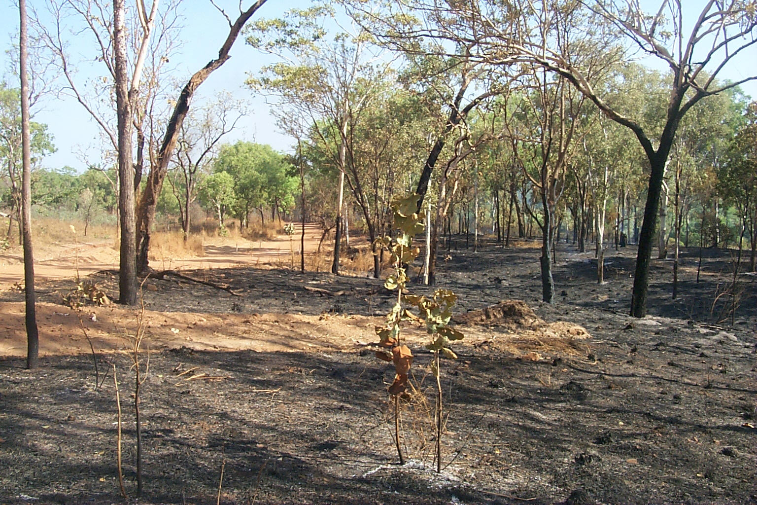

Accordingly the OSS requested the assistance of eriss to perform a more detailed survey of the gully and along the road in the general tailings dam/gully area. This information could then be used to provide Parks Australia with the appropriate assistance and advice regarding any radiological danger the area posed to staff or visitors to the site. In response to this request a radiological survey of the gully region and along and either side of the Gunlom road was carried out on the 20th and 21st September 1999 by staff of eriss and a staff member from OSS. The objective of this report is to provide current data on the radiological hazards present in the area, and to define the area affected by the exposed material. This was done with a view to providing Parks Australia and the OSS with some of the information required for remediation needs and to permit a risk assessment of the site.

2 Previous Surveys

The 1984 survey reported gamma-ray dose rates ~2 μGy·h⁻¹ along the road near the tailings dam, with levels around 5-10 μGy·h⁻¹ at the start of the erosion gully and falling to about 0.3 μGy·h⁻¹ close to the river.

Following the hazard reduction works at Rockhole an extensive radiological survey of the mill site and surrounding area was conducted by eriss scientists and staff of the OSS in October 1991. The former tailings dam area was considered to be particularly important to survey because its leveled nature and proximity to the road and river made it a potentially attractive camping site. It was noted that the erosion gully was the main run-off for the road and the water catchments of the extended mill tailings dam area. Accordingly a survey of the gully area was also included in the 1991 program. As part of this survey, natural datum heights at selected points between the mill tailings area and RMC, and bounded by the road and the SAR, were measured. The results are presented in Figure 2; point 14 corresponds to the location where tailings material crossed the road.

Figure 2. South Alligator mill area map from the 1991 survey with selected datum heights.

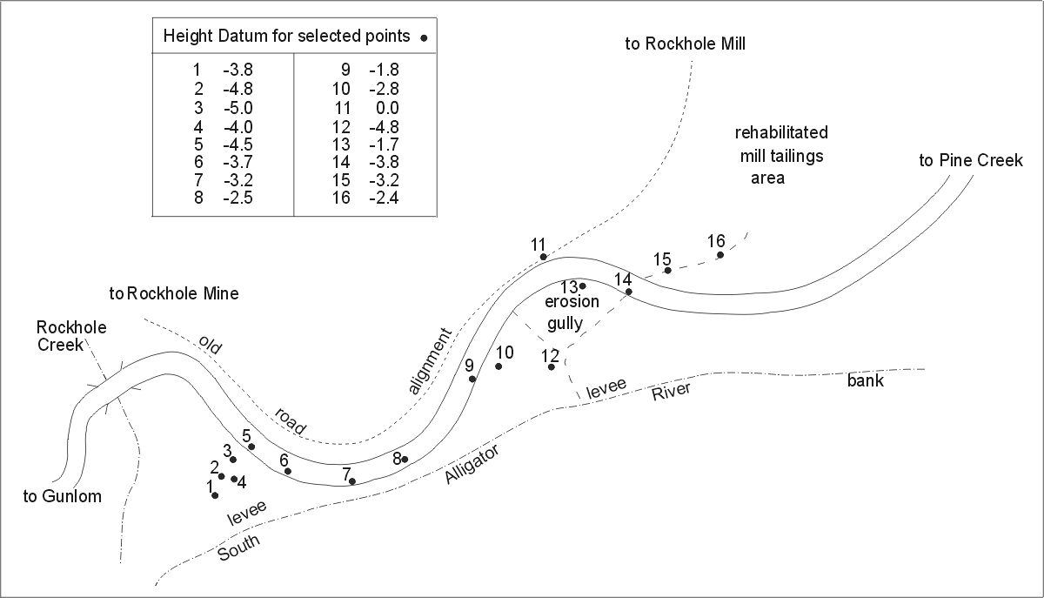

It was noted that gamma dose rates in the erosion gully were frequently 5-6 μGy·h⁻¹, which was more than double the highest levels recorded over the (hazard reduced) tailings dam area at this time, the average for which was ~0.9 μGy·h⁻¹. Furthermore, at a distance of 150 m along the road in the downstream direction from the site, readings were still 0.5-1.0 μGy·h⁻¹. The data from this survey are presented in Figure 3. Taken together, the datum height and gamma dose rate surveys are consistent with the proposition that tailings from the mill area were deposited along and across the road, following the natural datum heights, and were to a degree diluted with soils of the environment.

The location of 3 sites within the gully where soil samples were collected for high-resolution gamma spectroscopy analysis are also indicated in Figure 3. The results, which are presented in Table 1, show a strong disequilibrium between uranium and the other members of the decay series. Whereas the 230Th, 226Ra and 210Pb activity concentrations within each sample are similar, the 238U activity concentrations are much lower. This is as expected for uranium mill tailings; the milling process removes uranium (which is the desired product for sale) while the other radionuclides remain predominantly in the tailings.

It is also evident that the relative concentrations at site A are considerably lower than those at sites B and C, by a factor of 6-9. Furthermore, it is also worthy to note that the concentrations at site C increase with depth, by 8% for 238U and 32% for 230Th, 226Ra and 210Pb. These somewhat surprising changes in concentration were noted at the time of the 1991 survey and, together with the magnitude of the dose rates recorded in the erosion gully, were taken as evidence that further investigations into measures to reduce the potential radiological hazard at the site were necessary.

Table 1. Radionuclide concentrations of soil samples from the Rockhole mine erosion gully site, collected on 2/10/1991. All results are in Bq.kg-1 dry weight ± 1 standard deviation. The locations of sites A, B and C are indicated in Figure 3. Sites A and B are shown as squares, with site A being in the gully floor area, and the location of site C is indicated by the circle.

Site | Soil Depth  (cm) | 238U  (Bq.kg-1) | 230Th  (Bq.kg-1) | 226Ra  (Bq.kg-1) | 210Pb  (Bq.kg-1)
A | 0-1 | 196 ± 83 | 3325 ± 394 | 2698 ± 23 | 2726 ± 62
B | 0-1 | 1481 ± 486 | 22614 ± 2178 | 21387 ± 168 | 24824 ± 461
C | 0-2 | 942 ± 270 | 22024 ± 638 | 19653 ± 119 | 21468 ± 228
C | 10-12 | 1015 ± 340 | 29665 ± 778 | 25406 ± 153 | 28621 ± 302

Following the 1991 program the OSS and the Australian Nature Conservation Agency (now Parks Australia North) discussed the issue of the remaining tailings in the Rockhole mine area. After consideration of the location of the tailings, the state of the site, the funds available for hazard reduction and the level of risk to the community involved it was concluded that there were insufficient grounds to warrant further intervention. In particular the park managers considered that an ongoing surveillance program was preferable to any remediation works and possible consequent environmental impact(s). It was therefore decided to leave the site as it was and to monitor the situation as part of the annual inspection program.

3 Experimental Details and Results

In the 1999 survey gamma radiation levels were recorded on Mini Instrument Type 6-80 Environmental radiation meters with external high-sensitivity, compensated Geiger Muller tubes. These are identical instruments to those used to carry out the 1991 survey. The tubes are known to operate reliably under the severe climatic conditions present in the region. The sensitivity of the tubes is approximately 18 counts per second for a dose rate of 1 μGy·h⁻¹. The calibration for each tube is based on gamma rays arising from the decay of 226Ra and its progeny. These are the same isotopes that provide the bulk of the radiation dose from uranium ore, and consequently are well suited to dose assessment at uranium mine sites. The tubes were mounted in the horizontal position 1 m above ground height to even out topographic effects and to minimise any tube contamination. The associated meters provide output in the form of total number of counts for a given time period and a common analogue meter which provides output in μGy·h⁻¹.

Measurements were made at 11 sites located sequentially at 100 m intervals along the road, in roughly an east to west direction. The location of each site is indicated in Figure 4. At each site a recording was made above the windrow on the southern edge of the road, and also on both sides of the road at 25 m distance from the windrow, measured at right angles to the road. Count periods of 300 s duration were used for each recording. The statistical error on each measurement was never more than 3.5 %, and was typically 2.1 %. The results for the terrestrial gamma dose rate are presented in Table 2. The first letter of each site label presented in Table 2 indicates where the recording was made: R refers to those measurements made close to the road (above the windrow), S to those made to the south of the road (towards the SAR) and N to those made to the north of the road. A contribution of 0.07 μGy·h⁻¹, corresponding to the estimated cosmic ray background for the area, has been subtracted from the dose rate values recorded in the present survey. This estimate was taken from the work of Marten (1992).

Table 2. Terrestrial gamma dose rate at sites along and either side of the road to Gunlom falls, to the southwest of the South Alligator mill vicinity. Site numbers are defined in the accompanying text.

Site | Counts ·s-1 | Dose Rate (μGy·h⁻¹) | Site | Counts·s-1 | Dose Rate (μGy·h⁻¹) | Site | Counts·s-1 | Dose Rate (μGy·h⁻¹)
R1 | 3.26 ± 0.10 | ~0.09 | S1 | 2.94 ± 0.10 | ~0.07 | N1 | 7.97 ± 0.16 | ~0.34
R2 | 6.23 ± 0.14 | ~0.25 | S2 | 4.00 ± 0.12 | ~0.13 | N2 | 12.12 ± 0.20 | ~0.56
R3 | 7.15 ± 0.15 | ~0.30 | S3 | 4.56 ± 0.12 | ~0.16 | N3 | 16.27 ± 0.23 | ~0.78
R4 | 5.78 ± 0.14 | ~0.22 | S4 | 57.94 ± 0.44 | ~2.99 | N4 | 3.43 ± 0.11 | ~0.10
R5 | 8.01 ± 0.16 | ~0.34 | S5 | 17.85 ± 0.24 | ~0.86 | N5 | 3.95 ± 0.11 | ~0.13
R6 | 5.07 ± 0.13 | ~0.19 | S6 | 11.85 ± 0.20 | ~0.55 | N6 | 3.40 ± 0.11 | ~0.10
R7 | 3.48 ± 0.11 | ~0.10 | S7 | 8.55 ± 0.17 | ~0.37 | N7 | 3.37 ± 0.11 | ~0.10
R8 | 4.49 ± 0.12 | ~0.16 | S8 | 4.05 ± 0.12 | ~0.13 | N8 | 3.61 ± 0.11 | ~0.11
R9 | 5.06 ± 0.13 | ~0.19 | S9 | 7.99 ± 0.16 | ~0.34 | N9 | 4.25 ± 0.12 | ~0.14
R10 | 4.81 ± 0.13 | ~0.17 | S10 | 3.37 ± 0.11 | ~0.10 | N10 | 3.68 ± 0.11 | ~0.11
R11 | 3.29 ± 0.10 | ~0.09 | S11 | 3.08 ± 0.10 | ~0.08 | N11 | 2.72 ± 0.10 | ~0.06

A survey was made using the analogue meters to determine the extent of the affected area. The dose rate across the surveyed region was found to vary considerably, even over distances ~2-3 m. Accordingly, in order to facilitate the interpretation of the data, areas of similar activity have been classed together so that they fall into one of four categories. The terrestrial component of the gamma dose rate within a category 1 zone is largely in the range 0-0.14 μGy·h⁻¹ and is probably typical of the local background for the SAR valley. In categories 2, 3 and 4 the dose rates fall into the general ranges 0.14-0.40 μGy·h⁻¹, 0.40-1.0 μGy·h⁻¹ and 1.0-6.0 μGy·h⁻¹, respectively. The maximum dose rate recorded over the course of these recordings was 6 μGy·h⁻¹. The results from the analogue survey are presented in Figures 4 and 5. As can be seen in the photograph presented in Figure 6, which is of the location where the maximum dose rate was recorded, exposed tailings are clearly visible in the immediate area.

The presence of exposed tailings that did not appear to be significantly diluted with soils from the local environment within the category 4 area warranted further investigation. To facilitate access to the survey area a representative from Parks Australia North burned off the site immediately prior to commencement of the study. Holes were then augered at selected sites within and around the region at the locations indicated in Figure 5. These sites were selected on the basis of their position in the landscape and/or the presence of visible tailings deposits on the soil surface. This surface expression appeared to be associated with animal burrows or erosion. A photograph taken on the northern edge of the erosion gully where road maintenance activities had piled local soil over the top of tailings material is presented in Figure 7. The colour difference between the tailings (which are light gray) and the soil (which varies from orange to yellow in the immediate vicinity) can easily be seen. Similarly, the presence of undiluted tailings in the auger samples was also easy to detect visually, and radiation meters subsequently showed that the activity of the undiluted portions of the samples was well above normal background levels and higher than that of the mixed material.

Figure 6. Exposed tailings at the erosion gully site to the west of the South Alligator mill tailings dam. This area is immediately adjacent to the road to Gunlom falls. Numerous small gray mounds, such as those visible in the center foreground below, are present between the bottom of the gully and the road and appear to be tailings.

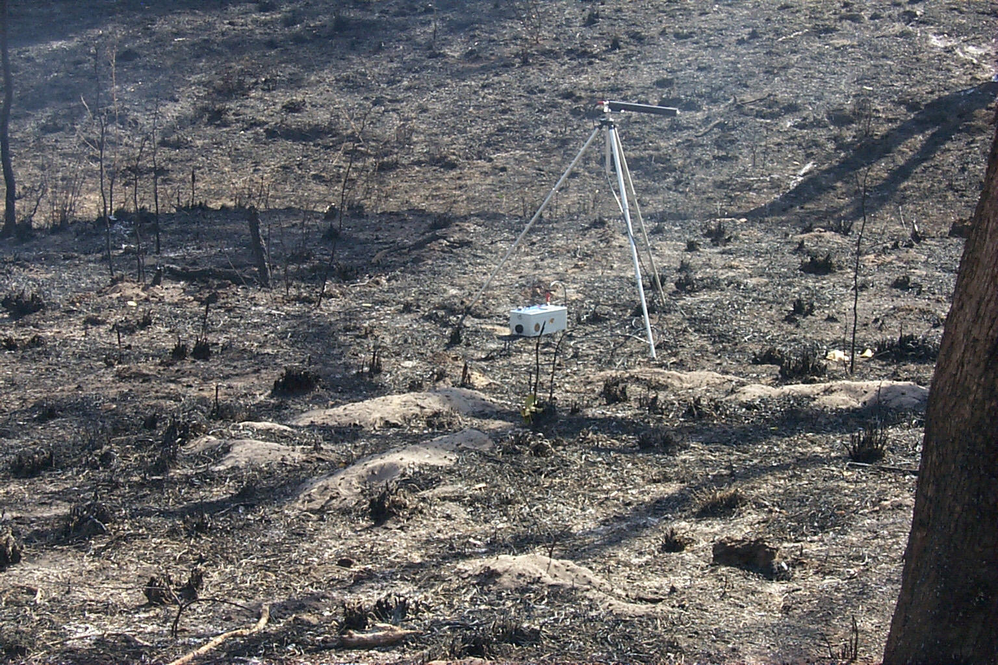

The auger samples suggested that most of the area surveyed was covered with a relatively thin layer of radioactive material. At most of the sites the samples showed that a considerable amount of tailings had become incorporated in the near surface layer with little evidence of undiluted tailings at depths below 150 mm. However, as can be seen in Figure 8, substantial tailings deposits of up to 1.5 meters thick, which was the maximum depth augered, were found within the category 4 region. Tailings extracted from the auger hole shown in Figure 8 has been laid out in two sections which correspond to the top ~25 cm and the lower ~25 – 150 cm of material. As can be seen in the photograph the extracted material is essentially undiluted tailings down to a depth ~120 cm, below which it progressively darkens in colour as it becomes mixed with local material.

4 Discussion

It is evident from a visual inspection of the area that more than one mechanism is responsible for the dispersal of tailings material. At least two locations close to the mill tailings dam area have been disturbed by road maintenance activities and tailings material has clearly been exposed. Furthermore, there are strong indications that the work has led to the dispersal of this material along the road for a considerable distance, and that this has happened on more than one occasion. Most of this dispersed material appears to be confined to the windrow on the southern side of the road, but elevated gamma radiation levels were also noted over some sections of the road surface, and over parts of the windrow to the north of the road. However, the exact distance over which dispersal can clearly be attributed to the road maintenance activities is somewhat unclear. The northern boundary of the above background regions that lie to the north of the Gunlom road appear to coincide with what could reasonably be expected to be the typical maximum flood height of the SAR. The reappearance of above background areas to the west of the RMC- SAR confluence also indicates that at least some of the material has been dispersed via wet season surface waters. It is almost certain that some of the dispersed material will have been deposited along the road. In addition the elevated gamma dose rate results at sites N1, N2 and N3 support the original observations that tailings material was also transported directly from the mill area, via the breach in the southwestern corner of the tailings dam and across the road, into the southeastern tip of the erosion gully area.

However, the depth of the tailings material in the auger samples from the category 4 area, and their essentially undiluted appearance, implies that the bulk of the radioactive material in the erosion gully has not been deposited as part of the natural dispersal of tailings from the mill area. Indeed, the datum heights from Figure 1 show that the northeastern side of the category 4 area was higher than the point where material from the tailings dam crossed the road, and that sites B and C could well have been up to 2 m above this point. Similarly, as can be seen in Figures 4 and 5, in the vicinity of the erosion gully the northern boundary of the above background region is very close to the road. Hence surface water transport of material from the mill area to the northern part of the category 4 zone could only occur when flood waters were at their maximum, and would be unlikely to result in the deposition of largely undiluted material.

This conclusion is supported by the dose rates presented in Table 2. Excluding site S4, which is within the category 4 area, the mean dose rate for the sites in Table 2 is ~0.23 μGy·h⁻¹, more than an order of magnitude lower than that at site S4 and more than 25 times lower than the maximum dose rate recorded in the category 4 region. Furthermore, data recorded during the 1991 survey of the tailings dam area lead to a mean dose rate for the tailings dam region of ~0.90 μGy·h⁻¹, significantly lower than that typically found in the category 4 zone.

It is therefore likely that most of the radioactive material in the category 4 zone has derived from a tailings dump, and that this dump was at least partially covered over at the time of the earlier surveys. The radionuclide concentrations reported in Table 1 support this conjecture. The concentrations at site A, which was in the gully floor, are significantly lower than at sites B and C. In addition the concentrations at site C, which at the surface are similar to those of site B, increase with depth.

The dose rate values presented in Figure 2 generally agree with those found during the analogue survey of the erosion gully area. However the shape of the category 4 zone has changed slightly over the intervening period. This change is most likely associated with topographic changes to the region, as a result of road maintenance activities and/or erosion, and also with the dispersal of both covering and tailings material via wet season surface waters. Accordingly, the apparent agreement between the dose rate value obtained at site S4 in the present survey (~3.0 μGy·h⁻¹) and the mean of the dose rate values given in Figure 2 (~2.6 μGy·h⁻¹) should not be over emphasized, and is perhaps a little surprising. However, the average dose rate within the category 4 zone is probably ~2-3 μGy·h⁻¹. The approximate upper limit on the direct gamma component of the whole body effective dose rate is therefore ~18-26 mSv·y⁻¹ (Tims and Ryan (1998)), and hence to remain below the public dose limit of 1 mSv·y⁻¹ the total time spent within the category 4 zone should remain below 2 weeks per year. Given the small physical size of the zone it is considered unlikely that total occupation periods would exceed this limit.

However, the dump is probably the source for the bulk of the radioactive material within the category 3 area, with dispersal of material from the tailings dam area providing a smaller additional contribution. Furthermore the bulk of the dispersed material presumably washes down the gully and into the SAR. It is therefore recommended in Appendix A that the site be cleared of residual tailings to the greatest extent practicable at the earliest opportunity, and that a further γ radiation survey be carried out at the completion of these activities.

The presence of tailings material along the road provides a potential source for an additional contribution to the total dose received. The passage of vehicles along those portions of the road where tailings material has been deposited can potentially generate airborne radioactive dust. Inhalation of such dust could make a significant contribution to the total dose received. In addition, resuspension of radioactive dust from the exposed tailings within the category 4 zone and surrounding area by more “natural” processes could also contribute to the net radioactive dust load. The complexity of the analysis required to determine the component of the total dose received from the inhalation of dust will most likely depend on the magnitude of the net radionuclide concentration. However, it is quite plausible that removal works will effect the distribution of the tailings on the road surface and also reduce the contribution to the total radioactive dust load that arises from any “natural” resuspension. Accordingly, measurements of the concentrations of radionuclides in dust were not made during the present study. It is therefore recommended that preliminary measurements of the concentration of radionuclides in dust be made at the conclusion of the removal works. This should enable an assessment of the requirements of any further studies needed to permit determination of the inhaled component of the total dose received.

4 References

DPIE (1998). Rehabilitation proposals for abandoned uranium mines in the Northern Territory. Report 88/2. Department of Primary Industries and Energy / Construction Group – Department of Administrative Services 1988.

DHC (1986). Report on survey of abandoned mines on Gimbat Pastoral Lease, Northern Territory. Department of Housing and Construction South Australia/Northern Territory Region 1986. Unpublished report.

Fry, R. M. (1989). Personal Communication.

Marten, R. (1992). External gamma dose rate survey of the Ranger Uranium Mine land application plot in: Proceedings of the workshop on land application of effluent water from uranium mines in the Alligator Rivers Region, Jabiru 11-13 September 1991. Supervising Scientist for the Alligator Rivers Region, AGPS Canberra.

Tims, S. and Ryan, B. (1998). γ Radiation surveys of El Sherana camp site and Sliesbeck pit and waste rock piles. Internal Report 284, Supervising Scientist, Canberra. Unpublished paper.

Waggitt, P. (1996). Hazard reduction works at abandoned uranium mines in the upper South Alligator valley, Northern Territory in: Radiological aspects of the rehabilitation of contaminated sites, workshop Darwin/Jabiru 20-22 June 1996. Editors R.A. Akber and
P. Martin (1998). South Pacific Environmental Radioactivity Association 1998.

5 Acknowledgements

A number of people have helped with the preparation of this report. The authors would like to thank eriss ex-staff members John Pfitzner, Rainer Marten and Riaz Akber for the initial sample collection and analysis of the data reported in this study. We would also like to thank Greg Ryan from Parks Australia North for his assistance in preparing access to the surveyed areas.

6 Appendix A

Recommendations
It is recommended that:
- The site be cleared of residual tailings to the greatest extent practicable at the earliest opportunity. A draft outline program of works is attached at Appendix B.
- A special survey should be undertaken to establish if the roadway itself needs to be removed. Consideration should be given to sealing/surfacing the roadway as an alternative to total removal and re-building.
- A consulting engineer should be engaged by PAN to establish if the integrity of the road’s foundations will be threatened by the removal of the tailings deposits. If so the engineer will need to develop a strategy and design for the remedial works to restore the road to a safe and stable condition.

7 APPENDIX B
Draft outline program of works.

- Appointment of consulting civil engineer with suitable roads and earthworks experience.
- Topographical survey of the affected area, production of plans at a scale sufficient to enable earthworks quantities to be measured and taken off.
- Detailed radiological study of area beneath road surface to establish if tailings are present.
- Preparation of tender documents for initial project assuming 8000 cubic meters +/-5% of material to be moved and agreement on rates for quantities outside these limits. Surface area for clearing etc to be taken off the plan.
- Call for tenders.
- Selection of contractor.
- Appointment of Radiological Safety Officer (RSO).
- Mobilization of contractor and project team.
- Marking out of area to be cleared in consultation with RSO.
- Induction of workforce into radiological protection program.
- Construction of containment at agreed site.
- Clearing of vegetation from affected area.
- Main earthworks program (to be carried out under close supervision of RSO who will clear areas before they are signed off as completed as cleaned).
- Remedial works for road to be designed and constructed (if needed).
- Construction of any new erosion control works/structures needed.
- Close out radiological survey and radiological sign off for site.
- Final site topographical survey for calculation of final earthworks quantities and measurements for contract payment.
- Revegetation of cleared areas with seed etc. from local provenances.
- Preparation of documentation for archive records.
- Installation of permanent markers at containment sites.
- Demobilization of contractor and project team.
- Completion of engineering tasks.
- Completion of project.

Figure 3. Gamma dose rate readings from the 1991 survey of the erosion gully area at Rockhole mine.

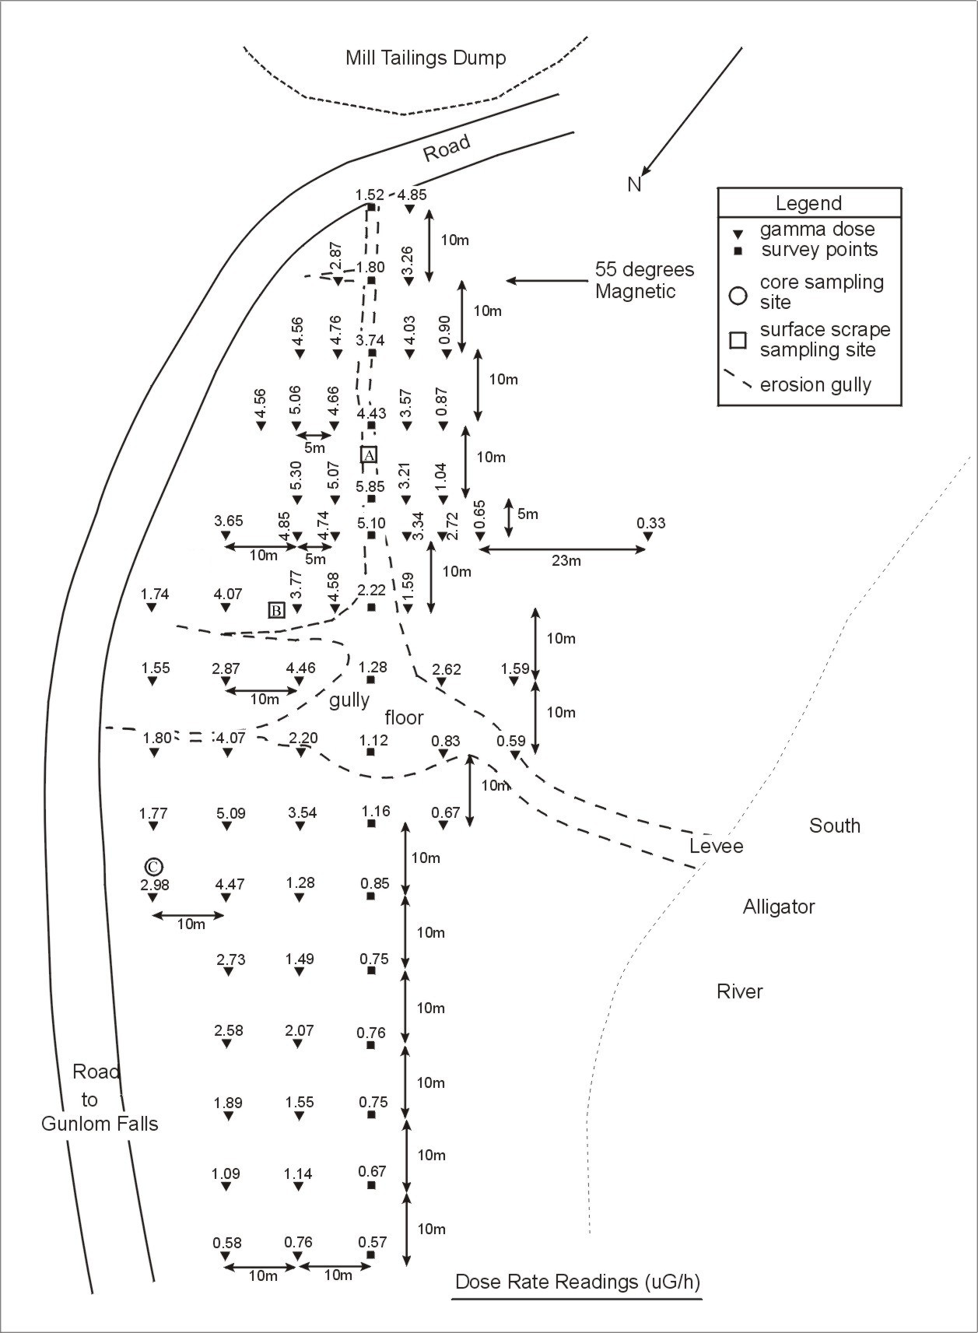
Figure 4. Aerial photograph of the Rockhole mine site area. The sites of the 11 measurements from the 1999 gamma dose-rate survey are indicated. The red, green and blue lines respectively correspond to the approximate extents of the category 4, 3 and 2 areas discussed in the text.

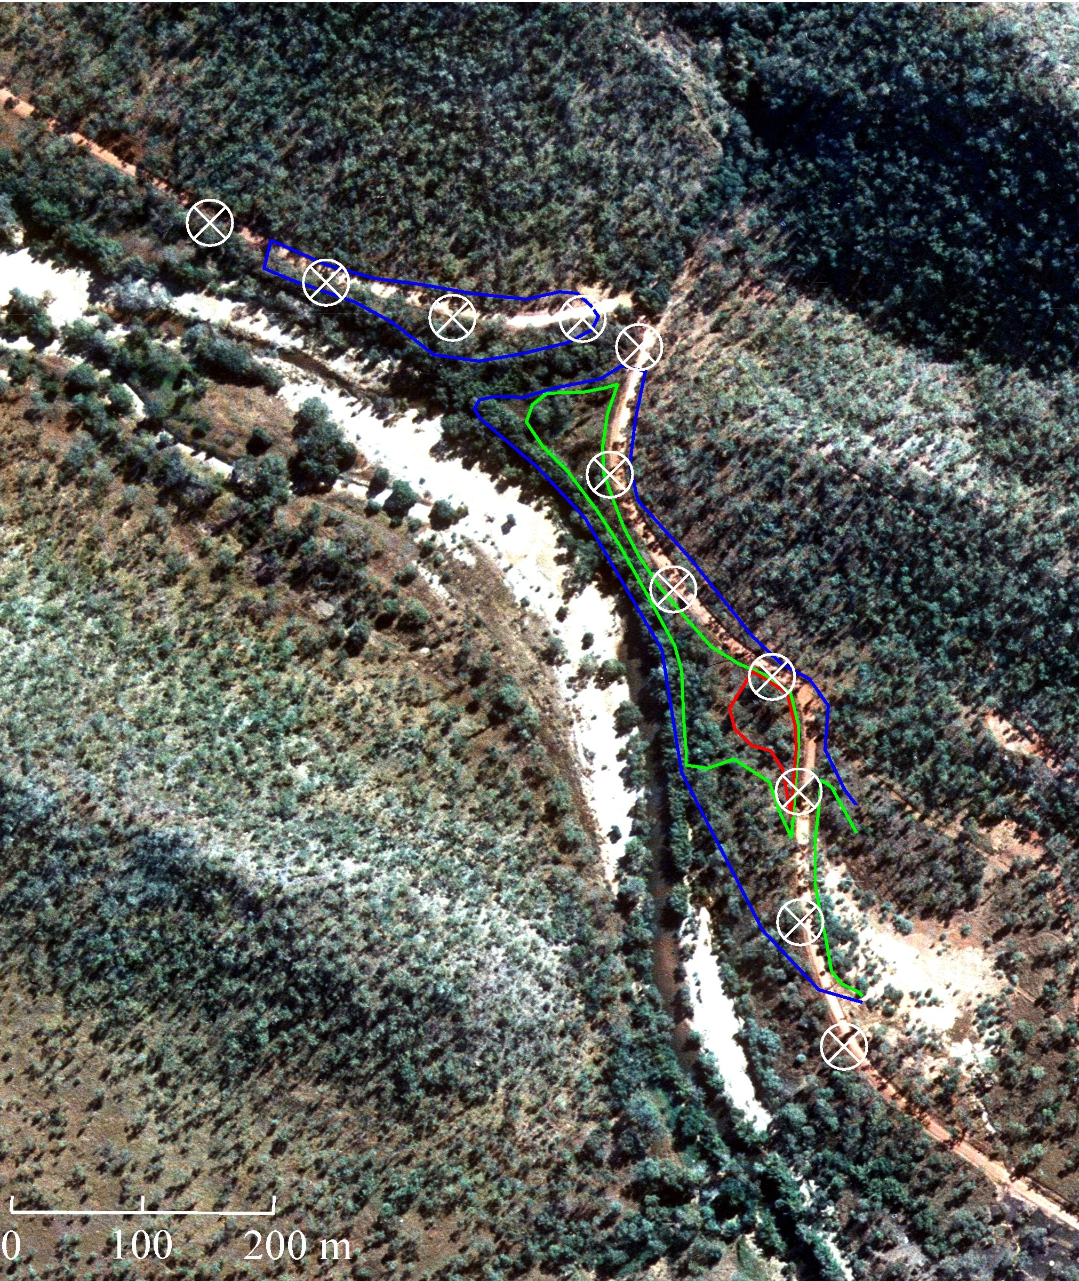
Figure 5. Enlargement of the erosion gully area from the photograph presented in figure 3. Auger sites from the 1999 survey are indicated by + signs.

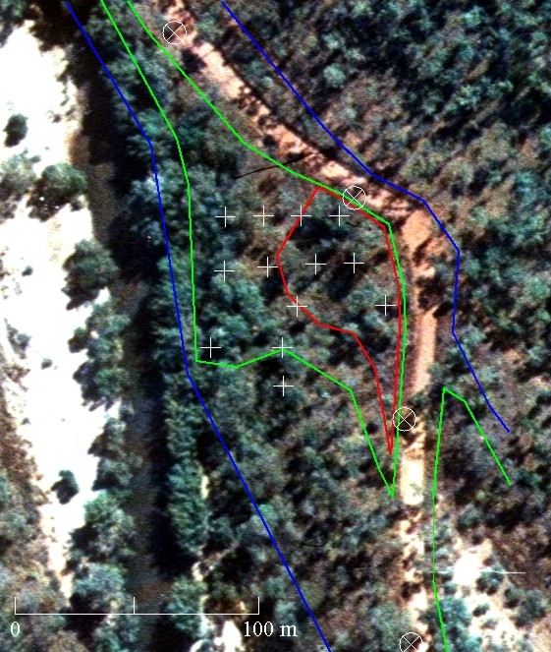
Figure 7. Tailings material covered with local soil as a result of road maintenance activities. This photograph was taken on the northern edge of the category 4 zone.

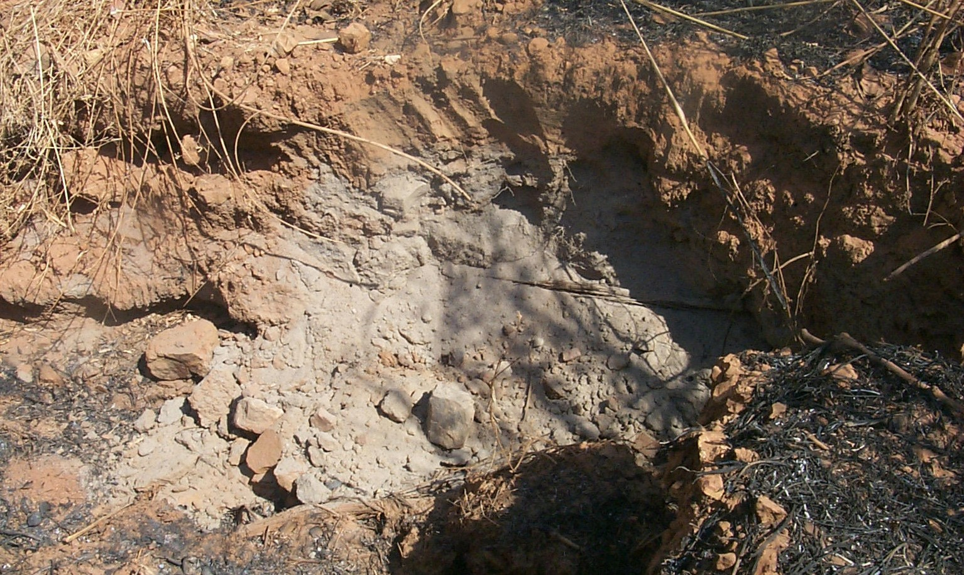

Figure 8. Tailings material removed from an auger hole in the category 4 zone. The surrounding brown/yellow soil can be seen as patches in the black/gray background (which is largely ash from the recent burn off). The undiluted tailings are light gray in colour and comprise all of the material removed from the 1.5 m hole.

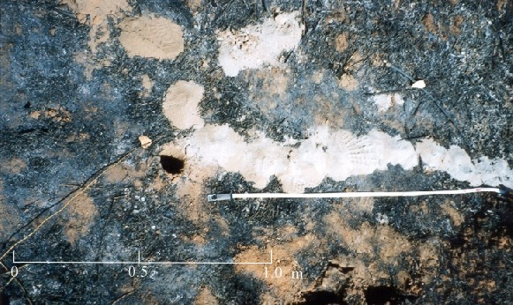

For several points at the western end of the survey the distance from the windrow was less than 25 m because the steep riverbank and road cutting restricted the access.
The evidence for this is the presence of windrows that clearly pre-date the latest road maintenance works, and that also have gamma activity levels that are elevated with respect to their immediate background levels.
During the 1999 survey localized above background areas were also noted along the side of the road at considerable distances westward of the RMC-SAR junction. These sites were generally in or close to topographically depressed areas, such as those associated with creeks and drainage lines, and were present at least to distances ~2-3 km west of the confluence.
A comparison of photographs taken during the 1991 and 1999 survey shows that the general topography of the erosion gully area appears to have changed somewhat. The gully has broadened significantly and a new gully appears to have developed at its western end, possibly as a deliberate result of road maintenance works. This newer gully develops near the edge of the road and seems to border the category 4 zone until it joins the floor of the original erosion gully (shown in figure 2). Thus the category 4 area is essentially within the region bounded by the road and the two gullies.
During an earlier meeting at Gunlom in September it was established that Traditional Owners wanted the site cleaned up and were in agreement that the contaminated materials should be contained in a pit adjacent to the existing location at the former South Alligator village site.

