Outcome 1, Question: 192
Topic: Low Value of the Australian Dollar
Hansard Page: ECITA 250

Senator Lundy asked:

Can you provide the committee with details of that supplementary funding? Did it only occur in the one year, in the last financial year?

Answer:

In the 2001-02 Budget the National Library of Australia received supplementation of $382,000 to cover the decline in value of the Australian dollar against the US dollar since 1 July 1999. The amount received was ongoing and is subject to an annual review at estimates preparation time - around February each year. There was no adjustment to the supplementation for the 2002-03 Budget, as the value of the Australian dollar had remained virtually unchanged at February 2001 and February 2002 at around US$0.52.

Outcome 1 Question: 193
Topic: Online trend activity
Hansard Page/Written Question on Notice: ECITA 251

Senator Lundy asked:

Can you provide details of the activity and either the trend figures or actual figures of usage just to help us set a benchmark so we can come back to it in the future?

Answer:

As set out in the graph below, at the end of April 2002 the National Library of Australia has experienced an 80% increase in the number of visits to its website compared to the same period last financial year. At the end of April 2002 there has been a total of 5,231,500 visits to the Library's website, compared to 2,904,088 at the same time last year.

A visit is defined as an action or series of actions that begin when a visitor views their first page from the server, and ends when the visitor leaves the site or remains idle beyond thirty minutes. A visit may therefore include numerous page views or hits.

Website access by individuals 2001-02
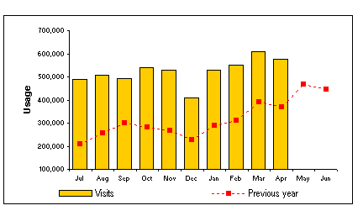

Outcome One Question: 194
Topic: ASL Reductions
Hansard Page: ECITA 251

Senator Lundy asked:

Can I get you to provide details about those reductions – the impact internally in the budget and how many people, and just make sure I get the full details of those?

Answer:

Please find attached a table setting out the required information.

Attachment to qon194

Project | ASL Reduction | Budget Impact | Impact of Cessation
A benchmarking exercise designed to compare library services against like services performed in other agencies | 0.7 | $159,000 | The cessation of this project will not impact upon ongoing operations
A number of Anniversary Celebrations including the Treasures from the World's Great Libraries Exhibition | 6.2 | 3,255,000 | This project has been completed and will not impact upon ongoing Library operations.
The rollout of a new voice system and new desktop PCs | 0.9 | 34,000 | This project has been completed and will not impact upon ongoing operations
The development of a new version of software to support harvesting and permission management for the archiving of Australian websites. | 1.7 | 89,000 | This project has been completed and will not impact upon ongoing operations
The cataloguing of older collection materials online | 8.0 | 300,000 | The project will continue at slower pace in 02-03
Listing and barcoding copies of Australian books for loan | 2.4 | $90,000 | Work suspended pending availability of further resources.
Collection maintenance and treatment projects | 1.4 | 120,000 | The project will continue at slower pace in 02-03
Supplement existing efforts to transcribe oral history interviews and clear manuscript processing backlogs | 1.2 | 54,000 | Work will continue at a slower pace in 02-03.
Bringing Them Home Project - to record a range of experiences of people directly involved in the separation of Indigenous children from their families, including the children themselves, their parents and other relatives, and those involved in the many aspects of care, administration and policy related to separation events. | 2.1 | $100,000 | Additional funding was provided by Government for this one-off project which is due to be completed this calendar year
TOTAL | 24.6

