

ROADS ACT

STUDY BRIEF

FOR

GUNGAHLIN DRIVE EXTENSION
WESTERN ALIGNMENT

ENVIRONMENTAL HEALTH ASSESSMENT

BRIEF No. AC 02-06

Project No. US01176C

17 June 2002

PROJECT: GUNGAHLIN DRIVE EXTENSION
WESTERN ALIGNMENT
ENVIRONMENTAL HEALTH ASSESSMENT

STUDY BRIEF

CONTENTS

1. Background
2. Objectives
3. Site of works
4. Scope of works
5. REFERENCE Information
6. CRITICAL DATES
7. Budget
8. DELIVERABLES
9. Liaison

10. CONSULTANT SELECTION PROCESS

11. SITE PLAN

Background

Roads ACT (RA) is a part of the City Mangement Group of the Department of Urban Services and manages all ACT road, bridge, cyclepath, pedestrian, traffic signal and Street lighting assets to ensure a safe, efficient and effective transport network for the people of the ACT.

Asset Creation, a section within RA is responsible for the development and delivery of the RA capital works program.

Asset Creation identifies the need to undertake studies to help it scope work proposals, as is the case here.

The Government is now committed to the “Western alignment” option for the Gungahlin Drive extension between Barton Highway and Belconnen Way. A number of alignment alternatives were examined as part of the John Dedman Parkway Preliminary Assessment (the PA) completed in October 1997.

The Australian Sports Commission (ASC) have raised concerns about the Western alignment for the Gungahlin Drive extension, in relation to the environmental impacts the road will have on the health and performance of athletes, in particular the noise and air pollution (notably ozone) impacts. It has therefore been agreed that the two parties will undertake a joint study to assess these issues.

Objectives

The objective of this project is to complete an assessment of environmental health issues on the “western alignment” for the Gungahlin Drive Extension in the area adjoining the Australian Institute of Sport.

This project is to:
- assess the potential environmental health issues, effects and impacts (eg noise and air pollution) of the construction and use of Gungahlin Drive Extension on the Australian Institute of Sport (AIS), specifically in relation to high performance athletes training at the AIS facilities (including the athletics track) and living/staying in the AIS residences;
- provide advice on available options to ensure that the ASC’s and AIS’ operations continue at standards which do not reduce in any way the quality of athlete living and training conditions and athletic performance.

Site of works

The area of this study is shown on the Site Plan included as Section 11. This Site Plan details a possible western alignment for the Gungahlin Drive extension between Barton Highway and Caswell Drive. Caswell Drive is also to be duplicated, with the location of the new carriageway currently being assessed.

Scope of works

The scope of work is as follows:

- Meet with the project team at the beginning of the project. This meeting will include representatives from the Department of Urban Services and the Australian Sports Commission (ASC), and will be held in Canberra.

- Establish existing conditions in regards to noise and air quality at the Australian Institute of Sport (AIS) which would then be used as the basis for determining any impacts arising from Gungahlin Drive Extension. The majority of this information is available in the documents listed in Section 5 Reference Information.

- Assess the potential environmental health issues, effects and impacts (eg from noise and air pollution) of the construction and use of Gungahlin Drive Extension on the Australian Institute of Sport (AIS). This is specifically in relation to high performance athletes training at the AIS facilities (including the athletics track) and living/staying in the AIS residences.

- If the assessment shows that there are any impacts, provide advice on available options to ensure that the ASC’s and AIS’ operations continue at standards which do not reduce in any way the quality of athlete living and training conditions and athletic performance.

- Prepare draft and final reports

REFERENCE Information

The reference documents and information available include:
- Gungahlin Drive Extension (western alignment) Air Quality Study report prepared by Holmes Air Sciences (brief no. AC 02-04)
- Gungahlin Drive Extension (western alignment) Engineering Feasibility Study report prepared by SMEC (brief no. AC 01-09). This report will detail the recommended route and grade for this new road.
- Noise Predictions and Mitigation Measures, Gungahlin Drive Extension report prepared by Marion Burgess of Unisearch (brief no. AC 01-12)
- John Dedman Parkway Preliminary Assessment (including attached working papers) – October 1997, Maunsell Pty Ltd
- Liaise with Ann Fox (ph 02 62141390) or e-mail ann.fox@ausport.gov.au as a contact on behalf of the AIS and ASC to clarify, determine and document the existing standards for the ASC’s and AIS’ operations in relation to the quality of athlete living and training conditions and athletic performance.
- Exisiting historic air quality monitoring data in the ACT – available from David Power, Environment ACT, (ph 02 62075311) or e-mail david.power@act.gov.au
- Liaise with John Woollard, General Manager of the Health Protection Service (ph 02 62051722) and Dr Paul Dugdale, Chief Health Officer (ph 02 62050881), as contacts on behalf of the Department of Health and Community Care.
- ASC/AIS report prepared by Eldamar Research Associates on the impacts of a western alignment on the health, living, training and performance of high performance athletes utilising the AIS campus.

CRITICAL DATES

The following are the milestone dates for the project.

- Issue brief 17 June 2002
- Deadline for proposals 28 June 2002 (COB)
- Award Consultancy 8 July 2002
- Submission of Draft Report 8 August 2002
- Submission of Final Report 30 August 2002

Budget

The study is to be performed as a time based fee invoiced monthly with an upper limit of $10,000. The upper limit shall not be exceeded without prior permission from the RA Project Officer.

DELIVERABLES

Proposal:

The deadline for receipt of proposals to undertake the work required by this brief is by close of business (COB) on 28 June 2002. The proposal is to be sent to Tony Gill at the following postal address, fax number or e-mail address.
Roads ACT,
Locked Bag 2000,
Civic Square ACT 2608
fax: 02 62076587
e-mail: tony.gill@act.gov.au

Report:

The draft report is to be provided to the RA Project Officer by 8 August 2002, this can be as an electronic copy via email. Five copies of the final report, one unbound are to be provided to the RA Project Officer by 30 August 2002, after review of the draft report by RA and Australian Sports Commission staff.

The report shall include a stand alone executive summary which outlines in plain English, the process, findings and recommendations in a succinct manner.
All pages and sections of the report, whether draft or final must be numbered and also title and revision provided in the header/footer for clear referencing in discussions.
The report is also to be provided in Word 6.0/95 format, either on disk or CD.

Maps

Any maps and material covering the locations modelled should be provided as part of the report.

Liaison

This project is to be jointly managed by RA and the Australian Sports Commission.

The RA Project Manager is Hamish McNulty (ph 02 62076399) or e-mail hamish.mcnulty@act.gov.au. The ASC project manager is Ann Fox (ph 02 62141390) or e-mail ann.fox@ausport.gov.au.

The RA Project Officers are Tony Gill (ph 02 62076588) or e-mail tony.gill@act.gov.au, and Julie Pearson (ph 02 62075568) or e-mail julie.pearson@act.gov.au. A RA Project Officer shall be kept informed regularly during all phases of the project.

Any additional information required by the consultant can be obtained through a RA Project Officer.

- CONSULTANT SELECTION PROCESS

The Consultant to undertake this brief will be selected by a selection panel made up of representatives from RA and ASC. This panel will be Hamish McNulty, Tony Gill, Ann Fox and Dr Peter Fricker.

The criteria used to evaluate the Consultant’s proposals will be:

Experience/background of the consultancy team in similar projects and issues

Management capacity and ability to resolve issues during the study

Ability to demonstrate that the study and reports can be completed and delivered within the agreed time frame

Methodology proposed for undertaking the study

These evaluation criteria will be given even weighting.

The scoring regime which will be used by the selection panel when evaluating the proposals is as per the table below.

Rating | Description | Score
Excellent | Exceeds requirements in all ways, with very little or no risk | 10
Excellent / Very Good | Exceeds requirements in most ways, with very little or no risk | 9
Very Good | Meets requirements in all ways, exceeds it in some, little risk involved | 8
Very Good / Good | Meets the requirement, little risk involved | 7
Good | Meets the requirement and is workable, acceptable risk | 6
Good / Marginal | Meets the requirement, may require work in some areas, some element of risk | 5
Marginal | Meets the requirement, workable but may be deficient or limited in some areas, element of risk | 4
Marginal / Poor | Nearly meets requirement, deficient or limited in most areas, high element of risk | 3
Poor | Information provided does not meet the requirement, is not workable and is deficient, high element of risk | 2
Poor / Non-compliant | Information provided does not meet the requirement, is not workable and is deficient, higher element of risk | 1
Non-compliant | Tenderer has either stated non-compliance, demonstrated non-compliance, or there is insufficient information to assess. | 0

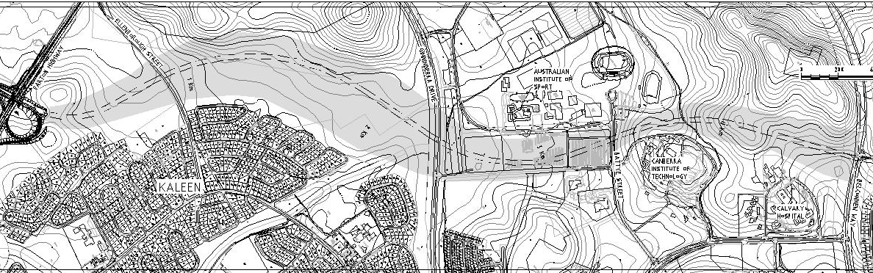
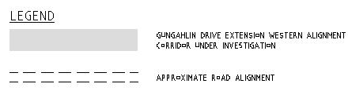
11 SITE PLAN

Area of study

