1 Executive Summary 1
January 2000
CANBERRA
Environment Australia
Pricing Review of
Outputs 1.2 and 1.7
and Corporate Services
2 Background 7
2.1 Government Reforms 7
2.2 Output Pricing Review 7
2.3 ERC Consideration 8
3 Approach 9
3.1 Terms of Reference 9
3.2 Scope of Review 11
3.3 Output Definition 11
3.4 Approach to review of output prices 12
3.4.1 Cost Assessment 12
3.4.2 External Benchmarking 14
3.4.3 Internal Benchmarking 14
3.5 Competitive Tendering and Contracting (CTC) 15
3.6 Departmental / Administered split 16
3.7 Adjustment for work performed for other agencies 16
3.8 Internal Levies 16
4 Results of Review 17
4.1 Overview of Output Group 1.2 – Scheme / Grant / Program Admin 17
4.2 Benchmarked outputs 17
4.3 Cost-assessed outputs 18
4.4 Results (Output 1.2 Grant Administration) 19
4.5 Interpretation of Results 30
4.6 Results (Output Group 1.7) Research and Assessments 36
4.7 Interpretation of Results 37
5 Corporate Services Overheads 41
5.1 Overview 41
5.2 Corporate Services – Commonwealth Agency benchmarking information 42
5.3 Corporate Services – External Benchmarking information 52
5.4 Other issues concerning Corporate Overheads 62
5.4.1 Appropriateness of allocative base 62
6 External Benchmarking for other Outputs 1.2 and 1.7 64
6.1 Output 1.2.1 Tax Concession administration 64
6.2 Outputs 1.2.3: Grants to Voluntary Environment and Heritage Organisations – Review of prices 68
6.2.1 Grants to Voluntary Environment and Heritage Organisations 68
6.2.2 Comparison between costs of administration of both programs 70
6.3 External Benchmarking Partners 70
7 Qualifications 73
7.1 Output definitions 73
7.2 Issues of remoteness 74
7.3 Distortions caused by overhead allocations 75
8 Conclusions 79
8.1 Inefficiencies 79
8.2 Savings 80
8.3 Outsourcing Options 81
8.4 Redefine Outputs 81
9 Future Output Pricing and Reporting Practices 83
Appendix 1 – Reconciliation to Portfolio Budget Statements 90
Appendix 2 – Reconciliation of Revised Output Prices 93
Appendix 3 – Terms of Reference 97

Executive Summary
In October 1999 the Department of Finance and Administration (DOFA) and the Department of the Environment and Heritage (DOEH) jointly commissioned an output pricing review. This review focussed on testing the reasonableness of the price currently being paid for output group 1.2 (scheme/grant/program administration) and output group 1.7 (research and assessments). In addition the corporate services costs relating to each of the seven output groups in outcome 1 was examined.
The review aimed, to the extent possible, to compare the services provided by DOEH to alternative service providers or other organisations. By comparing the price of similar services to alternative organisations a best practice standard is established from which point the goal of the process then becomes one to improve performance to that of best practice. A series of benchmarking exercises were undertaken to attempt to establish a benchmark price to compare to the price of DOEH outputs and determine the reasonableness of the Department’s overall output costs.
The initial part of the process was to assess the costs of providing the outputs and the corporate costs and then to:
- Independently verify the results against other comparable goods and services provided by other organisations (external benchmarking); or, where it proved difficult to find suitable organisations, to
- Compare the results against similar outputs produced by different groups within the organisation (internal benchmarking).
Given the lack of available benchmark data it proved to be a difficult task to gather comparative data in order to make an assessment of likely opportunities for improvement. There was a reluctance by many external organisations to provide data from which conclusions or assessments could be made about efficiency of operations. However, sufficient material was available during the course of the review to draw some initial conclusions and further work in this area is continuing.
The internal benchmarking primarily focussed on the grants administration program which incurs costs of $6.098m. A number of benchmark measures were used to compare the cost of administering the grants program between each group within the organisation. Cost per grant, cost per value of grant and cost of grant per employee were some of the measures used to establish comparable results. If all groups, whose individual average exceeded the average for the group, were to reduce their costs to the group average, savings in the order of $0.6m to $0.8m could be possible.
The remaining aspects of output group 1.2 (program administration and schemes) as well as output group 1.7 (research and assessments) proved more difficult to benchmark. However this did not preclude the possibility that these functions could be considered for a market testing study. Several benchmark organisations were mentioned as being possible candidates such as ANSTO Environmental Science Division and many of the functions currently performed by AFFA.
DOEH should vigorously pursue further opportunities for benchmarking partners and continue to develop a forward program of market testing that is expected to reduce prices in a number of areas that are the subject of this output pricing review.
The corporate service cost allocations to groups form a substantial proportion of the total costs of outputs produced. The total corporate costs for the Department is currently $37.9m but for the purpose of this review was reduced by $6.591m for the distortion impact caused by attributing corporate overhead to outputs for the budgets of Parks, Heritage Commission and the Greenhouse Office.
Extensive micro level benchmarking information has been used to assess the performance of the functions currently incorporated in corporate services. This included benchmarking measures of records management, human resource management, ministerials, internal audit and finance. Comparisons were made with other Commonwealth agencies as well as a sample benchmark of public sector, private sector and an overall sample of several industries.
An assessment of all corporate activities compared to best practice and group averages suggests that improvements in the range of $3.0m to $5.0m could be attainable by the Department if they were to adopt practices and procedures equivalent to those organisations currently performing better in these functional areas.
Apart from establishing information from which to make decisions on output pricing the output pricing review has highlighted a number of other results and also benefits for the organisation.
Some of the deficiencies in the current output structure include:
- The existing output structure is far too complex and confusing. Many of the outputs seem to be more in the nature of activities and functions rather than actual outputs. The level and complexity of the output structure would suggest an inordinate amount of time and resources would be required to attribute budgeted costs and then to report throughout the year on achievement of outputs in terms of quantity, quality, timeliness and cost.
- Many of the existing output definitions are unclear and some output groups have intermingled outputs of different natures. This makes output pricing comparisons and benchmarking difficult.
- There was also an intermingling of departmental and administered costs and some costings for outputs were actually included in completely different outputs.
- Corporate overheads are allocated on a straight average staffing level (ASL) basis across all outputs which do not take account of costs incurred by a specific group. This could lead to an inequitable and disproportionate allocation of costs to outputs.
A number of positive features emerged during the review process. These include:
- Management and staff within their respective business units have gained a better understanding of their internal systems and business practices.
- The results of the review should enable groups to become more output focussed and more knowledgeable about becoming more competitive in the outputs they deliver.
- Management and staff were also made aware of industry best practices. Being aware of best practice should assist people in striving to emulate best practice and take responsibility and ownership of the processes in order to get there.
The output price review process was conducted over a very short timeframe and participants were asked to provide extensive amounts of data and feedback on findings. Weekly meetings and bilateral discussions were held with participants to discuss progress and information requirements and these were all regularly attended by each of the groups. The co-operation and participation by all individuals, during a time of competing demands, was certainly welcomed and appreciated.
This work has, in our view, established a sound platform to enable the Department to continue the work completed to date and address pricing of other Outputs.

Background

Government Reforms
The adoption of outcome / output budgeting in 1999-2000 has altered the focus of budget scrutiny away from the traditional concentration on input costs towards a concentration on the value for money which the government receives from agencies for the services they deliver.
Together with the conversion of the budget presentation from cash to an accrual basis, there is now a strong emphasis on enhanced performance and value for money in government services.

Output Pricing Review
The traditional review role of the Department of Finance and Administration has been to concentrate on the level of inputs consumed by agencies, and to apply pressure to reduce input costs.
Under the new budgetary framework, a more appropriate response is to review the outputs produced by the agencies, and the prices charged for them. However, the distinction between cost and price is a fundamental one. A purchaser is more concerned with the price of an output, and its comparison to the price and quality of alternative providers, than with the cost of production.
The concept of an output pricing review is to look at what the Department produces, and to determine whether that service provides value for money at the price being paid. This can best be done through external comparison with providers of similar services. Where such comparison cannot be made, surrogate measures may be used, such as an examination of the production efficiency of the service.

ERC Consideration
The Expenditure Review Committee (ERC) has required agencies jointly with DOFA to undertake a series of Output Price Reviews in order to inform decision making during the 2000-01 Budget process. Eight agencies are participating in the first round of reviews.
The essence of these reviews is to test the “reasonableness” of the prices put forward by Departments for the provision of outputs. Each Department has been allowed to adopt its own approach to the conduct of the review.
Environment Australia is a participant in this first round of pricing reviews.

Approach

Terms of Reference
This project has been conducted according to the Terms of Reference developed jointly by the Department and DOFA for the Output Pricing Review.
The key elements in the Terms of Reference are as follows:
- The objectives of the review are to determine whether the prices of DOEH outputs are reasonable (for example, relative to comparable outputs in other agencies), and to provide guidance for future output reporting practices in DOEH.
- The review will be based on agreed costing methodology (consistent both within DOEH and across comparable Departments), and will include costs at the sub-output and activity level to the extent possible. The review will involve collection of relevant data relating to quantity and cost of outputs, and analysis of the information produced.
- The review may employ a range of approaches to achieve its objectives, including:
- using a consistent approach so that the cost of DOEH activities can be benchmarked against comparable activities in other public sector and private organisations;
- incorporating consideration of competitive prices of outputs from, for example, competitive tendering (recognising and assessing opportunities for Competitive Tendering and Contracting, and including the outcome of these assessments in the report);
- building information links with other relevant reviews within DOEH; and
- incorporating other methods that the steering Committee considers appropriate for the Department
- The methodology, findings and lessons learnt from this review will be used in:
- minimising/eliminating any differences in methodology/approach adopted by different parts of DOEH in assigning activities to output groups and in output pricing;
- revising and strengthening the costing methodology prior to the commencement of later stages of the review;
- subsequent refinement and improvement of the Department’s output pricing structure for reporting in future years (including accuracy, appropriateness and consistency of pricing methodology)

Scope of Review
Due to the time constraints surrounding this review, the first stage of the review will concentrate on Output 1.2 (Scheme / grant / program admin); Output 1.7 (Assessments and Research) and Corporate Services within Outcome 1 (Environment).
Whilst corporate services are not an output, they are a significant component of the cost of all outputs. A range of micro level benchmark data has been provided to benchmark Corporate services costs but across the board comparisons are not available at this time. An examination of the “reasonableness” of the Department’s corporate service costs will play a large part in determining the “reasonableness” of its overall output costs.

Output Definition
Effective benchmarking or market-testing of outputs depends greatly on the clarity of definition of the service being provided. In the course of this pricing review, the output definitions have been scrutinised to ensure that outputs are classified correctly. In some instances, this has necessitated considering sub-outputs or activities that are currently not included in output 1.2 or 1.7, but are sufficiently similar to be considered alongside the target outputs.

Approach to review of output prices
A multi-faceted approach has been adopted to review the output prices published in the 1999-00 Departmental Portfolio Budget Statement (PBS).

Cost Assessment
Where verification of output prices through benchmarking is not available, an alternative process is to assess the cost of output production. Cost assessment is less useful than benchmarking, but is helpful in determining whether or not a cost-based price is reasonable. In undertaking the cost assessment, a number of elements were examined.
Each organisation group responsible for producing specific outputs or sub-outputs was asked to identify three components of the output price:
- Direct costs - these are group costs directly incurred in order to produce the output (eg salaries of staff administering grant payments)
- Indirect costs – these are support costs incurred by the group which cannot be traced directly to the production of an output (eg building rental, accounting staff, recruitment expenses)
- Corporate overheads – these are support costs incurred by head office and allocated to organisation groups (eg IT, finance, payroll processing).
The direct cost of output provides an objective base from which to assess output price. Direct costs do not rely on a subjective allocation process to transfer costs to the end product, unlike indirect costs and corporate overheads. The higher the proportion of direct costs in the output price, the more determinate the final output price.
Indirect group costs are separately identified for three reasons. Firstly, they are costed to the final output, via an allocation process, and therefore are open to greater subjectivity (and possible mis-allocation) in the costing process.
Secondly, there is a possibility for duplication or “double-counting” of support activities. This can occur where groups carry out a support function that is also carried out centrally by the corporate services group. Organisation groups have also been asked to identify support costs (eg recruitment, accommodation, accounts processing) carried out within the group. This is to identify where functions may be duplicated at central and group levels, or where a central overhead burden is allocated inadvertently for a support function which has been devolved to the organisation group level.
A third benefit of identifying the split of group costs into direct and indirect components is that it is helpful for benchmarking total corporate services costs. The degree to which corporate costs are devolved to business units varies from agency to agency. For accurate comparisons to be drawn, it is important to identify all overhead costs, whether incurred centrally or locally. Benchmarking total support costs will therefore assist in identifying best practice.
Finally, a knowledge of the direct costs of production for each output is also valuable, because in the event of a change in the quantity, quality, or method of production of an output, it is the direct costs that will initially be affected. This information will be useful when framing any savings proposals in response to possible changes in funding levels.

External Benchmarking
In the ideal situation, the prices of all outputs and sub-outputs produced by the Department would be independently verifiable against other comparable goods and services offered by other organisations. In such circumstances, the Department’s outputs could be checked against alternative offerings, with allowances made for differences in quality, quantity, location, or other variations which would need to be taken account of in any comparison.
Wherever possible, external benchmarks have been sought and used. However, the non-generic nature of many of the services provided by the Department, coupled with the short timeframe for the exercise, has made it difficult to obtain suitable external benchmark data in many cases.

Internal Benchmarking
Internal benchmarks have also been used to compare the prices of similar outputs produced by different organisational groups within the Department. Whilst less objective than the external benchmarks, they come from more reliable information sources, and can provide valuable insight to the comparative “reasonableness” of output prices within the Department’s confines.

Competitive Tendering and Contracting (CTC)
As part of the data gathering exercise, all organisation groups have been asked to identify potential alternative providers of their outputs, sub-outputs, or component activities. Particularly in cases where benchmark data is not available due to the specialist nature of the output, market-testing via competitive tendering or contracting out may provide an excellent alternative method to test the robustness of output prices.
Where CTC is applied, the ability to differentiate between the direct and overhead components of the Department’s output price will be very important in evaluating whether an outsource option is worthwhile. Whilst external providers may offer a lower price, the Government may not necessarily be better off to purchase the service from that provider, if for instance, the price difference was due to an inappropriate share of corporate overhead included in the Department’s output price.
Secondly, where an outsourced provider uses facilities provided by the agency (eg accommodation, IT facilities), it will be necessary to adjust the purchase price to incorporate an appropriate share of the Departmental indirect costs, in order to provide a true cost comparison between the alternatives.

Departmental / Administered split
Determination of output price and evaluation of reasonableness of that price can be distorted by inappropriate separation of departmental and administered elements of the Department’s budget. In some cases, the departmental and administered components must be considered together when comparing an in-house offering against an external provider. The pricing review provides comment on these issues where required.

Adjustment for work performed for other agencies
During the review, groups were asked to identify if any costs were incurred in performing activities that contributed to the outputs of other Departments. In such cases, the output costs of the Department would be overstated and the costs of the beneficiary Department would be understated.

Internal Levies
Output costs can be distorted where services are provided by one group with the assistance of funding levied from another group. This overstates the output price of the levy-payers and underprices the output of the levy recipient.
Organisation groups have identified instances where such distortions occur, and a correction to the output prices is shown at Appendix 2.

Results of Review

Overview of Output Group 1.2 – Scheme / Grant / Program Admin
Output 1.2 is comprised of 11 sub-outputs with a total price of $18.461m.
Where practicable, these sub-outputs have been subjected to a benchmarking process. This provides an objective assessment of the reasonableness of their prices.
Where benchmark information either does not exist, is not readily available, or would not be meaningful, a cost assessment of the sub-output has been undertaken. This information, whilst not as robust as a benchmark price, provides some assurance as to the reasonableness of the price by scrutinising key aspects of the production cost.

Benchmarked outputs
The Grant Administration component is a generic activity which has been benchmarked internally (between different Groups within Environment Australia) and is capable of being benchmarked externally with other Departments having Grant Administration outputs.
The Program Administration component of this output has not been benchmarked at this stage but it is expected this will be done in due course as suitable data is gathered from appropriate organisations.
The Tax Concession scheme, whilst less generic than Grant Administration, has counterparts in at least one other Department (Department of Communications, Information Technology and the Arts – Register of Cultural Organisations), with the potential to provide a meaningful external benchmark. Due to limited external benchmark data, a cost-assessment approach has also been taken.

Cost-assessed outputs
The Environment Resource Officer (ERO) Scheme is a conditional grant to peak local government associations to improve environmental performance. Due to the non-generic nature of the ERO scheme, it is not meaningful to benchmark this activity against other Departments. However, its price (including the subsidy component) can be compared with the cost of directly employing ERO’s within the Department and seconding them to States and Territory organisations.
Program Administration outputs are non-generic services which do not have close comparators available either internally or externally for benchmarking purposes. Therefore this review concentrates on the input costs of providing these services. Some program administration outputs are suitable for market-testing to assess value for money.

Results (Output 1.2 Grant Administration)
The following tables and charts provide information on grant administration for internal benchmarking purposes.

Table 4.1 – Total Costs by Group
 |  | Direct Costs  $’000 | Indirect Costs  $’000 | Corp. Overheads  $’000 | Total Costs  $’000
Marine Group | 1.2.10 | 845 | 269 | 183 | 1,297
AWHG | 1.2.11 | 21 |  | 21 | 42
 | 1.2.8 | 13 |  | 13 | 26
 | 1.2.6 | 611 |  | 363 | 974
Sub-total |  | 645 | 0 | 397 | 1,042
Biodiversity Group
 | 1.2.7 (ii) | 216 |  | 134 | 350
 | 1.2.9 (i) | 311 |  | 174 | 485
 | 1.2.9 (ii) | 252 |  | 178 | 430
1.2.7 (i) and 1.2.9(iv) |  | 1,191 |  | 1,079 | 2,270
Sub-total |  | 1,970 | 0 | 1,565 | 3,535
Environment Protection Group |  | 31 |  | 19 | 50
Portfolio Strategies Group 1.2.3 |  | 99 | 3 | 72 | 174
TOTAL |  | 3,590 | 272 | 2,236 | 6,098
Table 4.2 – Grant and Employee data by Group
 |  |  | Number of Grants | Value of Grants $’000 | Number of Employees
Marine Group |  |  | 249* | 30,169 | 14.90
AWHG | 1.2.11 |  | 10 | 404 | 0.33
 | 1.2.2 |  | 93 | 1,390 | 2.00
 | 1.2.8 |  | 1 | 5,070 | 1.00
GRANTS | 1.2.6 |  | 141 | 33,289 | 7.50
Sub-total |  |  | 245 | 40,153 | 10.88
Biodiversity Group | 1.2.9 (iii)
 | 1.2.7 (ii) |  | 127 | 3,789 | 3.00
 | 1.2.9 (i) |  | 54 | 3,121 | 3.90
 | 1.2.9 (ii) |  | 216 | 4,200 | 4.00
1.2.7 (i) and 1.2.9(iv) |  |  | 1,099 | 56,617 | 18.50
Sub-total |  |  | 1,496 | 67,727 | 29.40
Environment Protection Group |  |  | 14 | 1,036 | 0.31
Portfolio Strategies Group 1.2.3 |  |  | 106 | 1,650 | 0.75
TOTAL |  |  | 2,110 | 140,735 | 56.24
* This number reflects the number of grants for the first five months only.

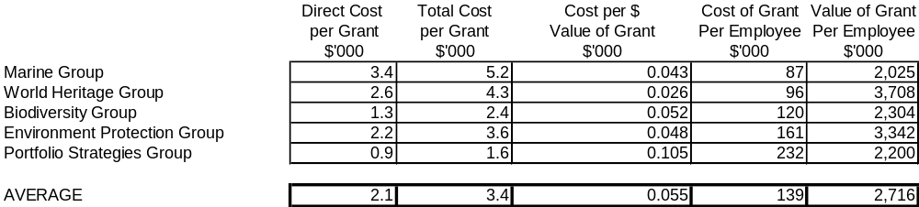Table 4.3 – Benchmarking Results by Group (using data from Tables 4.1 and 4.2)

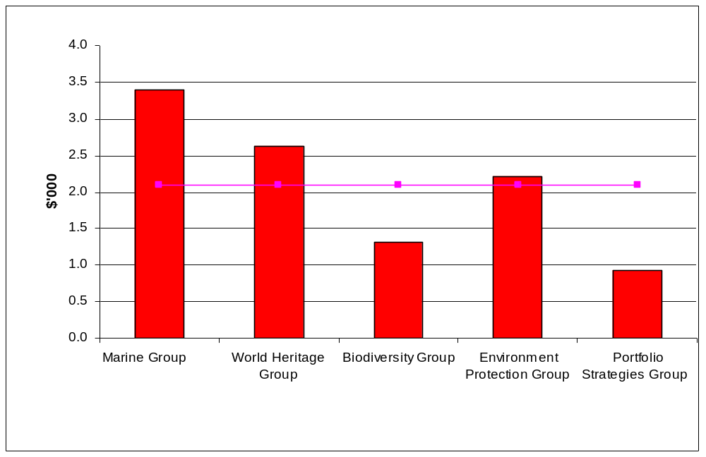
Chart 4.1 – Direct Cost per Grant (from Table 4.3)
(average)

average

This chart shows, for each group, the direct cost incurred that is attributable to each grant:
ie. | Direct Costs
 | Number of Grants
This shows that the Marine Group and Australian and World Heritage Group are above average and Biodiversity Group and Portfolio Strategies Group are below average for this measure.

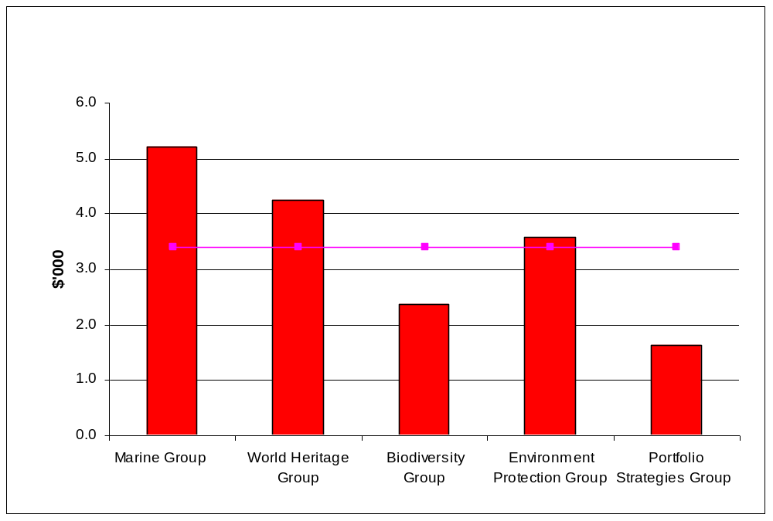
Chart 4.2 – Total Cost per Grant (from Table 4.3)
(average)

average

This chart shows for each group the total cost incurred that is attributable to each grant:
ie. | Total Costs
 | Number of Grants
This compares how much it costs to administer each grant across all groups.
Similar to Chart 4.1 the result reveals that Marine Group and Australian and World Heritage Group are above average and Biodiversity Group and Portfolio Strategies Group are below average for this measure.

Chart 4.3 – Cost per $ Value of Grant (from Table 4.3)
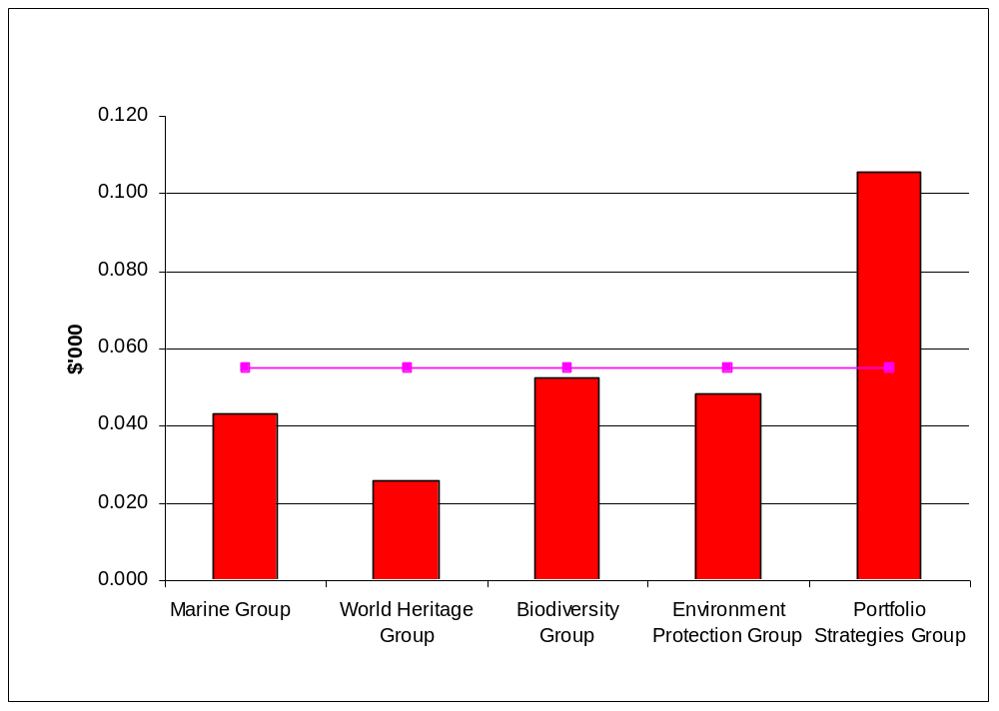

average

This chart measures the cost of each grant compared to the total monetary value of the grant:
ie. | Total Costs
 | Total Value of Grant
For each group this compares how much it costs for each dollar of grant that is ultimately forwarded to a third party.
The Portfolio Strategies Group is well above average compared to the other groups for this measure. This suggests that for every dollar of grant which is given to organisations it is costing this group considerably more.

Chart 4.4 – Cost of Grant per Employee (from Table 4.3)
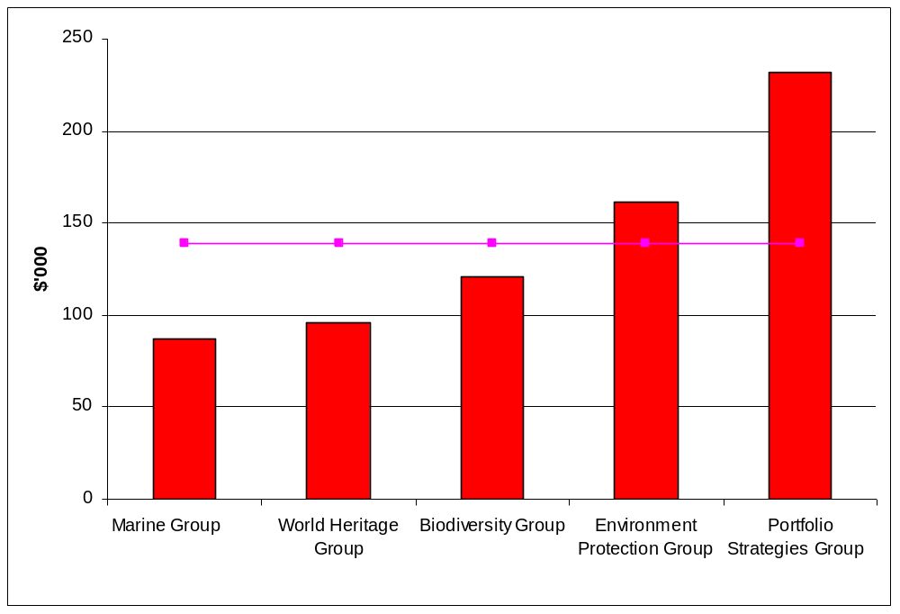

average

This chart measures the total cost of administering each grant for each employee responsible for administering the grant:
ie. | Total Cost
 | Number of Employees
For each group this compares, for each employee, the total cost of administering individual grants.
Portfolio Strategies Group is above average and to a lesser extent Environment Protection Group. All other groups are below average.

Chart 4.5 – Value of Grant per Employee (from Table 4.3)
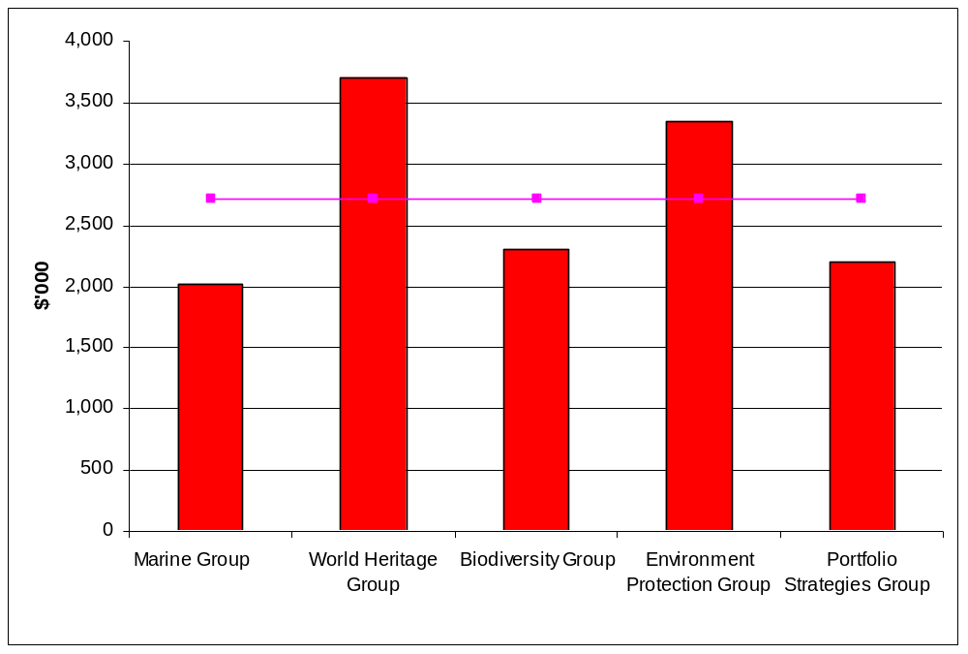

average

This chart measures the total value of the grant for each employee responsible for administering the grant:

ie. | Total Value of Grant
 | Number of Employees
For each group this compares (for each employee) the total value of grants being processed and ultimately forwarded to a third party.
Australian and World Heritage Group and Environment Protection Group rate best for this measure as they are able to administer more dollars of grants per employee that the other groups which are below the average.

Interpretation of Results

Overview of 1.2 Grant Administration
The total budgeted price to be paid by Government for Output Group 1.2 is $18.461m in 1999-2000. This is comprised of Grant Administration ($11.110m – including $4.213m of actual grant funds), $6.863m of Program Administration funds and $0.427m for Schemes. The remaining difference of $61,000 is due to some reclassification of costs both into and out of this part of the output. A full reconciliation table can be found at Appendix 1.
As a result of this pricing review the price for outputs by the Department has been adjusted further to account for a disproportionate allocation of corporate overheads. This has arisen from two factors. Firstly the allocation of corporate costs to outputs included amounts for AGO, Parks and AHC which overstated total corporate allocations by $6.591m or 17.4%. Secondly, some of the internal allocations by the groups of overheads to outputs was incorrect and adjustments have subsequently been made to more correctly reflect the true cost of outputs. None of these adjustments reduces the overall corporate costs for the Department. They merely attempt to classify the costs more appropriately against outputs. A reconciliation table of these adjustments can be found at Appendix 2.
The total cost of grant administration is $6.098m for 1999-2000. This compares with the budgeted amount of $6.897m in 1999-00. This figure comprises the relevant sub outputs within Output 1.2. The major providers of Grant Administration services are the Marine Group (price $1.297m); Australian and World Heritage Group (price $1.042m) and Biodiversity Group (price $3.535m).
The other two providers are relatively minor, being Environment Protection Group (price $0.050m) and Portfolio Strategies Group (price $0.174m).
The total value of grant payments budgeted for payment in 1999-00 is $140.7m.

Analysis of internal benchmark comparisons
Whilst caution is required when making comparisons between the outputs of differing providers, some broad observations are possible.
Total cost per grant payment made varies from a low of $1,600 per grant (Portfolio Strategies Group) to a high of $5,200 per grant (Marine Group). The average across all groups was $3,400.
The cost as a percentage of the value of the grants varied from a low of 2.6% (Australian and World Heritage Group) to a high of 10.5% (Portfolio Strategies Group). The average across all groups was 5.5%.
The cost per employee of administering grants varied from a low of $87,000 (Marine Group) to a high of $232,000 (Portfolio Strategies Group). The average for all groups was $139,000.
Australian and World Heritage Group was able to administer the most amount of grant money per employee ($3.708m) and Marine Group the least ($2.025m worth of grants per employee). The average was $2.716m per employee.
Some groups have indicated that the data used to produce these results have been based on preliminary estimates stemming from their actual performance to date and there may be some improvement in the results come year end once actual data is known.
Overall, direct costs accounted for $3.590m (59%) of the total price, whilst indirect and corporate costs accounted for $2.508m (41%) of the total price.
Note: The data for Marine Group was based on grants processed to the end of November 1999.

Performance Improvement Opportunities – Grant Administration
These comparisons suggest that there is scope for improvement in some of the groups. For instance if all groups whose individual average could be reduced to the group average then the results would potentially be as follows:
- Chart 4.1 Results
The direct cost per grant for Marine Group and Australian and World Heritage Group is $3,400 and $2,600 respectively. The group average is $2,100 per grant.
If the direct cost per grant for each of these groups were to reduce to the average for all groups reductions in the order of $1,300 per grant for Marine Group and $500 per grant would be possible. This equates to $0.324m and $0.123m for each respective group.
- Chart 4.2 Results
The total cost per grant for Marine Group and Australian and World Heritage Group is $5,200 and $4,300 respectively. The group average is $3,400 per grant.
As Marine Group currently exceeds the average cost by $1,800 per grant and issues 249 grants potential savings of $0.448m could be achievable. Similarly Australian and World Heritage Group exceeds the average cost by $900 per grant and issues 245 grants. This equates to $0.221m.

- Chart 4.3 Results
Portfolio Strategies Group’s current cost per value of grant is 10.5%. If this were to reduce to the average of 5.5% then improvements of $0.081m could potentially be considered.
- Chart 4.4 Results
Portfolio Strategies’ costs are above average and improvement to the tune of $0.088m would see them equivalent to the average.
However, even if such a performance improvement is possible in theory, there may have to be significant changes in grant assessment and approval procedures to achieve such a level. For example, grant procedures may have to be critically reviewed to group more grant payments or streamline the process further to seek additional improvement.
The costs associated with grant proposal assessment can often be considerably higher than administered grants. Another factor that drives price for the Biodiversity Group is the individual assessment and the Ministerial approval process for each project. These areas will need to be considered further when revising the cost allocations and determining the price of outputs.

Results (Output Group 1.7) Research and Assessments
The following table provides information on research and assessments for internal benchmarking purposes. The total price paid for this output group is $13.715m which is comprised of $7.926m direct costs and $5.789m in overheads. The products in this output group varied considerably which made it difficult to provide worthwhile internal benchmark measures. However it is considered that appropriate external benchmark comparisons could be found from similar external organisations. Also a process of market testing could be undertaken to determine the appropriateness of the price of this output group.

Table 4.4 – Total Costs by Group
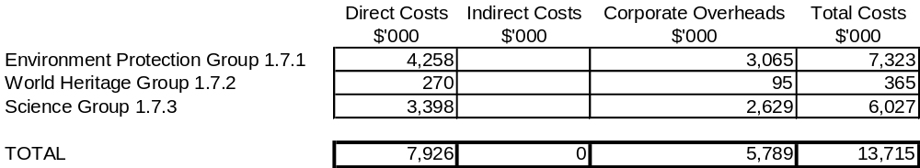

Interpretation of Results

Overview of 1.7 – Research and Assessments
The total budgeted price to be paid for this sub-output in 1999-00 according to the PBS is $13.715m. The price includes an allocation of corporate overheads of $5.789m. For a reconciliation of this output group refer to Appendix 1.
The groups providing this service are the Environment Protection group, World Heritage Group and Science Group, with contributions to this sub-output coming from the Environmental Research Institute of the Supervising Scientist (ERISS) and the Office of the Supervising Scientist.

Analysis of Performance
No internal benchmark information is currently available for this sub-output. The specialist nature of the work makes benchmarking difficult, although some external benchmarks may be possible with organisations such as ANSTO Environmental Science Division.
Cost assessment and market-testing provide more meaningful analysis for this output group. For cost assessment, there are two areas of primary interest:
- Many of the support functions are undertaken locally at ERISS. The ratio of direct versus indirect cost appears favourable. The Corporate Overhead figure appears high as head office corporate services do not provide range of support functions to ERISS. As these functions are being duplicated at both local and central level, additional unnecessary costs are being incurred.
- A decision has been taken to relocate ERISS from Jabiru to Darwin. This would be likely to reduce operating costs at ERISS, which are currently higher than normal due to the extra allowances, etc, necessary to keep staff in a remote location.
No contestable suppliers of equivalent services were identified by Science Group for market-testing purposes. However, once any revisions to the output price resulting from overhead reduction and relocation have been completed, it is recommended that a market testing study be set up for research and assessment services.
The total set of environmental impact assessment functions undertaken by the Department (EPG) is not directly comparable to other organisations in either the Commonwealth or State Governments or in the private sector. Some functions may be able to be benchmarked with State agencies with similar environmental and/or planning approval responsibilities and others may be benchmarked in the future with Commonwealth agencies with non-environmental assessment functions, such as AQIS. Preparation of formal assessment reports could be benchmarked with private sector consultants (however no jurisdiction uses private consultants to prepare such assessment reports at present) and this represents only one element of the total process of administering the relevant legislation, which also requires management of project proponents through a chain of statutory processes, providing public information on assessments, providing advice to prospective proponents and advising the Minister.

Performance Improvement Opportunities
No internal benchmark information is currently available for this sub-output. It is considered that cost assessment and market-testing will provide more meaningful analysis for this output group. It is recommended that a market testing study be set up for research and assessment services.

The Government's new environmental legislation - the Environment Protection and Biodiversity Conservation Act - comes into effect in July 2000. The change in processes required by the new Act provides opportunities to pursue efficiencies and best practice while at the same time imposing significant new requirements and functions on the Department. The Department is pursuing performance improvements through the introduction of new technologies for project management, work tracking and document management and the development of a new range of performance indicators relevant to the requirements of the new legislation. Further opportunities to benchmark components of the new system will arise once these performance indicators are in place.

Corporate Services Overheads

Overview
Corporate Services cost allocations to groups form a substantial proportion of the total cost of outputs produced.
Any cost assessment of outputs must include the “reasonableness” of the corporate costs of the organisation.
This section benchmarks Environment Australia’s total corporate costs against those of similar Commonwealth organisations.
A further breakdown of corporate costs into major sub-categories is being developed by the Department for lower level benchmarking against other similar organisations. The categories are:
- Finance;
- HR;
- IT;
- Accommodation;
- Ministerials;
- Travel;
- Internal Audit; and
- Comcover.
This will enable the Department to identify any particular areas where corporate costs exceed the peer group average.

Corporate Services – Commonwealth Agency benchmarking information
The following tables are based on corporate benchmark information gathered as a result of previous studies of Corporate Services in the Environment Australia. Findings are drawn for each table.

Data collection note

Some Agencies have agreed to provide benchmark data but have been unable to supply verified data within the require timeframe. Other Agencies have supplied data but have requested that it not be directly sourced to them, whilst others have requested not to be named as participating in the survey, although they have been happy for their data to be used anonymously.

Table 5.1 – Records Management
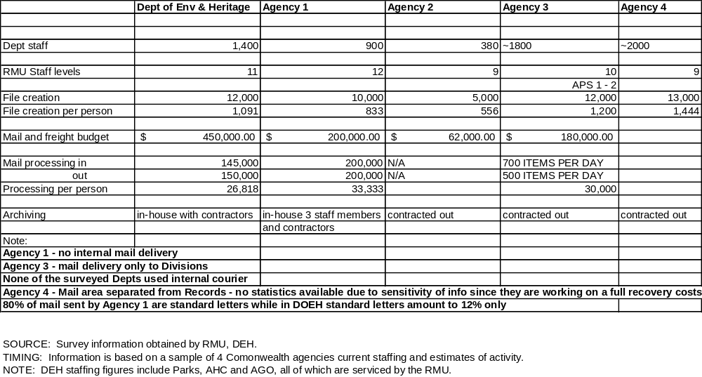

Findings
This table demonstrates that, in general terms Environment Australia is comparable with the other Government Agencies.
However, there are opportunities for savings from the mail and freight budget and from reduction of workload (eg. reducing and streamlining file creation). Opportunities for savings lie in sending less and specifically in sending fewer non-standard articles and fewer overnight deliveries rather than in reduced charges. Currently only 12% of mail is standard, compared to 80% in some other departments.
Any streamlining of file creation will have to take account the requirements of the National Archives of Australia requirements to implement AAA Keyword Thesaurus and the departmental Functional Thesaurus.
Source – Corporate Relations and Information Branch.

Table 5.2 – Human Resource Management
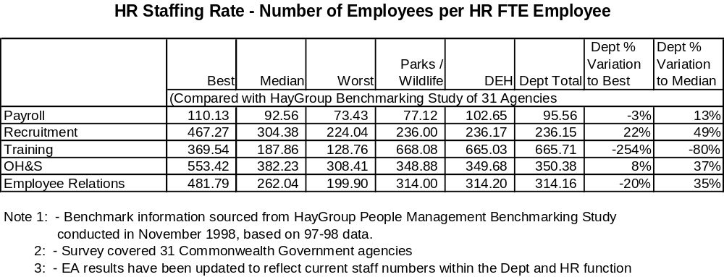

Findings
The following findings are drawn from Table 5.2 information:
 | Agency staff per payroll staff: | near median (3% higher than median; 13% lower than best)
 | Agency staff per recruitment staff: | near lowest (22% lower than median; 50% lower than best)
 | Agency staff per OH&S: | near median (8% lower than median; 37% lower than best)
 | Agency staff per employee relations: | better than median (20% higher than median; 35% lower than best)
This information suggests that Environment Australia is broadly comparable overall with other Government Agencies. However there are opportunities to reduce cost in the recruitment process.
For Environment Australia to reach the best performers, in terms of recruitment, payroll, OH&S and employee relations, gains of 13% to 50% could be expected.

Table 5.3 – Ministerial Services Activity
Agencies | No. of Staff | Av. No. of Ministerials & Campaigns Per Year | % Responded To | Ministerials Processed Per FTE
A | 3 | 5,000 | 69% | 1,667
B | 5 | 9,000 | 47% | 1,800
C  | 4.5 | 9,000 |  | 2,000
D | 6 | 12,000 |  | 2,000
E | 10 | 23,000 | 80% | 2,300
DOEH | 4 | 17,000 | 73% | 4,250
G  | 8 | 39,000 | 65% | 4,875
H | 4 | 25,000 | 40% | 6,250
I | 1.5 | 12,000 | 80% | 8,000
TOTAL | 46 | 151,000 |  | 3,283
Responses are based on current staff and estimates of annual activity. This data has been collected from 9 Commonwealth Agencies including DTRS, AFFA, DISR, FaCS, Treasury and AG’.
 % Responded to does not include campaign correspondence
 No figures available for campaign correspondence

Findings
Environment Australia compares well overall but there may be some opportunity for savings if operations can be more closely aligned with the best performers.
Ministerials per staff member in the Ministerials coordination area is 29% better than average, but 47% lower than the best, out of a group of nine Departments.

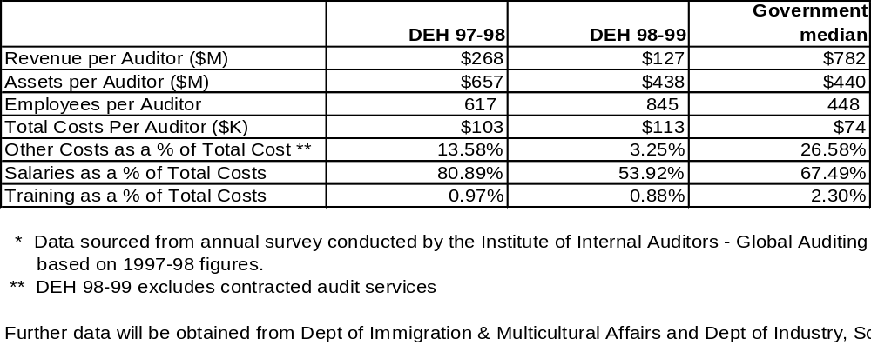Table 5.4 – Internal Audit Activity

Findings
Compared to other Australian Government agencies surveyed the Environment Australia results were:
 | Agency revenue per auditor: | 84% lower than average ($127m for DoEH compared with $782m)
 | Agency assets per auditor: | 1% lower than average ($438m for DoEH compared with $440m)
 | Employees per auditor: | 89% higher than average (845 for DoEH compared with 448)

There are a number of factors which influence the results including a distortion in revenue caused by revenue being received in the NHT trust fund in one year but not being expended until the next year. Other factors that need to be considered include the level of risks that need to be addressed through the internal audit function. Notwithstanding this there appears to be opportunities for savings in the internal audit function when compared to other organisations.

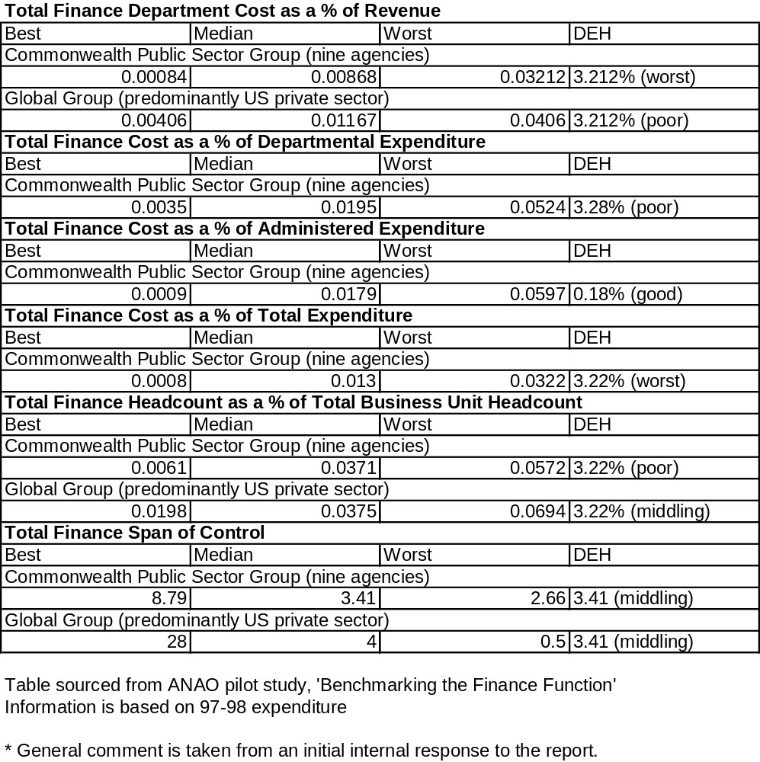Table 5.5 – Financial Services Activities
Note: By and large the department rates fairly poorly, however we believe the base data may be flawed to an extent that might have materially affected the results. The cost comparisons have been made against the Department’s budget, however the finance function services a number of external bodies being the Australian Greenhouse Office, the Australian Heritage Commission and Parks Australia (which also has remote areas and associated inefficiencies with payroll processing). We will be working with the Australian National Audit Office to neutralise these abnormalities in the next stage. (Source - Departmental comment on initial benchmarking data.)

Findings
This data indicates that Environment Australia rates poorly overall when compared to the group of nine agencies. The table above indicates the differing ratings (from middling to worst) across the various categories.
It is clear that a detailed examination could be undertaken to realise improvements across the financial services operations. Comparable data should be obtained from additional surveys currently being undertaken, eg. the DOFA survey.
One of the options for achieving savings in the Finance Branch budget is rental costs. Every effort should be made to dispose of surplus rental space in a cost effective manner.

Corporate Services – External Benchmarking information
External benchmarks, where available, provide the most objective assessment as to the “reasonableness” of the output prices offered by the Department.
The following external benchmark comparisons have been sourced from “Corporate Benchmark Monitor” 1999. A publication by William M. Mercer Cullen Egan Dell Ltd. This study gathered data from several hundred organisations across several industries. For the purpose of this comparison we have chosen a private sector industry (Finance/Insurance) and the Public Sector participants to compare against. Further information on this benchmark study can be obtained from email customerservice@ced.com.au.

Table 5.6 – Percentage of Staff to Total Staff
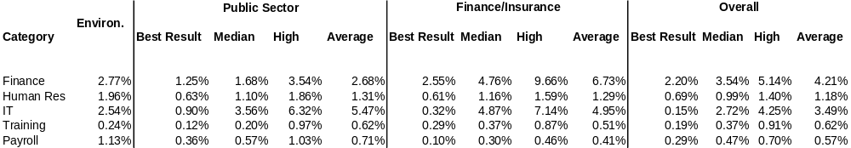

This table is included as a reference for the Charts 5.1 to 5.5 in the following parts of this Section. The table measures, for each category, the number of staff compared to total staff.
Charts 5.1 to 5.5 provide comparisons for corporate overheads against the public sector, finance/insurance sector, and the global results (which includes six sectors).

Chart 5.1 – Finance Staff as a Percentage of Total Staff
Chart 5.1 – Finance Staff as a Percentage of Total Staff
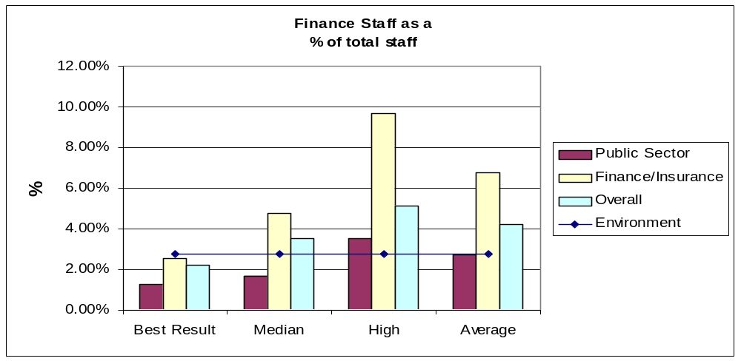

Public Sector
Finance/insurance
Overall
Environment

Overall these results suggest that the total finance staff as a percentage of total staff is fairly consistent with the average, particularly for the public sector.
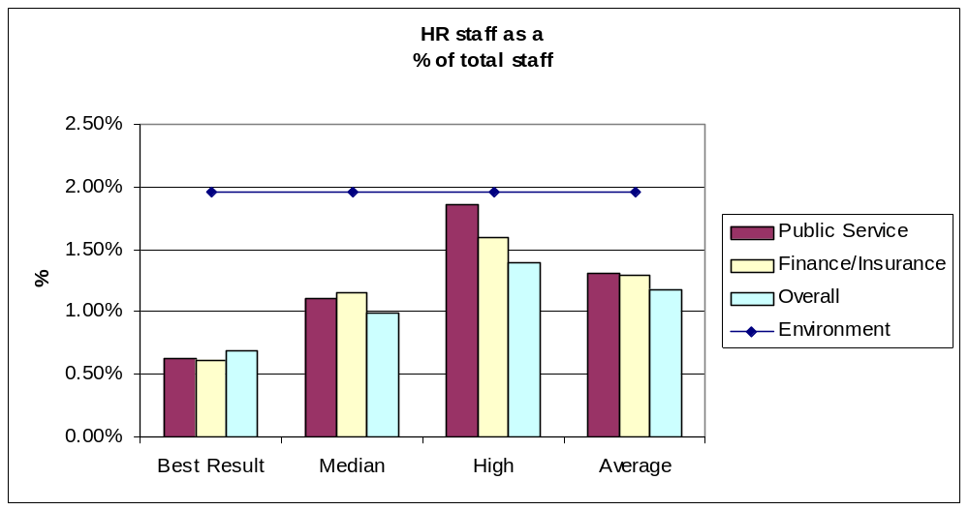
Chart 5.2 – HR staff as a Percentage of Total Staff
Public Sector
Finance/insurance
Overall
Environment

The number of staff in the Human Resource area is well above average for all the sectors which would suggest there is scope for improvement in this area.

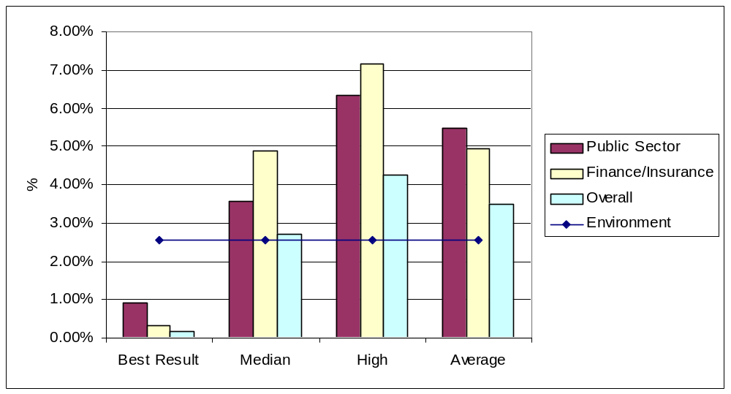Chart 5.3 – Information Technology staff as a Percentage of Total Staff
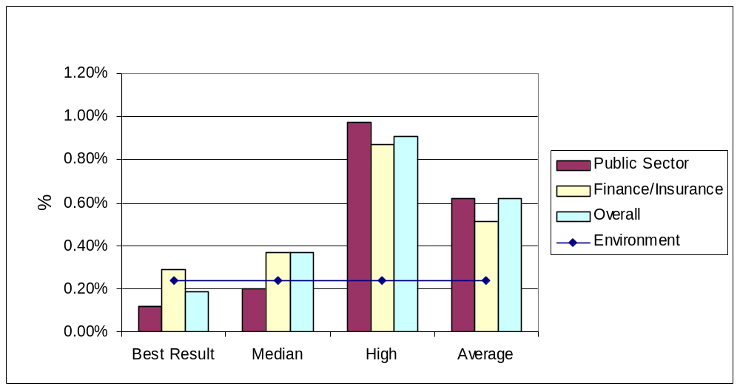Apart from the best results in each of the sectors the results show that the Department is exhibiting better performance when compared to the other categories.

Chart 5.4 – Training staff as a Percentage of Total Staff
The Department rates very well compared to the benchmarking results for training staff.
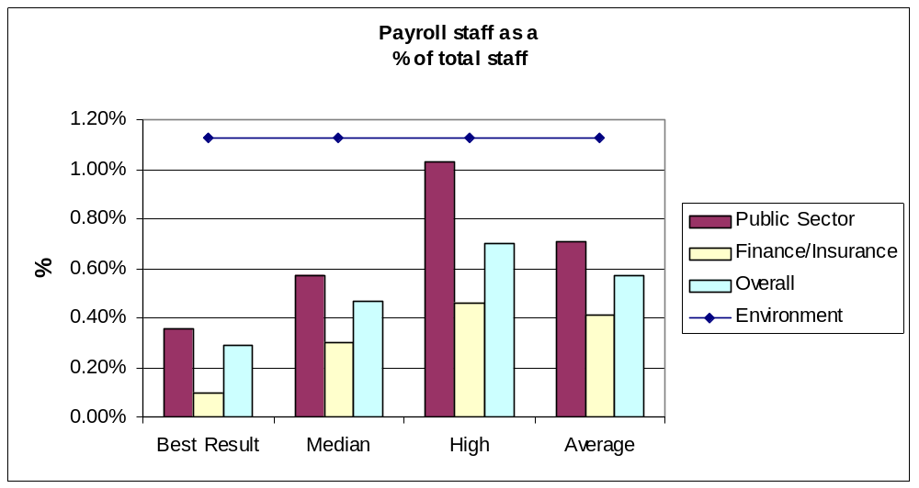
Chart 5.5 – Payroll staff as a Percentage of Total Staff

The Department is well above average compared to all sectors in the number of payroll staff to total staff.

Table 5.7 - $ Budget per employee
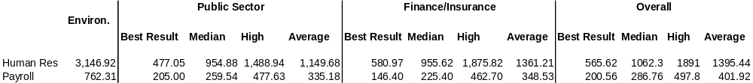

This table is included as a reference for Charts 5.6 and 5.7 in the following parts of this Section. The table measures the budget for each of the HR functions and the Payroll functions by employees.
Note: DOEH HR costs include a number of large items administered on behalf of the Department which are not strictly part of the HR function. These total $1.78m and include GAA costs, Comcare premium, IT outsourcing project, removal costs, SAP repayment and employee expenses, such as eyesight testing, financial counselling and Employee Assistance Program.

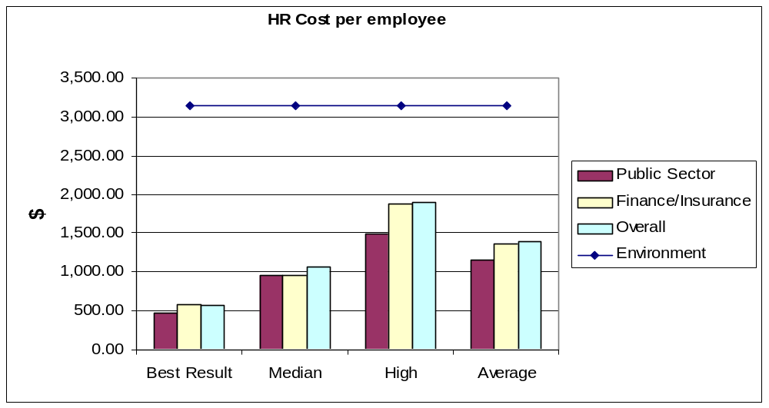
Chart 5.6 – HR costs per employee

The cost per employee is considerably higher than the other comparative sectors suggesting that there is certainly scope for improvement in this function.

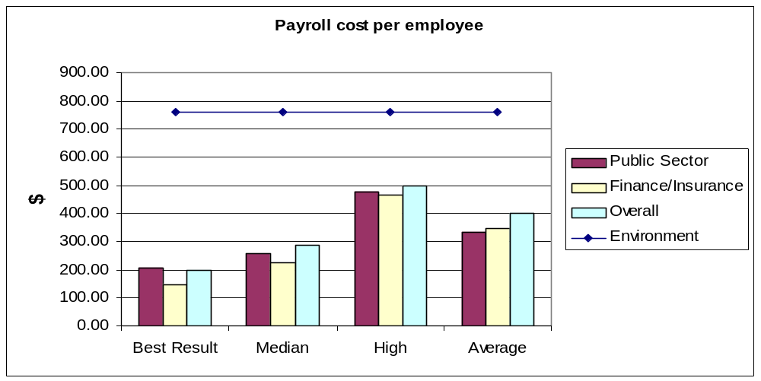
Chart 5.7 – Payroll costs per employee

This result demonstrates also that the payroll cost per employee is well above the comparative benchmark sectors.

Performance Improvement Opportunities
Based on the external benchmark comparative information there are potential areas for improvement in the corporate overhead costs, particularly in the Human Resource and payroll areas of the Department.
For instance if the HR and payroll areas were to reduce their costs per employee to the benchmark average there would be potential savings of $2.596m and $0.555m respectively. If best practice is sought the savings would be even greater at $3.471m and $0.725m.
However, the benchmark comparative information is only broadly indicative of possible savings as the Department has included costs in the order of $1.78m for items which may not be included in the benchmark comparisons (see footnote page 32). The level of potential savings therefore need to be confirmed through market testing.
As more Output Price Reviews are conducted, it is likely that additional external benchmarks will become available.

Other issues concerning Corporate Overheads

Appropriateness of allocative base
Corporate overheads are allocated to Groups on the basis of ASL. Groups then allocate the corporate overhead to sub-outputs, using their own preferred methodology – usually ASL or direct dollar cost.
During the review process, Groups have been asked to indicate whether the allocation process resulted in a fair and reasonable distribution of corporate overhead to Groups, outputs and sub-outputs.
Two main issues arise from the overhead allocation methodology:
- Ensuring that any corporate service cost incurred for a specific group is charged to that group directly, rather than being allocated across all groups
- Identifying duplication of services at central and group levels. For example, accommodation costs paid locally by a remotely located group, whilst being allocated a share of the corporate accommodation charge which is not being used by the group.

External Benchmarking for other Outputs 1.2 and 1.7
The level of external benchmarking available for outputs other than the corporate services activities was scarce, given the time available to prepare data. However, the following information has been provided (6.1 and 6.2) and is included to provide indicative material currently available or being sought. We have also indicated at 6.3 a list of the external benchmarking Partners being sought by the Department to enhance this data.

Output 1.2.1 Tax Concession administration
Comparison between the Register of Environmental Organisations administered by Department of the Environment and Heritage and the Register of Cultural Organisations administered by the Department of Communications, Information Technology and the Arts:

Table 6.1 – Resource Comparisons between REO and RCO
Financial Year | REO  Total Donations | RCO  Total Donations | REO  Total No of Org.s | RCO  Total No of Org.s | REO  ASL | RCO  ASL | REO  Increase in Org.s | RCO  Increase in Org.s
1993/94 | $4 265 965. | $8 266 745.00 | 65 | 436 | 1.0 (est) |  | 35 | 73
1994/95 | $5 906 114.00 | $11 000 882.00 | 81 | 471 | 1.0 (est) |  | 16 | 40
1995/96 | $10 054 817.40 | $14 593 224.00 | 120 | 555 | 1.0 (est) |  | 39 | 131
1996/97 | $11 245 516.13 | $14 114 363.00 | 141 | 619 | 1.0 (est) |  | 21 | 98
1997/98 | $15 801 190.66 | $15 117 664.00 | 156 | 673 | 1.0 (est) |  | 15 | 80
1998/99 | $22 000 000.0+ | $14 182 377.0+ | 177 | 732 | 1.1 | 2.7 | 21 | 96

1998/99 Cost of ASL used for listing of an Organisation onto the Registers

 | ASL | Increase in Org.s | ASL used per listing
REO | 1.1 | 21 | 0.052
RCO | 2.7 | 96 | 0.028

The RCO (Register of Cultural Organisations) has been in operation for a longer period than the REO Register of Environmental Organisations). The RCO was able to generate over $8 million in donations in 1993-94 which was almost twice the amount generated through the REO. Donations increased more rapidly through REO and by 1997-98 REO donations exceeded those contributed through RCO and, by 1998-99 donations through REO had almost doubled those through RCO.
The RCO used about 2.4 times the ASL of REO (2.7 ASL compared to 1.1 for REO) and in most years RCO would list more than 2.4 times the number of organisations.
Organisations listed on the REO appear to be larger with the ability to consistently generate more donations through REO than is possible at present through RCO.
The following charts reflect trends in donation and entries associated with these Registers.

Chart 6.1 – Donations given to each Register
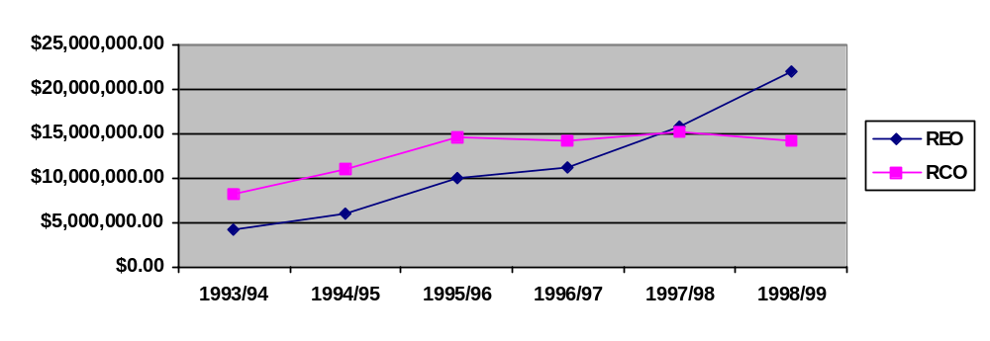

Chart 6.2 – Entries to the Registers
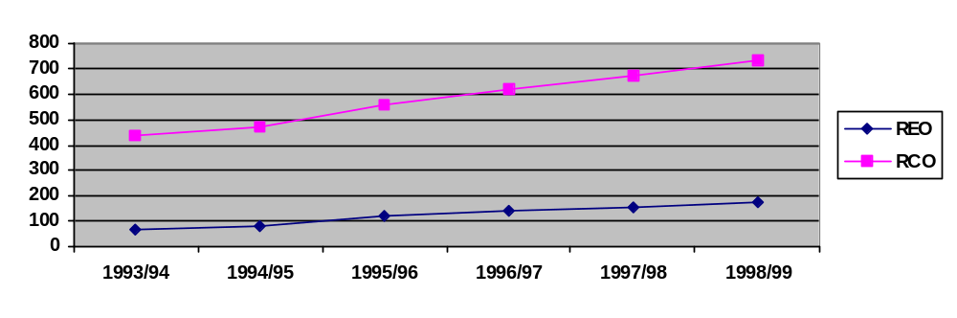

Outputs 1.2.3: Grants to Voluntary Environment and Heritage Organisations – Review of prices

Grants to Voluntary Environment and Heritage Organisations
The Queensland Department of Environment operates a program of Grants to Non-Government Conservation Organisations (NGCO) which bears some similarities to the GVEHO program. Both programs provide grants to voluntary conservation organisations, eligibility criteria for funding is similar between the two programs and both programs provide funding to assist the organisations with their administrative costs (although the QLD program also provides some funding for the organisations to undertake specific projects).
A comparison of the estimated operating costs of the two programs is set out below:
 | GVEHO |  |  | NGCO
Funds and Activities
Total funds 1999-2000 | $1.65 mill |  |  | $120,000
Number of applications | 175 |  |  | (n a)
Organisations funded | 106 |  |  | 25 (est)
Administrative Costs
Direct admin costs (Est) | $99,000 |  |  | $8 ,000
Corporate support costs (Est) | $90,000 |  |  | $12,000
Total admin costs | $189,000 |  |  | $20,000
Note: The assessment of GVEHO applications is more comprehensive than for the NGCO and would require more resources.

Comparison between costs of administration of both programs
Indicators | GVEHO |  | NGCO
Cost per application | $1,783 |  | $800
Admin costs as per cent of total program funds | 11.45% |  | 16.67%

The cost of processing each application through the GVEHO program is estimated at $1,783, compared to $800 for the NGCO. The level of funds allocated through the NGCO is much smaller than that available for allocation through the GVEHO and the total estimated cost of administration of the GVEHO program as a percentage of the total funds allocated is 11.45% compared to 16.67% for the NGCO.

External Benchmarking Partners
This section lists potential external benchmarking counterparts specifically identified by Groups for each sub-output. It is proposed that these benchmarking suggestions be followed up with the relevant organisations, with the aim of establishing objective external benchmarks where appropriate for the 2000-01 budget year.
Sub-output Number | Description | Group | Benchmark
1.2.1 | Tax Concession Administration | PSG | DoCITA – Cultural Tax Register
1.2.2 | ERO Scheme | PSG | Natural Heritage Trust –State and Territory Program Facilitators
1.2.3 | Grants to Voluntary Environment and Heritage Organisations | PSG | Qld Department of Environment – Grants to Non-Govt Conservation Orgns
1.2.4 | International Conservation Program | PSG | AusAID – Government Sector Linkages Program with Indonesia
1.2.5 | Environment protection grants and programs | EPG | AFFA, BRS, ABS – chemicals program administration
1.2.6 | Provision of Grants- Australian Heritage | AWHG | DoCITA – Federation Fund grants
1.2.7 | Biodiversity Grants Program and Program Admin | BG | AFFA – NHT schemes
1.2.8 | World Heritage funding to the States | AWHG | To be identified.
1.2.9 | Program Admin – Reserves systems; Wetlands; NHT; Reg Land use | BG | AFFA NHT schemes
1.2.10 | Marine and Coastal Grants Programs | MG | AFFA – NHT schemes
1.2.11 | Administer Historic Shipwreck Grants | AWHG | State and Territory heritage agencies
1.7.1 | Environment Protection Assessments and Research | EPG | NOHSC & TGA – chemicals;  AQIS & GBRMPA – environment
1.7.2 | World Heritage assessments and nominations | AWHG | To be identified.
1.7.3 | Research and Assessments | Science Group | ANSTO – Environmental science division

Qualifications

Output definitions
It is recognised that at the time of compiling the 1999-2000 Budget agencies were faced with the difficult task of defining an output structure and costing those outputs, often in very short time periods. However the following observations about the output structure and definitions for the Environment Australia should be noted.
Outcome 1 for the Department is comprised of 7 output groups which in turn have 58 separate outputs. This review focussed only on two output groups made up of 14 outputs. The existing output structure is far too complex and confusing. Indeed many of the outputs seem to be more in the nature of activities and functions rather than actual outputs. The level and complexity of the output structure would suggest an inordinate amount of time and resources would be required to attribute budgeted costs and then to report throughout the year on achievement of outputs in terms of quantity, quality, timeliness and cost.
Many of the existing output definitions are unclear and some output groups have intermingled outputs of different natures. This makes output pricing comparisons and benchmarking difficult. An example of this is in output group 2 where program administration should be clearly separated from grant administration. There was also an intermingling of departmental and administered costs. For instance some of the grants money paid to organisations was incorrectly shown as a departmental cost of output instead of an administered expense.
Some outputs or components of outputs have been included in the wrong output group. During the review several adjustments had to be made to move some costs out of output group 1.2 because they were considered to be better classified elsewhere. This has the effect of overstating the cost of certain outputs and understating the cost of others which again makes benchmarking and comparisons difficult.
No provision has been made in the output structure for services provided to other agencies on a fee for service basis. Instead these costs have been attributed across all outputs resulting in an over attribution of corporate services costs to outputs and overpricing of final outputs

Issues of remoteness
The remote site location of Science Group in Jabiru NT (close to uranium mine being monitored) will make scientific research and assessment expensive compared with major city laboratory locations. This is principally due to the necessary requirement to carry out various support functions locally that normally could be arranged centrally. Central overhead allocation should be checked to ensure that corporate charges are not being levied for services that are not available to the Jabiru location.

Distortions caused by overhead allocations
Total corporate overhead costs for the Department have been overstated for the 1999-2000 Budget by $6.591 m as a result of the particular way of treating the budget being held centrally by Corporate Services for the Australian Greenhouse Office ($0.391m), Parks ($4.2m) and the AHC ($2.0m). This in turn has resulted in the cost of all outputs being overstated by 17.4% due to the attribution of these costs to Environment outputs. This needs to be remedied to overcome the distortion effect on the price of outputs.
The Department provides corporate support and central services in varying degrees to Environment Australia, Parks, Heritage Commission, Greenhouse Office, Bureau of Meteorology and Antarctic Division. At the moment the total overheads of $37.9million are attributed across Environment Australia outputs only as there is no facility within the output or appropriation structure to show the costs of services provided to external outputs. Assuming the attribution rules are correct, the effect of this is to:

- overstate EA’s outputs cost;
- understate Parks and AHC outputs cost as corporate overhead funds have been transferred to the Department and, as such, are no longer shown as part of their appropriations; and
- show that AGO’s output cost are correct as they pay the Department for services out of their appropriation, but still inflates EA’s output cost as there is no facility to separate the external service provision.
- services provided to BoM and AAD are minor and would not have a material effect on the price of the Department’s outputs.

The cost of servicing Parks, AHC and AGO needs to be extracted from EA’s output cost. In the case of Parks and AHC, the overhead cost needs to be added to their output costs to show the true total cost of outputs.

Marginal Cost

In 1997-98 resources were transferred from the AHC and Parks to the Department to cover the marginal cost of providing their corporate support. AGO have a memorandum of understanding with the Department where they also pay the marginal cost of providing a limited range of corporate support. Under this arrangement corporate overheads attributed to the Department’s outputs are currently overstated by 17.4%.

The business rationale for maintaining this arrangement is that it is based on an arms length agreement and there is no financial penalty to the Department from providing this service. (The Department retains the same infrastructure or base costs regardless of whether it services additional agencies.) Moreover, there is a commercial advantage to the user organisations (and thus to the Government as a whole) as they may obtain their services more cost effectively than they could provide in-house. However, due to the reporting arrangements for external revenue, which cannot be netted off the corporate support costs, there is an apparent cost penalty to Departmental outputs, which receive a share of the full support costs (including those incurred on behalf of the AGO, AHC and Parks).

Full Cost

If the full rather than marginal cost of support was attributed across all agencies, there would be a 30% decrease in the corporate overheads attributed to the Department’s outputs.

The rationale for full cost sharing would be that the Department is indirectly subsidising the other agencies by covering all base costs within its outputs. If the 4 agencies were starting together from scratch it wouldn’t be unreasonable to expect all to fund the base costs.

All corporate costs are allocated initially by Corporate Services to organisational groups and then by the groups across the outputs. This has been done in the most part by average staffing levels (ASL). Some groups have taken the opportunity to revise their allocation of corporate costs across the outputs. This was done as the original allocation gave a disproportionate amount to some of the outputs. This has not changed the total amount of corporate costs but merely reapportioned them across different outputs. This has subsequently had some impact on the current price for individual outputs.
The benchmarking study undertaken by the ANAO and the Corporate Benchmark Monitor published by William M. Mercer Cullen Egan Dell Ltd has revealed areas of relative inefficiency for DOEH corporate functions. If savings in those areas specifically identified as costing more than the average benchmark comparison are pursued and ultimately achieved, this would flow on to potentially lower output prices.

Conclusions

Inefficiencies
The results of the internal benchmarking comparisons suggest there may be potential inefficiencies or different work practices between the groups leading to less efficient results for some groups.
The external benchmarking information for the corporate services functions certainly demonstrates that there is considerable room for improvement in some of the functions currently undertaken as central corporate functions. In particular the comparisons are demonstrated in Sections 6 and 8 of this Report.
The accommodation costs for the Department currently amounts to approximately $9.5m per annum. The Department currently pays for a significant proportion of accommodation related to the NCH premises. A large proportion of this space is vacant and has been so
since February 1999 when the Department moved into John Gorton Building. The Department has been unable to extricate themselves from the lease or sub-let it, so as a result are stuck paying rent for empty space until the lease expires in September 2001. This is costing approximately $1.456m per annum to service this excess lease space.

Savings
There are several areas for potential savings resulting from the findings in this review.
The results of individual internal benchmarking comparisons for grant administration costs suggests that savings ranging from $0.6m to $0.8m could be possible if the average cost of the comparative results were reduced back to the average for the group.
It was difficult to gain benchmarking data on the remaining costs of output group 1.2 and 1.7 but it is considered that a process of service contestability and further efforts to provide benchmark comparisons will also suggest potential for further savings.
The Corporate Services functions that are performing less than selected benchmark comparisons include Records Management, Human Resource Management, Ministerials, Internal Audit and Finance. The external benchmark data sourced from Mercer Cullen Egan Dell reinforced these findings particularly in the payroll and human resource functions. Cost saving opportunities ranging from $3m to $5m.
There are also potential savings resulting from relocating ERISS to Darwin but these savings would not be evident until year two as the cost of relocation would be significant enough to erode all savings in the first year.

Outsourcing Options
IT outsourcing is currently being evaluated as a possible future occurrence and will eventuate in due course.
Groups are continuing to explore possibilities for alternative outsource providers.
Where no benchmark data is readily available to test the cost effectiveness of outputs it is proposed to conduct some market testing which will aim to identify feasible outsource providers

Redefine Outputs
In our view there is a need for Environment to simplify and rationalise the current output structure. The Department has 3 outcomes and 66 outputs. Many of the outputs appear to replicate other outputs and differ only in who performs them. Policy advice is one such example. Instead of the eight policy advice outputs listed in 1.1, (separated by each policy provider) these could be combined into a single output. By doing so, this would simplify costing and future reporting and accountability for the organisation.
Some outputs appear more in the nature of an activity or function than an output (e.g. Participation in international issues). In this instance, the output might be redefined in terms of the product that arises from the participation in international forums.
Finally, many of the outputs appear to be derived from the existing organisation structure (often without reference to a customer requirement). This is not necessarily desirable or meaningful.
It is suggested that the Department should aim to completely revise its output structure and should do so for the 2001-02 Budget year, as 2000-01 is too close to undertake this task thoroughly. The output re-definition process should be undertaken in isolation from the existing organisation structure and should be focussed solely on customer requirements. Once this has been achieved, the organisation structure may need to be re-assessed to ensure that it is appropriate to support the newly defined outputs.
Another aspect to consider when redefining the output structure is to look at defining outputs in ways that make them comparable for benchmarking with other similar providers. As further studies are conducted with other organisations for benchmarking purposes it may become more apparent as to what the best output structure would be to achieve this.

Future Output Pricing and Reporting Practices
The approach adopted by the Department in examining Outputs 1.2 and 1.7 and Corporate Services has resulted in a very positive commencement of the pricing review process.
However it is also true to say that it is the commencement of the process, not the completion. The benchmark findings in this report are merely the start of what could continue to be extremely valuable decision making information for management and staff of the organisation. Some of the benefits from this benchmarking exercise have meant that staff within their respective business units have gained a better understanding of their internal systems and business practices. The results should enable groups to become more output focussed and more knowledgeable about becoming more competitive in the outputs they deliver. Being aware of best practice should assist people in striving to emulate best practice and take responsibility and ownership of the processes in order to get there.
Section 4 of the Terms of Reference included as an objective for the pricing review “to provide guidance for future output reporting practices in DOEH”.
We consider that the Department is still at a relatively early stage in the development of its output reporting, and that there is ample scope for further enhancement of the current position.
The following areas may be worth further consideration:
- Identifying needs of report users. Output reporting is aimed principally at external users (e.g. Parliament, Ministers, ERC, DoFA, other agencies, the general public) but is also relevant to internal users (e.g. the Executive, Group Managers, budget holders). Each of these user groups will have different requirements of the information, and therefore these requirements should be taken into account when designing the output reporting framework.
- Needs of external users. External users need output reports for budget setting and monitoring, value for money comparison, accountability documentation and general information. The current output information provided in the Portfolio Budget Statements is at too detailed a level, lacks clarity, and frequently lumps together dissimilar main services provided by the department. The 58 outputs listed against Outcome 1 should be reduced to a more manageable number (ideally less than 20), and separated into main product types (e.g. Policy Advice, Scheme Administration, Program Administration, Grant Administration, Assessments, Research, etc).
It is not necessary to superimpose the organisational structure onto the output types. (For example, at the PBS level, it should not be necessary to separate the payment of Environment Protection grants from Australian Heritage grants.)
For budget presentation and appropriation purposes, a summary level of detail (up to 20 outputs) is sufficient. Further clarification of the nature of the output should be contained in the performance measure specifications.
In revising the output structure, the Department should consider specifying major output types which could be compared with and benchmarked against the outputs of other external agencies. This will be important for participation in future pricing review processes and for market-testing against external service providers.
- Needs of internal users. Internal users (including the Executive, Group Managers and line managers) will need to monitor output performance (quantity, quality, timeliness and cost) against budget on a regular basis. It is recommended that output operating statements be prepared for each output, showing costs incurred and revenue earned (from appropriation and other non-budget sources) in order to monitor financial performance of each product, and to provide a guide as to future pricing policy.
Further detail may be required internally than is provided at to external users. For example, internal comparisons of grant administration costs by grant type would be useful for understanding and optimising internal performance in this service area. Reporting systems should therefore be able to dis-aggregate output data to the level of detail required for internal management.
It is also becoming recognised that financial information alone is not sufficient for managing an organisation on a sustainable basis. The Department should consider integrating its output reporting regime into a “Balanced Scorecard” approach, which looks at broader non-financial performance measures designed to help it to track its progress in implementing its organisational strategy.

In Section 9 of the Terms of Reference, it is stated that the methodology, findings, and lessons learnt from this review will be used in:
- minimising/eliminating any differences in methodology/approach adopted by different parts of DOEH in assigning activities to output groups and in output pricing;
- revising and strengthening the costing methodology prior to the commencement of later stages of the review; and
- subsequent refinement and improvement of the Department's output pricing structure for reporting in future years (including accuracy, appropriateness and consistency of pricing methodology).

In the course of the review, the following observations have been made in regard to output costing and pricing:
- Minimising/eliminating any differences in methodology/approach adopted by different parts of DOEH in assigning activities to output groups and in output pricing – This objective should in part be achieved through revisiting the output definitions. It was observed that a number of activities were not consistently applied to the same output group. For example, a number of grant payments carried out by EPG were not recorded under Output Group 1.2 (Scheme / grant / program admin) but were classified as 1.1 (Policy advice and accountability) and 1.4 (Participation in international issues).
It is recommended that guidelines on activity attribution to outputs be prepared centrally and distributed to all organisation groups. In addition, it is recommended that all activity attributions are reviewed centrally during the output costing process in order to ensure consistency across all parts of the Department.
- Revising and strengthening the costing methodology prior to the commencement of later stages of the review – A number of areas of possible improvement in the costing methodology have been identified. Some general improvements include:
- Providing central guidance on the costing policies to be utilised, and checking the application of such policies to output costs
- Maximising the percentage of direct costs traceable to outputs through linking organisation cost structure to output structure, and avoiding complex, multi-staged cost allocation processes such as ABC;
- Identifying the purpose for which a particular costing methodology is to be used (e.g. full costing for appropriation purposes; marginal costing for fee for service opportunities; avoidable costs for outsourcing decisions);
- Possibly using timesheets in specific parts of the organisation where staff are working on multiple outputs;
- Ensuring corporate overheads are allocated on a fair and equitable basis. Wherever possible, identify corporate costs which are incurred directly for a particular Group, and charge such costs as direct support;
- Replacing ASL with a more relevant allocation base (where appropriate) for the allocation of specific corporate support costs to organisation groups (e.g. use floorspace to allocate building costs);
- Introducing a “cascade” system within the corporate support area to more accurately attribute support costs across corporate areas as well as output delivery areas.
- Tracking the cost of corporate support work that is devolved to Groups.
- Subsequent refinement and improvement of the Department's output pricing structure for reporting in future years (including accuracy, appropriateness and consistency of pricing methodology). – Some refinements to the output pricing structure to be considered in future years include:
Whilst refining the Department’s outputs, considering the implications for output management, output reporting and output pricing;
Using external and internal benchmarks to set target prices for all outputs (where these are lower than current price) and identifying savings to achieve target price;
Devolving corporate support budgets out to organisation groups and enabling them to negotiate for the provision of support services
Using market testing to improve internal performance. (For instance Defence Logistics Branch estimate that by going through the market testing process, they saved 20% of costs, even though they retained an in-house service provider.In addition, Defence states the overall savings from their Commercial Support Program is of the order of 32%). See www.csp.gov.au

Appendix 1 – Reconciliation to Portfolio Budget Statements

Appendix 1 - Reconciliation to Portfolio Budget Statements

Output 1.2 Scheme, Grant and Program Admin
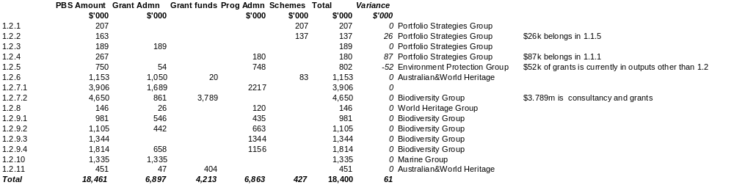

Output 1.7 Assessments and Research

Appendix 2 – Reconciliation of Revised Output Prices

Grant Administration Adjusted Price
Adjusted Price for Output Group 1.2 (with group and central adjustments to Corp overheads)
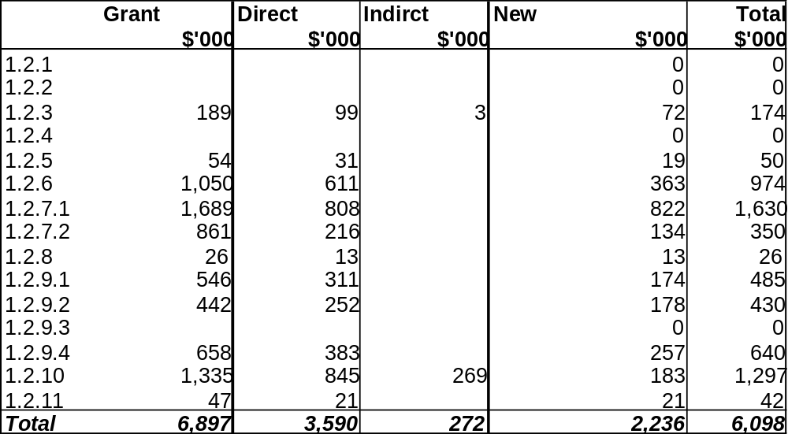

Program Administration Adjusted Price
Adjusted Price for Output Group 1.2 (with group and central adjustments to Corp overheads)
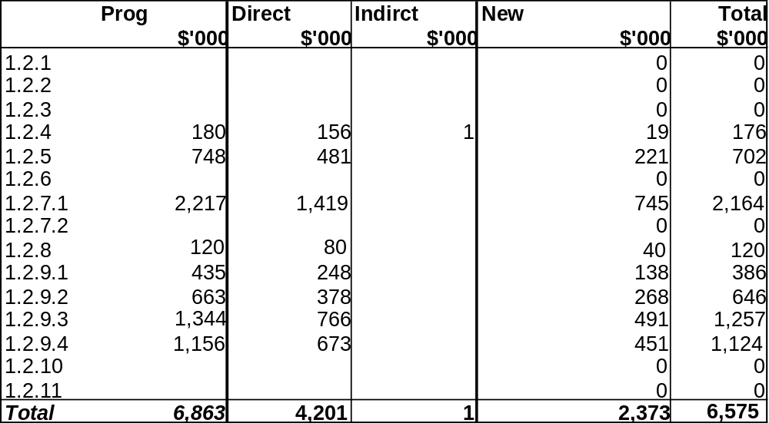

Schemes Adjusted Price
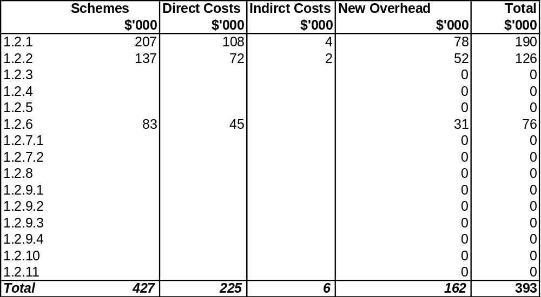
Adjusted Price for Output Group 1.2 (with group and central adjustments to Corp overheads)

Appendix 3 – Terms of Reference

Department of the Environment and Heritage

Output Pricing Review
Terms of Reference

- The Departments of the Environment and Heritage (DOEH) and Finance and Administration (DOFA) will undertake a joint review of the prices of DOEH outputs, to report to the Expenditure Review Committee in the 2000-01 Budget and 2001-02 Budget processes.

- A Steering Committee comprising representatives from DOEH and DOFA will oversee the review and develop a joint report for the agreement of both Ministers. The Steering Committee's principal members are Dr Don Gunasekera, Assistant Secretary, Policy and Accountability Branch, DOEH, and Ms Cate McKenzie, Branch Manager, Agency Advice Unit, DOFA.
- data from the review will be shared with DOFA as it becomes available

- Consultants will be commissioned to conduct the review, and will be assisted by both the Steering Committee and a departmental Working Group within DOEH (comprising officers from each Group within the Department).

- The objectives of the review are to determine whether the prices of DOEH outputs are reasonable (for example, relative to comparable outputs in other agencies), and to provide guidance for future output reporting practices in DOEH.

- The review will be based on agreed costing methodology (consistent both within DOEH and across comparable Departments), and will include costs at the sub-output and activity level to the extent possible. The review will involve collection of relevant data relating to quantity and cost of outputs, and analysis of the information produced.

- The review may employ a range of approaches to achieve its objectives, including:
- using a consistent approach so that the cost of DOEH activities can be benchmarked against comparable activities in other public sector and private organisations;
- incorporating consideration of competitive prices of outputs from, for example, competitive tendering (recognising and assessing opportunities for CTC, and including the outcome of these assessments in the report);
- building information links with other relevant reviews within DOEH; and
- incorporating other methods that the Steering Committee considers appropriate for the Department.

- DOEH has three primary outcomes:
Outcome 1 Environment – the environment, especially those aspects that are matters of national environmental significance, is protected and conserved;
Outcome 2 Meteorology – Australia benefits from meteorological and related science and services; and
Outcome 3 Antarctic – Australia’s interests in Antarctica are advanced.

- Recognising that time constraints limit the examination of all outputs before the next ERC, a first stage of the review will focus on the program administration, assessments and research, and corporate services elements of Outcome 1, currently estimated at 50% of the price of outputs for this outcome. This initial stage of the review will:
- address the program administration elements itemised in Output Group 1.2 in the Environment and Heritage Portfolio Budget Statements 1999-2000 (pp.62-67, 152, 216-217), totalling $8.592 million (with a further $5.353 million in revenue from independent sources contributing to this Output Group);
- address assessments and research as itemised in Output Group 1.7 in the Environment and Heritage Portfolio Budget Statements 1999-2000 (pp.80-81, 220), totalling $7.336 million (with a further $2.523 million in revenue from independent sources contributing to this Output Group);
- address the specific corporate services costs relating to each of the seven Output Groups in Outcome 1, totalling $40 million; and
- identify the least cost options for corporate services and provide significant information upon which to base assumptions for further stages of the review.

- The methodology, findings, and lessons learnt from this review will be used in:
- minimising/eliminating any differences in methodology/approach adopted by different parts of DOEH in assigning activities to output groups and in output pricing;
- revising and strengthening the costing methodology prior to the commencement of later stages of the review; and
- subsequent refinement and improvement of the Department's output pricing structure for reporting in future years (including accuracy, appropriateness and consistency of pricing methodology).

- Examination of the remaining elements of Outcome 1 and full consideration of Outcomes 2 & 3, are to be completed by November 2000 and reported to the ERC in the 2001-02 Budget process.

- A first draft of the consultancy report on Stage 1 of the Output Pricing Review will be submitted to DOEH on Friday 10 December 1999, and a final consultancy report submitted by Friday 24 December 1999.
- DOFA will be asked to comment on the draft report.

- Upon completion of Stage 1 of the Output Pricing Review, the Departments will oversee the preparation of a joint DOEH/DOFA submission to ERC on the scope for improving output pricing. This joint report, including a detailed project plan for reviewing the remaining elements of Outcome 1 and Outcomes 2 & 3, will be presented to the Minister for the Environment and Heritage and the Minister for Finance and Administration in late January 2000.

- So that Ministers are aware of progress, a report on the review of the remaining elements of Outcome 1 and Outcomes 2 & 3 will be provided to ERC during the 2000-01 Budget process.

