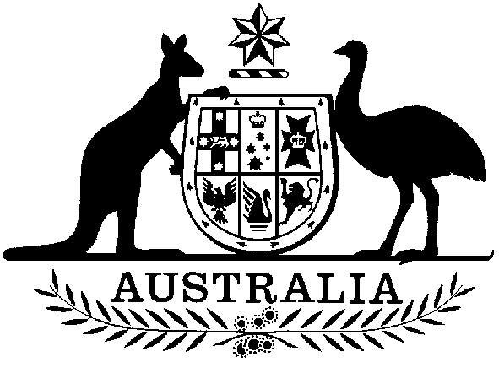 | Bronwyn Bishop MP  Chairman  House of Representatives Standing Committee on Legal and Constitutional Affairs  MEDIA RELEASE
BB030412 12 April 2003

Bishop Announces Inquiry into Averment Provisions and Customs Legislation

The House of Representatives Standing Committee on Legal and Constitutional Affairs has announced an inquiry into averment provisions in customs legislation.

The Committee shall inquire into the use of averment provisions as contained in the Customs Act 1901 and examine cases that have relied on averment provisions in Australian customs prosecutions.

The Committee Chairman, Bronwyn Bishop, said that many issues have been raised with regard to the use of averments, particularly as they shift the evidentiary burden of proof from the prosecutor to the defendant.

“This inquiry will examine the circumstances in which averments have been used and will subsequently make recommendations to the parliament outlining the effectiveness and appropriateness of these provisions,” Mrs Bishop said.

The Committee is seeking submissions from organisations and individuals with an interest or experience in these matters.

Submissions to the inquiry close on 9 May 2003, and the Committee expects to report to the Parliament before the end of the year.

Note:
For further details and to obtain a copy of the terms of reference please contact the Inquiry Secretary on 02.6277 2358 or visit the Committee website at:
www.aph.gov.au/house/committee/laca

Media Contact:
Damien Jones (Mrs Bishop’s Office) 02.9972 2355 or 0409 147 247

