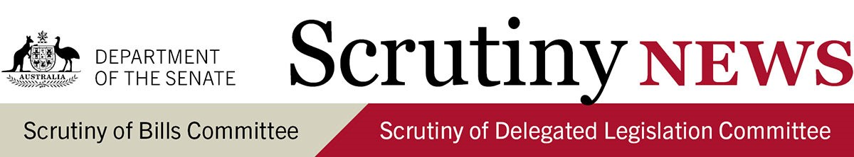
20 November 2023

Introduction
This newsletter highlights key aspects of the work of the Senate Scrutiny of Bills Committee and the Senate Scrutiny of Delegated Legislation Committee. It has a particular focus on information that may be useful while bills are under consideration and legislative instruments are subject to disallowance and seeks to raise awareness about the committees' scrutiny principles set out in Senate standing orders 23 and 24.
For more detail and discussion of these matters see the committees' Scrutiny Digests and Delegated Legislation Monitors.

Scrutiny of Bills Committee
Scrutiny Digest 14 of 2023 reports on the committee's consideration of 5 bills which were introduced into the Parliament during recent sitting weeks. It also contains the committee's comments on ministerial responses in relation to 3 bills. The committee has not commented on bills introduced into the Parliament between November 6 and November 10 in Scrutiny Digest 14 of 2023.

Scrutiny of Delegated Legislation Committee

Key scrutiny issues: Legislative instruments (Delegated Legislation Monitor 14 of 2023) Migration Amendment (Biosecurity Contravention) Regulations 2023 [F2023L01443]
- Adequacy of consultation: the committee is requesting the minister's advice as to whether further detail can be provided about what consultation was undertaken in relation to this instrument. If no consultation was undertaken with the public, visa holders, relevant peak bodies or other experts, the committee also requests the justification for this.
- Delegation of discretionary powers: the committee requests the minister's advise as to why it is necessary and appropriate to delegate the powers and functions in the instrument, who the powers will be delegated to and whether any safeguards or limitations apply to the exercise of these powers or functions.

Competition and Consumer (Gas Market Code) Regulations 2023 [F2023L00994]
- Availability of independent merits review: following an undertaking from the minister to include further information in relation to excluding merits review for policy decisions of a high political content in the explanatory statement, the committee is excluding its examination of this instrument.
Notices of motion to disallow
The Scrutiny of Delegated Legislation Committee gave notice of its intention to withdraw notices of motions to disallow the following instruments on 17 November 2023:
- Offshore Competition and Consumer (Gas Market Code) Regulations 2023 [F2023L00994]
All legislative instruments subject to a notice of motion for disallowance in either House of the Parliament are listed in the Disallowance Alert.

For any comments or questions, please contact:
Fattimah Imtoual, Secretary (A/g)
Senate Scrutiny of Bills Committee
02 6277 3050 | scrutiny.sen@aph.gov.au
Senate Scrutiny of Delegated Legislation Committee
02 6277 3066 | sdlc.sen@aph.gov.au

