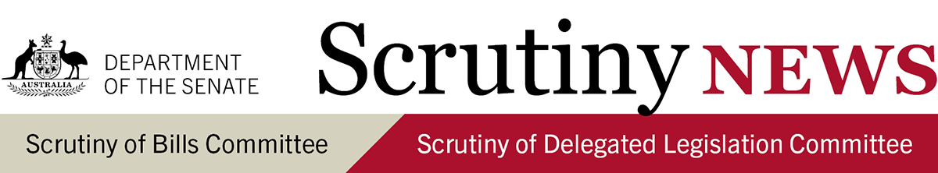
6 August 2021

Introduction
This newsletter highlights key aspects of the work of the Senate Scrutiny of Bills Committee and the Senate Scrutiny of Delegated Legislation Committee. It has a particular focus on information that may be useful while bills are under consideration and legislative instruments are subject to disallowance, and seeks to raise awareness about the committees' scrutiny principles (see Senate Standing Orders 23 and 24).
For more detail and discussion of these matters see the committees' Scrutiny Digests and Delegated Legislation Monitors.

Key scrutiny issues: Bills (Scrutiny Digest 11 of 2021)

Major Sporting Events (Indicia and Images) Protection and Other Legislation Bill 2021
- Significant matters in delegated legislation: the committee welcomes the minister's undertaking to amend the bill to prescribe the new FIFA entity as an event body for the purposes of the Major Sporting Events (Indicia and Images) Protection Act 2014, and to include high-level guidance within the bill as to when it will be appropriate to prescribe additional event bodies in the rules.

Social Security Legislation Amendment (Streamlined Participation Requirements and Other Measures) Bill 2021
- Non-disallowable instruments: the committee leaves to the Senate the appropriateness of providing that certain instruments made under the bill are not legislative instruments and therefore not subject to appropriate parliamentary oversight.
- Section 96 grants to the states/broad discretionary power: the committee leaves to the Senate the appropriateness of conferring on the Employment Secretary a broad power to make arrangements and grants and of not including a requirement that written agreements with the states and territories be tabled in the Parliament.

Key scrutiny issues: Legislative instruments (Delegated Legislation Monitor 11 of 2021)

Australia’s Foreign Relations (State and Territory Arrangements) Rules 2020 [F2020L01569]
- Matters more appropriate for parliamentary enactment/clarity of drafting: noting the importance of the matters set out in the instrument to the scope of the new Foreign Arrangement Scheme, the committee reiterated its request that the instrument be amended so that it repeals five years from commencement.

Scrutiny of COVID-19 related legislations
The Scrutiny of Delegated Legislation Committee has continued to list all delegated legislation made in response to COVID-19 on its website. As of 29 July 2021, 533 legislative instruments have been made, of which 16.9 per cent are exempt from disallowance.

Other bills commented on (Scrutiny Digest 11 of 2021)
- Court and Tribunals Legislation Amendment (2021 Measures No 1) Bill 2021: the committee welcomes the Attorney-General's undertaking to update the explanatory memorandum to include information in relation to provisions which allow delegated legislation to modify the operation of the Legislation Act 2003.
- Education Services for Overseas Students (Registration Charges) Amendment Bill 2021: the committee leaves to the Senate the appropriateness of provisions which provide the minister with broad discretionary powers to exempt providers from a charge in delegated legislation.
- Family Assistance Legislation Amendment (Child Care Subsidy) Bill 2021: the committee leaves to the Senate the appropriateness of provisions which allow delegated legislation to modify the operation of primary legislation in relation to eligibility for Child Care Subsidy.
- Financial Sector Reform (Hayne Royal Commission Response – Better Advice) Bill 2021: the committee leaves to the Senate the appropriateness of provisions which establish a strict liability offence with a maximum penalty of 120 penalty units, reverse the evidential burden of proof, and provide the minister with a broad discretion to create an enforceable Code of Ethics for financial planners and advisers by legislative instrument.
- Migration Amendment (Tabling Notice of Certain Character Decisions) Bill 2021: the committee expressed its scrutiny concerns in relation to provisions in the bill which provide that certain decisions are exempt from the new tabling requirements introduced by the bill.
- Treasury Laws Amendment (2021 Measures No. 3) Bill 2021: the committee expressed its scrutiny concerns in relation to provisions in the bill which leave the core elements of the proposed Family Home Guarantee to non-disallowable delegated legislation.
- Treasury Laws Amendment (2021 Measures No. 5) Bill 2021: the committee requested that the explanatory memorandum be updated to include information in relation to a provision which reverses the evidential burden of proof.

Other legislative instruments commented on (Delegated Legislation Monitor 11 of 2021)
- The Scrutiny of Delegated Legislation committee considered 139 disallowable legislative instruments registered on the Federal Register of Legislation between 22 May 2021 and 18 June 2021. The committee is continuing to engage with ministers and agencies in relation to 36 instruments, and has concluded its consideration of 16 instruments.
- All legislative instruments subject to a notice of motion for disallowance in either House of Parliament are listed in the Disallowance Alert.

Notices of motion to disallow
The Senate Scrutiny of Delegated Legislation Committee gave a notice of motion to disallow the following instrument on 4 August 2021:
- Aged Care Legislation Amendment (Serious Incident Response Scheme) Instrument 2021 [F2021L00222].
This document contains a very brief summary of some recent comments made by the Senate Scrutiny of Bills Committee (Chair: Senator Helen Polley and Deputy Chair: Senator Dean Smith) and the Senate Scrutiny of Delegated Legislation Committee (Chair: Senator the Hon Concetta Fierravanti-Wells and Deputy Chair: Senator the Hon Kim Carr).
For any comments or questions, please contact:
Glenn Ryall, Secretary
Senate Scrutiny of Bills Committee
02 6277 3050 | scrutiny.sen@aph.gov.au
Senate Scrutiny of Delegated Legislation Committee
02 6277 3066 | sdlc.sen@aph.gov.au

