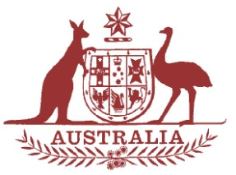
PARLIAMENT OF AUSTRALIA

PARLIAMENTARY JOINT STANDING COMMITTEE ON
THE NATIONAL DISABILITY INSURANCE SCHEME

The Parliamentary Joint Standing Committee on the National Disability Insurance Scheme is a federal parliamentary committee that was established in December 2013 to review the implementation and administration of the National Disability Insurance Scheme (NDIS).
The committee will be holding a town hall style public hearing on Wednesday, 6 April 2016 in the Crystal Room at Mercure Townsville, Woolcock St, Townsville.
This is an opportunity for people preparing for the commencement of the NDIS in North Queensland to speak to the committee about their perspectives on the NDIS.
To take part, the committee is inviting registrations from prospective NDIS participants and their nominees, carers and family members, as well as service providers and registered plan management providers in North Queensland.
This hearing will be divided into two open public sessions:
- Future NDIS participants in North Queensland and their nominees, carers and family members NDIS service providers; followed by,
- Queensland State Government and National Disability Insurance Agency representatives relevant to the trial site.
If you are interested in speaking to the committee about your preparation for the NDIS in North Queensland, you will need to register your interest by contacting the committee secretariat on:
Tel: 02 6277 3083
Email: ndis.sen@aph.gov.au

Registration numbers are limited. On registration, the committee will provide you with a program that will indicate the appropriate time for you to participate.

