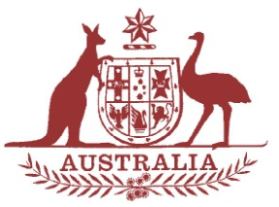

Parliamentary Joint Committee on the National Disability Insurance Scheme

Chair

The Hon. Mal Brough MP

Deputy Chair
Senator Alex Gallacher

Members
Senator Matthew Canavan
Dr David Gillespie MP
Ms Jill Hall MP
Mr Steve Irons MP
The Hon. Jenny Macklin MP
Senator Linda Reynolds
The Hon. Amanda Rishworth MP
Senator Zed Seselja
Senator Rachel Siewert
Senator Anne Urquhart

Correspondence and inquiries to:

Committee Secretary
PO Box 6100
Parliament House
CANBERRA ACT 2600

Tel: 02 6277 3083
Fax: 02 6277 5829

Email:
ndis.sen@aph.gov.au

Internet:
www.aph.gov.au/joint_ndis

National Disability Insurance Scheme
Public Hearing

Date 21 July 2015
Time 10.00am – 3.00pm
Venue Litchfield Room, Northern Territory Parliament House
Darwin

10.00am – 11.30am | NT Trial Site Hearing  NDIS providers, participants and stakeholders
11.30am – 12.30pm | Advocacy and Indigenous Health  Advocacy and Indigenous health providers
12.30pm – 1.30pm | Adjournment – Lunch
1.30pm – 2.00pm | NT Government
2.00pm – 3.00pm | NDIA – NT Manager
 | Adjournment

