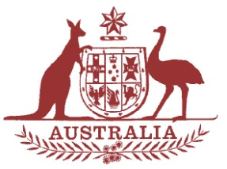

Parliamentary Joint Committee on the National Disability Insurance Scheme

Chair

The Hon. Mal Brough MP

Deputy Chair
Senator Alex Gallacher

Members
Senator Matthew Canavan
Dr David Gillespie MP
Ms Jill Hall MP
Mr Steve Irons MP
The Hon. Jenny Macklin MP
Senator Linda Reynolds
The Hon. Amanda Rishworth MP
Senator Zed Seselja
Senator Rachel Siewert
Senator Anne Urquhart

Correspondence and inquiries to:

Committee Secretary
PO Box 6100
Parliament House
CANBERRA ACT 2600

Tel: 02 6277 3083
Fax: 02 6277 5829

Email:
ndis.sen@aph.gov.au

Internet:
www.aph.gov.au/joint_ndis

National Disability Insurance Scheme
Public Hearing

Date 19 June 2015
Time 8.00am – 9.45am
Venue Committee Room 1S3
Parliament House, Canberra

8.00am – 8.30am | Assistant Minister for Social Services  Senator the Hon Mitch Fifield
8.30am – 9.15am | Department of Social Services  Mr Finn Pratt, Secretary  Ms Felicity Hand, Deputy Secretary  Dr Nick Hartland, NDIS Group Manager
9.15am – 9.45am | First Peoples Disability Network Australia  Mr Damian Griffis  Mr Scott Avery
9.45am | Adjournment

