21 October 2021
Government finances – June quarter 2021

Fiscal balance results for the financial year better than anticipated at Budget
Final Budget Outcome results for 2020-21 were stronger than estimated at the Budget in May, revealing a fiscal balance deficit of $136.1 billion for the 2020-21 financial year, an improvement of $27.1 billion compared to Budget estimates. Both revenue and expenses in the June quarter were higher relative to the March quarter.
Net debt was $592.2 billion (or 28.6 per cent of GDP) at the end of June 2021, an increase of $4.7 billion from March 2021 and a $25.3 billion improvement from what was forecast in the 2021-22 Budget. Better than anticipated economic outcomes contributed to a decrease in borrowing requirements and an improvement in net debt.
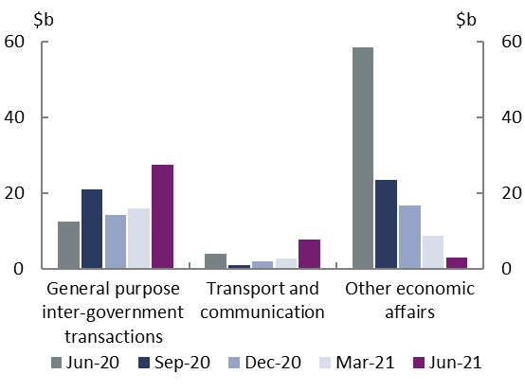
Expenses were $152.3 billion in the June quarter, $9.8 billion higher than the March 2021 quarter. This was primarily driven by an increase in ‘general purpose inter-government transactions’, reflecting the increased estimate of GST entitlements for 2020-21 being recognised in the June quarter. National Partnership Payments for Road Transport and Rail Transport also increased in the transport and communication category. The rise in expenses was, however, partially offset by the continued unwinding of temporary policies, such as the JobKeeper Payment (captured in ‘other economic affairs’).
Quarterly expenses
June 2020 to June 2021

Source: Commonwealth Government Monthly Financial Statements, Final Budget Outcome and PBO analysis.
Revenue was $154.2 billion in the June quarter, $27.0 billion (or 21 per cent) higher than the March quarter. Revenue was higher than expenses during the June quarter, reflecting strengthening economic conditions and regular seasonal patterns of tax collections. Personal income tax and company tax, the two largest taxes, made up around two-thirds of the increase from last quarter, consistent with solid labour market outcomes and commodity prices.

Budget balances
The fiscal deficit for the 2020-21 financial year was $136.1 billion and the underlying cash deficit was $134.2 billion. Both of these fiscal aggregates were better than expected at the 2021-22 Budget.

Key quarterly fiscal aggregates
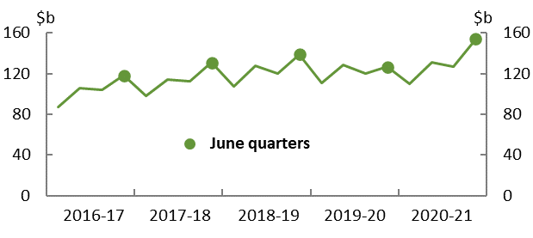
Revenue¹

Expenses¹
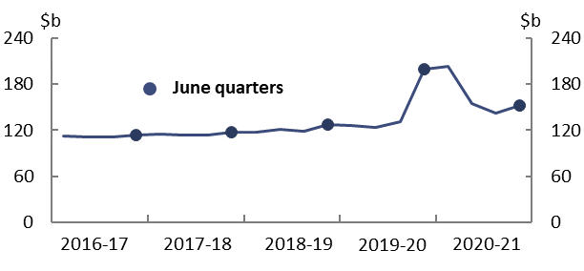

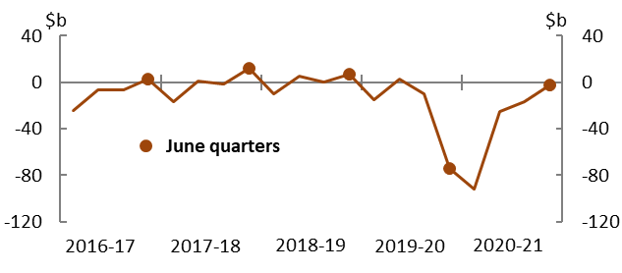
Fiscal balance¹

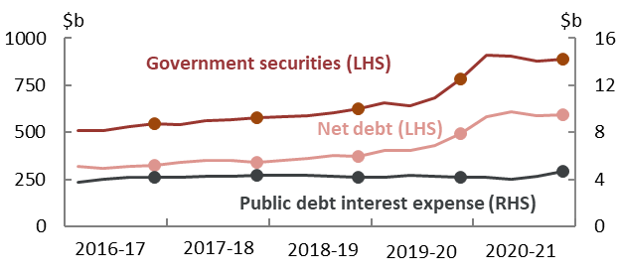
Debt and public debt interest²

¹ Numbers are for the quarter. Seasonal patterns for revenue, expenses and fiscal balance reflect key dates in revenue collection and transfer expenditure.
² Government securities (also known as government bonds) refers to Australian Government Securities at market value. Public debt interest expenses are interest payments on Australian Government Securities. Government securities and net debt values are as at the end of each quarter; public debt interest values are the expense for that quarter. Dots show results at the end of June for debt or over the June quarter for interest.
Source: Commonwealth Government Monthly Financial Statements, Final Budget Outcome, and PBO analysis.

The Commonwealth Government released the financial statements for April 2021 on 28 May 2021 and for May 2021 on 25 June 2021. The financial statement for June 2021 was taken from the Final Budget Outcome (FBO) for 2020-21, released on 30 September 2021. Monthly statements are available at https://www.finance.gov.au/publications/commonwealth-monthly-financial-statements/previous The FBO is available at https://archive.budget.gov.au/2020-21/fbo/download/fbo_2020-21.pdf.
The increase largely relates to the timing of the recognition of the GST entitlements, between the March, June and September quarters, rather than an underlying increase in payments. ‘Lumpy’ movements in the GST entitlement for the June quarter are not uncommon.

