8 July 2020
Government finances – May 2020

COVID-19 impacts reflected in rising expenses and slowing revenue
Government expenses continue to rise faster than revenue is slowing, but the weakness in revenue due to the deteriorating economic situation has become increasingly evident in May’s Monthly Financial Statements.
Expenses were $79.5 billion in May 2020, almost double those in May 2019, driven by the policy response to the COVID-19 pandemic, including the measures JobKeeper Payment and Boosting Cash Flow for Employers.
Revenue was $9.7 billion (or 18 per cent) lower for May 2020 than in May 2019, mainly due to lower company tax and personal income tax revenue as a result of the impact of COVID-19, and administrative support. This compares with a 5 per cent drop in April relative to the same time last year. Goods and services tax revenue – which flows directly through to state and territory budgets – was $1.3 billion (or 19 per cent) lower than in May 2019 but remains close to Mid-Year Economic and Fiscal Outlook (MYEFO) expectations for the year to date. Dividend income, which includes dividends received by the Future Fund, was $1.2 billion lower than in May 2019, although this may reflect higher-than-normal dividend revenue last year.
Change in revenue, May 2019 to May 2020
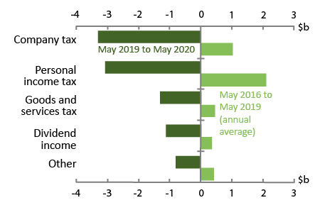
Note: Personal income tax is referred to as ‘Individuals and other withholding taxes’ in the Monthly Financial Statements.
Source: Commonwealth Government Monthly Financial Statements and PBO analysis.
Relative to expectations at the 2019–20 MYEFO, total revenue for the 2019–20 financial year to May was $18.1 billion lower. To put this in perspective, this is roughly equivalent to the Commonwealth’s annual spending on family tax benefits or schools.

Other key facts
- The fiscal balance for the period July 2019 to May 2020 was -$68.5 billion. The comparable expected fiscal balance at the 2019–20 MYEFO was $3.0 billion.
- The underlying cash balance for the period July 2019 to May 2020 was -$64.9 billion compared to an expected -$4.0 billion.
- Commonwealth net debt at the end of May 2020 was around $464 billion, which is $71 billion higher than the MYEFO forecast for the end of the 2019–20 financial year, with an uptick in the issue of government securities of around $58 billion in May 2020.

Key fiscal aggregates
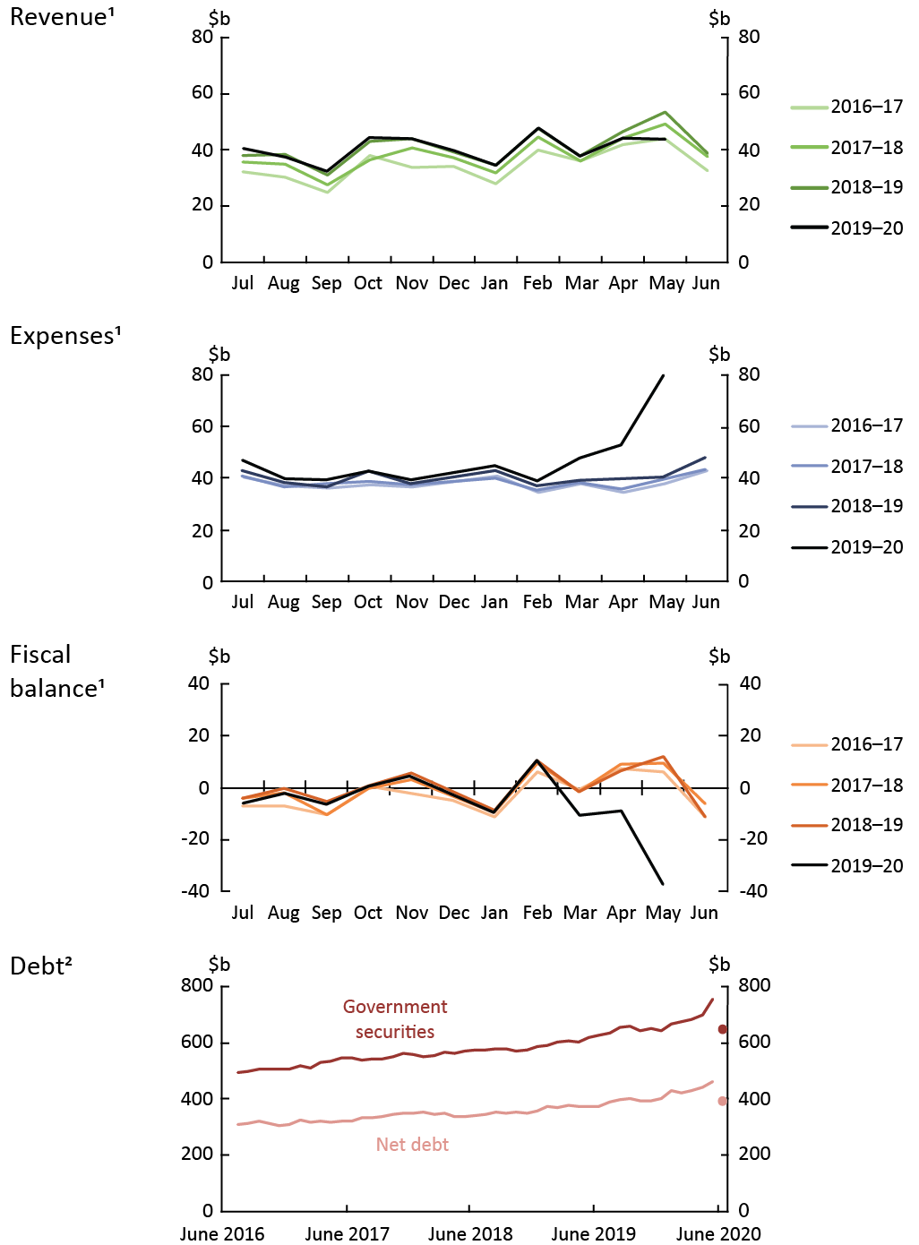
¹ Patterns for revenue, expenses and fiscal balance reflect key dates in revenue collection and transfer expenditure.
² Dots in the debt chart show 2019–20 Mid-Year Economic and Fiscal Outlook (MYEFO) estimates.
Note: The charts use accrual accounting and record income when earned and expenses when incurred, regardless of when the related cash is received or paid. The accrual amounts will generally show the impact of the COVID-19 measures earlier than the cash amounts.
Source: Commonwealth Government Monthly Financial Statements, Final Budget Outcomes, 2019–20 MYEFO, and PBO analysis.

The Commonwealth Government released the financial statements for May 2020 on 26 June 2020. Monthly Financial Statements are available online at https://www.finance.gov.au/publications/commonwealth-monthly-financial-statements.

