11 November 2020
Government finances – September quarter 2020

Rising debt due to ongoing elevated expenses amidst some revenue weakness
The latest monthly financial statements show Commonwealth debt has risen significantly, driven in particular by higher expenses that reflect the government’s policy responses to COVID-19.
Net debt as at the end of September 2020 was $580.8 billion, almost $160 billion above its level just prior to the commencement of the pandemic, mainly driven by financing higher expenses. Nonetheless, public debt interest expenses remain low due to historically low government borrowing costs.
Expenses were $202.7 billion in the September quarter, up from $125.8 billion over the same three months in 2019. To put this in context, this increase is more than annual Commonwealth spending on defence and Medicare combined. The increase was driven by the policy response to the pandemic, including JobKeeper payments (captured within ‘other economic affairs’), and transfers to households such as the Coronavirus Supplement (captured in social security and welfare).
Change in expenses, Sept qtr 2019 to Sept qtr 2020
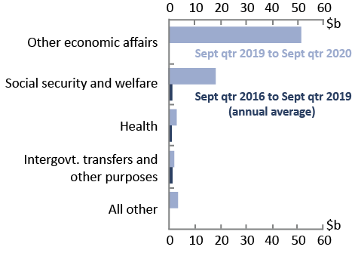
Source: Commonwealth Government Monthly Financial Statements and PBO analysis.

Revenue in the September quarter of 2020 was similar to that for the same period in 2019, when it would normally be expected to be higher. This weakness is a result of the economic deterioration. That said, personal income tax revenue was actually higher than in the same quarter in 2019. This may reflect tax revenue from the JobKeeper Payment and responses (including earlier lodgement) to the Boosting Cash Flow for Employers measure.

Budget balances
While fiscal aggregates in the September quarter 2020 remain in line with 2020-21 Budget estimates, the September quarter 2020 aggregates are significantly different to recent historical outcomes. The fiscal balance for the period July 2020 to September 2020 was -$92.1 billion. In comparison, the fiscal balance outcome for the September quarter 2019 was -$14.7 billion. The underlying cash balance for the period July 2020 to September 2020 was -$80.9 billion compared to the September quarter 2019 outcome of -$13.9 billion.

Key fiscal aggregates
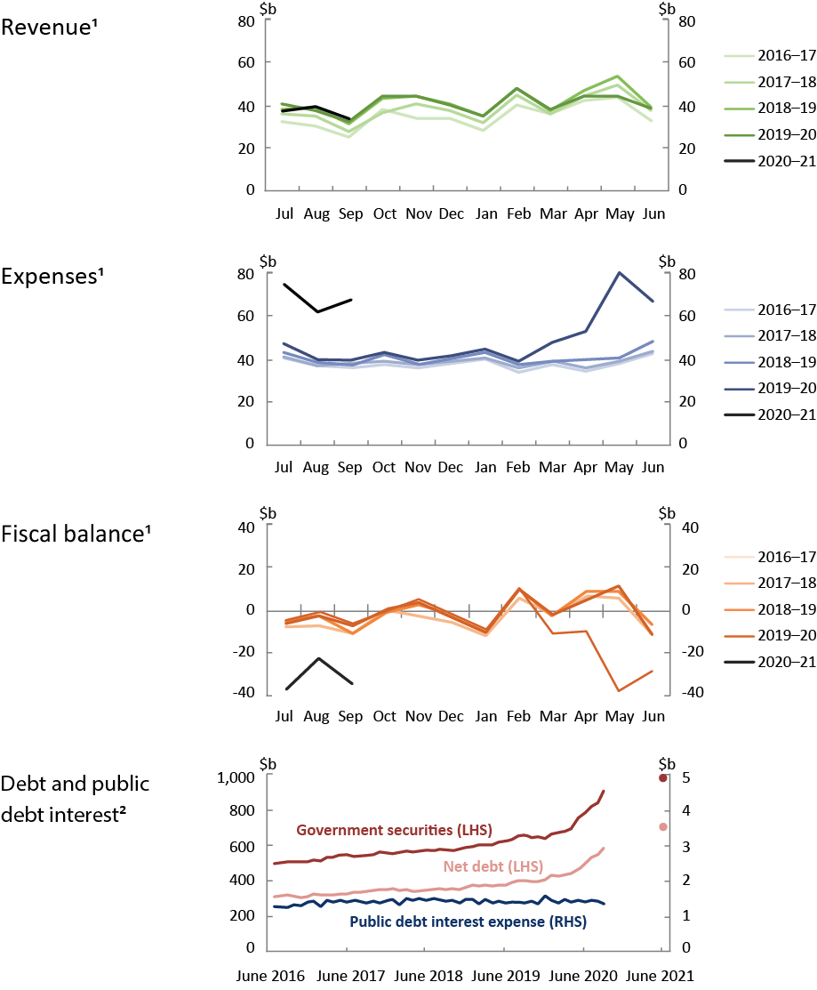
¹ Patterns for revenue, expenses and fiscal balance reflect key dates in revenue collection and transfer expenditure.
² Dots in the debt chart show 2020-21 Budget estimates. Government securities refers to Australian Government Securities on issue. Public debt interest expenses are primarily associated with debt servicing costs on Australian Government Securities. Net debt and Government securities values are as at the end of each month; public debt interest values are the expense for that month.
Note: The charts use accrual accounting and record income when earned and expenses when incurred, regardless of when the related cash is received or paid. The accrual amounts will generally show the impact of developments related to COVID-19 earlier than the cash amounts, for example with respect to the Boosting Cash Flows for Employers measure (see the 2020-21 Budget,
Budget Paper No. 1, p. 10-22).
Source: Commonwealth Government Monthly Financial Statements, Final Budget Outcomes, 2020–21 Budget, and PBO analysis.

The Commonwealth Government released the financial statements for July, August and September 2020 on 23 October 2020. This edition of Government finances therefore covers the quarter rather than one month. Monthly Financial Statements are available online at https://www.finance.gov.au/publications/commonwealth-monthly-financial-statements.

