2020-21 medium-term   
fiscal projections

Report No.

04/2020

|  |
| --- |
| © Commonwealth of Australia 2020  ISBN 978-0-6487474-0-6 (online)  Copyright notice  This work is licensed under the Creative Commons Attribution-NonCommercial-NoDerivs 3.0 Australia License <http://creativecommons.org/licenses/by-nc-nd/3.0/au/>    Attribution  This publication should be attributed as follows: Parliamentary Budget Office, 2020-21 Medium-term fiscal projections.  Use of the Coat of Arms  The terms under which the Coat of Arms can be used are detailed on the following website: <https://www.pmc.gov.au/government/commonwealth-coat-arms>  Feedback  If you found this report useful, or have suggestions for improvement, please provide feedback to [feedback@pbo.gov.au](mailto:feedback@pbo.gov.au). |

Contents

Overview 2

1 Projected underlying cash balance 3

1.1 Underlying cash balance 3

1.2 Medium-term fiscal strategy 5

1.3 Changes from the PBO’s 2019-20 Medium-term projections 6

2 Projected receipts 10

2.1 Total receipts 10

2.2 Personal income tax 11

2.3 Company tax receipts 14

2.4 Goods and services tax (GST) receipts 14

2.5 Superannuation fund tax receipts 14

2.6 Other receipts 14

2.7 Risks around projected receipts 15

3 Projected payments 17

3.1 Total payments 17

3.2 Payments growth by program 19

3.3 National Disability Insurance Scheme 20

3.4 Defence 20

3.5 Medicare Benefits Schedule 20

3.6 Aged care 20

3.7 Schools 21

3.8 Child care 21

3.9 Income support for the unemployed 21

3.10 Public debt interest 22

3.11 The Contingency reserve 22

3.12 Other payments 23

3.13 Risks around expected payments 23

4 Projected net debt and net financial worth 25

4.1 Net debt 25

4.2 Debt beyond the medium term 26

4.3 Risks around debt projections 28

4.4 Net financial worth 28

Appendix A – Trends in projections over the medium term 30

Appendix B – Changes in the PBO’s projections since the previous report 32

Appendix C – Receipt projection methodology 36

Appendix D – Payments projection methodology 38

Appendix E – Changes in fiscal strategy over time 45

Appendix F – Glossary 47

This report was authored by John Clark and Kate Wagner, with contributions from Kathryn Smith, Lok Potticary, Anthea Guthrie, Binod Nepal, Nicholas Ramirez, Travis Ey, Vijay Murik, and Anderson Cheung and the benefit of   
comments from Stein Helgeby and Linda Ward. The contents of the report are the sole responsibility of   
the Parliamentary Budget Office.

Overview

This is the fifth edition of the Parliamentary Budget Office’s annual medium-term fiscal projections report. It shows the profound impact that the COVID-19 pandemic will have on Australia’s fiscal position.

The 2020-21 Commonwealth Budget forecast an underlying cash deficit of $214 billion in 2020-21. At 11 per cent of GDP this is around 2.5 times greater than the previous worst deficit of the last   
fifty years.

The financial position is projected to improve over the medium term as a result of the anticipated economic recovery and the winding back of the COVID-19 related policy response.

In this report, the PBO projects the fiscal position will improve over the medium term to an underlying cash deficit of $51 billion, or 1.6 per cent of GDP, in 2030‑31.

The COVID-19 pandemic will have an enduring effect on public finances…

Net debt is forecast to increase from 19 per cent of GDP in 2018-19 to 44 per cent of GDP in 2023‑24. The PBO projects that net debt will then stabilise and slowly fall to around 41 per cent of GDP by 2030-31. In last year’s report, net debt was projected to be close to zero by the end of the decade.

Gross debt as a share of GDP is expected to reach its highest level since the Second World War, but public debt interest payments are projected to remain lower than for most of the last 75 years (at around 0.9 per cent of GDP) due to historically low interest rates.

…while higher government payments will unwind, lower receipts are projected to continue over the medium term…

Total payments are forecast in the budget to increase from 24.5 per cent of GDP in 2018-19 to 34.8 per cent of GDP in 2020-21, at the height of pandemic related measures, and are projected to then fall back to 26.1 per cent of GDP by 2030-31, 1.6 percentage points higher than 2018-19. While payments are significantly higher in the short term due to the COVID-19 related policy response, this impact is projected to be largely unwound by the end of the forward estimates and medium term.

Total receipts are projected to reach 24.5 per cent of GDP by 2030-31 (0.4 percentage points below receipts in 2018-19, prior to COVID-19). In dollar terms, the impact on receipts is long-lasting due to the close link between economic activity and tax collections.

The trends in payments and receipts can be obscured when looking solely at projected receipts and payments as a percentage of GDP, as the level of nominal GDP is permanently lower as a result of this pandemic‑induced economic shock.

… and considerable risks remain to the fiscal outlook.

The near future remains highly uncertain, depending on both the health and economic situation.

A slower-than-expected economic recovery or greater government spending associated with additional COVID-19 outbreaks or fiscal stimulus would flow through to slower improvements in receipts and to higher payments. This would result in higher deficits and government debt.

By contrast, if the Australian economy performs strongly, avoiding a prolonged period of weak productivity growth or negligible price growth, then both the budget balance and debt position could improve faster than projected here.

# Projected underlying cash balance

|  |
| --- |
| Key points   * The budget position has deteriorated significantly as a result of the COVID-19 pandemic and the associated policy response. * In 2020-21, the budget forecasts the underlying cash balance to be the biggest deficit since at least 1970-71, at $214 billion, or 11.0 per cent of GDP. * The Parliamentary Budget Office (PBO) projects that the fiscal position will improve over the medium term but that there will still be a significant underlying cash deficit of $51 billion, or 1.6 per cent of GDP, in 2030-31. * This deficit reflects a combination of lower receipts and higher payments that will endure across the medium term. |

## Underlying cash balance[1]

The COVID-19 pandemic and associated policy response has led to the largest deterioration in the Commonwealth Government’s fiscal position since the Second World War.

The 2020-21 Budget forecast a historically high underlying cash deficit and net debt over the next few years.[2], [3] By the end of the decade, the PBO projects that the budget will remain in deficit, with the deterioration, compared to 2018-19, resulting from both increased payments and decreased receipts due to a reduction in the level of economic activity.[4]

After a balanced budget in 2018-19, the underlying cash balance (UCB) for 2019-20 was a deficit of $85 billion, or 4.3 per cent of GDP, the biggest deficit since 1970-71 (Figure 1–1). The government forecasts a deficit of $214 billion, or 11.0 per cent of GDP, in 2020-21, with the deficit then getting progressively smaller over the rest of the forward estimates period, falling to 3.0 per cent of GDP in 2023-24. This change reflects the wind down of new payments made in response to the pandemic. The PBO projects that the UCB will improve gradually over the next decade to a deficit of $51 billion, or 1.6 per cent of GDP, in 2030-31.

Information on the PBO’s approach to our medium‑term fiscal projections report and the assumptions underlying the projections are provided in Box 1.

Figure 1–1: Underlying cash balance, 1970-71 to 2030-31

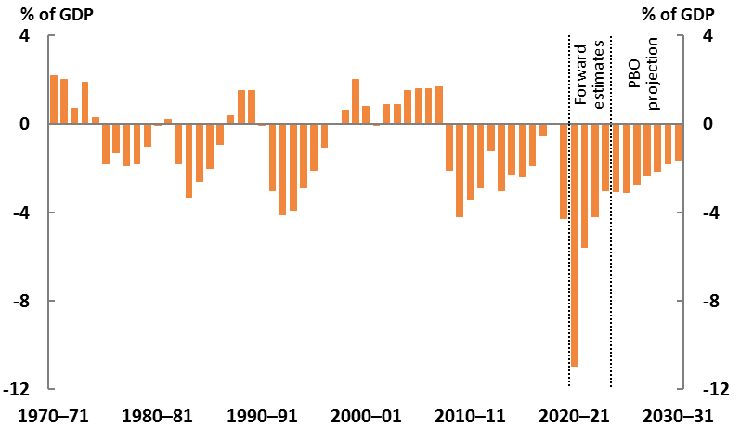

Source: 2020-21 Budget and PBO analysis.

The improvement to the budget balance after the forward estimates period reflects both declining payments as the COVID-related policy response is unwound and improving receipts as the economy recovers (Figure 1–2). Surpluses occur when total receipts are greater than total payments, and deficits occur when total payments are greater than total receipts. The budget deficit remains over the medium term, but falls in size as the gap between payments and receipts diminishes.

Figure 1–2: Total receipts and payments, 1970-71 to 2030-31

|  |  |
| --- | --- |
|  | |
| Note: Net Future Fund earnings are included in the underlying cash balance from 2020-21, consistent with the 2020-21 Budget treatment. Net Future Fund earnings contribute 0.2 per cent of GDP to the underlying cash balance in 2020-21, the first year these earnings become available to meet the government’s superannuation liability. The shaded areas broadly correspond to a surplus (green) or deficit (blue) by today’s definition of the underlying cash balance. Source: 2020-21 Budget and PBO analysis. | |

The PBO’s projections over the next decade are broadly consistent with the medium-term budget position presented in the 2020-21 Budget. The PBO’s projection for the UCB in 2030-31 is not significantly different to that presented in the budget, with the PBO’s lower projected payments offset by similarly lower projected receipts.

|  |
| --- |
| Box 1: The PBO’s medium-term fiscal projections: approach  This report provides independent medium-term projections of receipts and payments including detailed components of each, as well as the UCB and debt. These projections are based on the policy settings, budget estimates and economic parameters at the time of the 2020-21 Budget, which are discussed in Box 2.  While the PBO uses the forward estimates as published in the budget in this report, for the medium term we independently model receipts and payments using government data and applying our own professional judgement. The same economic parameters as the Budget are applied, consistent with our legislation.  These projections reflect current government policy and do not assume future government decisions, nor do they attempt to ascertain whether additional fiscal stimulus will be required. The PBO’s projections provide a reasonable quantitative basis on which to assess the strength and sustainability of the current fiscal position, and provide a baseline against which future decisions should be added or subtracted. The PBO does not attempt to predict the future, or to anticipate future policy decisions.[5] Where government policy has not been made explicit beyond the forward estimates period, the PBO’s projections broadly assume the continuation of current policy settings and arrangements.  Due to the health crisis associated with COVID-19, this year’s budget was delayed to 6 October 2020. This has meant that the PBO’s own medium-term fiscal projections have been published later than normal this year. |

## The Commonwealth Government’s medium-term fiscal strategy

The budget sets out the government’s medium-term fiscal strategy. As the fiscal strategy is part   
of current government policy, the PBO’s medium-term projections take the strategy as an   
underlying assumption.[6]

The government significantly revised its fiscal strategy in the 2020-21 Budget to reflect the economic crisis arising from the COVID-19 pandemic and the need for additional support for the economy over the period ahead.

The 2019-20 MYEFO strategy, published before the pandemic, focused on achieving budget surpluses on average over the course of the economic cycle, building on the balanced budget in 2018-19 and the forecast return to surplus in 2019-20.  The fiscal strategies before that focused on budget repair.

The revised strategy in the 2020-21 Budget has two phases: an Economic Recovery Plan to promote employment growth and business and consumer confidence until the unemployment rate is ‘comfortably below 6 per cent’; and, a medium‑term fiscal strategy focused on economic growth to stabilise and reduce debt.  The strategy includes elements of stabilising and reducing gross and net debt as a share of the economy and ‘targeting a budget balance, on average, over the course of the cycle, that is consistent with the debt objective.’  The budget surplus or deficit is a means of achieving a debt objective, with the possibility that a budget deficit could still be consistent with stabilising and reducing net debt.

Appendix E provides a summary of key changes to the fiscal strategy over time since the 2014‑15 Budget.

The PBO intends to publish analysis on the relationship between budget balances and the path for debt as part of its forthcoming framework for assessing fiscal sustainability.

## Changes from the PBO’s 2019-20 Medium-term projections

As well as presenting the PBO’s current medium-term projections, this report can be used to analyse how these projections have changed over time. Figure 1–3 shows how projections for total receipts, total payments and the UCB have changed since the last year’s projections.

The dramatic changes in the PBO’s projections of the UCB, receipts, and payments are largely driven by the COVID-19 pandemic and the associated policy response.

The ongoing weaker UCB projection compared to the previous report is due to four main factors. In dollar terms, the effect on receipts is likely to be long lasting while the impact on payments will largely be temporary.

Firstly, reduced immigration during the pandemic has contributed to a weaker projected economy in the medium term.

Secondly, at the time the budget was released, the pandemic was expected to have reduced national income by over 7 per cent in the June quarter.[7] While nominal GDP *growth* is expected to recover to pre-pandemic rates, the *level* of GDP is expected to be permanently lower in each year compared to its pre-pandemic projection (see below for further discussion).[8] Taxes are correspondingly lower throughout the medium term, particularly for personal income tax.

Thirdly, while tax receipts are strongly linked to economic activity, many payments are not as closely linked. Spending on defence, the aged, the National Disability Insurance Scheme and health are the most significant components of payments which have not reduced in dollar terms commensurately with the reduced size of the economy.

Fourthly, debt incurred to fund the response to the pandemic results in modestly higher public debt interest payments in dollar terms, reflecting historically low interest rates.

Figure 1–3: Revisions to projections compared to the previous report, 2019-20 to 2029-30

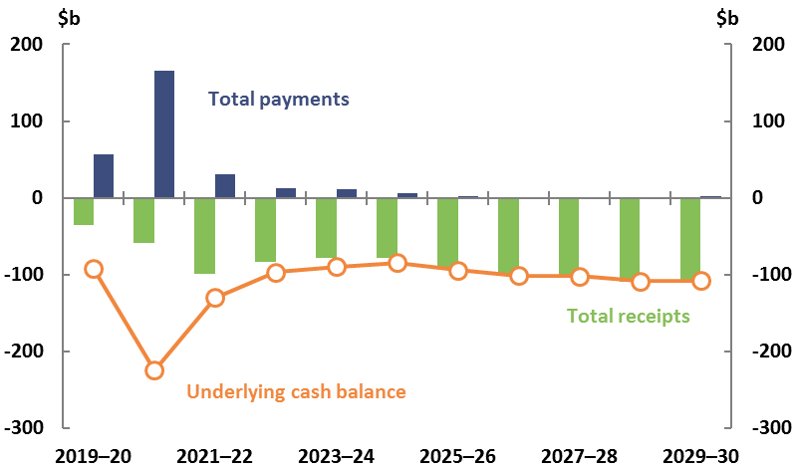

Note: Revisions to Future Fund earnings are included in total receipts in this figure, however they are only included in the underlying cash balance from 2020-21, consistent with the treatment in the 2020-21 Budget.  
Source: 2020-21 Budget and PBO analysis.

Receipts are projected to be around $100 billion lower near the end of the medium term when compared to our 2019-20 projections. Such a large shortfall a decade later may be surprising, given that key economic measures are projected to have largely returned to their pre‑COVID rates of growth by that time.

Nominal GDP is projected to grow at an average rate of 5.3 per cent from 2024-25 to 2030-31, almost identical to the growth projected at the 2019-20 MYEFO, before the pandemic. However, the reduction in the projected level of nominal GDP of around $170 billion by 2023-24 is not recovered. As a result, while nominal GDP growth is projected to have largely recovered by 2023-24, the projected level of nominal GDP remains lower in every year, as shown in Figure 1–4.

The revisions to nominal GDP reflect the very low immigration during the pandemic, and lower projected prices and wages, as well as the government’s revised projection methodology, as discussed in Box 2. Tax receipts are projected to be lower in dollar terms, particularly personal income tax, with lower wage growth leading to less bracket creep.

Revisions to government payments are more complex. Over the forward estimates period, government payments were forecast in the budget to increase dramatically as result of temporary policy changes to help maintain employment throughout the pandemic, increase payments to people on income support, and build additional infrastructure. The number of people on income support also increased as unemployment rose and incomes fell.

Between 2024-25 and 2029-30, the PBO projects government payments to be similar overall to the projections in the previous report. [9] Policies to assist Australia through the pandemic are designed to be temporary.

Figure 1–4: Nominal GDP forecasts and projections, 2018-19 to 2030-31

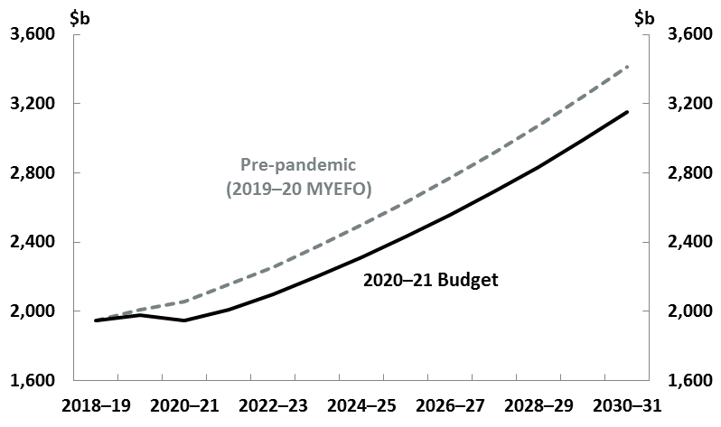

Note: This chart is a simplified version of Chart 14 of Budget Paper No. 1 in the 2020‑21 Budget.

Source: 2020-21 Budget.

Despite the much larger government debt, the interest the government pays on that debt is expected to increase only modestly over the medium term, as new debt is being issued at very low interest rates.

Some improvements to PBO modelling, as discussed later, have also resulted in revisions to projections for receipts and payments.

Although the dollar value of payments are projected to be lower compared to last year’s projections, payments as a share of GDP are projected to be substantially higher as the projected size of the economy has been revised lower. This is explained further in Chapter 3.

|  |
| --- |
| Box 2: Changes to the economic inputs into the PBO’s projections  The budget includes a set of ‘parameters’ that describe how important aspects of the economy, such as GDP and employment, are likely to evolve over time. The PBO is required, under legislation, to use these parameters when constructing independent medium-term fiscal projections. The changes to parameters since the previous report are sizeable and reflect both revisions due to COVID‑19, and methodological changes in the budget’s approach to modelling the economy over the medium term.  The budget’s detailed economic forecasts represent the government’s estimate of how the economy will unfold over the next two years (the budget year and the following year).  Over the medium term, the parameters converge to long-run trends based on assumptions for the working-age population, workforce participation and productivity. Long-run or ‘potential’ GDP is the product of these three factors. The ‘output gap’—the difference between projected and potential GDP—would be expected to be sizeable during the recovery from an economic downturn. The assumptions around how big the gap is and how fast it closes are both important for projecting the fiscal impacts of COVID‑19.  The 2020-21 Budget included changes to population assumptions, including both lower expected migration owing to the pandemic and revised fertility rates. Lower migration has a significant and permanent effect on the level of GDP because the reduced population is not assumed to return to previously projected levels in the medium term, for example through higher migration. The fertility rates, which were revised before the COVID-19 pandemic, will affect potential GDP growth beyond the medium term. This effect is due to a lower working‑age population than would have otherwise been the case.  In addition to these changes to assumed population, and hence GDP, the 2020-21 Budget also included a new approach to modelling the path from the forecasts of the next two years to the long run. In the 2020-21 Budget both potential output and the approach to the closure of the output gap changed, compared to previous budgets. Prior to this budget, it was assumed that the output gap would be closed over five years following the two year forecast period. When output is below its potential level, this method led output to grow above its potential rate for a period of time so that full employment is reached and productive equipment is back in use. In the 2019-20 Budget this led to projections of 3 per cent growth for several years, before returning to the sustainable growth rate of 2¾ per cent. Instead of this approach, the 2020-21 Budget uses a macroeconometric model of the economy to inform how quickly the output gap is closed.[10] |

# Projected receipts

|  |
| --- |
| Key points   * Receipts dropped substantially as a result of the COVID-19 pandemic, and the government forecasts a partial recovery over the forward estimates period. * Beyond the forward estimates, the PBO projects receipts as a percentage of GDP will improve by 2030-31 but will still not have recovered to the 2018-19 level. This reflects  the close relationship between tax collections and economic activity. * In dollar terms, total receipts are projected to increase from $485 billion in 2018-19 to $772 billion in 2030-31. |

## Total receipts

Total receipts are expected to be volatile over the forward estimates period as a result of the COVID‑19 pandemic and associated policy response, as well as the implementation of tax cuts. By the end of the medium term in 2030-31, total receipts are projected to reach $772 billion, or 24.5 per cent of GDP. This is 0.4 percentage points lower than the pre-pandemic level of 24.9 per cent of GDP ($485 billion) in 2018-19, as shown in Figure 2–1.

Figure 2–1: Total receipts and tax receipts, 2002-03 to 2030-31

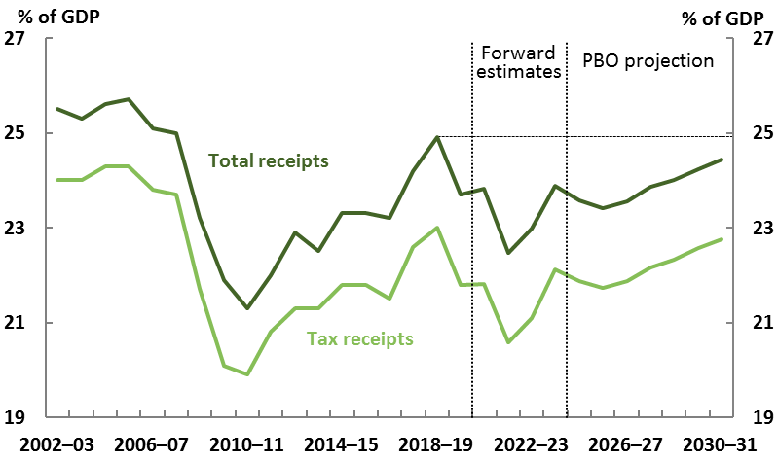

Notes: Total receipts includes tax and non-tax receipts. Non-tax receipts include interest and dividend earnings (including Future Fund earnings), NDIS contributions from the states and territories, royalties and the sale of non-financial assets. The dashed horizontal line shows the 2018-19 level for comparison.

Source: 2020-21 Budget and PBO analysis.

In dollar terms, total receipts are projected to increase by around 59 per cent between 2018-19 and 2030-31. However, nominal GDP is projected to grow by 62 per cent over the same timeframe, meaning that total receipts as a proportion of the overall size of the economy are projected to   
be lower.

Projections for personal income tax, company tax and other receipts as a share of GDP are shown   
in Figure 2–2. While personal income tax receipts are projected to be higher in 2030-31 than in 2018‑19 as a per cent of GDP, company tax receipts and the combination of all other receipts are projected to be lower.[11] While governments have a high degree of control over their revenue, ongoing downward trends in indirect tax receipts as a share of GDP mean that income taxes, particularly from individuals, will provide a larger share of government income, under current   
policy settings.

As part of its fiscal strategy, the Government has a commitment to maintaining the ratio of tax receipts to GDP at or below 23.9 per cent of GDP. The Government’s tax-to-GDP cap of 23.9 per cent of GDP is not expected to be a constraint over the medium term.[12]

Figure 2–2: Breakdown of receipts, 2002-03 to 2030-31

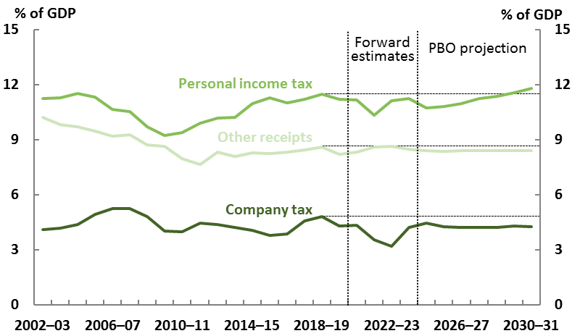

Note: The breakdown shows the two largest heads of revenue, with all other receipts grouped   
together as ‘other receipts’. The dashed horizontal lines show the 2018-19 levels for comparison.  
Source: 2020-21 Budget and PBO analysis.

## Personal income tax

Following the temporary impact of COVID-19, and the government’s tax cuts, personal income tax receipts are projected to increase over the medium term, to 11.8 per cent of GDP in 2030-31, 0.3 percentage points higher than in 2018-19.

Personal income tax receipts are the biggest component of taxation for the Commonwealth Government. Over the period to 2024-25, personal income tax receipts will adjust as the government implements the later stages of its Personal Income Tax Plan. Beyond this, personal income tax receipts are projected to trend upwards as bracket creep leads to increasing average   
tax rates, but would have risen higher if not for the pandemic.

Personal income tax receipts have been revised downward by $147 billion over the four years to 2023-24 compared to the previous report. This downward revision is mainly due to the weaker wage growth and employment as a result of the COVID-19 pandemic. The bring‑forward of Stage 2 of the government’s *Personal Income Tax Plan* also contributes to the revision.

A longer history of personal income tax receipts and a comparison of this year’s and last year’s projections are shown in Figure 2–3.

Figure 2–3: Personal income tax, 1982-83 to 2030-31[13]

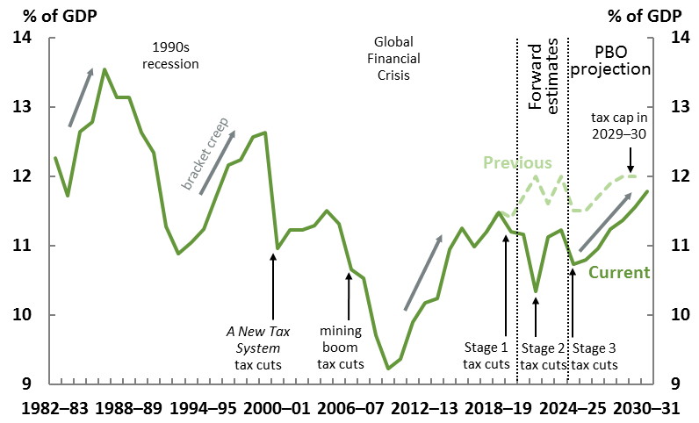

Note: 'Previous' refers to projections published in last year's report.

Source: 2020-21 Budget and PBO analysis.

Following the deep recession of the early 1990s and the global financial crisis of 2007-2010, personal income tax increased rapidly as a share of GDP partly from ‘bracket creep’, a key component of the longer‑term improvement in the fiscal position.

As the personal income tax system is progressive and the thresholds are static, when incomes rise compared to the thresholds, the average personal income tax rate paid by individuals increases.   
This is known as bracket creep.

If wage and price inflation is relatively low, incomes do not increase as much compared to the thresholds, leading to less bracket creep and slower growth in personal income tax as a share of GDP.

The budget’s economic projections include lower wage and price inflation over the medium term than was experienced following previous downturns, resulting in less bracket creep. The result is that over the ten years to 2031, personal income tax is projected to increase relatively slowly as a share of GDP, even abstracting from the legislated tax cuts.

Bracket creep is illustrated in Figure 2–3 by the grey arrows, with the projected impact of bracket creep in the medium term less steep than for previous episodes.

The distributional effects of the income tax cuts are discussed in Box 3.

|  |
| --- |
| Box 3: Distributional effects of personal income tax changes  As part of the government’s JobMaker Plan, the 2020‑21 Budget brought forward the second of three stages of substantial personal income tax changes announced in the 2018-19 and 2019‑20 Budgets from 1 July 2022 to 1 July 2020 while retaining the low and middle income tax offset for 2020‑21. These measures have the effect of decreasing personal income tax rates, with the final stage legislated to come into effect in 2024-25.[14] Countering these tax cuts, bracket creep (driven by ongoing growth in wages) will have the effect of increasing average personal income tax rates. The overall change in average tax rates is the combination of both bracket creep and tax cuts. Figure 2–4 shows the projected change in average tax rates for different taxable income quintiles over the period 2017-18 to 2030-31. The fifth quintile, individuals with a taxable income of above $89,000, is projected to have a lower average tax rate in 2030-31 compared to 2017-18, while all other quintiles are projected to experience increasing average rates over that time.  Figure 2–4: Change in average tax rates by income, 2017-18 to 2030-31    Note: Analysis comprises individuals who filed a tax return in 2017-18, divided into quintiles according to taxable income. Taxable income ranges are for 2018-19.  Source: Australian Taxation Office data, parameters underlying the 2020-21 Budget, and PBO analysis.  This analysis shows that individuals in the second and third quintiles (together spanning the taxable income range $20,001 to $58,000), are expected to face the largest effects of bracket creep. As Figure 2–4 shows, the overall impact of the tax cuts up until 2023-24 are most beneficial to those in the third quintile. The effects of the stage three tax cuts legislated for 2024-25 are substantially more beneficial to those in the higher income quintiles, resulting in those taxpayers being the largest overall beneficiaries of the tax cuts. |

## Company tax receipts

After a COVID-19 related dip in the forward estimates period, company tax receipts are projected to remain relatively stable as a share of GDP over the medium term. However, the level of receipts will remain around 0.6 per cent of GDP lower than the pre-pandemic level, with company tax receipts at 4.2 per cent of GDP in 2030-31, compared to 4.8 per cent of GDP in 2018-19. Company tax receipts were particularly strong in the base year for comparison, 2018-19, when they reached their highest rate as a share of GDP since the Global Financial Crisis (Figure 2–2), consistent with strong prices for key commodities such as coal and natural gas. Our projection for company tax is broadly in line with long-run trends.

## Goods and services tax (GST) receipts

Compared to the previous report, projected GST receipts have been revised down $33 billion over the four years to 2023-24, due to travel and business restrictions related to the COVID-19 pandemic.

Over the medium term, the PBO projects that GST receipts will be lower than was projected in the previous report, but as a share of the economy, are likely to stabilise. The PBO has revised its methodology for projecting goods and services tax receipts to incorporate the falling share of household consumption subject to GST (see Box 4). This has resulted in lower annual real projected growth for GST compared to the previous report.

Changes to projections of the GST will not affect the overall Commonwealth budget balance, as the GST is entirely paid to the states and territories.

## Superannuation fund tax receipts

Superannuation fund tax receipts are forecast by the government to fall as a result of the COVID-19 pandemic, before recovering within the forward estimates period. The PBO projects superannuation fund tax to further improve over the medium term, and to be 0.2 percentage points higher in 2030‑31 than in 2018-19.

The COVID-19 pandemic has affected superannuation tax in several ways, through both the contributions made to superannuation accounts and the earnings made on the assets in   
these accounts.

The pandemic has reduced contributions to superannuation as unemployment has increased and wages have not grown strongly, thus reducing tax on contributions.

The value of many assets, including those held in superannuation accounts, has also been impacted by market turbulence associate with the pandemic, which will in turn affect capital gains tax.

In addition, the government’s 2020-21 Budget measure *COVID-19 Response Package – temporary early access to superannuation* has lowered the total stock of superannuation assets*.* Lower   
assets mean lower earnings on superannuation, and therefore reduce tax collections on superannuation earnings.

## Other receipts

Table 2–1 shows the PBO’s projections of the change in receipts by each major category over the period 2018-19 to 2030-31, their projected contribution to growth in total receipts, and the main drivers of the trends over the medium term. Appendix A provides a short description of the drivers of trends between 2018-19 and 2030-31 for all modelled receipts and payments.

Table 2–1: Receipts

|  |  |  |  |  |  |  |  |  |
| --- | --- | --- | --- | --- | --- | --- | --- | --- |
| **Receipts** | **Nominal receipts** | | | **Per cent of GDP** | | **Change in percentage points of GDP** | **Annual real growth** | **Share of total receipts** |
| **2018-**  **19** | | **2030-31** | **2018-**  **19** | **2030-**  **31** | **2018-19 to 2030-31** | | **2030-31** |
|  | **$b** | | | **%** | | **%** | **%** | **%** |
| Individuals and other withholding taxes | 224 | 372 | | 11.5 | 11.8 | 0.3 | 2.4 | 48.2 |
| Company tax | 94 | 134 | | 4.8 | 4.2 | -0.6 | 1.1 | 17.4 |
| Goods and services tax | 65 | 106 | | 3.3 | 3.3 | 0.0 | 2.2 | 13.7 |
| Excise and customs duty | 39 | 61 | | 2.0 | 1.9 | -0.1 | 1.8 | 7.9 |
| Superannuation taxes | 11 | 23 | | 0.6 | 0.7 | 0.2 | 4.2 | 3.0 |
| Other taxes and charges | 9 | 13 | | 0.5 | 0.4 | 0.0 | 1.4 | 1.7 |
| Fringe benefits tax | 4 | 6 | | 0.2 | 0.2 | 0.0 | 1.9 | 0.8 |
| Wine equalisation tax | 1 | 2 | | 0.1 | 0.0 | 0.0 | 1.7 | 0.2 |
| Luxury car tax | 1 | 1 | | 0.0 | 0.0 | 0.0 | -0.2 | 0.1 |
| Resource rent taxes | 1 | 1 | | 0.1 | 0.0 | 0.0 | -3.9 | 0.1 |
| **Total tax receipts** | **449** | **718** | | **23.0** | **22.7** | **-0.3** | **2.1** | **93.0** |
| Non-tax receipts | 37 | 54 | | 1.9 | 1.7 | -0.2 | 1.3 | 7.0 |
| **Total receipts** | **485** | **772** | | **24.9** | **24.5** | **-0.4** | **2.0** | **100.0** |
| *Memorandum items:* |  |  | |  |  |  |  |  |
| Capital gains tax | 18 | 24 | | 0.9 | 0.7 | -0.2 | 0.4 | 3.1 |

Note: Numbers may not sum due to rounding.

Source: 2020-21 Budget and PBO analysis.

## Risks around projected receipts

The PBO’s projections are based on the policy settings underlying the 2020-21 Budget and assume no change to these settings over the medium term.  The projections assume no changes to tax rates or thresholds beyond those announced by the government.

In the short term the most significant risks to receipts are from a slower-than-anticipated economic recovery or further outbreaks of the pandemic, affecting taxes through weaker economic activity and weaker prices.  An extended period of international travel restrictions would further reduce immigration, reducing population and hence the level of GDP.  Receipts would be reduced across   
the medium term from the permanently lower level of nominal GDP.

In the longer term, weaker-than-assumed productivity growth would have a large and compounding effect on tax receipts.

These and other risk factors are discussed further in Chapter 4.

|  |
| --- |
| Box 4: Improvements to the PBO’s medium-term models  The PBO has an ongoing program of analysing longer-term trends in important areas of revenue and expenditure and adjusting our projections approaches in response to our findings.  As part of this work we have implemented methodological improvements since the previous report. These improvements have been applied to a number of important areas of revenue and expenditure, including GST receipts, income support to the unemployed and childcare payments. The largest impact of these changes relates to GST, and therefore do not affect the projections of the Commonwealth Government’s budget position.  For this year’s report, our projections for GST receipts incorporate findings from our recently published research report *Structural Trends in GST*.[15] The PBO has improved its previous projections approach by incorporating the trend decline in the share of household spending subject to GST into our projections of GST receipts.  The share of household payments subject to the GST has been in trend decline since its introduction, reflecting a combination of changing consumer preferences, unequal price growth and demographic trends. This includes, for example, continued increases in household spending on many GST-free items such rent (both actual and imputed), education and health. At the same time there has been a relative decline in spending in areas such as food and drink, tobacco, transport, recreation, hotels and restaurants, and clothing, much of which is subject to GST.  With this adjustment, GST receipts are expected to be almost $3 billion lower in 2030-31 than under the previous methodology. This methodological change will not affect the PBO’s projections of the budget balance because there is an equivalent and offsetting impact on GST payments to the states. This revenue shortfall is lower than projected in our GST report, due to the significant revisions to the economic parameters announced in the 2020-21 Budget. This is shown in Figure 2–5 below.  Figure 2–5: GST as a share of household consumption, dwelling investment and ownership transfer costs    Source: 2020-21 Budget and PBO analysis. |

# Projected payments

|  |
| --- |
| Key points   * Payments increased significantly as a result of the COVID-19 pandemic and associated policy response. The government forecasts payments to fall again over the forward estimates period as the temporary measures come to an end. * Beyond the forward estimates period, the PBO projects payments as a share of GDP will decrease gradually, but will still be considerably higher in 2030-31 than in 2018-19. * These higher payments, relative to pre-pandemic levels, reflect the drivers of government spending – population and prices – increasing more than GDP between 2018-19 and 2030‑31. |

## Total payments

Commonwealth Government payments increased sharply in 2019-20 in response to the COVID-19 pandemic. Payments rose from 24.5 per cent of GDP in 2018-19 to 27.7 per cent of GDP in 2019‑20, an increase of $72 billion. The budget forecasts payments as a share of GDP to increase further to 34.8 per cent of GDP in 2020-21 and to decline sharply thereafter, reflecting the temporary nature of assistance measures. Under the policy settings at the 2020-21 Budget, the PBO projects payments as a share of GDP to continue to decline over the medium term, reaching 26.1 per cent of GDP by 2030‑31 as shown in Figure 3–1.

Comparing pre-pandemic payments in 2018-19 with 2030-31, payments are projected to be higher overall by 1.6 percentage points, mainly reflecting slower growth in GDP.

The economy is expected to have several years of lower growth than had been forecast prior to the pandemic. This means that the overall level of GDP for each year of the medium term is lower than had previously been projected. As a result, payments compared to the overall size of the economy (nominal GDP) are now substantially higher than the PBO previously projected, as shown in Figure 3–1.

The biggest increases in payments as a share of GDP between 2018-19 and 2030-31 come from the National Disability Insurance Scheme (NDIS), defence, and aged care. Partially offsetting these increases are decreases in family tax benefit and disability support pension.

Figure 3–1: Total payments, 1994-95 to 2030-31



Note: 'Previous' refers to projections published in last year's report.

Source: 2020-21 Budget and PBO analysis.

As well as payments increasing as a proportion of GDP between 2018-19 and 2030-31, real government payments per person are projected to grow over the next decade (see Figure 3–2).   
This measure adjusts for inflation and population growth.

Figure 3–2: Average annual growth in real payments per person, 1992-93 to 2030-31

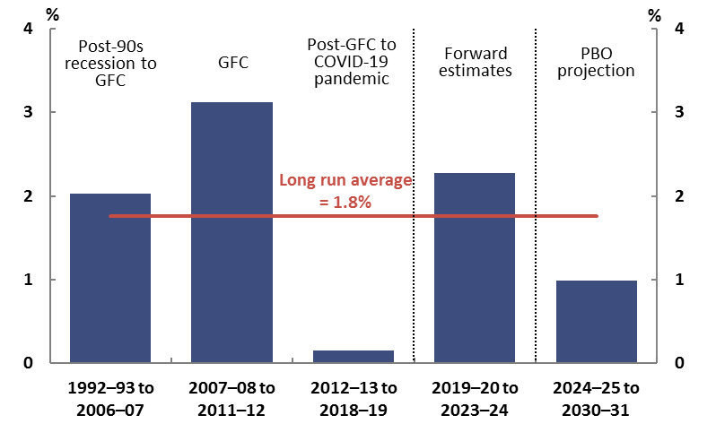

Source: 2020-21 Budget and PBO analysis.

Over the forward estimates period, the government projects that real per person payments will increase by an average of 2.3 per cent per year. This is a substantial increase in payments growth compared to the period 2012-13 to 2018-19, with real government payments per person moving above their long‑term growth rate as a result of the temporary increase in payments. Beyond the forward estimates period, the PBO projects that real government payments will increase by the lower rate of 0.9 per cent per year, as a combination of low indexation of eligibility thresholds for payments and low indexation for the payment rate of some programs puts downward pressure on payments as a per cent of GDP.

Historical growth rates for payments are driven by a combination of economic conditions, social trends (including demographic), policy changes, and other impacts. These factors may be specific   
to particular periods such that average historical growth rates may not be a reasonable guide to future trajectories.

## Payments growth by program

The PBO’s payments projections are based on individual analysis of 23 major program areas. Projections of payments generally assume policy settings and arrangements as contained in the budget estimates. Payments outside of the 23 major programs account for around 20 per cent of total payments, with the exception of 2019-20 and 2020-21 where many payments related to COVID‑19 were delivered outside of major ongoing programs. Appendix D provides detail on the approaches taken to generate the projections for each major program.

The change in projected payments between 2018-19 and 2030-31 is shown in Figure 3–3. Overall, payments are projected to increase as a share of GDP between 2018-19 and 2023-24, and then decrease as a share of GDP between 2023-24 and 2030-31.

Figure 3–3: Projected change in payments as a share of GDP, 2018-19 to 2030-31

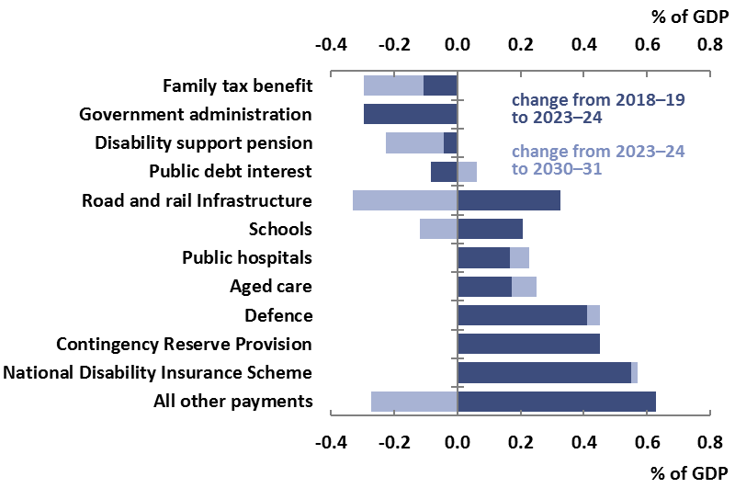

Note: ‘All other payments’ includes the total of all payments programs not separately identified in this chart.

Source: 2020-21 Budget and PBO analysis.

The largest increases in payments as a share of GDP are projected for the National Disability Insurance Scheme, Contingency reserve provision, defence, aged care and public hospitals.

Decreases are projected for some payment programs. This results from two broad factors. Firstly, income eligibility thresholds for payments often increase at a rate lower than wages growth, reducing the number of eligible recipients of some payments. Secondly, indexation for the payment rate of some programs is often lower than GDP, reducing the size of payments as a share of GDP. The decline in payments as a share of GDP on government administration over the forward estimates period is consistent with previous budgets and driven, in part, by the government’s efficiency dividend. After the forward estimates period, the PBO assumes that government administration payments will remain stable as a share of GDP for the rest of the decade.

## National Disability Insurance Scheme

The National Disability Insurance Scheme (NDIS) is the largest single contributor to growth in payments over the next decade. NDIS payments are projected to increase substantially from 0.6 per cent of GDP in 2018‑19 to 1.1 per cent in 2020‑21, reflecting the completion of the Scheme’s geographic rollout across Australia on 1 July 2020.  From 2022‑23, these payments are projected to remain stable at around 1.1 per cent of GDP.

## Defence

Defence payments are projected to increase by 0.5 percentage points to 2.4 per cent of GDP between 2018‑19 and 2030‑31, reflecting the government’s funding commitments in the *2016 Defence White Paper* and the *2020 Defence Strategic Update*. Defence payments in dollar terms are broadly consistent with projections included in the previous report, but this represents a larger increase as a percentage of GDP due to downward revisions to projected GDP levels.

There remains uncertainty around the projections in individual years, given that the acquisition of military equipment is inherently ‘lumpy’ in nature and can be subject to changes in the timing   
of delivery.

## Medicare Benefits Schedule

Payments on Medicare are projected to increase by 0.2 percentage points between 2018‑19 and 2030‑31. The increase is broadly in line with the pattern of recent years, which is driven by ongoing trends such as technological change and consumer preferences. While older individuals on average require additional health services, ageing is not the principal driver of projected health costs. Rather, there is a trend increase in spending on health across all age groups.[16]

## Aged care

Aged care payments are projected to increase by 0.3 percentage points between 2018‑19 and 2030‑31, from 1.0 per cent of GDP to 1.3 per cent of GDP, mainly reflecting the impact of the ageing population on the demand for aged care services.

Aged care consists of programs worth more than $20 billion with around two thirds of payments devoted to subsidies for residential care places and most of the remainder to the government’s two home care programs. In the 2020-21 Budget, the government announced an additional 23,000 home care packages as part of aged care, increasing payments over the forward estimates period by $1.6 billion.

The PBO assumes that the nominal value of payments for age care package subsidies grows in line with a combination of wages and other prices growth beyond the forward estimates period.  This is the same assumption applied to value of NDIS services beyond the forward estimates, reflecting the common cost pressures and related workforces across these sectors.

## Schools

Payments on schools are projected to grow by 0.1 percentage points to 1.1 per cent of GDP between 2018‑19 and 2030‑31. For the first few years, the budget forecasts schools payments to increase as a share of GDP, consistent with the government’s commitment to ensuring all schools currently funded below the Commonwealth share of the Schooling Resource Standard target will reach the target by 2023. The PBO projects schools funding to then decline gradually as a share of GDP to the end of the medium term. This is because projected nominal GDP growth is higher than the projected growth in schools funding resulting from the legislated indexation factor and the increase in student numbers.

## Child care

Payments for child care are projected to increase by 0.1 percentage points of GDP between 2018‑19 and 2030‑31. The government forecasts payments to increase over the forward estimates period, primarily due to increasing demand.

From 2024-25, the PBO projects that child care payments as a share of GDP will start to trend downward toward the end of the medium term. The subsidy rate for the child care subsidy (CCS) is income tested. As incomes are projected to increase faster than the thresholds, the average subsidy rate for households is expected to slowly decrease over the medium term.

## Income support for the unemployed

Income support for the unemployed, which is mostly JobSeeker payments and youth allowance (other) payments, is projected to be 0.5 per cent of GDP in both 2018-19 and in 2030-31. In aggregate, the annual real growth in income support for the unemployed over this time frame is projected to be 1.9 per cent.

The PBO has incorporated an adjusted methodology for this year’s projections of income support for the unemployed. Our 2019‑20 projections were based on the changes in the aggregate ratio of unemployed people as a share of the working age population. Our revised projections incorporate age- and gender-specific variations in the tendency to receive unemployment benefits by looking at the historical changes in the relationship between unemployed people and benefit recipients by gender and five-year age groups.[17]

Incorporating this level of demographic detail means the PBO will be better able to project the impacts of economic conditions and social welfare policy changes on different groups of unemployment benefit recipients. Based on the revised projections, the number of female recipients is expected to overtake the number of male recipients by around the mid-2020s. This is consistent with the trends observed prior to COVID-19.

While the longer-term trends identified in the report and accounted for in these projections will maintain upward pressure on unemployment benefits into the medium term, in aggregate, the effect of the change to methodology is less than $1 billion in any given year. The downward revisions to the government’s projections of the consumer price index (CPI) and population mean that total spending on income support for the unemployed is projected to be around $1.1 billion lower in 2029‑30 compared to the projections in the previous report.

While the outlook is highly uncertain, the trajectory for unemployment benefits will depend in part on the extent and nature of further COVID‑19 outbreaks in Australia and how these and the associated response measures affect the economic recovery, as well as broader labour market and population developments over the medium term.

## Public debt interest

Public debt interest payments at the end of the medium term are projected to be similar to 2018-19, at around 0.9 per cent of GDP. While government debt is now larger than in 2018-19 as a result of the pandemic and associated policy response, interest rates are historically low, keeping interest payments stable as a share of GDP. Low interest rates reflect the recent weakness in economic and price growth and the Reserve Bank of Australia (RBA) seeking to support the Australian economy.[18] Other central banks around the world are also setting interest rates low, in part to stimulate   
their economies.

Compared to the previous report, which projected a fall in government debt, interest payments toward the end of the medium term are 0.3 percentage points higher, as illustrated in Figure 3–4, and shown in Appendix B. The small volatility in the projections for public debt interest reflects the maturity dates for the various bond lines requiring re-financing.

Figure 3–4: Public debt interest

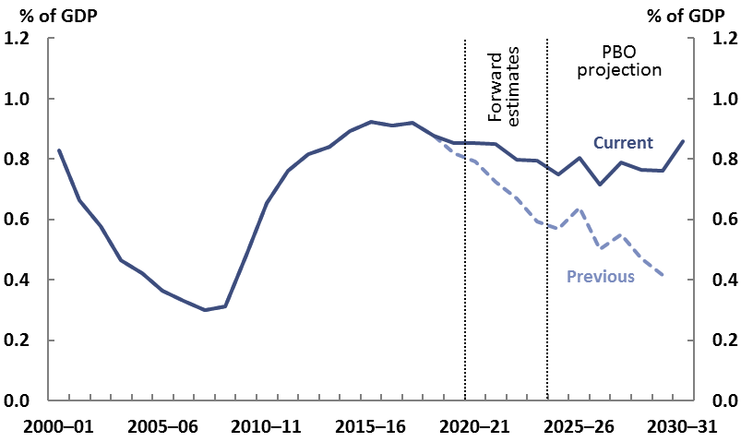

Note: 'Previous' refers to projections published in last year's report.

Source: Final Budget Outcomes, 2020-21 Budget and PBO analysis.

## The Contingency reserve

The Contingency reserve is an allowance within the [budget](https://www.aph.gov.au/About_Parliament/Parliamentary_Departments/Parliamentary_Budget_Office/Online_Budget_Glossary#budget) for policy changes or other items that the government expects but cannot allocate to specific government [programs](https://www.aph.gov.au/About_Parliament/Parliamentary_Departments/Parliamentary_Budget_Office/Online_Budget_Glossary#program) or publish separately in the budget.

A range of items may be put into the contingency reserve, such as the ‘conservative bias allowance’; items that are too sensitive to be disclosed separately, such as those that are commercial‑in‑confidence or that affect national security; provision for underspends in the current financial year; decisions that are taken by government but were not announced before the budget; expenses where the final cost depends on negotiations with another entity such as state and territory governments; and provisions for other specific events and pressures that are expected to affect the budget estimates but have not yet taken place.

The conservative bias allowance is typically the largest component of the Contingency reserve and accounts for the tendency for the costs of some existing government programs (particularly [demand‑driven programs](https://www.aph.gov.au/About_Parliament/Parliamentary_Departments/Parliamentary_Budget_Office/Online_Budget_Glossary#demand%20driven%20program)) to be higher than estimated.

The 2020-21 Budget includes additional provisions to the Contingency reserve totalling around $10 billion in 2023-24.[19] The PBO’s projections assume that the amounts allocated to the Contingency reserve, including the conservative bias allowance and the additional provisions, grow with nominal GDP over the medium term.

## Other payments

Table 3–1 shows the PBO’s projections of the change in payments by each major program over the period 2018-19 to 2030-31, each program’s projected contribution to growth in total payments, and the main drivers of the trends in each category. Appendix A provides a short description of the drivers of trends between 2018-19 and 2030-31 for all modelled receipts and payments. Appendix B provides a description of the drivers of changes since the previous report.

## Risks around expected payments

As mentioned earlier, the PBO’s projections are based on the policy settings underlying the 2020‑21 Budget and assume no change to these settings over the medium term. That is, the projections for payments assume no new payments initiatives beyond those that have been announced by government.

The largest risk to payments relates to the pandemic and the economic situation.  Either future outbreaks of COVID‑19, or a weaker‑than‑expected recovery from the economic downturn would be expected to increase payments through both ‘automatic stabilisers’ (for example, higher than expected unemployment benefits due to higher than expected unemployment levels) or the deployment of additional fiscal stimulus.  A related risk is that ongoing weaknesses in GST receipts and other state and territory revenue sources could result in calls for the Commonwealth to provide greater transfer payments to the states and territories.

Another risk around payments is ongoing pressures for increased payments in some payments areas. Many commentators, for example, have identified potential sources of payments pressure, such as in JobSeeker and aged care, reflecting community expectations around the level of income support and services that the government should provide.  While some of these pressures predated COVID‑19, in some cases they may have been made more salient by the pandemic.

Some behavioural responses to COVID‑19 could be persistent, including for example the balance of office‑ and home‑based work, and the ability to receive more services (such as GP visits) remotely.  While potentially resulting in profound changes in some people’s lives, in many cases the impacts on payments could be limited.  For example, a shift to more home‑based work in the same occupations would not have any direct impacts on the assistance families receive from government.  In other cases there could be shifts in demand for services such as telehealth.    
The size and nature of these kinds of impacts on payments or receipts are highly uncertain and have not been accounted for in this analysis.

Table 3–1: Payments by key program area

|  |  |  |  |  |  |  |  |
| --- | --- | --- | --- | --- | --- | --- | --- |
| **Payments** | **Nominal payments** | | **Per cent of GDP** | | **Change in percentage points of GDP** | **Annual real growth** | **Share of total payments** |
| **2018-**  **19** | **2030-31** | **2018-19** | **2030-31** | **2018-19 to 2030-31** | | **2030-31** |
|  | **$ billion** | | **%** | | **%** | **%** | **%** |
| GST transfers to states | 66 | 107 | 3.4 | 3.4 | 0.0 | 2.2 | 13.0 |
| Age pension | 47 | 79 | 2.4 | 2.5 | 0.1 | 2.6 | 9.6 |
| Defence | 38 | 76 | 1.9 | 2.4 | 0.5 | 4.0 | 9.2 |
| Medicare Benefits Schedule | 24 | 45 | 1.2 | 1.4 | 0.2 | 3.5 | 5.5 |
| Public hospitals | 22 | 42 | 1.1 | 1.3 | 0.2 | 3.8 | 5.1 |
| Aged care | 20 | 41 | 1.0 | 1.3 | 0.3 | 4.0 | 5.0 |
| National Disability Insurance Scheme | 11 | 36 | 0.6 | 1.1 | 0.6 | 8.2 | 4.4 |
| Schools | 20 | 35 | 1.0 | 1.1 | 0.1 | 2.9 | 4.2 |
| Public debt interest | 17 | 27 | 0.9 | 0.9 | 0.0 | 2.0 | 3.3 |
| Pharmaceutical Benefits Scheme | 13 | 21 | 0.7 | 0.7 | 0.0 | 2.3 | 2.5 |
| Disability support pension | 17 | 20 | 0.9 | 0.6 | -0.2 | -0.4 | 2.4 |
| Family tax benefit | 18 | 20 | 0.9 | 0.6 | -0.3 | -1.0 | 2.4 |
| Carer income support | 9 | 16 | 0.5 | 0.5 | 0.0 | 3.1 | 1.9 |
| Income support for the unemployed | 10 | 15 | 0.5 | 0.5 | 0.0 | 1.9 | 1.8 |
| Child care | 7 | 14 | 0.4 | 0.4 | 0.1 | 3.7 | 1.7 |
| Government superannuation | 7 | 13 | 0.4 | 0.4 | 0.0 | 2.8 | 1.6 |
| Fuel Tax Credit Scheme | 7 | 11 | 0.4 | 0.3 | 0.0 | 1.6 | 1.3 |
| Commonwealth Grants Scheme | 7 | 9 | 0.4 | 0.3 | -0.1 | 0.4 | 1.1 |
| Private Health Insurance Rebate | 6 | 9 | 0.3 | 0.3 | -0.1 | 0.8 | 1.0 |
| Road and rail infrastructure | 6 | 8 | 0.3 | 0.3 | -0.1 | 2.1 | 1.0 |
| Parenting payments | 5 | 6 | 0.3 | 0.2 | -0.1 | -0.6 | 0.7 |
| Official Development Assistance | 4 | 5 | 0.2 | 0.2 | 0.0 | 0.0 | 0.6 |
| Veterans support | 6 | 4 | 0.3 | 0.1 | -0.2 | -4.1 | 0.5 |
| **Total modelled payments** | **388** | **659** | **19.9** | **20.9** | **1.0** | **2.6** | **80.1** |
| **Other payments** | **90** | **164** | **4.6** | **5.2** | **0.6** | **3.2** | **19.9** |
| *Government administration* | *34* | *46* | *1.8* | *1.5* | *-0.3* | *0.6* | *5.6* |
| *Contingency reserve provision* | *0* | *14* | *0.0* | *0.5* | *0.5* | *-* | *1.7* |
| *Remaining payments* | *56* | *104* | *2.9* | *3.3* | *0.4* | *3.3* | *12.6* |
| **Total payments** | **478** | **823** | **24.5** | **26.1** | **1.6** | **2.7** | **100.0** |

Note: Numbers may not sum due to rounding.

Source: 2020-21 Budget and PBO analysis.

# Projected net debt and net financial worth

|  |
| --- |
| Key points   * The government projects that net debt will rise from 19.2 per cent of GDP ($374 billion) in 2018-19 to 43.8 per cent of GDP ($966 billion) in 2023-24. * Beyond the forward estimates period, the PBO projects net debt will gradually decrease as a share of GDP, to 40.9 per cent of GDP at the end of 2030-31. * Historically low interest rates mean that maintaining interest payments on higher debt levels is manageable, but the long-run improvement to the health of the budget will rely on economic growth. |

## Net debt

With the record increase in payments combined with the decrease in receipts, it follows that the 2020-21 Budget forecast a large increase in net debt over of the forward estimates period, from 19.2 per cent of GDP ($374 billion) in 2018-19 to 43.8 per cent of GDP ($966 billion) in 2023-24.

Net debt as a share of GDP is projected to peak in 2024-25, then stabilise and decline in the following years, reflecting decreasing budget deficits as payments decline and receipts continue to recover. The PBO projects that net debt will decline to 40.9 per cent of GDP ($1,291 billion) by 2030-31 (Figure 4–1), a significantly different outlook to the previous report when net debt was projected to be close to zero by the end of the medium term.[20]

Figure 4–1: Net debt, 1970-71 to 2030-31

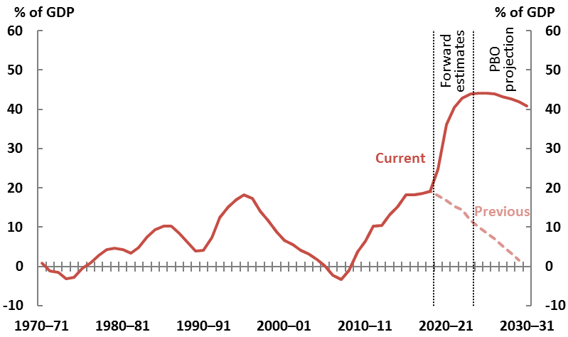

Note: 'Previous' refers to projections published in last year's report.

Source: 2020-21 Budget, 2019-20 Budget and PBO analysis.

As the budget is projected to remain in deficit, the gross debt-to-GDP ratio continues to increase over most of the decade. The net debt-to-GDP ratio declines over the medium term due to projected increases in asset balances (such as those held by the Future Fund) offsetting the extra debt issuance. A deficit is more readily managed when the growth of the economy is greater than the growth in the deficit and the interest payments associated with the government’s debt. The current low interest rate environment assists with the affordability of debt.[21]

While lower interest rates are favourable for issuing Australian Government Securities (AGS) in terms of lower servicing costs, lower interest rates have an adverse effect on the valuation of government debt. Lower future interest rates mean that the existing stock of government bonds already in the market is more attractive for investors, increasing the market value of debt as reported on the government’s balance sheet, including the measure of net debt.[22] The money the government needs to pay bond holders on maturity, however, is the face value of the bond, not the market value.

## Debt beyond the medium term

By the end of the medium term, the PBO projects the budget to remain in deficit and debt to remain high. While these projections do not extend beyond 2030-31, some of the longer‑term issues may be considered by comparison with two previous episodes: the early 1990s recession and the Second World War. As net debt was not recorded before 1970-71, in order to make these historical comparisons gross debt (AGS on Issue) is used (Figure 4–2).

The early 1990s recession resulted in debt increasing to 21 per cent of GDP but it fell to 5 per cent of GDP less than 15 years later in 2006. During this time income taxes recovered well, first through bracket creep and later through the mining boom of the 2000s decade. In addition, government sales of public assets, particularly Telstra, and cuts to government payments, resulted in debt being reduced more quickly than would have been possible otherwise.

Going back much earlier, the largest Commonwealth Government debt as a share of GDP in history was a result of the financing of the Second World War, through the issuance of special War Bonds, also used during the First World War. This debt reduced rapidly over the next 15 years, primarily as a result of very strong nominal GDP growth, averaging 14 per cent in the decade after the war, driven by high inflation, particularly during the Korean War wool boom in the early 1950s. With interest payments on the war bonds already ‘locked in’ at around 3.5 per cent, the real value of interest and debt decreased rapidly.

A primary mechanism for reducing debt in both cases was not paying back the debt, but allowing the economy, and hence government revenue streams, to grow naturally and reduce the relative value of the debt. For example, in 1945-46 war debt stood at over four times larger than government revenue, compared with less than 1.5 times larger in 1955-56, despite the value of debt remaining almost unchanged at around £160 million.

In both historical episodes Australia was the beneficiary of price spikes driven by unprecedented foreign demand, for our wool and iron ore, respectively. The Commonwealth was also able to proceed with considerable asset sales in the 1990s and 2000s to assist with paying down debt.

Figure 4–2: Gross debt (securities on issue, excluding borrowing on behalf of the states)   
and nominal GDP growth 1910-11 to 2030-31

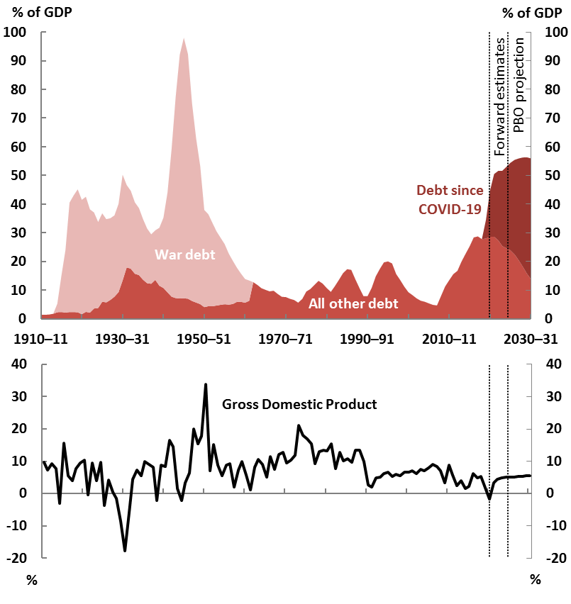

Note: Debt was zero from 1900-01 to 1910-11. War debt ceased being separately identified in Budget documents after 1962.[23] Debt since COVID-19 includes all debt incurred since the 2019-20 MYEFO. The figures in this chart differ from those published in Table 5 of Budget Paper 1, Statement 11. Until the mid-1990s the Australian Government managed State debt on their behalf. This debt is included in the historical tables in the Budget Papers, while Figure 4–2 abstracts from the State debt. Consistent with the treatment in the Budget, securities held by government investment funds have been netted out (on a pro-rata basis between Commonwealth non-war debt and State debt). GDP figures before 1959-60 are based on growth rates calculated by NG Butlin for the period to 1949-50 and from the Commonwealth Statistician, as published by the Reserve Bank of Australia for the period from 1949-50 to 1958-59.[24]

Source: Budget Papers 1901–2020 and PBO analysis.

There are, however, good reasons to consider that the current projected debt levels are similarly manageable. The government’s fiscal position prior to the pandemic was comparatively sound by international standards, and provided that the pandemic remains relatively controlled in Australia, the fiscal position is well placed to recover. Interest rates are currently highly favourable and government debt is largely ‘locked in’ at these rates for the next decade. Provided interest rates on government debt remain on average lower than economic growth then debt will reduce, albeit slowly. In addition, productivity growth increasing beyond that currently assumed would result in a faster reduction in the real value of the COVID-19 related debt.

## Risks around debt projections

While government finances will remain capable of withstanding economic cycles of historical magnitudes, more regular or larger disruptions, perhaps exacerbated by more frequent natural disasters, present a greater challenge if debt is already high, even if interest rates remain   
historically low.

Many of the risks around the fiscal position, including debt, relate to long-term economic growth prospects.  Strong nominal GDP growth, which will more rapidly reduce the real value of debt, will depend on the four factors of population, workforce participation, productivity and prices.  The government will update its long-run view on these in the next *Intergenerational Report*, expected   
in mid‑2021.

All four factors present challenges.  Firstly, projected fertility rates have already been revised down by the government, affecting long-run population growth.[25] Secondly, the ageing population is expected to constrain workforce participation. Thirdly, productivity growth may remain closer to the trend of around 1 per cent on average since 2005, lower than the 1.5 per cent assumed at the 2015 Intergenerational Report.[26] Fourthly, price growth may remain low through the medium term and beyond in the context of potential ongoing weakness in the global economy.

An additional key longer-term structural risk may arise from the nature of the current tax bases.  While governments have a high degree of control over their revenue, downward trends in indirect tax bases (fuel, tobacco, alcohol and the GST) mean that income taxes, particularly from individuals, will provide a larger share of government income, under current policy settings.

These are not new risks brought about by the pandemic.  The current level of debt, however, naturally prompts a longer-term view.  Some of these considerations will be examined further in the PBO’s forthcoming report on fiscal sustainability.

## Net financial worth

Net financial worth is a broader measure of the strength of the government’s balance sheet than net debt as it includes all of the Commonwealth’s financial assets and liabilities, including the unfunded superannuation liability and equity investments.

Net financial worth shows a sharp deterioration similar to that projected for net debt, with the 2020‑21 Budget forecasting net financial worth to worsen from -35.6 per cent of GDP ($694 billion) in 2018-19 to ‑49.9 per cent of GDP ($1,099 billion) in 2023-24, as shown in Figure 4–3.

From 2024-25 to the end of the medium term, net financial worth is then projected to improve to ‑43.5 per cent of GDP, driven by the same factors driving the reduction in net debt.[27]

Figure 4–3: Net financial worth

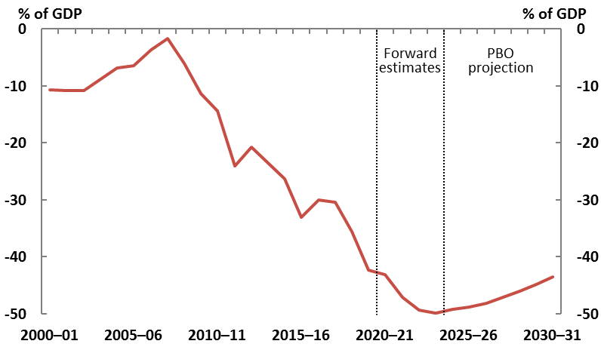

Source: 2020-21 Budget, 2019-20 Final Budget Outcome and PBO analysis.

Appendix A – Trends in projections over the medium term

This appendix describes the drivers of changes in all modelled receipts and payments between 2018‑19 and 2030-31.

Table A-1: Drivers of changes in receipts over the medium term

|  |  |  |  |  |
| --- | --- | --- | --- | --- |
| **Receipts** | **Per cent of GDP** | | | **Drivers of change (percentage points of GDP) over the medium term** |
| **2018-19** | | **2030-31** | **2018-19 to 2030-31** |
|  | **%** | | |  |
| Individuals and other withholding taxes | 11.5 | 11.8 | | Increases due to bracket creep, despite the implementation of Stages 2 and 3 of the government’s personal income tax plan. |
| Company tax | 4.8 | 4.2 | | Corporate profits were particularly strong in 2018‑19, due to high commodity prices. The medium term is broadly in line with recent trends. |
| Goods and services tax | 3.3 | 3.3 | | Dip in forward estimates period, but broadly unchanged by the end of the medium term, following the methodology change (see Box 4). |
| Excise and customs duty | 2.0 | 1.9 | | Decreases due to declining tobacco and alcohol consumption, combined with provisions for free trade agreements. |
| Superannuation taxes | 0.6 | 0.7 | | Increases as the superannuation system grows faster than GDP. |
| Other taxes and charges | 0.5 | 0.4 | | Broadly unchanged. Other taxes encompass a range of sources of revenue, including the major bank levy and agricultural levies. |
| Fringe benefits tax | 0.2 | 0.2 | | Broadly unchanged. |
| Wine equalisation tax | 0.1 | 0.0 | | Broadly unchanged at 0.05 per cent of GDP. |
| Luxury car tax | 0.0 | 0.0 | | Constant at 0.03 per cent of GDP. |
| Resource rent taxes | 0.1 | 0.0 | | Increases over the period to 2026-27 and then slowly declines by 2030-31. |
| **Total tax receipts** | **23.0** | **22.7** | |  |
| Non-tax receipts | 1.9 | 1.7 | | Decreases due to lower interest receipts, as interest rates are comparatively lower than nominal GDP growth. |
| **Total receipts** | **24.9** | **24.5** | |  |
| *Memorandum items:* |  |  | |  |
| *Capital gains tax* | 0.9 | 0.7 | | Decreases due to weaker asset prices from  COVID-19. |

Source: 2020-21 Budget and PBO analysis.

Table A-2: Drivers of changes in payments over the medium term

| **Payments** | **Per cent of GDP** | | **Drivers of change (percentage points of GDP) over the medium term** |
| --- | --- | --- | --- |
| **2018-19** | **2030-31** | **2019-20 to 2030-31** |
|  | **%** | |  |
| GST transfers to states | 3.4 | 3.4 | Unchanged overall, in line with GST receipts. |
| Age pension | 2.4 | 2.5 | Increases slightly as recipients grow with the ageing population. |
| Defence | 1.9 | 2.4 | Increase reflects the government’s funding commitments in the 2020 Defence Strategic Update. |
| Medicare Benefits Schedule | 1.2 | 1.4 | Increase reflects increases in demand for services. |
| Public hospitals | 1.1 | 1.3 | Increases reflecting the government’s previous commitment to the states and territories for the Commonwealth to fund 45 per cent of the efficient growth in activity based services for public hospitals. |
| Aged care | 1.0 | 1.3 | Increase reflects the increasing demand for aged care services as the population ages. |
| Schools | 1.0 | 1.1 | Increases in line with the government’s commitment to ensuring all schools currently funded below the Commonwealth share of the Schooling Resource Standard target will reach the target by 2023, then declines marginally as a share of GDP. |
| National Disability Insurance Scheme | 0.6 | 1.1 | Increases as the system expands to national coverage, then remains stable at 1.1 per cent of GDP from 2022‑23. |
| Public debt interest | 0.9 | 0.9 | Broadly unchanged. |
| Pharmaceutical Benefits Scheme | 0.7 | 0.7 | Broadly unchanged. |
| Disability support pension | 0.9 | 0.6 | Decreases overall, due to the assumed continuation of the trend decline in the use of this payment. |
| Family tax benefit | 0.9 | 0.6 | Decreases in line with historical decrease due to bracket creep |
| Carer income support | 0.5 | 0.5 | Broadly unchanged. |
| Income support for the unemployed | 0.5 | 0.5 | Broadly unchanged. |
| Child care | 0.4 | 0.4 | Broadly unchanged. |
| Government superannuation | 0.4 | 0.4 | Broadly unchanged. |
| Fuel Tax Credit Scheme | 0.4 | 0.3 | Broadly unchanged. |
| Commonwealth Grants Scheme | 0.4 | 0.3 | Decreases slightly over the medium term as funding is indexed to growth in the CPI, which is lower than growth in GDP. |
| Private Health Insurance Rebate | 0.3 | 0.3 | Decreases slightly overall, due to the assumed continuation of the slight historical trend decline in the coverage ratio over the last 10 years. |
| Road and rail infrastructure | 0.3 | 0.3 | Broadly unchanged. |
| Parenting payments | 0.3 | 0.2 | Decreases slightly overall, reflecting continuation of historical trend decline in uptake and lower expected population growth. |
| Official Development Assistance | 0.2 | 0.2 | Broadly unchanged. |
| Veterans support | 0.3 | 0.1 | Decreases over the medium term due to decline in recipients. |
| **Total modelled payments** | **19.9** | **20.9** |  |
| **Other payments** | **4.6** | **5.2** |  |
| *Government administration* | *1.8* | *1.5* | *Reduced spending (excluding NDIS and Defence) over the forward estimates extends into the medium term.* |
| *Contingency reserve provision* | 0.0 | 0.5 | *Increases over the forward estimates but remains steady in the medium term as the PBO’s projections assume that the Contingency reserve grows with nominal GDP.* |
| *Remaining payments* | 2.9 | 3.3 | *Increases, largely owing to the government's conservative bias allowance adjustment over the forward estimates* |
| **Total payments** | **24.5** | **26.1** |  |

Source: 2020-21 Budget and PBO analysis.

Appendix B – Changes in the PBO’s projections since the previous report

This appendix describes the reasons for changes in modelled receipts and payments as a per cent of GDP in this report compared to the previous report.

Table B-1: Changes in receipts projections

|  |  |  |  |
| --- | --- | --- | --- |
| **Receipts** | **Per cent of GDP, 2029-30** | | **Drivers of difference from previous report  (percentage points of GDP)** |
| **Previous report** | **Current report** |
|  | **%** | |  |
| Individuals and other withholding taxes | 12.0 | 11.6 | Downward revision driven by lower wages levels. |
| Company tax | 4.9 | 4.3 | Downward revision since previous report, resulting from weaker company tax receipts due to the  COVID-19 pandemic. |
| Goods and services tax | 3.4 | 3.3 | Broadly unchanged overall, but affected by revised methodology (see Box 4). |
| Excise and customs duty | 2.1 | 1.9 | Lower CPI and wage projections, affecting indexation rates. |
| Superannuation fund taxes | 0.7 | 0.7 | Broadly unchanged. |
| Other taxes and charges | 0.4 | 0.4 | Broadly unchanged. |
| Fringe benefits tax | 0.2 | 0.2 | Broadly unchanged. |
| Wine equalisation tax | 0.1 | 0.0 | Broadly unchanged at 0.05 per cent of GDP. |
| Luxury car tax | 0.0 | 0.0 | Broadly unchanged at 0.03 per cent of GDP. |
| Resource rent taxes | 0.0 | 0.0 | Broadly unchanged at 0.03 per cent of GDP. |
| **Total tax receipts** | **23.9** | **22.6** |  |
| Non-tax receipts | 1.6 | 1.7 | Broadly unchanged. |
| **Total receipts** | **25.5** | **24.3** |  |

Source: PBO analysis.

Table B-2: Changes in payments projections

| **Payments** | **Per cent of GDP, 2029-30** | | **Differences from last year's projections (percentage points of GDP)** |
| --- | --- | --- | --- |
| **Previous report** | **Current report** |  |
|  |  |  |  |
| GST transfers to states | 3.4 | 3.4 | Broadly unchanged overall, but affected by revised methodology and lower parameters. |
| Age pension | 2.4 | 2.5 | Higher due to an increase in the number of age pension customers and a lower level of GDP, partially offset by lower prices growth. |
| Defence | 2.2 | 2.4 | Higher as a share of GDP due to the government’s funding commitments in the 2020 Defence Strategic Update and the lower level of nominal GDP. |
| Medicare Benefits Schedule | 1.4 | 1.4 | Little change. |
| Public hospitals | 1.2 | 1.3 | Higher as a share of GDP due to a higher assumed national efficient price for services and the level of nominal GDP being lower than last year’s projections. |
| Aged care | 1.3 | 1.3 | Little change. |
| National Disability Insurance Scheme | 1.0 | 1.2 | Higher due to an increase in participants and average client costs. |
| Schools | 1.0 | 1.1 | Higher as a share of GDP due to the lower level of nominal GDP. |
| Public debt interest | 0.4 | 0.8 | Higher as a share of GDP due to the increase in debt. |
| Pharmaceutical Benefits Scheme | 0.5 | 0.7 | Higher due to a change in the way payments are administered, but this is not a real increase in net payments as a commensurate increase is seen in non-tax receipts. Growth is lower due to lower population and CPI forecasts. |
| Disability support pension | 0.7 | 0.7 | Little change. |
| Family tax benefit | 0.7 | 0.7 | Little change. |
| Carer income support | 0.5 | 0.5 | Little change. |
| Income support for the unemployed | 0.5 | 0.5 | Slightly higher, due to the PBO incorporating a demographic‑based sensitivity to unemployment. |
| Child care | 0.5 | 0.4 | Slightly lower by the end of the medium term reflecting changes in the methodology. Slightly higher for much of the rest of the medium term due to higher demand and the lower level of nominal GDP. |
| Government superannuation | 0.4 | 0.4 | Little change. |
| Fuel Tax Credit Scheme | 0.4 | 0.3 | Revised down in line with fuel excise, due to lower expectations for consumption over the medium term. |
| Commonwealth Grants Scheme | 0.3 | 0.3 | Little change. |
| Private Health Insurance Rebate | 0.3 | 0.3 | Little change |
| Road and rail infrastructure | 0.2 | 0.3 | Higher due to an increase in announced spending over the period 2020-21 to 2029-30. |
| Parenting payments | 0.2 | 0.2 | Little change. |
| Official Development Assistance | 0.1 | 0.2 | Higher as a share of GDP due to the lower level of nominal GDP. |
| Veterans support | 0.1 | 0.1 | Little change. |
| **Total modelled payments** | **19.6** | **20.9** |  |
| **Other payments** | **4.3** | **5.2** |  |
| *Government administration* | *1.5* | *1.5* | *Little change.* |
| *Contingency reserve provision* | *0.0* | *0.5* | *Revised up due to additional provisions to the Contingency reserve in the 2020-21 Budget.* |
| *Remaining payments* | *2.8* | *3.3* | *Revised in line with changing economic and fiscal conditions* |
| **Total payments** | **23.9** | **26.1** |  |

Source: PBO analysis.

Appendix C – Receipt projection methodology

The PBO’s projections comprise individual receipt projections of all of the Commonwealth government’s major heads of revenue.

The PBO’s projections of receipts are generally prepared using a base-plus-growth methodology. Economic parameters are used to estimate growth rates, which are then applied to the relevant   
base. The economic parameters used to estimate growth rates in this report are the same as   
those underpinning the 2020-21 Budget, as required by the PBO’s legislation.

For policy decisions where the impact is not already factored into the base-year data or the economic parameters, the projected impact of these measures are added to the base projections.

In order to incorporate the impact of recent trends in tax collection, the PBO uses the   
2020-21 Budget receipt forecasts for 2020-21, 2021-22, 2022-23 and 2023-24 as the base years for   
its projections.

Details of the methodology used to arrive at projections for the heads of revenue are outlined   
in the table below.

| Model | Description | Methodology |
| --- | --- | --- |
| Gross income tax withholding and gross other individuals and refunds | These heads of revenue broadly cover all personal income tax, including revenue from salary and wages, the Medicare Levy and Medicare Levy Surcharge, personal income tax offsets, income from profits from unincorporated businesses, primary production and investment activities, as well as capital gains. | The aggregate taxable income for individuals over the medium term is calculated by growing individual income items from the Australian Taxation Office’s Taxation Statistics data by the relevant economic parameters, most notably compensation of employees.  For each year, an average gross tax rate is applied, reflecting the policy settings and the economic parameters at the time of the  2020-21 Budget.  Projected tax offsets are applied and the timing of tax collections is taken into account to arrive at the receipts projections. |
| Company tax | Tax on profits, including capital gains, of incorporated businesses. | The projections are based on an approach whereby company tax revenue is recognised at the point that a company-tax-payable liability arises for a company from its underlying economic activity. Three industry groupings – Mining, Finance and all Other companies – are utilised in the projection modelling, to reflect structural differences in companies from different industries. The tax base across the three sector groupings  is grown with the Gross Operating Surplus economic parameter corresponding to the relevant industry grouping. Adjustments are made to capture depreciation and net  capital gains.  Adjustments are made to account for other elements (principally the research and development tax offset) that are reported against company tax receipts. |
| Goods and services tax (GST) | Indirect tax on the consumption of certain goods and services. | GST receipts are projected based on the growth in consumption, private dwelling investment, and ownership transfer costs. Growth is tapered to account for the declining trend in household consumption subject to GST. |
| Customs and excise | Includes customs duties on textiles, clothing and footwear, passenger motor vehicles and other imports, excise on fuel, and excise and customs duties on tobacco and alcohol (except wine, for which WET applies). | Receipts from each category of excise and customs duty are projected in a similar way:  a growth rate is determined using a quantity parameter, and where appropriate, prices are grown using the appropriate price parameter.  The relevant parameters are:   * fuel—private consumption of fuel, real GDP and the CPI * textile, clothing and footwear—imports of textiles, clothing and footwear * passenger motor vehicles—imports of non-industrial transport equipment * other imports—imports of endogenous goods less imports of non-industrial transport equipment, textiles, clothing and footwear * tobacco—private consumption of cigarettes and Average Weekly Ordinary Time Earnings * alcohol—private consumption of alcohol and the CPI.   Provisions for free trade agreements are also applied, consistent with budget estimates. |
| Superannuation  fund taxes | Tax on superannuation fund contributions and investment earnings, including capital gains, of Australian Prudential Regulation Authority (APRA) funds and self-managed super funds. | Projections for the taxable income of  APRA-regulated superannuation funds and  self-managed superannuation funds are based on the structure of a superannuation fund’s  tax return.  Historical data from APRA’s Annual Superannuation Bulletin and the Australian Taxation Office’s Taxation Statistics data are grown by relevant economic parameters for projections of taxable income. Statutory tax rates are then applied to the projections of taxable income.  Projected tax offsets are applied and the timing of tax collections is taken into account to arrive at the receipts’ projections. |
| Other taxes and charges | Other indirect taxes and levies, including the major bank levy and agricultural levies. | Other taxes and charges are projected based on the growth in nominal GDP. |
| Fringe benefits tax (FBT) | FBT is separate to income tax and is paid by employers, based on the taxable value of the fringe benefit provided to employees. | FBT receipts are projected based on the compensation of employees parameter. |
| Wine equalisation tax (WET) | A value-based tax on wine consumed in Australia. | WET receipts are projected based on the growth in private consumption of alcohol. |
| Luxury car tax (LCT) | A tax on luxury cars sold or imported, where their value exceeds a threshold. | LCT receipts are projected based on the growth in sales of cars, and the motor vehicle price indicator. |
| Petroleum Resources Rent Tax (PRRT) | Tax on profits from sales of petroleum products. | PRRT receipts are calculated on a project-by-project basis using expenditure and output data and the oil price parameter underpinning the 2020-21 Budget, which is grown by CPI beyond the forward estimates period. |
| Non-tax receipts | Includes interest and dividend earnings (including Future Fund earnings), NDIS contributions from the states and territories, sale of non-financial assets, and other non-tax receipts. | The largest component of receipts from the sales of goods and services are NDIS contributions from the states and territories, which are consistent with the PBO’s profile of NDIS expenditure over the medium term.  Future Fund earnings are projected over the medium term using the projection methodology from PBO Report no. 01/2017 *Future Fund drawdown scenarios: Budget implications*. Reflecting the government’s decision to delay the drawdown of the Future Fund and to reduce its target return to at least the CPI plus 4 to 5 per cent, drawdowns are assumed to occur in 2030-31. Assumed asset allocations and benchmark returns are used to project future earnings and balances for the Future Fund. Under the *Future Fund Act 2006*, net Future Fund earnings will be available to meet the government superannuation liability in 2020-21. Consistent with the 2020-21 Budget assumption, the underlying cash balance includes expected net Future Fund earnings from 2020-21.  The remainder of non-tax receipts are consistent with the 2020-21 Budget forward estimates period and then assumed to remain as a constant share of nominal GDP over the medium term. |

Source: PBO analysis.

Appendix D – Payments projection methodology

The PBO’s payments projections comprise 23 individual projections of key government payments, which in total comprise approximately 80 per cent of total government payments.

Up to 2023-24, the PBO’s payments projections are consistent with the 2020-21 Budget forward estimates period and are used as the base for projecting expenditure over the medium term.

Projected levels of payments beyond 2023-24 have been prepared using a range of PBO models based on information provided by government agencies, which take account of population growth, the age structure of the population, estimates of trends in the demand for government services, and program indexation arrangements.

The PBO’s projections are based on the policy settings underlying the 2020-21 Budget and assume no change to these settings over the medium term. Where government policy has not been made explicit beyond the forward estimates period, the PBO’s projections assume the continuation of the current policy settings.

The main exception to this is the projection for payments on pharmaceutical benefits, which is inextricably linked to decisions of government. To not factor in any policy decisions would result in implausibly low estimates of payments over the next decade.

Departmental expenses have been excluded from modelled programs, except in the cases of defence payments and the NDIS where departmental costs are an integral part of the program.

Details of the methodology used to arrive at projections for individual programs are outlined in the table below.

| Model | Description | Methodology |
| --- | --- | --- |
| GST transfers to states | GST receipts less non-general interest charge penalties collected. | See Appendix C – Receipts projection methodology, GST receipts. |
| Age pension | Includes the age pension under  the Income Support for Seniors program. | Projected expenditure for the age pension is calculated as projected recipients multiplied by the average payment rate.  Age pension recipients are projected by applying a trend of age pension recipients to the Australian population of age pension age over the medium term, adjusted for changes in the age pension eligibility age.  The projected average rate of payment is based on projections of Male Total Average Weekly Earnings, CPI, and Pensioner and Beneficiary Cost of Living Index, and the proportions of full-rate and part-rate age pension recipients. |
| Defence | The net cost of service for the Department of Defence (including the Australian Signals Directorate), including employee costs, supplies, and purchases of capital including specialist military equipment. | Projections of defence spending over the medium term are based on long-term funding commitments made in the 2020 Defence Strategic Update, updated for developments in the 2020-21 Budget.  For 2030-31 the PBO has assumed growth in defence spending is maintained at the  2029-30 rate. |
| Medicare Benefits Schedule (MBS) | Comprises Department of Health related payments under the Medicare Benefits Schedule. | Detailed historical data is used to model payments by age, gender and service type (eg general practitioner services, allied health, etc). Historical average levels in services per capita and real benefits per service are used to project total payments. Methodology is based on PBO research and is described in more detail in Appendix C – Technical notes and sources of the PBO Report no. 04/2015 *Medicare Benefits Schedule: Payments trends and projections*. |
| Public hospitals | Commonwealth funding of  public hospitals | Projected Commonwealth funding for public hospitals over the medium term is set with reference to the annual determination of the National Efficient Price (NEP).  This funding profile is based on the 2020-2025 National Health Reform Agreement.  The PBO assumes that the funding arrangement will continue over the projection period.  The projection of price growth in providing hospital services is based on the indexation rate in the latest NEP determination.  Growth in the number of patient services is projected based on the trend of historical number of services provided annually. |
| Aged care | Consists of subsidies for residential care, the Commonwealth Home Support Program, and subsidies for Home Care Packages. | The number of subsidised aged care places reflects government policy to provide 80 residential and restorative aged care places per 1,000 persons aged 70 years and over and also includes the increased number of home care packages announced in the 2020-21 Budget. The average value of aged care package subsidies is assumed, by the PBO, to grow by a composite index consisting of 75 per cent wages and 25 per cent CPI. The Commonwealth Home Support Program is an annual appropriation projected to grow at a wage cost index plus 3.5 per cent (in line with the aged care measure announced in the 2014-15 Budget). |
| National Disability Insurance Scheme (NDIS) | The coverage of the NDIS projections is the administered and departmental payments of the National Disability Insurance Agency (NDIA). | Expenditure projections (in accrual terms) of recipients’ care and support are based on projections of the number of recipients of two cohorts, aged 0–64 years and aged 65 years and over, and the average disability package costs. Beyond the forward estimates period, the PBO assumes that average disability package costs are grown annually by a combination of wage growth (75 per cent weighting) and the change in the CPI (25 per cent weighting). The number of recipients is assumed to grow in line with population growth.  Spending projections (in cash terms) are calculated by applying a ratio of payments to expenses. From around 97 per cent by the end of the forward estimates period, this ratio increases to 100 per cent by the end of the medium term, largely reflecting a reduction of in-kind payment arrangements between states and territories and the Commonwealth.  The departmental spending of the NDIA is assumed to grow in line with overall administered NDIS spending beyond the forward estimates period. |
| Schools | Comprises the Quality Schools National Specific Purpose Payment from the Commonwealth to states  and territories for government and  non‑government schools. | Projections are based on the Quality Schools policy as legislated under the *Australian Education Act 2013*.  This was further enhanced through the legislation of the *Australian Education Amendment Act 2017*, which introduced, amongst other reform measures, a new method for calculating a school communities’ capacity to contribute based on a direct measure of income and additional funding to assist transition for non-government schools.  Schools are funded by a per-student amount based on the Schooling Resource Standard and additional amounts for six loadings that reflect the student profile, location and size of the school.  Schools expenditure over the medium term is calculated based on achieving target levels of the funding as a share of the Schooling Resource Standard by 2029.  The target for non-government schools (Catholic and independent) is 80 per cent.  The target for government schools is 20 per cent.  Schools funded below the target will transition by 2023, while those above the target will transition by 2029. |
| Public debt interest (PDI) | Interest paid on Australian Government Securities on issue. | Public debt interest payments are projected based on the financing task implied by PBO projections of receipts and all other payments (excluding PDI payments), and adopt the same assumptions regarding interest rates on Australian Government Securities as the 2020‑21 Budget. |
| Pharmaceutical Benefits Scheme | Comprises the special appropriation of the Pharmaceutical Benefits Scheme. | Pharmaceutical benefit projections are calculated by taking historical expenditure data, grouped by age and gender cohorts, and calculating the historical per capita growth in expenditure. This is then used to derive a trend growth for pharmaceutical benefits payments per capita over the medium term. |
| Payments to individuals | Social security payments including the Family Tax Benefit; Disability Support Pension; Carer income support (primarily Carer Payment and Carer Allowance); Parenting Payments (Single and Partnered); and income support for the unemployed (includes JobSeeker payment and Youth Allowance (Other), as well as Sickness Allowance and Newstart historically). | Projected expenditure on these payments is calculated as projected recipients multiplied by the average payment rate.  Recipient numbers for each payment are projected by applying historical trends in take-up rates (by age and gender cohorts) to medium-term population projections. Income support payments for the unemployed are also adjusted for projected changes in unemployment and sensitivity to the unemployment rate by age and gender cohorts. Some working age payments are also adjusted to reflect the increase in the age pension eligibility age from 65 to 67 by 2023-24.  The average rate of payment is grown by the respective legislated indexation factor (for example the CPI). |
| Child care | Child Care Subsidy | The number of recipients of the CCS is projected based on the rate of population growth of young children plus an additional growth factor (based on historical data) to account for usage growing faster than the eligible population.  Child care prices are projected to grow in line with recent historical trends in child care fees, adjusted to account for the impact of the fee cap.  The average subsidy rate is calculated based on the projected thresholds for the income tests in each future year. |
| Government superannuation | Cash payments associated with the unfunded civilian and military schemes. | Projections are based on the *Long Term Cost Reports* updated for developments in subsequent budgets. |
| Fuel tax credit scheme | Credits for the excise or customs duty on fuel a business uses in machinery, plant, equipment, heavy vehicles and light vehicles travelling off public roads or on private roads. | Fuel Tax Credit Scheme expenditure is calculated by applying credit scheme rates on projected fuel excise and customs duty revenue collections (see Appendix C – Receipts projection methodology, Customs and excise). Credit scheme rates are projected by indexing them in line with the CPI. |
| Commonwealth Grant Scheme (CGS) | Grant funding to higher education providers for students enrolled in a Commonwealth Supported Place (CSP) at the institution. | CGS expenditure is calculated based on the arrangements announced as part of the Government’s Job-ready Graduates package, and incorporates CSP student enrolment projections across subject bands, with varying per-student amounts for areas of study. |
| Private health insurance (PHI) rebate | Department of Health and Australian Taxation Office payments related to the  PHI rebate. | Expenditure on PHI is projected to grow in line with the population, CPI, and coverage ratio. The coverage ratio has been modelled based on recent historical trends. |
| Road and rail Infrastructure | Comprises payments for road and rail projects. | The PBO projection accounts for all announced projects.  Expenditure from 2020-21 to 2030-31 reflects the PBO’s projected profile of spending on currently agreed road and rail infrastructure projects included in the 2020-21 Budget.  The PBO projection is lower than total Commonwealth infrastructure investment as it does not include infrastructure investment funded through equity injections into public non-financial corporations such as the Australian Rail Track Corporation or concessional loans such as the loan to the New South Wales Government for the WestConnex project. |
| Official Development Assistance | Comprises expenditure on foreign aid administered by the Department of Foreign Affairs and Trade, and a small component for associated spending in other departments. | After an indexation freeze introduced in the 2017‑18 Budget, Official Development Assistance has been capped at $4.0 billion to 2021-22 before indexation recommences. Expenditure beyond the forward estimates is projected by indexing the payment to growth in the CPI. |
| Veterans’ support | Comprises expenditure on income support and health programs for veterans, widowers and dependents. | Projections of expenditure on veterans’ support are based on projected growth in recipient numbers and the average payment for the service provided.  Recipient projections are based on 10-year Pensioner Beneficiary Statistics prepared by  the Department of Veterans’ Affairs.  The average rate of payment is grown by the relevant indexation factor for that program, adjusted for historical trends in payment rates for those payments which are income tested. |
| Contingency reserve | The Contingency reserve is an allowance within the budget for policy changes or other items that the government expects but cannot allocate to specific government programs or publish separately in the budget. The Contingency reserve may include a range of items, such as the ‘conservative bias allowance’; items that are too sensitive to be disclosed separately such as those that are commercial in-confidence or that affect national security; provision for underspends in the current financial year; decisions that are taken by government but were not announced before the budget; expenses where the final cost depends on negotiations with another entity such as state and territory governments; and provisions for other specific events and pressures that are expected to affect the budget estimates but have not yet taken place. | Amounts allocated to the Contingency reserve, including the conservative bias allowance and the additional provisions, are grown by the growth rate of nominal GDP over the medium term. |
| Other payments | Other payments include payments that are not modelled by the PBO. This covers government administration, a range of small grant and subsidy programs, and smaller specific purpose payments to the states (ie other than health, education and infrastructure). | Payments not modelled by the PBO are grown by the growth rate of nominal GDP over the medium term. |

Source: PBO analysis.

Appendix E – Changes in fiscal strategy over time

| **Budget update** | **Strategic focus** | **Medium term strategy** | **Goal** | **Metric** | **Note** | **Source** |
| --- | --- | --- | --- | --- | --- | --- |
| 2014-15 Budget | Budget repair | Medium term fiscal strategy is to achieve budget surpluses, on average, over the course of the economic cycle | To deliver budget surpluses building to at least 1 per cent of GDP by 2023-24 | Surplus as % of GDP | Target date of 2023-24, end of MT | BP 1, p. 3‑7 (Box 1) |
| 2015-16 Budget | Budget repair | Medium term fiscal strategy is to achieve budget surpluses, on average, over the course of the economic cycle | To deliver budget surpluses building to at least 1 per cent of GDP by 2023-24 | Surplus as % of GDP | Target date of 2023-24, end of MT | BP 1, p. 3‑4 (Box 1) |
| 2015-16 MYEFO | Budget repair | Medium term fiscal strategy is to achieve budget surpluses, on average, over the course of the economic cycle | To deliver budget surpluses building to at least 1 per cent of GDP as soon as possible | Surplus as % of GDP | No target date | MYEFO,  p. 18. |
| 2016-17 Budget | Budget repair | Medium term fiscal strategy is to achieve budget surpluses, on average, over the course of the economic cycle | To deliver budget surpluses building to at least 1 per cent of GDP as soon as possible | Surplus as % of GDP | No target date | BP1, p. 3-7 (Box 1) |
| 2017-18 Budget | Budget repair | Medium term fiscal strategy is to achieve budget surpluses, on average, over the course of the economic cycle | To deliver budget surpluses building to at least 1 per cent of GDP as soon as possible | Surplus as % of GDP | No target date | BP1, p. 3-7 (Box 1) |
| 2018-19 Budget | Budget repair | Medium term fiscal strategy is to achieve budget surpluses, on average, over the course of the economic cycle | To deliver budget surpluses building to at least 1 per cent of GDP as soon as possible. Maintaining the tax-to-GDP ratio at or below 23.9 per cent of GDP.[28] | Surplus as % of GDP | No target date | BP1, p. 3-7 (Box 1) |
| 2019-20 Budget | Budget repair & balanced budget | Medium term fiscal strategy is to achieve budget surpluses, on average, over the course of the economic cycle | To deliver budget surpluses building to at least 1 per cent of GDP as soon as possible. Maintaining the tax-to-GDP ratio at or below 23.9 per cent of GDP. | Surplus as % of GDP | No target date | BP 1, p. 3‑8 (Box 1) |
| 2019-20 MYEFO | Balanced budget | Fiscal strategy is to achieve budget surpluses, on average, over the course of the economic cycle. | Building sustainable budget surpluses of at least 1 per cent of GDP when economic circumstances permit to build resilience and support fiscal flexibility. Maintaining the tax-to-GDP ratio at or below 23.9 per cent of GDP. | Surplus as % of GDP | No target date | MYEFO,  p. 31  (Box A) |
| 2020-21 Budget | Economic recovery | Medium term fiscal strategy is to grow the economy in order to stabilise and reduce debt. | **Phase 1**: Promote employment, growth and business and consumer confidence; **Phase 2**: stabilise and then reduce gross and net debt as a share of the economy. Maintaining the tax-to-GDP ratio at or below 23.9 per cent of GDP. | Gross and net debt | Phase 1: Unemployment rate comfortably below 6 per cent  Phase 2: No target date | BP 1, p. 3‑8 (Box 1) |

Source: Budget papers.

Appendix F – Glossary

|  |  |
| --- | --- |
|  |  |
| **Accrual accounting** | Accrual accounting records income when it is earned, and records costs when they are incurred, regardless of when the related cash is received or paid. Under accrual accounting, government income is called ‘revenue’ and costs are generally called ‘expenses’. As an example, under accrual accounting, goods and services tax revenue is recorded in the financial year that the goods and services are purchased, even though the government may not receive the related tax amounts until the following financial year. |
| **Cash accounting** | Cash accounting records income when cash is received, and records costs when cash is paid out, regardless of when those amounts are earned or incurred. For example, under cash accounting, goods and services tax receipts are recorded in the financial year they are received, even though those tax amounts may relate to goods and services purchased in the previous financial year. Under cash accounting, government income is called ‘receipts’ and costs are called ‘payments’. |
| **Net debt** | Net debt is the sum of selected financial liabilities (deposits held, advances received, government securities, loans and other borrowings) less the sum of selected financial assets (cash and deposits, advances paid, and investments, loans and placements). It is a common measure of the strength of a government’s financial position. |
| **Net financial worth** | Net financial worth measures the total financial assets (such as cash or shares in a company) held by a person or organisation at a fixed point in time, minus the value of any liabilities, such as outstanding debts. |
| **Payments** | Payments capture all outgoing cash transactions from the Commonwealth Government to individuals, organisations or other levels of government. In the Commonwealth budget context, payments are those that affect the underlying cash balance and comprise cash transactions for operating activities and the purchase of non-financial assets. Examples include an age pension payment, a Medicare rebate for a doctor's visit, and the wages of  a Centrelink employee. |
| **Public debt interest** | Public debt interest (PDI) is the borrowing costs of the government, mainly incurred through issuing and servicing government debt, and recorded as a cost to government in the budget. In 2018‑19, public debt interest expenses were around $17 billion, about the same size as expenditure on the Family Tax Benefit. |
| **Receipts** | Receipts are the government's income, recorded at the time they are received as reported on a ‘cash accounting’ basis. In the Commonwealth budget context, receipts are those that affect the underlying cash balance, so exclude the repayment of loans and other cash flows relating to the exchange of financial assets. The majority of government receipts are tax receipts, such as company tax, personal income tax, and goods and services tax. The government also receives non-tax receipts, such as interest earned on government loans and dividends from government investments. |
| **Underlying cash balance** | The underlying cash balance (UCB) is the difference between the government's receipts and its payments. It is one of several indicators known as ‘budget aggregates’ that measure the impact of the government's budget on the economy. When the government or the media say the budget is in surplus or deficit, they are generally referring to the underlying cash balance, or sometimes the net operating balance or fiscal balance. |

1. The budget balance is a key driver of the change in net debt from year to year. The underlying cash balance (UCB) is commonly referred to in public discussion about the budget balance, but is a cash concept while net debt is an accrual concept. In this respect, the two are not directly related within government financial statements. The next edition of the PBO’s medium-term projections will incorporate projections on an accrual basis, including the fiscal balance, to show the connections between the fiscal stocks and flows.
2. The UCB is only available back to 1970‑71, and is included in the 2020‑21 Budget Paper no. 1, Statement 11.
3. See Appendix F for a brief glossary defining underlying cash balance and other budget terms and the PBO’s [online budget glossary](https://www.aph.gov.au/About_Parliament/Parliamentary_Departments/Parliamentary_Budget_Office/Online_Budget_Glossary) for further information.
4. In previous medium-term fiscal projections report, the base year of comparison has been the year prior to the budget year, which for this report would be 2019‑20. However, 2019‑20 was unusual due to the COVID-19 pandemic and associated policy response. In order to focus on the longer‑term effects of the pandemic on the budget, this report instead uses 2018–19 as the comparison year.
5. For further information on the difference between projections and predictions, see Box 1 in PBO Report no. 03/2019 *2019–20 Medium-term fiscal projections* (hereafter referred to as ‘the previous report’).
6. The requirement for publishing a fiscal strategy is set out in the *Charter of Budget Honesty Act 1998* (the Charter) which provides the legal foundation for Commonwealth fiscal policy. The Charter’s framework and principles are deliberately broad, giving governments scope and flexibility to set out a strategy that focuses on matters of importance given the economic situation and their particular priorities, while remaining consistent with the principles of sound fiscal management set out in legislation.
7. The June quarter 2020 saw a six per cent decrease in gross national income, followed by a four per cent recovery in the September quarter 2020.
8. Further discussion on the effect of the pandemic on GDP can be found in the Reserve Bank of Australia’s *Statement on Monetary Policy*, November 2020.
9. For a short description of the drivers of difference between the PBO’s projections for specific receipts and payments in the previous report and the current report, see Appendix B.
10. See 2020‑21 Budget Paper no. 1, p. 2-32.
11. Appendix C describes the methodology used to generate projections for different taxes and other receipts.
12. Total receipts are equal to tax receipts plus non-tax receipts. The tax cap does not apply to non-tax receipts.
13. Smaller tax cuts, such as those through 2003 to 2006, are not separately identified.
14. The 2018‑19 Budget included the Government’s *Personal Income Tax Plan*, and the 2019‑20 Budget included *Lower taxes for hard-working Australians: Building on the Personal Income Tax Plan*. The 2020‑21 Budget adjusted the tax plan timing with the measure *JobMaker Plan — bringing forward the Personal Income Tax Plan and retaining the low and middle income tax offset*.
15. PBO report no. 02/2020 *Structural trends in GST*.
16. See discussion in PBO report no. 02/2020 *Structural trends in GST.*
17. This revision to methodology was foreshadowed in the recent PBO report 03/2020 *JobSeeker Payment: Understanding economic and policy trends affecting Commonwealth expenditure.*
18. In a recent speech (*Monetary Policy in 2020*, Australian Business Economists Webinar, 24 November 2020), Deputy Governor Guy Debelle outlined how the RBA has taken several actions to support the economy including a reduction in the cash rate target.
19. 2020‑21 Budget Paper no. 1, p. 6-45. The total Contingency reserve expense in 2023‑24 is forecast to be $21.6 billion, of which around $10 billion is from the conservative bias allowance and around $1 billion from decisions taken by not yet announced (Budget Paper no. 2, pp. 45 and 174).
20. This compares with the budget’s projection of net debt reaching 39.6 per cent of GDP by the end of the medium term.
21. The net debt position is a consequence of the accumulated receipt and payments flows discussed in previous chapters, as well as revaluations of some government assets. Should these flows change from those projected in this report, this would also change the projected level of net debt.
22. PBO Report no. 05/2017 *2017‑18* *Budget medium-term projections: economic scenario analysis*.
23. Although official documents report figures regarding war debt as being ‘no longer available’ after 1962 (eg Commonwealth Grants Commission 34th Report, 1967, p. 167), Parliamentary Hansard reports ‘unacquired war debt’ of over $1 billion (4 per cent of GDP) still outstanding as at 30 June 1968 (Question Upon Notice No. 951, from   
    Mr Hayden to then Treasurer McMahon, answered 26 November 1968).
24. *The Australians: Historical Statistics Chapter 8 – Australian National Accounts* (1987), accessed at: socialsciences.org.au
25. Centre for Population, *A projection of Australia’s future fertility rates* (2020).
26. Productivity Commission, *PC Productivity Insights: Recent Productivity Trends* (2020).
27. Historical net financial worth data, published in Final Budget Outcome documents, have recently been much larger than estimated in budget documents. These revisions largely reflect differing valuations for the government’s defined benefit superannuation liability, due to differences between budget and accounting methodologies. At the 2020‑21 Budget, defined benefit superannuation liabilities were valued using a discount rate of 5.0 per cent per year, which is an average annual rate estimated to apply over the remainder of the term to maturity. For the Final Budget Outcome, Australian Accounting Standards require the use of the current long-term government bond rate, which for 2019‑20 was between 1.0 and 1.7 per cent per year (depending on the scheme). See the 2019‑20 Final Budget Outcome, p. 45.
28. Before the 2014‑15 Budget, the tax element of the fiscal strategy was to keep taxes as a share of GDP on average below the level for 2007‑08.