JobSeeker payment
Report No.
03/2020
Understanding economic and policy trends affecting Commonwealth expenditure

© Commonwealth of Australia 2020
ISBN 978-0-6483701-8-5 (online)
Copyright notice
This work is licensed under the Creative Commons Attribution-NonCommercial-NoDerivs
3.0 Australia License http://creativecommons.org/licenses/by-nc-nd/3.0/au/
Attribution
This publication should be attributed as follows: Parliamentary Budget Office, JobSeeker Payment: Understanding economic and policy trends affecting Commonwealth expenditure.
Use of the Coat of Arms
The terms under which the Coat of Arms can be used are detailed on the following website: https://www.pmc.gov.au/government/commonwealth-coat-arms
Feedback
If you found this report useful, or have suggestions for improvement, please provide feedback to feedback@pbo.gov.au.

Contents
Overview ii
1 JobSeeker expenditure: understanding changes over the last three decades 1
1.1 Total Commonwealth spending on social security and welfare 1
1.2 Historical trends in JobSeeker expenditure 3
2 Changing composition of the JobSeeker population—trends and drivers 8
2.1 JobSeeker recipients’ demographics have changed significantly 9
2.2 The share of longer-term JobSeeker recipients is rising 15
2.3 Almost half of all JobSeeker recipients are not required to search for jobs 18
3 Impact of COVID-19 on JobSeeker expenditure 21
3.1 JobSeeker recipient changes since the pandemic commenced 22
4 Budget implications over the medium term 25
Appendix A: JobSeeker and JobKeeper 27

This paper was authored by Binod Nepal and Kathryn Smith, with the benefit of comments by Liyi Pan, Linda Ward, John Clark and Nick Ramirez. The contents of the report are the sole responsibility of the Parliamentary Budget Office.

Overview
JobSeeker expenditure averages around six per cent of social security and welfare expenditure…
JobSeeker payment (previously Newstart allowance) is the main income support payment for people aged 22 through to age pension age who are looking for work.
…but can be a major source of fiscal pressure during times of economic crisis.
For example, spending on unemployment benefits in 2019–20 was almost double the government’s forecast before the COVID-19 pandemic, with a near-doubling of both the effective JobSeeker payment rate (via a temporary supplement) and the number of recipients, relative to their pre-COVID levels. While the extent of this increase is greater than other recent economic crises, these too have seen elevated spending on unemployment benefits.
Historically the relationship between unemployment levels and benefits has been quite close…
The historical relationship between the unemployment level and unemployment benefit recipients has been the primary factor for many economists when projecting future fiscal pressures associated with the Jobseeker payment.
…but the JobSeeker recipient population has changed….
A growing share of recipients—two-thirds in 2019 compared to half in 2007—have been on the payment for more than a year, and a growing share does not have full capacity to work.
…with the typical recipients now older people rather than younger men.
In the 1990s, two in five recipients were men under 35. By 2019, this was around one in six, and half of all recipients were aged 45 years or above. Of those aged 60 and over, there were more females, with women aged 60 and above making up more than eight per cent of all recipients in 2019.
The link between unemployment rates and JobSeeker payments is weakening for some groups.
From the end of the 1990s to around 2007, JobSeeker recipient numbers tracked unemployment relatively closely for both genders. However, a noticeable and often growing divergence between JobSeeker recipients and unemployment can be seen for women from around 2011. This divergence is driven particularly by older female recipients.
Changes in the JobSeeker recipient population are partly driven by changes in eligibility requirements for other income support payments.
Successive governments’ changes to eligibility criteria for payments including the disability support pension, parenting payment and the age pension have had the net effect of diverting some prospective or existing recipients onto JobSeeker, some of whom are likely to experience higher barriers to employment. This means that improvements in economic conditions may have less effect on the employment outcomes of these recipients.
These trends will have implications for the medium-term outlook for the payment.
These historical trends suggest the Parliamentary Budget Office (PBO)’s approach to compiling its medium-term projections may need to be adjusted to allow for differing responses to changes in unemployment rates for diverging groups such as short- and longer-term recipients. This may result in higher expenditure projections than was previously the case. The PBO will examine this further in the context of its forthcoming 2020–21 Budget medium-term fiscal projections report.

JobSeeker expenditure: understanding changes over the last three decades
JobSeeker payment is the main income support payment for people aged 22 through to age pension age who are looking for and have the capacity to work. The JobSeeker payment replaced the previous Newstart Allowance from March 2020, with basic rates and indexation unaltered.
JobSeeker generally represents a relatively small proportion of total social security and welfare spending (approximately 6 per cent over the past decade). However, during times of economic crisis it can be a source of major fiscal pressure. This has certainly been the case during the COVID-19 pandemic, when both the level of income support provided to JobSeeker recipients and the number of recipients has increased significantly in response to the economic situation.
Historically there has been a close relationship between unemployment levels and unemployment benefits. With many structural changes to the payment having taken place in recent decades, the profile of recipients has changed somewhat.
Understanding the way in which this connection between unemployment benefits and unemployment has changed is important when considering the fiscal outlook over the medium term. This is because it facilitates an understanding of how expenditure on unemployment benefits might move in response to economic factors in the future. There are also implications for expenditure on other income support payments due to interactions between the payments.
To support an understanding of the implications for Commonwealth Government expenditure on the JobSeeker payment over the medium term, this report examines historical trends in payment expenditure and recipient demographics, and the drivers of these trends.
Given the Parliamentary Budget Office’s (PBO’s) mandate, this report focuses solely on the fiscal considerations relating to unemployment benefits and does not include consideration of the social policy outcomes associated with the payment or the circumstances of recipients.
For simplicity, the term ‘JobSeeker’ is used in this paper to refer to both the previous Newstart and the current JobSeeker payments, with the exception of some specific historical references. A brief comparison of JobSeeker recipients and unemployed persons is provided in Box 1. Detailed descriptions of JobSeeker eligibility and payment rates, and a brief history of the payment and its predecessor Newstart are at Appendix A.

Total Commonwealth spending on social security and welfare
Social security and welfare spending is the largest share of Commonwealth Government spending by function (around 35 per cent of total expenses in 2018–19). Commonwealth Government expenditure on JobSeeker represents a relatively small part of this total at $9.7 billion in 2018–19, or 5.7 per cent of Commonwealth spending on social security and welfare in that year (Figure 1–1).
This spending on Newstart Allowance (JobSeeker) made up around 91 per cent of the $10.6 billion spending on unemployment payments in 2018–19, with the balance relating to unemployed recipients of the Youth Allowance (referred to as Youth Allowance (unemployed) in this report).

Figure 1–1: Commonwealth Government expenditure on social security and welfare, 2018–19 (total, $170 billion)

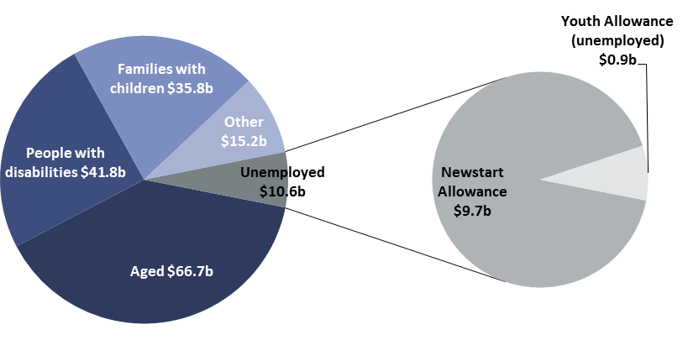
Note: Major components of categories other than unemployed are as follows: ‘Aged’ includes age pension and aged care services; ‘People with disabilities’ includes disability support pension, National Disability Insurance Scheme, carer payment and carer allowance; ‘Families with children’ includes family tax benefit, child care subsidy and parenting payments, ‘Other' includes assistance to veterans and dependants, other welfare programs, assistance for Indigenous Australians where programs are not elsewhere classified, and general administration. Youth Allowance (unemployed) is also referred to as Youth Allowance (other) or Youth Allowance (job seeker). Figures may not sum due to rounding.
Source: Final Budget Outcome 2018–19, pp. 79–81, and Department of Social Services (DSS) Annual Report 2018–19, pp. 44–45.

For those individuals requiring income support payments, three key factors affect their eligibility for JobSeeker instead of another form of payment:
- age – qualifying ages for JobSeeker versus youth allowance for younger people and the age pension for older people influence the numbers on each payment
- capacity to work – the nature and stringency of tests for the disability support pension (DSP), for example an individual’s capacity for work per fortnight, affect the distribution of people across that pension and JobSeeker
- dependent children – the qualifying arrangements for parenting payments, for example the maximum allowable age of the youngest child, affect how principal carers of dependent children are distributed across parenting payment and JobSeeker.
As the basic rate for single JobSeeker recipients is lower than that for all of the payments above except Youth Allowance, policy changes that shift recipients onto JobSeeker will tend to lower total government spending, other things equal.

Historical trends in JobSeeker expenditure
To assess the outlook, it is important to first understand the historical trends in Jobseeker payment. In this way, we can understand the extent to which Jobseeker expenditure has been influenced by changes to payment rates, recipient numbers, or some combination of both.
The chart below (Figure 1–2) shows two sets of information about expenditure on JobSeeker over the last three decades: the government’s total expenditure on the payment (the blue lines), and the maximum fortnightly payment rate for a single recipient without children (the pink lines).
As can be seen in the chart, the nominal fortnightly rate (lighter pink line on the chart) has risen over time as the payment is indexed to the consumer price index, with the real fortnightly rate (darker pink line) essentially unchanged. Accordingly, total nominal expenditure on JobSeeker has increased while inflation-adjusted (real) expenditure has remained lower, with the gap widening over time.

Figure 1–2: Expenditure on JobSeeker and fortnightly payment rates, 1991–92 to 2018–19
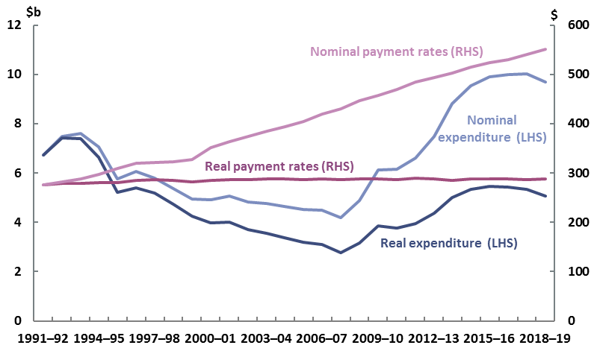
Note: Fortnightly payment rates are weighted averages of maximum basic amounts for a single recipient without children. Expenditure data in ABS year books were sourced from government departments.
Source: DSS annual reports, ABS year books (cat no. 1301.0), ABS consumer price index (cat no. 6401.0), DSS Social Security Guide (historical rates) and PBO analysis.
This means that changes in total real expenditure on JobSeeker over the last three decades (the dark blue line on the chart) primarily reflect changes in the number of recipients and their individual circumstances (affecting average payment rates) rather than changes to the maximum payment rate itself. In turn, these changes in the number and circumstances of recipients have been driven by both economic conditions and policy changes in the social welfare system.
One good indicator of overall economic conditions is the level of unemployment. The link between the numbers of JobSeeker recipients and unemployed persons is illustrated in Figure 1–3.
Comparing the light blue and dark blue lines shows that, over the last three decades, there have been times when the number of unemployed people and the number of JobSeeker recipients have been closely related and other times when this has not been the case.

Figure 1–3: JobSeeker recipients and unemployed persons, 1992 to 2019
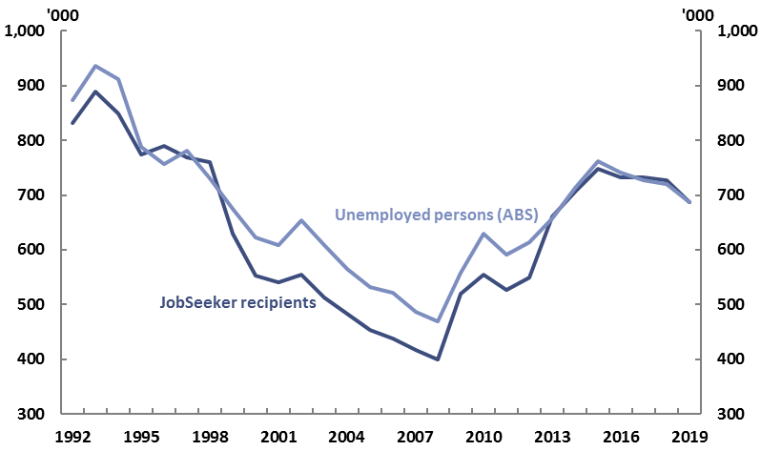
Note: Unemployed persons are averages of monthly counts (seasonally adjusted) over the year to June. The minimum age of unemployed persons is lower than minimum age of JobSeeker recipients; see Appendix A for a figure including recipients of Youth Allowance (unemployed). Recipient data in ABS year books were sourced from government departments.
Source: DSS Payment Demographic Data, ABS year books (cat no. 1301.0), ABS labour force (cat no. 6202.0) and PBO analysis.
When economic conditions are the dominant driver of Jobseeker spending overall, changes in the total number of recipients track changes in the aggregate unemployed population relatively closely and the lines on the chart move roughly in parallel. This was the case in much of the 2000s, for example.
On the other hand, when policy factors are the dominant driver, changes in recipient numbers and the unemployed population can diverge, either in aggregate or for some cohorts.
At the aggregate level, this can be seen in the chart in 2012 to 2013, for example. Around this time, the lines on the chart stop moving in rough parallel as the number of JobSeeker recipients rises faster than the number of unemployed people.
While these trends are not always noticeable at the aggregate level, divergence between unemployment and JobSeeker numbers can also be quite pronounced for some parts of the population. This is explored further in section two.
As discussed above, changes in total real expenditure on JobSeeker over the last three decades mainly reflect changes in the number of recipients and their average payment rates, which in turn have been driven by both economic and policy factors. Figure 1–4 explores this further, showing in more detail the movements in real expenditure growth over the last three decades, and the key factors responsible for the sharp increases and falls in these figures. It is useful to look at real expenditure growth as it shows broad phases of the fiscal cost of JobSeeker after adjusting for inflation.
The first of the key phases in JobSeeker expenditure growth occurred in the early 1990s as a result of the 1990s recession. During this time, real expenditure surged reflecting high and rising unemployment.
There was then a sustained period of falling expenditure up to the Global Financial Crisis (GFC). In fact, after the 1990s recession, real spending growth on JobSeeker was negative until 2008 as unemployment rates fell from a peak of around 11 per cent in 1992–93 to a trough of about 4 per cent in 2007–08.

Figure 1–4: Annual growth in real JobSeeker expenditure and growth in unemployed persons, 1991–92 to 2018–19
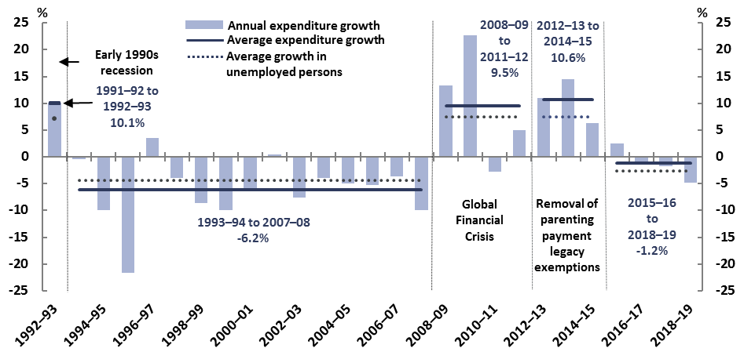
Note: Average expenditure growth and average growth in unemployed persons are simple averages of their respective annual growth rates over the reference period.
Source: DSS annual reports, ABS year books (cat no. 1301.0), ABS consumer price index (cat no. 6401.0), ABS labour force (cat no. 6202.0) and PBO analysis.

The start of the GFC saw real expenditure increase again, growing by around 13 per cent in 2008–09 and 23 per cent in 2009–10, year-on-year. This was due to increased unemployment and the temporary relaxation of some eligibility criteria in response to economic conditions.
JobSeeker expenditure then grew strongly again after the GFC, peaking at around 15 per cent in 2013–14. This time, growth was primarily influenced by policy changes. Specifically, changes in eligibility for other income support payments targeted at people of working age, such as parenting payments and the DSP, diverted new applicants and some existing recipients onto JobSeeker.
Finally, the period leading up to the COVID-19 pandemic brought a marginal decline in real JobSeeker expenditure growth. During this period, JobSeeker expenditure decreased a little (averaging -1.2 per cent per year) between 2015–16 and 2018–19, as the number of recipients generally stabilised or declined marginally each year. This reflected the net impact of movements in demand from both directions: downward pressure from declining unemployment and upward pressure from policy changes which meant some JobSeeker recipients were likely to remain on the payment for longer—for example, increases in the age pension qualifying age for both men and women.
The next section investigates these trends and their drivers in further detail.

Box 1: JobSeeker payment and unemployment
While JobSeeker payment is the main income support payment for unemployed people, not all JobSeeker recipients are unemployed and not all unemployed people receive an unemployment benefit. Indeed, the overlap between receiving JobSeeker and being unemployed is much smaller than might be expected.
The JobSeeker payment is only available to people under specified income and assets thresholds, and who satisfy ‘mutual obligation’ requirements to search for jobs and undertake other required annual activities, unless exempt (see Appendix A). Recipients can be counted as any of unemployed, underemployed, employed or not in the labour force using the Australian Bureau of Statistics’ (ABS) standard labour force classifications (Table 1–1).
The ABS uses internationally consistent standards to measure labour force status through a monthly survey. These standards count persons aged 15 years and over as ‘employed’ if they work at least one paid hour in the survey week. People are counted as unemployed if they are without work during the survey week, but were actively looking for work at any time in the four weeks up to the end of the survey week and available for work in the survey week.
Table 1–1 JobSeeker payment and measured unemployment
Personal circumstances | Labour force status (ABS)
Receiving JobSeeker AND
– Not working, looking for a paid job | Unemployed
– Working at least one hour a week in a paid job  - looking for more hours | Employed  - underemployed
– Not employed, exempt from job search | Not in labour force
Not receiving JobSeeker (eg due to income/assets test)  AND not working  AND looking for work | Unemployed

Changing composition of the JobSeeker population—trends and drivers
The nature of the JobSeeker recipient population has changed markedly since the early 1990s recession, and even since the GFC.
Understanding these changes helps to explain how future economic conditions might affect existing JobSeeker recipients and overall expenditure on the JobSeeker payment. This will be particularly relevant as the Australian economy recovers from the impact of the COVID-19 pandemic.
To begin exploring the changes it is useful to compare two annual snapshots of recipients; one just before the GFC and one in 2019, before COVID-19 (Figure 2–1). Comparing two ‘pre-economic crisis’ years helps to understand recipient profiles during relatively stable periods and to discern the underlying long-term trends that are helpful for projecting medium-term expenditure. Economic crises tend to result in high numbers of temporary recipients that are not typical of the usual JobSeeker population.

Figure 2–1: JobSeeker recipients by selected characteristics, 2007 and 2019
Men | Women
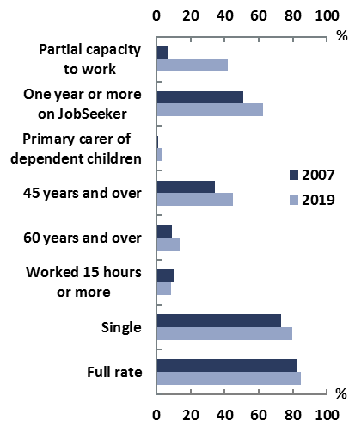 | 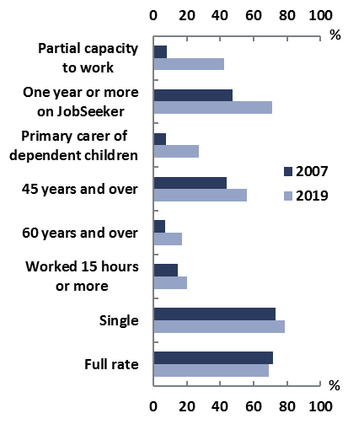
Note: ‘Partial capacity to work’ refers to activity tested recipients having an assessed physical, intellectual or psychiatric impairment, which would prevent them from working 30 hours per week. ‘Primary carer of dependent children’ relates to children under 16. ‘Worked 15 hours or more’ refers to 15 hours or more from all jobs in the last fortnight. Figures are as at June each year.
Source: PBO analysis of DSS Bluebook, a deidentified administrative dataset. References to Bluebook throughout this report are to point-in-time snapshots in June.

Three broad trends in the JobSeeker population have become evident over time, as shown in Figure 2–1.
Firstly, JobSeeker recipients were mostly younger men and are now older people, with an increasing share of older women. The share of recipients aged 45 years and older increased from 44 to 56 per cent among females and from 34 to 45 per cent among males between 2007 and 2019. The share of recipients aged 60 and older also increased for both genders, with a larger rise among females. The share of recipients who are primary carers of dependent children is also rising. For females, it increased from 7 to 27 per cent between these years. It also increased among male recipients but remains very small (below 5 per cent).
Secondly, the share of longer-term JobSeeker recipients is rising. More people, especially females, have been on the payment for more than one year. The relative increase was higher for females (from 48 to 71 per cent) than males (51 to 63 per cent) between 2007 and 2019.
Thirdly, the shares of recipients searching for work and assessed as having full capacity for work are falling. Recipients of both genders experienced a large increase in recipients with only a partial capacity to work, from below 10 per cent in 2007 to over 40 per cent in 2019.
These trends are explored further in this section.

JobSeeker recipients’ demographics have changed significantly
The demographics of JobSeeker recipients have substantially changed over time, with women and men now making up almost equal shares of JobSeeker recipients, as shown in Figure 2–2.

Figure 2–2: Share of JobSeeker recipients by gender, 1992 to 2019
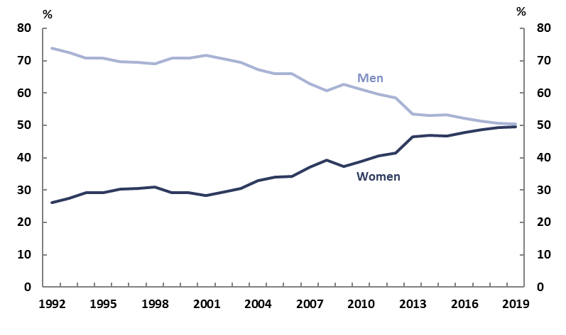
Note: Data on JobSeeker are as at June except for 2000 which are as at May.
Source: DSS Payment Demographic Data, ABS Year Book Australia 2002 for 2000, and PBO analysis.
This chart illustrates how the share has shifted from 74 per cent males and 26 per cent females in 1992 to almost 50 per cent of both males and females in 2019. However, this only tells a partial story about the change. Looking closer at changes in both gender and age group provides a more nuanced picture (Figure 2–3).
In the 1990s and early 2000s, JobSeeker recipients were typically young men in their 20s or 30s. Older men and women were also represented in the pool of welfare recipients, however, those requiring income support were likely receiving other payments such as parenting payment, age pension, or disability support pension (DSP).

Figure 2–3: Share of JobSeeker recipients by gender and age group, 2001 and 2019
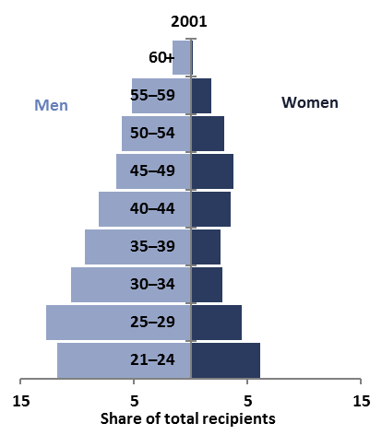 | 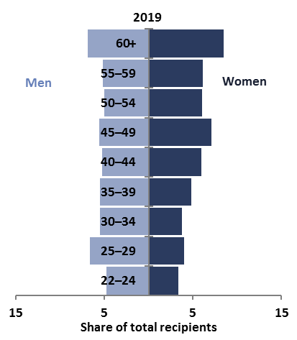
Note: ‘60+’ category comprises 60 to under 62 years for women and under 65 years for men in 2001, and under 66 for both genders in 2019. The age pension qualifying age was 61.5 years for females and 65 years for males in June 2001 and 65.5 years for both genders in June 2019. Figures are as at June.
Source: PBO analysis of DSS Bluebook.
However, by 2019, this picture of recipients by gender and age group had changed considerably. JobSeeker payment recipients were predominantly people in their 40s or above, with an increasing share of older women. Only around one in six recipients were men under 35 years of age.
Half of recipients were 45 years or older in 2019, with around 15 per cent being 60 or above (Figure 2–3). The number of females was higher than the number of males among those aged 45 and older. This was also true for recipients aged 60 and above, with females aged 60 and over accounting for more than eight per cent of all recipients. In contrast, two decades ago, around two per cent of recipients were 60 or older, virtually all of whom were males.

These observations raise the obvious question of what has happened to produce such a shift in the gender and age of JobSeeker recipients. Although there have undoubtedly been significant changes to Australia’s economy over this time, and the population is ageing, policy changes have also played a major role.

Policy changes have affected men and women differently
Perhaps counterintuitively, the policy changes affecting Jobseeker payments relate primarily to other income support payments, not to Jobseeker payment itself.
Modifications to the eligibility requirements of four income support payments have increased the likelihood that people receiving income support will receive the JobSeeker payment. Three of the four significant changes over the past two decades have affected women and men differently.
The first of these is the closure of ‘partner payments’—income support payments provided solely or largely to women based solely on the income support status of their domestic partner. These payments have been closed to new entrants as social and economic norms have changed. The largest of these are partner allowance and wife pension.
Partner allowance was a benefit paid to the domestic partners of income support recipients, meaning that unemployed partners of unemployed people would not appear as JobSeeker recipients themselves. In 2003, about 83 per cent of partner allowance recipients were women aged 50 and over and eligibility was already limited to persons born before 1955. The closure of the allowance to new entrants in 2003 diverted unemployed people in this cohort to Newstart Allowance. Partner allowance will cease completely on 1 January 2022 when all remaining recipients reach age pension age.
In addition, wife pension was previously paid to wives of age pension or DSP recipients. From 1995, the payment was closed to new claimants who were diverted to other income support payments, including Newstart, if eligible. Wife pension ceased when JobSeeker replaced Newstart in March 2020, at which point an estimated 2,900 recipients transferred automatically to JobSeeker but with their payment rate unchanged, and without obligations for job search.
Other legacy payments that affect females requiring income support include Widow B Pension and widow allowance.
The second key change was the increase in the age pension age. This meant older people without employment remained on JobSeeker for longer. Between 1995 and 2013, the pension qualifying age for women increased from 60 to 65, and between 2017 and 2023 the age is increasing from 65 to 67 years for both genders., Accordingly, this change has had a much greater impact on the number of females receiving JobSeeker payments, where previously they would have received the age pension, if eligible.
The third significant change has been reforms to the parenting payment, firstly under the 2006 Welfare to Work reforms, and then the removal of its legacy arrangements in 2013. This diverted a largely female cohort onto JobSeeker. Among female JobSeeker recipients, those caring for dependent children increased from 7 to 27 per cent between 2007 and 2019 (see Figure 2–1 above).
These reforms lowered the qualifying age limit of a parenting payment claimant’s youngest child from 16 to eight (for singles) or six (for couples). The main options for those who would have otherwise been eligible for parenting payment before this change included transitioning to employment, study, or to Newstart if eligible. The reforms initially applied only to new applicants, with existing parents remaining on parenting payment until their youngest child turned 16. The removal of this legacy arrangement in 2013 is estimated to have shifted around 65,000 women from parenting payment onto Newstart Allowance, noting that on average between 2003 and 2013, 94 per cent of parenting payment recipients were women. ,
Finally, the fourth key change, which affected both women and men, was the tightening of the eligibility criteria for the DSP. This change is highly likely to have diverted many applicants onto JobSeeker.
These measures include lowering the partial capacity to work test from 30 to 15 hours per week from July 2006, assessing disability based on function rather than medical diagnoses from January 2012 and using government-appointed doctors in assessment from January 2015. ,, Together, these changes contributed to a reduction in the share of new applicants granted access to the DSP from an average of 63 per cent during 2001–02 to 2010–11 to 43 per cent during 2011–12 to 2014–15.
People not meeting the disability assessment criteria but with a capacity to work of less than 30 hours per week have their mutual obligations adjusted but receive JobSeeker rather than the DSP.
Collectively, these policy changes have affected both men and women with a more pronounced impact on women as evident in the increased number of female recipients. The influence of these social welfare policy changes on women has likely driven some divergence between the numbers of female JobSeeker recipients and unemployed females, primarily among older groups.
This divergence can be seen in Figure 2–4, which shows the relationship between unemployment and JobSeeker recipient numbers for men and women.
During the period of falling unemployment from the end of the 1990s recession to 2007, JobSeeker recipient numbers tracked unemployment relatively closely for both genders. In the 1990s, male recipients generally declined in line with the unemployed male population. The relationship with unemployment was somewhat less tight for women than for men over this period, possibly reflecting changes to partner payments. In the early 2000s, female recipient numbers remained broadly flat and tracked the number of unemployed females until after the 2006 Welfare to Work reforms.
A noticeable and often growing divergence between JobSeeker recipients and unemployment can be seen for women from around 2011 as several of the social welfare changes above were active simultaneously.

Figure 2–4: JobSeeker recipients and unemployed persons by gender, 1992 to 2019;
key economic and policy changes
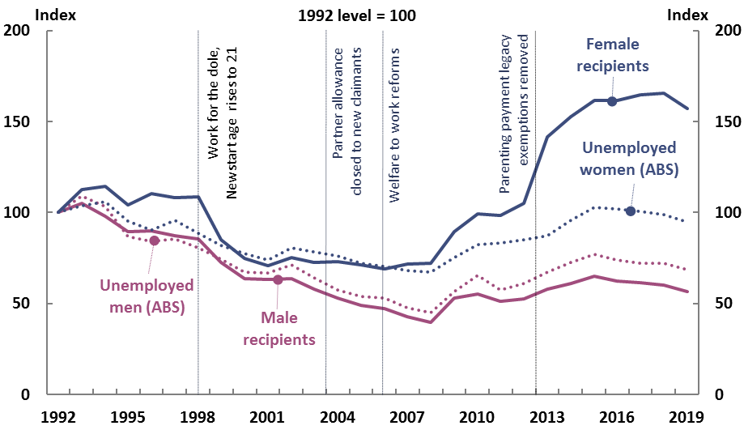Note: Data on JobSeeker recipients are as at June except for 2000 which are as at May. Data on unemployment are averages of seasonally adjusted monthly data over the year from July to June.
Global financial crisis…….
Source: DSS Payment Demographic Data, ABS year books (cat no. 1301.0), ABS labour force (cat no. 6202.0) and PBO analysis.
The divergence between JobSeeker recipients and unemployment is noticeably stronger among older people than younger people, and strongest among older women (Figure 2–5). That is, there are many more older women on JobSeeker than are counted as unemployed.

Figure 2–5: JobSeeker recipients and unemployed persons by gender and age, 1992 to 2019
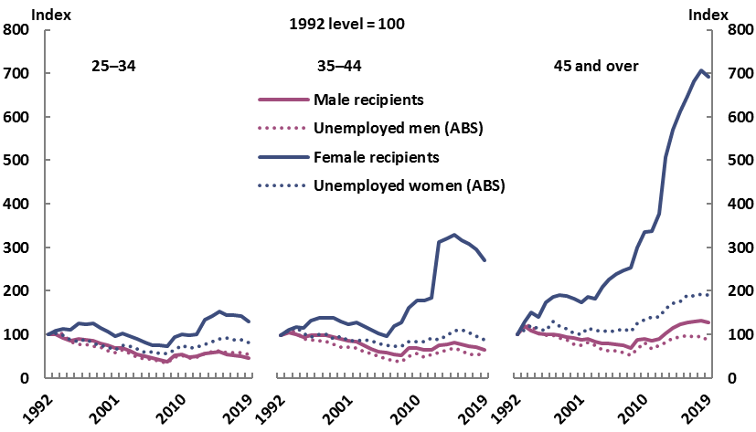
Note: Data on JobSeeker are as at June except for the year 2000 which are as at May. Data on unemployment are averages of original monthly data over the year July to June. JobSeeker data to 2013 are from DSS Payment Demographic Data; JobSeeker data from 2014 to 2019 are sourced from DSS Bluebook. ’45 and over’ refers to 45–64 for unemployment data.
Source: DSS Payment Demographic Data, ABS year books (cat no. 1301.0), ABS labour force (cat no. 6291.0.55.001), DSS Bluebook and PBO analysis.
While increases in the age pension qualifying age for women and the phase-out of partner payments have increased the likelihood that older women are on JobSeeker, these do not explain the large share of older women recipients who are not unemployed. These women are either working or counted as ‘not in the labour force’ but are receiving JobSeeker (see Box 1 for the relationship between JobSeeker status and labour force status).
Given the substantial increase in labour market participation recorded by older people, and older women in particular, over this period, some part of this divergence may be due to older women with low income and assets receiving JobSeeker. This increase in participation among older people has been observed among many developed countries and contributing factors in addition to pension qualifying ages are improved health at older ages, the increasing availability of part-time work, and the financial situation of older households, with a correlation between increasing expected retirement age and household indebtedness. ,
Another aspect of Figure 2–5 that stands out is the divergence followed by some convergence between female recipients and the number of unemployed women aged 35 to 44, which can be seen in the chart from 2006 onwards.
This pattern is likely due to the changes in parenting payment eligibility described above, including the removal of legacy arrangements in 2013 diverting many women from parenting payment to JobSeeker.
The subsequent convergence could be partly due to different cohorts having different abilities to react to the policy change. Those affected by the initial change may not have expected the removal of legacy arrangements so could have taken longer to adjust, while parents entering parenting payment under the new arrangements would know well in advance the date by which they would have to study, find employment or shift onto JobSeeker payment.

The share of longer-term JobSeeker recipients is rising
Along with the change in the demographics of JobSeeker recipients, there has also been a change in the average length of time spent on the payment.
The Department of Social Services (DSS) classifies people receiving income support payments for 12 months or more as ‘long-term recipients’. An increasing share of JobSeeker recipients have been on the payment for five years or more, which can be seen in Figure 2–6.

Figure 2–6: Distribution of recipients by duration on JobSeeker, 2007 to 2019
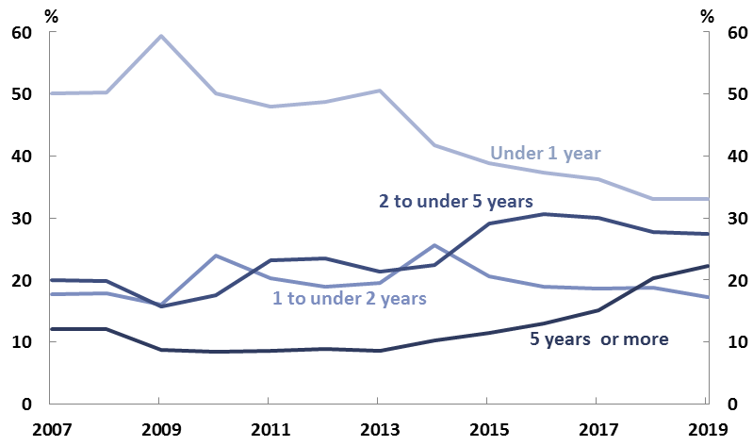
Source: 2007 to 2013: PBO analysis of DSS Bluebook; 2014 to 2019: DSS Payment Demographic Data.

This chart shows that in June 2007, 12 per cent of all JobSeeker recipients were on the payment for five or more years, compared to about 50 per cent for less than a year. Around 2008, short-term recipients surged as those who lost work during the GFC sought JobSeeker payment until they found new work.
However, after this period, the share of recipients on JobSeeker for five years or more grew, reaching 22 per cent by June 2019 (Figure 2–6). The average duration on JobSeeker reached around three years in 2019, up from two years in 2014.
Longer-term recipients of JobSeeker have been growing faster among women and older people.
Recipients of JobSeeker for one year or more have generally grown faster among women than men, both in absolute numbers and shares of recipients. Figure 2–7 shows that there were around 60,000 fewer female recipients than male recipients in 2007 but the number of female recipients grew strongly and overtook male recipients by 2016. Between 2007 and 2019, the share of recipients on JobSeeker for one year or more rose from 48 to 71 per cent for women and from 51 to 63 per cent for men (Figure 2–8).
These longer-term recipients of JobSeeker tend to have a higher chance of being on the payment after one year than short-term recipients (for further information see Box 2).

Figure 2–7: Number of recipients spending one year or more on JobSeeker, 2007 to 2019 | Figure 2–8: Recipients on JobSeeker for one year or more, share of all recipients by gender, 2007 to 2019
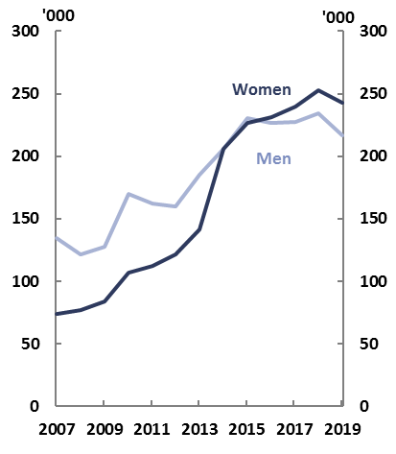 | 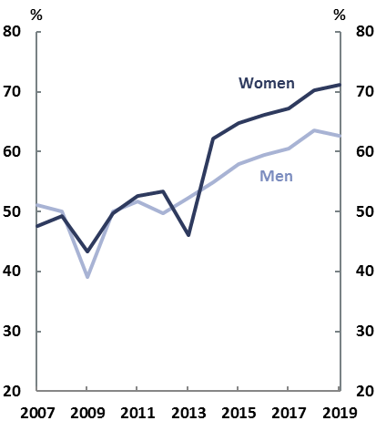
Source: PBO analysis of DSS Bluebook. | Source: PBO analysis of DSS Bluebook.
There has been strong growth in the share of recipients who have been on the payment for a very long time. By June 2019, 24 per cent of female and 20 per cent of male recipients had been on JobSeeker for five or more years (Figure 2–9). While long-term receipt of JobSeeker has grown for all age groups, those aged 55 and above have grown to have the highest share of all recipients who have been on the payment for five years or more, closely followed by those aged 45 to 54.

Figure 2–9: Recipients on JobSeeker for five years or more,
share of all JobSeeker recipients by gender and age, 2007 to 2019
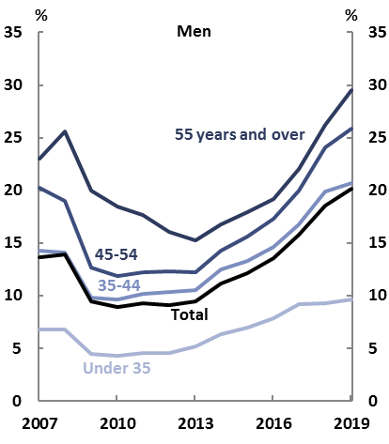 | 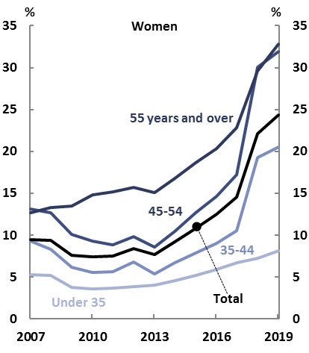
Source: PBO analysis of DSS Bluebook.

By June 2019, 33 per cent of women and 29 per cent of men on JobSeeker aged 55 and above had been on the payment for five or more years (Figure 2–9). As discussed in Appendix A, this group have less stringent mutual obligation requirements than recipients aged 54 and below, with the ability to be completely exempt from job search after 12 months (for 55 to 59 year olds) or with no waiting period (for those aged 60 and above) if they are completing 30 hours per fortnight of paid or approved voluntary work (or some combination).
Single recipients aged 60 and above without dependent children also receive a slightly higher basic rate of payment after nine months on the payment than singles under 60 without dependent children. This recognises that older unemployed people have more limited prospects of finding full-time work than those in younger age groups. Overall, JobSeeker appears to be functioning as a kind of pre-age pension payment for some older Australians.
The combined impact of eligibility changes to other income support payments may have contributed to this increasing share of longer-term JobSeeker recipients. Changes to eligibility for the DSP, parenting payment, the age pension and partner payments (such as partner allowance and wife pension) have had the net effect of diverting some prospective or existing recipients onto JobSeeker, some of whom are likely to have higher barriers to employment. This in turn would suggest that improvements in general macroeconomic conditions may have less effect on the employment outcomes of these recipients, which in turn has implications for future projections of JobSeeker payment recipients and expenditure.

Box 2: Duration on JobSeeker and likelihood of leaving the payment
The likelihood of leaving JobSeeker is very different for short term and longer term recipients. Figure 2–10 illustrates this using data for 2017–18. At the start of that year there were approximately 733,000 JobSeeker recipients.
- During that year, 355,000 additional JobSeeker recipients took up the payment, and around two thirds of these people left the payment within a year.
- However, of the 733,000 people who started the year on the payment, only one-third had left the payment one year later.

Figure 2–10: Exits from JobSeeker in a year: stock and new entrants
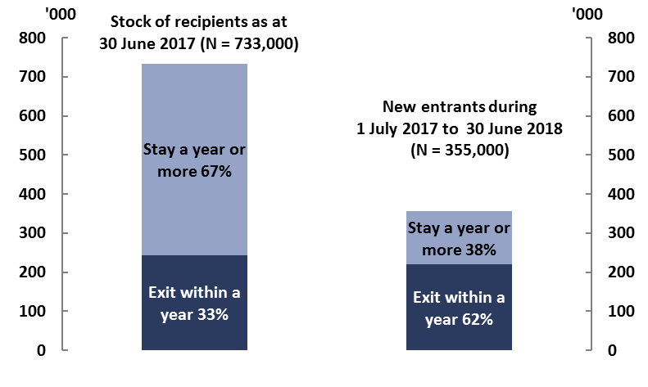
Note: Figures in parentheses are rounded to the nearest 1,000 recipients. Figures in left column are based on snapshots of Newstart Allowance recipients on payment as at 30 June 2017 by recorded income support payment as at 29 June 2018. Any movement in and out of income support or between income support payments between these two dates may not be reported. Figures in right column do not include direct transfer from another income support payment but some may have previously received income support.
Source: PBO analysis of DSS Bluebook, and DSS Payment Demographic Data June 2019.

Almost half of all JobSeeker recipients are not required to search for jobs
A third significant change to the Jobseeker recipient profile has been a decrease in the shares of recipients searching for work and assessed as having full capacity for work.
A snapshot of JobSeeker recipients reveals that as at June 2019, half of women and nearly 40 per cent of men on JobSeeker were exempt from job search; for women this is up more than 10 percentage points since the same time in 2007 (Figure 2–11).
Some recipients were not required to search for a paid job because they were already meeting the mutual obligation requirements by undertaking approved voluntary work or a combination of voluntary and part-time work. For the others, reasons for exemptions from job search included temporary illness or incapacity, undertaking training or self-development, or being assisted to find a job through a disability employment service.
Figure 2–11: Job search and conditions for exemptions by gender, 2007 and 2019
June 2007
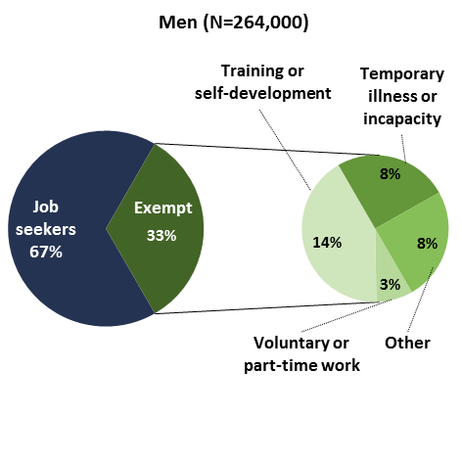 | 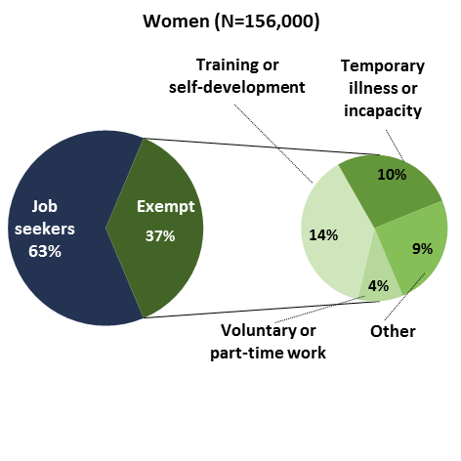
June 2019
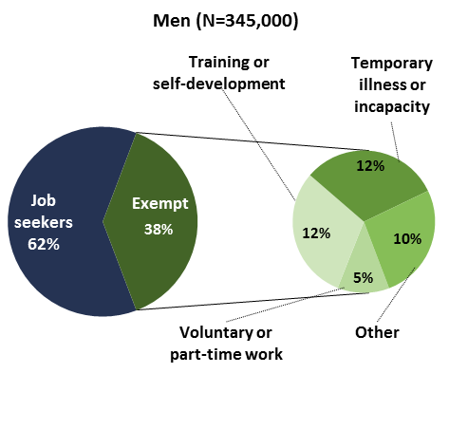 | 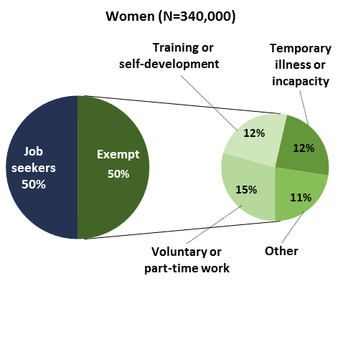
Note: JobSeeker figures are derived from the average numbers of recipients over the reference month and may not be directly comparable with figures based on a snapshot on a particular day of the month. For 2019, ‘Other’ includes recipients who are known not to have participation requirements and recipients participating in Disability Management Services. For 2007, 'Other' includes recipients who are known not to have participation requirements. Numbers in parentheses are rounded to the nearest 1,000. Figures may not sum due to rounding.
Source: DSS Labour Market and Related Payments: a monthly profile, June 2007 and June 2019, and PBO analysis.

The pattern of these mutual obligation exemptions was broadly similar for men and women in 2007. By comparison, in 2019, a larger share of women than men were exempt due to undertaking part-time work or approved volunteering. This increase in exemptions from job search is to be expected, given the gradual increase in age pension qualifying ages and the eligibility requirements that provide age-based exemption from job search. JobSeeker recipients aged 55 to age pension age can be exempt from job search solely by completing a specified amount of paid or voluntary work, while JobSeeker recipients aged under 55 cannot (see Appendix A for further information).
The expansion of voluntary and part-time work for female JobSeeker recipients since 2007 is another potential explanation for the finding discussed earlier that there are more women on JobSeeker than are counted as unemployed. Recipients in voluntary or part-time positions would not be technically unemployed, but would qualify for JobSeeker because of low hours and/or wage rates (if the work was paid), combined with having assets and other income below the means test.
These full exemptions are separate to partial exemptions which may be applied to recipients caring for a dependent child over six, or who have been assessed as having reduced capacity to work because of a physical, intellectual or psychiatric impairment. Recipients in these categories have a partial capacity to work and have adjusted mutual obligation requirements.
Around 40 per cent of JobSeeker recipients were assessed as having an ongoing partial capacity to work in June 2019, up from less than 10 per cent at the same time in 2007.
The size of this change was very similar across men and women. As the overall prevalence of disability in the community actually decreased somewhat over a similar period, it is likely that the increase in job seekers with an ongoing partial capacity to work was driven by the tightening eligibility requirements for the DSP.
The combined impact of a higher share of JobSeeker recipients with partial capacity to work and a lower share of recipients searching for work overall means that of those JobSeeker recipients looking for jobs, more are likely to have only a partial capacity to work than was the case in the past.
The changing characteristics of the JobSeeker recipient population outlined in this chapter mean that comparisons of JobSeeker recipient numbers and expenditure in the current COVID-19 crisis with that of previous downturns and their recoveries should be undertaken with some care.
The next section briefly examines the impact of COVID-19 on unemployment and JobSeeker so far.

Impact of COVID-19 on JobSeeker expenditure
The analysis presented so far in this report is drawn from historical data over the last three decades. However, it must be noted that the JobSeeker payment has undergone significant temporary changes in both recipient numbers and the total income support for recipients as a result of the COVID-19 pandemic and associated economic downturn.
Increased unemployment as a result of the pandemic affects the budget balance through three main channels: increased expenditure due to higher JobSeeker recipient numbers, increased expenditure due to temporary increases in payment rates and other assistance measures, and reductions in government revenue through lower personal income tax collections.
The impacts through these channels have been visible in the government’s monthly financial statements. For example, total Commonwealth Government expenses were $13.2 billion (or 34 per cent) higher for April 2020 than April 2019, driven by the policy response to the COVID-19 pandemic, including transfers such as the commencement of the Coronavirus supplement provided to JobSeeker, Youth Allowance and some other income support recipients.
As at July 2020, the government estimated a budget deficit of $85.8 billion (4.3 per cent of GDP) for 2019–20 and $184.5 billion (9.7 per cent of GDP) for 2020, resulting in a deterioration of $281.4 billion for these two years relative to the pre-COVID forecast at the 2019–20 Mid-Year Economic and Fiscal Outlook (MYEFO). Contributions to the change since MYEFO included many measures to support households and businesses in managing the impacts of the pandemic. Measures affecting Jobseeker recipients included the Coronavirus supplement ($16.8 billion) and relaxation of the partner income test for JobSeeker recipients ($2.0 billion). The provision of the supplement combined with increased unemployment meant that Commonwealth expenditure on unemployment benefits in 2019–20 was almost double the government’s forecast before the COVID-19 pandemic.
The fiscal impacts over coming months are likely to remain uncertain because of the dynamic nature of the pandemic. The cost to the budget is expected to extend over the next decade even if the economy begins to improve after 2020–21. The rest of this section examines how the JobSeeker recipient population is evolving during the economic downturn so far.

JobSeeker recipient changes since the pandemic commenced
JobSeeker payment recipients surged rapidly from March 2020 rising from about 793,000 total recipients in March to a peak of around 1,464,000 recipients in May, as set out in Figure 3–1 below. The number of recipients has since remained just under the May peak.
These increases in recipient numbers occurred across both genders and all age groups. Between March and May, the increase in male recipients (about 375,000 or 92 per cent) was larger than the increase in female recipients (about 296,000 or 77 per cent) (Figure 3–2).

Figure 3–1: Total JobSeeker recipients by month, March 2018 to August 2020 | Figure 3–2: Total JobSeeker recipients  by gender, March to August 2020
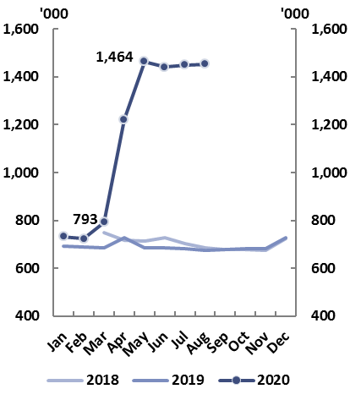 | 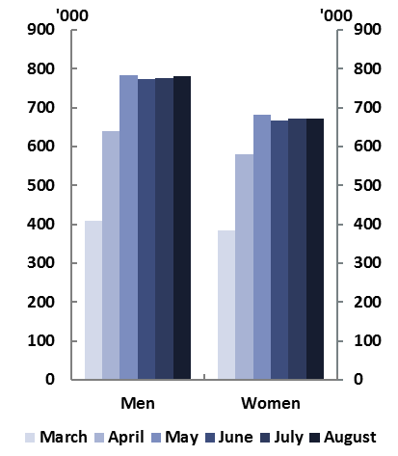
Source: DSS JobSeeker Payment and Youth Allowance recipients – monthly profile, various releases. | Source: DSS JobSeeker Payment and Youth Allowance recipients – monthly profile, various releases.
Overall, these increases are not as large as they would otherwise have been, due to the government’s roll out of the JobKeeper payment. This payment allowed people who might otherwise have qualified for JobSeeker to retain their employment. In addition, an unusually high share of people who lost work in April and May left the labour force altogether.
The growth in JobSeeker recipients was higher among younger age groups than older groups (Figure 3–3), reflecting a larger absolute increase in unemployment among younger people. Recipients aged 22–24 and 25–34 more than doubled between March and May. Youth Allowance (unemployed) recipients, who are aged 16–21, also increased, with recipient numbers nearly doubling over the same period.

Figure 3–3: Total JobSeeker and Youth Allowance (unemployed) recipients
by gender and age, March to August 2020
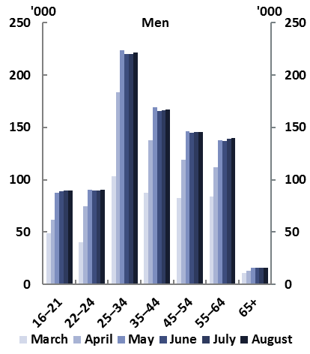 | 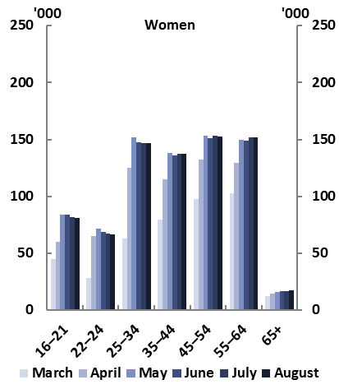
Note: ‘65+’ category comprises persons aged 65 to under age pension age (66 years at present). Those aged 16–21 receive Youth Allowance (unemployed) and those 22 to age pension age receive JobSeeker payment.
Source: DSS JobSeeker Payment and Youth Allowance recipients – monthly profile, various releases.
One possible reason for higher measured unemployment among young people is that they are under-represented in the JobKeeper program relative to their share of the pre-pandemic employment distribution. Younger people are more likely to be working in industries hardest hit by COVID-19 related restrictions and in casual jobs, some of which would be ineligible for JobKeeper.,
While the impact on younger workers is not without precedent for an economic downturn, the gender impacts are more unusual and complicated.
While the increases in JobSeeker recipient numbers since COVID-19 are higher for men than women, data on job losses shows higher losses for women between March and June, and more women leaving the labour force altogether, in part reflecting higher concentration of women in the industries most affected by the early stages of COVID-19 restrictions.,
The predominantly female parenting payment has also seen a striking increase, with parenting payment (partnered) recipients increasing by 36 per cent and single recipients by 6 per cent between March and June 2020. Recipient numbers for both payments had previously been trending downwards. While some jobs held by women have recovered through June, total job losses from mid-March to June were still greater for women than for men.
It is too soon to tell whether this pattern of withdrawal from the labour force by females will continue or whether it is largely a cyclical response to macroeconomic conditions which will reverse as these improve.
If it were to persist, this pattern would represent a material risk to the budget over the medium-term. This is because strong female participation rates have made an important contribution to economic growth in recent decades. Any persistent falls in participation rates could be expected to flow through to lower receipts and higher payments in the future.
The evolution of unemployment and JobSeeker recipient numbers over coming months will depend on the extent of COVID-19 cases and the associated restrictions on some economic activity to protect public health. While the monthly figures for JobSeeker recipients were highest in May, the measured unemployment rate peaked in July as some people who had left the labour market started searching for work again.
As indicated by the new outbreaks of COVID-19 in July, without a vaccine or method of reducing the severity of the disease, some degree of public health measures limiting economic activity could continue for some time. The outcome for JobSeeker recipient and expenditure numbers over the months and years ahead will reflect these evolving macroeconomic conditions in addition to the longer-term trends identified in this report.

Budget implications over the medium term
Unemployment will rightly receive a great deal of attention over the coming months and years. While the outlook is highly uncertain, the trajectory for unemployment will depend in part on the extent and nature of further COVID-19 outbreaks in Australia and how these and the associated response measures affect the economic recovery.
In its August Statement on Monetary Policy, the Reserve Bank of Australia forecast unemployment to peak in late 2020 at almost 10 per cent and to not return to its pre-COVID-19 level of around 5¼ per cent until beyond 2022. In addition to these ‘baseline’ forecasts, the Statement included an upside scenario, based on a rapid lifting of many restrictions on economic activity where the unemployment rate returns to pre-COVID levels by mid-2022, and a downside scenario, based on further periods of outbreaks where the unemployment rate in mid-2022 is still around 8 per cent. Jobseeker expenditure may therefore remain elevated for the much of the 2020s.
If Australia’s economic recovery can progress without further prolonged, severe or widespread COVID-19 disruptions, periods may be observed where changes in JobSeeker recipients track changes in unemployment relatively closely as the share of short-term recipients would be higher than in recent years, as was the case during the GFC.
From an expenditure perspective, a higher share of these ‘cyclical’ JobSeeker recipients may receive a part rate of payment due to other income and assets, so average expenditure per recipient may be somewhat lower for some years.
However, the major trends in the JobSeeker population before the pandemic mean the recipient population is quite different from that during the 1990s recession, and even since that observed during the post-GFC period. The Australian economy and labour market has also changed markedly in the past three decades. Such changes include the growing share of women in the labour force and the rise of services as a share of the economy.
These changes imply that using historical trends as a guide to future JobSeeker recipient numbers or expenditure may not provide an accurate picture.
In particular, the key trends likely to affect Jobseeker expenditure over the medium-term include:
- the increasing share of women and older recipients
- a growing reliance on JobSeeker for longer periods, particularly among older age groups
- a falling share of recipients with full capacity to work.
The rise of long-term recipients and older recipients is likely to continue irrespective of short-term fluctuations in unemployment, given the gradual increase in age pension qualifying age to 67 currently underway and the JobSeeker payment appearing to function as a kind of pre-age-pension payment for some older Australians in the labour market.
Changes to eligibility for other payments over previous decades may mean that the JobSeeker recipient population has a larger share of recipients with higher barriers to employment than was previously the case. This is reflected in the lower proportion of existing recipients (also referred to as the ‘stock’) who move off the payment each year relative to new recipients and will likely lead to higher JobSeeker expenditure in the future.
It is important to note, however, that this increased expenditure is at least partially offset by savings from other income support payments due to eligibility changes. These eligibility changes mean expenditure on these other payments such as DSP and the age pension is lower than it would have otherwise been as a result of the payment rate for JobSeeker being lower relative to these payments.
Overall, these longer-run developments are likely to maintain upward pressure on JobSeeker expenditure into the medium term.
The PBO will continue to monitor developments and adapt its projection approaches across payments in the social welfare system as a whole, given the importance of these inter-relationships for expenditure trends.
The PBO currently estimates medium-term JobSeeker expenditure primarily looking at average payment rates, indexation rates (CPI) and the aggregate ratio of unemployed people as a share of the working age population. Adjustments are also made to allow for the impact of the gradual increase in the age pension qualifying age to 67.
The analysis of longer-term trends in this report and those of the cohort of new JobSeeker recipients as a result of COVID-19 suggests that future projection modelling should take account of more than these factors alone. This is likely to involve a change to the assumed responses to changes in unemployment rates for diverging groups such as short- and longer-term recipients which may result in higher expenditure projections than was previously the case.
The PBO will examine this further in the context of its 2020–21 Budget medium-term fiscal projections to be published later this year.

Appendix A: JobSeeker and JobKeeper

JobSeeker payment: eligibility, payment rates and history
The JobSeeker payment is means tested and activity tested. Under means testing, the payment is only available to people under specified income and assets thresholds, with tests also applied to recipients’ domestic partners.
Under ‘mutual obligation’ arrangements, recipients are generally required to search for jobs and satisfy activity tests under an ‘annual activity requirement’, with the total required hours of activity decreasing with age. Activities that can count towards the annual requirement include Work for the Dole, paid work and voluntary work. Broadly speaking, there are two kinds of exemptions to mutual obligation:
- Full exemptions to mutual obligation may apply under conditions such as bereavement, temporary illness or injury.
- Partial exemptions may apply to recipients assessed as having a longer-term reduced capacity to work because of physical, intellectual or psychiatric impairment, or to principal carers of dependent children aged six to under 16. Job seekers are assessed as having partial capacity due to an impairment if both their baseline capacity and capacity within two years with intervention are less than 30 hours per week.
The amount of job search activity required of recipients varies according to age and other factors.
- JobSeeker recipients aged under 55 cannot be exempt from job search solely by completing a specified amount of paid or voluntary work.
- JobSeeker recipients aged 55 to age pension age can be exempt from job search if they complete sufficient paid and voluntary work. For recipients aged 55 to 59 after 12 months on JobSeeker, exemptions apply if recipients do 30 hours per fortnight of a combination of paid work and voluntary work. For recipients age 60 to age pension age, these exemptions can apply without waiting for 12 months.
The current basic rates of JobSeeker payment per fortnight are $565.70 for a single without children, $612.00 for a single with children and $510.80 for partnered recipients. Singles over age 60 who have been on the payment for nine months or more receive $612.00, about $46 per fortnight more than for singles without children. The payment is indexed by the consumer price index in March and September each year.
Under the COVID-19 economic response package, the Commonwealth Government introduced a temporary supplement for all JobSeeker recipients and temporarily relaxed some eligibility criteria. In the first phase of this measure from late April 2020 to 24 September 2020, the supplement rate was $550 per fortnight and the government implemented changes including:
- waiving assets tests and some waiting periods
- relaxing partner income rules to significantly raise the partner income test cut-out amount to $3,068.80 per fortnight
- making job search obligations flexible over this period.,
From 25 September until the end of December 2020, the supplement has been reduced to $250 per fortnight and some of the eligibility criteria are reinstated.
The government also made changes including increasing the income threshold to qualify for the full rate of payment from $106 to $300 per fortnight but reducing the ‘taper rate’ at which benefits decrease with income.
The JobSeeker payment replaced Newstart Allowance and a number of smaller payments in March 2020, with the payment rate and eligibility criteria unaltered.
While some arrangements for unemployment benefits have changed over time, the basic eligibility and indexation have been the same since 1991 when the Unemployment Benefit was replaced by Newstart Allowance and Job Search Allowance (for younger people).
These two payments merged in September 1996 under the name Newstart Allowance. The minimum eligible age for Newstart Allowance was increased to 21 years from July 1998 and to 22 years from July 2012. Youth Allowance (unemployed) is provided to young job seekers aged 16 to 21. Figure A1 below shows measured unemployment, JobSeeker recipient numbers and total recipients of unemployment benefits (the grey line, which combines Youth Allowance (unemployed) and JobSeeker recipient numbers).

Figure A1: JobSeeker and Youth Allowance (unemployed) recipients and unemployed persons, 1992 to 2019
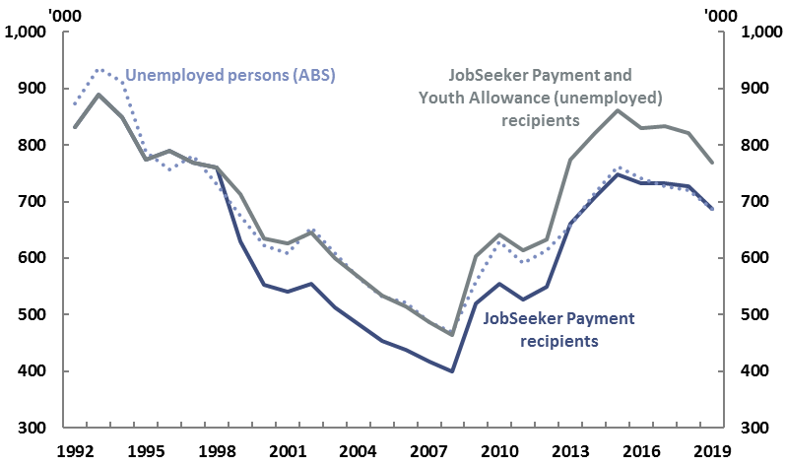
Note: Unemployed persons are averages of monthly counts (seasonally adjusted) over the year to June. Recipient data in ABS year books were sourced from government departments.
Source: DSS Payment Demographic Data, ABS year books (cat no. 1301.0), ABS labour force (cat no. 6202.0) and PBO analysis.

This chart extends Figure 1–3 in section 1 to include total unemployment benefit recipients. As discussed in section 1, comparing the light blue dashed line and the dark blue line shows that, over the last three decades, there have been times when the number of unemployed people and the number of JobSeeker recipients have been closely related and other times when this has not been the case.
Comparing the dashed blue line and the grey line shows that this relationship between unemployment benefits and unemployment remains broadly similar when looking at total unemployment benefit recipients (JobSeeker plus the smaller Youth Allowance (unemployed) payment) rather than JobSeeker, although the total number of unemployment benefit recipients has exceeded total unemployed persons by more than 80,000 persons each year since 2013.

JobKeeper wage subsidy
The JobKeeper program, part of the Commonwealth Government’s ongoing response to the COVID-19 pandemic, subsidises wages for eligible employees in eligible businesses and not-for-profit organisations until March 2021.
This policy is aimed at assisting businesses to cover the cost of wages so that more employees can remain attached to their employer, even if work is not available, than would otherwise be the case. As these workers still have an employer even if they have been stood down and work zero hours, they are counted as employed by the ABS, and measured unemployment is lower than in the absence of the scheme.
Phase one of JobKeeper ran from 30 March until 27 September 2020 and the extension phase runs until 28 March 2021. The first phase of the JobKeeper program provided businesses with $1,500 per fortnight per eligible employee from 30 March 2020 if they were eligible for the JobKeeper scheme as at 1 March 2020. Under the JobKeeper extension, after September 2020 fortnightly payments were reduced to $1,200 from 28 September 2020 and will reduce to $1,000 from 4 January 2021 to 28 March 2021. Eligibility criteria were also tightened. Individuals working fewer than 20 hours a week on average receive $750 per fortnight from September 2020 and $650 per fortnight from January 2021.
Additional changes announced on 7 August 2020 included increasing employee eligibility for both the scheme and extension by shifting the employment eligibility date from 1 March to 1 July. The scheme is estimated to cost $101.3 billion over 2019–20 and 2020–21, of which $30.6 billion is for payments until 21 June 2020 covering around 3.5 million individuals in over 960,000 organisations.,

This name change coincided with some COVID-19 response measures, but is unrelated to them. The change was published in the 2017–18 Budget measure Working Age Payments Reforms (2017–18 Budget paper no. 2, pp. 158–159).
PBO estimates based on budget papers, various years.
Final Budget Outcome 2018–19, pp. 79–81 and PBO analysis.
For further information, see PBO 2018, Disability Support Pension – Historical and projected trends, Report no. 01/2018.
In this report we often look at the relationship between unemployment and JobSeeker recipients by looking at the number of unemployed persons rather than the unemployment rate. The number of unemployed persons is directly comparable with the number of JobSeeker recipients because both are ‘headcount’ measures.
These patterns remain broadly similar when both the JobSeeker and the smaller Youth Allowance (unemployed) payment are combined, although the total number of unemployment benefit recipients has exceeded total unemployed persons by more than 80,000 persons each year since 2013 (see Figure A1 in Appendix A).
Unless otherwise specified, the term ‘DSS Payment Demographic Data’ is used in this report to refer to income support payment demographic data including statistical and occasional papers published by DSS and its predecessors such as the Department of Families, Community Services and Indigenous Affairs (FaCSIA), Department of Families, Housing, Community Services and Indigenous Affairs (FaHCSIA) and Department of Family and Community Services (FaCS), and available at data.gov.au/data/dataset/dss-payment-demographic-data.
Averages of seasonally adjusted monthly unemployment rates (ABS labour force, cat no. 6202.0).
The threshold for liquid assets was temporarily doubled to $5,000 for singles without dependents and $10,000 for others from April 2009 to March 2011 in recognition of the GFC (Social Security Guide v 1.269 section 3.1.2.20).
Data from the most recent Australian Bureau of Statistics Survey of Housing and Income (2017–18) indicate that around one in four JobSeeker recipients were counted as unemployed and two in five were counted as not in the labour force; almost one in three unemployed persons were in receipt of JobSeeker payment (Vandenbroek P 2019, ‘Measuring overlap between the unemployed and people 'on the dole'’, Parliamentary Library FlagPost 10 December 2019).
This report uses ‘exemption’ for simplicity. Technically, JobSeeker recipients who are not required to look for work either have an exemption or are undertaking approved activities other than job search.
Australian Bureau of Statistics 2018, Labour Statistics: Concepts, Sources and Methods (cat no. 6102.0.55.001).
Given the PBO’s national outlook, the focus of this report is on national trends. Recent discussions of geographical differences can be found in Community Affairs References Committee 2020, Adequacy of Newstart and related payments and alternative mechanisms to determine the level of income support payments in Australia, eg p.126, and Day, I and Jenner, K, ‘Labour market persistence from recessions’, Reserve Bank of Australia Bulletin, September 2020.
For example, in the 1990s, two in five recipients were men under 35 (FaHCSIA 2010, Income support customers: a statistical overview 2009, p.2; FaCS 2001, Income support and related statistics: a 10-year compendium, 1989–1999). Figure 2–3 starts with 2001 rather than the introduction of Newstart Allowance in the 1990s to provide a comparable age breakdown with 2019, and with 2001 rather than 2007 as per Figure 2–1 to provide a comparison over a longer time period.
Department of Families, Community Services and Indigenous Affairs 2006, Income support customers: a statistical overview 2003, pp. 50–52. From 1 July 1995, partner allowance was only granted to persons born on or before 1 July 1955, ie those 40 years or older by 1995. Just before their closure to new claimants, there were about 103,000 partner allowance recipients.
Social Services Legislation Amendment (Welfare Reform) Bill 2017 Explanatory Memorandum, p.12. Just before its closure to new claimants in June 1995 there were about 161,000 wife pension recipients, of whom 96 per cent were under 60 years old (PBO analysis based on Income support and related statistics: a 10-year compendium, 1989–1999, pp. 28–30).
Social Security Guide, v 1.270 section 3.4.1.10.
The closure of mature age allowance, a payment for people aged 60 through to age pension age, was also a factor, though smaller and mostly affecting men. This payment was introduced in 1994, closed to new claimants in 2003 and phased out in 2008. Recipient numbers peaked at around 60,000 in 1997(FaHCSIA 2010, Income support customers: a statistical overview 2009, p.2; FaCS 2001, Income support and related statistics: a 10-year compendium, 1989–1999, p. 52).
Atalay and Barrett (2015) estimated that switching to other income support payments reduced the net saving to government from this change to one-fifth of the saving without switching. Oguzoglu et al (2020) find that around 90 per cent of this switching is due to women remaining on their existing payment, including JobSeeker, for longer (Atalay, K and Barrett, G 2015, ‘The impact of age pension eligibility age on retirement and program dependence: evidence from an Australian experiment’ Review of Economics and Statistics, 97(1) pp 71–87; Oguzoglu et al 2020, ‘Impacts from delaying access to retirement benefits on welfare receipt and expenditure: evidence from a natural experiment‘ Economic Record 96(312) pp. 65–86).
DSS 2014, Income support customers: a statistical overview 2013, and DSS Demographics June 2019.
PBO estimates based on annual changes in the number of parenting payment and Newstart recipients from June 2009 to 2013 and a departmental response to Senate Estimates Question on Notice of 13 February 2013, SQ13-000052.
While very likely, this is difficult to verify because the number of applicants applying for but not being granted the DSP and then successfully applying for JobSeeker is not visible in the DSS administrative dataset Bluebook used in this report. However, the number of DSP recipients has fallen since this change.
Social Security Guide v 1.269 section 3.6.1.12.
Announced in the 2009–10 Budget measure Disability Support Pension — better and fairer assessments and defined in the Social Security (Tables for the Assessment of Work-related Impairment for Disability Support Pension) Determination 2011.
In addition, the 2006 introduction of provisional payment arrangements for DSP claimants who may receive JobSeeker while their pension claim is being determined would also increase, at least temporarily, the number of JobSeeker recipients. See Social Security Guide v1.273 section 3.2.1.60 for a description of provisional arrangements.
PBO 2018, Disability Support Pension – Historical and projected trends, Report no. 01/2018, p. 15. In 2018–19, the grant rate for claims was 37 per cent (PBO estimate from Community Affairs References Committee 2020, Adequacy of Newstart and related payments and alternative mechanisms to determine the level of income support payments in Australia, p.113).
Between the early 1990s and late 2010s, labour force participation increased from around 60 to over 70 per cent among men aged 55–64, and from around 25 to over 60 per cent among women aged 55–64; among those aged 45–54, it remained just under 90 per cent for men but increased from about 65 to 80 per cent among women (ABS labour force, cat no. 6291.0.55.001).
Brown, A and Guttmann, R 2017, ‘Ageing and Labour Supply in Advanced Economies’ Reserve Bank of Australia Bulletin December 2017.
These drivers are discussed in Debelle, G 2019, ‘Employment and wages’, Speech to the Australian Council of Social Services national conference.
For example, DSS note in their Labour market and related payments – a monthly profile June 2019 that long-term recipients are those persons who have been receiving an income support payment for 12 months or more. Duration refers to the period of time on income support and includes time spent on other income support payments. For the purpose of calculating duration on income support, a long-term recipient can go up to 13 weeks without an income support payment before their duration is reset to zero. For short-term recipients (those on an income support payment for less than 12 months), a gap of up to six weeks is permitted before their duration is reset to zero.
PBO calculations from DSS Demographics June 2019. This increase in duration on the payment has not been accompanied by an increase in the share of recipients reporting income other than the JobSeeker payment, which has been basically stable at below 20 per cent of recipients since 2001 as follows: 16 per cent in 2001, 18 per cent in 2007 and 19 per cent in 2019 (Income support customers: A statistical overview 2001 (p.36), Income support customers: a statistical overview 2007 (p.45) and DSS payment demographics June 2019).
Multi-agency Government submission to the Senate inquiry into the Adequacy of Newstart and related payments and alternative mechanisms to determine the level of income support payments in Australia (submission 80, p. 13). A detailed discussion of barriers to employment for older Australians can be found in Productivity Commission 2013, An Ageing Australia: Preparing for the Future, Commission Research Paper, Canberra.
A recent discussion of barriers to employment among recipients can be found in Community Affairs References Committee 2020, Adequacy of Newstart and related payments and alternative mechanisms to determine the level of income support payments in Australia.
From 20.4 to 16.5 per cent for males and from 19.1 to 15.7 per cent for females between 2003 and 2018 (ABS 2019, Disability, Ageing and Carers, Australia: Summary of Findings, 2018, cat no. 44300 Table 1.3).
See Appendix A for a discussion of the JobKeeper wage subsidy and temporary increases in Jobseeker payment rates.
PBO analysis of Monthly Financial Statements reported in Government finances – April 2020.
Economic and Fiscal Update July 2020, p.3.
These are costs over five years from 2019–20 but most of these amounts are incurred the first two years. In addition to the Coronavirus supplement, the $16.8 billion cost of that measure includes broadening relevant eligibility criteria to include sole traders and the self-employed, and the temporary waiver of assets tests, certain waiting periods and the Seasonal Work Preclusion Period. See Economic and Fiscal Update July 2020 measures COVID-19 Response Package — JobSeeker Partner Income Test measure, p. 162 and COVID-19 Response Package — income support for individuals pp. 160–161.
Final Budget Outcome 2019-20, p.42. Note this represents total assistance to the unemployed so includes unemployed recipients of Youth Allowance.
PBO, Updated medium-term fiscal scenarios: impact of COVID-19 pandemic and response, 20 August 2020.
The seasonally adjusted participation rate decreased from 65.9 per cent in March to 62.7 per cent in May 2020 (ABS labour force July 2020 cat no. 6202). Usually, people who become unemployed but are not searching for a job would not be eligible for JobSeeker, however with job search temporarily obligations relaxed due to COVID-19, they could apply for the payment (see Appendix A).
ABS Labour force (original series) (cat no. 6291.0.55.001).
DSS JobSeeker Payment and Youth Allowance recipients – monthly profile, various releases.
The Treasury, The JobKeeper Payment: three-month review, June 2020, p.19.
Coates, B et al 2020, Shutdown: estimating the COVID-19 employment shock, Grattan Institute, p.22.
Gilfillan, G 2018, ‘Characteristics and use of casual employees in Australia’, Australian Parliamentary Library Research Paper.
Borland, J and Coelli, M 2020, ‘Is it dog days for the young in the Australian labour market?’; Day, I and Jenner, K, ‘Labour market persistence from recessions’, Reserve Bank of Australia Bulletin, September 2020.
Borland, J 2020, ‘Female and male employment during recessions in Australia: then and now’ Labour market snapshot #62, Jun 2020. Job loss data are sourced from the ABS Weekly Payroll Jobs and Wages in Australia series, cat no 6160.0.55.001.
Labour force participation rates fell more among women than men across all age groups, with the fall being larger among younger age groups (ABS labour force May 2020 cat no. 6291.0.55.001).
PBO estimates based on DSS demographic data.
Some payroll jobs held by women have recovered through June (0.8 per cent increase, compared to 0.1 per cent decrease for males), although total female job losses from mid-March to end June were still greater for females (6.0 per cent) than for males (5.4 per cent). (ABS Weekly Payroll Jobs and Wages in Australia, Week ending 27 June 2020, cat no. 6160.0.55.00.)
The seasonally adjusted participation rate increased from its trough of 62.7 per cent in May to 64.1 per cent in June and 64.8 per cent in August; unemployment reached 7.5 per cent in July, but fell to 6.8 per cent in August (ABS labour force August 2020, cat no. 6202).
Reserve Bank of Australia Statement on Monetary Policy, August 2020.
PBO, Updated medium-term fiscal scenarios: impact of COVID-19 pandemic and response, 20 August 2020.
Day, I and Jenner, K, ‘Labour market persistence from recessions’, Reserve Bank of Australia Bulletin, September 2020; Department of Jobs and Small Business 2019, Australian Jobs 2019.
DSS Social security guide v 1.271, sections 3.11.4, 3.11.6.
Eight or older for singles. Parenting payment may be available to principal carers of dependent children under these ages.
DSS Social security guide v 1.271, section 3.11.7.
DSS Social security guide v 1.271, sections 3.11.4, 3.11.6.
DSS Social security guide v 1.271, section 3.11.6.
Services Australia 2020, A guide to Australian Government payments 25 September to 31 December 2020, p. 29.
The Treasury 2020, Economic response to Coronavirus: Support for individuals, Fact sheet 14 April 2020.
Economic and Fiscal Update July 2020 measures COVID-19 Response Package — JobSeeker Partner Income Test measure, p. 162 and COVID-19 Response Package — income support for individuals pp. 160–161.
Except for principal carers of dependent children, see the Economic and Fiscal Update July 2020 measure COVID-19 Response Package — income support for individuals, pp.160-161.
Including sickness allowance, bereavement allowance and wife pension (for those under age pension age). The consolidation of these payments was introduced in the 2017–18 Budget measure Working Age Payments Reforms (2017-18 Budget paper no. 2, p. 158–159).
ABS 2020, Spotlight: Classifying people during the COVID-19 period, 25 July 2020.
Coronavirus Economic Response Package (Payments and Benefits) Rules 2020, Clause 7 (1) (a).
Economic and Fiscal Update July 2020 measure COVID-19 Response Package — JobKeeper Payment, p. 167.
The Treasury 2020, Extension of the JobKeeper Payment, Fact sheet last updated 10 August 2020.
Prime Minister of Australia and the Treasurer, ‘More support for more businesses and workers’, media release 7 August 2020.
Economic and Fiscal Update July 2020, p. 7.

