5 June 2020
Medium-term fiscal projection scenarios:
impact of COVID-19 pandemic and response

Sustained fiscal impact to occur over the next decade as a result of COVID-19
The delay in the Commonwealth Budget to October means that the PBO’s annual medium-term fiscal projections report has also been delayed. Instead, we present here medium-term fiscal scenarios based on the Reserve Bank of Australia’s (RBA) latest economic forecasts to provide timely information on what is a rapidly evolving situation.
Our analysis shows that the impact of COVID-19 may result in Commonwealth Government net debt in 2029-30 being between 11 and 18 per cent of GDP (up to $620 billion) higher than it would have been otherwise, as shown in the chart. At last December’s Mid-Year Economic and Fiscal Outlook (MYEFO), net debt was projected to fall to 1.8 per cent of GDP by 2029-30.
Uncertainty about the implications of the COVID-19 pandemic for the future fiscal position is likely to persist for some time. To support an understanding of the likely magnitude of the budget impact over the medium term, three fiscal scenarios are presented here, based on three economic scenarios published by the RBA; a baseline of a gradual economic recovery, an upside scenario of a faster recovery (resulting in less additional debt), and a downside scenario of a slower recovery (resulting in more additional debt).  Higher net debt is largely the result of lower revenue and significant borrowing in 2019-20 and 2020-21 to fund the Government’s pandemic response measures. While the impact of these policies on the underlying cash balance (UCB) reduces over time (see page 2), the impact on net debt endures through to 2029-30. Net debt is still expected to remain lower than most developed countries. | 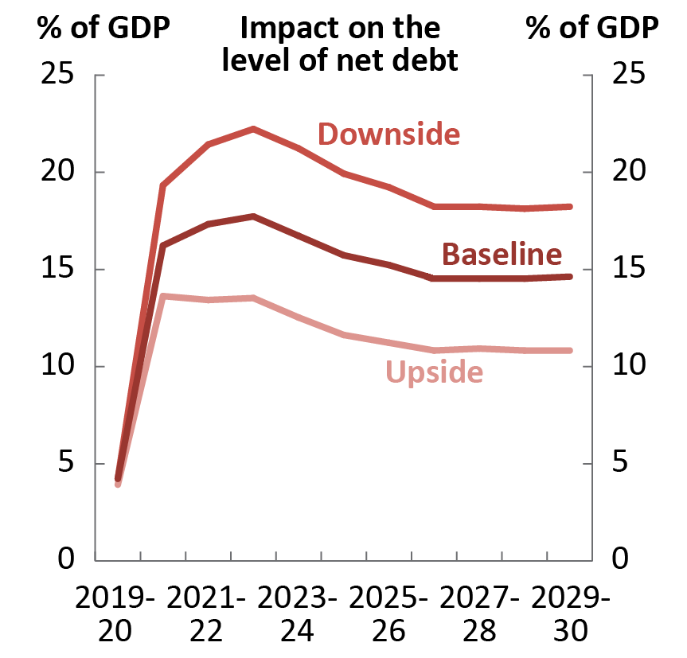  Source: RBA published data and PBO calculations
The results shown here are indicative of the impact of COVID-19 only and are shown as a deviation from a MYEFO baseline; they are not equivalent to budget forecasts. Other policy decisions taken since MYEFO, including the bushfire response, and some revenue impacts not directly related to GDP are not reflected in this analysis. The methodology for this report is detailed further in the technical appendix. The PBO will publish comprehensive medium-term projections following the release of the 2020-21 Budget.

Impact of scenarios on key fiscal aggregates
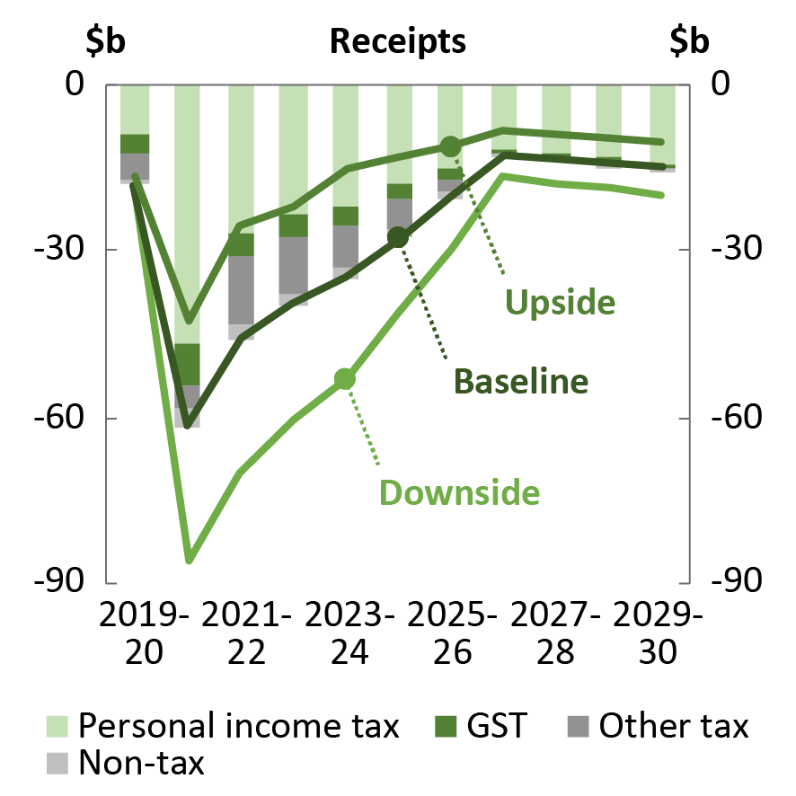 | Receipts are estimated to be between $10 billion and $20 billion lower in 2029-30 in each of the three scenarios, compared to the 2019-20 MYEFO. This is primarily a result of revenue being closely tied to growth in the economy.  Nominal GDP is permanently lower under each scenario because the RBA’s forecast lower prices in the short term result in enduring lower levels for prices and wages. This fall in nominal economic growth flows through to revenue, the largest impact being on personal income tax. Weaker goods and services tax receipts do not affect the overall Commonwealth Government budget balance, but will flow through to the budgets of states and territories.
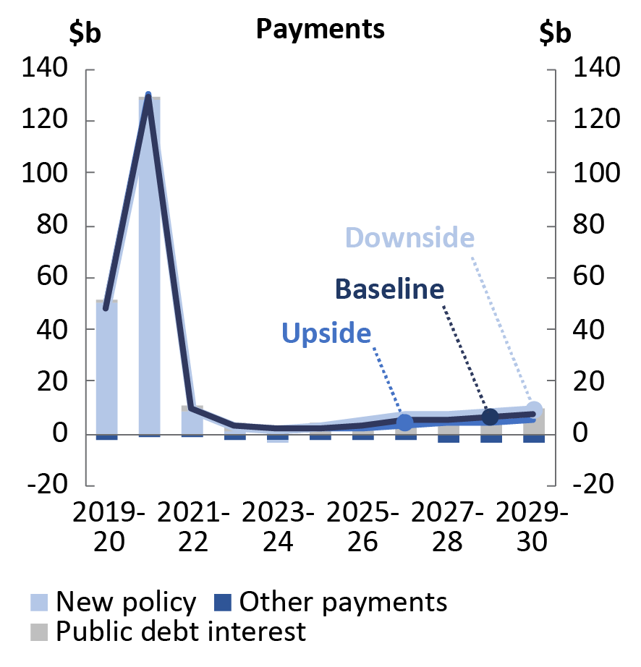 | Payments are higher under each scenario, by between $6 billion and $10 billion in 2029-30, compared to the 2019-20 MYEFO.  The initial increase in payments is due to the impact of the Government’s policy measures, worth around $190 billion, which are due to be largely wound down by 2022.  The increase in payments over the medium term is a result of higher public debt interest that results from the increased financing task associated with higher net debt levels and reduced capacity to pay down existing debt. Payments are also higher due to increased JobSeeker recipients as a result of higher forecast unemployment rates in most years.
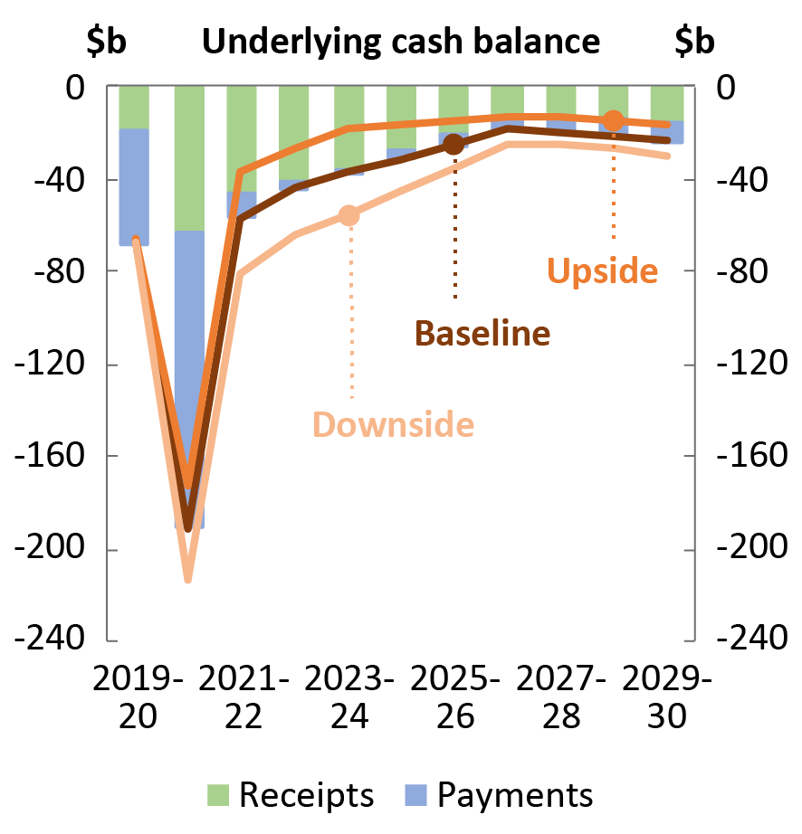 | The underlying cash balance deteriorates by between $16 billion and $30 billion in 2029-30 under the three scenarios, compared to the 2019-20 MYEFO.  In 2019-20 and 2020-21, the impact is mainly due to the policy measures and their effect on payments (shown in blue in the chart).  Once the policy measures wind down, the lower UCB is due primarily to the effect on receipts of slower-than-previously-forecast economic growth (shown in green in the chart).  By 2029-30, the revenue impact is smaller as real economic growth is assumed to return to its potential. This is, however, offset by increasing public debt interest payments.

Source: RBA published data and PBO calculations

Key uncertainties and risks
No enduring economic impact from the downturn is factored into the scenarios, except for the permanently lower price level. The economic scenarios are constructed around the economy returning to ‘potential’ growth by 2027-28. Any ongoing negative impact on economic growth, from lower immigration for example, could result in a significant further deterioration in the fiscal aggregates in these scenarios.
The Government’s COVID-19 policy response measures are assumed to be temporary. The PBO’s fiscal scenarios incorporate the Government’s published costs for its COVID-19 policy response measures as at 3 June 2020: the JobKeeper Payment scheme ($70 billion); Boosting cash flow for employers ($32 billion); Supporting Individuals and Households ($25 billion); Supporting the flow of credit ($15 billion); Other support for business ($8 billion); and legislated Advances to the Finance Minister ($40 billion) for unforeseen expenditure. Any new spending measures, unless offset by other savings, would result in a further deterioration in the fiscal aggregates in these scenarios. The scenarios do not account for other policy decisions taken since the 2019-20 MYEFO, including the bushfire response; the focus of this analysis is on the impact of COVID-19 alone.
The scenarios for public debt interest costs assume that interest rates revert to their long-run average over the medium term, consistent with the 2019-20 MYEFO methodology. Sustained low interest rates would reduce public debt interest costs relative to those presented in these scenarios.
The analysis does not account for some impacts on revenue not directly related to GDP, such as capital losses, the timing of tax payments, and carried-forward losses. These are likely to further reduce revenue.

How did we prepare the fiscal scenarios?
This analysis uses the three economic forecast scenarios (baseline, upside and downside) published by the RBA in the May 2020 Statement on Monetary Policy. It compares these with the forecasts in the February statement, prior to the main impact of COVID-19, to estimate the economic impact of the pandemic.  In each of the scenarios, the RBA forecasts real GDP growth to be slower to 2021-22. The three scenarios primarily vary depending on the assumed timing of the relaxation of current domestic containment measures, such as social distancing, and how long uncertainty and diminished confidence weigh on households’ and businesses’ spending, hiring and investment plans. In the medium term, we assume GDP returns to its long-run potential, consistent with the approach in the budget.  The scenarios incorporate the fiscal impact of the Government’s policy responses to the pandemic, as well as broad economic impacts on revenue and expenses. | Real GDP scenarios  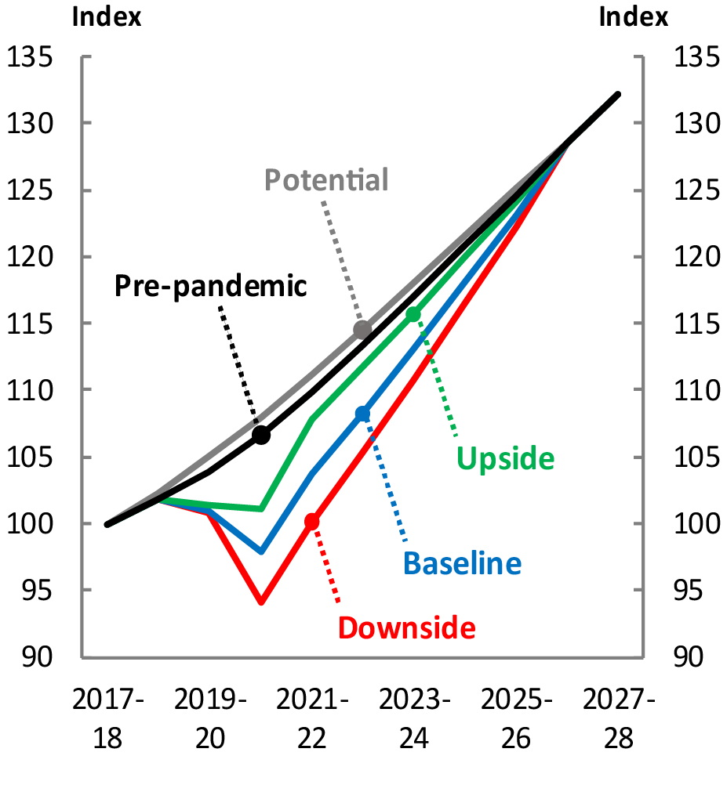  Source: RBA published data and PBO calculations
The scenarios do not assume changes to any economic variables beyond those published in each Statement on Monetary Policy. For the RBA’s upside and downside scenarios, the PBO constructed the components of GDP such that they differ proportionally with GDP from the RBA’s baseline scenario. The next RBA update of the economic outlook is due in August 2020.

RBA forecasts as published in the Statement on Monetary Policy for February and May. Beyond 2022-23, the PBO has followed the standard budget assumption that the economy returns to its long-run potential.

