8 May 2020
Government finances – March 2020

Government expenses for March reflect initial COVID-19 payments
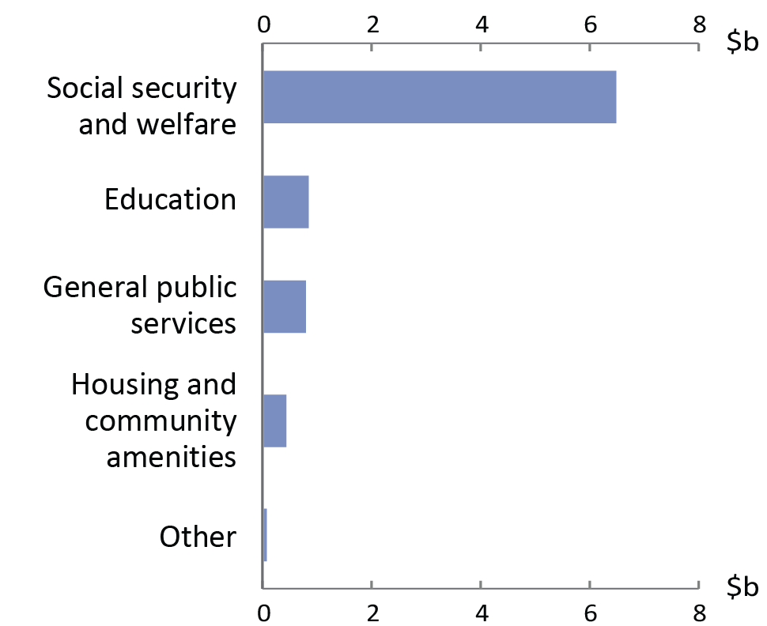
The Commonwealth Government releases financial statements each month, most recently on 24 April. For the month of March 2020, expenses were $8.7 billion higher than March last year, driven by social security and welfare expenses being $6.5 billion higher than for March last year, as shown in the chart.
Change in expenses from March 2019 to March 2020
This partly reflected the government’s initial economic response to the COVID-19 pandemic, which included expenses for eligible individuals recognised on 31 March even if the cash payments were made later.
Other effects of the COVID-19 pandemic and the associated policy measures will feed through to the financial statements in the coming months. Some of the effects will take time to flow through, so it could take an extended period to understand the full fiscal impact.
Source: Commonwealth Government Monthly Financial Statements and PBO analysis

Other key facts
Introduction to this publication
This is the first in a series of monthly publications designed to track the effect of COVID-19 and the associated policy response on the Commonwealth’s fiscal position.
Page two shows charts for revenue, expenses, fiscal balance and debt.
The figures here mostly use accrual accounting, recording income when it is earned and expenses when they are incurred, regardless of when the related cash is received or paid. The accrual amounts will generally show the impact of the COVID-19 measures earlier than the cash amounts.
- Revenue for March 2020 was similar to March 2019.
- The fiscal balance for the financial year up to the end of March was -$22.0 billion. The comparable expected fiscal balance was -$13.8 billion, as reported in the Monthly Financial Statement and consistent with the 2019 mid-year economic and fiscal outlook (MYEFO) report.
- The year-to-date underlying cash balance was
-$22.4 billion compared to an expected -$12.5 billion.
- Australia’s net debt at the end of March 2020 was around $430 billion, which is around $37 billion higher than the most recent forecast for the end of this financial year.

Key fiscal aggregates
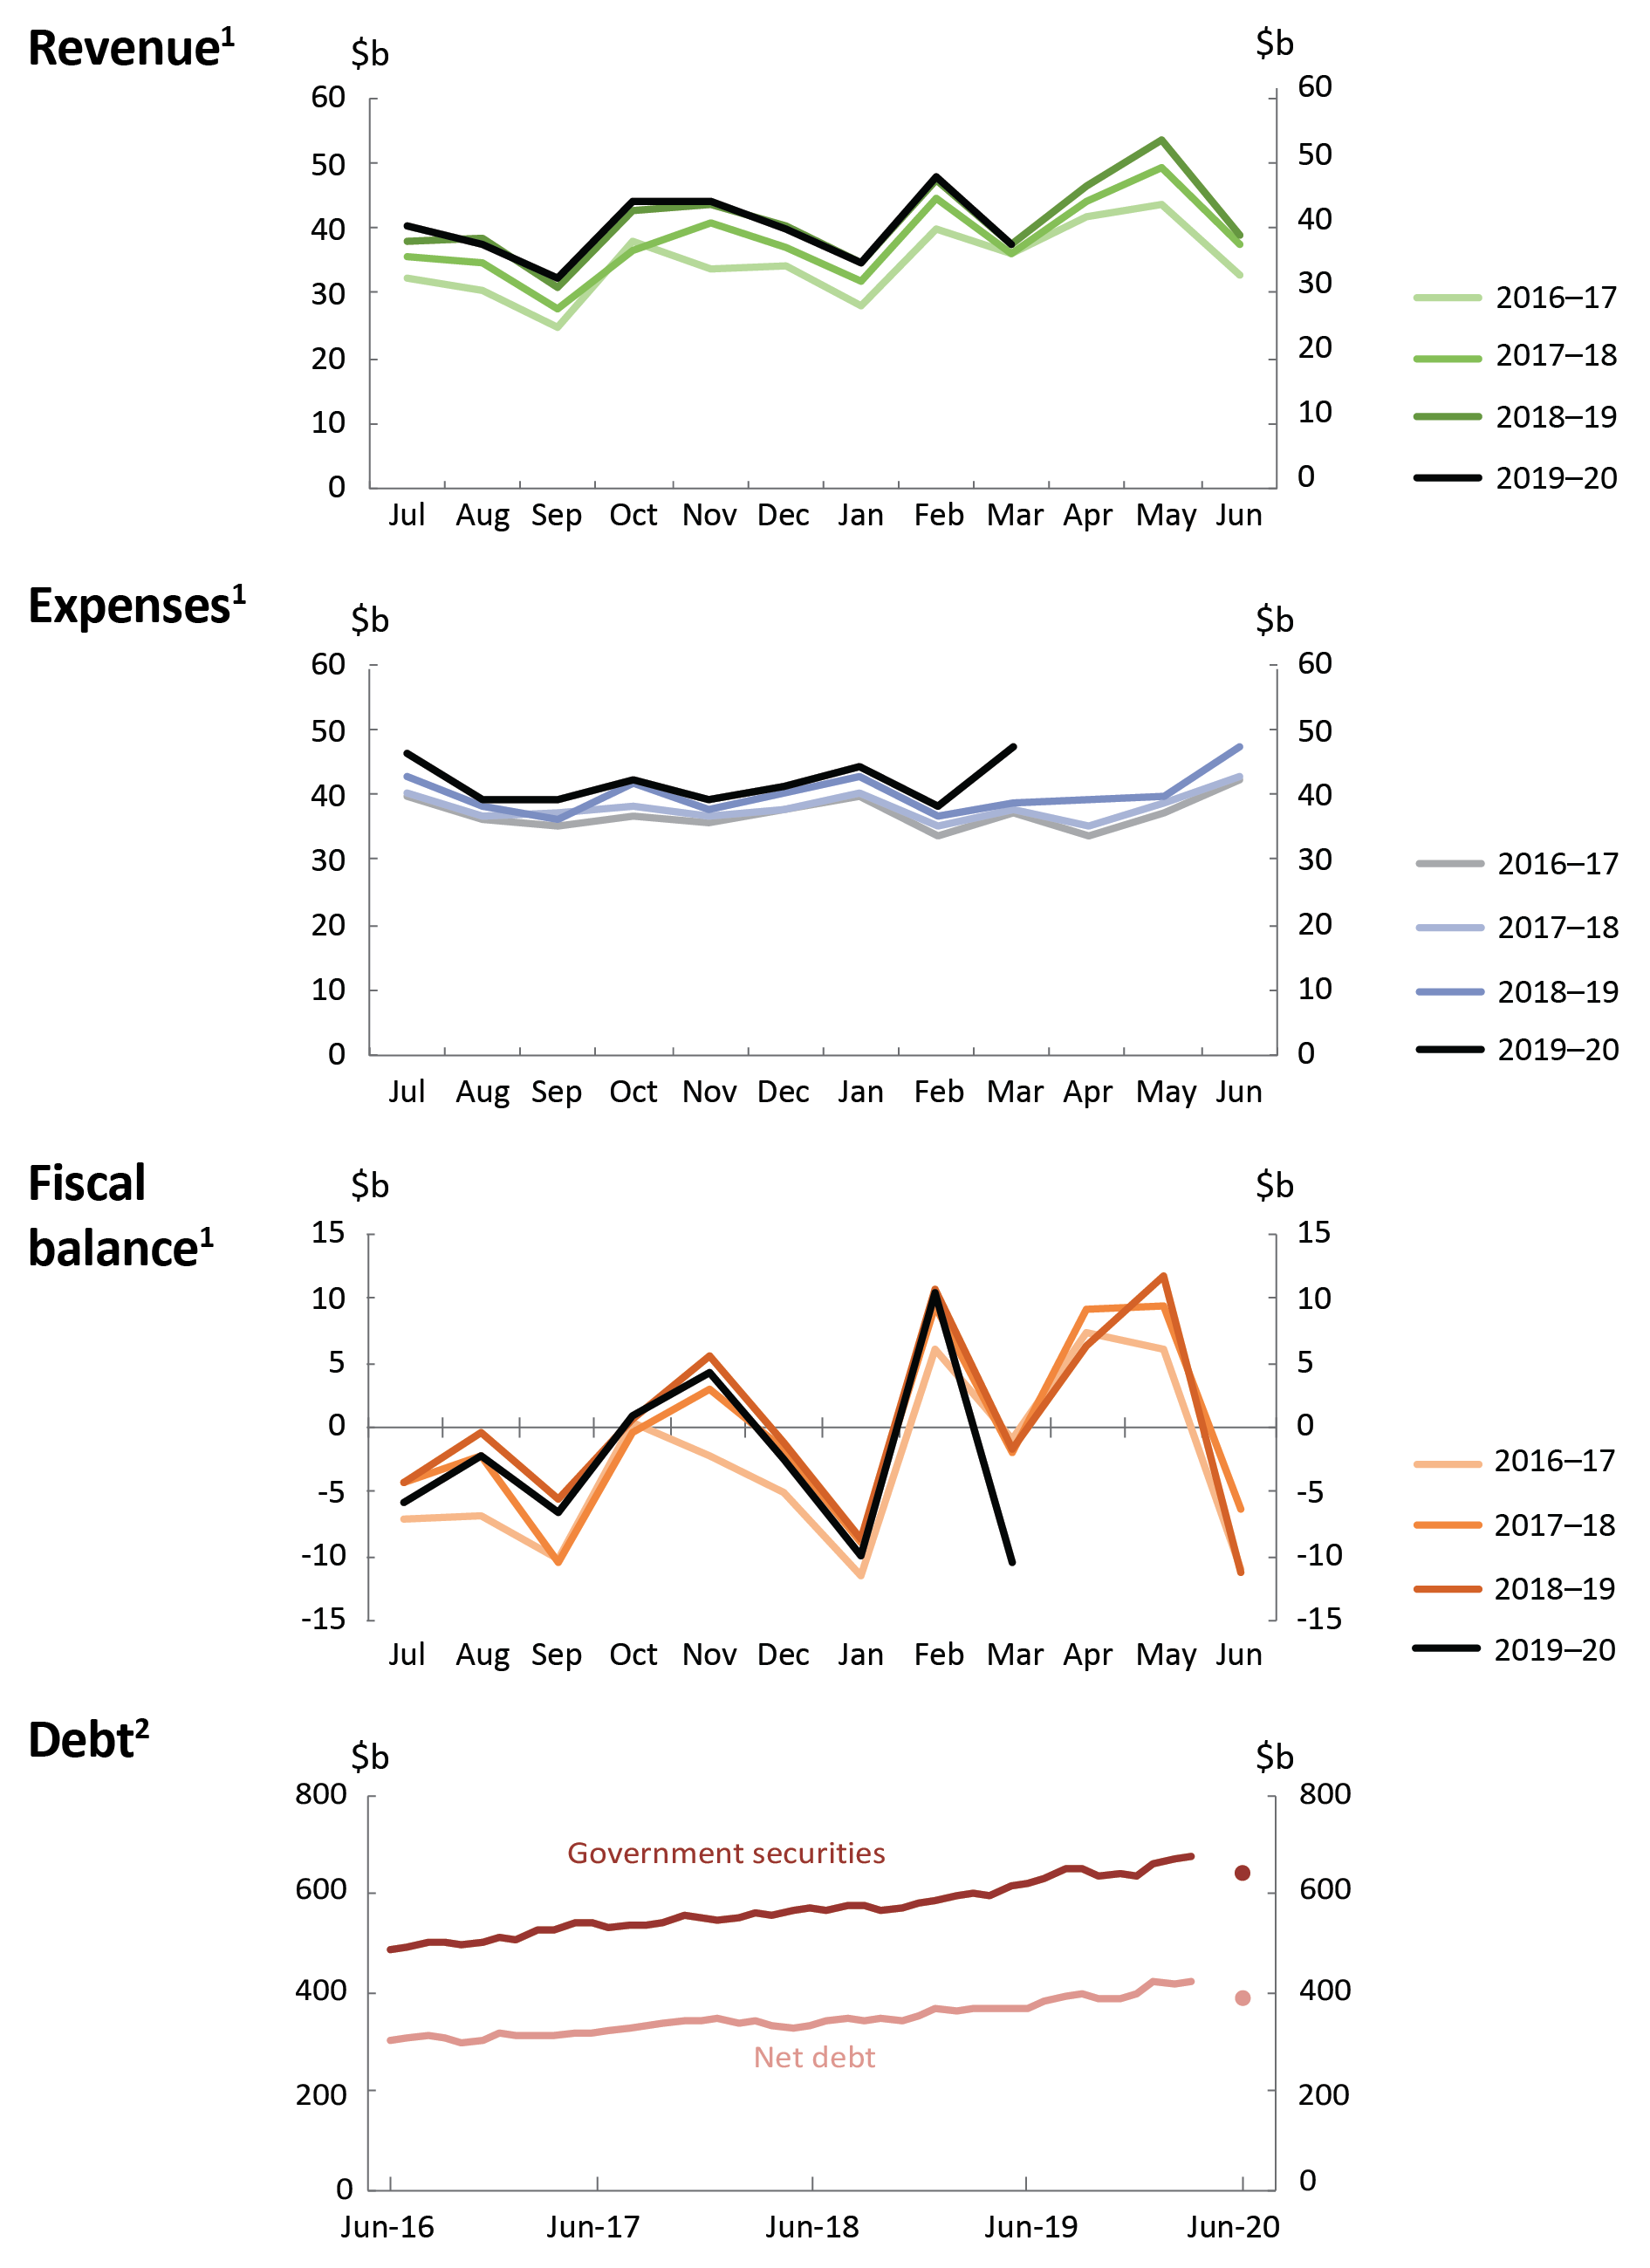
¹ Patterns across the months for revenue, expenses, and fiscal balance reflect key dates in revenue collection and transfer expenditure.
² Dots in the debt chart show 2019-20 MYEFO estimates.
Source: Commonwealth Government Monthly Financial Statements, Final Budget Outcomes, 2019-20 MYEFO and PBO analysis.

Monthly Financial Statements available online at https://www.finance.gov.au/publications/commonwealth-monthly-financial-statements

