9 June 2020
Government finances – April 2020

COVID-19 response reflected in higher expenses for April
Change in expenses from April 2019 to April 2020
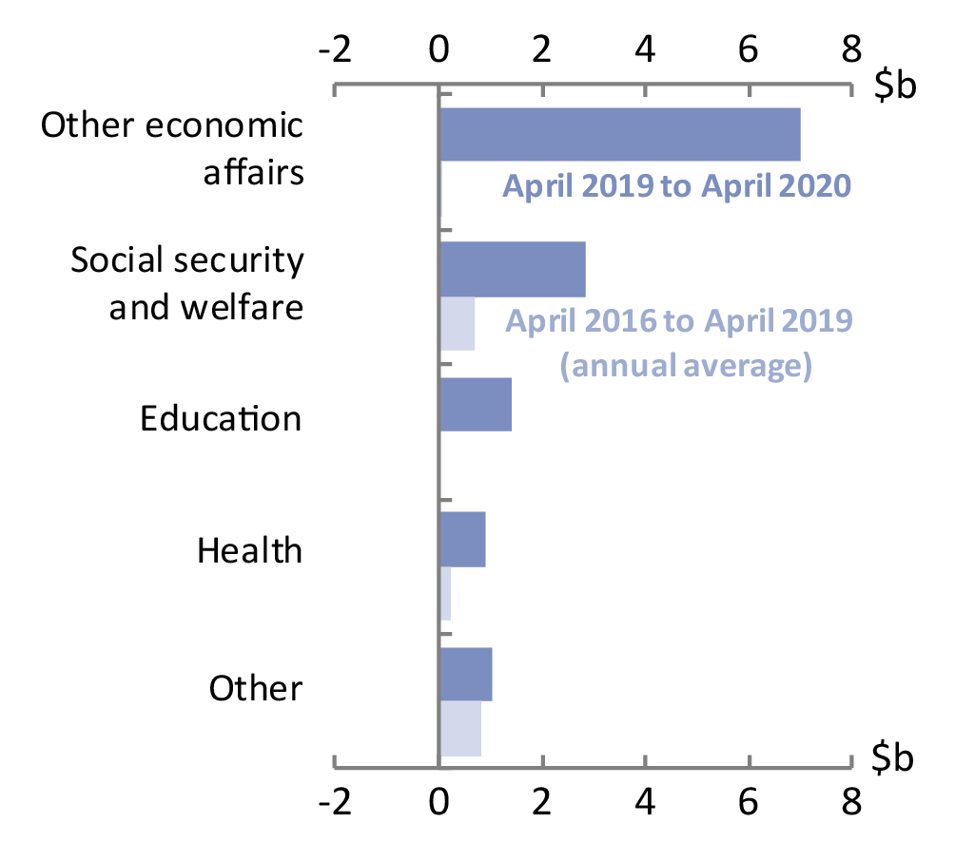
The Commonwealth Government released the financial statements for April 2020 on 29 May 2020. Expenses were $13.2 billion (or 34 per cent) higher for April 2020 than April 2019, driven by the policy response to the COVID-19 pandemic, including Boosting Cash Flow for Employers (captured in ‘other economic affairs’ in the chart), and transfers such as the commencement of the Coronavirus Supplement (captured in social security and welfare). Education and health spending were also higher due to the COVID-19 response, which included the Early Childhood Education and Care Relief Package and Medicare Support at Home. For last month’s update, the largest comparable increase was social security and welfare expenses, up $6.5 billion.
For comparison, the average change in expenses for the preceding three years is also shown in the chart.
Source: Commonwealth Government Monthly Financial Statements and PBO analysis.

Other key facts
A closer look at revenue
Two factors contribute to revenue being higher than some might have expected.
- Both JobKeeper payments and the Coronavirus Supplement are taxable income, and so contribute to personal income tax revenue.
- Company tax revenue for April is mostly based on economic activity in March, so was less affected by COVID-19 restrictions.
- Revenue for April 2020 was $2.2 billion (or 5 per cent) lower than April 2019, mainly due to lower company tax and personal income tax revenue.
- The fiscal balance for the financial year up to the end of April was -$31.1 billion. The comparable expected fiscal balance was -$4.6 billion as reported in the Monthly Financial Statements and consistent with the 2019–20 Mid-Year Economic and Fiscal Outlook (MYEFO) report.
- The year-to-date underlying cash balance was -$40.0 billion compared to an expected -$7.6 billion.
- The Government’s net debt at the end of April 2020 was around $441 billion, which is $49 billion higher than the most recent forecast for the end of this financial year.

Key fiscal aggregates
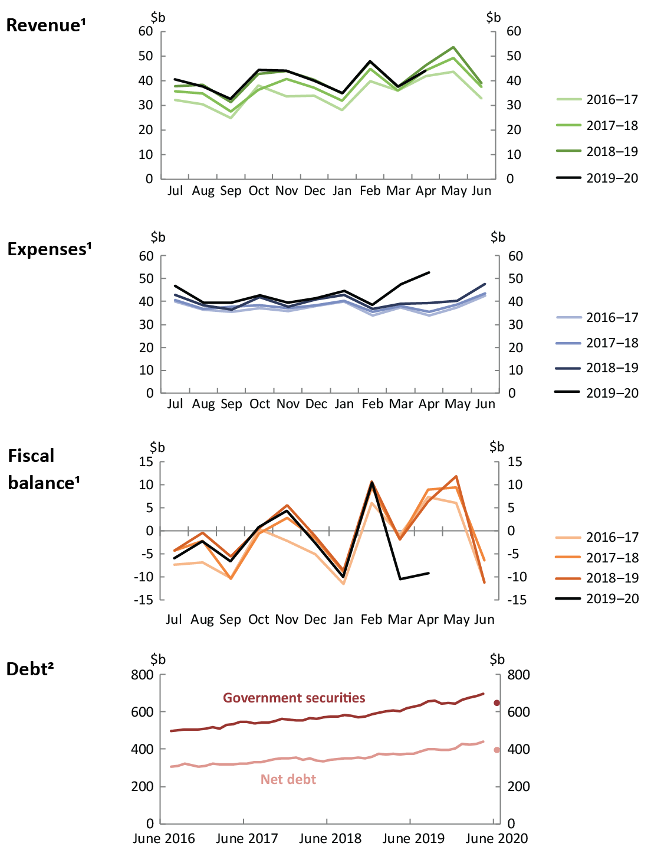
¹ Patterns across the months for revenue, expenses, and fiscal balance reflect key dates in revenue collection and transfer expenditure.
² Dots in the debt chart show 2019-20 MYEFO estimates.
Note: The charts use accrual accounting, and record income when earned and expenses when incurred, regardless of when the related cash is received or paid. The accrual amounts will generally show the impact of the COVID-19 measures earlier than the cash amounts.
Source: Commonwealth Government Monthly Financial Statements, Final Budget Outcomes, 2019-20 MYEFO and PBO analysis.

Monthly Financial Statements are available online at https://www.finance.gov.au/publications/commonwealth-monthly-financial-statements.

