2019–20
Medium-term
FISCAL projections
Report No. 03/2019

© Commonwealth of Australia 2019
ISBN 978-0-6483701-3-0 (online)
Copyright notice
This work is licensed under the Creative Commons Attribution-NonCommercial-NoDerivs
3.0 Australia License http://creativecommons.org/licenses/by-nc-nd/3.0/au/
Attribution
This publication should be attributed as follows: Parliamentary Budget Office, 2019–20 Medium-term fiscal projections.
Use of the Coat of Arms
The terms under which the Coat of Arms can be used are detailed on the following website: https://www.pmc.gov.au/government/commonwealth-coat-arms
Feedback
If you found this report useful, or have suggestions for improvement, please provide feedback to feedback@pbo.gov.au.

Contents
Overview 1
1 Projected underlying cash balance 2
1.1 Underlying cash balance 2
1.2 Changes since the 2018–19 Medium-term projections 4
2 Projected receipts 6
2.1 Total receipts 6
2.2 Personal income tax and fringe benefits tax receipts 8
2.3 Company tax receipts 8
2.4 Goods and services tax receipts 10
2.5 Excise, customs duty, and wine equalisation tax receipts 10
2.6 Non-tax receipts 10
2.7 Superannuation fund tax receipts 11
2.8 Resource rent tax receipts 11
2.9 Risks around projected receipts 11
3 Projected spending 13
3.1 Total spending 13
3.2 Spending growth by program 14
3.3 National Disability Insurance Scheme 16
3.4 Defence 17
3.5 Medicare 17
3.6 Pharmaceutical benefits 17
3.7 Aged care and the age pension 18
3.8 Family tax benefit 18
3.9 Disability support pension 18
3.10 Public hospitals 19
3.11 Child care 19
3.12 Schools 19
3.13 Road and rail infrastructure 20
3.14 Risks around projected spending 20
4 Projected net debt and net financial worth 22
4.1 Net debt 22
4.2 Net financial worth 24
Appendix A – Receipt projection methodology 25
Appendix B – Spending projection methodology 28
This report was authored by John Clark, Anthea Guthrie, Liyi Pan and Lok Potticary, with the benefit of comments from Linda Ward. The contents of the report are the sole responsibility of the Parliamentary Budget Office.

Overview
This fourth edition of the Parliamentary Budget Office’s (PBO’s) medium-term projections report shows that ongoing government spending restraint, combined with lower public debt interest payments, are driving an improving fiscal position…
The underlying cash balance is projected to improve over the next decade to a surplus of 1.6 per cent of gross domestic product (GDP) by 2029–30. This is projected to result in a significant reduction in government debt, with net debt projected to have peaked in 2018–19 and to then decline to 1.6 per cent of GDP by 2029–30.
The improvement is driven by a decline in spending over the next decade of around 1.0 per cent of GDP, to 23.9 per cent of GDP, largely reflecting the ongoing impact of policy changes to tighten eligibility and constrain payments growth in a number of major programs, along with declining public debt interest payments as debt is paid down.
…with significant personal income tax cuts offsetting much of the impact of bracket creep…
Personal income tax receipts are also projected to contribute to an improving fiscal position, driven by bracket creep, although this effect is somewhat offset by cumulative tax cuts worth around 1.6 per cent of GDP in 2029–30.
Even with the tax cuts, average tax rates are projected to continue to increase with growth in incomes, particularly for low- to middle-income groups (those with a taxable income in the range of $20,000 to $58,000). In contrast, the average tax rate for the top 20 per cent of income earners (those with a taxable income above $90,000) is projected to be little changed.
…but this has removed the buffer against adverse revenue shocks…
Until recently, tax receipts were projected to exceed the government’s tax cap, so the budget position was partly shielded from the risk of adverse economic shocks. That is, there was an in-built allowance for unspecified tax cuts that could be adjusted depending on how economic conditions evolved. The effect of the government’s personal income tax cuts has been to remove this buffer, so any weakness in tax receipts before 2029–30 would directly affect the budget balance.
…and significant risks to the fiscal projections remain.
The projected surpluses over the medium term are predicated on above-trend economic growth for much of the period and a return to close-to-trend wages growth by the end of 2022–23. Weaker-than-projected economic circumstances, such as lower-than-assumed commodity prices, would deteriorate the budget position. On the other hand, stronger-than-expected economic activity would improve the budget position.
The spending restraint seen over the past few years may be increasingly difficult to maintain over coming years given the length of time over which restraint has been applied, the pressures emerging in some spending areas, and the potential need for fiscal stimulus, noting that the projected improvement in the budget balance is mildly contractionary.
Notwithstanding these risks, these projections do not include predictions about the possible future direction of government policy. This is not the role of the PBO. Rather, these projections inform Parliament and the general public about the underlying trajectory for the budget balance under current policy settings, which provides a baseline against which future decisions can be compared.

Projected underlying cash balance

Underlying cash balance
The underlying cash balance is projected by the Government to move from a small deficit in 2018–19 to a surplus of 0.4 per cent of GDP ($9.2 billion) by 2022–23. Beyond the forward estimates period, the PBO projects the surplus to reach 1.6 per cent of GDP ($53.7 billion) by 2029–30 (Figure 1–1). The PBO’s projection over the next decade is broadly consistent with the medium-term budget position presented in the 2019–20 Budget, although the profile varies somewhat from year to year resulting in a slightly higher projection for net debt (Section 4).

Figure 1–1: Underlying cash balance
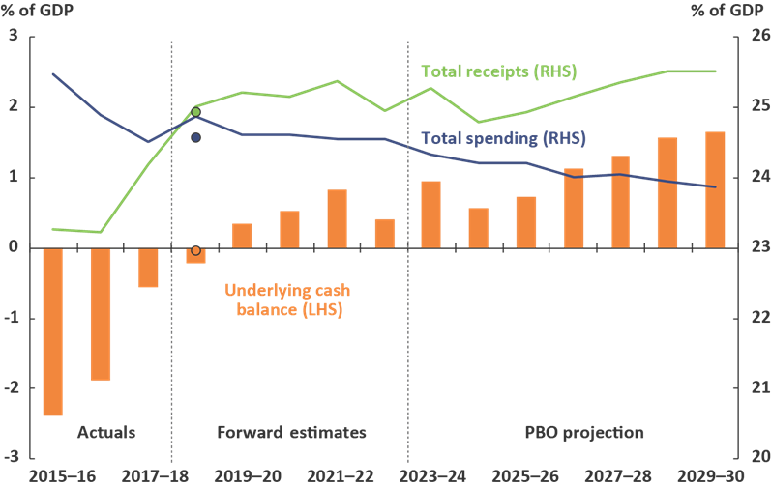
Note: Dots represent the 2018–19 final budget outcomes, for total receipts of 24.9 per cent of GDP, payments of 24.6 per cent of GDP and an underlying cash balance of 0.0 per cent of GDP in 2018–19. Net Future Fund earnings are included in the underlying cash balance from 2020–21, consistent with the 2019–20 Budget treatment.
Source: 2019–20 Budget, 2018–19 Final Budget Outcome and PBO analysis.
The improvement in the budget balance over the medium term reflects declining spending as a share of GDP, which the PBO projects to fall by around 1.0 per cent of GDP over the decade to 2029–30, to 23.9 per cent of GDP.
Beyond the forward estimates period, the PBO projects total receipts to fall in 2024–25 with the implementation of Stage 3 of the Government’s personal income tax cuts, but to continue to increase as a share of GDP thereafter. Net Future Fund earnings contribute 0.3 per cent of GDP to the underlying cash balance from 2020–21, the first year these earnings become available to meet the Government’s superannuation liability.

These projections are based on the policy settings, budget estimates and the economic parameters at the time of the 2019–20 Budget (see Boxes 1 and 2 below), and include the impact of underlying trends, such as ageing, which will have a noticeable fiscal impact over the next two decades. The outcomes reported in the 2018–19 Final Budget Outcome, released in September and noted in the figures for comparison, would not be expected to materially change the medium-term trends and pressures presented in this report. The underlying trends in the components of receipts and spending are explored in more detail in the following sections.

Box 1: Medium-term projections vs predictions
One criticism of medium-term projections can be that they largely reflect current government policy and do not incorporate likely future government decisions.
This is intentional. The PBO’s projections are not attempts to predict the future, or future policy decisions, but rather to provide a reasonable quantitative basis on which to assess the strength and sustainability of the current fiscal position, and to provide a baseline to which future decisions should be added or subtracted.
The projections are designed to perform the following functions.
First, they present significant detail beyond the forward estimates period for major receipts and spending programs. The 2019–20 Budget papers included projections of the underlying cash balance, total receipts, total payments, net debt and net financial worth to 2029–30, but did not include detailed breakdowns of receipts and spending beyond the forward estimates period, which ends in 2022–23. The additional detail provided in this report enables a more informed assessment of the fiscal policy settings, including the impact on the budget of significant programs that mature beyond the forward estimates period.
Second, although the PBO’s legislation requires it to use the economic parameters that underpin the 2019–20 Budget (Box 2), the PBO’s projections provide an independent assessment of how those economic parameters, along with underlying demographic trends and developments in individual program areas, translate into fiscal aggregates.
Third, the projections provide an annual update on the strength of the budget position over the next decade. The major development in fiscal policy architecture in Australia over the past twenty years has been extending budgeting over a longer timeframe, but the Intergenerational Report, first published in 2002, is updated only every five years. The economic and policy contexts can evolve more quickly, even over a decade horizon, suggesting a benefit of more regular updates.
Fourth, the projections provide an assessment of the Government’s capacity to fund both commitments that mature beyond the forward estimates period and future policy decisions. The PBO includes the Government’s policy settings as presented in the most recent budget. Where government policy has not been made explicit beyond the forward estimates period, the PBO’s projections broadly assume the continuation of current policy settings and arrangements. The PBO does not speculate on future government policy decisions.

Changes since the 2018–19 Medium-term projections
As well as presenting the latest estimate of the PBO’s medium-term projections, this report can be used to analyse how these projections have changed over time. Figure 1–2 shows how projections for total receipts, total spending and the underlying cash balance have changed since the PBO’s 2018–19 projections.
The increase in the underlying cash balance in 2018–19 relative to the previous projections is largely due to upward revisions to receipts, particularly personal income tax, company tax and superannuation fund taxes. Over the remainder of the projection period, receipts have been revised downward, with the main contributors being personal income tax and the goods and services tax (GST), partly offset by upward revisions in company tax. The primary cause of the lower personal income tax projections is the Government’s second round of personal income tax cuts.
Offsetting the downward revisions to projections for receipts are downward revisions to projections for payments. The decrease in payments in 2018–19 relative to the previous projections is mainly due to downward revisions to spending on the National Disability Insurance Scheme (NDIS). The largest contributors to the downward revision for payments over the remainder of the projection period are GST transfers to the states and territories, and public debt interest payments. As the GST is collected by the Commonwealth and then paid out to the states and territories, the downward revision in GST payments reflects the lower-than-expected GST receipts.
The downward revision to public debt interest payments is the result of two main factors: a lower bond yield assumption in this report relative to the previous report (consistent with the budget), and a lower amount of debt being expected to be issued due to the higher underlying cash balance over the period 2018–19 to 2021–22. The downward revision in GST and public debt interest payments are partly offset by upward revisions to spending on infrastructure and pharmaceutical benefits.
Figure 1–2: Revisions to projections
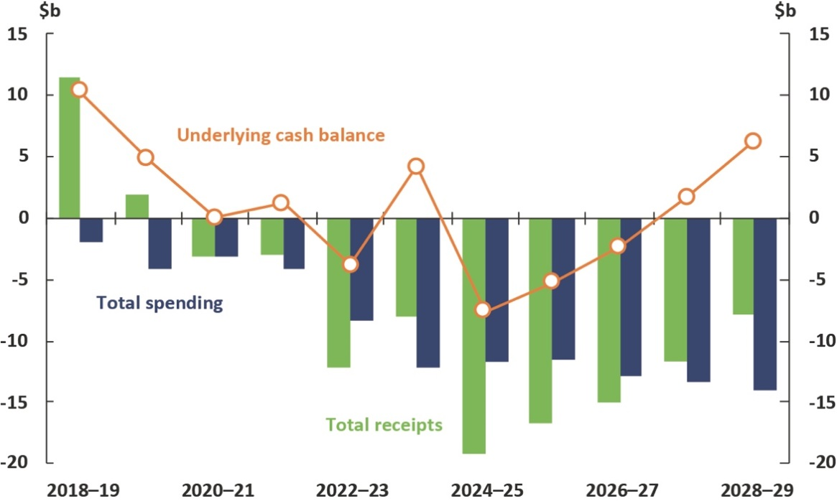
Note: Revisions in Future Fund earnings are included in total receipts in this figure, however they are only included in the underlying cash balance from 2020–21, consistent with the treatment in the 2019–20 Budget.
Source: PBO analysis.
Box 2: Understanding the budget’s economic parameters
The budget’s economic forecasts represent the Government’s estimate of how the economy will unfold over the next two years (the budget year and the following year). The economic projections, over the subsequent nine years, are based on an assessment of the sustainable level of output, given projections for population, labour participation and productivity.,
Taken together, the forecasts and projections comprise the economic parameters that underpin the Government’s budget. The PBO is required, under legislation, to use these parameters when constructing the medium-term projections.
Given economic activity has been operating below its sustainable level for the past decade, with inflation below its target range, the projections assume there will be a period of ‘catch-up’ (the adjustment period) during which growth is above its sustainable rate. This is often referred to as ‘closing the output gap’. Once the output gap has been closed, the economy is assumed to return to growing at its sustainable rate.
Figure 1–3 shows the real GDP projections for each of the last four budgets relative to the budget year. Other parameters, including inflation, unemployment, consumption, profits and wages, are projected consistently within this methodology.

Figure 1–3: Real GDP growth
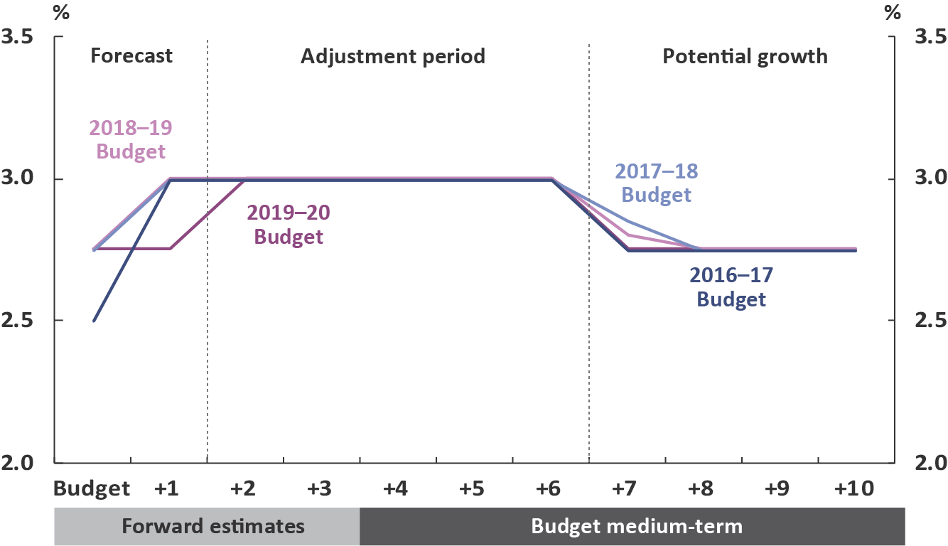
Note: For the 2019–20 Budget, the tenth year is 2029–30.
Source: Budget papers.
The majority of the PBO’s payment and receipt projections use a framework whereby the latest budget outcomes are grown forward in line with the relevant economic parameters. This is often called a ‘base-plus-growth’ framework. Revisions to the economic projections will flow through to the receipt and payment projections, and thereby the overall budget position. A structural change in the economy, such as an enduring change in the rate of productivity growth, would have a significant and compounding effect on the budget position over time.

Projected receipts

Total receipts
Total receipts are expected to be broadly flat over the forward estimates period, and to increase to around 25.5 per cent of GDP in 2029–30 (Figure 2–1). The Government’s tax-to-GDP cap of 23.9 per cent of GDP is expected to bind in 2029–30 (see Box 4). Without this constraint, tax receipts would have been projected to be above the cap, at 24.1 per cent of GDP in 2029–30, and consequently total receipts would have been projected to rise to 25.7 per cent of GDP.

Figure 2–1: Receipts
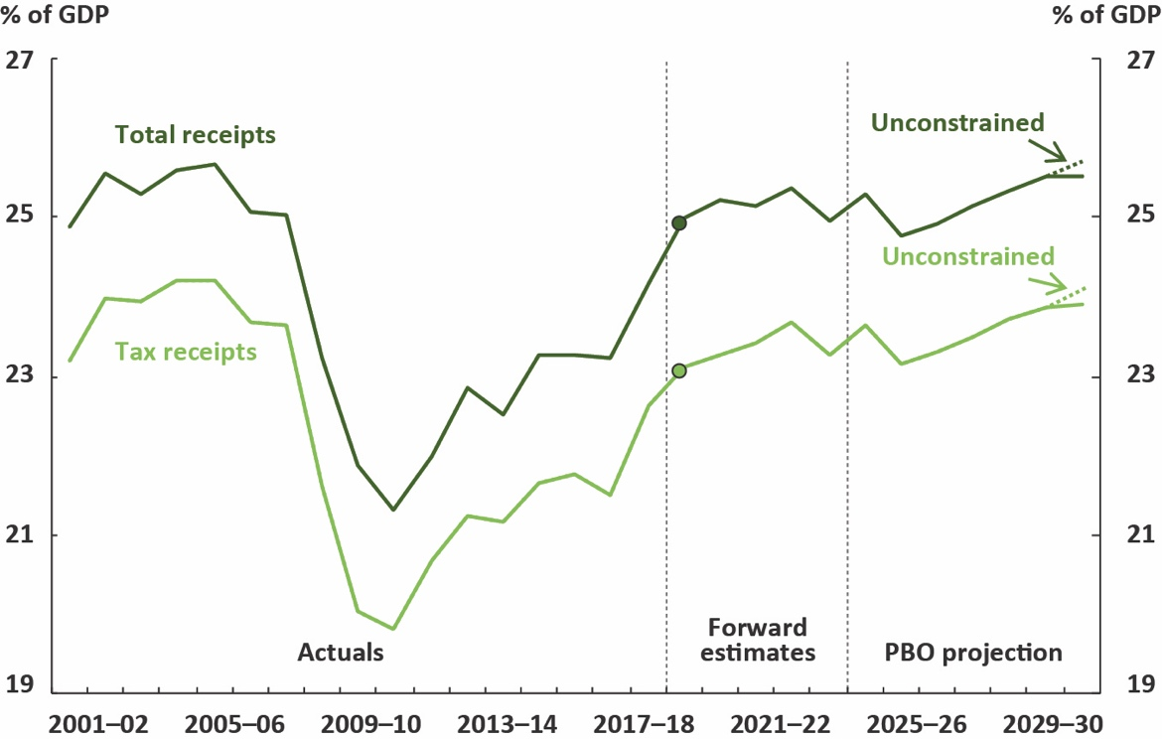
Note: Dots represent the 2018–19 final budget outcomes for total receipts of 24.9 per cent of GDP and tax receipts of 23.0 per cent of GDP.
Source: 2019–20 Budget, 2018–19 Final Budget Outcome and PBO analysis.
The main driver of the increase in total receipts in the second half of the decade is a projected rise in personal income tax (reported in the budget as ‘Individuals and Other Withholding Tax’ receipts). This increase occurs even after factoring in all stages of the Government’s personal income tax cuts, as announced in the 2018–19 and 2019–20 Budgets (Figure 2–2), worth around 1.6 per cent of GDP by the end of the decade. Without the personal income tax changes, the tax cap would have been expected to bind in 2021–22.
Figure 2–2: Breakdown of receipts
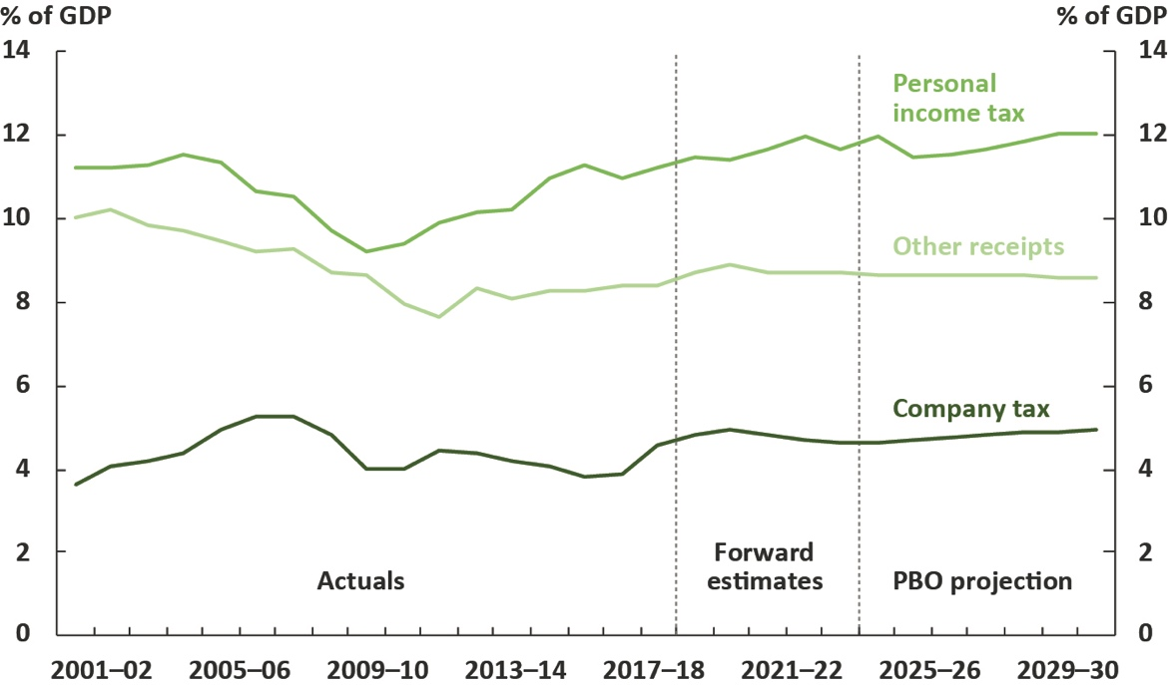
Note: The breakdown shows the two largest heads of revenue, with all other receipts grouped
together as ‘other receipts’.
Source: 2019–20 Budget and PBO analysis.
Table 2–1 shows the PBO’s projections of the change in receipts by each major category over the period 2018–19 to 2029–30, and their projected contribution to growth in total receipts. It shows that there is expected to be little change in receipts as a percentage of GDP, other than in those categories discussed above.

Table 2–1: Receipts
Receipts | Nominal receipts |  | Per cent of GDP |  | Change in per cent of GDP | Annual real growth | Share of total receipts
 | 2018–19 | 2029–30 | 2018–19 | 2029–30 | 2018–19 to 2029–30 |  | 2029–30
 | $b |  | % |  | % | % | %
Individuals and other withholding taxes | 223 | 393 | 11.5 | 12.0 | 0.5 | 2.9 | 47.2
Superannuation fund taxes | 11 | 24 | 0.6 | 0.7 | 0.2 | 4.7 | 2.9
Company tax | 94 | 160 | 4.8 | 4.9 | 0.1 | 2.6 | 19.3
Excise and customs duty | 40 | 67 | 2.0 | 2.1 | 0.0 | 2.5 | 8.1
Fringe benefits tax | 4 | 6 | 0.2 | 0.2 | 0.0 | 2.7 | 0.8
Wine equalisation tax | 1 | 2 | 0.1 | 0.1 | 0.0 | 2.6 | 0.2
Other taxes and charges | 9 | 15 | 0.4 | 0.4 | 0.0 | 2.4 | 1.7
Luxury car tax | 1 | 1 | 0.0 | 0.0 | 0.0 | 2.2 | 0.1
Goods and services tax | 66 | 110 | 3.4 | 3.4 | 0.0 | 2.4 | 13.2
Resource rent taxes | 1 | 1 | 0.1 | 0.0 | 0.0 | -3.8 | 0.1
Total tax receipts | 449 | 780 | 23.1 | 23.9 | 0.8 | 2.7 | 93.7
Non-tax receipts | 36 | 53 | 1.9 | 1.6 | -0.3 | 1.0 | 6.3
Total receipts | 485 | 832 | 25.0 | 25.5 | 0.5 | 2.6 | 100.0
Memorandum item:
Capital gains tax | 18 | 32 | 0.9 | 1.0 | 0.1 | 3.3 | 2.0
Source: 2019–20 Budget and PBO analysis.

Personal income tax and fringe benefits tax receipts
Personal income tax receipts are projected to increase by 0.5 per cent of GDP over the next decade, from 11.5 per cent of GDP in 2018–19 to 12.0 per cent of GDP in 2029–30. For these projections, we assume that when the tax cap binds, it will be met through additional unspecified personal income tax cuts.
The profile for personal income tax receipts largely reflects the staged implementation of the Government’s personal income tax cuts, which are discussed further in Box 3. These changes to the personal income tax system reduce the impact of bracket creep, but bracket creep will continue to occur as average tax rates increase with growth in incomes, particularly for low- to middle-income groups.
Personal income tax receipts have been revised downward by $11.4 billion over the four years to 2022–23 compared to the previous report. Downward revisions to personal income tax receipts since the previous report are mainly due to the additional tax measures announced in the
2019–20 Budget, particularly the reduction of the 32.5 per cent bracket to 30 per cent, with some contribution from the downward revisions to forecast wage growth.
The income tax changes are also expected to affect fringe benefits tax receipts towards the end of the medium term, as the reduction in marginal tax rates reduces the incentive for those employees who are no longer in the top tax bracket to take additional compensation in the form of fringe benefits. Although not factored into the projections, the PBO would expect the decrease in fringe benefits tax receipts to be mostly offset by a corresponding increase in personal income tax receipts.

Company tax receipts
Company tax receipts are projected to remain relatively stable as a share of GDP over the medium term, increasing from 4.8 per cent of GDP in 2018–19 to 4.9 per cent of GDP in 2029–30. Company tax receipts have been revised upward by $6.7 billion over the four years to 2022–23 compared to the previous report, largely due to expected strong mining profits over the forward estimates period. While elevated commodity prices have contributed to the strength over the forward estimates period, their impact on profits is expected to diminish over the medium term as commodity prices are assumed to revert towards historical levels.
The future path of key commodity prices remains, as always, one of the significant risks to the budget projections.

Box 3: Distributional effects of personal income tax changes
The past two budgets have seen substantial changes to the personal income tax system.
These changes will have the effect of decreasing personal income tax rates over
the coming years. Countering this, bracket creep (driven by ongoing growth in wages)
is projected to have the effect of increasing average personal income tax rates. The overall change in the average tax rate is the combined impact of these two effects. The overall effect on an individual’s average tax rate over the period 2017–18 to 2028–29 depends on their taxable income. Figure 2–3 shows the projected change in average tax rates for different taxable income quintiles.

Figure 2–3: Change in average tax rates by income quintile, 2017–18 to 2028–29

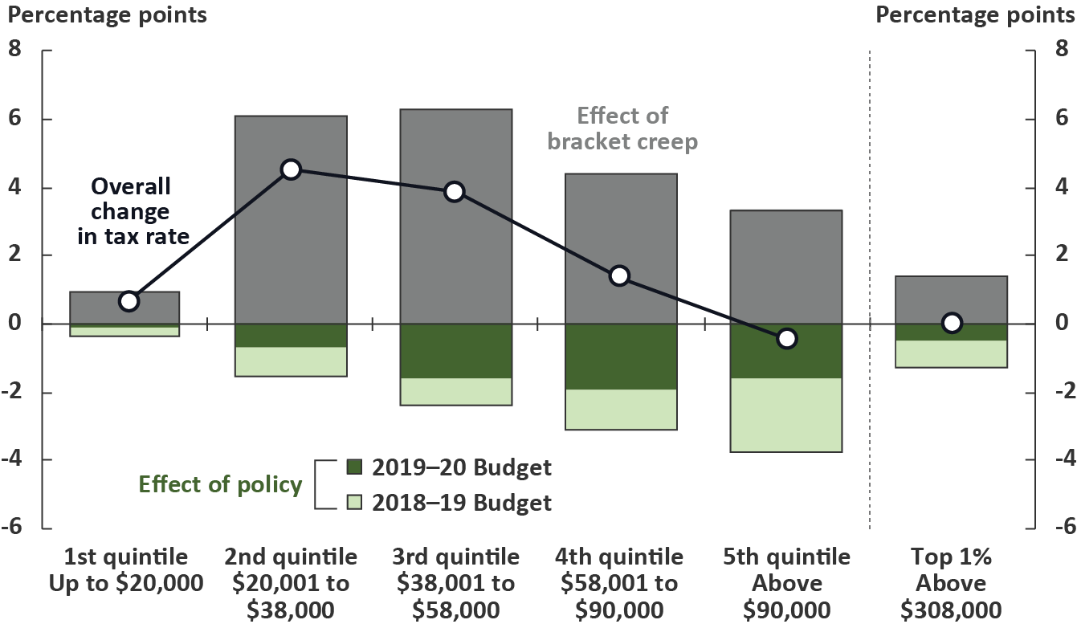
Note: Analysis comprises individuals who filed a tax return in 2016–17, divided into quintiles according to taxable income. Taxable income ranges are for 2018–19.
Source: PBO analysis, Australian Taxation Office data, and parameters underlying the 2019–20 Budget.
This analysis shows that individuals in the second and third quintiles (together spanning the taxable income range $20,001 to $58,000), are expected to face the largest effects of bracket creep, while the benefits of the tax cuts are greater at higher quintiles. Overall, average tax rates for individuals in the second and third quintiles are projected to increase by 4.5 percentage points and 3.9 percentage points respectively over the period to 2028–29, while average tax rates for individuals in the top quintile (with taxable incomes above $90,000) are projected to fall marginally.

Goods and services tax receipts
Goods and services tax receipts are expected to remain flat at around 3.4 per cent of GDP over the next decade. Compared to the previous report, GST receipts have been revised downward by $13.9 billion over the four years to 2022–23, driven by downward revisions to the forecast growth in prices, consumption and dwelling investment.
The profile of GST receipts is affected by a 2018–19 Mid-year Economic and Fiscal Outlook measure which provides additional funding to the Australian Taxation Office to enforce GST compliance. This is expected to boost receipts from 2019–20 but winds down in 2023–24. The projections assume that the expected effectiveness of the measure is realised and then ceases as planned, however we note that successive governments have often extended previous GST compliance activities before they have expired. An extension of the measure would be expected to boost GST receipts.

Excise, customs duty, and wine equalisation tax receipts
Excise and customs duty receipts are projected to peak at 2.3 per cent of GDP in 2019–20 before declining to 2.1 per cent of GDP in 2029–30. The peak in 2019–20 is driven by tobacco excise, reflecting additional receipts due to the commencement of the 2018–19 Budget measure Black Economy Package – Combatting illicit tobacco. Excise and customs duty receipts have been revised downward over the forward estimates period, driven by downward revisions to the forecast growth in household consumption since the previous report.
Over the medium term, excise and customs duty receipts are expected to grow at rates slower than the historical average, reflecting both the implementation of free trade agreements, which reduce the proportion of imports subject to excise and customs duties (particularly for textiles, clothing and footwear, and motor vehicles), and declining demand for highly taxed items such as tobacco, fuel and alcohol.
Wine equalisation tax receipts are expected to remain flat at around 0.05 per cent of GDP over the next decade. Wine equalisation tax receipts have been revised upward by $500 million over the four years to 2022–23. The stability in wine equalisation tax receipts over the forward estimates period reflects the interaction between changing consumption patterns, with falling consumption of alcohol per capita offset by shifting consumer preferences towards wine rather than beer. Over the medium term these shifts in alcohol consumption patterns are a downside risk to revenue projections, as the two different alcohol tax systems mean that most beer categories are subject to a higher effective rate of taxation than most of the wine consumed in Australia.

Non-tax receipts
Non-tax receipts (including Future Fund earnings) are projected to decrease slightly from a peak of 2.0 per cent of GDP in 2019–20 to 1.6 per cent of GDP in 2029–30. Non-tax receipts have been revised upward by $6.3 billion over the four years to 2022–23 compared to the previous report, primarily due to increased Future Fund earnings.

Superannuation fund tax receipts
Superannuation fund tax receipts are projected to increase to 0.7 per cent of GDP in 2022–23 and remain around that level for the rest of the medium term.
Compared to the previous report, superannuation fund taxes have been revised downward by around $400 million over the four years to 2022–23, largely reflecting a downward revision in
2019–20 attributable to the impact of recent off-market share buybacks.

Resource rent tax receipts
Resource rent taxes are primarily comprised of the petroleum resource rent tax (PRRT). Petroleum resource rent tax receipts are projected to increase over the period to 2026–27 and then decline as a result of more established projects paying less PRRT, and a gap between that and newer projects becoming liable for PRRT, which may occur beyond the end of the medium-term projection period. The PRRT is particularly sensitive to the oil price assumption.

Risks around projected receipts
As discussed in Box 2, the projections over the medium term are predicated on above-trend economic growth for much of the period and return-to-trend wages growth by the end of the forward estimates period. The receipts projections have become more sensitive to macroeconomic risks because the Government’s personal income tax cuts mean the tax cap now binds in the final year of the medium term (see Box 4). As a result, any weakness in tax receipts before that point will directly affect the receipts projections, and therefore the budget balance.
The most significant short-term macroeconomic risks affecting receipts include weaker-than-expected commodity prices, wages, and labour market outcomes. In the long term, weaker-than-assumed productivity growth would have a large and compounding effect on tax receipts.
Owing to the aggregated nature of the medium-term economic parameters, the projection for receipts may also be overstated, as the economic parameters do not capture some of the significant trends expected to reduce revenue in the coming years. For example, the economic projections, being at an aggregated level, do not capture trends towards low emission vehicles, which will reduce fuel excise, or declining smoking rates, which will reduce tobacco excise. Many of these issues were discussed in the PBO report Trends affecting the sustainability of Commonwealth taxes. Further work to quantify the fiscal impact of these trends will be undertaken by the PBO to inform the
2020–21 medium-term projections.
Box 4: Fiscal risk and the tax cap
In the absence of changes to tax rates and thresholds, projected personal income tax receipts increase over time due to the impact of bracket creep. In previous medium-term projections, the projected path for receipts has included the Government’s commitment to maintain tax receipts at or below a ‘cap’ of 23.9 per cent of GDP. The receipts projections have therefore incorporated future unspecified tax cuts.
The tax-to-GDP cap has historically applied well before the end of the medium term, giving ample fiscal space to absorb any downside risks to receipts. The personal income tax cuts announced in the last two budgets have, however, now specified (and legislated) the majority of the ‘unspecified tax cuts’ that were previously implicitly factored into the medium term, with the result that the tax-to-GDP cap is now not projected to bind until 2029–30 (see Figure 2–4 below).

Figure 2–4: Tax receipts - unconstrained
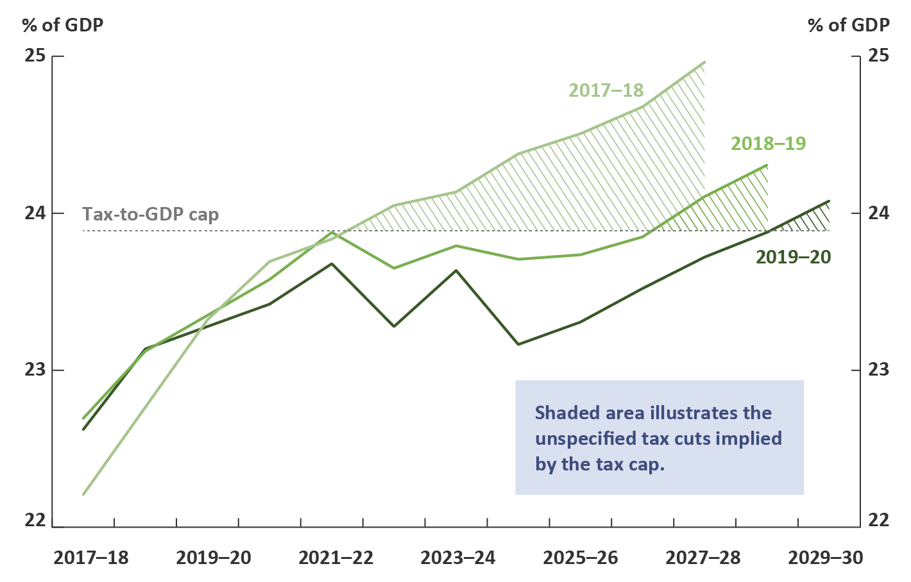
Source: PBO analysis.

Projected spending

Total spending
Total spending has reduced considerably since 2013–14 and, under current policy settings, is projected to continue to decline over the medium term, reaching 23.9 per cent of GDP by 2029–30.
A key driver of the decline in spending over the next decade is public debt interest payments, which are projected to fall by 0.5 per cent of GDP over the period 2018–19 to 2029–30 due to the projected improvement in the budget balance and a reduction in government debt. All other payments combined are projected to fall by 0.5 per cent of GDP over the same period (Figure 3–1).
Compared to the PBO’s previous projections, total spending has been revised downward by around 0.4 per cent of GDP each year. Around a quarter of the revision reflects lower public debt interest payments, largely owing to a reduction in the assumption for long-term government bond yields from 2.5 per cent in last year’s report to 1.9 per cent for this report.

Figure 3–1: Total spending
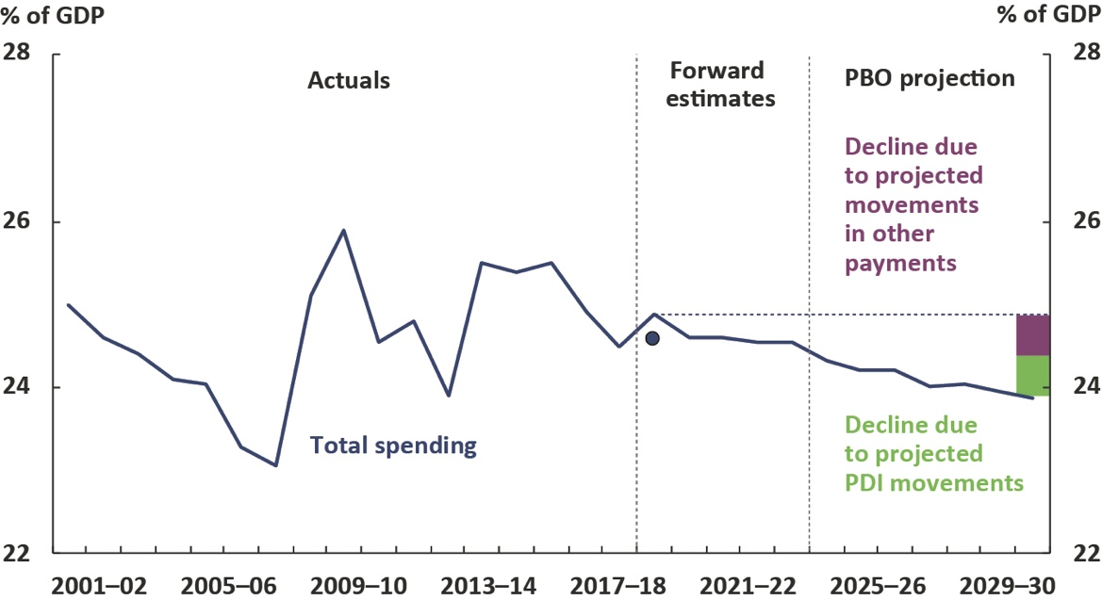
Note: The dot represents the 2018–19 final budget outcome for total payments of 24.6 per cent of GDP.
Source: 2019–20 Budget, 2018–19 Final Budget Outcome and PBO analysis.
The decline in spending as a proportion of GDP over the next decade also reflects the ongoing impact of policy changes and spending restraints that have seen growth across a number of key payments slow significantly over the past six years. These payments include the age pension, Medicare, family tax benefit, disability support pension, pharmaceutical benefits, and carer income support. The decline occurs notwithstanding the increase in spending on the NDIS as it approaches maturity.
While government spending is projected to decline as a proportion of GDP, real government spending per capita (which adjusts for inflation and population growth) is projected to grow over the next decade (see Figure 3–2). Over the forward estimates period, the Government projects that real per-capita spending will increase by 0.3 per cent per year. Beyond the forward estimates period, the PBO projects that it will increase by 0.9 per cent per year. This is a reversal of the negative growth trend over the period 2012–13 to 2017–18, but real government spending per capita is not projected to return to its pre-global financial crisis growth, or its long-run average growth of 1.8 per cent.

Figure 3–2: Average annual growth in real spending per capita
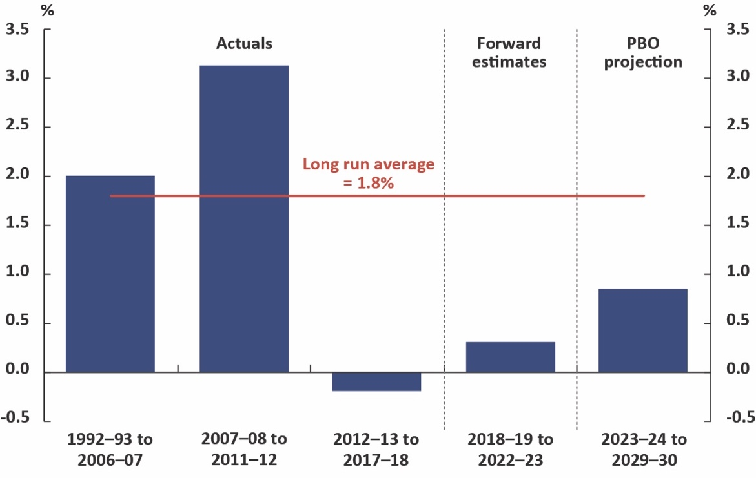
Source: 2019–20 Budget and PBO analysis.

Spending growth by program
The PBO’s spending projections are based on individual analysis of 23 major program areas. Projections of spending generally assume policy settings and arrangements as contained in the budget estimates. Spending on new pharmaceutical benefits listings is assumed to be in line with historical trends in Pharmaceutical Benefits Advisory Committee approvals. The profile of infrastructure spending in the medium term is projected to return to pre-GFC levels as a share of GDP.
For remaining spending (outside of the 23 major programs), amounting to around 18 per cent of total spending, the fiscal implications of current policies are less clear over the medium term. The approach used by the PBO is to project spending in these areas in aggregate, and assume that continuing government policy will maintain this spending as a proportion of GDP, noting that specific elements may change. Appendix B provides further detail on the approaches taken to generate the projections for each major program.
As illustrated in Figure 3–3, the largest contributor to the growth in spending over the next decade is spending on the NDIS, which is projected to increase as a share of GDP by 0.4 per cent. The next largest contributor to growth is defence spending (projected to increase by 0.3 per cent of GDP), followed by spending on aged care (projected to increase by 0.2 per cent of GDP) and spending on the Medicare Benefits Schedule (projected to increase by 0.1 per cent of GDP).

Figure 3–3: Projected spending over the next decade
Change from 2018–19 to 2029–30
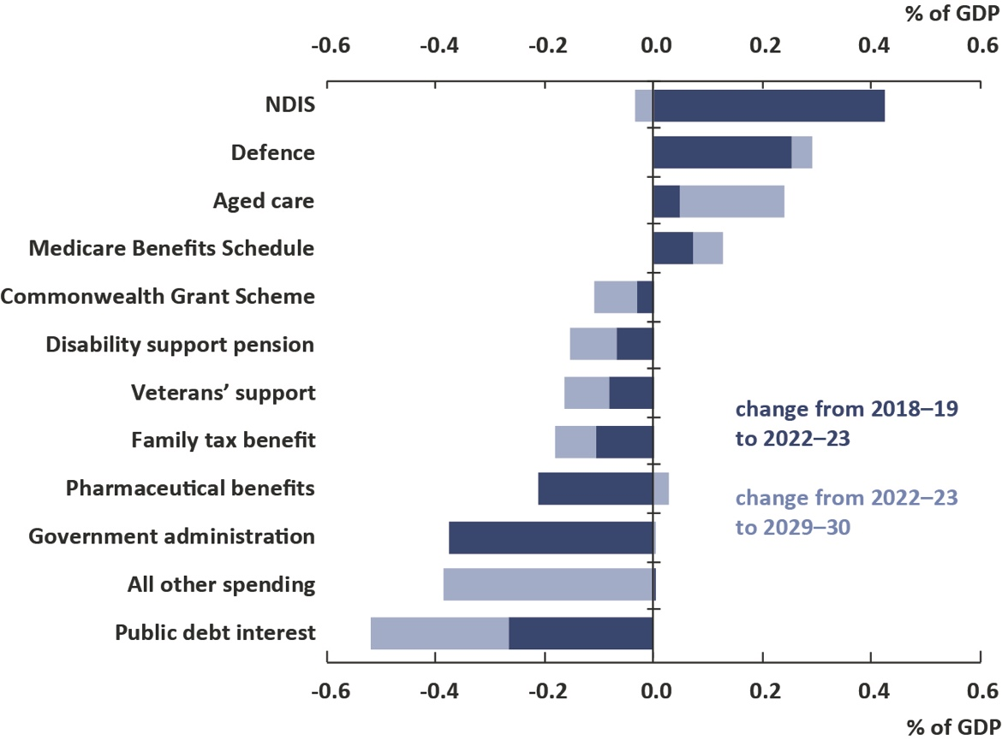
Note: All other spending includes the total of all spending programs not separately identified in this chart.
Source: 2019–20 Budget and PBO analysis.
More than offsetting the above increases are declines in spending as a proportion of GDP for other items. The largest decline is in public debt interest, which is projected to decrease as a share of GDP by 0.5 per cent over the next decade, in line with the improvement in the budget balance.
Declines are projected across a range of payment programs, a significant proportion of which are expected to occur over the forward estimates period. The largest decline in spending on payments programs over the next decade is on pharmaceutical benefits, which is projected to decrease by 0.2 per cent of GDP, although this reflects a change in administrative arrangements rather than policy restraint. The decline in spending on government administration over the forward estimates period is also a significant source of restraint, after which it is projected by the PBO to remain stable as a share of GDP for the rest of the decade.
Table 3–1 shows the PBO’s projections of the change in spending by each major category over the period 2018–19 to 2029–30 and each category’s projected contribution to growth in total spending. Trends in each of the major spending categories are further discussed below.

Table 3–1: Spending by key program area
Payments | Nominal payments |  | Per cent of GDP |  | Change in per cent of GDP | Annual real growth | Share of total payments
 | 2018–19 | 2029–30 | 2018–19 | 2029–30 | 2018–19 to 2029–30 |  | 2029–30
 | $b |  | % |  | % | % | %
National Disability Insurance Scheme | 11 | 32 | 0.6 | 1.0 | 0.4 | 7.2 | 4.1
Defence spending | 37 | 71 | 1.9 | 2.2 | 0.3 | 3.7 | 9.1
Aged care | 20 | 42 | 1.1 | 1.3 | 0.2 | 4.3 | 5.4
Medicare Benefits Schedule | 24 | 45 | 1.3 | 1.4 | 0.1 | 3.2 | 5.8
Child care | 8 | 15 | 0.4 | 0.5 | 0.1 | 3.6 | 1.9
Public hospitals | 22 | 38 | 1.1 | 1.2 | 0.0 | 2.7 | 4.9
Government superannuation | 7 | 12 | 0.3 | 0.4 | 0.0 | 3.0 | 1.6
Carer income support | 9 | 15 | 0.5 | 0.5 | 0.0 | 2.7 | 2.0
Fuel tax credit scheme | 7 | 12 | 0.4 | 0.4 | 0.0 | 2.7 | 1.5
Schools | 20 | 33 | 1.0 | 1.0 | 0.0 | 2.4 | 4.3
Age pension | 47 | 78 | 2.4 | 2.4 | 0.0 | 2.3 | 10.1
GST transfers to states | 66 | 110 | 3.4 | 3.4 | 0.0 | 2.3 | 14.1
Private Health Insurance Rebate | 6 | 9 | 0.3 | 0.3 | 0.0 | 1.0 | 1.2
Parenting payments | 5 | 7 | 0.3 | 0.2 | 0.0 | 0.7 | 1.0
Official Development Assistance | 4 | 5 | 0.2 | 0.1 | -0.1 | -1.3 | 0.6
Job seeker income support | 11 | 16 | 0.6 | 0.5 | -0.1 | 1.0 | 2.0
Road and rail infrastructure | 6 | 7 | 0.3 | 0.2 | -0.1 | -0.7 | 1.0
Commonwealth Grant Scheme | 7 | 8 | 0.4 | 0.3 | -0.1 | -0.9 | 1.1
Disability support pension | 17 | 23 | 0.9 | 0.7 | -0.2 | 0.5 | 3.0
Veterans’ support | 6 | 5 | 0.3 | 0.1 | -0.2 | -4.4 | 0.6
Family tax benefit | 18 | 24 | 0.9 | 0.7 | -0.2 | 0.4 | 3.1
Pharmaceutical benefits | 13 | 16 | 0.7 | 0.5 | -0.2 | -0.6 | 2.0
Public debt interest | 18 | 14 | 0.9 | 0.4 | -0.5 | -4.9 | 1.7
Total modelled spending | 388 | 639 | 20.0 | 19.6 | -0.4 | 2.1 | 82.1
Other spending | 94 | 140 | 4.9 | 4.3 | -0.6 | 1.2 | 17.9
Government administration | 37 | 49 | 1.9 | 1.5 | -0.4 | 0.3 | 6.3
Remaining spending | 58 | 90 | 3.0 | 2.8 | -0.2 | 1.7 | 11.6
Total spending | 483 | 778 | 24.9 | 23.9 | -1.0 | 2.0 | 100.0
Source: 2019–20 Budget and PBO analysis.

National Disability Insurance Scheme
The largest contributor to the growth in spending over the next decade is spending on the NDIS,
which is projected to increase by 0.4 per cent of GDP. Growth in NDIS spending is expected to increase significantly to 2020–21, at which point the Scheme achieves national coverage. From 2020–21 spending is expected to stabilise at 1.0 per cent of GDP as the NDIS reaches maturity. Although NDIS spending has been lower than expected over the past few years, reflecting lower-than-expected numbers of participants entering the NDIS and lower utilisation of support packages, projections of the fully rolled-out scheme over the medium term have remained consistent between updates.
The NDIS is still in the early stages of implementation and, as with any program which is yet to mature, there are risks that the longer-term costs associated with the NDIS may increase. While the Productivity Commission noted that preliminary data indicated that the costs of the NDIS were broadly in line with National Disability Insurance Agency’s long-term estimates, it is possible that spending pressures will emerge as the NDIS is fully rolled out.

Defence
Defence spending is projected to increase by 0.3 per cent of GDP over the next decade, reflecting the Government’s funding commitments in the 2016 Defence White Paper. This is broadly consistent with projections included in the previous report. There remains uncertainty around the projections in individual years, given that the acquisition of military equipment is inherently ‘lumpy’ in nature and can be subject to changes in the timing of delivery.

Medicare
Spending on Medicare is projected to be relatively stable as a proportion of GDP, increasing from 1.3 per cent of GDP in 2018–19 to 1.4 per cent of GDP in 2029–30. Growth in Medicare services in recent years has been driven by increased usage, particularly by people aged 65 and over. Medicare payments are projected to experience price growth over the medium term as the freeze on indexation is lifted on more Medicare items in 2019 and 2020.

Pharmaceutical benefits
Spending on the Pharmaceutical Benefits Scheme (PBS) is projected to decline by 0.2 per cent of GDP to 0.5 per cent of GDP in 2020–21 before stabilising as a proportion of GDP over the medium term. The significant fall within the forward estimates period does not represent a real saving in budget balance terms but is the result of a change in administrative arrangements and is offset by a reduction in non-tax receipts.
There remains a large degree of uncertainty regarding projections for spending on pharmaceutical benefits. The PBO’s projections include the costs for currently listed medicines and an allowance for new listings over the medium term, based on historical trends in listings. While this methodology captures the potential influence of population ageing and new listings, it does not capture the potential impact of the listing of revolutionary medicines, which is difficult to project. A recent example is the listing of Hepatitis C medicines in early 2016, which resulted in volatility in PBS spending over the following 18 months, although it did not have a significant medium-term impact on PBS spending due to the nature of the treatment.

Aged care and the age pension
Aged care spending is projected to increase by 0.2 per cent of GDP over the next decade, from 1.1 per cent of GDP in 2018–19 to 1.3 per cent in 2029–30, reflecting the impact of the ageing population on the demand for aged care services.
Aged care is currently a $20 billion program with around 70 per cent of spending devoted to subsidies for residential care places and the remainder to the Government’s two home care programs. Indexation applied to the aged care subsidies has generally been below inflation, however the average cost has grown strongly due to the steady increase in the average intensity of care needed by residents. The rate of increase in average costs is expected to slow due to the implementation of compliance measures on the care requirement rating system, as well as reduced space for further increases in the average cost, with 31 per cent of residents currently on the highest rating. Indexation of aged care spending is assumed to move towards wages growth over the medium term, reflecting the cost pressures facing aged care providers, including the competition for health care workers as a result of the expansion of the NDIS.
Spending on the age pension is expected to remain steady at 2.4 per cent of GDP over the next decade. Growth in the number of recipients over the forward estimates period has been revised down over time, with the tightening of the assets test applied in 2017 appearing to have a larger effect than originally expected. Conversely, growth from 2025–26 has been revised up from the previous projections due to the decision to not proceed with the increase in the qualifying age to age 70. This increase is partially offset by corresponding reductions in job seeker income support, disability support pension, and carer income support that older people would have otherwise accessed.
Future fiscal risks related to the ageing population may come from the Royal Commission into Aged Care Quality and Safety, which has the potential to motivate further reforms, and potential changes to the composition of consumption not currently factored into the medium-term economic parameters, due to an increase in the relative size of the health and aged care sectors.

Family tax benefit
Spending on the family tax benefit payment is projected to decline by 0.2 per cent of GDP over the next decade. Much of this decline occurs over the forward estimates period, due in part to the freeze in the indexation of payment rates, and income thresholds that affect access to the payment. While this indexation freeze is scheduled to end on 1 July 2021, the PBO projects that this payment will continue to decline relative to GDP over the medium term, reflecting lower projected birth rates and wages growth, which will continue to reduce the number of people able to access the payment.

Disability support pension
Spending on the disability support pension is projected to fall by 0.2 per cent of GDP over the next decade. The main driver of this is past policies that have focussed on tightening eligibility for the payment, in particular compliance and assessment measures that applied from 1 January 2012. These measures are projected to have an ongoing effect, such that the impact on spending over the next decade is shared equally between the forward estimates period and the period beyond.
Tightening the eligibility criteria around the disability support pension may reduce direct expenditure on this payment, but this is generally partly offset by expenditure increases on other payments such as Newstart (a main component of job seeker income support), which is paid at a lower rate.
The projections for disability support pension payments have been revised down over the past two updates, reflecting the observed falls in recipients, particularly older cohorts, which have been driven by eligibility criteria and compliance measures.

Public hospitals
Spending on public hospitals is projected to remain steady at 1.2 per cent of GDP from 2022–23 onwards. Public hospital funding to the states and territories is based on the National Health Reform Agreement under which the Commonwealth contributes 45 per cent of the growth in the ‘efficient cost’ of hospital services, as determined by an independent Commonwealth agency.
The fiscal risk of the payment has been limited through the imposition of a cap on the growth of
total Commonwealth funding at 6.5 per cent per annum. This cap was reached in 2018–19, but is
not projected to bind over the medium term.

Child care
Spending on child care is projected to increase by 0.1 per cent of GDP over the next decade. The Child Care Subsidy introduced in July 2018 provides a higher subsidy on average compared to the old system, but this has been partly offset by restrictions in access to subsidised hours of care through a revised activity test. The imposition of a fee cap also meant the exposure of the Commonwealth to price growth in child care has been reduced under the Child Care Subsidy.
The first six months of Child Care Subsidy data contained in the recent quarterly Child Care in Australia report suggests relatively minor changes in overall child care use since the start of the new system. Consistent with this, the current projections have allowed for no behavioural responses to the new system.

Schools
Spending on schools is projected to grow at above 6 per cent per annum over the forward estimates period, before stabilising at a growth rate of just below 4 per cent over the medium term. Schools spending as a share of GDP is projected to increase slightly from 1.0 per cent of GDP in
2019–20 to peak at 1.1 per cent of GDP in 2020–21, before returning to 1.0 per cent of GDP towards the end of the medium term.
The current projections are around $3.9 billion higher over the ten years to 2028–29 than the projections in the previous report. This primarily reflects the recent reforms affecting funding for the non-government schools sector, which allowed for additional funding to assist non-government schools to transition to the new funding framework over the three years from 2020. The higher spending growth over the forward estimates period is also consistent with the Government’s commitment to ensuring all schools currently funded below the Schooling Resource Standard target will reach the target by 2023.

Road and rail infrastructure
Spending on road and rail infrastructure is projected to increase from 0.3 per cent of GDP in 2018–19 to 0.4 per cent of GDP in 2022–23, before falling to around 0.2 per cent of GDP by the end of the decade (Figure 3–4), close to the pre-GFC level. The PBO’s projections into the medium term account for all announced projects.

Figure 3–4: Road and rail infrastructure spending
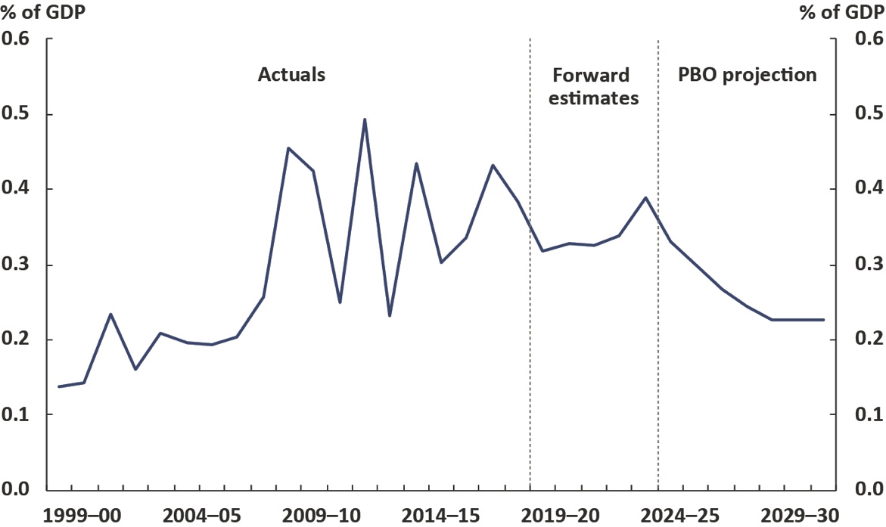
Source: 2019–20 Budget and PBO analysis.
There is a possibility that lower ongoing funding costs result in an increased willingness by government to fund projects than in the past, however this has not been factored into the projections.
These figures include spending relating to road and rail infrastructure, including grants to state, territory and local governments. They understate the Government’s total investment in infrastructure as they do not capture infrastructure investment funded through equity injections into public non‐financial corporations such as the Australian Rail Track Corporation, or concessional loans such as the loan to the New South Wales Government for the WestConnex project.

Risks around projected spending
As mentioned earlier, the PBO’s projections are based on the policy settings underlying the 2019–20 Budget and assume no change to these settings over the medium term. That is, the projections for spending assume no new spending initiatives beyond those that have been announced by Government.
The key risks around these projections for spending are that the spending restraint seen over the past few years may be increasingly difficult to maintain given the length of time restraint has been applied and the pressures emerging in some spending areas. Many commentators, for example, have identified potential sources of spending pressure, such as in Newstart and aged care, reflecting community expectations around the level of income support and services that the government should provide.
A further risk is that weaknesses in GST receipts and other state and territory revenue sources, as well as disparities in growth across the states and territories, could result in calls for the Commonwealth to provide greater transfer payments to the states and territories.
On the other hand, if lower long term interest rates are sustained, public debt interest payments could be lowered even further, putting downward pressure on payments.
Finally, with monetary policy close to the lower bound, there could be pressure in the future for fiscal stimulus. While such stimulus would present a risk to the current budget projections, it would not necessarily present a risk to medium-term fiscal sustainability. This would depend on the nature of stimulus spending.

Projected net debt and net financial worth

Net debt
In the 2019–20 Budget, the Government projected that net debt will fall from 19.2 per cent of GDP ($373.5 billion) in 2018–19 to 14.4 per cent of GDP ($326.1 billion) in 2022–23. Beyond the forward estimates period, the PBO projects that net debt will fall to 1.6 per cent of GDP ($51.8 billion) by 2029–30 (Figure 4–1).
Net debt is projected to have peaked in 2018–19 and is expected to decline over the next decade, reflecting the reduced financing task from the projected move to budget surpluses. Based on this trend, net debt is projected to fall to zero in 2030–31, one year later than the projection in the
2019–20 Budget. This difference reflects cumulative minor differences in the profile for the underlying cash balance projection.

Figure 4–1: Net debt
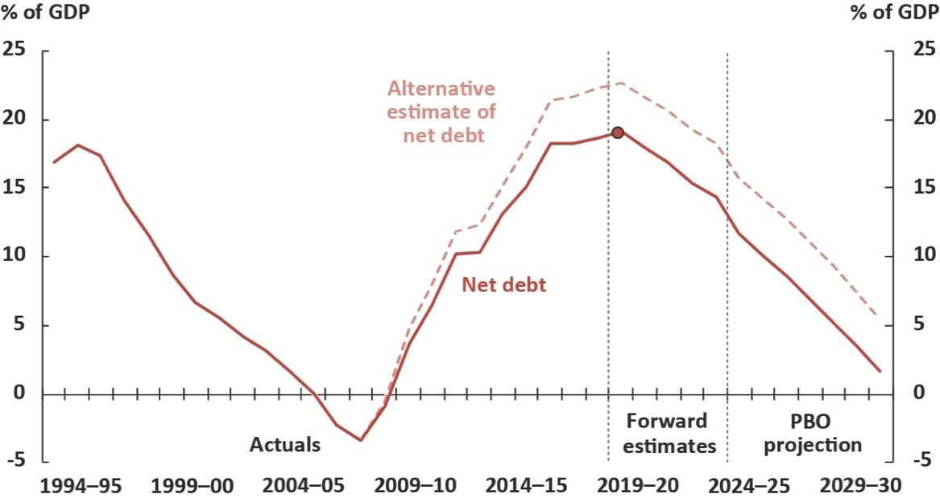
Note: The dot represents the 2018–19 final budget outcome for net debt of 19.2 per cent of GDP.
Source: 2019–20 Budget, 2018–19 Final Budget Outcome and PBO analysis.
The PBO’s alternative estimate of net debt, which looks through to all underlying assets held by government investment funds regardless of the investment structures used (see Box 5), is around 21.7 per cent of GDP in 2019–20. This is 3.7 per cent of GDP higher in 2019–20 than the standard projection. The alternative estimate of net debt would be expected to equal 5.5 per cent of GDP in 2029–30, 3.9 per cent of GDP higher than the standard projection.

Net debt is affected by lower interest rates, or bond yields, which have two offsetting impacts. On one hand, lower interest rates result in lower public debt interest payments on new borrowings, which increases the underlying cash balance and reduces future requirements for raising debt. On the other hand, lower bond yields lead the existing stock of government debt to be revalued upwards, increasing net debt.
As Figure 4–1 illustrates, the projected improvement in the net debt position over the next decade is not without precedent. Following expansionary fiscal policy in the wake of the early 1990s recession, net debt increased to 18.2 per cent of GDP in 1995–96. Net debt fell continuously over the next decade to reach -3.4 per cent of GDP in 2007–08. There were unique factors, however, behind this improvement in the budget balance and net debt over this period, such as the sale of major government assets.
The net debt position is a consequence of the accumulated receipt and spending flows discussed
in previous chapters. To the extent that the downside risks to the budget balance identified in this report eventuate, this will result in higher levels of net debt over the next decade.

Box 5: An alternative estimate of net debt
Net debt, as a partial measure of the Commonwealth balance sheet, is sensitive to the investment strategies and the investment structures used by the government investment funds, most notably the Future Fund.
Future Fund investments made through investment structures called ‘collective investment vehicles’ are treated as debt-like assets on the Commonwealth balance sheet and therefore contribute to offsetting debt liabilities in the calculation of net debt. This is despite a significant share of the underlying assets appearing to be equity-like in nature. Equity investments are not included as an offsetting asset in the calculation of net debt.
As discussed in the PBO report Net debt and investment funds – Trends and balance sheet implications, an alternate approach to calculating net debt would ‘look through’ these investment structures to the underlying asset. Figure 4–1 illustrates the upper bound of the impact of a look-through calculation of net debt - that is, if all investment fund assets in collective investment vehicles were determined to be equity-like in nature.
This alternative estimate of net debt demonstrates the degree to which investment structures can affect the measure of net debt. This paper also highlights the benefit of analysing broader measures of the balance sheet.

Net financial worth
Net financial worth is a broader measure of the strength of the Government’s balance sheet than net debt as it includes all of the Commonwealth’s financial assets and liabilities, including the unfunded superannuation liability and equity investments.
Net financial worth shows a broadly similar improvement to that projected for net debt, improving from a 2019–20 Budget estimate of -25.3 per cent of GDP (-$490.8 billion) in 2018–19 to
-1.8 per cent of GDP (-$59.7 billion) in 2029–30 (Figure 4–2). The improvement in net financial worth is driven by the same factors driving the reduction in net debt, along with a projected increase in the value of the Future Fund.

Figure 4–2: Net financial worth
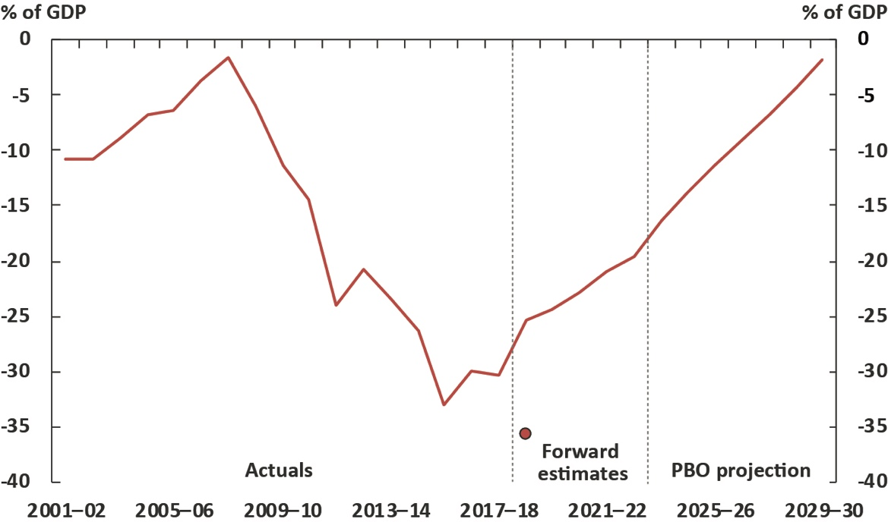
Note: The dot represents the 2018–19 final budget outcome for net financial worth of -35.7 per cent of GDP. Consistent data for net financial worth is only available from 1999–00.
Source: 2019–20 Budget, 2018–19 Final Budget Outcome and PBO analysis.
The 2018–19 Final Budget Outcome reported net financial worth of -$694.4 billion (-35.7 per cent of GDP), much larger than estimated at the 2019–20 Budget. These revisions largely reflect differing valuations for the Government’s defined benefit superannuation liability, due to differences between budget and accounting methodologies.

Appendix A –
Receipt projection methodology
The PBO’s projections comprise individual receipt projections of all of the Commonwealth Government’s major heads of revenue.
The PBO’s projections of receipts are generally prepared using a base-plus-growth methodology. Economic parameters are used to estimate growth rates, which are then applied to the relevant
base. The economic parameters used to estimate growth rates in this report are the same as
those underpinning the 2019–20 Budget, as required by the PBO’s legislation.
For policy decisions where the impact is not already factored into the base-year data or the economic parameters, the projected impact of these measures are added to the base projections.
In order to incorporate the impact of recent trends in tax collection, the PBO uses the
2019–20 Budget receipt forecasts for 2019–20, 2020–21, 2021–22 and 2022–23 as the base years for its projections.
Details of the methodology used to arrive at projections for the heads of revenue are outlined
in the table below.

Model | Description | Methodology
Gross income tax withholding and gross other individuals and refunds | These heads of revenue broadly cover all personal income tax, including revenue from salary and wages, the Medicare Levy and Medicare Levy Surcharge, personal income tax offsets, income from profits from unincorporated businesses, primary production and investment activities, as well as capital gains. | The aggregate taxable income for individuals over the medium term is calculated by growing individual income items from the Australian Taxation Office’s Taxation Statistics data by the relevant economic parameters, most notably compensation of employees.  For each year, an average gross tax rate is applied, reflecting the policy settings and the economic parameters at the time of the  2019–20 Budget.  Projected tax offsets are applied and the timing of tax collections is taken into account to arrive at the receipts projections.  From 2029–30, the PBO adjusts the individual and other withholding tax receipt projections such that total tax receipts remain at 23.9 per cent of GDP, reflecting the Government’s commitment of a tax-to-GDP cap.
Company tax | Tax on profits, including capital gains, of incorporated businesses. | The projections are based on an approach whereby company tax revenue is recognised at the point that a company-tax-payable liability arises for a company from its underlying economic activity. Three industry groupings, Mining, Finance and all Other companies, are utilised in the projection modelling, to reflect structural differences in companies from different industries.  The tax base across the three sector groupings  is grown with the Gross Operating Surplus economic parameter corresponding to the relevant industry grouping. Adjustments are made to capture depreciation and net capital gains.  Adjustments are made to account for other elements (principally the research and development tax offset) that are reported against company tax receipts.
Superannuation  fund taxes | Tax on superannuation fund contributions and investment earnings, including capital gains, of Australian Prudential Regulation Authority (APRA) funds and self-managed super funds. | Projections for the taxable income of  APRA-regulated superannuation funds and  self-managed superannuation funds are based on the structure of a superannuation fund’s tax return.  Historical data from APRA’s Annual Superannuation Bulletin and the Australian Taxation Office’s Taxation Statistics data are grown by relevant economic parameters for projections of taxable income. Statutory tax rates are then applied to the projections of taxable income.  Projected tax offsets are applied and the timing of tax collections is taken into account to arrive at the receipts’ projections.
Customs and excise | Includes customs duties on textiles, clothing and footwear, passenger motor vehicles and other imports, excise on fuel, and excise and customs duties on tobacco and alcohol (except wine, for which WET applies). | Receipts from each category of excise and customs duty are projected in a similar way:  a growth rate is determined using a quantity parameter, and where appropriate, prices are grown using the appropriate price parameter.  The relevant parameters are:  - fuel—private consumption of fuel, real GDP and the CPI  - textile, clothing and footwear—imports of textiles, clothing and footwear  - passenger motor vehicles—imports of non-industrial transport equipment  - other imports—imports of endogenous goods less imports of non-industrial transport equipment, textiles, clothing and footwear  - tobacco—private consumption of cigarettes and Adult Ordinary Time Earnings  - alcohol—private consumption of alcohol and the CPI.
Petroleum Resources Rent Tax (PRRT) | Tax on profits from sales of petroleum products. | PRRT receipts are calculated on a project-by-project basis using expenditure and output data and the oil price parameter underpinning the 2019–20 Budget, which is grown by CPI beyond the forward estimates period.
Goods and services tax (GST) | Indirect tax on the consumption of certain goods and services. | GST receipts are projected based on the growth in consumption, private dwelling investment, and ownership transfer costs.
Wine equalisation tax (WET) | A value-based tax on wine consumed in Australia. | WET receipts are projected based on the growth in private consumption of alcohol.
Fringe benefits tax (FBT) | FBT is separate to income tax and is paid by employers, based on the taxable value of the fringe benefit provided to employees. | FBT receipts are projected based on the compensation of employees parameter.
Luxury car tax (LCT) | A tax on luxury cars sold or imported, where their value exceeds a threshold. | LCT receipts are projected based on the growth in sales of cars, and the motor vehicle price indicator.
Other taxes and charges | Other indirect taxes and levies, including the major bank levy, agricultural levies and the Skilling Australians Fund levy. | Other taxes and charges are projected based on the growth in nominal GDP.
Non-tax receipts | Includes interest and dividend earnings (including Future Fund earnings), NDIS contributions from the states and territories, sale of non-financial assets, and other non-tax receipts. | The largest component of receipts from the sales of goods and services are NDIS contributions from the states and territories, which are consistent with the PBO’s profile of NDIS expenditure over the medium term.  Future Fund earnings are projected over the medium term using the projection methodology from PBO Report no. 01/2017 Future Fund drawdown scenarios: Budget implications. Reflecting the Government’s decision to delay the drawdown of the Future Fund and to reduce its target return to at least the CPI plus 4 to 5 per cent, drawdowns are assumed to occur in 2027–28. Assumed asset allocations and benchmark returns are used to project future earnings and balances for the Future Fund. Under the Future Fund Act 2006, net Future Fund earnings will be available to meet the Government superannuation liability in 2020–21. Consistent with the 2019–20 Budget assumption, the underlying cash balance includes expected net Future Fund earnings from 2020–21.  Other interest receipts and dividend receipt projections are consistent with the  2019–20 Budget forward estimates period and then grown consistent with recent history over the medium term.  The remainder of non-tax receipts are consistent with the 2019–20 Budget forward estimates period and then assumed to remain as a constant share of nominal GDP over the medium term.

Appendix B –
Spending projection methodology
The PBO’s spending projections comprise 23 individual projections of key Government payments, which in total comprise approximately 80 per cent of total government spending.
Up to 2022–23, the PBO’s spending projections are consistent with the 2019–20 Budget forward estimates period and are used as the base for projecting expenditure over the medium term.
Projected levels of spending beyond 2022–23 have been prepared using a range of PBO models based on information provided by government agencies, which take account of population growth, the age structure of the population, estimates of trends in the demand for government services, and program indexation arrangements.
The PBO’s projections are based on the policy settings underlying the 2019–20 Budget and assume no change to these settings over the medium term. Where government policy has not been made explicit beyond the forward estimates period, the PBO’s projections assume the continuation of the current policy settings.
The main exception to this is the projection for spending on pharmaceutical benefits, which is inextricably linked to decisions of government. To not factor in any policy decisions would result in implausibly low estimates of spending over the next decade.
Departmental expenses have been excluded from modelled programs, except in the cases of defence spending and the NDIS where departmental costs are an integral part of the program.
Details of the methodology used to arrive at projections for individual programs are outlined in the table below.

Model | Description | Methodology
National Disability Insurance Scheme (NDIS) | The coverage of the NDIS projections is the administered and departmental spending of the National Disability Insurance Agency (NDIA). | Expenditure projections (in accrual terms) of recipients’ care and support are based on projections of the number of recipients and the average disability package costs of two cohorts, those aged 0–64 years and those aged 65 years and over.  Spending projections (in cash terms) are calculated by applying a ratio of payments to expenses. From around 92 per cent by the end of the forward estimates period, this ratio increases to around 96 per cent by the end of the medium term, largely reflecting a reduction of in-kind payment arrangements between states and territories and the Commonwealth.  The departmental spending of the NDIA is assumed to be relatively flat over the  medium term.
Aged care | Consists of subsidies for residential care, the Commonwealth Home Support Program, and subsidies for Home Care Packages. | The number of subsidised aged care places follows Government policy to provide 125 aged care places per 1,000 persons aged over 70 years by 2021–22 and maintains this ratio beyond 2021–22. The value of residential care and home care packages subsidies are assumed, by the PBO, to grow by the growth in wages beyond the forward estimates period.  The Commonwealth Home Support Program is an annual appropriation projected to grow at a wage cost index plus 3.5 per cent (in line with the aged care measure announced in the  2014–15 Budget).
Child care | Includes the Child Care Subsidy (CCS). | The number of recipients of the CCS is projected based on the rate of population growth of young children plus an additional growth factor (based on historical data) to account for usage growing faster than the eligible population.  Child care prices are projected to grow in line with recent historical trends in child care fees, adjusted to account for the impact of the fee cap.
Defence spending | The net cost of service for the Department of Defence (excluding the Australian Signals Directorate), including employee costs, supplies, and purchases of capital including specialist military equipment. | Projections of defence spending over the medium term are based on long-term funding commitments to 2025–26 made in the 2016 Defence White Paper, updated for developments in subsequent budgets.  From 2026–27 the PBO has assumed growth in defence spending is maintained at the 2025–26 rate.
Schools | Comprises the Quality Schools National Specific Purpose Payment from the Commonwealth to states  and territories  for government and  non-government schools. | Projections are based on the Quality Schools policy as legislated under the Australian Education Act 2013. This was further enhanced through the legislation of the Australian Education Amendment Act 2017, which introduced, amongst other reform measures, a new method for calculating a school communities’ capacity to contribute based on a direct measure of income and additional funding to assist transition for non-government schools. Schools are funded by a per-student amount based on the Schooling Resource Standard and additional amounts for six loadings that reflect the student profile, location and size of the school.  Schools expenditure over the medium term is calculated based on achieving target levels of the funding as a share of the Schooling Resource Standard by 2029. The target for non-government schools (Catholic and independent) is 80 per cent. The target for government schools is 20 per cent. Schools funded below the target will transition by 2023, while those above the target will transition by 2029.
Payments to individuals | Social security payments including the Family Tax Benefit; Disability Support Pension; Carer income support (primarily Carer Payment and Carer Allowance); Parenting Payments (Single and Partnered); and Job Seeker Income Support (Newstart, Youth Allowance (Other), Sickness Allowance, becoming Jobseeker Payment). | Projected expenditure on these payments is calculated as projected recipients multiplied by the average payment rate.  Recipient numbers are projected by applying the latest historical per-capita take-up of payments (by age and gender cohorts) to medium-term population projections. Job seeker income support payments are also adjusted for projected changes in unemployment. Some working age payments are also adjusted to reflect the increase in the age pension eligibility age from 65 to 67.  The average rate of payment is grown by the respective legislated indexation factor (i.e. CPI or wages).
Medicare Benefits Schedule (MBS) | Comprises Department of Health related expenditure under the Medicare Benefits Schedule. | Detailed historical data is used to model expenditure by age, gender and service type (eg general practitioner services, allied health, etc). The MBS projection methodology is described in detail in Appendix C – Technical notes and sources of the PBO Report no. 04/2015 Medicare Benefits Schedule: Spending trends and projections.
Public hospitals | Commonwealth funding of  public hospitals | Projected Commonwealth funding for public hospitals over the medium term is set with reference to the annual determination of the National Efficient Price (NEP).  This funding profile is based on the current National Health Reform Agreement that expires in 2020, and the proposed agreement to extend the funding arrangement to 2025. The PBO assumes that the funding arrangement will continue over the projection period.  The projection of price growth in providing hospital services is based on the indexation rate in the latest NEP determination.  Growth in the number of patient services is projected based on the trend of historical number of services provided annually.
GST transfers to states | GST receipts less non-general interest charge penalties collected. | See Appendix A – Receipts projection methodology, GST receipts.
Fuel tax credit scheme | Credits for the excise or customs duty on fuel a business uses in machinery, plant, equipment, heavy vehicles and light vehicles travelling off public roads or on private roads. | Fuel Tax Credit Scheme expenditure is calculated by applying credit scheme rates on projected fuel excise and customs duty revenue collections (see Appendix A – Receipts projection methodology, Customs and excise). Credit scheme rates are projected by indexing them in line with the CPI.
Government superannuation | Cash payments associated with the unfunded civilian and military schemes. | Projections are based on the Long Term Cost Reports updated for developments in subsequent budgets.
Age pension | Includes the age pension under the Income Support for Seniors program. | Projected expenditure for the age pension is calculated as projected recipients multiplied by the average payment rate.  Age pension recipients are assumed to grow broadly in line with the Australian population of age pension age, adjusted for the impact of the increase in the age pension eligibility age to 67.  The projected average rate of payment is based on projections of Male Total Average Weekly Earnings, CPI, and Pensioner and Beneficiary Cost of Living Index, and the proportions of full-rate and part-rate age Pension recipients. It is assumed that the proportion of part-rate age pension recipients gradually increases over the medium term in line with increasing superannuation balances.
Private health insurance (PHI) rebate | Department of Health and Australian Taxation Office payments related to the  PHI rebate. | Expenditure on PHI is projected to grow in line with the population and CPI, with the insurance coverage ratio assumed to be unchanged through the medium term at the estimated 2022–23 level
Official Development Assistance | Comprises expenditure on foreign aid administered by the Department of Foreign Affairs and Trade, and a small component for associated spending in other departments. | After an indexation freeze introduced in the 2017-18 Budget, Official Development Assistance has been capped at $4.0 billion to 2021–22. Expenditure beyond 2021–22 is projected by indexing the payment to growth in the CPI.
Commonwealth Grant Scheme (CGS) | Grant funding to higher education providers for students enrolled in a Commonwealth Supported Place (CSP) at the institution. | CGS expenditure is calculated based on recent trends in CSP student enrolment projections across eight clusters, with varying per-student amounts for areas of study reflecting associated course costs.
Pharmaceutical benefits | Comprises the special appropriation of the Pharmaceutical Benefits Scheme. | Pharmaceutical benefit projections are calculated by taking historical expenditure data, grouped by age and gender cohorts, and calculating the historical per-capita growth in expenditure. This is then used to derive a trend growth for pharmaceutical benefits spending per capita over the medium term.
Veterans’ support | Comprises expenditure on income support and health programs for veterans. | Projections of expenditure on veterans’ support are based on projected growth in recipient numbers and the average payment for the service provided.  Recipient projections are based on 10-year Pensioner Beneficiary Statistics prepared by  the Department of Veterans’ Affairs.  The average rate of payment is grown by the relevant indexation factor for that program.
Road and rail Infrastructure | Comprises expenses for road and rail projects. | Expenditure from 2018–19 to 2027–28 reflects the PBO’s projected profile of spending on currently agreed road and rail infrastructure projects included in the 2019–20 Budget. From 2028–29 to 2029–30 road and rail expenditure is projected to grow in line with nominal GDP.
Public debt interest (PDI) | Interest paid on Commonwealth Government Securities on issue. | Public debt interest payments are projected based on the financing task implied by PBO projections of receipts and all other payments (excluding PDI payments), and adopt the same assumptions regarding interest rates on Commonwealth Government Securities as the 2019–20 Budget.
Other payments | Other payments include payments that are not modelled by the PBO. This covers government administration, a range of small grant and subsidy programs, smaller specific purpose payments to the states (ie other than health, education and infrastructure), and the conservative bias allowance. | Payments not modelled by the PBO are grown  by the growth rate of nominal GDP over the medium term.

See PBO Report no. 02/2019 Australia’s ageing population – Understanding the fiscal impacts over the next decade.
See PBO Report no. 03/2018 2018–19 Budget: Medium-term projections (hereafter referred to as ‘the previous report’).
The ten-year bond yield assumption used in this report was 1.9 per cent, 0.6 percentage points lower than the assumption of 2.5 per cent used in last year’s report.
Sustainable output is the level of economic activity consistent with a stable unemployment rate and stable inflation, often referred to as the economy operating ‘at potential’.
Bullen, J., Greenwell, J., Kouparitsas, M., Muller, D., O’Leary, J. & Wilcox, R., 2014b. Treasury’s Medium-Term Economic Projection Methodology. Treasury Working Paper, 2014–02.
Information on the projection methodology for individual revenue and payments items is in Appendices A and B.
See PBO Report no. 05/2017 2017–18 Budget medium-term projections: economic scenario analysis.
Total receipts are equal to tax receipts plus non-tax receipts. As part of its fiscal strategy, the Government has a commitment to maintaining the ratio of tax receipts to GDP at or below 23.9 per cent of GDP. The tax cap does not apply to non-tax receipts.
The 2018–19 Budget included the Government’s Personal Income Tax Plan, and the 2019–20 Budget included Lower taxes for hard-working Australians: Building on the Personal Income Tax Plan. The 2019–20 Budget included an increase in tax offsets for low- and middle-income earners, increasing the top threshold of the 19 per cent bracket from $41,001 to $45,000, and reducing the 32.5 per cent marginal tax rate to 30 per cent. These changes are staged, with the first changes implemented from the 2018–19 tax year, and the final changes implemented from 2024–25.
See PBO Report no. 02/2018 Trends affecting the sustainability of Commonwealth taxes.
Australian Government (2019), 2019–20 Budget, Budget Paper No. 1, page 4–12.
PBO report no. 02/2018 Trends affecting the sustainability of Commonwealth taxes.
The projections incorporate the Government’s policy as at the 2019–20 Budget, but do not incorporate the election commitment to continue the efficiency dividend rate at its 2018–19 level of 2 per cent for two additional years (2019–20 and 2020–21) and set the efficiency dividend rate at 1.5 per cent in 2021–22. This commitment would be expected to further decrease spending on government administration.
Productivity Commission 2017, National Disability Insurance Scheme (NDIS) Costs, Study Report.
Under current administrative arrangements, the Government usually pays the higher publicly published price of a drug, and the difference between this and a negotiated lower price is returned as a rebate by the manufacturer. This rebate is recognised as non-tax revenue. Under the new administrative arrangements, the Government will pay the lower negotiated price directly to the suppliers. This has the effect of reducing both spending and non-tax revenue, with no net impact on the budget. The effect of this policy change will be complete by 2021–22.
Including an allowance for new PBS listings reflects the Government’s commitment to list all new medicines recommended by the Pharmaceutical Benefits Advisory Committee and this is expected to continue into the future.
See PBO Report no. 01/2018 Disability Support Pension – Historical and projected trends.
It is difficult to establish the extent to which growth in Newstart recipients has been affected by people who have been unsuccessful in applying for the DSP. Over the next decade, projected growth in Newstart spending is primarily driven by the unemployment rate.
See the PBO Report no. 01/2018 Disability Support Pension – Historical and projected trends.
Department of Education, Child Care in Australia report December quarter 2018.
GST is distributed among the states and territories (the states) based on the GST revenue sharing relativities recommended by the Commonwealth Grants Commission. From 2021–22, the current horizontal fiscal equalisation system will progressively transition over six years to an equalisation standard that is based on the fiscal capacity of the stronger of New South Wales or Victoria. During the transition phase, the Government will also boost the states’ GST entitlement each year, with additional funding to ensure each state receives the cumulative better of the old or new system.
Net debt is the sum of selected financial liabilities (deposits held, advances received, government securities, loans and other borrowings) less the sum of selected financial assets (cash and deposits, advances paid, and investments, loans and placements). It is a common measure of the strength of a government’s financial position.
The two projections fall within a reasonable margin of error, given the economic parameters and policy settings.
The alternative measure presents the upper bound of the impact of a look-through calculation of net debt – that is, if all assets in collective investment vehicles held by government investment funds were determined to be equity-like in nature. It is likely that assets in collective investment vehicles will be a mix of debt-like and equity-like assets, however the actual split is not known. If some assets were determined to be debt-like in nature, the gap between the alternative measure and the standard estimate of net debt would be smaller.
PBO Report no. 05/2017 2017–18 Budget medium-term projections: economic scenario analysis.
PBO Report no. 01/2019 Net debt and investment funds – Trends and balance sheet implications.
At the 2019–20 Budget, defined benefit superannuation liabilities were valued using a discount rate of 5.0 per cent per annum, which is an average annual rate estimated to apply over the remainder of the term to maturity. For the Final Budget Outcome, Australian Accounting Standards require the use of the current long-term government bond rate, which is between 1.4 and 1.9 per cent per annum (depending on the scheme). See the 2018–19 Final Budget Outcome, page 13.

