ALTERNATIVE FINANCING of Government policies
Report No.
01/2020
Understanding the fiscal costs and risks of loans, equity injections and guarantees

© Commonwealth of Australia 2020
ISBN 978-0-6483701-6-1 (online)
Copyright notice
This work is licensed under the Creative Commons Attribution-NonCommercial-NoDerivs
3.0 Australia License http://creativecommons.org/licenses/by-nc-nd/3.0/au/
Attribution
This publication should be attributed as follows: Parliamentary Budget Office, Alternative financing of government policies: Understanding the fiscal costs and risks of loans, equity injections and guarantees.
Use of the Coat of Arms
The terms under which the Coat of Arms can be used are detailed on the following website: www.itsanhonour.gov.au/coat-arms
Feedback
If you found this report useful, or have suggestions for improvement, please provide feedback to feedback@pbo.gov.au.

Contents
Overview 1
1 How government policy is paid for 2
1.1 Ways in which government can fund policy 2
1.2 The use of alternative financing arrangements is growing 4
1.3 How a policy is financed is important for the budget aggregates 6
2 What are the costs associated with different policies? 8
2.1 Budget reporting is based on two key categories 8
2.2 Transactions 10
2.3 Revaluations 11
2.4 Policy financing: transactions and revaluations 12
3 The size of revaluations 14
3.1 The NBN 14
3.2 The Higher Education Loan Program 15
4 Budget presentation of policies that use alternative financing 17
4.1 Reporting the expected financial impacts of new policies 17
4.2 Reporting the expected financial impacts of ongoing programs 20
4.3 Supporting assessments of existing and historical policy outcomes 21
4.4 Taking a broader assessment of key budget aggregates 22
Appendix A: Visual glossary 24
Appendix B: Other sources of information about the budget impacts of policies 31
Appendix C: Balance sheet metrics 32
Appendix D: Equity injections – an expense or a financial asset? 33

This report was authored by Kate Wagner, with contributions and the benefit of comments by Kathryn Morrison, Lok Potticary, Nicholas Ramirez and Linda Ward. The contents of the report are the sole responsibility of the Parliamentary Budget Office.

Overview
The use of alternative financing arrangements to deliver policy outcomes has been increasing…
Under successive governments there has been a shift toward delivering more government policies using alternative financing arrangements rather than direct payments. These arrangements usually involve the government undertaking an equity investment, loan or guarantee.
…the full cost of which is not captured in the underlying cash balance.
The underlying cash balance is the metric by which the government’s fiscal position is frequently assessed in public commentary. In most cases this is appropriate, since the impact of policy decisions on the fiscal position is broadly in line with the impact on the underlying cash balance. But this is not the case for policies that are funded using alternative financing. For these policies, understanding the fiscal impact also requires an understanding of the value of assets acquired.
Revaluation-related costs from alternative financing arrangements can be substantial…
Recent experience has shown that these arrangements can have a significant impact on the fiscal position through revaluation-related costs. For example, successive governments’ equity investments in NBN Co had resulted in a $20.8 billion deterioration in the balance sheet as at 30 June 2019, which is not captured in the underlying cash balance. Similarly, a material share of loans issued under the Higher Education Loan Program (HELP) is never expected to be repaid – partly by design. The debt that is not expected to be repaid is not fully captured in the underlying cash balance, yet was worth $1.2 billion for new HELP loans issued in 2018–19.
…and such costs are not clear from current budget reporting, which could be enhanced.
While detail is provided in budget documents about most government spending and taxation, very limited information is provided about revaluation-related impacts. This makes it difficult to understand the balance sheet impact of policies using alternative financing arrangements when they are announced and to assess their performance over time. There are a number of ways in which the transparency of budget reporting could be improved, with some possible enhancements set out in this paper.
Providing accessible information on the full fiscal costs and risks (whether estimated or realised) for all significant areas of spending would assist parliamentarians and the broader public to make informed judgements about policies. If the use of alternative financing arrangements continues to grow without a change to reporting practices, a larger share of government spending would be difficult to scrutinise, which could pose risks to the Commonwealth Government’s fiscal position over the longer term.
The underlying cash balance should not be relied upon as the sole indicator of the fiscal position.
The use of different financing arrangements reinforces the importance of reviewing a range of budget indicators in order to form an assessment of the overall fiscal position. There is a risk that focusing only on the underlying cash balance (or fiscal balance) may distort government decision making to the extent that it is guided by the impact on these aggregates alone.
The fiscal and underlying cash balances should be viewed together with other published indicators, such as net financial worth and net debt, to provide a more complete picture of the health of the balance sheet. It is important to note that Australia’s fiscal position is significantly stronger than many other countries and could reasonably be considered sustainable by any budget metric.

How government policy is paid for
In its role of improving the understanding of the Parliament and the general public about the budget and fiscal policy, the Parliamentary Budget Office (PBO) receives many costing and budget analysis requests from parliamentarians and parliamentary committees, along with general queries from the public about the budget. It has been our experience that the ways government can fund policy are areas that can be complex and difficult to understand, particularly for those outside of government. For this reason, the PBO has produced this paper to explain these funding options in more detail and to provide a guide to how this information is reported in the budget. Some technical concepts that arise in this report are explained at Appendix A.
Over time, the level of transparency provided in the budget papers has evolved and improved. In the 1980s, three-year forecasts of spending were introduced and the budget-year spending was explicitly linked back to the previous estimate given.
In the 1990s, the Charter of Budget Honesty was introduced, requiring the government to be explicit about its fiscal strategy and to produce the expected outcomes of its key fiscal measures over four years of forecasts. The Charter of Budget Honesty also required the assumptions underpinning the estimates, a sensitivity analysis, and a statement of fiscal risks to be published.
The budget documents adopted accrual accounting in the 1999–2000 Budget, so reporting was no longer as strongly based on cash flows. Since 2000, the structural budget balance, net cash flows for some investments for policy purposes, and information on major government loans have also been added. The budget documents now give a much more comprehensive picture of the government’s fiscal position than was the case before these transparency improvements.
There is, however, scope to improve transparency further, particularly as the proportion of government policy financed through mechanisms other than grants increases. To support consideration of transparency in budget papers, this paper provides some options that could be adopted in the future to further enhance public understanding.

Ways in which government can fund policy
The implementation of government policy usually requires financial resources.
A common way for governments to pay for policies is through direct funding, where money is transferred from the government to individuals or other entities.
Direct funding can be capped, meaning the government spends a fixed amount of money; an example of this is a grant for an infrastructure project. Direct funding can also be demand-driven, where the government commits to provide funding when certain criteria are met; for example, the total spent on the age pension each year depends on the number of eligible people who apply for this payment.
There are other ways of financing policies that do not involve direct funding – we refer to them here as alternative financing arrangements. Alternative financing arrangements usually involve the government providing the financial resources for a policy and receiving a financial asset in return.
Examples include the government purchase of an equity stake (often 100 per cent) in a company such as NBN Co, or the government lending money to students to pay their tuition costs under HELP. It is these financing mechanisms that are the focus of this paper.
In addition to direct funding and alternative financing, the government can equally choose to collect less tax than it otherwise would in particular circumstances, through what is known as tax expenditure. Descriptions and examples of the major ways governments can implement policy are shown in Table 1–1.
Table 1–1: Ways for government to fund policy
 |  | Description | Examples
Direct funding | Capped | The government spends a fixed amount for a policy, such as a grant. | The Commonwealth Government provides a grant to a state government to build roads.
 | Demand- driven | The government agrees to provide funding for every eligible participant in a policy. The cost depends on the number of participants, which may change over time. | Age pension and other welfare payments.
Alternative financing | Equity injection | The government invests in a business and then owns all or part of that business. The government may receive a flow of dividends from ownership and can sell its share of the business at a later date. | Investment in NBN Co to implement the National Broadband Network (NBN); investment in the Australian Rail Track Corporation to implement the inland rail project; investment in WSA Co for the building of Western Sydney airport.
 | Government loan | A loan issued by the government, which is often offered at conditions more favourable than would be offered commercially. For example the loan may have a lower-than-commercial interest rate and repayments may be contingent on income or some other factors. The government may receive repayments and interest from the loan. | HELP; loans for infrastructure projects such as Westconnex; loan to NBN Co; drought loans; loans through the Northern Australia Infrastructure Facility and the Clean Energy Finance Corporation.
 | Government guarantee | The government agrees to assume the debt or performance obligations of another party in the instance of a default. | First Home Loan Deposit Scheme; Accommodation Payment Guarantee Scheme.
Tax expenditure |  | The government has lower taxes for a particular purpose or circumstance compared to a ‘benchmark’ level. | Concessional taxation for superannuation contributions; the capital gains tax discount.

The use of alternative financing arrangements is growing
The trend toward greater use of alternative financing arrangements is evident in several areas of Commonwealth Government spending, such as transport, energy and telecommunications infrastructure and education.
By way of example, Figure 1–1 shows the increasing share of transport infrastructure funded using alternative financing arrangements. Between 2007–08 and 2016–17, the average proportion of the Commonwealth Government’s annual investment in transport infrastructure funded through alternative financing arrangements was around 5 per cent. From 2017–18 to the end of the
2019–20 Budget forward estimates period in 2022–23, the proportion is set to average 20 per cent.
Figure 1–1: Commonwealth Government transport infrastructure investment
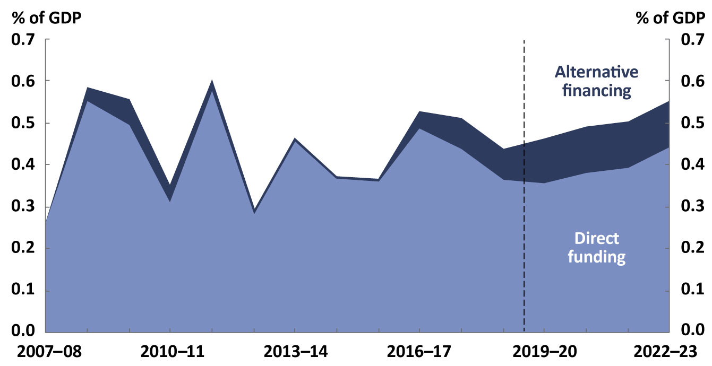
Note: Support through alternative financing includes equity injections to support major projects such as inland rail and the building of Western Sydney Airport, as well as concessional loan arrangements, such as for Westconnex and Sunshine Coast Airport. The forecasts for transport infrastructure investment provided through alternative financing arrangements are averaged over the 2019–20 Budget forward estimates period to address confidentiality concerns.
Source: Department of Finance, as provided to the Joint Committee of Public Accounts and Audit on 19 September 2018; information provided to the PBO by the Department of Infrastructure, Regional Development and Cities; and PBO calculations.
A more comprehensive way of assessing the degree to which alternative financing arrangements are being used to implement policy is to look at the net cash flow associated with these arrangements. The budget documents refer to this item as the ‘total net cash flows from investments in financial assets for policy purposes’.
The net cash flow over the period 2006–07 to 2018–19 is represented by the black line in Figure 1–2.
When the government makes equity investments and issues loans, the amount of cash held on the government’s balance sheet is reduced, reflecting an outflow of cash from government to another entity. This lowers the net cash flow.
Conversely, when the government sells investments and receives loan repayments, the amount of cash held on its balance sheet increases, reflecting an inflow of cash to government from another entity. This increases the net cash flow.
When this cash impact is negative over a period of time, more cash has flowed out from government to other entities, in the form of new investments or loans, than cash has flowed in from other entities to government, in the form of proceeds from investments sold or loan repayments.
Figure 1–2: Net cash flows from investments in financial assets for policy purposes
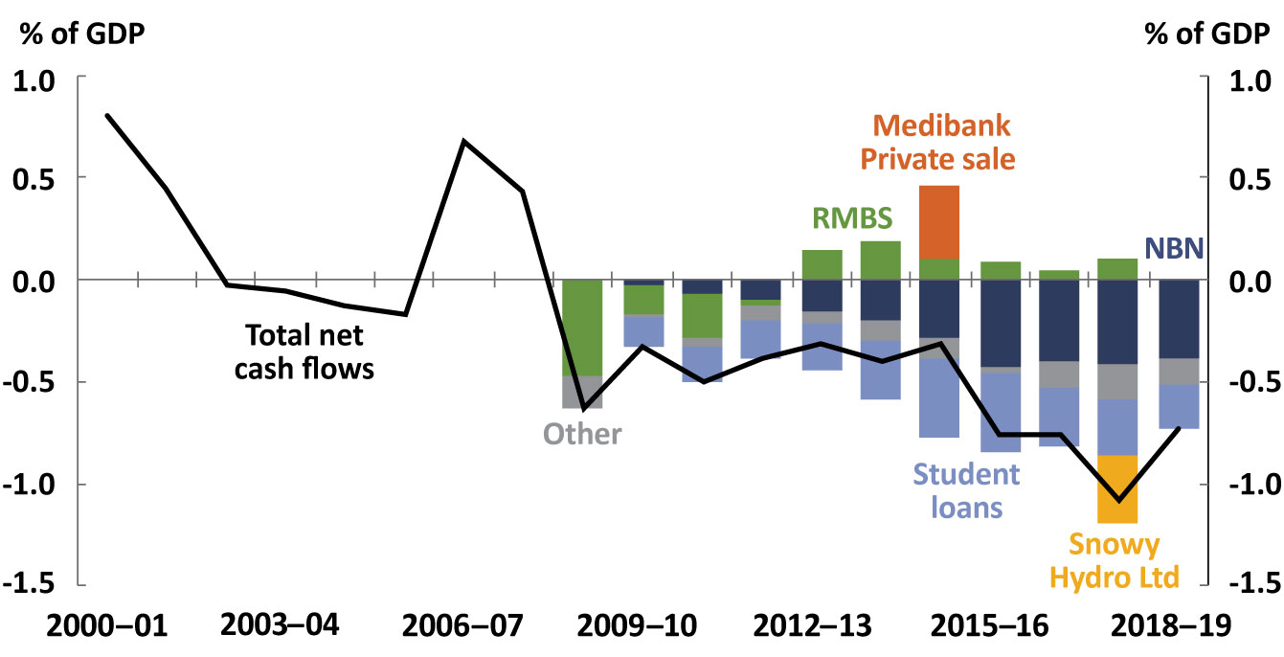
Note: The cash flows shown relate to the acquisition, sale or repayment of financial assets. They do not include interest or dividend payments. RMBS stands for Residential Mortgage Backed Securities. ‘Other’ includes Westconnex, trade support loans, Clean Energy Finance Corporation loans and investments, Northern Australian Infrastructure Facility, drought and rural assistance loans, National Water Infrastructure loan facility, Australian Capital Territory asbestos removal, and other items aggregated in the budget. Prior to 2009–10, the breakdown of net cash flows was not available in budget documents.
Source: Final Budget Outcome, 2006–07 to 2018–19; NBN Co annual reports, 2008–09 to 2012–13; Australian Office of Financial Management annual reports, 2008–09 to 2015–16.
The 1990s and early 2000s generally saw a positive net cash flow for the Commonwealth Government, supported by the sales of assets such as Telstra, Qantas and the Commonwealth Bank. This net cash flow became negative in 2008–09, in part due to the government responding to the Global Financial Crisis (GFC) by purchasing Residential Mortgage Backed Securities. These securities were progressively sold from 2012–13, with the final batch being sold in 2017–18.
The net cash flow has remained negative since 2008–09, with the net outflow reaching 1.1 per cent of GDP in 2017–18, the largest negative outflow recorded since the 1970s. The past four years have seen net cash outflows from investments in financial assets for policy purposes greater than during the GFC.
Major contributors to the higher outflow of cash in recent years are equity injections and loans for the NBN, and the increased issuance of student and other loans for both higher education and vocational education. The one-off investment in Snowy Hydro Ltd also contributed to the substantial cash outflow in 2017–18.
The use of alternative financing arrangements for policy purposes is expected to continue into the future. During the 2019 general election campaign, the three largest parties each committed to policies using alternative financing arrangements. This was outlined in the PBO’s election commitments report and is discussed further in Box 1 on page 7.

How a policy is financed is important for the budget aggregates
There are sound policy reasons for using alternative financing arrangements to fund particular government policies.
Income-contingent student loans, for example, recognise that there are both individual and community benefits to higher education. The Productivity Commission has found that these loans are an effective way to fund a share of the cost of higher education and recognise that individuals typically benefit substantially when they complete further studies.
For infrastructure projects, governments may wish to make equity investments where a project is too large or risky for private sector investors, or to inject competition into particular sectors. Governments also take into account the broader social or public benefits, such as improved productivity from shorter commuting times. Governments may also make the decision to hold the infrastructure in a corporation, rather than have it administered by a government department, if this is considered likely to improve the efficiency of the operation.
Whether a policy is financed through direct or alternative methods should depend on the merits of the different financing methods for that policy.
The majority of the costs associated with alternative financing arrangements are not fully captured in the commonly cited budget aggregates of the fiscal balance or underlying cash balance. As the focus of the budget papers tends to be on explaining the fiscal impact of policy on these aggregates rather than, for example, net financial worth, there is less information available about the fiscal impact of a policy when it is implemented using alternative financing.
While under current reporting practice some of this information is available across different budget documents, it is often hard to find, sometimes has different accounting requirements, and is not comprehensive. Multiple documents are often required – budget papers, portfolio budget statements, annual reports – to get a picture of the history and budget impact of a particular arrangement. For completeness, Appendix B outlines where and how additional information is provided in other budget documents.
The International Monetary Fund (IMF) has discussed the issue of governments shifting activity to where it is less likely to be scrutinised. It has commented that Such cost shifting undermines the quality of fiscal statistics, reduces the effectiveness of fiscal rules, and undermines the financial performance of public corporations.
In the Australian context, a lack of transparency presents a risk that decision making on the most appropriate funding arrangement for a given policy could be influenced by its budget treatment and presentation. It also makes it more difficult for some significant elements of government spending to be scrutinised and effectively evaluated. Regardless of the financing arrangement used to fund a policy, to have a robust decision-making process, parliamentarians and the public need to be able to assess and understand the full costs involved (noting these may be realised or estimated costs).
Exactly what kinds of fiscal costs are associated with policies using alternative financing arrangements is explored further in the next section.
Box 1: Alternative financing arrangements and the 2019 general election
Following the 2019 general election, the PBO published its election commitments report that detailed the budget impact of the policy platforms for each of the major parties.
All major parties announced commitments involving the use of alternative financing arrangements. A useful indicator of the size of the proposed alternative financing arrangements is the difference between the impacts of the party platforms on the underlying cash balance and the headline cash balance. Greater use of alternative financing arrangements usually results in a wedge opening between the underlying cash balance impact and the headline cash balance impact, with the initial headline cash balance impact being the lower of the two.
As part of the 2019 election campaign, the Coalition announced six commitments involving the use of alternative financing arrangements, resulting in the headline cash balance impact being $0.6 billion lower than the underlying cash balance impact over the 2019–20 Budget forward estimates period. This impact to the headline cash balance is in addition to those elements of its platform included in the 2019 Pre-election Economic and Fiscal Outlook (PEFO). The Australian Labor Party announced nine commitments involving the use of these instruments that would result in the headline cash balance being $8.6 billion lower than the underlying cash balance impact over the forward estimates period. The Australian Greens announced seven such commitments that would result in the headline cash balance being $26.6 billion lower than the underlying cash balance impact over the forward estimates period.
When taking into account the effect of policies using alternative financing already included in the 2019 PEFO, the total difference between the underlying cash balance and headline cash balance over the 2019–20 Budget forward estimates period is $45.2 billion for the Coalition, $53.2 billion for the Australian Labor Party and $71.2 billion for the Australian Greens.

What are the costs associated with different policies?
When considering which policies they would like to have implemented, parliamentarians weigh up the social or economic outcomes of a policy against the financial cost to the government. In order to make informed decisions, parliamentarians need to have accurate and accessible information on the costs of both existing and potential policies.
In general terms, the cost of a policy can be considered as the amount by which the policy affects the government’s fiscal position at a point in time. That is, its impact on the government’s balance sheet. The main measures used to evaluate this impact are net worth (assets less liabilities), net financial worth (financial assets less liabilities), and net debt (selected financial liabilities less selected financial assets).
Net financial worth is used in this report as it is a more comprehensive indicator of the health of the government’s balance sheet than narrower measures such as net debt. Unlike net worth, non-financial assets such as property are not included. It also has a stronger conceptual connection to the fiscal balance, as discussed in this chapter.
For some types of policies, determining the cost to the government is relatively straightforward. For example, if the government transfers a fixed amount of money to one of the states in order to assist with building a road (an example of ‘capped’ direct funding) then the cost is known, fixed ahead of time and straightforward to report after implementation.
For policies that use alternative financing arrangements, estimating the costs is more complex. Some of this complexity comes from the inherent uncertainty of these arrangements. For instance, when issuing loans, there is uncertainty around whether and when the loans will be repaid. When making an equity injection into a business, the impact on the government’s balance sheet will depend on a valuation of the business which, in turn, depends on a range of factors.
This section discusses the underlying framework for budget reporting and illustrates how this applies to different financing arrangements.

Budget reporting is based on two key categories
The accounting practice adopted in the budget classifies all changes to the Commonwealth Government’s financial position (the balance sheet) as resulting from either transactions or revaluations.
To understand the distinction, it can be illustrative to consider a household and the ways its wealth might change over time.
- A household’s wealth might change through receiving income from an employer, purchasing items from shops, giving gifts to others, paying taxes to governments, and receiving government payments. These changes all involve interactions with another person or entity – they are the result of transactions.
- A household’s wealth might change as the value of financial assets they already own change. For example, a household may own shares that increase in value. This change does not involve an interaction with another person or entity – it is the result of a revaluation.
More general characteristics of transactions and revaluations, and some government-specific examples, are shown in Table 2–1.
Table 2-1: Classification of changes in the government’s fiscal position
 | Transactions | Revaluations
Who is involved | A transaction involves two entities; the movement of assets between these entities is clear, mutually understood, and reflected in both entities’ balance sheets. | A revaluation involves a single entity (in this case, a government agency); its balance sheet is adjusted.
What flows occur | For transactions, we can ask the question ‘where does this money go?’ and the answer is to a specific entity, such as an organisation or an individual. | If we ask the question ‘where does this money go?’ the answer is not a specific entity, because no money is transferred.
Policy examples | Pension payments, tax collection, grants, interest payments on loans, loan repayments. | Changes to the value of government-owned equity, or loans that are owed to the government but are not expected to be recovered.
Budget treatment | Changes to net financial worth that result from transactions are included in the fiscal, underlying cash, net operating, and headline cash balances. | Changes to net financial worth that result from revaluations are not included in the fiscal, underlying cash, or net operating balances.  The headline cash balance captures the full amount invested. Once a purchase is made, revaluations don’t affect the level of cash held by the government until an asset is sold, so do not affect the headline cash balance.
The distinction between transactions and revaluations is fundamental to the way that costs in the budget are presented.
The main focus of budget reporting is on transactions. The long-standing focus on transactions is with good reason; government policy is a major driver of transactions. Government policy generally does not drive revaluations, which can be volatile, fluctuating with domestic and global markets. In general, revaluations are meant to capture the impact of unexpected events, outside of the government’s control, that affect the balance sheet.

Transactions
The most commonly quoted figures from the budget documents relate to the government’s transactions.
The fiscal and underlying cash balances are sometimes called the ‘main budget aggregates’ since they are the most commonly used indicators. When the government refers to a budget surplus or deficit, this generally refers to the underlying cash balance. Both the fiscal and underlying cash balances relate to the effect of transactions on the government’s balance sheet. These balances do capture changes to the estimated impact of the transactions (for example, due to an unexpected increase in demand for a government payment or downward revision to tax receipts), but by definition they do not capture the effect of revaluations.
The definitions of some common budget terms are shown in Table 2–2. For further explanation on the terms used here, see Appendix A and Appendix B.
Table 2–2: Definitions of common budget terms^{(a)}
Fiscal balance | - The change in net financial worth due to transactions.  - Measured on an accrual basis.
Net operating balance | - The change in net worth due to transactions.  - Measured on an accrual basis.
Headline cash balance | - The change in the amount of cash held by the government.  - Measured on a cash basis.
Underlying cash balance | - A concept to help manage fiscal policy, the underlying cash balance has similarities to the headline cash balance (being on a cash basis) and to the fiscal balance (excluding investments in financial assets for policy purposes).  - Defined by government.^{(b)}  - In practice, this is broadly in line with the change in net financial worth due to transactions.^{(c)}  - Measured on a cash basis.
Notes:
(a) These definitions exclude transactions for cash management purposes, which can be performed by the Future Fund and Australian Office of Financial Management (AOFM), and transactions related to financing activities as bonds are issued and repaid. Interest payments for bonds on issue are still captured.
(b) Australian Treasury, Future Fund and fiscal policy, Economic Roundup Winter 2006. Available online at https://treasury.gov.au/publication/economic-roundup-winter-2006/future-fund-and-fiscal-policy.
(c) Apart from being measured on a cash rather than an accrual basis, the underlying cash balance is also adjusted to exclude the effects of Future Fund earnings before 2020–21.
These definitions can be used to interpret statements made about the budget overall or statements made about costs to the budget.
- The statement the budget forecasts a surplus in 2020–21 can mean that government transactions in 2020–21 are forecast to increase net financial worth by the amount of the surplus.
- If someone says the budget cost of this policy is $100 million, they typically mean that the transactions related to a particular policy are expected to decrease the fiscal balance and net financial worth by $100 million.

Revaluations
Revaluations occur when the values of assets or liabilities owned by the government, and therefore included on the government’s balance sheet, change. These impacts are not included in the fiscal or underlying cash balances, consistent with Australian accounting standards for government financial reporting. Revaluations to financial assets or liabilities are included in the government’s net financial worth.
At the end of 2018–19, the government had $450 billion in financial assets and $1,150 billion in financial liabilities. With such a large collection of assets and liabilities, even small percentage changes to the value of the components can have substantial implications for net financial worth. The impact of revaluations on net financial worth over the period from 2000–01 to 2018–19 is shown in Figure 2–1.
Figure 2–1: Change in net financial worth
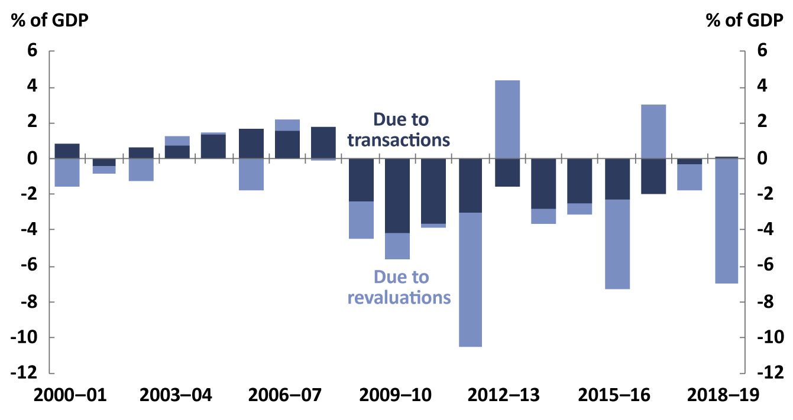
Source: Final Budget Outcome, 2000–01 to 2018–19.
The assets and liabilities on the balance sheet are the result of historical policy decisions. For instance, the government has a large superannuation liability related to the current and future retirement of some public servants and military personnel. The superannuation schemes that contribute to this liability are now closed to new members, but the superannuation liability remains, and the value of the liability is sensitive to changes in a range of factors, particularly the government bond rate. This sensitivity led to large downward revaluations of the government’s net financial worth in 2011–12, 2015–16 and 2018–19, and large upward revaluations in 2012–13 and 2016–17.
The revaluation of the government’s superannuation liability is an example of a revaluation caused by interest rate changes, the result of external factors largely outside the government’s control. This is part of the reason why the budget papers have traditionally focussed on transactions rather than revaluations.

In contrast, some government policy decisions can directly lead to revaluations of assets on the balance sheet, and these are relevant when considering the total costs of these policies. For instance, if a government loan program such as HELP results in a portfolio of loans that is immediately revalued because a proportion of loan recipients are not expected to pay back their loans, this revaluation is directly linked to the design of the underlying policy. Transparency around such revaluations is important to understand the costs and benefits of this program and to inform the design of potential future programs.
Similarly, government equity investments in infrastructure projects often experience significant revaluation impacts over time. With an equity injection, the government uses cash to invest in a project, and it generally then has the entity undertaking the project as a financial asset on its balance sheet. The initial value of the equity is taken to be the amount that the government paid, so the initial transaction does not have any impact on the government’s net financial worth (or the fiscal or underlying cash balances).
The value of the project entity will vary over time, however, both during the construction phase and once operational when the future cash flows associated with the operation of the finished project become clearer. As the Australian National Audit Office has noted, if the value of entities housing these investments deteriorates, it does not impact on the underlying cash even if the deterioration was a predictable result of a non-commercial policy decision. Ultimately, the total cost (or gain, as the case may be) of the government’s investment in the project will depend on the cash flows associated with the project once it is fully operational, and these affect the price at which the project could be sold.
Before a project is fully operational, the best information on its potential sale price is the fair value of the project in the audited financial statement. Different approaches can be used to estimate fair value, with the ‘net assets’ approach being the approach most commonly used during the construction phase. Any revisions to fair value over time are classified as revaluations, and they affect the Commonwealth Government’s fiscal position. Transparency around the fair value of these investments can assist parliamentarians to understand the total costs associated with such projects and inform decisions about similar investments in the future.

Policy financing: transactions and revaluations
For policies funded directly, such as via a grant or direct payment, almost all of the associated costs come from transactions, meaning the fiscal balance or underlying cash balance impact of the policy is generally a good indication of the overall cost of the policy.
Policies implemented using alternative financing arrangements, however, generally have some costs that are characterised as transactions and others as revaluations. Transactions associated with alternative financing arrangements may occur upfront or across many years, and are generally reported in the relevant budget measure. Examples include costs associated with concessional loans, and the receipt of interest payments across the life of a loan.
Revaluations can at times take place immediately, but must be undertaken at least annually as at a reporting date (under accounting standards). Revaluations can be substantial and affect the government’s balance sheet and net financial worth, but are not fully reflected in the fiscal or underlying cash balances. This means that the fiscal and underlying cash balance impacts of policies that use alternative financing arrangements are less likely to reflect the full cost to the government’s balance sheet.
An outline of the way in which the components of a financing mechanism can be categorised into transactions or revaluations is outlined in Table 2–3. As can be seen, there are generally transactions associated with all mechanisms to some degree, but substantial revaluation effects are generally associated with alternative financing arrangements alone.
Table 2–3: Impacts of different types of financing on net financial worth
 | Type of funding | Transactions | Revaluations
Direct funding | Capped or demand-driven | - Transfers to individuals, states, or other entities, including any revisions to estimates of these transfers. | - Minor.
Alternative financing | Equity injections | - Purchase or sale of company or stake in company.  - Government receipt of dividends. | - Revaluation of a company.
 | Government loan | - Issue and repayment of loans.  - Government receipt of interest on loans.  - Government decision to forgive debts. | - Revaluation of loans (mainly through debt not expected to be repaid).
 | Guarantee | - Expected liability, for financial guarantees. | - Changes if value of guarantee changes.

The size of revaluations
To illustrate the impact of revaluations in more detail, this section looks at two of the most substantial examples that have been in place under successive governments. These examples relate to equity injections into the NBN, and loans under HELP.

The NBN
The NBN is a very large infrastructure investment project, with NBN Co receiving $29.5 billion in equity over several years in order to build the network.
The historical revisions to the fair value of NBN Co are shown in Figure 3–1. This shows that the fair value of NBN Co has been consistently below the cumulative amount of equity injected into the company. The equity injected into NBN Co is not captured in the fiscal or underlying cash balances, but is included in the headline cash balance. Further information on how equity injections affect the budget balances is provided at Appendix D.
Figure 3–1: Fair value of administered investment in NBN Co
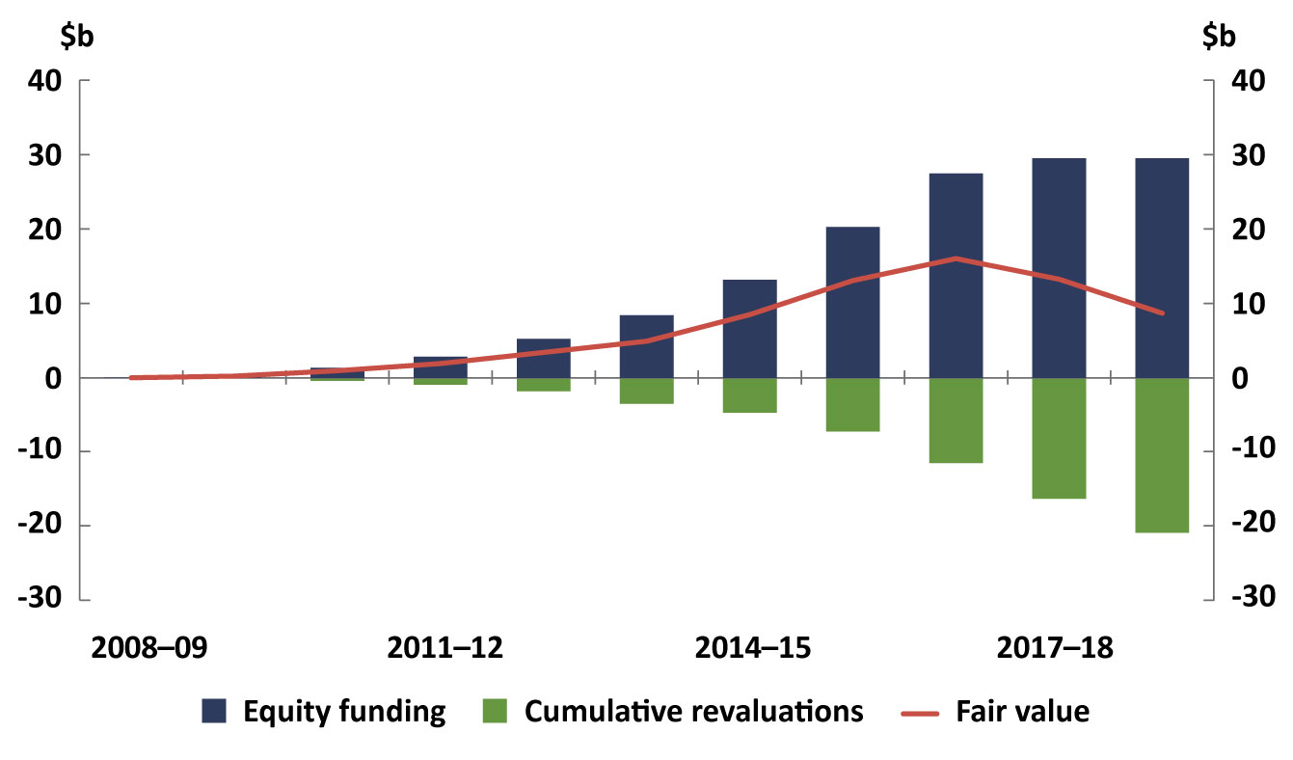
Note: The fair value of NBN Co represents the price that would be received if it were to be sold at that point in time in an orderly transaction between market participants (see AASB 13 Fair Value Measurement for full definition). Equity funding is in cumulative terms.
Source: Annual reports, Department of Communications and the Arts, 2008–09 to 2018–19.

As shown in the chart above, the total equity that has been invested in NBN Co is $29.5 billion. The most recent fair value estimate of NBN Co, as at 30 June 2019, was $8.7 billion. The $20.8 billion difference between the amount paid and the current fair value is a revaluation. It reflects the extent to which the Commonwealth Government’s balance sheet has directly deteriorated as a result of this investment as at 30 June 2019. By definition, this impact is not captured in the fiscal or underlying cash balances, though it is captured in net financial worth. This value is a point-in-time estimate and may change in the future.
It is important to note that the main budget documents show only the aggregated effect of all revaluations across the general government sector, rather than revaluations at an individual company or project level. The information provided here was compiled from successive annual reports for the Department of Communications and the Arts, and NBN Co.

The Higher Education Loan Program
The Higher Education Loan Program (HELP) is a longstanding government program that helps remove upfront cost barriers that may prevent potential students from obtaining a tertiary education. It is the Commonwealth Government’s largest loan program.
Issuing loans affects the Commonwealth Government’s fiscal position through both transactions and revaluations that in some cases can be estimated ahead of time.
A key element in the design of HELP is that repayments are linked to each borrower’s income and only need to be repaid when the borrower earns above certain thresholds. The future earnings of borrowers differ, and some do not earn a sufficient income for a long enough time that the debt is repaid. The result of this policy feature is that a substantial proportion of the new debt (around 16 per cent of new debt in 2018–19) is not expected to be repaid.
When the government estimates the financial impact of establishing a loan program, the proportion of loans that is unlikely to be repaid is estimated and taken into account; this ‘debt not expected to be repaid’ is typically classified as a revaluation rather than a transaction in the budget documents.
The full expected cost associated with issuing the loans is therefore included in the budget forecast of net financial worth, but is not included in the budget forecasts of the fiscal or underlying cash balances.
In 2018–19, around $7.1 billion in new HELP loans were issued, and $1.2 billion of these were not expected to be repaid. This revaluation component of the cost to the Commonwealth Government of the loans for that year was therefore expected to be around $1.2 billion. This is shown on the left of Figure 3–2.
While the $1.2 billion of loans not expected to be repaid is incorporated into the fair value estimate of the HELP loan portfolio that is included in the budget documents’ forecast balance sheet (for instance, in net financial worth), it is aggregated with other expected revaluations and is not readily identifiable as a cost of HELP.

Figure 3–2: New HELP loans, 2018–19
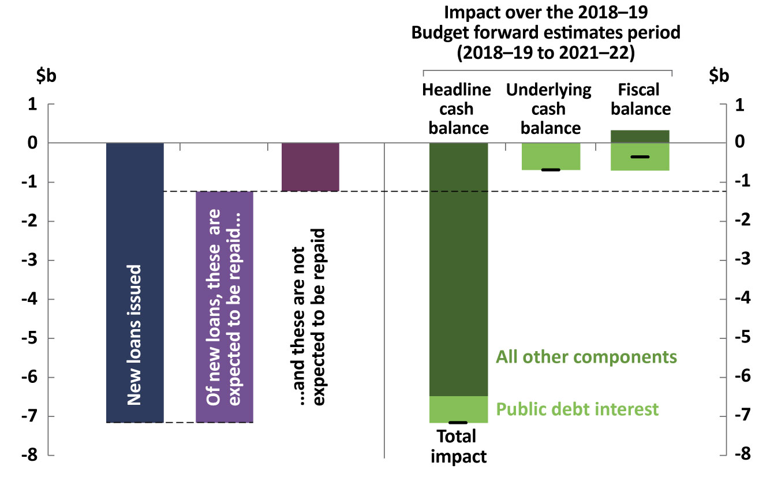
Note: This includes HELP, FEE-HELP, OS-HELP, SA-HELP, and VET FEE-HELP.
Source: New loans issued and the associated debt not expected to be repaid was from the Department of Education and Training Annual Report 2018–19. Fiscal and underlying cash balance impacts estimated by the PBO. ‘All other components’ comprises interest from loans for all balances, the net concessional loan discount for the fiscal balance, and loans issued and repayments received for the headline cash balance.
The right side of Figure 3–2 shows the estimated impact of the loans on the main budget aggregates over the 2019–20 Budget forward estimates period. This shows the transaction-related impacts of issuing these loans – $0.4 billion for the fiscal balance and $0.7 billion for the underlying cash balance.
By the end of the 2019–20 Budget forward estimates period, the total impact on net financial worth of issuing these loans is the combined impact of transactions on net financial worth (the fiscal balance impact, a cost of $0.4 billion) and of revaluations on net financial worth (the largest component of which is around $1.2 billion of debt not expected to be repaid), giving a total impact of around $1.5 billion, substantially more than is reflected in the main budget aggregates.
Understanding the likely costs from revaluations of loan programs – particularly when those can be estimated at the time policy decisions are made, such as when new loans are issued – would assist parliamentarians in weighing the benefits of the policy against the expected costs.

Budget presentation of policies that use alternative financing
When planning a significant purchase, members of a household might ask themselves questions along the following lines.
- How much will this purchase cost, now and into the future?
- What is the expected return?
- What additional risks come with this purchase?
- What can I learn from previous times I have made similar purchases?
By answering these questions, households can improve their financial decision making.
When parliamentarians and society more broadly consider policies for the nation, similar considerations can aid the decision-making process. Ideally, information relevant to answering these questions would be available and accessible as policy proposals are considered and debated. When alternative financing arrangements are employed in policies, however, these questions can be more difficult to answer.
The increasing use of alternative financing arrangements to fund government policies means it is timely to revisit whether the information provided under the current reporting arrangements is sufficient.
To support public debate on this matter, the PBO has identified some specific elements of budget reporting that could be enhanced in order to support a better understanding of alternative financing arrangements by parliamentarians and the general public.

Reporting the expected financial impacts of new policies
At every budget, the comprehensive set of new policies that the government has committed to is presented in Budget Paper No. 2, called ‘Budget Measures’. At the mid-year economic and fiscal outlook update, policy decisions taken since the previous budget are presented in Appendix A of the update.
Since 1997–98, Budget Paper No. 2 has included a description and estimate of the impact on the fiscal balance of each budget measure – a marked improvement in transparency from previous arrangements. The provision of this information on specific new policies is designed to allow for more meaningful debate around the costs and benefits of individual policies.
When alternative financing arrangements are employed to fund a policy, the measure descriptions do not provide full information on how the policy is likely to affect the Commonwealth Government’s net financial worth, including the effect of revaluations. In some cases, the presentation of just the fiscal balance impact can be confusing to the general reader.

Additional detail on government loans
When the government plans a new loan program (or changes to an existing loan program), the two most significant balance sheet impacts are the total size of the loan program (which feeds into the government’s interest payments) and the estimate of the proportion of debt that is not expected to be repaid. The estimates of ‘debt that is not expected to be repaid’ will depend on the design of the program, for example whether there is an income-contingent element to expected repayments, and it may be revised over time. As discussed in Section 3.2, since this is classified as a revaluation rather than a transaction, the expected non-repayment is not included in the fiscal balance impact shown in the measure description.
For all loan programs, as well as the total expected size of the loan program, a more comprehensive measure description would present the upfront estimate of the expected amount of debt that will not be repaid, based on the design of the program and historical experience. The terms of loans (such as interest rate, concessions, duration and repayment timing) would also be useful additions to measure descriptions.

Risk of revaluations
When the government invests in a business, the investment must pass a ‘threshold test’ (a real rate of return greater than zero and a reasonable expectation that the investment will be recovered) to be treated as an investment asset on the balance sheet rather than a grant. If it is deemed to qualify as an equity injection, the investment is assumed to maintain its value over the forward estimates period, however this clearly presents a risk of future revaluations, potentially up to the full value of the equity injection.
The inland rail project, to be delivered by the Australian Rail Track Corporation through an equity injection, provides a recent example of the application of the accounting standards. This involved the assessment of the ‘threshold test’ being made at the level of the entity rather than the project.
The Australian Rail Track Corporation as an entity is expected to deliver a positive real rate of return, in aggregate, in respect of its assets. It is not clear, however, whether the inland rail project itself would be expected to meet the government’s stated criteria for an equity investment. The business case for inland rail noted that …Inland Rail would not generate enough revenue to provide a return on its full construction cost.
This information suggests that, as a consequence of the policy decision to provide an equity injection into Australian Rail Track Corporation to build inland rail, the value of the Corporation may be revalued downward at some point in the future. Such a revaluation would deteriorate the Commonwealth Government’s fiscal position, but was not mentioned in the measure description for the inland rail project at the time of the decision and under current budget reporting practice would not be reported in a disaggregated form in the event that it occurred.

For equity injections, a more comprehensive measure description would include:
- the full value of the equity injection
- the expected rate of return at inception
- the key assumptions underpinning the expected return on the equity injection
- the expected impact on fiscal aggregates such as net financial worth.

Associated public debt interest costs
When the government borrows money to implement a policy, it issues debt liabilities and becomes liable for repayments of both the principal and interest. The quantity of debt liabilities that the government has to issue is determined by the total amount of spending and revenue raised across all programs, and is generally determined at a whole-of-government level. The long-standing convention in Budget Paper No. 2 is that the interest costs on the debt liabilities are not attributed to any individual policy measure.
When governments use their balance sheet to invest in a project or to issue loans under a program, however, the interest the government pays (or forgoes) to secure the funding can be the largest cost associated with the policy. This can offset the often-significant flow of interest or dividend payments that the government expects to receive from the recipient of the loan or equity injection.
Under current reporting conventions, the fiscal balance impact as it appears in the budget measure description does not include the interest costs associated with the program. This means that the reported fiscal impact can materially understate the expected cost or overstate the expected net revenue of a policy.
By way of example, in 2016 the government included a measure in the budget for a National Water Infrastructure Loan Facility, shown here in Figure 4–1. The measure description has a table showing the fiscal balance impact, which includes the expected revenue from interest payments from the facility over the 2016–17 Budget forward estimates period. This could be interpreted as the measure being expected to improve the fiscal position by around $23 million over the forward estimates period.
The public debt interest payments associated with the financing of this loan were expected to cost around $21 million over the forward estimates at the time the measure description was published. A more comprehensive estimate of the net financial impact of this loan over the forward estimates period, therefore, would have been closer to a $2 million improvement.
Figure 4–1: Loan measure description from the 2016–17 Budget
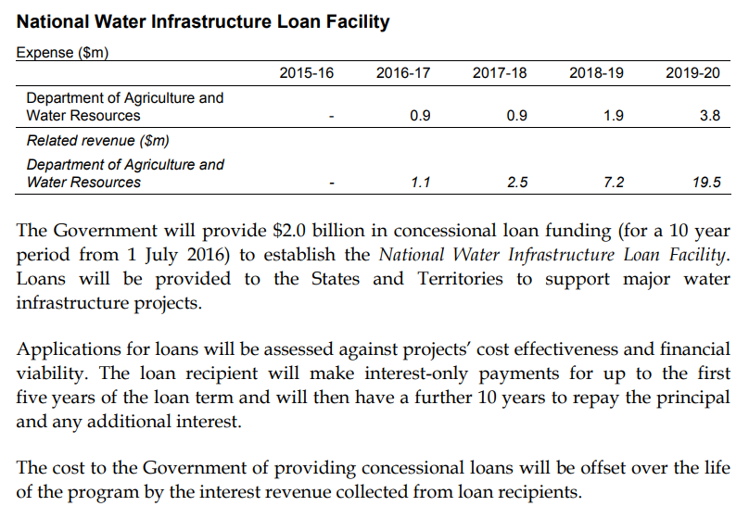
Source: 2016–17 Budget, Budget Paper No. 2, p.64.
For all policies involving alternative financing arrangements, a more comprehensive measure description would present information in the text on the PDI payments associated with the measure.
This has been a budget convention in the past, although it was not applied consistently and has not been applied in recent years. It is standard practice for the PBO to include this information in its costings when financial assets are purchased or sold.

Reporting the expected financial impacts of ongoing programs
In addition to announcing new policies, budgets provide updated estimates of the ongoing impact on the underlying cash balance for existing policy areas.
In policy areas where there is a significant use of alternative financing arrangements, the presentation of only the underlying cash balance impact leaves two significant gaps, as discussed below.

Expected revaluation amounts
In the main budget documents, the cost of current policy is presented as the impact on the fiscal balance in Budget Paper No. 1, Statement 5 (in the 2019–20 Budget). This Statement provides forecasts of government expenses by function (such as ‘social security and welfare’) and sub-function (such as ‘Assistance to the aged’). Also listed separately are the 20 largest programs by expense (such as ‘Income Support for Seniors’). The expense for each individual program is not shown, reflecting the trade-off in budget reporting between providing transparency and having documents that are not longer than necessary.
The information presented on spending by policy area in Statement 5 may not capture the full expected impact on net financial worth when policies using alternative financing arrangements are employed, since on some occasions there are expected costs that come in the form of revaluations.
This makes it difficult to understand how the costs of some policy areas are likely to change over the forecast period. In many cases, revaluations are unknown and are not forecast, but there are cases such as some loan programs where revaluations can be estimated.
Consideration should be given to including information on expected revaluations, where known or able to be estimated (for example, in relation to HELP), recognising that there will be instances where this is not possible. This could be achieved in Budget Paper No. 1 by:
- showing a detailed breakdown of forecast revaluations
- including a section showing the forecast effect of revaluations on net financial worth by policy area
- including a section showing forecast revaluations at a program level where the expected revaluation is greater than $200 million over the forward estimates period.

Potential cost of government guarantees
The Statement of Risks in the budget documents (Budget Paper No. 1, Statement 8) provides some information on the guarantees that the government currently offers – some are quantifiable and some are not. Some, but not all, relate to alternative financing arrangements.
Of the quantifiable guarantees, the amount that is covered is not always shown. For example, the government offers an Accommodation Payment Guarantee Scheme for residents of aged care facilities. As of 30 June 2019, the total potential exposure for this Scheme was $27.5 billion. However, this amount was not shown in the description in the Statement of Risks in the
2019–20 Budget.
Consideration could be given to including a table on guarantees in the Statement of Risks that includes both the total potential exposure and the expected value of the exposure.

Supporting assessments of existing and historical policy outcomes
To help inform policy decisions, it is useful for parliamentarians to be able to see the outcomes of policies.
The most comprehensive document for reporting outcomes is the Consolidated Financial Statements, which are audited and include information on both the general government sector and the government as a whole. Alternatively, the Final Budget Outcome is prepared on the same basis as the budget documents, and is released within three months of the end of each financial year.

Disaggregation of revaluation-related information
The Final Budget Outcome estimates of net financial worth include all revaluations. The documents also have breakdowns (with varying degrees of policy detail) of ‘net cash flows from investments in financial assets for policy purposes’, giving an indication of how much cash is flowing toward policies using alternative financing arrangements.
The documents do not disaggregate revaluations in a way that allows the reader to understand the impact of policy on the Commonwealth Government’s fiscal position when alternative financing arrangements are used. In particular, no distinction is drawn between different drivers of revaluations. Furthermore, the available information on revaluations is not disaggregated by policy area or provided at a major program level.
Reporting the components of revaluations in either the Final Budget Outcome or the Consolidated Financial Statements could be achieved by including revaluations at a project or program level. This could consist of:
- revaluations separated into those for newly acquired financial assets and for existing financial assets, where relevant
  - For example, when reporting on revaluations for HELP loans in 2019–20, this could show revaluations associated with new HELP loans issued in 2019–20 separately from revaluations associated with the stock of HELP loans as at 30 June 2019.
- a discussion on the drivers of revaluations, such as changes in market prices, exchange rates and actuarial revaluations
- a summary of revaluations for all Commonwealth Government financial assets that involved cumulative equity injections greater than $200 million, showing the cumulative equity injected and the most recent fair value estimate of the entity.

Taking a broader assessment of key budget aggregates
In conclusion, alternative financing arrangements are becoming a more significant feature of budget financing than they have been in the past. If the use of alternative financing arrangements continues to grow without a change to reporting practices, a larger share of government spending would be difficult to scrutinise, which could pose risks to the Commonwealth Government’s fiscal position over the longer term.
This suggests that it is timely to review the current budget reporting mechanisms that are well established in relation to transactions but less detailed for revaluations. Providing information on the full fiscal costs and risks (whether estimated or realised) for all significant areas of spending in an accessible way would assist parliamentarians and the public to make informed judgements about policies. A summary of the PBO’s suggestions for possible enhancements to budget reporting is provided in Table 4.
Notwithstanding the scope to provide more transparency around alternative financing arrangements, the use of different financing arrangements reinforces the importance of reviewing a range of budget indicators in order to form an assessment of the overall fiscal position.
In this regard, the fiscal and underlying cash balances, while important ways to assess budget management, should not be viewed in isolation. Other reported aggregates, such as net financial worth, net worth and net debt, should also be considered to form a complete picture of the health of the balance sheet.
It is worth noting that Australia’s current fiscal position is significantly stronger than many other countries and could reasonably be considered sustainable by any budget metric.

Table 4: Possible enhancements to budget reporting – summary
The expected financial impacts of new policies | Measure descriptions could include:  - for loans, the total expected size of the loan program; an estimate of the amount of debt that is not expected to be repaid; and detail on the terms of the loan  - for equity injections, the full value of the equity injection; the expected rate of return at inception; the key assumptions underpinning the expected return on the equity injection; and the expected impact on fiscal aggregates, such as net financial worth  - for all policies using alternative financing, the public debt interest associated with the measure.
The expected financial impacts of ongoing programs | When revaluations are expected or ‘known’, budget documents could include:  - a detailed breakdown of forecast revaluations  - the forecast effect of revaluations on net financial worth by policy area  - forecast revaluations at a program level, where the expected revaluation is greater than $200 million over the forward estimates period.  To improve the transparency of the risks associated with government guarantees, the Statement of Risks could include:  - a table showing the total potential exposure and expected value of exposure associated with each quantifiable government guarantee.
The outcomes of existing and historical policy | The Final Budget Outcome could include:  - revaluations, separated into those for newly acquired financial assets and for existing financial assets  - discussion of the drivers of revaluations, such as changes in market prices, exchange rates, and actuarial revaluations  - a summary of all Commonwealth Government financial assets that have had cumulative equity injections of greater than $200 million. This should show the cumulative equity injected and the most recent fair value estimate of the entity.
Note: In making these suggestions, the PBO is not in a position to assess the practicality of the timing of publication of this additional information in budget papers.

Appendix A: Visual glossary
Budget documents use a range of metrics, including the main budget aggregates, to convey the current and expected future economic and fiscal position of the Commonwealth Government. This visual glossary defines these metrics and shows where they can be found in the financial statements.

Categorising budget aggregates by type – flow vs stock, cash vs accrual
To better understand how financial resources are used by the Commonwealth Government it is important to appreciate how budget aggregates are grouped conceptually. This grouping considers two complementary sets of metrics (see Figure A1).
- Flows vs stocks– communicates whether the budget aggregate captures changes over a given period, or represents a value as at a fixed point in time.
  - A flow shows the changes in the fiscal position during the budget year. For example, receipts of personal income across a financial year would be considered a flow metric.
  - A stock shows the fiscal position at a particular point in time (such as the end of the budget year). For example, the amount of cash in a personal bank account on a specific day is a stock.
- Cash vs accrual– indicates whether a metric is based purely on amounts already transferred (cash), or additionally includes amounts that are owed.
  - Cash metrics reflect when the amounts are received or payments made. For example, a payment to an employee would be recorded on a cash basis when the payment is made.
  - Accrual metrics represent income earned or costs incurred, regardless of when the actual cash is transferred. Unlike cash metrics, accrual metrics include money that is ‘owed’ by one entity or individual to another. For example, when an individual completes their tax return, they may be notified that they owe additional tax, at which point, on an accrual basis, the government has an additional asset (the money it is owed) and the individual has an additional liability (the money they owe).
Flow and stock, and cash and accrual, are complementary concepts that can apply to the same budget aggregate. For example, the underlying cash balance is both a flow and cash metric; and net financial worth is both a stock and accrual metric (see Figure A1).
Figure A1: Budget aggregates classified by metric type and financial statement
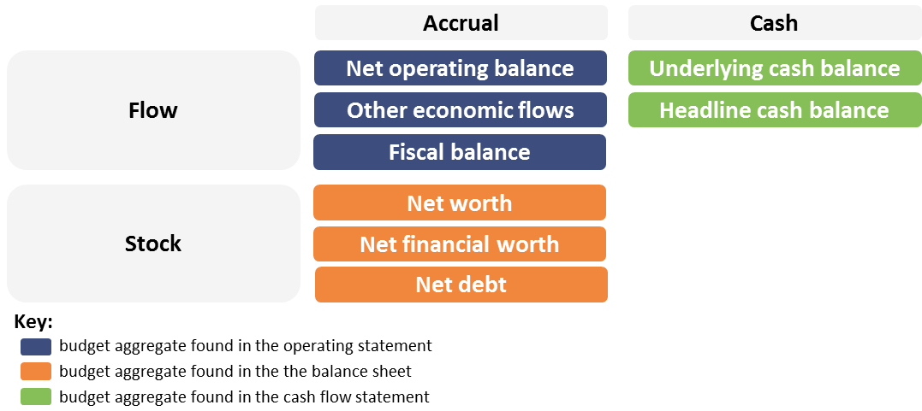
Source: PBO diagram based on information in the Uniform Presentation Framework.

Financial statements in the budget – where to locate budget aggregates
The Commonwealth Budget consists of four budget papers which, combined, present a picture of the Commonwealth Government’s fiscal position, performance and outlook. The budget contains a set of financial statements that publish values of budget aggregates across the forward estimates period (ie the budget year plus three additional years). The set of financial statements comprise the:
- operating statement, which is a record of changes to the government’s fiscal position over a specific period of time
- balance sheet, which shows the stocks of government assets (financial and non-financial) and liabilities at a point in time
- cash flow statement, which identifies how cash has been received and used in a single accounting period.
In the 2019–20 Budget, the financial statements can be found in Budget Paper No. 1, Statement 9.
The following pages describe each of the three financial statements, demonstrate where the financial statements are located in the budget papers (Figure A2) and define budget aggregates found in each financial statement (Figure A3 to A5).
The mid-year economic and fiscal outlook update, published around six months after the Budget, also includes these financial aggregates.
Figure A2: Financial statements and where to find them – Budget Paper No. 1, Statement 9
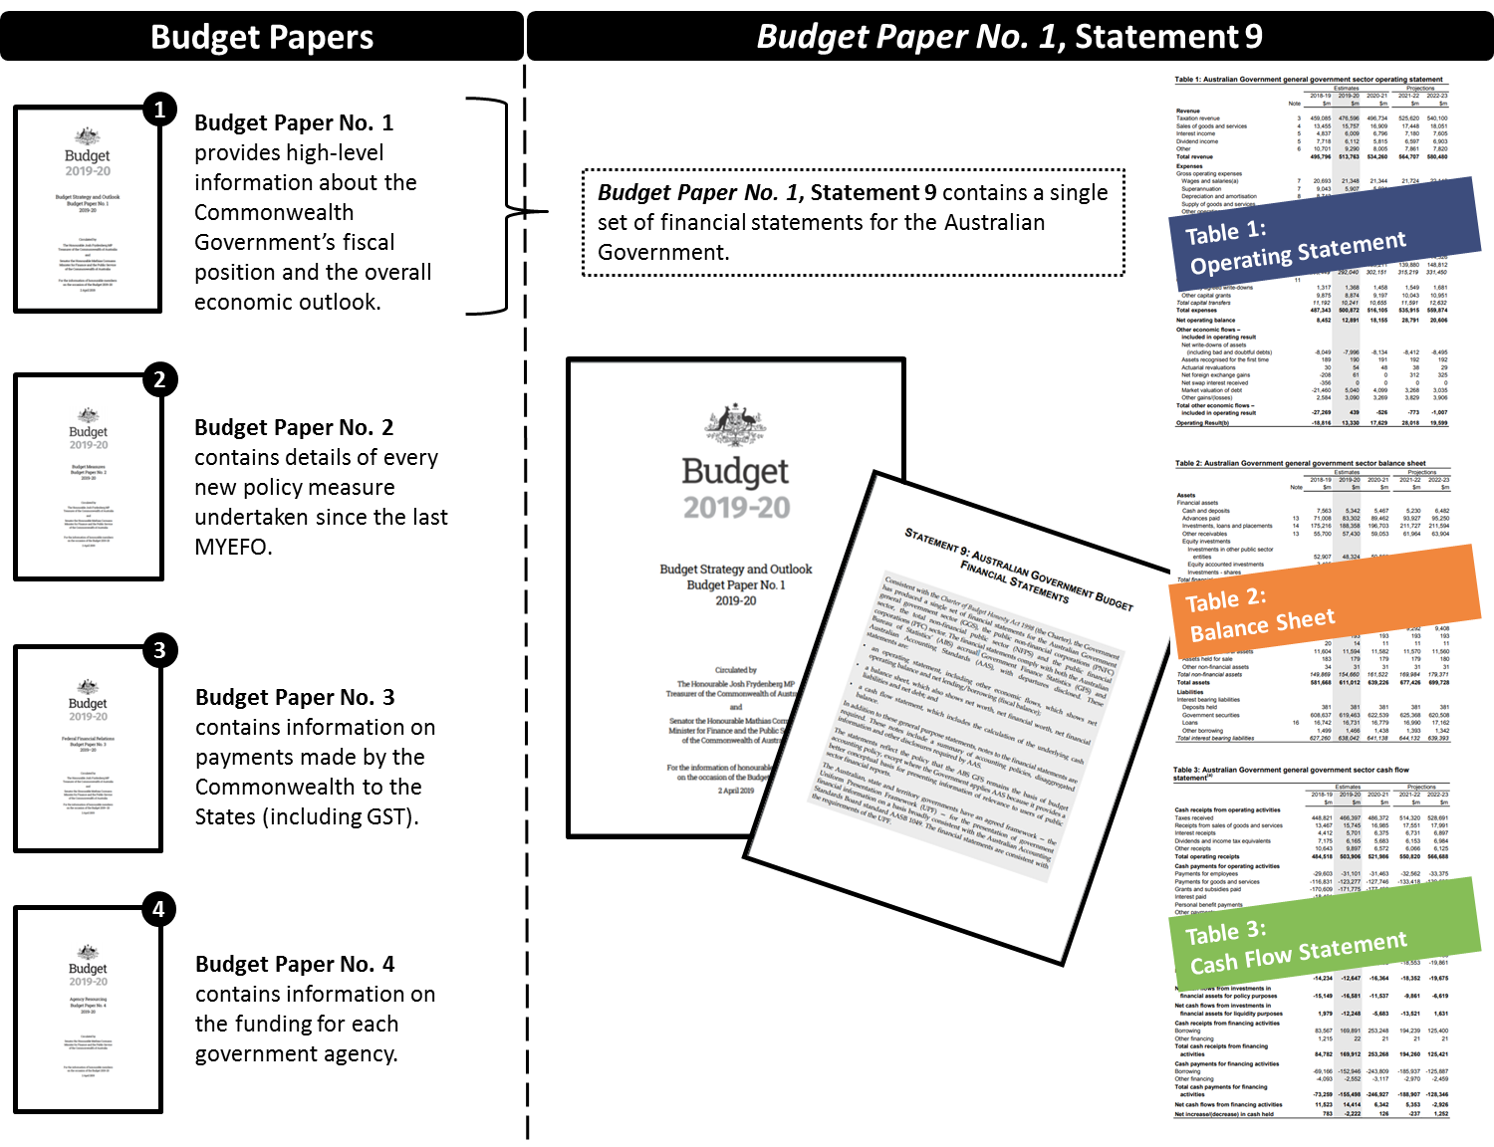
Source: PBO diagram based on content in the 2019–20 Budget.

Definitions of key terms used in the operating statement
The operating statement presents details of changes to the government’s fiscal position through transactions (such as revenue and expenses) and through other economic flows (such as revaluations and adjustments). Transactions, other economic flows and some budget aggregates are defined below, with Figure A3 highlighting where they appear in the operating statement.
Transactions represent an event where there is a movement of assets (including cash) between two entities. Examples include pension payments, tax collection, grants, interest payments on loans, and loan repayments.
The net operating balance is equal to the government’s revenue (including tax collections) minus its expenses (including grants) and includes accrual accounting items such as depreciation. It indicates whether government revenue is sufficient to cover expenses from operating activities (where insufficient, government will have to borrow from financial markets). The net operating balance is equivalent to the change in net worth due to transactions.
Other economic flows comprise revaluations and adjustments that typically arise from changes in market prices, actuarial valuations, exchange rates, and gains or losses on the sale of assets.
Fiscal balance measures, in accrual terms, the gap between government revenue and expenses, adjusted for government investment in non-financial assets. It is equivalent to the change in net financial worth due to transactions.
Figure A3: Budget aggregates in the operating statement (excerpt)
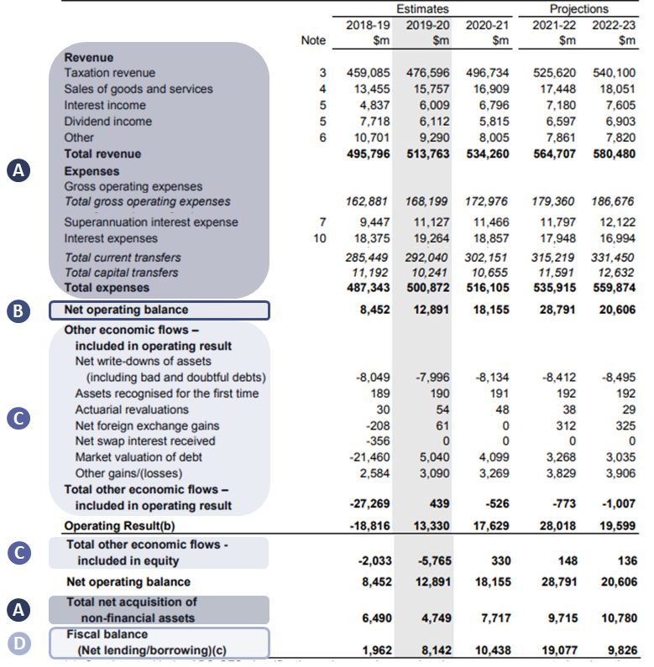
Note: For brevity, Figure A3 is an excerpt of the operating statement and excludes certain line items.
Source: 2019–20 Budget, Budget Paper No.1, Statement 9, Table 1: Australian Government general government sector operating statement, pp. 9–5 to 9–6. Available at https://budget.gov.au/2019-20/content/bp1/download/bp1.pdf.
Definitions of key terms in the balance sheet
The balance sheet shows the government’s assets (financial and non-financial) and liabilities, and the stock metrics derived from these. It presents budget aggregates such as ‘net worth’, ‘net financial worth’ and ‘net debt’. These budget aggregates are defined below, with Figure A4 highlighting where they can be found using an excerpt of the balance sheet.
Further information on what items are included in the different balance sheet aggregates is provided at Appendix B.
Financial assets represent a financial claim that entitles the owner to receive funds or other resources from another entity. An equity investment is one example of a financial asset.
Non-financial assets represent a store of value that provides an economic benefit to its owner through their use or by changes in their value. Non-financial assets can be tangible (such as land or structures) or intangible (such as software).
Liabilities represent an obligation to provide funds or other resources to another entity.
Net worth shows the government’s overall wealth, calculated as total assets (both financial and non-financial) less total liabilities.
Net financial worth measures the government’s net holdings of financial assets. It is calculated as financial assets less liabilities. It is one of the broader balance sheet indicators reported in the budget. It includes unfunded superannuation liabilities and holdings of equity, and excludes non-financial assets such as land, buildings, equipment and infrastructure.
Net debt subtracts selected financial assets from selected financial liabilities. It equals the sum of selected financial liabilities (deposits held, advances received, government securities, loans and other borrowings) less the sum of selected financial assets (cash and deposits, advances paid, and investments, loans and placements).
Additional definitions related to alternative financing arrangements in the balance sheet
A range of concepts are used to determine the value of assets associated with alternative financing arrangements. For example, the value of equity investments in the balance sheet reflects fair value valuation techniques such as the discounted cash flows method or the net asset method. The values of government loans are also affected to the extent the loans are income-contingent. These concepts are defined below.
Fair value is defined in Australian accounting standards as the price that would be received from the sale of an asset or the price paid to transfer a liability in an orderly transaction between market participants (see AASB 13 Fair Value Measurement for further information). Valuation techniques are used to ascertain a fair value measurement, which reflect either the observable market price, an income technique (such as the discounted cash flows method) or a combination of approaches (such as the net asset method).
Discounted cash flows method is a fair value valuation technique that converts estimates of expected future cash flows over the useful life of the asset to a single amount, known as the present value. This present value is derived using a rate of return that considers the time-value of money. This is used when the investment in the entity generates significant non-government cash flow.
Net asset method is a fair value valuation technique that considers the value of total assets less the value of the total liabilities of the entity invested in. This method is used when an investment in an entity does not generate significant non-government cash flow.
Income-contingent loans are loans where the repayments are linked to the income of the borrower. Higher Education Loan Program loans are the primary example of income-contingent loans because the borrower only needs to make repayments when they earn above a certain threshold. Repayment amounts fluctuate, with some amounts not expected to be repaid, due to future earnings of borrowers changing year-to-year, including earning below the threshold.
Figure A4: Budget aggregates in the balance sheet (excerpt)
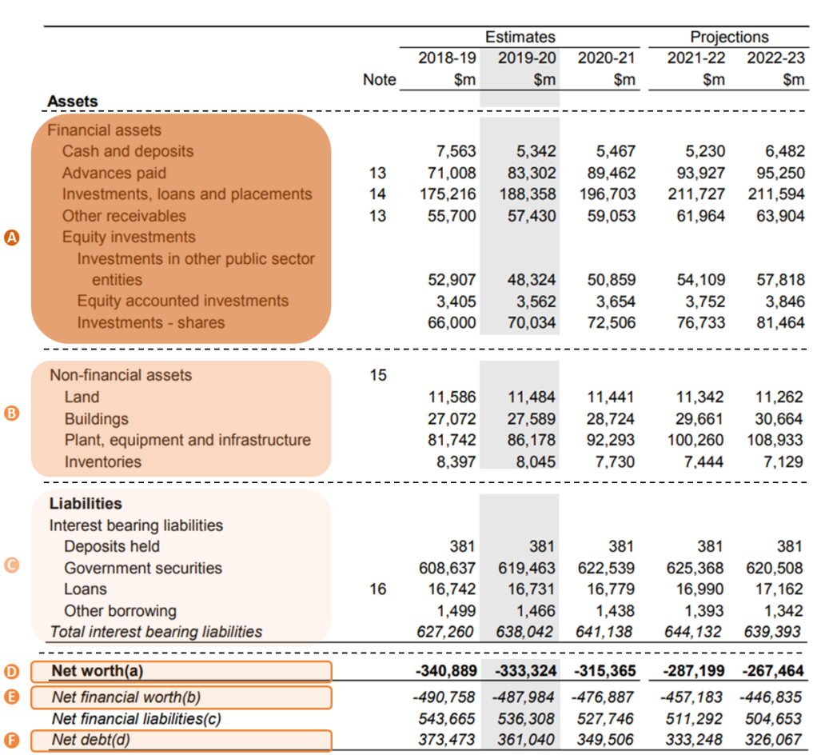
Note: For brevity, Figure A4 is an excerpt of the balance sheet and excludes certain line items.
Source: 2019–20 Budget, Budget Paper No.1, Statement 9 Table 2: Australian Government general government sector balance sheet, pp.9–7 to 9–8. Available at https://budget.gov.au/2019-20/content/bp1/download/bp1.pdf.

Definitions of key terms in the cash flow statement
The cash flow statement shows how the government receives and uses cash, and how the cash inflows and outflows are allocated between activities. It presents budget aggregates such as the ‘underlying cash balance’ and the ‘headline cash balance’. These budget aggregates are defined below, with Figure A5 highlighting where they can be found using an excerpt of the cash flow statement. The definitions below also include ‘net cash flows from investments in financial assets for policy purposes’.
Underlying cash balance is a cash metric that reflects the government’s cash flow requirements. The underlying cash balance is equal to the government’s receipts (for example from tax collections) less payments from its operations (from providing services such as Medicare and payments such as the age pension), less net cash capital acquisitions and Future Fund earnings before 2020–21. The underlying cash balance is broadly in line with the change in net financial worth due to transactions (apart from being measured on a cash basis, rather than accrual basis, and in excluding the effects of Future Fund earnings before 2020–21).
Net cash flows from investments in financial assets for policy purposes consists of cash inflows and cash outflows associated with the sale or purchase of financial assets used for the purposes of achieving a particular policy outcome. The financial impact of alternative financing arrangements often appears here.
Headline cash balance is a cash metric that reflects a broad range of cash transactions into and out of the general government sector. It shows whether the government has to borrow from financial markets to cover its operating activities, capital activities (net investments in non-financial assets used in the provision of goods and services), and net investment in financial assets for policy purposes.
Figure A5: Budget aggregates in the cash flow statement (excerpt)
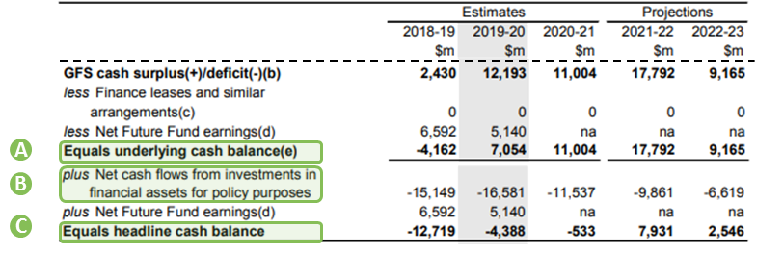
Note: For brevity, Figure A5 is an excerpt of the cash flow statement and excludes certain line items.
Source: 2019–20 Budget, Budget Paper No.1, Statement 9 Table 3: Australian Government general government sector cash flow statement, p.9–9. Available at https://budget.gov.au/2019-20/content/bp1/download/bp1.pdf.

Appendix B: Other sources of information about the budget impacts of policies
Source | Details
Portfolio budget statements | Each government department produces an annual portfolio budget statement with more detail on their expected departmental and administered expenditure over the forward estimates period. This includes some additional information on, for instance, HELP loans, but is also prepared on a different set of accounting requirements to the main budget documents, so is not directly comparable.
General government sector entity annual reports | The annual report of the general government sector entity administering a policy has additional information on the outcomes of the policies. For instance, the fair value of equity injections and the level of debt not expected to be repaid for large loan programs is often found in the relevant annual report.
Government-owned corporation annual reports | The annual report of a government-owned corporation includes information on the amount of equity that has been injected into the corporation, as well as other information on assets and losses.
Consolidated financial statements | The Consolidated financial statements provide some additional information to the Final Budget Outcome, and are audited by the Australian National Audit Office. In particular, these statements have notes to the financial statements that give some additional information on the effect of revaluations on net worth.
Other | The Australian National Audit Office produces occasional reports on specific programs and projects that use alternative financing arrangements.
 | Parliamentary Committees have public inquiries on relevant topics, and the inquiry reports and associated documents are publicly available.

Appendix C: Balance sheet metrics
Figure C1: General government sector balance sheet (2019–20 Budget) 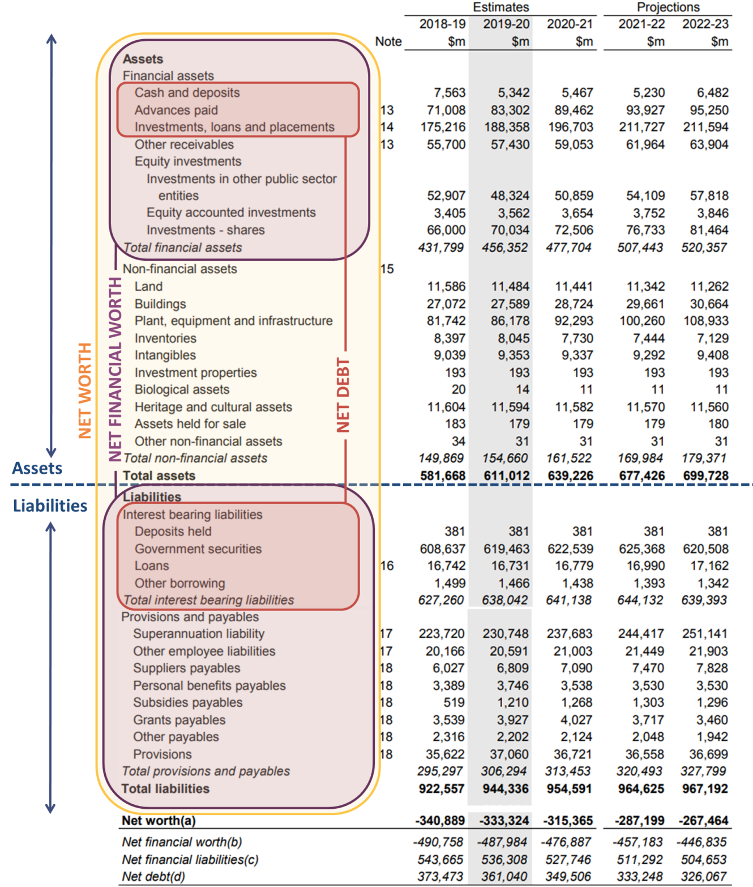

Net worth = total assets – total liabilities

Net financial worth = total financial assets – total liabilities
Net debt = total interest bearing liabilities – selected financial assets

Appendix D: Equity injections – an expense or a financial asset?
The Australian Bureau of Statistics’ Australian System of Government Finance Statistics 2015 (GFS) provides guidance on the accounting treatment of equity injections, and this guidance is then interpreted and applied by Commonwealth and state governments.
According to the GFS, an equity injection in a corporation results in a financial asset on the balance sheet if ‘a realistic return’ is expected from the investment.
Where the equity injection, or a portion of it, does not have an expectation of a realistic rate of return, the equity injection (or the relevant portion of it) is treated as a capital grant.
A simplified, illustrative example is presented at Figure D1. The example highlights how the treatment of an equity injection could lead to different impacts on key budget aggregates.
Figure D1: Treatment of an equity injection depends on the expectation of a realistic rate of return
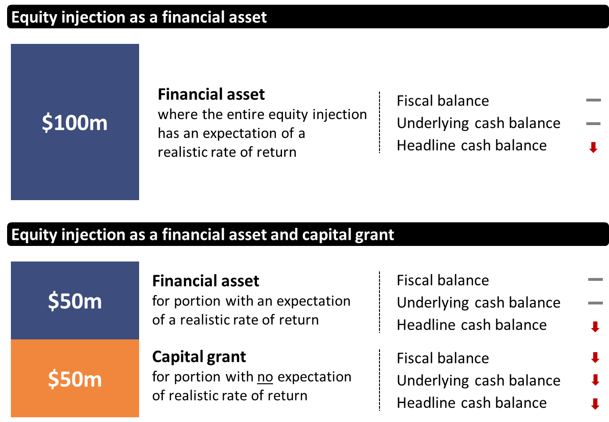
Source: PBO diagram using information from the GFS (pp. 272–273) and the Uniform Presentation Framework (pp. 7–11).
Note: For simplicity, the example only considers the impact on budget aggregates at the time the funds are recognised and only in terms of direction and not magnitude. Impacts from public debt interest, dividends, revaluation, or sale of the financial asset are not considered in this simplified example.

This terminology is consistent with Department of Finance Resource Management Guide 308: Commonwealth Investments. Available online at: https://www.finance.gov.au/publications/resource-management-guides/commonwealth-investments-resource-management-guide-308.
Public-Private Partnerships (PPPs) can also be considered a form of alternative financing of government policy. This report focuses on Commonwealth Government policy; in Australia, PPPs are mainly used by state governments.
In order to be recorded as equity, these injections must be assessed as providing a reasonable expectation of a sufficient rate of return to comply with the Australian Bureau of Statistics’ guidance for Government Finance Statistics. The Commonwealth Government has defined this as a real return of zero at a minimum. State governments have different requirements for the selection of equity investments. For example, the guidelines for corporations owned by the Queensland Government states that they should seek to earn a rate of return at least equal to the appropriate risk-adjusted Weighted Average Cost of Capital.
2019–20 Budget, Budget Paper No. 1, Statement 3, Page 3-26.
Australian Office of Financial Management annual reports, 2012–13 to 2017–18.
Parliamentary Budget Office 2019, 2019 Post-election report of election commitments, Canberra.
Productivity Commission 2017, University Education, Shifting the Dial: 5 year Productivity Review, Supporting Paper No 7, Canberra.
The impact of alternative financing arrangements is partially captured in ‘Other economic flows’, and is fully captured in ‘Net financial worth’. Detailed disaggregated information on ‘Other economic flows’ is not available in the budget documents.
International Monetary Fund 2012, Fiscal Transparency, Accountability, and Risk. Available at: https://www.imf.org/external/np/pp/eng/2012/080712.pdf.
PBO calculation. The larger differences indicate more cash flows from government due to alternative financing arrangements. In 2019–20, the underlying cash balance used for this calculation was adjusted for net future fund earnings to be comparable with later year figures.
Note that the definition of the cost of a policy adopted here – the associated change to net financial worth – is not necessarily the same definition used elsewhere in government, particularly in a technical accounting context. The PBO has chosen to use the word ‘cost’ in a way that attempts to align with the understanding of a general reader who is not an expert in formal financial statements.
The balance sheet is one of three connected financial statements included in the budget. As the financial statements are connected, this could instead be described in terms of changes in any of the three financial statements. For simplicity, we use the balance sheet. Further information on the financial statements is provided at Appendix C.
Budget-related documents refer to ‘Other economic flows’. The main type of ‘Other economic flow’ is the revaluation of assets. For simplicity, this report uses the term ‘revaluations’ in place of ‘Other economic flows’. There are other types of ‘Other economic flows’ also captured in this category, which are not the subject of this paper.
Distinguishing between transactions and revaluations is in line with the IMF’s standards, as detailed in the Government Finance Statistics Manual (IMF 2014).
Transactions can also be influenced by factors outside of the government’s control, such as commodity prices.
An overall surplus can refer to a surplus in the fiscal balance, in which case it relates to net financial worth, or can refer to a surplus in the underlying cash balance, which differs because it is measured on a cash basis.
These are based on international accounting standards and the IMF Government Finance Statistics Framework.
Australian National Audit Office, Auditor–General Report No.20 2019–20: Audits of the Financial Statements of Australian Government Entities for the Period Ended 30 June 2019. Available online at https://www.anao.gov.au/work/financial-statement-audit/audits-financial-statements-australian-government-entities-period-ended-30-june-2019.
A ‘net assets’ approach is used when an investment in an entity does not generate significant non-government cash flow. It is taken as the value of the total assets less the value of the total liabilities of the entity investment. A common alternative to the ‘net assets’ approach to valuation is the ‘discounted cash flow’ technique, which is used when the investment in the entity generates significant non-government cash flow. Entities use a valuation technique (or multiple techniques) as is appropriate to the circumstances and for which data is available (Australian Accounting Standards Board 13).
All the financing types shown in this table do have some additional transactions, such as the issuance of Australian Government Securities (bonds) to fund the outflow of cash, payment of interest on these bonds, and any necessary departmental costs for their administration. The fact that the issued bonds are subject to revaluation also means that all of the funding types technically have some associated revaluations. Broadly speaking, costs associated with direct funding overwhelmingly result from transactions, and costs associated with alternative financing are more likely to result from both transactions and revaluations.
The fair value is the best information currently available on the company. Note that the fair value assessment was performed on a ‘net assets’ basis; under this methodology there is often a decline in value, though the extent of the decline differs. Often as investment entities mature, valuation methodology is switched to discounted cash flows, at which point the fair value may increase.
2018–19 Annual report, Department of Communication and the Arts, and 2018–19 Annual report, NBN Co.
The $20.8 billion change in value does not include the interest payments associated with making the investment, which have also deteriorated the balance sheet by around $4.1 billion as at 30 June 2019 (PBO calculation).
2018–19 Annual report, Department of Education and Training.
The revaluation would not be exactly $1.2 billion as it would also be affected by technical accounting components such as the concessional loan discount and the subsequent unwinding of the discount.
The fiscal balance impact comprises government spending of $0.7 billion on interest payments to bondholders, the accrual of $0.4 billion in interest from students, and expenditure of $0.1 billion on other components (mainly technical accounting components such as the concessional loan discount and subsequent unwinding of the discount). The underlying cash balance impact comprises $0.7 billion in interest payments to bondholders.
In making these suggestions, the PBO is not in a position to assess the practicality of the timing of publication of this additional information in budget papers. In the event that this additional information needed to be provided in a supplementary document at a later date, there would still be considerable value in publishing it.
A loan must be expected to be repaid in order to not be classified as a grant. For a loan program, a proportion of loans will statistically be unlikely to be repaid – this is the non-repayment referred to in this section.
Department of Finance, Finance Advice Paper, Q&A – Equity Investments, August 2018.
The focus of accounting for equity in public and private sector is often at the entity level.
Australian Rail Track Corporation, The Case for Inland Rail. Available online at https://inlandrail.artc.com.au/13251/documents/31860.
2016–17 Budget, Budget Paper No. 2, p171; 2017–18 Budget, Budget Paper No. 2, p189.
As calculated by the PBO, based on the profile presented in 2016–17 Budget, Budget Paper No. 1, Statement 3.
See, for example, costings PER314 and PER634 in the PBO’s 2019 Post-election report of election commitments.
Department of Health Annual Report 2018–19.
This could be comparable to the table showing the magnitude of government loans (Table 3, p.8–41 in 2019–20 Budget, Budget Paper No. 1.
The financial statements discussed here refer to those of the Australian general government sector. The sector consists primarily of government departments and agencies that provide non-market public services funded mainly through taxes. Their financial statements are published in the budget, the mid-year economic and fiscal outlook update and the consolidated financial statements.
Financial statements are included in Budget Paper No. 1, Statement 9 in the 2019–20 Budget. 2017–18 and 2018–19 Budgets included financial statements at Budget Paper No. 1, Statement 10. Financial statement updates can also be found at each mid-year economic and fiscal outlook (MYEFO) update. As at 2019–20 MYEFO, financial statements were published in Part 7: Australian Government Budget Financial Statements.
The GFS defines the realistic rate of return on the funds as ‘the intention to earn a rate of return that is sufficient to generate dividends or holding gains at a later date, and includes a claim on the residual value of the corporation’ (p.273).
See section 4.1.2 for how this is applied for Commonwealth equity injections.

