**NaTIONAL FISCAL OUTLOOK: AS AT   
2018–19 BUDGETS**

**Report No. 04/2018**

|  |
| --- |
| © Commonwealth of Australia 2018  **978-0-6482138-8-8** National fiscal outlook: As at 2018–19 budgets (PDF) **978-0-6482138-9-5** National fiscal outlook: As at 2018–19 budgets (DOCX)  Copyright notice  This work is licensed under the Creative Commons Attribution-NonCommercial-NoDerivs 3.0 Australia License <http://creativecommons.org/licenses/by-nc-nd/3.0/au/>    Attribution  This publication should be attributed as follows: Parliamentary Budget Office, National fiscal outlook: As at 2018–19 budgets.  Use of the Coat of Arms  The terms under which the Coat of Arms can be used are detailed on the following website: [www.itsanhonour.gov.au/coat-arms](http://www.itsanhonour.gov.au/coat-arms)  Acknowledgements  This report was prepared by Aaryn Lally and Anupam Sharma with the benefit of comments by Linda Ward. The report was prepared for publication by Lauren Pratley. |

Contents

Overview 1

1 National fiscal outlook: what has changed since last year’s budgets? 2

1.1 Budget balance 2

1.2 Net infrastructure investment 3

1.3 Net debt 4

2 Trends in revenue and spending 7

2.1 Commonwealth trends 7

2.2 State trends 11

Appendix A – Glossary and notes 20

Data and methodology 21

Overview

This annual publication provides a national perspective on the fiscal outlook and a complete picture of the size of general government by examining outcomes across all levels of Australian government.[1]

The national fiscal outlook has improved since last year and is projected to strengthen over the forward estimates…

The net operating balance has been revised upwards by $24.9 billion (0.3 per cent of GDP) for the period 2017–18 to 2020–21. This upward revision is driven by an increase in Commonwealth revenue.

Looking forward, the national net operating balance is projected to move from a surplus of 0.1 per cent of GDP in 2017–18 to a surplus of 2.1 per cent of GDP by 2021–22. This projected increase is driven by the Commonwealth, largely stemming from increased personal income tax revenue due to a projected pick-up in wages growth.

Further contributing to the improving net operating balance is subdued growth in expenses at both the Commonwealth and state levels.

…but there are risks to the outlook

On the revenue side, risks to the net operating balance include lower-than-expected receipts if economic outcomes are weaker than current economic projections.[2] For example, more subdued wages growth would flow through to personal income tax receipts and a slower than expected property market would lead to lower transfer duty revenue. Rising expenditure beyond projected levels is also a risk, noting in particular that this financial year will see a number of elections take place, increasing the possibility of new spending commitments arising. Further, these projections do not factor in any decisions that have been taken since 2018–19 budgets.

State infrastructure investment is projected to grow strongly over the next two years…

States have primary responsibility for the delivery of infrastructure and make up the large majority of national net capital investment (95 per cent in 2017–18). Net capital investment has seen a major upwards revision of $19.5 billion for the forward estimates compared to the previous outlook. This is largely due to major infrastructure projects in New South Wales and Victoria.

Total state net capital investment is projected to increase rapidly over the forward estimates peaking at 1.1 per cent of GDP in 2018–19 before declining to 0.6 per cent of GDP in 2021–22. This is primarily driven by the timing of New South Wales’ spending on infrastructure projects, which increases rapidly over the next two years and then declines as projects are completed.

…flowing through to aggregate state net debt, which more than doubles.

States are borrowing to fund their investment with aggregate state net debt projected to more than double over the forward estimates to reach 5.2 per cent of GDP. In contrast, Commonwealth net debt, which makes up 90 per cent of national net debt, is projected to decline over the latter part of the forward estimates driven by improving budget balances.

This year a complementary product – the *2018-19 National Fiscal Outlook at a Glance* – provides a graphical snapshot of each of the Commonwealth, state and territory budgets in three charts.

# National fiscal outlook: what has changed since last year’s budgets?

This section examines how the national fiscal outlook has changed since jurisdictions released their 2017‑18 budgets.[3]

## Budget balance

The 2018‑19 national fiscal outlook has improved since the previous national outlook, with the net operating balance being revised up by $24.9 billion for the period 2017‑18 to 2020‑21 (0.3 per cent of GDP) (Figure 1–1). Looking forward, the national net operating balance is projected to move from a surplus of 0.1 per cent of GDP in 2017‑18 to a surplus of 2.1 per cent of GDP by 2021‑22.

|  |  |
| --- | --- |
| Figure 1–1: National net operating  balance | Figure 1–2: Change in net operating  balance since 2017‑18 |
|  |  |
| Source: Australian Bureau of Statistics (ABS), Commonwealth and state budget papers,  Parliamentary Budget Office (PBO) analysis. | Source: ABS, Commonwealth and state budget papers, PBO analysis. |

Most of the improvement in the national net operating balance since the previous national outlook is due to an upward revision in the Commonwealth net operating balance (Figure 1–2). This reflects an upward revision in projected Commonwealth revenue of $21.3 billion for the period 2017‑18 to 2020‑21, driven by higher company tax revenue from stronger collections in 2017‑18 and continuing higher expected commodity prices flowing through to increased company profitability. Excise and customs duty revenue has also been revised up due to stronger collections for alcohol and tobacco in 2017‑18 and policy decisions to combat illicit tobacco. These increases are partly offset by a downwards revision to revenue from 2019‑20, reflecting the impact of personal income tax cuts.

In addition, Goods and Services Tax (GST) revenue has been revised up by $6.1 billion for the period 2017‑18 to 2020‑21, reflecting higher forecast consumption. This has increased the pool of funding available for distribution to the states (see Section 2.2.1).

The revision to Commonwealth revenue is partially offset by an upward revision to Commonwealth expenses of $2.6 billion for the period 2017‑18 to 2020‑21. This mainly reflects higher GST payments to the states (equal to the higher GST revenue described above) and increased Commonwealth funding to the states for public hospitals under the National Health Reform Agreement.

The rest of the improvement in the national net operating balance since last year is due to an upward revision in the aggregate net operating balance of state, territory and local governments (referred to as ‘states’ for the remainder of Section 1), primarily in 2017‑18 (Figure 1‑2).

State revenue has been revised up by $16.3 billion for the period 2017‑18 to 2020‑21 compared with the previous national outlook, largely reflecting higher forecast revenue in Queensland and Victoria.

The upward revision to revenue in Queensland is primarily driven by higher royalty revenue stemming from higher than projected coal prices. This combined with higher net flows from government-owned corporations, is one of the largest contributors to the improvement in the aggregate state position in 2017‑18.

Victoria’s revenue was also revised up significantly for the period 2017‑18 to 2020‑21 due to upwards revisions to transfer duty and land tax revenue.[4]

The upward revision in state revenue is partially offset by an upward revision to projected state expenses of $10.2 billion for the period 2017‑18 to 2020‑21, driven by higher forecast spending across most states since the previous national outlook. Upward revisions are particularly notable for Victoria due to significant spending on health, education and transport.

Queensland has also revised expenditure up since the previous national outlook, reflecting increased employee expenses as a result of strong growth in demand for health and education services. In addition, South Australian expenditure has increased since the previous national outlook, in part reflecting new spending committed as part of the 2018 state election, particularly in the area of health.

## Net infrastructure investment

National infrastructure investment, as measured by net capital investment, is projected to be $19.5 billion higher for the period 2017‑18 to 2020‑21 than was projected in the previous national outlook (Figure 1–3).

The overwhelming majority of this ($18.3 billion) is due to an upward revision in state net capital investment. This substantial increase is largely driven by New South Wales and Victoria whose net capital investment for the period has been revised upwards by $11.7 billion and $6.3 billion respectively. These increases reflect significant investment in public transport and roads, health and education, particularly in the latter part of the forward estimates. The fall in 2017‑18 in Figure 1–4 reflects the re-profiling of state investment from 2017‑18 into later years.

|  |  |
| --- | --- |
| Figure 1–3: National net capital  investment | Figure 1–4: Change in net capital  investment since 2017‑18 |
|  |  |
| Source: ABS, Commonwealth and state budget papers, PBO analysis. | Source: ABS, Commonwealth and state budget papers, PBO analysis. |

## Net debt

National net debt is projected to peak as a share of GDP in 2018‑19 at 20.9 per cent ($398.0 billion), 2.3 percentage points ($40.7 billion) lower than the previous projected peak in the 2017‑18 outlook (Figure 1–5). This reflects large underlying variations to Commonwealth and state net debt over the period (Figure 1–6).

|  |  |
| --- | --- |
| Figure 1–5: National net debt | Figure 1–6: Change in net debt since 2017‑18 |
|  |  |
| Source: ABS, Commonwealth and state budget papers, PBO analysis. | Source: ABS, Commonwealth and state budget papers, PBO analysis. |

Commonwealth net debt is projected to be $334.3 billion in 2020‑21, $31.9 billion lower than projected in the previous national outlook. This improvement is primarily driven by a decrease in the financing task from a projected improvement in the budget balance over the forward estimates. It also reflects a fall in the market value of Commonwealth Government Securities due to the budget assumption of higher average yields over the forward estimates period.

State net debt is projected to be $84.9 billion in 2020‑21, $2.6 billion higher than projected in the previous national outlook. The change in the state net debt profile in Figure 1‑6 reflects a significant improvement in New South Wales’ net debt (and to a lesser extent Victoria’s), driven in part by the sale of New South Wales’ and Victoria’s share of the Snowy Hydro to the Commonwealth. As the proceeds from the sale are then reinvested in other infrastructure projects, net debt improves by a smaller amount each subsequent year before deteriorating in 2020‑21. Stronger than expected net operating balances in Queensland and Western Australia in the early part of the forward estimates also contribute to the improvement in net debt since the previous national outlook.

|  |
| --- |
| Box 1: International comparison of net debt  Looking across all levels of government, Australia’s net debt is projected to improve over the forward estimates. This is largely because the Commonwealth budget moves from deficit to surplus thus reducing the financing task. While Australia’s net debt is now high by historical standards, it remains relatively low by international standards.  Like many countries, Australia’s net debt increased significantly during and following the global financial crisis (GFC). This reflected the cyclical downturn in revenue and increase in expenditure that occurred, as well as the significant stimulus packages and personal income tax cuts that were introduced.  While net debt increased substantially between 2007‑08 and 2017‑18, Australia had the advantage, compared with most other countries, of starting with very low levels of government debt (Figure 1–7). This in large part reflected the strong balance sheet position of the Commonwealth, due to the sale of government assets, and the sustained boost to the terms of trade that occurred, which boosted national income and taxation revenue.  Many states also had very low levels of net debt prior to the GFC which reinforced this strong balance sheet position. For example, Queensland and Western Australia, whose operating balances were also buoyed by strong commodity prices, had negative net debt during the middle of the past decade.[5]  Of the countries shown in Figure 1–7, the United States is the only country projecting an increase in national net debt as a per cent of GDP, reflecting a persistent ongoing gap between revenue and expenses over the next decade.  Figure 1–7: Projected consolidated net debt position of selected countries[6]    Source: *IMF World Economic Outlook*, October 2018. |

# Trends in revenue and spending

This section breaks down the national fiscal outlook between the Commonwealth and the states. It analyses trends in revenue, expenses, net capital investment and net debt over the forward estimates period by level of government.[7]

## Commonwealth trends

Before the GFC, Commonwealth revenue exceeded expenses. Revenue was boosted by a strong economy and a record terms of trade position, which enabled the Commonwealth government to sustain high levels of spending growth and provide tax cuts while still achieving budget surpluses. The onset of the GFC saw a sharp decline in Commonwealth revenue (with personal income tax cuts contributing to a further revenue decline from 2008‑09) and a sharp increase in expenses as the Commonwealth government provided fiscal stimulus. Expenditure moderated and revenue began to recover from 2010‑11 (Figure 2–1 and Figure 2–2).

Commonwealth budget papers project revenue to grow significantly from 2017‑18 to 2021‑22, with expenditure as a proportion of GDP projected to decline over the period.

|  |  |
| --- | --- |
| Figure 2–1: Commonwealth revenue  and expenses  Share of GDP | Figure 2–: Commonwealth revenue  and expenses  Annual real growth |
|  |  |
| Source: ABS, Commonwealth budget papers, PBO analysis. | Source: ABS, Commonwealth budget papers, PBO analysis. |

### Trends in Commonwealth revenue

According to the 2018‑19 Budget, Commonwealth revenue is projected to increase from   
24.9 per cent of GDP in 2017‑18 to 26.1 per cent of GDP in 2021‑22, which would see Commonwealth revenue as a proportion of GDP returning to pre-GFC levels.

The increase in revenue growth over the forward estimates is predominantly due to a projected rise in personal income tax, which makes up around half of total revenue in 2017‑18. Personal income tax is projected to rise from 11.5 per cent of GDP in 2017‑18 to 12.3 per cent of GDP in 2021‑22, largely due to a projected pick-up in wages growth resulting in a higher proportion of income being taxed in higher income tax brackets. A key risk to this projection is that the assumed increase in wages growth to trend levels does not eventuate.[8]

Company tax, the second largest category of revenue, accounting for close to 20 per cent of total Commonwealth revenue in 2017‑18, is projected to remain around 4.7 per cent of GDP across the forward estimates.[9] Company tax projections are supported by ongoing growth in corporate profitability, as depreciation and losses carried forward from resources investment decline over time.

Goods and services tax, which makes up around 15 per cent of total Commonwealth revenue in 2017‑18, is projected to increase by 0.1 per cent of GDP across the forward estimates to reach   
3.7 per cent of GDP in 2021‑22. This reflects strong household consumption forecasts.

### Trends in Commonwealth expenses

The Commonwealth budget projects expenses to decline from 25.5 per cent of GDP in 2017‑18 to 24.9 per cent of GDP in 2021‑22 (Figure 2–1). This fall in expenses as a share of GDP occurs even with the sharp increase in expenditure associated with the National Disability Insurance Scheme (NDIS).

The largest contributor to expenditure growth over the forward estimates period, the NDIS, is projected to increase by 0.7 per cent of GDP over the forward estimates to reach 1.1 per cent of GDP in 2021‑22. On current projections, the Scheme is expected to achieve national coverage by 2019‑20. Defence spending is projected to increase by 0.1 per cent of GDP over the forward estimates to reach 2.1 per cent of GDP in 2021‑22, driven by the Commonwealth Government’s funding commitments in the *2016 Defence White Paper*.[10] Aged care spending is projected to increase by 0.1 per cent of GDP over the forward estimates to 1.1 per cent of GDP in 2021‑22, reflecting the impact of the ageing population on the demand for aged care services.

More than offsetting these increases is a decline in spending as a proportion of GDP across a number of payment programs. Spending on government administration is projected to decline by 0.3 per cent of GDP over the forward estimates period to reach 1.5 per cent of GDP in 2021‑22, reflecting measures to restrain the size of the public sector.[11] Spending on the Family Tax Benefit (FTB) is projected to decline by 0.2 per cent of GDP over the forward estimates to 0.8 per cent of GDP in 2021‑22, partially due to policy decisions to freeze FTB income thresholds and payment rates.

Of particular relevance to the national fiscal outlook is that spending on road and rail infrastructure is projected to fall by 0.2 per cent of GDP over the forward estimates to 0.2 per cent of GDP in 2021‑22, reflecting the profile of spending on announced road and rail infrastructure projects included in the 2018‑19 Budget. Much of this expenditure relates to funding provided to the states for road and rail projects, and partly explains the decline in specific purpose payments to the states (see Section 2.2.1).

These figures understate the Commonwealth Government’s investment in infrastructure as they only include the spending relating to road and rail infrastructure, including grants to state and territory governments. They do not capture infrastructure investment funded through equity injections into Commonwealth government public non-financial corporations such as the Australian Rail Track Corporation, or concessional loans such as the loan to the New South Wales Government for the WestConnex project.

Importantly, the projections of Commonwealth spending assume no new spending initiatives beyond those contained in the 2018‑19 Budget. Ongoing low spending growth may be increasingly difficult to maintain with an improving budget outlook and an upcoming election. In recent months, the Commonwealth Government has announced additional funding for schools and has revised arrangements for distributing the GST to the states. The NDIS is still in the early stages of implementation and, as with any program that is yet to mature, there are risks that the longer-term costs associated with the NDIS may increase.

### Trends in Commonwealth net capital investment

Commonwealth net capital investment is projected to increase from close to zero in 2017‑18 to 0.4 per cent of GDP in 2021‑22 (Figure 2–3).

The net capital investment the Commonwealth undertakes directly is relatively small and is largely in the area of defence. The profile is affected by the scheduling of major defence weapons purchases and sales of non-financial assets. The decrease in net capital investment in 2017‑18 is due to the auctioning of spectrum licences.

In addition to direct investment, the Commonwealth also provides funding to the states for infrastructure projects through grants and increasingly through equity and debt financing, which are not captured in direct Commonwealth government investment.

Figure 2–: Commonwealth net capital investment

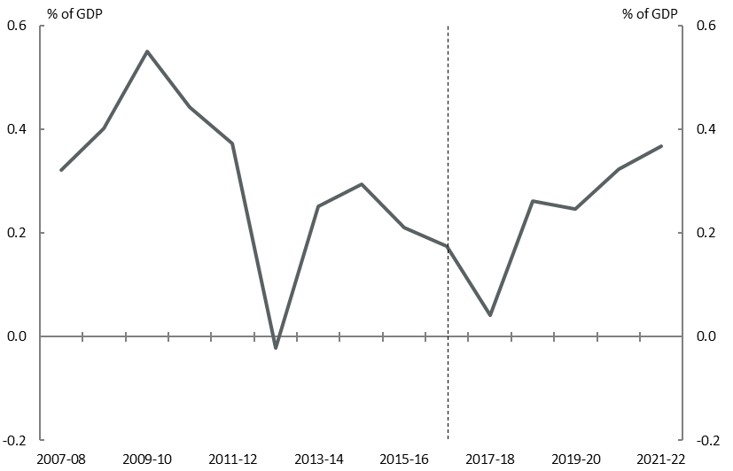

Source: ABS, Commonwealth budget papers, PBO analysis.

### Trends in Commonwealth net debt

Commonwealth budget papers show that net debt is projected to fall from a peak of 18.6 per cent of GDP ($341.0 billion) in 2017‑18 to 14.7 per cent of GDP ($319.3 billion) by 2021‑22 (Figure 2–4).

Figure 2–: Commonwealth net debt

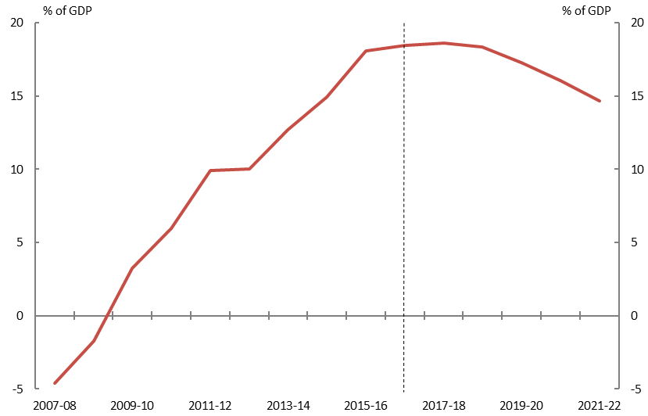

Source: ABS, Commonwealth budget papers, PBO analysis.

The improvement in net debt over the forward estimates primarily reflects the reduced financing task as the budget moves into surplus over the latter half of the forward estimates period (for more background regarding the historical drivers of net debt see Section 5 of the PBO’s *2018‑19 Budget: medium‑term projections* report).

## State trends

State revenue and expenditure, including transfers from the Commonwealth, are around 55 per cent of the comparable Commonwealth totals. In contrast, state net capital investment over the forward estimates is around three times greater than that undertaken by the Commonwealth.

Compared to the Commonwealth, state revenue and expenses in aggregate have historically moved in line with each other due to a less volatile revenue base, with variations among individual states.

Over the forward estimates, state budget papers indicate revenue and expenditure are projected to decline as a share of GDP (Figure 2–5 and Figure 2–6), partly reflecting spikes in revenue and expenditure early in the forward estimates period, which are not projected to continue over the entirety of the period. Similarly, following strong growth at the beginning of the forward estimates, net capital investment is projected to decline as a share of GDP by 2021‑22.

|  |  |
| --- | --- |
| Figure 2–: State revenue and expenses  Share of GDP | Figure 2–: State revenue and expenses  Annual real growth |
|  |  |
| Source: ABS, state budget papers, PBO analysis. | Source: ABS, state budget papers, PBO analysis. |

### Trends in state revenue

According to state budgets, revenue is projected to decline from 14.8 per cent of GDP in 2017‑18 to 13.9 per cent of GDP in 2021‑22, with close to zero real growth from 2018‑19 onwards. State government revenue is made up of transfers from the Commonwealth government and own-source revenue (Figure 2–7).

Figure 2–: State revenue composition

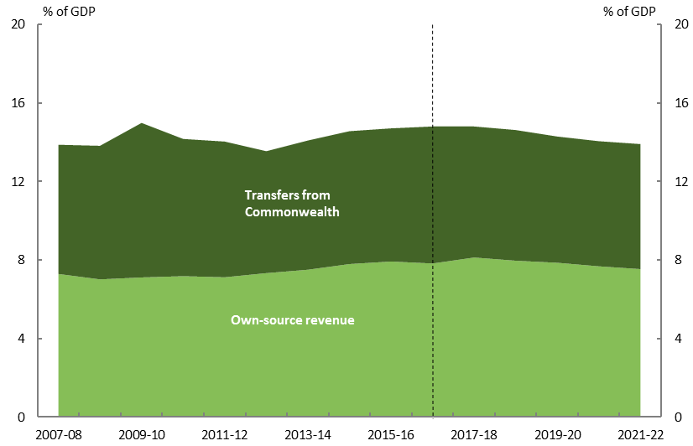

Source: ABS, Commonwealth and state budget papers, PBO analysis.

#### Transfers from the Commonwealth to the states

Around 45 per cent of total state revenue in 2017-18 was from Commonwealth transfers, with this proportion projected to remain constant over the forward estimates. Transfers received by state governments consist of general revenue assistance for use at the discretion of the recipient state government (mainly comprising of GST) and specific purposes payments which are to be used in specific sectors or to deliver programs agreed in partnership with the Commonwealth government (Figure 2–8).

As a per cent of GDP, Commonwealth transfers to the states are projected to fall from 6.7 per cent of GDP in 2017‑18 to 6.4 per cent of GDP in 2021‑22. This is largely driven by a fall in specific purposes payments to the states, partly reflecting the funding arrangements as jurisdictions transition to the NDIS. Rather than providing funding to the states for disability services, the Commonwealth, through the National Disability Insurance Agency, will provide funding to individuals directly for disability support services. States will also contribute to the cost of the scheme. Further contributing to the decline in specific purpose payments are infrastructure payments to the states, which decline as projects are completed.

Figure –: Trends in the composition of Commonwealth transfers[12]

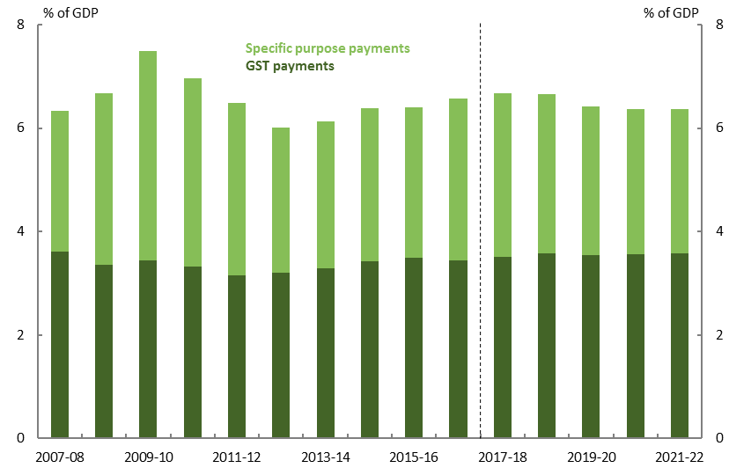

Source: ABS, Commonwealth budget papers, PBO analysis.

States depend on these transfers from the Commonwealth government to differing extents. For example, on average over the five years to 2016-17 transfers from the Commonwealth made up around three quarters of the Northern Territory’s total revenue compared with around one third for Western Australia (Figure 2–9). However, on a per capita basis, the variations between the larger states over the period are less prominent (Figure 2–10), taking into account both own-source revenue and Commonwealth transfers. The composition of revenue for a state is driven by their ability to raise their own revenue and the cost of delivering services.[13] This is then reflected in the GST relativities that apply across different states, which are determined by the Commonwealth Grants Commission on an annual basis.[14]

|  |  |
| --- | --- |
| Figure –: State revenue  Share of GDP, average 2012–13 to 2016–17 | Figure –: State per-capita revenue  $ thousand, average 2012–13 to 2016–17 |
|  |  |
| Source: ABS, Commonwealth and state budget papers, PBO analysis. | Source: ABS, Commonwealth and state budget papers, PBO analysis. |

#### Own-source revenue

The remainder of state revenue is derived from their own sources. Key revenue sources for the states are taxes on property (including land tax and municipal rates), payroll tax, transfer duty, revenue from sales of goods and services, and for resource rich states, royalty revenue. Payments from government-owned corporations have also become an increasing source of revenue for state governments.[15]

Own-source revenue for the states has been relatively stable averaging 7.4 per cent of GDP over the past decade. Own-source revenue has been stronger in recent years but is projected to fall from 8.1 per cent of GDP in 2017‑18 to 7.5 per cent of GDP by 2021‑22. The decline in own-source revenue over the forward estimates reflects strong growth in certain states’ revenue in 2017‑18 and 2018‑19 which is not projected to continue over the remainder of the forward estimates. This includes a large spike in Queensland royalty revenue in 2017‑18 from high metallurgical coal prices, which are then assumed to decline to longer-term averages over the forward estimates.

Similarly, a strong property market in Victoria is fuelling strong growth in transfer duty and land tax revenue collections in 2017‑18, with growth projected to moderate over the remainder of the forward estimates. Transfer duty has historically been a volatile revenue stream for the states, which can be challenging to forecast and can pose a risk to state budget bottom lines (Box 2).

|  |
| --- |
| Box 2: Transfer duty revenue  Transfer duty revenue accounted for around 15 per cent of aggregate state own-source revenue in 2016‑17.[16] Transfer duty revenue has been particularly important for New South Wales and Victoria, with these two states together accounting for around 70 per cent of all transfer duty revenue in 2016‑17. As Figure 2–11 illustrates, transfer duty revenue grew strongly over the past five years in both states, but more subdued growth is projected over the forward estimates.  Both the volume and price of property sales affect transfer duty revenue. The fluctuating nature of residential transaction volumes and difficulty predicting turning points in the market can make transfer duty a volatile revenue source, and a source of risk for state budgets.[17]  Figure 2–11: Transfer duty revenue for New South Wales and Victoria    Source: State budget papers, PBO analysis. Transfer duty data for both New South Wales and Victoria relates to property transactions, and excludes motor vehicle and other non-property related duty.  Victoria’s 2018‑19 Budget projected strong transfer duty revenue growth in 2017‑18 consistent with strong property market outcomes, with residential property prices and transaction volumes projected to moderate over the forward estimates.[18] For New South Wales, the decline in transfer duty revenue in the early part of the forward estimates reflects the general slowing in the Sydney property market and policies aimed at improving housing affordability (in particular exemptions for first home buyers). Since the 2017‑18 Budget, New South Wales has revised transfer duty revenue downwards by $7.2 billion for the period  2017‑18 to 2020‑21.  Housing data released since the publication of state budgets indicates that property price growth is slowing across Australia, particularly in Sydney and Melbourne. While states have factored in softening property markets into their revenue projections, further reductions present a downside risk to state budget bottom lines. This is particularly the case as weaker house prices often have a compounding effect on transaction volumes, as owners tend to resist selling when prices are falling. |

### Trends in state expenses

State expenditure is projected to decline from 14.5 per cent of GDP in 2017‑18 to 13.6 per cent of GDP in 2021‑22. Many states are projecting growth in expenses to spike in 2017‑18 and 2018‑19 before dropping sharply afterwards, reflecting ‘one-off’ increases in expenses which do not persist over the entirety of the forward estimates.

For example, Victoria’s spending grows strongly in 2017‑18 and 2018‑19, largely driven by payments to the National Disability Insurance Agency for disability services as part of the full rollout of the NDIS, and an increase in employee expenses due to increased spending in the education, health and community service sectors. These expenses are projected to moderate over the forward estimates period.

In Queensland, expenditure in 2017‑18 was elevated by spending on the Gold Coast 2018 Commonwealth Games, provisioning for the National Redress Scheme, and continued strong growth in demand for health and education services.

In Western Australia, the decision to transfer operational responsibility for the NDIS from a planned State-run scheme to the Commonwealth-run scheme starting from 1 July 2018 results in a reduction in state expenses (given that the State Government will no longer deliver the NDIS). This revision has the largest impact in the latter part of the forward estimates, and is matched by a reduction in Commonwealth grants.

As per the Commonwealth projections, the state figures presented here assume no new spending initiatives beyond those contained in 2018‑19 budgets. There is the possibility that spending and net capital investment may rise above the baselines included in current budget outlooks as additional policy commitments are announced.

### Trends in state net capital investment

States account for the large majority of government net capital investment in Australia, making up around 95 per cent of total net capital investment by governments in 2017‑18.

Over the first half of the forward estimates, aggregate state net capital investment is projected to rise sharply, peaking at 1.1 per cent of GDP in 2018‑19, before declining to 0.6 per cent of GDP by the end of the forward estimates (Figure 2–12).

This increase follows a trend of declining state investment since the peak in 2009‑10. Investment in the peak period was driven by the Commonwealth’s fiscal stimulus packages that supported state infrastructure projects. The proportion of state investment was more weighted to Queensland in that period, which had large transport infrastructure spending as well as reconstruction spending following natural disasters in 2010‑11.

Figure –: State net capital investment

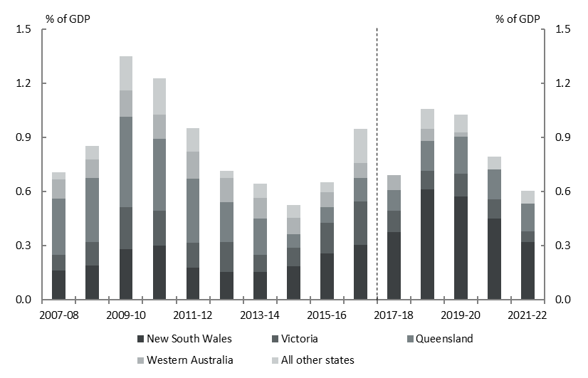

Source: ABS, state budget papers, PBO analysis.

The increase in net capital investment over the period ahead is largely driven by New South Wales, which is projecting net capital investment to increase from 0.4 per cent of GDP in 2017‑18 to 0.6 per cent of GDP in 2018‑19. This reflects spending on major road and rail projects including Sydney Metro, but also multiple hospital expansions and redevelopments and capital works in schools and TAFEs. As a share of GDP, the projected peak in New South Wales’ net capital investment in 2018‑19 is around double the peak following the GFC. The finalisation of infrastructure projects in New South Wales is the primary reason that aggregate state net capital investment declines by the end of the forward estimates.

Queensland is the second largest contributor to net capital investment over the forward estimates, with net capital investment peaking at 0.2 per cent of GDP in 2019‑20. This includes spending on major transport projects, such as the Brisbane Cross River Rail project and the Toowoomba Second Range Crossing, and health and education infrastructure.

As noted in previous sections, some of this net capital investment is funded by the Commonwealth through capital grants to the states (such as for a specific road project), GST revenue which is then used by the states for capital expenditure, or through financing assistance to the states for capital projects.

More broadly, state-owned corporations play a key role in undertaking net capital investment and contribute a significant portion of the net capital investment undertaken by the public sector (see Box 3).

|  |
| --- |
| Box 3: Net capital investment by state general government and government-owned corporations  A significant component of state net capital investment occurs through government‑owned corporations.[19] These corporations typically have significant capital costs reflecting the goods and services they provide, such as electricity and water.  Looking at net capital investment across both the general government sector (the focus of this report) and government-owned corporations can provide a more complete picture of the public investment taking place. It also overcomes classification differences between states due to which sectors deliver particular services.  From 2007‑08 to 2013‑14, net capital investment by state-owned corporations accounted for around half of all state net capital investment over the period (Figure 2–13). This largely reflected strong investment in water, transport and electricity infrastructure by Queensland, New South Wales and Victoria. Following the GFC related surge, the level of investment by state-owned corporations fell, with general government sector infrastructure projects becoming a relatively more important source of state net capital investment.  Figure –: State net capital investment by general government  and government-owned corporations    Source: ABS, state budget papers, PBO analysis.  In 2017‑18, state government-owned corporations are estimated to account for around  40 per cent (0.5 per cent of GDP) of all state net capital investment, which is projected to decline to 20 per cent (0.2 per cent of GDP) by the end of the forward estimates. The projected decline reflects a fall in investment in New South Wales as major road and rail projects are completed, and the planned sale of the Sydney Motorway Corporation as part of New South Wales’ asset recycling program. Importantly, Figure 2–13 only includes the infrastructure projects currently agreed to, and hence there is likely to be a pick-up in total state net capital investment as new projects enter the pipeline in the latter part of the forward estimates. |

### Trends in state net debt

As the previous section highlighted, revenue and expenses for the states are expected to track each other closely over the forward estimates, leading to small operating surpluses. However these operating surpluses are insufficient to fund the strong level of investment the states plan to undertake over the forward estimates. States will need to sell assets or borrow to fund their planned investment, with a consequent impact on their net debt positions.

The aggregate net debt of the states is around a tenth of the Commonwealth’s net debt in 2017‑18. State net debt is projected to increase sharply over the forward estimates from 2.0 per cent of GDP in 2017‑18 to 5.2 per cent of GDP in 2021‑22 (Figure 2–14). This largely reflects infrastructure investment commitments in New South Wales, and to a lesser extent Victoria and Queensland (Figure 2–15). New South Wales’ plans to reinvest the proceeds from the partial long-term lease of government-owned electricity businesses and the sale of its share of Snow Hydro to the Commonwealth will increase its net debt from -0.5 per cent of GDP in 2017‑18 to 1.3 per cent of GDP in 2021‑22.

Queensland’s net debt position is projected to increase from close to zero net debt in 2017‑18 to 0.6 per cent of GDP in 2021‑22, reflecting strong investment in transport, health and education infrastructure. Similarly, net debt in Victoria is projected to increase from 1.1 per cent of GDP in 2017‑18 to 1.4 per cent of GDP in 2021‑22, as it reinvests the proceeds from the partial long-term lease of the Port of Melbourne into other infrastructure projects.

|  |  |
| --- | --- |
| Figure –: Aggregate state net debt  Share of GDP | Figure –: Net debt of selected states  Share of GDP |
|  |  |
| Source: ABS, state budget papers, PBO analysis. | Source: ABS, state budget papers, PBO analysis. |

# Appendix A – Glossary and notes

Glossary

#### Net operating balance

The net operating balance is an accrual aggregate which measures the difference between recurrent revenue and expenses. It does not include net capital investment, but does include the consumption of capital (depreciation).

#### Net capital investment

Net capital investment is primarily the purchase of non-financial assets less asset sales and depreciation.

#### Fiscal balance

The fiscal balance is the net operating balance less net capital investment. It is an accrual measure of the government’s investment-saving balance.

#### Net debt

Net debt is a widely used measure of the strength of the government’s balance sheet. Net debt is the sum of selected financial liabilities (deposits held, advances received, government securities, loans and other borrowings) less the sum of selected financial assets (cash and deposits, advances paid, and investments, loans and placements). It does not include superannuation related liabilities.

General government sector

The general government sector consists primarily of government departments and agencies providing non-market public services which are funded mainly through taxes.

#### Government-owned corporations

Government-owned corporations, also known as public non-financial corporations, are corporations which provide services to consumers on a fee for service basis. These corporations are funded through a combination of revenue from the provision of goods and services and government grants.

## Data and methodology

#### Data sources

This report focusses on the general government sector. From 2007-08 to 2016-17, data are from   
ABS 5512.0 – Government Finance Statistics, Australia. From 2017-18 to 2021-22 data are sourced from Commonwealth, state and territory budgets. Data are generally comparable across the two periods, but there are differences in the budget treatment of items across jurisdictions.

The New South Wales projections of revenue and expenses have been adjusted by the PBO to improve comparability across periods. New South Wales budget estimates exclude Commonwealth transfers that ‘pass through’ their state accounts and, as such, their reported revenue and expenses do not include these amounts (these mainly relate to payments to non-government schools and local governments which the Commonwealth makes through the states). In contrast the ABS requires that the full ‘grossed up’ amount be reported. There are also differences in when Commonwealth grants are recognised between the New South Wales budget papers and the ABS. To gain a more consistent series, the PBO has estimated New South Wales revenue and expenses from 2017-18 onwards by applying the growth rates in the New South Wales budget estimates to the latest available ABS data.

From 2017-8 local government data is projected by the PBO using historical trends. This is included in the analysis in Section 1 only.

#### Final budget outcomes not included

The data in this report do not incorporate 2017-18 final budget results of the Commonwealth and states. The figures in this report also do not incorporate the *2018-19 Victorian Pre-Election Budget Update* or any announcements since budgets*.*[20]

Partially updating the forward estimates for final budget results may misrepresent trends across the forward estimates. For example, the Commonwealth’s 2017-18 Final Budget Outcome contained a number of underspends for payments to the states. This funding is likely to be shifted to subsequent years. Factoring in only the 2017-18 reduction in expenses without any change in the other years would create an inconsistency within the forward estimates period.

1. The PBO removes transfers between levels of government to enable it to do this analysis on a consistent basis.
2. Risks to Commonwealth payments and receipts are discussed in more detail in the PBO’s *2018‑19 Budget: medium-term projections* report.
3. Data and figures in this section have been adjusted to eliminate transfers between levels of government and include local government.
4. This analysis is based on the 2018‑19 Budget. In its *2018‑19 Pre-Election Budget Update* released on 5 November 2018, Victoria revised down its transfer duty revenue by $2.4 billion for the period 2018‑19 to 2021‑22.
5. The Queensland government holds a large pool of investments on its balance sheet sufficient to fully meet its superannuation liabilities. This significantly improves its net debt position.
6. These data differ from the data presented in the body of the paper due to the inclusion of the multi‑jurisdictional sector (which mainly comprises public universities) and adjustments made by the IMF to standardise data across countries.
7. This section uses figures from the ABS and Commonwealth and state budget papers as published. It does not include local government. The figures have not been adjusted for transfers between levels of government.
8. Detailed analysis of trends in receipts and payments can be found in *PBO Report 03/2018: 2018‑19 Budget: medium‑term projections.*  The figures in this report are based on accrual data which differ slightly from the cash data presented in the medium-term projections report.
9. This is based on the 2018‑19 Budget baseline and does include the impact of not proceeding with unlegislated reductions in company tax rates (and subsequent changes for small businesses). See Box 2 in *PBO Report 03/2018: 2018‑19 Budget: medium‑term projections* for further details.
10. This includes spending on the Australian Signals Directorate.
11. Departmental spending excludes National Disability Insurance Agency spending that is administered in nature and defence spending.
12. As data in this chart are sourced from state budget papers, they will differ from the transfer total presented in   
    Figure 2‑7 which is based on ABS data. The GST component also includes some other relatively small payments (primarily for royalties).
13. For example, the Northern Territory’s transfer from the Commonwealth reflects the fact that it faces high costs in delivering services to a remote population and has a relatively low ability to raise its own revenue.
14. The Commonwealth Government has proposed transitioning to a new system of distributing the GST from 2019‑20. This includes putting a floor on the amount of GST that any state can receive, with transition arrangements to ensure that no state is worse off. This will result in states with highly volatile revenue sources (such as Western Australia) having their share of transfers from the Commonwealth increased. This is projected to cost the Commonwealth government $9.0 billion over the next decade.
15. In recent budgets, a number of states have been increasing the dividend payable from government-owned corporations to the recipient state government, or prescribing that government-owned corporations hold less capital with the ‘excess’ returned to the recipient state government. This has occurred in Queensland, New South Wales and Western Australia, resulting in increases in state government revenue.
16. Transfer duty is paid on the sale or transfer of a property (or business asset) by the purchaser of the property.
17. Given the volatility of transfer duty and its share of their revenue base, both New South Wales and Victoria provide sensitivity analysis around property sale prices and volumes in their budget documents.
18. This analysis is based on the 2018‑19 Budget. In its *2018‑19 Pre-Election Budget Update* released on 5 November 2018, Victoria revised down its transfer duty revenue by $2.4 billion for the period 2018‑19 to 2021‑22.
19. These are formally referred to as public non-financial corporations (PNFCs) and provide services to consumers on a fee‑for-service basis. The general government sector primarily consists of government departments and agencies providing non-market public services which are funded mainly through taxes.
20. Victoria will release a complete mid-year economic and fiscal update in December 2018, which will incorporate the impact of election commitments not factored into its *2018-19 Pre–Election Budget Update*.