2018–19 Budget Snapshot
Figure 1: Underlying cash balance | Figure 2: Total payments and receipts | Figure 3: Net debt
Figure 4: Change in Budget position since  2017–18 MYEFO² | Figure 5: Components of change in underlying cash balance | Figure 6: Economic parameters in the 2018–19 Budget
 |  | 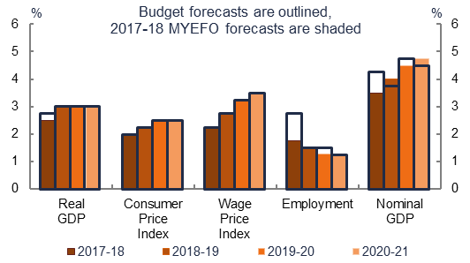
Figure 7: Policy decisions in the  2018–19 Budget—payments and receipts2, | Figure 8: Policy decisions in the 2018–19 Budget—  top five revenue measures, | Figure 9: Policy decisions in the 2018–19 Budget—  top five expense measures5^{,6}
Figure 10: Parameter and other variations in the  2018–19 Budget—payments and receipts2,, | Figure 11: Drivers of growth in revenue5, | Figure 12: Drivers of growth in expenses5,9
Figure 13: Payments to states in 2018–19, $127b | Figure 14: Revenue in 2018–19, $489b5 | Figure 15: Expenses in 2018–19, $486b5

Figures are prepared using data contained in the 2018–19 Budget Papers and 2017–18 Mid-year Economic and Fiscal Outlook (MYEFO). Any changes shown are since 2017–18 MYEFO.
Figures are based on payments and receipts which are on a cash basis.
Figure 6 presents selected economic parameters underpinning the 2018–19 Budget estimates.
An increase in receipts results in an improvement in the underlying cash balance. An increase in payments results in a deterioration in the underlying cash balance. A decrease in payments results in an improvement in the underlying cash balance. A decrease in receipts results in a deterioration in the underlying cash balance.
Figures are on an accrual (fiscal) basis.
This is the net fiscal impact of the measure. Where a measure effects both revenue and expenses it has been classified according to its principal impact (consistent with Budget Paper No. 2).
Parameter and other variations refer to changes in parameters and assumptions used to estimate payments/expenses and receipts/revenue.
This figure excludes the impact of parameter variations on the Goods and Services Tax (GST) payments and receipts.
This is the percentage point contribution to total annual rea growth from 2017–18 to 2021–22. Total growth is presented in the total bar in this figure.
Payments to states refer to the amount of funding provided to states and territories under the Federal Financial Relations framework. This includes the transfer of the GST collected by the Commonwealth to states and territories for use on general purposes.

