2018-19 Budget:
Medium-term
projections
Report No. 03/2018

© Commonwealth of Australia 2018
978-0-6482138-6-4 2018-19 Budget medium-term projections (PDF)
978-0-6482138-7-1 2018-19 Budget medium-term projections (DOC)
Copyright notice
This work is licensed under the Creative Commons Attribution-NonCommercial-NoDerivs
3.0 Australia License http://creativecommons.org/licenses/by-nc-nd/3.0/au/
Attribution
This publication should be attributed as follows: Parliamentary Budget Office, 2018-19 Budget medium-term projections.
Use of the Coat of Arms
The terms under which the Coat of Arms can be used are detailed on the following website: www.itsanhonour.gov.au/coat-arms

Contents
Foreword iv
Overview 1
1 Introduction 2
2 Projected underlying cash balance 3
3 Projected receipts 4
3.1 Total receipts 4
3.2 Personal income tax receipts 5
3.3 Company tax receipts 7
3.4 Superannuation fund tax receipts 9
3.5 Other receipts 9
3.6 Risks around projected receipts 10
4 Projected spending 12
4.1 Spending growth by program 15
4.2 Risks around projected spending 18
5 Projected net debt and net financial worth 19
5.1 Net debt 19
5.2 Net financial worth 20
Appendix A – Receipt projection methodology 21
Appendix B – Spending projection methodology 24
Appendix C – Influence of policy decisions on payments 29

Foreword
After the release of the Government’s budget, the PBO produces an annual report that provides detailed projections of receipts and payments over the next decade to highlight the factors that explain, and assess the sustainability of, the projected underlying cash balance and net debt position. We consider this an important contribution to increasing the understanding of the budget projections.
This report was authored by Tim Pyne, Paul Gardiner, Lok Potticary and Anupam Sharma. The projections were prepared by Aaryn Lally, Sam McInerney, Hanna Maslen, Cid Mateo, Vijay Murik, Sam Pelly, Lok Potticary, Anupam Sharma, Nutan Singh and Kate Wagner. The report was prepared for publication by Lauren Pratley.
Jenny Wilkinson
Parliamentary Budget Officer
6 September 2018

Overview
The underlying cash balance is projected by the Government to move from a deficit of 1.0 per cent of GDP in 2017-18 to a surplus of 0.8 per cent of GDP by 2021-22. Beyond the forward estimates, the PBO projects the surplus to reach 1.3 per cent of GDP by 2028-29. Our projection over the next decade is broadly consistent with the medium-term position presented in the 2018-19 Budget.
The main contribution to the projected improvement in the budget position comes from a rise in personal income tax receipts. With increasing wages, a larger proportion of income is taxed in higher income tax brackets resulting in a rise in the average tax rate. Personal income tax receipts are projected to increase by 1.3 per cent of GDP over the next decade, with the average tax rate projected to increase from 22.9 to 25.2 per cent. The projected increase in personal income tax receipts and the average tax rate occurs even with the cuts to personal income taxes resulting from the Government’s Personal Income Tax Plan. Our distributional analysis highlights that the largest increases in average tax rates occur in the low- to middle-income groups.
Further contributing to the improvement in the budget position is a projected fall in spending of
0.9 per cent of GDP over the next decade. While spending on the NDIS increases significantly over this period, it is more than offset by projected falls in spending as a share of GDP on a number of large payments including Family Tax Benefit, pharmaceutical benefits and the Disability Support Pension. The decline in spending on government administration over the forward estimates period, as forecast in the 2018-19 Budget, is also a significant source of restraint. These projected declines in spending reflect the ongoing impact of policy changes and spending restraint that has seen the growth in these payments slow dramatically over the past five years.
These projections reflect the fiscal position at the time of the 2018-19 Budget. The recent government decision not to proceeed with unlegislated reductions in company tax rates will improve the budget balance over the period 2018-19 to 2026-27 if not offset by other measures.
There are three key areas of risk in the medium-term projections.
Firstly, there are the risks that result from uncertainty in the underlying economic parameters. The projected surpluses over the medium term are predicated on above trend economic growth for much of the period and a return to close to trend wages growth by the end of the forward estimates period. The projections for the budget position have become more sensitive to these macroeconomic risks because of the effect of the Personal Income Tax Plan. Based on the 2018-19 Budget, we project tax receipts will not reach the Government’s tax-to-GDP cap of 23.9 per cent of GDP until 2027-28, although this may now be achieved earlier with the recent company tax decision. Any weakness in tax receipts before the tax cap is reached will flow through directly to the budget bottom line. In preceding medium-term projection reports, in contrast, tax receipts were projected to be well above the Government’s tax-to-GDP cap for most of the medium term. This meant that if weaker economic circumstances occurred, they could have weakened tax receipts without adversely affecting the budget balance.
Secondly, our recent analysis of the broad trends within the Commonwealth tax system highlighted specific downside risks to a number of consumption taxes. Ongoing weakness in the consumption tax base would lead receipts and the budget balance to be lower than our central projections.
Thirdly, the projections of spending assume no new spending initiatives beyond those contained in the budget estimates. The spending restraint seen over the past few years may be increasingly difficult to maintain with an improving budget outlook.

Introduction
The 2018-19 Budget papers include projections of the underlying cash balance, net debt and net financial worth to 2028-29 but do not include projections of receipts and spending beyond the forward estimates period which ends in 2021-22.
In this regular PBO report we analyse projections for receipts and spending at a detailed level over the period to 2028-29 to explain the main reasons for the projected return to surplus, fall in net debt, and increase in net financial worth over this period. This analysis takes the budget forward estimates as the starting point and projects receipts and spending for an additional seven years. As required by our legislation, our budget projections use the economic forecasts and other parameters that underpin the 2018-19 Budget.
The projections assume that the Government’s policy settings remain unchanged from those incorporated in the 2018-19 Budget. Where government policy has not been made explicit beyond the forward estimates period, our projections assume the continuation of current policy settings.
The detailed projections contained in this report increase transparency and highlight the policy trade-offs that are being made. They illustrate the impact on the budget of significant programs that mature beyond the forward estimates period and identify potential areas of the budget that present challenges and risks for ongoing fiscal sustainability. While projections are subject to uncertainty, this information is an important contribution to improving the understanding of fiscal policy settings.

Projected underlying cash balance
The underlying cash balance (UCB) is projected by the Government to move from a deficit of 1.0 per cent of GDP ($18.2 billion) to a surplus of 0.8 per cent of GDP ($16.6 billion) by 2021-22. Beyond the forward estimates, the PBO projects the surplus to reach 1.3 per cent of GDP
($42.3 billion) by 2028-29 (Figure 2–1). Our projection over the next decade is broadly consistent with the medium-term budget position presented in the 2018-19 Budget.

Figure 2–1: Underlying cash balance
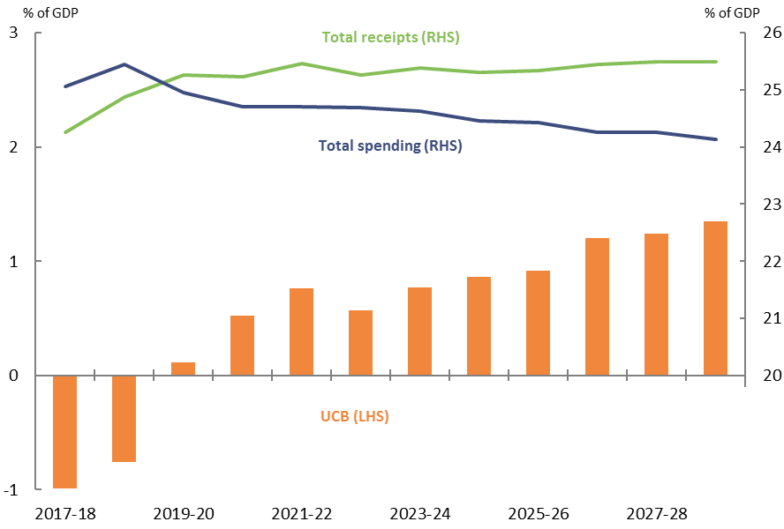
Note: Net Future Fund earnings are included in the underlying cash balance from 2020-21 consistent with the 2018-19 Budget treatment.
Source: 2018-19 Budget and PBO analysis.
The return to surplus in 2019-20 primarily reflects an increase in total receipts of 1.0 per cent of GDP between 2017-18 and 2019-20. Beyond the forward estimates, the PBO projects total receipts to remain broadly flat, with the Government’s cap on the tax-to-GDP ratio of 23.9 per cent of GDP being reached in 2027-28. The continuing improvement in the UCB over the latter part of the decade reflects declining spending as a share of GDP, which we project to fall from 24.7 per cent of GDP in 2021-22 to 24.1 per cent of GDP by 2028-29. Net Future Fund earnings contribute to the UCB from 2020-21 onwards, adding 0.2 per cent of GDP to the surplus from 2020-21.
These projections reflect the policy settings and the economic parameters at the time of the 2018-19 Budget. The projected UCB surplus would be further improved from 2019-20 by the recent government decision not to proceed with reductions in the company tax rate for larger companies if not offset by other measures. This decision will increase receipts, and consequently the UCB, until tax receipts reach the Government’s tax-to-GDP cap of 23.9 per cent of GDP (see Box 2).
The underlying trends in the components of receipts and spending are explored in more detail in the following sections.

Projected receipts

Total receipts
Total receipts are projected by the Government to increase from 24.3 per cent of GDP in 2017-18 to 25.5 per cent of GDP in 2021-22. The PBO projects receipts to remain around this level over the next decade (Figure 3–1).

Figure 3–1: Total receipts
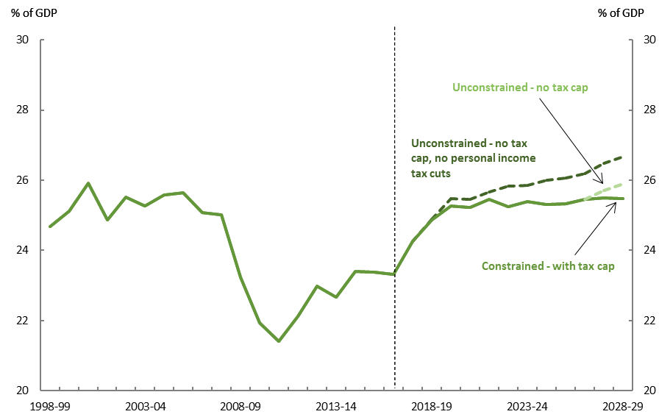
Source: 2018-19 Budget and PBO analysis.
Prior to the announcement of the Government’s Personal Income Tax Plan, receipts were projected to grow strongly reaching 26.7 per cent of GDP in 2028-29, and taxation receipts would have exceeded the Government’s tax-to-GDP cap of 23.9 per cent of GDP from 2021-22. With the personal income tax cuts, tax receipts will not reach the Government’s tax-to-GDP cap of
23.9 per cent of GDP until 2027-28.
In the absence of the tax cap, total receipts are projected to be 25.9 per cent of GDP in 2028-29.
The main driver of the increase in total receipts as a per cent of GDP is the projected rise in personal income tax (reported in the Budget as ‘Individuals and Other Withholding Tax’ receipts) over the next decade. This increase occurs even when factoring in the Personal Income Tax Plan that was announced in the 2018-19 Budget (Figure 3–2).
Figure 3–2: Breakdown of receipts
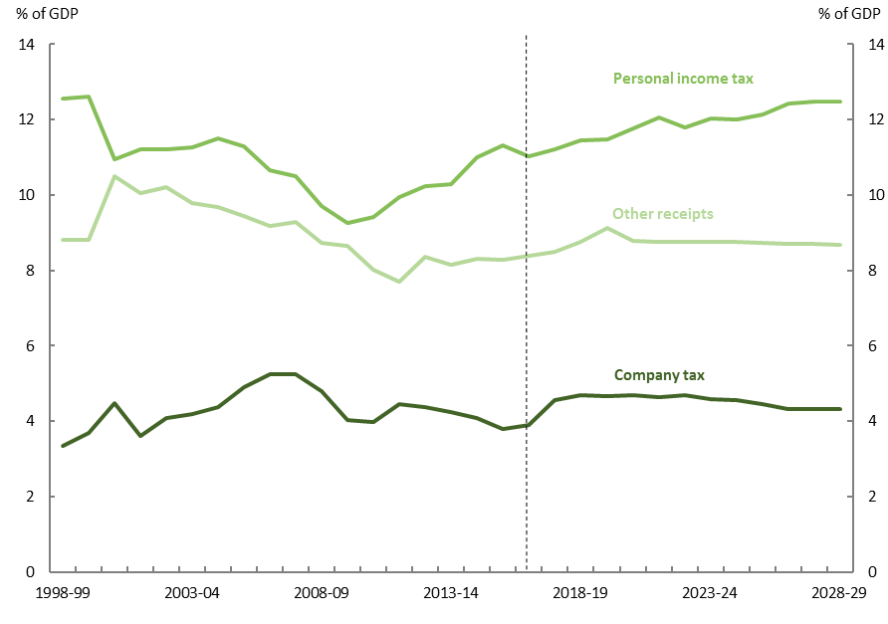
Note: The breakdown of receipts presented here differs from the breakdown shown in the previous PBO report Trends affecting the sustainability of Commonwealth taxes. The breakdown for the current report shows the two largest heads of revenue as identified in the 2018-19 Budget, with all other receipts grouped together. The previous report instead used the conceptual categories of labour, capital, and consumption tax receipts. While tax on labour mainly comprises personal income tax and tax on capital mainly comprises company tax, the categories differ in the treatment of several taxes, most notably taxes on superannuation and capital gains tax for individuals, as well as the treatment of franking credits.
Source: 2018-19 Budget and PBO analysis.

Personal income tax receipts
Personal income tax receipts are projected to increase by 1.3 per cent of GDP over the next decade, from 11.2 per cent of GDP in 2017-18 to 12.5 per cent of GDP in 2028-29. The projected rate of growth in personal income tax receipts slows once the Government’s commitment of a tax-to-GDP cap of 23.9 per cent of GDP is reached in 2027-28. The growth in personal income tax receipts is largely the result of the assumed trajectory for wage growth over the next decade leading to higher average tax rates as a result of bracket creep.
The profile for projected personal income tax receipts largely reflects the staged implementation of the Government’s Personal Income Tax Plan. The fall in personal income tax receipts as a share of GDP in 2022-23 occurs because the top threshold for the 32.5 per cent bracket increases from $90,000 to $120,000 on 1 July 2022. On 1 July 2024, the top threshold of the 32.5 per cent bracket will increase to $200,000, thereby removing the current 37 per cent bracket and reducing the number of tax brackets from five to four. These changes to the personal income tax system reduce the impact of bracket creep, but bracket creep will continue to occur as average tax rates increase with growth in incomes (see Box 1).
Box 1: Changes in average personal income tax rates
The Government’s Personal Income Tax Plan changed a number of marginal tax rates and thresholds in the personal income tax system (see Figure 3-3). Once fully implemented on
1 July 2024, the Personal Income Tax Plan will extend the 32.5 per cent bracket to individuals on income up to $200,000 and eliminate the 37 per cent bracket. These changes will result in changes to the average tax rates applying to taxable income across the income distribution. Across all income levels above $37,000, average tax rates will be lower in 2024-25 than they are in 2017-18.
Figure 3–3: Average and marginal tax rates in 2017-18 and from 2024-25
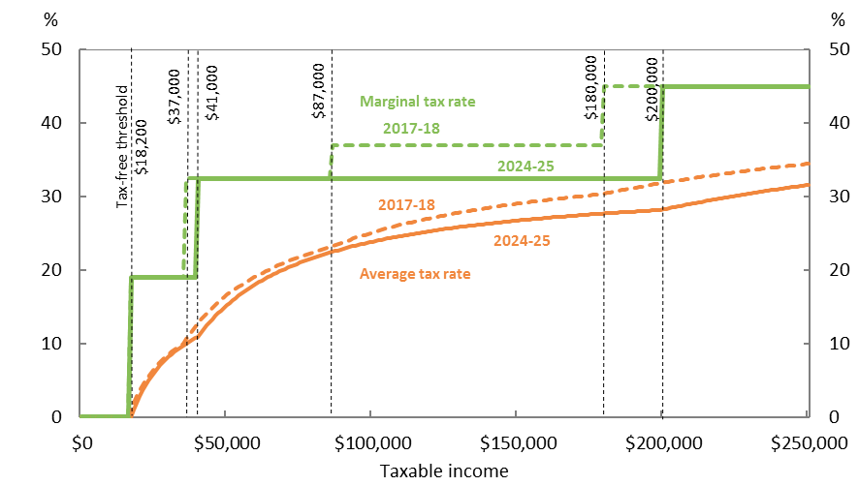
Note: This chart does not include the Medicare Levy and surcharge or tax offsets, which can vary depending on the characteristics of the taxpayer.
Source: PBO analysis.
Figure 3–3 shows that both with and without the Personal Income Tax Plan, average tax rates increase as taxable incomes increase, even in circumstances where income earners do not cross a marginal tax rate threshold. This means that although the impact of bracket creep will be reduced as a result of the Personal Income Tax Plan, taxpayers will continue to experience higher average tax rates as their incomes grow over time. Overall, taking into account both the Personal Income Tax Plan and bracket creep, personal income tax receipts are projected to increase by 1.3 per cent of GDP over the next decade, with the average tax rate across all taxpayers projected to increase from 22.9 to 25.2 per cent.
Figure 3–4 shows the projected change in average tax rates by income quintile between
2017-18 and 2026-27. The change has been decomposed into two effects: the effect of nominal income growth and that of policy change. The nominal income growth component shows that bracket creep (in the absence of policy change) increases the average tax rate paid at all income quintiles. This increase is partly offset by the effect of the income tax cuts legislated in the Personal Income Tax Plan. The net result of these two effects is shown by the dots in Figure 3–4.
Average tax rates are projected to increase for all income quintiles over the period to 2026-27, though at a slower rate than would have occurred without the legislated income tax cuts. The second and third quintiles are projected to experience the largest increases in average tax rates over this period.
Figure 3–4: Change in average tax rates from 2017-18 to 2026-27 by income quintile
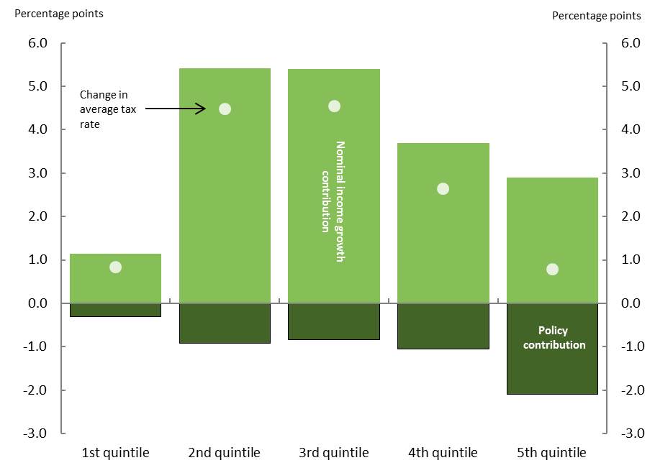
Source: PBO analysis, ATO data and parameters underlying the 2018-19 Budget.

Company tax receipts
Company tax receipts are projected to increase from 4.6 per cent of GDP in 2017-18 to 4.7 per cent of GDP in 2022-23, largely driven by forecast growth in corporate profitability as depreciation and losses carried forward from resources investment decline over time. Company tax receipts are then projected to decline as a share of GDP from 2023-24 onwards to 4.3 per cent of GDP in 2028-29, due to the policy of further reductions in the company tax rate that applied at the 2018-19 Budget. The decision to not proceed with further reductions will see company tax as a share of GDP rise slightly over the medium term (see Box 2).
Box 2: Impact of not proceeding with unlegislated company tax cuts
The recent decision not to proceed with the unlegislated company tax cuts, in the absence of any other changes in tax policy, will increase total receipts and the UCB over the period 2018-19 to 2026-27.
With this decision, tax receipts are projected to reach the Government’s tax-to-GDP cap of 23.9 per cent of GDP in 2023-24 and to be well above levels implied by the tax cap towards the end of the decade (Figure 3–5). These stronger projections could provide a more significant buffer against weaker economic circumstances, were they to eventuate, unless alternative measures are announced.
Figure 3–5: Total receipts
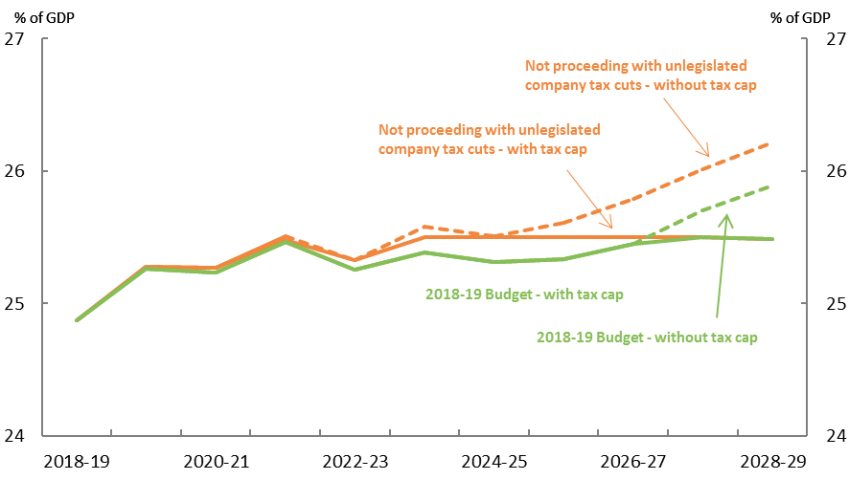
Source: 2018-19 Budget and PBO analysis
The company tax rate reductions under the Enterprise Tax Plan, if fully implemented, had been projected to result in company tax receipts as a share of GDP falling over the medium term. With the unlegislated company tax cuts no longer proceeding, company tax receipts are projected to rise over the medium term with increased corporate profitability (Figure 3–6).
Figure 3–6: Company tax receipts
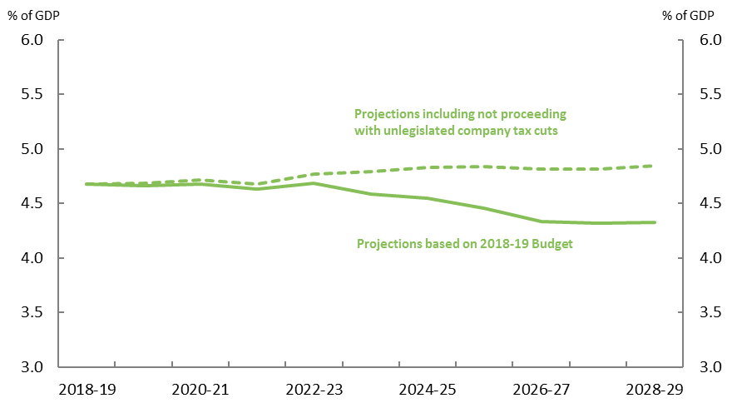
Source: 2018-19 Budget and PBO analysis

Superannuation fund tax receipts
Superannuation fund tax receipts are projected to increase by 0.1 per cent of GDP over the period from 2017-18 to 2028-29. Growth in superannuation fund tax receipts in 2017-18 was very strong, partly reflecting one-off increases due to strong net foreign exchange gains for superannuation funds in 2016-17. The growth in superannuation fund tax receipts over the remainder of the next decade is the result of the projected increase in taxes on realised capital gains and the increase in superannuation contributions resulting from the rise in the compulsory superannuation guarantee from 1 July 2021.

Other receipts
Table 3–1 shows our projections of the change in receipts by each major category over the period 2017-18 to 2028-29 and their projected contribution to growth in total receipts. It shows that, based on the Government’s economic parameters, there is expected to be a small increase in the Goods and Services Tax (GST) as a percentage of GDP, but little change in other receipts, other than those already discussed above.

Table 3–1: Receipts, tax cap applied from 2027-28
Receipts | Nominal receipts |  | Per cent of GDP |  | Change in per cent of GDP | Annual real growth | Share of total receipts
 | 2017-18 | 2028-29 | 2017-18 | 2028-29 | 2017-18 to 2028-29 |  | 2028-29
 | $b |  | % |  | % | % | %
Individuals and other withholding taxes | 206 | 391 | 11.2 | 12.5 | 1.3 | 3.5 | 49.0
Company tax | 84 | 136 | 4.6 | 4.3 | -0.2 | 2.0 | 17.0
Superannuation fund taxes | 11 | 22 | 0.6 | 0.7 | 0.1 | 3.8 | 2.7
Goods and services tax | 64 | 111 | 3.5 | 3.6 | 0.1 | 2.7 | 14.0
Fringe benefits tax | 4 | 7 | 0.2 | 0.2 | 0.0 | 2.6 | 0.9
Resource rent taxes | 1 | 2 | 0.1 | 0.1 | 0.0 | 1.5 | 0.2
Wine equalisation tax | 1 | 1 | 0.0 | 0.0 | 0.0 | 2.0 | 0.2
Luxury car tax | 1 | 1 | 0.0 | 0.0 | 0.0 | 2.3 | 0.1
Excise and customs duty | 38 | 64 | 2.1 | 2.0 | 0.0 | 2.4 | 8.0
Other taxes and charges | 8 | 14 | 0.4 | 0.4 | 0.0 | 2.7 | 1.8
Total tax receipts | 416 | 749 | 22.7 | 23.9 | 1.2 | 3.0 | 93.8
Non-tax receipts | 29 | 50 | 1.6 | 1.6 | 0.0 | 2.6 | 6.2
Total receipts | 445 | 799 | 24.3 | 25.5 | 1.2 | 3.0 | 100
Memorandum item:
Capital gains tax | 16 | 32 | 0.9 | 1.0 | 0.1 | 4.0 | 4.0
Source: 2018-19 Budget and PBO analysis.

Risks around projected receipts
The PBO projections for receipts use the economic parameters that underpin the 2018-19 Budget, which are prepared by the Treasury according to their medium-term economic projection methodology. As with any medium-term projections, there is uncertainty around the assumptions underpinning the parameter projections.
PBO Report no. 05/2017 2017-18 Budget medium-term projections: economic scenario analysis, showed that Government revenue is particularly sensitive to variations in the growth rate of the nominal economy. Changes to the economic projections directly translate into revenue projections. This report showed that a structural change in the economy, such as an enduring change in the rate of productivity growth, would have a significant and compounding effect on tax receipts over time. A temporary deviation from the projected economic parameters, such as a slower return to trend wages growth than is currently projected, would weaken tax receipts for a period.
The projections for receipts over the medium term are dependent on above-trend economic growth for much of the period and a return to trend wages growth. Based on the 2018-19 Budget, tax receipts will not reach the Government’s tax-to-GDP cap of 23.9 per cent of GDP until 2027-28, although this may now be achieved earlier with the recent company tax decision. Any weakness in receipts before the tax cap is reached will flow through directly to the budget bottom line.
Our projections are also subject to risk from trends in the tax system that could lead to revenue being weaker than projected. PBO Report no. 02/2018 Trends affecting the sustainability of Commonwealth taxes outlined that there are significant downside risks to a number of Commonwealth taxes, most notably taxes on consumption, including the GST and excises on fuel, alcohol and tobacco (see Box 3).
Weaknesses in the consumption tax base would likely mean one of three things: either receipts would be lower and therefore the UCB surplus would be smaller than our central projections; other taxes will need to increase in order to achieve our central tax projections; or, if the weakness is in the GST base, the states and territories would be worse off.
In the absence of policy change, weaker economic projections or lower consumption taxes (other than the GST) would result in a weaker underlying cash balance in the period up to 2027-28, given that, over this period, the tax-to-GDP cap is not projected to bind.

Box 3: Risks to revenue from consumption tax trends
Trends in tax receipts can shift over time as a result of changes in policy and the economic environment, as well as changes in the behaviour of individuals, companies, and other entities. These changes were discussed in the PBO report Trends affecting the sustainability of Commonwealth taxes.
There are four consumption tax trends that pose a particular risk to tax receipts.
- The proportion of household spending on goods and services that are subject to the GST has fallen steadily since the introduction of the GST in 2000-01. This is largely due to households allocating a larger share of their spending towards goods and services that are GST exempt, including housing, health, and education.
- The average fuel consumption for passenger vehicles has fallen since the mid-2000s meaning that households are consuming less fuel per kilometre driven.
- Alcohol consumption per capita has fallen, and at the same time, consumption patterns have moved away from higher taxed products (beer) towards lower taxed products (wine).
- Increases in the cost of tobacco products from excise rate increases and the lower take up of smoking by younger people have resulted in the proportion of adults who are daily smokers falling from 22.4 per cent in 2001 to 14.5 per cent in 2014-15.
A continuation of these observed trends over the next decade, which are not currently factored into the economic parameters, is projected to result in lower taxation receipts from consumption taxes compared to our central projections. The magnitude of this impact could be between ¼ and ½ per cent of GDP.

Projected spending
Spending is projected by the Government to decline from 25.1 per cent of GDP in 2017-18 to
24.7 per cent of GDP by 2021-22. Beyond the forward estimates, and given current policy settings, the PBO projects spending to decline further, reaching 24.1 per cent of GDP by 2028-29 (Figure 4–1).

Figure 4–1: Total spending
Per cent of GDP
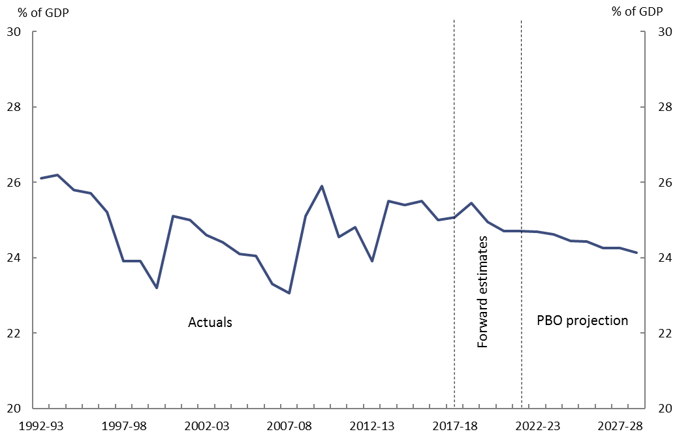
Source: 2018-19 Budget and PBO analysis.
The decline in spending as a per cent of GDP over the next decade reflects the ongoing impact of policy changes and spending restraint that have seen the growth across a number of key payments slow significantly over the past five years (see Box 4). The decline occurs notwithstanding the increase in spending on the National Disability Insurance Scheme (NDIS), which contributes to the uptick in spending in 2018-19 as the NDIS approaches maturity.
While receipts are more closely linked to economic growth, changes in nominal GDP will, amongst other things, affect spending when expressed as a proportion of GDP. To the extent that nominal GDP over the next decade is higher (lower) than that underlying our projections, then spending as a proportion of GDP will be lower (higher).
As an alternative, it is instructive to examine spending adjusted for inflation and population growth. Figure 4–2 illustrates that while government spending is projected to decline as a proportion of GDP, government spending per person is still projected to grow over the next decade in real terms. Over the forward estimates period the Government projects that real per capita spending will increase by 0.2 per cent per year. Beyond the forward estimates the PBO projects that it will increase by 1.0 per cent per year.

Figure 4–2: Total spending
Real per capita, 2017-18 dollars

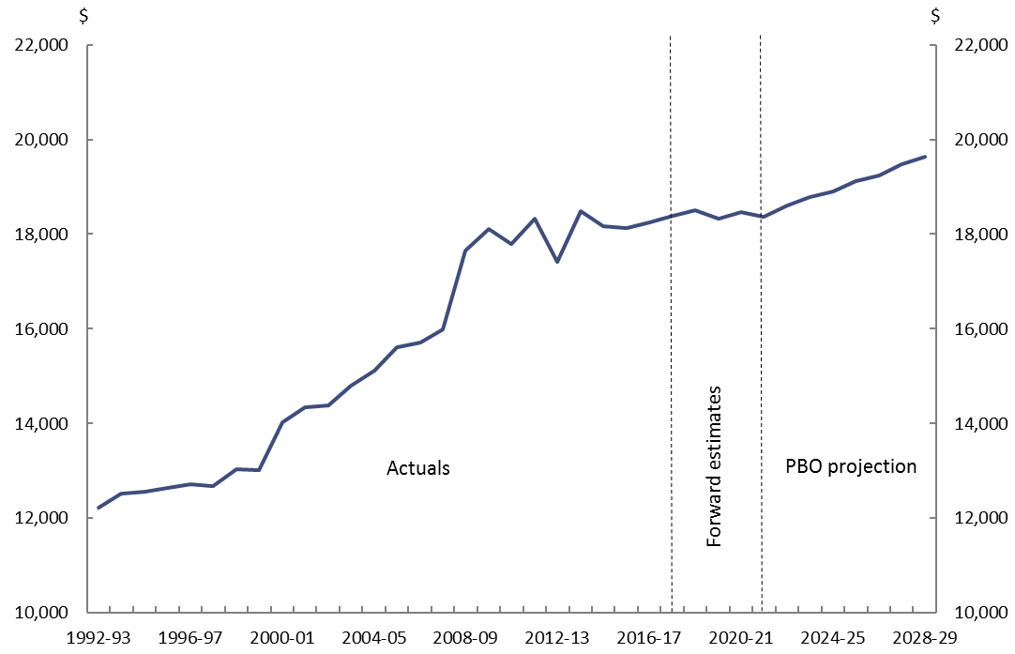
Source: 2018-19 Budget and PBO analysis.
As already discussed, the PBO’s projections are based on the policy settings underlying the 2018-19 Budget assuming no change to these settings over the medium term. That is, the PBO does not make an explicit allowance against particular programs for new policy decisions other than in two areas – infrastructure and pharmaceutical benefits (see Appendix B for further detail). Ongoing spending restraint is therefore embodied in these projections.
Projections for spending at a program level are explored in more detail below.

Box 4: Historical and projected spending growth
The analysis in this Box provides some historical context for the projected growth in spending. It examines real growth in spending in five distinct periods, to abstract from some of the artificial ‘lumpiness’ in government spending from one year to the next.
As illustrated in Figure 4–3, from 1992-93 through to 2006-07, the period between economic downturns in Australia, real annual growth in spending averaged 3.2 per cent. From 2007-08 to 2011-12, spending growth spiked with the onset of the global financial crisis (GFC) and associated stimulus (averaging 4.9 per cent annually). Spending growth has fallen sharply in the aftermath of the GFC, averaging 1.5 per cent annually.
The Government’s forward estimates and our projections imply that growth will rebound somewhat (to 1.8 and 2.4 per cent respectively), but not return to the rates experienced prior to the GFC.

Figure 4–3: Historical and projected real payments growth
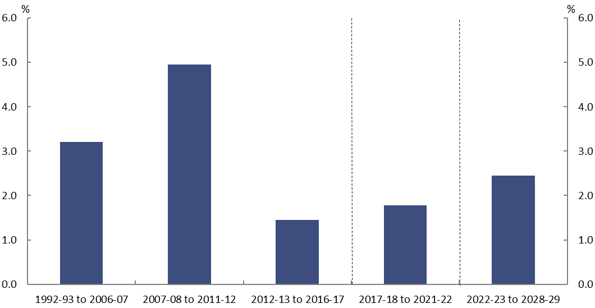
Source: 2018-19 Budget and PBO analysis.
One of the most striking features of Figure 4–3 is the decline in spending growth over the past five years. A key factor behind this has been policy restraint – a stemming in the flow of new spending decisions and a tightening of eligibility for payments.
This has occurred across a range of major payment programs including the Age Pension, Medicare, Family Tax Benefit, Disability Support Pension, pharmaceutical benefits and carer income support. These payments experienced strong growth prior to (and during) the GFC, but recent growth has been more subdued. Policy decisions have played a key role in this restraint (see Appendix C for more detail).
The above analysis also highlights that anchoring expectations of future growth in spending to longer term historical trends may no longer be appropriate. For many programs, the rules around eligibility, the regime for assessing compliance, or the benefit paid by government are fundamentally different from those applying a decade ago.

Spending growth by program
The largest contributor to the growth in spending over the next decade is spending on the NDIS (Figure 4–4), which is projected to increase by 0.6 per cent of GDP. Growth in NDIS spending is expected to increase significantly up to 2019-20 at which point the scheme achieves national coverage. Beyond 2019-20 spending growth is expected to stabilise as the NDIS matures.
Aged care spending is projected by the PBO to increase by 0.3 per cent of GDP over the next decade. We project spending on aged care will continue to rise beyond the forward estimates reflecting the impact of the ageing population on the demand for aged care services.
The PBO projects defence spending to increase by 0.2 per cent of GDP over the next decade reflecting the Government’s funding commitments in the 2016 Defence White Paper. There is uncertainty around the projections in individual years, given that the acquisition of military equipment is inherently ‘lumpy’ in nature and can be subject to changes in the timing of delivery.

Figure 4–4: Projected spending over the next decade
Change from 2017-18 to 2028-29
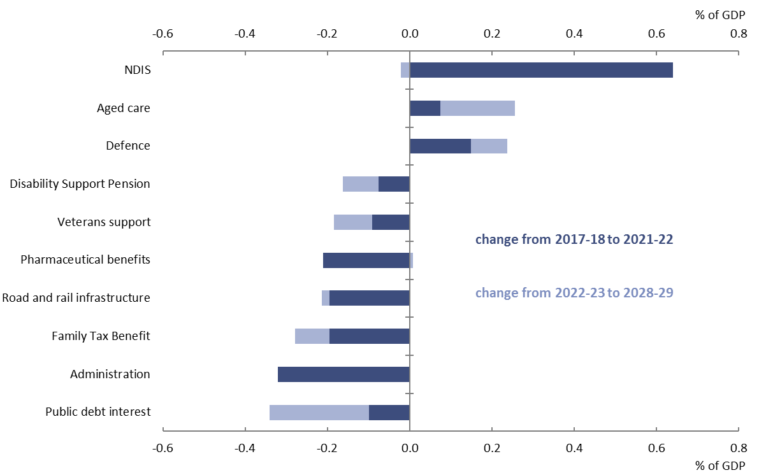
Source: 2018-19 Budget and PBO analysis.

More than offsetting the above increases is a decline in spending as a proportion of GDP across a range of payment programs, a significant proportion of which are expected to occur over the forward estimates.
Spending on government administration is projected to decline by 0.3 per cent of GDP over the next decade. All of this fall takes place in the forward estimates period, with the 2018-19 Budget projecting government administration to fall in nominal terms from 2017-18 to 2021-22. This reflects measures across successive governments to restrain the size of the public sector, including efficiency dividends and restrictions on public service employee wage growth. Beyond 2021-22, for projection purposes, spending on government administration is assumed by the PBO to grow in line with nominal GDP. This implies that the size of government administration, as a share of the overall economy, will stay broadly constant from 2021-22 onwards.
Spending on the Family Tax Benefit (FTB) payment is also projected to fall by 0.3 per cent of GDP over the projection period. Most of the projected decline occurs in the period 2017-18 to 2020-21 partially due to the impact of policy decisions to freeze FTB higher income free thresholds until
2020-21, and pause indexation of FTB payment rates for two years from 2017-18.
Spending on road and rail infrastructure is also projected to fall by 0.2 per cent of GDP over the next decade. Spending declines over the forward estimates period (by 0.2 per cent of GDP) before picking up in 2022-23. This reflects the PBO’s projected profile of spending on announced road and rail infrastructure projects included in the 2018-19 Budget. After 2024-25, the PBO assumes infrastructure spending grows in line with projected nominal GDP growth, recognising that projects yet to be agreed will come on line over the latter half of the next decade. Note that these figures understate the Government’s investment in infrastructure as they only include the spending relating to road and rail infrastructure, including grants to state and territory governments. They do not capture infrastructure investment funded through equity injections into Australian government public non-financial corporations such as the Australian Rail Track Corporation, or concessional loans such as the loan to the New South Wales Government for the WestConnex project.
Spending on pharmaceutical benefits is projected to decline by 0.2 per cent of GDP, with all of this fall occurring over the forward estimates. Much of the decline is due to the revised administrative arrangements for pharmaceutical benefits and the ongoing impact of pricing reforms. Beyond the forward estimates we have projected spending as a proportion of GDP to stabilise, which largely reflects the expected ongoing listing of new drugs and a more moderate ongoing impact from pricing reforms.

Table 4–1: Spending by key program area
Payments | Nominal payments |  | Per cent of GDP |  | Change in per cent of GDP | Annual real growth | Share of total payments
 | 2017-18 | 2028-29 | 2017-18 | 2028-29 | 2017-18 to 2028-29 |  | 2028-29
 | $b |  | % |  | % | % | %
National Disability Insurance Scheme | 7 | 31 | 0.4 | 1.0 | 0.6 | 12.3 | 4.1
Aged care | 18 | 40 | 1.0 | 1.3 | 0.3 | 4.6 | 5.2
Defence spending | 35 | 68 | 1.9 | 2.2 | 0.2 | 3.6 | 8.9
Child care | 7 | 15 | 0.4 | 0.5 | 0.1 | 4.5 | 2.0
GST transfers to states | 64 | 111 | 3.5 | 3.5 | 0.1 | 2.6 | 14.7
Medicare Benefits Schedule | 23 | 41 | 1.3 | 1.3 | 0.1 | 2.9 | 5.5
Carer income support | 8 | 15 | 0.5 | 0.5 | 0.0 | 3.0 | 2.0
Fuel Tax Credit Scheme | 7 | 12 | 0.4 | 0.4 | 0.0 | 3.1 | 1.6
Schools | 18 | 31 | 1.0 | 1.0 | 0.0 | 2.5 | 4.2
Government superannuation | 7 | 12 | 0.4 | 0.4 | 0.0 | 2.5 | 1.5
Public hospitals | 21 | 35 | 1.1 | 1.1 | 0.0 | 2.4 | 4.6
Parenting payments | 5 | 8 | 0.3 | 0.3 | 0.0 | 1.3 | 1.1
Private Health Insurance Rebate | 6 | 9 | 0.3 | 0.3 | -0.1 | 0.9 | 1.1
Official Development Assistance | 4 | 5 | 0.2 | 0.2 | -0.1 | -0.6 | 0.6
Age Pension | 45 | 74 | 2.4 | 2.4 | -0.1 | 2.2 | 9.8
Job Seeker Income Support | 11 | 16 | 0.6 | 0.5 | -0.1 | 0.7 | 2.1
Commonwealth Grants Scheme | 7 | 8 | 0.4 | 0.3 | -0.1 | -0.9 | 1.1
Disability Support Pension | 16 | 23 | 0.9 | 0.7 | -0.2 | 0.6 | 3.0
Veterans support | 6 | 5 | 0.3 | 0.2 | -0.2 | -4.4 | 0.7
Pharmaceutical benefits | 12 | 13 | 0.6 | 0.4 | -0.2 | -1.1 | 1.8
Road and rail infrastructure | 7 | 6 | 0.4 | 0.2 | -0.2 | -4.2 | 0.8
Family Tax Benefit | 19 | 24 | 1.0 | 0.8 | -0.3 | -0.4 | 3.1
Public debt interest | 16 | 17 | 0.9 | 0.5 | -0.3 | -1.9 | 2.3
Total modelled spending | 371 | 620 | 20.2 | 19.8 | -0.5 | 2.3 | 82.0
Other spending | 89 | 137 | 4.8 | 4.4 | -0.5 | 1.5 | 18.0
Government administration | 34 | 48 | 1.8 | 1.5 | -0.3 | 0.7 | 6.3
Remaining spending | 55 | 89 | 3.0 | 2.8 | -0.2 | 2.0 | 11.7
Total spending | 460 | 757 | 25.1 | 24.1 | -0.9 | 2.1 | 100.0
Source: 2018-19 Budget and PBO analysis.

Spending on the Disability Support Pension (DSP) is projected to fall by 0.2 per cent of GDP over the next decade. The main driver of this is past policies which have focussed on stemming the flow of people onto the payment. In particular, compliance and assessment measures which applied from
1 January 2012, have had an impact in reducing the growth in the number of people being assessed as eligible for the payment. We project that these measures will have an ongoing effect, such that the impact on spending over the next decade is shared equally between the forward estimates and the period beyond.
The DSP interacts with other income support payments, including Newstart (which makes up the bulk of Job Seeker Income Support). Tightening the eligibility criteria around the DSP may reduce direct expenditure on the DSP, but from a whole-of-government expenditure perspective this may be partly offset by expenditure increases on other payments such as Newstart which is paid at a lower rate.
The decline in veterans support (0.2 per cent of GDP) reflects a continual decrease in the eligible population over the next decade.
Public debt interest falls by 0.3 per cent of GDP over the next decade in line with the projected improvement in the budget balance.

Risks around projected spending
As with receipts, the payment projections are subject to uncertainty. In general, the projections of spending assume no new spending initiatives beyond those contained in the budget estimates. The spending restraint seen over the past few years, as illustrated in Box 4, may be increasingly difficult to maintain with an improving budget outlook. In recent months, in particular, we note the public discussion that suggests spending pressures may arise in relation to expenditures on programs such as the Newstart allowance and on education.
The NDIS is in the early stages of implementation and as with any program which is yet to mature there are risks that the longer-term costs associated with the NDIS may increase. While the Productivity Commission noted that preliminary data indicated that the costs of the NDIS were broadly in line with National Disability Insurance Agency long-term estimates, it is likely that spending pressures will emerge as the NDIS is fully rolled out.
There is a large degree of uncertainty regarding our projections for spending on pharmaceutical benefits. Future drug listings would increase the quantity of drugs available and hence the costs associated with the program, as evidenced by the recent listing of drugs to treat Hepatitis C. Working in the other direction, the price falls of listed drugs coming off patent has been significant in recent years but future trends are challenging to predict.

Projected net debt and net financial worth

Net debt
The Government projects that net debt will fall from 18.6 per cent of GDP ($341.0 billion) in
2017-18 to 14.7 per cent of GDP ($319.3 billion) in 2021-22. Beyond the forward estimates, the PBO projects that net debt will fall to 2.8 per cent of GDP ($88.0 billion) by 2028-29 (Figure 5–1).

Figure 5–1: Net debt
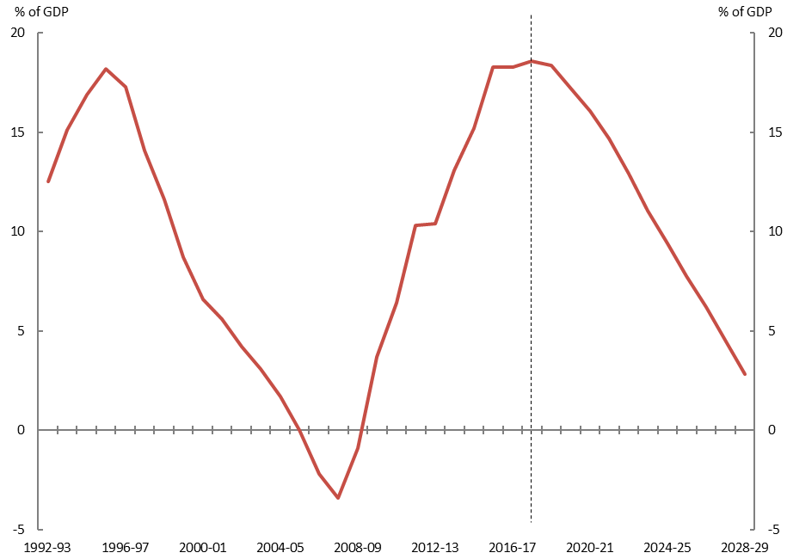
Source: 2018-19 Budget and PBO analysis.
Net debt is projected to have peaked in 2017-18 and then decline over the next decade reflecting the reduced financing task from the projected move to budget surpluses. Falls in the market value of government debt also contribute to this decline as the yield on long-term securities is assumed to increase over the projection period, consistent with the 2018-19 Budget.
As Figure 5–1 illustrates, the projected improvement in the net debt position over the next decade is not without precedent. Following expansionary fiscal policy in the wake of the early 1990s recession, net debt increased to 18.2 per cent of GDP in 1995-96. Net debt fell continuously over the next decade to reach -3.4 per cent of GDP in 2007-08. However, there were unique factors behind the improvement in the budget balance and consequently net debt over this period.
In particular, the Government undertook a program of selling government-owned businesses
(public non-financial corporations), using the proceeds to pay off Government debt. The sales were large and staggered over the period and included the sale of the Commonwealth Bank, airports and, most significantly, Telstra. Further aiding the speed of fiscal consolidation was the largest sustained boost to the terms of trade in Australia’s history, which translated through to a considerable boost to national income and taxation revenue. These factors are unlikely to be repeated over the next decade.
The net debt position is a consequence of the accumulated receipt and spending flows discussed in previous chapters. To the extent that the downside risks to the budget balance identified in this report do eventuate, then this will result in higher levels of net debt over the next decade.

Net financial worth
An alternative measure of the strength of the government’s balance sheet is net financial worth. Net financial worth is a broader measure than net debt as it includes all of the Commonwealth’s financial assets and liabilities, including the unfunded superannuation liability and equity investments.
Net financial worth shows a broadly similar improvement to that projected for net debt, improving from -25.4 per cent of GDP (-$466.3 billion) in 2017-18 to -6.4 per cent of GDP (-$199.1 billion) in 2028-29 (Figure 5–2). The improvement in net financial worth is driven by the same factors driving the reduction in net debt, along with a projected increase in the value of the Future Fund.

Figure 5–2: Net financial worth
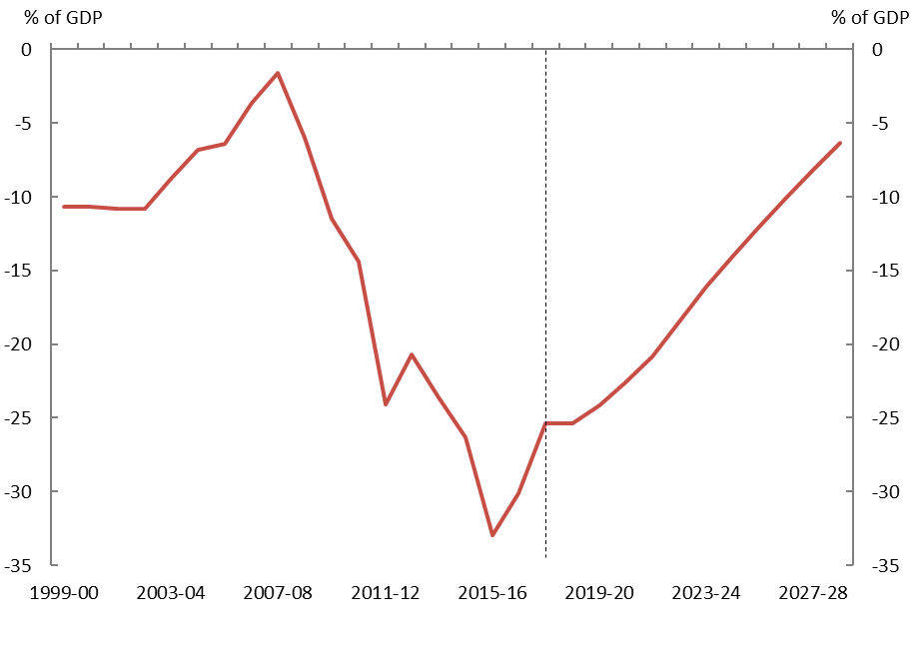
Note: Consistent data for net financial worth is only available from 1999-00.
Source: 2018-19 Budget and PBO analysis.

Appendix A – Receipt projection methodology
The PBO’s projections comprise individual receipt projections of all of the Commonwealth Government’s major heads of revenue.
The PBO’s projections of receipts are generally prepared using a base plus growth methodology. Economic parameters are used to estimate growth rates which are then applied to the relevant base. The economic parameters used to estimate growth rates in this report are the same as those underpinning the 2018-19 Budget, as required by the PBO’s legislation.
For policy decisions where the impact is not already factored into the base year data or the economic parameters, the projected impact of these measures are added to the base projections.
In order to incorporate the impact of recent trends in tax collection, the PBO uses the
2018-19 Budget receipt forecasts for 2018-19, 2019-20, 2020-21 and 2021-22 as the base years for the PBO’s projections.
Details of the methodology used to arrive at projections for individual revenue heads are outlined in the table below.

Model | Description | Methodology
Gross income tax withholding and gross other individuals and refunds | These revenue heads broadly cover all personal income tax, including revenue from salary and wages, the Medicare Levy and Medicare Levy Surcharge, personal income tax offsets, income from profits from unincorporated businesses, primary production and investment activities, as well as capital gains. | The aggregate taxable income for individuals over the medium term is calculated by growing individual income items from the ATO’s Taxation Statistics data by the relevant economic parameters, most notably compensation of employees.  For each year, an average gross tax rate is applied reflecting the policy settings and the economic parameters at the time of the 2018-19 Budget.  Projected tax offsets are applied and the timing of tax collections is taken into account to arrive at the receipts projections.  From 2027-28, the PBO adjusts the individual and other withholding tax receipt projections such that total tax receipts remain at 23.9 per cent of GDP, consistent with the Government’s commitment of a tax-to-GDP cap.
Company tax | Tax on profits, including capital gains, of incorporated businesses. | The projections are based on an approach whereby company tax revenue is recognised at the point that a company tax payable liability arises for a company from its underlying economic activity. Three industry groupings, Mining, Finance and all Other companies are utilised in the projection modelling, to reflect structural differences in companies from different industries.  The tax base across the three sector groupings (itself derived from the 2014-15 company tax return unit record data), is grown with the Gross Operating Surplus economic parameter corresponding to the relevant industry grouping. Adjustments are made to capture depreciation and net capital gains.  The timing of tax collections is taken into account to arrive at the receipts projections.  Adjustments are made to account for other elements (principally the R&D tax offset) that are reported against company tax receipts.
Superannuation  fund taxes | Tax on super fund contributions and investment earnings, including capital gains, of Australian Prudential Regulation Authority funds and  self-managed super funds. | Projections for the taxable income of  APRA-regulated superannuation funds and  self-managed superannuation funds are based on the structure of a superannuation fund’s tax return.  Historical data from APRA’s Annual Superannuation Bulletin and the ATO’s Taxation Statistics data are grown by relevant economic parameters for projections of taxable income. Statutory tax rates are then applied to the projections of taxable income.  Projected tax offsets are applied and the timing of tax collections is taken into account to arrive at the receipts projections.
Customs and excise | Includes customs duties on textiles, clothing and footwear, passenger motor vehicles and other imports, excise on fuel and excise and customs duties on tobacco and alcohol (except wine, for which WET applies). | Receipts from each category of excise and customs duty are projected in a similar way: a growth rate is determined using a quantity parameter, and where appropriate, prices are grown using the appropriate price parameter.  The relevant parameters are:  - fuel—private consumption of fuel, real GDP and the Consumer Price Index  - textile, clothing and footwear—imports of textiles, clothing, footwear  - passenger motor vehicles—imports of non-industrial transport equipment  - other imports—imports of endogenous goods less imports of non-industrial transport equipment and imports of textiles, clothing, footwear  - tobacco—private consumption of cigarettes and Adult Ordinary Time Earnings  - alcohol—private consumption of alcohol and the Consumer Price Index.
Petroleum Resources Rent Tax (PRRT) | Tax on profits from sales of petroleum products. | PRRT receipts are projected based on volume and AUD price of oil (Malaysian Tapis) in the forward estimates period, and AUD price of oil only beyond the forward estimates period.
Goods and services tax (GST) | Indirect tax on the consumption of certain goods and services. | GST receipts are projected based on the growth in consumption subject to GST using the following parameters: consumption subject to GST, private dwelling investment, and ownership transfer costs.
Wine equalisation tax (WET) | A value-based tax on wine consumed in Australia. | WET receipts are projected based on the growth in private consumption of alcohol.
Luxury car tax (LCT) | A tax on luxury cars sold or imported, where their value exceeds a threshold. | LCT receipts are projected based on the growth in sales of cars and station wagons and the motor vehicle price indicator.
Other taxes and charges | Other indirect taxes and levies, including the major bank levy, agricultural levies and the Skilling Australians Fund levy. | Other taxes and charges are projected based on the growth in nominal GDP.
Non-tax receipts | Includes interest and dividend earnings (including Future Fund earnings), NDIS contributions from the States and Territories, sale of non-financial assets, and other non-tax receipts. | The largest component of receipts from the sales of goods and services are NDIS contributions from the States and Territories, which are consistent with the PBO’s profile of NDIS expenditure over the medium-term.  Future Fund earnings are projected over the medium-term using the projection methodology from PBO Report no. 01/2017. Reflecting the Government’s decision to delay the drawdown of the Future Fund and to reduce its target return to at least the Consumer Price Index (CPI) plus 4 to 5 per cent, drawdowns are assumed to occur once the projected Fund balance reaches its projected target asset level in 2027-28. Under the Future Fund Act 2006, net Future Fund earnings will be available to meet the Government superannuation liability in 2020-21. Consistent with the 2018-19 Budget assumption, the underlying cash balance includes expected net Future Fund earnings from 2020-21.  Other interest receipts and dividend receipt projections are consistent with the 2018-19 Budget forward estimates period and then grown consistent with recent history over the medium-term.  The remainder of non-tax receipts are consistent with the 2018-19 Budget forward estimates period and then assumed to remain as a constant share of nominal GDP over the medium-term.

Appendix B – Spending projection methodology
Our spending projections comprise 23 individual projections of key Government payments, which in total comprise approximately 80 per cent of total government spending.
Up to 2021-22, our spending projections are consistent with the 2018-19 Budget forward estimates and are used as the base for projecting expenditure over the medium term.
Projected levels of spending beyond 2021-22 have been prepared based on information provided by government agencies using a range of PBO models which take account of population growth, the age structure of the population, estimates of trends in the demand for government services and program indexation arrangements.
Our projections are based on the policy settings underlying the 2018-19 Budget assuming no change to these settings over the medium term. Where government policy has not been made explicit beyond the forward estimates period the PBO’s projections assume the continuation of the current policy settings.
The two exceptions to this are projections for spending on road and rail infrastructure and pharmaceutical benefits, which are inextricably linked to decisions of government. To not factor any policy decisions in for these programs would result in implausibly low estimates of spending on these programs over the next decade.
Departmental expenses have been excluded from modelled programs except in the cases of Defence spending and the NDIS where departmental costs are an integral part of the program.
Details of the methodology used to arrive at projections for individual programs are outlined in the table below.

Model | Description | Methodology
National Disability Insurance Scheme (NDIS) | The coverage of the NDIS projections is the administered and departmental spending of the National Disability Insurance Agency and transitional funding. | Expenditure projections (in accrual terms) of recipients’ care and support are based on projections of the number of recipients and the average disability package costs of two cohorts, those aged 0–64 years and those aged 65 years and over.  Spending projections (in cash terms) are calculated by applying a ratio of payments to expenses. From around 90 per cent by the end of the forward estimates period, this ratio increases to around 95 per cent by the end of the medium-term largely reflecting a reduction of in-kind payment arrangements between States and the Commonwealth.  The departmental spending of the NDIA is assumed to be relatively flat over the  medium-term.
Aged Care | Consists of subsidies for residential care, the Commonwealth Home Support Program and subsidies for Home Care Packages. | The number of subsidised aged care places follows Government policy to provide 125 aged care places per 1,000 persons aged over 70 years old by 2021-22 and maintains this ratio beyond 2021-22. The value of residential care and home care packages subsidies are assumed by the PBO to grow by the growth in wages beyond the forward estimates period.  The Commonwealth Home Support Program is an annual appropriation projected to grow at a wage cost index plus 3.5 per cent (in line with the aged care measure announced in the  2014-15 Budget).
Child Care | Includes the Child Care Benefit and Child Care Rebate for  2017-18 becoming the Child Care Subsidy in 2018-19. | The number of recipients of the Child Care Subsidy is projected based on the rate of population growth of young children plus an additional growth factor (based on historical data) which takes into account that child care hours used has grown faster than eligible population growth.  Child care prices are projected to grow in line with recent historical trends in child care fees, adjusted to account for the impact of the fee cap.
Defence spending | The net cost of service for the Department of Defence (including the Australian Signals Directorate) including employee costs, supplies and purchases of capital including specialist military equipment. | Projections of defence spending over the medium term are based on long-term funding commitments to 2025-26 made in the 2016 Defence White Paper updated for developments in subsequent budgets.  From 2026-27 the PBO has assumed growth in Defence spending is maintained at the 2025-26 rate.
Schools | Comprises the Quality Schools National Specific Purpose Payment from the Commonwealth to states and territories (states) for government schools and the non-government sector. | Projections are based on the Quality Schools policy as legislated under the Australian Education Act 2013. Schools are funded by a per student amount based on the Schooling Resource Standard (SRS) and additional amounts for six loadings that reflect the student profile and location and size of the school.  Schools expenditure over the medium term is calculated based on achieving target levels of the funding as share of the SRS to 2027. The target for non-government schools (Catholic and Independent) is 80 per cent. The target for government schools is 20 per cent. Schools funded below the target will transition by 2023 those above the target will transition by 2027.  Government schools funding increases from  17.8 per cent of the SRS in 2018 19 to 20 per cent by 2023-24 and 77.3 per cent in 2018-19 to  80 per cent by 2027-28 for non-government schools.
Payments to individuals | Social security payments including the Family Tax Benefit; Disability Support Pension; Carer income support (primarily Carer Payment and Carer Allowance); Parenting Payments (Single and Partnered); and Job Seeker Income Support (Newstart, Youth Allowance (Other), Sickness Allowance, becoming Jobseeker Payment). | Projected expenditure on these payments is calculated as projected recipients multiplied by the average payment rate.  Recipient numbers are projected by grouping them into age and gender cohorts and calculating the historical per capita growth in take-up of the payment. This  per-capita take-up growth is applied to medium-term population projections. Job seeker income support also adjusts for projected changes in unemployment. Some working age payments are also adjusted to include greater numbers of over 65 year old recipients as the Age Pension eligibility age is progressively increased.  The average rate of payment is grown by the legislated indexation factor for that program (which is either CPI or wages).
Medicare Benefits Schedule | Includes non-DVA related expenditure under the Medicare Benefits Schedule. | Detailed historical data is used to model expenditure by age, gender and service type (e.g. GP services, allied health etc.). The MBS projection methodology is described in detail in Appendix C - Technical Notes and Sources of the PBO Report no. 04/2015 Medicare Benefits Schedule.
Public hospitals | Commonwealth funding of public hospitals | Projected Commonwealth funding for public hospitals over the medium term is set with reference to the annual determination of the National Efficient Price (NEP).  This funding profile is based on the current National Health Reform Agreement that expires in 2020, and the proposed agreement to extend the funding arrangement to 2025. The PBO has made an indicative assumption that the funding arrangement will continue over the projection period.  The projection of price growth in providing hospital services is based on the indexation rate in the latest NEP determination.  Growth in the number of patient services is projected based on the trend of historical number of services provided annually.
GST transfers to states | GST receipts less non-general interest charge penalties collected. | See Receipts projection methodology, GST receipts.
Fuel Tax Credit Scheme | Credits for the excise or customs duty on fuel a business uses in machinery, plant, equipment, heavy vehicles and light vehicles travelling off pubic roads or on private roads. | Fuel Tax Credit Scheme expenditure is calculated by applying credit scheme rates on projected fuel excise and customs duty revenue collections (see Receipts projection methodology, Customs and excise). Credit scheme rates are projected by indexing them in line with the CPI.
Government superannuation | Cash payments associated with the unfunded civilian and military schemes. | Projections are based on the Long Term Cost Reports updated for developments in subsequent budgets.
Age Pension | Includes the Age Pension under the Income Support for Seniors program. | Projected expenditure for the Age Pension is calculated as projected recipients multiplied by the average payment rate.  Historical Age Pension recipient data is used and grown at the same rate as the growth in the Australian population of Age Pension age. The impact of the increase in the Age Pension eligibility age to 70 is included over the medium term.  The projected average rate of payment is based on projections of MTAWE, CPI and Pensioner and Beneficiary Cost of Living Index and the proportions of full-rate and part-rate Age Pension recipients. It is assumed that the proportion of part-rate Age Pension recipients gradually increases over the medium term in line with increasing superannuation balances.
Private Health Insurance (PHI) rebate | Department of Health and Australian Taxation Office payments related to the PHI rebate. | Detailed historical PHI data is used to project the proportion of persons covered by health insurance. These coverage ratios are then applied to future population estimates. The coverage ratios remain fixed over the medium term, reflecting the recent flattening in PHI coverage.
Official Development Assistance | Comprises expenditure on foreign aid administered by the Department of Foreign Affairs and a small component for associated spending in other departments. | After a two-year indexation freeze introduced in the 2017-18 Budget, Official Development Assistance has been capped at $4.0 billion from 2018-19 to 2021-22. Expenditure over the medium term is projected by indexing the payment to growth in the CPI.
Commonwealth Grants Scheme | Grant funding to higher education providers for each student enrolled in a Commonwealth Supported Place (CSP) at the institution. | Commonwealth Grants Scheme (CGS) expenditure is calculated based on recent trends in CSP student enrolment projections across eight clusters with varying per student amounts for areas of study reflecting associated course costs.
Pharmaceutical benefits | Comprises the special appropriation of the Pharmaceutical Benefits Scheme. | Pharmaceutical benefit projections are calculated by taking historical expenditure data grouped by age and gender cohorts and calculating the historical per capita growth in expenditure. This is then used to derive a trend growth for pharmaceutical benefits spending per capita over the medium term.
Veterans Support | Comprises expenditure on income support and health programs for veterans. | Projections of expenditure on veterans support are based on projected growth in recipient numbers and the average payment for the service provided.  Recipient projections are based on 10-year Pensioner Beneficiary Statistics prepared by the Department of Veterans Affairs.  The average rate of payment is grown by the relevant indexation factor for that program.
Road and rail Infrastructure | Comprises expenses for road and rail projects. | Expenditure from 2017-18 to 2024-25 reflects the PBO’s projected profile of spending on currently agreed road and rail infrastructure projects included in the 2018-19 Budget. From 2025-26 to 2028-29 road and rail expenditure is projected to grow in line with the growth rate of nominal GDP.
Public debt interest | Interest paid on Commonwealth Government Securities on issue. | Public debt interest payments are projected based on the financing task implied by PBO projections of receipts and all other payments, and adopt the same assumptions regarding interest rates on Commonwealth Government Securities as the 2018-19 Budget.
Other payments | Other payments include payments that are not modelled by the PBO. This covers government administration, a range of small grant and subsidy programs, smaller specific purpose payments to the states (i.e. other than health, education and infrastructure) and the conservative bias allowance. | Payments not modelled by the PBO are grown by the growth rate of nominal GDP over the medium term.

Appendix C – Influence of policy decisions on payments
As noted in the body of the report, policy decisions have been a key factor in driving the relatively strong growth in spending prior to (and during) the GFC, and the lower rates of growth more recently. This Appendix looks at four major spending programs, which make up around 20 per cent of total government spending, to highlight the importance of policy in influencing spending growth.

Age Pension
The Age Pension program is the second largest government payment, accounting for 10 per cent of projected spending ($45 billion) in 2017-18. Demographics are a key driver of underlying growth in Age Pension spending, but policy changes have also contributed to strong growth in the payment up to 2013-14 (Figure C–1).
In particular, the pension assets test was relaxed in 2007 as part of the Simpler Superannuation reforms, in which the assets test withdrawal rate was halved from $3 per $1,000 above the relevant thresholds to $1.50 per $1,000. The 2009-10 Budget included a more generous payment rate, changes to the income test and future increases in the eligibility age (reaching 67 years by
1 July 2023).

Figure C–1: Real growth in Age Pension spending
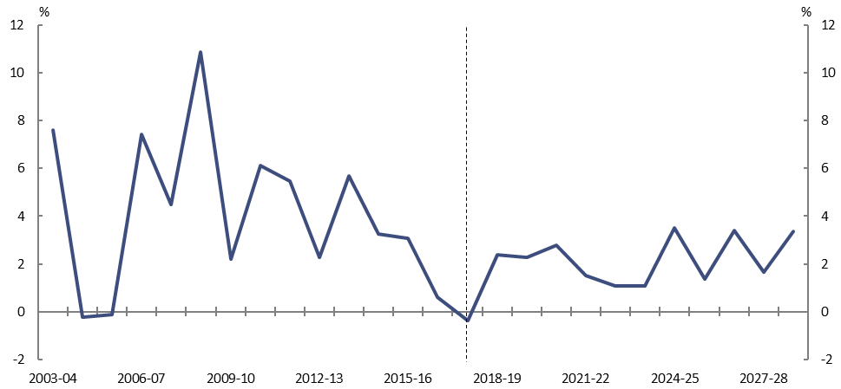
Note: Data prior to 2017-18 is on an accrual basis, whereas data from 2017-18 onwards is on a cash basis. This has a slight effect on the growth between 2016-17 and 2017-18.
Source: Department of Social Services annual reports, 2018-19 Budget, and PBO analysis.
Further increases to the Age Pension were provided as part of the Clean Energy Future package, which made a one-off payment to pensioners in 2012 and introduced the Clean Energy Supplement (now the Energy Supplement) with effect from 2013.
However, more recently growth has slowed, with no new major policy initiatives being announced and the introduction of savings measures in the 2014-15 and 2015-16 Budgets. This included a further increase in the eligibility age (to 70 years by 1 July 2035) and a doubling of the assets test taper rate from 1 January 2017. These savings measures are projected to have a significant effect on Age Pension spending, partially offsetting the impact of ageing on the payment over the next decade.

Medicare
Medicare is the fourth largest government payment, accounting for 5 per cent of projected spending ($23 billion) in 2017-18.
From 2003-04 to 2014-15, the significant increase in growth was due to major policy decisions that applied to services provided by general practitioners (GPs) (Figure C–2). The increase in the GP rebate from 85 per cent to 100 per cent of the Schedule Fee and the introduction of bulk billing incentives resulted in higher government benefits being paid for GP services. Increased benefits were also introduced for after-hours GP services at the same time.

Figure C–2: Real growth in Medicare spending
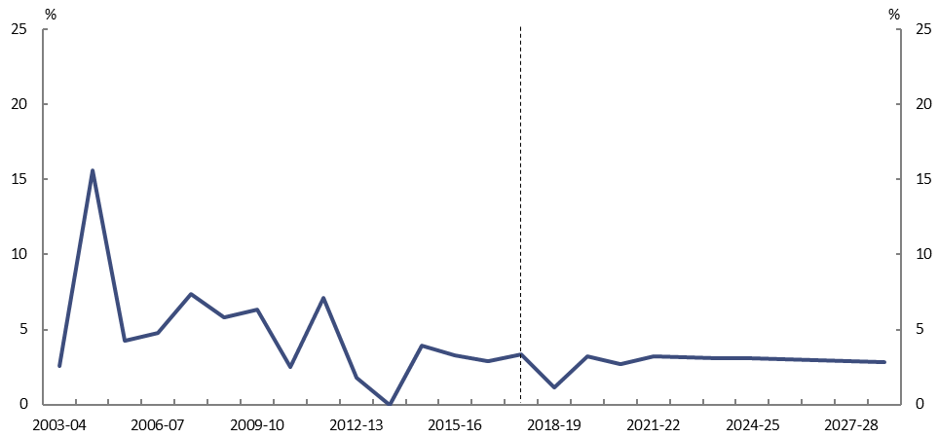
Note: Data prior to 2017-18 is on an accrual basis, whereas data from 2017-18 onwards is on a cash basis. This has a slight effect on the growth between 2016-17 and 2017-18.
Source: Department of Health annual reports, 2018-19 Budget, and PBO analysis.
The addition of allied health services further broadened the scope of Medicare and contributed to real growth in spending. In 2004-05 benefits were made available for a wide range of allied health services (such as physiotherapy) and allied mental health services were added in 2006-07.
The Extended Medicare Safety Net (EMSN) was introduced in 2003-04 and paid 80 per cent of
out-of-hospital patient expenses over a set threshold. This meant that increased benefits were paid when providers charged substantially more than the government-determined Schedule Fee. The introduction of the EMSN primarily affected surgeries and treatments and specialist services by significantly increasing the benefit paid by the government for these services.
In response, the Government progressively introduced a range of EMSN benefit caps from
1 January 2010, which limit the out-of-pocket expenses the MBS will cover for certain services. This, along with no large new additions to the Schedule, and freezing the indexation of certain benefits on the Schedule, has resulted in slower growth in spending more recently. Even with the progressive unfreezing of certain benefits over the forward estimates the slower growth is projected to continue over the next decade.

Disability Support Pension
Disability Support Pension (DSP) accounts for 4 per cent of projected spending ($23 billion) in 2017-18.
From introduction of the payment in 1991-92 to 2007-08, growth in DSP spending was relatively stable. However, in 2008-09 growth increased sharply coinciding with softer labour market conditions due to the global financial crisis (GFC) (Figure C–3). The pension rate was also increased from 25 per cent to 27.7 per cent of Male Total Average Weekly Earnings (MTAWE) in 2009-10.

Figure C–3: Real growth in Disability Support Pension spending
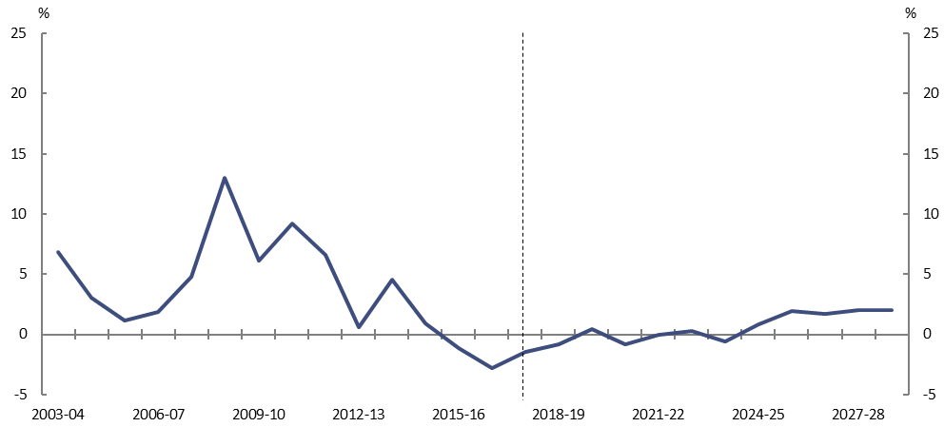
Note: Data prior to 2017-18 is on an accrual basis, whereas data from 2017-18 onwards is on a cash basis. This has a slight effect on the growth between 2016-17 and 2017-18.
Source: Department of Social Services annual reports, 2018-19 Budget, and PBO analysis.
From 2012-13 growth in DSP expenditure slowed sharply. This has been affected by significant changes to assessment processes, particularly the introduction of new assessment tables for work-related impairment which took effect from 1 January 2012 and additional job capacity assessments of new applicants which commenced in 2011-12. The introduction of new assessment tables and processes has effectively resulted in a structural break over the historical period, as the regime for assessing eligibility for the DSP fundamentally changed from 2011-12.
The DSP compliance measures are projected to have an ongoing impact over the next decade. The projections incorporate a rebound in recipient numbers from historically low levels, along with the increase in the Age Pension eligibility age (which results in an increase in the number of people who remain on the DSP).

Carer income support
Carer income support is comprised of multiple payment programs offered to individuals who care for persons with severe disabilities and medical conditions. Carer income support makes up around 2 per cent of projected spending in 2017-18 ($8 billion) and has been one of the fastest growing government payments during the past decade. While demographics have played a part in this growth, policy change has been the largest contributor (Figure C–4).

Figure C–4: Real growth in carer income support spending
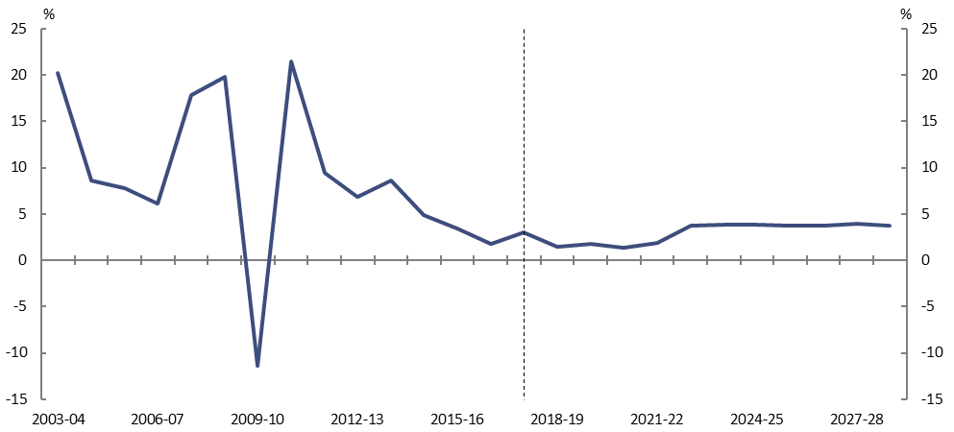
Note: Data prior to 2017-18 is on an accrual basis, whereas data from 2017-18 onwards is on a cash basis. This has a slight effect on the growth between 2016-17 and 2017-18.
Source: Department of Social Services annual reports, 2018-19 Budget, and PBO analysis.
With a relatively strong budget position during the early part of the past decade, policy decisions increased a number of carer income support payments. This included the payment of one-off carer bonuses each year from 2003-04 to 2007-08. The Child Disability Assistance Payment was also introduced in July 2007 and the Carer Supplement two years later.
However, with relatively few policy changes since 2009, growth has been more subdued. Recent historical outcomes suggest that growth in the take up of carer payments among key age cohorts has plateaued (or declined), which points to relatively slower growth over the next decade.

As part of its fiscal strategy, the Government has a commitment to maintaining the ratio of tax receipts to GDP at or below 23.9 per cent of GDP.
Bracket creep occurs due to a combination of static tax thresholds and growing incomes resulting in taxpayers facing higher average tax rates over time. For more detail on the effects of bracket creep, see PBO Report no. 03/2017 Changes in average personal income tax rates: distributional impacts.
Based on the PBO’s projections, the Government’s tax-to-GDP cap would require an unspecified change in tax policy to reduce taxes from 2027-28 onwards. As distributional analysis cannot be undertaken in the absence of specific policy, the analysis presented here ends in 2026-27.
A longer time period is examined here compared with the analysis published in PBO Report no. 03/2017 Changes in average personal income tax rates: distributional analysis. This leads to slightly different results for the bracket creep component to those that have previously been published. The previous analysis had a greater impact for the third quintile than for the second quintile. Typically an individual’s average income tax rate will increase at its greatest rate when they have just crossed a tax threshold. The longer time period in this analysis means that bracket creep pushes a substantial proportion of individuals in the second quintile into a higher tax bracket. However, the longer time period does not cause any additional individuals in the third quintile to cross a tax threshold, so their average tax rate continues to grow, but not as quickly. Together, these two effects lead to a similar change in average tax rate for the second and third quintile.
The estimated impact of not proceeding with unlegislated company tax cuts is indicative and based on parameters in the 2018-19 Budget. The costings of decisions included in the Government’s next economic and fiscal update will be based on the economic parameters at that time.
Australian Government (2018), 2018-19 Budget, Budget Paper No. 1, page 5-12
Bullen, J., Greenwell, J., Kouparitsas, M., Muller, D., O’Leary, J. & Wilcox, R., 2014b. Treasury’s Medium-Term Economic Projection Methodology. Treasury Working Paper, 2014–02.
This is a partial analysis as it does not account for any corresponding impact of the scenarios on other economic parameters.
Since GST receipts are paid to the states, lower GST receipts would also decrease Commonwealth payments.
For example, from 2003-04 to 2007-08, the strong growth in the terms of trade, and consequently nominal GDP, contributed to the fall in spending as a proportion of GDP over the same period.
Spending was affected by the bringing forward and deferral of Commonwealth payments across a range of areas into 2011-12 and 2013-14 respectively. Spending in 2013-14 was also heavily affected by a cash injection to the Reserve Bank of Australia that was treated as a grant in the Commonwealth Budget papers.
Departmental spending excludes National Disability Insurance Agency spending that is administered in nature and defence spending. See 2018-19 Budget, Budget Paper no. 4.
Under current administrative arrangements, the government negotiates agreements with drug manufacturers to contain the cost to the budget of subsidising pharmaceutical benefits. One type of agreement involves the manufacturer repaying the difference between the higher publicly published price of a drug and a confidential price negotiated between the manufacturer and government. This repayment, or rebate, from the manufacturer lowers the effective price faced by the government and is recognised as non-tax revenue. The agreements allow Australia to access drugs at a lower cost-effective price without affecting the price for the drug in other markets. Under the new administrative arrangements, rather than paying the higher published price and receiving a rebate, the government will pay the lower negotiated price to the suppliers. This has the effect of reducing both spending and non-tax revenue, with no net impact on the budget.
See PBO Report no. 01/2018 Disability Support Pension – Historical and projected trends.
It is difficult to establish the extent to which growth in Newstart recipients has been affected by people that have been unsuccessful in applying for the DSP. Over the next decade projected growth in Newstart spending is primarily driven by the unemployment rate.
To address some of this uncertainty the Government has included a $1.0 billion provision in the Contingency Reserve for future increases in new medicine listings. This is not included in the estimates for pharmaceutical benefits and will be progressively recognised when new listings are announced. This is included in ‘other spending’.
Net debt is the sum of selected financial liabilities (deposits held, advances received, government securities, loans and other borrowings) less the sum of selected financial assets (cash and deposits, advances paid, and investments, loans and placements). It is a common measure of the strength of a government’s financial position.
Real growth in the Age Pension will increase from that projected in this report due to the announcement that the Government will not proceed with the change in the eligibility age to 70 years. This affects the projections from 2025-26.

