|  |
| --- |
| Trends affecting the sustainability of Commonwealth taxes |
| Report no. 02/2018 |

|  |
| --- |
| © Commonwealth of Australia 2018  **978-0-6482138-4-0** Trends affecting the sustainability of Commonwealth taxes (PDF)  **978-0-6482138-5-7** Trends affecting the sustainability of Commonwealth taxes (DOCX)  **Copyright notice**  This work is licensed under the Creative Commons Attribution-NonCommercial-NoDerivs  3.0 Australia License <http://creativecommons.org/licenses/by-nc-nd/3.0/au/>    **Attribution**  This publication should be attributed as follows: Parliamentary Budget Office, Trends affecting the sustainability of Commonwealth taxes.  **Use of the Coat of Arms**  The terms under which the Coat of Arms can be used are detailed on the following website: [www.itsanhonour.gov.au/coat-arms](http://www.itsanhonour.gov.au/coat-arms) |

Contents

Foreword v

Overview vi

1 Introduction 1

2 Taxes on consumption 3

2.1 Goods and services tax 4

2.2 Excise duty 7

2.2.1 Fuel excise 8

2.2.2 Tobacco excise 10

2.2.3 Alcohol excise 13

2.3 Wine Equalisation Tax (WET) 16

2.4 Other import tariffs 17

2.5 Luxury Car Tax 18

3 Taxes on capital 19

3.1 Company tax 20

3.2 Superannuation earnings tax 24

3.3 Taxes on capital gains for individuals 26

3.4 Resource rent taxes 27

4 Taxes on labour 30

4.1 Personal income tax 31

4.2 Superannuation contributions tax 34

4.3 Fringe benefits tax 36

5 Other taxes 39

Conclusion 40

References 44

Foreword

This report examines the broad trends within the Commonwealth tax system since 2001–02 and the risks they present. An awareness of these risks allows policy makers to work to ensure the sustainability of the tax system over the medium term.

This report was prepared by Kate Wagner and Lok Potticary, with input from Hanna Maslen, Vijay Murik, Jonas Lloyd, and Michael Robinson. It has benefitted from comments from Paul Gardiner and Tim Pyne. The report was prepared for publication by Helen Moorhouse and Lauren Pratley.

I wish to thank the external referees who provided comments on the report, including Paul Abbey, Professor Robert Breunig, Robert Carling, Melinda Cilento, Saul Eslake, and Danielle Wood.

The assistance of external reviewers does not imply any responsibility on their part for the content of the final report, which rests solely with the PBO.

Jenny Wilkinson

Parliamentary Budget Officer

18 July 2018

Overview

The composition of Commonwealth tax receipts shifts over time as a result of changes in policy and the economic environment, as well as changes in the behaviour of individuals, companies, and other entities.

The sustainability of Australia’s tax system depends on the overall level of taxes as well as the mix of taxes, which influences the efficiency and equity of the tax system overall. Information on the trends within the tax system can help inform judgements about whether enough revenue will be collected to fund a desired level of government spending, and whether the tax system is optimally designed.

This paper examines the broad trends within the Commonwealth tax system and the risks they present. It shows that since 2001–02, the most significant overall changes in tax receipts as share of GDP have been:

* a fall in fuel excise, driven by the previous freeze to indexation arrangements and ongoing improvements in fuel efficiency;
* a fall in customs receipts as free trade agreements and other tariff changes have come into effect; and
* a fall in company tax receipts as investment has become more concentrated in capital intensive industries, which have higher losses that are carried forward.

The changes to tax receipts since 2001–02 are shown in Figure 1.

Figure 1: Change in tax receipts as a share of GDP

2001–02 to 2015–16

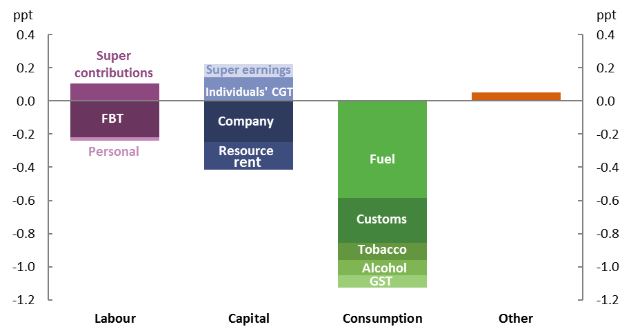

Source: ATO, ABS and Treasury Final Budget Outcome data and PBO analysis.

Based on recent trends and current policy, the coming decade is likely to see further changes to tax receipts, including:

* a decrease in company tax receipts due to policy changes, though there could be a counteracting positive effect as losses carried forward in the resources industry are exhausted;
* an increase in personal income tax receipts due to ongoing bracket creep, notwithstanding the Personal Income Tax Plan in the 2018–19 Budget; and
* ongoing decreases in various consumption tax receipts, driven by consumer behaviour and technological change.

Looking beyond these trends, there remain risks to tax receipts from other sources. Internationally, there is increasing uncertainty stemming from policy changes in company tax rates and tariffs, both of which could have flow-on effects for Australia. At the same time, the peer‑to‑peer ‘share economy’ is growing, which may increase the volatility in personal income tax receipts as well as increasing the scope for tax minimisation, although the impacts of this are not yet evident.

Overall, given current policy settings and recent consumption and structural trends, there is a likelihood that taxes on consumption will continue to trend downwards, taxes on capital will be flat or trend downwards and an increasing proportion of labour income will be taxed concessionally through the superannuation system. If these risks to tax receipts eventuate, and in the absence of other taxation reforms, maintaining Commonwealth Government revenue at recent levels as a share of GDP will lead to an increasing reliance on taxes on labour income through the personal income tax system.

# Introduction

Over time, economies inevitably undergo structural changes. These changes can arise from factors including changing patterns of employment, technology, and consumption.[1], [2]

The sustainability of tax revenue is a key consideration for a government’s fiscal sustainability.[3] A sustainable tax base requires a tax system that is robust in its design and that evolves in light of the structural changes that emerge over time.

The level of vulnerability to structural change is typically lower for parts of the tax system that feature a broad economic base, meaning there are few exemptions and concessions, and where a consistent tax rate is applied.

When products are taxed at broadly the same rate, relative prices are unaffected and there is less of an impact on the decisions of individuals and businesses. A broad base also enables a lower rate of tax for a given revenue objective, which results in smaller distortions to people’s and businesses’ choices. Narrowly-based taxes can, however, improve resource allocation where they address cases of market failure or support improved social outcomes.[4]

The general tax principles of efficiency, equity, and simplicity are also related to the maintenance of a sustainable tax base. While these terms are usually used by tax policy experts, the principles reflect the values of the broader population when it comes to taxes. Efficiency relates to an unwillingness of the population to have their living standards lowered more than necessary to raise the required revenue.[5] Equity relates to perceptions of fairness of the tax system. Simplicity relates to making any associated compliance as easy as possible. It is important that these principles are reflected in tax policy, noting that there is an inevitable trade-off between these principles that varies between different types of tax.

This report details the trends that have historically affected the sustainability of Commonwealth taxes. Tax receipts, and expected future tax receipts, adjust as economic conditions change, with the 2018–19 Budget showing an improvement in some of the most substantial Commonwealth taxes. Notwithstanding these improvements, the report outlines trends which suggest vulnerabilities within the tax system remain over the period ahead. Being aware of these trends helps to inform policy makers in making judgements about whether the current tax policy settings in Australia are likely to result in sufficient revenue being collected to finance government spending over the medium to long term, and whether that revenue is raised in an optimal way.

We can categorise almost all Commonwealth taxes as being in one of three broad categories:

* taxes on labour, paid on income or other benefits earned by individuals
* taxes on capital, paid on the returns that flow from assets, and
* taxes on consumption, paid on the purchase of goods and services.

The taxes for each of these categories have changed over the decades in response to changes in policy and the broader economy, as shown in Figure 2. This report focuses on more recent trends, looking at changes in the taxes since 2001–02, in order to consider potential vulnerabilities that currently exist.[6]

Figure 2: Categories of Commonwealth Taxes

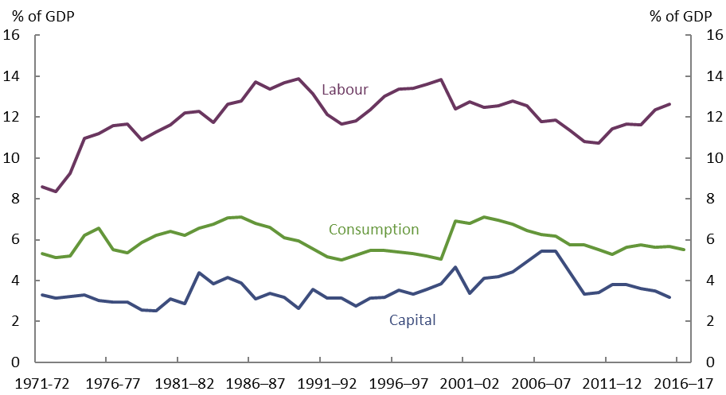

Source: ATO data and PBO analysis.

The remainder of the report is structured around these three categories of Commonwealth taxes. Section 2 covers taxes on consumption, section 3 covers taxes on capital and section 4 covers taxes on labour. Each section outlines the individual taxes that are included in that category of taxes, the recent trends that have impacted on them and discusses changes that may affect future tax receipts.

# Taxes on consumption

Receipts from taxes on consumption have decreased steadily as a share of GDP since  
2001–02. The two main consumption taxes are the Goods and Services Tax (GST) and excise duties (including excise‑equivalent customs duties), as shown in Figure 3. Other minor consumption taxes that are currently in place are other customs duties, the Wine Equalisation Tax, and the Luxury Car Tax.

Figure 3: Taxes on Consumption

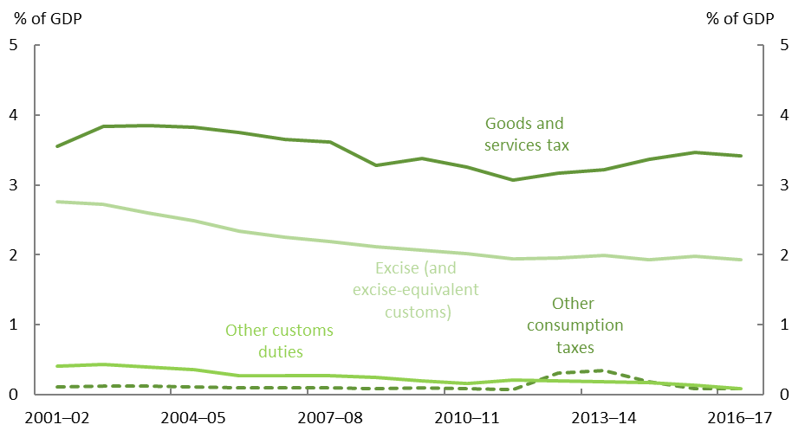

Note: Other consumption taxes include WET, LCT, and the carbon pricing mechanism in the years that it operated.

Source: ATO data, Final Budget Outcomes 2015-16 and 2016-17, and PBO analysis.

Nominal consumption expenditure as a share of GDP shows no discernible trend when viewed over several decades. Despite this, taxes on consumption as a share of GDP have decreased from 6.8 per cent of GDP in 2001–02 to 5.5 per cent in 2016–17, due to a combination of behavioural, price and policy changes.

## Goods and services tax

|  |  |
| --- | --- |
| **GST receipts as a per cent of GDP (2016–17):** 3.4 per cent  This makes up 15.8 per cent of Commonwealth receipts. | |
| **Major drivers of the tax base** | * Total consumption levels * Consumption mix |
| **Trends** | The proportion of household consumption expenditure on goods and services that are GST-free has increased since the tax matured in the early 2000s, leading to a narrowing of the tax base. |

The GST was introduced on 1 July 2000, replacing the Wholesale Sales Tax and a range of state taxes. The GST applies at a rate of 10 per cent on the sale of most goods and services; however, there are a few significant categories, notably fresh food, rent for housing, health and education services, which are exempt from the tax. While the federal government administers the GST, all of the revenue raised (minus a small administration charge) is paid to the states and territories.

Figure 4: Goods and Services Tax and Consumption

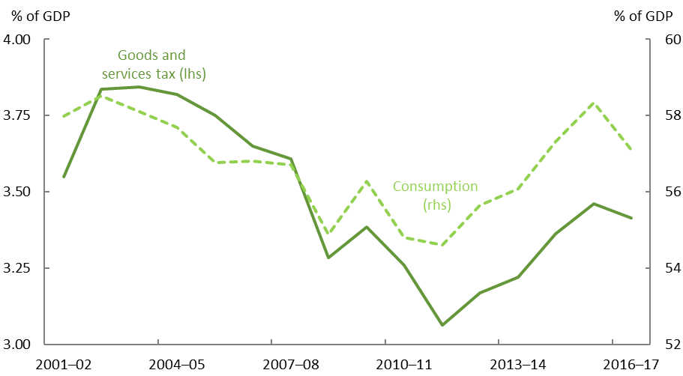

Source: ATO and ABS data, Final Budget Outcomes 2015–16 and 2016–17, and PBO analysis.

When the GST was introduced, GST receipts were 3.4 per cent of GDP. The GST peaked shortly after, in 2003–04, at 3.8 per cent of GDP, reflecting the maturing of the new tax. Since then, GST receipts have declined as a share of GDP to 3.4 per cent in 2016–17, as shown in Figure 4, notwithstanding a recent rebound following a trough in 2011–12.

By their nature, GST receipts are highly correlated with consumer spending. GST receipts as a share of GDP are therefore influenced by changes in the saving rates that consumers adopt. Although consumption expenditure tends to be relatively stable, around the time the GST was introduced the household savings ratio was at historically low levels and consumption as a share of GDP was correspondingly high. With the terms of trade boom during the 2000s, Australian real incomes rose and households largely opted to save rather than consume the gain, leading to a fall in consumption as a per cent of GDP. The global financial crisis then also led to higher saving as households rebuilt their balance sheets.

Since 2008–09, consumption as a per cent of GDP has increased as the household savings ratio has decreased from around 8 per cent to less than 3 per cent.

Another factor that has led to a decline in GST receipts as a share of GDP has been the change in the consumption mix over time. Since the GST was introduced, households have spent progressively more of their income on goods and services that are exempt from the GST.

The decrease in the proportion of household consumption subject to GST has largely occurred as prices of goods and services exempt from the GST have grown faster than those goods and services subject to the GST. In fact, the volume of consumption subject to GST has remained relatively stable since the introduction of the GST (Figure 5).

Figure 5: Household spending subject to GST

Per cent of total household spending

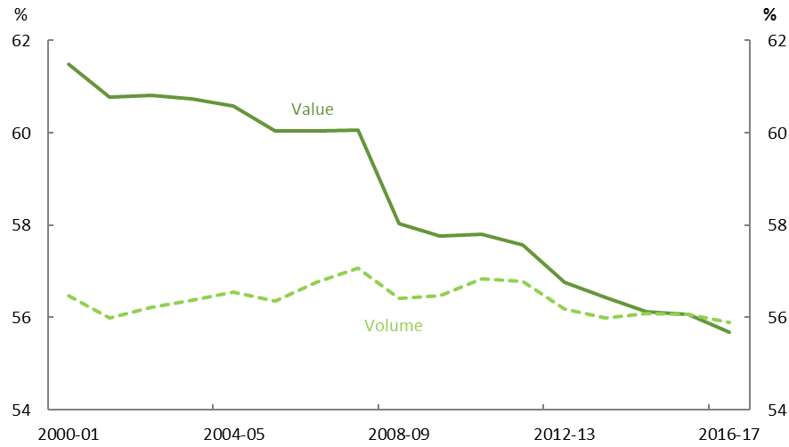

Source: ABS and PBO analysis.

Figure 6 shows the change in the share of key GST exempt components of household consumption over the period 2001–02 to 2016–17. The share of household expenditure on rent, health and education have all increased over the period, while the share of expenditure on food has decreased slightly.

Figure 6: Major consumption components not subject to GST

Change in share by value of household consumption, 2001-02 to 2016-17

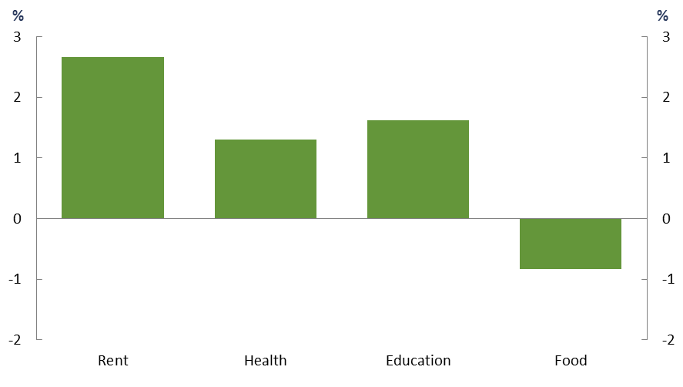

Source: ABS and PBO analysis.

Over the same period, the increase in international internet purchases, which were largely exempt from GST, also put downward pressure on GST receipts. This was likely a smaller contributor to the decline in GST as a share of GDP than the other factors already discussed. This effect should improve as the lower GST threshold (announced in the 2016‑17 Budget) is applied to imports, effectively increasing the proportion of imported goods that are subject to GST.

Changes that could affect future receipts

Even though the GST does not affect the Commonwealth budget position, as GST receipts are paid to the states and territories, any ongoing decline in GST receipts could lead to calls for the Australian Government to make increased payments to the states and territories. The Australian Government recently announced additional permanent funding to be distributed among the states, following a series of ‘GST top-up payments’ allocated to Western Australia in the 2016–17, 2017–18, and 2018–19 Budgets. Weaknesses in GST receipts could provide an incentive for the states and territories to make better use of their tax bases; however, this incentive may be somewhat muted by the precedent now set for top‑up funding being provided by the Australian Government.

As discussed, there has been a decrease in the proportion of the value of household expenditure on goods and services subject to the GST. This trend appears likely to continue, with households allocating a higher proportion of their consumption to housing, health services and education services, putting ongoing downward pressure on GST receipts as a share of GDP over time.

The emerging peer-to-peer economy has begun to disrupt certain industries in recent years. The peer-to-peer economy, by its nature, encourages the use of individual or small operators and suppliers who may fall under the GST registration threshold.[7] [8] This could lead to the displacement of the traditional larger firms who are required to levy and remit the GST to the government. In some industries, such as accommodation services, the short-stay services in the peer-to-peer economy are usually exempt from charging GST, but their competitors, such as hotels, are not. This trend could lead to those service providers that are required to levy GST becoming a smaller proportion of the market, resulting in a lower level of GST receipts for the same quantity of the service being provided (Grattan, 2016).

Another factor that will affect GST receipts in the future is the household savings ratio. The household savings ratio has varied substantially since the GST was introduced, with recent years seeing a fall from the post-GFC highs. The propensity of households to save versus consume will have an impact on the level of consumption and therefore GST receipts. There is uncertainty about whether the recent falls in the household savings ratio will continue, or whether households will be cautious about allocating a greater proportion of their income to consumption.

If the recent decrease in the household savings ratio continues, the resulting increase in household consumption would be expected to result in higher GST receipts. The ageing of the population could contribute to this as people in retirement tend to draw down on their savings to fund consumption.

## Excise duty

Excise and excise-equivalent duties act together as a consumption tax that is levied on fuel, tobacco, and alcohol (excluding wine). Excise duty is a form of volumetric taxation[9] that is levied on the domestic production of these goods. Imported excise-like goods are subject to customs duty at a rate equivalent to the excise rate that would apply, had the products been produced domestically.[10]

Figure 7: Excise duty

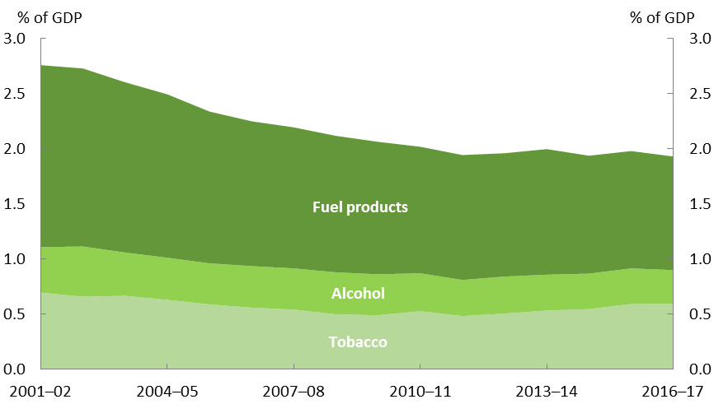

Note: Data includes excise and excise-equivalent duty.

Source: ATO, ABS, Final Budget Outcomes 2015–16 and 2016–17, and PBO analysis.

Excise duty, as a proportion of the overall economy, has fallen by around 30 per cent since 2001–02 from around 2.8 per cent of GDP in 2001–02 to around 1.9 per cent in  
2016–17, as shown in Figure 7. Around three quarters of the decline is a result of fuel excise, as the rate was not indexed, and therefore declining in real terms, between March 2001 and November 2014.

### Fuel excise

|  |  |
| --- | --- |
| **Fuel excise as a per cent of GDP (2016–17):** 1.0 per cent  This makes up 5 per cent of Commonwealth receipts. | |
| **Major drivers of the tax base** | * Fuel consumption |
| **Trends** | After indexation was abolished in March 2001, fuel excise declined as a per cent of GDP. The re-introduction of indexation in November 2014 has addressed this somewhat, although improvements in fuel efficiency have led to further declines. |

Figure 8: Fuel excise receipts

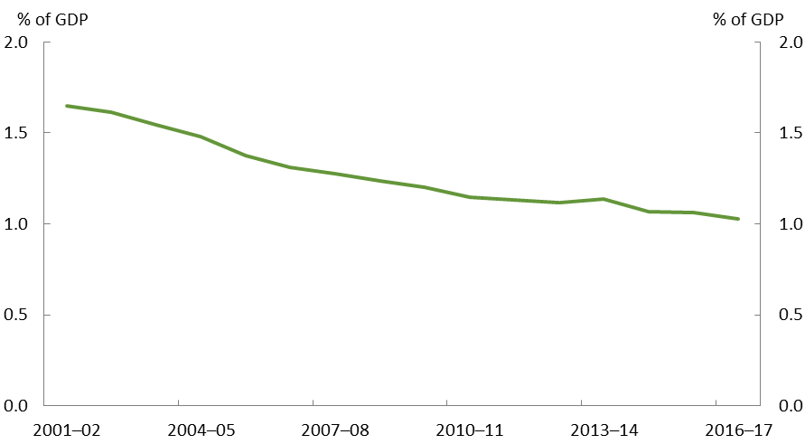

Note: Data includes excise and excise-equivalent duty.

Source: ATO, ABS, Final Budget Outcomes 2015–16 and 2016–17, and PBO analysis.

Excise is levied on a number of fuel products including petrol, diesel, ethanol, biodiesel, aviation fuels and heating oils. Excise on petrol and diesel is the largest component of fuel excise and is currently levied at a rate of 40.9 cents per litre (cpl).[11]

When the GST was introduced, the fuel excise rate was reduced by 15 per cent. The excise rate was further reduced on 2 March 2001 by around 4 per cent and the bi-annual indexation of fuel excise rates was abolished.[12]

Even though indexation of fuel excise rates was re‑introduced on 10 November 2014, fuel excise has continued to decline, falling from 1.6 per cent of GDP in 2001–02 to 1.0 per cent in 2016–17, as seen in Figure 8.

A significant contributor to the fall in fuel excise has been the increased efficiency of passenger vehicles. Falls in average fuel consumption have put downward pressure on growth in the quantity of private fuel consumption. The average fuel consumption per passenger vehicle in 2001 was 11.4 litres per 100 kilometres (L/100 km). By 2016, average fuel consumption was down to 10.6 L/100 km[13] (Figure 9).

Figure 9: Average fuel consumption for passenger vehicles

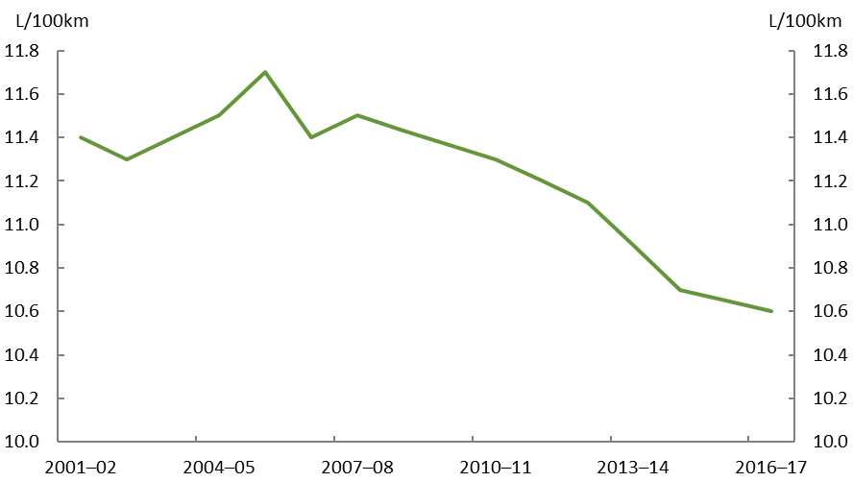

Source: ABS and PBO analysis.

Changes that could affect future receipts

Continued improvements in the fuel efficiency of the passenger motor vehicle fleet in Australia are likely to contribute to a further slowing of the growth in total fuel consumption, further constraining growth in fuel excise.

The uptake of electric vehicles could further accelerate the rising fuel efficiency of the passenger motor vehicle fleet in Australia. Electric vehicles are only a small proportion of the market and are therefore having little effect on fuel excise receipts at the present time.

However, under the Australian Energy Market Operator’s neutral scenario for electricity consumption, electric vehicles are projected to represent around 19 per cent of the light vehicle fleet in Australia by 2036–37 (AEMO 2018). The impact on fuel consumption of an increasing uptake of electric vehicles would further erode the fuel excise base.

### Tobacco excise

|  |  |
| --- | --- |
| **Tobacco excise as a per cent of GDP (2016-17):** 0.6 per cent  This makes up 3 per cent of Commonwealth receipts. | |
| **Major drivers of the tax base** | * Tobacco consumption |
| **Trends** | Tobacco consumption has been falling for some time as people’s attitudes towards smoking have changed, however excise rates have increased significantly recently, more than offsetting the recent decline in consumption. |

Historically, when cigarettes, cigars and loose tobacco were produced in Australia, they were subject to tobacco excise, paid by the manufacturer. If these tobacco products are imported, they are instead subject to an excise-equivalent rate of customs duty.

Tobacco excise was around 0.7 per cent of GDP in 2001–02 before falling to around 0.5 per cent in 2009–10. Tobacco excise then rose to 0.6 per cent of GDP in 2016–17 (Figure 10).

Figure 10: Tobacco excise receipts

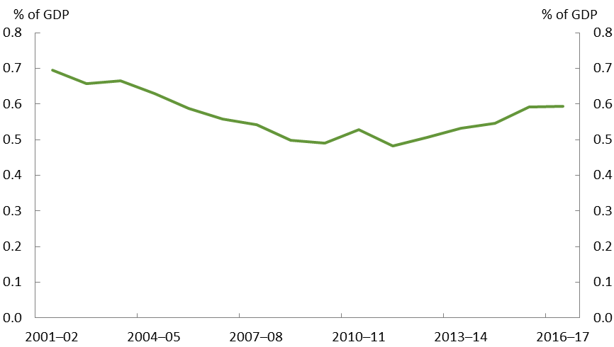

Note: Data includes excise and excise-equivalent customs duty.

Source: ATO, ABS, Treasury Final Budget Outcome, Budget 2017–18, and PBO analysis.

Since November 1999, cigarettes have been subject to tobacco excise on a ‘per stick’ basis and loose tobacco on a ‘per kilogram’ basis. Historically, as with alcohol excise, tobacco excise rates were indexed bi-annually based on the consumer price index. On 1 March 2014, the indexation of tobacco excise rates was changed to be based on average weekly ordinary time earnings to ensure that smoking did not become more affordable over time relative to incomes.

Excise rates have increased dramatically in recent years due to government policy decisions, which reversed the decline in tobacco excise receipts as a share of GDP. The government implemented a 25 per cent increase in the excise rate on 30 April 2010 and an increase of 12.5 per cent on 1 December 2013, followed by successive annual increases of 12.5 per cent from 1 September 2014 (Figure 11).

Figure 11: Tobacco consumption and excise rate

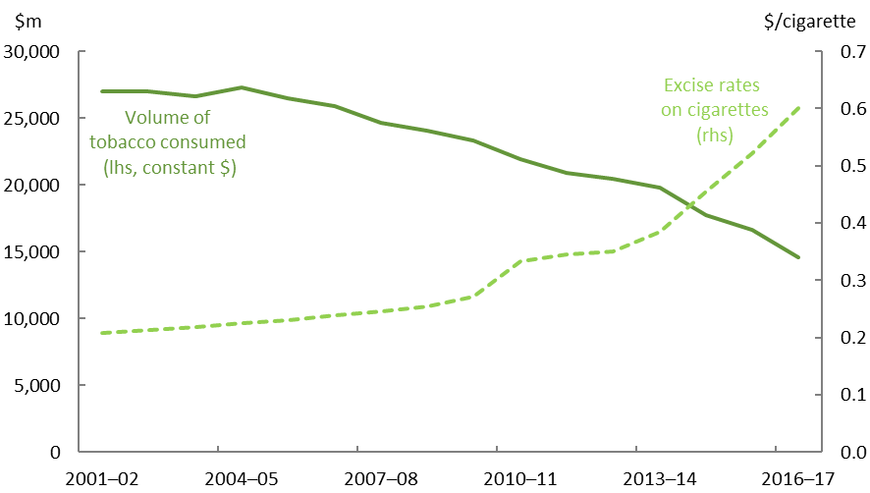

Source: ABS, ATO, and PBO analysis.

The increase in excise rates has more than offset the impact of decreasing tobacco consumption. The consumption of tobacco has been falling over time, with the proportion of adults who are daily smokers falling from 22.4 per cent in 2001 to 14.5 per cent in 2014–15.[14] In addition to the increasing cost of tobacco, a range of other measures have been introduced by governments to reduce tobacco consumption, including restrictions on where people are permitted to smoke, the banning of tobacco advertising, health warnings on packets and the introduction of plain packaging.

Changes that could affect future receipts

The tobacco excise rate is set to increase further in coming years. There are 12.5 per cent increases scheduled to occur on 1 September in 2018, 2019 and 2020. There is also a phased measure to align the excise rate on loose tobacco with manufactured cigarettes, which will be achieved by calculating the per kilogram rate on loose tobacco on the basis that the average tobacco content of a cigarette is 0.7 grams (instead of the previous assumption of 0.8 grams). This began on 1 September 2017 and will continue to phase in until 1 September 2020 alongside the 12.5 per cent excise rate increases.

The increases in tobacco excise rates and resulting increase in the cost of tobacco could accelerate the decline in tobacco consumption. The impact on tobacco excise will depend on the degree to which consumption responds.

It has been claimed that the increases in the price of cigarettes that have resulted from the increases to the tobacco excise rate may be leading to an increase in the black market for cigarettes and tobacco. The Department of Immigration and Border Protection has previously said that the size of the illicit tobacco market in Australia is unknown and estimates of its size vary considerably (DIBP, 2016). Estimates of the revenue forgone due to illicit tobacco vary between $1.6 billion and $4 billion per year (Treasury, 2018). The 2018–19 Budget measures to combat illicit tobacco, including collecting tobacco duties from importers at the border rather than after importation and warehousing, is expected to help address some of the loss in tobacco excise receipts from illegal tobacco sales.

### Alcohol excise

|  |  |
| --- | --- |
| **Alcohol excise as a per cent of GDP (2016-17):** 0.3 per cent  This makes up 1 per cent of Commonwealth receipts. | |
| **Major drivers of the tax base** | * Alcohol consumption |
| **Trends** | There has been a steady decline in alcohol excise receipts as a proportion of GDP as people’s alcoholic beverage preferences change from beer towards wine, which is not taxed under the alcohol excise system. |

Alcohol excise (and excise-equivalent customs duty) is levied on most alcoholic beverages, excluding wine. It is levied on a per litre of pure alcohol basis, at rates that vary according to the type of beverage, size of container and alcoholic strength.

Alcohol excise has fallen from 0.4 per cent of GDP in 2001–02 to 0.3 per cent of GDP in  
2016–17 (Figure 12).

Figure 12: Alcohol excise receipts

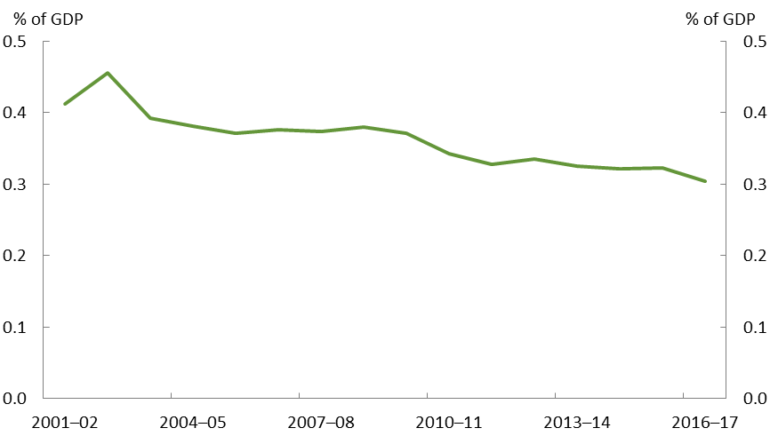

Note: Data includes excise and excise-equivalent duty.

Source: ATO, ABS, Treasury Final Budget Outcome, Budget 2017–18, and PBO analysis.

The decline in alcohol excise reflects two trends in consumption patterns. The first is a decrease in alcohol consumption per capita in recent years from 10.8 litres of pure alcohol in 2006–07 to 9.7 litres in 2015–16. The second trend is a switch in alcohol consumption from beer to wine. In 2001–02, beer represented around half of total alcohol consumption in Australia. This fell to around 40 per cent in 2016–17. Over the same period, wine increased from 32 per cent to around 38 per cent of total alcohol consumption.

Changes that could affect future receipts

If alcohol consumption patterns continue to change in line with current trends, this will lead to a deterioration of the alcohol excise tax base and therefore weaker alcohol excise receipts.

If alcohol was taxed equally on a volumetric basis, a shift in consumer preferences from one alcoholic beverage to another, all other things being equal, wouldn’t affect total alcohol tax receipts. However, as most beer categories are subject to a higher effective rate of taxation than most of the wine consumed in Australia, a reduction in the alcohol excise tax base and corresponding increase in the wine equalisation tax base will result in alcohol tax receipts continuing to fall as a share of the economy (Box 1 and section 2.3 on the wine equalisation tax).

The 2018–19 Budget measure to reduce the container size threshold for draught beer, which is taxed at a lower rate than packaged beer, will put further downward pressure on alcohol excise receipts.

|  |
| --- |
| Box 1: Current structure of the alcohol taxation system in Australia  The current structure of alcohol taxation is complex, involving two systems for taxing alcohol:   * Volumetric taxation (excise and excise-equivalent customs duty system for domestically produced and imported alcohol, respectively), which essentially taxes beer and spirits on their alcohol content (that is, based on dollars per litre of alcohol) * *Ad valorem* taxation (wine equalisation tax, or WET) which taxes wine on its wholesale value.   Within the excise system, there are a wide range of tax rates, with varying exemptions and concessions available to different products.  The WET was introduced alongside the introduction of the GST on 1 July 2000, replacing the wholesale sales tax. The rate of 29 per cent on the final wholesale sale price of wine (in combination with the GST) was designed to offset the removal of the wholesale sales tax.  The complexity in the taxation of alcoholic beverages has arisen from changes to the system that have been based on specific objectives at the time the changes were made, rather than having been designed from a set of consistent policy principles.  The different systems of alcohol taxation mean that it is difficult to compare the rate of alcohol taxation across products. The effective excise rates for alcoholic beverages are listed in Table 1 below. |
| Table 1: Effective excise rates by beverage and alcohol content, 2016–17 |

|  |  |  |  |
| --- | --- | --- | --- |
|  | Alcohol type | Effective excise rate  ($ per litre of pure alcohol) |  |
|  | Non-commercial beer, low-strength | 1.76 |  |
|  | Non-commercial beer, mid- to full-strength | 2.59 |  |
|  | Draught beer, low-strength | 4.99 |  |
|  | Draught beer, mid-strength | 17.40 |  |
|  | Draught beer, full-strength | 26.14 |  |
|  | Packaged beer, low strength | 24.97 |  |
|  | Packaged beer, mid-strength | 32.36 |  |
|  | Packaged beer, full-strength | 37.11 |  |
|  | Brandy | 76.25 |  |
|  | Spirits | 81.65 |  |
|  | Ready-to-drink beverages | 81.65 |  |
|  | Wine, $15 cask (4L) | 3.09 |  |
|  | Wine, $7 bottle | 8.23 |  |
|  | Wine, $15 bottle | 17.64 |  |
|  | Wine, $40 bottle | 47.05 |  |
| Source: PBO estimates based on ABS, ATO, and Department of Home Affairs data and Budget figures. Effective excise rates are calculated as per the methodology of the previous PBO report *Alcohol taxation in Australia*. | | | |

## Wine Equalisation Tax (WET)

|  |  |
| --- | --- |
| **WET as a per cent of GDP (2016–17):** 0.05 per cent  This makes up 0.2 per cent of Commonwealth receipts. | |
| **Major drivers of the tax base** | * Wine consumption * Wine price |
| **Trends** | Wine consumption per person has increased overall since 2001–02, but this has not resulted in higher WET receipts. This is in part because WET is levied on the value of the wine, and wine prices have decreased since 2001–02. |

Figure 13: WET receipts and the price of wine

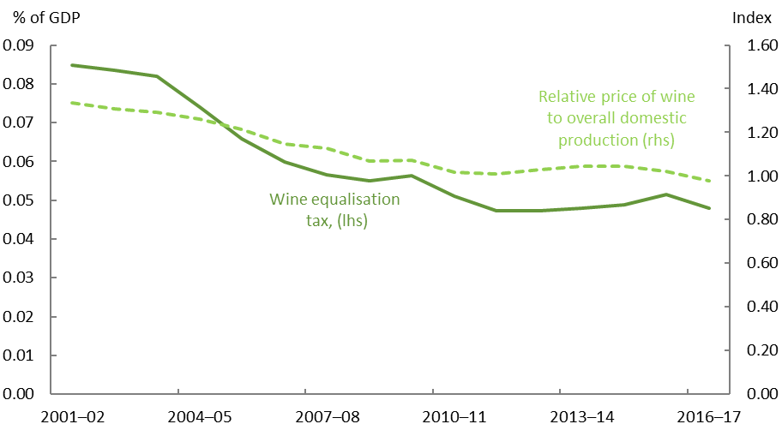

Source: ATO, ABS, Final Budget Outcomes 2015–16 and 2016–17, and PBO analysis.

Wine has been taxed under the wine equalisation tax (which is a form of *ad valorem* taxation, applying to value, not volumes) since 1 July 2000, replacing the wholesale sales tax that had applied prior to the introduction of the GST. WET generally applies to the final wholesale price of both domestic and imported wine at a rate of 29 per cent. [15]

WET receipts as a per cent of GDP have decreased from 0.08 per cent in 2001–02 to 0.05 per cent in 2016–17 (Figure 13).

While there has been a significant shift in consumer preferences for alcoholic beverages away from beer towards wine, the WET is levied on the total wholesale value of wine sold rather than the volume of alcohol sold. The price of wine has fallen relative to prices overall in the economy, leading to a decline in the revenue raised from the WET as a per cent of GDP.

## Other import tariffs

|  |  |
| --- | --- |
| **Other import tariffs as a per cent of GDP (2016–17):** 0.1 per cent  This makes up 0.4 per cent of Commonwealth receipts. | |
| **Major drivers of the tax base** | * Free trade agreements and other tariff changes |
| **Trends** | Other import tariffs have decreased as a share of GDP since 2001–02, despite relatively flat imports over this time. The decrease reflects the long-term decline in import tariffs and free trade agreements that Australia has entered into. |

Figure 14: Other import tariffs and imported goods

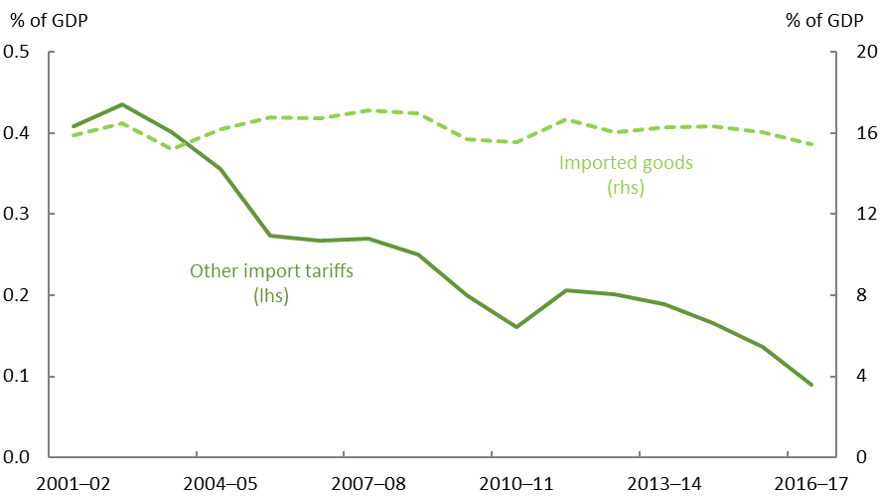

Source: ATO, ABS, Final Budget Outcomes 2015–16 and 2016–17, and PBO analysis.

Receipts from tariffs on imported goods (excluding excise-equivalent customs duty which has been included with excise in this analysis) have been in long-term decline, from 0.4 per cent of GDP in 2001–02 to 0.1 per cent of GDP in 2016-17 (Figure 14).

The primary driver of this decline has been the substantial reductions in import tariffs over the period, with the maximum tariff rate in 2015 sitting at five per cent. Another factor has been the increasing number of free trade agreements that Australia has entered into with other nations that allow the importation of many goods without tariffs applying. As Australia enters into more free trade agreements, receipts from import tariffs are expected to decline further.

## Luxury Car Tax

|  |  |
| --- | --- |
| **Luxury car tax as a per cent of GDP (2016–17):** 0.04 per cent  This makes up 0.2 per cent of Commonwealth receipts. | |
| **Major drivers of the tax base** | * Car purchases and prices |
| **Trends** | Luxury car tax receipts have been relatively stable since the introduction of the tax in 2001–02. |

Figure 15: Luxury car tax receipts

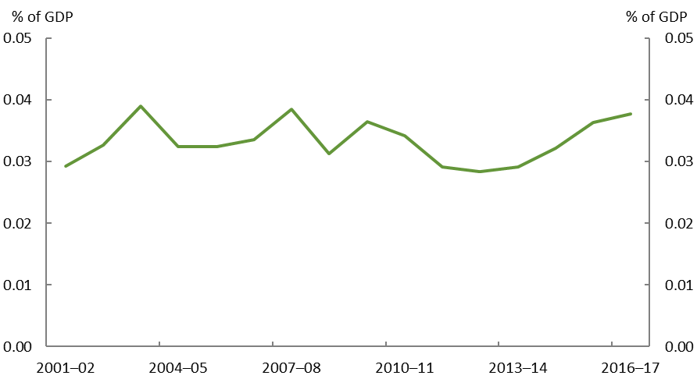

Source: ATO data, Final Budget Outcomes 2015–16 and 2016–17, and PBO analysis.

The luxury car tax was introduced alongside the GST to avoid an effective tax cut on higher priced cars upon the abolition of wholesale sales tax.

The luxury car tax currently applies at a rate of 33 per cent to cars with a purchase price over the luxury car tax threshold of $65,094. A higher threshold of $75,526 applies for fuel‑efficient cars.

Luxury car tax is a relatively small revenue head, making up about 0.04 per cent of GDP in 2016–17 and has historically been fairly stable (Figure 15).

# Taxes on capital

Receipts from taxes on capital have decreased from 3.4 per cent of GDP in 2001–02 to around 3.2 per cent in 2015–16,[16] with significant variations in individual components during this period (Figure 16). Nearly 80 per cent of tax on capital is levied through company tax.

A portion of company profits is collected as company tax, but the final amount of tax paid on the profits depends on who owns the companies. For foreign shareholders, company tax is the final tax paid to the Commonwealth Government on the profits (or income). For domestic shareholders, company tax functions as a withholding tax on the income, but ultimately, the income is taxed according to the marginal tax rate of the shareholder.

Other taxes on capital include individual capital gains tax, superannuation funds’ earnings tax (including superannuation capital gains tax) and resource rent taxes.

Figure 16: Taxes on Capital

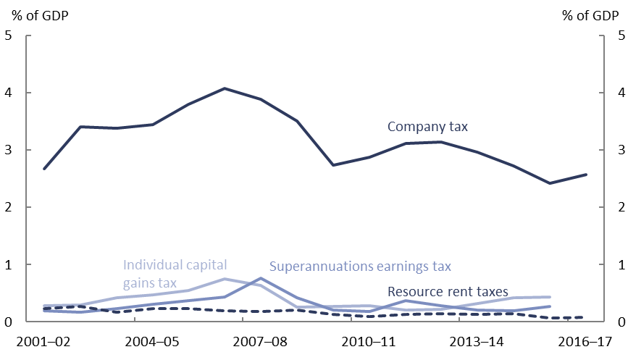

Note: Company tax is adjusted for franking credits claimed by superannuation funds. Superannuation earnings tax is derived from total superannuation tax and deductible contributions, and is adjusted for franking credits.

Source: ATO data and PBO analysis.

## Company tax

|  |  |
| --- | --- |
| **Company tax as a per cent of GDP (2016–17):**[17]2.6 per cent  This makes up 11.9 per cent of Commonwealth receipts. | |
| **Major drivers of the tax base** | * Company profits (“gross operating surplus”) * Depreciation |
| **Trends** | Company tax receipts have decreased slightly from 2.7 per cent of GDP in 2001–02 to 2.6 per cent of GDP in 2016–17. Given Government policy includes a reduction in the company tax rate from 30 per cent to 25 per cent, company tax receipts as a share of GDP are likely to decrease further over the next decade. |

Although the company tax rate has been stable at 30 per cent since 2001–02,[18] company tax receipts have fluctuated substantially, and have decreased overall as a share of GDP. Since 2001–02, company profits have increased marginally as a share of GDP, but the extent to which this has flowed through to company tax receipts has been tempered by increased depreciation deductions and utilisation of carried forward losses (Figure 17).

Figure 17: Company tax receipts and company profits

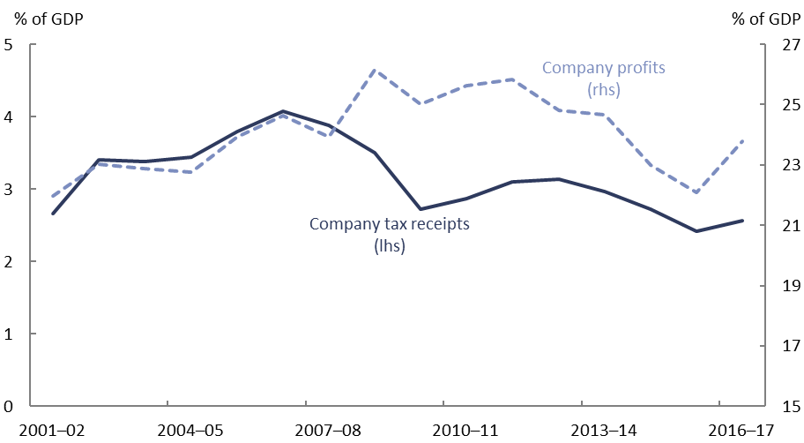

Note: Company tax receipts have been adjusted for franking credits. Company profits do not include deductions for depreciation and accumulated losses carried forward, which have increased since the mid-2000s.

Source: ABS, ATO data and PBO analysis.

The main drivers of the growth in company tax receipts are economic activity and prices, including prices for internationally traded goods and services, which affect company profitability. Higher company profits generally result in higher taxable income and tax receipts, however the nexus between company profitability, as measured by gross operating surplus (GOS), and taxable income is affected by tax deductions. This is particularly relevant for the resources industry, since resources are highly capital intensive, and require large investment with very little income (and therefore large operating losses) for some years. These losses can offset later profits. Once losses are exhausted, profits flow more directly into company tax receipts.

There have been a number of significant policy developments in the company tax system since the 1980s, including some changes resulting from major policy reviews. Substantial reductions in the statutory company tax rate that were implemented over part of this period (shown in Figure 18) were made alongside measures that broadened the company tax base. Base-broadening measures such as reductions to tax concessions, combined with improvements to compliance, have largely offset the impact of statutory company tax rate reductions to date. The effective tax rate has thus not followed the downward trend evident in the statutory tax rate.

Figure 18: Company Tax Rate

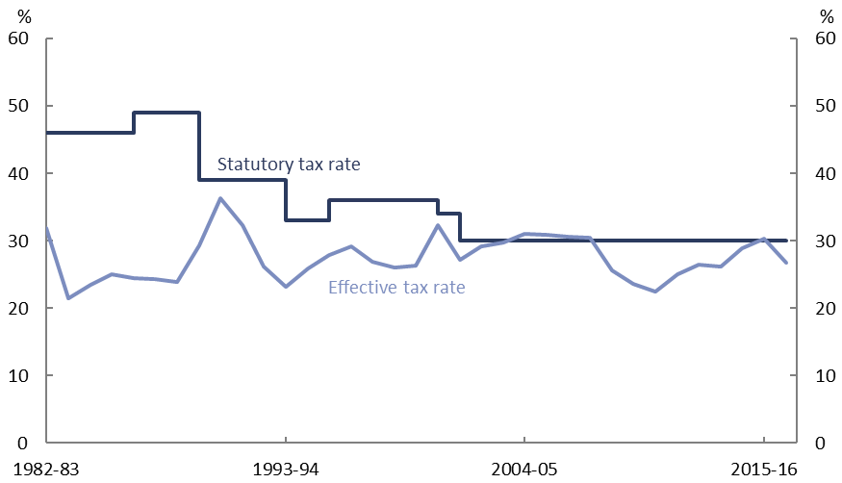

Note: The effective company tax rate is the ratio of company tax receipts (excluding CGT) to net operating surplus (NOS). NOS has been calculated as gross operating surplus (for private companies) less consumption of fixed capital. CGT has been excluded from company tax because there is no simple way to include an appropriate measure of the income associated with CGT in the effective tax rate calculation.

Source: PBO based on data from the ABS and Treasury.

These long term movements in Australia’s company tax policy are broadly in line with those seen across OECD countries. Company tax rates have fallen worldwide in recent years (Figure 19). For example, since 2008, the United Kingdom, Canada and Singapore have all reduced their main company tax rate. In early 2018, the United States cut its company tax rate from 35 per cent to 21 per cent, combined with base‑broadening measures such as a floor applying to the taxation of intangible assets. In keeping with this trend, Australia’s company tax rate will be reduced to 27.5 per cent for companies with a turnover under $50 million in 2018–19, and Government policy includes a reduction to 25 per cent for all companies by 2026–27, albeit without changes to the company tax base.

Figure 19: International Company Tax Rates

Central government statutory tax rates

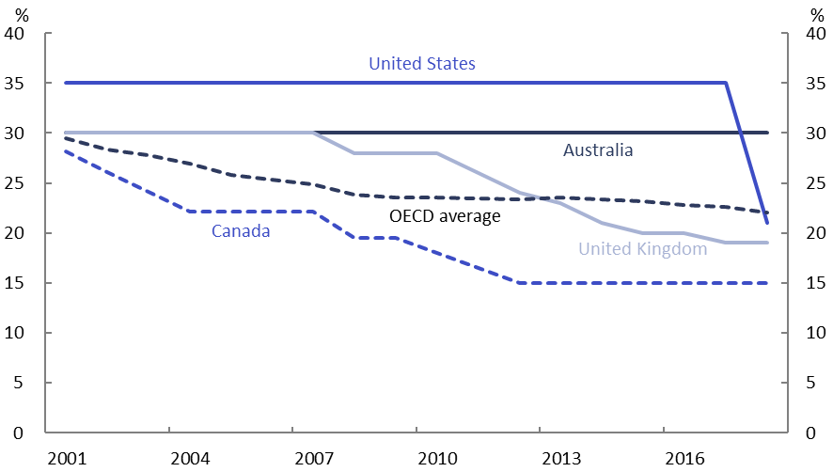

Source: OECD.

The decreases in company tax rates internationally have in part reflected views that there are disincentives to domestic and international investment flows that arise from having a high company tax rate relative to other countries and that this can adversely affect economic growth.

For many countries including Australia, company tax receipts have been adversely affected by the increasing use of international tax planning practices, known as Base Erosion and Profit Shifting (BEPS), by multinational companies. The cross-border activities of multinational companies have led to concerns about company tax bases being eroded due to economic activity being conducted offshore or via offshore companies. It is important to note that these activities are not usually illegal; rather they are designed to facilitate the minimisation of tax liabilities across jurisdictions.

The OECD/G20 BEPS framework is attempting to lessen the effects of these tax planning strategies. The BEPS rules aim to address specific channels through which multinational companies structure their activities to move taxable income towards lower taxing jurisdictions, such as transfer pricing, excessive interest deductions and the exploitation of differences in relevant tax treaties and domestic tax laws. The BEPS rules face significant challenges; among the criticisms is the view that the BEPS framework retains the current features of the international tax system, rather than revisiting the principles of international taxation.[19]

Australia has adopted a separate legislative response to tighten the tax laws for multinational companies, including the Diverted Profits Tax (DPT) and Multinational Anti-Avoidance Law (MAAL), which appear to be having some effect. These laws apply to significant global entities that take part in a scheme with the principal purpose of obtaining a tax benefit. The ATO reported that the MAAL led to the return of over $6.5 billion in sales to the Australian tax base as at 30 June 2017 (ATO 2017).

#### Changes that could affect future receipts

The progressive reduction in Australia’s company tax rate over the period to 2026–27, in the absence of any expansion of the company tax base, would be expected to put downward pressure on company tax receipts as a share of GDP.

The divergence between company profits and company tax receipts experienced since  
2008–09 is expected to close as depreciation and losses carried forward from the unprecedented growth in resources investment decline over time. However, there is uncertainty over when company profits are likely to translate into company tax receipts to the same extent experienced in the early 2000s.

Changes to international company tax policy and legislation in one country tend to increase the uncertainty faced by companies that operate across borders and the other tax jurisdictions in which they operate. The changes to US company tax laws in particular have significant uncertainty around how they will operate.

There are also likely to be ongoing challenges associated with multinational companies whose operations span multiple countries shifting profits and putting downward pressure on company tax receipts, notwithstanding the international efforts and changes in Australian law that are attempting to address this issue.

## Superannuation earnings tax

|  |  |
| --- | --- |
| **Superannuation funds’ earnings tax as a per cent of GDP (2015–16):** 0.3 per cent  This makes up 1.2 per cent of Commonwealth receipts. | |
| **Major drivers of the tax base** | * Assets in superannuation funds * Returns on assets |
| **Trends** | Superannuation earnings tax as a share of GDP is now slightly higher than in 2001–02. Although assets in superannuation funds have increased as a per cent of GDP since 2001–02, losses accumulated from the GFC have limited the tax on the earnings on these assets. |

Figure 20: Superannuation Earnings Tax

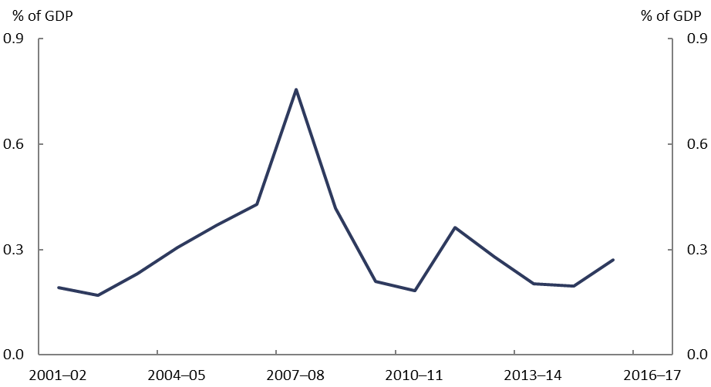

Note: Superannuation earnings tax is derived from overall superannuation tax and the level of superannuation contributions, and is adjusted for the franking credits claimed by superannuation funds (see Appendix A).

Source: ATO data and PBO analysis.

Superannuation tax generally has two components: tax on superannuation contributions as they go into the fund; and tax on the earnings of the assets once they are in the fund.[20] Superannuation contributions are a form of labour income, so the associated tax is included in the “Taxes on labour” section of this report. The earnings on superannuation assets are a return on capital, and so the relevant tax is included here and shown in Figure 20.

Superannuation earnings have a concessional headline tax rate of 15 per cent.[21] The exception to this is for earnings on assets that are currently supporting pensions (that is, assets in the “retirement phase”) which are untaxed.

The level of assets held within superannuation funds has increased over time as a share of GDP, and this is likely to continue into the future, increasing the tax expenditure that arises from the concessional tax treatment of superannuation earnings.[22] However, the changes to superannuation tax introduced as part of the 2016–17 Budget limit the concessional tax treatment of superannuation earnings, which will tend to increase tax receipts on superannuation earnings in the future.[23]

Conceptually, superannuation earnings tax should vary with the stock of superannuation assets that are taxed (that is, assets in the “accumulation phase”) and the rate of return on these assets. However, there are two likely reasons why this is not always the case – carried forward losses and the treatment of capital gains.

Capital losses within a superannuation fund can be carried forward to offset future capital gains that would otherwise be taxed. Following the GFC, there was a significant stock of capital losses, reducing superannuation earnings tax receipts over the subsequent decade. As the stock of capital losses is depleted, the income from capital gains on accumulation phase assets is likely to increase.

The treatment of capital gains in the tax system also delays the increase in tax receipts. The stock of assets in the accumulation phase generally increases each year. However, capital gains tax is only collected when assets are sold, leading to a delay between the asset base increasing and the tax receipts increasing.

There is an additional consequence of the timing of capital gains tax. Tax on superannuation earnings depends on whether account holders are in the retirement phase (in which case earnings are untaxed), or whether account holders are not yet in the retirement phase (in which case earnings face a tax rate of 10 or 15 per cent). One consequence of the age varying tax rate is that as a superannuation fund matures and a higher proportion of the members move into the retirement phase, the tax rate that applies to the earnings of the fund decreases. Given that capital gains are taxed when the asset is sold, there is an incentive for superannuation funds to hold assets until most members are in the retirement phase and minimise the tax on the gains that have accumulated in the value of the asset, potentially over many years.[24]

#### Changes that could affect future receipts

The peak in superannuation earnings taxation in 2007–08 may have been the result of a one‑off response to events such as the GFC and the policy changes made to the superannuation system at the time and so this is likely not a good indication of where superannuation earnings tax receipts are likely to return to in the near future. While GFC losses have largely been exhausted, the tax incentives to defer the realisation of capital gains until the tax on these gains is minimised will limit the growth in future tax receipts.

## Taxes on capital gains for individuals

|  |  |
| --- | --- |
| **Capital gains tax for individuals as a per cent of GDP (2015–16):** 0.4 per cent  This makes up 2.0 per cent of Commonwealth receipts. | |
| **Major drivers of the tax base** | * Price growth in investment assets * Individuals’ choices as to when to realise gains |
| **Trends** | CGT for individuals has increased from 0.3 to 0.4 per cent of GDP since 2001–02. Capital gains tend to be volatile, and have a complex set of rules governing the application of the tax. |

Figure 21: Individuals’ Capital Gains Tax

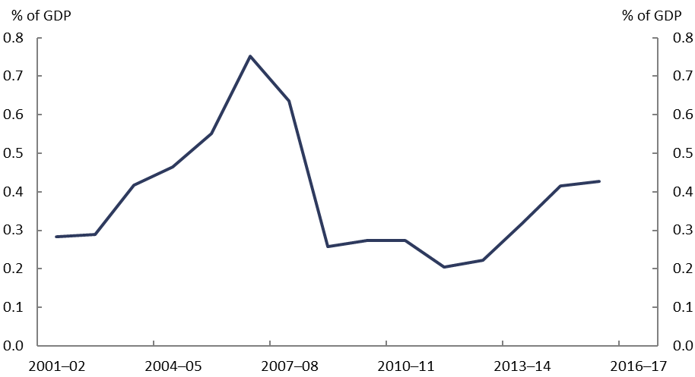

Source: ATO data and PBO analysis.

Capital gains tax for individuals is levied through the personal income tax system at the time when an asset is sold.

While capital gains are subject to the individual’s marginal tax rate, this is after the application of a 50 per cent discount for assets that have been held for over 12 months. Prior to 1999, CGT was levied on the real gain (where the nominal gain is decreased by inflation) from the asset sale. When asset prices grow at more than twice the rate of inflation, the 50 per cent discount is more generous. When asset prices grow at less than twice the rate of inflation, the previous method of taxing real capital gains is more generous.

There are also exemptions from capital gains tax, most notably the main residence exemption, which means increases in the value of the family home are not subject to tax.

Since markets fluctuate, capital gains are relatively uncertain as a revenue stream. In addition, individuals can choose when they realise their capital gains and hence their capital gains tax liability. As a result, capital gains tax revenue can be volatile, as shown in Figure 21.

#### Changes that could affect future receipts

The combination of market fluctuations and the ability of individuals to choose when they realise their capital gains tax liability through the sale of assets is likely to mean that capital gains tax receipts will continue to be volatile into the future.

Growth in asset prices will have an impact on future capital gains tax receipts. To the extent that asset price growth in the future is lower than has been experienced in the past, including in the residential housing market, this would put downward pressure on capital gains tax receipts.

Indirectly, future capital gains tax receipts could also be reduced by the increase in the use of superannuation funds to hold investment assets, although recent changes to superannuation contribution arrangements reduces the opportunity for some savings to be diverted into superannuation accounts. As previously discussed, superannuation fund capital gains typically face a lower tax rate (or no tax for capital gains realised in the retirement phase) than the capital gains for assets held by individuals outside of superannuation funds.

## Resource rent taxes

|  |  |
| --- | --- |
| **Resource rent taxes as a per cent of GDP (2016–17):** 0.08 per cent  This makes up 0.4 per cent of Commonwealth receipts. | |
| **Major drivers of the tax base** | * International oil and gas prices * Deductible expenditure for petroleum projects |
| **Trends** | Petroleum Resource Rent Tax (PRRT) has decreased as a share of GDP since 2001–02, despite the increase in petroleum production and exports and strong price growth through much of the period. |

Figure 22: Resource Rent Taxes

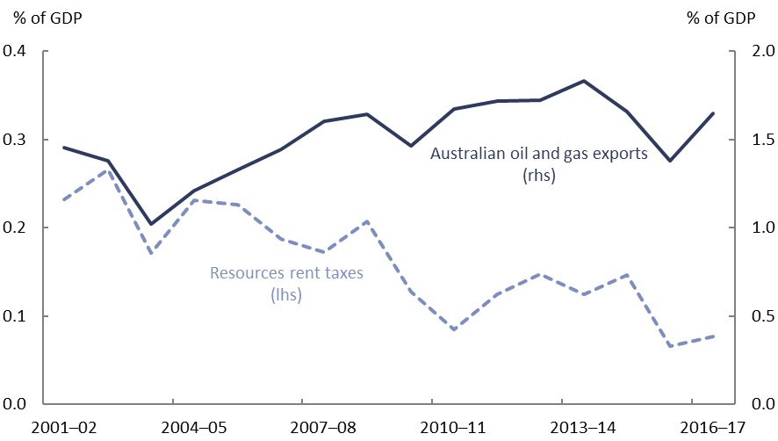

Note: Resource rent taxes comprise PRRT, MRRT, and crude oil excise. This line only includes Commonwealth taxes. North West Shelf royalty revenue, which is collected by the Commonwealth but classified as non-tax revenue, is not included.  
Source: Department of Industry, Innovation and Science - Resources and Energy Quarterly, ATO data and PBO analysis.

The PRRT is levied at a rate of 40 per cent of a petroleum or gas project’s taxable profit and applies to all onshore and offshore petroleum projects in Australia.[25] The decline in PRRT revenue shown in Figure 22 reflects reductions in oil and gas prices, declining production in mature projects, growing deductible expenditure from the recent large investment in new projects and the transfer of exploration expenditure between companies in wholly owned groups (Treasury, 2017).

The development of petroleum and gas resources requires investment, and has an associated return on that investment. If the return on the investment exceeds the return that is typically required to attract commercial investment, then this is known as an *economic rent*. The PRRT aims to capture a portion of this rent.

The taxable PRRT profit (which conceptually attempts to reflect the economic rent) arises in a year when a project has assessable receipts that exceed deductible expenditures. In years where deductible expenditure exceeds assessable PRRT receipts for a project, the excess deductible expenditure is carried forward with an annual “uplift” rate.[26]

One of the recommendations that arose from the 2017 *Petroleum Resource Rent Tax Review* was that PRRT arrangements be updated (through a consultative process) including the consideration of changes to the uplift rates for new projects. *Australia’s Future Tax System* *Review* has previously argued that the current uplift rates are too high.

While PRRT is the main resource rent tax operating in Australia currently, the Minerals Resource Rent Tax (MRRT) was applied to profits from the extraction of iron ore, coal and some coal seam gas in Australia from 1 July 2012 to 30 September 2014. The crude oil excise regime is also included as a resource rent tax, although this has been of relatively limited application since the commencement of the PRRT in 1987–88, and the transfer of Bass Strait production to the PRRT regime in 1990–91.

#### Changes that could affect future receipts

Although Australia is expected to become a leading producer and exporter of Liquefied Natural Gas (LNG) and therefore the tax base for the PRRT is expanding, there is a significant likelihood that this will not translate into higher PRRT revenue.

This is because the cost of developing many recent LNG projects in Australia has been significantly higher than estimated when companies took the decision to proceed and global gas prices are significantly lower than when these investment decisions were made.

Lower gas prices reduce the profitability of petroleum projects and result in the stock of accrued deductible expenditure for projects taking longer to be drawn down. The larger stock of accrued deductible expenditure, in turn, will continue to grow annually in line with the uplift rates, further increasing the stock of accrued deductible expenditure held by companies to offset future revenue and reduce PRRT liabilities.

# Taxes on labour

Receipts from taxes on labour were at around the same level as a share of GDP in 2016–17 as they were in 2001–02. Over 90 per cent of tax on labour is levied through the personal income tax system, since salaries and wages fall under this regime. The other main forms of income, fringe benefits and superannuation contributions, have taxes levied separately, and are shown in Figure 23. The extent to which these other forms of income are used depends on policy settings, with individuals and businesses responding to the incentives presented to them by different taxation arrangements.

Figure 23: Taxes on Labour

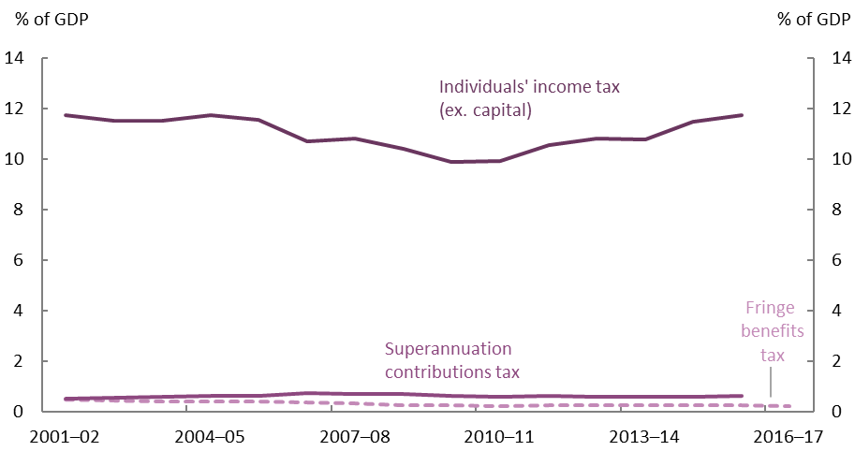

Source: ATO data and PBO analysis.

## Personal income tax

|  |  |
| --- | --- |
| **Personal income tax as a per cent of GDP (2015–16):** 11.7 per cent  This makes up 53.7 per cent of Commonwealth receipts. | |
| **Major drivers of the tax base** | * Employment and wages * Superannuation contributions |
| **Trends** | Personal income tax was at around the same level as a per cent of GDP in 2015–16 as it was in 2001–02. Within this timeframe, there was a period where personal income tax was decreasing due to a series of tax cuts, followed by a period where personal income tax has increased on account of bracket creep. Bracket creep means that without legislative changes to the tax rates and/or thresholds, personal income tax as a per cent of GDP tends to increase over time. |

Figure 24: Personal Income Tax and Salaries and Wages

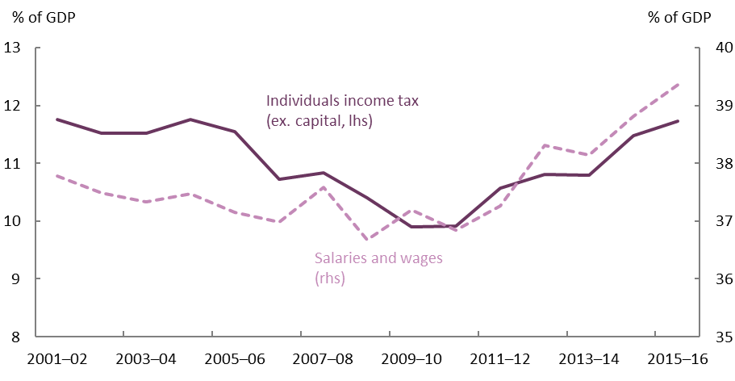

Note: Capital gains tax is not included in personal income tax and is addressed in section 3.3.

Source: ATO and ABS data, and Treasury and PBO analysis.

Personal income tax accounts for over half of the Commonwealth’s total receipts. Australia’s personal income tax system is progressive, meaning that the average tax rate paid by individuals increases with incomes. The marginal tax rate for additional income depends on an individual’s level of taxable income. The progressivity of the system is thus sensitive to policy changes to the tax thresholds and rates. It is also sensitive to the effects of bracket creep, since the tax thresholds in the personal income tax system are not indexed to wages growth.

Since bracket creep increases the average tax rate for lower-income individuals more than it does for higher‑income individuals, it lowers the progressivity of the personal income tax system over time.[27] The mid-2000s saw a series of substantial personal income tax cuts, and more recent years have seen the effects of these cuts largely reversed through bracket creep, as shown in Figure 24. Since 2009–10, bracket creep has steadily increased personal income tax receipts as a per cent of GDP, notwithstanding additional tax cuts in 2012–13.

The 2018–19 Budget included the Personal Income Tax Plan which consists of phased personal income tax cuts over the period 2018–19 to 2024–25. These changes will reduce personal income tax receipts relative to the rates and thresholds that applied prior to the change and will return some of the bracket creep that would have otherwise occurred over the medium term.

Over the longer term, bracket creep is generally returned to taxpayers through periodic tax cuts, like those included in the 2018–19 Budget. A personal tax system that manages bracket creep through periodic tax cuts provides government with flexibility around when tax cuts are offered. It also means that the distributional effects of the tax and transfer system can be taken into consideration when determining tax cuts.

#### Changes that could affect future receipts

One of the strongest factors that affect personal income tax receipts is growth in salaries and wages. If wages growth were not to recover from its subdued recent levels, this would put downward pressure on personal income tax receipts. This could occur if labour productivity growth does not improve, as has previously been analysed in the PBO publication: *The sensitivity of budget projections to changes in economic parameters*. The risks around the outlook for wages growth have been raised in a number of speeches by RBA officials (RBA 2018).

Another factor that can affect personal income tax receipts is the interaction between labour income that is taxed through the personal income tax system and other forms of labour income. In most circumstances, an employer has a specific amount that they are willing to spend to secure the services of an employee. This amount takes into account all forms of remuneration the employer provides, including superannuation contributions and fringe benefits. If superannuation contributions increase, for instance through changes to the Superannuation Guarantee, this is likely to lead to lower wage increases.[28] Since employer superannuation contributions are typically taxed concessionally compared to wages, higher superannuation contributions would be expected to result in lower tax receipts overall.

There are many changes occurring in the Australian labour market, including the well‑established increase in part time work and an anticipated shift towards a peer-to-peer economy whereby an increasing proportion of workers are likely to be at least partially self‑employed.

Increasing self-employment could reduce the proportion of people having personal income tax deducted from their wages and remitted to the ATO by their employer and increase the proportion of people that are required to assess and remit their full tax liability to the ATO themselves. The shift towards a peer-to-peer economy also has the potential to increase participation in the black economy. However, so far the proportion of individuals who identify as self-employed for their main job has not increased, as shown in Figure 25. There has also not been a sustained decrease in salaries and wages as a share of GDP (Figure 24), which might be expected if the tax base were deteriorating substantially.

Although the many disruptions taking place in the labour market will undoubtedly lead to challenges, the current data does not reveal negative implications for the personal income tax base so far.

Figure 25: Makeup of Australian workforce

Per cent of working population

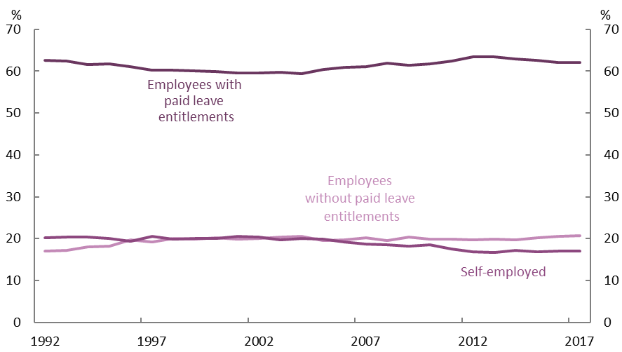

Note: Self-employed individuals are owner-managers of incorporated and unincorporated enterprises. ABS surveys ask about the participant’s “main job”, so people using the share economy as a secondary income source would not be apparent in the data.

Source: ABS data and PBO analysis.

## Superannuation contributions tax

|  |  |
| --- | --- |
| **Superannuation contributions tax as a per cent of GDP (2015–16):** 0.6 per cent  This makes up 2.9 per cent of Commonwealth receipts. | |
| **Major drivers of the tax base** | * Salary and wages * Voluntary concessional superannuation contributions |
| **Trends** | Superannuation contributions tax has increased slightly from 0.5 per cent of GDP in 2001–02 to 0.6 per cent in 2015–16. This reflects the increase in superannuation contributions over this time. |

Figure 26: Superannuation Contributions Tax

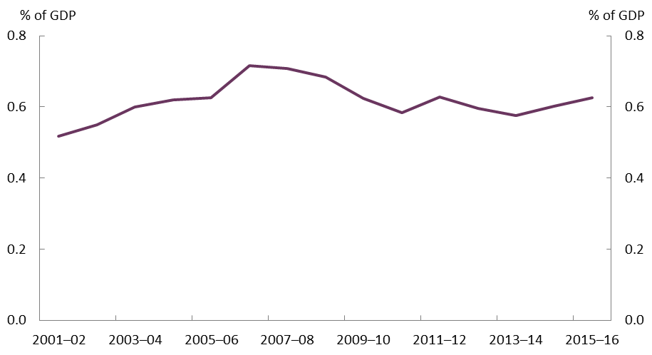

Source: ATO data and PBO analysis.

In addition to wages, labour income typically includes contributions to superannuation accounts, where the income is held until retirement. Most of these contributions are made by employers on behalf of their employees, with the Superannuation Guarantee (SG) requiring most employers to contribute 9.5 per cent of each employee’s ordinary time earnings to the employee’s superannuation fund. These contributions are made before personal income tax is applied, and are then generally taxed within the superannuation fund at the concessional rate of 15 per cent. For most individuals, the tax on superannuation contributions is not progressive, unlike the personal income tax system. The exception is for individuals with an income under $37,000 or over $250,000.[29]

As well as the compulsory employer SG contributions, employers can make additional contributions as a part of an employee’s remuneration, for example, through salary sacrifice arrangements and employees can make additional personal contributions that are concessionally taxed. This results in there being some discretion regarding the timing of superannuation contributions and the resulting superannuation contributions tax.

This discretion led to the peak in superannuation contributions tax that occurred in 2006–07 that can be seen in Figure 26. The “Simpler Super” reforms that came into effect in 2007–08 introduced changes to many related parts of the superannuation system. In particular,   
2006–07 presented strong incentives for individuals to concentrate their savings in their superannuation accounts, taking advantage of both the $50,000 annual cap on concessional contributions and the one year $1 million cap on non-concessional contributions. Since then, more stringent caps have progressively been applied.

The breakdown in remuneration growth, with a significantly higher superannuation component in 2006–07, is shown in Figure 27. This also shows the negative contribution of superannuation contributions to remuneration growth in 2009–10 and 2012–13. These flowed from decreases to the concessional superannuation caps that were introduced.

Figure 27: Contributions to nominal employee remuneration growth

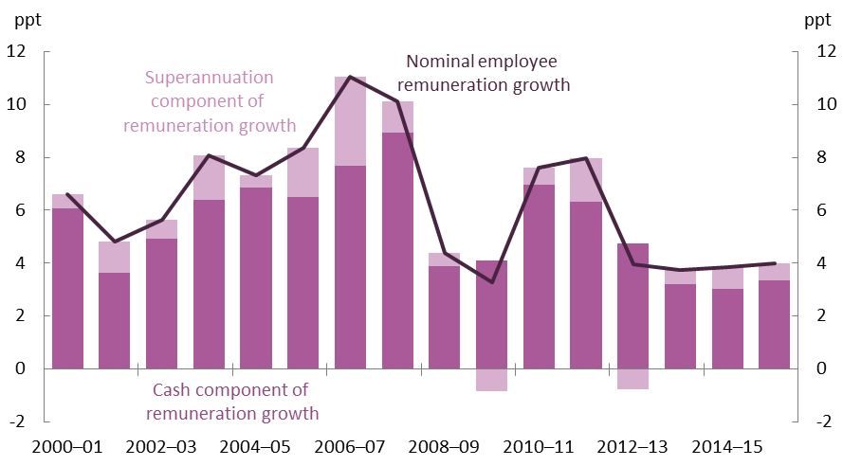

Note: Fringe benefits are also a form of remuneration. These have not been included here as complete data on fringe benefits is not collected.

Source: Taxation Statistics.

#### Changes that could affect future receipts

Around three quarters of concessional superannuation contributions are from compulsory employer contributions. These contributions, and the tax receipts associated with them, are likely to increase with the scheduled SG increases starting in 2021–22 and ending in 2025–26. Partly offsetting this, discretionary contributions and the associated tax receipts will decrease from 2015–16 levels, since a lower concessional superannuation contribution cap applies from 1 July 2017.

While increases in compulsory superannuation contributions will lead to an increase in revenue in this component of the tax system, they will lead to a fall in revenue overall, as less tax will be collected through the personal income tax system.

## Fringe benefits tax

|  |  |
| --- | --- |
| **Fringe benefits tax as a per cent of GDP (2016–17):** 0.2 per cent  This makes up 1.1 per cent of Commonwealth receipts. | |
| **Major drivers of the tax base** | * Non-cash benefits * Workforce trends |
| **Trends** | Fringe Benefits Tax (FBT) has decreased from 0.5 per cent of GDP in 2001–02 to 0.2 per cent in 2016–17, despite the increase in reportable fringe benefits over this time. This reflects a shift in the use of fringe benefits toward workplaces that are exempt from FBT. |

Figure 28: Fringe Benefits Tax

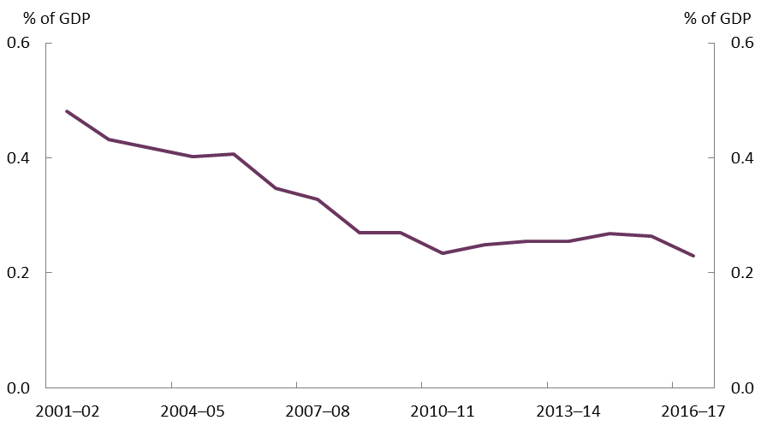

Source: ATO data and PBO analysis.

Before the 1980’s, non-cash benefits (or fringe benefits) provided to employees in Australia were untaxed. The introduction of FBT broadened the base for taxing labour remuneration, and decreased the scope for employment arrangements that minimised tax liabilities for a given level of total remuneration. FBT is paid by employers and is generally set to the highest marginal tax rate in the personal income tax system, including the Medicare levy.

Given that the introduction of FBT effectively removed the incentive to preferentially remunerate employees through fringe benefits rather than salaries or wages, it is unsurprising that FBT receipts appear to be declining steadily, as shown in Figure 28. As other policy changes were made to the personal income tax system over this period, the use of (non-exempt) fringe benefits became a more expensive option for employee remuneration.

In 2001–02, the threshold for the top personal income tax bracket was $60,000 and around 13 per cent of taxpayers were in this bracket. The threshold for the top personal income tax bracket was progressively increased from 2003–04, reaching $180,000 in 2008–09 with around 2 per cent of taxpayers in this bracket. As the FBT rate is generally set to align with the top marginal personal income tax rate, the attractiveness of fringe benefits over cash remuneration has diminished for those employees that are no longer in the top personal income tax bracket. As such, many employers opted to “cash out” benefits, replacing fringe benefits with allowances or higher salaries, which are then taxed through the personal income tax system.

Although these changes to employment arrangements have seen the use of fringe benefits by many employers decline, there are some notable exceptions. Reportable fringe benefits[30] have increased as a share of GDP over the period since 2001–02. This is partly a result of some workplaces, such as public and not-for-profit hospitals, being exempt from FBT, and therefore opting to continue using fringe benefits as a form of remuneration. In 2016‑17, almost 90 per cent of reportable fringe benefits were attributable to benefits for employees in these exempt industries, up from almost 70 per cent in 2008–09. There are also some specific types of fringe benefits that have concessional arrangements, again limiting the degree to which fringe benefits flow into FBT.[31]

#### Changes that could affect future receipts

The increase in use of fringe benefits by employers in industries that are exempt from FBT is likely to continue, given the strong growth in employment in the healthcare sector. As this remuneration is exempt from FBT, it is unlikely to translate into higher tax receipts. The increasing use of remuneration paid as fringe benefits will tend to decrease personal tax receipts. Overall, FBT is likely to remain around its current levels as a per cent of GDP.

# Other taxes

|  |  |
| --- | --- |
| **Other taxes as a per cent of GDP (2016–17):** 0.4 per cent  This makes up 1.7 per cent of Commonwealth receipts. | |
| **Major drivers of the tax base** | * Changes to charges and levies |
| **Trends** | Other taxes have increased from 0.3 per cent of GDP in 2001–02 to 0.4 per cent in 2016–17, reflecting various changes to fees and charges. |

Figure 29: Other Taxes

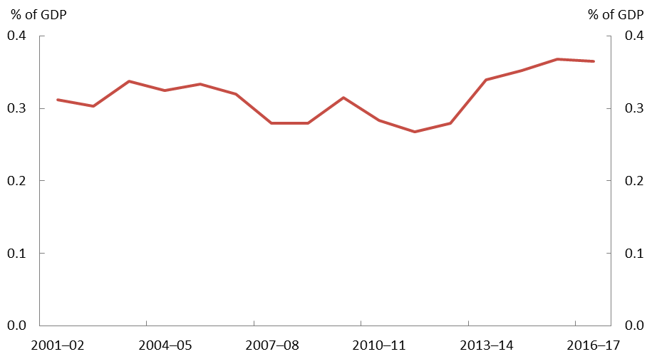

Source: Treasury data and PBO analysis.

The other taxes category comprises an eclectic collection of taxes that do not fit under the broader categories of consumption, capital, and labour taxes.

This includes items such as the passenger movement charge, agricultural levies, visa application fees, and corporations law fees.

The historical level shown in Figure 29 is higher than that which was shown in the previous PBO report *Trends in Australian Government* *receipts*. This reflects changes in the classification of various fees and charges between non-taxation receipts and taxation receipts.

Other taxes have collectively represented a small proportion of total Commonwealth taxes. Other taxes are expected to increase from 2017–18 with the introduction of the Major Bank Levy, and then remain fairly stable as a per cent of GDP.

Conclusion

Over time, economies and tax systems continually evolve. A sustainable tax base requires a tax system that is robust in its design and that evolves in light of the structural changes in the economy that occur over time.

Since 2001–02, behavioural changes and policy decisions have led to a decline in consumption tax receipts as a share of GDP. A larger share of consumption has moved to those categories that are exempt from the goods and services tax (GST). Excise duties (and excise‑equivalent customs duties) have declined across all categories, with the most notable decline observed for fuel products, resulting from the policy decision to cease the indexation of fuel excise rates between 2001 and 2014 and the improvements in fuel efficiency that have occurred over the past decade.

Similarly, both tobacco and alcohol excise have decreased as a per cent of GDP. The decrease in tobacco excise reflects the dramatic decrease in the consumption of tobacco since  
2001–02, which has been partly offset by policy decisions to increase the excise rate. The reduction in alcohol excise reflects changing consumer preferences combined with the complex and inconsistent taxation of alcohol products.

Tax on capital in Australia is primarily captured through company tax. Policy changes over recent decades have generally reduced the statutory tax rate and broadened the company tax base. Given the Government’s policy to reduce the company tax rate over the next decade, company tax receipts as a share of GDP are expected to come under further downward pressure.

For many countries including Australia, company tax receipts have been adversely affected by the increasing use of international tax planning practices, known as Base Erosion and Profit Shifting (BEPS), by multinational companies. The OECD/G20 BEPS framework is attempting to lessen the effects of these tax planning strategies, though it faces significant challenges. Australia has adopted a separate legislative response to tighten the tax laws for multinational companies, which appear to be having some effect.

Although most of the tax on capital is collected through company tax, there are other forms of savings that generate returns and are taxed outside of this system. Since 2001–02, it has become increasingly common for individuals to hold savings in superannuation, particularly since access to generous tax concessions was made more flexible. These savings are taxed concessionally (or are tax-exempt), leading to lower tax receipts from returns to this form of capital relative to other forms of capital. Further increases in the Superannuation Guarantee (which is legislated to increase from 9.5 to 12.0 per cent over the medium term) will increase the share of labour income that is concessionally taxed and the share of savings that are concessionally taxed.

Labour income can come in the form of direct earnings, superannuation contributions or fringe benefits. Direct labour earnings are taxed through the progressive personal income tax system. However, as personal income tax thresholds are not indexed, without policy change, personal income tax receipts rise as a share of GDP due to bracket creep as incomes rise. The increasing use of the ‘share economy’ could potentially affect personal income tax receipts, but as of yet the data does not show a substantial effect.

Commonwealth taxes on consumption, capital and labour each have potential vulnerabilities that warrant monitoring. Given current policy settings and recent consumption and structural trends, there is a likelihood that taxes on consumption will continue to trend downwards, taxes on capital will be flat or trend downwards and an increasing proportion of labour income will be taxed concessionally through the superannuation system. If these risks to tax receipts eventuate and in the absence of other taxation reforms, then maintaining Commonwealth Government revenue at recent levels as a share of GDP will lead to an increasing reliance on taxes on labour income through the personal income tax system.

1. – Treatment of franking credits
   1. What are franking credits?

If a company pays dividends to shareholders, these dividends sometimes come with associated franking credits. The franking credits are essentially recognition of tax that has already been paid by the company on its profit before that profit is paid out as dividends. Eligible shareholders can later be reimbursed for the tax already paid. [32]

If a company pays an unfranked dividend, the company generates a profit, pays company tax to the ATO on that profit and then pays the dividend to a shareholder. The shareholder includes the dividend as part of their taxable income, and pays tax on the (already taxed) dividend at their marginal tax rate. This is shown below in Figure A1.

**Figure A1: Taxes on profits – unfranked case**

Source: ATO and APRA data and PBO analysis.

The franked dividend case is more complex. In this case when the company generates a profit, it pays tax on this profit to the ATO (if the dividend is fully franked, this will be taxed at the full corporate tax rate) and the remaining profit is paid to the shareholder. The dividend and associated franking credit is then counted as part of the shareholder’s taxable income, which is taxed at the shareholder’s marginal tax rate and counts toward their tax liability. While the tax is originally paid by the company, this tax is refunded to the shareholder who receives the dividend – most often individuals or superannuation funds. For shareholders with a high marginal tax rate, this prevents the profit from being taxed twice. For shareholders with a low marginal tax rate, this can result in an overall refund from the ATO. This is shown below in Figure A2.

**Figure A2: Taxes on profits – franked case**

1. Shareholder with a high marginal tax rate



1. Shareholder with a low marginal tax rate



* 1. Treatment of franking credits in this report

In the case of fully franked dividends, the net tax on the company profit that is received by the ATO is determined by the shareholder’s marginal tax rate. For this reason, this is the tax that is counted as relating to the profit throughout this report.

Franking credits claimed by shareholders have been counted as reducing the original tax paid by the company, since this is the tax that is being refunded.

This avoids the confusion that can be encountered in superannuation earnings tax, where it can appear as though the return on an asset is negatively taxed. In net terms, the profit is not negatively taxed.

* 1. Effect of adjusting for franking credits

The effect of adjusting for franking credits can most easily be seen through superannuation earnings tax. Franking credits claimed by superannuation funds have increased steadily since 2001–02. With the changes in superannuation policy in the mid-2000s, the use of franking credits has the appearance of making superannuation earnings tax negative, as shown in Figure A3.

**Figure A3: Franking Credits Tax Offsets Claimed by Superannuation Funds**

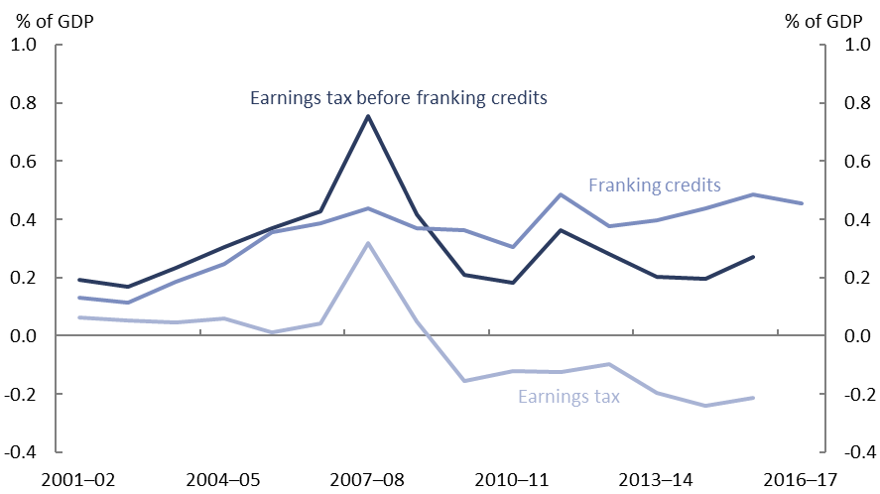

Source: ATO and APRA data and PBO analysis.

For the purposes of this report, superannuation earnings tax is the line labelled “Earnings tax before franking credits”. Measures of company taxes and the personal income taxes have been adjusted similarly.

References

|  |  |
| --- | --- |
| **ABS, 2015** | Australian Bureau of Statistics, *National Health Survey: First Results*, cat. no. 4363.0.55.001, 2014‑15 |
| **ABS, 2017** | Australian Bureau of Statistics, *Survey of Motor Vehicle Use*, cat. no. 9208.0, 2001‑2016 |
| **AEMO, 2018** | Australian Energy Market Operator (2018), *Electricity Forecasting Insights*, March 2018 |
| **ATO, 2017** | Commissioner of Taxation, *Annual Report* 2016-17 |
| **Devereux, 2017** | Devereux, Michael and Vella, John, *Implications of digitalization for international corporate tax reform,* July 2017. Oxford University Centre for Business Taxation, Working Paper 17/07 |
| **DIBP, 2016** | Department of Immigration and Border Protection, *Submission to Inquiry into illicit tobacco*, 2016 |
| **Grattan, 2016** | Grattan Institute, *Peer-to-peer pressure: Policy for the sharing economy*, April 2016 |
| **PBO, 2017** | PBO report no. 03/2017: *Changes in average personal income tax rates: distributional impacts* |
| **RBA, 2018** | Philip Lowe, *Productivity, Wages and Prosperity*, Address to the Australian Industry Group, 13 June 2018  Guy Debelle, *The Outlook for the Australian Economy*, Opening Keynote at the CFO Forum, 15 May 2018  Luci Ellis, *Three Questions About the Outlook*, Address to the ABE Conference, 13 February 2018 |
| **Treasury, 2002** | Treasury, *Treasury Submission to the Fuel Tax Inquiry*, 2002. |
| **Treasury, 2017** | Treasury, *Petroleum Resource Rent Tax Review - Final Report,* 2017 |
| **Treasury, 2018** | Treasury, Black Economy Taskforce, *Final Report,* 2018 |
|  |  |
|  |  |
|  |  |
|  |  |



[www.pbo.gov.au](http://www.pbo.gov.au/)

1. The ageing population is one of the major structural issues facing Australia. This long-term change and its associated effects on Australia’s demography and participation rate will be separately covered in the forthcoming PBO report on the implications for the budget of Australia’s ageing population.
2. Tax revenue is also susceptible to shocks to the overall state of the economy, as already shown in the PBO publication: *The sensitivity of budget projections to changes in economic parameters*.
3. Fiscal sustainability is the ability of the government to meet both current and future financial obligations (including debt servicing obligations) without major policy adjustment. Fiscal sustainability allows the government to avoid the excessive accumulation of debt that would eventually require corrective action to address.
4. Australian Government 2010, *Australia’s Future Taxation System Review* (Henry Tax review), Australian Government, Canberra.
5. This is known in economics as the “deadweight loss of taxation”.
6. While this report considers only Commonwealth taxes, we note that Commonwealth and state taxes are not entirely independent. For example, state taxes such as mining royalties and payroll tax are deductable expenses when calculating company income tax liabilities.
7. Businesses need to register for GST with the ATO if they meet certain criteria, including having a GST turnover (gross income minus GST) of $75,000 or more, or by providing taxi or limousine travel for passengers in exchange for a fare as part of their business, regardless of GST turnover.
8. However, it is only the “value added” by these operators that would not be subject to GST. The inputs purchased by the operators are still taxed.
9. Volumetric taxation is tax imposed at a fixed rate per unit of volume.
10. For the purposes of this analysis, excise duty and excise-equivalent duty are combined and referred to as excise duty for simplicity.
11. As at 5 February 2018.
12. The abolition of indexation was implemented in response to community concerns over high fuel prices (Treasury, 2002).
13. ABS, 2017.
14. This is calculated as number of current daily smokers divided by total persons (ABS 2015). As this calculation excludes the number of smokers who smoke less often than daily, this will slightly underestimate the proportion of smokers.
15. Wine producers are also eligible for a rebate of 29 per cent of the wholesale value of eligible sales, up to a maximum of $500,000 per year, which effectively offsets up to $500,000 of WET paid by each producer. From 1 July 2018, this maximum rebate will be reduced to $350,000. The producer rebate means that many small wine producers pay no net WET.
16. In this report, “taxes on capital” refers to those taxes that are levied on capital income, ie. earnings from investments and savings. Ideally this would include dividends, interest, net rental and business income, and capital gains (as per the definition in *Australia’s Future Tax System*), however the components that are more difficult to separate from the personal income tax system (interest and net rental income to individuals) have remained in the “taxes on labour” category.
17. Note that company tax receipts have been reduced by franking credits claimed by Australian residents, since the final tax is paid by the entities who receive dividend income. For a more detailed description, please see Appendix A.
18. Note that from 2015–16, there has been a lower small business company tax rate.
19. The international tax system is based on the principles of residency and source based taxation. These principles have become increasingly challenging to apply with the growth in intangible assets and cross‑border activities of multinational companies. For further discussion see the *Re:Think Tax Discussion Paper* 2015. An alternative that is often raised is a tax based on cash flow, as was raised in *Australia’s Future Tax System* *Review* 2012.

    For a critical discussion of the BEPS framework and its predication on the source based taxation system, see Devereux, 2017 ‑ *Implications of digitalization for international corporate tax reform,* Oxford University Centre for Business Taxation, Working Paper 17/07.
20. Taxes on withdrawals can also apply if superannuation assets are accessed before preservation age, or for defined benefit superannuation funds (as with some government superannuation schemes).
21. For capital gains, the capital gains tax discount (one third for superannuation funds) means that the nominal gain would be taxed at 10 per cent rather than 15 per cent for assets held for at least 12 months.
22. The concessional tax treatment is shown in item C4 in the 2017 Tax Expenditures Statement.
23. Based on the original costing in the 2016–17 Budget document, the measure to “introduce a $1.6 million superannuation transfer balance cap” will increase superannuation earnings tax receipts by around 0.03 per cent of GDP in 2017–18, increasing to 0.04 per cent of GDP in 2018–19.
24. This possibility has been raised elsewhere, for instance the Treasury *Re:Think* discussion paper and the Grattan Institute *Super Tax Targeting* report.
25. In 2012–13, the PRRT was extended to onshore oil and gas projects and the North West Shelf.
26. The uplift rate is given by the long-term bond rate plus either 15 percentage points for exploration expenditure or 5 percentage points for general project expenditure. Exploration expenditure incurred after 1 July 1990 is also transferable to other petroleum projects covered by the PRRT within a company under certain conditions.
27. A static tax schedule combined with growing nominal incomes results in higher personal income tax receipts over time compared to the overall size of the economy, in a process known as ‘bracket creep’. For more detail on the impacts of bracket creep, see PBO 2017.
28. Bateman and Pigott’s 1998 paper *Mandatory Retirement Saving in Australia* describes how increases in mandatory superannuation contributions have previously been taken into account in negotiations for overall remuneration packages, as was the intention when the SG arrangements were first introduced.
29. Low income earners are also eligible for the Low-Income Superannuation Tax Offset (LISTO) so they do not face a higher rate of tax on superannuation contributions than on their income earned through the personal income tax system. Additional tax applies for individuals who earn over $250,000 in a financial year.
30. If an employer provides certain fringe benefits with a total taxable value in excess of a particular threshold ($2,000 for the FBT year ending 31 March 2018), they are required to report the value of the fringe benefits to the Australian Taxation Office (ATO) through the employee's payment summary for the corresponding income year. Organisations that are exempt from FBT are still required to report the fringe benefits in excess of the threshold to the ATO.
31. For a full list of exemptions to FBT, see items D1 through to D50 in Treasury’s 2017 Tax Expenditures Statement.
32. This is not all shareholders. The main exception is foreign residents, who are unable to claim franking credits.