Net Debt and Investment Funds
Report No.
01/2019
Trends and Balance Sheet Implications

© Commonwealth of Australia 2019
ISBN 978-0-6483701-0-9 (online)
Copyright notice
This work is licensed under the Creative Commons Attribution-NonCommercial-NoDerivs
3.0 Australia License http://creativecommons.org/licenses/by-nc-nd/3.0/au/
Attribution
This publication should be attributed as follows: Parliamentary Budget Office, Net Debt and Investment Funds – Trends and balance sheet implications.
Use of the Coat of Arms
The terms under which the Coat of Arms can be used are detailed on the following website: www.itsanhonour.gov.au/coat-arms
Feedback
If you found this report useful, or have suggestions for improvement, please provide feedback to feedback@pbo.gov.au.

NET DEBT AND INVESTMENT FUNDS—Trends and balance sheet implications
Contents
Overview 1
1 Understanding net debt 2
2 A closer look at the Future Fund and other investment funds 8
3 Alternative net debt calculation 13
4 Net Financial Worth as a broader measure of sustainability 15
Appendix A 17
References 18

Overview
When parliamentarians, journalists, and other interested members of the community look to
the budget for a longer term indicator of the sustainability of the government’s financial position, they often look to net debt. Indeed, this is a figure that successive Commonwealth governments
have referred to when discussing the fiscal position. This paper examines the impact of growth in government investment funds on net debt.
The gap between gross debt and net debt has widened considerably over the past decade,
largely due to growth of government investment funds, especially the Future Fund.
This widening gap illustrates how government investment funds have strengthened the balance sheet. Almost all of the increase in the gap between gross and net debt is explained by increases in assets classified as ‘investments, loans and placements’. These are primarily Future Fund investments made through investment structures called ‘collective investment vehicles’.
Estimates of net debt are increasingly sensitive to both the investment strategies and the particular investment structures adopted by these funds.
As the value of investment fund assets increases, changes in the share of assets held in debt securities rather than listed equities have more significant impacts on net debt. Furthermore, increasing use of investment structures such as collective investment vehicles affect estimates of
net debt. This is because investments made through such structures are treated as debt-like assets
in the calculation of net debt. This is despite a significant share of the underlying assets in collective investment vehicles appearing to be equity-like in nature. If these equity-like assets were held directly by the investment funds, measures of net debt would be higher.
Conceptually, an alternative approach would be to focus on the underlying assets held in investment funds when defining net debt.
This approach would ‘look through’ investment structures to the underlying assets and would mean measures of net debt would not be affected by whether assets are held directly or through particular investment structures. Calculated in this way, net debt could be up to around $70 billion (just under 4 per cent of GDP) higher in 2017–18.
This is a matter of budget reporting and transparency; not accounting treatment.
The accounting treatment of these assets in the Commonwealth Financial Statements has been reviewed by the Auditor-General and is not in question here. The focus in this report is conceptual—whether the long-standing frameworks that define net debt would benefit from review in light of the growing use of investment funds. Either way, additional transparency around the treatment of these investment fund assets would aid public understanding given their size and growing impact. Currently over 50 per cent of the assets that offset the liabilities in the net debt calculation are classified as ‘Other’ in the budget papers.
Net financial worth, which is also published in the budget, is a broader measure of fiscal sustainability that includes all financial assets and liabilities.
Over the period ahead, broader measures of the fiscal position, such as measures of net financial worth, will arguably provide a more comprehensive and consistent indicator of the Commonwealth balance sheet position because they include a wider range of assets and liabilities.

Understanding net debt
Over recent years, governments have increasingly focussed public debate on balance sheet indicators, with reducing net debt and improving net financial worth currently part of the
medium-term fiscal strategy. In public debate, net debt is widely regarded as a key budget indicator by which fiscal sustainability can be assessed.
What is meant by net debt and how it is calculated, however, is often not well understood.
Most households and companies would measure their net debt as the total amount of debt they
hold less their interest-bearing assets (cash and interest bearing deposits) that could be used to pay off the debt immediately if required. While the Commonwealth government’s net debt figures are produced using a broadly comparable framework, there are important nuances in the calculation of net debt which this report seeks to explain.
This report highlights, in particular, the impact of assets held in investment funds on measures of
net debt and how the treatment of these assets is reducing the measured level of net debt.
It is important to emphasise that the focus of this report is on budget transparency and improving public understanding of net debt concepts and trends. The appropriate accounting treatment of assets in the Commonwealth’s Consolidated Financial Statements is a matter for the Department
of Finance, and is reviewed annually by the Auditor-General.

Defining net debt
Net debt is defined by the International Monetary Fund (IMF) as gross debt minus financial assets corresponding to debt instruments.
The definition adopted by the Commonwealth government is that net debt is the sum of government securities (at market value) and other interest bearing liabilities, minus the sum of cash and deposits, advances paid (such as student loans) and investments, loans and placements (which includes some of the assets managed by government investment funds such as the Future Fund)., The specific components of net debt on the Commonwealth balance sheet, along with some examples of the types of liabilities and assets in each category, are set out in Table 1-1.

Table 1–1: Components of net debt
 |  | Net Debt
Liabilities | Commonwealth Government Securities on issue – Market Value | 
 | Other interest bearing liabilities  (eg. Deposits held, loans, other borrowing) | 
 | Superannuation liabilities
 | Other liabilities
Financial Assets | Cash and deposits | 
 | Advances paid  (eg. Student loans, loans to state & territory governments) | 
 | Investments, loans and placements  (eg. IMF quota, Future Fund collective investment vehicles and interest-bearing securities) | 
Other receivables
(eg. Taxes receivable, prepayments)
Equity investments
(eg. Future Fund investments in listed equities)
Source: 2018–19 Mid-Year Economic and Fiscal Outlook

As net debt comprises certain financial assets and liabilities but not others, it is a partial indicator
of the balance sheet.
The budget papers also publish information on gross debt and net financial worth, amongst other indicators, to allow for a more comprehensive analysis of fiscal sustainability. Net financial worth
is discussed further in Section 4.

How and where is net debt defined?
The content of the Commonwealth budget, and the financial statements contained within it,
is governed by a range of legislation, accounting standards and frameworks.
Net debt is a budget concept defined by government, drawing on the application of
accounting standards.
Framework for Budget reporting
The Charter of Budget Honesty Act 1998 requires that budget estimates are based on external reporting standards. These are:
- the Australian Accounting Standards, which include International Financial Reporting Standards as adopted in Australia and the public sector specific standard AASB 1049
Whole of Government and General Government Sector Financial Reporting; and
- the Australian Bureau of Statistics’ accrual Government Finance Statistics publication, which in turn is based on the International Monetary Fund accrual Government Finance Statistics framework.
The Australian Accounting Standards determine how assets are valued and classified in the budget. They do not define net debt, nor do they require the publication of net debt in the consolidated financial statements. The Australian Bureau of Statistics’ Government Finance Statistics publication provides a number of alternative measures of net debt to provide a broader picture of the government's fiscal position.
Defining net debt
The Commonwealth, state and territory governments have an agreed framework —
the Uniform Presentation Framework — for how government financial information will be presented on a consistent basis across jurisdictions. The Uniform Presentation Framework specifies that net debt is to be measured using the framework set out in Table 1-1.
This definition illustrates that the classification of assets for accounting purposes directly affects their treatment in net debt calculations. This approach to measuring net debt is long standing and has been consistently applied by Governments since 1999.
Auditing of Commonwealth finances
At the end of each financial year, the government releases a set of financial statements which consolidates the audited accounts of entities across the public sector.
These are prepared in accordance with the relevant Australian Accounting Standards.
The Auditor-General independently audits the consolidated financial statements.
The Commonwealth budget, the financial statements contained within it, and additional indicators such as net debt are not independently audited by the Auditor-General.
Source: 2018–19 Budget Paper no.1; Commonwealth of Australia consolidated financial statements for the year ended 30 June 2018; Uniform Presentation Framework, February 2019

Size of Commonwealth Government net debt
Although Australia’s debt levels remain relatively low by international standards, both gross and net debt have increased significantly since the Global Financial Crisis. In the 2018–19 Mid-Year Economic and Fiscal Outlook, net debt as a proportion of GDP is assessed as having peaked in 2017–18 and is projected to decline over the next decade reflecting the reduced financing task from the projected move to budget surpluses.
Figure 1-1 shows net debt and gross debt over the period 1999–2000 to 2028–29. It illustrates that the Government projects that net debt will fall from 18.5 per cent of GDP ($342.0 billion) in 2017–18 to 14.3 per cent of GDP ($312.6 billion) in 2021–22. Beyond the forward estimates, the Government projects that net debt will fall to 1.5 per cent of GDP ($48.4 billion) by 2028–29.

Figure 1-1: Commonwealth Government debt
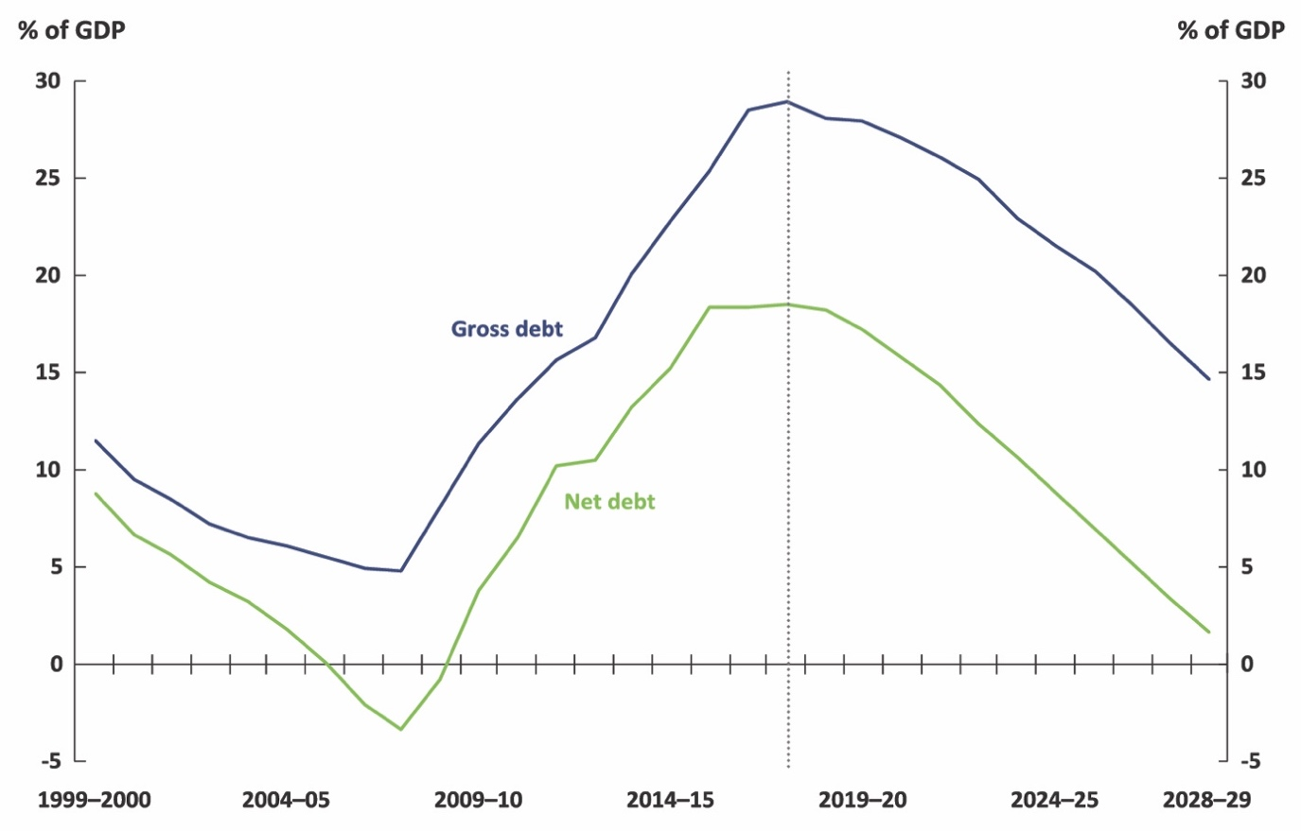
Source: Mid-Year Economic and Fiscal Outlook, 2018–19

As outlined in the PBO’s 2018–19 Budget Medium-term projections report, the projected improvement in the net debt position over the next decade is not without precedent.
Following expansionary fiscal policy in the wake of the early 1990s recession, net debt increased
to 18.2 per cent of GDP in 1995–96. Net debt fell continuously over the next decade to reach
-3.4 per cent of GDP in 2007–08.
There were specific factors that drove the improvement in the budget balance and consequently
net debt over this period. In particular, the Government undertook a program of selling government-owned businesses (public non-financial corporations), using the proceeds to pay off Government debt.
The sales were large and staggered over the period and included the sale of the Commonwealth Bank, airports and, most significantly, Telstra. Further aiding the speed of fiscal consolidation was the largest sustained boost to the terms of trade in Australia’s history, which translated into a considerable boost to national income and taxation revenue. Over the next decade, the reduction in net debt, in contrast, is projected to be driven predominantly by ongoing fiscal discipline leading to the maintenance of budget surpluses.

Growing difference between gross debt and net debt
Figure 1-1 also illustrates that the gap between gross debt and net debt has widened substantially over the past two decades, from 2.7 per cent of GDP in 1999–2000 to 10.4 per cent of GDP in
2017–18. Figure 1-2 shows that almost all of this difference can be explained by increases in assets characterised as ‘investments, loans and placements’. While the impact of ‘net other’ changes is significant in some individual years, it cannot explain the trend increase in the difference between gross and net debt.

Figure 1-2: Drivers of the difference between gross debt and net debt
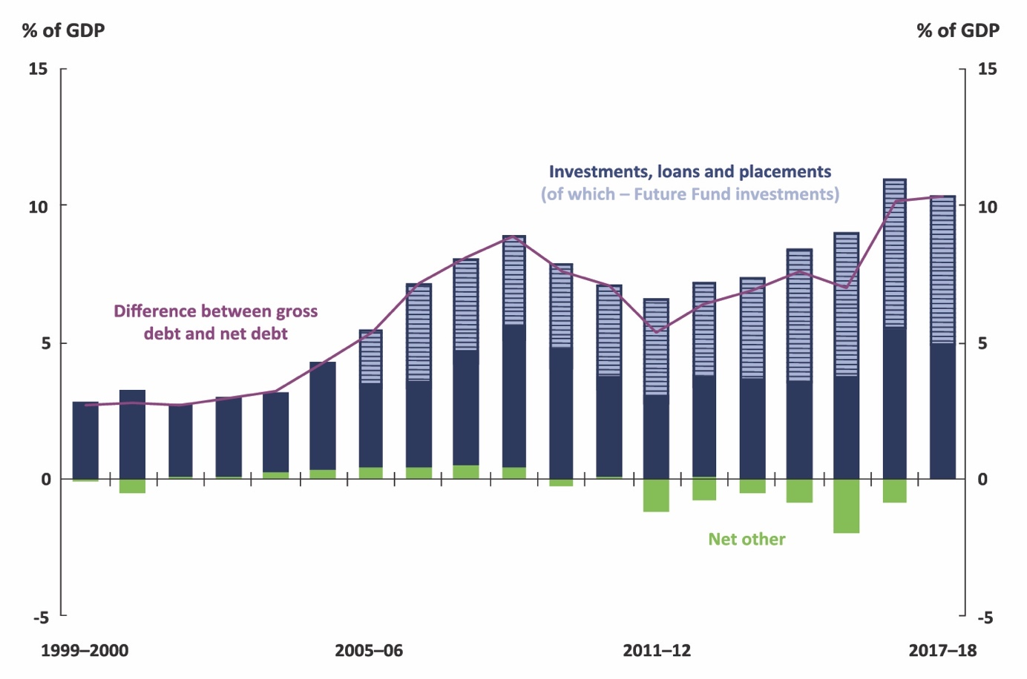

Note: The balance sheet components that have been aggregated into ‘Net Other’ are ‘Advances Paid’, ‘Cash and Deposits’, ‘the difference between the face value and market value of CGS’ and ‘Other Interest-Bearing Liabilities’.
Source: ABS; AOFM data; FFMA Annual Reports (investment performance section and notes to audited financial statements); Budget Papers historical data and PBO calculations based on publicly available information

Within the budget papers, ‘investments, loans and placements’, in turn, are broken down into
three categories—‘deposits’, the ‘IMF quota’ and ‘other’. The ‘other’ category accounts for around 70 per cent of ‘investments, loans and placements’. This is the category that captures investment fund assets, including assets held by the Future Fund, that are offset against liabilities when calculating net debt.
Not surprisingly, and as shown in Figure 1-2, within ‘investments, loans and placements’, the most significant development has been the establishment of, and growth in, the Future Fund, although other assets captured by this budget line item have also roughly doubled as a share of GDP over
the past two decades.
Given the growing size and impact of ‘investments, loans and placements’ in the calculation of
net debt, additional detail on its components, particularly the ‘other’ component, would be a valuable addition to the budget papers and would aid the public understanding of, and confidence
in, measures of net debt. Currently over 50 per cent of the value of assets that are offset against interest-bearing liabilities in the calculation of net debt are characterised as ‘other’ in the
budget papers.
The budget treatment of the assets held in investment funds is explored further in the next section; and a complete reconciliation of gross debt and net debt in the budget is provided at Appendix A.

A closer look at the Future Fund
and other investment funds
Successive Commonwealth Governments have created a number of investment funds since 2006, which have grown to a combined total value of $175.5 billion (9.5 per cent of GDP) as at 30 June 2018.
The Future Fund is a sovereign wealth fund designed to strengthen the Commonwealth’s long-term financial position, while other investment funds have been established for specific purposes with drawdowns hypothecated to specific programs or priorities.
The Future Fund was valued at $145.8 billion (7.9 per cent of GDP) as at 30 June 2018, with the other investment funds collectively valued at $29.8 billion (1.6 per cent of GDP). These other funds include the DisabilityCare Australia Fund ($14.8 billion), the Medical Research Future Fund ($7.2 billion),
the Building Australia Fund ($3.9 billion), and the Education Investment Fund ($3.9 billion).
The combined value of these investment funds is more than one third of the total financial assets
on the Commonwealth balance sheet, and is projected to continue to grow over the medium term.

Future Fund investment allocations
As the largest of the investment funds, the Future Fund’s impact on the government’s balance
sheet has been particularly pronounced. The Future Fund was initially financed by contributions
from the Commonwealth Government, consisting of cash from budget surpluses and Telstra shares.
The Telstra shares were gradually sold off as the Future Fund began progressively diversifying its portfolio, which today includes investments in a wide range of assets including cash, interest-bearing securities, listed equities, private equities, tangibles (property, infrastructure and timberland assets) and alternative assets.
In addition, the Future Fund increasingly invests through ‘collective investment vehicles’, which are entities that enable investors to pool their money and invest the pooled funds, rather than buying assets directly. Future Fund assets in collective investment vehicles accounted for 47 per cent of the total portfolio value – or $67.9 billion – as at 30 June 2018.
A significant proportion of Future Fund assets, including those held in collective investment vehicles, are invested via holding companies, which are used by the Future Fund for administrative and tax purposes. Approximately $47.2 billion of the assets held in collective investment vehicles are invested via these holding companies. These holding companies are wholly owned by the
Future Fund.
Given the complexity of these arrangements, this report does not distinguish between collective investment vehicles held directly and indirectly by the Future Fund. This is consistent with their treatment on the Commonwealth balance sheet where all Future Fund assets held in collective investment vehicles are treated in the same way.

Budget treatment of Future Fund assets
Figure 2.1 shows the Future Fund asset portfolio on two different bases. Figure 2.1a shows
the Future Fund assets as they are captured in the Commonwealth budget. It shows that as at 30 June 2018, 23 per cent of the Future Fund portfolio was invested in interest-bearing securities, 30 per cent was directly invested in equities and 47 per cent was invested through collective investment vehicles.
Figure 2-1: Future Fund asset portfolio
- Commonwealth budget treatment | - Look-through basis
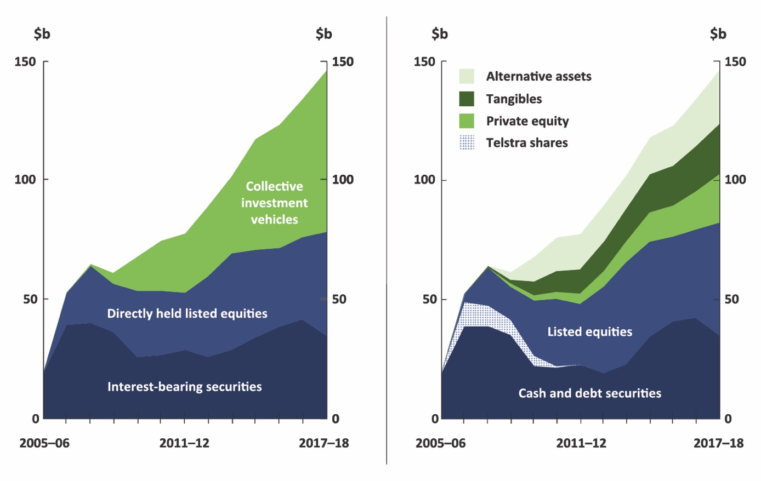

Note: Some categories in the asset class look-through basis (RHS) approximately correspond to the Commonwealth Budget categories (LHS); however the categories are not strictly equivalent. For example, most listed equities (RHS) are directly held (LHS), however some listed equities are held in collective investment vehicles. Similarly, most (but not all) alternative assets, tangibles, and private equities are held through collective investment vehicles. Cash and debt securities (RHS) differs slightly from interest-bearing securities (LHS) due to differences between reporting for budget purposes and Future Fund Annual Reports (investment performance section and notes to audited financial statements).
Source: Future Fund Annual Reports (investment performance section and notes to audited financial statements) and PBO calculations

In the budget papers, both interest-bearing securities and collective investment vehicle holdings
are classified as ‘investments, loans and placements’ while directly-held listed equities are generally classified as ‘equity investments’. These classifications are based on the accounting standards.
Given that, as outlined in Table 1-1, net debt is calculated as interest-bearing liabilities minus selected financial assets, and since these selected financial assets include all assets characterised
as ‘investments, loans and placements’, around 70 per cent of the value of Future Fund assets contributed towards reducing estimates of net debt in 2017-18.
Figure 2-1b shows the underlying asset classes of the Future Fund portfolio on a look-through basis, as disclosed in the Future Fund annual reports and quarterly portfolio updates. As at 30 June 2018, cash and debt securities accounted for 24 per cent of total assets, total equities (private and listed) accounted for 46 per cent of total assets and tangibles (largely infrastructure investments) and alternative assets accounted for the remaining 30 per cent.
A comparison of figures 2-1a and 2-1b illustrates that as the Future Fund portfolio has grown over the past decade and there has been an increase in the share of assets held in collective investment vehicles, there has also been a commensurate increase in holdings of private equities, tangibles and alternative assets. A significant proportion of these assets have characteristics that appear to be closer to equity-type assets than debt-type assets.
This examination of the Future Fund illustrates two points.
First, net debt is now quite sensitive to the investment strategy adopted by the Future Fund given the significant value of assets under management. While the Future Fund is managed independently from Government under a legislated investment mandate, the choice of assets purchased by the Future Fund can have a material impact on net debt. By way of example, if the Future Fund increased the share of directly-held listed equities to 40 per cent of the portfolio, net debt would have been around $15 billion or close to one per cent of GDP higher in 2017–18. A broader indicator of the balance sheet, such as net financial worth, would not be affected.
Second, net debt is sensitive to the investment structures used by the Future Fund. Since the Future Fund’s inception, net debt figures published in budget documents by successive governments have treated assets in collective investment vehicles as debt-like assets. This treatment was initially determined when Future Fund assets consisted mainly of listed equities, cash and debt securities, while investments through collective investment vehicles were small in value. The increasing use
of collective investment vehicles to hold equity-type assets has reduced estimates of net debt relative to the alternative of holding these assets directly. If the Future Fund had decided to sell all
of its directly-held listed equities and repurchase those same equities through collective investment vehicles, net debt would have been around $44 billion or 2.4 per cent of GDP lower in 2017–18.
This second point shows that under the current budget treatment, changes in investment structures may affect estimates of net debt even when there is no change in the underlying assets held by the fund. Section 3 presents an alternative conceptual approach to the treatment of these assets in the calculation of net debt.

Budget treatment of other investment funds
Before turning to this alternative approach, it is worth briefly examining the current budget treatment of assets held in the other government investment funds.
Under current budget conventions, all of the assets held in any government investment fund other than the Future Fund are captured in the ‘other’ category of ‘investments, loans and placements’.
As such, all the assets in these other funds are treated as debt-like assets and reduce estimates of net debt. The Department of Finance Annual Report shows that most of these funds are predominantly invested in interest-bearing securities.
However, this is not currently the case for the Medical Research Future Fund. Figure 2.2a shows
that the majority of the Medical Research Future Fund portfolio is held in interest-bearing securities,
but around 15 per cent of the assets are directly-held listed equities and around 30 per cent are held
in collective investment vehicles. Unlike the Future Fund, however, all of the assets of the Medical Research Future Fund, including the directly-held listed equities, have been classified as ‘investments, loans and placements’ in the budget papers.

Figure 2-2: Medical Research Future Fund asset portfolio
- Commonwealth budget treatment | - Look-through basis
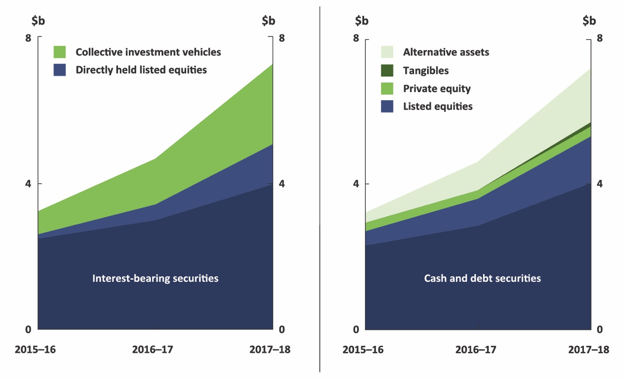

Note: The portfolio values presented in figures 2-2a and 2-2b are as at 30 June, however the total
portfolio values differ slightly between the Future Fund portfolio updates and the Department of Finance
Annual Consolidated Financial Statements. Some Commonwealth Budget categories (LHS) approximately correspond to the categories in the look-through basis (RHS); however the categories are not strictly equivalent. Cash and debt securities (RHS) differs slightly from interest-bearing securities (LHS) due to differences between reporting for budget purposes and disclosure statements in quarterly portfolio updates from the Future Fund.
Source: Department of Finance Annual Reports, and Future Fund portfolio updates

Figure 2.2b shows the underlying asset classes of the Medical Research Future Fund portfolio on a look-through basis, as disclosed in the Future Fund quarterly portfolio updates. As at 30 June 2018, around 45 per cent of the underlying assets held by the Medical Research Future Fund were listed equities, private equity, tangibles (such as property) and alternative assets. The remaining 55 per cent were cash and debt securities. Like the Future Fund, a significant proportion of the Medical Research Future Fund’s assets appear to be equity-type in nature.
As the Government’s balance sheet has expanded and it is being used more actively for fiscal policy purposes, transparency around these evolving structures and the impact on key fiscal indicators is important to understand underlying trends.

Alternative net debt calculation
An alternative conceptual approach would be to treat collective investment vehicles on a
look-through basis in the calculation of net debt; that is, to assess net debt on the basis of the underlying assets. This would remove the effect that different investment structures can have on the measure. On the evidence available, this would suggest a significant proportion of the assets held in these vehicles would be treated as equity-type assets and therefore not used to offset liabilities in the calculation of net debt.
The degree of complexity involved for the Future Fund to report on the underlying assets for the purposes of net debt calculations in the budget is unclear, although information on the underlying asset classes is currently disclosed in notes to its audited financial statements and in the budget papers. For forecasts and projections in the budget, one option could be to use the latest portfolio asset class allocation. Alternative approaches could also be considered.
For illustrative purposes, Figure 3-1 shows the impact on net debt of assuming that all of the assets held in collective investment vehicles are equity-type in nature and treating them like ‘equities’ rather than ‘investment, loans and placements’ in the calculation of net debt.

Figure 3-1: Commonwealth Government debt
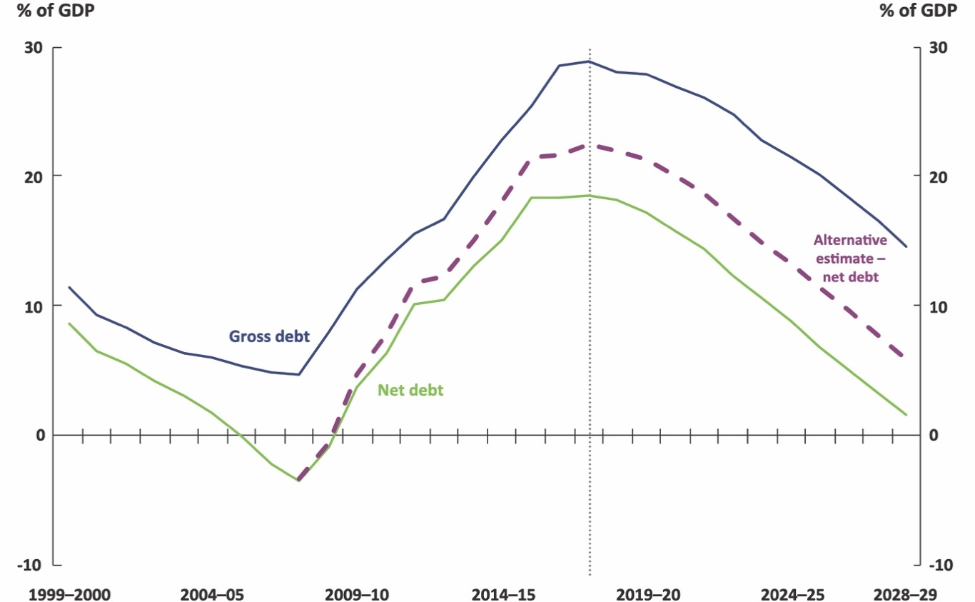
Note: Under the alternative estimate – net debt approach, the only Future Fund and Medical Research Future Fund assets that are used to offset liabilities in the net debt calculation are the directly held assets that are cash or debt-like in nature. Projections assume that the portfolio asset class shares as at 30 June 2018 are held constant over the medium-term.
Source: 2018–19 Mid-Year Economic and Fiscal Outlook, Department of Finance Annual Reports, Future Fund Annual Reports (investment performance section and notes to audited financial statements) and PBO calculations
Under this alternative approach, the only Future Fund and Medical Research Future Fund assets used to offset liabilities in the net debt calculation are the directly held assets that are cash or debt-like in nature. The portfolio asset class shares as at 30 June 2018 are assumed to be held constant over the medium-term projection period.
This alternative estimate of net debt is around $70 billion (just under 4 per cent of GDP) higher in 2017–18 than was reported in the budget papers and would be expected to be just under 4.5 per cent of GDP higher in 2028–29 as the value of these funds continues to grow.
This example presents the upper bound of the impact of a look-through calculation of net debt –
that is, if all assets in collective investment vehicles were determined to be equity-like in nature.
If some ‘alternative assets’ were determined to be closer to debt-like in nature, the gap between
this alternative measure and current estimates of net debt would be smaller.
This alternative estimate demonstrates the degree to which investment structures can affect the measure of net debt. Changing the net debt treatment of equity-type assets held in collective investment vehicles has no impact on the balance sheet or the sustainability of the budget position, because the total value of the government’s assets are unchanged. However, it would have a material impact on the measure of net debt.
As the value of government investment funds continues to grow, there may be merit
in reviewing whether the current treatment of these funds in the net debt calculation remains appropriate given the changing nature of the underlying assets and their growing impact. A review would need to consider the conceptual purpose of a measure of net debt and the role of net debt
in the government’s fiscal strategy. It would also need to take into account the broader budget frameworks and standards as well as the international standards which are drawn upon. Such a review would be particularly important if governments were to adopt more specific targets for net debt over specific time horizons, as under the current framework, the achievement of these targets could inadvertently depend on the investment structures used in government investment funds.

Net Financial Worth as a broader measure of sustainability
As discussed earlier in this paper, net debt is one of a number of balance sheet indicators published in each budget update that is given particular prominence as a key indicator of fiscal sustainability.
Net financial worth is one of the broader balance sheet indicators reported in the budget. It measures
the total financial liabilities of the government offset by its financial assets. It excludes only non-financial assets such as land, buildings, equipment and infrastructure. Importantly, it includes unfunded superannuation liabilities and holdings of equity which are significant components of the balance sheet.
Table 4-1 shows a comparison of the components of the Commonwealth balance sheet that are captured in net debt and net financial worth. Figure 4-1 shows historic and projected levels of net debt and net financial worth.

Table 4–1: Components of net debt and net financial worth
 |  | Net Debt | Net Financial Worth
Liabilities | Commonwealth Government Securities on issue – Market Value |  | 
 | Other interest bearing liabilities  (eg. Deposits held, loans, other borrowing) |  | 
 | Superannuation liabilities |  | 
 | Other liabilities |  | 
Financial Assets | Cash and deposits |  | 
 | Advances paid  (eg. Student loans, loans to state & territory governments) |  | 
 | Investments, loans and placements  (eg. IMF quota, Future Fund collective investment vehicles and interest-bearing securities) |  | 
 | Other receivables  (eg. Taxes receivable, prepayments) |  | 
 | Equity investments  (eg. Future Fund investments in listed equities) |  | 
Source: 2018–19 Mid-Year Economic and Fiscal Outlook

Figure 4-1: Commonwealth net debt and net financial worth
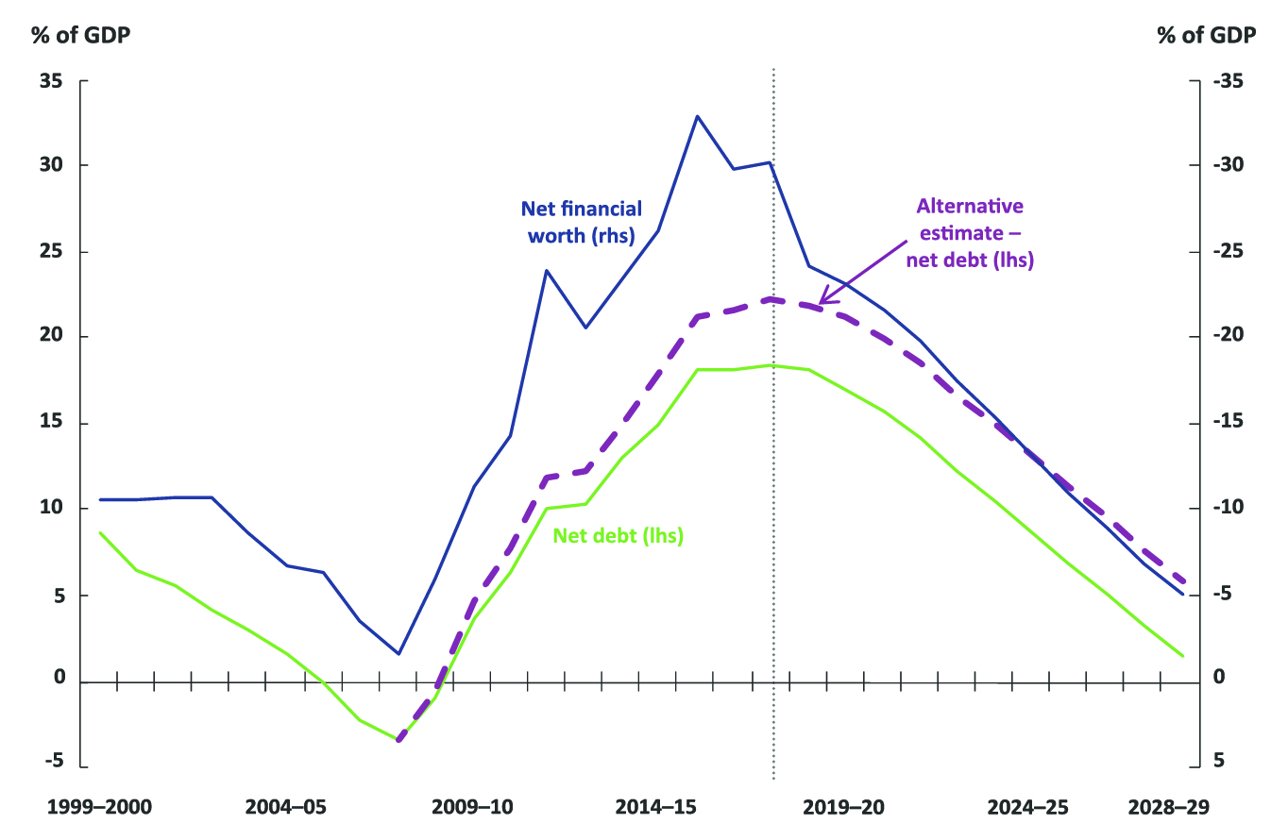
Note: Under the ‘alternative estimate - net debt’ approach, the only Future Fund and Medical Research Future Fund assets that are used to offset liabilities in the net debt calculation are the directly held assets that are cash or debt-like in nature. Projections assume that the portfolio asset class shares as at 30 June 2018 are held constant over the medium-term.
Source: 2018–19 Mid-Year Economic and Fiscal Outlook, Department of Finance Annual Reports, Future Fund Annual Reports (investment performance section and notes to audited financial statements) and PBO calculations

The main drawback of net financial worth is that it is more affected by revaluations of assets and liabilities, particularly in relation to unfunded superannuation liabilities and the Commonwealth’s equity-type investments. This can result in net financial worth being more volatile than net debt.
Unlike net debt, however, net financial worth is not affected by asset allocation decisions within investment funds as all financial assets are included in its calculation. Similarly net financial worth does not depend on whether financial assets are classified as debt- or equity-like investments, or by investment funds changing the structure of their investment portfolio through the use of structures such as collective investment vehicles. And, as highlighted above, it captures the full balance sheet impact of the government’s investment funds which are increasing over time.
Furthermore, because net financial worth includes superannuation liabilities as well as assets which have been accumulated to help manage these liabilities, it will be less affected than net debt by the impact of drawing down on the Future Fund assets in the future. This is because these drawdowns will correspond with a period in which the corresponding liabilities are also falling.
Overall, net financial worth is a broader indicator of the sustainability of the fiscal position. The fact that net financial worth includes a broader range of assets and liabilities means that it arguably provides a more comprehensive and consistent picture of the balance sheet over time.

Appendix A
Table A–1: Reconciliation of gross debt and net debt in the budget as at 30 June 2018
 | $b
Gross Debt (Commonwealth Government Securities at Face Value) | 531.9
Difference Between Face – Market Value | 43.5
Commonwealth Government Securities (Market Value) | 575.4
[+] Deposits held | 0.4
[+] Loans | 18
[+] Other Borrowing | 1.5
Interest Bearing Liabilities | 595.4
[-] Cash and deposits | 6.8
[-] Advances paid | 56.1
Loans to State and Territory Governments | 3.9
Student Loans | 40.9
Other | 11.5
Less Provisions for doubtful debts | -0.4
[-] Investments, loans and placements | 190.6
IMF Quota | 12.5
Investments – Deposits | 49.6
Other | 128.6
Net Debt | 342.0
Source: 2017–18 Final Budget Outcome

References
Australian Bureau of Statistics (2018) Government Finance Statistics, 55120DO002, Australia, 2016-17
Australian Bureau of Statistics (2015) Australian System of Government Finance Statistics: Concepts, Sources and Methods, ABS Catalogue No. 5514.0.
Australian Office of Financial Management, (2018) https://aofm.gov.au/statistics/overview-of-portfolio/
Commonwealth of Australia (2018) the Mid-Year Economic and Fiscal Outlook 2018-19, December 2018
Commonwealth of Australia (2018) Budget 2018-19, May 2018
Commonwealth of Australia (2018) Final Budget Outcome 2017-18, September 2018
Commonwealth of Australia (2019) Uniform Presentation Framework, February 2019
Department of Finance (2018-2015) Annual Reports 2017-18 to 2014-15
Future Fund (2018-2006) Annual Reports 2017-18 to 2005-06, Future Fund Board of Guardians.
Future Fund (2018-2016) Quarterly Portfolio Updates 2017-18 to 2015-16, Future Fund Board of Guardians.
IMF (2014) Government Finance Statistics Manual 2014, Washington, D.C
PBO (2018) National fiscal outlook, Parliamentary Budget Office, Report no 04/2018, Parliament of Australia.
PBO (2018) 2018-19 Budget: Medium-Term Projections, Parliamentary Budget Office, Report no 03/2018, Parliament of Australia.

This report was prepared by Senan Gibson and Lok Potticary, with the benefit of comments from Linda Ward and other PBO staff. The authors benefited from discussions with the Department of Finance, the Treasury, and Tim Pyne in the preparation of the report. The contents of the report are the sole responsibility of the Parliamentary Budget Office.
Mid-Year Economic and Fiscal Outlook, 2018–19, page 38.
The IMF (2014: p207) defines gross debt as consisting of all liabilities that are debt instruments. In the Commonwealth budget papers, gross debt is defined as the face value of Commonwealth Government Securities on issue and is not equal to the amount of liabilities included in the net debt calculation.
The Australian Government Budget Financial Statements includes a breakdown of advances paid into loans to state and territory governments, student loans and ‘other’, less provisions for doubtful debts. Investments, loans and placements is broken down into investments – deposits, IMF quota and ‘other’.
The Uniform Presentation Framework (2019) details the definitions of the balance sheet indicators that have been agreed between the Commonwealth, states and territories.
The budget papers publish the value of Commonwealth government securities on issue at both the face and market value. References to gross debt in the budget papers are on a face value basis, and for consistency the same approach has been adopted in this paper.
These standards are issued by the Australian Accounting Standards Board
Australian System of Government Finance Statistics: Concepts, Sources and Methods, 2015 (cat. no. 5514.0)
Parliamentary Budget Office (2018)
The Future Fund component of Investments, Loans and Placements is calculated as the total value of the portfolio minus directly held listed equities, as per Future Fund Annual Reports (investment performance section and notes to audited financial statements) as at 30 June.
See note 14 (page 274) of the financial statements in 2018–19 MYEFO.
The Australian Government’s audited Consolidated Financial Statements contain some additional historic detail on the composition of ‘investments, loans and placements’.
The Medical Research Future Fund (MRFF), for example, is projected to grow in value to $20 billion by 2020. The Future Fund portfolio is projected to grow as a proportion of GDP until 2026–27, at which point the government has signalled that it plans to commence drawing down on the fund.
Alternative asset investments are comprised of a combination of active management skill based strategies and exposure to other diversifying risk premia via hedge funds and derivative financial instruments.
The Future Fund invests through both wholly- and partly-owned collective investment vehicles.
2018–19 Mid-Year Economic and Fiscal Outlook p. 282
The Future Fund portfolio values in Future Fund annual reports differ to those reported in budget documents. This report uses the publicly available figures published by the Future Fund.
This looks through to the underlying asset class, regardless of whether assets are held directly by the fund, or through a collective investment vehicle.
The PBO has been advised that the budget treatment of collective investment vehicles was reviewed by the Departments of Treasury and Finance in 2012.
Department of Finance Annual Report (2017-18 C2.2 Investment funds financial position)
On the information available, investments in tangibles and private equity would appear to be equity-like in nature. Insufficient information is available to make an assessment with respect to alternative assets.
2018–19 Budget Paper no. 1 p. 7–17
The notes to the Budget financial statements do not disclose what the ‘other’ category is comprised of. This category was valued at 7 per cent of GDP as at 30 June 2018, and is largely comprised of investment fund assets. The Australian Government’s audited Consolidated Financial Statements contain some additional detail on the composition of the ‘other’ category of investments, loans and placements.

