2017–18 Budget — charts
A graphical summary of the 2017–18 Budget relative to the 2016–17 MYEFO, showing the impact of key policy decisions and other factors
Date issued: 31 May 2017

© Commonwealth of Australia 2017
ISSN 978-0-9953836-1-6 (Online)
This work is licensed under the Creative Commons Attribution-NonCommercial-NoDerivs 3.0 Australia License.
The details of this licence are available on the Creative Commons website: http://creativecommons.org/licenses/by-nc-nd/3.0/au/
Use of the Coat of Arms
The terms under which the Coat of Arms can be used are detailed on the following website: www.itsanhonour.gov.au/coat-arms
Produced by: Parliamentary Budget Office
Designed by:
First Assistant Parliamentary Budget Officer
Fiscal Policy Analysis Division
Parliamentary Budget Office
Parliament House
PO Box 6010
CANBERRA ACT 2600
Phone: (02) 6277 9500
Email: pbo@pbo.gov.au

Contents
Notes 1
Underlying cash balance 3
Total receipts 4
Total payments 5
Revenue – individuals and other withholding taxes 6
Revenue – company tax 7
Revenue – goods and services tax 8
Revenue – major bank levy 9
Revenue – non-tax revenue 10
Expenses – Family Tax Benefit 11
Expenses – Disability Support Pension 12
Expenses – job seeker income support 13
Expenses – National Disability Insurance Scheme 14
Expenses – paid parental leave 15
Expenses – Medicare Benefits Schedule 16
Expenses – pharmaceutical benefits 17
Expenses – assistance to the states and territories for public hospitals 17
Expenses – private health insurance rebate 19
Expenses – assistance to the states and territories for schools 20
Expenses – higher education grants 21
Expenses – road and rail infrastructure 22
Expenses – General revenue assistance to the states and territories 23

Notes
These charts provide a visual summary of the key drivers of the change between the
2016–17 Mid-Year Economic and Fiscal Outlook (MYEFO) and the 2017–18 Budget. The estimates in this chart pack are the Government’s not the PBO’s and cover the period
2016–17 to 2020–21.
This series of charts differs from previous versions published by the PBO. Rather than examining all major heads of revenue and payment programs as done previously, this version focusses only on the areas which are driving the change between MYEFO and Budget. The PBO will be seeking feedback from stakeholders on the new approach later in the year.
Each page contains two charts. The top chart shows the historical trend and the estimates for the 2017–18 Budget and the previous MYEFO. The bottom chart decomposes the change between MYEFO and the 2017-18 Budget into policy changes, and parameter and other variations.
Data contained in these charts are primarily based on information published in the
2017–18 Budget, as well as the 2016–17 MYEFO and government agency annual reports. Where applicable, additional information provided by agencies has supplemented the publicly available information.
At the aggregate level the underlying cash balance, total receipts, and total payments charts have been prepared on a cash basis. Charts on individual revenue heads and expenditure programs have been prepared on an accruals basis, consistent with the presentation of decisions in the Budget papers.
Consistent with the Budget, the charts show the financial impact of policy decisions up to and including 2020–21. The charts show movements due to parameter and other variations since the 2016–17 MYEFO, which are only available for the 2016–17 to 2019–20 years. This is because the last year of the forward estimates at MYEFO was 2019–20, with the 2020–21 projection only being published at Budget.
The PBO does not have access to the details of provisions for individual items in the Contingency Reserve. Accordingly, the charts in this report are subject to the qualification that they are prepared in the absence of information on the possible impact of any provisions in the Contingency Reserve.

Underlying cash balance
Figure 1: Underlying cash balance – change from 2016–17 MYEFO to 2017–18 Budget estimates
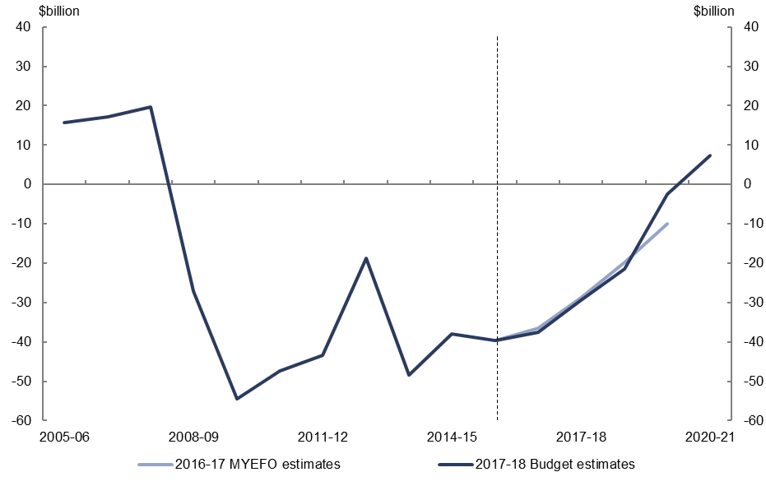
Figure 2: Underlying cash balance – change from 2016–17 MYEFO to 2017–18 Budget estimates by measures and other variations
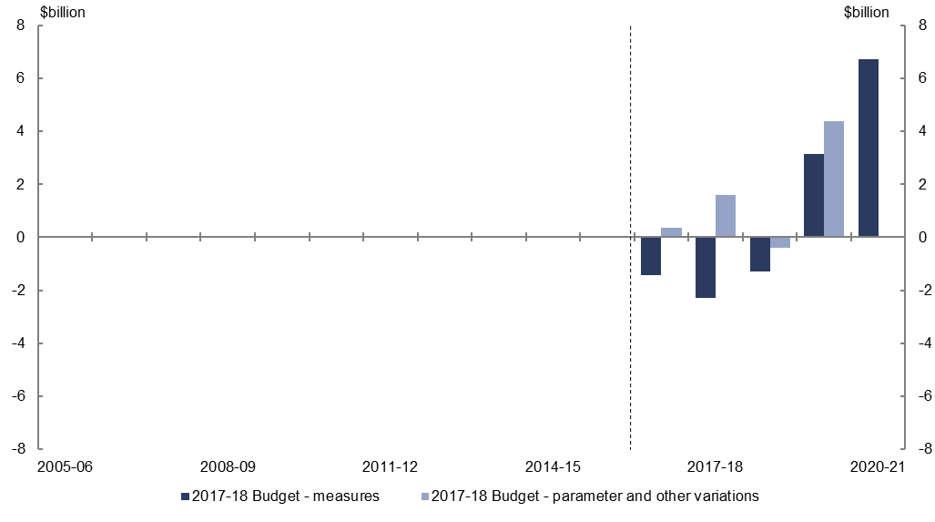
- Relative to the 2016–17 MYEFO, policy decisions are expected to increase the underlying cash balance by $4.8 billion over the five years to 2020–21.
- Parameter and other variations are expected to increase the underlying cash balance by $5.9 billion over the four years to 2019–20, relative to the 2016–17 MYEFO.

Total receipts
Figure 3: Total receipts – change from 2016–17 MYEFO to 2017–18 Budget estimates
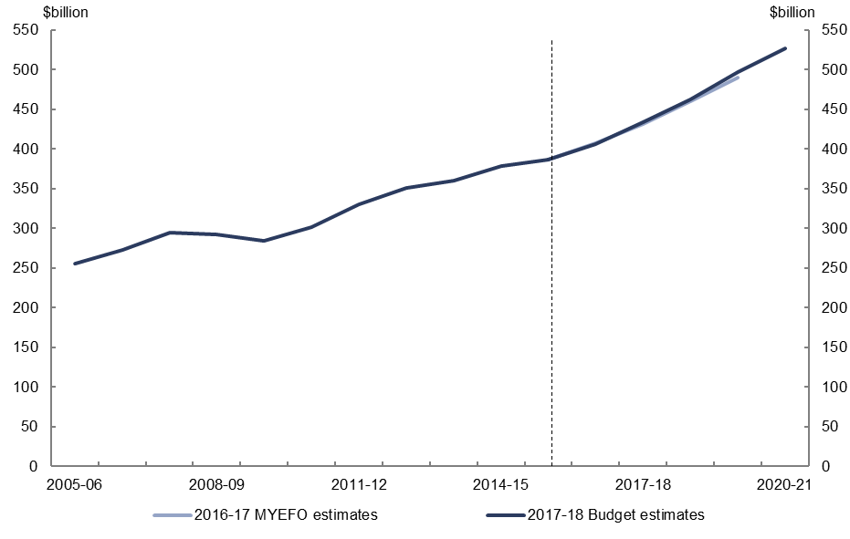
Figure 4: Total receipts – change from 2016–17 MYEFO to 2017–18 Budget estimates by measures and other variations
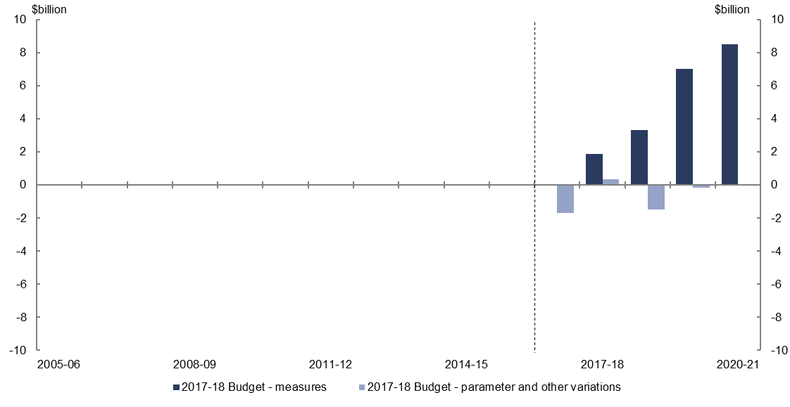
- Relative to the 2016–17 MYEFO, policy decisions are expected to increase total receipts by $20.8 billion over the five years to 2020–21.
- Parameter and other variations are expected to decrease total receipts by $3.0 billion over the four years to 2019–20, relative to the 2016–17 MYEFO.

Total payments
Figure 5: Total payments – change from 2016–17 MYEFO to 2017–18 Budget estimates
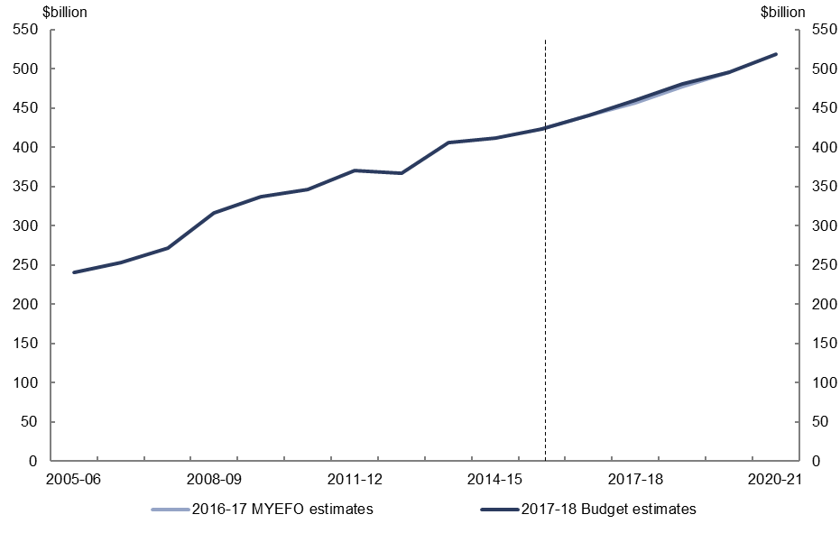
Figure 6: Total payments – change from 2016–17 MYEFO to 2017–18 Budget estimates by measures and other variations
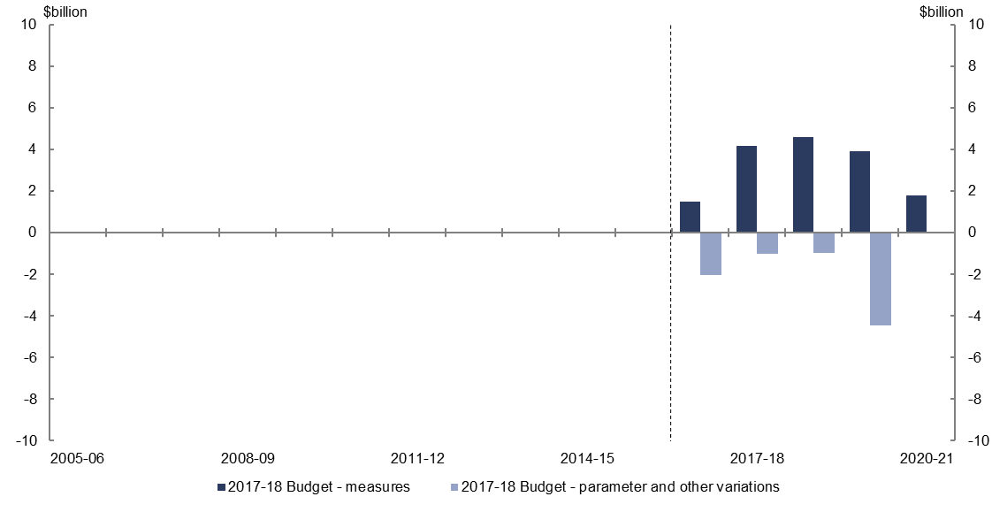
- Relative to the 2016–17 MYEFO, policy decisions are expected to increase total payments by $16.0 billion over the five years to 2020–21.
- Parameter and other variations are expected to decrease total payments by $8.5 billion over the four years to 2019–20, relative to the 2016–17 MYEFO.

Revenue – individuals and other withholding taxes
Figure 7: Revenue – individuals and other withholding taxes – change from 2016–17 MYEFO to 2017–18 Budget estimates
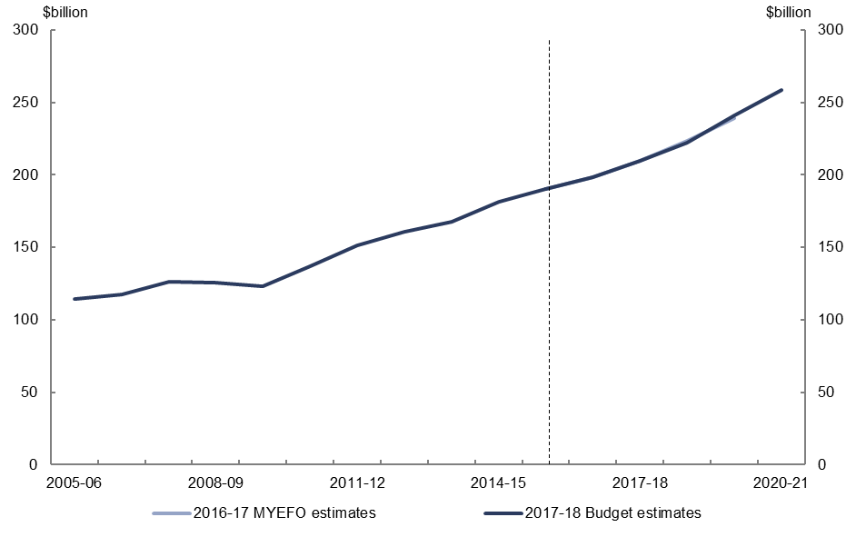
Figure 8: Revenue – individuals and other withholding taxes – change from 2016–17 MYEFO to 2017–18 Budget estimates by measures and other variations
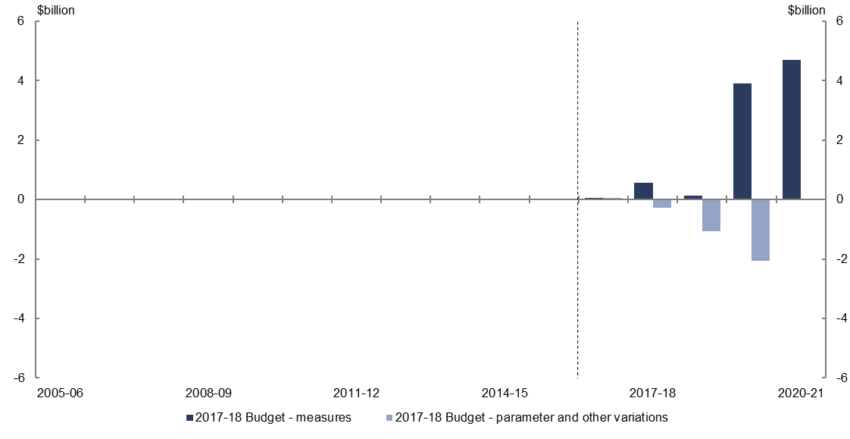
- Relative to the 2016–17 MYEFO, policy decisions are expected to increase individuals and other withholding tax revenue by $9.3 billion over the five years to 2020–21, largely due to the increase in the Medicare levy from 2 to 2.5 per cent from 2019–20.
- Parameter and other variations are expected to decrease individuals and other withholding tax revenue by $3.4 billion over the four years to 2019–20, relative to the 2016–17 MYEFO, due to lower forecast wages growth.

Revenue – company tax
Figure 9: Revenue – company tax – change from 2016–17 MYEFO to 2017–18 Budget estimates
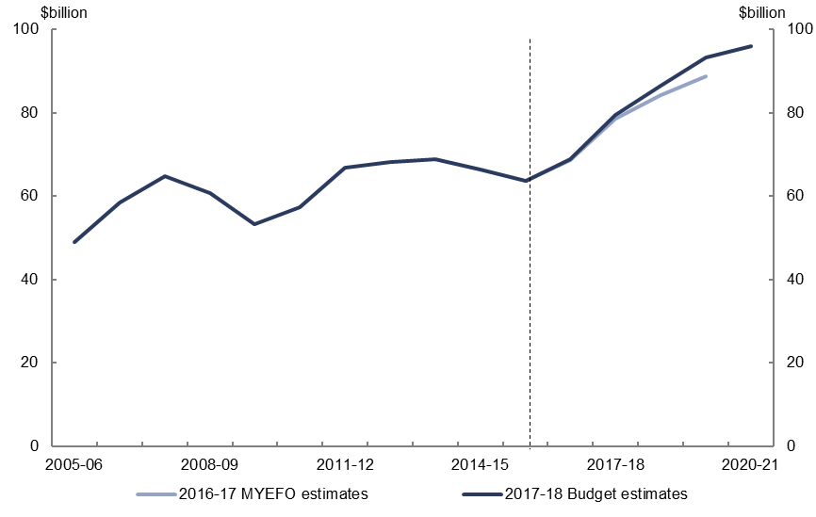
Figure 10: Revenue – company tax – change from 2016–17 MYEFO to 2017–18 Budget estimates by measures and other variations
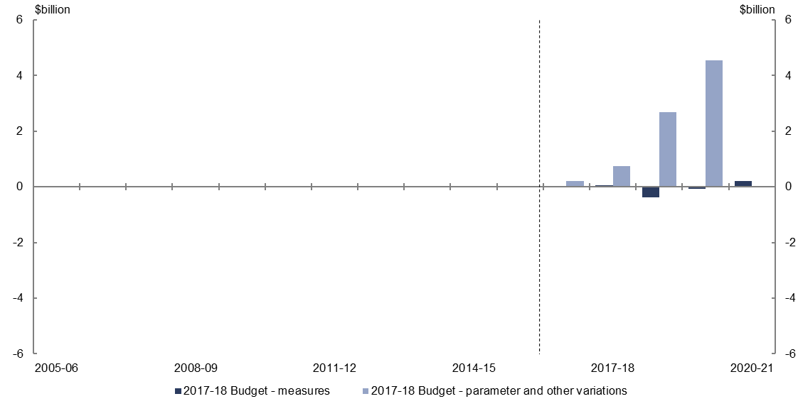
- Relative to the 2016–17 MYEFO, policy decisions are expected to decrease company tax revenue by $0.2 billion over the four years to 2020–21.
- Parameter and other variations are expected to increase company tax revenue by $8.2 billion over the four years to 2019–20, relative to the 2016–17 MYEFO, from higher expected corporate profitability.

Revenue – goods and services tax
Figure 11: Revenue – goods and services tax – change from 2016–17 MYEFO to 2017–18 Budget estimates
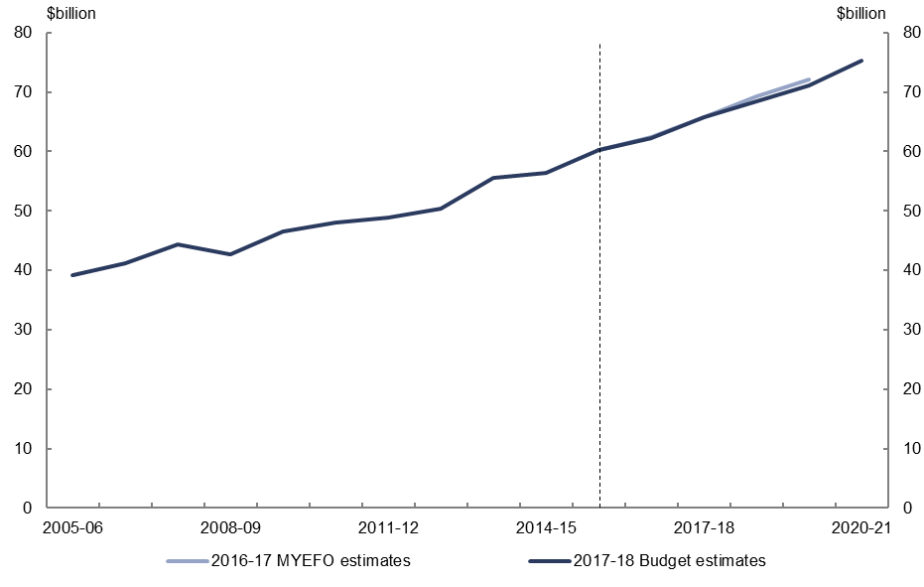
Figure 12: Revenue – goods and services tax – change from 2016–17 MYEFO to 2017–18 Budget estimates by measures and other variations
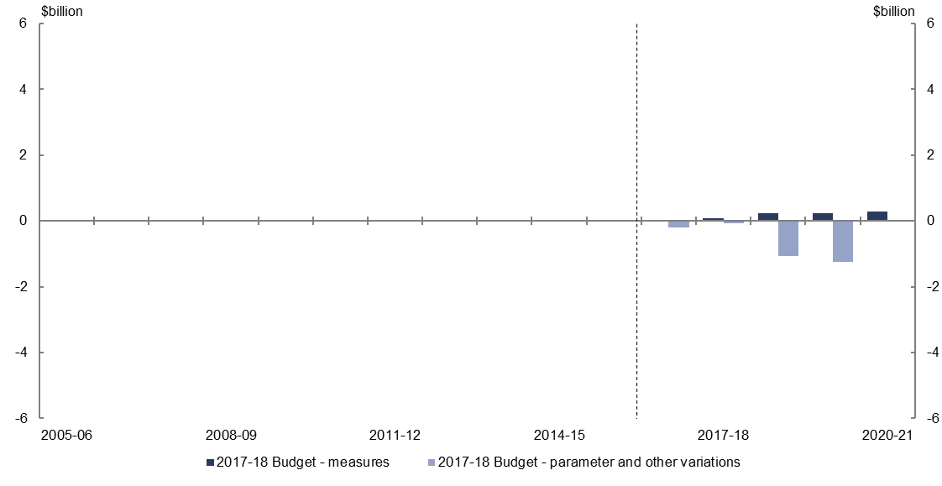
- Relative to the 2016–17 MYEFO, policy decisions are expected to increase goods and services tax revenue by $0.9 billion over the four years to 2020–21, reflecting the measure to strengthen compliance with GST law on property transactions.
- Parameter and other variations are expected to decrease goods and service tax revenue by $2.6 billion over the four years to 2019–20, relative to the 2016–17 MYEFO, reflecting lower forecast household consumption and private dwelling investment.

Revenue – major bank levy
Figure 13: Revenue – major bank levy – change from 2016–17 MYEFO to 2017–18 Budget estimates
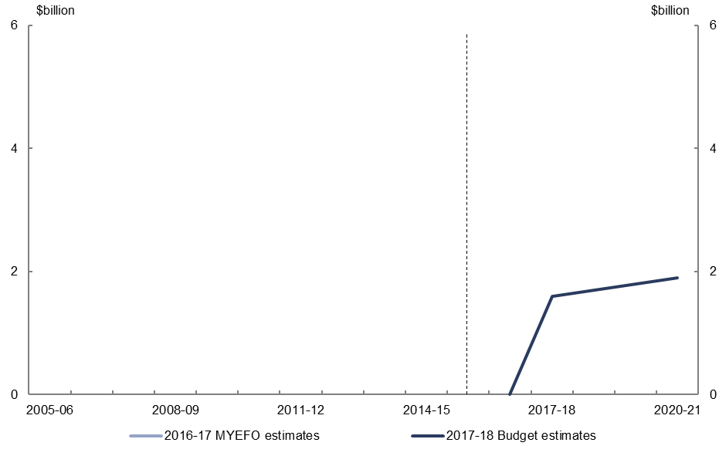
Figure 14: Revenue – major bank levy – change from 2016–17 MYEFO to 2017–18 Budget estimates by measures and other variations
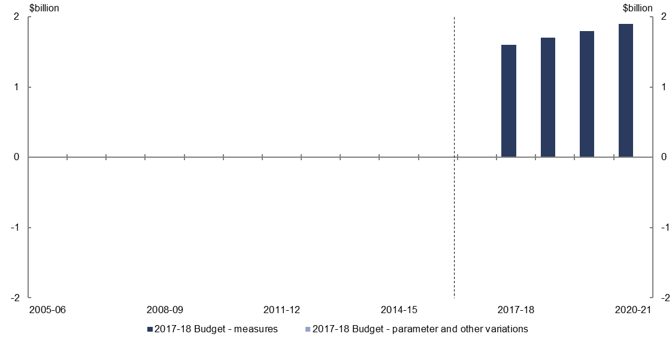
- The introduction of the major bank levy is expected to increase tax revenue by $6.2 billion over the four years to 2020–21. This is made up of major bank levy revenue of $7.0 billion, with related decreases in company tax and individuals and other withholding taxes totalling $0.8 billion.

Revenue – non-tax revenue
Figure 15: Revenue – non-tax revenue – change from 2016–17 MYEFO to 2017–18 Budget estimates
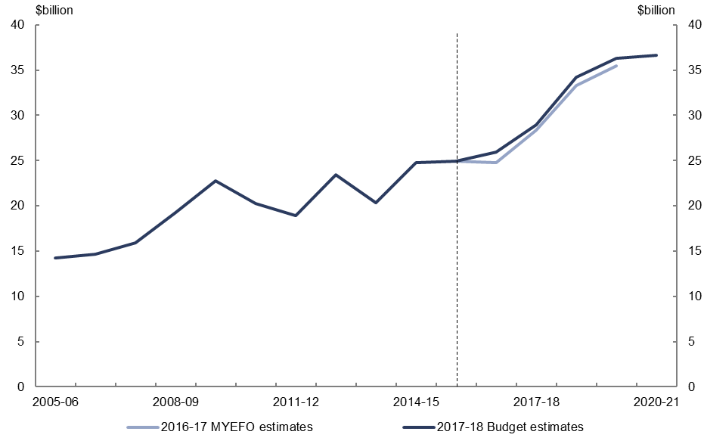
Figure 16: Revenue – non-tax revenue – change from 2016–17 MYEFO to 2017–18 Budget estimates by measures and other variations
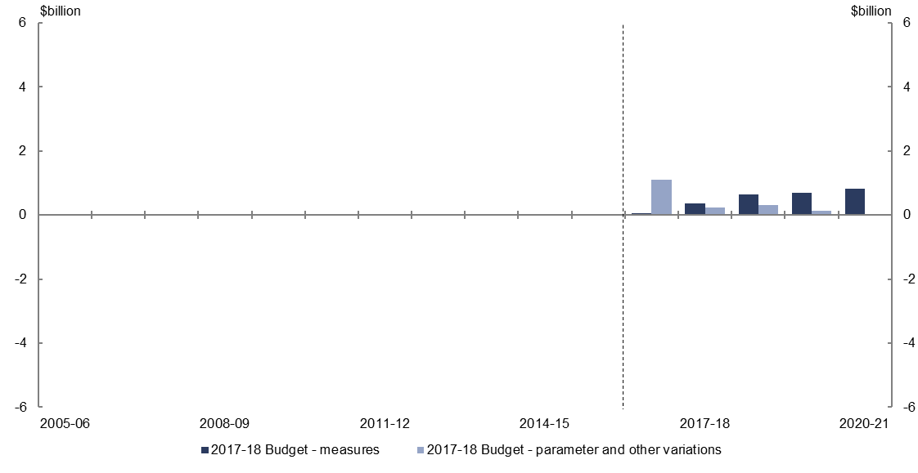
- Relative to the 2016–17 MYEFO, policy decisions are expected to increase non-tax revenue by $2.6 billion over the five years to 2020–21, reflecting the decision not to proceed with the removal of the loan fee for FEE-HELP as announced in the 2014–15 Budget, and allowing permanent residents and New Zealand citizens to access concessional loans through HELP rather than through the Commonwealth Grants Scheme. This is offset by decreased non-tax revenue for the National Disability Insurance Scheme (NDIS), as Western Australia moves to deliver the NDIS under a locally administered model.
- Parameter and other variations are expected to increase non-tax revenue by $1.8 billion over the four years to 2019–20, relative to the 2016–17 MYEFO, which largely reflects an upward revision in projected dividend revenue from the Reserve Bank of Australia.

Expenses – Family Tax Benefit
Figure 17: Expenses – Family Tax Benefit – change from 2016–17 MYEFO to 2017–18 Budget estimates
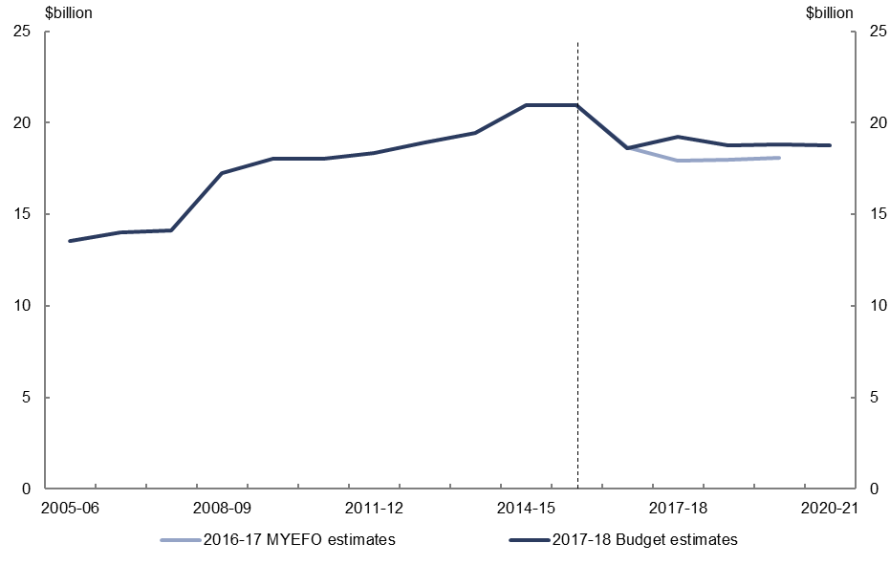
Figure 18: Expenses – Family Tax Benefit – change from 2016–17 MYEFO to 2017–18 Budget estimates by measures and other variations
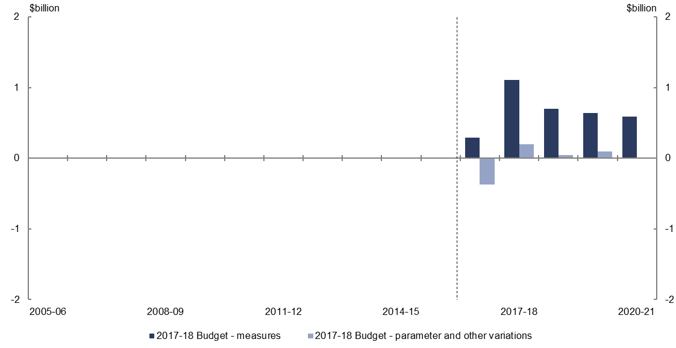
- Relative to the 2016–17 MYEFO, policy decisions are expected to increase expenses on Family Tax Benefit (FTB) by $3.3 billion over the five years to 2020–21, largely due to not ceasing the remaining FTB end-of-year supplements. This is partially offset by the measure to maintain FTB payment rates at their current levels for two years from 2017–18 and not proceeding with increasing the maximum rate of FTB A as announced in the 2015–16 MYEFO.
- Parameter and other variations are expected to have a broadly neutral impact on Family Tax Benefit expenses over the four years to 2019–20, relative to the 2016–17 MYEFO.

Expenses – Disability Support Pension
Figure 19: Expenses – Disability Support Pension – change from 2016–17 MYEFO to 2017–18 Budget estimates
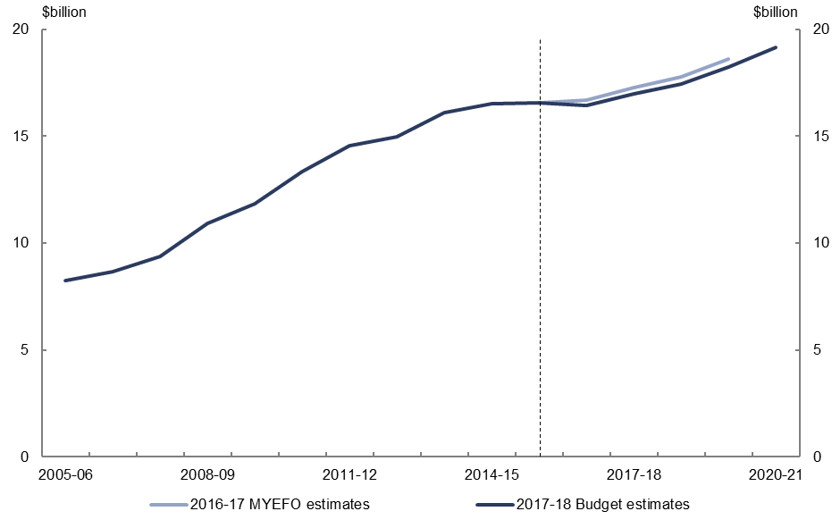
Figure 20: Expenses – Disability Support Pension – change from 2016–17 MYEFO to 2017–18 Budget estimates by measures and other variations
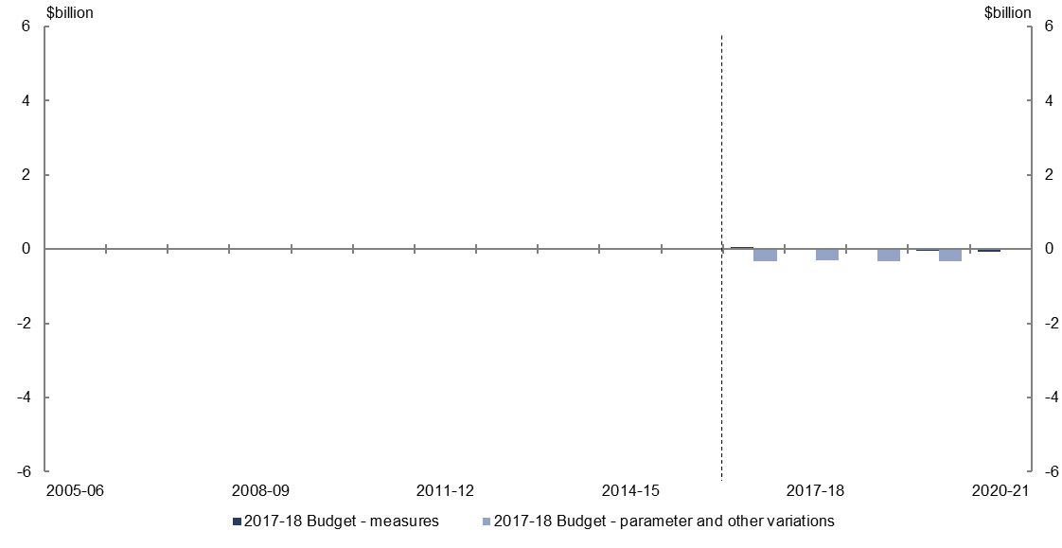
- Relative to the 2016–17 MYEFO, policy decisions are expected to decrease expenses on the Disability Support Pension by $0.1 billion over the five years to 2020–21.
- Parameter and other variations are expected to decrease expenses on the Disability Support Pension by $1.3 billion over the four years to 2019–20, relative to the
2016–17 MYEFO, largely reflecting lower growth in expected recipient numbers and payment rates.

Expenses – job seeker income support
Figure 21: Expenses – job seeker income support – change from 2016–17 MYEFO to 2017–18 Budget estimates
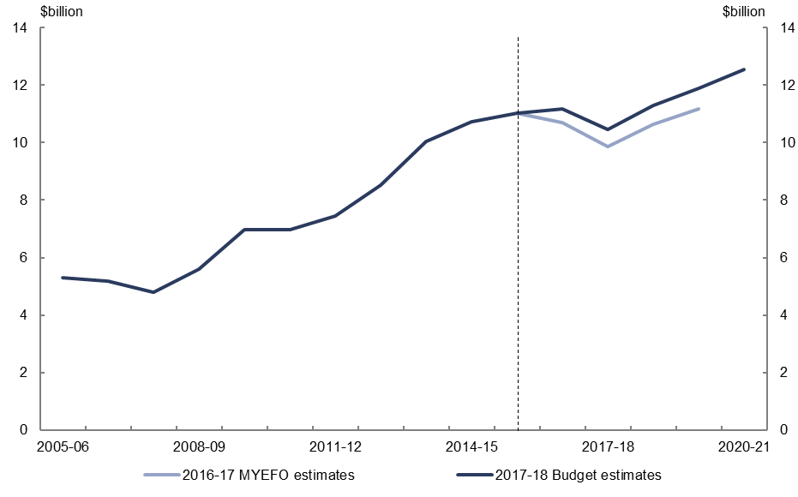
Figure 22: Expenses – job seeker income support – change from 2016–17 MYEFO to 2017–18 Budget estimates by measures and other variations
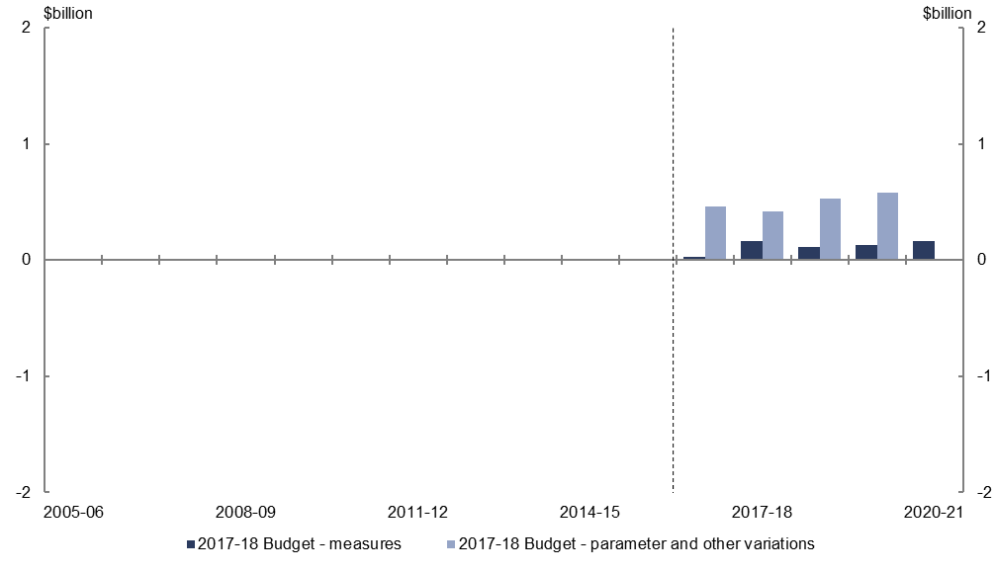
- Relative to the 2016–17 MYEFO, policy decisions are expected to increase expenses on job seeker income support by $0.6 billion over the five years to 2020–21, primarily due to not proceeding with the measure to increase the age eligibility for Newstart Allowance which was announced in the 2014–15 Budget.
- Parameter and other variations are expected to increase expenses on job seeker income support by $2.0 billion over the four years to 2019–20, relative to the
2016–17 MYEFO, largely reflecting a higher forecast unemployment rate.

Expenses – National Disability Insurance Scheme
Figure 23: Expenses – National Disability Insurance Scheme – change from 2016–17 MYEFO to 2017–18 Budget estimates
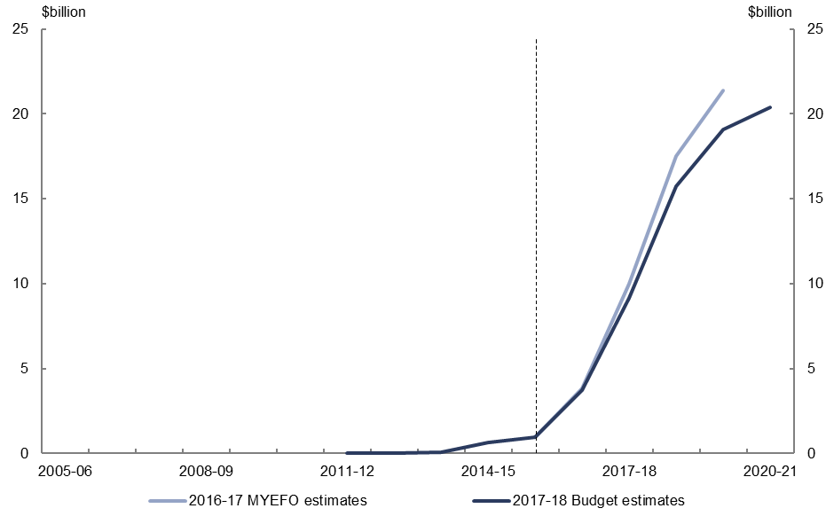
Figure 24: Expenses – National Disability Insurance Scheme – change from 2016–17 MYEFO to 2017–18 Budget estimates by measures and other variations
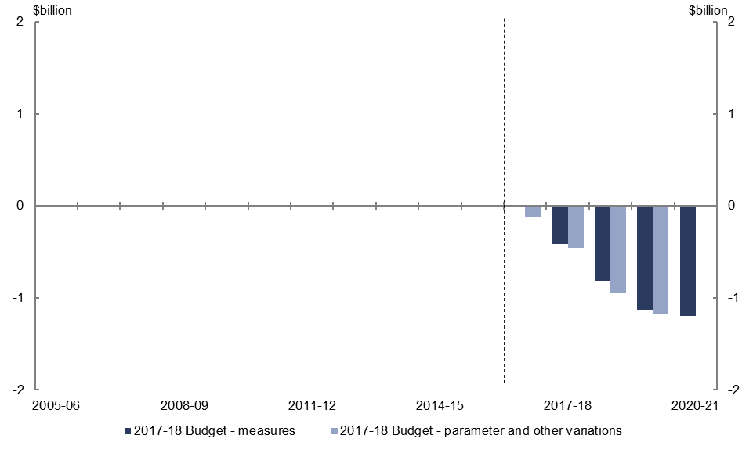
- Relative to the 2016–17 MYEFO, policy decisions are expected to decrease expenses on the National Disability Insurance Scheme by $3.5 billion over the four years to 2020–21, largely reflecting a reduction in Commonwealth expenses due the agreement between the Commonwealth and the Western Australian governments that the NDIS will be delivered under a locally administered model in Western Australia.
- Parameter and other variations are expected to decrease expenses on the National Disability Insurance Scheme by $2.7 billion over the four years to 2019–20, largely reflecting a reduction in expenses financed from state contributions (with a corresponding reduction in non-tax revenue), due the agreement between the Commonwealth and the Western Australian governments that the NDIS will be delivered under a locally administered model in Western Australia.

Expenses – paid parental leave
Figure 25: Expenses – paid parental leave – change from 2016–17 MYEFO to 2017–18 Budget estimates
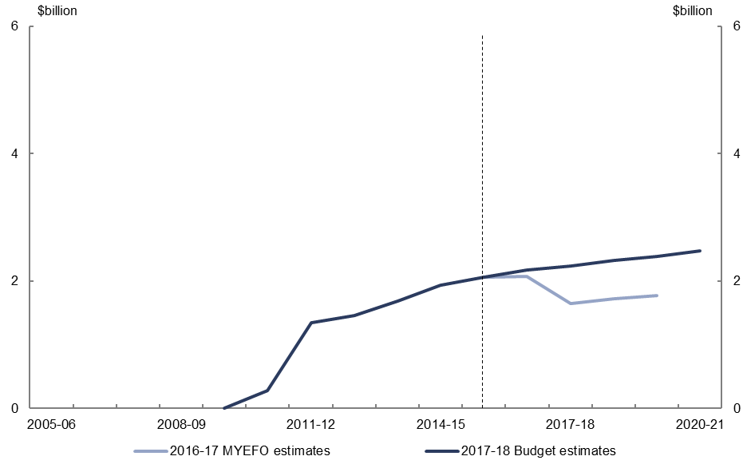
Figure 26: Expenses – paid parental leave – change from 2016–17 MYEFO to 2017–18 Budget estimates by measures and other variations
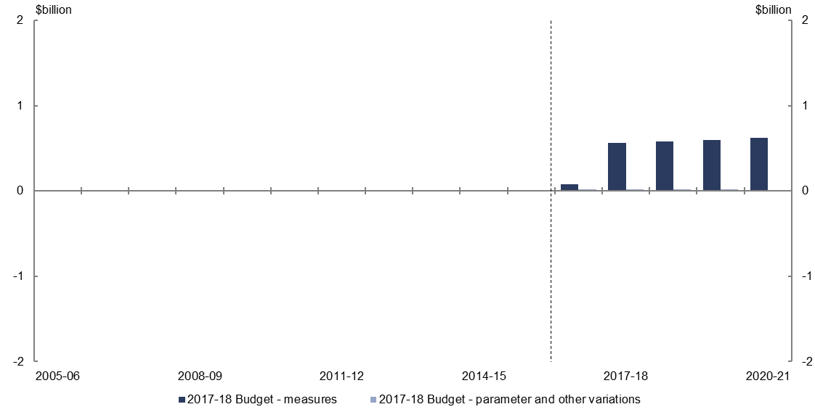
- Relative to the 2016–17 MYEFO, policy decisions are expected to increase expenses on paid parental leave by $2.4 billion over the five years to 2020–21, largely due to not proceeding with the measure announced in the 2015–16 Budget to restrict individuals accessing government-provided paid parental leave in addition to any
employer-provided parental leave entitlements.
- Parameter and other variations are expected to increase expenses on paid parental leave by $0.1 billion over the four years to 2019–20, relative to the 2016–17 MYEFO.

Expenses – Medicare Benefits Schedule
Figure 27: Expenses – Medicare Benefits Schedule – change from 2016–17 MYEFO to 2017–18 Budget estimates
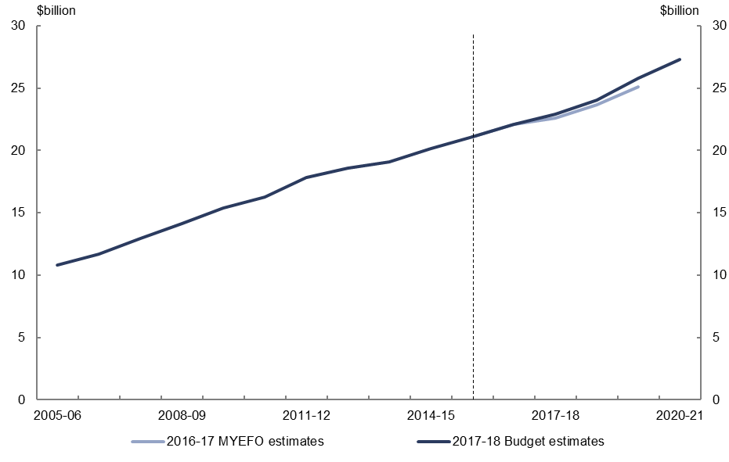
Figure 28: Expenses – Medicare Benefits Schedule – change from 2016–17 MYEFO to 2017–18 Budget estimates by measures and other variations
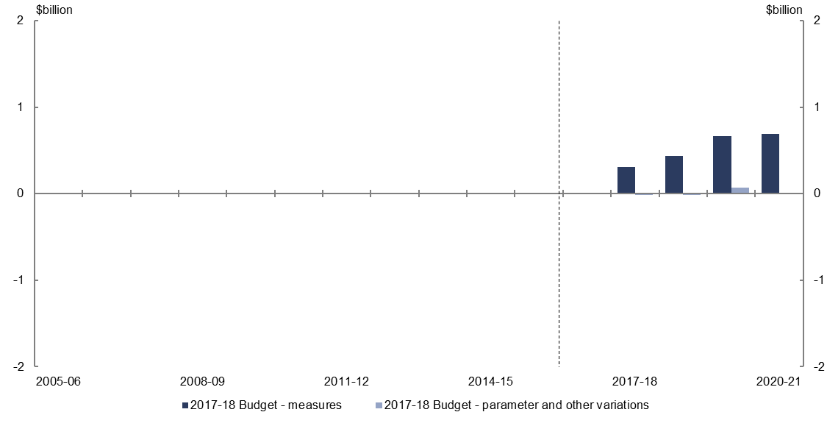
- Relative to the 2016–17 MYEFO, policy decisions are expected to increase expenses on Medicare by $2.1 billion over the five years to 2020–21, largely due to the progressive reintroduction of indexation of certain items on the Medicare Benefits Schedule, and not proceeding with the reductions to bulk-billing incentives for diagnostic imaging and pathology services announced in the 2015–16 MYEFO.
- Parameter and other variations are expected to have a broadly neutral impact on Medicare expenses over the four years to 2019–20, relative to the 2016–17 MYEFO.

Expenses – pharmaceutical benefits
Figure 29: Expenses – pharmaceutical benefits – change from 2016–17 MYEFO to 2017–18 Budget estimates
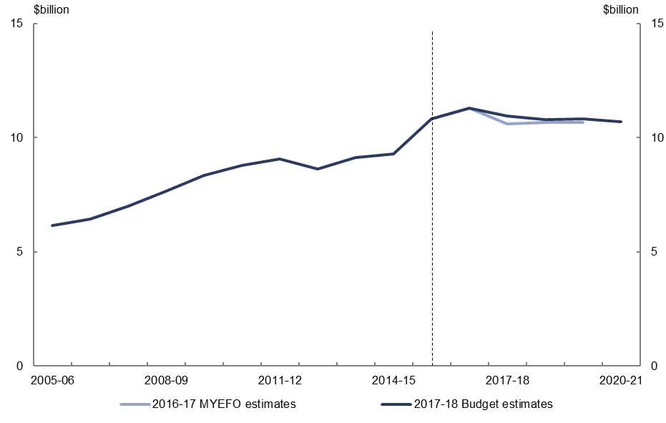
Figure 30: Expenses – pharmaceutical benefits – change from 2016–17 MYEFO to 2017–18 Budget estimates by measures and other variations
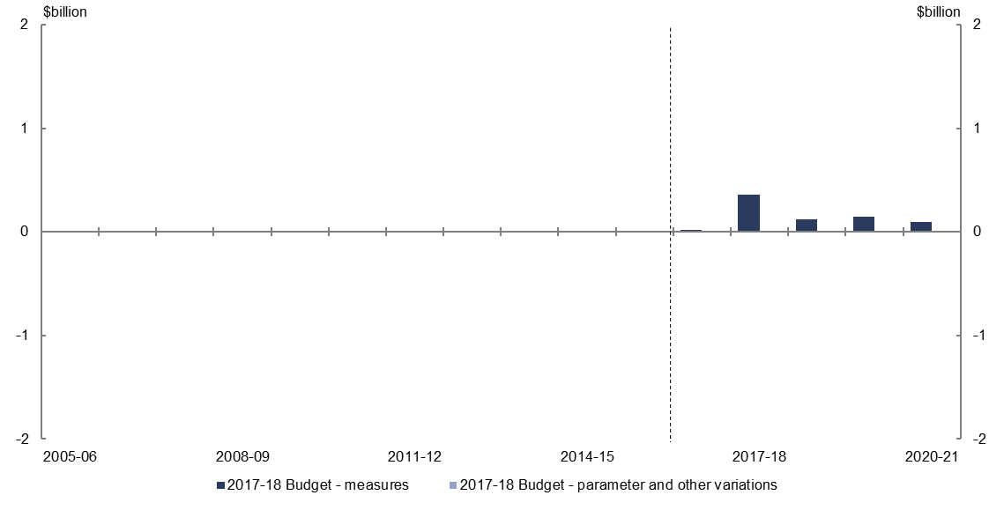
- Relative to the 2016–17 MYEFO, policy decisions are expected to increase expenses on the Pharmaceutical Benefits Scheme by $0.7 billion over the five years to 2020–21, due to new listings of drugs and not proceeding with the increase in PBS co-payments and safety net thresholds originally announced in the 2014–15 Budget. This is partially offset by extending statutory price reductions for certain listed medicines.
- Parameter and other variations are expected to have a broadly neutral impact on Pharmaceutical Benefits Scheme expenses over the four years to 2019–20, relative to the 2016–17 MYEFO.

Expenses – assistance to the states and territories for public hospitals
Figure 31: Expenses – assistance to the states and territories for public hospitals – change from 2016–17 MYEFO to 2017–18 Budget estimates
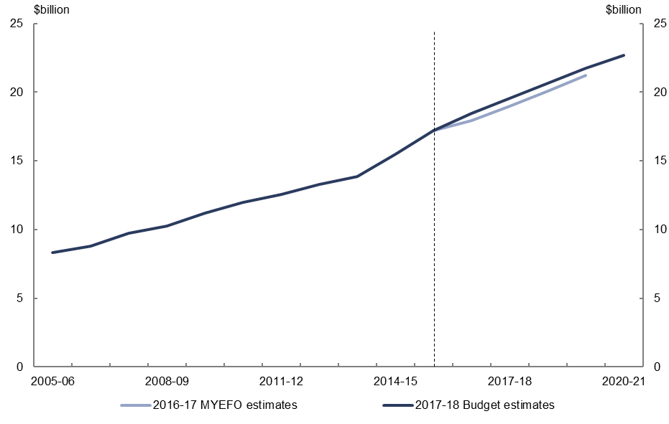
Figure 32: Expenses – assistance to the states and territories for public hospitals – change from 2016–17 MYEFO to 2017–18 Budget estimates by measures and other variations
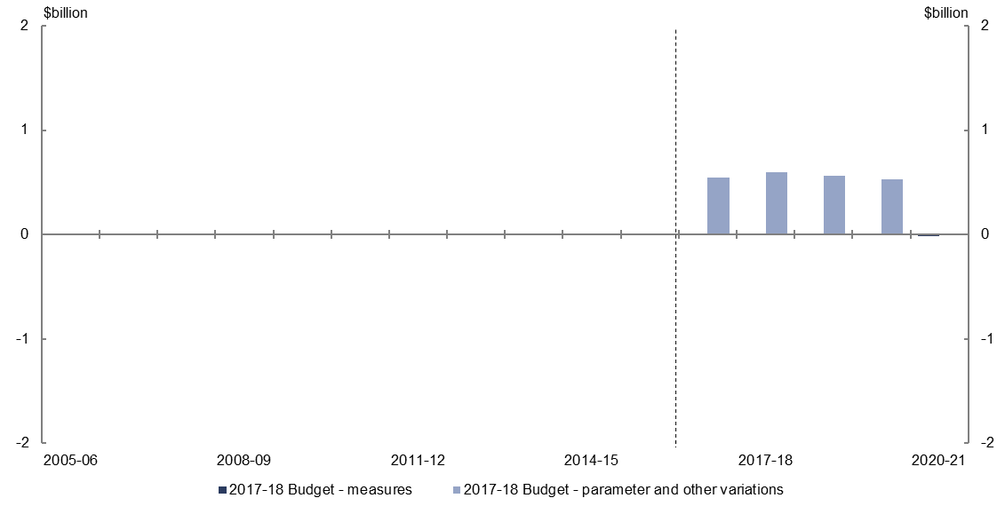
- Relative to the 2016–17 MYEFO, policy decisions are expected to have a minimal impact on assistance to the states and territories for public hospitals expenses over the five years to 2020–21.
- Parameter and other variations are expected to increase assistance to the states and territories for public hospitals expenses by $2.2 billion over the four years to 2019–20, relative to the 2016–17 MYEFO, largely reflecting increased hospital activity estimates.

Expenses – private health insurance rebate
Figure 33: Expenses – private health insurance rebate – change from 2016–17 MYEFO to
2017–18 Budget estimates
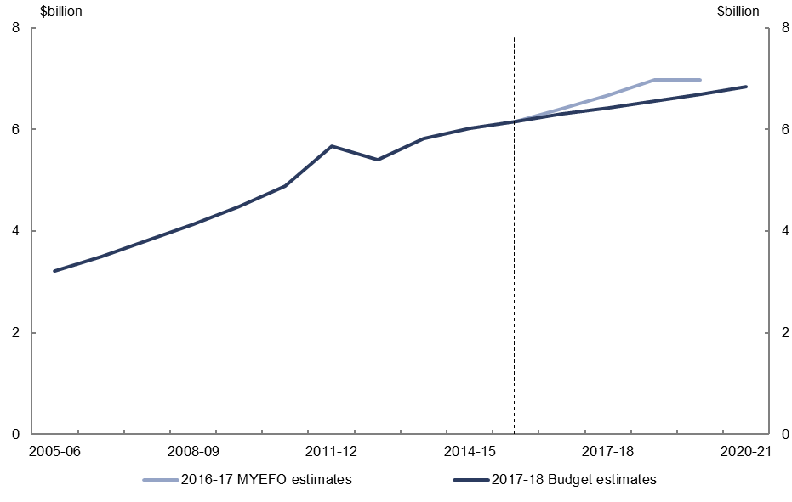
Figure 34: Expenses – private health insurance rebate – change from 2016–17 MYEFO to
2017–18 Budget estimates by measures and other variations
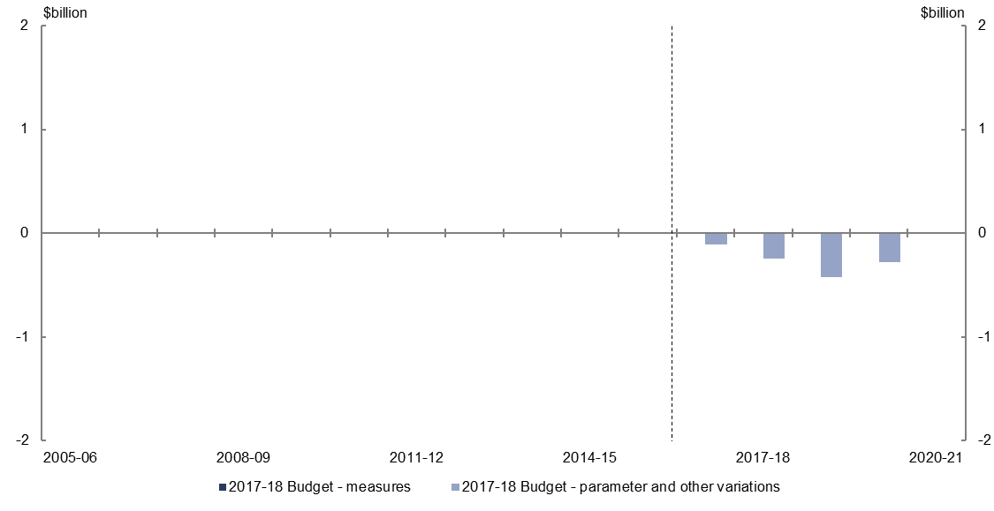
- Parameter and other variations are expected to decrease expenses on the private health insurance rebate by $1.1 billion over the four years to 2019–20, relative to the 2016–17 MYEFO largely reflecting a reduction in the growth in private health insurance participation.

Expenses – assistance to the states and territories for schools
Figure 35: Expenses – schools – change from 2016–17 MYEFO to 2017–18 Budget estimates
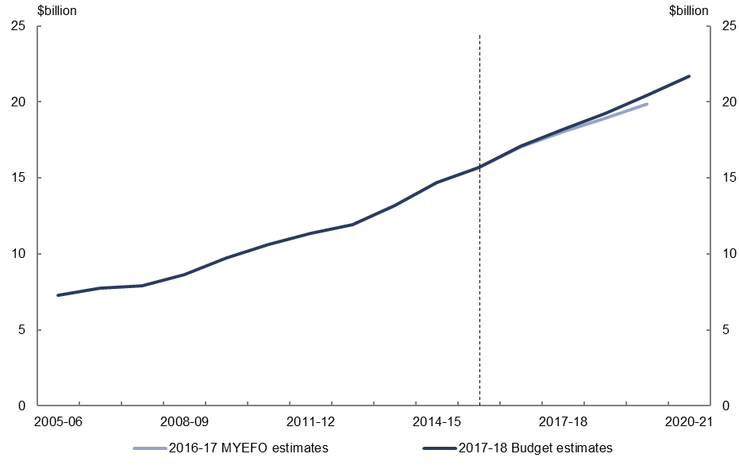
Figure 36: Expenses – schools – change from 2016–17 MYEFO to 2017–18 Budget estimates by measures and other variations
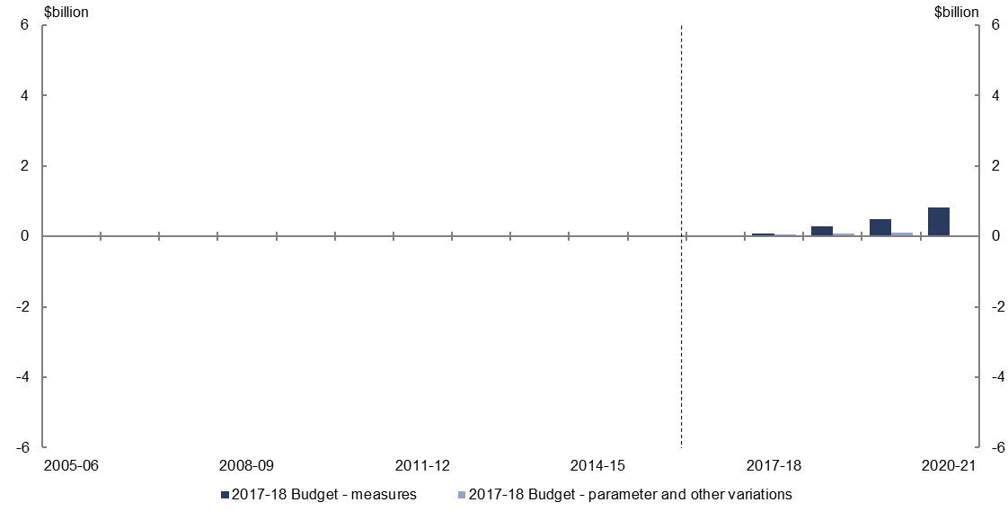
- Relative to the 2016–17 MYEFO, policy decisions are expected to increase expenses on schools by $1.7 billion over the four years to 2020–21, due to transitioning to a new schools funding model for government and non-government schools.
- Parameter and other variations are expected to increase expenses on schools by $0.3 billion over the four years to 2019–20, relative to the 2016–17 MYEFO, reflecting updated school enrolment projections.

Expenses – higher education grants
Figure 37: Expenses – higher education grants – change from 2016–17 MYEFO to 2017–18 Budget estimates
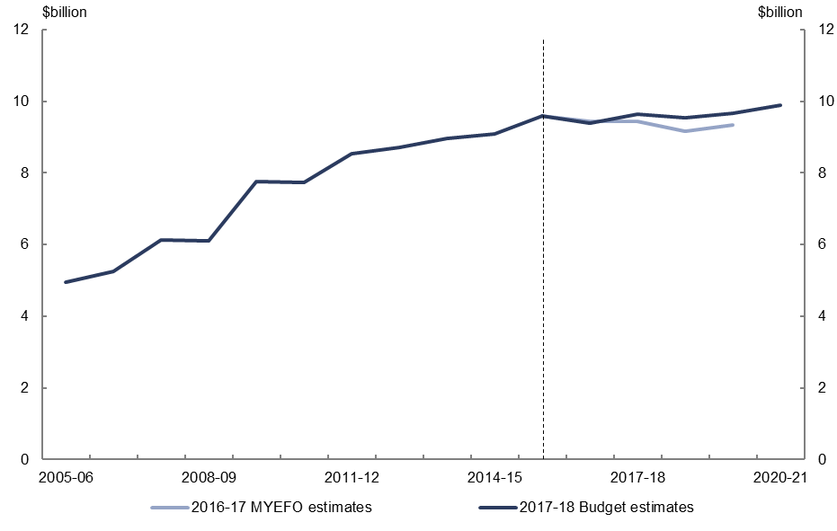 Figure 38: Expenses – higher education grants – change from 2016–17 MYEFO to 2017–18 Budget estimates by measures and other variations
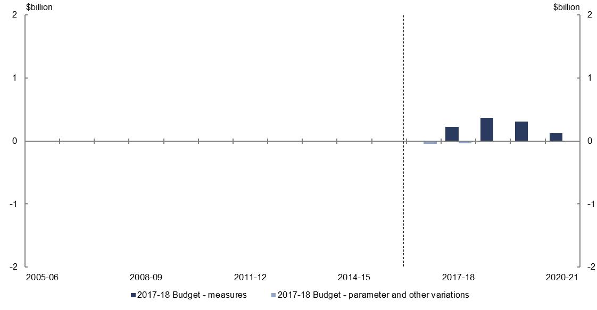
- Relative to the 2016–17 MYEFO, policy decisions are expected to increase expenses on higher education grants by $1.0 billion over the four years to 2020–21. This reflects the government’s decision to not proceed with the reduction in Commonwealth Grants Scheme funding as announced in the 2014–15 Budget, partially offset by measures in the revised higher education package. The revised package applies a 2.5 per cent efficiency dividend in 2018 and 2019 on the Commonwealth Grants Scheme and increases student contributions for Commonwealth supported students.
- Parameter and other variations are expected to decrease expenses on higher education grants by $0.1 billion over the four years to 2019–20, relative to the 2016–17 MYEFO.

Expenses – road and rail infrastructure (excluding equity and loan financing)
Figure 39: Expenses – road and rail infrastructure – change from 2016–17 MYEFO to 2017–18 Budget estimates
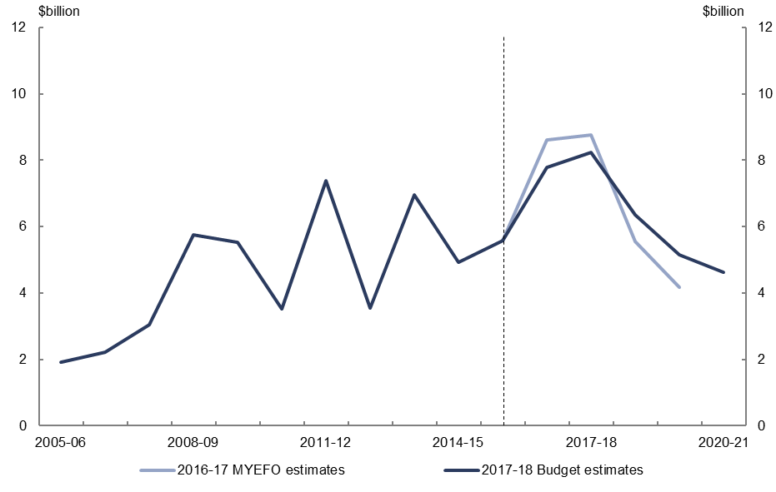
Figure 40: Expenses – road and rail infrastructure – change from 2016–17 MYEFO to 2017–18 Budget estimates by measures and other variations
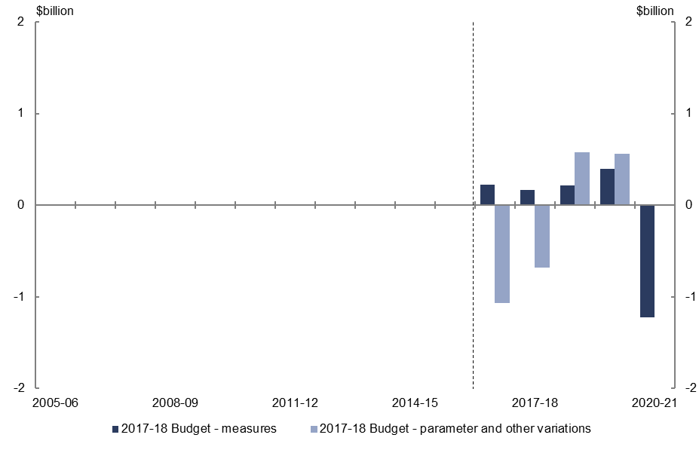
- Relative to the 2016–17 MYEFO, policy decisions are expected to decrease road and rail infrastructure expenses by $0.2 billion over the five years to 2020–21. This reflects the Government decision to redirect a portion of funds from the Infrastructure Investment Programme to non-rail and road projects in the Infrastructure and Regional Development Portfolio. These charts only include the direct expenses relating to road and rail infrastructure. They do not capture capital investment funded through equity injections into public non-financial corporations such as the Australian Rail Track Corporation and Western Sydney Airport Corporation, or concessional loans such as the loan to the New South Wales Government for the WestConnex project.
- Parameter and other variations are expected to decrease infrastructure expenses by $0.6 billion over the four years to 2019–20, relative to the 2016–17 MYEFO. The profile over the forward estimates largely reflects the movement of funding from earlier to later years to align with the delivery of road and rail projects in the Infrastructure Investment Programme.

Expenses – General revenue assistance to the states and territories
Figure 41: Expenses – general revenue assistance to the states and territories – change from 2016–17 MYEFO to 2017–18 Budget estimates
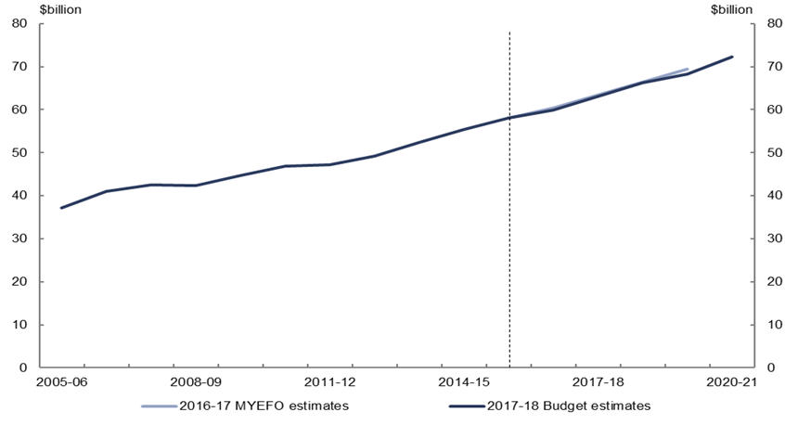
Figure 42: Expenses – general revenue assistance to the states and territories – change from 2016–17 MYEFO to 2017–18 Budget estimates by measures and other variations
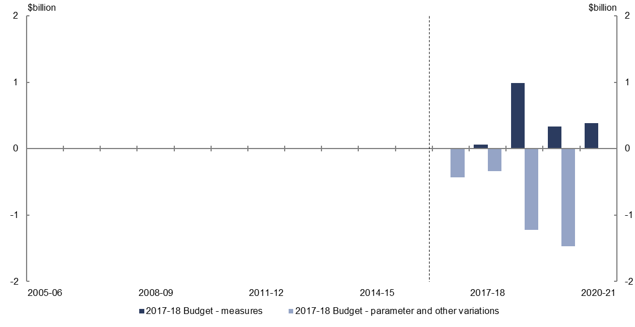
- Relative to the 2016–17 MYEFO, policy decisions are expected to increase expenses on general revenue assistance by $1.8 billion over the five years to 2020–21, largely reflecting the increased revenue being paid to the states from the measure to strengthen compliance with GST law on property transactions.
- Parameter and other variations are expected to decrease expenses on general revenue assistance by $3.5 billion over the four years to 2019–20, relative to the
2016–17 MYEFO, consistent with the lower forecast growth in GST revenue.
www.pbo.gov.au
www.pbo.gov.au

This relates to the expenses of the National Disability Insurance Agency. This differs from Commonwealth payments to the states and territories relating to the NDIS and disability services which are covered in separate agreements between the Commonwealth and the states and territories.

