National fiscal outlook
As at 2017–18 budgets
Report no. 04/2017

© Commonwealth of Australia 2017
ISBN 978-0-9953836-6-1 (Online)
This work is licensed under the Creative Commons Attribution-NonCommercial-NoDerivs 3.0 Australia License.
The details of this licence are available on the Creative Commons website: http://creativecommons.org/licenses/by-nc-nd/3.0/au/
Use of the Coat of Arms
The terms under which the Coat of Arms can be used are detailed on the following website: www.itsanhonour.gov.au/coat-arms
Produced by: Parliamentary Budget Office
Designed by: Studio Tweed
First Assistant Parliamentary Budget Officer
Fiscal Policy Analysis Division
Parliamentary Budget Office
Parliament House
PO Box 6010
CANBERRA ACT 2600
Phone: (02) 6277 9500
Email: pbo@pbo.gov.au

Contents
Foreword v
Overview 7
1 National fiscal outlook 8
1.1 Net operating balance 8
1.2 Net capital investment 10
1.3 Net debt 11
2 Trends in Commonwealth and state revenue and spending 14
2.1 Commonwealth trends 14
2.2 Total state trends 20
Appendix A — State net operating balances 31
Appendix B — Glossary and notes 33
Data and Methodology 33

Foreword
This report provides a national perspective on the fiscal outlook, examining outcomes across all levels of Australian government on a consistent basis.
The first part of the report highlights how the national fiscal outlook has changed since jurisdictions released their 2016–17 Budgets. The second part of the report focusses on trends in Commonwealth and state and territories revenue, expenditure, net capital investment and net debt over the forward estimates period.
The report focusses on the net operating balance, that is, the difference between recurrent revenue and expenses, and on net capital investment. The net operating balance is the key budget measure reported by the states and was adopted by the Commonwealth as their primary accrual measure in the 2017–18 Budget. Net capital investment is not included in the net operating balance but is a key component of Commonwealth and state budgets as it still needs to be financed, whether from recurrent revenue, selling assets or borrowing.
To allow for the most consistent comparison across jurisdictions historical data are sourced from the ABS from 2006–07 to 2015–16. From 2016–17 to 2020–21 data are based on Commonwealth, state and territory budgets.
The report was prepared by Sam Pelly and Anupam Sharma with the benefit of comments by Paul Gardiner and Tim Pyne. The report was prepared for publication by Lauren Pratley.
Jenny Wilkinson
Parliamentary Budget Office
19 October 2017

Overview
The 2017–18 national fiscal outlook remains broadly in line with the 2016–17 outlook, with the net operating balance deteriorating by only $13.4 billion for the period 2016–17 to
2019–20 (0.2 per cent of GDP). National net debt is projected to be $22.9 billion (1.3 per cent of GDP) higher in 2019–20 than was projected in the 2016–17 outlook.
Australia’s fiscal position compares favourably with other countries, with levels of spending and revenue around the OECD average but with relatively low net debt. Ongoing risks to revenue and expense projections at both Commonwealth and state levels, however, suggest a need for continued vigilance.
Over the 2017–18 forward estimates the national net operating balance is projected to move from a deficit of 1.4 per cent of GDP to a surplus of 1.6 per cent of GDP. As the PBO’s
2017–18 Budget medium-term projections report noted, this improvement relies on a pick-up in Commonwealth personal income tax revenue largely driven by higher wages growth.
The projected return to surplus over the 2017–18 forward estimates is also based on subdued expenses growth for both the Commonwealth and, in particular, the states. State expenses are projected to grow by 1.2 per cent annually in real terms over the five years to 2020–21, which is low by historical standards. This partly reflects spikes in expenses early in the period which are not projected to continue over the entirety of the forward estimates period.
While net capital investment is not included in the net operating balance, it is still a key component of Commonwealth and state budgets. National net capital investment is projected to grow strongly during the forward estimates driven by state infrastructure spending.
Aggregate state net capital investment is projected to increase rapidly over the period ahead, peaking at 0.9 per cent of GDP in 2018–19, before declining to 0.3 per cent of GDP by
2020–21. Much of this growth is driven by New South Wales, which makes up around 60 per cent of state net capital investment in 2018–19.
Commonwealth net debt, which makes up around 90 per cent of national net debt in
2016–17, is projected to decline over the latter part of the forward estimates. In contrast, state net debt as a share of GDP is projected to more than double over the forward estimates period, increasing from 2.0 per cent of GDP in 2016–17 to 4.7 per cent of GDP in 2020–21. This largely reflects the net borrowing of the states to finance their strong levels of net capital investment over the forward estimates period.

National fiscal outlook
This section examines how the national fiscal outlook has changed since jurisdictions released their 2016–17 Budgets. Data and figures in this section have been adjusted to eliminate transfers between levels of government.

Net operating balance
The 2017–18 national fiscal outlook remains broadly in line with the 2016–17 outlook, with the net operating balance deteriorating by only $13.4 billion for the period 2016–17 to
2019–20 (0.2 per cent of GDP) (Figure 1–1).
Figure 1–1: National net operating balance | Figure 1–2: Change in net operating balance since 2016–17 national fiscal outlook
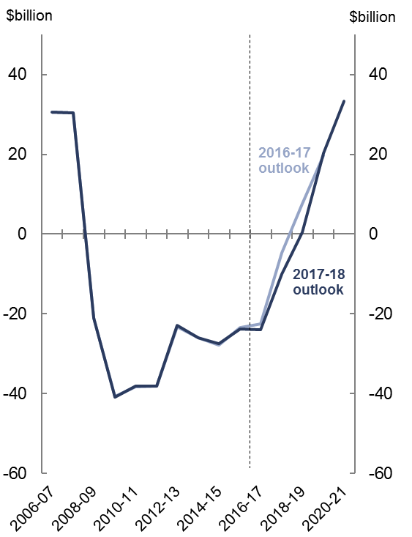  Source: Australian Bureau of Statistics (ABS), Commonwealth and state budget papers, Parliamentary Budget Office (PBO) analysis. | 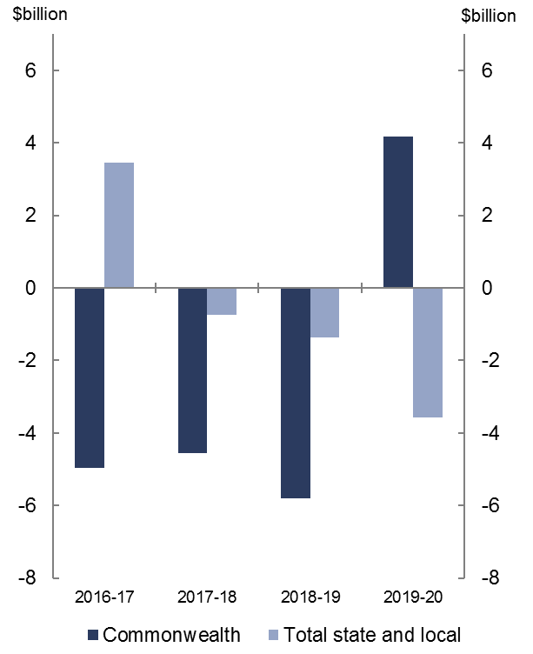  Source: ABS, Commonwealth and state budget papers, PBO analysis.

Most of the deterioration in the national net operating balance since the 2016-17 outlook is due to a downward revision in the Commonwealth net operating balance (Figure 1–2). This reflects a downward revision in projected Commonwealth revenue of $22.4 billion for the period 2016–17 to 2019–20, largely driven by lower personal income tax revenue from lower forecast wages growth. From 2019–20 the downwards revision is offset by revenue increases from the increase in the Medicare levy and the introduction of the major bank levy.
In addition, compared to the 2016–17 Budget, GST revenue has been revised down by $7.0 billion for the period 2016–17 to 2019–20, reflecting lower forecast household consumption and private dwelling investment. This has decreased the pool of funding available for distribution to the states (see Section 2).
The downward revision to Commonwealth revenue is partially offset by a downward revision to Commonwealth expenses of $11.2 billion for the period 2016–17 to 2019–20. This is driven by lower forecast growth in expected recipient numbers and payment rates across a range of Commonwealth payment programs.
The rest of the deterioration in the national net operating balance since the 2016–17 outlook is due to a small downward revision in the aggregate net operating balance of state, territory and local governments (hereafter referred to as ‘states’).
There has been an upward revision in state revenue of $26.5 billion for the period 2016–17 to 2019–20 compared with the 2016–17 outlook, largely driven by higher forecast revenue in New South Wales, Queensland and Victoria.
The upward revision in New South Wales revenue reflects higher forecast transfer duty from property price growth and stamp duty proceeds from the partial lease of electricity distributors Ausgrid and Endeavour Energy in 2016–17. Revenue from government-owned corporations has also increased since the 2016–17 outlook reflecting a new framework requiring government owned businesses to increase dividend payments or retain less capital with the ‘excess’ to be returned to the government.
Queensland’s higher forecast revenue primarily reflects higher royalties from higher metallurgical coal prices, particularly in 2016–17, and is a key driver of the strong improvement in the aggregate state position in that year.
Victoria’s higher forecast revenue is mainly due to stronger taxation revenue and Commonwealth transfers, in part reflecting strong population growth relative to other states.
The upward revision in state revenue is more than offset by an upward revision to projected state expenses of $28.7 billion for the period 2016–17 to 2019–20. This is driven by higher forecast expenditure across all states since the 2016–17 outlook, but in particular Victoria which has revised expenditure up by $12.3 billion for the period 2016–17 to
2019–20. This largely reflects significant spending on health services, family violence initiatives and policing.
New South Wales has revised expenditure up by $5.0 billion for the period 2016–17 to
2019–20, driven by additional spending on schools, new housing and transport. The $5.1 billion upward revision in Queensland expenses for the same period is largely associated with recovery efforts for Tropical Cyclone Debbie and a government package to assist with the cost of living.

Net capital investment
National net capital investment is projected to be $2.9 billion higher for the period 2016–17 to 2019–20 than was projected in the 2016-17 outlook (Figure 1–3).
The net capital investment the Commonwealth undertakes directly is relatively small and is largely in the area of defence (see section 2.1.3). Commonwealth net capital investment has been revised downwards by $5.0 billion for the period 2016–17 to 2019–20, largely reflecting the expected proceeds from the auction of spectrum licences in 2017–18 (Figure 1–4).
In contrast, state net capital investment has been revised upwards by $7.9 billion for the period 2016–17 to 2019–20. This increase since the 2016–17 outlook is largely driven by New South Wales, which is forecasting additional net capital investment of $4.3 billion for the period, reflecting new investment in education, health and housing infrastructure.
Figure 1–3: National net capital investment | Figure 1–4: Change in net capital investment since 2016–17 national fiscal outlook
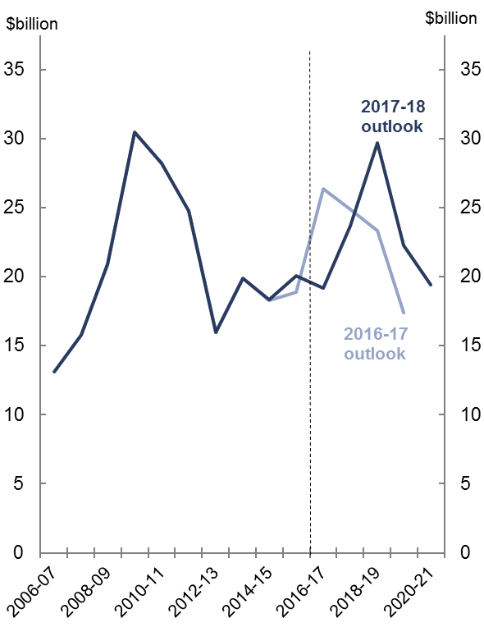  Source: ABS, Commonwealth and state budget papers, PBO analysis. | 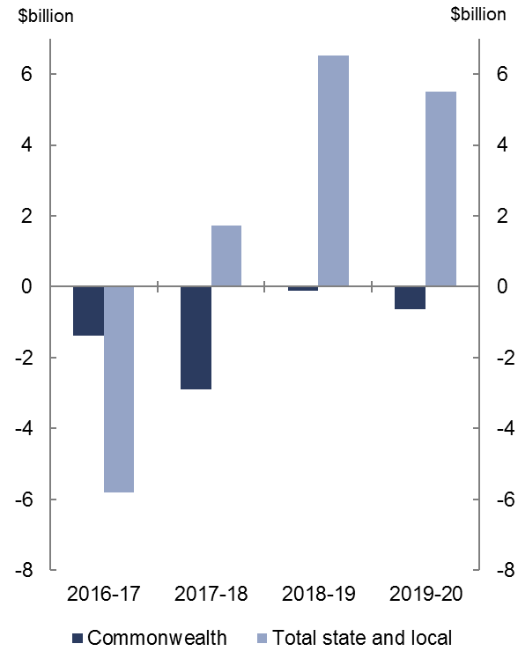  Source: ABS, Commonwealth and state budget papers, PBO analysis.

Net debt
National net debt is projected to peak as a share of GDP in 2018–19 at 23.2 per cent
($438.7 billion), 0.6 percentage points ($10.2 billion) above the previous projected peak. Compared to the 2016–17 outlook, national net debt is projected to be 1.3 per cent of GDP ($22.9 billion) higher in 2019–20 (Figure 1–5). There are large underlying variations in Commonwealth and state net debt over the period 2016–17 to 2019–20 (Figure 1–6).
Figure 1–5: National net debt  (Share of GDP) | Figure 1–6: Change in net debt since 2016–17 national fiscal outlook
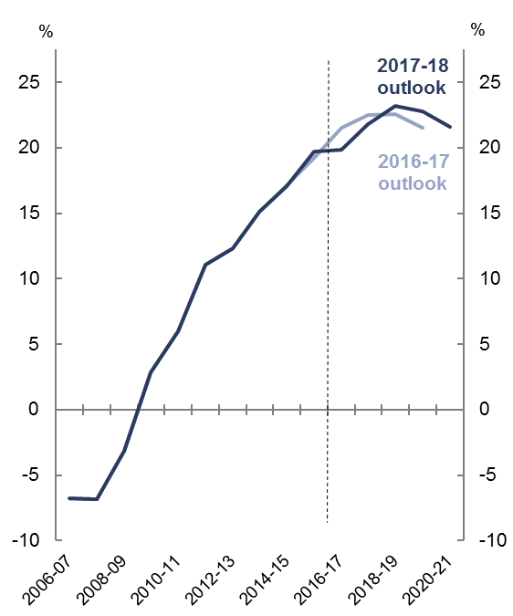  Source: ABS, Commonwealth and state budget papers, PBO analysis. | 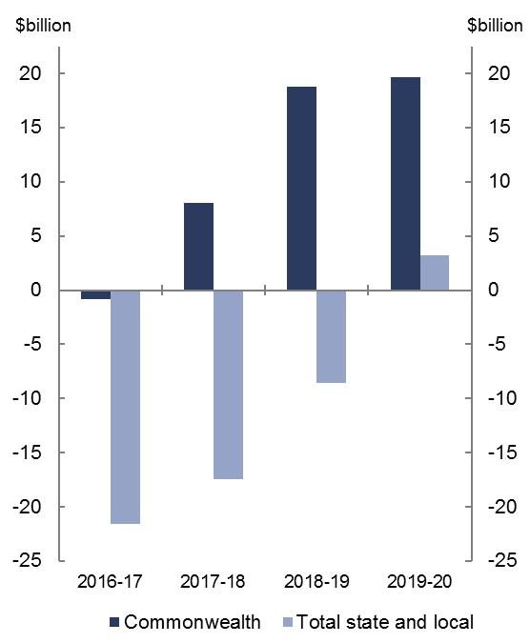  Source: ABS, Commonwealth and state budget papers, PBO analysis.
Commonwealth net debt is projected to be $374.7 billion in 2019–20, $19.6 billion higher than projected in the 2016–17 outlook. This is primarily driven by an increase in the financing requirement due to larger projected budget deficits since the 2016–17 Budget.
State net debt is projected to be $76.9 billion in 2019–20, $3.3 billion higher than projected in the 2016–17 outlook. The change in the state net debt profile reflects a significant improvement in New South Wales’ net debt position. The partial long-term lease of Endeavour Energy and Ausgrid in 2016–17 increases cash holdings thereby reducing net debt and is the key contributor to the decline in national debt in 2016–17. As the proceeds from these assets sales are then reinvested in other infrastructure projects net debt improves by a smaller amount each subsequent year before deteriorating in 2019–20.

Box 1: International comparison of spending and revenue
One of the benefits of examining the Australian national fiscal position, that is the fiscal position across all levels of government, is that more meaningful international comparisons of the size of the Australian government sector can be made.
Countries may have different systems of government (e.g. federal or unitary), or even where the system of government is the same, each level of government may undertake different functions. Focussing on only one level of government may overlook potential differences in expenditure and taxation responsibilities between levels of government internationally. This is overcome by looking at the national fiscal position.
Figure 1–7 shows total spending (expenses plus net capital investment) and revenue across all levels of government for G20 countries. In terms of both spending and revenue Australia is clustered in a group of countries in the middle range, and around the OECD average.
Figure 1–7: Spending and revenue in G20 countries in 2015
(Share of GDP)
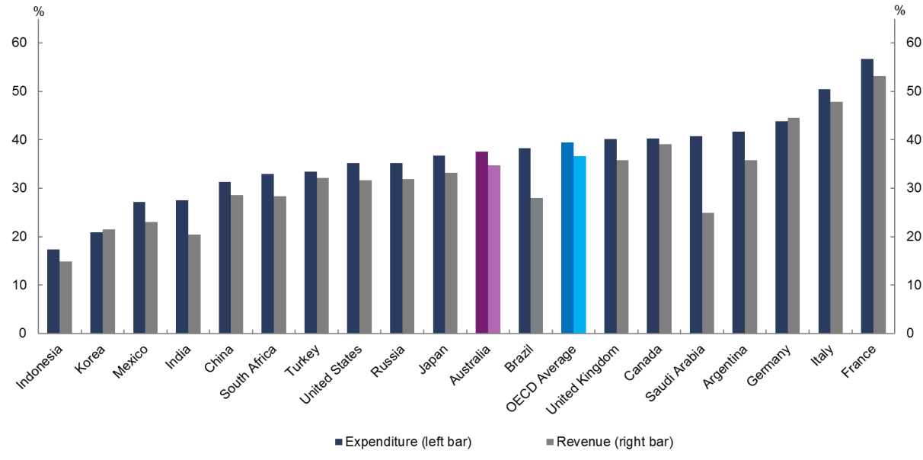
Source: International Monetary Fund (IMF).
The diversity of taxation and spending regimes across G20 countries means that some caution should be exercised when making specific cross-country comparisons. For example, Australia relies in part on the mandated savings of superannuation to support retirement incomes, which is not classified as revenue (nor is the drawdown of superannuation balances in retirement classified as spending). Other countries, particularly in Europe, rely more heavily on public provision of pensions and therefore have higher revenue to fund the higher public expenditure.
While the above analysis provides a snapshot of the level of spending and revenue in 2015, it does not give an indication about how differences between spending and revenue have accumulated over time. This requires looking at a stock measure of government finances, such as net debt.
Figure 1–8 shows the net debt position of G20 countries for which data are available. While Australia’s net debt has increased significantly in recent years and is now high by historical standards, Australia has a relatively low level of net debt by international standards. Ongoing risks to revenue and expense projections at both Commonwealth and state levels, however, suggest a need for continued vigilance.
Figure 1–8: Net debt in G20 countries in 2015
(Share of GDP)
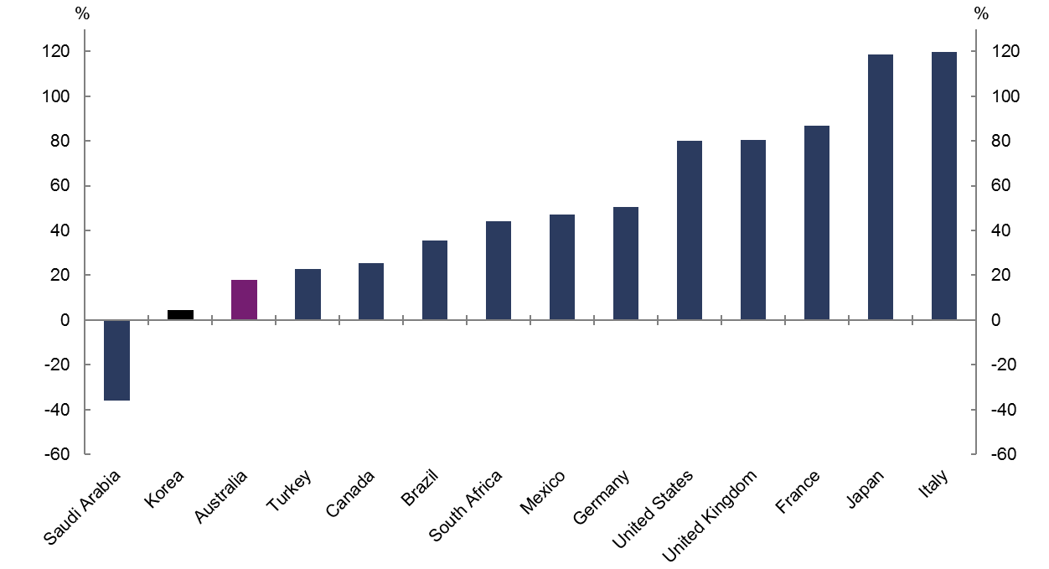
Source: IMF.

Trends in Commonwealth and state revenue and spending
This section breaks down the national fiscal outlook between the Commonwealth and the states. It analyses trends in revenue, expenses, net capital investment and net debt over the forward estimates period by level of government. This section uses figures from the ABS and state budget papers which have not been adjusted for transfers between levels of government.

Commonwealth trends
Prior to the global financial crisis Commonwealth revenue exceeded expenses. A strong economy, as well as the terms of trade boom, boosted revenue and resulted in the Commonwealth government being able to sustain high rates of spending growth and provide tax cuts, and still achieve budget surpluses.
With the onset of the global financial crisis there were sharp declines in Commonwealth government revenue, and sharp increases in expenses as the government provided fiscal stimulus. Personal income tax cuts also contributed to declining revenue from 2008–09. Expenditure moderated and revenue began to recover from 2010–11 (Figure 2–1 and
Figure 2–2).
Commonwealth budget papers project revenue to grow significantly and expenditure to decline as a proportion of GDP over the forward estimates.
Figure 2–1: Commonwealth revenue  and expenses (Share of GDP) | Figure 2–2: Commonwealth revenue and expenses (Annual real growth)
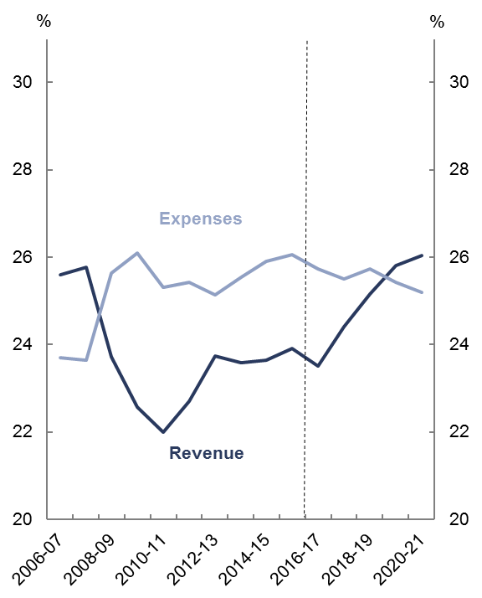  Source: ABS, Commonwealth budget papers, PBO analysis. | 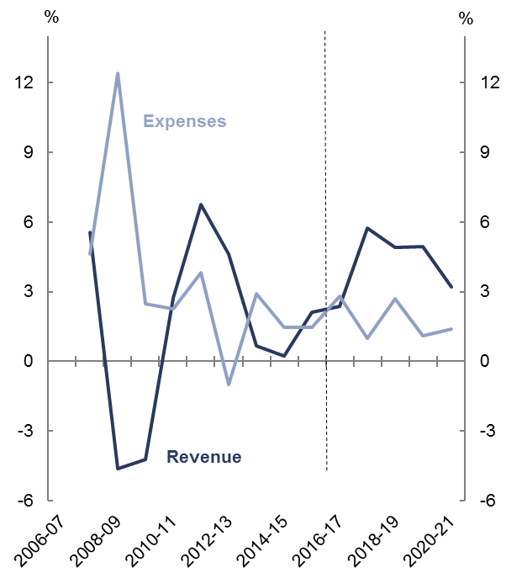  Source: ABS, Commonwealth budget papers, and PBO analysis.

Revenue
According to the 2017–18 Commonwealth budget, revenue is projected to increase from
23.5 per cent of GDP in 2016–17 to 26.0 per cent of GDP in 2020–21, growing sharply from
2017–18. This would see Commonwealth revenue as a proportion of GDP returning to
pre-global financial crisis levels.
The increase in revenue growth over the forward estimates is predominately due to a projected rise in personal income tax, the largest component of total Commonwealth revenue. Personal income tax makes up around half of total revenue in 2016–17, and is projected to rise from 11.3 per cent of GDP in 2016–17 to 12.5 per cent of GDP in 2020–21. This is driven by a pick-up in wages growth and an increase in the Medicare levy from
2019–20.
Company tax, the second largest revenue head making up 17 per cent of total Commonwealth revenue in 2016–17, is projected to increase from 3.9 per cent of GDP in 2016–17 to 4.6 per cent of GDP in 2020–21. This is driven by projected increasing corporate profitability across the economy as the economy transitions toward broad-based activity following the mining investment boom.
Goods and services tax, which makes up 15 per cent of total Commonwealth revenue in 2016–17, is projected to remain at 3.6 per cent of GDP across the forward estimates. The transfer of GST revenue to the states is treated as an expense for the Commonwealth. As the payment to the states is equivalent to the GST revenue collected, there is no net impact on the Commonwealth budget. However, any reductions in GST revenue will have an impact on state revenue (see section 2).

Expenses
The Commonwealth budget projects expenses to decline from 25.7 per cent of GDP in
2016–17 to 25.2 per cent of GDP in 2020–21 (Figure 2–1). In part, this is due to the use of different discount rates to value government superannuation benefits in the current year and the forward estimates.
The treatment of government superannuation benefits aside, Commonwealth expenses as a per cent of GDP are projected to be broadly flat over the forward estimates. Underlying this flatness are countervailing pressures on expenditure.
The largest contributor to expenditure growth over the forward estimates period, the National Disability Insurance Scheme (NDIS), is projected to increase by 0.8 per cent of GDP over the forward estimates period to reach 1.0 per cent of GDP in 2020–21, reflecting the full rollout of the Scheme by 2019–20. Child care is projected to increase by 0.1 per cent of GDP over the forward estimates period to reach 0.5 per cent of GDP in 2020–21, mainly reflecting the rollout of the new Child Care Subsidy in 2018–19. Aged care is also projected to increase by 0.1 per cent of GDP over the forward estimates to 1.1 per cent of GDP in 2020–21, reflecting the impact of the ageing population on the demand for aged care services.
These spending pressures are broadly offset by declines as a per cent of GDP in a number of other programs, in particular the cost of government administration and a range of smaller grant subsidy and personal benefit programs. In addition, Family Tax Benefit (FTB) is projected to decline by 0.2 per cent of GDP over the forward estimates to 0.9 per cent of GDP in 2020–21 due to the impact of budget initiatives to freeze FTB higher income free thresholds until 2020–21, and pause indexation of FTB payment rates for two years from 2017–18.
Commonwealth road and rail infrastructure expenditure is also projected to fall by 0.2 per cent of GDP over the forward estimates period to 0.2 per cent of GDP in 2020–21, reflecting the funding profile for road and rail infrastructure projects included in the 2017–18 Budget.
It is important to note that the decline in direct Commonwealth expenditure on road and rail infrastructure does not capture infrastructure investment funded through other financing arrangements such as concessional loans and equity injections into government-owned corporations, which are recognised as the acquisition of assets rather than expenses. The concessional loan to the New South Wales government for the WestConnex project, and equity injections to finance the Melbourne to Brisbane Inland Rail project and the Western Sydney Airport are all examples of other financing arrangements the Commonwealth is using to support infrastructure funding.

Box 2: State and Commonwealth revenue and spending growth
Figure 2–3 provides some historical context for the projected growth in Commonwealth and state revenue and expenses. The period 2001–02 to 2015–16 has been broken into three equal 5-year periods and compared to the period 2016–17 to 2020–21 which encompasses the forward estimates.
Figure 2–3: Average annual real growth in revenue and expenses
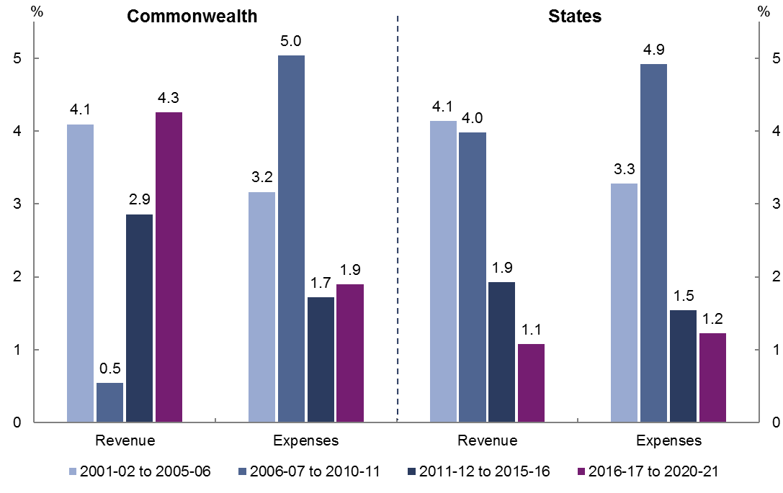
Source: ABS, Commonwealth and state budget papers, PBO analysis.
For the Commonwealth, growth in revenue is projected to increase strongly over the five years to 2020–21 compared to the previous five years, from 2.9 per cent annual average real growth to 4.3 per cent. Growth in expenditure over the five years to 2020–21 is projected to remain roughly unchanged averaging 1.9 per cent annually in real terms. The significant pickup in revenue growth combined with subdued expenditure growth is driving the projected improvement in the Commonwealth net operating balance over the forward estimates.
In contrast, real growth in states’ revenue and expenses are projected to decrease over the five years to 2020–21, both growing at around 1 per cent annually in real terms. This reflects spikes in both revenue and expenses early in the period which are not projected to continue over the entirety of the upcoming five-year period (see section 2.2.1 and 2.2.2).
Annual real growth in state revenue is projected to be around half that of the previous five years, falling from 1.9 to 1.1 per cent. Annual real growth in expenses is projected to decline to 1.2 per cent, which is low by historical standards. The combination of subdued projected revenue and expense growth results in small net operating surpluses for the states in aggregate over the forward estimates.

Net capital investment
Commonwealth net capital investment is projected to increase from 0.1 per cent of GDP in 2016–17 to 0.3 per cent of GDP in 2020–21 (Figure 2–4).
Figure 2–4: Commonwealth net capital investment
(Share of GDP)
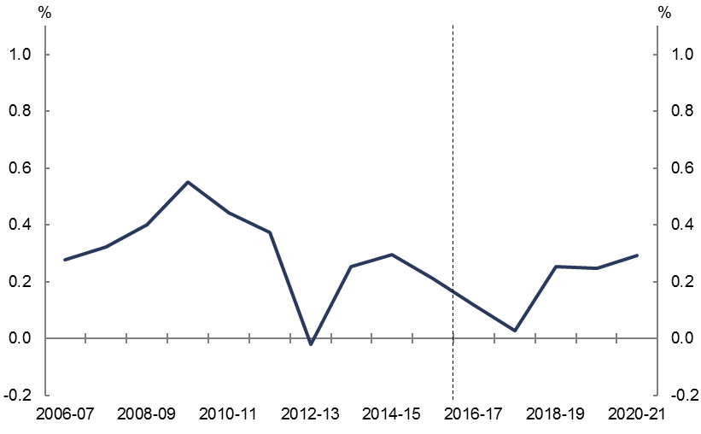
Source: ABS, Commonwealth budget papers, PBO analysis.
The net capital investment the Commonwealth undertakes directly is relatively small and is largely in the area of defence. The profile is affected by the scheduling of major defence weapons purchases and sales of non-financial assets. The sharp decrease in net capital investment in 2017–18 is due to the auctioning of spectrum licences.
Although it does not form part of general government net capital investment, Commonwealth-owned corporations have been increasing their levels of investment, driven largely by the rollout of the National Broadband Network (see Box 3).
Apart from direct investment and the activities of Commonwealth-owned corporations, the Commonwealth has a key role in providing funding and financing to the states for infrastructure projects. It does this through grants and increasingly through equity and debt financing for projects, which are not captured in direct Commonwealth government investment.

Net debt
Commonwealth budget papers indicate that net debt is projected to increase from
18.6 per cent of GDP ($325.1 billion) in 2016–17, to peak as a per cent of GDP at 19.8 per cent ($375.1 billion) in 2018–19, before declining to 17.6 per cent of GDP ($366.2 billion) by
2020–21 (Figure 2–5).
Figure 2–5: Commonwealth net debt
(Share of GDP)
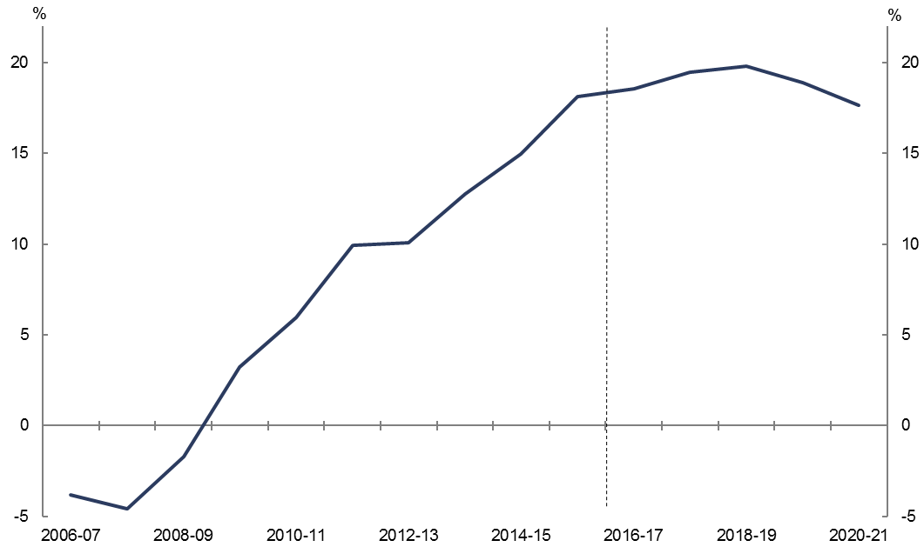
Source: ABS, Commonwealth budget papers, PBO analysis.
The improvement in net debt over the forward estimates reflects the reduced financing task as the budget moves into surplus over the latter half of the forward estimates period.

Total state trends
State revenue and expenditure, including transfers from the Commonwealth, are on average around 60 per cent of the comparable Commonwealth totals in 2016–17. In contrast, state net capital investment in 2016–17 is around five times greater than that undertaken by the Commonwealth.
Compared to the Commonwealth, state revenue and expenses in aggregate have historically moved in line with each other, with variations among individual states (see Appendix A for state net operating balances). This reflects the less volatile revenue base for the states, with fluctuations largely caused by changes in the Commonwealth payments to the states for specific purposes.
State net capital investment grew strongly over the latter part of the past decade, driven in part by Commonwealth transfers.
Over the forward estimates period, state budget papers indicate that revenue and expenditure are projected to decline as a per cent of GDP (Figure 2–6 and Figure 2–7), with net capital investment projected to grow strongly over the first half of the forward estimates, before declining as a per cent of GDP by 2020–21.
Figure 2–6: State revenue and expenses  (Share of GDP) | Figure 2–7: State revenue and expenses  (Annual real growth)
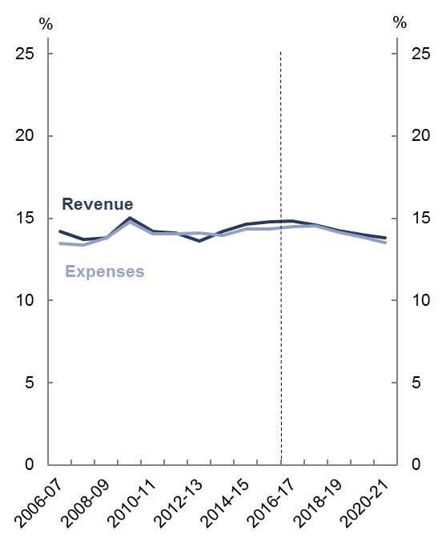  Source: ABS, state budget papers, PBO analysis | 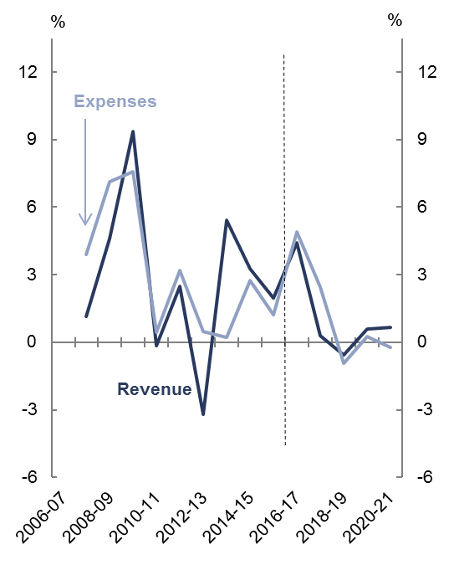  Source: ABS, state budget papers, PBO analysis.

Revenue
According to state budgets, revenue is projected to decline from 14.8 per cent of GDP in 2016–17 to 13.8 per cent of GDP in 2020–21, with zero or negative real growth from
2017–18 onwards.
State government revenue is made up of transfers from the Commonwealth government and own-source revenue (Figure 2–8).
Figure 2–8: State revenue
(Share of GDP)
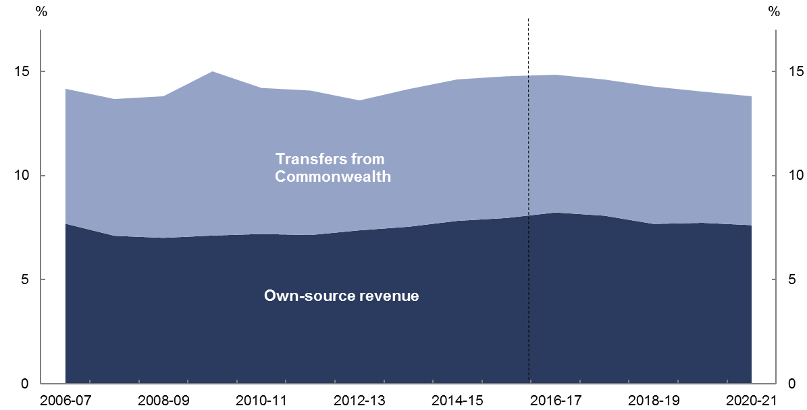
Source: ABS, Commonwealth and state budget papers, PBO analysis.

Transfers from the Commonwealth to the states
Around 45 per cent of total state revenue in 2016–17 is from Commonwealth transfers. Transfers received by state governments are made up of general revenue assistance for use at the discretion of the recipient government and specific purpose payments which are to be used in specific sectors or to deliver programs agreed in partnership with the Commonwealth government. General revenue assistance mainly comprises the transfer of GST revenue to the states.
As a per cent of GDP, Commonwealth transfers to the states are projected to fall from 6.6 per cent of GDP in 2016-17 to 6.2 per cent of GDP in 2020-21 according to Commonwealth budget papers. This is largely driven by a fall in specific purpose payments to the states, partly reflecting the new funding arrangements as jurisdictions transition to the NDIS. Rather than providing funding to the states for disability services, the Commonwealth, through the National Disability Insurance Agency, will provide funding to individuals directly for disability support services. States will also contribute to the cost of the scheme. Further contributing to the decline in specific purpose payments are infrastructure payments to the states, which decline as projects are completed.
States depend on transfers to differing extents. For example, on average over the five years to 2015–16 transfers from the Commonwealth made up around 70 per cent of the Northern Territory’s total revenue compared with around 30 per cent for Western Australia
(Figure 2–9). These shares are largely a function of the GST relativities that apply across different states which are determined by the Commonwealth Grants Commission on an annual basis.
Figure 2–10 illustrates the variations in state revenue per person across states over the five years to 2015–16, taking into account both own-source revenue and transfers from the Commonwealth.
Figure 2–9: State revenue
(Share of GDP, average, 2011–12 to 2015–16)
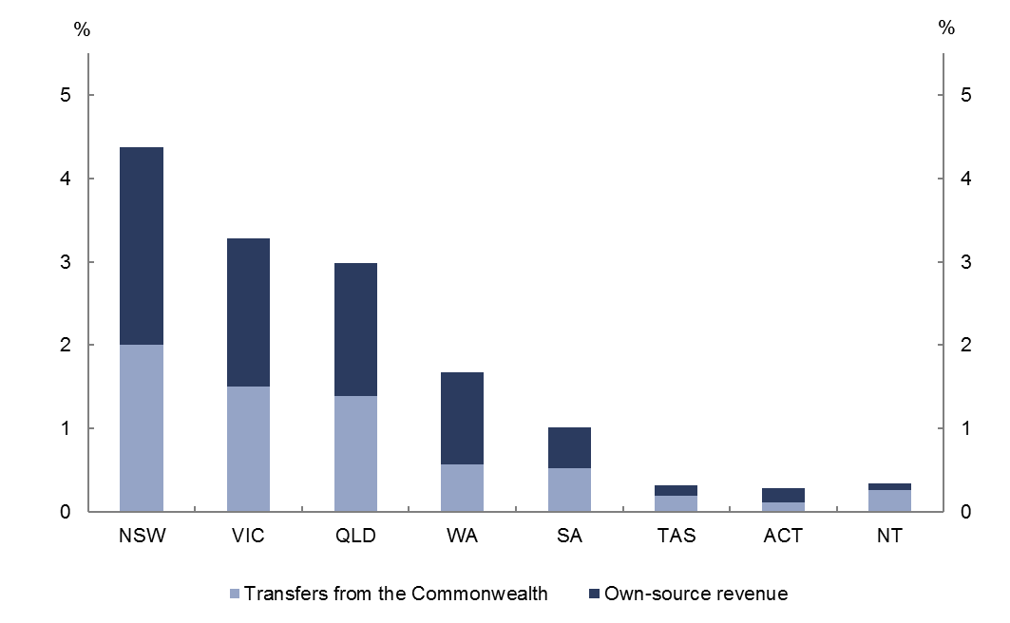
Source: ABS, Commonwealth and state budget papers, PBO analysis.
Figure 2–10: State per-capita revenue
(Average, 2011–12 to 2015–16)

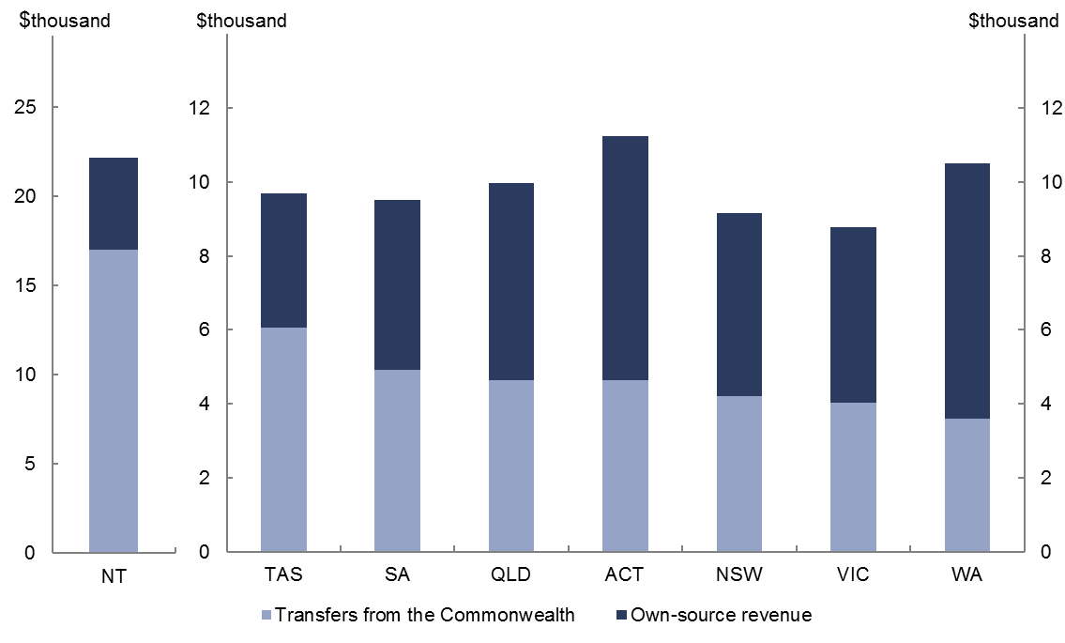
Source: ABS, Commonwealth and state budget papers, PBO analysis.

Own-source revenue
The remainder of state revenue is derived from their own sources. Key revenue sources for the states are taxes on property (land tax and municipal rates), payroll tax, stamp duty, revenue from sales of goods and services, and for resource rich states, royalty revenue. Payments from government-owned corporations have also become an increasing source of revenue for state governments.
Own-source revenue for the states in aggregate has been relatively stable. It has averaged 7.4 per cent of GDP over the past decade. Own-source revenue is projected to fall as a proportion of GDP from 8.2 per cent of GDP in 2016–17 to 7.6 per cent of GDP in 2020–21.
This decline reflects strong growth in certain states’ revenue in 2016–17 and 2017–18 which is not projected to continue over the remainder of the forward estimates. This includes a spike in Queensland royalty revenue from high metallurgical coal prices, which are then assumed to decline over the forward estimates.
Similarly, a strong property market is fuelling strong growth in New South Wales transfer duty in 2016–17, with growth projected to moderate over the forward estimates. Further, a
one-off increase in stamp duty from the long-term lease of AusGrid and Endeavour Energy contributes to growth at the beginning of the forward estimates in New South Wales.
Western Australia also has strong revenue growth in 2017–18 reflecting a large increase in revenue from government-owned corporations, where the government has mandated increases in the dividends paid by these corporations.

Expenses
State expenses are projected to decline from 14.5 per cent of GDP in 2016–17 to
13.5 per cent of GDP in 2020–21, with negative and flat real growth from 2018–19 onwards. This reflects weak expenditure growth across jurisdictions over the forward estimates period, with Queensland, Western Australian, South Australia, Tasmania and Northern Territory all projecting zero or negative real growth from 2016–17 to 2020–21.
Many states are projecting strong growth over 2016–17 and 2017–18, before growth drops sharply over the latter half of the forward estimates periods. This reflects a combination of ‘one-off’ increases in expenses in 2016–17 and 2017–18 combined with savings initiatives, which are primarily aimed at public sector employee expenses (the largest expenditure category for states), taking effect over the latter half of the forwards estimates. This is a further decrease on the already low growth in spending over the previous five years (see
Box 2).
In New South Wales, strong growth from 2016–17 to 2017–18 is largely driven by expenditure on education, health, major transport and grants and subsidy expenses. This is dampened by the application of an efficiency dividend and procurement savings which have the largest impact over the latter part of the forward estimates.
In Queensland, expenditure in 2016–17 and 2017–18 is inflated by spending on the Gold Coast Commonwealth games, recovery activities for Tropical Cyclone Debbie and continued strong growth in the demand for health and education services.
To address operating deficits, Western Australia has introduced a number of measures to reduce expenses growth including public service redundancies and capping public sector wage increases to $1,000 per annum. These measures have the biggest impact from 2018–19 onwards.
In South Australia, large one-off factors contribute to strong growth in 2016–17 and 2017–18. After that employee expenses decline in real terms across the forward estimates, primarily reflecting reductions in general government sector employment numbers, and measures to constrain public sector wages growth over the forward estimates.

Net capital investment
States account for the large majority of government net capital investment in Australia, making up around 80 per cent of total net capital investment by governments in 2016–17.
Over the first half of the forward estimates, aggregate state net capital investment is projected to rise sharply, peaking at 0.9 per cent of GDP in 2018–19, before declining to
0.3 per cent of GDP by 2020–21 (Figure 2–11).
This increase follows a trend of declining state investment since the peak in 2009–10. Investment in the peak period was driven by the Commonwealth’s fiscal stimulus packages that supported state infrastructure projects. The composition of state investment was more weighted to Queensland in that period which had large transport infrastructure spending as well as reconstruction spending following natural disasters in 2010–11.
Figure 2–11: State net capital investment
(Share of GDP)
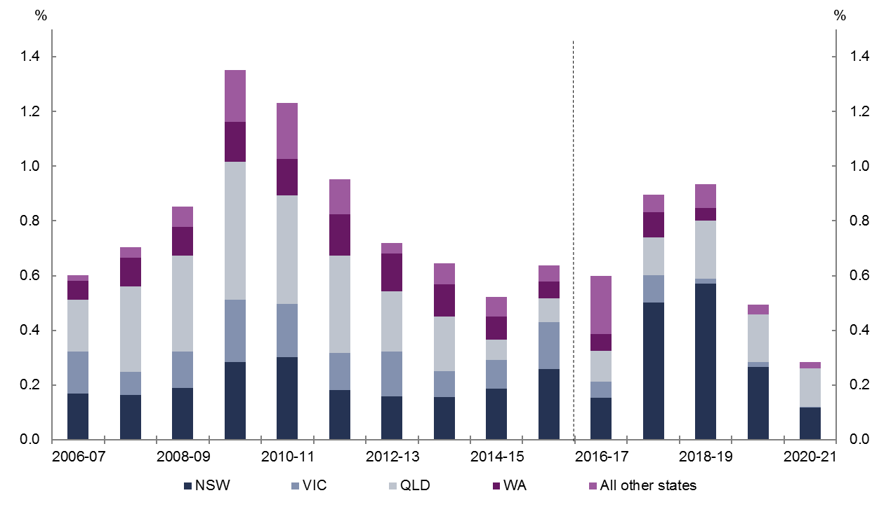
Source: ABS, state budget papers, PBO analysis.
The increase in net capital investment over the period ahead is largely driven by New South Wales, which is projecting net capital investment to increase from 0.2 per cent of GDP in 2016–17 to 0.6 per cent of GDP in 2018–19. This reflects spending on major transport projects including WestConnex and the Sydney metro, capital works in schools and TAFEs, and multiple hospital expansions and redevelopments. As a per cent of GDP, the projected peak in New South Wales net capital investment in 2018–19 is around double the peak following the global financial crisis.
Queensland is also undertaking major investment over the period, making up over half of all net capital investment in 2020–21. This includes spending on major projects such as the Brisbane Cross River Rail project, Toowomba Second Range Crossing, the Gold Coast light-rail, the purchase of new trains, road projects and health infrastructure. Net capital investment remains lower than peaks seen at the beginning of the decade.
As noted in previous sections, some of this net capital investment is funded by the Commonwealth through capital grants to the states (e.g. for a specific road project), GST revenue which is then used by the states for capital expenditure, or through financing assistance to the states for capital projects. This latter category for example includes the concessional loan to the New South Wales Government for the WestConnex project.
More broadly, state-owned corporations play a key role in undertaking net capital investment and contribute a significant portion of the net capital investment undertaken by the public sector (Box 3).
Box 3: Net capital investment by government-owned corporations
The analysis in this report focusses on the general government sector. This sector primarily consists of government departments and agencies providing non-market public services which are funded mainly through taxes.
The general government sector does not include government-owned corporations which provide services to consumers on a fee for service basis (e.g. the National Broadband Network (NBN), Australia Post, some electricity companies and other utilities). These corporations are funded through a combination of revenue from the provision of goods and services and government grants.
Government-owned corporations, particularly for states, typically have significant capital costs reflecting the goods and services they provide, such as electricity and water.
Looking at net capital investment across both sectors can provide a more complete picture of the public investment taking place, and also overcomes classification differences between states due to which sectors deliver particular services.
Figure 2–12 and Figure 2–13 show general government and government-owned net capital investment for the Commonwealth and the states.
Figure 2–12: Commonwealth net capital investment by government and government-owned corporations (Share of GDP) | Figure 2–13: State net capital investment by government and government-owned corporations (Share of GDP)
Source: ABS, Commonwealth budget papers, PBO analysis. | Source: ABS, state budget papers, PBO analysis.
From 2006–07 to 2012–13 net capital investment by state government-owned corporations grew strongly reflecting strong investment by Queensland, New South Wales and Victoria at various stages over the period.
From 2006–07 to 2008–09 Queensland government-owned corporations were the key contributor to growth, reflecting investment in water, electricity, rail and ports infrastructure. New South Wales government-owned corporation investment increased significantly in 2008–09 and 2009–10 due to investment in water infrastructure, the electricity sector and social housing. Strong growth in 2012–13 was driven by Victorian government-owned corporations’ investment in water and rail infrastructure.
In 2016–17, state government-owned corporations are estimated to account for around half (0.5 per cent of GDP) of all state net capital investment. The projected decline in investment after 2018–19 reflects a fall in New South Wales, as major road and rail projects are completed, and the planned sale of the Sydney Motorway Corporation.
In contrast net capital investment by Commonwealth government-owned corporations has been relatively small, but has grown sharply due to the roll-out of the NBN. In
2016–17, net capital investment from Commonwealth government-owned corporations is projected to be 0.4 per cent of GDP, primarily comprising the NBN. As the NBN rollout reaches completion, projects such as the Melbourne to Brisbane Inland Rail project and the Western Sydney Airport are expected to be the key contributors to the growth in net capital investment by Commonwealth-owned government corporations, although most of these impacts are expected to fall outside the 2017-18 forward estimates.

Net debt
As the previous section highlighted, revenue and expenses for the states are expected to track each other closely over the forward estimates, leading to small operating surpluses. However these operating surpluses are insufficient to fund the strong level of investment the states plan to undertake over the forward estimates. States must sell assets or borrow to fund investment, with a consequent impact on their net debt positions.
The aggregate net debt of the states is around a tenth that of the Commonwealth in
2016–17. State net debt is projected to increase sharply over the forward estimates, increasing from 2.0 per cent of GDP in 2016–17 to 4.7 per cent of GDP in 2020–21
(Figure 2–14). This in large part reflects the investment profile of New South Wales
(Figure 2–15).

Figure 2–14: Aggregate state net debt  (S (Share of GDP) | Figure 2–15: Net debt of selected states  (Share of GDP)
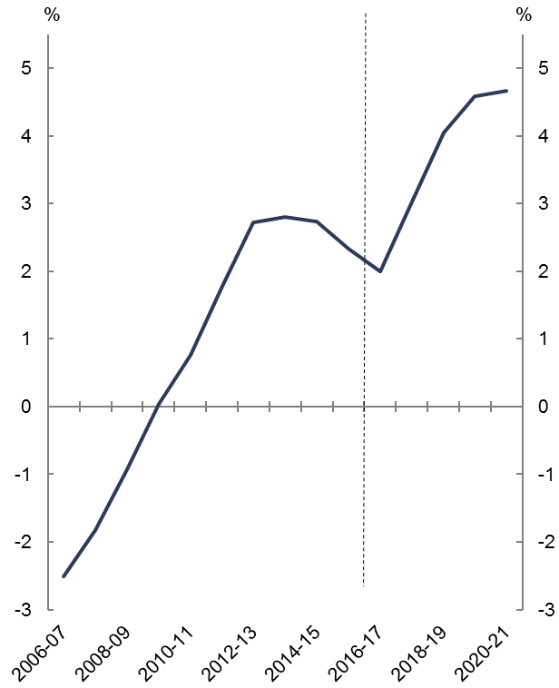  Source: ABS, state budget papers, PBO analysis. | 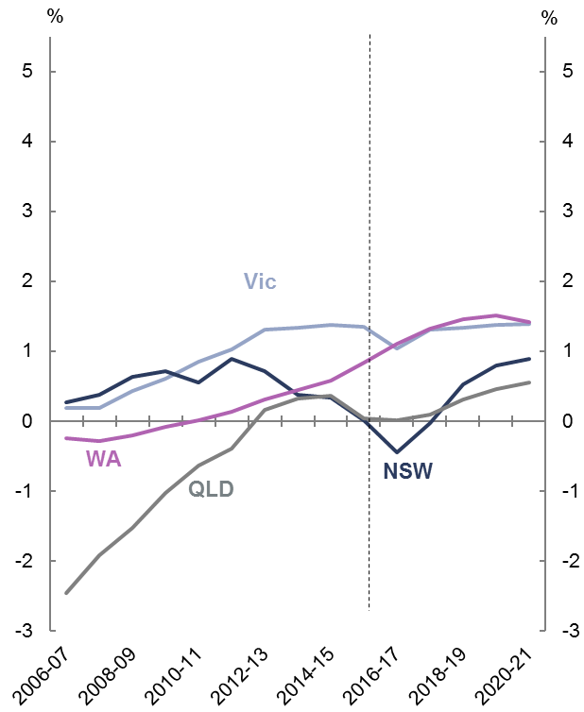  Source: ABS, state budget papers, PBO analysis.
The fall in net debt in 2016–17 reflects the proceeds from the sale of non-financial assets; the partial lease of two government-owned electricity network businesses Ausgrid and Endeavour Energy in New South Wales and the partial long-term lease for the Port of Melbourne in Victoria. As the proceeds from these sales are reinvested into other capital projects, net debt rises.
Queensland’s net debt also declines as a percentage of GDP at the beginning of the forward estimates, reflecting increased royalty revenue in 2016–17. Net debt then increases as a result of increased borrowings to fund infrastructure projects over the remainder of the forward estimates period.
Western Australia’s net debt position reflects increased infrastructure spending on rail projects in 2016–17 and 2017–18, combined with borrowing to fund operating deficits over the forward estimates to 2019–20.

Appendix A — State net operating balances
New South Wales | Victoria
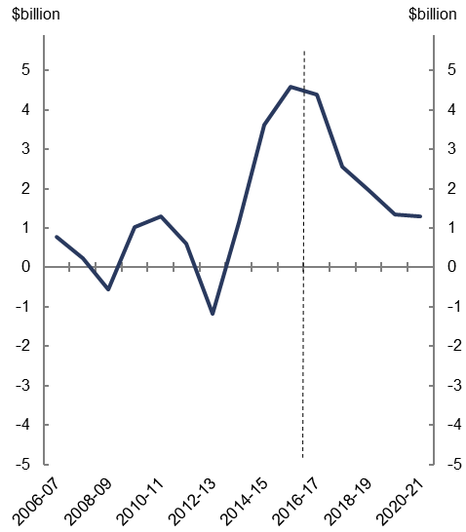  Source: ABS, state budget papers, PBO analysis. | 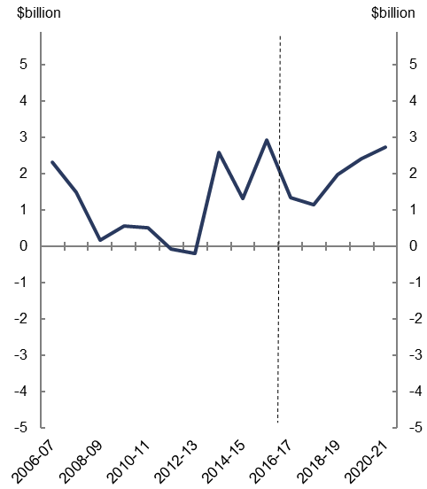  Source: ABS, state budget papers, PBO analysis.
Queensland | Western Australia
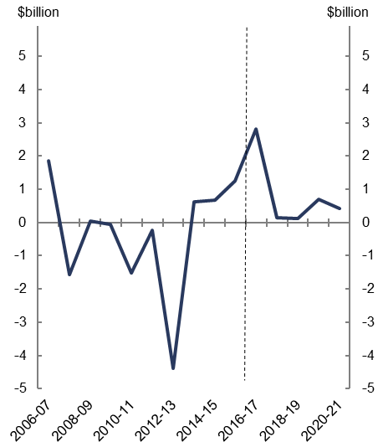  Source: ABS, state budget papers, PBO analysis. | 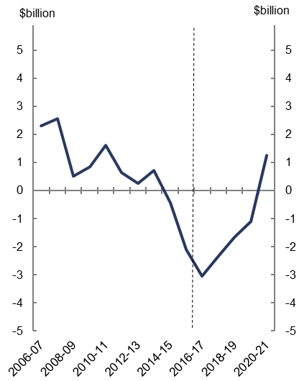  Source: ABS, state budget papers, PBO analysis.

South Australia | Tasmania
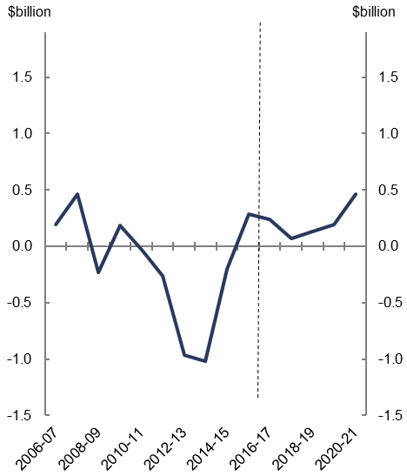  Source: ABS, state budget papers, PBO analysis. | 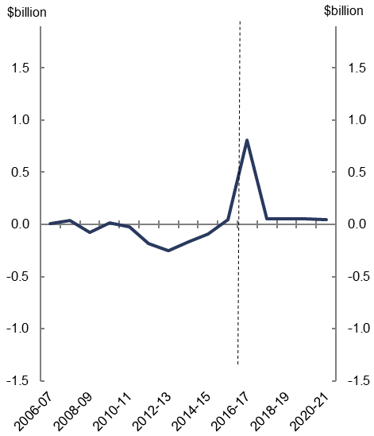  Source: ABS, state budget papers, PBO analysis.
Australian Capital Territory | Northern Territory
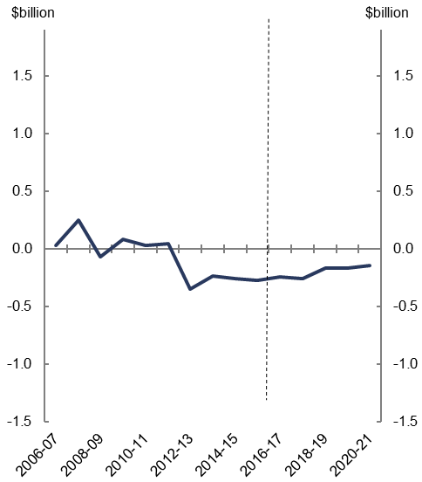  Source: ABS, state budget papers, PBO analysis. | 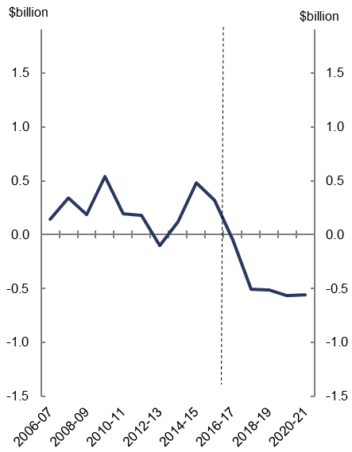  Source: ABS, state budget papers, PBO analysis.

Appendix B — Glossary and notes

Net operating balance
The net operating balance measures the difference between recurrent revenue and expenses. It does not include net capital investment, but does include the consumption of capital (depreciation).

Net capital investment
Net capital investment is primarily the purchase of non-financial assets less asset sales and depreciation.

Fiscal balance
The fiscal balance is the net operating balance less net capital investment. It measures the government’s investment-saving balance.

Net debt
Net debt is a widely used measure of the strength of the government’s balance sheet. Net debt is the sum of selected financial liabilities (deposits held, advances received, government securities, loans and other borrowings) less the sum of selected financial assets (cash and deposits, advances paid, and investments, loans and placements). It does not include superannuation related liabilities.

General government sector
The general government sector consists primarily of government departments and agencies providing non-market public services which are funded mainly through taxes.

Government-owned corporations
Government-owned corporations, also known as public non-financial corporations, are corporations which provide services to consumers on a fee for service basis. These corporations are funded through a combination of revenue from the provision of goods and services and government grants.

Data and Methodology
The report focusses on the general government sector.
From 2006–07 to 2015–16 data are based on accrual data from ABS 5512.0 - Government Finance Statistics, Australia. From 2016–17 to 2020–21 accrual data are sourced from Commonwealth, state and territory budgets. Data is generally comparable across the two periods, but there are differences in the budget treatment of items across jurisdictions.
The New South Wales projections of revenue and expenses have been adjusted by the PBO to improve comparability across periods. New South Wales exclude Commonwealth transfers that ‘pass through’ their state accounts and as such their reported revenue and expenses do not include these amounts (these mainly relate to payments to non-government schools and local governments which the Commonwealth makes through the states). In contrast the ABS requires that the full ‘grossed up’ amount be reported. There are also differences in when Commonwealth grants are recognised between the New South Wales budget papers and the ABS. To gain a more consistent series, the PBO has estimated New South Wales revenue and expenses from 2016–17 onwards.
The data in this report do not incorporate 2016–17 final budget results of the Commonwealth and states. Partially updating the forward estimates for final budget results may misrepresent trends across the forward estimates. For example, the Commonwealth’s
2016–17 Final Budget Outcome contained a $0.5 billion underspend for payments to the states for infrastructure and housing due to delays in state projects. This funding is likely to be shifted to subsequent years. Factoring in only the 2016-17 reduction in expenses without any change in the other years would create an inconsistency within the forward estimates period. These changes will be factored in at the time of mid-year budget updates.
The report focusses on the general government sector, which consists of government departments and agencies providing non-market public services which are funded mainly through taxes.
From 2016–17 local government data is projected by the PBO using historical trends.

www.pbo.gov.au

Previous PBO reports and Commonwealth budgets focussed on the fiscal balance, which is the net operating balance less net capital investment. More detail on budget aggregates and reporting are available in the ‘Glossary and notes’ section.
To allow for the most consistent comparison across jurisdictions data are sourced from the ABS from 2006–07 to 2015–16. From 2016–17 to 2020–21 data are based on Commonwealth, state and territory budgets (2016–17 data are estimates as the final budget outcome for that year is not available for all states at time of publication). This section includes the local government sector, which is estimated by the PBO over the forward estimates period as there are no data available.
Public non-financial corporations.
The data used in these charts are IMF data from the 2017 October World Economic Outlook database. These data differ slightly from the data presented in the body of the paper due to the inclusion of the multi-jurisdictional sector (which mainly comprises public universities) and adjustments made by the IMF to standardise data across countries. The OECD average is weighted by GDP.
To allow for the most consistent comparison across jurisdictions data are sourced from the ABS from 2006–07 to 2015–16. From 2016–17 to 2020–21 data are based on Commonwealth, state and territory budgets. Data and figures in this section do not include local government.
In accordance with accounting standards, the superannuation expenses for 2016–17 apply a discount rate equal to the long-term government bond rate at the start of the financial year (2.7 per cent). The remainder of the forward estimates are based on the discount rate applied by the superannuation scheme actuaries in preparing long-term cost reports (6 per cent). This results in government superannuation benefit expenses falling from $9.0 billion in 2016-17 to $3.7 billion in 2017–18.
This relates to the expenses of the National Disability Insurance Agency, and does not include either the Commonwealth or Western Australian contributions to the Western Australian NDIS. The Commonwealth and the previous Western Australian government agreed that the NDIS would be delivered under a locally administered model in Western Australia from 1 July 2017. The current Western Australian Government is reviewing these arrangements to determine whether the existing agreement should be retained or alternative arrangements negotiated with the Commonwealth.
Capital grants to the states are treated as an expense for the Commonwealth. Financing arrangements such as the concessional loan to the New South Wales Government for the WestConnex project are recognised as the acquisition of assets rather than an expense.
In recent budgets a number of states have been increasing the dividend payable from government-owned corporations to the government, or prescribing that government-owned corporations hold less capital with the ‘excess’ returned to government. This has occurred in Queensland, New South Wales and Western Australia, resulting in increases in government revenue.
Budget data for Commonwealth government-owned corporations are only available to 2017–18. Data beyond that are the projected gross capital investment on the NBN from NBN Co’s latest corporate plan.

