|  |
| --- |
| Changes in average personal income tax rates: distributional impacts |
| Report no. 03/2017 |

|  |
| --- |
| © Commonwealth of Australia 2017  ISSN 978-0-9953836-5-4 (Online)  This work is licensed under the Creative Commons Attribution-NonCommercial-NoDerivs 3.0 Australia License.    The details of this licence are available on the Creative Commons website: <http://creativecommons.org/licenses/by-nc-nd/3.0/au/>  Use of the Coat of Arms  The terms under which the Coat of Arms can be used are detailed on the following website: [www.itsanhonour.gov.au/coat-arms](http://www.itsanhonour.gov.au/coat-arms)  Produced by: Parliamentary Budget Office Designed by: Studio Tweed  First Assistant Parliamentary Budget Officer  Fiscal Policy Analysis Division  Parliamentary Budget Office  Parliament House  PO Box 6010  CANBERRA ACT 2600  Phone: (02) 6277 9500  Email: pbo@pbo.gov.au |

Contents

Foreword v

Overview vii

1 Distributional analysis of personal income tax changes 1

1.1 Introduction 1

1.2 Distribution of Australia’s taxpayers 1

1.3 Projected change in average tax rate by quintile 5

1.4 What is causing the change in average tax rates? 6

1.5 Historic analysis of average tax rates 9

2 Technical appendix 11

2.1 Methodology 11

2.2 Quintile characteristics 12

2.3 Population included in analysis 13

Foreword

This report builds on the analysis included in the Parliamentary Budget Office (PBO) report *2017–18 Budget medium‑term* *projections* which illustrated, among other things, the expected increase in average personal income tax rates over the period ahead. It provides additional analysis to inform the public discussion that has emerged around who would bear the burden of this increase in personal income tax rates.

This report analyses the expected increase in average tax rates for individuals in different parts of the taxable income distribution and examines the factors that are driving these outcomes. The paper also examines trends in average tax rates over a longer time period, using historical data from 2000–01 and projections up to 2021–22.

The report was prepared by Kate Wagner with the benefit of comments by Lok Potticary, Jonathan Regan-Beasley, Paul Gardiner and Tim Pyne. The report was prepared for publication by Lauren Pratley.

Jenny Wilkinson

Parliamentary Budget Officer

11 October 2017

Overview

The PBO’s *2017–18 Budget medium-term projections* report identified that the projected return to surplus in 2020–21 is predominantly due to a projected increase in personal income tax revenue.

The average tax rate faced by individuals is estimated to increase by 2.3 percentage points over the period from 2017–18 to 2021–22. This report examines how the projected increase in the average tax rate is expected to vary across individual taxpayers in different parts of the taxable income distribution.

The average tax rate for individuals in every income quintile is projected to increase over the period from 2017–18 to 2021–22. The largest increase is expected to be faced by individuals in the middle income quintile, whose taxable income is expected to average $46,000 in 2017–18. This group of taxpayers is projected to face an increase in their average tax rate of 3.2 percentage points by 2021–22, as a higher proportion of their income is taxed at the 32.5 per cent rate. Their average tax rate is expected to increase from 14.9 per cent to 18.2 per cent.

Increases in the average tax rate of between 1.9 and 2.5 percentage points are projected for individuals in the second, fourth and fifth quintiles. The average tax rate for individuals in the lowest quintile is projected to rise by only 0.2 percentage points because most of their income remains below the effective tax‑free threshold.

Across all quintiles, the largest driver of the increase in average tax rates is expected increases in nominal incomes. This reflects the impact of bracket creep, on account of both inflation and real income growth. In addition to the effect of nominal income growth, average tax rates are projected to increase due to policy changes, most notably the policy decision to increase the Medicare Levy from 2019–20.

Taking a longer term perspective illustrates the net effect of nominal income growth and changes to tax policy on average tax rates over the period since 2000–01. This shows that for all but the lowest quintile, the increases in average tax rates since 2009–10 are offsetting reductions in average tax rates that occurred during the 2000s. By 2021–22, the average tax rate for individuals in the lowest two quintiles is still expected to be below its average in 2000–01, while the most significant increases will have occurred for individuals in the top two income quintiles.

# Distributional analysis of personal income tax changes

## Introduction

Personal income tax is a large and growing component of the Commonwealth’s budget. [1] It is the single largest source of revenue in Australia’s taxation system, accounting for over half of the Commonwealth’s tax receipts in 2016–17.[2] As the PBO’s *2017–18 Budget medium-term projections* report discussed, the projected return to surplus in 2020–21 is predominantly due to a projected increase in personal income tax revenues as average tax rates on personal income increase. This report outlines the distributional impact of the projected increase in average personal income tax rates.

The analysis presented here is based on Government policy as at the 2017–18 Budget, which includes a technical assumption that the tax‑to‑GDP ratio will not rise above 23.9 per cent of GDP. Based on the PBO’s 2017–18 Budget projections, the Government’s cap on the ratio of tax-to-GDP would require an unspecified change to Government tax policy from 2022–23 onwards. As distributional analysis cannot be undertaken in the absence of specified policy, the analysis presented here ends in 2021–22.

## Distribution of Australia’s taxpayers

Australia has a progressive personal income tax system, meaning that higher income earners pay higher marginal tax rates as their income exceeds designated income thresholds. Figure 1 shows the projected distribution of taxpayers according to their taxable income for 2017–18.[3],[4] The taxpayers are divided into quintiles — the dark purple indicates the 20 per cent of taxpayers with the lowest taxable income and the dark blue indicates the 20 per cent of taxpayers with the highest taxable income. The figure also illustrates the income levels at which the different marginal tax rates apply.

The tax thresholds are not indexed and so, in the absence of legislative amendments, they do not change over time. Incomes, on the other hand, tend to grow over time. One consequence of static tax thresholds combined with growing incomes is that taxpayers are subject to average tax rates that increase over time. This effect is sometimes referred to as ‘bracket creep’ or ‘fiscal drag’.

Figure 1: The distribution of taxpayers by taxable income, 2017–18

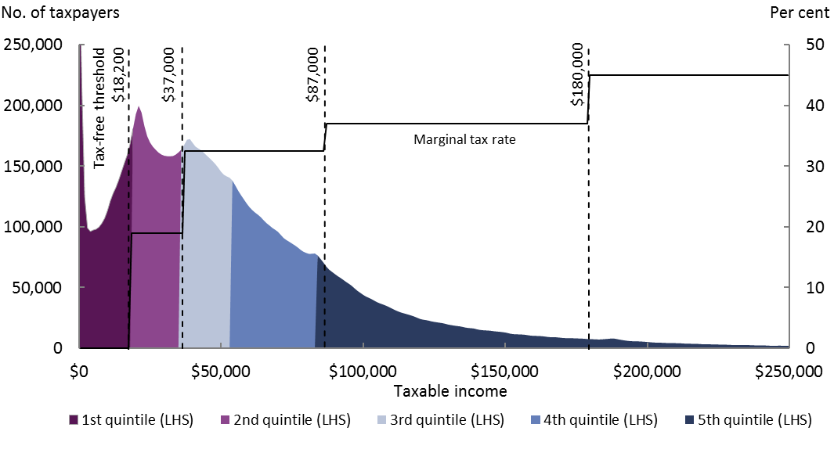

Source: PBO analysis, Australian Tax Office (ATO) data and parameters underlying the 2017–18 Budget.

Note: The marginal tax rate in this chart doesn’t include the Medicare Levy and surcharge or tax offsets, which can vary depending on the characteristics of the taxpayer.

Figure 2: The distribution of taxpayers by taxable income, 2021–22

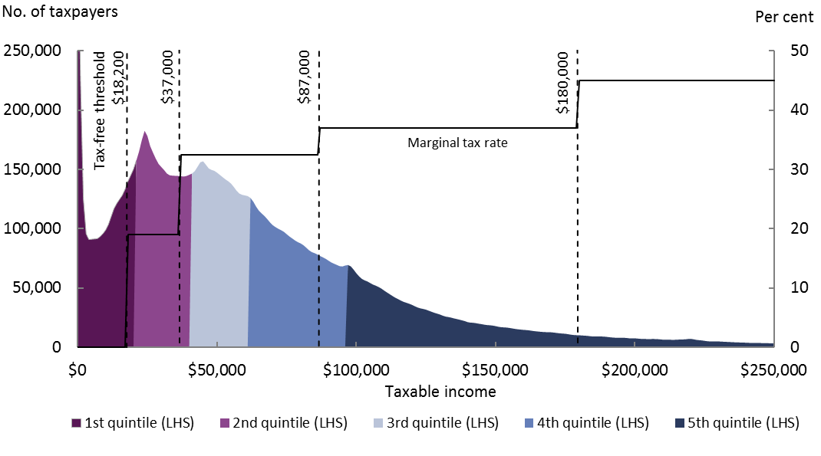

Source: PBO analysis, ATO data and parameters underlying the 2017–18 Budget.

Note: The marginal tax rate in this chart doesn’t include the Medicare Levy and surcharge or tax offsets, which can vary depending on the characteristics of the taxpayer. The projected distribution does not take into account behavioural effects that may arise, such as people adjusting their taxable income to maintain access to particular transfer payments or remaining below a particular income threshold. This could result in an overestimate of the number of individuals who cross tax thresholds.

Figure 2 shows the projected distribution of taxpayers according to the taxable incomes they are estimated to receive in 2021–22. Comparing figures 1 and 2 shows that as incomes increase, the distribution of taxpayers moves to the right. This increases average tax rates for each quintile and increases the marginal tax rates facing some individuals. The difference between average and marginal tax rates is described in Box 1.

Between 2017–18 and 2021–22, a number of individuals are expected to move across a tax threshold as a result of income growth. In this case, each additional dollar received in taxable income is taxed at a higher rate. Projections over these four years show 6.3 per cent of taxpayers, or over 900,000 people, move from a marginal tax rate of 32.5 per cent to 37 per cent. Similarly, around 5 per cent of taxpayers, or 700,000 people, are projected to move from a marginal tax rate of 19 per cent to 32.5 per cent.

For individuals whose incomes increase without crossing a tax threshold, they pay the same marginal tax rate for each additional dollar earned. However a higher proportion of their taxable income is taxed at their marginal tax rate, meaning that their average tax rate still increases.

Box 1: Average and marginal tax rates

|  |
| --- |
| Australia’s personal income tax system comprises a set of tax thresholds with corresponding progressive tax rates that apply between thresholds. The income tax rates specified are marginal tax rates, so they specify the additional tax payable if additional taxable income is received. This differs from the average tax rate, which takes the total tax payable and divides this by total taxable income. Marginal tax rates are of interest when investigating incentives to increase or reduce taxable income for different groups of taxpayers. Average tax rates are of interest when investigating the overall tax burden for groups of taxpayers. The marginal and average tax rates are shown in Figure 3 below for the 2017–18 base income tax rates. The chart, and the analysis in this report, does not include the effects of transfer payments.  Figure 3: Average and marginal tax rates, 2017–18    Note: This chart doesn’t include the Medicare Levy and surcharge or tax offsets, which can vary depending on the characteristics of the taxpayer. The diamonds indicate a taxable income of $70,000, used in the example below.  As an example of how these tax rates are related, consider a person earning a salary of $70,000 each year (with no other income). This person’s tax is calculated by adding the following:   * $0 tax for the first $18,200 of income * $3,572 tax on the income between $18,200 and $37,000 (19 per cent tax rate) * $10,725 tax on the income between $37,000 and $70,000 (32.5 per cent, the person’s marginal tax rate).   This gives a total of $14,297 in tax (excluding the Medicare levy). The average tax rate is then given by $14,297/$70,000 = 20.4 per cent. The marginal and average tax rates for this person are shown in Figure 3 with the diamond-shaped markers on the curves.  After the application of the basic income tax rates to taxable incomes, various tax offsets, such as the low income tax offset and the seniors and pensioners’ tax offset, are applied for eligible taxpayers and serve to reduce the tax burden for some individuals. The Medicare levy and surcharge are then applied, where relevant, increasing the tax burden. In previous years, other levies have also been applied, such as the temporary budget repair levy and the flood levy. The amount of tax payable after the application of offsets and levies is known as the net tax, which then allows us to calculate the average tax rate net of offsets and levies. |

## Projected change in average tax rate by quintile

While Figures 1 and 2 demonstrate the principle that nominal income growth increases personal income tax rates, they don’t show the relative change in the tax burden for taxpayers on different incomes. The following analysis takes the quintiles shown in these charts and projects the change in average tax rate for each quintile over the period from 2017–18 to 2021–22. This analysis takes into account the base income tax rates (shown in Box 1) as well as tax offsets (such as the seniors and pensioners’ tax offset), the Medicare levy, and the Medicare levy surcharge. This measure of average tax rates is therefore an effective measure of the personal income tax burden.

To estimate changes to average tax rates over the coming years, current and future levels of tax and taxable income were modelled using a 16 per cent sample of individual tax return data. This model uses both Government policy and parameters as at the   
2017–18 Budget to calculate the changes for taxpayers over time. Further details on the modelling and methodology can be found in the Technical appendix at the end of this report.

Figure 4: Change in tax rates from 2017–18 rates by income quintile

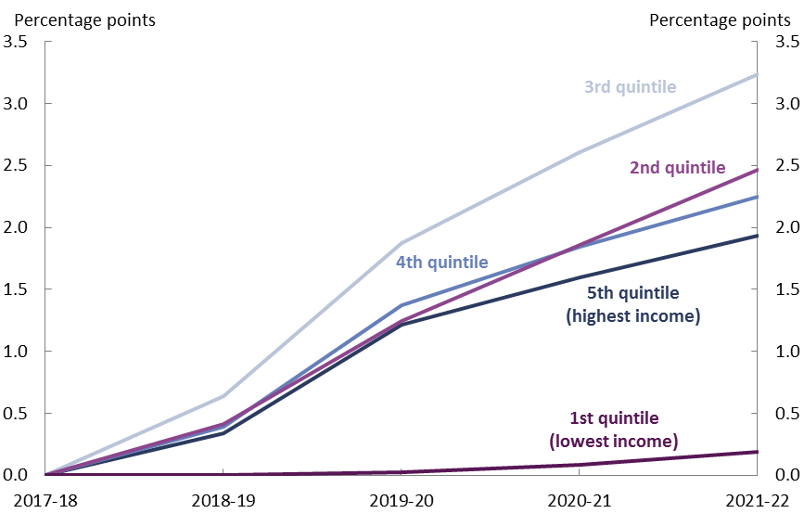

Source: PBO analysis, ATO data and parameters underlying the 2017–18 Budget.

Figure 4 shows that the average tax rate is expected to increase the most for the third income quintile, which has an average taxable income of $46,000 in 2017–18. The average tax rate for this group is projected to increase by 3.2 percentage points by 2021–22 as a higher proportion of their income is taxed at the 32.5 per cent rate.

The second, fourth, and fifth quintiles are projected to experience increases in the average tax rate of between 1.9 and 2.5 percentage points by 2021–22. The first income quintile is projected to experience very little change (an increase of 0.2 percentage points) to their average tax rate as most of their income remains below the effective tax‑free threshold, including the low income tax offset.

## What is causing the change in average tax rates?

The growth in the average tax rate that is projected to occur over the period from 2017–18 to 2021–22 is the cumulative effect of several drivers:

* the impact of nominal income growth
* policy changes
* demographic changes.

How each of these drivers affects the average net tax rate across the population is described and modelled in this section. All estimates use the parameters and population projections underlying the 2017–18 Budget.

As nominal taxable incomes increase in a progressive tax system, average tax rates also increase, as was shown in Figure 3. Growth in nominal income is itself a combination of income growth that offsets inflation and real income growth. The impact of the inflation component of rising incomes on the average tax rate is modelled by uniformly growing incomes by the projected rate of inflation and calculating the resulting additional tax liability for the projected levels of taxable income.

The second component of nominal income growth is the projected increase in real incomes. Growth in real salaries and wages (the largest component of total personal income) is applied differentially across taxpayers based on historical remuneration growth by gender and level of remuneration. The contribution of real income growth to the change in average net tax rate is estimated by calculating the additional tax liability given the projected growth in real incomes.

Policy changes that are due for implementation between now and 2021–22 are included for each individual in the analysis to evaluate their impact on average tax rates. The most material change to policy is the increase in the Medicare levy that is due to be implemented in 2019–20.

The changing age composition of the population (demographics) is also projected to have a small impact on the average tax rate. Average incomes vary among age cohorts, and since in a progressive tax system tax rates depend on incomes, a changing age composition indirectly affects the average tax rate. Net tax rates also differ depending on age due to the availability of an additional tax offset to seniors.

The impact that these drivers have on the average tax rate across the entire taxpaying population is shown in Figure 5.

Figure 5: Drivers of the projected change in average tax rate, cumulative effect from 2017–18

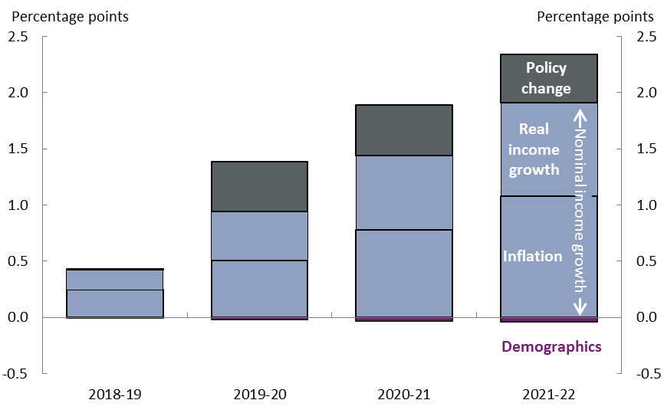Source: PBO analysis, ATO data and parameters underlying the 2017–18 Budget.

The projected growth in nominal incomes is the largest driver of the change in the average tax rate. As mentioned above, this comprises both an inflation component and a real income component, both of which contribute to bracket creep.

Figure 5 implies that if incomes were to only grow enough to compensate for inflation over the next four years and there were no other changes to the tax system, the average tax rate would increase by 1 percentage point across the taxpaying population. After the effect of nominal income increases, the main contributor to growth in the average net tax rate is policy change.

Demographic changes also have a very small negative impact on the average tax rate between 2017–18 and 2021–22. There are two effects driving the demographic impact among taxpayers.

* Net migration leads to a slight increase in the proportion of young working age individuals in the taxpaying population.
* The aging population leads to a slight increase in the proportion of seniors in the taxpaying population.

Both of these effects lead to a slight decrease in the average net tax rate between 2017–18 and 2021–22. Senior Australians have a lower average tax rate as they are eligible for the Seniors and pensioners’ tax offset. Among the working age population, incomes tend to rise the longer individuals have been in the workforce, leading to lower average tax rates among younger workers and higher average tax rates among older workers. A higher proportion of younger workers through net migration then tends to lower the average tax rate.

Overall, the average tax rate is projected to increase by 2.3 percentage points between 2017–18 and 2021–22. However, as was shown in Figure 4, the projected change in the average tax rate is not consistent across the taxpaying population, reflecting the fact that the underlying drivers have a different impact depending on where a taxpayer lies on the taxable income distribution.

Figure 6 shows the impact of each of the different factors on the increase in average tax rate for each income quintile.

Figure 6: Drivers of projected change in tax rates between 2017–18 and 2021–22 by quintile

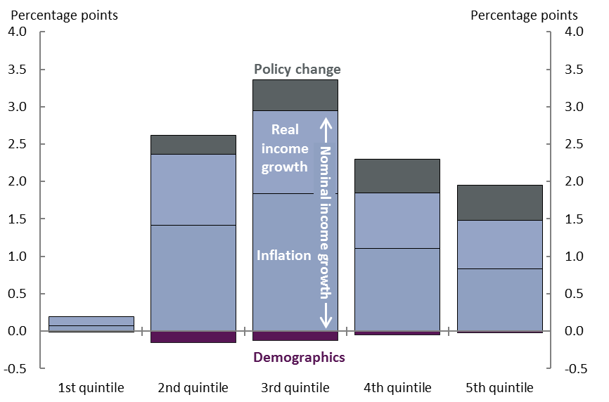

Source: PBO analysis, ATO data and parameters underlying the 2017–18 Budget.

Bracket creep does not impact on all taxpayers equally — Figure 6 shows that bracket creep has the greatest impact on average tax rates for individuals in the third income quintile, corresponding to an average taxable income of $46,000 in 2017–18, followed by individuals in the second income quintile, with an average taxable income of $28,000.[5] Figure 6 also implies that if incomes were to only grow enough to compensate for inflation over the next four years and there were no other changes to the tax system, the average tax rate would increase by over 1 percentage point for the second, third, and fourth income quintiles.

The impact of real income growth on top of bracket creep is generally less than the inflation component of nominal income growth, but is similarly material.

Policy changes also contribute to the increasing average tax rate between 2017–18 and   
2021–22. The policy component primarily reflects the increase in the Medicare levy that is due to be implemented in 2019–20.[6] The increase in the Medicare levy has the greatest impact on individuals in the third, fourth, and fifth income quintiles. Medicare levy concessional arrangements eliminate this impact for the first income quintile and limit the impact for the second.

## Historic analysis of average tax rates

While the distributional impact of changes in personal income tax rates over the coming years is clearly of interest for informing public policy discussions, it is also useful to have the additional context that historical comparisons provide. To this end, individual tax returns for each year from 2000–01 were analysed to illustrate how the average tax rate has changed for each income quintile historically. The results from the historical period as well as the modelled projections to 2021–22 are shown in Figure 7.

Figure 7: Change in average tax rates since 2000–01 by income quintile

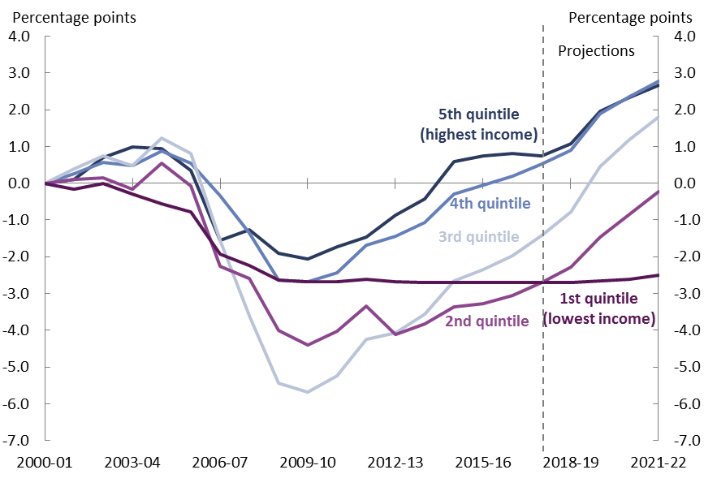

Note: The chart shows the actual data collected by the ATO up to 2013–14; PBO estimates based on ATO data combined with economic data from 2014–15 to 2016–17, and PBO projections based on ATO data and the parameters underlying the 2017–18 Budget from 2017–18 onwards.

Figure 7 shows changes in the average tax rate by income quintile over the period from 2000–01 to 2021–22. There were many changes to the personal income tax rates and thresholds during this period. The most material changes for the purposes of understanding Figure 7 were between 2005–06 and 2008–09. The average tax rate decreased across all income quintiles as a result of the combination of decreases to the tax rates and thresholds and increases in the low‑income tax offset. The most substantial decreases in average tax rates occurred for the second and third income quintiles.

Since 2009–10, average tax rates have increased for all quintiles except the first quintile and are projected to continue to increase over the period to 2021–22. The first income quintile has maintained a lower tax rate due to the operation of the low income tax offset.

Overall, this longer term analysis illustrates that while the third income quintile is projected to experience the largest increase in average tax rates over the period to 2021–22, this was also the quintile that benefitted from the most significant reductions in average tax rates during the 2000s. Over the period since 2000–01, the net effect of nominal income growth and changes to tax policy has increased the progressivity of Australia’s income tax system.

# Technical appendix

## Methodology

The distributional projections of the average personal income tax rate by quintile are estimated using a 16 per cent sample of de‑identified personal income tax and superannuation returns for 2013–14 provided by the Australian Taxation Office (ATO). The estimates use the parameters and population projections underlying the 2017–18 Budget. Wages growth is applied differentially across taxpayers based on historical remuneration growth by gender and level of remuneration. Remuneration comprises income from salaries and wages and concessional superannuation contributions.

The historical distributional analysis is based on de-identified personal income tax returns for 2000–01 through to 2013–14 provided by the ATO.

All analysis excludes individuals who are non-residents for taxation purposes. These individuals are subject to different tax rates and thresholds.

Calculations of the average net tax rate (usually referred to as average tax rate throughout this report) take the sum of the net tax for the relevant group of taxpayers and divide this by the sum of the taxable income for the same group of taxpayers.[7]

The net tax is calculated as:

|  |
| --- |
| **Net tax**  *equals*  **Gross tax**  *less*  **Non-refundable tax offsets**  *plus*  **Medicare Levy (and surcharge)** |

Note that this does not include tax credits such as franking credits or the private health insurance rebate.

All figures presented are on an accrual basis. As an example, this means that for the projected tax rate in 2017–18, we are comparing the tax liability on the earnings for 2017–18 to the taxable income for that same year. On an accrual basis, tax is calculated this way even if some of the tax is actually paid a year later.

While annual results within this distributional analysis can be compared, there are some methodological differences to the figures presented in the PBO’s *2017–18 Budget medium‑term projections* report. In particular, the medium-term projections report is on a cash rather than accrual basis, and it also included tax credits in the calculations of tax and tax rates.

## Quintile characteristics

The income quintiles projected for 2017–18 and used for the analysis in this report, are shown in Table 1. In 2017–18, each quintile contains around 2.9 million taxpayers.

Table 1: The characteristics of each quintile by taxable income

|  |  |  |  |  |  |  |
| --- | --- | --- | --- | --- | --- | --- |
| **Quintile** | **Taxable income range, 2017–18** | **Average taxable income, 2017–18** | **Growth in average taxable income(a)** | **Average tax rate (per cent), 2017–18** | **Projected increase in average tax rate(b)** | **Growth in average tax (a)** |
| 1 | Up to $20,000 | $8,000 | $800 | .. | 0.2 | .. |
| 2 | $20,000 to $37,000 | $28,000 | $3,500 | 5.5 | 2.5 | $900 |
| 3 | $37,000 to $56,000 | $46,000 | $6,100 | 14.9 | 3.2 | $2,500 |
| 4 | $56,000 to $85,000 | $69,000 | $9,600 | 21.9 | 2.2 | $3,700 |
| 5 | $85,000 and above | $156,000 | $23,400 | 32.0 | 1.9 | $10,700 |
| All | n/a | $62,000 | $8,700 | 23.9 | 2.3 | $3,600 |

Source: PBO analysis, ATO data and parameters underlying the 2017–18 Budget.

Note: Average taxable income figures are rounded to the nearest $1,000.

.. Not zero, but rounded to zero.

(a) Increase in 2017–18 dollars between 2017–18 and 2021–22. These figures are rounded to the nearest $100.

(b) Increase in percentage points between 2017–18 and 2021–22.

## Population included in analysis

This analysis includes all Australian residents who file a tax return. Some individuals, particularly those on lower incomes, are not required to submit a tax return, and so they are not captured in this analysis. The population captured in the historical analysis may have changed over time as the population that is obliged to file a tax return has changed, in particular with the change in the tax‑free threshold in 2012‑13.

The analysis accounts for all Australian residents who submitted a tax return, regardless of whether they paid net personal income tax. This is in order to capture as broad a representation of Australia’s population as possible in an analysis that uses only the personal income tax returns.



[www.pbo.gov.au](http://www.pbo.gov.au/)

1. Parliamentary Budget Office 2017, *2017–18 Budget: medium‑term* *projections*, http://www.aph.gov.au/About_Parliament/Parliamentary_Departments/Parliamentary_Budget_Office/Reports/Research_reports
2. Commonwealth of Australia 2017, *2016–17 Final Budget Outcome,* http://www.budget.gov.au/2016-17/content/fbo/html/
3. “Taxpayer” refers to an Australian resident who submits a tax return, regardless of whether they pay net personal income tax.
4. The distribution of taxable income among individuals who submit a tax return is different from the distribution of annual earnings for employees covered by the earnings surveys published by the Australian Bureau of Statistics (ABS) such as *Employee Earnings and Hours, 6306.0*.

   Key differences include:

   there are individuals who submit tax returns but do not receive salary or wage earnings and therefore are not represented in the ABS survey

   taxable income includes income from sources other than salaries and wages and takes into account tax deductions.

   In 2015–16, median earnings according to the employee earnings survey was $55,100, and median taxable income among taxpayers was estimated to be $44,000.
5. The taxable income range, average taxable income, and average tax rate for each income quintile is provided in the Technical appendix.
6. Other policy changes related to tax offsets and the superannuation system are also taken into account. The impact of these changes in the context of this distributional analysis is very small.
7. One implication of this is that an average result across the quintiles is not equivalent to the result if calculated for the entire population of taxpayers.