2017–18 Budget: medium-term projections
Report no. 02/2017

© Commonwealth of Australia 2017
ISBN 978-0-9953836-3-0 (Online)
This work is licensed under the Creative Commons Attribution-NonCommercial-NoDerivs 3.0 Australia License.
The details of this licence are available on the Creative Commons website: http://creativecommons.org/licenses/by-nc-nd/3.0/au/
Use of the Coat of Arms
The terms under which the Coat of Arms can be used are detailed on the following website: www.itsanhonour.gov.au/coat-arms
Produced by: Parliamentary Budget Office
Designed by: Studio Tweed
First Assistant Parliamentary Budget Officer
Fiscal Policy Analysis Division
Parliamentary Budget Office
Parliament House
PO Box 6010
CANBERRA ACT 2600
Phone: (02) 6277 9500
Email: pbo@pbo.gov.au

Contents
Foreword v
Overview vii
1 Introduction 1
2 Projected underlying cash balance 2
3 Projected receipts 3
4 Projected payments 7
5 Projected net debt and net financial worth 13
Technical appendix 15
Receipt projection methodology 15
Payment projection methodology 19

Foreword
The 2017–18 Budget papers include projections of the underlying cash balance, net debt and net financial worth to 2027–28 but do not include projections of receipts and payments beyond the forward estimates period ending 2020–21.
In this report the Parliamentary Budget Office (PBO) provides detailed projections of receipts and payments over the period beyond the forward estimates to 2027–28 to explain the drivers of the 2017–18 Budget aggregates.
I wish to thank the following PBO staff involved in the preparation of this report: Tim Pyne, Paul Gardiner, Anupam Sharma, Lok Potticary, Rithy Lim, Nutan Singh, Vijay Murik, Cid Mateo, Kate Wagner, Samuel Pelly and John Mao. The report was prepared for publication by Lauren Pratley.
Phil Bowen PSM FCPA
Parliamentary Budget Officer
5 July 2017

Overview
The PBO has prepared detailed projections of receipts and payments over the period beyond the forward estimates to 2027–28 to explain the main drivers of the projected return to surplus, fall in net debt, and increase in net financial worth over this period.
As required by its legislation, the PBO’s 2017–18 Budget medium-term projections are based on the economic forecasts and other parameters underpinning the 2017–18 Budget. The PBO’s projections assume that the Government’s policy settings remain unchanged from those current as at the 2017–18 Budget.
Underlying cash balance
The PBO projects the underlying cash balance (UCB) to move from a deficit of $37.6 billion (2.1 per cent of GDP) in 2016–17 to a surplus of $6.3 billion (0.3 per cent of GDP) in 2020–21 and then maintain surpluses over the remainder of the projection period with a surplus of $9.0 billion (0.3 per cent of GDP) in 2027–28.
The projected improvement in the UCB back to a surplus in 2020–21 reflects a projected increase in total receipts of 2.2 per cent of GDP combined with a decline in payments of 0.1 per cent of GDP. Net Future Fund earnings contribute 0.2 per cent of GDP to the UCB from 2020–21 onwards.
Receipts
Total receipts (both tax and non-tax receipts) are projected by the PBO to increase from 23.2 per cent of GDP in 2016–17 to 25.5 per cent of GDP in 2022–23. Total receipts are projected by the PBO to remain at 25.5 per cent of GDP to the end of the projection period, mainly due to the Government’s technical assumption of a tax-to-GDP ‘cap’ of 23.9 per cent of GDP from 2022–23 onwards.
The PBO’s projected increase in receipts as a per cent of GDP is predominantly due to a projected rise in personal income tax receipts over the entire medium-term period, largely as a result of wage increases driving income earners into higher income tax brackets, combined with the increase in the Medicare levy from 2019–20.
Personal income tax receipts are projected by the PBO to increase by 1.6 per cent of GDP over the medium term, from 11.1 per cent of GDP in 2016–17 to 12.6 per cent of GDP in 2027–28 (Figure 1). Once the tax ‘cap’ is reached, personal income tax receipts are projected by the PBO to continue to rise as a per cent of GDP as company tax receipts decline from 2023–24 as a result of the Government’s Enterprise Tax Plan. The PBO projects that the average tax rate on personal income will rise from 22.7 per cent in 2016–17 to 25.9 per cent in 2027–28.
Company tax receipts are projected by the PBO to increase from 3.9 per cent of GDP in
2016–17 to 4.6 percent of GDP in 2022–23, largely driven by forecast increases in corporate profitability, before declining to 4.2 per cent of GDP in 2027–28 due to the company tax cuts under the Government’s Enterprise Tax Plan.
Figure 1: Breakdown of receipts, per cent of GDP
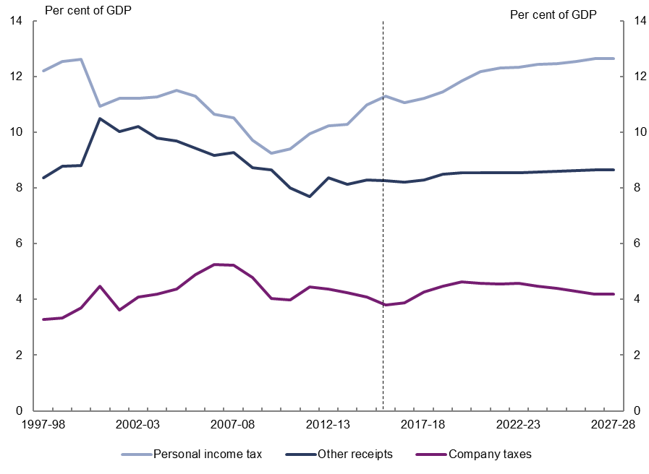
Note: Other receipts includes the goods and services tax, excise and customs duty, non-tax receipts, superannuation fund taxes, other taxes and charges, fringe benefits tax, wine equalisation tax, resources rent taxes, and luxury car tax.
Source: 2017–18 Budget and PBO analysis.
Payments
Total payments are projected by the PBO to remain broadly flat over the medium term, increasing from 25.1 per cent of GDP in 2016–17 to 25.2 per cent of GDP by 2027–28.
The largest contributor to the increase in spending over the projection period is the National Disability Insurance Scheme, which is projected by the PBO to increase by 0.8 per cent of GDP. This reflects the commitment to the full rollout of the Scheme by 2019–20.
Defence spending is projected by the PBO to increase by 0.3 per cent of GDP, with aged care and child care spending projected by the PBO to both increase by 0.2 per cent of GDP.
The largest projected decline in spending occurs in the cost of government administration of a range of smaller grant, subsidy and personal benefit programs of 0.6 per cent of GDP, with this entire projected decline occurring over the forward estimates period.
Other large projected declines over the projection period occur in Family Tax Benefit (FTB) (0.3 per cent of GDP), veterans support (0.2 per cent of GDP) and road and rail infrastructure (0.2 per cent of GDP).

Net debt and net financial worth
Net debt is projected by the PBO to increase from $325.1 billion in 2016–17 (18.6 per cent of GDP), to peak as a per cent of GDP at $375.1 billion (19.8 per cent of GDP) in 2018–19, before declining to $244.1 billion in 2027–28 (8.2 per cent of GDP).
Net financial worth is projected by the PBO to improve from -$428.2 billion in 2016–17 (-24.4 per cent of GDP) to -$305.5 billion in 2027–28 (-10.2 per cent of GDP).
Risks
The projected improvement in the UCB from strong growth in personal income tax receipts is based on the 2017–18 Budget’s projected sharp acceleration in wages growth over the forward estimates period and the medium term. The significant slowdown in wages growth experienced in the past few years suggests that this projected increase is subject to downside risk.
The projections of payments assume no further new spending initiatives beyond those contained in the budget estimates. Experience over the past decade suggests that the fiscal restraint necessary to containing spending growth has been difficult to achieve.
Considerable uncertainty exists with the projection of NDIS spending. The NDIS is in the early stages of implementation and as with any program which is yet to mature there are risks that the longer-term costs associated with the Scheme may increase. This issue is being explored in more detail by the Productivity Commission, which is scheduled to report to Government on scheme costs in September 2017.

Introduction
The 2017–18 Budget papers include projections of the underlying cash balance, net debt and net financial worth to 2027–28 but do not include projections of receipts and payments beyond the forward estimates period ending 2020–21.
In this report the Parliamentary Budget Office (PBO) provides detailed projections of receipts and payments over the period beyond the forward estimates to 2027–28 to explain the main drivers of the projected return to surplus, fall in net debt, and increase in net financial worth over this period. These detailed projections are available on the PBO website.
The detailed projections contained in this report increase the transparency of the aggregate projections and highlight the policy trade-offs that are being made, the impact on the budget of significant programs that mature beyond the forward estimates period and identify potential areas of the budget that present challenges for ongoing sustainability. While medium-term projections are subject to uncertainty this information is important in understanding the direction of fiscal policy settings.
As required by its legislation, the PBO’s projections are based on the economic forecasts and other parameters underpinning the 2017–18 Budget. The PBO’s projections also assume that the Government’s policy settings remain unchanged from those current as at the
2017–18 Budget. Where government policy has not been made explicit beyond the forward estimates period, the PBO’s projections assume the continuation of the current policy settings.
The focus of the report is on detailed receipt and payment projections that explain movements in the underlying cash balance. The infrastructure spending projection does not capture infrastructure investment funded through equity injections into Australian government public non-financial corporations such as the Australian Rail Track Corporation, or concessional loans such as the loan to the New South Wales Government for the WestConnex project. These investments are recognised as the acquisition of assets rather than payments, and only impact on the underlying cash balance through increasing public debt interest payments.

Projected underlying cash balance
Based on the policy settings and the official economic parameters underlying the Australian Government’s 2017–18 Budget, the PBO projects the underlying cash balance (UCB) over the next decade to move from a deficit of $37.6 billion (2.1 per cent of GDP) in 2016–17 to a surplus of $6.3 billion (0.3 per cent of GDP) in 2020–21 and then maintain surpluses over the remainder of the medium term with a surplus of $9.0 billion (0.3 per cent of GDP) in 2027–28 (Figure 2–1).
Figure 2–1: Underlying cash balance, per cent of GDP
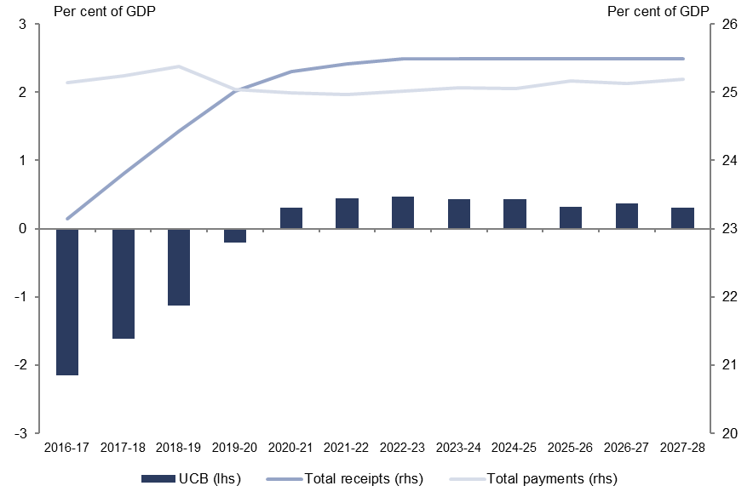
Note: Net Future Fund earnings are included in the underlying cash balance from 2020–21 consistent with the 2017–18 Budget treatment.
Source: 2017–18 Budget and PBO analysis.
The projected improvement in the UCB back to a surplus in 2020–21 reflects a projected increase in total receipts of 2.2 per cent of GDP combined with a decline in payments of
0.1 per cent of GDP. Net Future Fund earnings contribute to the UCB from 2020–21 onwards, adding 0.2 per cent of GDP to the surplus from 2020–21.
Over the remainder of the projection period the UCB surplus peaks at 0.5 per cent of GDP in 2022–23 before declining to 0.3 per cent of GDP by 2027–28. The Government’s technical assumption of a tax-to-GDP ‘cap’ of 23.9 per cent of GDP from 2022–23 is inherent in these projections.

Projected receipts
Total receipts are projected by the PBO to increase from 23.2 per cent of GDP in 2016–17 to 25.5 per cent of GDP in 2022–23 and to remain at this level to the end of the projection period. From 2022–23 the Government’s technical assumption of a tax-to-GDP ‘cap’ of 23.9 per cent of GDP applies (Figure 3–1).
Figure 3–1: Total receipts, per cent of GDP
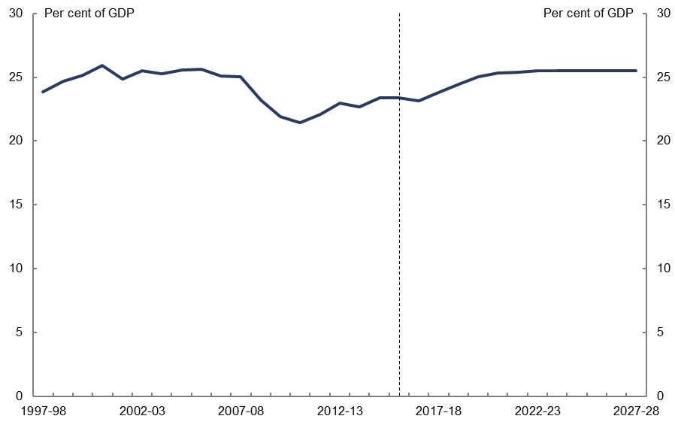
Source: 2017–18 Budget and PBO analysis.
The PBO’s projected increase in receipts as a per cent of GDP is predominantly due to a projected rise in Individuals and Other Withholding Tax receipts (personal income tax) over the entire medium-term period, largely as a result of the 2017–18 Budget projections of wage increases driving income earners into higher income tax brackets, combined with the increase in the Medicare levy from 2019–20 (Figure 3–2).
Figure 3–2: Breakdown of receipts, per cent of GDP
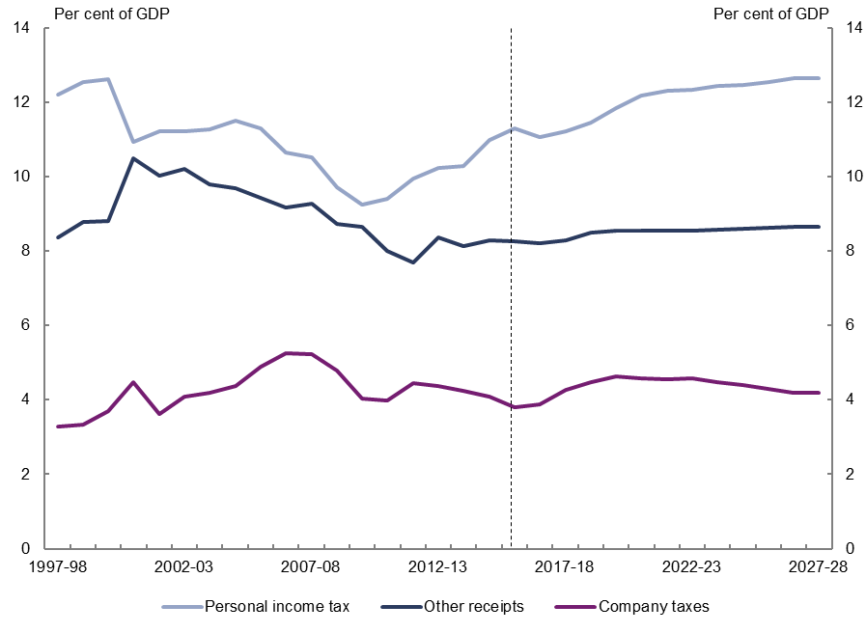
Note: Other receipts includes the goods and services tax, excise and customs duty, non-tax receipts, superannuation fund taxes, other taxes and charges, fringe benefits tax, wine equalisation tax, resources rent taxes, and luxury car tax.
Source: 2017–18 Budget and PBO analysis.
Personal income tax receipts are projected by the PBO to increase by 1.6 per cent of GDP over the medium term, from 11.1 per cent of GDP in 2016–17 to 12.6 per cent of GDP in 2027–28. The PBO’s projected rate of growth in personal income tax receipts slows once the Government’s technical assumption of a tax-to-GDP ‘cap’ of 23.9 per cent of GDP is reached in 2022–23.
Once the tax ‘cap’ is reached, personal income tax receipts are projected by the PBO to continue to rise as a per cent of GDP as company tax receipts decline from 2023–24 as a result of the Government’s Enterprise Tax Plan. The PBO projects that the average tax rate on personal income will rise from 22.7 percent in 2016–17 to 25.9 per cent in 2027–28.
Company tax receipts are projected by the PBO to increase from 3.9 per cent of GDP in
2016–17 to 4.6 percent of GDP in 2022–23, largely driven by forecast increases in corporate profitability, before declining to 4.2 per cent of GDP in 2027–28 due to the company tax cuts under the Government’s Enterprise Tax Plan.
Other receipts are projected by the PBO to increase from 8.2 per cent of GDP in 2016–17 to 8.7 per cent of GDP in 2027–28. Taxes on superannuation funds and other taxes and charges are the key drivers of this increase.
Taxes on superannuation funds are projected by the PBO to increase by 0.4 per cent of GDP over the period 2016–17 to 2027–28, largely due to a projected increase in superannuation fund capital gains tax and increases in superannuation contributions from the rise in the compulsory superannuation guarantee from 1 July 2021.
Other taxes and charges are projected by the PBO to increase by 0.1 per cent of GDP over the period 2016–17 to 2027–28, mainly driven by the introduction of the major bank levy.
Table 3–1 shows the PBO’s projections of the change in receipts by revenue head over the period 2016–17 to 2027–28 and their projected contribution to the growth in total receipts.
Table 3–1: Receipts, tax cap applied from 2022–23
Receipts | Nominal receipts |  | Per cent of GDP |  | Change in per cent of GDP | Annual real growth | Contributions to growth | Share of total receipts
 | 2016–17 | 2027–28 | 2016–17 | 2027–28 | 2016–17 to 2027–28 |  |  | 2027–28
 | $b |  | % |  | % | % | Percentage points | %
Individuals and other withholding taxes | 194 | 378 | 11.1 | 12.6 | 1.6 | 3.9 | 24.6 | 49.6
Company tax | 68 | 125 | 3.9 | 4.2 | 0.3 | 3.3 | 4.8 | 16.4
Superannuation fund taxes | 8 | 25 | 0.4 | 0.8 | 0.4 | 8.7 | 2.9 | 3.3
Goods and services tax | 59 | 103 | 3.4 | 3.4 | 0.0 | 2.7 | 5.1 | 13.5
Fringe benefits tax | 4 | 7 | 0.2 | 0.2 | 0.0 | 2.5 | 0.3 | 1.0
Resource rent taxes | 1 | 1 | 0.1 | 0.0 | 0.0 | 0.4 | 0.0 | 0.2
Wine equalisation tax | 1 | 2 | 0.0 | 0.1 | 0.0 | 3.8 | 0.1 | 0.2
Luxury car tax | 1 | 1 | 0.0 | 0.0 | 0.0 | 2.1 | 0.0 | 0.1
Total excise and customs duty | 36 | 61 | 2.0 | 2.0 | 0.0 | 2.6 | 2.8 | 8.0
Other taxes and charges | 6 | 12 | 0.3 | 0.4 | 0.1 | 4.1 | 0.8 | 1.5
Total tax receipts | 377 | 716 | 21.5 | 23.9 | 2.4 | 3.6 | 44.0 | 93.8
Non-tax receipts | 29 | 48 | 1.6 | 1.6 | 0.0 | 2.4 | 2.1 | 6.2
Total receipts | 406 | 763 | 23.2 | 25.5 | 2.3 | 3.5 | 46.1 | 100
Memorandum item:
Capital gains tax | 13 | 31 | 0.7 | 1.0 | 0.3 | 6.0 | 2.8 | 4.0
Note: Figures may not add due to rounding.
Source: 2017–18 Budget and PBO analysis.
These receipt projections are subject to a number of risks. The projected increase in personal income tax as a per cent of GDP is based on the 2017–18 Budget’s projected sharp acceleration in wages growth over the forward estimates period and the medium term. The significant slowdown in wages growth experienced in the past few years suggests that this projected increase is subject to downside risk.

The projected increase in superannuation fund capital gains tax is based on the
2017–18 Budget assumption that the realisation rates of capital gains by superannuation funds will increase in the forecast years from the lows observed recently. If this assumption proves overly optimistic, then the projected strong growth in superannuation fund tax receipts would not be realised.
The risks for the company tax receipt projections appear to be balanced given the recent improvements in corporate profitability and the measured outlook for commodity prices in the Budget.

Projected payments
Total payments are projected by the PBO to remain broadly flat over the medium term, increasing from 25.1 per cent of GDP in 2016–17 to 25.2 per cent of GDP by 2027–28
(Figure 4–1).
Figure 4–1: Total payments, per cent of GDP
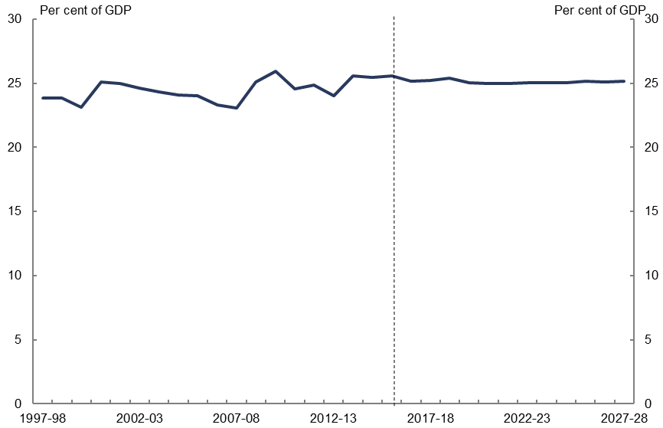
Source: 2017–18 Budget and PBO analysis.
The largest contributor to the increase in spending over the projection period is the National Disability Insurance Scheme (NDIS), which is projected by the PBO to increase by 0.8 per cent of GDP. This reflects the commitment to the full rollout of the Scheme by 2019–20. Consistent with the treatment in the Budget, the PBO’s projection of NDIS spending includes both Commonwealth and state contributions to the NDIS. The PBO’s projections of spending on the NDIS and the Commonwealth’s contribution to the scheme are shown in Figure 4–2.
Figure 4–2: Projected National Disability Insurance Scheme spending
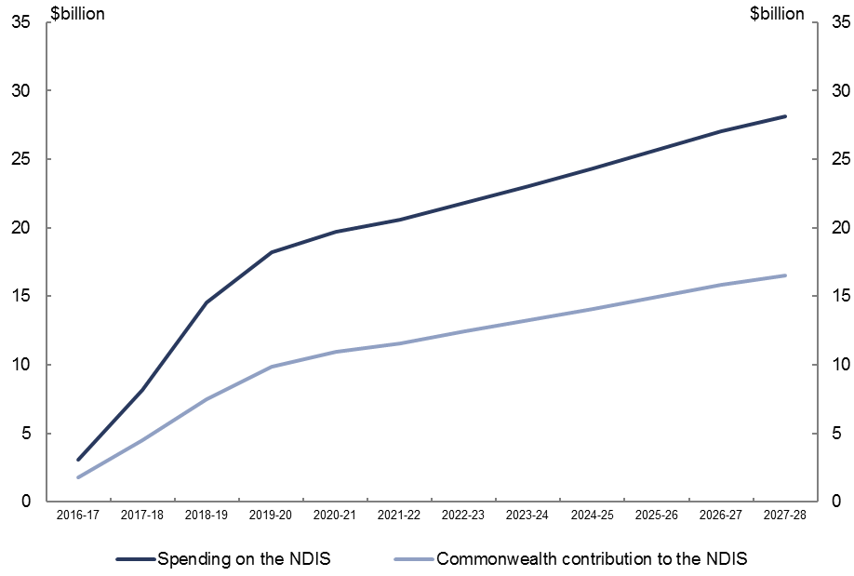
Source: 2017–18 Budget and PBO analysis.
Defence spending is projected by the PBO to increase by 0.3 per cent of GDP over the projection period reflecting the Government’s funding commitments in the 2016 Defence White Paper.
Aged care spending is projected by the PBO to increase by 0.2 per cent of GDP over the projection period reflecting the impact of the ageing population on the demand for aged care services.
Child care is projected by the PBO to increase by 0.2 per cent of GDP over the projection period, reflecting the impact of the Government’s new Child Care Subsidy which will commence in 2018–19, and projected ongoing strong growth in the demand for child care services over the medium term.
Payments to the states and territories for schools and hospitals, the Medicare Benefits Schedule and public debt interest payments are each projected by the PBO to increase by
0.1 per cent of GDP over the projection period.
Public debt interest payments are projected to increase by 0.1 per cent of GDP over the projection period, reflecting an increase in public debt interest payments attributable to the Higher Education Loan Programme of 0.2 per cent of GDP being partially offset by a fall in public debt interest payments for other purposes of 0.1 per cent of GDP.
Broadly offsetting these projected increases, are declines in spending as a per cent of GDP in ‘other payments’, Family Tax Benefit, road and rail infrastructure (excluding equity investments) and veterans’ support.
The largest projected decline in spending over the projection period, 0.6 per cent of GDP, occurs across a range of programs that are referred to as ‘other payments’. These programs include government administration and a range of smaller grant, subsidy and personal benefit programs. All of this change occurs over the forward estimates period. Beyond 2020–21, for projection purposes these programs are assumed to grow in line with projected growth in nominal GDP and are not individually modelled.
Family Tax Benefit (FTB) is projected by the PBO to fall by 0.3 per cent of GDP over the projection period. Most of the projected decline occurs in the period 2016–17 to 2020–21 due to the impact of budget initiatives to freeze FTB higher income free thresholds until 2020–21, and pause indexation of FTB payment rates for two years from 2017–18.
Road and rail infrastructure is projected by the PBO to fall by 0.2 per cent of GDP over the projection period. This decline occurs over the forward estimates period, reflecting the funding profile for road and rail infrastructure included in the 2017–18 Budget. Beyond the forward estimates period spending is assumed to grow in line with projected nominal GDP growth.
The infrastructure projections only include the expenses relating to road and rail infrastructure, including grants to state and territory governments. They do not capture infrastructure investment funded through equity injections into Australian government public non-financial corporations such as the Australian Rail Track Corporation, or concessional loans such as the loan to the New South Wales Government for the WestConnex project.
Veterans support is projected by the PBO to fall by 0.2 per cent of GDP over the projection period reflecting a decrease in the eligible population.
The private health insurance rebate, Official Development Assistance, job seeker income support, Commonwealth Grants Scheme and the Pharmaceutical Benefits Scheme (PBS) are each projected by the PBO to decline by 0.1 per cent of GDP over the projection period.
Figure 4–3 and Table 4–1 show the PBO’s projections of the change in payments by payment type over the period 2016–17 to 2027–28 and their projected contribution to the growth in total payments.
Figure 4–3: Drivers of projected payments over the projection period, change in per cent of GDP from 2016–17 to 2027–28
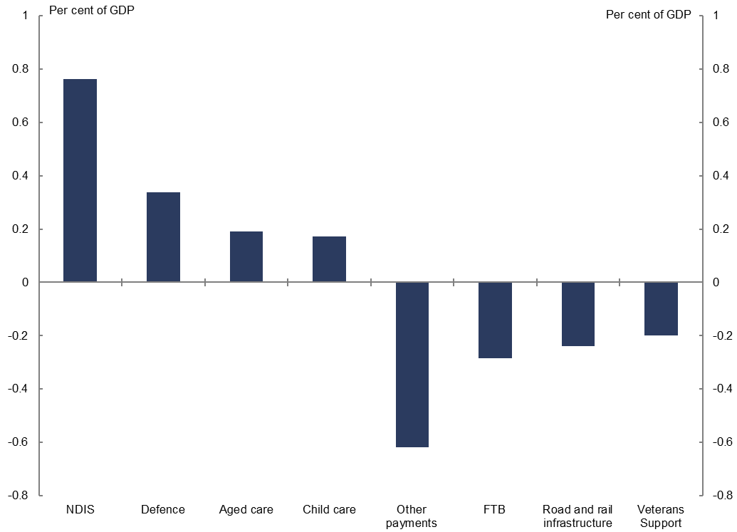
Source: 2017–18 Budget and PBO analysis.
Table 4–1: Payments
Payments | Nominal payments |  | Per cent of GDP |  | Change in per cent of GDP | Annual real growth | Contributions to growth | Share of total payments
 | 2016–17 | 2027–28 | 2016–17 | 2027–28 | 2016–17 to 2027–28 |  |  | 2027–28
 | $b |  | % |  | % | % | Percentage points | %
National Disability Insurance Scheme | 3 | 28 | 0.2 | 0.9 | 0.8 | 19.4 | 4.2 | 3.7
Defence spending | 32 | 65 | 1.8 | 2.2 | 0.3 | 4.1 | 4.1 | 8.6
Aged care | 17 | 35 | 1.0 | 1.2 | 0.2 | 4.2 | 2.2 | 4.7
Child care | 7 | 17 | 0.4 | 0.6 | 0.2 | 5.8 | 1.4 | 2.3
Schools | 17 | 32 | 1.0 | 1.1 | 0.1 | 3.3 | 1.6 | 4.2
Medicare Benefits Schedule | 22 | 39 | 1.3 | 1.3 | 0.1 | 2.9 | 1.9 | 5.2
Public hospitals | 18 | 33 | 1.1 | 1.1 | 0.1 | 3.0 | 1.6 | 4.4
GST transfers to states | 59 | 103 | 3.4 | 3.4 | 0.0 | 2.7 | 4.5 | 13.6
Carer income support | 8 | 15 | 0.5 | 0.5 | 0.0 | 3.1 | 0.7 | 2.0
Fuel Tax Credit Scheme | 6 | 11 | 0.4 | 0.4 | 0.0 | 3.0 | 0.5 | 1.5
Government superannuation | 6 | 11 | 0.4 | 0.4 | 0.0 | 2.7 | 0.5 | 1.5
Disability Support Pension | 16 | 28 | 0.9 | 0.9 | 0.0 | 2.6 | 1.2 | 3.8
Parenting payments | 6 | 9 | 0.3 | 0.3 | 0.0 | 1.5 | 0.2 | 1.2
Age Pension | 45 | 75 | 2.5 | 2.5 | 0.0 | 2.4 | 3.0 | 9.9
Private Health Insurance Rebate | 6 | 9 | 0.4 | 0.3 | -0.1 | 0.9 | 0.2 | 1.2
Official Development Assistance | 4 | 5 | 0.2 | 0.2 | -0.1 | -0.4 | 0.0 | 0.6
Job Seeker Income Support | 11 | 17 | 0.6 | 0.6 | -0.1 | 1.2 | 0.4 | 2.2
Commonwealth Grants Scheme | 7 | 9 | 0.4 | 0.3 | -0.1 | 0.2 | 0.0 | 1.2
Pharmaceutical benefits | 11 | 16 | 0.6 | 0.5 | -0.1 | 0.6 | 0.2 | 2.1
Veterans support | 6 | 5 | 0.4 | 0.2 | -0.2 | -4.4 | -0.6 | 0.7
Road and rail infrastructure | 8 | 6 | 0.4 | 0.2 | -0.2 | -4.5 | -0.7 | 0.8
Family Tax Benefit | 20 | 25 | 1.1 | 0.8 | -0.3 | -0.2 | -0.1 | 3.3
Public debt interest | 15 | 29 | 0.9 | 1.0 | 0.1 | 3.8 | 1.7 | 3.9
HELP | 3 | 11 | 0.2 | 0.4 | 0.2 | 10.3 | 1.2 | 1.4
Other | 12 | 19 | 0.7 | 0.6 | -0.1 | 1.5 | 0.0 | 2.5
Total modelled payments | 352 | 622 | 20.1 | 20.8 | 0.7 | 2.8 | 28.8 | 82.5
Other payments | 88 | 132 | 5.0 | 4.4 | -0.6 | 1.3 | 3.1 | 17.5
Total payments | 441 | 754 | 25.1 | 25.2 | 0.0 | 2.6 | 32.0 | 100.0
Note: Figures may not add due to rounding.
Source: 2017–18 Budget and PBO analysis.
The Age Pension, the second largest government payment, is projected by the PBO to remain flat as a per cent of GDP over the projection period. The impact of the ageing population is projected to contribute 0.4 per cent of GDP to spending on the Age Pension from 2016–17 to 2027–28. The impact of ageing is largely offset by government measures, in particular, the increase in the rate at which the Age Pension is reduced when the assets test threshold is exceeded, and the progressive rise in the Age Pension eligibility age to 70 by 1 July 2035. This latter change is projected to increase spending on the Disability Support Pension, Newstart Allowance and carer income support, as a number of previously eligible age pensioners are assumed to move on to these other payments (see box below).
Increasing the eligibility age for the Age Pension
The age from which a person is eligible for the Age Pension is to progressively increase from 65 to 70, beginning 1 July 2017. This is comprised of a legislated increase to 67 years by 1 July 2023 and a yet to be legislated increase from 67 to 70 by 1 July 2035.
The savings from this policy of reducing the growth in the Age Pension recipient numbers are expected to be partially offset by the claiming of other social security payments.
Figure 4–4 illustrates the savings to the Age Pension, the increased expenditure on Job Seeker Income Support, carer income support and the Disability Support Pension and the resultant net saving to Commonwealth payments (shown by the net result line).
In 2027–28, savings to the Age Pension are projected to be $9.4 billion, partially offset by increases to other payments of $7.7 billion, resulting in a net saving of $1.8 billion.
The impact of the savings initiative in relation to the Age Pension contributes to over a third of the average annual growth in the medium-term projection of Job Seeker Income Support, carer income support and the Disability Support Pension.
Figure 4–4: Increased expenditure and savings to social security payments from the increase to the Age Pension eligibility age
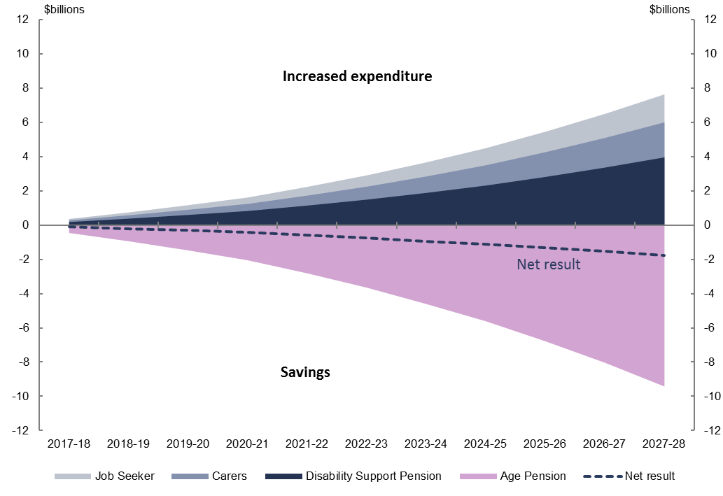
Source: 2017–18 Budget and PBO analysis.
These projections have a high degree of uncertainty. The increased expenditure on other social security payments depends significantly on the behavioural response of those aged over 65 years who are no longer eligible for the Age Pension, in particular, whether they continue to work, claim a payment or pursue other alternatives in the interim. This response could also be expected to change into the future as the eligibility age increases further.
As with receipts, the payment projections are subject to uncertainty. The projections assume no further new spending initiatives beyond those contained in the budget estimates. Experience over the past decade suggests that the fiscal restraint necessary to containing spending growth has been difficult to achieve.
The NDIS is in the early stages of implementation and as with any program which is yet to mature there are risks that the longer-term costs associated with the Scheme may increase. This issue is being explored in more detail by the Productivity Commission, which is scheduled to report to Government on scheme costs in September 2017.
In relation to the PBS there is a large degree of uncertainty regarding future listings of drugs which would increase the quantity of drugs available and hence the costs associated with the PBS. Working in the other direction, there is uncertainty regarding the impact of drugs coming off patent which would lower the prices of drugs already listed on the PBS.
Regarding child care, the new Child Care Subsidy is yet to commence and as such there is significant uncertainty as to how the price and demand for child care will respond under the new scheme.

Projected net debt and net financial worth
Net debt (Figure 5–1) is projected by the PBO to increase from $325.1 billion in 2016–17 (18.6 per cent of GDP), to peak as a per cent of GDP at $375.1 billion (19.8 per cent of GDP) in 2018–19, before declining to $244.1 billion in 2027–28 (8.2 per cent of GDP).
Figure 5–1: Net debt, per cent of GDP
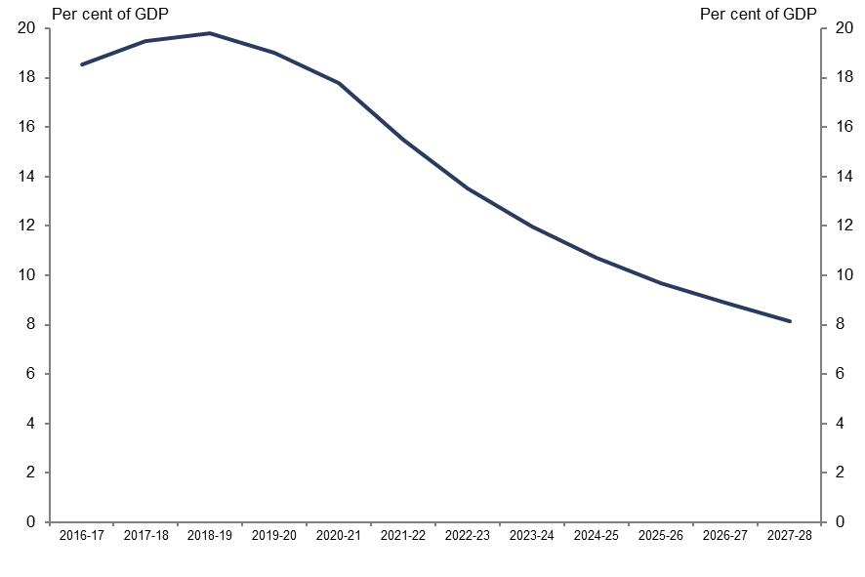
Source: 2017–18 Budget and PBO analysis.
Net financial worth (Figure 5–2) is projected by the PBO to improve from -$428.2 billion in 2016–17 (-24.4 per cent of GDP) to -$305.5 billion in 2027–28 (-10.2 per cent of GDP).
Figure 5–2: Net financial worth, per cent of GDP
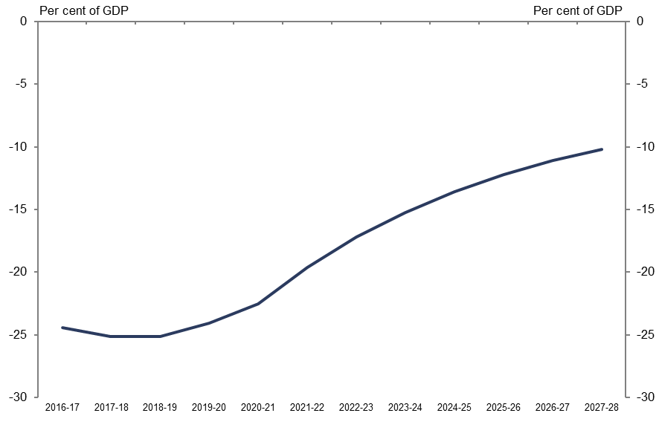
Source: 2017–18 Budget and PBO analysis.
The decrease in net debt and the increase in net financial worth over the projection period as a per cent of GDP reflect the reduced financing task from the projected move to budget surpluses and a decrease in the market value of government debt as the yield on long-term securities is assumed to increase over the projection period, consistent with the 2017–18 Budget. A projected increase in the value of the Future Fund also contributes to the increase in net financial worth.

Technical appendix

Receipt projection methodology
The PBO’s projections comprise individual receipt projections of all of the Commonwealth Government’s major heads of revenue.
The PBO’s projections of receipts are generally prepared using a base plus growth methodology. Economic parameters are used to estimate growth rates which are then applied to the relevant base. The economic parameters used to estimate growth rates in this report are the same as those underpinning the 2017–18 Budget, as required by the PBO’s legislation.
For policy decisions where the impact is not already factored into the base year data or the economic parameters, the projected impact of these measures are added to the base projections.
In order to incorporate the impact of recent trends in tax collection, the PBO uses the
2017–18 Budget receipt forecasts for 2017–18 and 2018–19 as the base years for the PBO’s projections.
Details of the methodology used to arrive at projections for individual revenue heads are outlined in the table below.
Model | Description | Methodology
Gross income tax withholding and gross other individuals and refunds | These revenue heads broadly cover all personal income tax, including revenue from salary and wages, the Medicare Levy and Medicare Levy Surcharge, personal income tax offsets, income from profits from unincorporated businesses, primary production and investment activities, as well as capital gains. | The aggregate taxable income for individuals over the medium term is calculated by growing individual income items from the ATO’s Taxation Statistics data by the relevant economic parameters, most notably compensation of employees.  For each year, an average gross tax rate is applied based on the parameters of the 2017–18 Budget and current Government policy.  Projected tax offsets are applied and the timing of tax collections is taken into account to arrive at the receipts projections.  From 2022-23, the PBO adjusts the individual and other withholding tax receipt projections such that total tax receipts remain at 23.9 per cent of GDP, consistent with the Government’s technical assumption of a tax-to-GDP ‘cap’.
Company tax | Tax on profits, including capital gains, of incorporated businesses. | The projections are based on an approach whereby company tax revenue is recognised at the point that a company tax payable liability arises for a company from its underlying economic activity. Three industry groupings, Mining, Finance and all Other companies are utilised in the projection modelling, to reflect structural differences in companies from different industries.  The tax base across the three sector groupings (itself derived from the 2014–15 company tax return unit record data), is grown with the Gross Operating Surplus economic parameter corresponding to the relevant industry grouping. Adjustments are made to capture depreciation and net capital gains.  The timing of tax collections is taken into account to arrive at the receipts projections.  Adjustments are made to account for other elements (principally the R&D tax offset) that are reported against company tax receipts.
Superannuation fund taxes | Tax on super fund contributions and investment earnings, including capital gains, of Australian Prudential Regulation Authority funds and self-managed super funds. | Projections for the taxable income of  APRA-regulated superannuation funds and  self-managed superannuation funds are based on the structure of a superannuation fund’s tax return.  Historical data from APRA’s Annual Superannuation Bulletin and the ATO’s Taxation Statistics data are grown by relevant economic parameters for projections of taxable income. Statutory tax rates are then applied to the projections of taxable income.  Projected tax offsets are applied and the timing of tax collections is taken into account to arrive at the receipts projections.
Customs and excise | Includes customs duties on textiles, clothing and footwear, passenger motor vehicles and other imports, excise on fuel and excise and customs duties on tobacco and alcohol (except wine, for which WET applies). | Receipts from each category of excise and customs duty are projected in a similar way: a growth rate is determined using a quantity parameter, and where appropriate, prices are grown using the appropriate price parameter.  The relevant parameters are:  - fuel—private consumption of fuel, real GDP and the Consumer Price Index  - textile, clothing and footwear—imports of textiles, clothing, footwear  - passenger motor vehicles—imports of non-industrial transport equipment  - other imports—imports of endogenous goods less imports of non-industrial transport equipment and imports of textiles, clothing, footwear  tobacco—private consumption of cigarettes and Adult Ordinary Time Earnings  - alcohol—private consumption of alcohol and the Consumer Price Index.
Petroleum Resources Rent Tax (PRRT) | Tax on profits from sales of petroleum products. | PRRT receipts are projected based on volume and AUD price of oil (Malaysian Tapis) in the forward estimates period, and AUD price of oil only beyond the forward estimates period.
Goods and services tax (GST) | Indirect tax on the consumption of certain goods and services. | GST receipts are projected based on the growth in consumption subject to GST using the following parameters: consumption subject to GST, private dwelling investment, and ownership transfer costs.
Wine equalisation tax (WET) | A value-based tax on wine consumed in Australia. | WET receipts are projected based on the growth in private consumption of alcohol.
Luxury car tax (LCT) | A tax on luxury cars sold or imported, where their value exceeds a threshold. | LCT receipts are projected based on the growth in sales of cars and station wagons and the motor vehicle price indicator.
Other taxes and charges | Other indirect taxes and levies, including the major bank levy, agricultural levies and the Skilling Australians Fund levy. | Other taxes and charges are projected based on the growth in nominal GDP.
Non-tax receipts | Includes interest and dividend earnings (including Future Fund earnings), NDIS contributions from the States and Territories, sale of non-financial assets, and other non-tax receipts. | The largest component of receipts from the sales of goods and services are NDIS contributions from the States and Territories, which are consistent with the PBO’s profile of NDIS expenditure over the medium-term.  Future Fund earnings are projected over the medium-term using the projection methodology from PBO Report No. 01/2017. Reflecting the Government’s decision to delay the drawdown of the Future Fund and to reduce its target return to at least the Consumer Price Index (CPI) plus 4 to 5 per cent, drawdowns are assumed to occur once the projected Fund balance reaches its projected target asset level in 2027–28. Under the Future Fund Act 2006, net Future Fund earnings will be available to meet the Government superannuation liability in 2020–21. Consistent with the 2017–18 Budget assumption, the underlying cash balance includes expected net Future Fund earnings from 2020–21.  Other interest receipts and dividend receipt projections are consistent with the 2017–18 Budget forward estimates period and then grown consistent with recent history over the medium-term.  The remainder of non-tax receipts are consistent with the 2017–18 Budget forward estimates period and then assumed to remain as a constant share of nominal GDP over the medium-term.

Payment projection methodology
The PBO’s payments projections comprise 23 individual projections of key Government payments, which in total comprise approximately 80 per cent of total government payments.
Up to 2020–21, the PBO’s projections for payments are broadly consistent with the
2017–18 Budget forward estimates and are used as the base for projecting expenditure over the medium term.
Projected levels of spending beyond 2020–21 have been prepared by the PBO based on information provided by government agencies using a range of PBO models which take account of population growth, the age structure of the population, estimates of trends in the demand for government services and program indexation arrangements.
The PBO’s projections are based on the policy settings underlying the 2017–18 Budget assuming no change to these settings over the medium term. Where government policy has not been made explicit beyond the forward estimates period the PBO’s projections assume the continuation of the current policy settings.
Departmental expenses have been excluded from modelled programs except in the cases of Defence spending and the NDIS where departmental costs are an integral part of the program.
Details of the methodology used to arrive at projections for individual programs are outlined in the table below.
Model | Description | Methodology
National Disability Insurance Scheme (NDIS) | The coverage of the NDIS projections is the administered and departmental spending of the National Disability Insurance Agency and transitional funding. The projections also include the Commonwealth contribution to the Western Australian NDIS. | Expenditure projections (in accrual terms) of recipients’ care and support are based on projections of the number of recipients and the average disability package costs of two cohorts, those aged 0-64 years and those aged 65 years and over.  Spending projections (in cash terms) are calculated by applying a ratio of payments to expenses. From around 90 per cent by the end of the forward estimates period, this ratio increases to around 95 per cent by the end of the medium-term largely reflecting a reduction of in-kind payment arrangements between States and the Commonwealth.  The departmental spending of the NDIA is assumed to be relatively flat over the medium-term.
Aged Care | Consists of subsidies for residential care, the Commonwealth Home Support Program and subsidies for Home Care Packages. | The number of subsidised aged care places follows Government policy to provide 125 aged care places per 1,000 persons aged over 70 years old by 2021–22 and maintains this ratio beyond 2021–22. The value of residential care and home care packages subsidies are assumed by the PBO to grow by the CPI beyond the forward estimates period.  The Commonwealth Home Support Program is an annual appropriation projected to grow at a wage cost index plus 3.5 per cent (in line with the aged care measure announced in the 2014–15 Budget).
Child Care | Includes the Child Care Benefit and Child Care Rebate for 2017–18 becoming the Child Care Subsidy in  2018–19. | The number of recipients of the Child Care Subsidy is projected based on the rate of population growth of young children plus an additional growth factor (based on historical data) which takes into account that child care hours used has grown faster than eligible population growth.  Child care prices are projected to grow in line with recent historical trends in child care fees, declining to the rate of wages growth over the medium term.
Defence spending | The net cost of service for the Department of Defence including employee costs, supplies and purchases of capital including specialist military equipment. | Projections of defence spending over the medium term are based on long-term funding commitments to 2025–26 made in the 2016 Defence White Paper updated for developments in subsequent budgets.  From 2026–27 the PBO has assumed Defence spending maintains its share of nominal GDP.
Schools | Comprises the National Specific Purpose Payment from the Commonwealth to states and territories (states) for government schools and the non-government sector. | Projections are based on the 2017–18 Budget Quality Schools policy, which does not include subsequent amendments passed by the Parliament.  Schools expenditure projections over the medium term are calculated based on achieving target levels of the Schooling Resource Standard (SRS) by sector over 10 years and projected growth in student enrolments.  Funding for government schools is calculated based on increasing per student SRS funding for government schools from 17 per cent in 2017 to 20 per cent by 2027 and 76.8 per cent in 2017 to 80 per cent by 2027 for non-government schools.
Payments to individuals | Social security payments including the Family Tax Benefit; Disability Support Pension; Carer income support (primarily Carer Payment and Carer Allowance); Parenting Payments (Single and Partnered); and Job Seeker Income Support (Newstart, Youth Allowance (Other), Sickness Allowance, becoming Jobseeker Payment). | Projected expenditure on these payments is calculated as projected recipients multiplied by the average payment rate.  Recipient numbers are projected by grouping them into age and gender cohorts and calculating the historical per capita growth in take-up of the payment. This  per-capita take-up growth is applied to medium-term population projections. Job seeker income support also adjusts for projected changes in unemployment.  The average rate of payment is grown by the legislated indexation factor for that program (which is either CPI or wages).
Medicare Benefits Schedule | Includes non-DVA related expenditure under the Medicare Benefits Schedule. | Detailed historical data is used to model expenditure by age, gender and service type (e.g. GP services, allied health etc.). The MBS projection methodology is described in detail in Appendix C - Technical Notes and Sources of the PBO report 04/2015 Medicare Benefits Schedule.
Public hospitals | Commonwealth funding of public hospitals | Projected Commonwealth funding for public hospitals over the medium term is set with reference to the annual determination of the National Efficient Price (NEP).  The current National Health Reform Agreement on Commonwealth funding for public hospitals will expire in 2020 with a commitment to consider a subsequent long-term agreement in 2018. The PBO has made an indicative assumption that current funding arrangement will continue over the projection period.  The projection of price growth in providing hospital services is based on the indexation rate in the latest NEP determination.  Growth in the number of patient services is projected based on the trend of historical number of services provided annually.
GST transfers to states | GST receipts less non-general interest charge penalties collected. | See Receipts projection methodology, GST receipts.
Fuel Tax Credit Scheme | Credits for the excise or customs duty on fuel a business uses in machinery, plant, equipment, heavy vehicles and light vehicles travelling off pubic roads or on private roads. | Fuel Tax Credit Scheme expenditure is calculated by applying credit scheme rates on projected fuel excise and customs duty revenue collections (see Receipts projection methodology, Customs and excise). Credit scheme rates are projected by indexing them in line with the CPI.
Government superannuation | Cash payments associated with the unfunded civilian and military schemes. | Projections are based on the Long Term Cost Reports updated for developments in subsequent budgets.
Age Pension | Includes the Age Pension under the Income Support for Seniors program. | Projected expenditure for the Age Pension is calculated as projected recipients multiplied by the average payment rate.  Historical Age Pension recipient data is used and grown at the same rate as the growth in the Australian population of Age Pension age. The impact of the increase to the Age Pension eligibility age is included over the medium term.  The projected average rate of payment is based on projections of MTAWE, CPI and Pensioner and Beneficiary Cost of Living Index and the proportions of full-rate and part-rate Age Pension recipients. It is assumed that the proportion of part-rate Age Pension recipients gradually increases over the medium term in line with increasing superannuation balances.
Private Health Insurance (PHI) rebate | Department of Health and Australian Taxation Office payments related to the PHI rebate. | Detailed historical PHI data is used to project the proportion of persons covered by health insurance. These coverage ratios are then applied to future population estimates. The coverage ratios remain fixed over the medium term, reflecting the recent flattening in PHI coverage.
Official Development Assistance | Comprises expenditure on foreign aid administered by the Department of Foreign Affairs and a small component for associated spending in other departments. | After a two-year indexation freeze introduced in the 2017–18 Budget, Official Development Assistance expenditure over the medium term is projected by indexing it to growth in the CPI in from 2021–22 to 2027–28.
Commonwealth Grants Scheme | Grant funding to higher education providers for each student enrolled in a Commonwealth Supported Place (CSP) at the institution. | Commonwealth Grants Scheme (CGS) expenditure is calculated based on recent trends in CSP student enrolment projections across eight clusters with varying per student amounts for areas of study reflecting associated course costs. Projections are adjusted for the impact of 2017–18 Budget measures.
Pharmaceutical benefits | Comprises the special appropriation of the Pharmaceutical Benefits Scheme. | PBS projections are calculated by taking historical expenditure data grouped by age and gender cohorts and calculating the historical per capita growth in PBS expenditure. This is then used to derive a trend growth for PBS spending per capita over the medium term.
Veterans Support | Comprises expenditure on income support and health programs for veterans. | Projections of expenditure on veterans support are based on projected growth in recipient numbers and the average payment for the service provided.  Recipient projections are based on 10-year Pensioner Beneficiary Statistics prepared by the Department of Veterans Affairs.  The average rate of payment is grown by the relevant indexation factor for that program.
Road and rail Infrastructure | Comprises expenses for road and rail projects. | From 2016–17 to 2020–21 infrastructure expenditure is based on the profile of road and rail expenditure in the 2017–18 Budget. Beyond 2020–21 road and rail expenditure is projected to grow in line with the growth rate of nominal GDP over the medium term.
Public debt interest | Interest paid on Commonwealth Government Securities on issue. | Public debt interest payments are projected based on the financing task implied by PBO projections of receipts and all other payments, and adopt the same assumptions regarding interest rates on Commonwealth Government Securities as the 2017–18 Budget.
Other payments | Other payments include payments that are not modelled by the PBO. | Payments not modelled by the PBO are grown by the growth rate of nominal GDP over the medium term.

The average tax rate is calculated by dividing projected total personal income tax receipts by projected total taxable income for individuals.
This includes the Commonwealth contribution to the Western Australian NDIS. The Commonwealth and Western Australian governments have agreed that the NDIS will be delivered under a locally administered model in Western Australia from 1 July 2017. The Western Australian Government’s contribution to its local Scheme is not included in the PBO’s projections.
With the exception of Western Australia, contributions from the states towards the cost of the NDIS go through the National Disability Insurance Agency (NDIA), which is the Commonwealth agency inside the General Government Sector responsible for delivering the NDIS. These state contributions are treated as non-taxation receipts for the Commonwealth. As the NDIA pays Scheme participants, these payments are treated as an expense of the Commonwealth, including the portion funded by state contributions.
There are also expected to be additional savings from increased tax receipts which are not included here.

