|  |
| --- |
| Disability Support Pension |
| Historical and projected trends |
| Report no. 01/2018 |

|  |
| --- |
| © Commonwealth of Australia 2018  ISSN 978-0-6482138-1-9 (Online)  This work is licensed under the Creative Commons Attribution-NonCommercial-NoDerivs 3.0 Australia License.    The details of this licence are available on the Creative Commons website: <http://creativecommons.org/licenses/by-nc-nd/3.0/au/>  Use of the Coat of Arms  The terms under which the Coat of Arms can be used are detailed on the following website: [www.itsanhonour.gov.au/coat-arms](http://www.itsanhonour.gov.au/coat-arms)  Parliamentary Budget Office  Parliament House  PO Box 6010  CANBERRA ACT 2600  Phone: (02) 6277 9500  Email: pbo@pbo.gov.au |

Contents

Foreword v

Overview vi

1 Introduction 7

1.1 Expenditure 7

2 Trends in Disability Support Pension expenditure 9

2.1 Recipients 11

2.2 Payment rates 22

3 Projections of DSP expenditure 23

3.1 Projection approach 23

3.2 Payment rate projections 24

3.3 Recipient projections 24

3.4 Projection scenarios 26

Appendix A – Technical notes 30

Appendix B – Significant changes affecting the Disability Support Pension 37

Appendix C – References 37

Foreword

The Disability Support Pension (DSP) represents a large component of social security spending for the Australian government.

This report examines the factors underlying the recent decline in DSP expenditure, highlighting the impacts of changes in government policy. It uses historical trends to provide updated projections of DSP expenditure over the next decade based on current policy settings.

The historical data underlying the analysis in this report are sourced from the Department of Social Services. The analysis, including projections, based on these data is available on the PBO website.

This report was prepared by Nutan Singh and Anupam Sharma with the benefit of comments by Paul Gardiner and Tim Pyne. The report was prepared for publication by Lauren Pratley.

I wish to thank the external referees who provided helpful comments and suggestions on the report, namely Professor Peter Whiteford, Director Social Policy Institute, Crawford School of Public Policy, Australian National University; and Dr Cain Polidano, Senior Research Fellow, Melbourne Institute of Applied Economics and Social Research, University of Melbourne.

The assistance of external reviewers does not imply any responsibility on their part for the content of the final report, which rests solely with the PBO.

Jenny Wilkinson

Parliamentary Budget Officer

20 February 2018

Overview

The Disability Support Pension (DSP) is an income support payment to individuals with permanent physical, intellectual or psychiatric impairments that prevent them from engaging in employment. It is one of the largest programs of Australian government spending. In 2016–17, DSP expenditure was $16.3 billion (10.6 per cent of social security spending) and there were around 760,000 DSP recipients.

Following the global financial crisis, DSP expenditure increased strongly, averaging 8.7 per cent annual real growth from 2008–09 to 2011–12. More recently, growth has slowed significantly, with annual real growth averaging 0.2 per cent from 2012–13 to   
2016–17. DSP expenditure has fallen in nominal terms since 2014–15, and the ratio of recipients to the working-age population (15 to 64) has now returned to levels recorded in the late 1990s.

The main driver of the slowdown in DSP expenditure has been policy measures which have focussed on stemming the flow of people onto the payment. In particular, new compliance and assessment measures, which applied from 1 January 2012, have led to a sharp decline in the number of people being assessed as being eligible for the payment. This resulted in the share of applicants granted access to the DSP (known as the grant rate) falling from an average of 63 per cent from 2001–02 to 2010–11, to 43 per cent from 2011–12 to 2014–15. Correspondingly the number of new DSP recipients fell from a peak of 89,000 in 2009–10 to 32,000 in 2016–17.

Underlying these overall trends, the population of DSP recipients has also undergone a marked compositional shift. The proportion of DSP recipients with physical impairments has declined and the proportion with psychiatric and intellectual impairments has increased.

In 2001–02, recipients with musculoskeletal conditions accounted for around 40 per cent of new DSP recipients. This fell to 11 per cent in 2016–17. Over the same time period, the share of new recipients with psychological conditions increased from 25 per cent to 33 per cent, and the share with intellectual conditions increased from 6 per cent to 17 per cent.

Taking these historical trends into account, we have significantly revised down the PBO medium-term projections for DSP expenditure. Our current projections for expenditure in 2027–28 are $4.8 billion lower than our 2017–18 Budget projections. Over the medium term, we are projecting that DSP expenditure will average 1.0 per cent annual real growth, which would see recipients as a proportion of the working‑age population continue to drift lower.

The PBO’s projection incorporates the 2017–18 Mid-Year Economic and Fiscal Outlook estimates up to 2020–21, which imply a significant rebound in new DSP recipients. The limited historical experience following the introduction of new compliance and assessment measures, makes interpreting the recent few years challenging. Given this uncertainty, the PBO has analysed a number of scenarios with alternative recipient projections to determine our medium-term projections. These scenarios suggest there are further downside risks to the DSP expenditure projections.

# Introduction

The Disability Support Pension (DSP) is an income support payment to individuals with permanent physical, intellectual or psychiatric impairments that prevent them from engaging in employment. It replaced the Invalid Pension in 1991 with the aim of improving rehabilitation and labour market engagement of recipients.[1]

To be eligible for the DSP, applicants must be:

* 16 years or older
* have a permanent disability preventing them from working more than 15 hours a week for at least two years[2]
* meet Australian residency requirements; and
* score at least 20 points on Centrelink Impairment Tables demonstrating a physical, intellectual or psychiatric impairment as assessed by a medical professional.

The Impairment Tables are a set of tables that assign ratings in proportion to the severity of an individual’s impairment. The tables are function‑based rather than diagnosis-based. If eligible for the payment, recipients are classified as having one of 23 primary medical conditions.[3]

As at 20 September 2017 the fortnightly maximum basic single rate for DSP was $814.00 and the equivalent combined couple’s rate was $1,227.20.

Recipients are also subject to income and assets tests which may result in a reduction in income support. The basic single rate is reduced by 50 cents for each dollar of income over $168 earned a fortnight. For a single homeowner the fortnightly pension is reduced by $3 for every $1,000 worth of assets above $253,750 (the assets threshold is $456,750 for non‑homeowners).[4]

## Expenditure

The DSP is one of the largest programs of Australian government spending totalling $16.3 billion in 2016–17. It comprises a significant portion of the largest single area of government expenditure—social security and welfare. In 2016–17 around 760,000 people received the DSP.

Figure 1–1 shows expenditure on the DSP and related payments as a share of the total social security and welfare budget in 2016–17. Other social security and welfare spending includes Family Tax Benefit, aged care, child care and parenting payments.

The DSP interacts with other income support payments, mainly the Age Pension and Newstart, with half of all new DSP recipients transitioning from another income support payment and half of all recipients who cease receiving the DSP moving onto the Age Pension. Tightening the eligibility criteria around the DSP may reduce direct expenditure on the DSP, but from a whole-of-government expenditure perspective this may be partly offset by expenditure increases on other payments such as Newstart which is paid at a lower rate.

Figure –: Social Security and Welfare Expenditure

2016–17

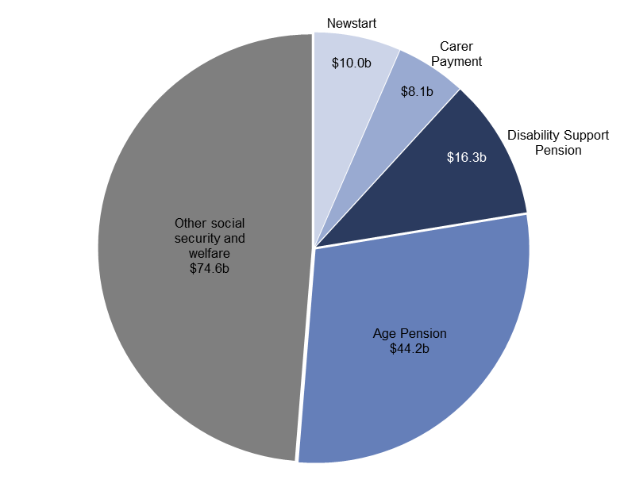

Source: 2017–18 Final Budget Outcome and Department of Social Services (DSS) 2016–17 Annual Report[5]

Until recently, the DSP had also been one of the fastest growing areas of government spending. However, growth in expenditure on the DSP has slowed significantly since 2012–13.

This report discusses the implications of this recent slowing in growth in DSP expenditure for medium-term projections of the payment. Section 2 explores recent trends in DSP expenditure in more detail, examining characteristics and trends in both recipient numbers and trends in payment rates. Section 3 presents the PBO’s latest projections for DSP expenditure and examines a range of scenarios for this expenditure.

# Trends in Disability Support Pension expenditure

The eligibility criteria, payment rates and assessment processes for the DSP have varied since the payment was introduced in 1991. Following largely positive growth in DSP expenditure for over two decades, the changes to assessment processes announced in the 2009–10 Budget (and to a lesser extent subsequent measures) have resulted in nominal expenditure on the DSP being below 2014–15 levels in each of the past two years. This has posed challenges in projecting expenditure on the DSP.

By way of illustration, at the time of the 2014–15 Budget, expenditure on the DSP for   
2016–17 was estimated at $17.8 billion. This compares to the final expenditure for 2016–17 of $16.3 billion, and included a downward revision in the number of recipients on the payment of more than 72,000 (around 10 per cent).

As Figure 2–1 highlights, subdued historical outcomes since 2012–13 have led to downward revisions in the budget estimates.

Figure –: Disability Support Pension Expenditure

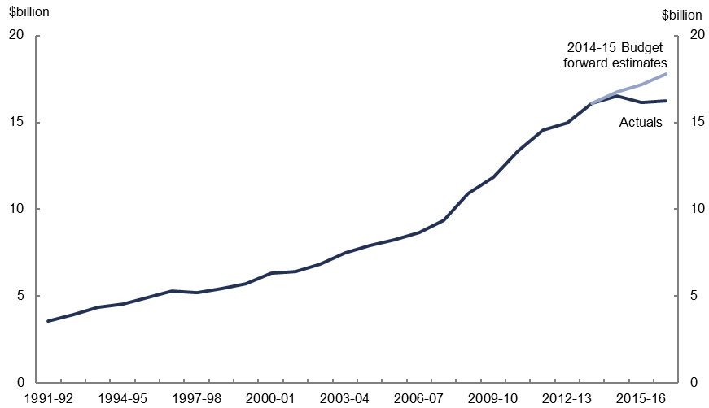

Source: 2014–15 Portfolio Budget Statements No. 1.15A and DSS Annual Reports

Understanding historical trends is fundamental to determining the factors that will drive growth in DSP expenditure over the forward estimates and medium term. A combination of changes in recipient numbers and payment rates has driven growth in expenditure over the past two decades.

Growth in expenditure on the DSP can be divided into three distinct periods (Figure 2–2). From introduction of the payment in 1991–92 to 2007–08, growth was relatively stable averaging 3.5 per cent annually in real terms.

Figure –: Disability Support Pension Expenditure

Annual real growth

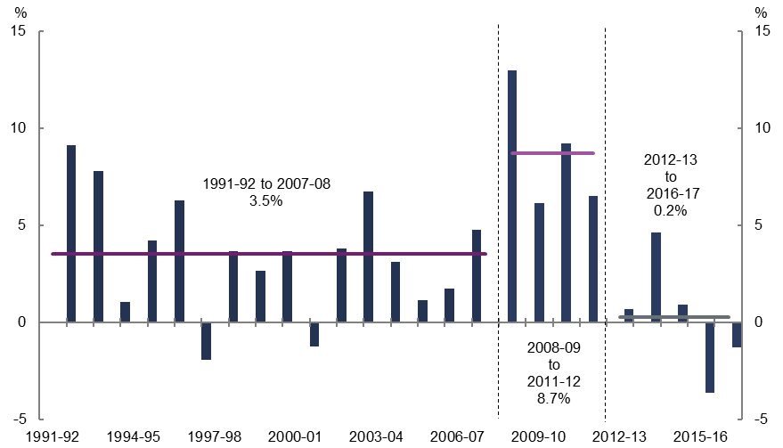

Source: PBO analysis

In 2008–09 growth increased sharply and averaged 8.7 per cent in real terms over the four years to 2011–12. This period coincided with softer labour market conditions due to the global financial crisis (GFC). The single base pension rate was also increased from 25 per cent to 27.7 per cent of Male Total Average Weekly Earnings (MTAWE) in 2009–10.

From 2012–13 growth in DSP expenditure slowed sharply, averaging 0.2 per cent annually in real terms over the five years to 2016–17. This has been driven by significant changes to assessment processes, particularly the introduction of new assessment tables for work‑related impairment which took effect from 1 January 2012 and additional job capacity assessments of new applicants which commenced in 2011–12.[6],[7] The introduction of new assessment tables and processes has effectively resulted in a structural break over the historical period, as the regime for assessing eligibility for the DSP fundamentally changed from 2011–12.

Figure 2–3 shows how changes in recipient numbers and the payment rate have contributed to growth in DSP expenditure over time.

Figure 2–3: Disability Support Pension Expenditure

Cumulative contributions to growth since 1991–92

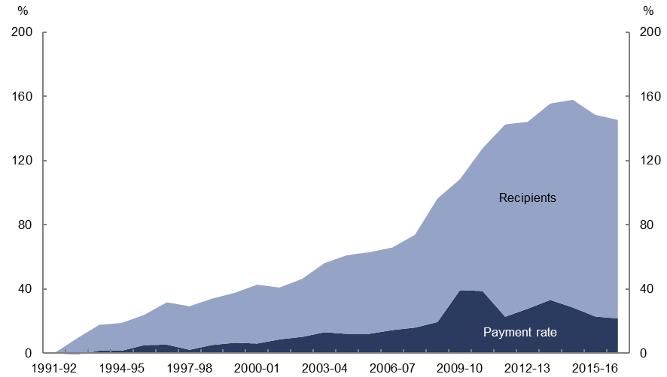

Source: PBO analysis

From 1991–92 to 2016–17, expenditure on the DSP has grown by 145 per cent in real terms. Most of this growth has been driven by increased recipient numbers, which have contracted in recent years. Trends in recipient numbers and payment rates are explored in more detail in the following sections.

## Recipients

As highlighted above, growth in the number of people on the DSP has been the key driver of DSP expenditure growth. Figure 2–4 shows the number of people on the DSP since the payment was introduced in 1991. Figure 2–5 shows these recipients as a share of the total working-age population to strip out the effect of population growth.[8]

Both of these figures illustrate that from the introduction of the payment up until the mid‑2000s, growth in the number of people on the DSP was relatively stable and strong.[9] There were increases in the number of both men and women on the DSP over this period. Strong growth in the number of women receiving the payment was influenced by the progressive increase in the Age Pension eligibility age for women from 60 to 65, which commenced in 1995 and finished in 2013. This resulted in the number of women on the DSP within this age group increasing by 90,000 over the period.[10]  Growth in the number of men on the DSP over this period was largely comprised of men with physical impairments such as musculoskeletal conditions and aged between 50 and 59.

|  |  |
| --- | --- |
| Figure –4: Disability Support Pension Recipients | Figure –5: Disability Support Pension Recipients  Share of total working‑age population |
|  |  |
| Source: DSS published data | Source: DSS data and ABS Cat. No. 3101 |

Following the onset of the GFC, the number of people on the DSP increased sharply, before a range of policy changes were enacted including changes to assessment processes and workforce participation requirements. After increasing for over two decades, the number of DSP recipients has declined for the past three years with recipients as a share of the working‑age population in 2016–17 falling to 4.7 per cent, around the same level as in  
1998–99. Over this period there was a decline in the prevalence of disability in the broader population with the share of people reporting a disability falling from 20 per cent in 2002–03 to 17 per cent in 2014–15 and increased labour force participation particularly for women.[11]

### Net change in DSP recipients

Trends in the number of people on the DSP reflect the net change in people receiving the DSP in any given year. This comprises those people that are new recipients of the DSP and those who cease receiving the payment (Figure 2–6).[12]

This net change in the current year is added to the number of recipients at the end of the previous year to form the total DSP population for the current year. For example, at the end of 2001–02 there were 657,000 people on the DSP. During 2002–03, there were 69,000 new recipients and 54,000 people who ceased receiving the payment, resulting in 672,000 people being on the payment at the end of 2002–03 (i.e., a net increase of 14,000 people).

Figure 2–: Net change in Disability Support Pension Recipients

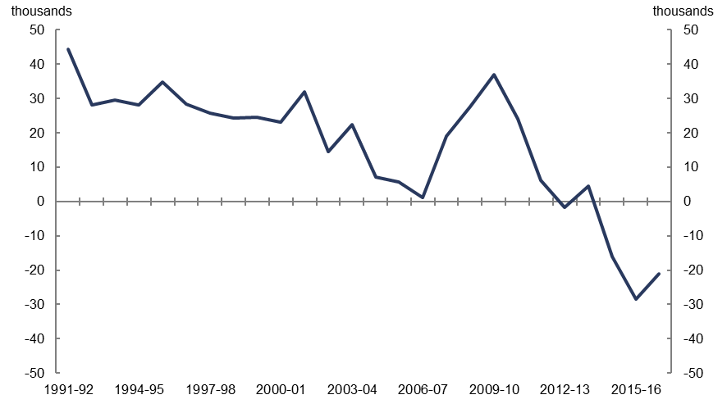

Source: DSS published data and PBO analysis

Figure 2–6 highlights how sharply the net change in the number of recipients on the payment has declined in recent years.

Breaking down net changes in the DSP recipient population between new recipients and persons who cease the payment allows for a more detailed analysis of the drivers of the recent sharp decline in recipient numbers.

Figure 2–7 shows that the number of people who ceased receiving the DSP has remained broadly stable over time while changes in the number of new DSP recipients have been the key factor driving the overall trends in the DSP recipient population since 2001–02.[13] The number of people who ceased receiving the DSP averaged around 55,000 per year from 2001–02 to 2016–17 while the number of new recipients peaked at almost 89,000 in 2009–10 and declined to around 32,000 in 2016–17.

The volatility in the number of new DSP recipients reflects the fact that key measures to change assessment and compliance arrangements have, in the main, focussed on tightening eligibility requirements for new applicants. People who are already on the payment are generally ‘grandfathered’ and exempt from changes. By contrast, the stability in the number of people who cease receiving the DSP reflects the fact that most of these people move onto the Age Pension. The ‘up and down’ pattern between years resulted from the staged increase in Age Pension eligibility age for women (see Box 2).

Figure –: Net change in Disability Support Pension Recipients

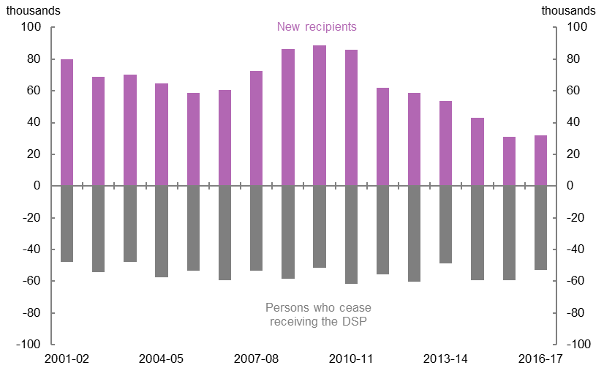

Source: DSS recipient characteristics data

### Trends in new recipients

As shown in Figure 2–7, the number of new DSP recipients has varied over time with trends in new recipients primarily driven by policy settings but also influenced by other factors such as demographics and labour market conditions.

From 2001–02 to 2004–05 there were around 71,000 new DSP recipients each year

(Figure 2–7). This number then declined with the introduction of the *Welfare to Work* package introduced in the 2005–06 Budget.[14] The measure *Welfare to Work —* *increasing participation of people with a disability* reduced the number of hours an individual is assessed as being capable of working before being excluded from the payment from 30 per week to 15. People assessed as being able to work between 15 and 29 hours could instead seek to access Newstart, which is subject to an obligation to seek part-time work.[15]

From 2008–09, with the onset of the global financial crisis and softer labour market conditions, the number of applicants granted entry onto the DSP increased significantly, with the number of new recipients on the DSP averaging around 87,000 per year from 2008–09 to 2010–11 (see Box 1).

Commencing in 2011–12, the number of new DSP recipients fell sharply, from almost 86,000 in 2010–11 to under 32,000 in 2016–17 largely reflecting the impact of measures contained in the 2009–10 Budget to tighten assessment criteria and processes. This in effect resulted in a structural break from earlier history, as the regime for assessing eligibility for the DSP fundamentally changed. The introduction of comprehensive Job Capacity Assessment processes requires Government assessors to take into account additional information such as past work history and previous access to employment services, in addition to medical advice, when determining an applicant’s capacity to work. New assessment tables for work-related impairment which commenced from 1 January 2012, moved to assess applicants based on the ability to perform certain activities rather than medical diagnoses of conditions.[16]

As Figure 2–8 shows, the above changes to assessment processes and criteria contributed to a significant fall in the average share of applicants granted entry onto the payment from 63 per cent between 2001–02 and 2010–11 to 43 per cent from 2011–12 to 2014–15, with the new lower average rate pointing to a fundamentally different assessment regime applying from 2011–12.

Figure –: Disability Support Pension Grant Rate

Share of applicants granted entry onto the DSP

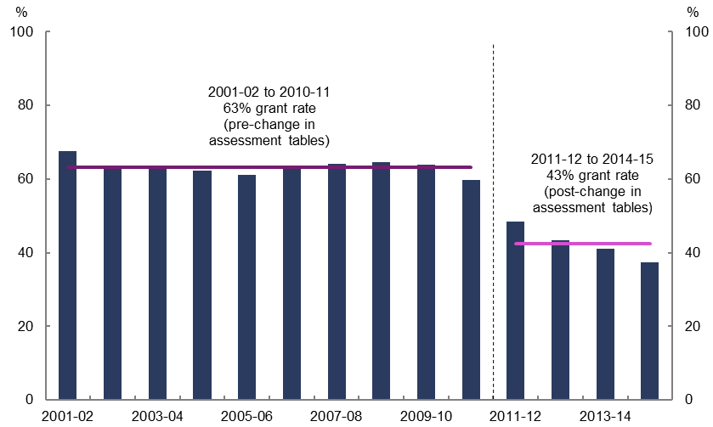Source: DSS Annual Reports

To a lesser extent, the recent decline in recipient numbers also reflects the impact of the 2014–15 Mid‑Year Economic and Fiscal Outlook (MYEFO) measure to replace treating doctor’s reports with Government Contracted Doctor’s reports on applications and the   
2015–16 MYEFO measure in relation to fraud prevention, debt recovery and assessment changes.

|  |
| --- |
| Box 1: Labour Market and the Disability Support Pension  Figure 2–9 shows the unemployment rate and DSP recipient growth as a share of the working age population since the payment was introduced in 1991.  **Figure 2–9: Disability Support Pension Recipients and the Unemployment Rate**    Source: ABS Cat. No. 6202.1 and DSS published data  From 1991–92 to 2006–07 the unemployment rate and change in the number of people on the DSP as a proportion of the working-age population broadly followed a similar downward trajectory. With the onset of the GFC, the unemployment rate increased to 5.7 per cent in 2009–10. This corresponded with an increase in the number of people on the DSP in the same year.[17]  The unemployment rate rose marginally over the period 2010–11 to 2016–17, averaging around 6 per cent. However, over the same period the growth in DSP recipients has fallen sharply.  This highlights how dominant a factor the recent policy changes have been on DSP recipient growth, overshadowing the link with underlying labour market conditions.[18] |

#### Primary medical condition and age

The composition of new DSP recipients has changed significantly over the past 15 years, with the type of medical condition and age of new entrants shifting over the period (Table 2–1).

Table –: New Disability Support Pension Recipients by Major Condition

|  |  |  |  |  |  |
| --- | --- | --- | --- | --- | --- |
| **Category** | **Entries (‘000)** | | **Share of total entries (%)** | | **Average age** |
| **2001–02** | **2016–17** | **2001–02** | **2016–17** | **2016–17** |
| Musculoskeletal (total) | 31.4 | 3.5 | 39.4 | 10.9 | 57 |
| *Male* | *18.9* | *2.0* | *23.7* | *6.1* | *57* |
| *Female* | *12.6* | *1.5* | *15.8* | *4.8* | *57* |
| Psychological (total) | 20.0 | 10.4 | 25.1 | 32.7 | 48 |
| *Male* | *11.6* | *6.8* | *14.6* | *21.2* | *46* |
| *Female* | *8.4* | *3.7* | *10.5* | *11.5* | *49* |
| Intellectual (total) | 4.4 | 5.3 | 5.5 | 16.5 | 37 |
| *Male* | *2.8* | *3.6* | *3.5* | *11.4* | *37* |
| *Female* | *1.7* | *1.6* | *2.1* | *5.2* | *38* |
| Other (total) | 23.9 | 12.7 | 29.9 | 39.9 | 51 |
| *Male* | *14.7* | *7.5* | *18.5* | *23.4* | *51* |
| *Female* | *9.1* | *5.3* | *11.4* | *16.5* | *51* |
| TOTAL | 79.7 | 31.9 | 100.0 | 100.0 | 50 |
| *Male* | *48.0* | *19.8* | *60.2* | *62.1* | *49* |
| *Female* | *31.8* | *12.1* | *39.8* | *37.9* | *51* |

1. Totals may not sum due to rounding.

Source: DSS recipient characteristics data and PBO analysis

DSP recipients are classified across 23 primary medical conditions. Of these, three conditions (musculoskeletal, psychological and intellectual) accounted for 60 per cent of new recipients on the DSP in 2016–17. Figure 2–10 shows how the primary medical condition of new DSP recipients has changed since 2001–02.

Figure –: New Disability Support Pension Recipients by Medical Condition

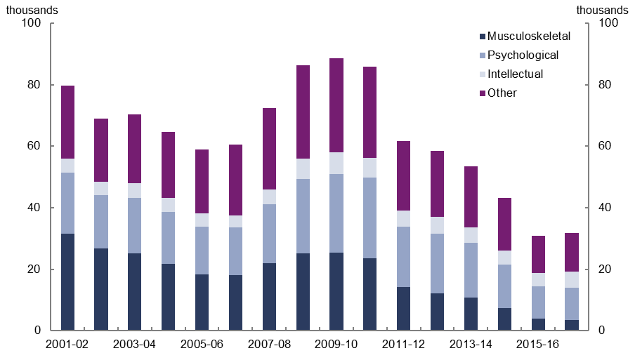

Source: DSS recipient characteristics data

One of the most significant changes in the composition of new DSP recipients has been the marked decline in the share of recipients with physical impairments and the increase in the share with psychiatric and intellectual impairments. This coincides with a fall in the proportion of all people with a disability reporting physical impairments from 84 per cent in 2002–03 to 79 per cent in 2014–15.[19]

In 2001–02, recipients with musculoskeletal conditions accounted for around 40 per cent of new DSP recipients. This fell to 11 per cent in 2016–17. Over the same period, the share of new recipients with psychological conditions increased from 25 per cent to 33 per cent, and the share with intellectual conditions increased from 6 per cent to 17 per cent.

The decline in musculoskeletal conditions is also apparent in the age profile of new DSP recipients. Recipients with musculoskeletal conditions typically commence receiving the DSP at an older age compared to recipients with other conditions. This is consistent with physical labour having an increasing impact on an individual’s capacity to work as they grow older. The average age of new DSP recipients with a musculoskeletal condition is 57. In contrast new DSP recipients with psychological or intellectual conditions are typically younger, with the average age of new recipients being 48 and 37 respectively.

Figure –: New Disability Support Pension Recipients by Age Group

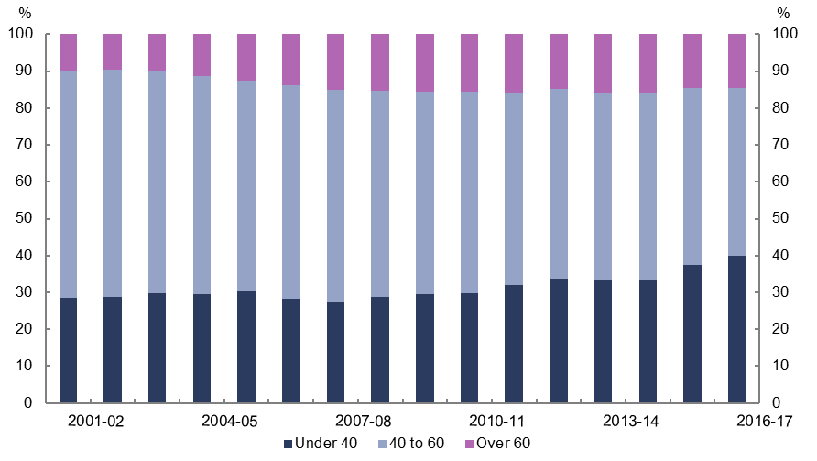

Source: DSS recipient characteristics data

Figure 2–11 shows that while new DSP recipients aged between 40 and 60 still make up the largest share of new recipients, this has shrunk from 61 per cent in 2001–02 to 45 per cent in 2016–17. In part, this reflects a fall in the size of the 40 to 60 cohort as the baby boomers grow older. In 2000–01, the baby boomers comprised 82 per cent of people aged between 40 and 60, this fell to 41 per cent in 2016–17.[20] The increasing workforce participation of women within this cohort has also contributed to the falling share of recipients in this age group over the period.

In contrast, those under 40 made up 28 per cent of new recipients in 2001–02, with this share increasing to 40 per cent in 2016–17. This increase is mainly driven by men with intellectual and psychological conditions entering the DSP. In 2016–17, men under 40 with these conditions accounted for three times as many new DSP recipients than women under 40 with the same conditions.

The change in the composition of new DSP recipients discussed above represents a key shift in the dynamics of the payment. While the number of new DSP recipients has fallen more generally, an increasing proportion of new recipients are more likely to stay on the payment for a longer period. This is because an increasing proportion of new DSP recipients are under 40 and more likely to have psychological and intellectual conditions. As most recipients with these conditions remain on the payment until they receive the Age Pension, this younger cohort could remain on the payment for over 20 years. Around a decade ago, in contrast, the average period of receiving the payment was around 10 years. This structural change will contribute to growth in DSP expenditure over the longer term as the total number of recipients will remain larger than would have otherwise been the case.

### Trends in recipients leaving the DSP

Around 55,000 people ceased receiving the DSP each year from 2001–02 to 2016–17. As shown in Figure 2–12, the primary reason that people cease receiving the DSP is that they move onto the Age Pension (49 per cent). Once a person reaches Age Pension age (currently 65), they have the option to continue to receive the DSP or to move onto the Age Pension. The vast majority of eligible 65 year olds choose to transition to the Age Pension as it has no medical eligibility rules. The next most common reason for ceasing to receive the DSP is death (24 per cent).

Figure –: Disability Support Pension Reasons for Leaving

Share of recipients who ceased receiving the DSP in 2016–17

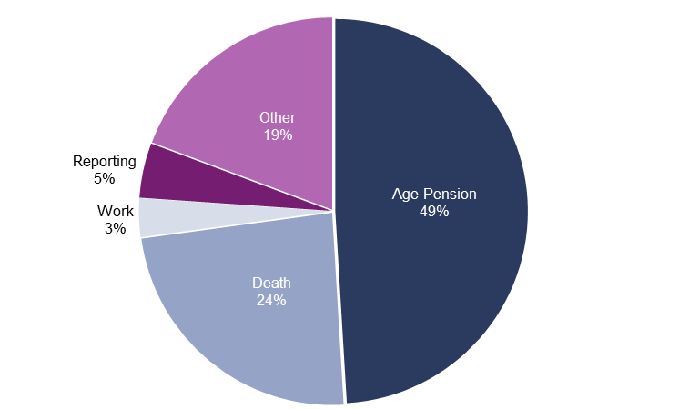

Source: DSS recipient characteristics data

Other reasons DSP recipients cease receiving the payment include exceeding the amount of time they are able to remain overseas while continuing to access income support payments, earning income or holding assets that exceed test thresholds, or going to prison. Exceeding the amount of time recipients are able to remain overseas accounted for a quarter of recipients ceasing the DSP in this category. The time permissible for receiving the DSP while overseas has been reduced from a period of 12 months to 4 weeks.

Each year around 70,000 people on the DSP are reviewed for compliance with criteria related to income, assets or medical condition. Only a small proportion of those reviewed are deemed ineligible for the payment.[21] These recipients accounted for around 5 per cent of all recipients leaving the DSP in 2016–17 (Figure 2–12). Most of these people were deemed ineligible for non-medical reasons. Similarly, the proportion of recipients leaving the payment to return to work accounted for only 3 per cent of recipients who ceased receiving the DSP in 2016–17.

#### Recipients leaving the DSP by gender

One of the only factors that has caused a significant variation in the number of people who cease receiving the DSP has been the increase in the Age Pension eligibility age for women from 60 to 65 from 1 July 1995 (Figure 2–13). This change drives the ‘zig zag’ pattern from the beginning of the period to 2013–14, at which point the Age Pension age for both men and women was 65 (See Box 2 for more detail).

Figure –: Disability Support Pension Recipients Leaving the Payment

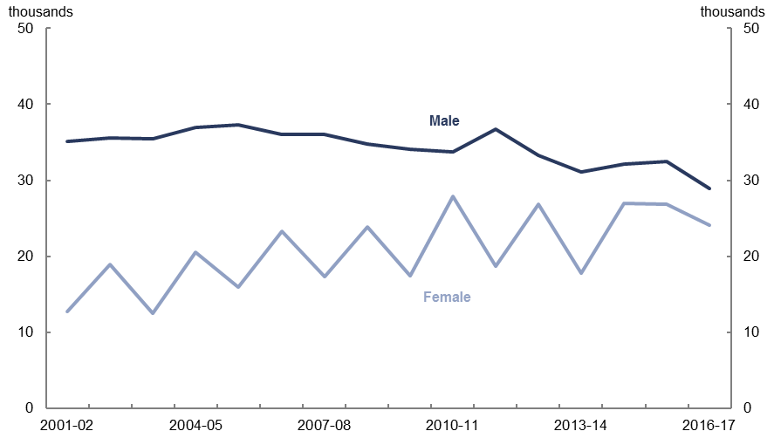

Source: DSS recipient characteristics data

|  |
| --- |
| Box 2: Age Pension Eligibility Age  Prior to 1 July 2013, the qualifying age for the Age Pension was different for men and women, depending on their date of birth. From 1 July 1995, the minimum age for women to qualify for the Age Pension began increasing by 6 months every two years. This had the effect of lifting the Age Pension eligibility age for women from 60 to 65 by 1 July 2013, at which point it was the same as the eligibility age for men.  This change affected women born between 1 July 1935 and 31 December 1948. For example, if a woman was born on 31 December 1939, the earliest date from which she could qualify for the Age Pension would be 1 July 2001.  The staged approach of increasing the eligibility age is the reason for the ‘zig zag’ pattern in Figure 2–13. Specifically, the pattern reflects that the changes to the Age Pension age (which apply according to the person’s date of birth), in effect only occurs over an 18 month period over two financial years.  Figure 2–14 shows when people would cease receiving the DSP and move onto the Age Pension for both men and women from 2001–02. The line for men is smooth, reflecting that once a man turned 65 he moved from the DSP to the Age Pension.  Figure 2–14: Moving from the Disability Support Pension onto the Age Pension  By birth year and gender from 2001–02 to 2016–17    Source: PBO analysis and Guide to Social Security Law  In contrast the line for women is staggered reflecting the schedule for changing the Age Pension eligibility age, with a partial effect in the first year of an increase in the age and larger impact in the subsequent year. For example, when the Age Pension eligibility age was increased to 63, entry to the Age Pension was deferred until the second half of the 2005–06 financial year, resulting in a pause for a six month period in the number of women within the age group that cease receiving the DSP. This pattern is repeated throughout the period as the eligibility age is increased.  The historical experience for women has informed the approach to projecting the number of people that cease receiving the DSP as the Age Pension eligibility age increases from 65 to 70 over the period 1 July 2017 to 1 July 2035. The effect is more pronounced over the medium term as the change affects both men and women. |

## Payment rates

The other key driver of DSP expenditure has been the pension payment rate (Figure 2–15). The DSP, Age Pension, Service Pension and Carer Payment, all share the same indexation arrangements. These indexation arrangements, which are set out in legislation, have varied significantly over the period.

Prior to 1997, pension payments were indexed in line with movements in the Consumer Price Index (CPI). From 1997–98 to 2009–10, the single rate pension was benchmarked to 25 per cent of MTAWE. ‘Benchmarked’ means that after it has been indexed, the relative pension rate is checked to see whether it is equal to or higher than the prescribed percentage of MTAWE (in this case 25 per cent for the single rate). If the rate is lower than this percentage, the rates are increased to the appropriate benchmark level.

Figure –: Disability Support Pension Payments

Growth in standard pension rate

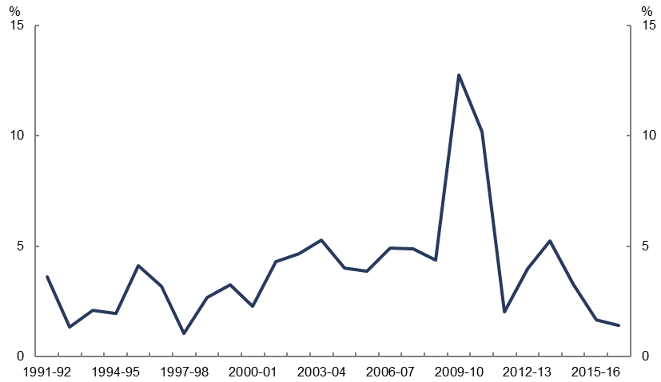

Source: PBO analysis and Guide to Social Security Law

The increase in 2009–10 reflects changes in the 2009–10 Budget, which increased the benchmarked single rate pension to 27.7 per cent of MTAWE and tied indexation to the greater of movements in the CPI, MTAWE or the Pensioner and Beneficiary Cost of Living Index (a pensioner specific index).

The rate of DSP paid to recipients is also affected by income and assets tests. The 2015–16 Budget measure *Social Security Assets Test—rebalance asset test threshold and taper rate* is expected to result in a reduction in recipient numbers due to an increase in the taper rate when the asset test threshold is exceeded. From 1 January 2017 the taper rate was doubled so that the payment is reduced by $3.00 (instead of $1.50) for every $1,000 above the asset test threshold. This was partly offset by one-off increases to the asset test thresholds from $209,000 to $250,000 for single homeowners and $296,500 to $375,000 for couples.[22]

# Projections of DSP expenditure

The PBO projects that expenditure on the DSP will grow on average by 1.0 per cent annually in real terms over the medium term, increasing from $16.3 billion in 2016–17 to $23.6 billion in 2027–28 (Figure 3–1).

These projections augment the Government’s expenditure estimates for the period 2017–18 to 2020–21, as contained in the 2017–18 MYEFO, with the PBO projections from 2021–22 onwards.

Figure –: Disability Support Pension Expenditure

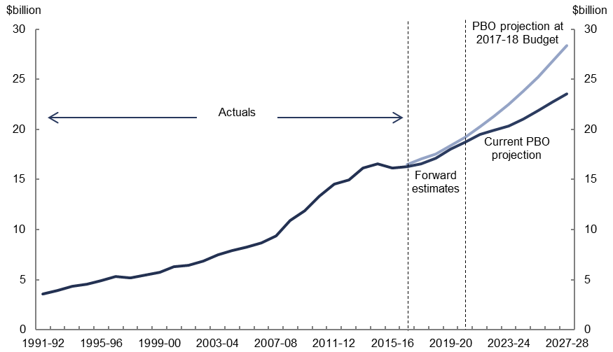

Source: DSS published data and 2017–18 MYEFO program estimates, and PBO projections

Figure 3–1 highlights that the PBO’s current projections for DSP expenditure are $4.8 billion lower in 2027–28 than our 2017–18 Budget projections.

## Projection approach

The PBO projections from 2021–22 to 2027–28 are prepared by modelling the net change in recipients taking into account recent trends, demographic change and the effect of policies, and applying this to an average payment rate. Recipients were modelled by gender, age and medical condition to reflect the variations in trends across these categories discussed in Section 2. The average payment rate applied to aggregate recipient projections was the legislated payment rate weighted for recipient characteristics and indexed to MTAWE.[23]

The PBO’s projections are based on current policy settings, and hence include the impact of a number of measures which are expected to have a downward influence on recipient numbers. These include:

* the introduction of new assessment tables and processes from 1 January 2012 to assess applicants based on the ability to perform certain activities rather than medical diagnoses which resulted in a fundamentally different assessment regime for new recipients than earlier history
* the 2014–15 MYEFO measure to replace treating doctor’s reports with Government Contracted Doctor’s reports on applications
* the 2016–17 Budget measure to undertake additional medical reviews of 90,000 existing DSP recipients over a three year period
* the extension of fraud prevention and debt recovery activity through data matching contained in the 2016–17 MYEFO.

Projections also include the effect of the 2009–10 Budget measure to increase the Age Pension eligibility age from 65 to 67 by six months every two years from 1 July 2017 and the yet to be legislated 2014–15 Budget measure to increase the Age Pension eligibility age to 70 from 1 July 2025. These measures increase expenditure on the DSP as recipients remain on the DSP for longer and a higher number of older individuals enter the DSP in lieu of the Age Pension.

From 2021–22 to 2027–28 the increase in the Age Pension eligibility age is projected to increase the amount of time 140,000 recipients spend on the DSP and result in an additional 30,000 recipients entering the DSP by 2027–28.

## Payment rate projections

As Section 2 highlighted, the recent subdued growth in new DSP recipients, which is projected to continue over the medium-term, means that growth in DSP expenditure from 2021–22 is largely driven by increases in the average payment rate. The average payment rate is projected to grow by 3.3 per cent annually over the medium term as it is indexed to MTAWE.

The average payment rate was projected by adjusting the legislated payment rate for the proportion of recipients expected to be on the full and part rate and those on the single or couple rate. More detail on the PBO’s projection methodology is provided at Appendix A.

## Recipient projections

The PBO projects that the number of DSP recipients will grow on an average by 0.4 per cent annually over the medium term, with the total number of recipients increasing from 760,000 in 2016–17 to 796,000 in 2027–28. This subdued growth would see the total number of DSP recipients remaining below the peak experienced following the GFC with total recipients in 2027–28 at around the same level as in 2009–10 (Figure 3–2).

Figure –: Disability Support Pension Recipients

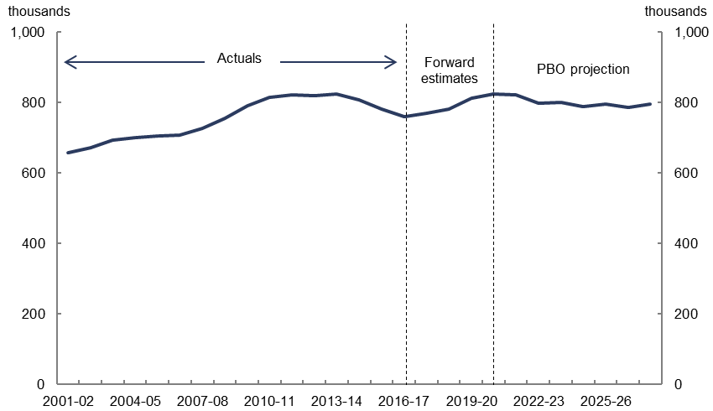

Source: DSS published data and 2017–18 MYEFO program estimates, and PBO projections

Figure 3–3 shows the projected number of new DSP recipients and those projected to cease receiving the payment underlying the projected total number of recipients on the DSP. Estimates of recipients from 2017–18 to 2020–21 are those implied by the official  
2017–18 MYEFO forward estimates.

Figure –: Net Change in Disability Support Pension Recipients[24]

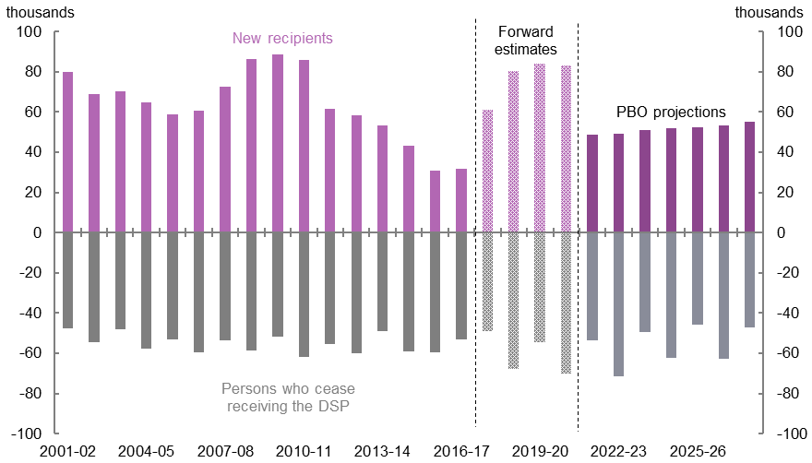

Source: DSS published data and 2017–18 MYEFO program estimates, and PBO projections

The number of new DSP recipients is projected to increase from 32,000 in 2016–17 to 55,000 in 2027–28. From 2017–18 to 2020–21, new DSP recipients are estimated to average 77,000 a year. This is projected to revert to around 52,000 a year from 2021–22 to 2027–28.

The number of recipients that cease receiving the DSP are projected to remain at relatively similar levels to those historically, averaging 58,000 a year from 2017–18 to 2027–28. As with the historical period, the ‘up and down’ profile of recipients leaving the payment reflects increases in the Age Pension eligibility age which occur over an 18-month period every two years (see Box 2). Increases in the eligibility age for both men and women aged between 65 and 68 are projected to increase the number of DSP recipients within this cohort from 29,000 in 2016–17 to 103,000 in 2027–28.

## Projection scenarios

As with all medium-term projections there are uncertainties surrounding the projections presented in this report. In particular, these relate to the limited historical experience of the new assessment regime and recent temporary compliance measures. These developments make interpreting the implications of the recent few years for the medium term challenging, particularly since the grant rate is yet to stabilise.[25]

Given this uncertainty, we analyse a number of scenarios using alternative assumptions for new recipients to see how they affect the projections (Figure 3–4).[26] These scenarios are based on alternative assumptions for the future trends in new recipients, as these are the largest driver of trends in the total DSP population and more likely to be influenced by changes in policy. These scenarios look at the implications if the average number of new recipients:

* remains at 2016–17 levels
* remains around the average recorded over the past five years, or
* increases back to the average recorded over the past 15 years.

The PBO’s projections beyond the forward estimates, as presented in the previous section, were modelled based on the average level of new recipients over the past five years. This approach captures the period following changes to DSP assessment processes and tables from 1 January 2012 that resulted in a structural break from earlier history and allows for a rebound from the current historcally low levels of new DSP recipients.

Using the most recent data (2016–17) to project new recipients would appear likely to understate future recipient numbers as these data partly reflect the temporary effect of compliance activity which is not expected to persist over the medium term.

In contrast, using the 15‑year average would likely overstate the number of future recipients as it captures a period of strong growth in recipient numbers that was largely based on assessment tables and participation requirements that have been significanty and effectively tightened over the past five years.

Figure 3–4 shows projections for new DSP recipients under the three scenarios outlined above. This illustrates that the PBO’s projections include a strong rebound in new recipients, based on official 2017–18 MYEFO estimates, before moving to a five-year average level.

Figure –: New Disability Support Pension Recipients

Projection scenarios

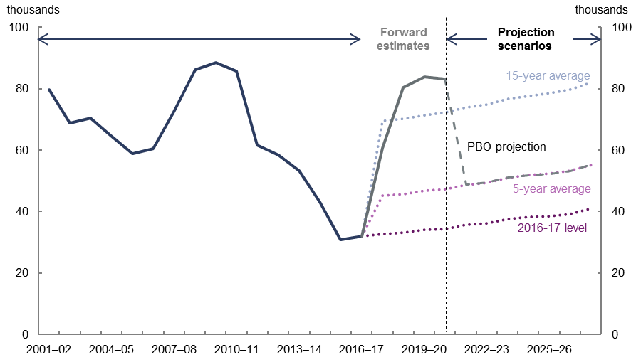

Source: DSS published data and 2017–18 MYEFO program estimates, and PBO analysis

Figure 3–5 shows how the projections for total recipients vary significantly across the scenarios. If the number of new recipients remained at the 2016–17 level over the medium term, the total number of recipients would fall from 760,000 to 630,000 by 2027–28. If the number of new recipients remained at around the average of the past five years, total recipients would fall from 760,000 in 2016–17 to around 740,000 by 2027–28. However, if new recipients increased to the average level experienced over the past 15 years, total recipients would be projected to rise to 954,000 in 2027–28.

These scenarios compare with the PBO’s current projection for total DSP recipients in   
2027–28 of 796,000. As the PBO’s projections incorporate the rebound in new recipients in the 2017–18 MYEFO estimates, the total number of recipients in 2027–28 is higher than it would have been if the five-year historical average of new recipients was applied from   
2016–17.

In the scenarios that use the lower levels of new recipients, there are falls in the total number of recipients over the projection period. This is due to the increasing number of people who are projected to cease receiving the DSP. This occurs as people who commenced receiving the DSP over the period of strong historical growth reach the age at which they are entitled to the Age Pension.

Figure –: Total Disability Support Pension Recipients

Projection scenarios

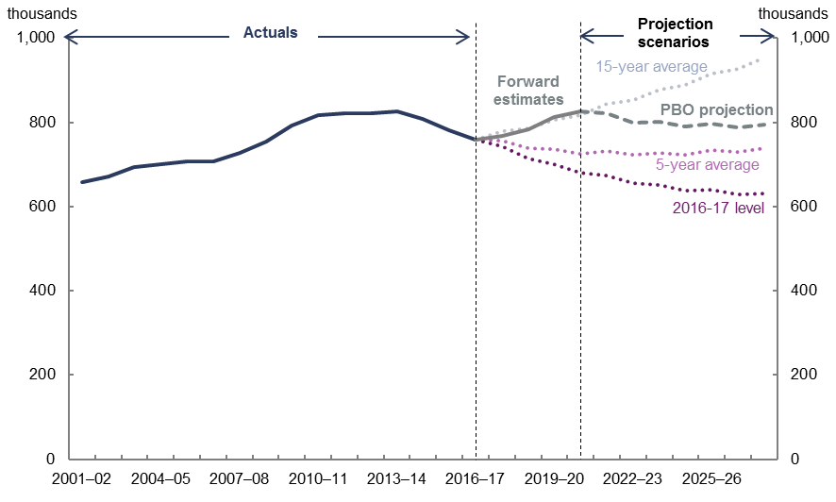

Source: DSS published data and 2017–18 MYEFO program estimates, and PBO analysis

Figure –: Total Disability Support Pension Expenditure

Projection scenarios

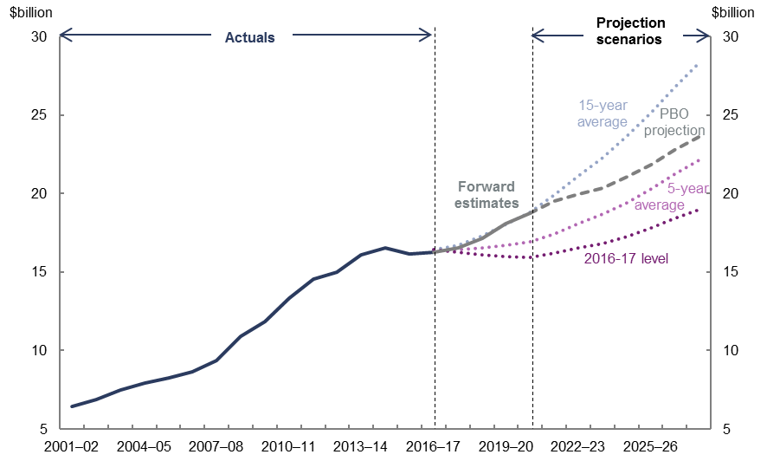

Source: DSS published data and 2017–18 MYEFO program estimates, and PBO analysis[27]

Figure 3–6 shows the corresponding expenditure projections under each scenario with the projections for 2027–28 ranging from $28.3 billion, based on a 15‑year average level of new recipients, to $18.9 billion if new recipients remained at 2016–17 levels. This compares with the PBO’s projection of DSP expenditure in 2027–28 of $23.6 billion.

Growth in the PBO’s expenditure projections over the forward estimates reflects the strong growth in the official 2017–18 MYEFO forward estimates for the program to 2020–21 with slowing of growth thereafter based on our lower projections for the ongoing level of new recipients. This scenario analysis suggests there are further downside risks to the DSP expenditure projections.

# Appendix A – Technical notes

* + 1. Data sources

This report uses unpublished DSP recipient characteristics data provided by the Department of Social Services (DSS) in the analysis of historical trends from 2001–02 to 2016–17.

Data underlying the 2017–18 MYEFO forward estimates for the DSP were sourced from DSS.

Economic parameters and population projections over the medium-term were provided by Treasury.

Average payment rates are based on settings as outlined in current legislation under the *Social Security Administration Act 1999*.

* + 1. Projections methodology

The projections contained in this report assume the forward estimates of DSP expenditure contained in the 2017–18 MYEFO and underlying recipient numbers provided by the DSS. These estimates cover the period from 2017–18 to 2020–21. The PBO has benchmarked its projection model to these estimates.

The PBO’s previously published projections of DSP expenditure, including those in its recent report *2017–18 Budget: medium-term projections* were modelled by projecting take-up rates based on long-term historical trends in the total DSP population by gender and age. These take-up rates were then applied to population projections to get a baseline projection. This baseline projection was then adjusted for the impact of increases in the Age Pension eligibility age, as some recipients who are no longer eligible for the Age Pension are expected to remain on, or apply for the DSP. An average payment rate, calculated based on total historical expenditure on the DSP and recipient numbers, grown by MTAWE. This was then applied to recipient projections to arrive at total expenditure projections.

Medium-term projections of DSP expenditure presented in this analysis were arrived at by modelling recipient numbers taking into account demographic change and the effect of policies and applying this to an average payment rate for recipients.[28] Projections have been based on detailed recipient characteristics data. In addition to age and gender, recipient projections have been modelled by major medical condition.

Further, recipient projections were prepared by looking at the number of new recipients and those who cease to receive the payment, rather than looking at the total DSP population. This approach better captures the dynamics underlying trends in DSP recipient numbers as new recipients have been the key driver of changes in DSP expenditure over the past 15 years.

Projections of both new recipients and those who cease to receive the DSP include adjustments for the increase in the Age Pension eligibility age over the projection period. New recipients have been projected on a per capita basis. Recipients who cease receiving the DSP have been projected based on the share of total recipients in the previous year expected to cease receiving the payment in the projection year. Total numbers of recipients in a year have been arrived at by adding projections of new recipients on the payment and subtracting projections of those who cease receiving the payment from the total number of recipients at the end of the previous year. This end of year estimate of recipients has then been converted to an annual average level based on the historical distribution of recipients throughout a year.

The average payment rate is then applied to the aggregate annual average recipient numbers to arrive at expenditure projections. The average payment rate was based on indexed pension rates as set out in current legislation under the *Social Security Administration Act 1999* adjusted for the DSP recipient profile (i.e. single, partnered and full and part-rate recipients).

The approach used to model new recipients, those leaving the DSP and total recipients including the effect of the increase in the Age Pension eligibility age is discussed below.

* + - 1. Major medical condition, gender and age

DSP recipients are classified across 23 primary medical conditions. The major categories used to prepare projections in this report have been based on the overall contribution of recipients across these medical conditions to total growth in DSP recipients from 2000–01 to 2016–17 (Table A–1). This allows the analysis to focus on the most significant drivers of changes in the DSP population over the past 15 years.

Table A‒: Major Categories for Analysis and Projections

| Category | Recipients (‘000) | | Contribution to growth | |
| --- | --- | --- | --- | --- |
| 2000-01 | 2016-17 | % | Share |
| Psychological/psychiatric | 136 | 252 | 18.6 | 86 |
| Intellectual/learning | 63 | 108 | 7.3 | 34 |
| Musculoskeletal | 200 | 169 | -5.0 | -23 |
| Nervous system | 25 | 39 | 2.3 | 11 |
| Circulatory | 35 | 25 | -1.5 | -7 |
| Cancer | 10 | 16 | 1.0 | 5 |
| Respiratory | 20 | 16 | -0.6 | -3 |
| Remaining | 137 | 135 | -0.5 | -2 |
| **Total** | **625** | **760** | 21.5 | 100 |

1. A negative number indicates a contraction. Recipient numbers are rounded to the nearest thousand. Totals may not sum due to rounding.

Source: PBO analysis and DSS recipient characteristics data

The PBO model projects recipient numbers based on the eight major categories in Table A‒1. The ‘remaining’ category includes: recipients granted entry before 1991; acquired brain injury; amputation; congenital abnormalities; chronic pain; endocrine and immune system; gastro-intestinal system; infectious diseases; inherited disorders; reproductive system; skin disorders and burns; sense organs; urogenital system and visceral disorder.

Major medical categories have been modelled by gender and 17 age groups to capture the effect of the change in the Age Pension age on new recipients and those who cease receiving the DSP along with trends across younger groups. Age groups are under 20s, 20 to 29, 30 to 39, 40 to 49, 50 to 59, 60, 61, 62, 63, 64, 65, 66, 67, 68, 69, 70 and Over 70.

* + - 1. New recipients

Over the medium-term new DSP recipients have been modelled for each major condition on a per capita basis by gender and age.

Historical data on new recipients was converted to per capita levels and projected forward based on a five‑year average of new recipients from 2012–13 to 2016–17 by each grouping. A five-year average was chosen as a fundamentally different assessment regime applied after 1 January 2012. New recipient projections were adjusted for the impact of the staged increase in the Age Pension eligibility age for recipients aged between 65 and 68 which occurs over the projection period.

* + - 1. Recipients leaving the DSP

Recipients leaving the DSP have been modelled based on the share of recipients in a cohort expected to leave the payment in the next year. Cohorts that cease receiving the payment have been modelled by medical condition, gender and age group.

Shares were fixed at three-year average levels from 2014–15 to 2016–17 for both men and women. A three-year average picks up the period at which the Age Pension eligibility age is the same for men and women (the Age Pension eligibility age change aside, the number of recipients who cease receiving the DSP are much less volatile than the number of new recipients). Average levels for recipients aged between 65 and 68 were adjusted for the effect of increasing the Age Pension eligibility age.

Figure A‒: Recipients Leaving the Disability Support Pension

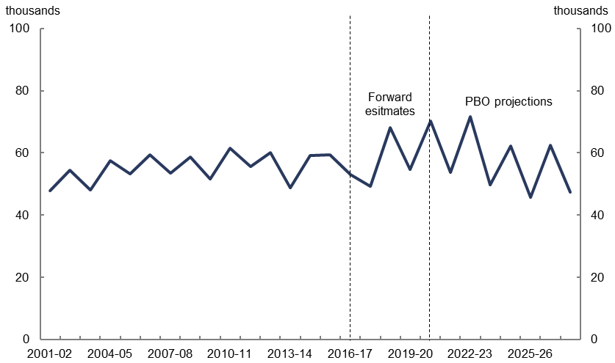

Source: DSS recipient characteristics data and PBO analysis

The staged approach of increasing the eligibility age is the reason for the ‘zig zag’ pattern of recipients who cease receiving the DSP with increases in the eligibility age occurring over two years with an impact over six months in the first year and a full year subsequently (see Box 2 in the body of the report). The pattern of exits in Figure A‒1 is more pronounced over the projection period reflecting the increase in the Age pension eligibility age for both men and women compared with the historical period when it only applied to women.

* + - 1. Benchmarking to 2017–18 MYEFO forward estimates

The PBO DSP model was benchmarked to the 2017–18 MYEFO forward estimates from

2017–18 to 2020–21. This was achieved by adjusting the number of new recipients and those who cease receiving the DSP from 2017–18 to 2020–21 to arrive at the total recipient numbers in the official estimates. Average payment rates were similarly benchmarked to official estimates over the period.

Implied numbers of new DSP recipients increase significantly over the forward estimates and were adjusted where possible to match the age profile contained in the official forward estimates. The effect of increasing the Age Pension eligibility age from 2017–18 to 2020–21 is assumed to be included in the official estimates.

The number of those ceasing to receive the DSP also increases as part of benchmarking to official estimates. The effect on the number of people ceasing to receive the DSP from benchmarking extends throughout the projection period from 2017–18 to 2027–28. This is due to the higher levels of new recipients over the forward estimates adding to the total number of recipients who cease receiving the payment over time.

* + - 1. Age Pension eligibility age increase

The increase in the Age Pension eligibility age has two effects on the DSP: it increases the number of new DSP recipients as they become ineligible for the Age Pension; and it impacts the timing of when recipients cease receiving the DSP.

Figure A‒2 summarises when the increase in the eligibility age is scheduled to occur over the medium term. The smooth green line represents what the profile of when recipients cease receiving the DSP would have been if the Age Pension eligibility age remained at 65 over the projection period. However, the profile of people who cease receiving the DSP is staggered, reflecting the six‑month increase every two years in the Age Pension eligibility age. This is analogous to the pattern of recipients who cease receiving the DSP in Figure 2–14 in Box 2 of the body of the report, except rather than the age at which women cease receiving the DSP converging to 65 years, the age at which both men and women cease to receive the DSP steadily moves away from 65 years.

Figure A‒: Moving from the Disability Support Pension onto the Age Pension

By birth year, from 2017–18 to 2027–28

Source: PBO analysis

*New recipients from the increase in the Age Pension eligibility age*

Underlying new recipients (as calculated in A1.2.2) in an affected age group were adjusted by using the historical experience of women aged between 62 and 65 for the period when the Age pension eligibility age for women was increased.

*Recipients who cease receiving the DSP from the increase in the Age Pension eligibility age*

Projections of people who cease to receive the DSP reflect the schedule for changing the Age Pension eligibility age (see Box 2 in the body of the report).

*Age groups impacted by the increase in the Age Pension eligibility age*

Figure A–3 shows the historical and projected profile of age groups within the DSP population impacted by the increase in the Age Pension eligibility age. It shows each of the impacted DSP cohorts as a proportion of the overall population for the cohort.

As the eligibility age for both men and women increases over the projection period the total number of recipients within these age groups is projected to increase. The ‘step’ in the curves reflects the staged approach for implementing the Age pension eligibility age. This profile matches the experience of when the female Age Pension eligibility age was increased in a similar manner and is benchmarked to the current government forward estimates from 2017–18 to 2020–21 (Figure A–4).

Figures over the forward estimates are official 2017–18 MYEFO forward estimates.

Figure A‒3: Disability Support Pension — impact of Age Pension eligibility age

Proportion of selected age cohorts (all recipients 65 to 68)

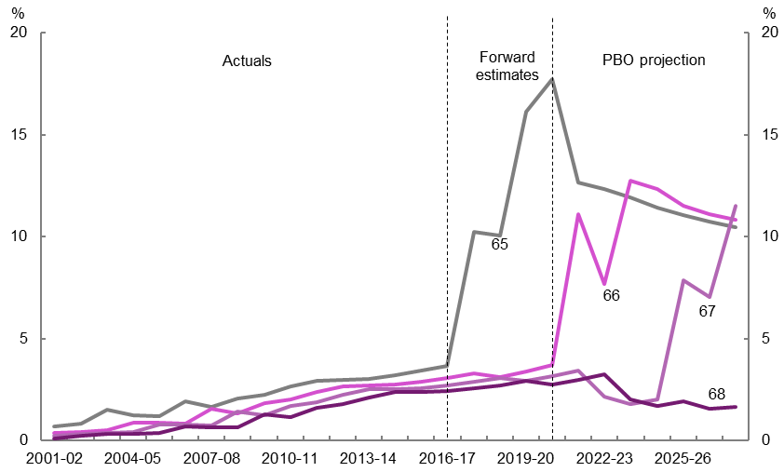

Source: DSS recipient characteristics data and PBO analysis

Figure A‒4: Disability Support Pension — impact of Age Pension eligibility age

Proportion of selected age cohorts (females 62 to 68)

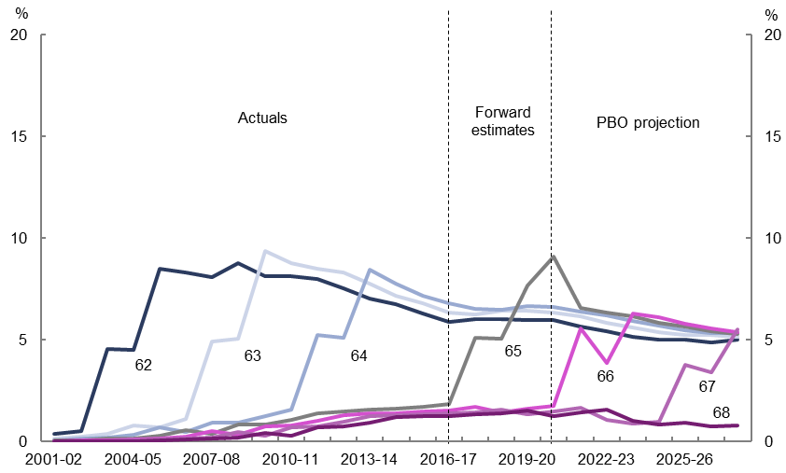Source: DSS recipient characteristics data and PBO analysis

* + - 1. Total number of DSP recipients

The total number of DSP recipients was modelled with an adjustment for projected changes in the overall population by converting per capita projections of new recipients and subtracting these from projections of those who cease to receive the DSP.

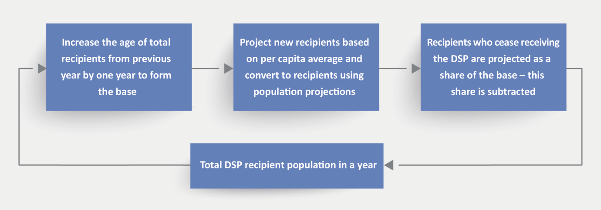

* + - 1. Payment rates

Payment rates were projected by growing the average payment rate over the forward estimates by MTAWE over the medium term. Average payment rates over the forward estimates were based on the legislated single and couple pension rate, the historical proportion of the DSP population on either, as well as those on the full and part rate. Medium-term projections of MTAWE are Treasury 2017–18 MYEFO projections.

# Appendix B – Significant changes affecting the Disability Support Pension

Table B‒: Developments impacting the Disability Support Pension

| Date | Development |
| --- | --- |
| 1991 | Disability Support Pension replaces invalid pension – *Social Security (Disability and Sickness Support) Amendment Act 1991*. Eligible recipients would need:   * to be 16 and over with a physical, intellectual or psychiatric impairment of 20 or more points under impairment tables * demonstrate a continuing inability to work 30 hours a week at award wages within two years * meet residency requirement of 10 years |
| 1994 | *Social Security Legislation Amendment Act 1994*   * Increase in Age Pension eligibility age for women from 60 to 65 moving more women onto the DSP going forward (1993–94 Budget measure) |
| 1999 | *A New Tax System (Compensation Measures Legislation Amendment) Act 1999*   * Introduction of the Pensioner Supplement |
| 2005 | *Employment and Workplace Relations Legislation Amendment (Welfare to Work and Other Measures) Act 2005*  Welfare to Work reforms:   * New activity test moving from 30 to 15 hours or more of work per week at award wages within two years reducing the number of people eligible * Workforce participation of 30 hours a week without losing the payment for recipients with an ongoing or regular program of support * Extension of provision to preclude recipients from the payment if the person’s partner earns above Average Weekly Ordinary Time Earnings six months before claiming the DSP (except in cases of permanent blindness) targeting high-income workers who are not subject to an income maintenance period * Removal of local labour market conditions in determining a person’s capacity to work (Grandfathering for recipients commencing before 10 May 2005) * Introduces requirement of ‘continuing inability to work’ * Voluntary participation available for DSP recipients to access Work for the Dole supplement of $20.80 * Applicants attend a Comprehensive Work Capacity Assessment to determine whether they are able to work 15 or more hours independently a week * Those assessed with capacity to work 15 hours or more independently are referred to Disability Open Employment Service * General grandfathering for claims made before 1 July 2006 |
| 2009 | *Social Security and Other Legislation Amendment (Pension Reform and Other 2009 Budget Measures) Act 2009*  Secure and Sustainable Pension Reform package:   * Increases in payment rates associated with Carbon Pollution Reduction Scheme compensation * Indexation of the legislated pension rate to the greater of CPI, MTAWE and Pensioner and Beneficiary Living Cost Index (PBLCI) * 10 per cent increase in the benchmark rate from 25 per cent to 27.7 per cent of MTAWE |
| 2011 | *Family Assistance and Other Legislation Amendment Act 2011*   * Implementation of the 2010–11 Budget measure to introduce Job Capacity Assessments which take into account the capacity of applicants to participate in the workforce based on functional capacity, previous work history as well information about the condition of recipients. Unsuccessful applicants are referred to employment services. Some approved applicants are referred for active participation in a program of support. |
| 2011 | *Clean Energy (Household Assistance Amendments) Act 2011*   * Clean Energy Supplement — increase in payment rate |
| 2011 | *Social Security (Tables for the Assessment of Work-related Impairment for Disability Support Pension) Determination 2011*   * Implementation of the 2009–10 Budget measure *Disability Support Pension— Better and Fairer Assessment of Work-related Impairment for Disability Support Pension* by introducing new impairment tables from 1 January 2012 that assess applicants based on physical capacity rather than medical diagnoses. |
| 2012 | *Social Security and Other Legislation Amendment (Disability Support Pension Participation Reforms) Act 2012*  Gives effect to 2011–12 Budget package *Building Australia’s Future Workforce* to:   * Allow DSP recipients to work up to 30 hours without having their payment suspended or cancelled * Require that recipients under 35 with a work capacity of at least eight hours a week engage with Centrelink through an initial participant’s interview and develop a participation plan * Limiting portability of the payment while overseas |
| 2014 | *Social Services and Other Legislation Amendment (2014 Budget Measures No. 6) Act 2014*   * Establishes reviews of new DSP recipients under 35 who commenced between 2008 and 2011 * Further limit DSP portability to 28 days in a 12-month period from 1 January 2015 |
| 2014 | Revised assessment process introducing Government Contracted Doctors to replace treating doctors’ reports on recipient applications |
| 2017 | Increase in residency requirement for recipients from 10 to 15 years from 1 July 2018 |

# Appendix C – References

Australian Bureau of Statistics 2017, *Australian National Accounts*, Cat. No. 5202, Canberra.

— *Australian Demographic Statistics,* Cat. No. 3101, Canberra.

— *Consumer Price Index,* Cat. No. 6401, Canberra.

— *Disability, Ageing and Carers, Australia*, Cat. No.4430, Canberra.

—*Labour Force Australia*, Cat. No. 6202, Canberra.

Australian Government *Budget Papers* and *Annual Reports* (various)

Australian National Audit Office Report 2016, *Qualifying for the National Disability Support Pension,* Report 18 of 2015­–16.

Burkhauser, R V, Daly, M C & Lucking, B T 2013, ‘Is Australia one recession away from a disability blowout? Lessons from other Organisation for Economic Co-operation and Development countries’, *The Australian Economic Review,* vol. 46, no. 3, pp.357–68.

Cai, V, Vu, H & Wilkins, R 2007, ‘Disability Support Pension recipients: Who gets off (and stays off) payments?’ *The Australian Economic Review*, vol. 40, pp. 37-61.

Department of Family and Community Services 2000, *Participation Support for a More Equitable Society: final report of the Reference Group on Welfare Reform,* Canberra.

Department of Social Security 1988, *Towards enabling policies: income support for people with disabilities*, Canberra.

McVicar, D & Wilkins, R 2013, ‘Explaining the Growth in the Number of Recipients of the Disability Support Pension in Australia,’ *The Australian Economic Review,* vol. 28, no. 3, pp. 345–56.

Productivity Commission 2011, ‘Appendix K: The Disability Support Pension’, *Productivity Commission Inquiry Report: Disability Care and Support*, No. 51, 31 July 2011, Canberra.

Saunders, P 2017, ‘Understanding social security trends: an expenditure decomposition approach with application to Australia and Hong Kong’, *Journal of Asian Public Policy*, vol. 10, no. 2, pp. 216-222.



[www.pbo.gov.au](http://www.pbo.gov.au/)

1. Strong growth in numbers and low workforce engagement of Invalid Pension recipients led to the introduction of the DSP. These reforms were informed by the *Towards Enabling Policies: Income Support for People with Disability* report from 1988 http://trove.nla.gov.au/work/15201454?selectedversion=NBD594.
2. This is referred to as a continuing inability to work. A person who is assessed as permanently blind automatically qualifies for the DSP and does not have to demonstrate a continuing inability to work.
3. For a detailed list of the primary medical conditions see Appendix A.
4. The income and assets tests do not bind for the large majority of DSP recipients, meaning they receive the full pension rate. Some recipients (such as individuals who are permanently blind) are not subject to income or asset tests.
5. Other social security and welfare spending includes $3.4 billion on the National Disability Insurance Scheme (NDIS). The amount of DSP paid to recipients is not affected if they access the NDIS. Data has been sourced from 2017­–18 Australian Government Final Budget Outcome, p. 10 and DSS 2016–17 Annual Report, p. 43.
6. Refer to 2010–11 Budget Paper No. 2, p. 139.
7. The Australian National Audit Office Report (ANAO) 2016 *Qualifying for the National Disability Support Pension,* Report 18 of 2015­–16 shows that the key determinant in gaining access to the DSP was meeting criteria under assessment tables, which were revised from 1 January 2012, p. 24. See also DSS (2014) *Disability Support Pension Recipient Characteristics Report, June 2013.*
8. Working-age population is defined as 15 to 64 year olds.
9. See Burkhauser, Daly & Lucking 2013 and McVicar & Wilkins 2013 for detailed discussions of the drivers of DSP growth over this period.
10. See Box 2, for further details.
11. ABS Cat. No. 4430. Data for 2001–02 is not available for this series.
12. For the most part, once an individual is assessed as eligible for the DSP they continue to receive support until they no longer require it. There is no standard requirement to be re-assessed over time although a sample of recipients is reviewed for compliance against eligibility criteria each year with only a small proportion of those reviewed leaving as a result of non-compliance.
13. Detailed data on new recipients and those who cease receiving the payment is only available from

    2001–02.
14. Refer to *Welfare to Work Reform Package 2005*, 2005–06 Budget Paper No. 2, p. 132-145*.*
15. This measure was originally introduced in 2003following the release of the *Participation Support for a More Equitable Society* report but was not legislated at the time.
16. This policy was introduced in the 2009–10 Budget through the measure *Disability Support Pension—better and fairer assessments*, Budget Paper 2, p. 228.
17. McVicar, D & Wilkins, R 2013, ‘Explaining the Growth in the Number of Recipients of the Disability Support Pension in Australia’ *The Australian Economic Review,* vol. 28, no. 3, pp. 345-56
18. The links between the DSP and underlying labour market conditions are explored in detail in McVicar & Wilkins 2013 cited above, p. 348-349.
19. ABS Cat. No. 4430. Data for 2001-02 is not available for this series.
20. This refers to individuals born between 1946 and 1966.
21. ANAO 2016, p. 41.
22. Rates of homeownership among the DSP population have fallen over time from 37 per cent of recipients in 2001–02 to 28 per cent in 2012–13. The asset test threshold for non-homeowners was also increased from $360,000 to $450,000 for singles and $448,000 to $575,000 from 1 January 2017.
23. This has been informed by the expenditure decomposition approach discussed in Saunders, P 2017, ‘Understanding social security trends: an expenditure decomposition approach with application to Australia and Hong Kong’, *Journal of Asian Public Policy*, vol. 10, no. 2, pp. 216-222.
24. From 2017–18 to 2020–21, the number of new recipients and those ceasing to receive the DSP are assumed at levels that match total recipient estimates in the official 2017–18 MYEFO forward estimates for the program.
25. Grant rate data is not published beyond 2014–15.
26. Scenarios are based on the average per capita level of new recipients in a year as a share of the total population with an adjustment for the impact of the increase in the Age Pension eligibility age. The average period captures the effect of policy settings and the per capita approach allows for the effect of changes in the overall population to be reflected in the projections. See Appendix A for further detail.
27. Growth in expenditure projections for each of the scenarios is stronger than projected growth in recipient numbers due to the growth in payment rates, with payment projections indexed to MTAWE.
28. This is discussed in the expenditure decomposition approach explored in Saunders, P 2017.