2016–17 Mid-Year Economic and Fiscal Outlook — charts
A graphical summary of the 2016–17 MYEFO relative to the 2016–17 Budget, showing the impacts of policy decisions and other factors
Date issued: 12 January 2017

© Commonwealth of Australia 2017
ISSN 978-0-9953836-0-9 (Online)
This work is licensed under the Creative Commons Attribution-NonCommercial-NoDerivs 3.0 Australia License.
The details of this licence are available on the Creative Commons website: http://creativecommons.org/licenses/by-nc-nd/3.0/au/
Use of the Coat of Arms
The terms under which the Coat of Arms can be used are detailed on the following website: www.itsanhonour.gov.au/coat-arms
Produced by: Parliamentary Budget Office
Designed by: Studio Tweed
First Assistant Parliamentary Budget Officer
Fiscal Policy Analysis Division
Parliamentary Budget Office
Parliament House
PO Box 6010
CANBERRA ACT 2600
Phone: (02) 6277 9500
Email: pbo@pbo.gov.au

Contents
Notes 1
Underlying cash balance 3
Total receipts 4
Total payments 5
Revenue – individuals and other withholding taxes 6
Revenue – company tax 7
Revenue – goods and services tax 8
Revenue – excise and customs duties 9
Revenue – non-tax revenue 10
Expenses – Age Pension 11
Expenses – Family Tax Benefit 12
Expenses – Disability Support Pension 13
Expenses – aged care 14
Expenses – job seeker income support 15
Expenses – income support for carers 16
Expenses – child care fee assistance 17
Expenses – parents’ income support 18
Expenses – Medicare Benefits Schedule 19
Expenses – assistance to the states and territories for public hospitals 20
Expenses – pharmaceutical benefits 21
Expenses – private health insurance rebate 22
Expenses – National Disability Insurance Scheme 23
Expenses – assistance to the states and territories for schools 24
Expenses – higher education grants 25
Higher Education Loan Programme 26
Defence (expenses and net capital investment) 27
Expenses – public debt interest 28
Expenses – public sector superannuation 29
Expenses – road and rail infrastructure 30
Official Development Assistance 31

Notes
These charts provide a visual summary of the key drivers of the 2016–17 Mid-Year Economic and Fiscal Outlook (MYEFO), and the policy decisions underpinning them.
Data contained in these charts are primarily based on information published in the
2016–17 MYEFO, as well as the 2016–17 Budget, the 2015–16 Final Budget Outcome and government agency annual reports. Where applicable, additional information provided by agencies has supplemented the publicly available information.
At the aggregate level the underlying cash balance, total receipts, and total payments charts have been prepared on a cash basis. Charts on individual revenue heads and expenditure programs have been prepared on an accruals basis (apart from the Higher Education Loan Programme and Official Development Assistance), consistent with the presentation of decisions in the Budget papers.
Consistent with MYEFO, the charts show the financial impact of policy decisions up to and including 2019–20. The charts show movements due to parameter and other variations since the 2016–17 Budget, which are available for the 2016–17 to 2019–20 years.
The PBO does not have access to the details of provisions for individual items in the Contingency Reserve. Accordingly, the charts in this report are subject to the qualification that they are prepared in the absence of information on the possible impact of any provisions in the Contingency Reserve.

Underlying cash balance
Figure 1: Underlying cash balance – change from 2016–17 Budget to 2016–17 MYEFO estimates
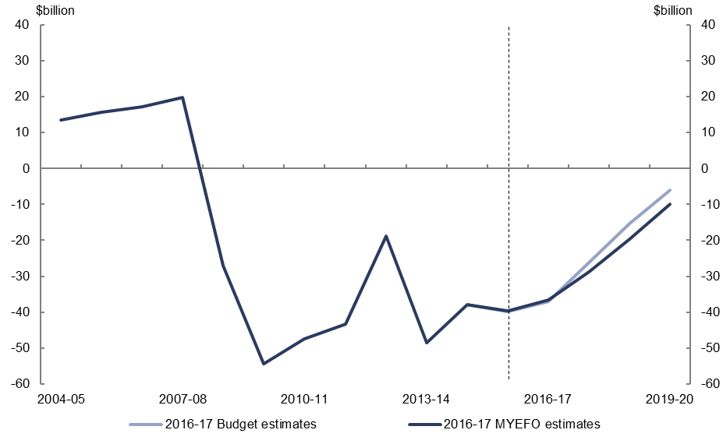
Figure 2: Underlying cash balance – change from 2016–17 Budget to 2016–17 MYEFO by measures and other variations
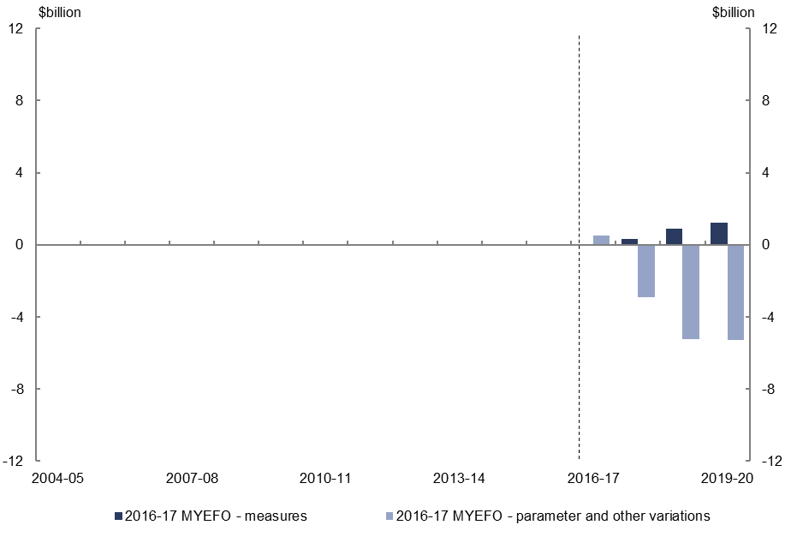
- Relative to the 2016–17 Budget, policy decisions are expected to increase the underlying cash balance by $2.5 billion over the four years to 2019–20.
- Parameter and other variations are expected to decrease the underlying cash balance by $12.8 billion over the four years to 2019–20, relative to the 2016–17 Budget.

Total receipts
Figure 3: Total receipts – change from 2016–17 Budget to 2016–17 MYEFO estimates
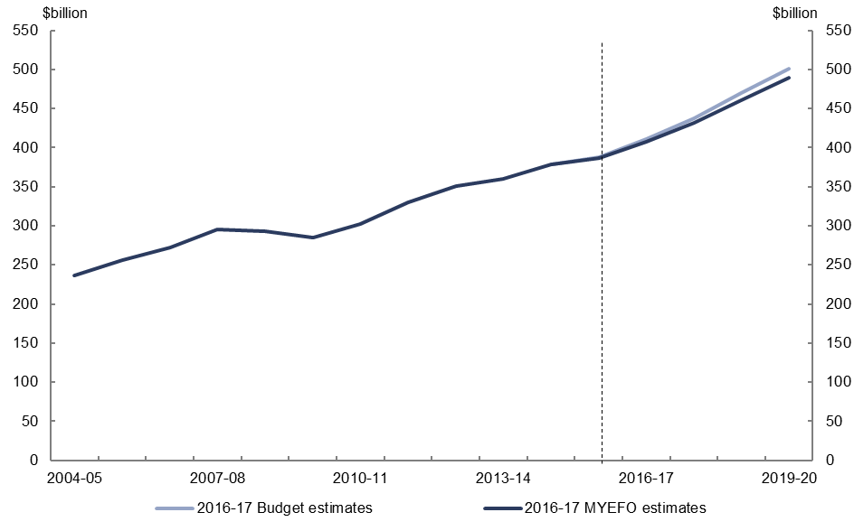
Figure 4: Total receipts – change from 2016–17 Budget to 2016–17 MYEFO by measures and other variations
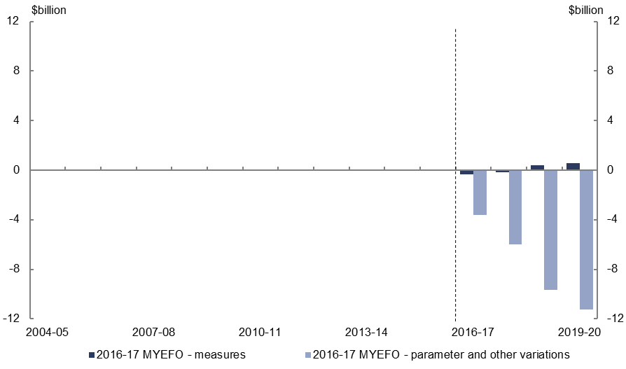
- Relative to the 2016–17 Budget, policy decisions are expected to increase total receipts by $0.5 billion over the four years to 2019–20.
- Parameter and other variations are expected to decrease total receipts by $30.5 billion over the four years to 2019–20, relative to the 2016–17 Budget.

Total payments
Figure 5: Total payments – change from 2016–17 Budget to 2016–17 MYEFO estimates
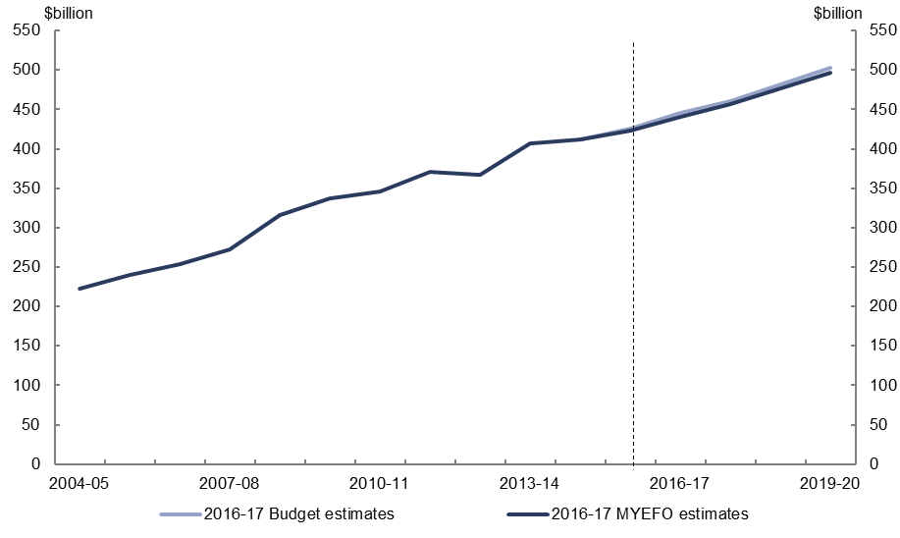
Figure 6: Total payments – change from 2016–17 Budget to 2016–17 MYEFO by measures and other variations
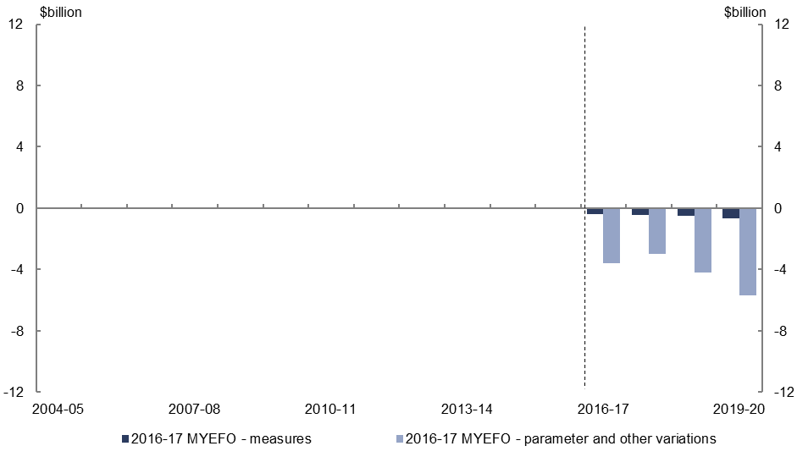
- Relative to the 2016–17 Budget, policy decisions are expected to decrease total payments by $2.0 billion over the four years to 2019–20.
- Parameter and other variations are expected to decrease total payments by $16.5 billion over the four years to 2019–20, relative to the 2016–17 Budget.

Revenue – individuals and other withholding taxes
Figure 7: Revenue – individuals and other withholding taxes – change from 2016–17 Budget to 2016–17 MYEFO estimates
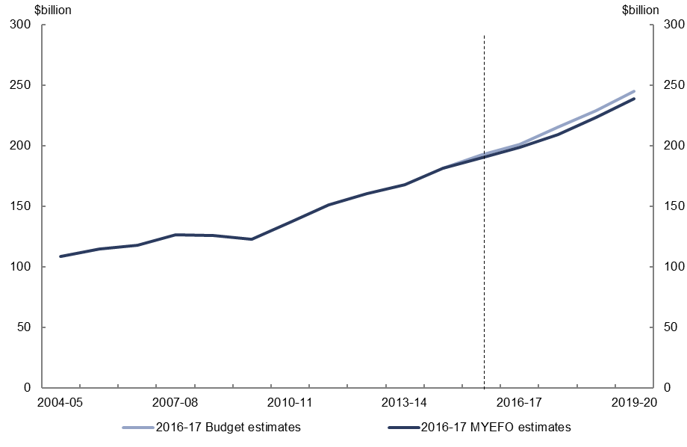
Figure 8: Revenue – individuals and other withholding taxes – change from 2016–17 Budget to 2016–17 MYEFO by measures and other variations
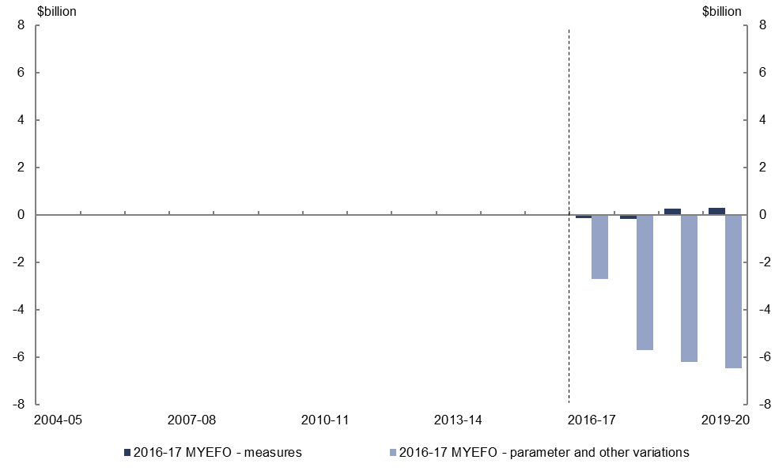
- Relative to the 2016–17 Budget, policy decisions are expected to increase individuals and other withholding tax revenue by $0.2 billion over the four years to 2019–20.
- Parameter and other variations are expected to decrease individuals and other withholding tax revenue by $21.1 billion over the four years to 2019–20, relative to the 2016–17 Budget, largely reflecting lower forecast wages growth.

Revenue – company tax
Figure 9: Revenue – company tax – change from 2016–17 Budget to 2016–17 MYEFO estimates
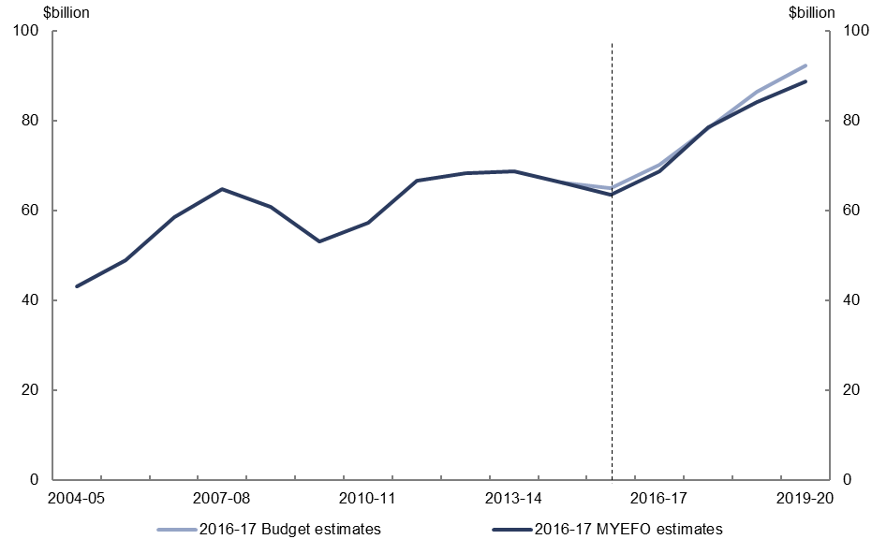
Figure 10: Revenue – company tax – change from 2016–17 Budget to 2016–17 MYEFO by measures and other variations
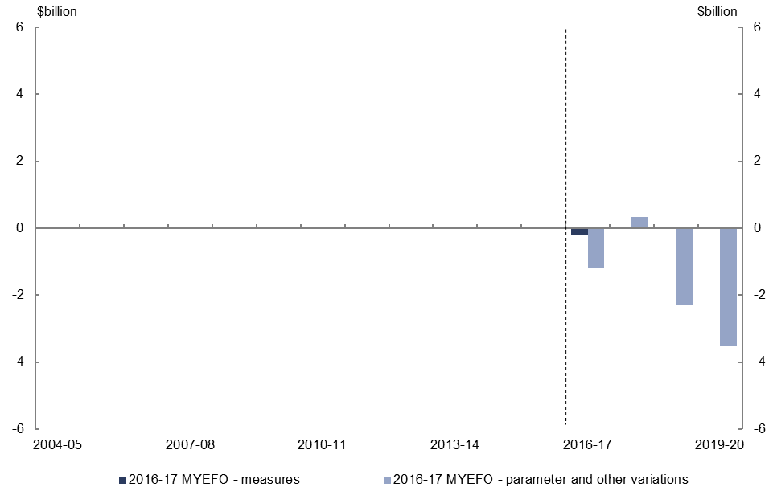
- Relative to the 2016–17 Budget, policy decisions are expected to decrease company tax revenue by $0.2 billion over the four years to 2019–20.
- Parameter and other variations are expected to decrease company tax revenue by $6.7 billion over the four years to 2019–20, relative to the 2016–17 Budget, largely due to weaker profits in the non-mining sector.

Revenue – goods and services tax
Figure 11: Revenue – goods and services tax – change from 2016–17 Budget to 2016–17 MYEFO estimates
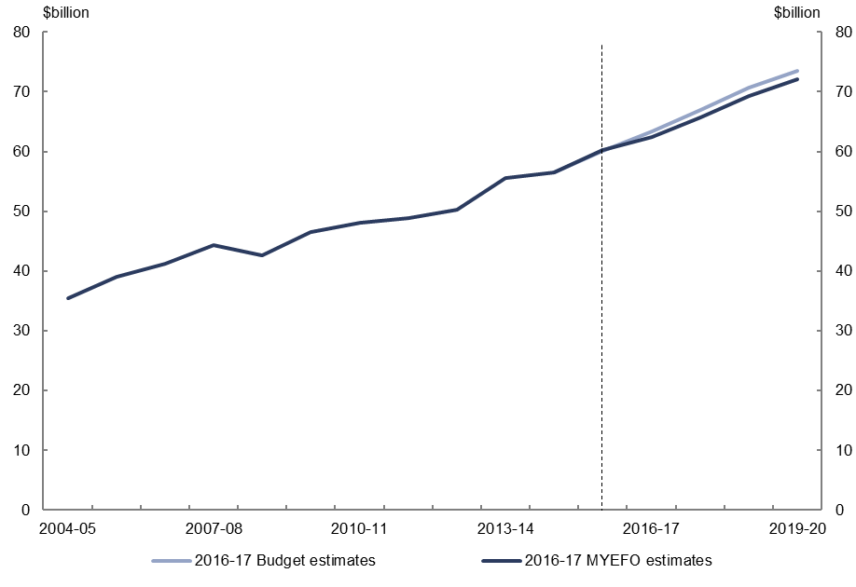
Figure 12: Revenue – goods and services tax – change from 2016–17 Budget to 2016–17 MYEFO by measures and other variations
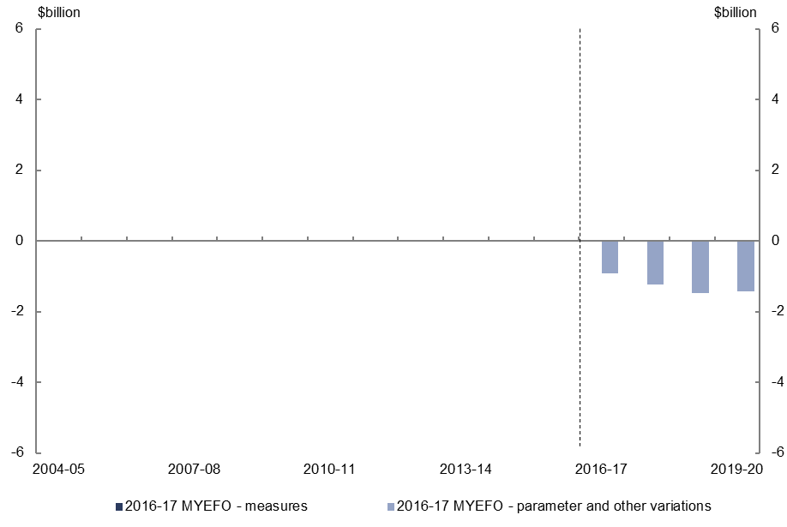
- Parameter and other variations are expected to decrease goods and service tax revenue by $5.1 billion over the four years to 2019–20, relative to the 2016–17 Budget, reflecting lower forecast household consumption growth over the period.

Revenue – excise and customs duties
Figure 13: Revenue – excise and customs duties – change from 2016–17 Budget to 2016–17 MYEFO estimates
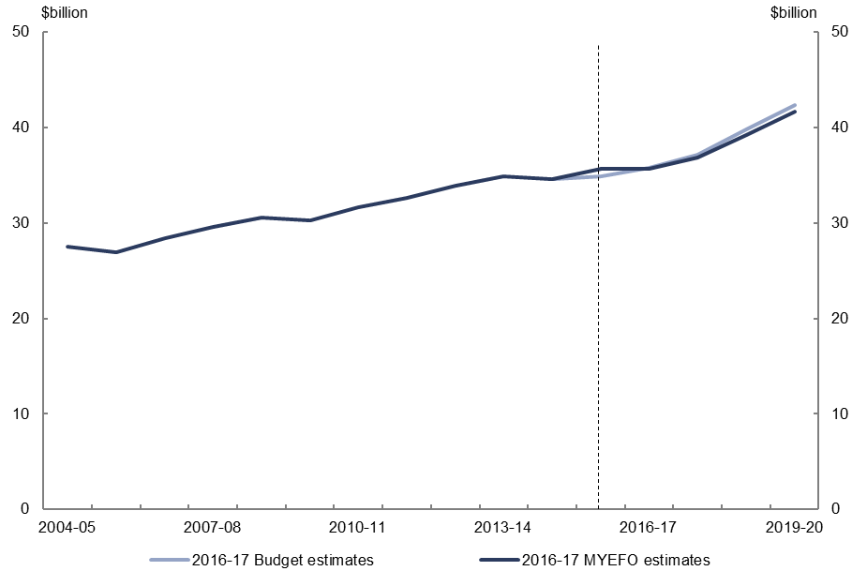
Figure 14: Revenue – excise and customs duties – change from 2016–17 Budget to 2016–17 MYEFO by measures and other variations
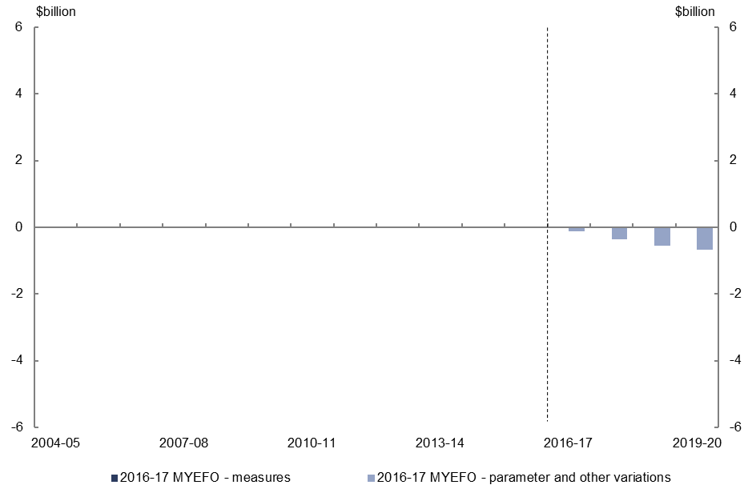
- Parameter and other variations are expected to decrease excise and customs revenue by $1.7 billion over the four years to 2019–20, relative to the 2016–17 Budget, largely reflecting lower forecast growth in fuel consumption.

Revenue – non-tax revenue
Figure 15: Revenue – non-tax revenue – change from 2016–17 Budget to 2016–17 MYEFO estimates
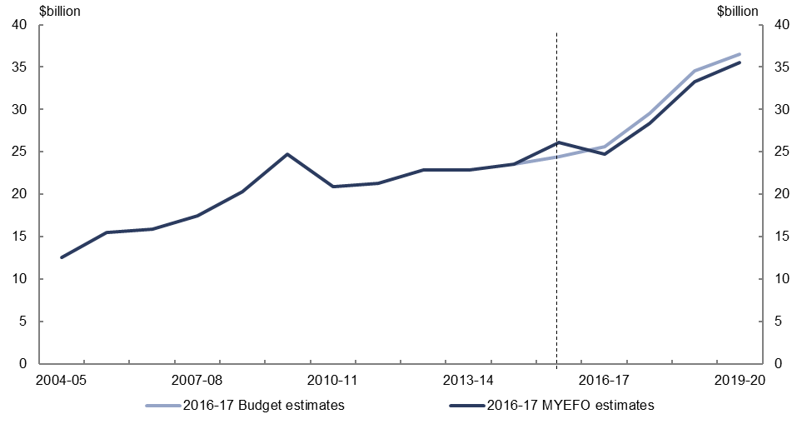
Figure 16: Revenue – non-tax revenue – change from 2016–17 Budget to 2016–17 MYEFO by measures and other variations
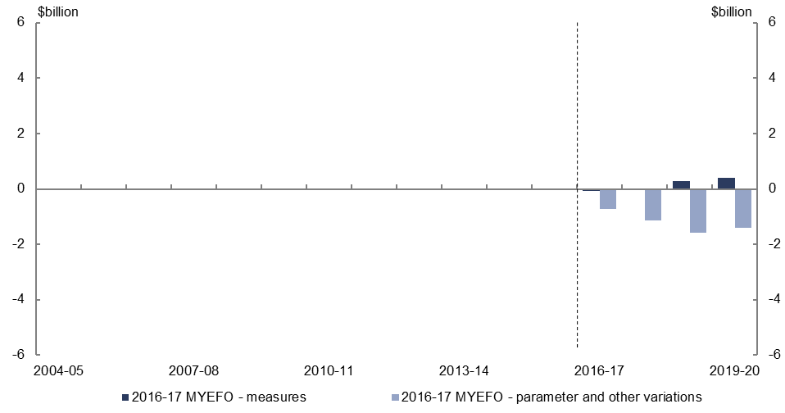
- Relative to the 2016–17 Budget, policy decisions are expected to increase non-tax revenue by $0.6 billion over the four years to 2019–20, largely reflecting interest revenue from the Government’s loan to NBN Co.
- Parameter and other variations are expected to decrease non-tax revenue by $4.9 billion over the four years to 2019–20, relative to the 2016–17 Budget, which includes reduced interest earnings from the Future Fund, and lower expected dividends from the Reserve Bank of Australia.

Expenses – Age Pension
Figure 17: Expenses – Age Pension – change from 2016–17 Budget to 2016–17 MYEFO estimates
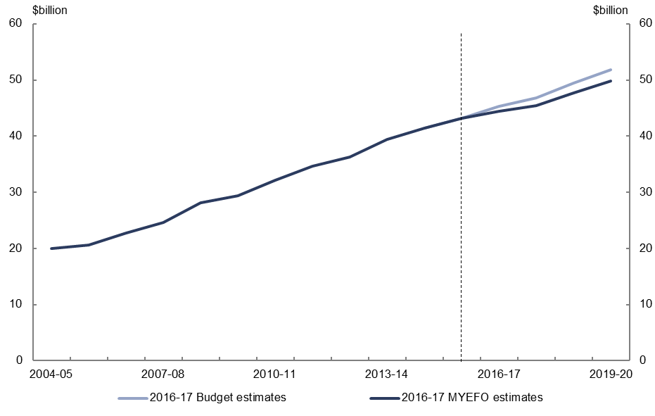
Figure 18: Expenses – Age Pension – change from 2016–17 Budget to 2016–17 MYEFO by measures and other variations
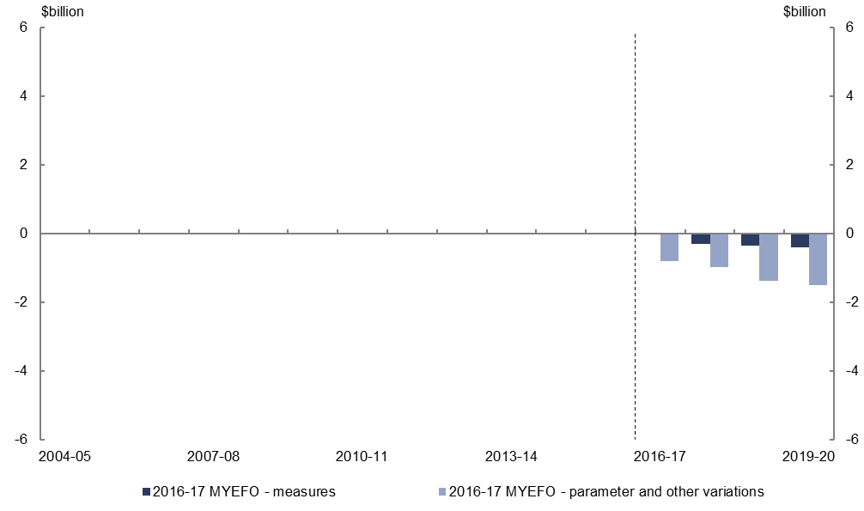
- Relative to the 2016–17 Budget, policy decisions are expected to decrease expenses on the Age Pension by $1.1 billion over the four years to 2019–20, primarily due to measures to enhance the integrity of social welfare payments, including expanding and extending data matching activities with the Australian Taxation Office.
- Parameter and other variations are expected to decrease expenses on the Age Pension by $4.7 billion over the four years to 2019–20, relative to the 2016–17 Budget, reflecting the lower indexation of payments due to lower forecast CPI growth, and lower expected average payment rates and recipient numbers.

Expenses – Family Tax Benefit
Figure 19: Expenses – Family Tax Benefit – change from 2016–17 Budget to 2016–17 MYEFO estimates
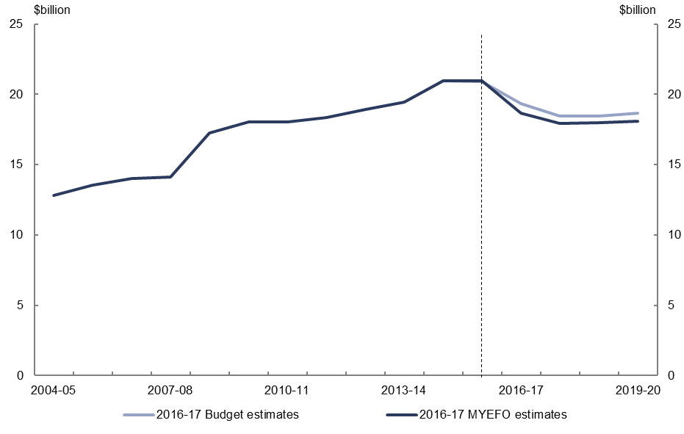
Figure 20: Expenses – Family Tax Benefit – change from 2016–17 Budget to 2016–17 MYEFO by measures and other variations
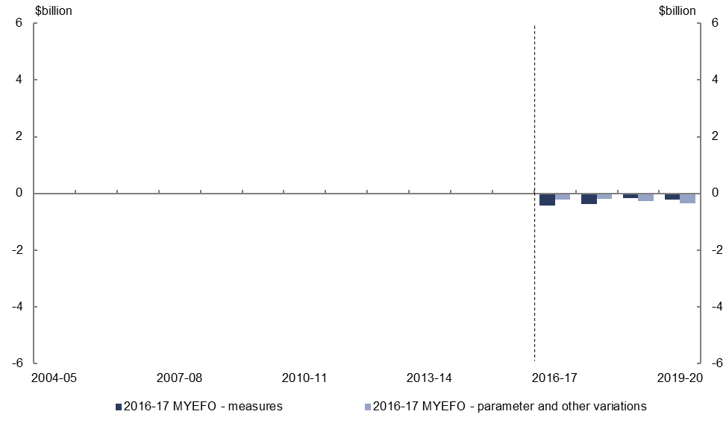
- Relative to the 2016–17 Budget, policy decisions are expected to decrease expenses on Family Tax Benefit (FTB) by $1.2 billion over the four years to 2019–20, due to ceasing the FTB Part A end-of-year supplement for families earning over $80,000 from 2016-17, and not increasing FTB Part B by $1,000 for families with a youngest child aged under one year.
- Parameter and other variations are expected to decrease expenses on Family Tax Benefit by $1.0 billion over the four years to 2019–20, relative to the 2016–17 Budget, reflecting the lower indexation of payments due to lower forecast CPI growth and lower expected payment rates.

Expenses – Disability Support Pension
Figure 21: Expenses – Disability Support Pension – change from 2016–17 Budget to 2016–17 MYEFO estimates
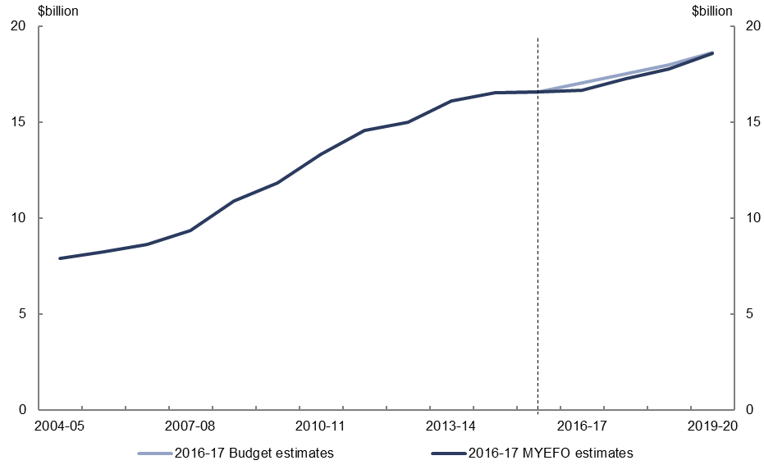
Figure 22: Expenses – Disability Support Pension – change from 2016–17 Budget to 2016–17 MYEFO by measures and other variations
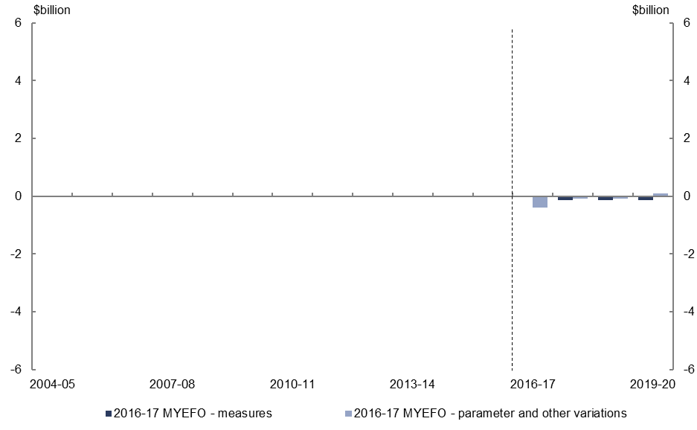
- Relative to the 2016–17 Budget, policy decisions are expected to decrease expenses on the Disability Support Pension by $0.4 billion over the four years to 2019–20, primarily due to measures to enhance the integrity of social welfare payments, including expanding and extending data matching activities with the Australian Taxation Office.
- Parameter and other variations are expected to decrease expenses on the Disability Support Pension by $0.5 billion over the four years to 2019–20, relative to the
2016–17 Budget, primarily due to the lower indexation of payments due to lower forecast CPI growth.

Expenses – aged care
Figure 23: Expenses – aged care – change from 2016–17 Budget to 2016–17 MYEFO estimates
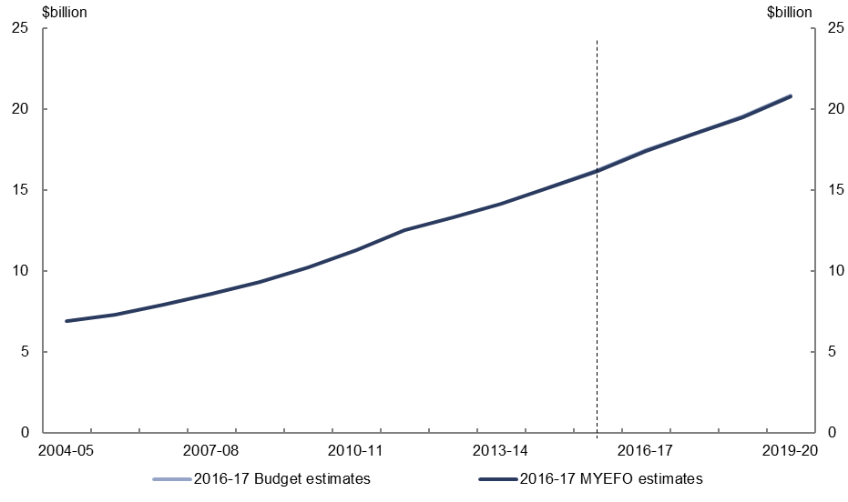
Figure 24: Expenses – aged care – change from 2016–17 Budget to 2016–17 MYEFO by measures and other variations
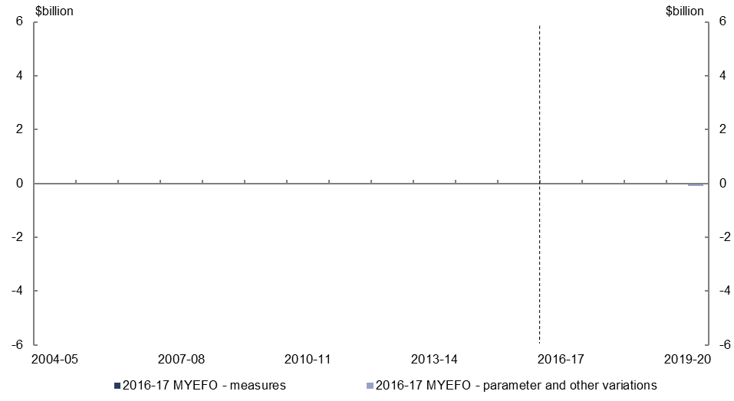
- Relative to the 2016–17 Budget, policy decisions are expected to decrease expenses on aged care by $0.1 billion over the four years to 2019–20.
- Parameter and other variations are expected to decrease expenses on aged care by $0.1 billion over the four years to 2019–20, relative to the 2016–17 Budget.

Expenses – job seeker income support
Figure 25: Expenses – job seeker income support – change from 2016–17 Budget to 2016–17 MYEFO estimates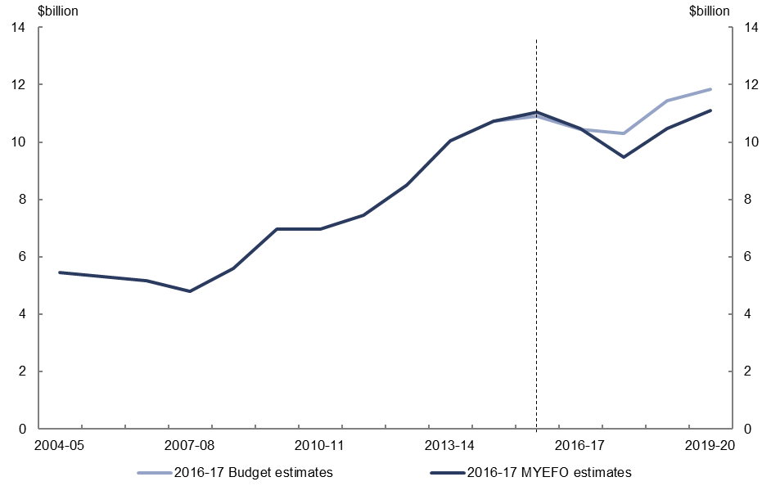
Figure 26: Expenses – job seeker income support – change from 2016–17 Budget to 2016–17 MYEFO by measures and other variations
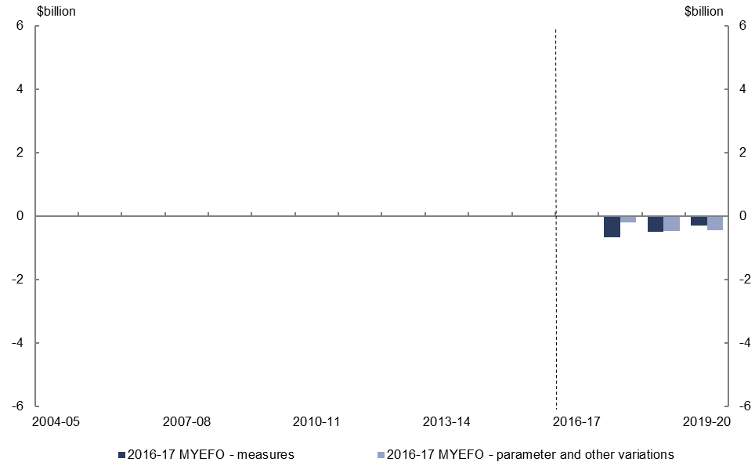
- Relative to the 2016–17 Budget, policy decisions are expected to decrease expenses on job seeker income support by $1.5 billion over the four years to 2019–20, primarily due to measures to enhance the integrity of social welfare payments, including expanding and extending data matching activities with the Australian Taxation Office.
- Parameter and other variations are expected to decrease expenses on job seeker income support by $1.1 billion over the four years to 2019–20, relative to the
2016–17 Budget, reflecting the lower indexation of payments due to lower forecast CPI growth.

Expenses – income support for carers
Figure 27: Expenses – income support for carers – change from 2016–17 Budget to 2016–17 MYEFO estimates 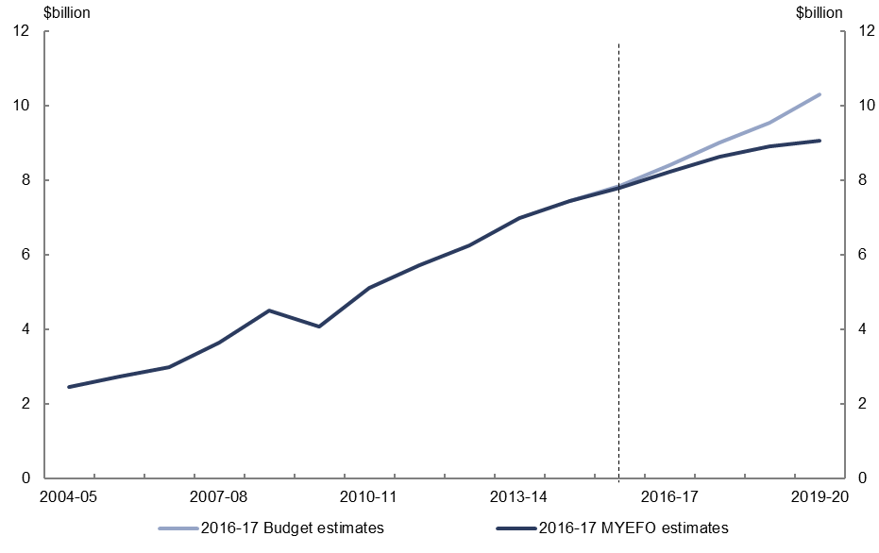
Figure 28: Expenses – income support for carers – change from 2016–17 Budget to 2016–17 MYEFO by measures and other variations
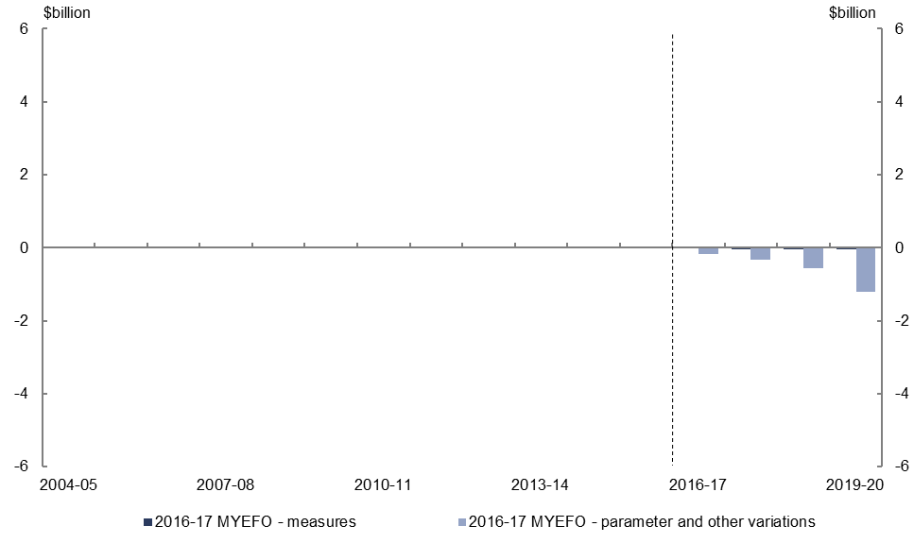
- Relative to the 2016–17 Budget, policy decisions are expected to decrease expenses on income support for carers by $0.2 billion over the four years to 2019–20.
- Parameter and other variations are expected to decrease expenses on income support for carers by $2.3 billion over the four years to 2019–20, relative to the
2016–17 Budget, largely reflecting lower growth in expected recipient numbers.

Expenses – child care fee assistance
Figure 29: Expenses – child care fee assistance – change from 2016–17 Budget to 2016–17 MYEFO estimates 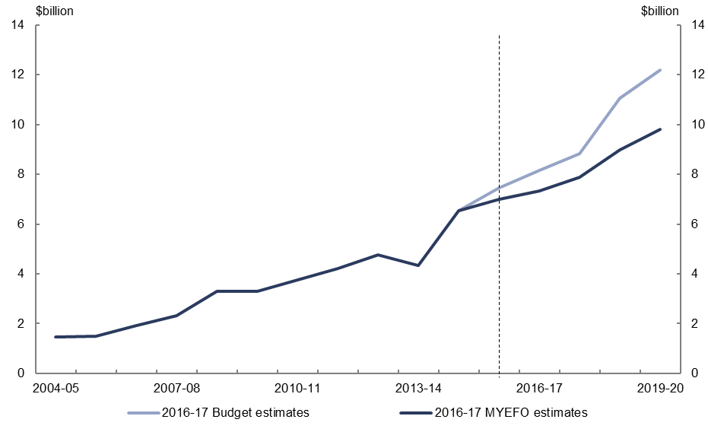
Figure 30: Expenses – child care fee assistance – change from 2016–17 Budget to 2016–17 MYEFO by measures and other variations
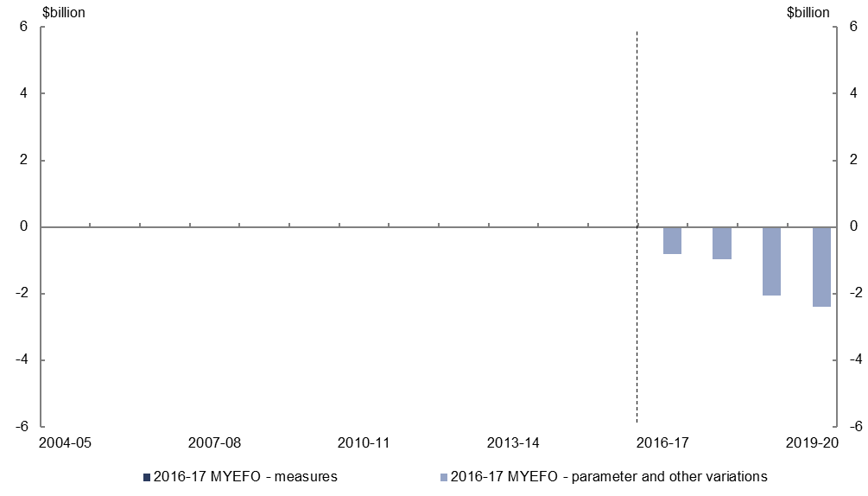
- Parameter and other variations are expected to decrease expenses on child care fee assistance by $6.2 billion over the four years to 2019–20, relative to the
2016–17 Budget, reflecting a significant decrease in the forecast number of hours of subsidised child care accessed.

Expenses – parents’ income support
Figure 31: Expenses – parents’ income support – change from 2016–17 Budget to 2016–17 MYEFO estimates 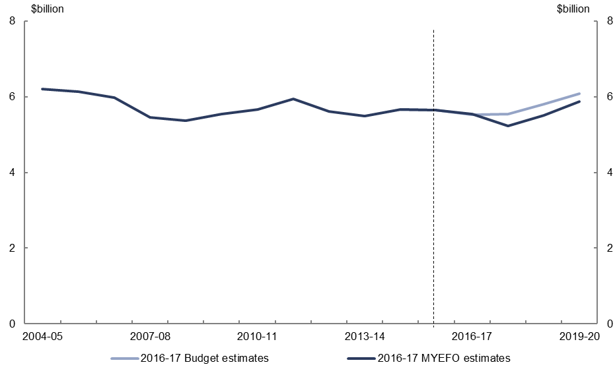
Figure 32: Expenses – parents’ income support – change from 2016–17 Budget to 2016–17 MYEFO by measures and other variations
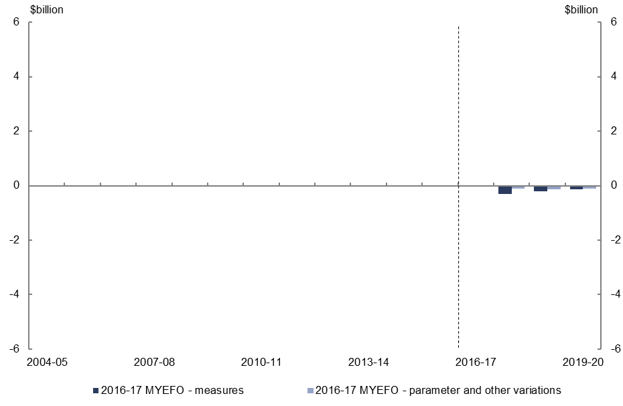
- Relative to the 2016–17 Budget, policy decisions are expected to decrease expenses on parents’ income support by $0.7 billion over the four years to 2019–20, primarily due to measures to enhance the integrity of social welfare payments, including expanding and extending data matching activities with the Australian Taxation Office.
- Parameter and other variations are expected to decrease expenses on parents’ income support by $0.4 billion over the four years to 2019–20, relative to the 2016–17 Budget.

Expenses – Medicare Benefits Schedule
Figure 33: Expenses – Medicare Benefits Schedule – change from 2016–17 Budget to 2016–17 MYEFO estimates 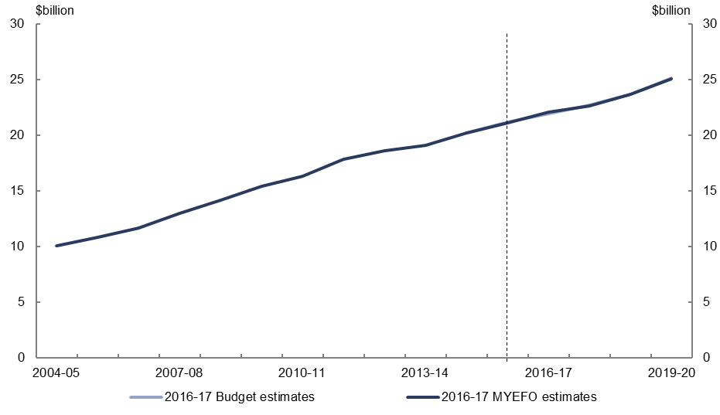
Figure 34: Expenses – Medicare Benefits Schedule – change from 2016–17 Budget to 2016–17 MYEFO by measures and other variations
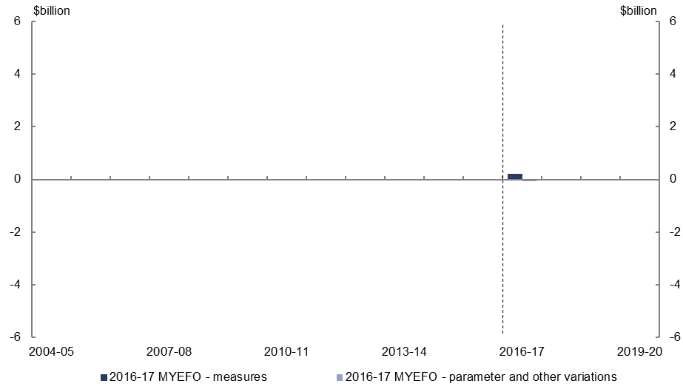
- Relative to the 2016–17 Budget, policy decisions are expected to increase expenses on Medicare by $0.2 billion over the four years to 2019–20.
- Parameter and other variations are expected to decrease expenses on Medicare by $0.1 billion over the four years to 2019–20, relative to the 2016–17 Budget.

Expenses – assistance to the states and territories for public hospitals
Figure 35: Expenses – assistance to the states and territories for public hospitals – change from 2016–17 Budget to 2016–17 MYEFO estimates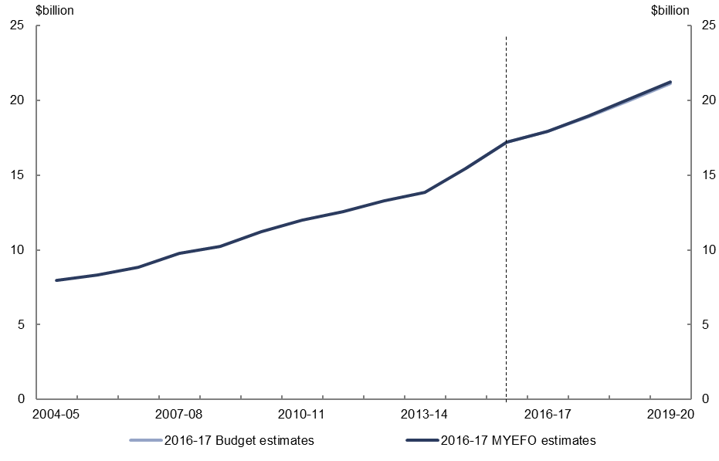
Figure 36: Expenses – assistance to the states and territories for public hospitals – change from 2016–17 Budget to 2016–17 MYEFO by measures and other variations 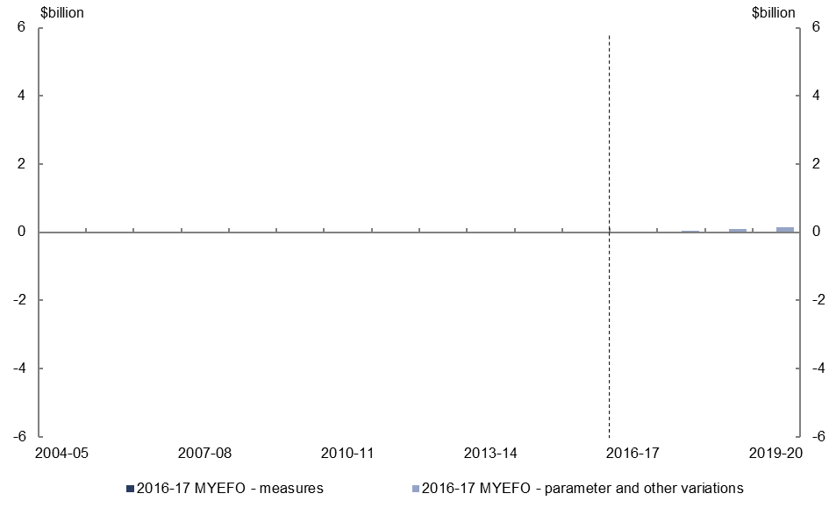
- Parameter and other variations are expected to increase assistance to the states and territories for public hospitals expenses by $0.3 billion over the four years to 2019–20, relative to the 2016–17 Budget.

Expenses – pharmaceutical benefits
Figure 37: Expenses – pharmaceutical benefits – change from 2016–17 Budget to 2016–17 MYEFO estimates
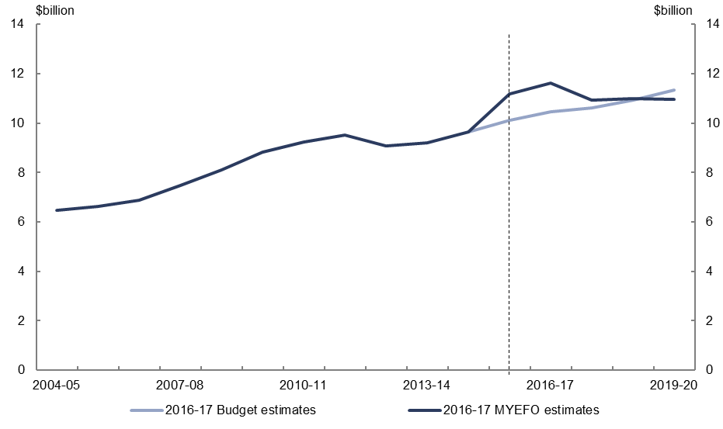
Figure 38: Expenses – pharmaceutical benefits – change from 2016–17 Budget to 2016–17 MYEFO by measures and other variations
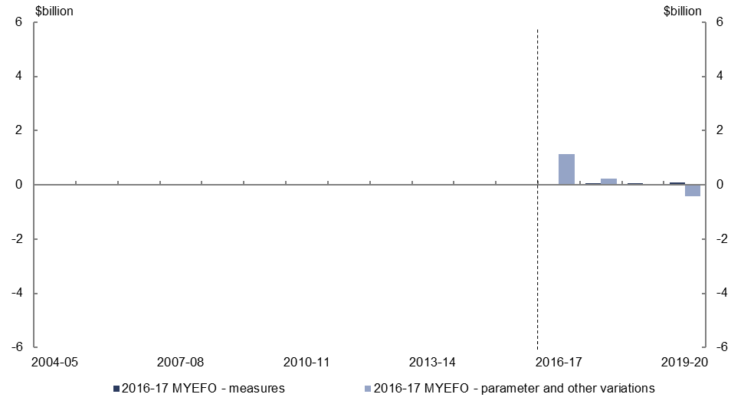
- Relative to the 2016–17 Budget, policy decisions are expected to increase spending on pharmaceutical benefits by $0.2 billion over the four years to 2019–20.
- Parameter and other variations are expected to increase pharmaceutical benefits expenses by $0.9 billion over the four years to 2019–20, relative to the
2016–17 Budget, primarily due to higher expected uptake by patients of recently listed Hepatitis C medicines.

Expenses – private health insurance rebate
Figure 39: Expenses – private health insurance rebate – change from 2016–17 Budget to
2016–17 MYEFO estimates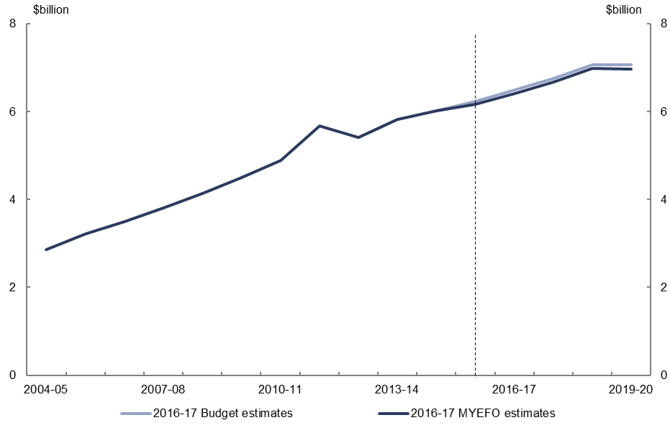
Figure 40: Expenses – private health insurance rebate – change from 2016–17 Budget to
2016–17 MYEFO by measures and other variations
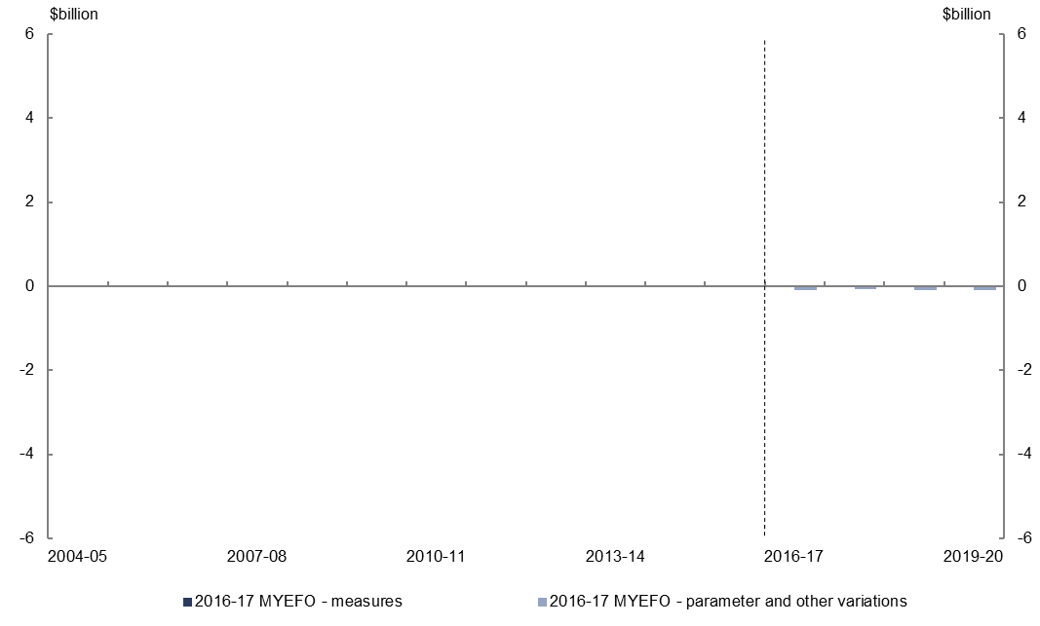
- Parameter and other variations are expected to decrease spending on the private health insurance rebate by $0.3 billion over the four years to 2019–20, relative to the 2016–17 Budget.

Expenses – National Disability Insurance Scheme
Figure 41: Expenses – National Disability Insurance Scheme – change from 2016–17 Budget to 2016–17 MYEFO estimates
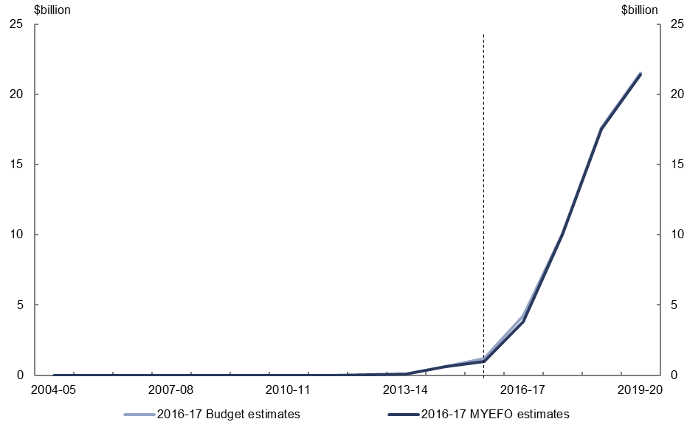
Figure 42: Expenses – National Disability Insurance Scheme – change from 2016–17 Budget to 2016–17 MYEFO by measures and other variations
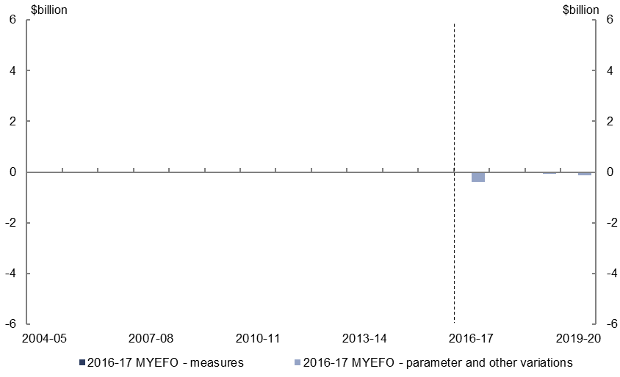
- Relative to the 2016–17 Budget, policy decisions are expected to have a neutral impact on the National Disability Insurance Scheme over the four years to 2019–20.
- Parameter and other variations are expected to decrease National Disability Insurance Scheme expenses by $0.6 billion over the four years to 2019–20.

Expenses – assistance to the states and territories for schools
Figure 43: Expenses – schools – change from 2016–17 Budget to 2016–17 MYEFO estimates
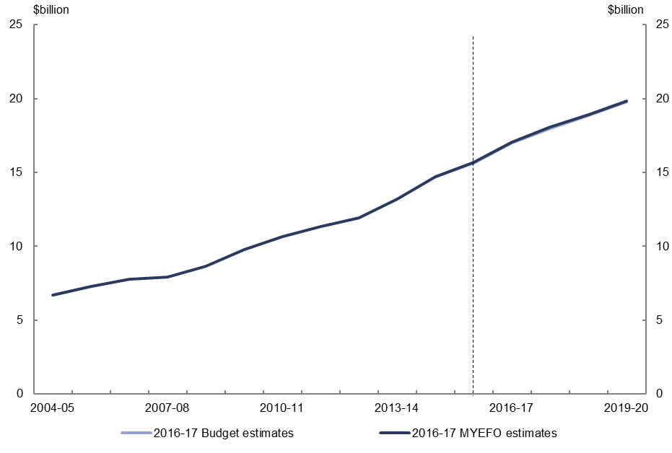
Figure 44: Expenses – schools – change from 2016–17 Budget to 2016–17 MYEFO by measures and other variations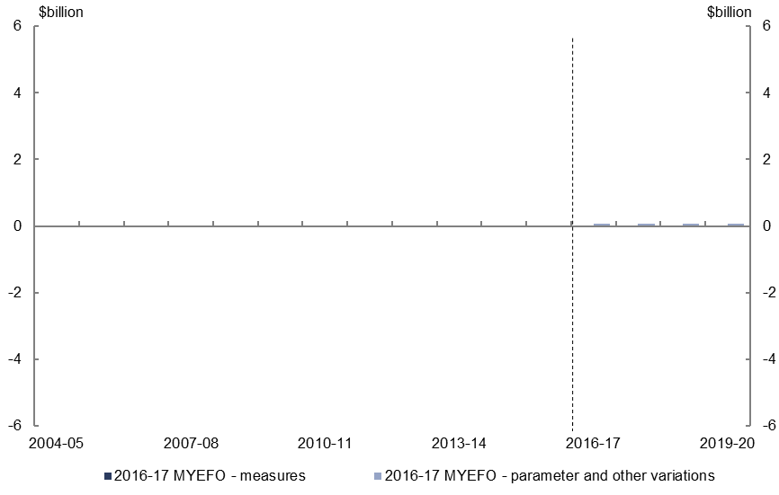
- Parameter and other variations are expected to increase spending on schools by $0.3 billion over the four years to 2019–20, relative to the 2016–17 Budget.

Expenses – higher education grants
Figure 45: Expenses – higher education grants – change from 2016–17 Budget to 2016–17 MYEFO estimates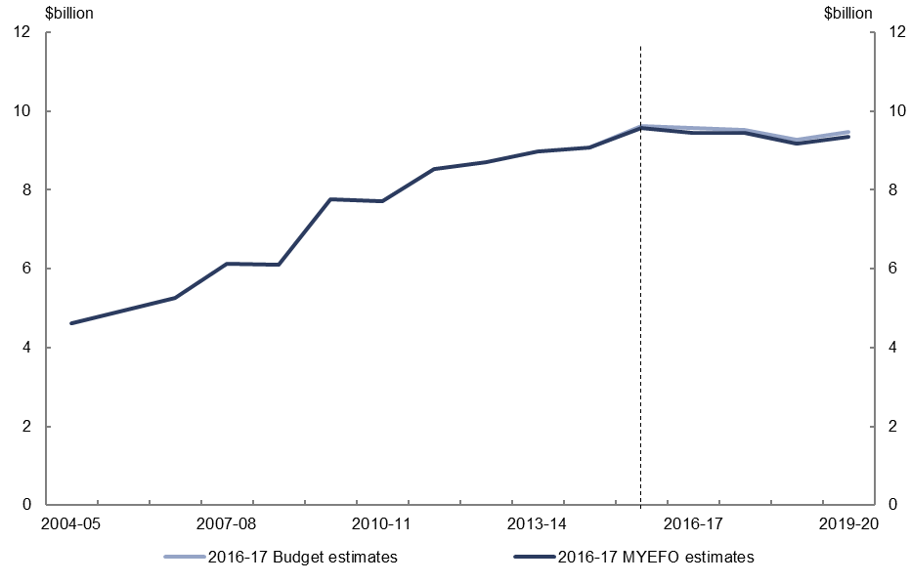
Figure 46: Expenses – higher education grants – change from 2016–17 Budget to 2016–17 MYEFO by measures and other variations
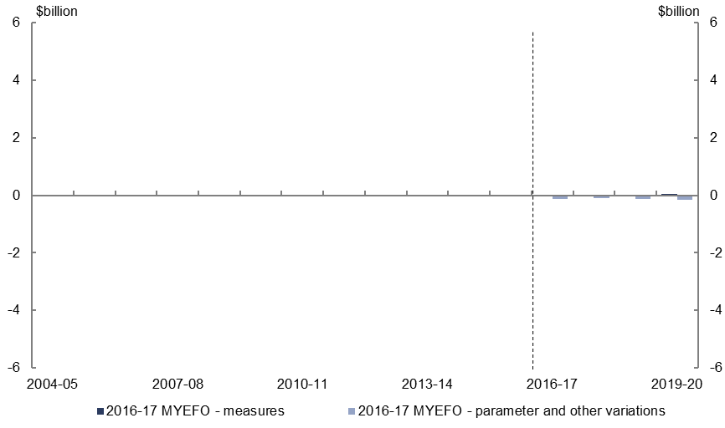
- Policy decisions are expected to increase expenses on higher education grants by $0.1 billion over the four years to 2019–20, relative to the 2016–17 Budget.
- Parameter and other variations are expected to decrease expenses on higher education by $0.5 billion over the four years to 2019–20, relative to the 2016–17 Budget, due to lower expected student numbers.

Higher Education Loan Programme,
Figure 47: Higher Education Loan Programme – change from 2016–17 Budget to 2016–17 MYEFO estimates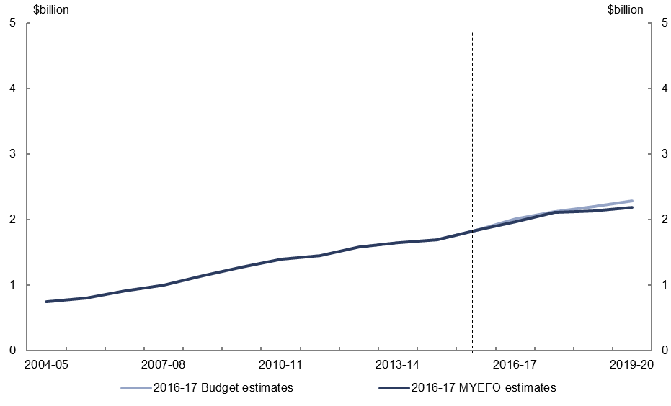
Figure 48: Higher Education Loan Programme – change from 2016–17 Budget to 2016–17 MYEFO by measures and other variations
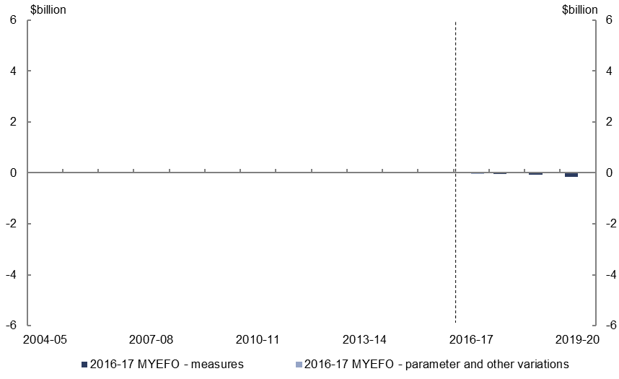
- Relative to the 2016–17 Budget, policy decisions are expected to decrease payments on the Higher Education Loan Programme (HELP) by $0.3 billion over the four years to 2019–20, due to the replacement of the VET-FEE-HELP loans scheme with a new VET Student Loans program.
- Parameter and other variations are expected to have a neutral impact on HELP expenses over the four years to 2019–20, relative to the 2016–17 Budget.

Defence (expenses and net capital investment)
Figure 49: Defence (expenses and net capital investment) – change from 2016–17 Budget to 2016–17 MYEFO estimates
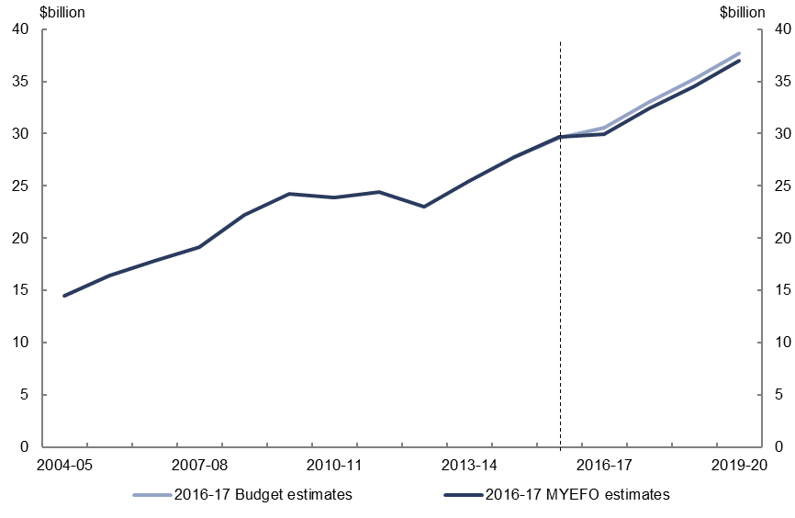
Figure 50: Defence (expenses and net capital investment) – change from 2016–17 Budget to 2016–17 MYEFO by measures and other variations
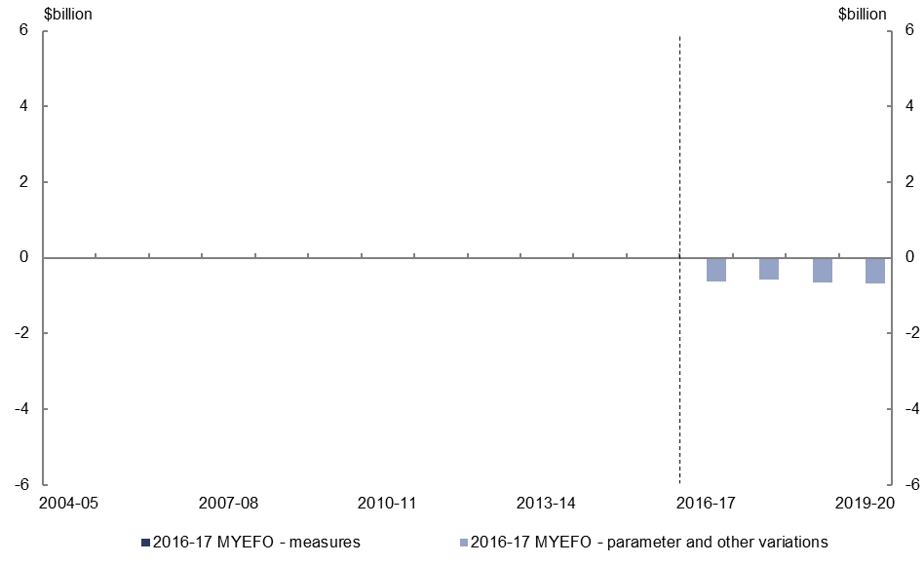
- Policy decisions are expected to have a neutral impact on defence spending over the four years to 2019–20, relative to the 2016–17 Budget.
- Parameter and other variations are expected to decrease defence spending by $2.5 billion over the four years to 2019–20, relative to the 2016–17 Budget, largely reflecting expected decreases in net capital investment as a result of foreign exchange movements.

Expenses – public debt interest
Figure 51: Expenses – public debt interest – change from 2016–17 Budget to 2016–17 MYEFO estimates
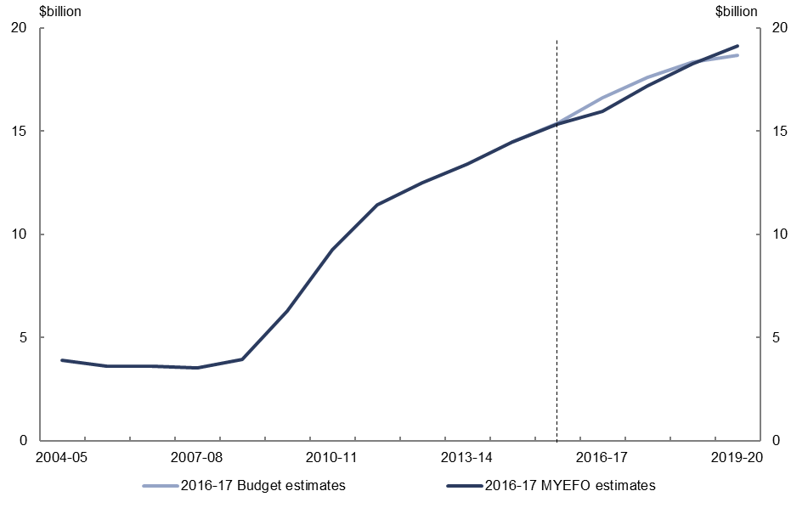
Figure 52: Expenses – public debt interest – change from 2016–17 Budget to 2016–17 MYEFO by measures and other variations
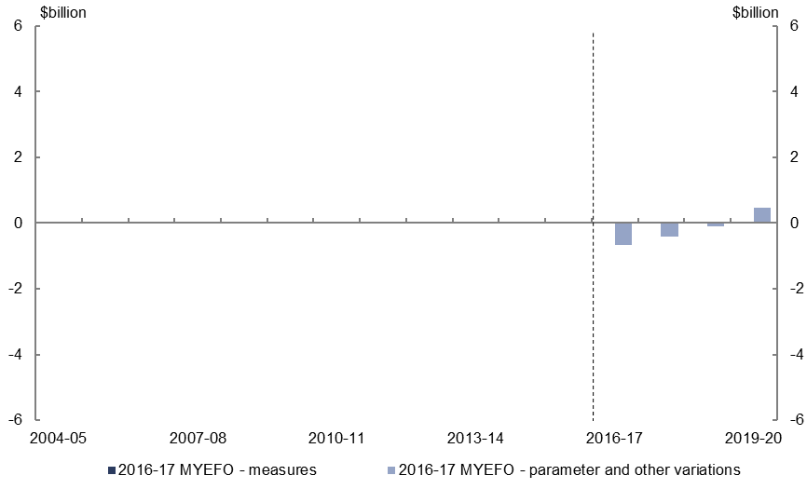
- Relative to the 2016–17 Budget, parameter and other variations are expected to decrease expenses on public debt interest by $0.7 billion over the four years to
2019–20. The profile for public debt interest expenses reflects increased deficits which are more than offset by reduced borrowing costs in the first half of the forward estimates.

Expenses – public sector superannuation
Figure 53: Expenses – public sector superannuation – change from 2016–17 Budget to 2016–17 MYEFO estimates
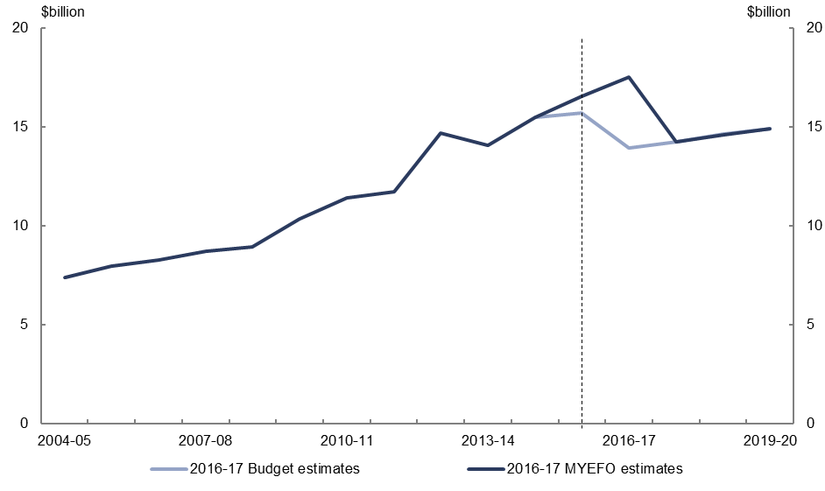
Figure 54: Expenses – public sector superannuation – change from 2016–17 Budget to 2016–17 MYEFO by measures and other variations
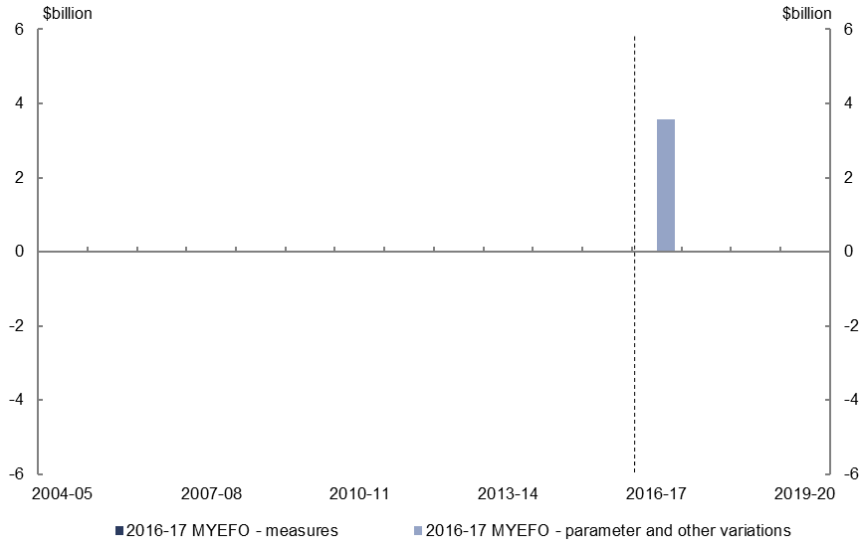
- Parameter and other variations are expected to increase public sector superannuation expenses by $3.6 billion over the four years to 2019–20, relative to the 2016–17 Budget. This is due to the practice of changing discount rates for the current year to the long-term government bond rate at MYEFO (2.7 per cent), from an actuarially based rate used at Budget (6.0 per cent).

Expenses – road and rail infrastructure
Figure 55: Expenses – road and rail infrastructure – change from 2016–17 Budget to 2016–17 MYEFO estimates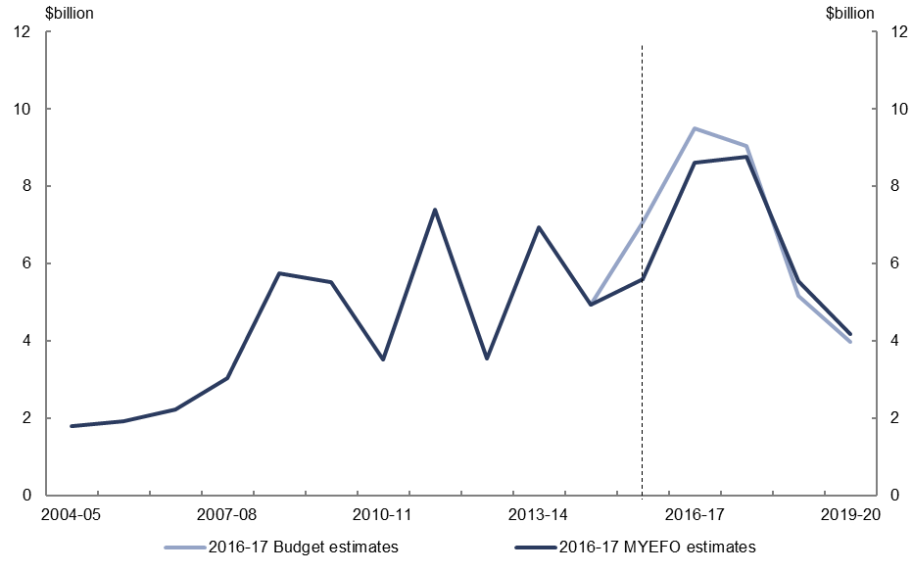
Figure 56: Expenses – road and rail infrastructure – change from 2016–17 Budget to 2016–17 MYEFO by measures and other variations
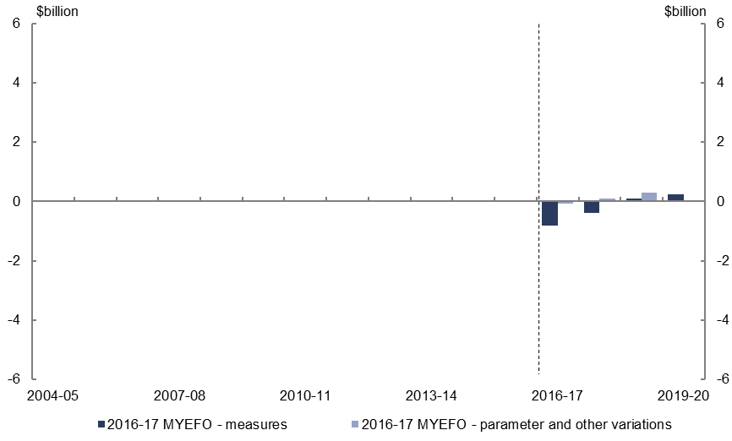
- Relative to the 2016–17 Budget, policy decisions are expected to decrease road and rail infrastructure expenses by $0.9 billion over the four years to 2019–20, largely reflecting the redirection of uncommitted funding to other community infrastructure and regional development projects.
- Parameter and other variations are expected to increase infrastructure expenses by $0.3 billion over the four years to 2019–20, relative to the 2016–17 Budget.

Official Development Assistance
Figure 57: Official Development Assistance – change from 2016–17 Budget to 2016–17 MYEFO estimates
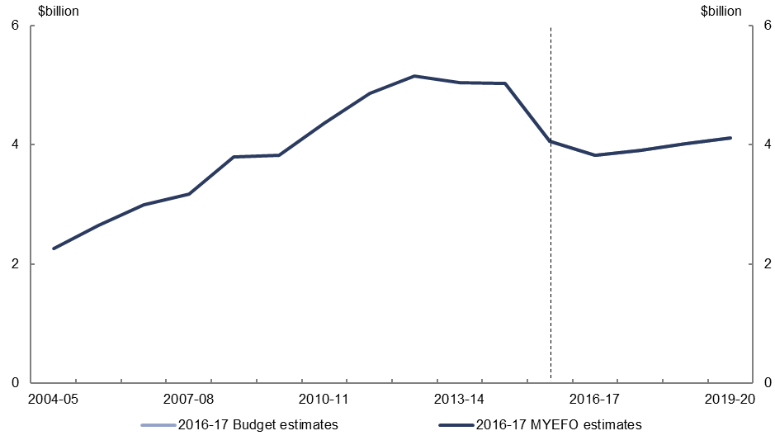
Figure 58: Official Development Assistance – change from 2016–17 Budget to 2016–17 MYEFO by measures and other variations
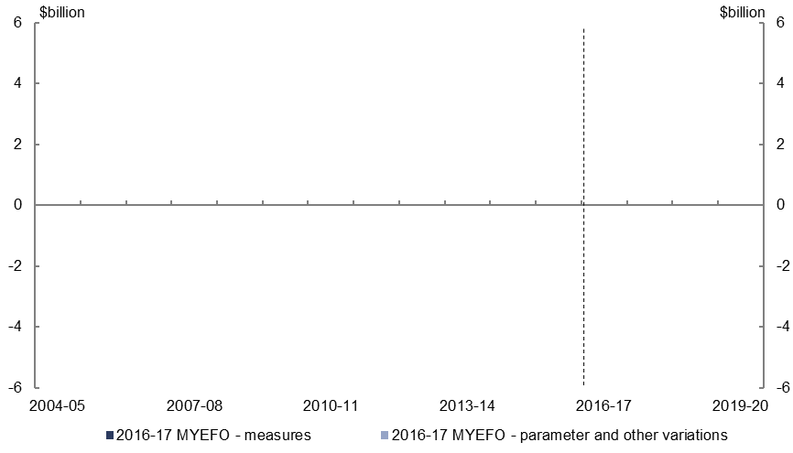
- Official Development Assistance spending is projected to remain in line with the
2016–17 Budget estimates.

www.pbo.gov.au
www.pbo.gov.au

This relates to the expenses of the National Disability Insurance Agency. This differs from Commonwealth payments to the states and territories relating to the NDIS and disability services which are covered in separate agreements between the Commonwealth and the states and territories.
Total spending on HELP is reported in cash terms. The cost of the HELP reflects the net public debt interest cost of providing these concessional loans.
The PBO has revised its methodology for calculating the financing cost of HELP on an underlying cash basis. Relative to the 2016–17 Budget chart pack, the historical underlying cash balance cost of HELP has been revised up and the cost over the 2016–17 Budget forward estimates has been revised down.
This includes the public debt interest costs associated with HELP.
Total Official Development Assistance spending is reported in cash terms consistent with the government commitment in this area.

