2016–17 Budget — charts
A graphical summary of the 2016–17 Budget relative to the 2015–16 MYEFO, showing the impacts of policy decisions and other factors
Date issued: 1 June 2016

© Commonwealth of Australia 2016
ISBN 978-0-9944547-1-3 (Online)
This work is licensed under the Creative Commons Attribution-NonCommercial-NoDerivs 3.0 Australia License.
The details of this licence are available on the Creative Commons website: http://creativecommons.org/licenses/by-nc-nd/3.0/au/
Use of the Coat of Arms
The terms under which the Coat of Arms can be used are detailed on the following website: www.itsanhonour.gov.au/coat-arms
Produced by: Parliamentary Budget Office
Designed by: Studio Tweed
Assistant Parliamentary Budget Officer
Fiscal Policy Analysis Division
Parliamentary Budget Office
Parliament House
PO Box 6010
CANBERRA ACT 2600
Phone: (02) 6277 9500
Email: pbo@pbo.gov.au

Contents
Notes 1
Underlying cash balance 2
Total receipts 3
Total payments 4
Revenue – individuals and other withholding taxes 5
Revenue – company tax 6
Revenue – goods and services tax 7
Revenue – excise and customs duties 8
Revenue – non-tax revenue 9
Expenses – Age Pension 10
Expenses – Family Tax Benefit 11
Expenses – Disability Support Pension 12
Expenses – aged care 13
Expenses – job seeker income support 14
Expenses – income support for carers 15
Expenses – child care fee assistance 16
Expenses – parents’ income support 17
Expenses – Medicare Benefits Schedule 18
Expenses – assistance to the states and territories for public hospitals 19
Expenses – pharmaceutical benefits 20
Expenses – private health insurance rebate 21
Expenses – National Disability Insurance Scheme 22
Expenses – schools 23
Expenses – higher education grants 24
Higher Education Loan Programme 25
Defence (expenses and net capital investment) 26
Expenses – public debt interest 27
Expenses – public sector superannuation 28
Expenses – road and rail infrastructure 29
Official Development Assistance 30

Notes
These charts provide a visual summary of the key drivers of the 2016–17 Budget, and the policy decisions underpinning them.
While the 2016 Pre-election Economic and Fiscal Outlook was released following the
2016–17 Budget, it did not contain any material changes to the economic or fiscal outlook. Therefore data contained in the charts are based on the 2016–17 Budget, as well as the 2015–16 Mid–Year Economic and Fiscal Outlook, and government agency portfolio budget statements. Where applicable, additional information provided by agencies has supplemented the publicly available information.
At the aggregate level for the underlying cash balance, total receipts, and total payments the charts have been prepared on a cash basis. Charts on individual revenue heads and expenditure programs have been prepared on an accruals basis (apart from the Higher Education Loan Programme and Official Development Assistance), consistent with the presentation of decisions in the Budget papers.
Consistent with the Budget, the charts show the financial impact of policy decisions up to and including 2019–20. The charts show movements due to parameter and other variations since the 2015–16 MYEFO, which are available for the 2015–16 to 2018–19 years.
The PBO does not have access to the details of provisions for individual items in the Contingency Reserve. Accordingly, the charts in this report are subject to the qualification that they are prepared in the absence of information on the possible impact of any provisions in the Contingency Reserve.

Underlying cash balance
Figure 1: Underlying cash balance – change from 2015–16 MYEFO to 2016–17 Budget estimates
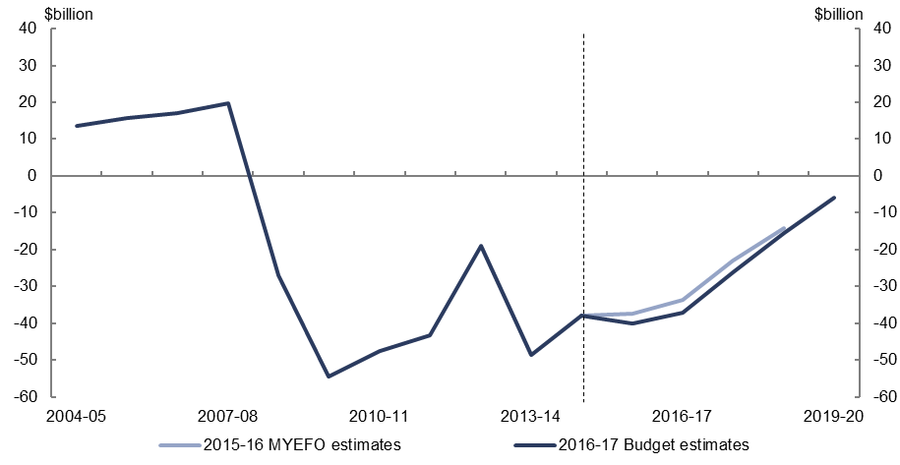
Figure 2: Underlying cash balance – change from 2015–16 MYEFO to 2016–17 Budget estimates by measures and other variations
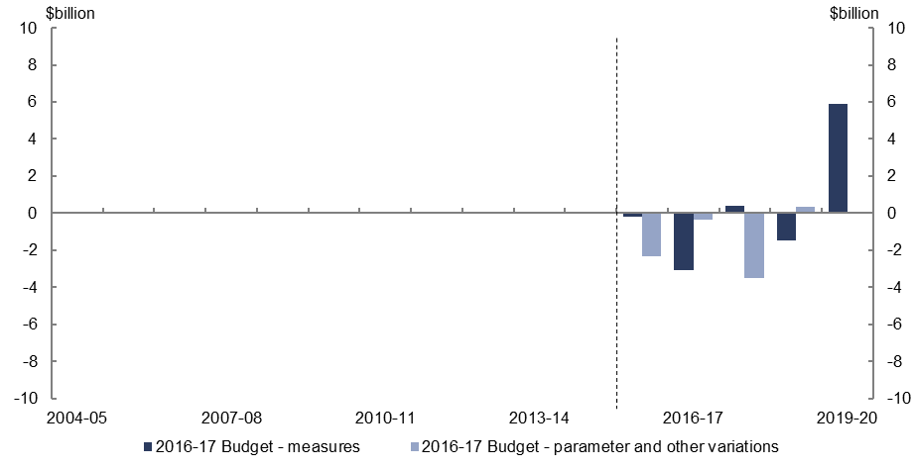
- Policy decisions are expected to increase the underlying cash balance by $1.5 billion over the five years to 2019–20, relative to the 2015–16 MYEFO.
- Parameter and other variations are expected to decrease the underlying cash balance by $5.9 billion over the four years to 2018–19, relative to the 2015–16 MYEFO.

Total receipts
Figure 3: Total receipts – change from 2015–16 MYEFO to 2016–17 Budget estimates
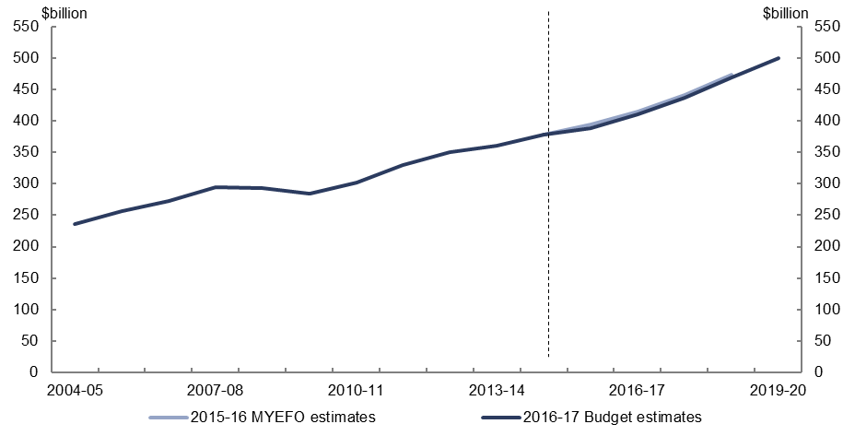
Figure 4: Total receipts – change from 2015–16 MYEFO to 2016–17 Budget estimates by measures and other variations
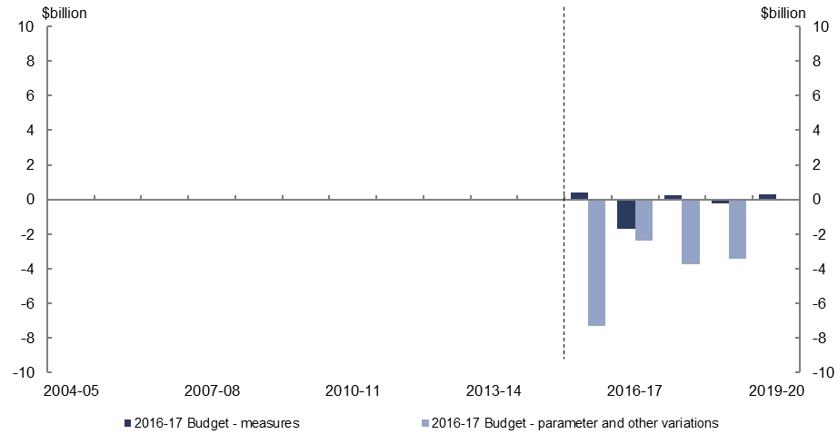
- Relative to the 2015–16 MYEFO, policy decisions are expected to decrease total receipts by $0.9 billion over the five years to 2019–20.
- Relative to the 2015–16 MYEFO, parameter and other variations are expected to decrease total receipts by $16.8 billion over the four years to 2018–19.

Total payments
Figure 5: Total payments – change from 2015–16 MYEFO to 2016–17 Budget estimates
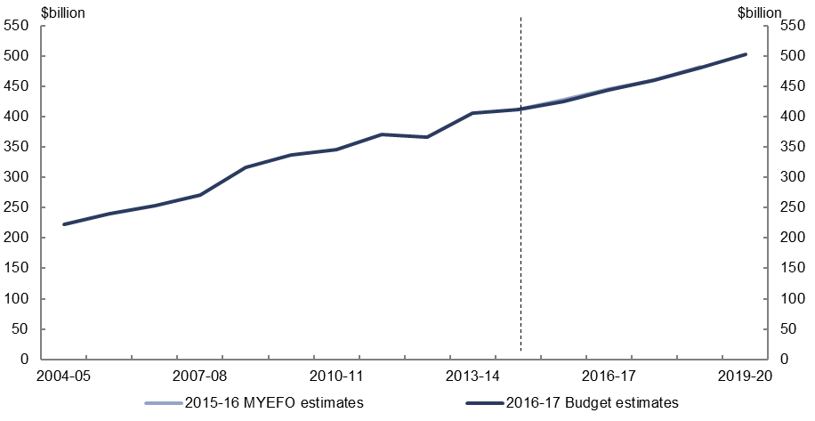
Figure 6: Total payments – change from 2015–16 MYEFO to 2016–17 Budget estimates by measures and other variations
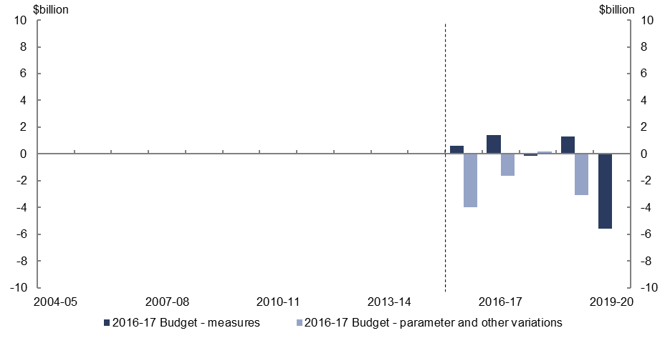
- Relative to the 2015–16 MYEFO, policy decisions are expected to decrease total payments by $2.4 billion over the five years to 2019–20. This includes a $2 billion decrease in 2019–20 from ‘decisions taken but not yet announced’ included in the Contingency Reserve.
- Relative to the 2015–16 MYEFO, parameter and other variations are expected to decrease total payments by $8.5 billion over the four years to 2018–19.

Revenue – individuals and other withholding taxes
Figure 7: Revenue – individuals and other withholding taxes – change from 2015–16 MYEFO to 2016–17 Budget estimates
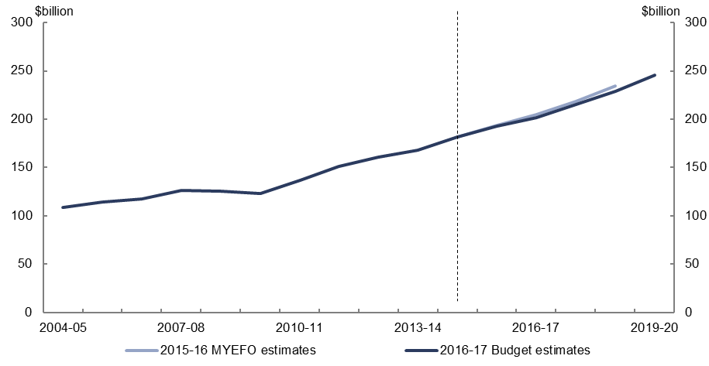
Figure 8: Revenue – individuals and other withholding taxes – change from 2015–16 MYEFO to 2016–17 Budget estimates by measures and other variations
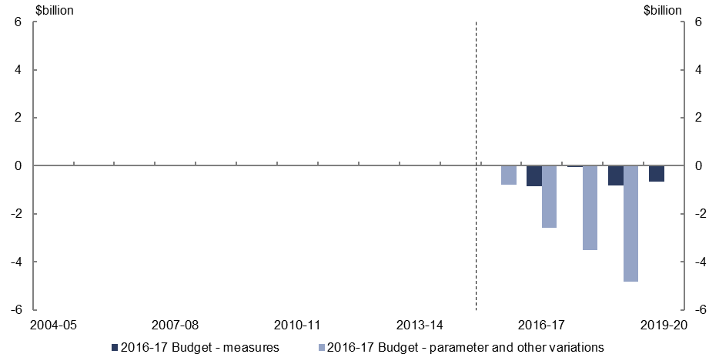
- Relative to the 2015–16 MYEFO, policy decisions are expected to decrease individuals and other withholding tax revenue by $2.4 billion over the five years to 2019–20, reflecting measures to provide personal income tax cuts and tax deductions for personal superannuation contributions.
- Parameter and other variations are expected to decrease individuals and other withholding tax revenue by $11.7 billion over the four years to 2018–19, relative to the 2015–16 MYEFO, largely reflecting lower forecast wages growth.

Revenue – company tax
Figure 9: Revenue – company tax – change from 2015–16 MYEFO to 2016–17 Budget estimates
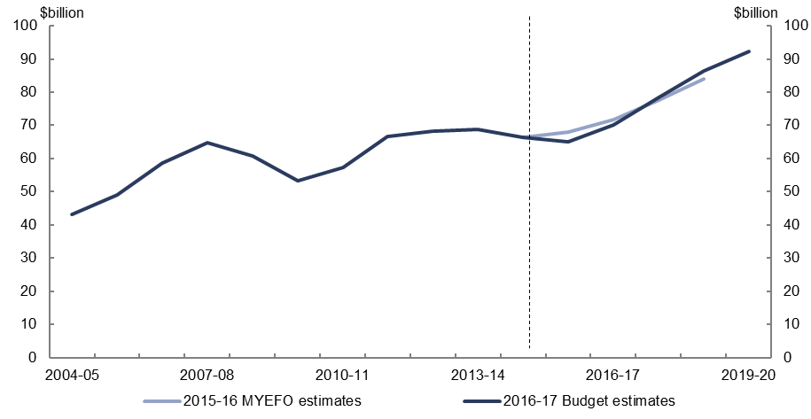
Figure 10: Revenue – company tax – change from 2015–16 MYEFO to
2016–17 Budget estimates by measures and other variations
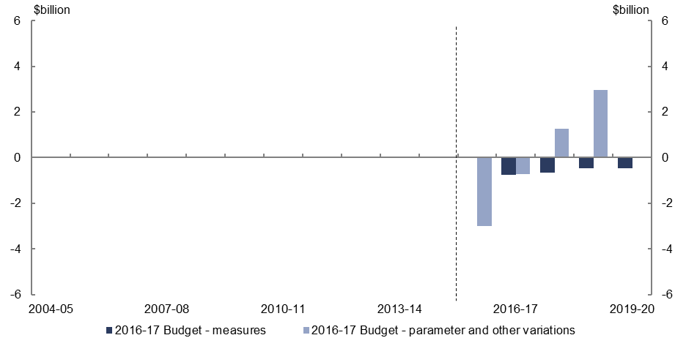
- Relative to the 2015–16 MYEFO, policy decisions are expected to decrease company tax revenue by $2.4 billion over the five years to 2019–20, reflecting measures to progressively reduce the company tax rate and increase the small business entity turnover threshold, partially offset by the expected gain to revenue from the establishment of the Corporate Tax Avoidance Taskforce within the Australian Taxation Office.
- Parameter and other variations are expected to increase company tax revenue by $0.5 billion over the four years to 2018–19, relative to the 2015–16 MYEFO, largely due to higher expected mining profits in 2017–18 and 2018–19.

Revenue – goods and services tax
Figure 11: Revenue – goods and services tax – change from 2015–16 MYEFO to
2016–17 Budget estimates
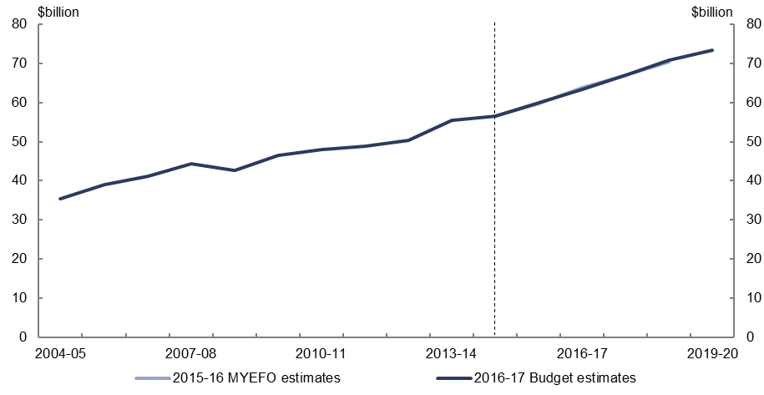
Figure 12: Revenue – goods and services tax – change from 2015–16 MYEFO to
2016–17 Budget estimates by measures and other variations
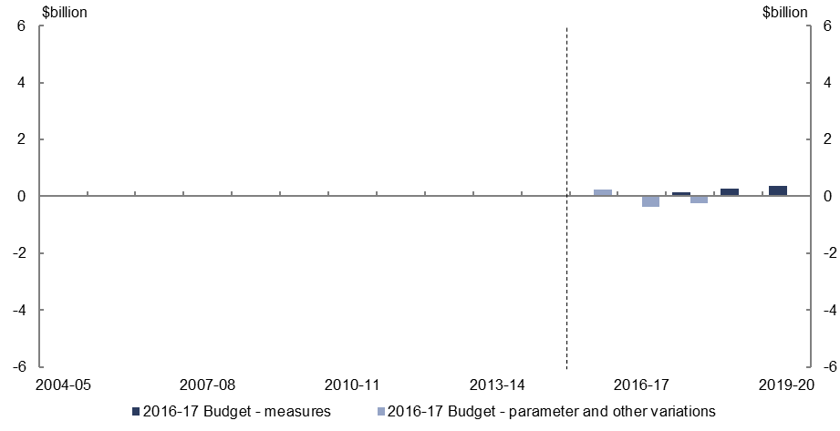
- Relative to the 2015–16 MYEFO, policy decisions are expected to increase goods and services tax revenue by $0.8 billion over the five years to 2019–20, reflecting measures to increase tobacco excise and apply GST to low-value goods imported by consumers.
- Parameter and other variations are expected to decrease goods and service tax revenue by $0.4 billion over the four years to 2018–19 reflecting lower forecast household consumption and private dwelling investment growth over the period.

Revenue – excise and customs duties
Figure 13: Revenue – excise and customs duties – change from 2015–16 MYEFO to
2016–17 Budget estimates
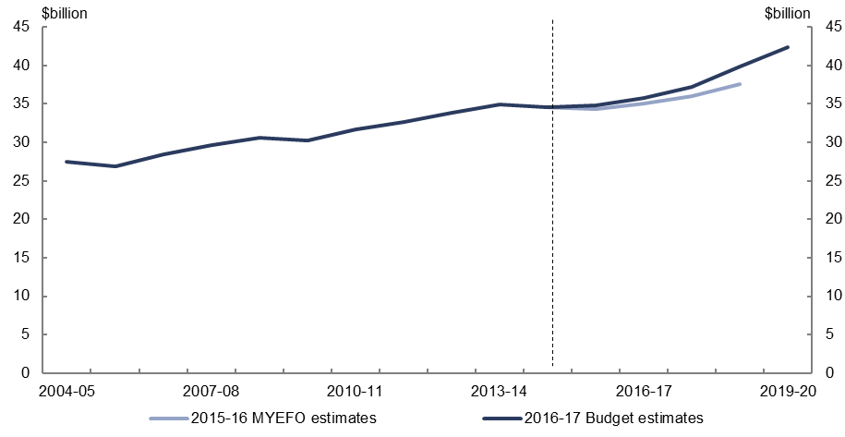
Figure 14: Revenue – excise and customs duties – change from 2015–16 MYEFO to
2016–17 Budget estimates by measures and other variations
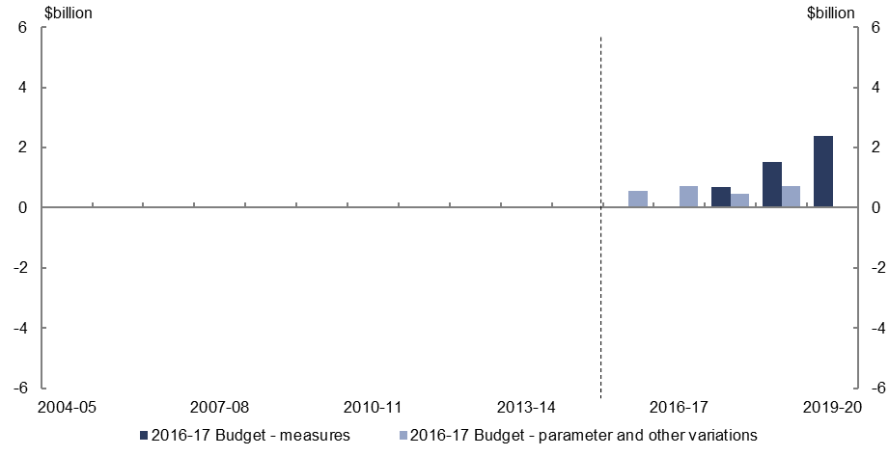
- Relative to the 2015–16 MYEFO, policy decisions are expected to increase excise and customs tax revenue by $4.6 billion over the five years to 2019–20, primarily due to the measure to raise the excise on tobacco.
- Parameter and other variations are expected to increase excise and customs revenue by $2.5 billion over the four years to 2018–19, relative to the 2015–16 MYEFO, largely reflecting higher forecast growth in fuel consumption.

Revenue – non-tax revenue
Figure 15: Revenue – non-tax revenue – change from 2015–16 MYEFO to
2016–17 Budget estimates
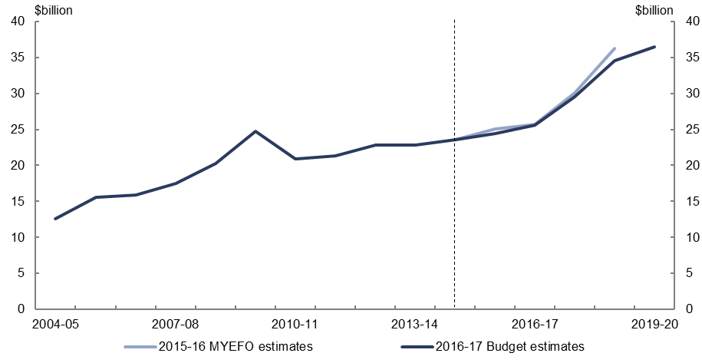
Figure 16: Revenue – non-tax revenue – change from 2015–16 MYEFO to
2016–17 Budget estimates by measures and other variations
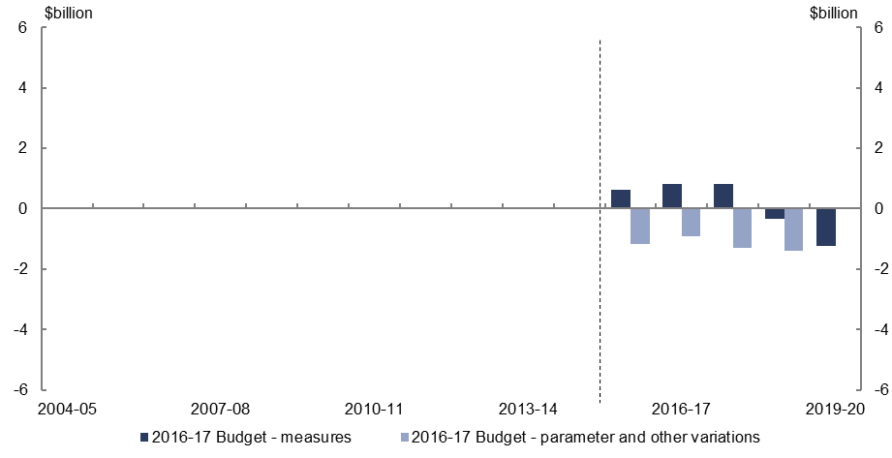
- Relative to the 2015–16 MYEFO, policy decisions are expected to increase non-tax revenue by $0.7 billion over the five years to 2019–20, including the decision to delay implementing the removal of the loan fee for FEE-HELP and VET-FEE HELP.
- Parameter and other variations are expected to decrease non-tax revenue by $4.8 billion over the four years to 2018–19, which includes the agreement with the Victorian Government to reinvest the $1.5 billion provided for the East West Link project which was previously budgeted to be returned to the Commonwealth, and reduced interest earnings from the Future Fund.

Expenses – Age Pension
Figure 17: Expenses – Age Pension – change from 2015–16 MYEFO to
2016–17 Budget estimates
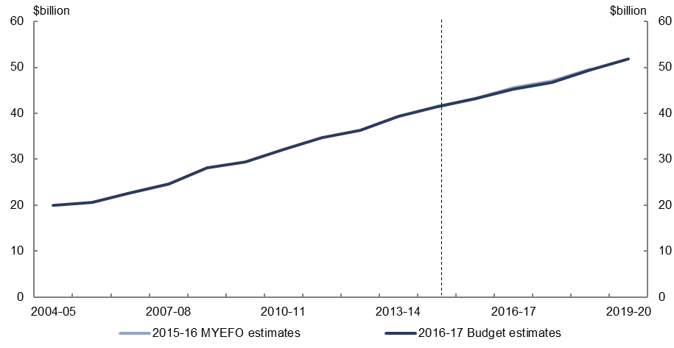
Figure 18: Expenses – Age Pension – change from 2015–16 MYEFO to
2016–17 Budget estimates by measures and other variations
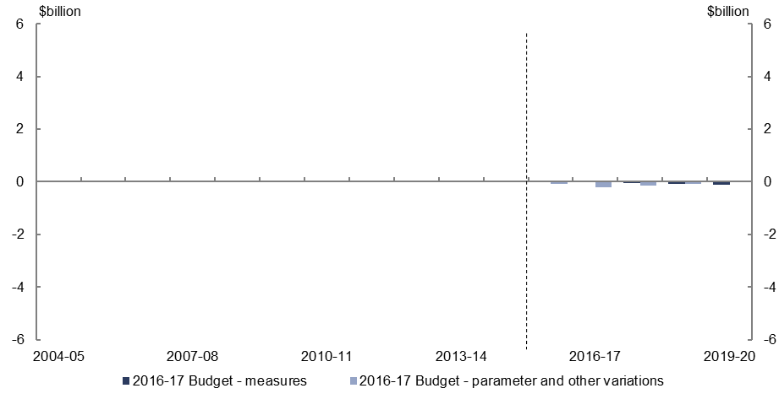
- Relative to the 2015–16 MYEFO, policy decisions are expected to decrease expenses on the Age Pension by $0.3 billion over the five years to 2019–20, due to abolishing the Energy Supplement for new customers of social security payments.
- Parameter and other variations are expected to decrease expenses on the Age Pension by $0.5 billion over the four years to 2018–19, relative to the 2015–16 MYEFO, largely reflecting the lower indexation of payments due to lower forecast CPI growth.

Expenses – Family Tax Benefit
Figure 19: Expenses – Family Tax Benefit – change from 2015–16 MYEFO to
2016–17 Budget estimates
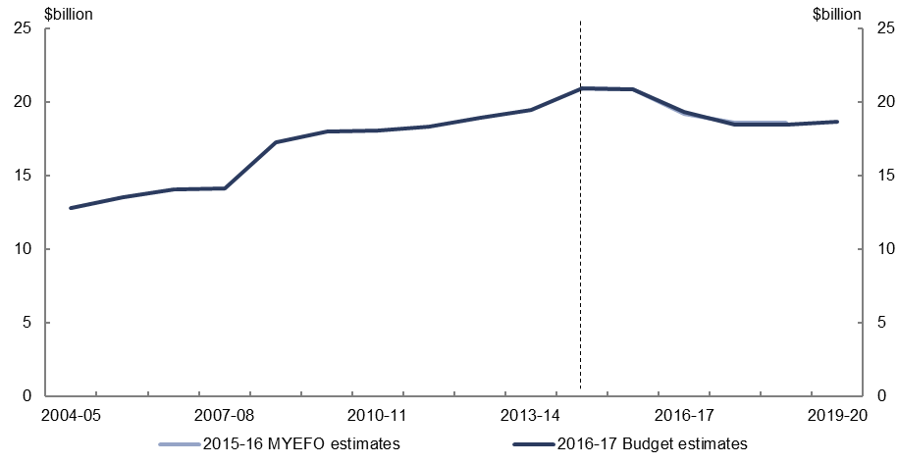
Figure 20: Expenses – Family Tax Benefit – change from 2015–16 MYEFO to
2016–17 Budget estimates by measures and other variations
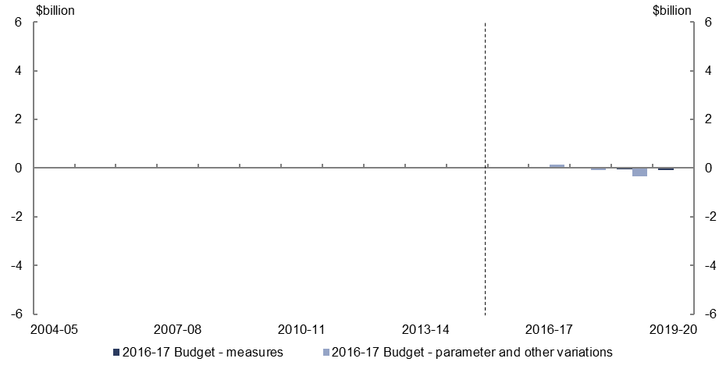
- Relative to the 2015–16 MYEFO, policy decisions are expected to decrease expenses on Family Tax Benefit by $0.1 billion over the five years to 2019–20.
- Parameter and other variations are expected to decrease expenses by $0.3 billion over the four years to 2018–19.

Expenses – Disability Support Pension
Figure 21: Expenses – Disability Support Pension – change from 2015–16 MYEFO to
2016–17 Budget estimates
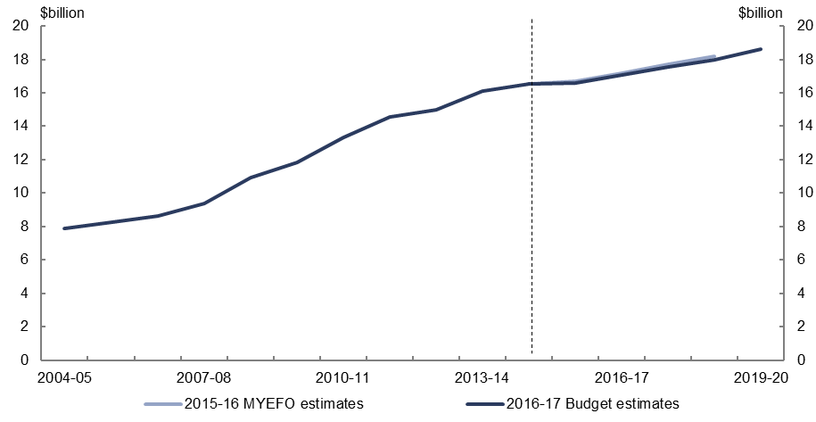
Figure 22: Expenses – Disability Support Pension – change from 2015–16 MYEFO to
2016–17 Budget estimates by measures and other variations
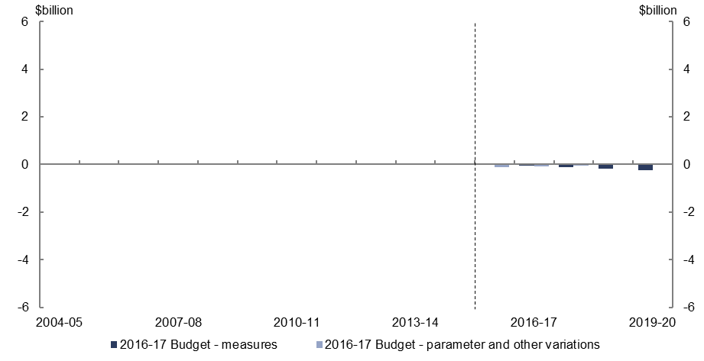
- Relative to the 2015–16 MYEFO, policy decisions are expected to decrease expenses on the Disability Support Pension by $0.6 billion over the five years to 2019–20, primarily due to the measure to medically review 30,000 Disability Support Pension recipients each year for three years to assess their capacity to work.
- Parameter and other variations are expected to decrease expenses on the Disability Support Pension by $0.3 billion over the four years to 2018–19, relative to the
2015–16 MYEFO.

Expenses – aged care
Figure 23: Expenses – aged care – change from 2015–16 MYEFO to 2016–17 Budget estimates
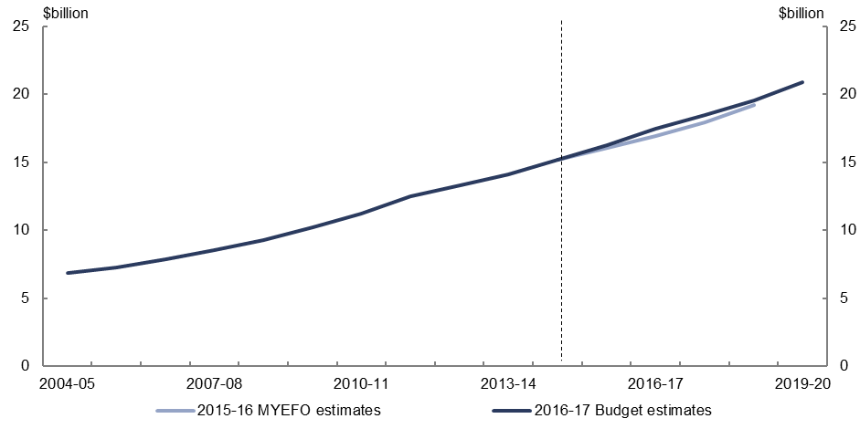
Figure 24: Expenses – aged care – change from 2015–16 MYEFO to 2016–17 Budget estimates by measures and other variations
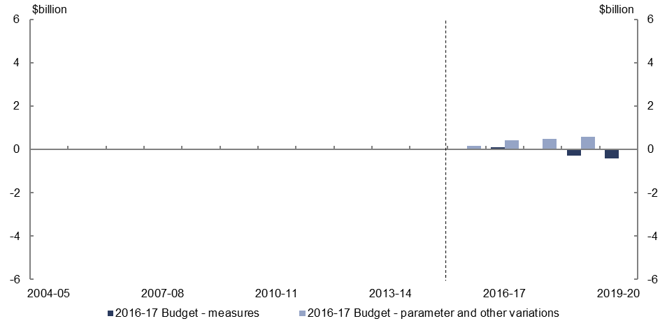
- Relative to the 2015–16 MYEFO, policy decisions are expected to decrease expenses on aged care by $0.5 billion over the five years to 2019–20, largely due to the measure to revise the Aged Care Funding Instrument (which determines the level of funding to aged care providers), partially offset by the continuation of the National Partnership Agreement for Home and Community Care with Western Australia.
- Parameter and other variations are expected to increase expenses on aged care by $1.7 billion over the four years to 2018–19, primarily due to higher expected growth in subsidies provided to residential aged care facilities.

Expenses – job seeker income support
Figure 25: Expenses – job seeker income support – change from 2015–16 MYEFO to
2016–17 Budget estimates
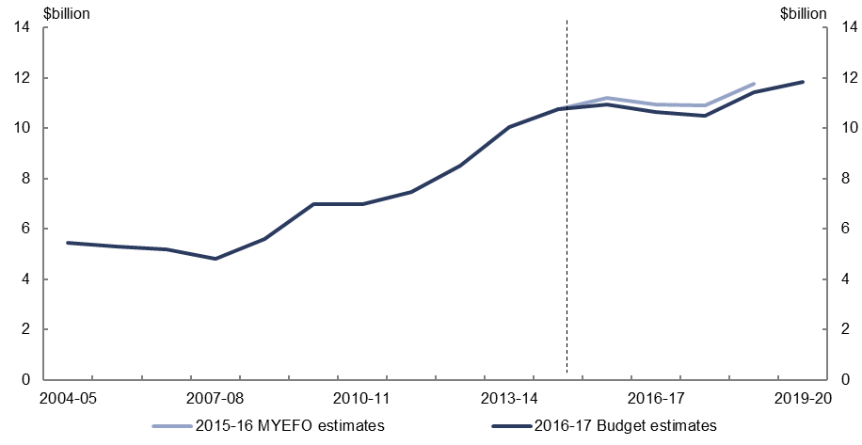
Figure 26: Expenses – job seeker income support – change from 2015–16 MYEFO to
2016–17 Budget estimates by measures and other variations
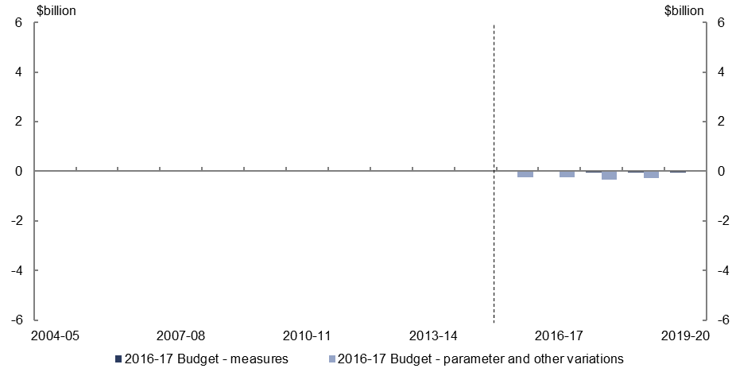
- Relative to the 2015–16 MYEFO, policy decisions are expected to decrease expenses on job seeker income support by $0.2 billion over the five years to 2019–20.
- Parameter and other variations are expected to decrease expenses on job seeker income support by $1.1 billion over the four years to 2018–19, relative to the
2015–16 MYEFO, largely reflecting a lower forecast unemployment rate.

Expenses – income support for carers
Figure 27: Expenses – income support for carers – change from 2015–16 MYEFO to
2016–17 Budget estimates
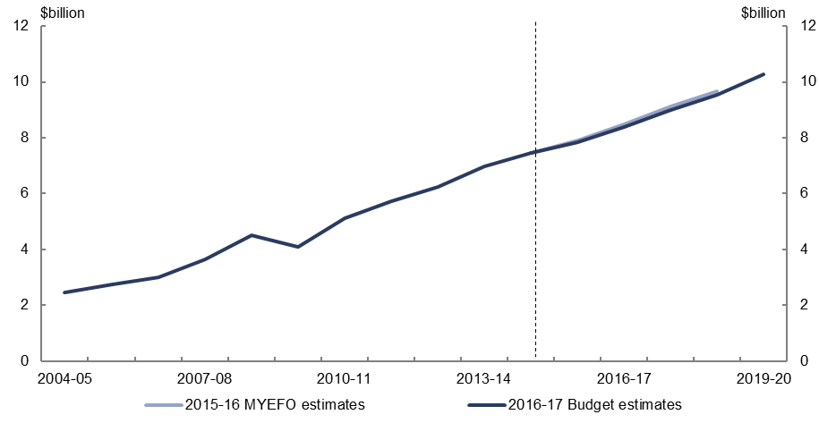
Figure 28: Expenses – income support for carers – change from 2015–16 MYEFO to
2016–17 Budget estimates by measures and other variations
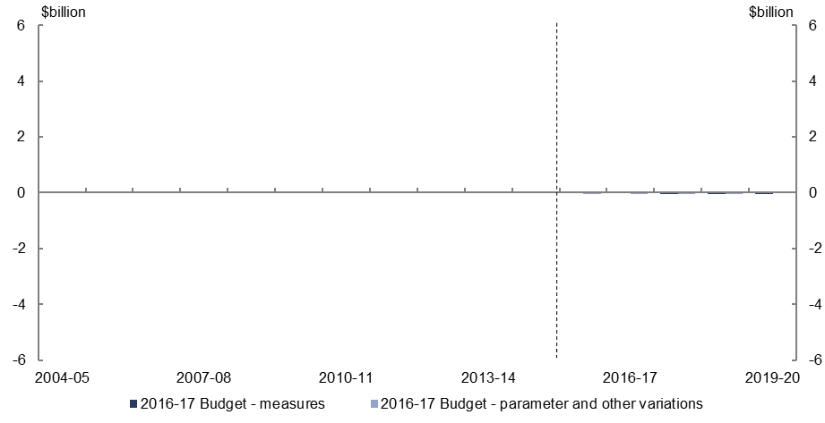
- Relative to the 2015–16 MYEFO, policy decisions are expected to decrease expenses on income support for carers by $0.2 billion over the five years to 2019–20.
- Parameter and other variations are expected to decrease expenses on income support for carers by $0.2 billion over the four years to 2018–19, relative to the
2015–16 MYEFO.

Expenses – child care fee assistance
Figure 29: Expenses – child care fee assistance – change from 2015–16 MYEFO to
2016–17 Budget estimates
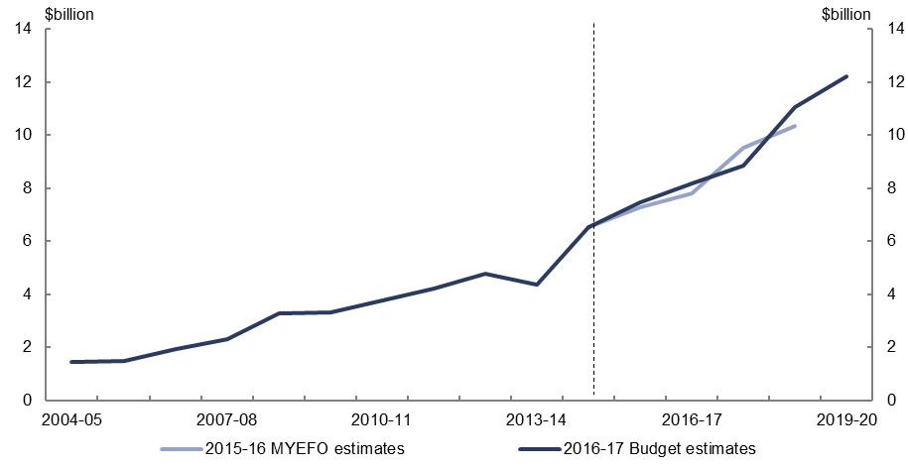
Figure 30: Expenses – child care fee assistance – change from 2015–16 MYEFO to
2016–17 Budget estimates by measures and other variations
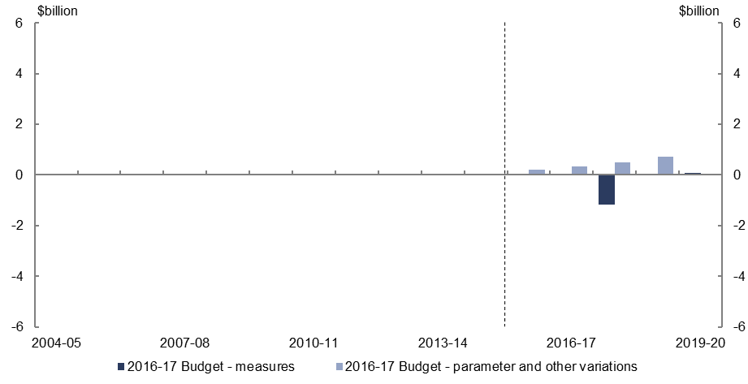
- Relative to the 2015–16 MYEFO, policy decisions are expected to decrease expenses on child care fee assistance by $1.1 billion over the five years to 2019–20, due to deferring the implementation of the Child Care Subsidy for one year to 2018–19.
- Parameter and other variations are expected to increase expenses on child care fee assistance by $1.7 billion over the four years to 2018–19, relative to the
2015–16 MYEFO, largely reflecting an increase in the forecast number of hours of child care used and average child care fees charged.

Expenses – parents’ income support
Figure 31: Expenses – parents’ income support – change from 2015–16 MYEFO to
2016–17 Budget estimates
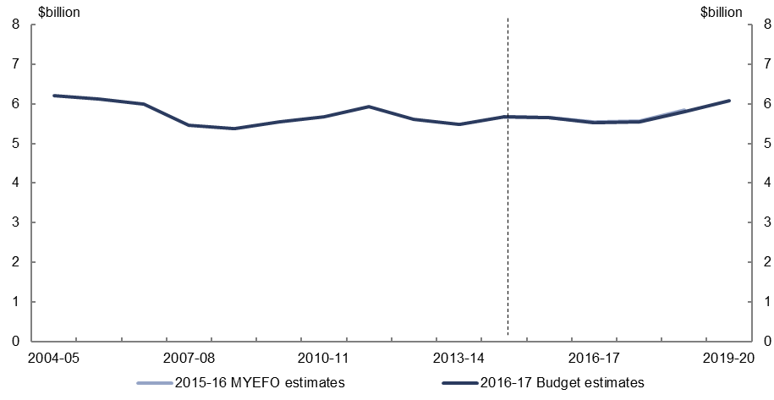
Figure 32: Expenses – parents’ income support – change from 2015–16 MYEFO to
2016–17 Budget estimates by measures and other variations
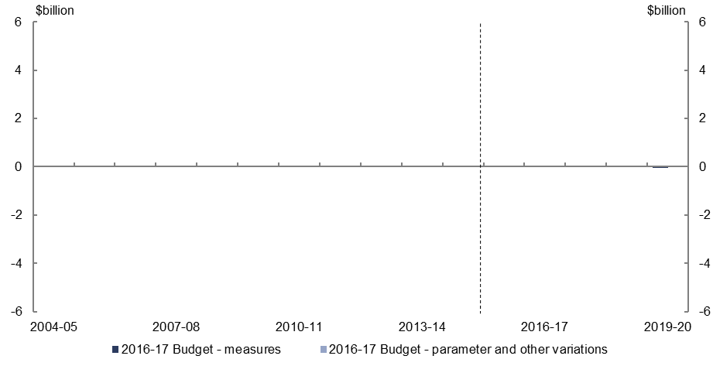
- Relative to the 2015–16 MYEFO, policy decisions are expected to decrease expenses on parents’ income support by $0.1 billion over the five years to 2019–20.
- Parameter and other variations are expected have a broadly neutral impact over the four years to 2018–19, relative to the 2015–16 MYEFO.

Expenses – Medicare Benefits Schedule
Figure 33: Expenses – Medicare Benefit Schedule – change from 2015–16 MYEFO to
2016–17 Budget estimates
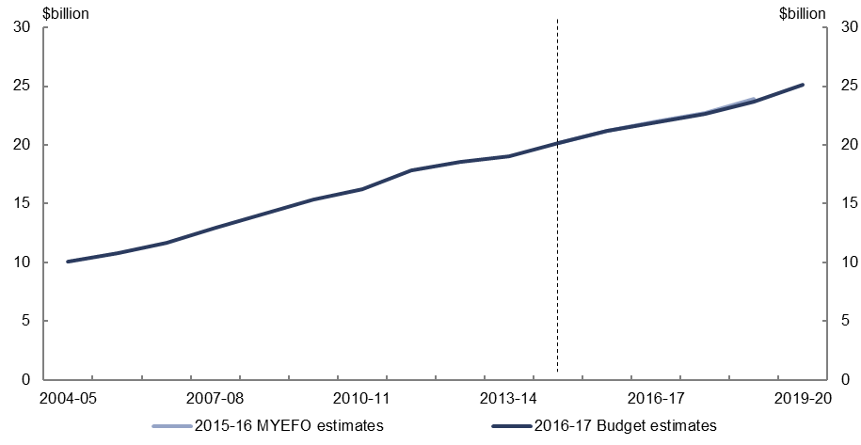
Figure 34: Expenses – Medicare Benefit Schedule – change from 2015–16 MYEFO to
2016–17 Budget estimates by measures and other variations
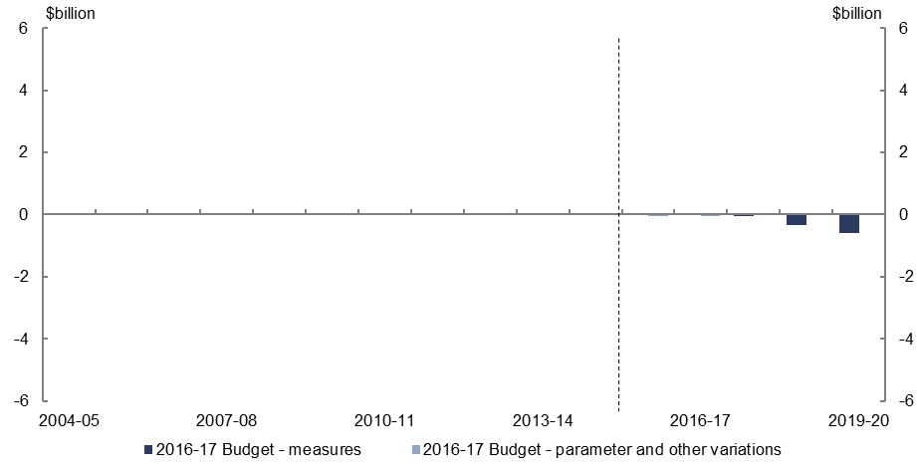
- Relative to the 2015–16 MYEFO, policy decisions are expected to decrease expenses on Medicare by $1.0 billion over the five years to 2019–20, reflecting the measure to extend the pause on indexation of Medicare benefits until 2019–20.
- Parameter and other variations are expected to decrease expenses on Medicare by $0.1 billion over the four years to 2018–19, relative to the 2015–16 MYEFO.

Expenses – assistance to the states and territories for public hospitals
Figure 35: Expenses – assistance to the states and territories for public hospitals – change from 2015–16 MYEFO to 2016–17 Budget estimates
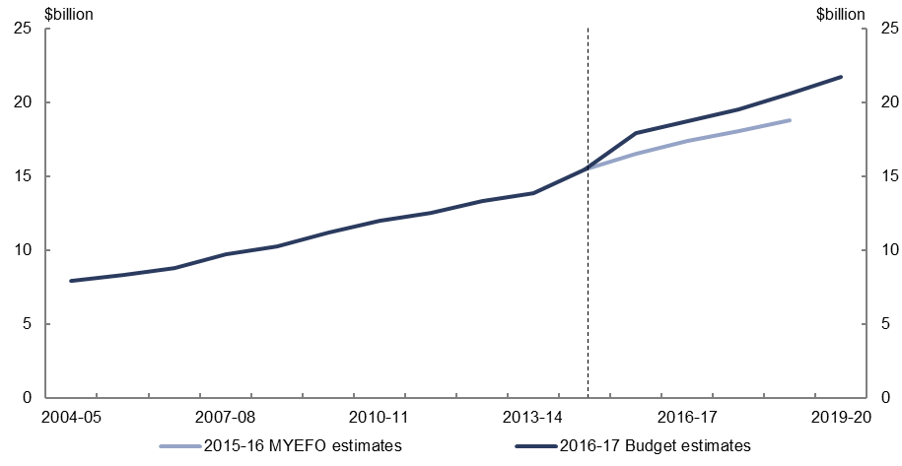
Figure 36: Expenses – assistance to the states and territories for public hospitals – change from 2015–16 MYEFO to 2016–17 Budget estimates by measures and other variations
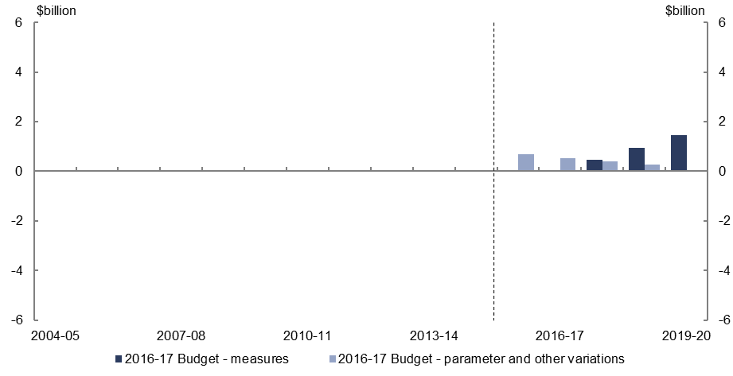
- Relative to the 2015–16 MYEFO, policy decisions are expected to increase expenses on assistance to the states and territories for public hospitals by $2.9 billion over the five years to 2019–20, reflecting the revised funding arrangements with the states for three years from 2017–18. Funding growth over the three years will be based on hospital activity and the national efficient price for public hospital services, rather than the previous policy of indexing funding to CPI and population growth.
- Parameter and other variations are expected to increase assistance to the states and territories for public hospitals expenses by $1.8 billion over the four years to 2018–19, largely reflecting increased hospital activity.

Expenses – pharmaceutical benefits
Figure 37: Expenses – pharmaceutical benefits – change from 2015–16 MYEFO to
2016–17 Budget estimates
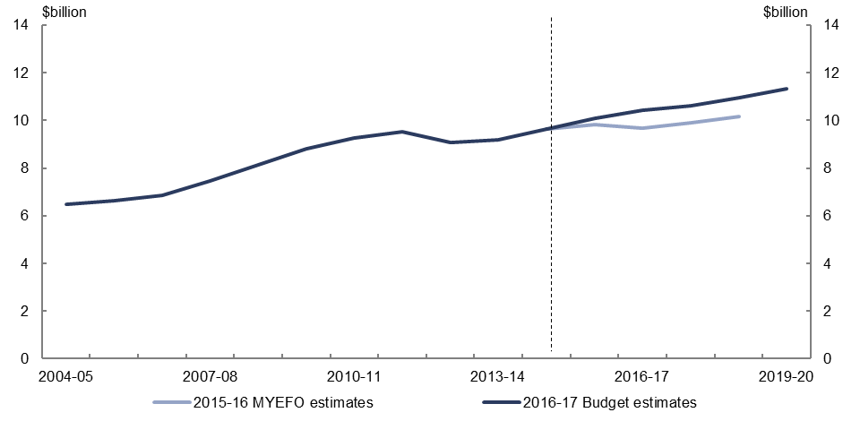
Figure 38: Expenses – pharmaceutical benefits – change from 2015–16 MYEFO to
2016–17 Budget estimates by measures and other variations
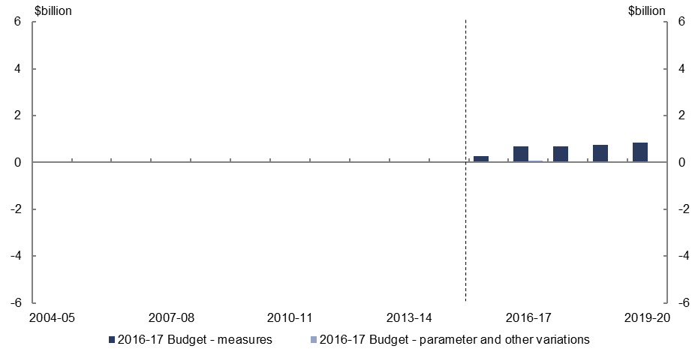
- Relative to the 2015–16 MYEFO, policy decisions are expected to increase spending on the Pharmaceutical Benefits Scheme by $3.3 billion over the five years to 2019–20, largely reflecting the listing of high-cost drugs for the treatment of Hepatitis C.
- Parameter and other variations are expected to increase pharmaceutical benefits expenses by $0.1 billion over the four years to 2018–19, relative to the
2015–16 MYEFO.

Expenses – private health insurance rebate
Figure 39: Expenses – private health insurance rebate – change from 2015–16 MYEFO to
2016–17 Budget estimates
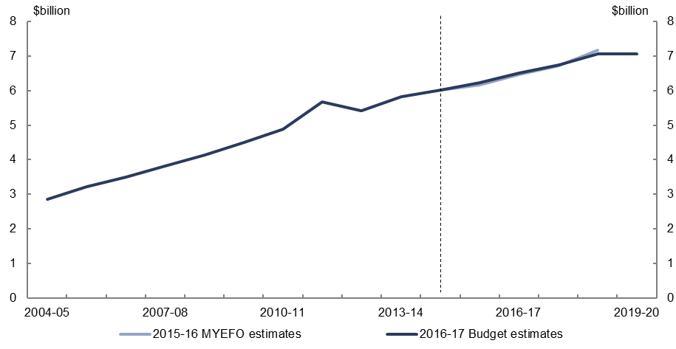
Figure 40: Expenses – private health insurance rebate – change from 2015–16 MYEFO to
2016–17 Budget estimates by measures and other variations
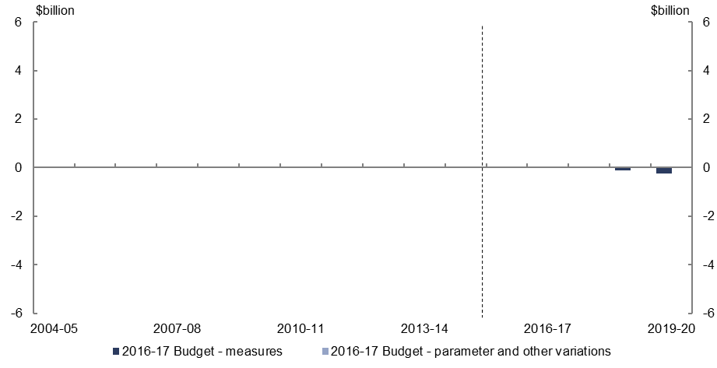
- Relative to the 2015–16 MYEFO, policy decisions are expected to decrease spending on the private health insurance rebate by $0.4 billion over the five years to 2019–20, reflecting the continuation of the pause in the indexation of the income thresholds for the private health insurance rebate.
- Relative to the 2015–16 MYEFO, parameter and other variations are expected to increase spending on the private health insurance rebate by $0.1 billion over the four years to 2018–19.

Expenses – National Disability Insurance Scheme
Figure 41: Expenses – National Disability Insurance Scheme – change from 2015–16 MYEFO to 2016–17 Budget estimates
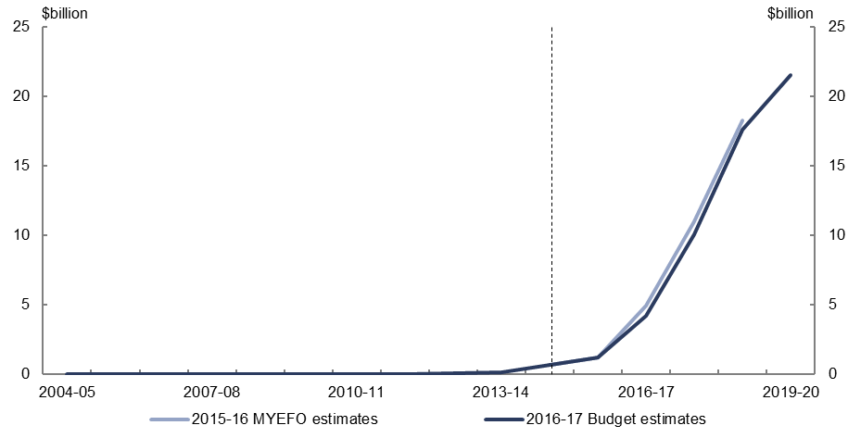
Figure 42: Expenses – National Disability Insurance Scheme – change from 2015–16 MYEFO to 2016–17 Budget estimates by measures and other variations
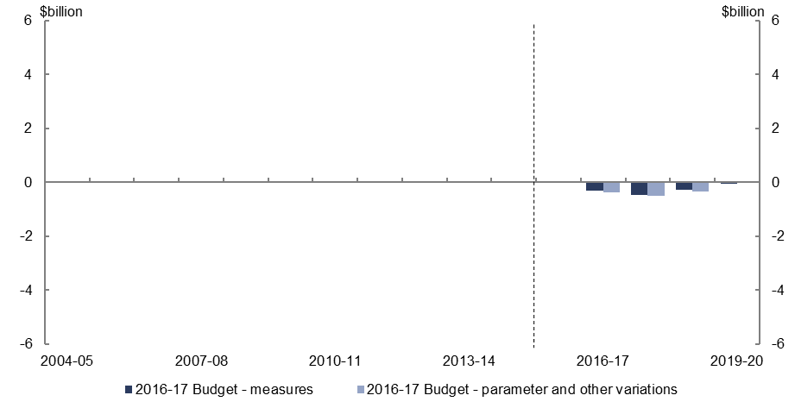
- Relative to the 2015–16 MYEFO, policy decisions are expected to decrease spending on the National Disability Insurance Scheme by $1.1 billion over the five years to 2019–20, reflecting a reduction in Commonwealth expenses due to the slower than expected transition to the full scheme following negotiations with state and territory governments.
- Parameter and other variations are expected to decrease National Disability Insurance Scheme expenses by $1.3 billion over the four years to 2018–19, reflecting a reduction in expenses financed from state contributions (with a corresponding reduction in non-tax revenue), due to the slower than expected transition to the full scheme following negotiations with state and territory governments.

Expenses – schools
Figure 43: Expenses – schools – change from 2015–16 MYEFO to 2016–17 Budget estimates
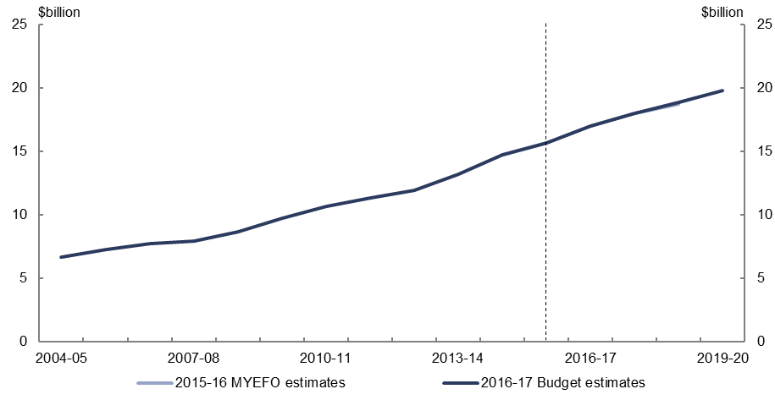
Figure 44: Expenses – schools – change from 2015–16 MYEFO to 2016–17 Budget estimates by measures and other variations
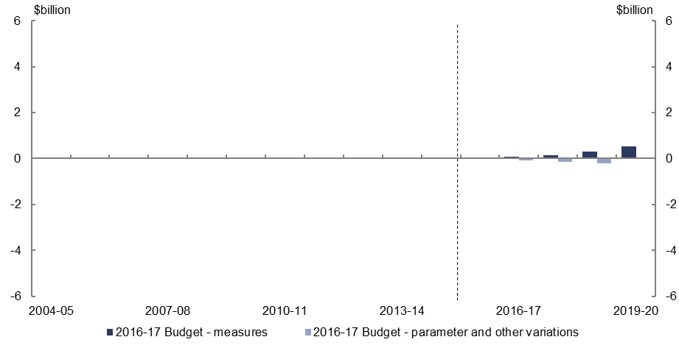
- Relative to the 2015–16 MYEFO, policy decisions are expected to increase spending on schools by $1.0 billion over the five years to 2019–20, reflecting revised indexation arrangements with the states for funding schools for the 2018 to 2020 school years. Funding growth for these years will be based on an education sector specific index, rather than changes in the CPI.
- Parameter and other variations are expected to decrease spending on schools by $0.4 billion over the four years to 2018–19, relative to the 2015–16 MYEFO.

Expenses – higher education grants
Figure 45: Expenses – higher education grants – change from 2015–16 MYEFO to
2016–17 Budget estimates
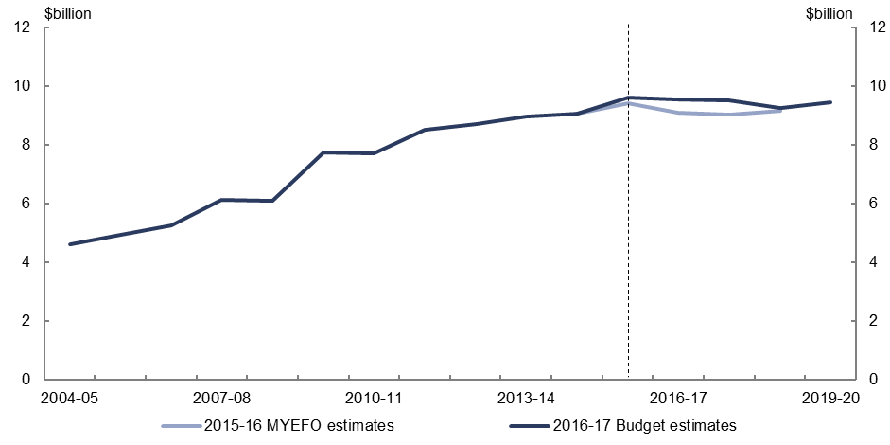
Figure 46: Expenses – higher education grants – change from 2015–16 MYEFO to
2016–17 Budget estimates by measures and other variations
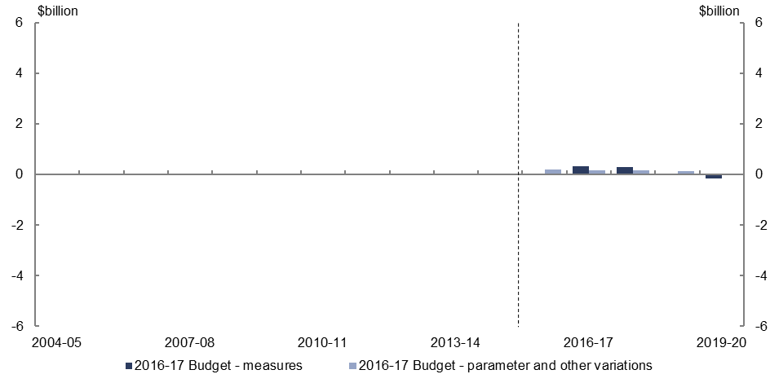
- Policy decisions are expected to increase expenses on higher education grants by $0.4 billion over the five years to 2019–20, relative to the 2015–16 MYEFO, reflecting the delay in implementing the reduction in Commonwealth Grants Scheme funding announced in the 2014–15 Budget.
- Parameter and other variations are expected to increase expenses on higher education by $0.7 billion over the four years to 2018–19, due to the Efficiency Dividend no longer being applied to Commonwealth Grants Scheme payments.

Higher Education Loan Programme
Figure 47: Higher Education Loan Programme – change from 2015–16 MYEFO to
2016–17 Budget estimates
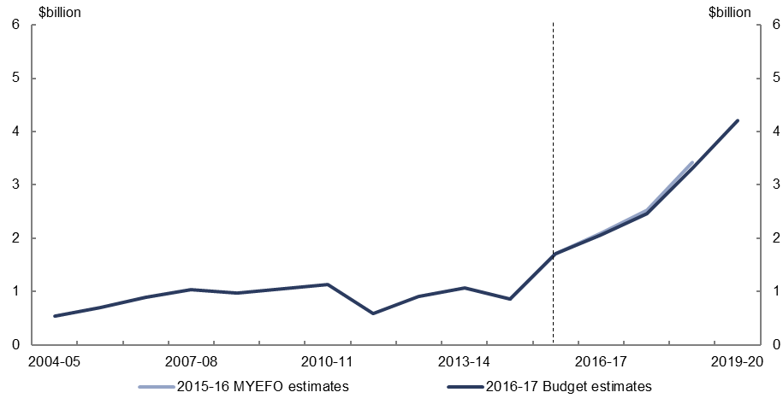
Figure 48: Higher Education Loan Programme – change from 2015–16 MYEFO to
2016–17 Budget estimates by measures and other variations
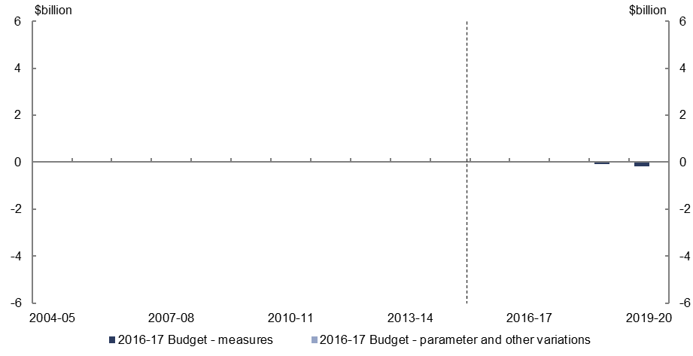
- Relative to the 2015–16 MYEFO, policy decisions are expected to decrease payments on the Higher Education Loan Programme (HELP) by $0.3 billion over the five years to
2019–20, due to the removal of increases in student contributions as part of the decision to no longer proceed with the deregulation of university fees as announced in the 2014–15 Budget.
- Parameter and other variations are expected to decrease expenses on HELP by $0.1 billion over the four years to 2018–19.

Defence (expenses and net capital investment)
Figure 49: Defence (expenses and net capital investment) – change from 2015–16 MYEFO to 2016–17 Budget estimates
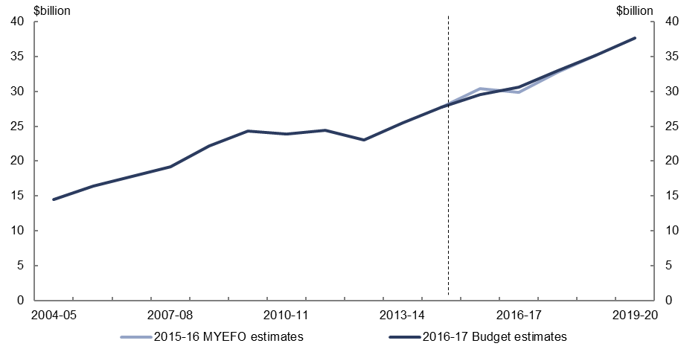
Figure 50: Defence (expenses and net capital investment) – change from 2015–16 MYEFO to 2016–17 Budget estimates by measures and other variations
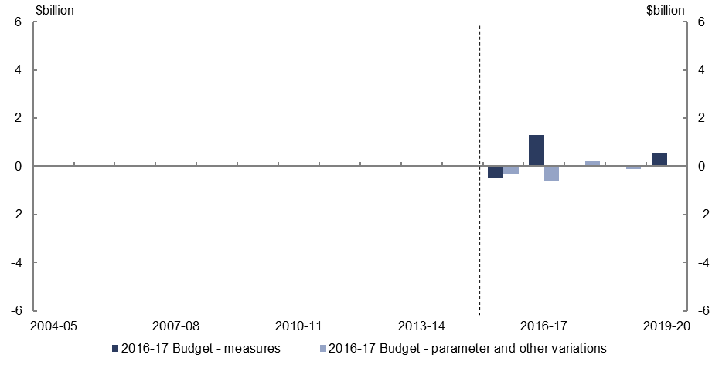
- Policy decisions are expected to increase defence spending by $1.4 billion over the five years to 2019–20, relative to the 2015–16 MYEFO, reflecting increased funding to deliver on the plans set out in the 2016 Defence White Paper, and to support major Australian Defence Force operations.
- Relative to the 2015–16 MYEFO, parameter and other variations are expected to decrease defence spending by $0.8 billion over the four years to 2018–19.

Expenses – public debt interest
Figure 51: Expenses – public debt interest – change from 2015–16 MYEFO to
2016–17 Budget estimates
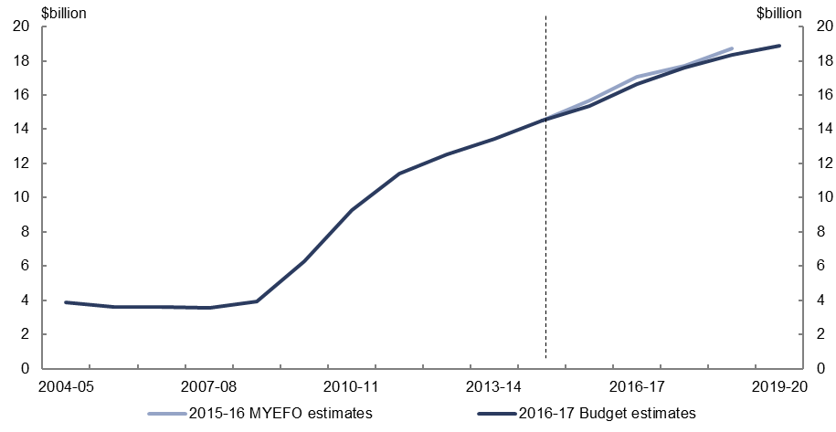
Figure 52: Expenses – public debt interest – change from 2015–16 MYEFO to
2016–17 Budget estimates by measures and other variations
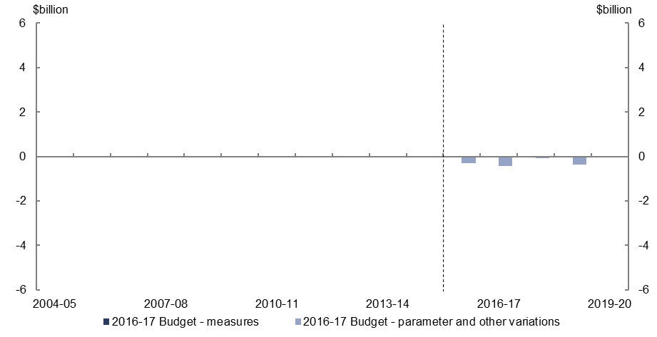
- Relative to the 2015–16 MYEFO, parameter and other variations are expected to decrease expenses on public debt interest by $1.2 billion over the four years to
2018–19 due to a fall in the weighted average cost of borrowing.

Expenses – public sector superannuation
Figure 53: Expenses – public sector superannuation – change from 2015–16 MYEFO to
2016–17 Budget estimates
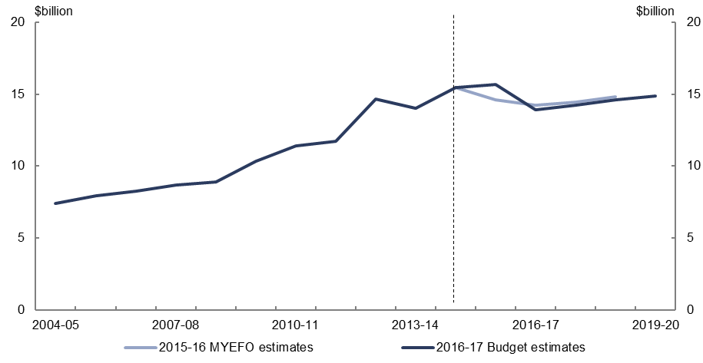
Figure 54: Expenses – public sector superannuation – change from 2015–16 MYEFO to
2016–17 Budget estimates by measures and other variations
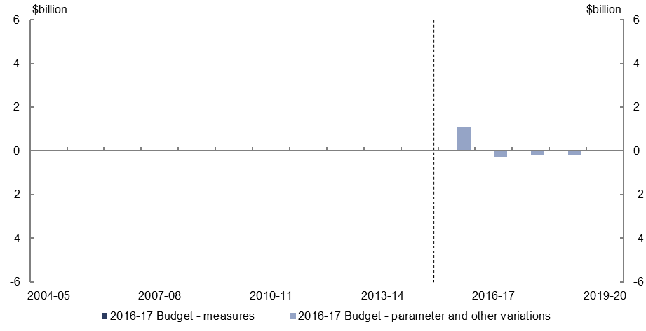
- Parameter and other variations are expected to increase public sector superannuation expenses by $0.4 billion over the four years to 2018–19, largely due to the practice of changing discount rates for the revised budget year from an actuarially based rate to the long-term government bond rate.

Expenses – road and rail infrastructure
Figure 55: Expenses – road and rail infrastructure – change from 2015–16 MYEFO to
2016–17 Budget estimates
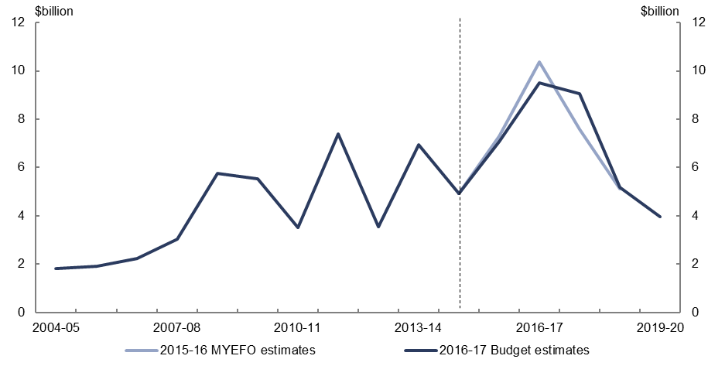
Figure 56: Expenses – road and rail infrastructure – change from 2015–16 MYEFO to
2016–17 Budget estimates by measures and other variations
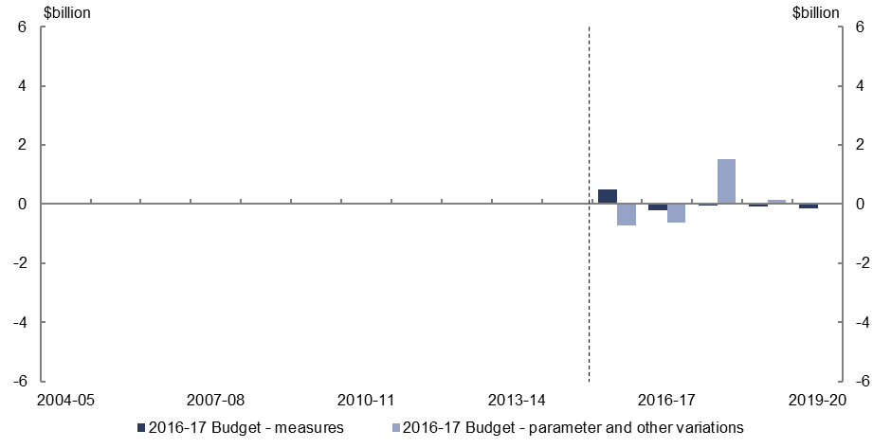
- Policy decisions are expected to have a broadly neutral impact over the five years to 2019–20 on road and rail infrastructure expenses.
- Parameter and other variations are expected to increase infrastructure expenses by $0.3 billion over the four years to 2018–19, with the profile over the forward estimates reflecting the re-phasing of funding for road infrastructure projects.

Official Development Assistance
Figure 57: Official Development Assistance – change from 2015–16 MYEFO to
2016–17 Budget estimates
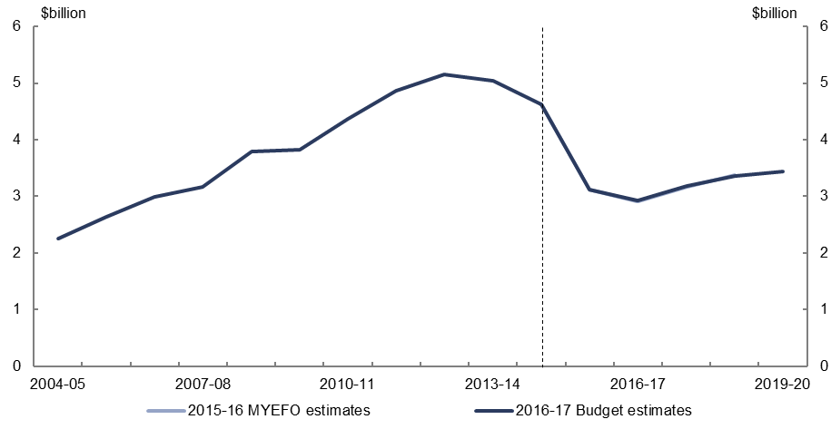
Figure 58: Official Development Assistance – change from 2015–16 MYEFO to
2016–17 Budget estimates by measures and other variations
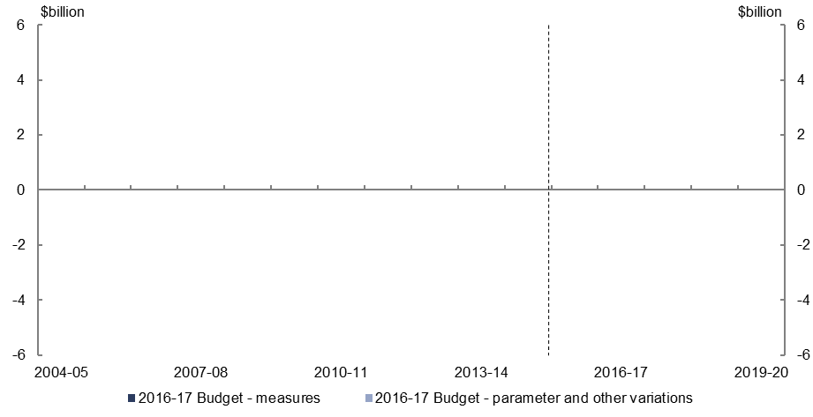
- Official Development Assistance spending is projected to remain in line with the
2015–16 MYEFO estimates.

www.pbo.gov.au
www.pbo.gov.au

This relates to the expenses of the National Disability Insurance Agency. This differs from Commonwealth payments to the states and territories relating to the NDIS and disability services which are covered in separate agreements between the Commonwealth and the states and territories.
Total spending on HELP is reported in cash terms. The cost of the Higher Education Loan Programme reflects the net public debt interest cost of providing these concessional loans.
This includes the public debt interest costs associated with HELP.
Total Official Development Assistance spending is reported in cash terms consistent with the government commitment in this area.

