|  |
| --- |
| National Broadband Network |
| Impact on the Budget |
| Report no. 04/2016 |

|  |
| --- |
| © Commonwealth of Australia 2016  ISBN 978-0-9944547-8-2 (Online)  This work is licensed under the Creative Commons Attribution-NonCommercial-NoDerivs 3.0 Australia License.    The details of this licence are available on the Creative Commons website: <http://creativecommons.org/licenses/by-nc-nd/3.0/au/>  Use of the Coat of Arms  The terms under which the Coat of Arms can be used are detailed on the following website: [www.itsanhonour.gov.au/coat-arms](http://www.itsanhonour.gov.au/coat-arms)  Produced by: Parliamentary Budget Office  Designed by: Studio Tweed  First Assistant Parliamentary Budget Officer  Fiscal Policy Analysis Division  Parliamentary Budget Office  Parliament House  PO Box 6010  CANBERRA ACT 2600  Phone: (02) 6277 9500  Email: pbo@pbo.gov.au |

Contents

Foreword v

Overview vi

1 Background 1

1.1 Establishment of NBN Co Limited 1

1.2 Legislation 1

1.3 Funding and rollout 2

2 Budget impact of the NBN 5

2.1 Impact on underlying cash balance 5

2.2 Impact on net worth 6

3 Budget risks 9

3.1 Long term value of NBN Co 9

3.2 Contingent liabilities 9

Foreword

The National Broadband Network (NBN) is a major infrastructure investment for the Australian Government.

This paper discusses the budget impact of the Commonwealth’s equity and debt financing of the NBN and the associated fiscal risks.

I would like to thank the PBO staff involved in the preparation of this report, namely Tim Pyne, Paul Gardiner, Lok Potticary and Liz Wakerly. The report was prepared for publication by Louise Milligan.

Phil Bowen PSM FCPA

Parliamentary Budget Officer

14 December 2016

Overview

The Australian Government has committed to provide $29.5 billion in equity funding to NBN Co Limited (NBN Co) for the rollout of the National Broadband Network (NBN) by 2020. The Government also recently agreed to provide NBN Co with a loan of $19.5 billion to complete the NBN rollout at an estimated total cost of $49 billion.

As at 30 June 2016, the Government had contributed $20.3 billion in equity funding to NBN Co. The Commonwealth’s equity in NBN Co at that time stood at $13.1 billion, representing a $7.2 billion deterioration in the Commonwealth’s equity holding in NBN Co.

The deterioration in the Commonwealth’s equity is principally due to NBN Co accumulating losses totalling $8.3 billion as at 30 June 2016 (see Figure 2–2, page 7). These losses reflect the early years of the rollout of the NBN. The deterioration in the Commonwealth’s equity in NBN Co is reflected in the Commonwealth’s aggregate net worth in its balance sheet and the Department of Communications and the Arts’ annual financial statements. It is not separately identified in the budget papers.

The annual cost to the budget of the Government’s investment in the NBN is estimated at around $580 million in 2016–17. Following the final drawdown of the $29.5 billion in equity and assuming the loan is drawn down from 2017–18 and paid back in full in 2020–21, the annual cost is estimated to rise to over $730 million in 2019-20 and to $2.1 billion by   
2026–27 (see Figure 2–1, page 5). These costs, while significantly impacting the budget bottom line, are not separately identified in the budget papers.

The key driver of the annual cost to the Commonwealth of the NBN is the public debt interest payments associated with the government’s equity injection in NBN Co. The provision of additional funding through a loan at an interest rate above the government’s cost of borrowing provides a partial offset to this annual cost.

The final cost of the Commonwealth’s financing of NBN Co will not be known until NBN Co is privatised and the market places a value on the NBN. Until then the Commonwealth will continue to bear an annual cost associated with its financing of NBN Co. If the sale price of NBN Co is less than the Commonwealth’s cumulative cost of financing NBN Co, then the NBN would have an enduring cost to the budget.

There is also a risk, albeit rated by the Government as small (less than five per cent probability), that the Government could be called upon to meet contingent liabilities it has entered into in relation to the NBN rollout. These contingent liabilities totalled $15.5 billion as at 30 June 2016.

# Background

## Establishment of NBN Co Limited

On 9 April 2009, the Rudd Government announced the establishment of NBN Co Limited (NBN Co), a wholly owned Commonwealth company, to design, build and operate Australia’s new wholesale-only, open access broadband network.[1]

NBN Co was to be jointly funded by the Government and the private sector, with investment of up to $43 billion over eight years to build the National Broadband Network (NBN). Full government ownership would be maintained until after the rollout was complete, allowing the Government to preserve policy flexibility and avoid diluting any returns.

In a Statement of Expectations provided to the Board of NBN Co in December 2010, the Government said that its central NBN policy objectives were to ‘deliver significant improvement in broadband service and quality to all Australians, address the lack of high‑speed broadband in Australia, particularly outside of metropolitan areas, and reshape the telecommunications sector’.[2]

The Government further specified that NBN Co would:

* design, build and operate an open-access, wholesale-only, national network, covering all premises
* connect 93 per cent of premises with fibre-to-the-premises (FTTP) technology providing broadband speeds of up to 100 megabits per second[3]
* serve all remaining premises by a combination of next-generation fixed wireless and satellite technologies providing peak speeds of at least 12 megabits per second, and
* operate as a commercial entity and, at an appropriate time, raise debt on its own behalf.

## Legislation

The legislation to provide the regulatory framework for the ownership, governance and operation of the NBN came into force in April 2011: the *National Broadband Network Companies Act 2011* (the NBN Companies Act) and the *Telecommunications Legislation Amendment (National Broadband Network Measures - Access Arrangements) Act 2011*.

NBN Co is a Government Business Enterprise (GBE)—a wholly owned Commonwealth company—represented by Shareholder Ministers, the Minister for Communications and the Minister for Finance.

Under the NBN Companies Act, the Commonwealth must retain ownership of NBN Co until at least all of the following are satisfied:

* the Minister for Communications has declared that the NBN network is built and fully operational
* the Productivity Minister has tabled a Productivity Commission inquiry report in both Houses of Parliament
* the Parliamentary Joint Committee on the ownership of NBN Co has examined the report, and
* the Minister for Finance has declared that conditions are suitable for an NBN Co sale scheme.

## Funding and rollout

The first NBN Co Corporate Plan (for 2010–11 to 2012–13) showed that NBN Co planned to complete the network by December 2020 with peak funding of $40.9 billion, comprising $27.5 billion of Government equity and $13.4 billion of debt funding from the private sector.[4] The projected internal rate of return (IRR) was 7.0 per cent (above the five-year Government bond rate of 5.4 per cent as at November 2010).[5]

Reflecting the funding requirements outlined in the 2011–2013 Corporate Plan, the Commonwealth and NBN Co entered into an Equity Funding Agreement (EFA) in June 2011. This EFA provided assurances to the Company that the Commonwealth would provide equity funding, capped at $27.5 billion, until 30 June 2021 (unless terminated earlier). Under the EFA, the Commonwealth committed to meet the termination and other costs of NBN Co in the event that the project is terminated or significantly reduced in scope.

In June 2011, NBN Co entered into Definitive Agreements (DAs) with both Telstra and Optus:

* providing NBN Co access to certain Telstra facilities
* requiring Telstra to progressively disconnect premises from Telstra’s copper and Hybrid Fibre Coaxial (HFC) networks,[6] and
* requiring Optus to progressively migrate HFC customers to the NBN as it is rolled out.

In August 2012, NBN Co released its 2012–2015 Corporate Plan.[7] At this stage, NBN Co planned to achieve completion of the NBN rollout by 2020–21 for capital expenditure of $37.4 billion and peak funding of $44.1 billion. The Commonwealth increased its total equity contribution from $27.5 billion to $30.4 billion, with the remaining funding requirement of $13.7 billion to be met from private sector debt. The IRR was forecast to increase to 7.1 per cent, reflecting higher levels of connections and revenues beyond 2020–21.

Following the election in September 2013, the Minister for Finance and the Minister for Communications announced the initiation of a Strategic Review (the Review) of the NBN. The final report was submitted to the Government on 12 December 2013.[8]

Given delays in deployment and consumer take-up of the NBN, and lower than planned average revenue per user, the Review estimated the peak funding requirement (equity plus debt) for the FTTP rollout would increase to $72.6 billion ($28.5 billion higher than outlined in the 2012–15 NBN Co Corporate Plan), with completion not occurring before June 2024.

The Review noted that attaining an IRR of 7.1 per cent under the FTTP rollout would require either price increases of 50 to 80 per cent or a Commonwealth subsidy of $1.9 to $2.5 billion per year to 2039–40 (if paid from 2014–15).[9]

Following publication of the Review, the Government issued NBN Co with a revised Statement of Expectations on 8 April 2014 which provided, among other things, that:

* to minimise cost and increase speed of deployment, the rollout of the NBN should allow for an optimised Multi-Technology Mix (MTM) model. The MTM deployment includes FTTP, Fibre to the Node (FTTN), HFC, fixed wireless and satellite networks[10]
* NBN Co has flexibility and discretion in operational, technology and network design decisions, within the constraints of a public equity capital limit of $29.5 billion.

In light of the Review and the change to an MTM model, NBN Co’s equity requirements were again revised. The EFA between the Commonwealth and NBN Co was amended in March 2014 with a commitment from the Commonwealth to provide equity to a funding cap of $29.5 billion.[11] Peak funding was estimated to be $41.0 billion for the MTM model, rather than $72.6 billion by continuing under the FTTP framework. Completion of the rollout was scheduled for 2020. The IRR was forecast at 3.1 to 5.3 per cent, only attaining 7.1 per cent if combined with an annual Commonwealth subsidy of $0.7 to $1.3 billion.[12]

Following the move to an MTM model, Revised Definitive Agreements (RDAs) were signed between NBN Co and Telstra and Optus on 14 December 2014. These enabled NBN Co to progressively take ownership of elements of Optus’ and Telstra’s HFC networks and Telstra’s copper network.

The 2016 NBN Co Corporate Plan indicated an increased peak funding requirement of $49 billion (within a range of $46 billion to $56 billion). This increase in peak funding was attributed to continued uncertainty and potential changes in the market and technology. Using the same long range assumptions as applied in the Strategic Review, the long‑term financial outlook forecast an IRR of 2.7 to 3.5 per cent.[13]

The 2017 NBN Co Corporate Plan supports a base case peak funding requirement of $49 billion (within a reduced range of $46 billion to $54 billion) with an expected IRR of 3.2 to 3.7 per cent.[14] The equity funding capital limit under the EFA with the Commonwealth remains at $29.5 billion which is expected to be contributed in full by 2016–17.

On 18 November 2016, the Minister for Finance and the Minister for Communications announced that the Government will provide the remaining $19.5 billion required to complete the rollout of the NBN through a Government loan to NBN Co, with the expectation that the loan will be re-financed by NBN Co on external markets in 2020–21.[15]

Based on advice from the Department of Communications and the Arts at the time of the announcement, the Government loan to NBN Co is expected to be provided on the following terms:

* monthly drawdowns totalling $10.0 billion in 2017–18, $6.6 billion in 2018–19, $2.5 billion in 2019–20 and $0.4 billion in 2020–21
* monthly interest payments at the four year swap rate current at the time of the first loan drawdown (2.61 per cent at time of announcement) plus a margin to reflect NBN Co’s credit rating, establishment and hedging costs (approximately an additional 1.10 per cent)—a total interest rate of 3.71 per cent, and
* repayment of principal in full in 2020–21.

# 

# Budget impact of the NBN

The equity and debt finance provided by the Government to NBN Co impacts on the Commonwealth’s operating balances and net worth. Since the impacts on the fiscal and underlying cash balances are similar, the following discussion focuses on the impacts of the NBN on the underlying cash balance and net worth. The PBO has not made any assessment of the broader economic impacts of the NBN.

## Impact on underlying cash balance

The Commonwealth’s equity contributions and its loan to NBN Co are funded through the issue of Commonwealth Government Securities (CGS) as part of the Government’s overall debt issuance program.

The associated annual public debt interest (PDI) costs and the interest receipts from the government loan to the NBN, although not separately identified in the budget papers, are included in the aggregate underlying cash balance.

The PBO estimates that in underlying cash terms the annual cost of the Government’s financing of the NBN Co in 2015–16 was around $580 million. This annual cost is estimated to increase to around $730 million by 2019–20 and to $2.1 billion in 2026–27 (Figure 2–1).

The negative impact on the underlying cash balance is entirely due to the PDI payable on the government borrowings required to support the government’s accumulated equity contributions to NBN Co. This cost is partially offset by the interest receipts from NBN Co over the period 2017–18 to 2020–21 which exceed the costs of the government’s borrowings to support the loan to NBN Co.

Figure 2–1: Annual cost of the NBN on an underlying cash balance basis ($ million)

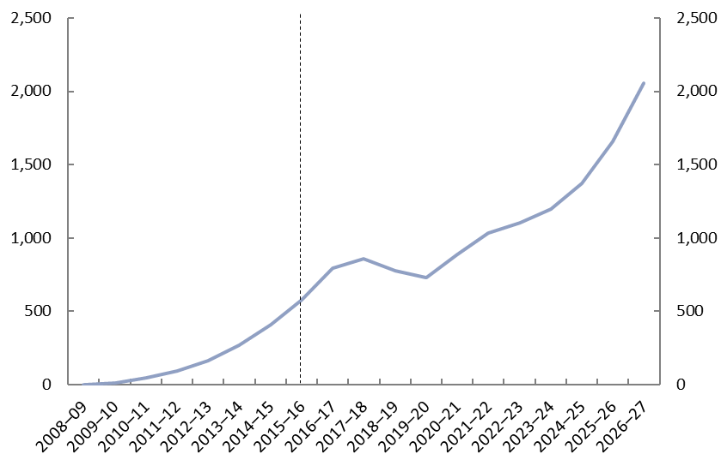

Source: PBO calculations.

In estimating the PDI cost, the PBO has assumed that:

* annual net issuance for the equity contribution is financed exclusively by 10-year CGS
* the Commonwealth’s $29.5 billion cap on equity injections is reached in 2016–17
* 10-year bond yields on CGS will remain relatively flat at 2.5 per cent to 2019–20 and then increase to 5.5 per cent by 2026–27, consistent with the approach used in the budget, and
* annual net issuance for the debt contribution over the period 2017–18 to 2020–21 is financed annually at yields on CGS of around 2.5 per cent.

There is currently no publicly available information on when NBN Co is projected to start paying dividends to the Commonwealth. If NBN Co pays dividends in the future, the dividend receipts would have a positive impact on the underlying cash balance.

## Impact on net worth

The Commonwealth’s net worth includes its equity in NBN Co. The Commonwealth’s equity in NBN Co reflects the fair value of NBN Co which comprises the Commonwealth’s accumulated equity contributions, less NBN Co accumulated losses, plus any NBN Co asset revaluations.

The fair value of the Commonwealth’s investment in NBN Co is included in the balance sheet in the budget papers. Changes in the fair value of NBN Co are included in the ‘other economic flows’ component of the operating statement in the budget papers, although they are not separately identified.[16] Changes in the fair value of NBN Co are not reflected in the fiscal or underlying cash balances.

As at 30 June 2016, the fair value of NBN Co totalled $13.1 billion, comprising accumulated Commonwealth equity contributions of $20.3 billion, less accumulated NBN Co losses of $8.3 billion, plus asset revaluations of $1.0 billion (Table 2–1 and Figure 2–2). The losses reflect the early years of the rollout of the NBN.

Table 2–1: Fair value of NBN Co ($ million)[17]

|  | 2008–09 | 2009–10 | 2010–11 | 2011–12 | 2012–13 | 2013–14 | 2014–15 | 2015–16 |
| --- | --- | --- | --- | --- | --- | --- | --- | --- |
| Accumulated equity injections | 10 | 312 | 1,362 | 2,832 | 5,228 | 8,418 | 13,185 | 20,275 |
| Accumulated total losses[18] | - | -80 | -403 | -908 | -1,811 | -3,494 | -5,477 | -8,252 |
| Accumulated valuation adjustment[19] | - | - | - | - | - | - | 793 | 1,046 |
| **Fair value** | **10** | **232** | **959** | **1,924** | **3,418** | **4,924** | **8,501** | **13,069** |

Source: NBN Co Annual Report, various years; NBN Co Corporate Plan, various years; Department of Communication and the Arts Annual Report 2015–16.

Figure 2–2: Fair value of NBN Co ($ million)

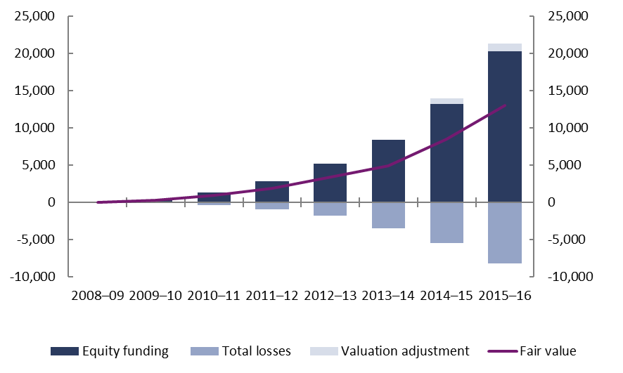

Source: NBN Co Annual Report, various years; Department of Communications and the Arts Annual Report, 2015–16.

The Government’s investment in NBN Co has resulted in a deterioration of around $8.8 billion in the Commonwealth’s net worth as at 30 June 2016. This deterioration in the Commonwealth’s balance sheet reflects the net impact of the accumulated losses and asset revaluations on NBN Co’s fair value, the accumulated cost to the Commonwealth of the PDI payments on the borrowings to support the Commonwealth’s equity and debt contributions to NBN Co, and any interest receipts from NBN Co (Table 2–2).

Table 2–2: Impact of NBN Co on Commonwealth net worth ($ million)

|  |  |  |  |  |  |  |  |  |
| --- | --- | --- | --- | --- | --- | --- | --- | --- |
|  | 2008–09 | 2009–10 | 2010–11 | 2011–12 | 2012–13 | 2013–14 | 2014–15 | 2015–16 |
| Accumulated total losses | - | -80 | -403 | -908 | -1,811 | -3,494 | -5,477 | -8,252 |
| Accumulated valuation adjustment | - | - | - | - | - | - | 793 | 1,046 |
| Accumulated PDI | - | -9 | -53 | -147 | -310 | -580 | -985 | -1,561 |
| Accumulated interest receipts[20] | - | - | - | - | - | - | - | - |
| Impact on net worth | - | -88 | -456 | -1,055 | -2,120 | -4,074 | -5,670 | -8,767 |

Source: NBN Co Annual Report, various years; NBN Co Corporate Plan, various years; Department of Communication and the Arts Annual Report 2015–16; PBO calculations.

# Budget risks

This section identifies the budget risks for the Commonwealth relating to the NBN.

## Long term value of NBN Co

The key driver of the cost to the Commonwealth of the NBN is the equity injection in NBN Co, although the provision of additional funding through a loan means that the Commonwealth’s total exposure to the NBN will reach $49 billion.

The final cost of the Commonwealth’s investment in NBN Co will not be known until NBN Co is privatised and will be dependent on the Commonwealth’s cumulative financing costs and the sale price of NBN Co. If the sale price is less than the cumulative cost of financing the Commonwealth’s investment in NBN Co up to the point of the sale, then the NBN will continue to have an enduring cost to the budget.

As outlined earlier in the paper, the Government expects that the loan to NBN Co will be refinanced on external markets in 2020–21. There is a risk that NBN Co will be unable to refinance this debt in the market at an acceptable rate.[21] If the Government decides to extend its loan, and assuming that the interest rate NBN Co is charged is above the Government’s borrowing costs, the net interest receipts from the loan would continue to have a small positive impact on the underlying cash balance for the duration of the extended loan.

The PBO has made no assessment of the impacts of potential changes in the market and technology on the long term value of NBN Co.

## Contingent liabilities

The Government has entered into agreements that may result in costs for the Commonwealth.

***NBN Co Termination Liability:*** in the event of a termination of the NBN rollout, the Government has committed to provide sufficient funds to NBN Co to meet its direct costs arising from the termination.

***Telstra Financial Guarantee:*** the Government has provided a guarantee to Telstra in respect of NBN Co’s financial obligations to Telstra. The liabilities arise progressively during the rollout of the network as infrastructure is accessed and subscribers to Telstra’s existing network are disconnected. The guarantee will terminate when NBN Co achieves specified credit ratings for a period of two continuous years and is either

* fully capitalised, or
* the Minister for Communications declares that the NBN should be treated as built and fully operational.

***Optus Financial Guarantee:*** The Government has provided a guarantee to Optus of NBN Co’s financial obligations to Optus. The guarantee will terminate in 2021. At June 2016, the guarantee was assumed to not exceed $50 million.

Table 3–1 and Figure 3–1 show the cumulative value of these contingent liabilities as at 30 June of each year.

Table 3–1: Value of contingent liabilities ($ million)

| As at 30 June: | 2013 | 2014 | 2015 | 2016 |
| --- | --- | --- | --- | --- |
| NBN Co termination liabilities | 4,300 | 6,700 | 8,500 | 10,800 |
| Telstra Financial Guarantee | 1,300 | 3,400 | 3,900 | 4,600 |
| Optus Financial Guarantee | .. | 5 | 17 | 50 |
| **Total** | **5,600** | **10,105** | **12,417** | **15,450** |

.. Not zero, but rounded to zero.

Source: Australian Government, Budget Paper No 1: Statement of Risks, various years; Department of Communications Annual Report, various years.

Figure 3–1: Value of contingent liabilities ($ million)a

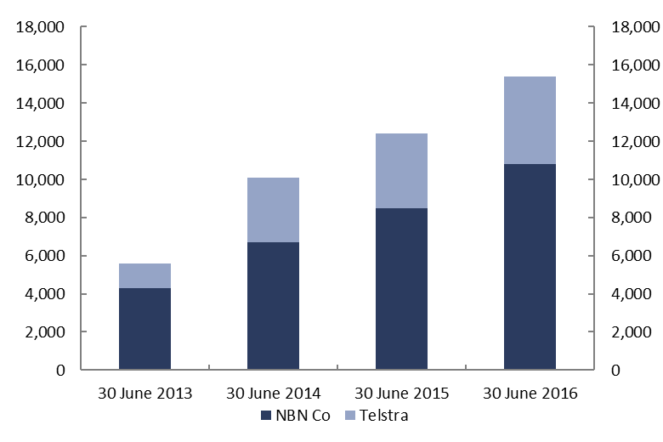

1. The Optus Financial Guarantee is assumed to not exceed $50 million as at 30 June 2016.

Source: Australian Government, Budget Paper No 1: Statement of Risks, various years; Department of Communications and the Arts Annual Report, various years.

Total contingent liabilities reached $15.5 billion as at 30 June 2016. However, the probability of these contingent liabilities materialising is considered by the Government to be very low (less than five per cent).[22] The costs of these commitments are included in Budget Paper No 1: Budget Strategy and Outlook (Statement 8: Statement of Risks).



[www.pbo.gov.au](http://www.pbo.gov.au/)

1. The announcement followed the Government’s decision to terminate the NBN Request for Proposals process on the basis of advice that none of the national proposals offered value for money.
2. Conroy, S (Minister for Broadband, Communications and the Digital Economy) and Wong, P (Minister for Finance and Deregulation) 2010, *Statement of Expectations*, Commonwealth of Australia, 17 December 2010.
3. An NBN fibre to the premises (FTTP) connection is used in circumstances where an optic fibre line runs from the nearest available fibre node to the premises. FTTP also requires an NBN network device to be installed in the premises.
4. NBN Co Limited 2010, *Corporate Plan 2011–2013*, NBN Co Ltd, Sydney. Average debt issuance per annum would be $1.9 billion over the six-year period from 2014–15 to 2020–21.
5. Ibid, p. 134.
6. Hybrid Fibre Coaxial (HFC) is used in circumstances where an existing pay TV or cable network can be used to reach premises. In this case, an HFC line runs from the nearest available fibre node to the premises.
7. NBN Co Limited 2012, *Corporate Plan 2012–15*, NBN Co Ltd, Sydney.
8. NBN Co Limited 2013, *Strategic Review*, NBN Co Ltd, Sydney.
9. Ibid, p. 68.
10. Cormann, M (Minister for Finance) and Turnbull, M (Minister for Communications) 2014, *Statement of Expectations*, Commonwealth of Australia, 8 April 2014. Fibre to the node (FTTN) connections are used in circumstances where the existing copper network can be used to make the final part of the NBN connection from a nearby FTTN (street) cabinet or micro-node to the premises. A fixed wireless connection involves data travelling from a transmission tower up to 14 kilometres from a premise to a rooftop antenna that has been fitted with an NBN installer. A satellite connection is used for connecting some remote and rural locations: a satellite dish is installed on the premises and receives the NBN network signal from a satellite.
11. NBN Co Limited 2014, *Corporate Plan 2014–17*, NBN Co Ltd, Sydney, p. 50.
12. NBN Co Limited 2013, *Strategic Review*, NBN Co Ltd, Sydney, p. 17 and p. 107.
13. NBN Co Limited 2015, *Corporate Plan 2016*, NBN Co Ltd, Sydney, p. 70.
14. NBN Co Limited 2016, *Corporate Plan 2017*, NBN Co Ltd, Sydney, p. 54.
15. Cormann, M (Minister for Finance) and Fifield, M (Minister for Communications) 2016, ‘Government loan secures NBN rollout’, *Joint Media Release,* Commonwealth of Australia, 18 November 2016
16. The fair value of the Commonwealth’s investment in NBN Co is reported in the Department of Communications and the Arts’ annual reports.
17. The remaining equity funding contribution of $9,225 million is expected to be drawn down in 2016–17, resulting in the equity capital limit of $29.5 billion being reached in that year.
18. Note that accumulated total losses equal revenue minus expenses plus ‘income tax (expense)/benefit’.
19. Department of Communications and the Arts 2016, *Annual Report 2015–16*, Communications, Canberra, p. 112. These adjustments were applied by the Department of Communications and the Arts to reflect NBN Co property, plant and equipment at fair value. The discounting of leave and superannuation liabilities was adjusted by applying the Government bond rate.
20. Interest receipts are not expected to be received by the Commonwealth until the loan starts being drawn down by NBN Co in 2017–18.
21. The Government has stated that NBN Co ‘has recently obtained strong indicative credit ratings from credit agencies, which shows that [NBN Co’s] business case is strong’. Cormann, M (Minister for Finance) and Fifield, M (Minister for Communications) 2016, ‘Government loan secures NBN rollout’, *Joint Media Release,* Commonwealth of Australia, 18 November 2016
22. Commonwealth of Australia 2015, *Consolidated Financial Statements for the year ended 30 June 2015*, Department of Finance, Canberra, p. 130.