Future Fund drawdown scenarios
Budget implications
Report no. 01/2017

© Commonwealth of Australia 2017
ISBN 978-0-9944547-9-9 (Online)
This work is licensed under the Creative Commons Attribution-NonCommercial-NoDerivs 3.0 Australia License.
The details of this licence are available on the Creative Commons website: http://creativecommons.org/licenses/by-nc-nd/3.0/au/
Use of the Coat of Arms
The terms under which the Coat of Arms can be used are detailed on the following website: www.itsanhonour.gov.au/coat-arms
Produced by: Parliamentary Budget Office
Designed by: Studio Tweed
First Assistant Parliamentary Budget Officer
Fiscal Policy Analysis Division
Parliamentary Budget Office
Parliament House
PO Box 6010
CANBERRA ACT 2600
Phone: (02) 6277 9500
Email: pbo@pbo.gov.au

Contents
Foreword iv
Overview v
1 Introduction 1
2 Future Fund drawdown scenarios 2
2.1 Draw down from 1 July 2020 2
2.2 Draw down when Future Fund assets offset the unfunded superannuation liability (2024–25) 4
2.3 Budget implications 5
2.4 Sensitivity of the projections to assumptions 7
Appendix A 10

Foreword
The Future Fund was established to strengthen the Commonwealth’s long-term financial position by making provision for the unfunded superannuation liabilities of Commonwealth employees.
This paper discusses scenarios for the drawdown of funds from the Future Fund to meet unfunded superannuation cash payments, and the budget implications of those scenarios.
I would like to thank the PBO staff involved in the preparation of the report, namely Tim Pyne, Paul Gardiner, Lok Potticary and Vijay Murik. The report was prepared for publication by Helen Seisun.
Phil Bowen PSM FCPA
Parliamentary Budget Officer
8 February 2017

Overview
The Future Fund was established in May 2006 to strengthen the Commonwealth’s long-term financial position by making provision for unfunded superannuation liabilities of Commonwealth employees that will become payable during a period when an ageing population is likely to place significant pressure on the Commonwealth’s finances.
The Future Fund Act 2006 allows the Future Fund to be drawn down by the Government to cover unfunded superannuation cash payments from whichever is the earlier of:
- the time when the balance of the Fund is greater than or equal to the target asset level (that is the amount that is expected to offset the present value of projected unfunded superannuation liabilities), or
- 1 July 2020.
As at February 2017, the Government has not announced when or to what extent it proposes to draw down on the Future Fund. The 2016–17 Mid-Year Economic and Fiscal Outlook (MYEFO) is based on the technical assumption that the Fund will be drawn down to the maximum extent permissible from 1 July 2020.
If the Government decides to draw down the Future Fund from 1 July 2020 to meet its unfunded superannuation liabilities, assuming the Future Fund continues to meet its target investment return, the PBO projects that the assets of the Future Fund would be exhausted by 2052–53 while, based on official projections, the Government’s unfunded superannuation liability would stand at $249.0 billion. If the Future Fund’s investment returns were to be lower than assumed in the PBO’s analysis, under the 1 July 2020 drawdown scenario the assets of the Fund would be exhausted sooner than 2052–53.
If the Government chooses to defer drawdowns from the Future Fund until the value of the Fund is sufficient to offset the Government’s unfunded superannuation liability, the PBO projects that the Fund would meet the annual unfunded superannuation payments on an ongoing basis. This would be achieved by deferring drawdowns until 2024–25 based on the Fund meeting its target investment return over the projection period.
Assuming the Fund continues to meet its target rate of return, the PBO projects that deferring drawdowns from the Fund until 2024–25 would result in the Commonwealth’s net financial worth being 3¾ per cent of GDP higher by 2054–55, compared to the 1 July 2020 drawdown scenario. Net financial worth includes all of the Government’s financial assets and liabilities, unlike net debt which excludes the Future Fund’s unrealised equity investments and the Government’s unfunded superannuation liability.
The PBO’s analysis is based on the central assumption that the Future Fund’s investment returns will continue to exceed the Government’s cost of borrowings. If, due to a less favourable investment climate, Future Fund investment returns were lower than assumed in the analysis, drawdowns from the Fund would need to be deferred further in order for the Fund to be sufficient to offset the unfunded superannuation liability and meet the annual unfunded superannuation payments on an ongoing basis. In these circumstances, provided the Future Fund’s investment returns continue to exceed the Government’s cost of borrowing, deferral of drawdowns would still improve the Commonwealth’s net financial worth.
Greater exposure to financial markets under a deferred drawdown policy could result in some increased short-term volatility in the budget aggregates. In the longer term the matching of the long-term Future Fund asset with the long-term unfunded superannuation liability could be expected to benefit the Commonwealth’s net financial worth.

Introduction
The Future Fund was established in May 2006 to strengthen the Commonwealth’s long-term financial position by making provision for unfunded superannuation liabilities of Commonwealth employees that will become payable during a period when an ageing population is likely to place significant pressure on the Commonwealth’s finances.
From its inception to 30 June 2016 the Future Fund’s annualised investment return has averaged 7.7 per cent, comparing favourably with its long-term target return of at least CPI plus 4.5 to 5.5 per cent.
As at 30 June 2016, the Future Fund was valued at $122.8 billion comprising $60.5 billion of contributions from the Government and $62.3 billion of investment returns (Appendix A1). The Commonwealth’s unfunded superannuation liability as at 30 June 2016 stood at $169.1 billion and is projected to peak at $283.5 billion in 2040–41 (Appendix A2).
The Future Fund Act 2006 allows the Fund to be drawn down to fund unfunded superannuation cash payments from whichever is the earlier of:
- the time when the balance of the Fund is greater than or equal to the target asset level (that is the amount that is expected to offset the present value of projected unfunded superannuation liabilities), or
- 1 July 2020.
The purpose of this report is to analyse the impact of the timing of drawdowns from the Future Fund on the Commonwealth’s balance sheet, with a particular focus on the Commonwealth’s net financial worth rather than net debt.
Net financial worth is a comprehensive measure of the strength of the Government’s financial position. It includes all of the Government’s financial assets and liabilities, including the value of the Future Fund and the unfunded superannuation liability. Net debt on the other hand excludes the Future Fund’s equity investments and the Government’s unfunded superannuation liability.

Future Fund drawdown scenarios
This chapter considers two drawdown scenarios:
- draw down from 1 July 2020
- draw down from when the Future Fund assets are projected by the PBO to be sufficient to offset the unfunded superannuation liability.
Under each scenario the PBO has used the official projections of the Government’s unfunded superannuation liability and cost of borrowing.
The PBO has assumed that:
- the Future Fund continues to achieve the midpoint of its mandated target return, namely CPI plus 5 per cent annually (over the long term this assumption implies that the Future Fund’s annual return of 7½ per cent is 1½ per cent above the Government’s assumed long-term cost of borrowing, which is 6 per cent)
- no further contributions are credited to the Fund by the Government
- the amount drawn down each year meets in full the unfunded cash superannuation payments that fall due within that year, consistent with the technical assumption in the 2016–17 MYEFO.
Further details of the modelling assumptions and methodology used by the PBO are at Appendix A3. A discussion of the sensitivity of the projections to underlying assumptions is at section 2.4 below.

Draw down from 1 July 2020
This scenario is consistent with the technical assumptions underpinning the medium-term projections of budget aggregates presented in the 2016–17 Mid-Year Economic and Fiscal Outlook (MYEFO) and the long-term projections in the 2015 Intergenerational Report. As at February 2017, the Government has not yet announced when the Fund will be drawn down or the magnitude of the drawdowns.
Under this scenario, the assets of the Future Fund are projected to be exhausted by
2052–53, while the Government’s unfunded superannuation liability is projected to be $249.0 billion with annual unfunded superannuation payments of $21.4 billion at that time (Figure 2–1).
The decline in the value of the Fund is driven by the fact that investment returns after accounting for costs are outstripped by drawdown cash outflows from around 2032 (Figure 2–2).
Figure 2–1: Future Fund assets and unfunded superannuation liability projections—2020–21 drawdowns
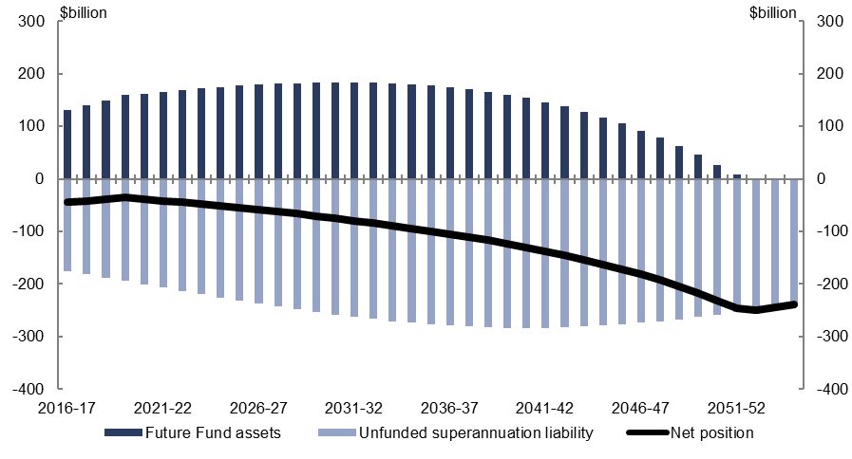
Source: Treasury data, Department of Finance data, PBO analysis.
Figure 2–2: Annual Future Fund net returns and unfunded superannuation liability payments—2020–21 drawdowns
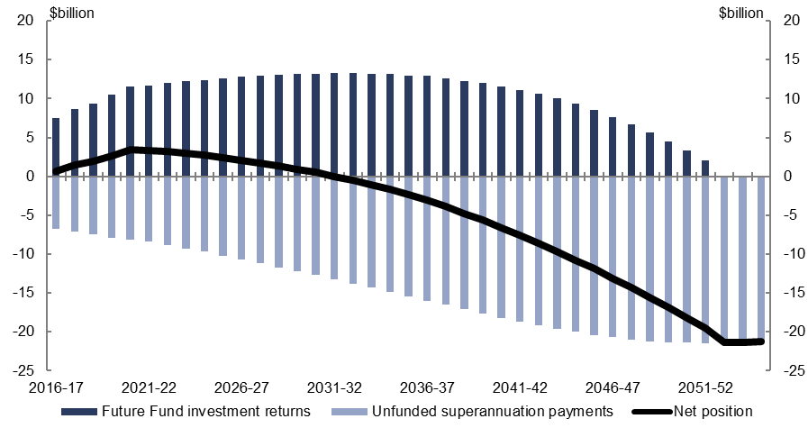
Source: Treasury data, Department of Finance data, PBO analysis.

Draw down when Future Fund assets offset the unfunded superannuation liability (2024–25)
The PBO projects that if the Future Fund drawdowns did not commence until 2024–25, the value of the Future Fund would be sufficient to offset the Government’s unfunded superannuation liability and meet the annual unfunded superannuation payments on an ongoing basis (Figure 2–3).
Figure 2–3: Future Fund assets and unfunded superannuation liability projections—2024–25 drawdowns
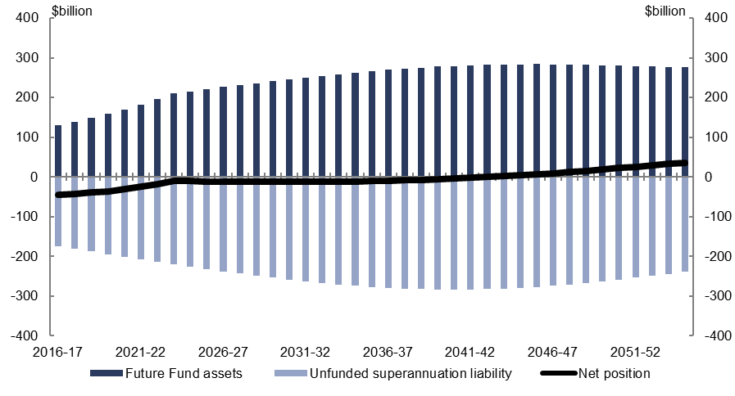
Source: Treasury data, Department of Finance data, PBO analysis.
Figure 2–4: Annual Future Fund net returns and unfunded superannuation liability payments—2024–25 drawdowns
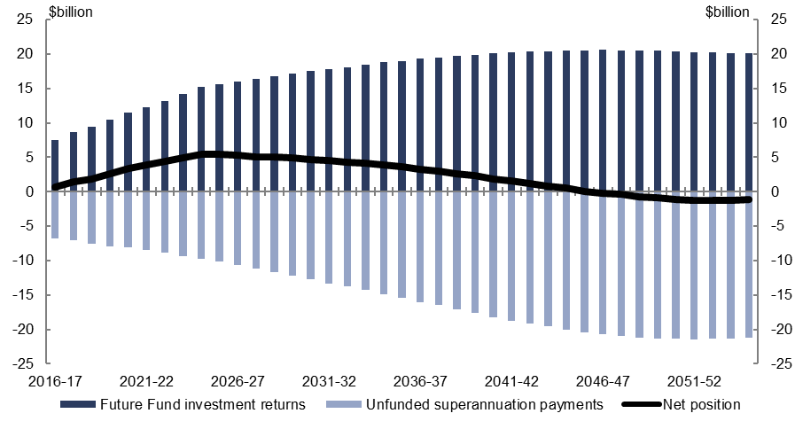
Source: Treasury data, Department of Finance data, PBO analysis.
The additional four years of accumulating returns under the deferred drawdown scenario enables the Future Fund to grow sufficiently to allow ongoing drawdowns for unfunded superannuation cash payments out of its investment returns (Figure 2–4).
Under this scenario, the Future Fund is projected to maintain an ongoing positive balance. In particular, the PBO projects that the Future Fund would have a positive balance once the unfunded superannuation liability arising from the closed civilian and military schemes is largely extinguished, around the year 2100.
This is because the residual value of the Fund that persists once the vast majority of unfunded superannuation cash payments are met is expected to continue to grow annually at the mandated target return. As current legislation does not allow drawdowns for purposes other than meeting payments relating to unfunded superannuation liabilities, if this scenario arose, it would be a matter for future governments to amend the legislative framework in order to decide the timing and application of the drawdown of this residual balance.

Budget implications
This section examines the impact of the drawdown scenarios on the Commonwealth’s fiscal and underlying cash balances, the Commonwealth’s net debt and the Commonwealth’s net financial worth.
To assess the budget implications of the two drawdown scenarios discussed in the previous sections, the PBO prepared long-term budget projections of the scenarios. The long-term projections were prepared by modifying the latest available long-term budget projections—the 2015 Intergenerational Report “currently legislated baseline”—to include the PBO’s Future Fund projections, and also the 2016–17 MYEFO unfunded superannuation projections. Of the three projection baselines included in the 2015 IGR, the currently legislated baseline provides the closest approximation of current policy settings as at the 2016–17 MYEFO.

Budget accounting treatment of the Future Fund
The Future Fund forms part of the Australian Government general government sector and its activities impact on the budget balances and the Government’s balance sheet.
The Future Fund’s net investment returns comprise realised gains from interest revenues and dividends, as well as unrealised capital gains, less management expenses. Each of these components, except for unrealised capital gains, are expected to impact on the Commonwealth’s fiscal and underlying cash balances from 2020–21 onwards, when the Fund becomes available to meet payments for unfunded superannuation liabilities. Over the years from 2016–17 to 2019–20, the Future Fund does not have any impact on the Commonwealth’s underlying cash balance.
The accumulated value of the Future Fund is included in the Commonwealth’s balance sheet as part of the Commonwealth’s net financial worth. Net financial worth includes all of the Commonwealth’s financial assets and liabilities, including the unfunded superannuation liability.
Net financial worth is a broader measure of fiscal sustainability than net debt. Net debt includes the interest bearing assets of the Future Fund but excludes the Commonwealth’s unfunded superannuation liability and the equity-like assets of the Future Fund.

Underlying cash balance and fiscal balance
The 2024–25 drawdown scenario results in slightly lower underlying cash and fiscal balance projections over the long-term relative to the 2020–21 drawdown scenario. The underlying cash and fiscal balance impacts of the deferred drawdown scenario is estimated by the PBO to be less than 0.1 per cent of GDP in any given year over the projection period.
The lower underlying cash and fiscal balances under the deferred drawdown scenario results from the cash returns on the Fund (dividend and interest receipts) being outweighed by the higher borrowing costs to finance unfunded superannuation cash payments over the period from 2020–21 to 2023–24. This arises because a large proportion of the investment return on the fund is in the form of unrealised capital gains that do not impact on the underlying cash or fiscal balances.

Net debt
The 2024–25 drawdown scenario results in higher net debt projections than the 2020–21 drawdown scenario because there is a need for additional borrowings in the period 2020–21 to 2023–24 to finance the annual unfunded superannuation payments pending the drawdowns from the Future Fund.
Net debt is projected to be up to 1¾ per cent of GDP higher throughout the period from 2016–17 to 2054–55 under the 2024–25 drawdown scenario compared to the 2020–21 drawdown scenario. The higher amount of debt being issued under the later drawdown scenario is only partially offset by the higher balances on non-equity-like assets in the Future Fund, leading to an increase in net debt under this scenario. However, this highlights the limitations of net debt as a measure for evaluating the budget implications of drawdown scenarios—net debt does not include the returns on equity-like assets in the Future Fund, which are higher in the later drawdown scenario.

Net financial worth
Net financial worth is projected to be higher under the 2024–25 drawdown scenario compared to the 2020–21 drawdown scenario (Figure 2–5). Net financial worth is projected to be higher by 3¾ per cent of GDP by 2054–55.
Figure 2–5: Net financial worth projections
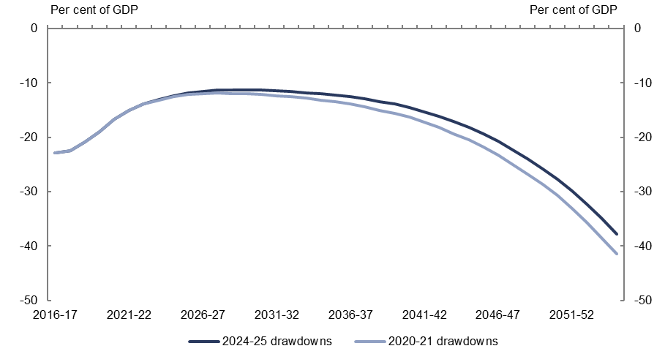
Source: Treasury data, PBO analysis.
The later drawdowns result in higher Fund balances from 2020–21. Although this scenario requires unfunded superannuation cash payments to be financed by additional borrowings over the period 2020–21 to 2023–24, net financial worth is improved because the investment returns on the higher Fund balances exceed the additional borrowing costs. As such, the Fund’s asset balance outweighs the additional stock of debt incurred in financing unfunded superannuation cash payments, thereby improving net financial worth.
In summary, drawing down later on the Future Fund is projected to strengthen the Government’s financial position over the long term. Drawing down later is estimated to result in projections of the Future Fund’s balance that are sufficient to offset the Government’s unfunded superannuation liability and meet the annual unfunded superannuation payments on an ongoing basis.

Sensitivity of the projections to assumptions
The PBO’s analysis is based on the official projections of the Government’s unfunded superannuation liability and the central assumption that the Future Fund’s investment returns will continue to exceed the Government’s cost of borrowings.
If, due to a less favourable investment climate, Future Fund investment returns were lower than assumed in the analysis, drawdowns from the Fund would need to be deferred further in order for the Fund to be sufficient to offset the unfunded superannuation liability and meet the annual unfunded superannuation payments on an ongoing basis. In these circumstances, provided the Future Fund’s investment returns continued to exceed the Government’s cost of borrowing, deferral of drawdowns would still improve the Commonwealth’s net financial worth.
Greater exposure to financial markets under a deferred drawdown policy could result in some increased short-term volatility in the budget aggregates. In the longer term the matching of the long-term Future Fund asset with the long-term unfunded superannuation liability could be expected to benefit the Commonwealth’s net financial worth.

Sensitivity analysis: Lower investment returns
The sensitivity analysis in this section uses the assumption that the Future Fund achieves an annual return that is one percentage point lower than the midpoint of its mandated target return, namely CPI plus 4 per cent annually, with interest rates on Commonwealth Government Securities held consistent with the assumptions used in the 2015 IGR. This focuses the sensitivity analysis on Fund performance relative to the risk-free benchmark Commonwealth Government Securities yield curve.
Under the lower return assumption and assuming drawdowns from 2020–21, the value of the Future Fund is projected to be exhausted by 2044–45, which is around eight years earlier than the case of the original return assumption. This is again well before the Fund is large enough to offset the Government’s unfunded superannuation liability. The lower value of the Fund is driven by the fact that the assumed lower investment returns are outstripped by drawdown cash outflows from around 2026–27.
Under the lower return assumption, the PBO projects that the value of the Future Fund would be sufficient to offset the Government’s unfunded superannuation liability over the remainder of the projection period if the Future Fund drawdowns did not commence until
2029–30. The additional years of accumulating returns would enable the Future Fund to grow sufficiently to cover drawdowns to meet unfunded superannuation cash payments out of its investment returns.
Under the lower returns assumption, deferring commencement of drawdowns until 2029–30 is projected to result in net financial worth being higher by 1 per cent of GDP by 2054–55. This increase in net financial worth from deferring drawdowns is not as large as under the original return assumptions as outlined in section 2.3.4. This is because the difference between the returns on the Fund and the Government’s borrowing costs are smaller.
This sensitivity analysis of returns shows that it is still possible for the Fund to offset the unfunded superannuation liability if it achieves a return that is lower than its current mandated investment target, but that this can only be achieved by further pushing back the commencement date of drawdowns from the Fund. It also demonstrates that the size of the positive impact of delaying drawdowns on the Future Fund (as measured by the impact on net financial worth) is dependent on the Fund’s ability to continue to deliver returns materially above the Government’s cost of borrowing over the long run.

Appendix A

Future Fund performance
As at 30 June 2016, the Future Fund was valued at $122.8 billion (Figure A‒1). This included $60.5 billion of contributions from the Government and $62.3 billion of investment returns.
Figure A‒1: Future Fund balance since inception
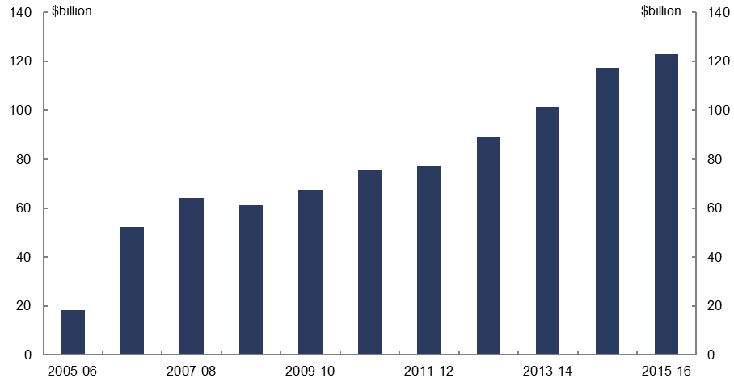
Source: Department of Finance.
Over the period from the Fund’s inception to 30 June 2016, the Fund’s annualised investment return was 7.7 per cent. The minimum of the target return mandate of CPI plus 4.5 per cent equated to 6.9 per cent annualised over the same period. Hence, as at 30 June 2016, the Fund achieved its mandated return target over the long-term (which the Future Fund Management Agency interprets as rolling 10 year periods). On an annual basis, the Fund has generally outperformed a return equivalent to CPI plus 4.5 per cent, but there have been years where the Fund did not meet this return level, typically due to volatile financial market conditions (Figure A‒2).
Figure A‒2: Future Fund annual returns and target returns since inception
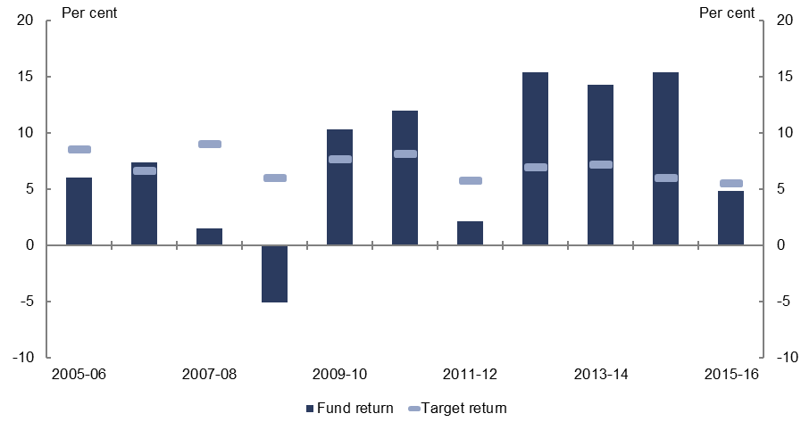
Source: Department of Finance.
As at 30 June 2016, the Fund had about 40 per cent of its assets in equity-like asset classes, 35 per cent in debt and cash, and the remainder in infrastructure, property and alternatives. As the various asset classes within the Fund’s portfolio typically exhibit different risk-return characteristics, the Fund’s asset allocation is a key determinant of both the Fund’s performance and its total portfolio risk.
The Fund’s asset allocation balances exposures to higher risk asset classes such as equities (which tend to have relatively higher expected returns), with lower risk asset classes such as bonds and cash (which tend to have relatively lower expected returns), thereby calibrating a level of total portfolio risk judged appropriate to best position the Fund to achieve its investment mandate over the long term. The Future Fund’s asset allocation is reviewed and adjusted through time with respect to its investment objective and risk tolerance in the context of financial market developments.
The asset allocation also supports the liquidity management of the Fund. When the Government decides to draw down on the Fund, the Fund will need to decide which of its holdings to liquidate. This in turn will have broader implications for the performance and risk profile of the Fund.

Unfunded superannuation liability
The unfunded superannuation liability as projected by the Department of Finance remains a significant liability of the Government over the long term. The value of the superannuation liability is projected to peak around 2040 and is still significant well beyond this point (Figure A‒3).
As all large civilian and military schemes are closed to new participants, the projected growth in the liability is caused by the accrual of benefits to members according to their tenure of service, retirement decisions and life expectancy. The valuation of the civilian schemes peaks in the mid-2030s and decreases after this time as the number of beneficiaries declines.
The military schemes are projected to continue to grow all the way to 2054–55, albeit at a slowing rate, given the later closure date of the Military Superannuation Benefits Scheme and the resulting younger age profile of participants in the military schemes relative to those of the civilian schemes.
Figure A‒3: Unfunded superannuation liability projections
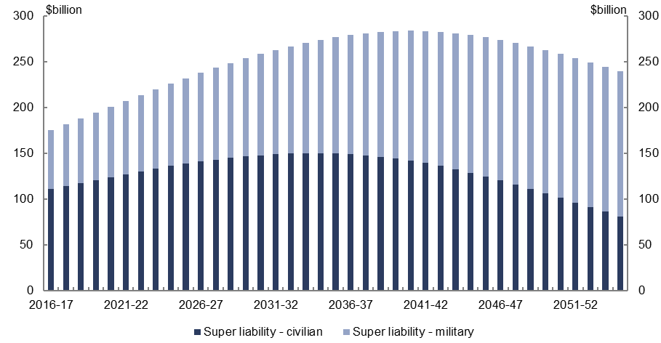
Source: Department of Finance.
Cash payments to superannuation recipients are also projected to grow according to the projected retirement decisions and life expectancy of scheme participants (Figure A‒4).
Projected cash payments peak around 2050, which is around 10 years later than the peak of the liability profile. The later timing of the peak in cash payments is due to the accrued benefits being recognised for scheme participants during their working lives, whereas those benefits are realised as cash payments only after their retirement.
Figure A‒4: Unfunded superannuation liability payment projections
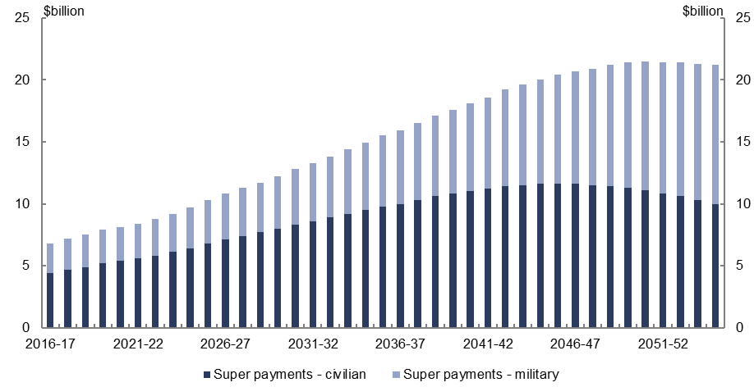
Source: Department of Finance.

Modelling assumptions
The long-term superannuation projections used in this report were provided to the PBO by the Department of Finance.
To project the Future Fund return and asset size, the PBO has made assumptions about expected returns (Table A‒1), and assumes that each year the Fund meets the mid-point of the mandated target return: annual CPI inflation plus five per cent.
Assumptions around interest income on the cash and debt asset classes, and dividend yields are consistent with those used in the 2016–17 MYEFO. The assumed asset allocation of the Fund is consistent with the forward estimates and medium-term assumptions in the
2016–17 MYEFO, and the medium-term asset allocation is assumed to be kept constant until the end of the long-term projection period in 2054–55.
Drawdowns are made from the cash asset class, and Fund portfolio weights are rebalanced according to the assumed asset allocation of the Fund, with the residual net cash flows in each asset class (after accounting for interest receipt and dividend receipt earnings and rebalancing) treated as capital gains. Expenses are a fixed proportion of Fund assets, and are deducted from the cash asset class each year.
Projections of the Government’s cost of borrowing in this report are based on Commonwealth Government Securities yield curve assumptions from the 2015 IGR. Consistent with the 2015 IGR and the 2016–17 MYEFO the long-term yield on 10-year Commonwealth Government Securities is 6 per cent.
Table A‒1: Future Fund technical assumptions
 | 2016–17 to 2019–20,  per cent | 2020–21 to 2054–55,  per cent
Expected gross nominal return | 6.90 | 7.50
Average annual CPI inflation | 1.90 | 2.50
Expected gross real return | 5.00 | 5.00
Assumed expenses | 0.26 | 0.26
Expected net real return | 4.74 | 4.74
Source: Department of Finance, Parliamentary Budget Office analysis.

www.pbo.gov.au

The 2015 Intergenerational Report (IGR) projects the balance of the Future Fund to be depleted by around the late-2040s as a result of drawdowns made from the Fund from 2020 (p 86). The 2015 IGR was released in March 2015. The projection of the Fund being depleted at a later date in this report relative to the 2015 IGR is a result of updated information on the Future Fund’s performance over the period from March 2015 through to the 2016–17 MYEFO.
Over the long term, this assumption implies that the Future Fund’s annual return of 6½ per cent is ½ percentage points above the Government’s assumed long-term cost of borrowing of 6 per cent.
There is a nexus between the investment returns earned by the Future Fund and financial market conditions, and the broader economy. As such, if nominal Future Fund returns are lower, it is likely that the Government’s borrowing costs and inflation will also be lower. The PBO has kept borrowing costs and inflation constant in this sensitivity analysis to emphasise the performance of the Future Fund relative to the Government’s borrowing costs as the key determinant of the Fund’s impact on net financial worth.
As with the later drawdown scenario considered in the previous section, under the lower returns scenario the Fund will still remain with a positive balance once the Government’s unfunded superannuation liability arising from the closed civilian and military schemes is extinguished, if drawdowns commence in 2029–30.
Future Fund Annual Report 2015–16, p 32.
For further details of the actuarial analysis underpinning these projections, see the Long Term Cost Reports released by Mercer for the civilian schemes and by the Australian Government Actuary for the military schemes. The latest releases of both reports were in 2014.

