2015–16 Mid-Year Economic and Fiscal Outlook — charts
A graphical summary of the 2015–16 MYEFO relative to the 2015–16 Budget, showing the impacts of policy decisions and other factors
Date issued: 13 January 2016

© Commonwealth of Australia 2016
ISBN 978-0-9944547-1-3 (Online)
This work is licensed under the Creative Commons Attribution-NonCommercial-NoDerivs 3.0 Australia License.
The details of this licence are available on the Creative Commons website: http://creativecommons.org/licenses/by-nc-nd/3.0/au/
Use of the Coat of Arms
The terms under which the Coat of Arms can be used are detailed on the following website: www.itsanhonour.gov.au/coat-arms
Produced by: Parliamentary Budget Office
Designed by: Studio Tweed
Assistant Parliamentary Budget Officer
Fiscal Policy Analysis Division
Parliamentary Budget Office
Parliament House
PO Box 6010
CANBERRA ACT 2600
Phone: (02) 6277 9500
Email: pbo@pbo.gov.au

Contents
Notes 1
Underlying cash balance 2
Total receipts 3
Total payments 4
Revenue – individuals and other withholding taxes 5
Revenue – company tax 6
Revenue – goods and services tax 7
Revenue – excise and customs duties 8
Revenue – non-tax revenue 9
Expenses – Age Pension 10
Expenses – Family Tax Benefit 11
Expenses – Disability Support Pension 12
Expenses – aged care 13
Expenses – job seeker income support 14
Expenses – income support for carers 15
Expenses – child care fee assistance 16
Expenses – parents’ income support 17
Expenses – Medicare Benefits Schedule 18
Expenses – assistance to the states and territories for public hospitals 19
Expenses – pharmaceutical benefits 20
Expenses – private health insurance rebate 21
Expenses – National Disability Insurance Scheme 22
Expenses – schools 23
Expenses – higher education 24
Defence (expenses and net capital investment) 25
Expenses – public debt interest 26
Expenses – public sector superannuation 27
Expenses – road and rail infrastructure 28
Expenses – Official Development Assistance 29

Notes
These charts provide a visual summary of the key drivers of the 2015–16 Mid-Year Economic and Fiscal Outlook (MYEFO), and the policy decisions underpinning them.
Data contained in these charts are primarily based on information published in the
2015–16 MYEFO, as well as the 2015–16 Budget, the 2014–15 Final Budget Outcome and government agency annual reports. Where applicable, additional information provided by the Treasury and the Department of Finance (Finance) has supplemented the publicly available information.
The charts prepared at the aggregate level for the underlying cash balance, total receipts, and total payments have all been prepared on a cash basis. Charts on revenue heads and selected programs are prepared on an accruals basis, consistent with the presentation of decisions in the MYEFO papers.
Consistent with MYEFO, the charts show the financial impact of policy decisions up to and including 2018–19. The charts show movements due to parameter and other variations since the 2015–16 Budget (Budget), which are available for the 2015–16 to 2018–19 years. Where there are differences between the 2014–15 estimate (as at the 2015–16 Budget) and the actual outcome for 2014–15 (as per the 2014–15 Final Budget Outcome) these have also been highlighted.
The PBO does not have access to the details of provisions for individual items in the Contingency Reserve. Accordingly, the charts in this report are subject to the qualification that they are prepared in the absence of information on the possible impact of any provisions in the Contingency Reserve.

Underlying cash balance
Figure 1: Underlying cash balance – change from 2015–16 Budget to 2015–16 MYEFO estimates
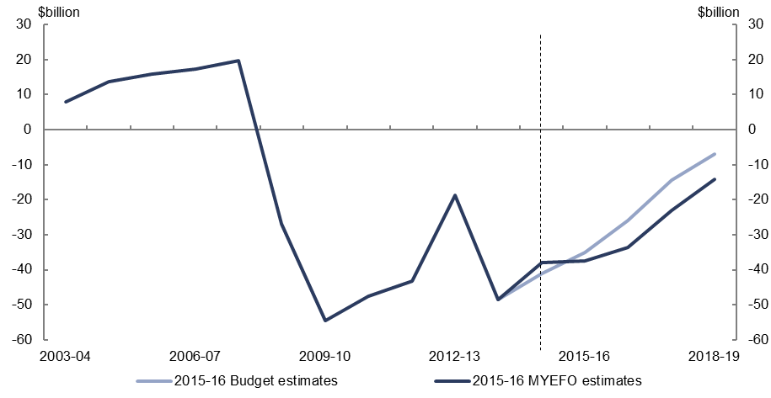
Figure 2: Underlying cash balance – change from 2015–16 Budget to 2015–16 MYEFO estimates by measures and other variations 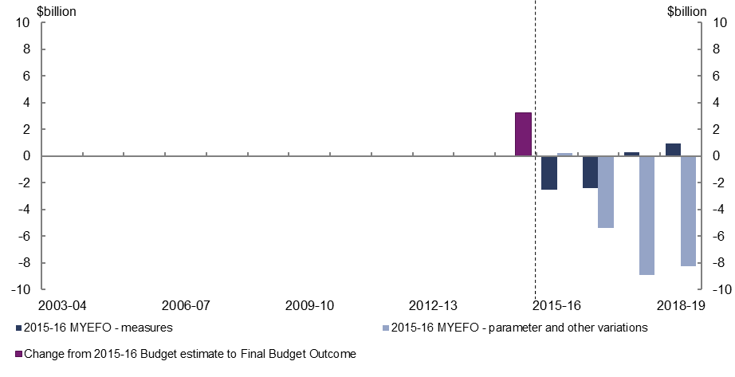
- Policy decisions are expected to decrease the underlying cash balance by $3.7 billion over the four years to 2018–19, relative to the 2015–16 Budget.
- Parameter and other variations are expected to decrease the underlying cash balance by $22.3 billion over the four years to 2018–19, relative to the 2015–16 Budget.

Total receipts
Figure 3: Total receipts – change from 2015–16 Budget to 2015–16 MYEFO estimates
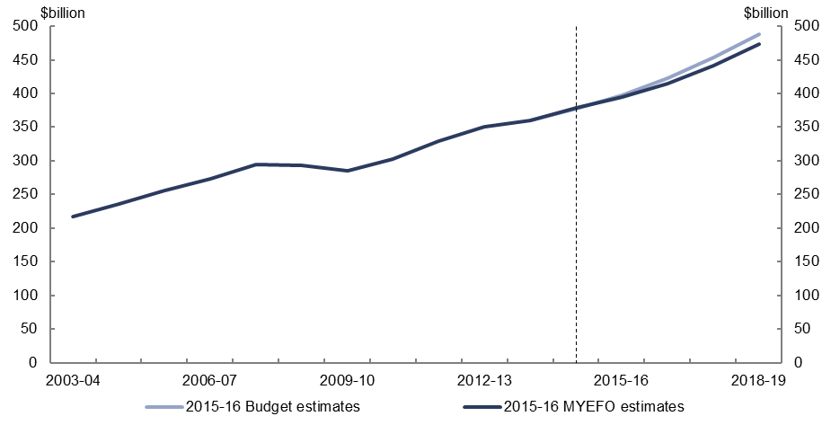
Figure 4: Total receipts – change from 2015–16 Budget to 2015–16 MYEFO estimates by measures and other variations
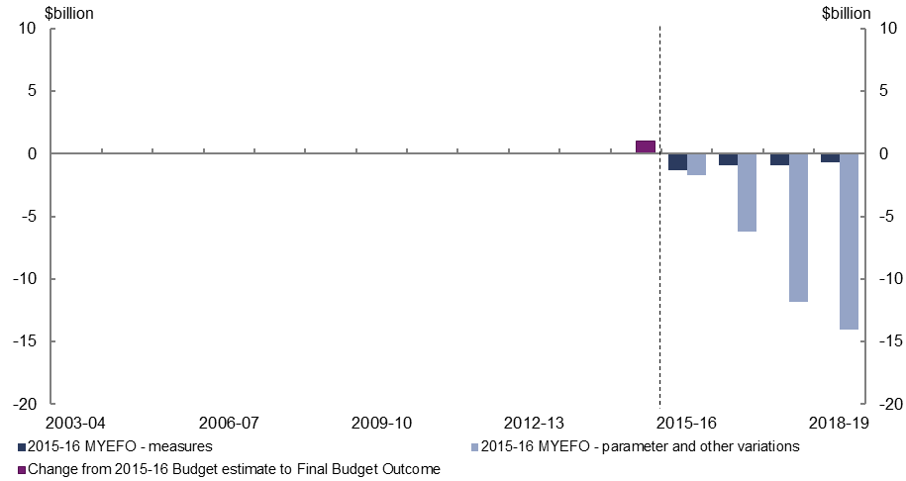
- Relative to the 2015–16 Budget, policy decisions are expected to decrease total receipts by $3.8 billion over the four years to 2018–19, with reduced tariff receipts associated with the China-Australia Free Trade Agreement ($4.2 billion) and not proceeding with the Financial Stability Fund ($1.5 billion), being only partially offset by increased receipts from States for the National Disability Insurance Scheme ($1.3 billion) and the delay of higher education reforms ($0.6 billion).
- Parameter and other variations are expected to decrease total receipts by $33.8 billion over the four years to 2018–19, relative to the 2015–16 Budget, largely driven by falls in commodity prices, a weaker outlook for incomes growth (due in part to lower projected population growth) and weaker equity markets impacting capital gains tax.

Total payments
Figure 5: Total payments – change from 2015–16 Budget to 2015–16 MYEFO estimates
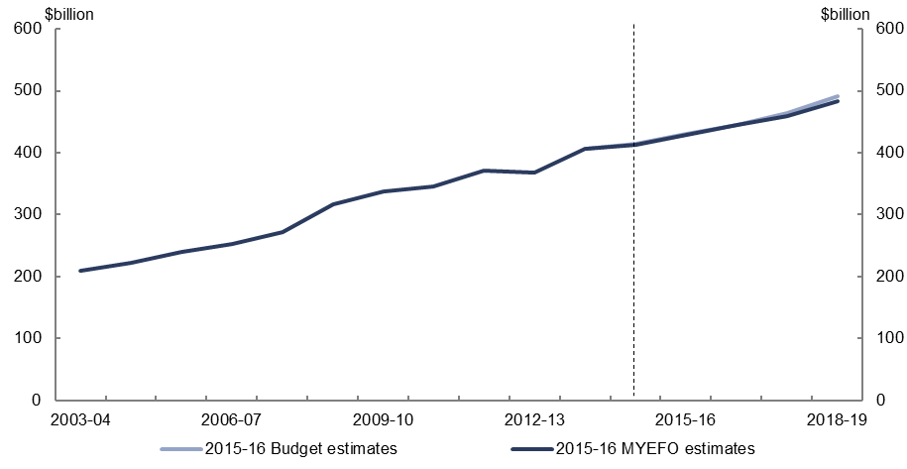
Figure 6: Total payments – change from 2015–16 Budget to 2015–16 MYEFO estimates by measures and other variations
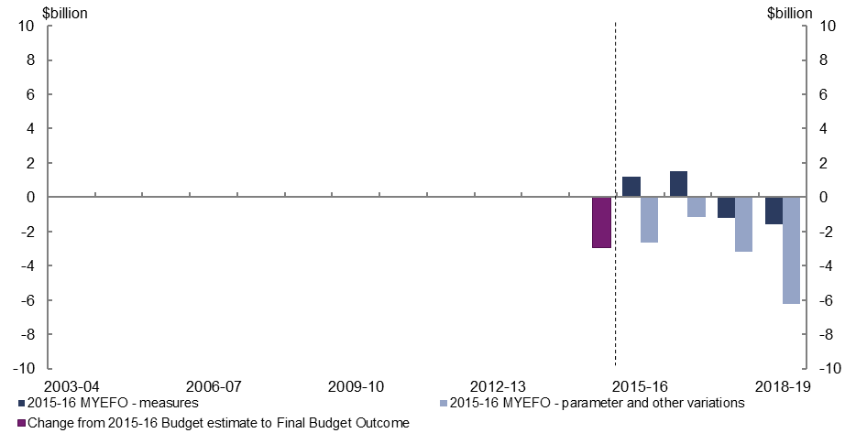
- Relative to the 2015–16 Budget, policy decisions are expected to decrease total payments by $0.1 billion over the four years to 2018–19, with increased payments for infrastructure investment ($0.9 billion) and Australia’s humanitarian program ($0.9 billion), broadly offset by a reduction in payments associated with increased compliance activity for welfare payments ($1.2 billion) and tightening eligibility for child care fee assistance for family day care educators ($0.9 billion).
- Parameter and other variations are expected to decrease total payments by $13.2 billion over the four years to 2018–19 largely reflecting lower than expected average payment rates and recipient numbers across a number of expense programs, partially offset by an increase in Public Debt Interest.

Revenue – individuals and other withholding taxes
Figure 7: Revenue – individuals and other withholding taxes – change from 2015–16 Budget to 2015–16 MYEFO estimates
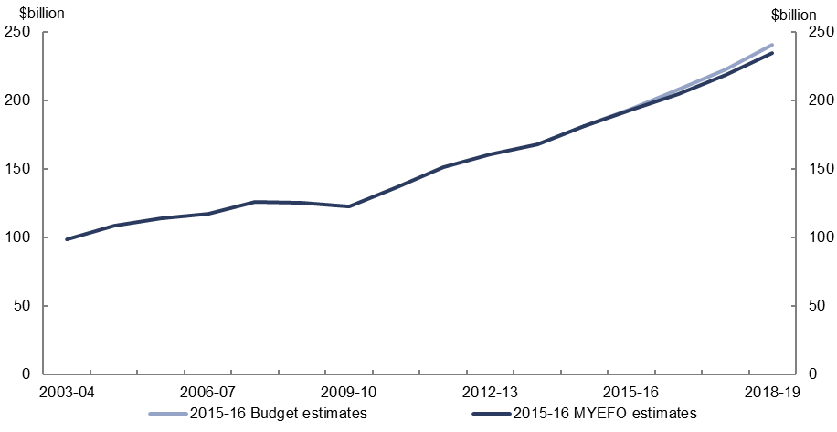
Figure 8: Revenue – individuals and other withholding taxes – change from 2015–16 Budget to 2015–16 MYEFO estimates by measures and other variations
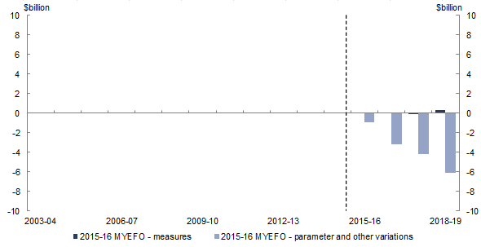
- Relative to the 2015–16 Budget, policy decisions are expected to increase individuals and other withholding tax revenue by $0.3 billion over the four years to 2018–19.
- Parameter and other variations are expected to decrease individuals and other withholding tax revenue by $14.4 billion over the four years to 2018–19, relative to the 2015–16 Budget, largely reflecting the weaker outlook for incomes growth (due in part to lower projected population growth).

Revenue – company tax
Figure 9: Revenue – company tax – change from 2015–16 Budget to 2015–16 MYEFO estimates
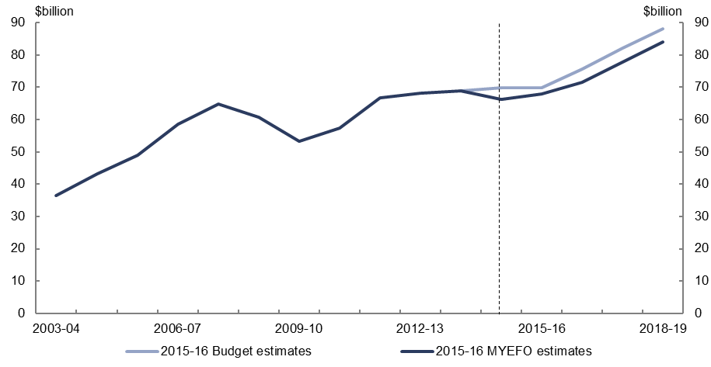
Figure 10: Revenue – company tax – change from 2015–16 Budget to 2015–16 MYEFO estimates by measures and other variations
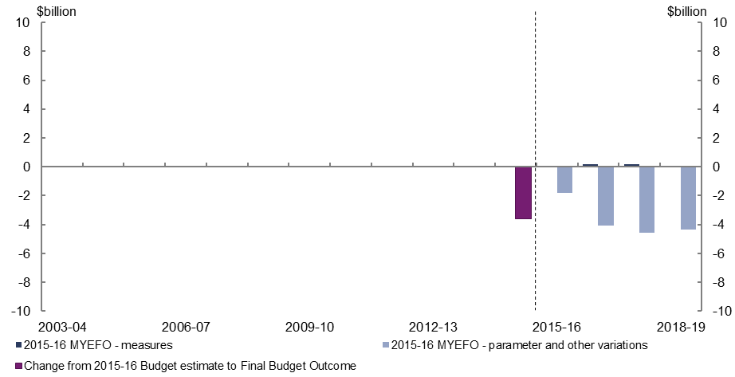
- Relative to the 2015–16 Budget, policy decisions are expected to increase company tax revenue by $0.4 billion.
- Parameter and other variations are expected to decrease company tax revenue by $14.8 billion over the four years to 2018–19, relative to the 2015–16 Budget, largely reflecting the impact of lower commodity prices.

Revenue – goods and services tax
Figure 11: Revenue – goods and services tax – change from 2015–16 Budget to
2015–16 MYEFO estimates
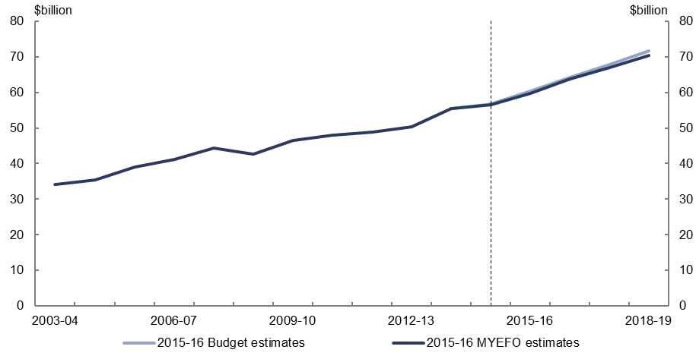
Figure 12: Revenue – goods and services tax – change from 2015–16 Budget to
2015–16 MYEFO estimates by measures and other variations
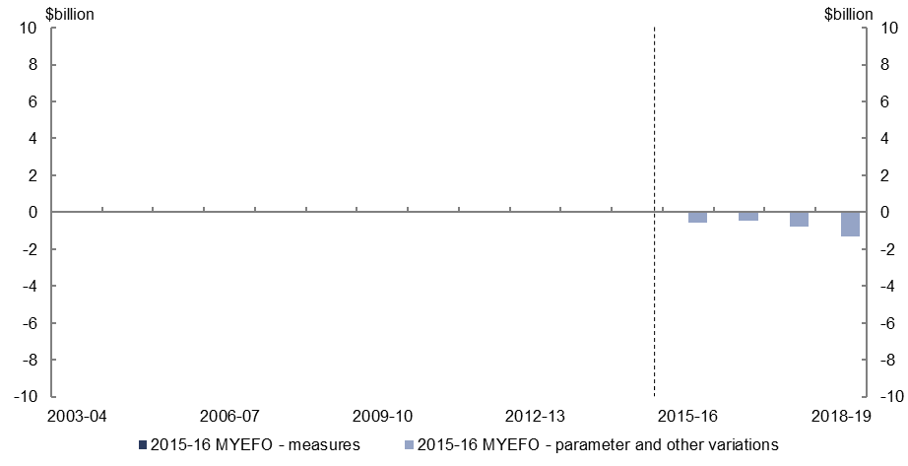
- Parameter and other variations are expected to decrease goods and services tax revenue by $3.1 billion over the four years to 2018–19, relative to the
2015–16 Budget, largely reflecting lower growth in the consumption of goods and services.

Revenue – excise and customs duties
Figure 13: Revenue – excise and customs duties – change from 2015–16 Budget to
2015–16 MYEFO estimates
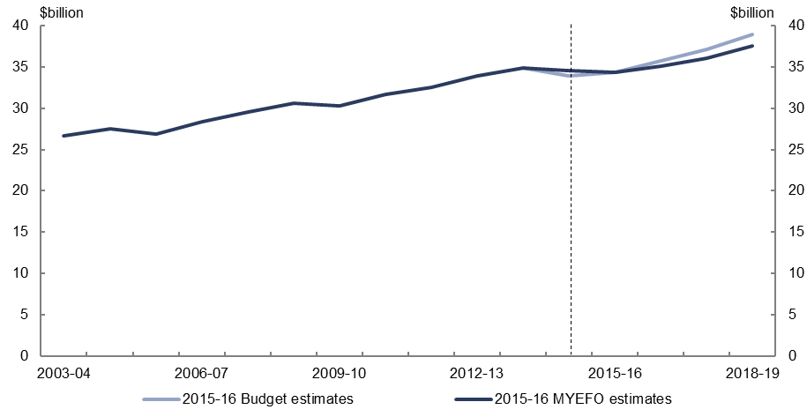
Figure 14: Revenue – excise and customs duties – change from 2015–16 Budget to
2015–16 MYEFO estimates by measures and other variations
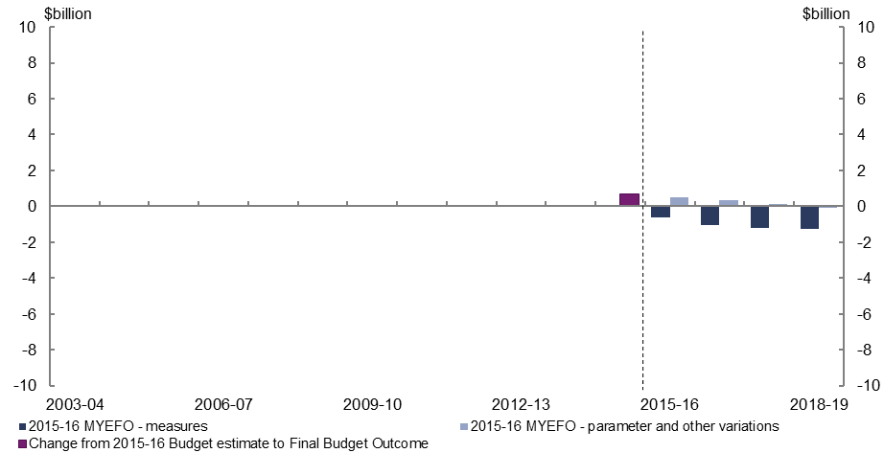
- Relative to the 2015–16 Budget, policy decisions are expected to decrease excise and customs duties by $4.2 billion over the four years to 2018–19, largely due to reduced tariff revenue associated with the China-Australia Free Trade Agreement.
- Parameter and other variations are expected to increase excise and customs duty revenue by $0.9 billion over the four years to 2018–19, relative to the 2015–16 Budget.

Revenue – non-tax revenue
Figure 15: Revenue – non-tax revenue – change from 2015–16 Budget to 2015–16 MYEFO estimates
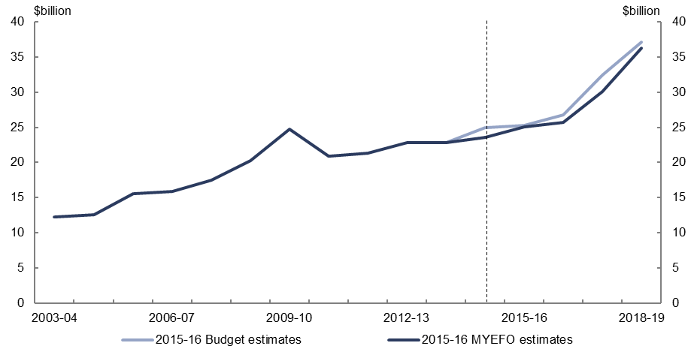
Figure 16: Revenue – non-tax revenue – change from 2015–16 Budget to 2015–16 MYEFO estimates by measures and other variations
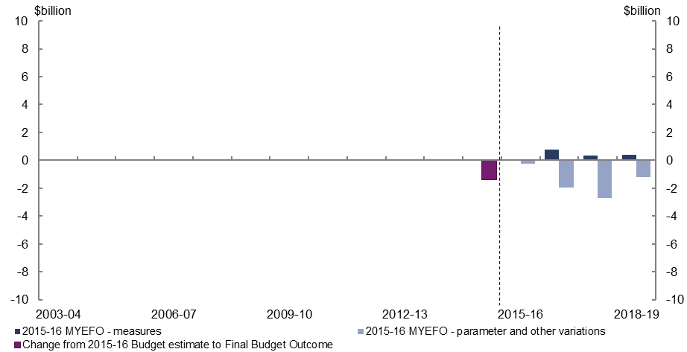
- Relative to the 2015–16 Budget, policy decisions are expected to increase non-tax revenue by $1.5 billion over the four years to 2018–19, largely reflecting changes in state contributions for the National Disability Insurance Scheme.
- Parameters and other variations are expected to decrease non-tax revenue by $6.0 billion over the four years to 2018–19, relative to the 2015–16 Budget, largely due to the reclassification of visa application charges from non-tax revenue to tax revenue.

Expenses – Age Pension
Figure 17: Expenses – Age Pension – change from 2015–16 Budget to 2015–16 MYEFO estimates
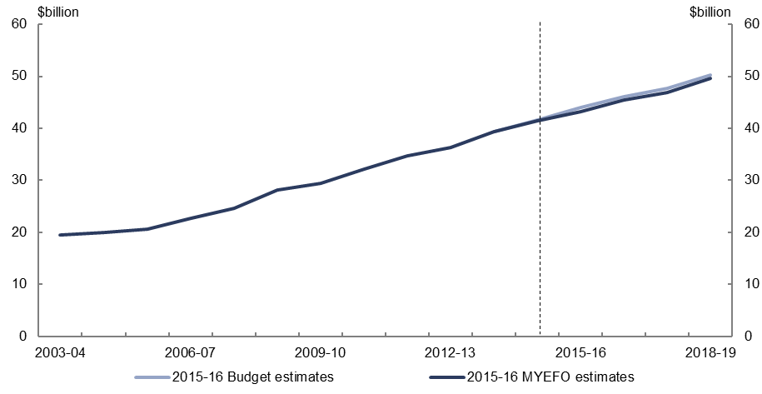
Figure 18: Expenses – Age Pension – change from 2015–16 Budget to 2015–16 MYEFO estimates by measures and other variations
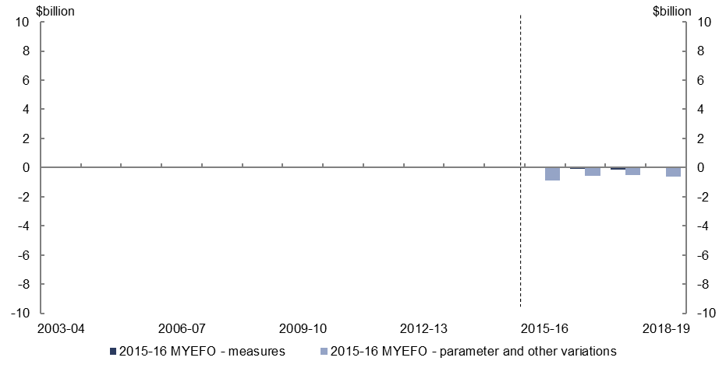
- Relative to the 2015–16 Budget, policy decisions are expected to decrease expenses on the Age Pension by $0.3 billion over the four years to 2018–19, largely due to the measures to enhance fraud prevention and debt recovery associated with welfare payments.
- Parameters and other variations are expected to decrease expenses on the Age Pension by $2.6 billion over the four years to 2018–19, relative to the 2015–16 Budget, largely reflecting lower than expected average payment rates and recipient numbers.

Expenses – Family Tax Benefit
Figure 19: Expenses – Family Tax Benefit – change from 2015–16 Budget to 2015–16 MYEFO estimates
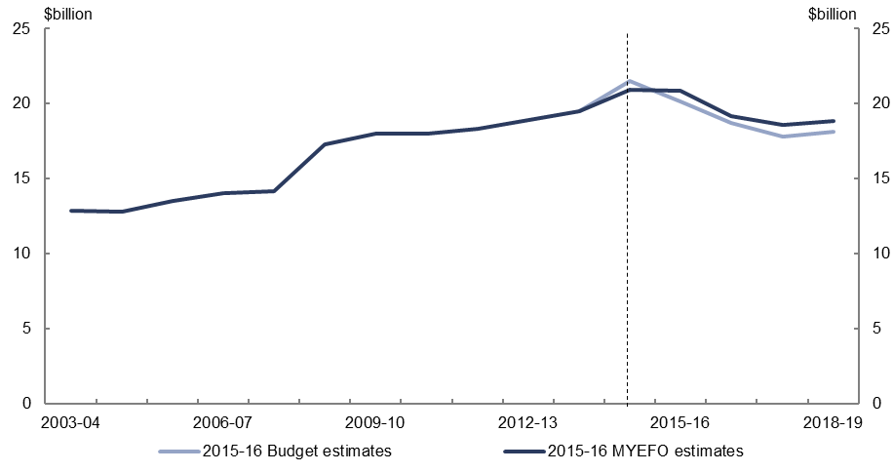
Figure 20: Expenses – Family Tax Benefit – change from 2015–16 Budget to 2015–16 MYEFO estimates by measures and other variations
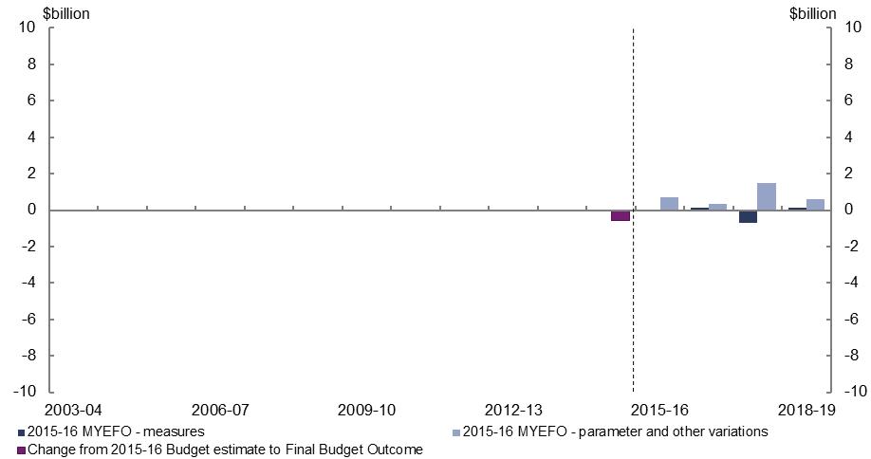
- Relative to the 2015–16 Budget, policy decisions are expected to decrease expenses on Family Tax Benefit by $0.4 billion over the four years to 2018–19, largely as a result of the introduction of the new Family Payment Reform package replacing measures informing the 2015–16 Budget estimates.
- Parameter and other variations are expected to increase expenses on Family Tax Benefit by $3.1 billion over the four years to 2018–19, relative to the 2015–16 Budget, largely due to the delay in legislating the previous family package, noting that these measures were subsequently replaced by a new suite of family tax benefit measures.

Expenses – Disability Support Pension
Figure 21: Expenses – Disability Support Pension – change from 2015–16 Budget to
2015–16 MYEFO estimates
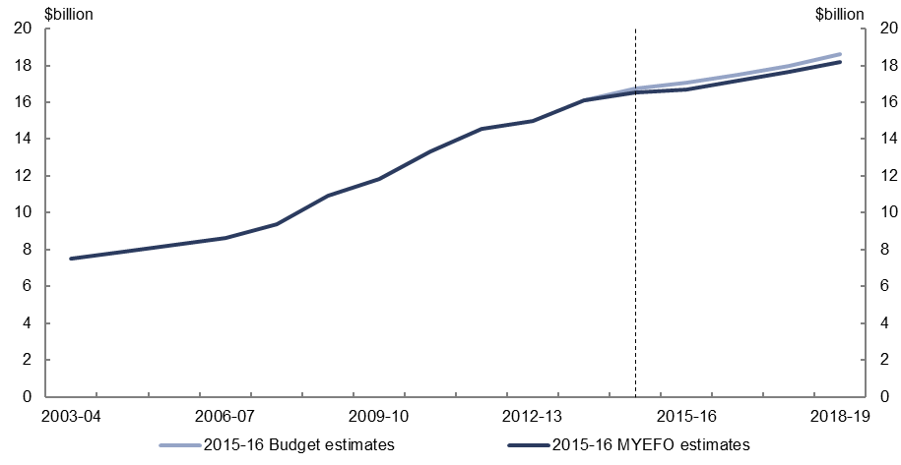
Figure 22: Expenses – Disability Support Pension – change from 2015–16 Budget to
2015–16 MYEFO estimates by measures and other variations
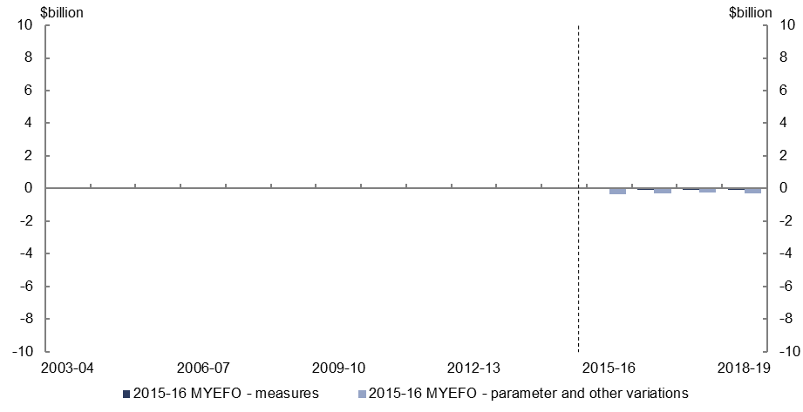
- Relative to the 2015–16 Budget, policy decisions are expected to decrease expenses on the Disability Support Pension by $0.2 billion over the four years to 2018–19, largely due to the measures to enhance fraud prevention and debt recovery associated with welfare payments.
- Parameter and other variations are expected to decrease expenses on the Disability Support Pension by $1.2 billion over the four years to 2018–19, largely reflecting lower than expected recipient numbers and average payment rates.

Expenses – aged care
Figure 23: Expenses – aged care – change from 2015–16 Budget to 2015–16 MYEFO estimates
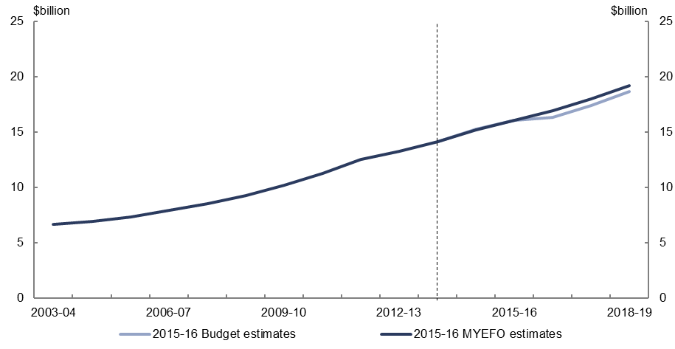
Figure 24: Expenses – aged care – change from 2015–16 Budget to 2015–16 MYEFO estimates by measures and other variations
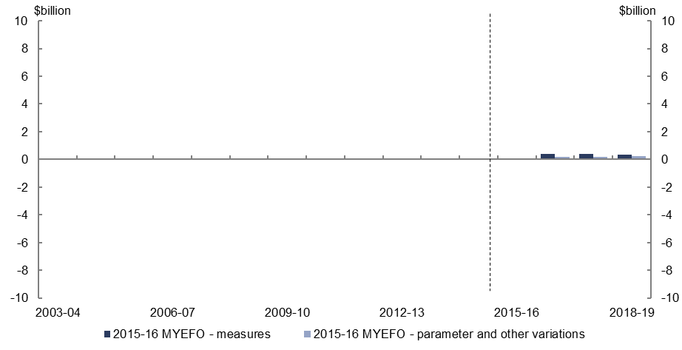
- Relative to the 2015–16 Budget, policy decisions are expected to increase expenses on aged care by $1.1 billion over the four years to 2018–19. This reflects an increase in transitional funding associated with the National Disability Insurance Scheme, partially offset by a reduction to the Aged Care Funding Instrument, which determines the level of funding to aged care providers.
- Parameter and other variations are expected to increase expenses on aged care by $0.7 billion over the four years to 2018–19, relative to the 2015–16 Budget, largely due to higher than expected growth in subsidies provided to residential aged care facilities.

Expenses – job seeker income support
Figure 25: Expenses – job seeker income support – change from 2015–16 Budget to
2015–16 MYEFO estimates

Figure 26: Expenses – job seeker income support – change from 2015–16 Budget to
2015–16 MYEFO estimates by measures and other variations
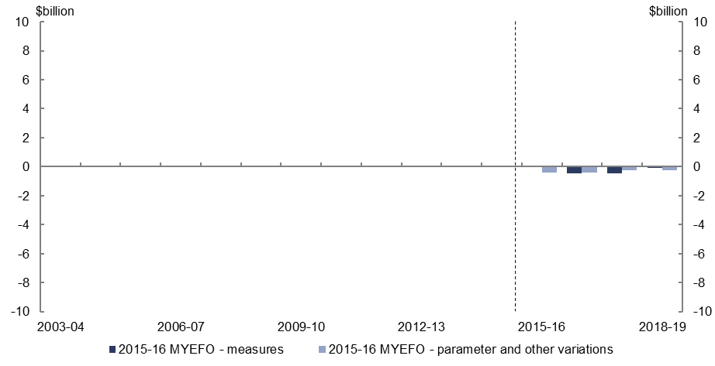
- Relative to the 2015–16 Budget, policy decisions are expected to decrease expenses on job seeker income support by $1.0 billion over the four years to 2018–19, largely due to the measures to enhance fraud prevention and debt recovery associated with welfare payments and the removal of family member exemptions from the newly arrived resident’s waiting period.
- Parameter and other variations are expected to decrease expenses on job seeker income support by $1.3 billion over the four years to 2018–19, largely reflecting lower than expected recipient numbers and average payment rates.

Expenses – income support for carers
Figure 27: Expenses – income support for carers – change from 2015–16 Budget to
2015–16 MYEFO estimates
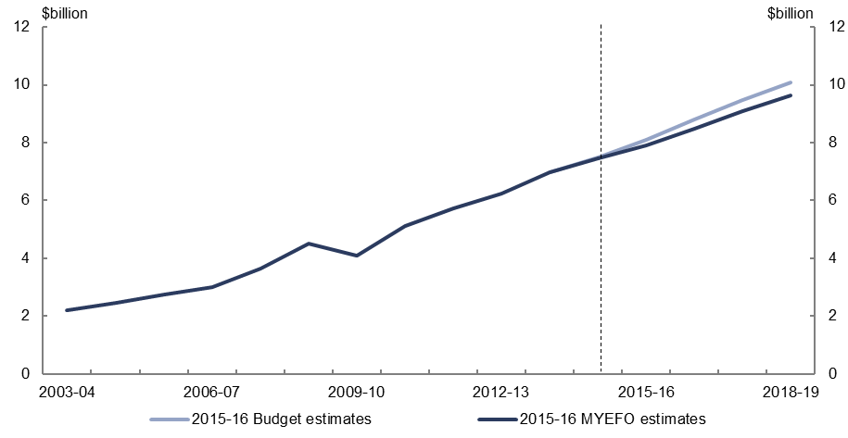
Figure 28: Expenses – income support for carers – change from 2015–16 Budget to
2015–16 MYEFO estimates by measures and other variations
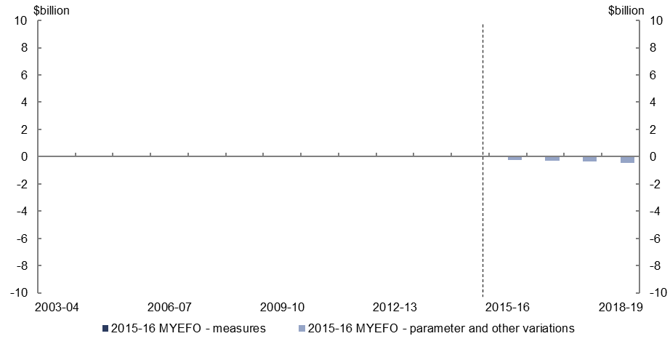
- Relative to the 2015–16 Budget, policy decisions are expected to be broadly neutral over the four years to 2018–19.
- Parameter and other variations are expected to reduce income support for carers’ expenses by $1.3 billion over the four years to 2018–19, relative to the 2015–16 Budget, reflecting lower than expected recipient numbers and average payment rates.

Expenses – child care fee assistance
Figure 29: Expenses – child care fee assistance – change from 2015–16 Budget to
2015–16 MYEFO estimates
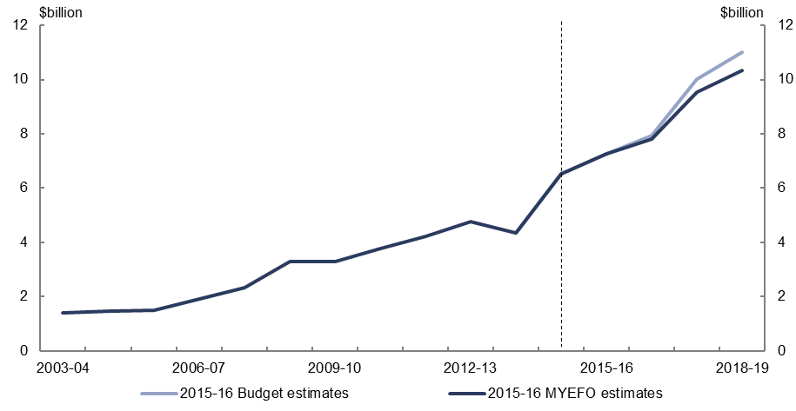
Figure 30: Expenses – child care fee assistance – change from 2015–16 Budget to
2015–16 MYEFO estimates by measures and other variations
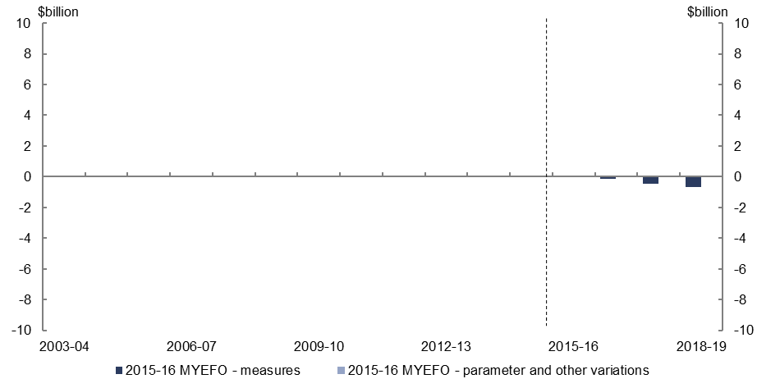
- Relative to the 2015–16 Budget, policy decisions are expected to decrease expenses on child care fee assistance by $1.3 billion over the four years to 2018–19, largely reflecting the measure to tighten eligibility for child care fee assistance for family day care educators and reductions to the child care subsidy for high income families.

Expenses – parents’ income support
Figure 31: Expenses – parents’ income support – change from 2015–16 Budget to
2015–16 MYEFO estimates
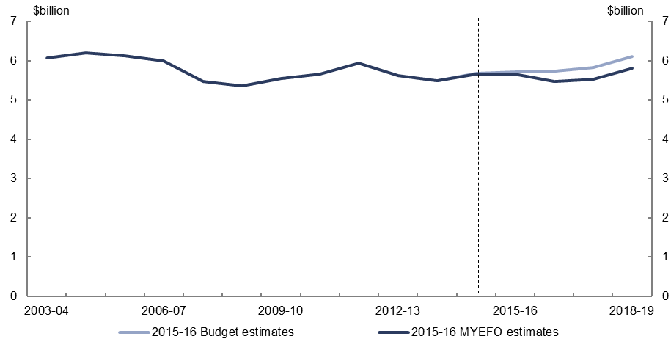
Figure 32: Expenses – parents’ income support – change from 2015–16 Budget to
2015–16 MYEFO estimates by measures and other variations
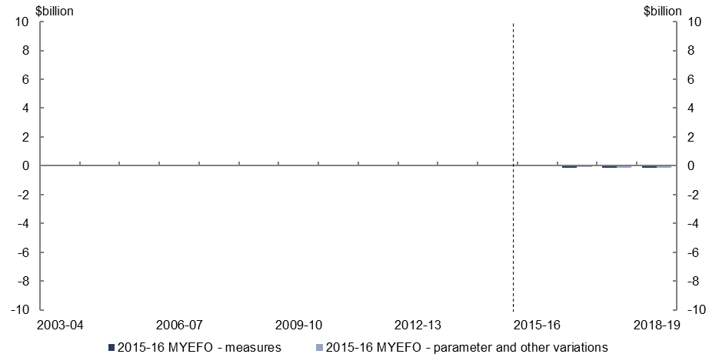
- Relative to the 2015–16 Budget, policy decisions are expected to reduce expenses on parents’ income support by $0.4 billion over the four years to 2018–19, largely reflecting the measures to enhance fraud prevention and debt recovery associated with welfare payments.
- Parameter and other variations are expected to decrease expenses on parents’ income support by $0.5 billion, relative to the 2015–16 Budget, largely reflecting lower than expected recipient numbers and average payment rates.

Expenses – Medicare Benefits Schedule
Figure 33: Expenses – Medicare Benefit Schedule – change from 2015–16 Budget to
2015–16 MYEFO estimates
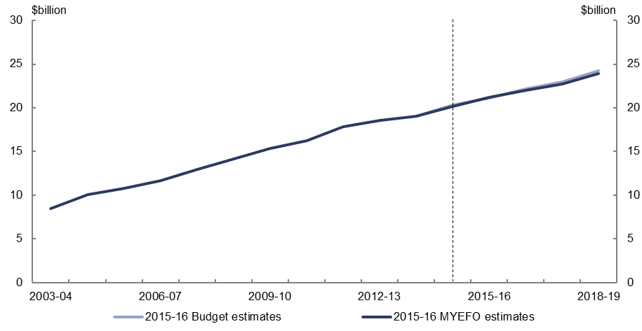
Figure 34: Expenses – Medicare Benefit Schedule – change from 2015–16 Budget to
2015–16 MYEFO estimates by measures and other variations
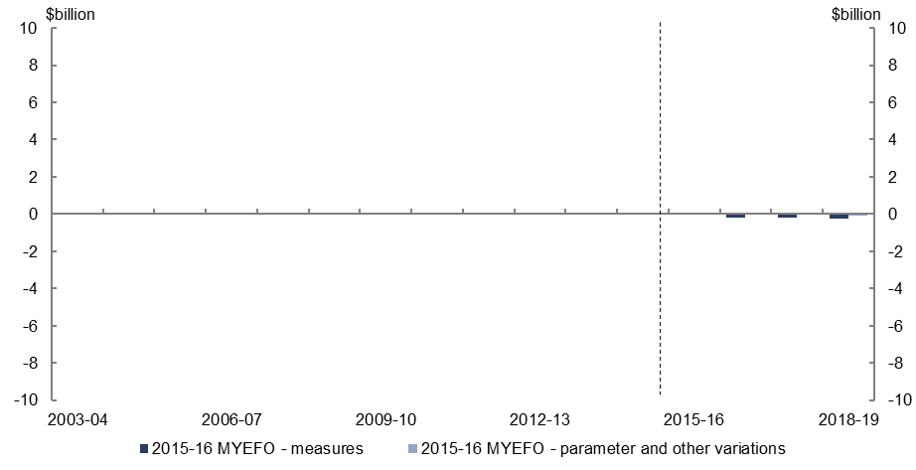
- Relative to the 2015–16 Budget, policy decisions are expected to decrease expenses on Medicare spending by $0.6 billion over the four years to 2018–19, largely reflecting the changes to bulk-billing incentives for diagnostic imaging and pathology services.
- Parameter and other variations are expected to have a broadly neutral impact over the four years to 2018–19, relative to the 2015–16 Budget.

Expenses – assistance to the states and territories for public hospitals
Figure 35: Expenses – assistance to the states and territories for public hospitals – change from 2015–16 Budget to 2015–16 MYEFO estimates
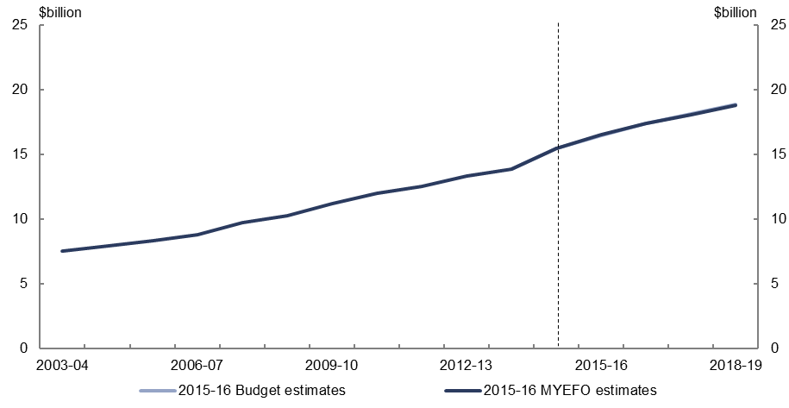
Figure 36: Expenses – assistance to the states and territories for public hospitals – change from 2015–16 Budget to 2015–16 MYEFO estimates by measures and other variations
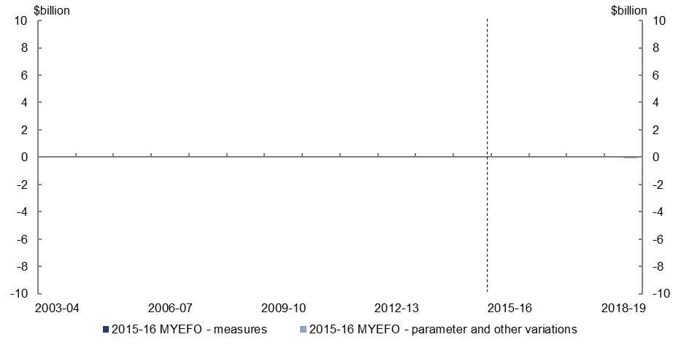
- The 2015–16 MYEFO does not include any significant policy or parameter variations for the assistance to the states and territories for public hospitals since the
2015–16 Budget.

Expenses – pharmaceutical benefits
Figure 37: Expenses – pharmaceutical benefits – change from 2015–16 Budget to
2015–16 MYEFO estimates
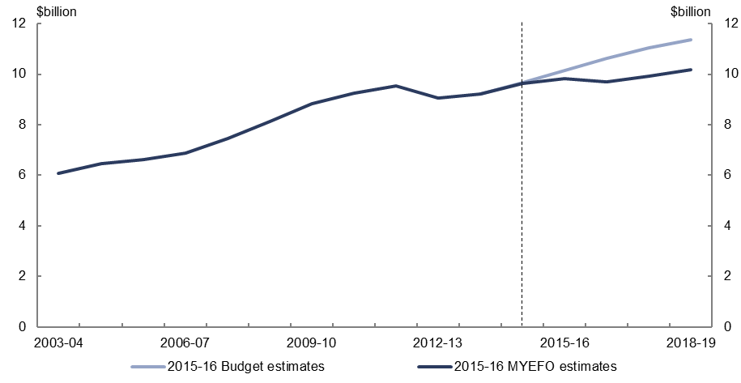
Figure 38: Expenses – pharmaceutical benefits – change from 2015–16 Budget to
2015–16 MYEFO estimates by measures and other variations
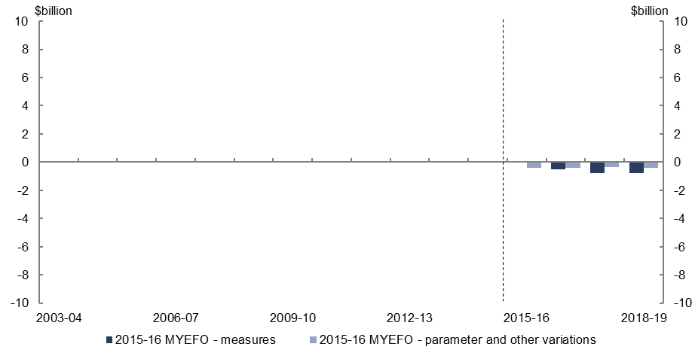
- Relative to the 2015–16 Budget, policy decisions are expected to decrease spending on the Pharmaceutical Benefits Scheme by $2.0 billion over the four years to 2018–19, largely reflecting the reforms to pricing, access and supply of medicines under the Sixth Community Pharmacy Agreement.
- Parameter and other variations are expected to reduce pharmaceutical benefits expenses by $1.6 billion over the four years to 2018–19, relative to the 2015–16 Budget, largely reflecting higher than expected savings from existing pricing policies.

Expenses – private health insurance rebate
Figure 39: Expenses – private health insurance rebate – change from 2015–16 Budget to
2015–16 MYEFO estimates
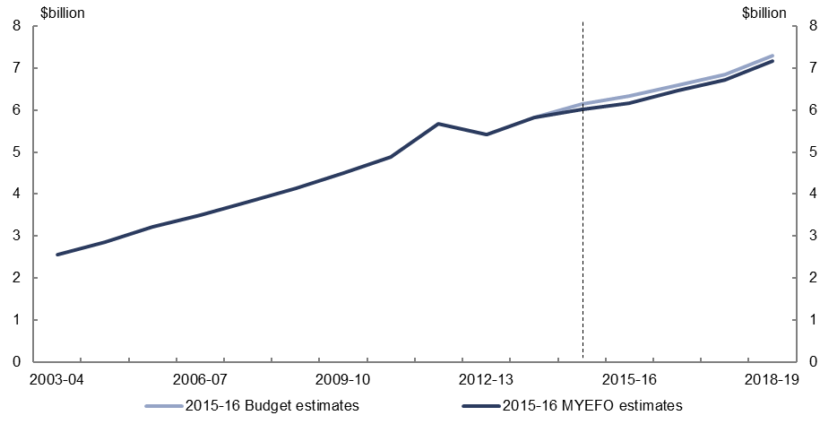
Figure 40: Expenses – private health insurance rebate – change from 2015–16 Budget to
2015–16 MYEFO estimates by measures and other variations
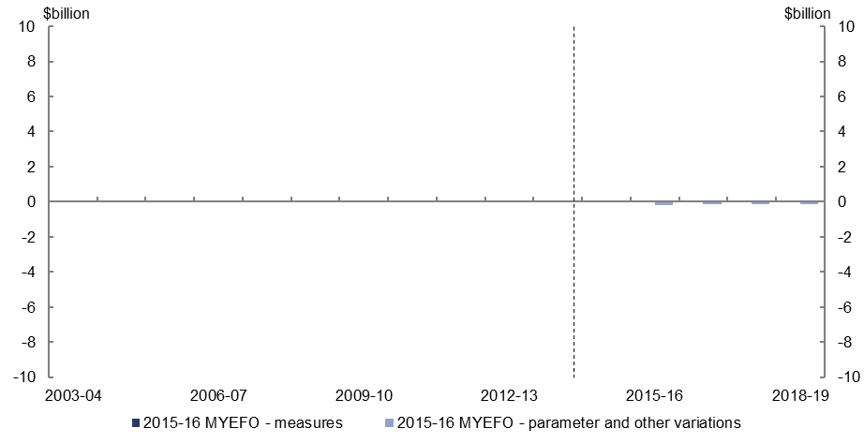
- Relative to the 2015–16 Budget, parameter and other variations are expected to decrease spending on the private health insurance rebate by $0.5 billion over the four years to 2018–19.

Expenses – National Disability Insurance Scheme
Figure 41: Expenses – National Disability Insurance Scheme – change from 2015–16 Budget to 2015–16 MYEFO estimates
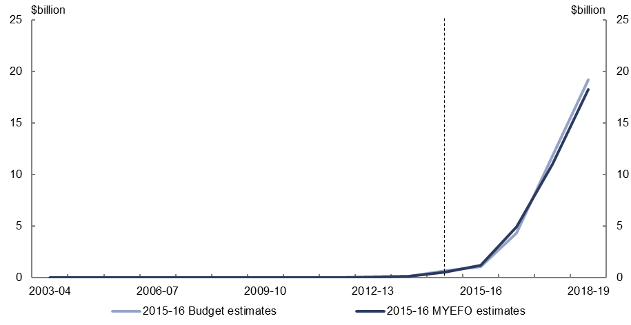
Figure 42: Expenses – National Disability Insurance Scheme – change from 2015–16 Budget to 2015–16 MYEFO estimates by measures and other variations
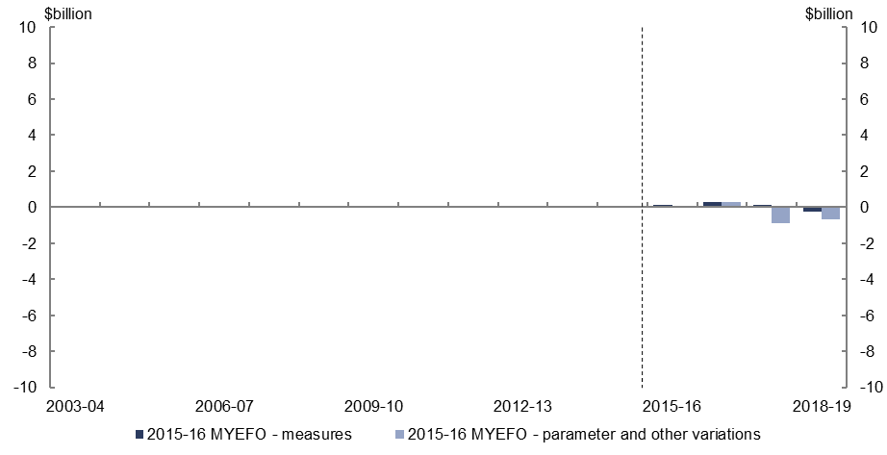
- Relative to the 2015–16 Budget, policy decisions are expected to increase spending on the National Disability Insurance Scheme by $0.3 billion over the four years to 2018–19, reflecting increased funding as the scheme transitions to full establishment.
- Parameter and other variations are expected to decrease National Disability Insurance Scheme expenses by $1.3 billion over the four years to 2018–19.

Expenses – schools
Figure 43: Expenses – schools – change from 2015–16 Budget to 2015–16 MYEFO estimates
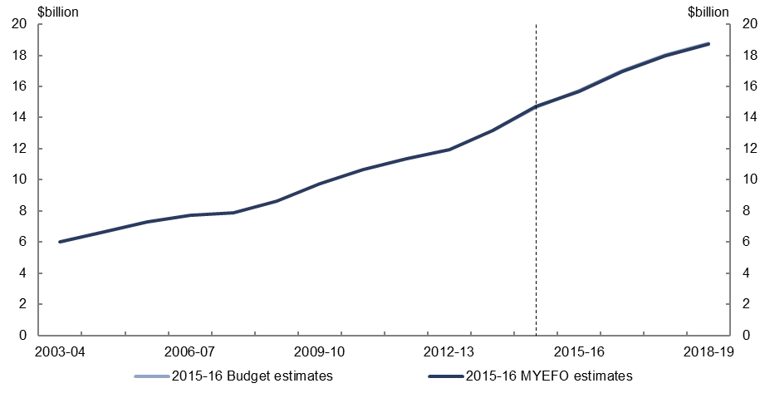
Figure 44: Expenses – schools – change from 2015–16 Budget to 2015–16 MYEFO estimates by measures and other variations
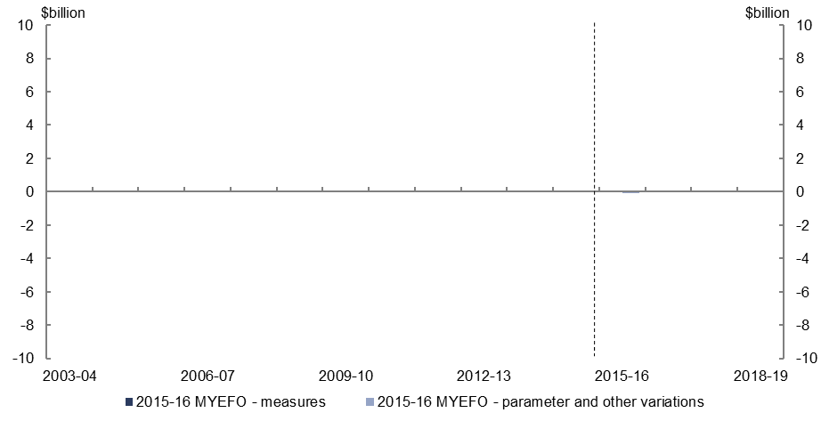
- Parameter and other variations are expected to decrease spending on schools by $0.2 billion over the four years to 2018–19, relative to the 2015–16 Budget.

Expenses – higher education
Figure 45: Expenses – higher education – change from 2015–16 Budget to 2015–16 MYEFO estimates
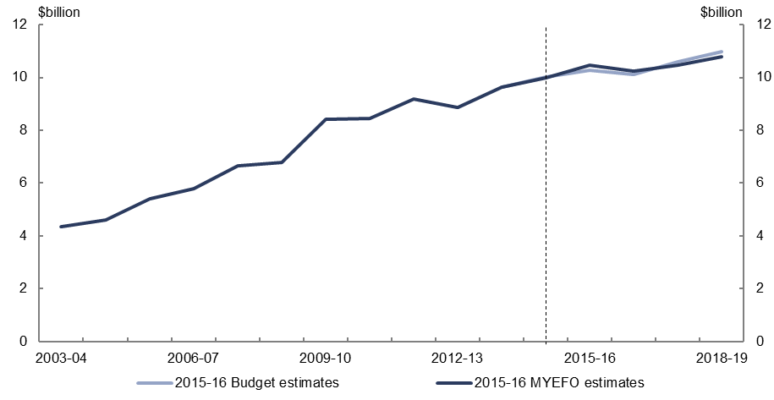
Figure 46: Expenses – higher education – change from 2015–16 Budget to 2015–16 MYEFO estimates by measures and other variations
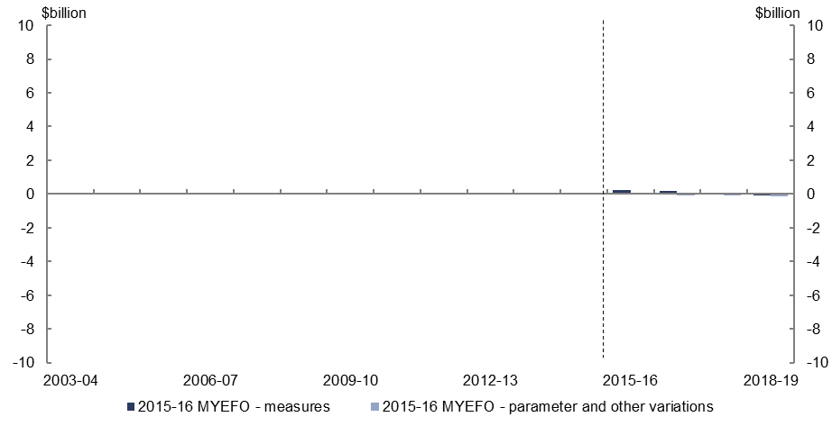
- Policy decisions are expected to increase expenses on higher education by $0.3 billion over the four years to 2018–19, relative to the 2015–16 Budget, reflecting the delays to the implementation of the higher education reforms announced in the 2014–15 Budget and the 2014–15 MYEFO.
- Parameter and other variations are expected to decrease expenses on higher education by $0.3 billion over the four years to 2018–19, relative to the
2015–16 Budget.

Defence (expenses and net capital investment)
Figure 47: Defence (expenses and net capital investment) – change from 2015–16 Budget to 2015–16 MYEFO estimates
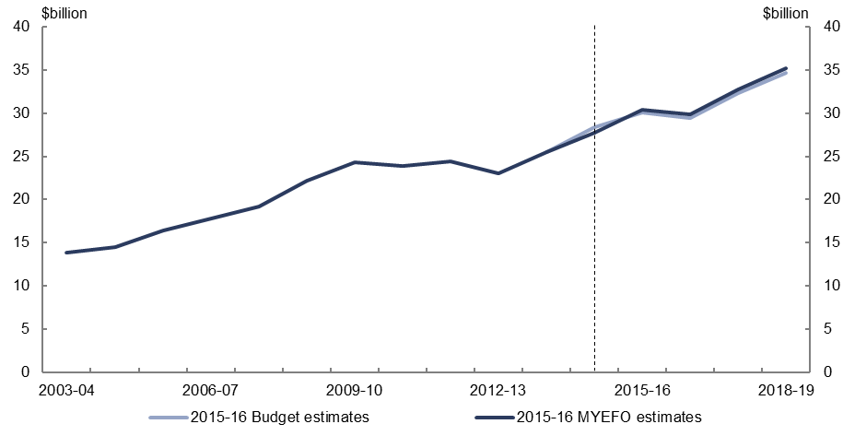
Figure 48: Defence (expenses and net capital investment) – change from 2015–16 Budget to
2015–16 MYEFO estimates by measures and other variations
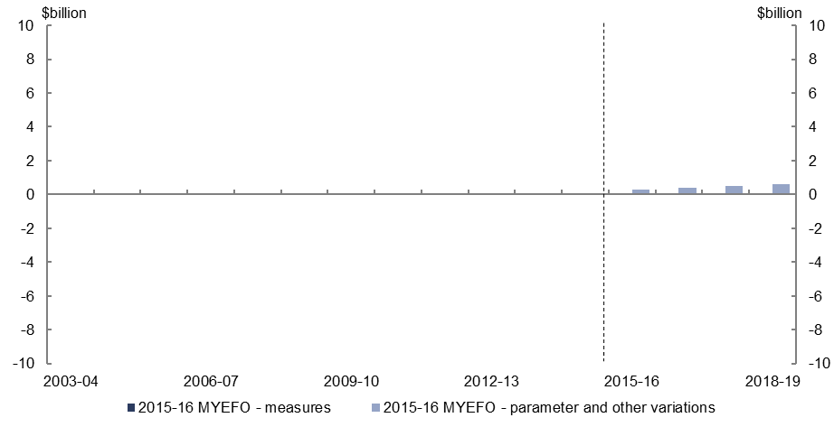
- Relative to the 2015–16 Budget, parameter and other variations are expected to increase defence spending by $1.8 billion over the four years to 2018–19, including expected increases in expenses and net capital investment as a result of foreign exchange movements.

Expenses – public debt interest
Figure 49: Expenses – public debt interest – change from 2015–16 Budget to 2015–16 MYEFO estimates
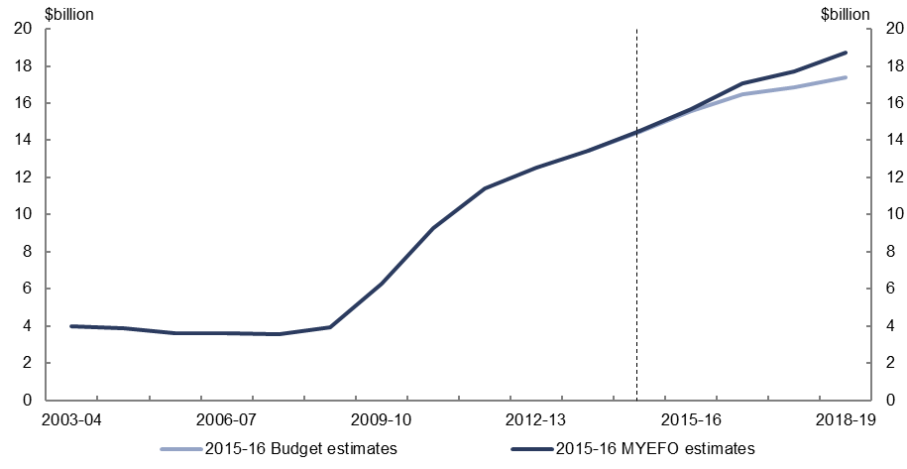
Figure 50: Expenses – public debt interest – change from 2015–16 Budget to 2015–16 MYEFO estimates by measures and other variations
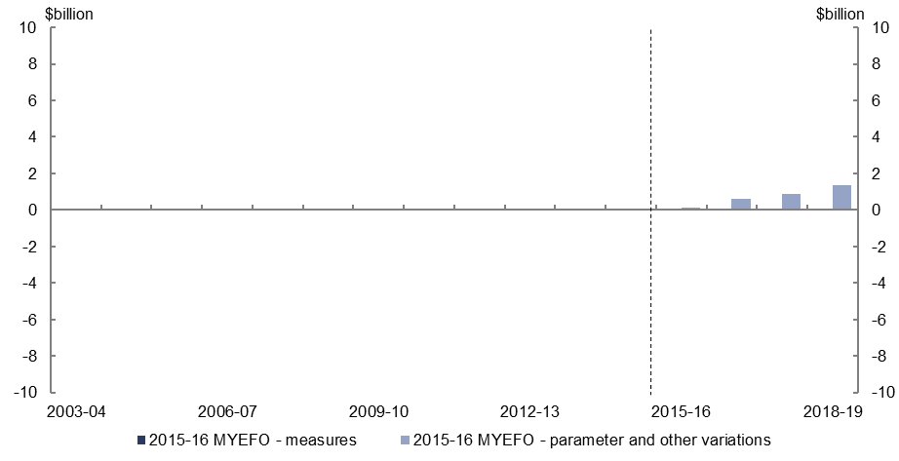
- Relative to the 2015–16 Budget, parameter and other variations are expected to increase expenses on public debt interest by $3.0 billion over the four years to 2018–19 due to increases in the financing requirement and an increase in the weighted average cost of borrowing.

Expenses – public sector superannuation
Figure 51: Expenses – public sector superannuation – change from 2015–16 Budget to
2015–16 MYEFO estimates
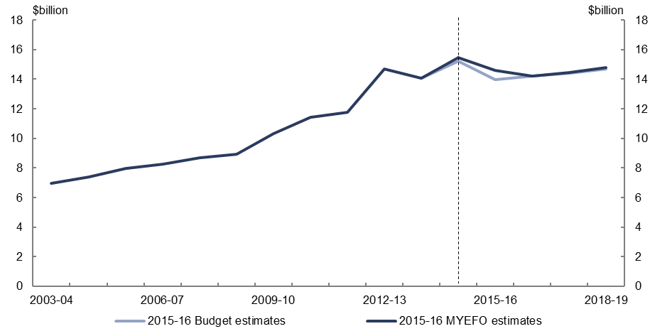
Figure 52: Expenses – public sector superannuation – change from 2015–16 Budget to
2015–16 MYEFO estimates by measures and other variations
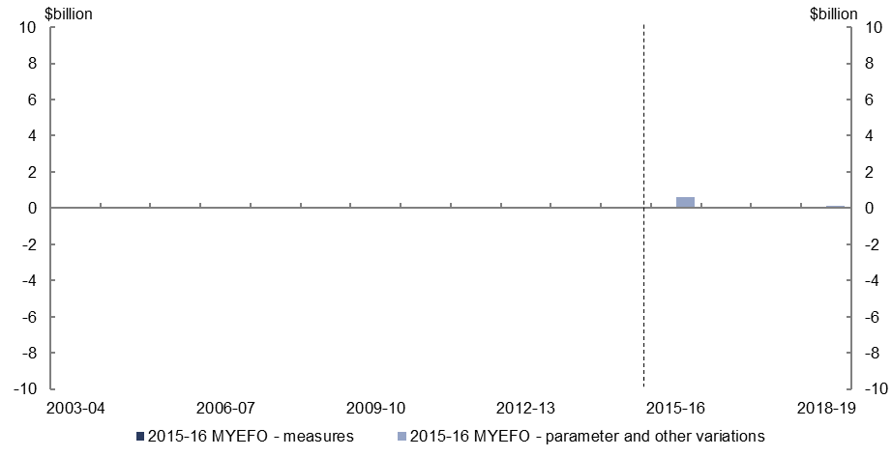
- Parameter and other variations are expected to increase public sector superannuation expenses by $0.8 billion over the four years to 2018–19.

Expenses – road and rail infrastructure
Figure 53: Expenses – road and rail infrastructure – change from 2015–16 Budget to
2015–16 MYEFO estimates
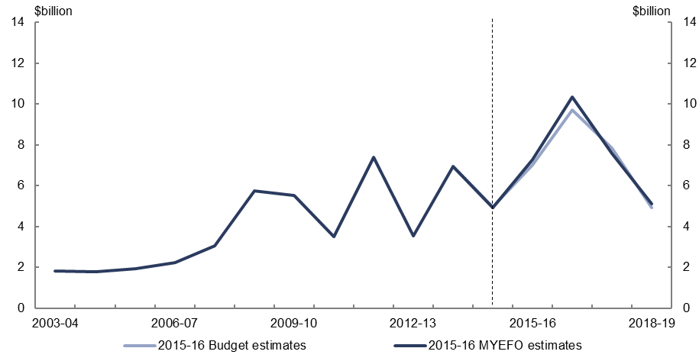
Figure 54: Expenses – road and rail infrastructure – change from 2015–16 Budget to
2015–16 MYEFO estimates by measures and other variations
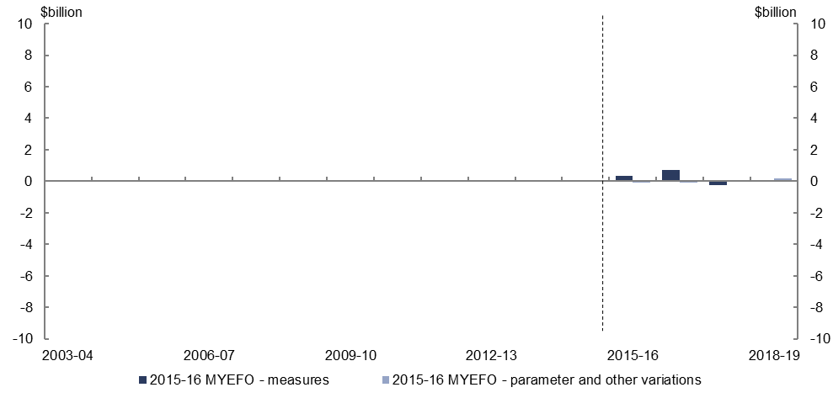
- Policy decisions are expected to increase expenses on road and rail infrastructure by $0.9 billion, relative to the 2015–16 Budget, largely reflecting decisions related to the Roads to Recovery programme.

Expenses – Official Development Assistance
Figure 55: Expenses – Official Development Assistance – change from 2015–16 Budget to 2015–16 MYEFO estimates
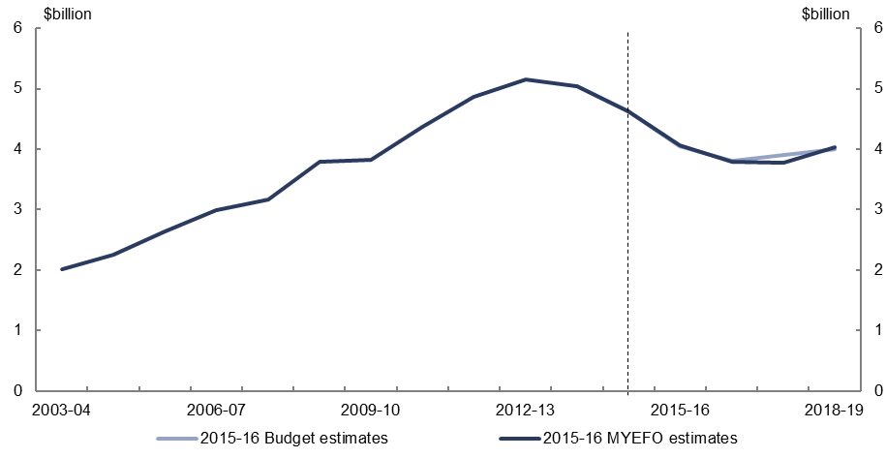
Figure 56: Expenses – Official Development Assistance – change from 2015–16 Budget to 2015–16 MYEFO estimates by measures and other variations
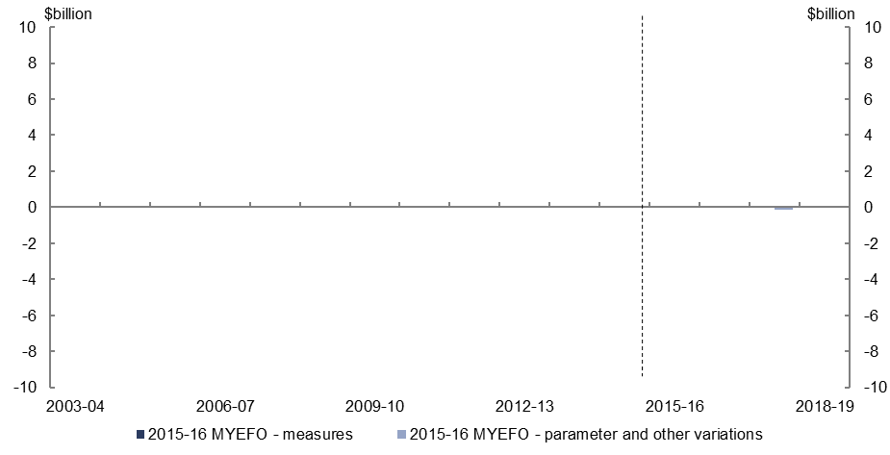
- Official Development Assistance expenses are projected to remain broadly in line with previous estimates over the four years to 2018–19, relative to the 2015–16 Budget.

www.pbo.gov.au

