Goods and Services Tax
Distributional analysis and indicative reform scenarios
Report no. 05/2015

© Commonwealth of Australia 2015
ISBN 978-0-9944547-0-6 (Online)
This work is licensed under the Creative Commons Attribution-NonCommercial-NoDerivs 3.0 Australia License.
The details of this licence are available on the Creative Commons website: http://creativecommons.org/licenses/by-nc-nd/3.0/au/
Use of the Coat of Arms
The terms under which the Coat of Arms can be used are detailed on the following website: www.itsanhonour.gov.au/coat-arms
Produced by: Parliamentary Budget Office
Designed by: Studio Tweed

Revenue Analysis Branch
Parliamentary Budget Office
Parliament House
PO Box 6010
CANBERRA ACT 2600
Phone: (02) 6277 9500
Email: pbo@pbo.gov.au

Contents
Foreword iv
Overview v
1 Introduction 1
2 The GST in Australia 2
2.1 Exclusions from the GST base 2
2.2 GST compensation arrangements 3
2.3 International comparison 5
3 Distributional analysis of the GST 7
3.1 Distributional analysis of household saving 8
3.2 Distributional analysis of the GST 9
3.3 Distributional analysis of GST concessions 10
4 Analysis of GST reform scenarios 18
4.1 Methodology and key assumptions 18
4.2 Scenario 1: basic food subject to GST 21
4.3 Scenario 2: remove concessions from GST base 23
4.4 Scenario 3: increase the GST rate to 15 per cent 25
4.5 Scenario 4: 15 per cent GST; basic food subject to GST 27
4.6 Scenario 5: 15 per cent GST; remove concessions 29
4.7 Summary 31
References 33
List of figures 35
List of tables 36
List of abbreviations 37
List of appendices 38

Foreword
The current discussion of reform of Australia’s tax system has invariably raised questions of the potential for reform of Australia’s Goods and Services Tax (GST).
This report seeks to inform public discussion of this important public policy issue.
It provides an independent analysis of the revenue and distributional impacts of five indicative GST reform scenarios that have been canvassed in public policy discussions.
Consistent with the Parliamentary Budget Office’s mandate, the report presents a factual analysis and does not include policy recommendations. The selection of GST reform scenarios for analysis in this report should not be interpreted as the PBO endorsing any of these scenarios.
I would like to thank the PBO staff involved in the preparation of this report. The report was prepared by Colin Brown, Tony McDonald, Andrew Watterson and Phillip Hawkins, with the benefit of comments from Tim Pyne. The report was prepared for publication by Louise Milligan and Helen Moorhouse.
I also wish to thank the external referees who provided helpful comments and suggestions on the report, namely Professor John Daley of the Grattan Institute, Professor John Freebairn of the University of Melbourne, and Ben Phillips of the National Centre for Social and Economic Modelling (NATSEM). The assistance of external reviewers does not imply any responsibility on their part for the content of the final report, which rests solely with the PBO.
Phil Bowen PSM FCPA
Parliamentary Budget Officer
9 December 2015

Overview
The Goods and Services Tax (GST) is a regressive tax. On average, households in the lowest income decile pay over 12 per cent of their disposable income on GST or about three times the proportion paid by those in the highest income decile.
The value of GST concessions represents around 4 per cent of the disposable incomes of households in the lowest income decile or about four times the proportion received by those in the highest income decile.
In absolute terms, the amount of GST paid increases in line with household income, from around $40 per week for the lowest income decile to over $140 per week for the highest income decile.
Similarly, in absolute terms, GST concessions provide substantially greater benefits to higher income households. The value of the GST concessions to households in the highest income decile is about $32 per week or around two and a half times that for households in the lowest income decile.
Proponents of GST reform typically argue that the GST is a more economically efficient way of raising revenue than most other taxes. On the other hand, there are concerns that the GST is a regressive tax and compensation put in place to protect lower income earners from an increase in the GST could be eroded over time.
The compensation arrangements for transfer payment recipients on the introduction of the GST largely remain in place, although the impact of personal tax reductions has been eroded over time by bracket creep, with the average personal tax rate projected to return to its pre-GST level by 2018–19.
A number of GST reform scenarios have been canvassed in public policy discussions that would either increase the rate of the GST or remove concessions from the GST base, or some combination of both.
This report presents analysis of the revenue and distributional impacts of five indicative GST reform scenarios, namely:
- include basic food in the GST base
- include basic food, health and medical care, education, child care and water and sewerage in the GST base
- increase the GST rate from 10 to 15 per cent
- GST rate 15 per cent and include basic food in the GST base
- GST rate 15 per cent and include basic food, health and medical care, education, child care and water and sewerage in the GST base.

Each scenario includes a compensation package that, in aggregate, would be sufficient to fully offset the impact of the changes on the bottom 40 per cent of households by disposable income. The specific design of compensation packages is a policy question, involving a range of possible changes to the tax and transfer systems about which the PBO has made no assumptions.
These scenarios would increase GST revenue, net of compensation, by between $4.8 billion (extending GST to basic food) and $49.3 billion (15 per cent rate, remove concessions from GST base) annually (Table 1). The ongoing impact of each scenario would grow broadly in line with nominal Gross Domestic Product (GDP).
Table 1: Summary of net GST revenue impact of scenarios
 | Additional GST Revenue ($b) | Compensation ($b) | Net Additional GST Revenue  ($b)
Scenario 1: Basic food subject to GST | 7.2 | 2.4 | 4.8
Scenario 2: Remove concessions from GST base | 21.6 | 5.6 | 16.0
Scenario 3: 15 per cent GST | 32.5 | 7.9 | 24.6
Scenario 4: 15 per cent GST; basic food subject to GST | 42.7 | 11.3 | 31.4
Scenario 5: 15 per cent GST; remove concessions | 65.8 | 16.5 | 49.3
Source: PBO analysis
The analysis in this report makes no assumptions as to how any net additional GST revenue would be utilised, or the nature and extent of any possible associated changes to the tax and transfer systems.
The report is intended to help inform public debate on this issue through objective analysis. Consistent with the PBO’s non-partisan mandate, the report contains no policy recommendations.

Introduction
The current discussion of reform of Australia’s tax system has raised questions of the potential for reform of Australia’s Goods and Services Tax (GST), with the International Monetary Fund (IMF) and Organisation for Economic Co-operation and Development (OECD) recommending broadening the base and increasing the rate of the GST.
The tax discussion paper released by the Treasury in March 2015 sought views on the extent to which current GST policy settings—particularly the rate and base—are appropriate. The paper also noted that ’the Australian Government will only consider progressing any such proposals if there is a broad political consensus for change’.
Proponents of increasing GST revenue stress that it is a more efficient way of raising revenue than most other taxes. In particular, Treasury modelling estimates that the GST has a lesser impact on the economy than company income tax, stamp duty and a progressive personal income tax.
On the other hand, others have expressed concern around the equity of GST reform proposals, noting that as the GST is a regressive tax, an increase in the GST would increase the tax burden on lower income earners.
The purpose of this report is to inform public discussion of issues around the impact of GST reform proposals by providing a more detailed analysis of the distributional effects of GST than set out in the tax discussion paper, and providing an independent analysis of the revenue and distributional impacts of different GST reform scenarios.
Consistent with the PBO’s mandate, this report does not include policy recommendations. The selection of GST reform scenarios for analysis in this report was based on proposals that have been widely canvassed in public policy discussion. This should not be interpreted as the PBO endorsing any of these scenarios.
The remainder of this report is structured as follows. Chapter 2 provides a brief outline of the GST in Australia, including the exclusions from the GST base, a recap of compensation arrangements on the introduction of the GST, and an international comparison. Chapter 3 provides a distributional analysis of the current GST system, giving estimates of the relative and absolute impacts of the GST and GST concessions on households. Chapter 4 provides estimates of the revenue and distributional impacts of five GST reform scenarios.

The GST in Australia
Australia’s Goods and Services Tax (GST) is a value added tax that applies to the consumption of most goods and services.
The GST applies at each stage of production until final consumption in Australia, with a credit provided for GST paid on inputs. As such, it applies to imports but not exports.
The GST commenced on 1 July 2000, replacing the previous Wholesale Sales Tax and a range of other taxes and charges.
Since its introduction, the GST has applied at a flat rate of 10 per cent.
The GST is collected and administered by the Australian Government, with GST receipts (less the cost of administration) transferred to States and Territories.
GST receipts in 2014–15 were $54.5 billion, or 3.4 per cent of GDP.
GST receipts have declined over the past decade from a peak of almost 3.8 per cent of GDP in 2003–04 to around 3.4 per cent of GDP in 2014–15. This reflects a decline in consumption as a share of GDP, and a shift in consumption patterns away from goods and services subject to GST.

Exclusions from the GST base
In its 1998 White Paper, the then government announced its intention to introduce the GST as part of a package of tax reforms.
As originally announced, the GST was intended to have a ‘very broad base’, with exclusions from the GST base limited to circumstances where the imposition would be ‘technically difficult’ (financial services) or ‘would create inequities between private and public sector providers’ (health and medical care; education; child care).
The original announcement also excluded water and sewerage rates and charges from the GST. While the policy intention was to ‘apply the GST to the commercial activities of all levels of government in the normal manner’, it was also recognised that ‘there are Constitutional limitations on subjecting some activities of government to the GST’.
Subsequently, as part of negotiations to secure the passage of GST legislation through parliament, the then government agreed to exclude basic food from the GST. The principal criticism of applying the GST to basic food was that it would be highly regressive. There were also concerns about the potential for adverse health consequences from taxing fresh food.
In most cases where the GST is not charged on goods and services the provider is still able to claim credit (or be refunded) for the GST it paid on the goods and services used in the provision of its goods and services. The main items this ‘GST-free’ treatment applies to are: basic food; health and medical care; education; child care; and water and sewerage.
Providers of financial services do not apply GST to the services they supply but are not able to claim credit (or be refunded) for the GST paid on the goods and services used in the provision of financial services. No OECD country applies the GST to financial services, reflecting the technical challenges in doing so. The impact of the exclusion of financial services from the GST is not analysed in this report.

GST compensation arrangements
The introduction of the GST in 2000 was accompanied by a number of other measures to provide compensation for low and middle income earners, namely increases in income support payments and family benefits, and reductions in personal income tax.

GST compensation: income support payments
Income support payments (pensions, allowances and benefits) were increased by four per cent on the commencement of the GST, with the intention of providing a two per cent real increase.
For income support payments indexed to the Consumer Price Index (CPI)—such as Newstart—the March 2001 indexation was offset by the estimated net CPI impact of the package ‘to avoid giving a double benefit’. The impact of this increase remains embedded within the base level of payments.
For example, $20.13 of the $523.40 per fortnight currently paid to single Newstart recipients who are 22 years or over with no children reflects the increase in payments following the introduction of the GST. It has been noted however that the level of Newstart payments relative to community living standards has declined over time.
For pensioners, GST compensation was provided as a supplement (the pension GST supplement) to ensure that it applied on top of the legislative requirement to maintain pensions at no less than a specified proportion of male total average weekly earnings (MTAWE). The maximum supplement was equal to four per cent of the pension at 1 July 2000, initially equivalent to $387.40 per annum for a single pensioner and $644.80 per annum for a couple. This amount has been indexed to the CPI, and is currently equal to $585.00 per annum for a single pensioner and $967.20 per annum for a couple.

GST compensation: family benefits
The package that introduced the GST consolidated ten forms of family assistance into two: Family Tax Benefit Part A for families with children, and an additional Family Tax Benefit Part B for single income families with children.
The Family Tax Benefit Part A preserved the payment structure of the four forms of assistance that it replaced, with the maximum benefit increasing by $140 per annum per dependent child and more generous taper rates applying.
The Family Tax Benefit Part B had a similar rate structure to the six forms of assistance that it replaced, with an additional $350 per annum for single income families with a child under 5 years and an additional $61 per annum for single income families where the youngest child is aged 5 to 16 years. There was also a significant relaxation of means testing, with the abolition of the income test on the primary income earner.
Broadly, the base payments for the Family Tax Benefit Part A and Family Tax Benefit Part B have been indexed to the CPI. However there have been a number of changes to these payments since 2000. Recipients now also receive annual supplement payments (from
2003–04 for Family Tax Benefit Part A; from 2004–05 for Family Tax Benefit Part B). On the other hand, there have been a number of changes to tighten eligibility arrangements, including the reintroduction of a primary income earner income test for Family Tax Benefit Part B, and pauses to the indexation of some thresholds and payments.

GST compensation: personal income tax cuts
Personal income tax cuts were provided as part of the compensation for the introduction of the GST in 2000–01, through a combination of lower marginal tax rates and higher thresholds. Overall, the average personal tax rate fell from nearly 25 per cent in 1999–2000 to just over 21½ per cent in 2000–01.
In the absence of explicit government policy decisions, average personal tax rates (and personal income tax collections) increase over time as a result of bracket creep.
- The average personal tax rate in 2014–15 was around one percentage point higher than that of 2000–01.
- Under current policy settings, by 2018–19 the average personal tax rate is projected to return to its level in 1999–2000 (before the introduction of the GST), and over one percentage point higher than its long run (30 year) average.

International comparison
All but one of the OECD countries has a value added tax on consumption, with the sole exception being the United States. While there are common core design principles of value added taxes across OECD countries, there are significant differences in the standard rate of taxation and the level and type of exclusions from the taxation base.
These differences translate to a wide disparity in the level of value added tax collections across OECD countries, which in 2013 ranged from 2.8 per cent of GDP in Japan to 9.4 per cent of GDP in New Zealand.

Australia’s GST collections are just over half the OECD average of value added taxes as a share of GDP.
- The main contributor to this outcome is that Australia’s GST rate of 10 per cent is just over half the OECD average standard rate of 19.1 per cent.
- Across the OECD, the standard rate of value added tax ranges from 5 per cent in Japan to 27 per cent in Hungary.
While most OECD countries exclude some items from value added taxation (VAT), there is significant variation in the type and extent of these exclusions. The OECD has constructed an estimate of the extent of these exclusions across countries—the VAT Revenue Ratio—where a rating of 100 per cent represents a situation with no exclusions.
The VAT Revenue Ratio ranges from 31 per cent in Mexico and 37 per cent in Greece, to 96 per cent in New Zealand, and 113 per cent in Luxembourg. Australia’s ratio of 47 per cent is below the OECD average of 55 per cent, suggesting that Australia has a higher level of exclusions from its GST base than the OECD average.

Distributional analysis of the GST
This chapter assesses the distributional impact of Australia’s GST. It presents estimates of the average GST paid by each decile of equivalised household disposable income, based on data from the Australian Bureau of Statistics (ABS) Household Expenditure Survey. This analysis is repeated for each of the principal exclusions from the GST base.
Interpretation of this analysis should be mindful of the limitations of the underlying data. In particular, inconsistencies between income and expenditure data in the Household Expenditure Survey are most apparent in the bottom decile of household income and mean that this analysis is likely to exaggerate the relative impact of the GST on this group.
The income of households can vary significantly over the course of their life cycle. To address this issue the OECD included analysis of value added taxes as a proportion of expenditure as part of its analysis of the distributional effects of consumption taxes. However, while the income of individuals can vary over time, the distribution of income and expenditure across the population is relatively stable over time. As a result, this report does not analyse the impact of the GST as a proportion of household expenditure.
Despite its limitations, the Household Expenditure Survey is the best data available for analysis of the distributional impact of the GST. Moreover, data issues are likely to affect the magnitude, but not the direction, of the relative impact of the GST across income groups.
Further details on the data, assumptions and methodology underpinning this analysis are presented in Appendix A.

Distributional analysis of household saving
A common criticism of the GST is that it is a regressive tax, as it applies at a flat rate and those on lower incomes tend to consume more of their income than those on higher incomes.
Figure 3–1 compares the level of income and expenditure by decile of equivalised household disposable income. It shows that, on average, low income households spend more than their disposable income. In particular, it suggests that households in the lowest income decile spend over $400 per week more than they receive in income. However, the very high level of dissaving by the lowest income decile is likely to mainly be due to limitations in the data rather than the actual behaviour of households.
Figure 3–1: Distribution of household income and expenditure
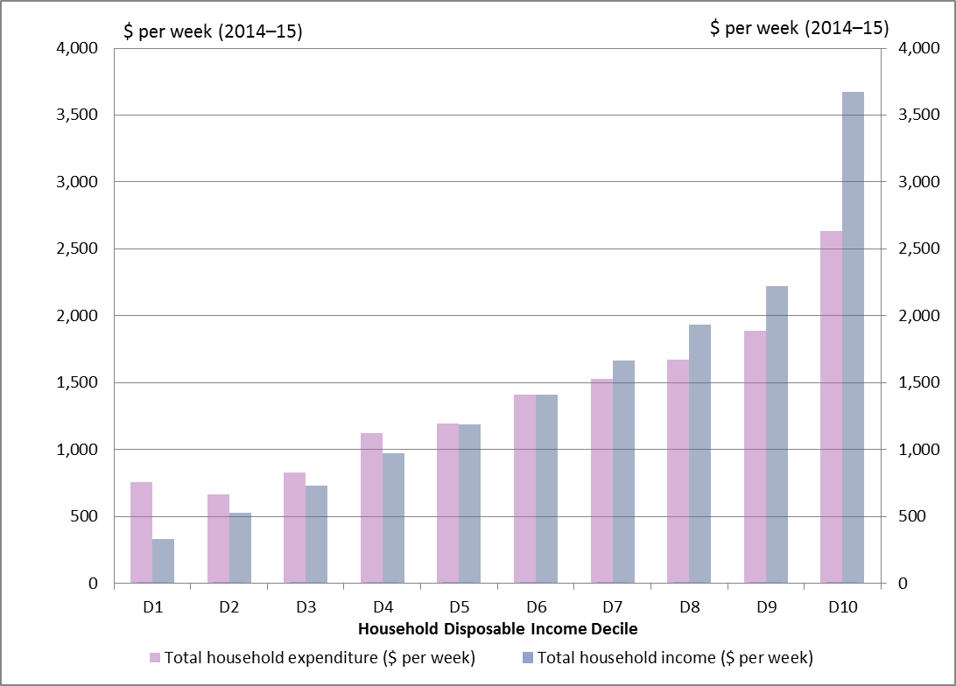
Source: PBO analysis based on data from the Australian Bureau of Statistics (ABS)
Figure 3–2 presents this data as a distributional analysis of household saving. Even allowing for data issues with the lowest income decile it shows that, on average, the lowest 40 per cent of income earners are dissaving—either drawing down on existing savings, or supporting current consumption by borrowing money—while the top 40 per cent of income earners are saving.
Figure 3–2: Distribution of household saving
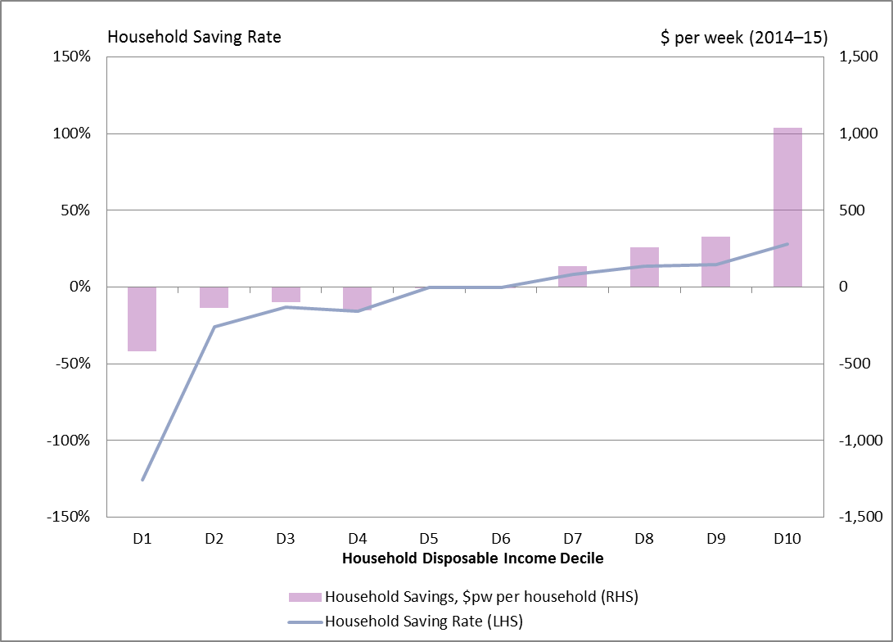
Source: PBO analysis based on data from the ABS
Further details of the composition of households in this analysis are provided in Appendix B.

Distributional analysis of the GST
Figure 3–3 presents a distributional analysis of the relative and absolute impact of the GST on households by income decile.
The regressive nature of the GST is highlighted by the progressive reduction in the proportion of income paid in GST as household incomes rise. On average those in the lowest income decile are estimated to pay over 12 per cent of their disposable income on GST, or about three times the proportion paid on average by those in the highest income decile. This disparity primarily reflects the distribution of household saving (as lower income households spend more as a proportion of their income than higher income households).
On the other hand, the total amount of GST paid generally increases in line with household income, from around $40 per week for the lowest income decile to over $140 per week for the highest income decile. The difference between the relative and absolute impact of the GST reflects the fact that the proportion of expenditure to income declines as household income increases.
Figure 3–3: Distributional impact of the GST
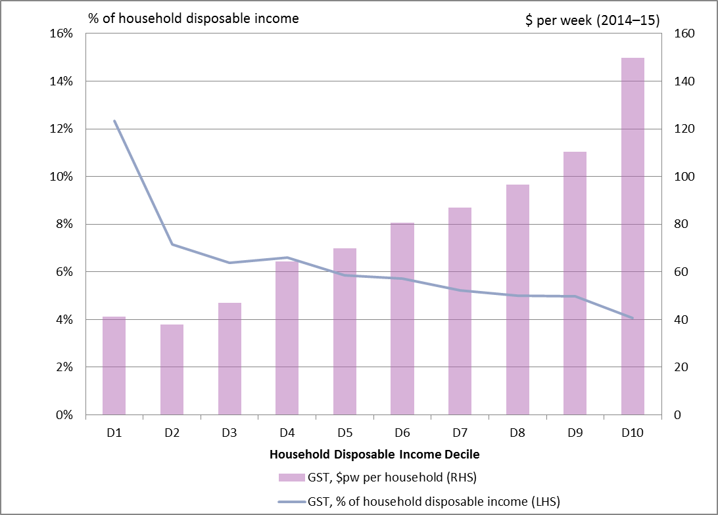
Source: PBO analysis based on data from the ABS and Treasury

Distributional analysis of GST concessions
This section analyses the relative and absolute impact of the principal exclusions from the GST tax base: basic food; health and medical care; education; child care; and water and sewerage rates and charges.
The value of the concessionary treatment by household decile has been calculated by multiplying the average amount of expenditure on each item by decile by the standard GST rate of 10 per cent. Differences in the distribution of the benefit of GST concessions thus reflect differences in the distribution of consumption patterns for these goods and services.

GST concession: basic food
A key criticism of the original proposal to subject basic food items to the GST was that it would be highly regressive. This is reflected in the analysis in Figure 3–4, with the value of the concession representing over two per cent of disposable income of the lowest income decile, or over six times the relative benefit to the highest income decile of around one third of one per cent.
Figure 3–4: Distribution of GST concession on basic food
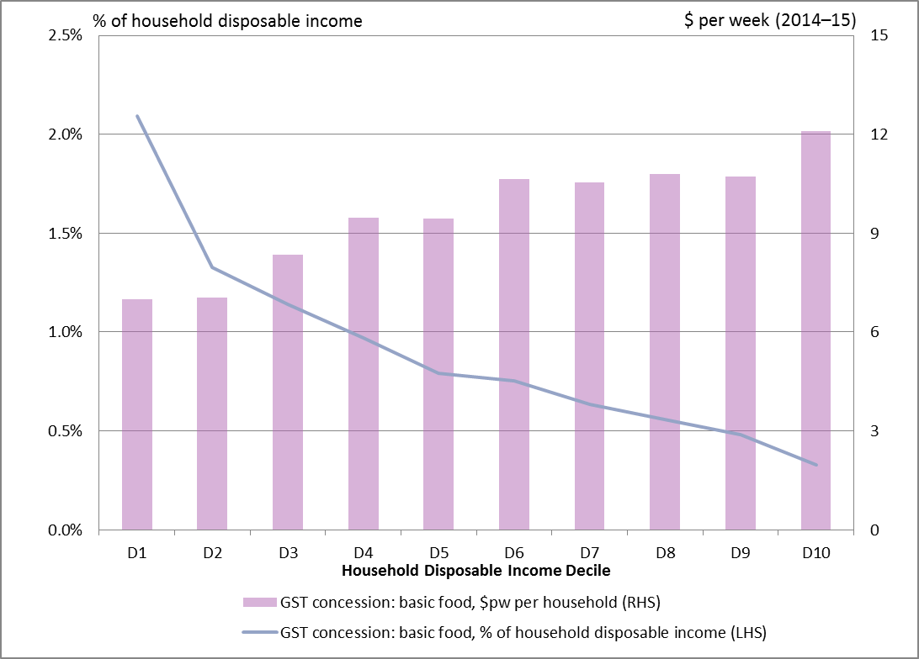
Source: PBO analysis based on data from the ABS and Treasury

That said, in absolute terms the exclusion of basic food from the GST provides a greater level of benefit to higher income earners, with the highest income decile receiving a benefit of nearly $12 per week, or over 70 per cent more than the benefit of around $7 per week to the lowest two income deciles.
Overall, only 33 per cent of the GST concession for basic food goes to the lowest 40 per cent of households by income. Clearly, if the principal objective of the exclusion of basic food from the GST is to provide assistance to lower income households, it is not well targeted at achieving this objective, especially relative to Australia’s relatively tightly targeted transfer system.

GST concession: health and medical care
The rationale for exclusion of health and medical care from Australia’s GST was to avoid creating inequities between private and public sector providers. There is also a view that as health and medical care is an essential service, subjecting it to the GST would be regressive.
Figure 3–5 presents estimates of the benefit of the GST-free treatment of health and medical care by household income decile. It shows that by far the greatest proportionate benefit of the GST concession on health and medical care (one per cent of income) goes to the lowest income decile. As noted above, data issues are likely to exaggerate the relative benefit of the GST concession for this group.
Over the remainder of the income distribution, the relative benefit of the concessional treatment of health and medical care varies within a relatively narrow range, from 0.25 per cent for the highest income decile to 0.45 per cent of income for the fourth lowest income decile.
In absolute terms, the exclusion of health and medical care from the GST provides a substantially greater level of benefit to higher income earners, with the highest income decile receiving a benefit of $9 per week, or nearly three times more than the benefit of a little over $3 per week to the lowest income decile. Overall, only 25 per cent of the GST concession for health and medical care goes to the lowest 40 per cent of households by income.
Figure 3–5: Distribution of GST concession on health and medical care
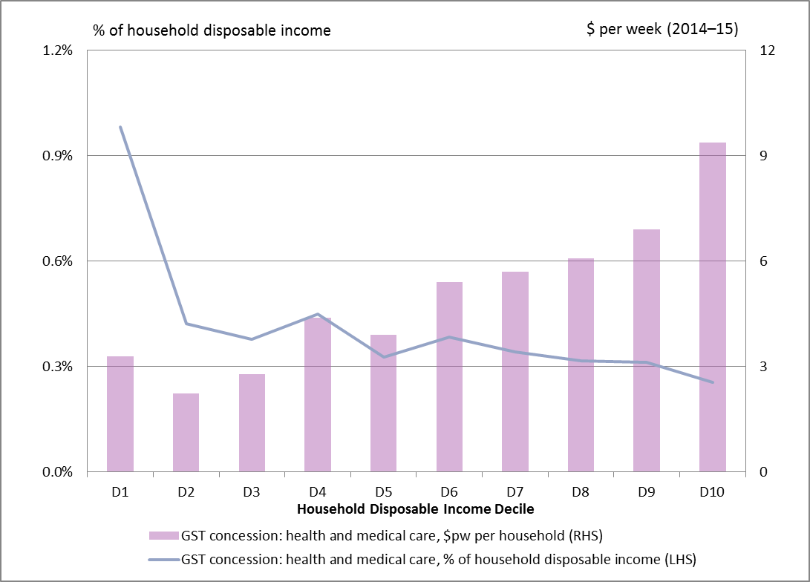
Source: PBO analysis based on data from the ABS and Treasury

GST concession: education
As with health and medical care, the rationale for excluding education from Australia’s GST was to avoid distorting the education market between private and public sector providers. Equally, as an essential service education is excluded from the VAT base of many OECD countries based on, among other things, concerns that its inclusion would be regressive.
Figure 3–6 presents estimates of the benefit of the GST-free treatment of education by household income decile. As with health and medical care, it shows that by far the greatest proportionate benefit of the GST concession on health and medical care (over 0.5 per cent of income) goes to the lowest income decile. Similarly, data issues are likely to exaggerate the relative benefit of the GST concession for this group.
Over the remainder of the income distribution, the greatest relative benefit of the concessional treatment of education is provided to the middle income households (the fourth to eighth deciles) at around 0.2 per cent of income, compared with around 0.15 per cent of income for upper and other lower income households.
In absolute terms, the exclusion of education from the GST generally provides a greater level of benefit to higher income earners, with the highest income decile receiving a benefit of over $7 per week, or about four times more than the benefit of under $2 per week to the lowest income decile. Overall, less than 20 per cent of the GST concession for education goes to the lowest 40 per cent of households by income.
Figure 3–6: Distribution of GST concession on education
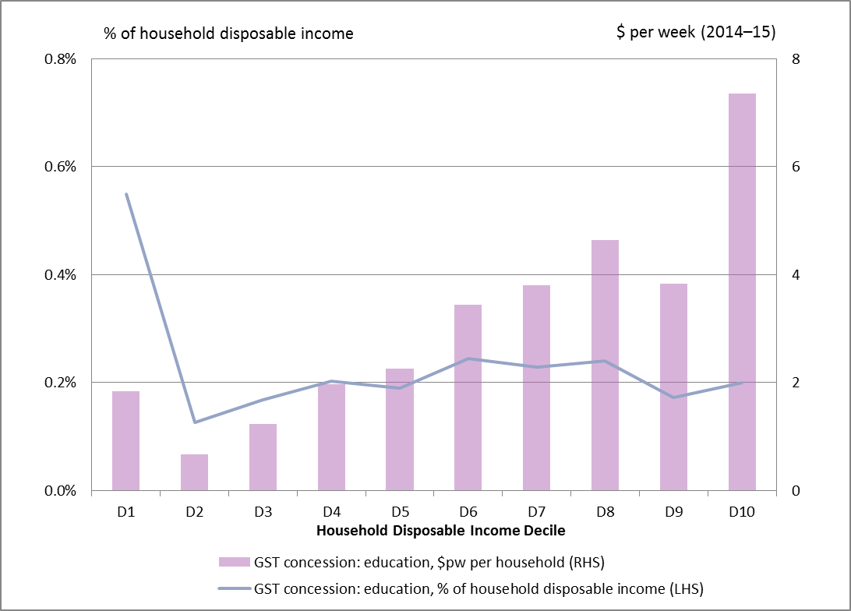
Source: PBO analysis based on data from the ABS and Treasury

GST concession: child care
Child care services are GST-free if the child care supplier is a registered carer, an approved child care service, or if the supplier is eligible for Commonwealth funding of family day care. The rationale for this concession is that child care often includes an educational component.
Figure 3–7 presents estimates of the benefit of the GST-free treatment of child care by household income decile. As with education, the concession provides a slightly greater relative benefit to middle income households than for upper and lower income households (except for the first decile).

The difference in the impact of the concession primarily reflects differences in the characteristics of households between income deciles. Couples with dependent children comprise a higher proportion of households in the middle income deciles. Within this group, the relative benefit of the concessional treatment of child care rises with income, peaking at just under 0.1 per cent of disposable income for the eighth income decile.
Similarly, in absolute terms, households in the eighth income decile receive the greatest benefit (around $1.75 per week). Overall, less than 20 per cent of the GST concession for child care goes to the lowest 40 per cent of households by income.
Figure 3–7: Distribution of GST concession on child care
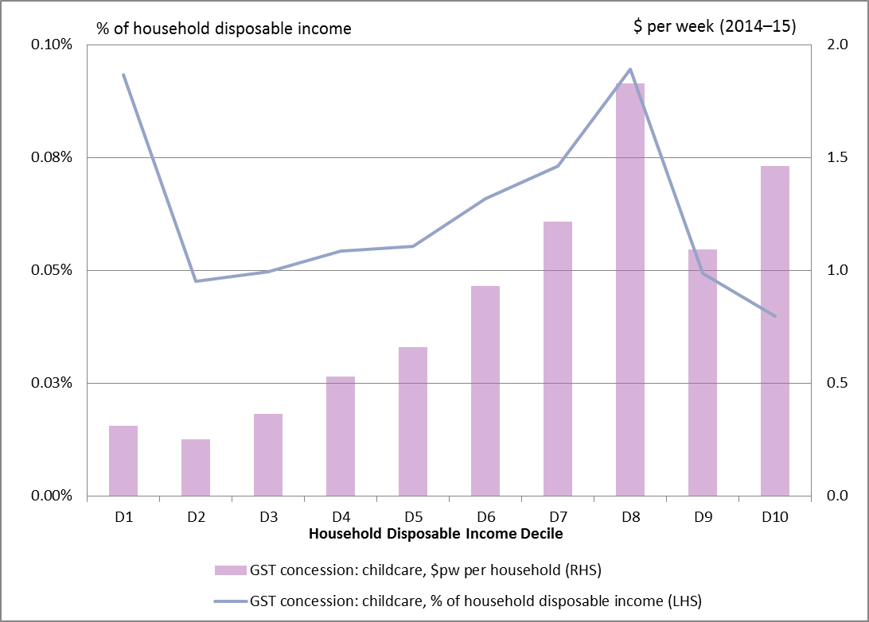
Source: PBO analysis based on data from the ABS and Treasury

GST concession: water and sewerage
Water and sewerage charges were excluded from the GST on the basis that they are government taxes and charges. More broadly, many OECD countries exclude these charges on the grounds that they are for essential services and subjecting them to VAT would be regressive.
Figure 3–8 shows that, while small relative to other GST concessions, the exclusion of water and sewerage charges from the GST provides a substantially greater proportionate benefit to lower income households. The value of the water and sewerage concession represents around 0.2 per cent of disposable income of the lowest income decile, or five times the relative benefit to the highest income decile.
In absolute terms the GST concession for water and sewerage provides a greater level of benefit to higher income earners, with the highest income decile receiving a benefit of around $1.25 per week, or more than double the benefit of just over $0.50 per week to the lowest income decile. Overall, around 30 per cent of the GST concession for water and sewerage goes to the lowest 40 per cent of households by income.
Figure 3–8: Distribution of GST concession on water and sewerage
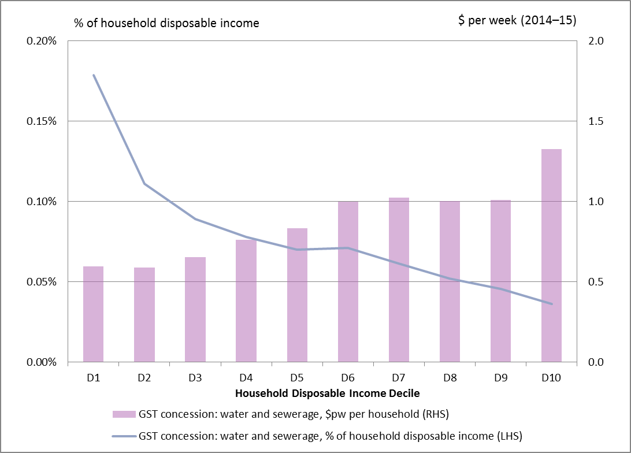
Source: PBO analysis based on data from the ABS and Treasury

Distribution of GST concessions: summary
Most, if not all, GST concessions are motivated at least in part by concern about the potential for the imposition of tax on essential services to disproportionately impact on low income households.
Figure 3–9: Overall distribution of GST concessions
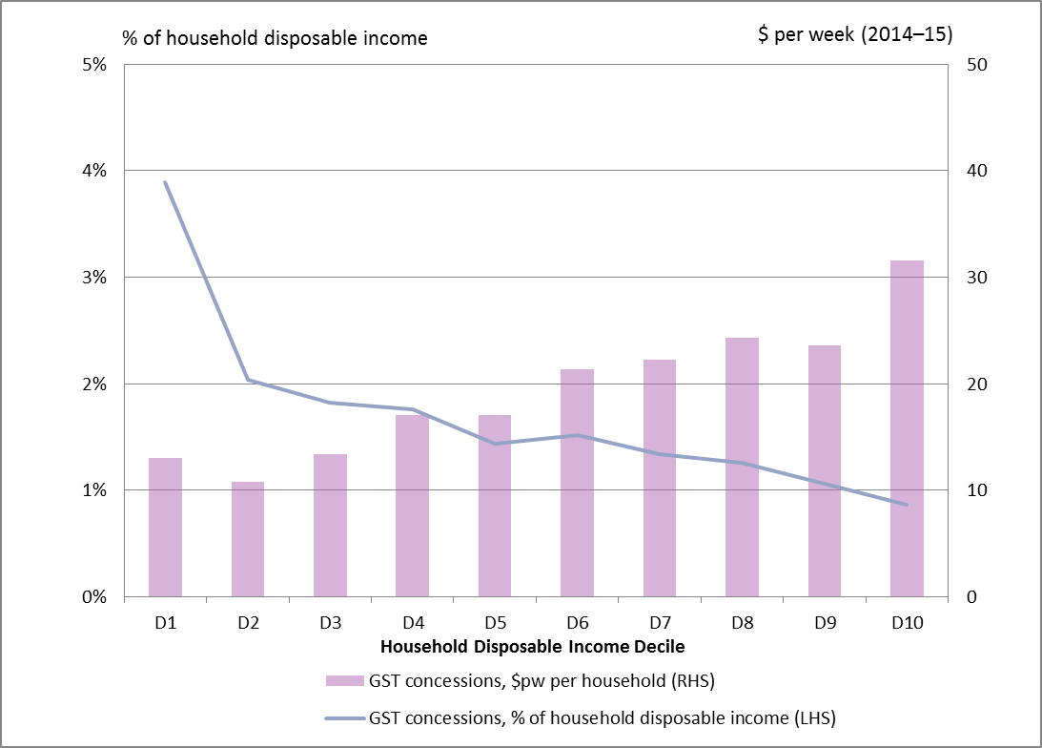
Source: PBO analysis based on data from the ABS and Treasury
The overall distribution of GST concessions presented in Figure 3–9 illustrates that, in isolation, removing all GST concessions would be regressive.
The value of GST concessions represents around four per cent of the disposable income of households in the lowest income decile and less than one per cent of the disposable income of the highest income decile. While data issues are likely to exaggerate the relative benefit of the GST concession for the lowest income decile, this trend is also evident across the rest of the income distribution.
In absolute terms, however, GST concessions provide substantially greater benefit to higher income earners. Households in the highest income decile effectively receive a benefit of about $32 per week from GST concessions, around 2.5 times as much as the $13 per week received by the lowest income decile.
Overall, around a quarter of the GST concessions goes to the lowest 40 per cent of households by income.
If the principal policy objective of GST concessions is to protect lower income households from disproportionate impact, they are not well targeted compared with Australia’s tightly means tested welfare system.

Analysis of GST reform scenarios
Public discussion of tax reform has almost invariably raised questions about the potential for reform of Australia’s GST. GST reform scenarios usually involve increasing the base rate of the GST and/or removing concessions from the GST base.
This chapter examines the net revenue and distributional impact of five GST reform scenarios that have been widely canvassed in public policy discussions:
- Basic food subject to GST
- Remove concessions from GST base
- Increase the GST rate from 10 per cent to 15 per cent
- GST rate 15 per cent; basic food subject to GST
- GST rate 15 per cent; Remove concessions from GST base
This report seeks to inform public discussion by providing an independent analysis of the financial impact of these scenarios. However, this does not mean that the PBO is endorsing any of these scenarios.

Methodology and key assumptions
This section provides a summary of the methodology and key assumptions underpinning the analysis of GST reform scenarios. Additional technical detail is provided in Appendix A.

Methodology
The financial implications of these GST reform scenarios were estimated using PRISMOD, a large-scale highly disaggregated model of the Australian economy that captures the flows of goods between production industries and final consumers.
Estimates of the total GST revenue under each of the GST reform scenarios were obtained by adjusting the effective GST rates on goods and services in PRISMOD in line with the relevant scenario. The additional GST revenue under each scenario is calculated by subtracting estimates of the base GST revenue.
Net additional GST revenue is the additional GST revenue less assumed compensation.
The distributional impact of the GST reform scenarios was estimated by comparing GST paid by households under the scenarios with the base.

Key assumptions
The analysis in this chapter assumes that reform scenarios take effect on 1 July 2017.
Under the terms of the Intergovernmental Agreement (IGA), all GST revenue raised, less the agreed administration costs of the Australian Taxation Office (ATO), is paid to the States and Territories. The analysis in this chapter presents the additional GST revenue raised (net of any additional ATO administration costs and household compensation) under each of the GST reform scenarios.
The analysis assumes that the GST reform scenarios apply on the basis that all other taxation settings are unchanged.
Several options have been put forward for the use of the additional revenue generated under GST reform scenarios. The PBO has made no assumption on how GST revenue (net of the assumed compensation package) would be used.

Technical assumption on compensation
Proponents of GST reform acknowledge that there would be a need to compensate lower income earners for the regressive impact of proposals. The specific design of compensation packages is a policy question, involving consideration of a range of possible changes to the tax and transfer system. The PBO has made no assumption on the specific form compensation packages might take.
Ignoring compensation completely, however, would reduce the usefulness of this analysis. For the purposes of this analysis, the PBO has made a technical assumption that there would be a compensation package that would have an aggregate financial impact equivalent to providing full compensation for the impact of proposals on the bottom 40 per cent of households by disposable income. The impact of the increase in the CPI on government payments is assumed to be included in this compensation.
It is recognised that in practice there would be challenges in targeting compensation solely to lower income groups.

Consumption response to GST reform scenarios
This analysis does not include any changes in the overall volume of goods and services purchased that may result from households changing their consumption behaviour in response to GST reform scenarios. The impact on GST revenue from the GST reform scenarios wholly reflects the impact from price changes.
This analysis incorporates an assumption to allow for a shift in consumption from taxable to non-taxable items in response to changes in relative prices under the GST reform scenarios. This has relatively little impact on the net additional revenue under each scenario.
Experience with the introduction of the GST in 2000 suggests that increasing the GST rate and/or broadening the GST base would be likely to see some consumption brought forward from 2017–18 to 2016–17. The extent of this bring forward would depend, among other things, on the timing of the announcement of any proposal, specific details of rules covering prepayments, and the response of producers to shifts in consumer demand.
The analysis in this report does not include any adjustment to reflect the impact of GST reform scenarios on the timing of consumption, reflecting its focus on the ongoing impact of GST reform scenarios rather than transitional effects.

Scenario 1: basic food subject to GST

Revenue impact of Scenario 1
Removing the GST-free status of basic food would increase GST revenue (net of the assumed compensation package) by $4.8 billion (0.3 per cent of GDP) in 2017–18 (Table 4-1).
Table 4–1: Revenue impact of Scenario 1 (basic food subject to GST)
 | 2017–18 | % of GDP
Additional GST revenue ($b) | 7.2 | 0.4%
Compensation: technical assumption ($b) | 2.4 | 0.1%
Net additional GST revenue: Scenario 1 ($b) | 4.8 | 0.3%
Source: PBO analysis based on data from the ABS and Treasury
GST revenue would increase by $7.2 billion (or 0.4 per cent of GDP) in 2017–18. The technical assumption that there would be compensation sufficient to fully offset the impact of the scenario on the bottom 40 per cent of households would cost $2.4 billion in 2017–18.
Additional detail on the revenue impact of Scenario 1 is provided in Appendix C.

Distributional impact of Scenario 1
Figure 4–1 presents a distributional analysis of the relative and absolute impacts of additional GST revenue under Scenario 1 on households by income decile.
Removing the GST-free status of basic food has a significantly greater relative impact on lower income earners.
In the absence of compensation arrangements targeting lower income households, those in the lowest income decile would pay an additional 1.9 per cent of their disposable income under this scenario, compared with the average of an additional 0.3 per cent paid by those in the highest income decile.
Figure 4–1: Distributional impact of Scenario 1 (basic food subject to GST)
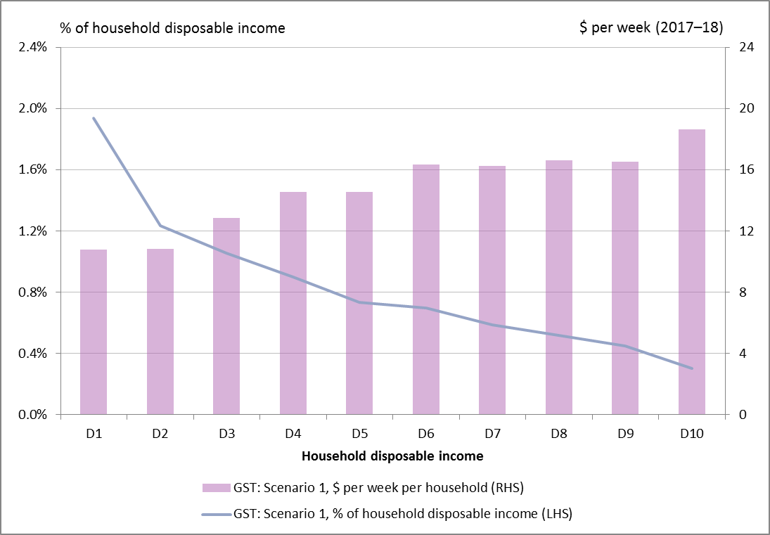
Source: PBO analysis based on data from the ABS and Treasury
Table 4–2 summarises the distribution of the relative impact of the additional GST revenue collected under Scenario 1 by decile of household disposable income before and after the assumed compensation package.
Table 4–2: Net additional GST revenue: relative impact of Scenario 1 (basic food subject to GST)
2017–18 | D1 | D2 | D3 | D4 | D5 | D6 | D7 | D8 | D9 | D10
Additional GST revenue | 1.9 | 1.2 | 1.1 | 0.9 | 0.7 | 0.7 | 0.6 | 0.5 | 0.4 | 0.3
Compensation | 1.9 | 1.2 | 1.1 | 0.9 | 0.0 | 0.0 | 0.0 | 0.0 | 0.0 | 0.0
Relative impact (%) | 0.0 | 0.0 | 0.0 | 0.0 | 0.7 | 0.7 | 0.6 | 0.5 | 0.4 | 0.3
Source: PBO analysis based on data from the ABS and Treasury
Table 4–3 summarises the distribution of the GST revenue collected under Scenario 1 by decile of household disposable income before and after the assumed compensation package. It shows that if the GST were applied to basic food in 2017-18, the bottom 40 per cent of households would pay an additional $2.4 billion in GST (or 33 per cent of the additional GST revenue), while the top 40 per cent of households would pay an additional $3.3 billion (or 46 per cent of the additional GST revenue).
Table 4–3: Net additional GST revenue: absolute impact of Scenario 1 (basic food subject to GST)
2017–18 ($b) | D1 | D2 | D3 | D4 | D5 | D6 | D7 | D8 | D9 | D10 | Total
Additional GST revenue | 0.5 | 0.5 | 0.6 | 0.7 | 0.7 | 0.8 | 0.8 | 0.8 | 0.8 | 0.9 | 7.2
Compensation | 0.5 | 0.5 | 0.6 | 0.7 | 0.0 | 0.0 | 0.0 | 0.0 | 0.0 | 0.0 | 2.4
Net additional GST revenue | 0.0 | 0.0 | 0.0 | 0.0 | 0.7 | 0.8 | 0.8 | 0.8 | 0.8 | 0.9 | 4.8
Source: PBO analysis based on data from the ABS and Treasury

Scenario 2: remove concessions from GST base

Revenue impact of Scenario 2
Removing the GST-free status of basic food, health and medical care, education, child care, and water and sewerage would increase GST revenue (net of the assumed compensation package) by $16.0 billion (0.9 per cent of GDP) in 2017–18 (Table 4–4).
Table 4–4: Revenue impact of Scenario 2 (remove concessions from GST base)
 | 2017–18 | % of GDP
Additional GST revenue ($b) | 21.6 | 1.2%
Compensation: technical assumption ($b) | 5.6 | 0.3%
Net additional GST revenue: Scenario 2 ($b) | 16.0 | 0.9%
Source: PBO analysis based on data from the ABS and Treasury
GST revenue would increase by $21.6 billion (or 1.2 per cent of GDP) in 2017–18. The technical assumption that there would be compensation sufficient to fully offset the impact of the scenario on the bottom 40 per cent of households would cost $5.6 billion in 2017–18.
Additional detail on the revenue impact of Scenario 2 is provided in Appendix C.

Distributional impact of Scenario 2
Figure 4–2 presents a distributional analysis of the relative and absolute impacts of additional GST revenue under Scenario 2 on households by income decile.
Expanding the GST base has a greater relative impact on lower income earners.
In the absence of compensation arrangements targeting lower income households, those in the lowest income decile would pay an additional 5.2 per cent of their disposable income under this scenario, compared with the average of an additional 1.3 per cent paid by those in the highest income decile.
Figure 4–2: Distributional impact of Scenario 2 (remove concessions from GST base)
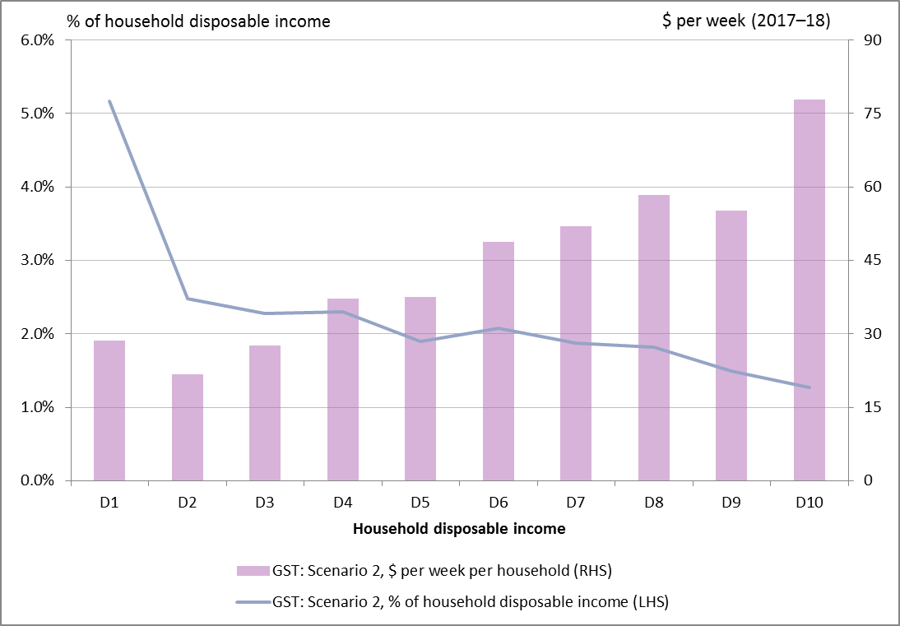
Source: PBO analysis based on data from the ABS and Treasury
Table 4–5 summarises the distribution of the relative impact of the GST revenue collected under Scenario 2 by decile of household disposable income before and after the assumed compensation package.
Table 4–5: Net additional GST revenue: relative impact of Scenario 2 (remove concessions from GST base)
2017–18 | D1 | D2 | D3 | D4 | D5 | D6 | D7 | D8 | D9 | D10
Additional GST revenue | 5.2 | 2.5 | 2.3 | 2.3 | 1.9 | 2.1 | 1.9 | 1.8 | 1.5 | 1.3
Compensation | 5.2 | 2.5 | 2.3 | 2.3 | 0.0 | 0.0 | 0.0 | 0.0 | 0.0 | 0.0
Relative impact (%) | 0.0 | 0.0 | 0.0 | 0.0 | 1.9 | 2.1 | 1.9 | 1.8 | 1.5 | 1.3
Source: PBO analysis based on data from the ABS and Treasury.
Table 4–6 summarises the distribution of the GST revenue collected under Scenario 2 by decile of household disposable income before and after the assumed compensation package. It shows that if GST concessions on basic food, health and medical care, education, child care, and water and sewerage were removed in 2017-18, the bottom 40 per cent of households would pay an additional $5.6 billion in GST (or 26 per cent of the additional GST revenue), while the top 40 per cent of households would pay an additional $11.8 billion (or 55 per cent of the additional GST revenue).
Table 4–6: Net additional GST revenue: absolute impact of Scenario 2 (remove concessions from GST base)
2017–18 ($b) | D1 | D2 | D3 | D4 | D5 | D6 | D7 | D8 | D9 | D10 | Total
Additional GST revenue | 1.4 | 1.1 | 1.3 | 1.8 | 1.8 | 2.4 | 2.5 | 2.8 | 2.7 | 3.8 | 21.6
Compensation | 1.4 | 1.1 | 1.3 | 1.8 | 0.0 | 0.0 | 0.0 | 0.0 | 0.0 | 0.0 | 5.6
Net additional GST revenue | 0.0 | 0.0 | 0.0 | 0.0 | 1.8 | 2.4 | 2.5 | 2.8 | 2.7 | 3.8 | 16.0
Source: PBO analysis based on data from the ABS and Treasury

Scenario 3: increase the GST rate to 15 per cent

Revenue impact of Scenario 3
Increasing the GST to 15 per cent would increase GST revenue (net of the assumed compensation package) by $24.6 billion (1.4 per cent of GDP) in 2017–18 (Table 4–4).
Table 4–7: Revenue impact of Scenario 3 (15 per cent GST)
 | 2017–18 | % of GDP
Additional GST revenue | 32.5 | 1.8%
Compensation: technical assumption | 7.9 | 0.4%
Net additional GST revenue: Scenario 3 | 24.6 | 1.4%
Source: PBO analysis based on data from the ABS and Treasury
GST revenue would increase by $32.5 billion (or 1.8 per cent of GDP) in 2017–18. The technical assumption that there would be compensation sufficient to fully offset the impact of the scenario on the bottom 40 per cent of households would cost $7.9 billion in 2017–18.
Additional detail on the revenue impact of Scenario 3 is provided in Appendix C.

Distributional impact of Scenario 3
Table 4–3 presents a distributional analysis of the relative and absolute impacts of additional GST revenue under Scenario 3 on households by income decile.
Increasing the GST to 15 per cent has a greater relative impact on lower income earners.
In the absence of compensation arrangements targeting lower income households, those in the lowest income decile would pay an additional 6.3 per cent of their disposable income under this scenario, compared with the average of an additional 2.1 per cent paid by those in the highest income decile.
Figure 4–3: Distributional impact of Scenario 3 (15 per cent GST)
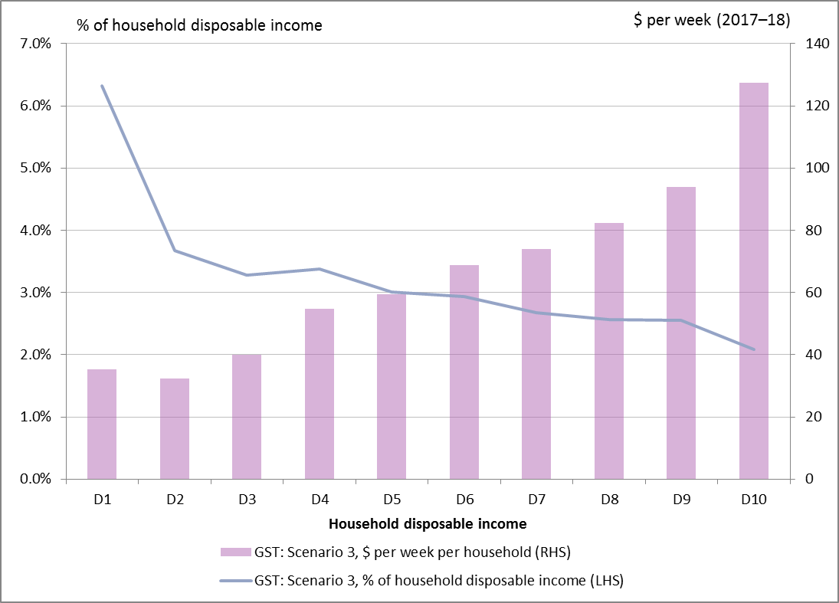
Source: PBO analysis based on data from the ABS and Treasury
Table 4–8 summarises the distribution of the relative impact of the GST revenue collected under Scenario 3 by decile of household disposable income before and after the assumed compensation package.
Table 4–8: Net additional GST revenue: relative impact of Scenario 3 (15 per cent GST)
2017–18 | D1 | D2 | D3 | D4 | D5 | D6 | D7 | D8 | D9 | D10
Additional GST revenue | 6.3 | 3.7 | 3.3 | 3.4 | 3.0 | 2.9 | 2.7 | 2.6 | 2.5 | 2.1
Compensation | 6.3 | 3.7 | 3.3 | 3.4 | 0.0 | 0.0 | 0.0 | 0.0 | 0.0 | 0.0
Relative impact (%) | 0.0 | 0.0 | 0.0 | 0.0 | 3.0 | 2.9 | 2.7 | 2.6 | 2.5 | 2.1
Source: PBO analysis based on data from the ABS and Treasury
Table 4-9 summarises the distribution of the GST revenue collected under Scenario 3 by decile of household disposable income before and after the assumed compensation package. It shows that if the GST were increased to 15 per cent in 2017-18, the bottom 40 per cent of households would pay an additional $7.9 billion in GST (or 24 per cent of the additional GST revenue), while the top 40 per cent of households would pay an additional $18.4 billion (or 57 per cent of the additional GST revenue).
Table 4–9: Net GST revenue: absolute impact of Scenario 3 (15 per cent GST)
2017–18 ($b) | D1 | D2 | D3 | D4 | D5 | D6 | D7 | D8 | D9 | D10 | Total
Additional GST revenue | 1.7 | 1.6 | 1.9 | 2.7 | 2.9 | 3.3 | 3.6 | 4.0 | 4.6 | 6.2 | 32.5
Compensation | 1.7 | 1.6 | 1.9 | 2.7 | 0.0 | 0.0 | 0.0 | 0.0 | 0.0 | 0.0 | 7.9
Net additional GST revenue | 0.0 | 0.0 | 0.0 | 0.0 | 2.9 | 3.3 | 3.6 | 4.0 | 4.6 | 6.2 | 24.6
Source: PBO analysis based on data from the ABS and Treasury

Scenario 4: 15 per cent GST; basic food subject to GST

Revenue impact of Scenario 4
Increasing the GST to 15 per cent and removing the GST-free status of basic food would increase GST revenue (net of the assumed compensation package) by $31.4 billion (1.7 per cent of GDP) in 2017–18 (Table 4–4).
Table 4–10: Revenue impact of Scenario 4 (15 per cent GST; basic food subject to GST)
 | 2017–18 ($b) | % of GDP
Additional GST revenue | 42.7 | 2.4%
Compensation: technical assumption | 11.3 | 0.6%
Net additional GST revenue: Scenario 4 | 31.4 | 1.7%
Source: PBO analysis based on data from the ABS and Treasury
GST revenue would increase by $42.7 billion (or 2.4 per cent of GDP) in 2017–18. The technical assumption that there would be compensation sufficient to fully offset the impact of the scenario on the bottom 40 per cent of households would cost $11.3 billion in 2017–18.
Additional detail on the revenue impact of Scenario 4 is provided in Appendix C.

Distributional impact of Scenario 4
Figure 4–4 presents a distributional analysis of the relative and absolute impacts of additional GST revenue under Scenario 4 on households by income decile.
Increasing the GST to 15 per cent and removing the GST-free status of basic food has a greater relative impact on lower income earners.
In the absence of compensation arrangements targeting lower income households, those in the lowest income decile would pay an additional 9.1 per cent of their disposable income under this scenario, compared with the average of an additional 2.5 per cent paid by those in the highest income decile.
Figure 4–4: Distributional impact of Scenario 4 (15 per cent GST; basic food subject to GST)
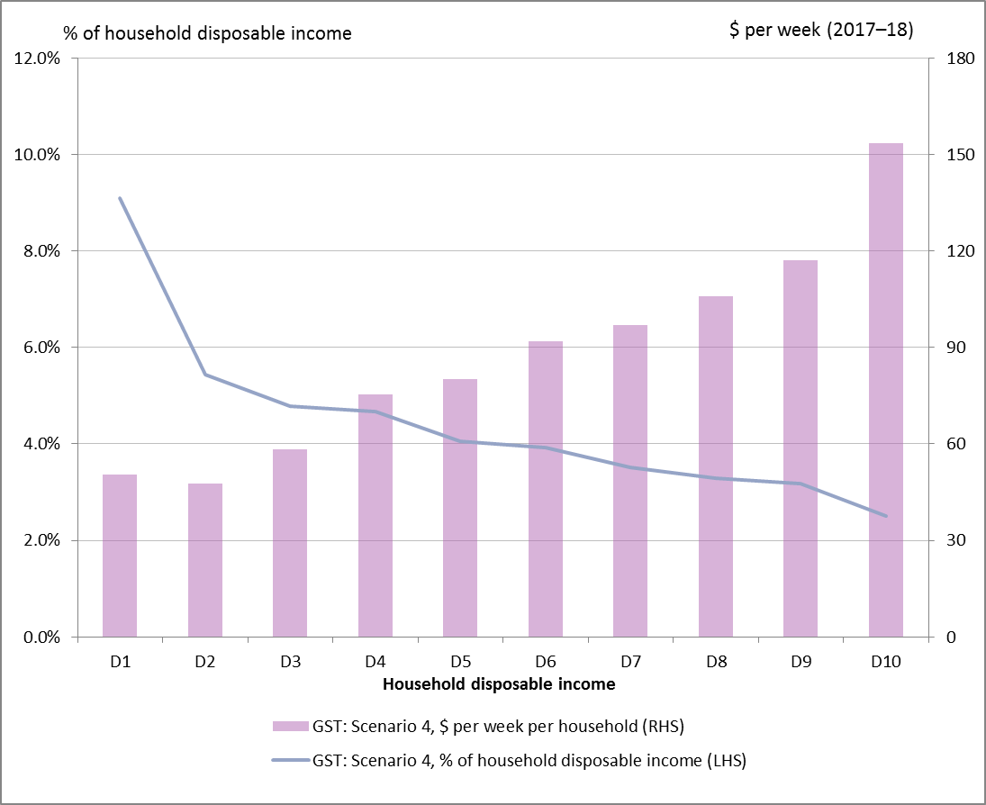
Source: PBO analysis based on data from the ABS and Treasury
Table 4–11 summarises the distribution of the relative impact of the GST revenue collected under Scenario 4 by decile of household disposable income before and after the assumed compensation package.
Table 4–11: Net additional GST revenue: relative impact of Scenario 4 (15 per cent GST; basic food subject to GST)
2017–18 | D1 | D2 | D3 | D4 | D5 | D6 | D7 | D8 | D9 | D10
Additional GST revenue | 9.1 | 5.4 | 4.8 | 4.7 | 4.0 | 3.9 | 3.5 | 3.3 | 3.2 | 2.5
Compensation | 9.1 | 5.4 | 4.8 | 4.7 | 0.0 | 0.0 | 0.0 | 0.0 | 0.0 | 0.0
Relative impact (%) | 0.0 | 0.0 | 0.0 | 0.0 | 4.0 | 3.9 | 3.5 | 3.3 | 3.2 | 2.5
Source: PBO analysis based on data from the ABS and Treasury
Table 4–12 summarises the distribution of the GST revenue collected under Scenario 4 by decile of household disposable income before and after the assumed compensation package. It shows that if the GST were increased to 15 per cent and applied to basic food in 2017-18, the bottom 40 per cent of households would pay an additional $11.3 billion in GST (or 26 per cent of the additional GST revenue), while the top 40 per cent of households would pay an additional $23.0 billion (or 54 per cent of the additional GST revenue).
Table 4–12: Net additional GST revenue: absolute impact of Scenario 4 (15 per cent GST; basic food subject to GST)
2017–18 ($b) | D1 | D2 | D3 | D4 | D5 | D6 | D7 | D8 | D9 | D10 | Total
Additional GST revenue | 2.5 | 2.3 | 2.8 | 3.7 | 3.9 | 4.5 | 4.7 | 5.1 | 5.7 | 7.5 | 42.7
Compensation | 2.5 | 2.3 | 2.8 | 3.7 | 0.0 | 0.0 | 0.0 | 0.0 | 0.0 | 0.0 | 11.3
Net additional GST revenue | 0.0 | 0.0 | 0.0 | 0.0 | 3.9 | 4.5 | 4.7 | 5.1 | 5.7 | 7.5 | 31.4
Source: PBO analysis based on data from the ABS and Treasury

Scenario 5: 15 per cent GST; remove concessions

Revenue impact of Scenario 5
Increasing the GST to 15 per cent and removing the GST-free status of basic food, health and medical care, education, child care, and water and sewerage would increase GST revenue (net of the assumed compensation package) by $49.3 billion (2.7 per cent of GDP) in 2017–18 (Table 4–13).
Table 4–13: Revenue impact of Scenario 5 (15 per cent GST; remove concessions)
 | 2017–18  ($b) | % of GDP
Additional GST revenue | 65.8 | 3.6%
Compensation: technical assumption | 16.5 | 0.9%
Net additional GST revenue: Scenario 5 | 49.3 | 2.7%
Source: PBO analysis based on data from the ABS and Treasury
GST revenue would increase by $65.8 billion (or 3.6 per cent of GDP) in 2017–18. The technical assumption that there would be compensation sufficient to fully offset the impact of the scenario on the bottom 40 per cent of households would cost $16.5 billion in 2017–18.
Additional detail on the revenue impact of Scenario 5 is provided in Appendix C.

Distributional impact of Scenario 5
Figure 4–5 presents a distributional analysis of the relative and absolute impacts of additional GST revenue under Scenario 5 on households by income decile.
Increasing the GST to 15 per cent and expanding the GST base has a greater relative impact on lower income earners.
In the absence of compensation arrangements targeting lower income households, those in the lowest income decile would pay an additional 14.2 per cent of their disposable income under this scenario, compared with the average of an additional 4.0 per cent paid by those in the highest income decile.
Figure 4–5: Distributional impact of Scenario 5 (15 per cent GST; remove concessions)
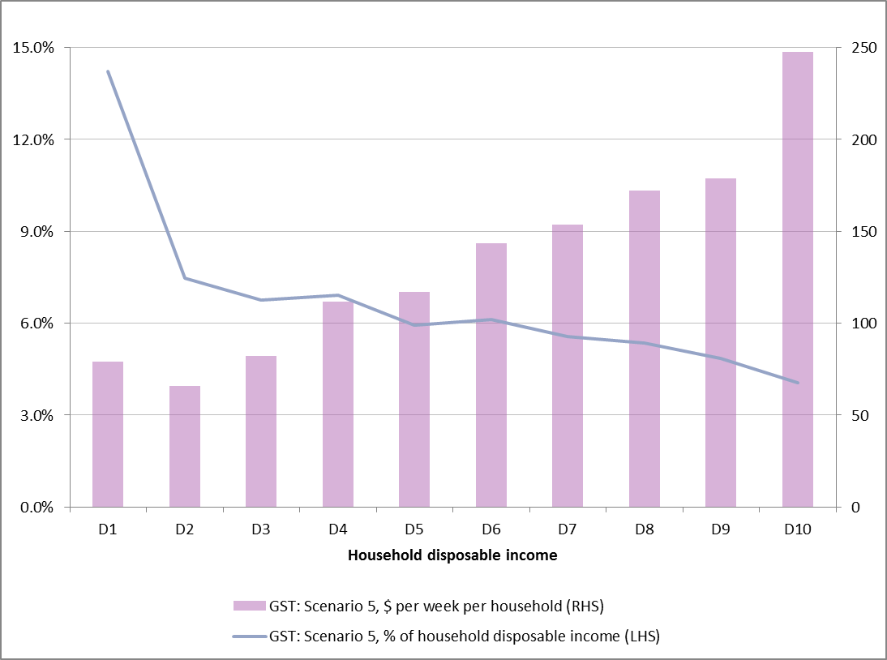
Source: PBO analysis based on data from the ABS and Treasury
Table 4–14 summarises the distribution of the relative impact of the GST revenue collected under Scenario 5 by decile of household disposable income before and after the assumed compensation package.
Table 4–14: Net additional GST revenue: relative impact of Scenario 5 (15 per cent GST; remove concessions)
2017–18 | D1 | D2 | D3 | D4 | D5 | D6 | D7 | D8 | D9 | D10
Additional GST revenue | 14.2 | 7.5 | 6.8 | 6.9 | 5.9 | 6.1 | 5.6 | 5.3 | 4.9 | 4.0
Compensation | 14.2 | 7.5 | 6.8 | 6.9 | 0.0 | 0.0 | 0.0 | 0.0 | 0.0 | 0.0
Relative impact (%) | 0.0 | 0.0 | 0.0 | 0.0 | 5.9 | 6.1 | 5.6 | 5.3 | 4.9 | 4.0
Source: PBO analysis based on data from the ABS and Treasury
Table 4–15 summarises the distribution of the GST revenue collected under Scenario 5 by decile of household disposable income before and after the assumed compensation package. It shows that if concessions were removed on basic food, health and medical care, education, child care, and water and sewerage and the GST were increased to 15 per cent in 2017-18, the bottom 40 per cent of households would pay an additional $16.5 billion in GST (or 25 per cent of the additional GST revenue), while the top 40 per cent of households would pay an additional $36.6 billion (or 56 per cent of the additional GST revenue).
Table 4–15: Net additional GST revenue: absolute impact of Scenario 5 (15 per cent GST; remove concessions)
2017–18 ($b) | D1 | D2 | D3 | D4 | D5 | D6 | D7 | D8 | D9 | D10 | Total
Additional GST revenue | 3.9 | 3.2 | 4.0 | 5.4 | 5.7 | 7.0 | 7.5 | 8.4 | 8.7 | 12.0 | 65.8
Compensation | 3.9 | 3.2 | 4.0 | 5.4 | 0.0 | 0.0 | 0.0 | 0.0 | 0.0 | 0.0 | 16.5
Net additional GST revenue | 0.0 | 0.0 | 0.0 | 0.0 | 5.7 | 7.0 | 7.5 | 8.4 | 8.7 | 12.0 | 49.3
Source: PBO analysis based on data from the ABS and Treasury

Summary
This chapter sets out the net revenue and distributional impacts of five GST reform scenarios.
These scenarios would increase GST revenue (net of the assumed compensation package) by between $4.8 billion (extending GST to basic food) to $49.3 billion (15 per rate, remove base concessions) in 2017–18.
The PBO has made no assumption on how GST revenue (net of the assumed compensation package) would be used.
Caution is needed in interpreting distributional analysis based on the Household Expenditure Survey, as data issues are likely to exaggerate the relative impact of the GST reform scenarios for the lowest income decile.
Nevertheless it is clear that, in the absence of compensation arrangements targeting lower income households, each of the scenarios analysed would have a greater relative impact on lower income earners.
The analysis in this report makes the technical assumption that, in aggregate, there would be full compensation on average for the impact of each scenario on the bottom 40 per cent of households by disposable income.
Overall, around 25 per cent of the additional revenue under the GST reform scenarios is paid by the lowest 40 per cent of households. That is, GST revenue net of the assumed compensation package is 75 per cent of gross additional GST.
Table 4–16 summarises the net additional GST revenue under the GST reform scenarios. Additional detail on the revenue impact of GST reform scenarios is provided in Appendix C.
Table 4–16: Summary of net additional GST revenue impact of scenarios
 | 2017–18 | % of GDP
Scenario 1: basic food subject to GST | 4.8 | 0.3%
Scenario 2: remove concessions from GST base | 16.0 | 0.9%
Scenario 3: increase the GST rate to 15 per cent | 24.6 | 1.4%
Scenario 4: GST rate 15 per cent; basic food subject to GST | 31.4 | 1.7%
Scenario 5: 15 per cent GST; remove concessions | 49.3 | 2.7%
Source: PBO analysis based on data from the ABS and Treasury

References
Australian Bureau of Statistics 2011a, Household Expenditure Survey, Australia: Summary of Results, 2009-10, cat. no. 6530.0, ABS, Canberra.
Australian Bureau of Statistics 2011b, Household Income and Income Distribution, Australia, 2009-10, cat. no. 6523.0, ABS, Canberra.
Australian Bureau of Statistics 2012, Household Expenditure Survey and Survey of Income and Housing – User Guide, Australia 2009-10, cat. no. 6503.0, ABS, Canberra.
Australian Council of Social Services 2015, ‘Using a higher GST to pay for income tax cuts is a “recipe for more inequality, with higher income earners the winners”’, ACOSS media release, 5 November 2015,available at: http://www.acoss.org.au/.
Cao, L, Hosking, A, Kouparitsas, M, Mullaly, D, Rimmer, X, Shi, Q, Stark, W & Wende, S 2015, ’Understanding the Economy-wide Efficiency and Incidence of Major Australian Taxes’, Treasury Working Paper 2015-01, The Treasury, Canberra.
Carnahan, M 1998, ‘Does Demand Create Poor Quality Supply: A Critique of Alternative Distributional Analysis’, Economic Roundup, The Treasury, Canberra.
Commonwealth of Australia 1998, Tax Reform: Not a New Tax, A New Tax System, Australian Government Publishing Service, Canberra.
Commonwealth of Australia 2015, Re:think — Tax discussion paper, The Treasury, Canberra.
Daley, J, Wood, D, Parsonage, H, & Coates, B 2015, A GST Reform Package, Grattan Institute.
Harding, A & Warren, N, 1998, An Introduction to Microsimulation Models of Tax Reform, Paper prepared for the Senate Select Committee for a New Tax System, National Centre for Social and Economic Modelling, University of Canberra, Canberra.
Harding, A, Warren, N, Robinson, M & Lambert, S 2000, ‘The Distributional Impact of Year 2000 Tax Reforms in Australia’, I, vol. 7, no. 1, pp 17-32.
International Monetary Fund 2015a, Australia: Staff Report for the 2015 Article IV Consultation, IMF Country Report No. 15/274, IMF, Washington.
International Monetary Fund 2015b, Options for Tax Policy and Federal Fiscal Relations Reform, IMF Country Report No. 15/275, IMF, Washington.
Organisation for Economic Co-operation and Development 2010, Tax Policy Reform and Economic Growth, OECD Publishing.
Organisation for Economic Co-operation and Development 2014a, OECD Economic Surveys: Australia, OECD Publishing.
Organisation for Economic Co-operation and Development 2014b, The Distributional Effects of Consumption Taxes in OECD countries, OECD Tax Policy Studies, no. 22, OECD Publishing.
Organisation for Economic Co-operation and Development 2014c, Consumption Tax Trends 2014, OECD Publishing.
Organisation for Economic Co-operation and Development 2015a, Revenue Statistics, OECD Publishing.
Organisation for Economic Co-operation and Development 2015b, In It Together: Why Less Inequality Benefits All, OECD Publishing, Paris.
Parliamentary Budget Office 2014, Trends in Australian Government Receipts: 1982–83 to 2012–13, PBO, Canberra.
Phillips, B & Taylor, M 2015, The Distributional Impact of the GST, National Centre for Social and Economic Modelling, University of Canberra, Canberra.
Productivity Commission 2015, Tax and Transfer Incidence in Australia, Commission Working Paper, Canberra.
Warren, N, Harding, A, Robinson, M, Lambert, S & Beer, G 1999, Distributional Impact of Possible Tax Reform Packages, Report to Senate Select Committee on a New Tax System, National Centre for Social and Economic Modelling, University of Canberra, Canberra.

List of figures
Figure 3–1: Distribution of household income and expenditure 8
Figure 3–2: Distribution of household saving 9
Figure 3–3: Distributional impact of the GST 10
Figure 3–4: Distribution of GST concession on basic food 11
Figure 3–5: Distribution of GST concession on health and medical care 13
Figure 3–6: Distribution of GST concession on education 14
Figure 3–7: Distribution of GST concession on child care 15
Figure 3–8: Distribution of GST concession on water and sewerage 16
Figure 3–9: Overall distribution of GST concessions 17
Figure 4–1: Distributional impact of Scenario 1 (basic food subject to GST) 22
Figure 4–2: Distributional impact of Scenario 2 (remove concessions from
GST base) 24
Figure 4–3: Distributional impact of Scenario 3 (15 per cent GST) 26
Figure 4–4: Distributional impact of Scenario 4 (15 per cent GST; basic food subject to GST) 28
Figure 4–5: Distributional impact of Scenario 5 (15 per cent GST; remove concessions) 30

List of tables
Table 1: Summary of net GST revenue impact of scenarios vi
Table 4–1: Revenue impact of Scenario 1 (basic food subject to GST) 21
Table 4–2: Net additional GST revenue: relative impact of Scenario 1 (basic food subject to GST) 22
Table 4–3: Net additional GST revenue: absolute impact of Scenario 1 (basic food subject to GST) 23
Table 4–4: Revenue impact of Scenario 2 (remove concessions from GST base) 23
Table 4–5: Net additional GST revenue: relative impact of Scenario 2 (remove concessions from GST base) 24
Table 4–6: Net additional GST revenue: absolute impact of Scenario 2 (remove concessions from GST base) 25
Table 4–7: Revenue impact of Scenario 3 (15 per cent GST) 25
Table 4–8: Net additional GST revenue: relative impact of Scenario 3
(15 per cent GST) 26
Table 4–9: Net GST revenue: absolute impact of Scenario 3 (15 per cent GST) 27
Table 4–10: Revenue impact of Scenario 4 (15 per cent GST; basic food
subject to GST) 27
Table 4–11: Net additional GST revenue: relative impact of Scenario 4 (15 per cent GST; basic food subject to GST) 28
Table 4–12: Net additional GST revenue: absolute impact of Scenario 4
(15 per cent GST; basic food subject to GST) 29
Table 4–13: Revenue impact of Scenario 5 (15 per cent GST; remove concessions) 29
Table 4–14: Net additional GST revenue: relative impact of Scenario 5
(15 per cent GST; remove concessions) 30
Table 4–15: Net additional GST revenue: absolute impact of Scenario 5
(15 per cent GST; remove concessions) 31
Table 4–16: Summary of net additional GST revenue impact of scenarios 32

List of abbreviations
ABS | Australian Bureau of Statistics
ATO | Australian Tax Office
CPI | Consumer Price Index
GDP | Gross Domestic Product
GST | Goods and Services Tax
IMF | International Monetary Fund
MTAWE | Male Total Average Weekly Earnings
NATSEM | National Centre for Social and Economic Modelling
OECD | Organisations for Economic Co-operation and Development
PBO | Parliamentary Budget Office
VAT | Value Added Tax

List of appendices
Appendix A: Data, methodology and assumptions 39
A1. Distributional analysis 39
A2. Revenue impact 41
Appendix B: Characteristics of households 46
Appendix C:Net GST revenue from scenarios 52
Scenario 1: basic food subject to GST 53
Scenario 2: Remove concessions from GST base 55
Scenario 3: Increase the GST rate to 15 per cent 57
Scenario 4: Increase the GST rate to 15 per cent; basic food subject
to GST 59
Scenario 5: Increase the GST rate to 15 per cent; remove concessions from GST base 61

– Data, methodology and assumptions

Distributional analysis
The distributional analysis in this report is based on data from the ABS Household Expenditure Survey.
    - Household Expenditure Survey
The Household Expenditure Survey provides details of the income and expenditures of Australian households, covering 600 expenditure items including expenditure on goods and services, income tax and a number of other taxes and charges.
An assessment was made on whether each of the 600 expenditure items was subject to the GST and, if so, an effective GST rate was estimated. Where the GST treatment was unclear (for example food, which includes taxable and non-taxable items), the effective GST rate was estimated by comparing data on GST payable by industry with ABS input-output tables.
The impact of GST on each household in the survey is the sum of the product of expenditure on each item and its estimated effective GST rate.
The analysis of the distributional impact of the GST is done by ranking households into deciles (10 per cent increments) on the basis of equivalised household disposable income.
Equivalised household disposable income is household income from all sources for all members of the household, less income tax and adjusted for the number of members in the household that the income supports.
The equivalence factors used in this analysis to adjust for differences in household size are those included by the ABS in the Household Expenditure Survey data file.
    - Limitations of the Household Expenditure Survey
The Household Expenditure Survey is widely used for distributional analysis of the type presented in this report. However there are well documented limitations in this data that should be kept in mind in interpreting the results of this analysis.
In particular:
- the composition of expenditure in the Household Expenditure Survey is inconsistent with the (higher quality) aggregate consumption data
- income data in the Household Expenditure Survey is not comprehensive and is inconsistent with aggregate data from ATO and DSS estimates.
These inconsistencies can have a potentially significant impact on the results of distributional analysis. It is possible that the large disparity between expenditure and income in the first decile of household disposable income (with the household saving rate of -126 per cent) reflects a disproportionate share of households in this decile with ‘missing’ or understated income in the Household Expenditure Survey.
One explanation for this high level of saving is the disparity between income reported under the Household Expenditure Survey data and aggregate consumption data. The ABS has estimated that, adjusting for classification differences, income reported under the Household Expenditure Survey is around 10 per cent lower overall than aggregate consumption data.
Unsurprisingly, the bottom income decile contains the households with zero or negative income. To the extent that this reflects problems in the data rather than the actual income of households will distort the analysis in this paper. Figure A‒1 suggests that there is a correlation between the high level of dissaving across age groups in the bottom income decile and the proportion of those households with zero or negative income.
Figure A‒1: Household saving and zero/negative income, bottom income decile
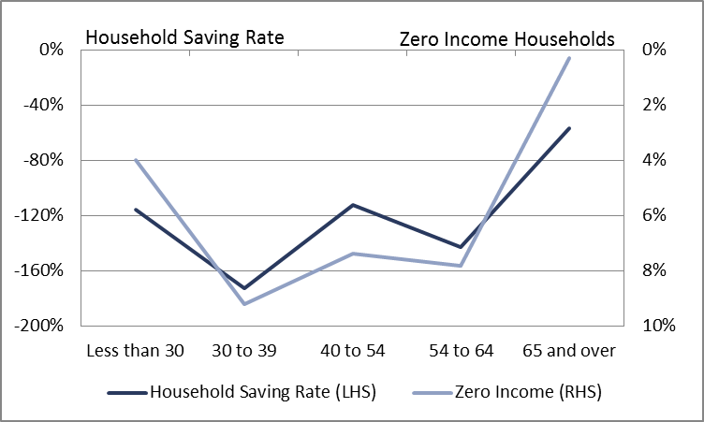
Source: PBO analysis based on data from the ABS
This suggests caution in drawing strong inferences from the impact of proposals on the first decile of income alone.
Moreover, while a range of adjustments have been proposed to correct for these differences, it is not clear that they produce more robust, or more accurate, results.

Revenue impact
    - Key assumptions
In estimating the net additional GST revenue of GST reform scenarios the PBO has made the following assumptions.
      - GST revenue assumptions
The analysis in this report presents the additional GST revenue of GST reform scenarios based on the assumption they take effect on 1 July 2017.
The analysis in this report assumes that GST reform scenarios apply on the basis that all other taxation settings are unchanged.
Under the terms of the Intergovernmental Agreement (IGA), all GST revenue raised, less the agreed administration costs of the Australian Taxation Office, is paid to the States and Territories. Several options have been put forward for the use of the additional revenue generated under GST reform scenarios.
The PBO has made no assumption on how GST revenue (net of the assumed compensation package) would be used.
      - Consumption response to GST reform scenarios
This analysis does not include any changes in the overall volume of goods and services purchased that may result from households changing their consumption behaviour in response to GST reform scenarios. The impact on GST revenue from the GST reform scenarios wholly reflects the impact from price changes.
This analysis incorporates an assumption to allow for a shift in consumption from taxable to non-taxable items in response to changes in relative prices under GST reform scenarios. This has relatively little impact on the net revenue under GST reform scenarios.
The experience with the introduction of the GST in 2000 suggests that increasing the GST rate and/or broadening the GST base would be likely to see some consumption brought forward from 2017–18 to 2016–17. The extent of this bring forward would depend, among other things, on the timing of the announcement of any proposal, specific details of rules covering prepayments, and the response of producers to shifts in consumer demand.
The analysis in this report does not include any adjustment to reflect the impact of GST reform scenarios on the timing of consumption, reflecting its focus on the ongoing impact of GST reform scenarios rather than transitional effects.
All price impacts from the GST rate changes are assumed to be passed through the production chain immediately and to be fully borne by final consumers of the good or service. As a result there is minimal impact on company or income tax.
      - Technical assumption on compensation
Proponents of GST reform invariably acknowledge that there would be a need to compensate lower income earners for the regressive impact of proposals. The specific design of compensation packages is a policy question, involving consideration of a range of possible changes to the tax and transfer system. The PBO has made no assumption on the specific form compensation packages might take.
Ignoring compensation completely, however, would reduce the usefulness of this analysis. For the purposes of this analysis, the PBO has made a technical assumption that there would be a compensation package that would have an aggregate financial impact equivalent to providing full compensation on average for the impact of proposals on the bottom 40 per cent of households by disposable income. The impact of the increase in the CPI on Government payments is assumed to be included in this amount.
      - Impacts of higher CPI: Government payments, fuel and alcohol revenues
The proposals would impact the CPI release for the quarter immediately after the GST change took effect (in this case the September quarter of 2017). The consequential impact of the higher CPI on Government payments and revenues has not been included in this analysis as in practice they would be factored into policy decisions.
- The impact of the increase in the CPI on Government payments is assumed to be included in the technical assumption on compensation.
- There were a number of policy decisions on alcohol and fuel excise (and the fuel tax credit) at the time of the introduction of the GST in 2000.
      - Impact on administration costs
The analysis does not include additional administration costs in the forward estimates period associated with implementing the proposal. The ongoing impact on the Australian Government’s administration costs is assumed to be relatively small.
      - Economy-wide (second-round) effects
The broader macroeconomic impacts of this proposal (including its potential impact on economic efficiency, wage growth and household consumption) have not been modelled. These effects are highly uncertain and hard to measure, particularly in the absence of information on how the additional revenue would be used.
    - Costing methodology
PRISMOD was used to estimate the revenue and consumer price implications of this proposal. It calculates how GST related price changes flow through industries in the production chain to the final consumption price of goods and services.
The model applies GST at all relevant points along the production chain capturing goods and services that are inputs to further production (generating input tax credits) as well as goods that represent final consumption. It calculates the effective GST tax rates on goods and services at the current 10 per cent GST rate. These represent the base effective rates of GST that apply to particular goods and services.
The effective rates may be less than the current statutory rate of 10 per cent, reflecting different levels of business input tax credits claimed for each good.
PRISMOD is calibrated to include the actual amount of GST revenue that was collected in the base year for the model.
The PBO estimated the revenue impact of GST rate and base changes by adjusting the effective GST rates on goods and services to reflect the GST reform scenario.
Comparing the GST revenue expected under the proposal with the base GST revenue amount gives the impact of the scenario.
Further detail on PRISMOD and its underlying assumptions is included below.
      - Rounding
GST revenue and expenditure estimates have been rounded to the nearest $50 million.
    - Data sources
Forecasts of economic parameters from the 2015–16 Budget were obtained from the Treasury.
- Modelling of the impacts on Government payments to households are based on data from the 2007–08 and 2009–10 ABS Surveys of Income and Housing.
- Unit record data for alcohol and fuel excise was obtained from the ATO and unit record data for excise equivalent customs duty was obtained from the Australian Customs and Border Protection Service.
Forward estimates of recipient numbers and expenses for Australian Government payments at the 2015–16 Budget were provided by the agencies responsible for administering these payments.
    - PRISMOD
PRISMOD is a large-scale highly disaggregated model of the Australian economy that captures the flows of goods between production industries and final consumers. PRISMOD data includes the transactions and consumption patterns of 109 industry categories and seven categories of final demand. PRISMOD is currently based on data from ABS 2009–10 Input-Output tables.
PRISMOD focuses on the inter-industry transmission of price changes. For example, it tracks how a change in the price of electricity impacts on all industries that purchase electricity, and on all industries that purchase from those industries, and so on until it estimates the impact of the price change on final consumer prices for goods and services.
PRISMOD also provides an estimate of the impact of price increases on the CPI by mapping the increase in final consumer prices to the CPI basket of goods and services used by the ABS.
The key assumptions that underpin PRISMOD are set out below.
Quantities of goods and services are held fixed and only price impacts are modelled. Price changes are calculated assuming that businesses continue to operate with exactly the same inputs, and produce exactly the same outputs, before and after the change being simulated.
Consumers’ consumption patterns do not vary over time so that they purchase a constant quantity of goods and services—only the prices of these goods and services vary over time.
All cost and price impacts are passed on fully to final consumers (such as governments and households). That is, it is assumed that higher GST rates would be passed through fully to domestic consumers in the form of higher prices.
The model does not provide information as to the timing of price changes. This means that short-term price increases may differ from the modelled result, for instance, if the proposal being estimated is slow to mature or it is not immediately passed on in practice.

– Characteristics of households
This appendix provides details of the financial and demographic characteristics of households by deciles of disposable income.
Table B‒1 sets out the financial characteristics of households by deciles of disposable income. From the second income decile, the level of expenditure, GST paid and household net worth increases with income. The proportion of households who own their home without a mortgage also increases with income, from 13 per cent from the second income decile to over 50 per cent for the top three income deciles. The trend for the overall level of home ownership is not as stark, as lower and middle income deciles are more likely to have a mortgage.
Table B‒2 sets out the demographic composition of households. From the second income decile the proportion of households with government pensions or allowances as their main source of income declines by income decile, while salary and wages becomes progressively more important.
Households where the household head is aged over 65 are more likely to be in lower income deciles. There is, however, a noticeable shift from the lowest income decile (27 per cent) and the second lowest income decile (56 per cent).
Table B‒3provides details of the composition of households. Single person households comprise a significant share of the bottom two income deciles (49 and 41 per cent respectively), and around 20 per cent of other income deciles. One parent households comprise around nine to 10 per cent of households in the bottom 50 per cent of households by income, before sharply declining to be less than one per cent of the top two income deciles.
The middle six income deciles were more likely to have dependent children, with the bottom and top income deciles having a lower share of dependent children than average.
Table B‒4 further disaggregates household saving, wealth and income data by the age of the head of the household as well as household income. The data implies a very high level of dissaving across all age groups in the bottom income decline, particularly for those of working age.
One explanation for this high level of dissaving is the disparity between income reported under the Household Expenditure Survey data and aggregate consumption data. The ABS has estimated that, adjusting for classification differences, income reported under the Household Expenditure Survey is around 10 per cent lower overall than aggregate consumption data.
Unsurprisingly, the bottom income decile contains the households with zero or negative income. To the extent that this reflects problems in the data rather than the actual income of households will distort the analysis in this paper. This suggests caution in drawing strong inferences from the impact of proposals on the first decile of income alone.

Table B‒1: Distribution analysis of households, financial characteristics
 |  | D1 | D2 | D3 | D4 | D5 | D6 | D7 | D8 | D9 | D10 | All
Gross household income | $ per week | 326 | 519 | 734 | 1,014 | 1,290 | 1,554 | 1,895 | 2,242 | 2,648 | 4,613 | 1,684
Income tax | $ per week | 1 | 4 | 22 | 69 | 132 | 187 | 277 | 365 | 493 | 1,047 | 260
Net household income | $ per week | 325 | 515 | 712 | 945 | 1,159 | 1,367 | 1,618 | 1,877 | 2,155 | 3,566 | 1,424
Household expenditure | $ per week | 694 | 616 | 776 | 1,026 | 1,112 | 1,253 | 1,400 | 1,559 | 1,708 | 2,209 | 1,235
GST paid | $ per week | 40 | 37 | 46 | 62 | 68 | 78 | 84 | 94 | 107 | 145 | 76
GST/disposable income | % | 12.3% | 7.1% | 6.2% | 6.2% | 5.3% | 5.0% | 4.5% | 4.2% | 4.0% | 3.1% | 4.5%
Household savings | $ per week | -369 | -101 | -64 | -81 | 47 | 114 | 218 | 318 | 447 | 1,357 | 189
Household saving rate | % | -114% | -20% | -9% | -9% | 4% | 8% | 13% | 17% | 21% | 38% | 13%
Household net worth | $ | 487,702 | 363,877 | 455,060 | 522,471 | 502,924 | 616,818 | 644,150 | 719,646 | 775,172 | 2,188,523 | 727,771
Home owner | % | 56.9% | 64.3% | 63.6% | 65.4% | 68.0% | 74.6% | 69.6% | 73.6% | 71.8% | 79.9% | 68.8%
Mortgage | % | 38.6% | 51.4% | 44.8% | 37.4% | 27.4% | 33.2% | 22.9% | 22.3% | 19.9% | 27.5% | 32.6%
Without mortgage | % | 18.2% | 12.9% | 18.8% | 28.0% | 40.5% | 41.3% | 46.7% | 51.2% | 51.9% | 52.4% | 36.2%
Renter | % | 36.8% | 32.9% | 32.8% | 31.8% | 27.8% | 24.0% | 29.4% | 25.1% | 25.4% | 18.2% | 28.4%
Other | % | 6.4% | 2.7% | 3.6% | 2.8% | 4.3% | 1.4% | 0.9% | 1.3% | 2.9% | 1.9% | 2.8%
Source: PBO analysis based on data from the ABS and Treasury
Table B‒2: Distribution analysis of households, household composition
 |  | D1 | D2 | D3 | D4 | D5 | D6 | D7 | D8 | D9 | D10 | All
Single person | % | 48.7% | 41.0% | 22.1% | 19.7% | 19.6% | 18.3% | 19.2% | 15.7% | 21.4% | 18.9% | 24.5%
Couple | % | 35.0% | 44.3% | 50.8% | 50.5% | 53.5% | 53.8% | 58.2% | 57.8% | 55.7% | 63.2% | 52.3%
No children | % | 16.9% | 33.0% | 31.3% | 22.1% | 17.6% | 20.9% | 22.7% | 27.9% | 31.8% | 38.9% | 26.3%
Dependent children | % | 16.9% | 9.3% | 17.0% | 23.2% | 31.5% | 27.4% | 29.5% | 26.0% | 19.9% | 19.9% | 22.1%
Dependent children and others | % | 1.2% | 2.0% | 2.5% | 5.2% | 4.5% | 5.5% | 5.9% | 3.9% | 4.0% | 4.4% | 3.9%
One parent | % | 9.7% | 9.5% | 10.7% | 9.2% | 9.2% | 5.0% | 2.8% | 1.8% | 0.9% | 0.7% | 5.9%
Dependent children | % | 9.0% | 7.9% | 9.2% | 7.0% | 6.5% | 2.5% | 2.6% | 1.2% | 0.7% | 0.7% | 4.7%
Dependent children and others | % | 0.7% | 1.7% | 1.5% | 2.2% | 2.7% | 2.5% | 0.2% | 0.7% | 0.2% | 0.0% | 1.2%
Multiple family households | % | 0.9% | 0.2% | 1.5% | 3.1% | 2.7% | 2.2% | 3.1% | 2.5% | 0.9% | 0.3% | 1.7%
Group households | % | 1.1% | 0.5% | 2.8% | 3.5% | 2.6% | 3.3% | 4.2% | 4.0% | 5.7% | 3.9% | 3.2%
Other | % | 4.6% | 4.5% | 12.2% | 14.0% | 12.4% | 17.4% | 12.6% | 18.2% | 15.4% | 13.1% | 12.4%
Dependent children | % | 28.5% | 21.0% | 31.5% | 40.2% | 47.9% | 38.9% | 39.4% | 33.3% | 25.1% | 25.0% | 33.1%
Source: PBO analysis based on data from the ABS and Treasury

Table B‒3: Distribution Analysis of Households, Demographics
 |  | D1 | D2 | D3 | D4 | D5 | D6 | D7 | D8 | D9 | D10 | All
Main source of income
Salary and wages | % | 12.1% | 9.9% | 30.1% | 53.3% | 76.7% | 81.4% | 87.9% | 90.9% | 89.8% | 81.5% | 61.3%
Business income | % | 3.9% | 3.4% | 3.8% | 7.9% | 5.3% | 5.5% | 3.0% | 2.7% | 5.5% | 6.4% | 4.7%
Government pension/allowance | % | 65.1% | 83.5% | 61.9% | 30.3% | 6.8% | 2.7% | 1.5% | 0.4% | 0.0% | 0.0% | 25.2%
Zero/negative income | % | 5.5% | 0.0% | 0.0% | 0.0% | 0.0% | 0.0% | 0.0% | 0.0% | 0.0% | 0.0% | 0.6%
Other income | % | 13.4% | 3.2% | 4.1% | 8.5% | 11.2% | 10.4% | 7.6% | 6.0% | 4.7% | 12.2% | 8.1%
Age of Household Head
18 to 24 years | % | 3% | 2% | 4% | 5% | 5% | 5% | 5% | 5% | 3% | 2% | 4%
25 to 54 years | % | 47% | 27% | 40% | 53% | 64% | 62% | 71% | 73% | 72% | 67% | 58%
55 to 64 years | % | 24% | 16% | 12% | 16% | 15% | 20% | 15% | 16% | 20% | 23% | 18%
65 + years | % | 27% | 56% | 43% | 27% | 16% | 13% | 9% | 6% | 5% | 8% | 21%
Source: PBO analysis based on data from the ABS and Treasury
Table B‒4: Distribution analysis of household saving and net worth by age of household head
 |  | D1 | D2 | D3 | D4 | D5 | D6 | D7 | D8 | D9 | D10 | All
Household Saving Rate
Under 30 years | % | -115% | -22% | -42% | -4% | 7% | 6% | 17% | 17% | 22% | 35% | 14%
30 to 39 years | % | -173% | -34% | -16% | -6% | 2% | 3% | 7% | 10% | 19% | 32% | 9%
40 to 54 years | % | -112% | -27% | -16% | -10% | 6% | 10% | 12% | 19% | 17% | 41% | 15%
54 to 64 years | % | -143% | -47% | -5% | -19% | -1% | 7% | 22% | 27% | 27% | 39% | 17%
65 + years |  | -57% | -5% | 6% | -4% | 6% | 19% | 17% | -2% | 33% | 43% | 9%
Household Net Worth
Under 30 years | $ | 138,368 | 49,506 | 90,349 | 111,742 | 86,478 | 154,901 | 140,835 | 155,602 | 199,322 | 442,284 | 169,712
30 to 39 years | $ | 291,954 | 140,371 | 249,114 | 260,309 | 261,367 | 315,504 | 386,779 | 394,226 | 480,273 | 747,966 | 384,583
40 to 54 years | $ | 410,913 | 353,256 | 401,018 | 630,334 | 502,338 | 614,245 | 631,076 | 811,492 | 961,451 | 3,111,895 | 873,358
54 to 64 years | $ | 542,834 | 398,847 | 563,455 | 704,022 | 820,985 | 891,995 | 1,065,934 | 1,132,770 | 1,165,939 | 2,823,050 | 1,073,972
65 + years | $ | 724,382 | 423,740 | 595,108 | 657,282 | 815,977 | 1,042,566 | 1,402,592 | 1,953,635 | 1,632,957 | 4,273,609 | 857,350
Zero Income
Under 30 years | % | 4.0% | n/a | n/a | n/a | n/a | n/a | n/a | n/a | n/a | n/a | 0.3%
30 to 39 years | % | 9.2% | n/a | n/a | n/a | n/a | n/a | n/a | n/a | n/a | n/a | 0.7%
40 to 54 years | % | 7.4% | n/a | n/a | n/a | n/a | n/a | n/a | n/a | n/a | n/a | 0.6%
54 to 64 years | % | 7.8% | n/a | n/a | n/a | n/a | n/a | n/a | n/a | n/a | n/a | 1.0%
65 + years | % | 0.3% | n/a | n/a | n/a | n/a | n/a | n/a | n/a | n/a | n/a | 0.0%
Source: PBO analysis based on data from the ABS and Treasury

– Net GST revenue from scenarios
This appendix provides details of the net additional GST revenue of each of the GST reform scenarios analysed in this paper.
Estimates are provided from 2017–18 to 2025–26, with summary totals provided for the medium term.
The second set of tables provides details of the composition of additional GST revenue under each scenario. It shows the revenue impact of a change in the rate of the GST separate from the revenue impact of changes in different components of the base (based on the current 10 per cent GST rate). Total additional GST revenue under each scenario also takes into account interactions between these proposals.

Scenario 1: basic food subject to GST
Table C–1: Net additional GST revenue: Scenario 1 (basic food subject to GST)
($b) | 2017–18 | 2018–19 | 2019–20 | 2020–21 | 2021–22 | 2022–23 | 2023–24 | 2024–25 | 2025–26 | Medium Term
Additional GST revenue | 7.2 | 7.5 | 7.8 | 8.2 | 8.5 | 8.9 | 9.3 | 9.7 | 10.1 | 77.2
Compensation: Technical Assumption | -2.4 | -2.5 | -2.6 | -2.7 | -2.8 | -2.9 | -3.1 | -3.2 | -3.3 | -25.5
Net additional GST revenue: Scenario 1 | 4.8 | 5.0 | 5.2 | 5.5 | 5.7 | 6.0 | 6.2 | 6.5 | 6.8 | 51.7
Source: PBO analysis based on data from the ABS and Treasury

Table C–2: Composition of additional GST revenue: Scenario 1 (basic food subject to GST)
($b) | 2017–18 | 2018–19 | 2019–20 | 2020–21 | 2021–22 | 2022–23 | 2023–24 | 2024–25 | 2025–26 | Medium Term
Impact of Rate Change
Increase GST rate to 15 per cent | 0.0 | 0.0 | 0.0 | 0.0 | 0.0 | 0.0 | 0.0 | 0.0 | 0.0 | 0.0
Impact of Base Change
Basic Food | 7.2 | 7.5 | 7.8 | 8.2 | 8.5 | 8.9 | 9.3 | 9.7 | 10.1 | 77.2
Health and Medical Care | 0.0 | 0.0 | 0.0 | 0.0 | 0.0 | 0.0 | 0.0 | 0.0 | 0.0 | 0.0
Education | 0.0 | 0.0 | 0.0 | 0.0 | 0.0 | 0.0 | 0.0 | 0.0 | 0.0 | 0.0
Child Care | 0.0 | 0.0 | 0.0 | 0.0 | 0.0 | 0.0 | 0.0 | 0.0 | 0.0 | 0.0
Water and Sewerage | 0.0 | 0.0 | 0.0 | 0.0 | 0.0 | 0.0 | 0.0 | 0.0 | 0.0 | 0.0
Interaction Effect | 0.0 | 0.0 | 0.0 | 0.0 | 0.0 | 0.0 | 0.0 | 0.0 | 0.0 | 0.0
Additional GST revenue | 7.2 | 7.5 | 7.8 | 8.2 | 8.5 | 8.9 | 9.3 | 9.7 | 10.1 | 77.2
Source: PBO analysis based on data from the ABS and Treasury

Scenario 2: Remove concessions from GST base
Table C–3: Net additional GST revenue: Scenario 2 (remove concessions from GST base)
($b) | 2017–18 | 2018–19 | 2019–20 | 2020–21 | 2021–22 | 2022–23 | 2023–24 | 2024–25 | 2025–26 | Medium Term
Additional GST revenue | 21.6 | 23.1 | 24.7 | 26.3 | 28.1 | 30.1 | 32.2 | 34.4 | 36.8 | 257.3
Compensation: Technical Assumption | -5.6 | -6.0 | -6.4 | -6.8 | -7.3 | -7.8 | -8.3 | -8.9 | -9.5 | -66.6
Net additional GST revenue: Scenario 2 | 16.0 | 17.1 | 18.3 | 19.5 | 20.8 | 22.3 | 23.9 | 25.5 | 27.3 | 190.7
Source: PBO analysis based on data from the ABS and Treasury

Table C–4: Composition of additional GST revenue: Scenario 2 (remove concessions from GST base)
($b) | 2017–18 | 2018–19 | 2019–20 | 2020–21 | 2021–22 | 2022–23 | 2023–24 | 2024–25 | 2025–26 | Medium Term
Impact of Rate Change
Increase GST rate to 15 per cent | 0.0 | 0.0 | 0.0 | 0.0 | 0.0 | 0.0 | 0.0 | 0.0 | 0.0 | 0.0
Impact of Base Change
Basic Food | 7.2 | 7.5 | 7.8 | 8.2 | 8.5 | 8.9 | 9.3 | 9.7 | 10.1 | 77.2
Health and Medical Care | 6.4 | 6.9 | 7.4 | 7.9 | 8.5 | 9.1 | 9.7 | 10.4 | 11.2 | 77.5
Education | 4.9 | 5.3 | 5.8 | 6.3 | 6.8 | 7.4 | 8.0 | 8.7 | 9.4 | 62.6
Child Care | 1.6 | 1.7 | 1.9 | 2.1 | 2.3 | 2.5 | 2.8 | 3.0 | 3.3 | 21.2
Water and Sewerage | 1.1 | 1.2 | 1.3 | 1.4 | 1.5 | 1.6 | 1.8 | 1.9 | 2.1 | 13.9
Interaction Effect | 0.4 | 0.5 | 0.5 | 0.4 | 0.5 | 0.6 | 0.6 | 0.7 | 0.7 | 4.9
Additional GST revenue | 21.6 | 23.1 | 24.7 | 26.3 | 28.1 | 30.1 | 32.2 | 34.4 | 36.8 | 257.3
Source: PBO analysis based on data from the ABS and Treasury

Scenario 3: Increase the GST rate to 15 per cent
Table C–5: Net additional GST revenue: Scenario 3 (increase the GST rate to 15 per cent)
($b) | 2017–18 | 2018–19 | 2019–20 | 2020–21 | 2021–22 | 2022–23 | 2023–24 | 2024–25 | 2025–26 | Medium Term
GST revenue | 32.5 | 34.4 | 35.8 | 37.8 | 40.1 | 42.4 | 44.7 | 47.1 | 49.7 | 364.5
Compensation: Technical Assumption | -7.9 | -8.4 | -8.7 | -9.2 | -9.7 | -10.3 | -10.8 | -11.4 | -12.0 | -88.4
Net additional GST revenue: Scenario 3 | 24.6 | 26.0 | 27.1 | 28.6 | 30.4 | 32.1 | 33.9 | 35.7 | 37.7 | 276.1
Source: PBO analysis based on data from the ABS and Treasury

Table C–6: Composition of additional GST revenue: Scenario 3 (increase the GST rate to 15 per cent)
($b) | 2017–18 | 2018–19 | 2019–20 | 2020–21 | 2021–22 | 2022–23 | 2023–24 | 2024–25 | 2025–26 | Medium Term
Impact of Rate Change
Increase GST rate to 15 per cent | 32.5 | 34.4 | 35.8 | 37.8 | 40.1 | 42.4 | 44.7 | 47.1 | 49.7 | 364.5
Impact of Base Change
Basic Food | 0.0 | 0.0 | 0.0 | 0.0 | 0.0 | 0.0 | 0.0 | 0.0 | 0.0 | 0.0
Health and Medical Care | 0.0 | 0.0 | 0.0 | 0.0 | 0.0 | 0.0 | 0.0 | 0.0 | 0.0 | 0.0
Education | 0.0 | 0.0 | 0.0 | 0.0 | 0.0 | 0.0 | 0.0 | 0.0 | 0.0 | 0.0
Child Care | 0.0 | 0.0 | 0.0 | 0.0 | 0.0 | 0.0 | 0.0 | 0.0 | 0.0 | 0.0
Water and Sewerage | 0.0 | 0.0 | 0.0 | 0.0 | 0.0 | 0.0 | 0.0 | 0.0 | 0.0 | 0.0
Interaction Effect | 0.0 | 0.0 | 0.0 | 0.0 | 0.0 | 0.0 | 0.0 | 0.0 | 0.0 | 0.0
Additional GST revenue | 32.5 | 34.4 | 35.8 | 37.8 | 40.1 | 42.4 | 44.7 | 47.1 | 49.7 | 364.5
Source: PBO analysis based on data from the ABS and Treasury

Scenario 4: Increase the GST rate to 15 per cent; basic food subject to GST
Table C–7: Net additional GST revenue: Scenario 4 (15 per cent GST; basic food subject to GST)
($b) | 2017–18 | 2018–19 | 2019–20 | 2020–21 | 2021–22 | 2022–23 | 2023–24 | 2024–25 | 2025–26 | Medium Term
Additional GST revenue | 42.7 | 45.0 | 46.8 | 49.4 | 52.1 | 54.9 | 57.8 | 60.8 | 63.9 | 473.4
Compensation: Technical Assumption | -11.3 | -11.9 | -12.4 | -13.0 | -13.8 | -14.5 | -15.3 | -16.1 | -16.9 | -125.2
Net additional GST revenue: Scenario 4 | 31.4 | 33.1 | 34.4 | 36.4 | 38.3 | 40.4 | 42.5 | 44.7 | 47.0 | 348.2
Source: PBO analysis based on data from the ABS and Treasury

Table C–8: Composition of additional GST revenue: Scenario 4 (15 per cent GST; basic food subject to GST)
($b) | 2017–18 | 2018–19 | 2019–20 | 2020–21 | 2021–22 | 2022–23 | 2023–24 | 2024–25 | 2025–26 | Medium Term
Impact of Rate Change
Increase GST rate to 15 per cent | 32.5 | 34.4 | 35.8 | 37.8 | 40.1 | 42.4 | 44.7 | 47.1 | 49.7 | 364.5
Impact of Base Change
Basic Food | 7.2 | 7.5 | 7.8 | 8.2 | 8.5 | 8.9 | 9.3 | 9.7 | 10.1 | 77.2
Health and Medical Care | 0.0 | 0.0 | 0.0 | 0.0 | 0.0 | 0.0 | 0.0 | 0.0 | 0.0 | 0.0
Education | 0.0 | 0.0 | 0.0 | 0.0 | 0.0 | 0.0 | 0.0 | 0.0 | 0.0 | 0.0
Child Care | 0.0 | 0.0 | 0.0 | 0.0 | 0.0 | 0.0 | 0.0 | 0.0 | 0.0 | 0.0
Water and Sewerage | 0.0 | 0.0 | 0.0 | 0.0 | 0.0 | 0.0 | 0.0 | 0.0 | 0.0 | 0.0
Interaction Effect | 3.0 | 3.1 | 3.2 | 3.4 | 3.5 | 3.6 | 3.8 | 4.0 | 4.1 | 31.7
Additional GST revenue | 42.7 | 45.0 | 46.8 | 49.4 | 52.1 | 54.9 | 57.8 | 60.8 | 63.9 | 473.4
Source: PBO analysis based on data from the ABS and Treasury

Scenario 5: Increase the GST rate to 15 per cent; remove concessions from GST base
Table C–9: Net additional GST revenue: Scenario 5 (15 per cent rate; remove concessions from GST base)
($b) | 2017–18 | 2018–19 | 2019–20 | 2020–21 | 2021–22 | 2022–23 | 2023–24 | 2024–25 | 2025–26 | Medium Term
Additional GST revenue | 65.8 | 69.9 | 73.7 | 78.3 | 83.3 | 88.6 | 94.1 | 99.9 | 106.1 | 759.7
Compensation: Technical Assumption | -16.5 | -17.5 | -18.5 | -19.6 | -20.9 | -22.2 | -23.6 | -25.0 | -26.6 | -190.4
Net additional GST revenue: Scenario 5 | 49.3 | 52.4 | 55.2 | 58.7 | 62.4 | 66.4 | 70.5 | 74.9 | 79.5 | 569.3
Source: PBO analysis based on data from the ABS and Treasury

Table C–10: Composition of additional GST revenue: Scenario 5 (15 per cent rate; remove concessions from GST base)
($b) | 2017–18 | 2018–19 | 2019–20 | 2020–21 | 2021–22 | 2022–23 | 2023–24 | 2024–25 | 2025–26 | Medium Term
Impact of Rate Change
Increase GST rate to 15 per cent | 32.5 | 34.4 | 35.8 | 37.8 | 40.1 | 42.4 | 44.7 | 47.1 | 49.7 | 364.5
Impact of Base Change
Basic Food | 7.2 | 7.5 | 7.8 | 8.2 | 8.5 | 8.9 | 9.3 | 9.7 | 10.1 | 77.2
Health and Medical Care | 6.4 | 6.9 | 7.4 | 7.9 | 8.5 | 9.1 | 9.7 | 10.4 | 11.2 | 77.5
Education | 4.9 | 5.3 | 5.8 | 6.3 | 6.8 | 7.4 | 8.0 | 8.7 | 9.4 | 62.6
Child Care | 1.6 | 1.7 | 1.9 | 2.1 | 2.3 | 2.5 | 2.8 | 3.0 | 3.3 | 21.2
Water and Sewerage | 1.1 | 1.2 | 1.3 | 1.4 | 1.5 | 1.6 | 1.8 | 1.9 | 2.1 | 13.9
Interaction Effect | 12.1 | 12.9 | 13.7 | 14.6 | 15.6 | 16.7 | 17.8 | 19.1 | 20.3 | 142.8
Additional GST revenue | 65.8 | 69.9 | 73.7 | 78.3 | 83.3 | 88.6 | 94.1 | 99.9 | 106.1 | 759.7
Source: PBO analysis based on data from the ABS and Treasury

IMF (2015a, 2015b), OECD (2014).
Commonwealth of Australia (2015).
IMF (2015a, 2015b), OECD (2010, 2014).
Cao et al (2015).
See, for example, ACOSS (2015) and Phillips, B, & Taylor, M 2015, The Distributional Impact of the GST, National Centre for Social and Economic Modelling, University of Canberra, Canberra.
The Federal Financial Relations Act 2009 sets out the details for determining the value of GST revenue grants to the States and Territories.
Parliamentary Budget Office 2014, Trends in Australian Government Receipts: 1982–83 to 2012–13, PBO, Canberra.
Commonwealth of Australia 1998, Tax Reform: Not a New Tax, A New Tax System, Australian Government Publishing Service, Canberra.
Commonwealth of Australia 1998, Tax Reform: Not a New Tax, A New Tax System, Australian Government Publishing Service, Canberra, p. 91.
Commonwealth of Australia 1998, Tax Reform: Not a New Tax, A New Tax System, Australian Government Publishing Service, Canberra, p. 98.
Howard, J 1999, Changes to the Goods and Services tax, Media Release 31 May 1999.
Senate Select Committee on a New Tax System 1999, Final Report, The Parliament of the Commonwealth of Australia, Canberra.
Senate Select Committee on a New Tax System, 1999, Final Report, The Parliament of the Commonwealth of Australia, Canberra.
Other items that attract GST-free treatment include official activities of diplomats and diplomatic missions and approved international organisations; supplies of religious services integral to the practice of a religion; non-commercial activities of charitable institutions and non-profit bodies. The impact of the GST-free treatment of these items is not analysed in this report.
This ‘input-taxed’ treatment also applies to rental housing (for consistency with the treatment of owner-occupied housing) and providers of goods and services below the GST turnover threshold. The impact of the input-taxed treatment of these items is not analysed in this report.
Kerrigan, A 2010, ‘The Elusiveness of Neutrality – Why Is It So Difficult To Apply VAT to Financial Services?’, International VAT Monitor, vol. 21(2), pp. 103–112.
Howard, J 1999, Changes to the Goods and Services tax, Media Release 31 May 1999.
Howard, J 1999, Changes to the Goods and Services tax, Media Release 31 May 1999.
The Senate Education, Employment and Workplace Relations References Committee 2012, The adequacy of the allowance payment system for jobseekers and others, the appropriateness of the allowance payment system as a support into work and the impact of the changing nature of the labour market, The Parliament of the Commonwealth of Australia, Canberra.
The GST pension supplement was included in the age pension, disability support pension, parenting payment, wife pension, widow B pension, carer payment, bereavement allowance, the pre-July 1996 mature age allowance and the mature age partner allowance.
The pension GST supplement has been incorporated into the consolidated pension supplement as the pension supplement basic amount.
PBO 2014, Trends in Australian Government Receipts: 1982–83 to 2012–13, PBO, Canberra.
PBO estimates based on the 2014–15 Final Budget Outcome and the methodology set out in PBO (2014).
PBO estimates based on the 2015–16 Budget parameters and the methodology set out in PBO (2014).
OECD (2014c).
In 2013, the most recent year for which international comparisons are available, Australia’s GST raised 3.5 per cent of GDP, just over half the 6.6 per cent of GDP unweighted average of OECD countries: OECD (2015).
In 2014 Japan increased its VAT rate to 8 per cent, with VAT increasing to 3.7 per cent of GDP.
The VAT Revenue Ratio is equal to ${\text{VAT revenue}}/{\left[\left(\text{Consumption - VAT revenue}\right)×\text{VAT rate}\right]}$, with consumption including government consumption: OECD 2014c.
The OECD attributes Luxembourg’s VAT Revenue Ratio of over 100 per cent to its position as an international financial centre, and European Union VAT rules that deny suppliers of financial services credit for VAT paid on inputs. As a large share of the final consumption of Luxembourg’s financial services occurs in other EU member states, this has the effect of increasing Luxembourg’s VAT revenues. The OECD also note that Luxembourg has the lowest VAT rate in the EU, which has acted as an incentive for e-suppliers to establish there, generating additional revenue for the country. See OECD (2014c), page 95 for more detail.
Disposable income is income from all sources for all members of the household, less income tax. Equivalised household disposable income is disposable income of the household adjusted for the number of members in the household that the income supports. The analysis of households in this report is on an equivalised basis. The equivalence factors used in this report to facilitate comparisons between households that comprise different numbers of adult and children are those included by the Australian Bureau of Statistics in the Household Expenditure Survey data file.
These limitations are acknowledged by the ABS, and have been well documented in previous studies. See, for example, Carnahan, M 1998, ‘Does Demand Create Poor Quality Supply: A Critique of Alternative Distributional Analysis’, Economic Roundup, The Treasury; Harding, A, and Warren, N 1998, An Introduction to Microsimulation Models of Tax Reform, Paper prepared for the Senate Select Committee for a New Tax System, National Centre for Social and Economic Modelling, University of Canberra, Canberra.
For example, the current income of tertiary students and retirees could reasonably be expected to be less than their average income over their lifetime.
OECD (2014b).
This issue is analysed in more detail in Appendix A and Appendix B.
The bottom four income deciles have the highest proportion of mortgages: see Table B-1 in Appendix B.
As noted previously, the impact of other exclusions from the GST (such as the input-taxed treatment of financial services and housing and other items that attract GST-free treatment) are not analysed in this report.
Food that is GST-free includes most food for human consumption that is prepared and/or consumed at home, such as fresh fruit and vegetables, fish, dairy products, bread and meat. GST-free beverages include unflavoured milk products, tea, coffee and fruit juices. Food currently subject to GST includes take away food and beverages, packaged meals, savoury snacks, confectionary, soft drinks, flavoured milk, restaurant meals and food consumed on the premises of sale.
See, for example, Quiggin, J 1998, ‘Should Food Be Taxed’, Perspectives on the GST Package, Discussion Paper No. 18, The Australia Institute, pp 23–32.
Even using the second lowest income decile (to allow for potential data issues), the relative benefit of the concession is four times larger than for the highest income decile.
GST-free health and medical care includes medical and health services, prescription drugs, medical aids and appliances, private health insurance, and certain residential care, community care and other care services.
Commonwealth of Australia 1998, Tax Reform: Not a New Tax, A New Tax System, Australian Government Publishing Service, Canberra.
Whitby, C 2000, ‘First Do No Harm: GST and Health Care Services’, Revenue Law Journal, vol. 10, iss. 1, Article 9; OECD 2014c, Consumption Tax Trends 2014, OECD Publishing.
GST-free treatment of education mainly relates to primary and secondary school education, tertiary and vocational education and related expenditures.
Australian Government, 1998, Tax Reform: Not a New Tax, A New Tax System, August 1998, AGPS.
OECD, 2014c, Consumption Tax Trends 2014, OECD Publishing.
Commonwealth of Australia 1998, Tax Reform: Not a New Tax, A New Tax System, Australian Government Publishing Service, Canberra.
Couples with dependent children comprise less than 20 per cent of the bottom three income deciles, around 30 per cent of income deciles four to eight, and about 25 per cent of the top two income deciles. See Table 2 in Appendix B for more detail.
OECD 2014c, Consumption Tax Trends 2014, OECD Publishing.
The IMF 2015 Article IV report recommended broadening the base and possibly raising the rate of the GST as part of shifting towards more efficient and simple taxes (IMF 2015a, IMF2015b). The OECD’s most recent economic survey of Australia recommended rebalancing the tax mix to more efficient tax bases could include making greater use of the GST by reducing preferential treatment and raising the rate (OECD 2014). A number of submissions in response to the Treasury’s discussion paper have canvassed specific GST reform proposals have been put forward.
Under this scenario, GST-free treatment would no longer apply to basic food, health and medical care, education, child care, and water and sewerage. As noted previously, for practical reasons the impact of the exclusion of financial services from the GST is not analysed in this report. Similarly, this scenario does not include the impact of the input-taxed treatment of rental housing (for consistency with the treatment of owner-occupied housing) or the several minor concessions primarily provided for practical reasons (for example, minimum threshold rules, simplified accounting methods) or following convention (diplomats and diplomatic missions and approved international organisations, religious services, charitable institutions and non-profit bodies).
Further detail on PRISMOD and its underlying assumptions is included at Appendix A.
There are slight differences in the distributional analysis in Chapters 3 and 4 due to the different year of analysis (2014–15 and 2017–18), the impact of cross-price effects in reform scenarios, and changes in consumption patterns over time.
The Federal Financial Relations Act 2009 sets out the details for determining the value of GST revenue grants to the States.
The bottom 40 per cent of the income distribution is often used as a benchmark in distributional analysis: for example, OECD 2015b, In It Together: Why Less Inequality Benefits All, OECD Publishing, Paris. This bottom 40 per cent of households are also those that the data suggests are net dissavers.
See, for example, Daley, J, Wood, D, Parsonage, H & Coates, B, 2015, A GST Reform Package, Grattan Institute.
All price impacts from the GST rate changes are assumed to be passed through the production chain immediately and to be fully borne by final consumers of the good or service.
Empirical estimates suggest cross-price elasticities between taxable and non-taxable items are relatively small. In addition, for scenarios that significantly broaden the GST tax base there are relatively few non-taxable items left to shift consumption to.
The sum of GST from each household equals the total GST collected. In practice some GST is collected from foreign tourists (rather than Australian households).
The equivalence factor is built up by allocating points to each person in a household (1 point to the first adult, 0.5 points to each additional person who is 15 years and over and 0.3 to each child under the age of 15) and then summing the equivalence points of all household members.
See, for example, Carnahan, M 1998, ‘Does Demand Create Poor Quality Supply: A Critique of Alternative Distributional Analysis’, Economic Roundup, The Treasury; Harding, A, and Warren, N 1998, An Introduction to Microsimulation Models of Tax Reform, Paper prepared for the Senate Select Committee for a New Tax System, National Centre for Social and Economic Modelling, University of Canberra, Canberra.
Warren, N, Harding, A, Robinson, M, Lambert, S, & Beer, G 1999, Distributional Impact of Possible Tax Reform Packages, Report to Senate Select Committee on a New Tax System, National Centre for Social and Economic Modelling, University of Canberra, Canberra.
The Federal Financial Relations Act 2009 sets out the details for determining the value of GST revenue grants to the States.
Empirical estimates suggest cross-price elasticities between taxed and non-taxable items are relatively small. In addition, for scenarios that significantly broaden the GST tax base there are relatively few non-taxable items left to shift consumption to.
Harding, A, and Warren, N 1998, An Introduction to Microsimulation Models of Tax Reform, Paper prepared for the Senate Select Committee for a New Tax System, National Centre for Social and Economic Modelling, University of Canberra, Canberra.

