2014–15 Mid-year Economic and Fiscal Outlook—charts
A graphical summary of the 2014-15 MYEFO relative to the 2014-15 Budget, showing the impacts of policy decisions and other factors
Date issued: 9 January 2015

© Commonwealth of Australia 2015
ISBN 978-0-9925131-4-6 (Online)
This work is licensed under the Creative Commons Attribution-NonCommercial-NoDerivs 3.0 Australia License.
The details of this licence are available on the Creative Commons website: http://creativecommons.org/licenses/by-nc-nd/3.0/au/
Use of the Coat of Arms
The terms under which the Coat of Arms can be used are detailed on the following website: www.itsanhonour.gov.au/coat-arms
Produced by: Parliamentary Budget Office
Design consultants:
Assistant Parliamentary Budget Officer
Fiscal Policy Analysis Division
Parliamentary Budget Office
Parliament House
PO Box 6010
CANBERRA ACT 2600
Phone: (02) 6277 9500
Email: pbo@pbo.gov.au

Contents
Notes 4
Underlying cash balance 5
Total receipts 6
Total payments 7
Revenue – individuals and other withholding taxes 8
Revenue – company tax 9
Revenue – excise and customs duties 10
Revenue – non-tax revenue 11
Expenses – Family Tax Benefit 12
Expenses – job seeker income support 13
Expenses – aged care 14
Expenses – child care fee assistance 15
Expenses – parents’ income support 16
Expenses – National Disability Insurance Scheme 17
Expenses – Medicare Benefits Schedule 18
Expenses – assistance to the states and territories for public hospitals 19
Expenses – private health insurance rebate 20
Expenses – schools 21
Expenses – higher education 22
Defence (expenses and net capital investment) 23
Expenses – public debt interest 24
Expenses – public sector superannuation 25
Expenses – Official Development Assistance 26

Notes
These charts provide a visual summary of the key drivers of the 2014–15 Mid-year Economic and Fiscal Outlook (MYEFO), and the policy decisions underpinning them.
Data contained in these charts are primarily based on information published in the 2014-15 MYEFO, as well as the Final Budget Outcome for 2013-14, and government agency annual reports. Where applicable, additional information provided by the Treasury and the Department of Finance (Finance) has supplemented the publicly available information.
The charts prepared at the aggregate level for the underlying cash balance, total receipts, and total payments have all been prepared on a cash basis. Charts on revenue heads and selected programs are prepared on an accruals basis, consistent with the presentation of decisions in the MYEFO papers.
Consistent with MYEFO, the charts show the financial impact of policy decisions up to and including 2017–18. The charts show movements due to parameter and other variations since the 2014-15 Budget (Budget), which are available for the 2014-15 to 2017-18 years.
The PBO does not have access to the details of provisions for individual items in the Contingency Reserve. Accordingly, the charts in this report are subject to the qualification that they are prepared in the absence of information on the possible impact of any provisions in the Contingency Reserve.

Underlying cash balance
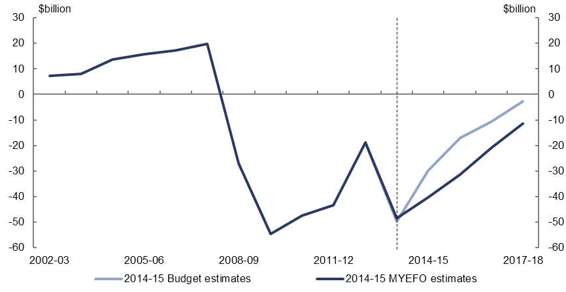
Figure 1: Underlying cash balance – change from 2014-15 Budget to 2014-15 MYEFO estimates
Historical data from 2002-03 to 2013-14 | 7.37 billion | 7.99 billion | 13.577 billion | 15.757 billion | 17.19 billion | 19.754 billion | -27.013 billion | -54.494 billion | -47.463 billion | -43.36 billion | -18.834 billion | -48.456 billion
2014-15 Budget estimates from 2014-15 to 2017-18 |  |  |  |  |  |  |  |  |  |  |  | -49.855 billion | -29.773 billion | -17.084 billion | -10.563 billion | -2.825 billion
Effect of 2014-15 MYEFO - measures |  |  |  |  |  |  |  |  |  |  |  |  | -2.314 billion | -2.195 billion | -0.501 billion | 0.95 billion
Effect 2014-15 MYEFO - parameter and other variations |  |  |  |  |  |  |  |  |  |  |  |  | -8.275 billion | -11.96 billion | -9.78 billion | -9.605 billion
2014-15 MYEFO estimates from 2014-15 to 2017-18 |  |  |  |  |  |  |  |  |  |  |  | -48.456 billion | -40.362 billion | -31.239 billion | -20.844 billion | -11.48 billion
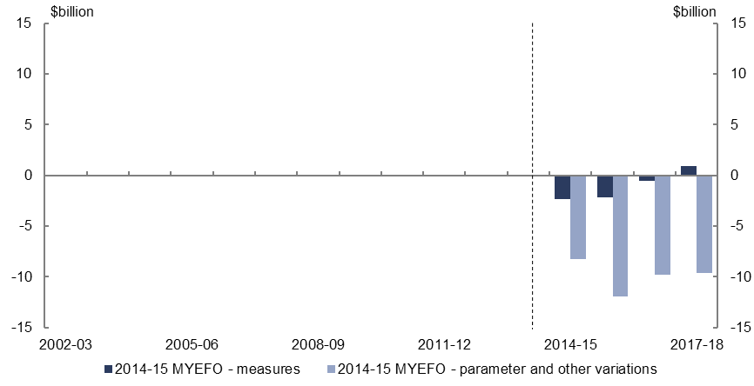
Figure 2: Underlying cash balance – change from 2014-15 Budget to 2014-15 MYEFO estimates by measures and other variations
Changes to 2014-15 to 2017-18 estimates in MYEFO
Effect of measures | -2.314 billion | -2.195 billion | -0.501 billion | 0.95 billion
Effect of parameter and other variations | -8.275 billion | -11.96 billion | -9.78 billion | -9.605 billion

- Policy decisions are expected to decrease the underlying cash balance by $4.1 billion over the four years to 2017-18, relative to the 2014-15 Budget.
- Parameter and other variations are expected to decrease the underlying cash balance by $39.6 billion over the four years to 2017-18, relative to the 2014-15 Budget. Most of the reduction occurs through lower receipts.

Total receipts
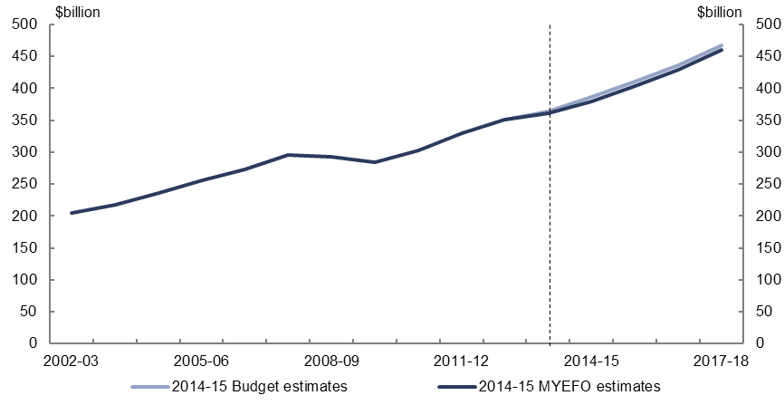
Figure 3: Total receipts – change from 2014-15 Budget to 2014-15 MYEFO estimates
Historical data from 2002-03 to 2013-14 | 204.613 billion | 217.775 billion | 235.984 billion | 255.943 billion | 272.637 billion | 294.917 billion | 292.6 billion | 284.662 billion | 302.024 billion | 329.874 billion | 351.052 billion | 360.322 billion
2014-15 Budget estimates from 2014-15 to 2017-18 |  |  |  |  |  |  |  |  |  |  |  | 363.496 billion | 385.778 billion | 410.427 billion | 436.849 billion | 467.985 billion
Effect of 2014-15 MYEFO - measures |  |  |  |  |  |  |  |  |  |  |  |  | -0.486 billion | -0.35 billion | -0.105 billion | -0.14 billion
Effect 2014-15 MYEFO - parameter and other variations |  |  |  |  |  |  |  |  |  |  |  |  | -5.809 billion | -6.715 billion | -7.516 billion | -8.039 billion
2014-15 MYEFO estimates from 2014-15 to 2017-18 |  |  |  |  |  |  |  |  |  |  |  | 360.322 billion | 379.483 billion | 403.362 billion | 429.228 billion | 459.806 billion
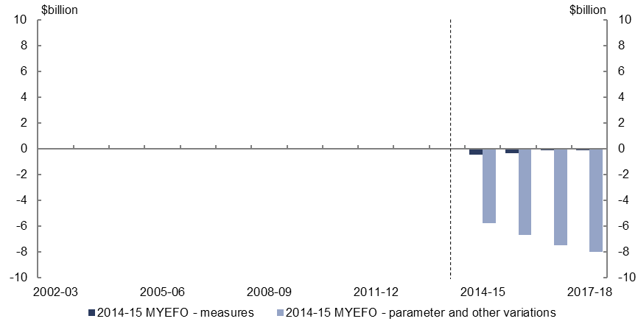
Figure 4: Total receipts – change from 2014-15 Budget to 2014-15 MYEFO estimates by measures and other variations
Changes to 2014-15 to 2017-18 estimates in MYEFO
Effect of measures | -0.486 billion | -0.35 billion | -0.105 billion | -0.14 billion
Effect of parameter and other variations | -5.809 billion | -6.715 billion | -7.516 billion | -8.039 billion
- Relative to the 2014-15 Budget, policy decisions are expected to decrease total receipts by $1.1 billion over the four years to 2017-18.
- Parameter and other variations are expected to decrease total receipts by $28.1 billion over the four years to 2017-18, relative to the 2014-15 Budget, largely due to lower company tax receipts.

Total payments
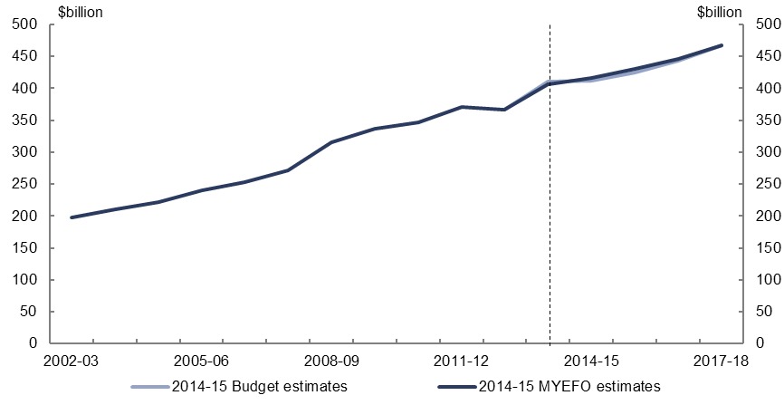
Figure 5: Total payments – change from 2014-15 Budget to 2014-15 MYEFO estimates
Historical data from 2002-03 to 2013-14 | 197.243 billion | 209.785 billion | 222.407 billion | 240.136 billion | 253.321 billion | 271.843 billion | 316.046 billion | 336.9 billion | 346.102 billion | 371.032 billion | 367.204 billion | 406.43 billion
2014-15 Budget estimates from 2014-15 to 2017-18 |  |  |  |  |  |  |  |  |  |  |  | 410.7 billion | 412.5 billion | 424.2 billion | 443.9 billion | 467.1 billion
Effect of 2014-15 MYEFO - measures |  |  |  |  |  |  |  |  |  |  |  |  | 1.827 billion | 1.844 billion | 0.396 billion | -1.09 billion
Effect 2014-15 MYEFO - parameter and other variations |  |  |  |  |  |  |  |  |  |  |  |  | 2.199 billion | 5.034 billion | 2.124 billion | 1.352 billion
2014-15 MYEFO estimates from 2014-15 to 2017-18 |  |  |  |  |  |  |  |  |  |  |  | 406.43 billion | 416.526 billion | 431.078 billion | 446.42 billion | 467.362 billion
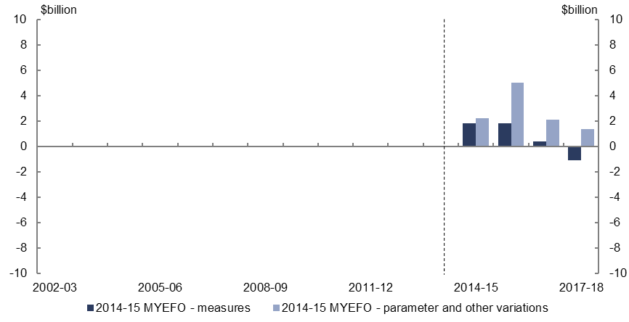
Figure 6: Total payments – change from 2014-15 Budget to 2014-15 MYEFO estimates by measures and other variations
Changes to 2014-15 to 2017-18 estimates in MYEFO
Effect of measures | 1.827 billion | 1.844 billion | 0.396 billion | -1.09 billion
Effect of parameter and other variations | 2.199 billion | 5.034 billion | 2.124 billion | 1.352 billion
- Relative to the 2014-15 Budget, policy decisions are expected to increase total payments by $3.0 billion over the four years to 2017-18. The largest contributors to the increase are the extensions to the Schoolkids Bonus, the Income Support Bonus and the Low Income Super Contribution, which result in increased payments of $6.8 billion over the four years. Partly offsetting this impact is a reduction in Official Development Assistance of $3.7 billion over the four years to 2017-18.
- Parameter and other variations are expected to increase total payments by $10.7 billion over the four years to 2017-18, relative to the 2014-15 Budget.

Revenue – individuals and other withholding taxes
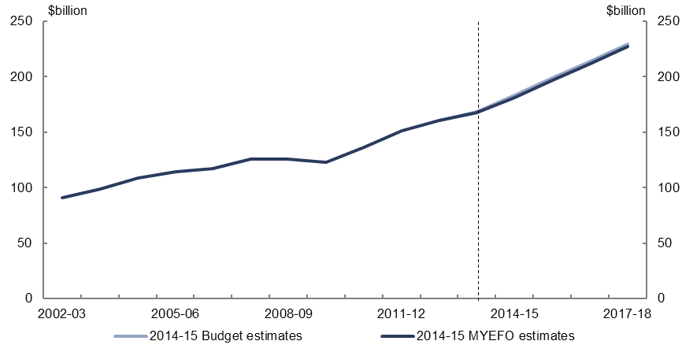
Figure 7: Revenue – individuals and other withholding taxes – change from 2014-15 Budget to 2014-15 MYEFO estimates
Historical data from 2002-03 to 2013-14 | 91.303 billion | 98.779 billion | 108.519 billion | 114.431 billion | 117.614 billion | 126.135 billion | 125.777 billion | 122.82 billion | 136.772 billion | 151.433 billion | 160.551 billion | 167.915 billion
2014-15 Budget estimates from 2014-15 to 2017-18 |  |  |  |  |  |  |  |  |  |  |  | 168.38 billion | 183.59 billion | 198.77 billion | 213.86 billion | 229.71 billion
Effect of 2014-15 MYEFO - measures |  |  |  |  |  |  |  |  |  |  |  |  | -0.014 billion | -0.063 billion | -0.059 billion | -0.072 billion
Effect 2014-15 MYEFO - parameter and other variations |  |  |  |  |  |  |  |  |  |  |  |  | -2.176 billion | -1.597 billion | -2.111 billion | -2.198 billion
2014-15 MYEFO estimates from 2014-15 to 2017-18 |  |  |  |  |  |  |  |  |  |  |  | 167.915 billion | 181.4 billion | 197.11 billion | 211.69 billion | 227.44 billion
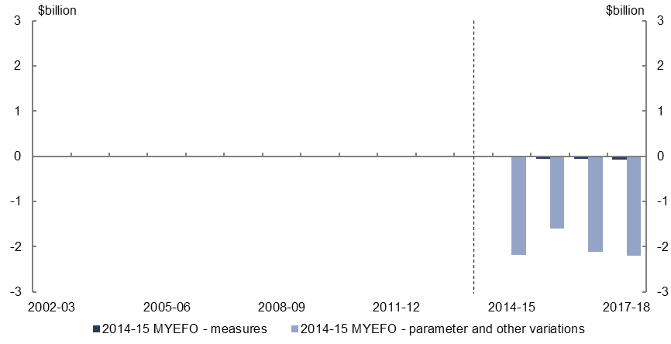
Figure 8: Revenue – individuals and other withholding taxes – change from 2014-15 Budget to 2014-15 MYEFO estimates by measures and other variations
Changes to 2014-15 to 2017-18 estimates in MYEFO
Effect of measures | -0.014 billion | -0.063 billion | -0.059 billion | -0.072 billion
Effect of parameter and other variations | -2.176 billion | -1.597 billion | -2.111 billion | -2.198 billion
- Relative to the 2014-15 Budget, policy decisions are expected to decrease individuals and other withholding tax revenue by $0.2 billion over the four years to 2017-18, largely reflecting changes to the taxation of employee share schemes.
- Parameter and other variations are expected to decrease individuals and other withholding tax revenue by $8.1 billion over the four years to 2017-18, relative to the 2014-15 Budget, largely reflecting a weaker outlook for wages growth and weaker employment growth in the short term.

Revenue – company tax
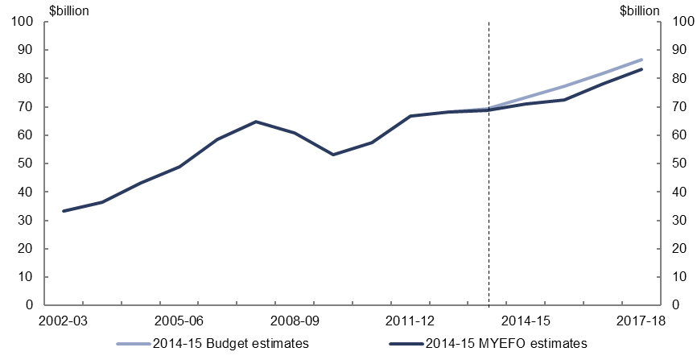
Figure 9: Revenue – company tax – change from 2014-15 Budget to 2014-15 MYEFO estimates
Historical data from 2002-03 to 2013-14 | 33.365 billion | 36.337 billion | 43.106 billion | 48.987 billion | 58.538 billion | 64.79 billion | 60.705 billion | 53.193 billion | 57.312 billion | 66.726 billion | 68.208 billion | 68.764 billion
2014-15 Budget estimates from 2014-15 to 2017-18 |  |  |  |  |  |  |  |  |  |  |  | 69.4 billion | 73.23 billion | 77.17 billion | 81.85 billion | 86.61 billion
Effect of 2014-15 MYEFO - measures |  |  |  |  |  |  |  |  |  |  |  |  | -0.35 billion | -0.05 billion | 0.243 billion | 0.264 billion
Effect 2014-15 MYEFO - parameter and other variations |  |  |  |  |  |  |  |  |  |  |  |  | -1.95 billion | -4.62 billion | -3.993 billion | -3.574 billion
2014-15 MYEFO estimates from 2014-15 to 2017-18 |  |  |  |  |  |  |  |  |  |  |  | 68.764 billion | 70.93 billion | 72.5 billion | 78.1 billion | 83.3 billion
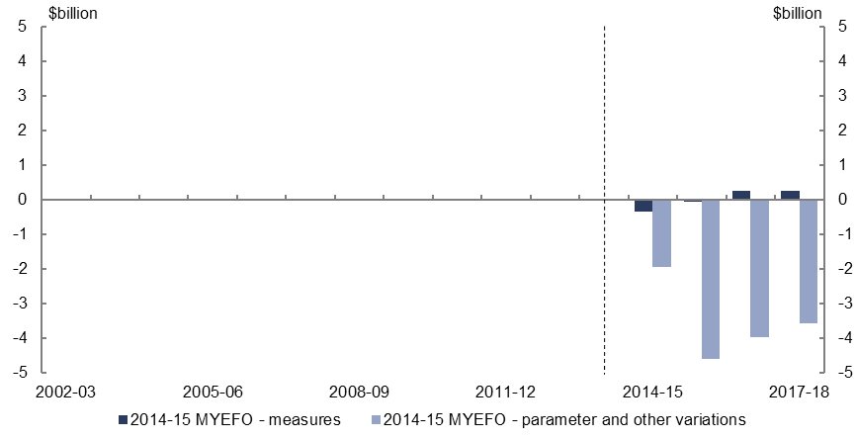
Figure 10: Revenue – company tax – change from 2014-15 Budget to 2014-15 MYEFO estimates by measures and other variations
Changes to 2014-15 to 2017-18 estimates in MYEFO
Effect of measures | -0.35 billion | -0.05 billion | 0.243 billion | 0.264 billion
Effect of parameter and other variations | -1.95 billion | -4.62 billion | -3.993 billion | -3.574 billion
- Relative to the 2014-15 Budget, policy decisions are expected to decrease company tax revenue by $0.1 billion over the four years to 2017-18. Reduced revenue due to the decision to amend the start date of the Research and Development targeting measure is largely offset by increased revenue from extending the effective life of in-house computer software for the purposes of depreciation.
- Parameter and other variations are expected to decrease company tax revenue by $14.1 billion over the four years to 2017-18, relative to the 2014-15 Budget, largely reflecting the impact of the sharper-than-anticipated fall in commodity prices, particularly for iron ore.

Revenue – excise and customs duties
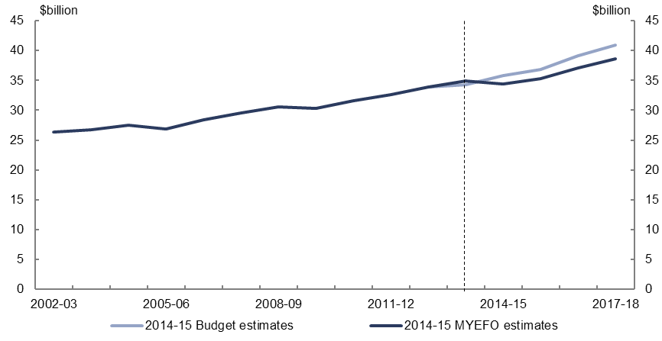
Figure 11: Revenue – excise and customs duties – change from 2014-15 Budget to 2014-15 MYEFO estimates
Historical data from 2002-03 to 2013-14 | 26.36 billion | 26.69 billion | 27.529 billion | 26.915 billion | 28.378 billion | 29.596 billion | 30.595 billion | 30.295 billion | 31.631 billion | 32.585 billion | 33.883 billion | 34.929 billion
2014-15 Budget estimates from 2014-15 to 2017-18 |  |  |  |  |  |  |  |  |  |  |  | 34.25 billion | 35.74 billion | 36.83 billion | 39.08 billion | 40.95 billion
Effect of 2014-15 MYEFO - measures |  |  |  |  |  |  |  |  |  |  |  |  | -0.185 billion | -0.44 billion | -0.495 billion | -0.53 billion
Effect 2014-15 MYEFO - parameter and other variations |  |  |  |  |  |  |  |  |  |  |  |  | -1.135 billion | -1.09 billion | -1.495 billion | -1.75 billion
2014-15 MYEFO estimates from 2014-15 to 2017-18 |  |  |  |  |  |  |  |  |  |  |  | 34.929 billion | 34.42 billion | 35.3 billion | 37.09 billion | 38.67 billion
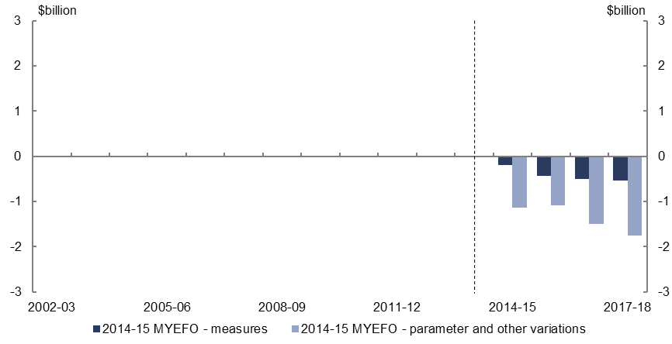
Figure 12: Revenue – excise and customs duties – change from 2014-15 Budget to 2014-15 MYEFO estimates by measures and other variations
Changes to 2014-15 to 2017-18 estimates in MYEFO
Effect of measures | -0.185 billion | -0.44 billion | -0.495 billion | -0.53 billion
Effect of parameter and other variations | -1.135 billion | -1.09 billion | -1.495 billion | -1.75 billion
- Relative to the 2014-15 Budget, policy decisions are expected to decrease excise and customs duties revenue by $1.7 billion over the four years to 2017-18, largely reflecting lower tariffs under the Japan-Australia Economic Partnership Agreement.
- Parameter and other variations are expected to decrease excise and excise equivalent customs duty revenue by $5.5 billion over the four years to 2017-18, relative to the 2014-15 Budget, largely as a result of lower expected fuel excise collections and the provision for reduced tariff revenue under the China Free Trade Agreement.

Revenue – non-tax revenue
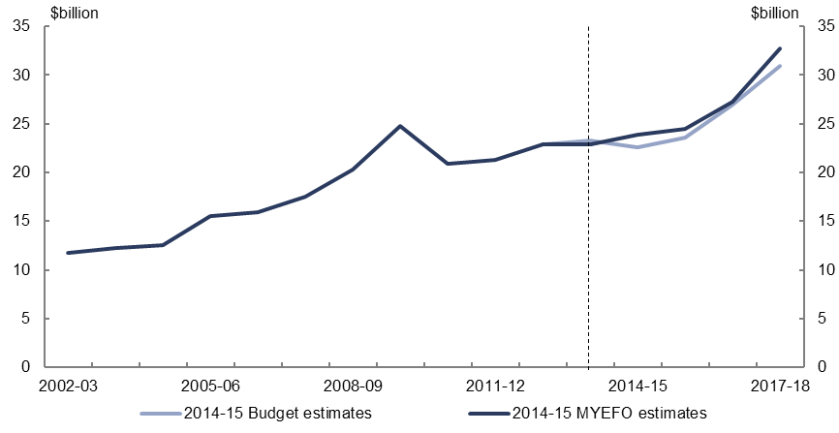
Figure 13: Revenue – non-tax revenue – change from 2014-15 Budget to 2014-15 MYEFO estimates
Historical data from 2002-03 to 2013-14 | 11.72 billion | 12.209 billion | 12.564 billion | 15.522 billion | 15.9 billion | 17.5 billion | 20.28 billion | 24.767 billion | 20.885 billion | 21.33 billion | 22.836 billion | 22.862 billion
2014-15 Budget estimates from 2014-15 to 2017-18 |  |  |  |  |  |  |  |  |  |  |  | 23.31 billion | 22.534 billion | 23.557 billion | 26.966 billion | 30.885 billion
Effect of 2014-15 MYEFO - measures |  |  |  |  |  |  |  |  |  |  |  |  | 0.101 billion | 0.084 billion | 0.054 billion | -0.002 billion
Effect 2014-15 MYEFO - parameter and other variations |  |  |  |  |  |  |  |  |  |  |  |  | 1.282 billion | 0.792 billion | 0.196 billion | 1.823 billion
2014-15 MYEFO estimates from 2014-15 to 2017-18 |  |  |  |  |  |  |  |  |  |  |  | 22.862 billion | 23.917 billion | 24.433 billion | 27.216 billion | 32.706 billion
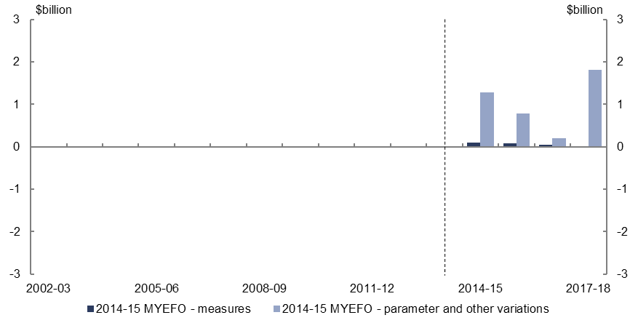
Figure 14: Revenue – non-tax revenue – change from 2014-15 Budget to 2014-15 MYEFO estimates by measures and other variations
Changes to 2014-15 to 2017-18 estimates in MYEFO
Effect of measures | 0.101 billion | 0.084 billion | 0.054 billion | -0.002 billion
Effect of parameter and other variations | 1.282 billion | 0.792 billion | 0.196 billion | 1.823 billion
- Relative to the 2014-15 Budget, policy decisions are expected to increase non-tax revenue by $0.2 billion over the four years to 2017-18, including the decision to increase the visa application charge for Partner Visas.
- Parameters and other variations are expected to increase non-tax revenue by $4.1 billion over the four years to 2017-18, relative to the 2014-15 Budget, largely due to an increase in expected dividend revenue.

Expenses – Family Tax Benefit
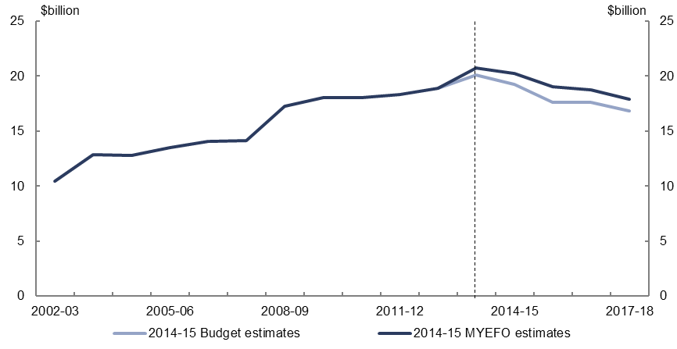
Figure 15: Expenses – Family Tax Benefit – change from 2014-15 Budget to 2014-15 MYEFO estimates
Historical data from 2002-03 to 2013-14 | 10.474 billion | 12.869 billion | 12.826 billion | 13.534 billion | 14.042 billion | 14.143 billion | 17.258 billion | 18.021 billion | 18.032 billion | 18.343 billion | 18.932 billion | 20.738 billion
2014-15 Budget estimates from 2014-15 to 2017-18 |  |  |  |  |  |  |  |  |  |  |  | 20.103 billion | 19.247 billion | 17.623 billion | 17.628 billion | 16.839 billion
Effect of 2014-15 MYEFO - measures |  |  |  |  |  |  |  |  |  |  |  |  | -0.002 billion | -0.003 billion | -0.387 billion | -0.493 billion
Effect 2014-15 MYEFO - parameter and other variations |  |  |  |  |  |  |  |  |  |  |  |  | 1.028 billion | 1.404 billion | 1.541 billion | 1.54 billion
2014-15 MYEFO estimates from 2014-15 to 2017-18 |  |  |  |  |  |  |  |  |  |  |  | 20.738 billion | 20.274 billion | 19.023 billion | 18.781 billion | 17.886 billion
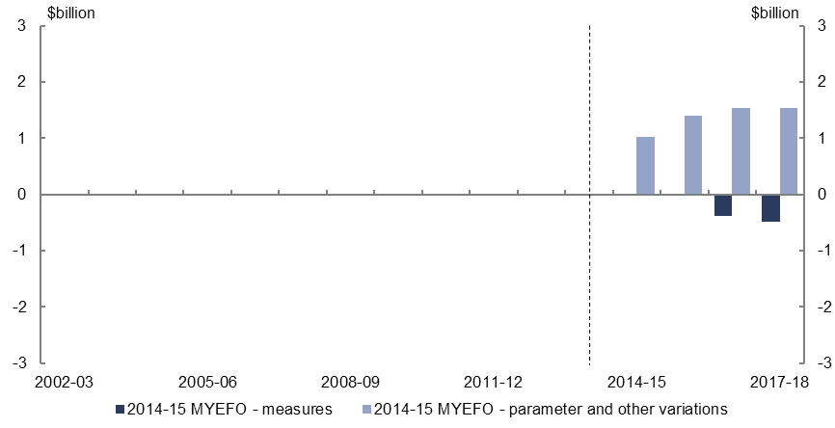
Figure 16: Expenses – Family Tax Benefit – change from 2014-15 Budget to 2014-15 MYEFO estimates by measures and other variations
Changes to 2014-15 to 2017-18 estimates in MYEFO
Effect of measures | -0.002 billion | -0.003 billion | -0.387 billion | -0.493 billion
Effect of parameter and other variations | 1.028 billion | 1.404 billion | 1.541 billion | 1.54 billion
- Relative to the 2014-15 Budget, policy decisions are expected to decrease expenses on Family Tax Benefit by $0.9 billion over the four years to 2017-18, largely due to the measure to extend the pause in the indexation of payment rates until 1 July 2017.
- Parameter and other variations are expected to increase expenses on the Family Tax Benefit by $5.5 billion over the four years to 2017-18, relative to the 2014-15 Budget, including the impact of lower expected wage growth driving up average payment rates and recipient numbers, and the impact of delays in passing legislation for 2014-15 Budget measures.

Expenses – job seeker income support
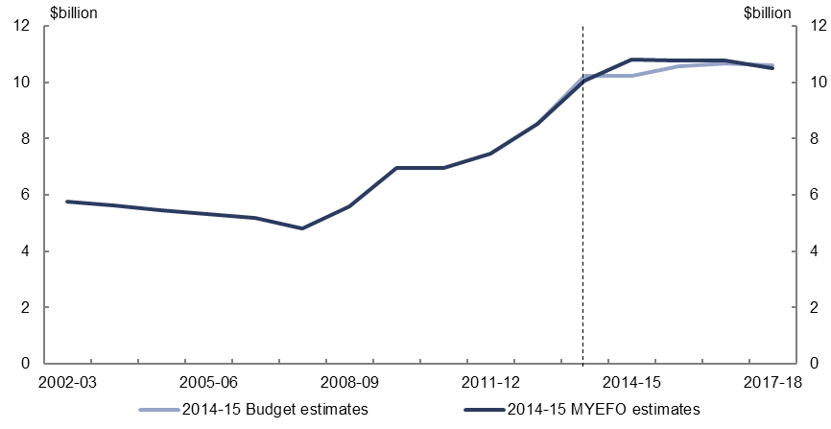
Figure 17: Expenses – job seeker income support – change from 2014-15 Budget to 2014-15 MYEFO estimates
Historical data from 2002-03 to 2013-14 | 5.765 billion | 5.625 billion | 5.443 billion | 5.311 billion | 5.183 billion | 4.796 billion | 5.585 billion | 6.974 billion | 6.967 billion | 7.453 billion | 8.519 billion | 10.05 billion
2014-15 Budget estimates from 2014-15 to 2017-18 |  |  |  |  |  |  |  |  |  |  |  | 10.227 billion | 10.233 billion | 10.57 billion | 10.686 billion | 10.609 billion
Effect of 2014-15 MYEFO - measures |  |  |  |  |  |  |  |  |  |  |  |  | 0.211 billion | 0.253 billion | 0.179 billion | 0.076 billion
Effect 2014-15 MYEFO - parameter and other variations |  |  |  |  |  |  |  |  |  |  |  |  | 0.367 billion | -0.062 billion | -0.082 billion | -0.178 billion
2014-15 MYEFO estimates from 2014-15 to 2017-18 |  |  |  |  |  |  |  |  |  |  |  | 10.05 billion | 10.811 billion | 10.76 billion | 10.783 billion | 10.507 billion
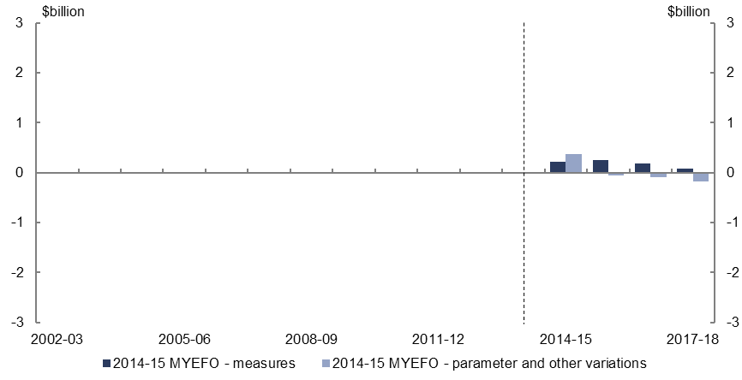
Figure 18: Expenses – job seeker income support – change from 2014-15 Budget to 2014-15 MYEFO estimates by measures and other variations
Changes to 2014-15 to 2017-18 estimates in MYEFO
Effect of measures | 0.211 billion | 0.253 billion | 0.179 billion | 0.076 billion
Effect of parameter and other variations | 0.367 billion | -0.062 billion | -0.082 billion | -0.178 billion
- Relative to the 2014-15 Budget, policy decisions are expected to increase expenses on job seeker income support by $0.7 billion over the four years to 2017-18, largely reflecting the measure to retain the Income Support Bonus until 31 December 2016.
- Parameter and other variations are expected to leave expenses on job seeker income largely unchanged over the four years to 2017-18. Increased expenses as a result of the impact of delays in passing legislation for 2014-15 Budget measures is largely offset by lower expected customer numbers.

Expenses – aged care
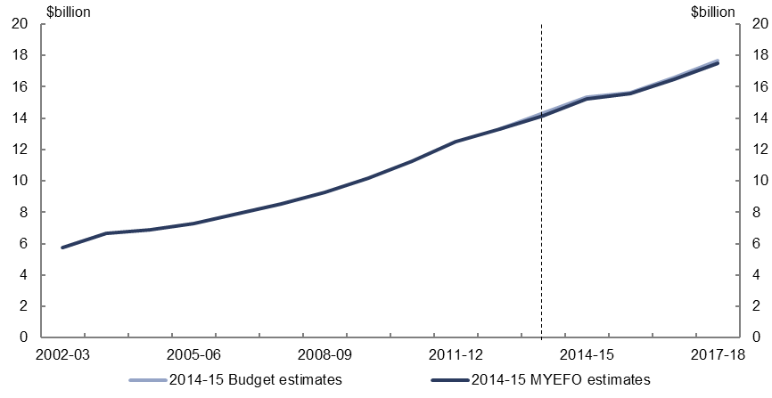
Figure 19: Expenses – aged care – change from 2014-15 Budget to 2014-15 MYEFO estimates
Historical data from 2002-03 to 2013-14 | 5.746 billion | 6.679 billion | 6.908 billion | 7.294 billion | 7.904 billion | 8.557 billion | 9.273 billion | 10.186 billion | 11.238 billion | 12.516 billion | 13.283 billion | 14.135 billion
2014-15 Budget estimates from 2014-15 to 2017-18 |  |  |  |  |  |  |  |  |  |  |  | 14.308 billion | 15.323 billion | 15.647 billion | 16.61 billion | 17.675 billion
Effect of 2014-15 MYEFO - measures |  |  |  |  |  |  |  |  |  |  |  |  | 0 billion | -0.016 billion | -0.017 billion | -0.018 billion
Effect 2014-15 MYEFO - parameter and other variations |  |  |  |  |  |  |  |  |  |  |  |  | -0.095 billion | -0.086 billion | -0.137 billion | -0.128 billion
2014-15 MYEFO estimates from 2014-15 to 2017-18 |  |  |  |  |  |  |  |  |  |  |  | 14.135 billion | 15.228 billion | 15.545 billion | 16.456 billion | 17.528 billion
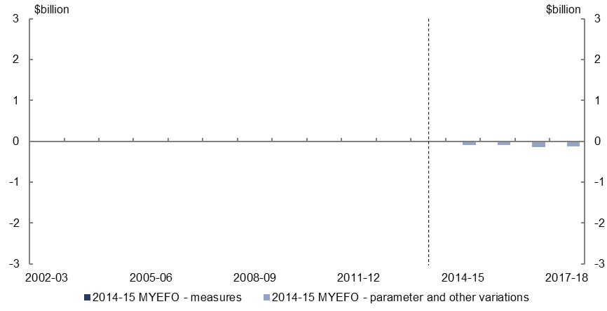
Figure 20: Expenses – aged care – change from 2014-15 Budget to 2014-15 MYEFO estimates by measures and other variations
Changes to 2014-15 to 2017-18 estimates in MYEFO
Effect of measures | 0 billion | -0.016 billion | -0.017 billion | -0.018 billion
Effect of parameter and other variations | -0.095 billion | -0.086 billion | -0.137 billion | -0.128 billion
- Parameter and other variations are expected to decrease expenses on aged care by $0.5 billion over the four years to 2017-18, relative to the 2014-15 Budget, including lower expected operational residential aged care places for approved care recipients.

Expenses – child care fee assistance
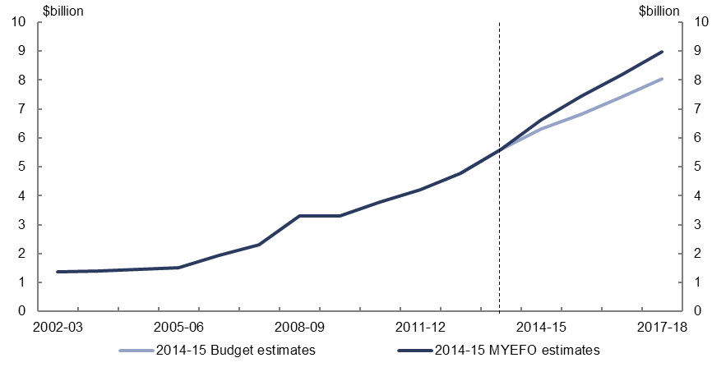
Figure 21: Expenses – child care fee assistance – change from 2014-15 Budget to 2014-15 MYEFO estimates
Historical data from 2002-03 to 2013-14 | 1.364 billion | 1.388 billion | 1.463 billion | 1.501 billion | 1.929 billion | 2.316 billion | 3.288 billion | 3.304 billion | 3.771 billion | 4.215 billion | 4.769 billion | 5.589 billion
2014-15 Budget estimates from 2014-15 to 2017-18 |  |  |  |  |  |  |  |  |  |  |  | 5.612 billion | 6.305 billion | 6.819 billion | 7.412 billion | 8.041 billion
Effect of 2014-15 MYEFO - measures |  |  |  |  |  |  |  |  |  |  |  |  | 0 billion | 0 billion | 0 billion | 0.001 billion
Effect 2014-15 MYEFO - parameter and other variations |  |  |  |  |  |  |  |  |  |  |  |  | 0.305 billion | 0.629 billion | 0.772 billion | 0.931 billion
2014-15 MYEFO estimates from 2014-15 to 2017-18 |  |  |  |  |  |  |  |  |  |  |  | 5.589 billion | 6.61 billion | 7.449 billion | 8.185 billion | 8.972 billion
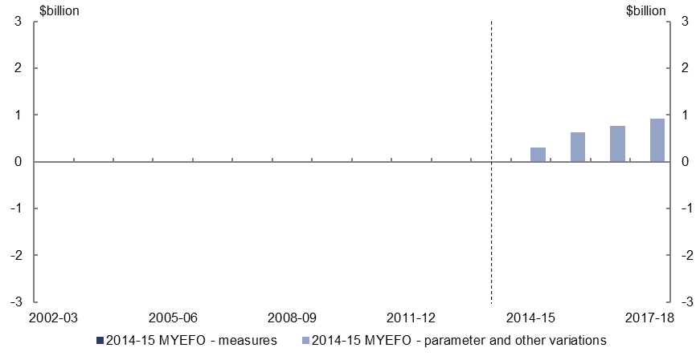
Figure 22: Expenses – child care fee assistance – change from 2014-15 Budget to 2014-15 MYEFO estimates by measures and other variations
Changes to 2014-15 to 2017-18 estimates in MYEFO
Effect of measures | 0 billion | 0 billion | 0 billion | 0.001 billion
Effect of parameter and other variations | 0.305 billion | 0.629 billion | 0.772 billion | 0.931 billion
- Parameter and other variations are expected to increase expenses on child care fee assistance by $2.6 billion over the four years to 2017-18, relative to the 2014-15 Budget, largely reflecting higher expected utilisation of demand driven child care services, and higher expected fees.

Expenses – parents’ income support
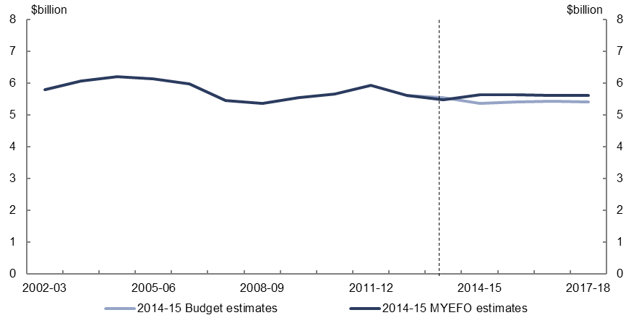
Figure 23: Expenses – parents’ income support – change from 2014-15 Budget to 2014-15 MYEFO estimates
Historical data from 2002-03 to 2013-14 | 5.8 billion | 6.067 billion | 6.206 billion | 6.127 billion | 5.986 billion | 5.462 billion | 5.366 billion | 5.546 billion | 5.665 billion | 5.939 billion | 5.612 billion | 5.488 billion
2014-15 Budget estimates from 2014-15 to 2017-18 |  |  |  |  |  |  |  |  |  |  |  | 5.538 billion | 5.362 billion | 5.414 billion | 5.427 billion | 5.408 billion
Effect of 2014-15 MYEFO - measures |  |  |  |  |  |  |  |  |  |  |  |  | 0.076 billion | 0.078 billion | 0.04 billion | -0.005 billion
Effect 2014-15 MYEFO - parameter and other variations |  |  |  |  |  |  |  |  |  |  |  |  | 0.196 billion | 0.148 billion | 0.151 billion | 0.204 billion
2014-15 MYEFO estimates from 2014-15 to 2017-18 |  |  |  |  |  |  |  |  |  |  |  | 5.488 billion | 5.633 billion | 5.64 billion | 5.618 billion | 5.607 billion
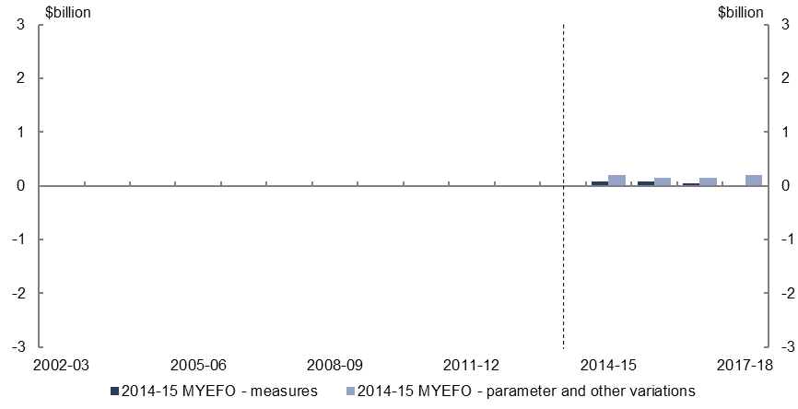
Figure 24: Expenses – parents’ income support – change from 2014-15 Budget to 2014-15 MYEFO estimates by measures and other variations
Changes to 2014-15 to 2017-18 estimates in MYEFO
Effect of measures | 0.076 billion | 0.078 billion | 0.04 billion | -0.005 billion
Effect of parameter and other variations | 0.196 billion | 0.148 billion | 0.151 billion | 0.204 billion
- Relative to the 2014-15 Budget, policy decisions are expected to increase expenses on parents’ income support by $0.2 billion over the four years to 2017-18, largely reflecting the measure to retain the Income Support Bonus until 31 December 2016.
- Parameters and other variations are expected to increase expenses on parents’ income support by $0.7 billion, including a delay in the passing of legislation for 2014-15 Budget measures and higher expected customer numbers and average payment rates.

Expenses – National Disability Insurance Scheme
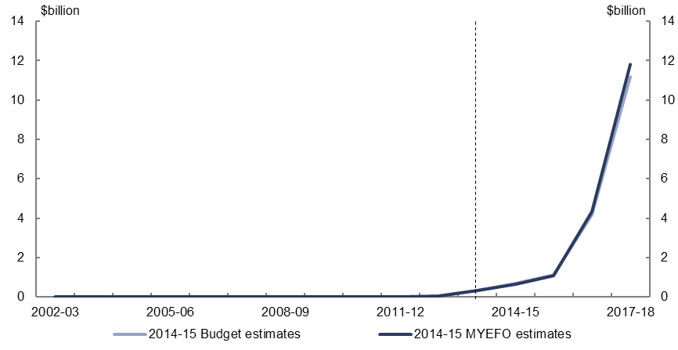
Figure 25: Expenses – National Disability Insurance Scheme – change from 2014-15 Budget to 2014-15 MYEFO estimates
Historical data from 2002-03 to 2013-14 | 0 billion | 0 billion | 0 billion | 0 billion | 0 billion | 0 billion | 0 billion | 0 billion | 0 billion | 0 billion | 0.033 billion | 0.313 billion
2014-15 Budget estimates from 2014-15 to 2017-18 |  |  |  |  |  |  |  |  |  |  |  | 0.313 billion | 0.673 billion | 1.105 billion | 4.196 billion | 11.161 billion
Effect of 2014-15 MYEFO - measures |  |  |  |  |  |  |  |  |  |  |  |  | -0.009 billion | -0.01 billion | 0 billion | -0.001 billion
Effect 2014-15 MYEFO - parameter and other variations |  |  |  |  |  |  |  |  |  |  |  |  | -0.014 billion | -0.021 billion | 0.16 billion | 0.666 billion
2014-15 MYEFO estimates from 2014-15 to 2017-18 |  |  |  |  |  |  |  |  |  |  |  | 0.313 billion | 0.65 billion | 1.073 billion | 4.356 billion | 11.826 billion
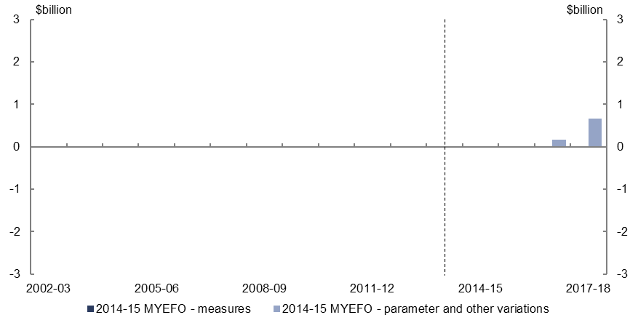
Figure 26: Expenses – National Disability Insurance Scheme – change from 2014-15 Budget to 2014-15 MYEFO estimates by measures and other variations
Changes to 2014-15 to 2017-18 estimates in MYEFO
Effect of measures | -0.009 billion | -0.01 billion | 0 billion | -0.001 billion
Effect of parameter and other variations | -0.014 billion | -0.021 billion | 0.16 billion | 0.666 billion
- Parameter and other variations are expected to increase National Disability Insurance Scheme expenses by $0.8 billion over the four years to 2017-18, relative to the 2014-15 Budget. This increase largely reflects the inclusion of expenses associated with resources received free of charge, which are also recognised in non-tax revenue.

Expenses – Medicare Benefits Schedule
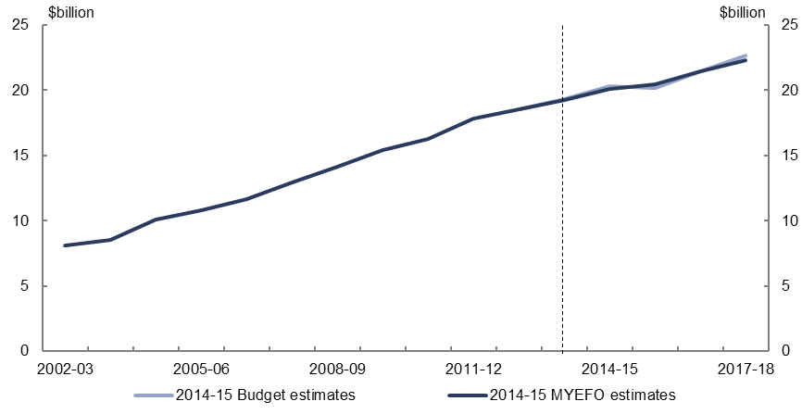
Figure 27: Expenses – Medicare Benefit Schedule – change from 2014-15 Budget to 2014-15 MYEFO estimates
Historical data from 2002-03 to 2013-14 | 8.092 billion | 8.498 billion | 10.063 billion | 10.825 billion | 11.673 billion | 12.957 billion | 14.142 billion | 15.387 billion | 16.266 billion | 17.826 billion | 18.56 billion | 19.263 billion
2014-15 Budget estimates from 2014-15 to 2017-18 |  |  |  |  |  |  |  |  |  |  |  | 19.334 billion | 20.317 billion | 20.176 billion | 21.48 billion | 22.647 billion
Effect of 2014-15 MYEFO - measures |  |  |  |  |  |  |  |  |  |  |  |  | -0.231 billion | 0.304 billion | -0.029 billion | -0.336 billion
Effect 2014-15 MYEFO - parameter and other variations |  |  |  |  |  |  |  |  |  |  |  |  | 0 billion | -0.006 billion | -0.007 billion | -0.023 billion
2014-15 MYEFO estimates from 2014-15 to 2017-18 |  |  |  |  |  |  |  |  |  |  |  | 19.263 billion | 20.087 billion | 20.473 billion | 21.444 billion | 22.288 billion
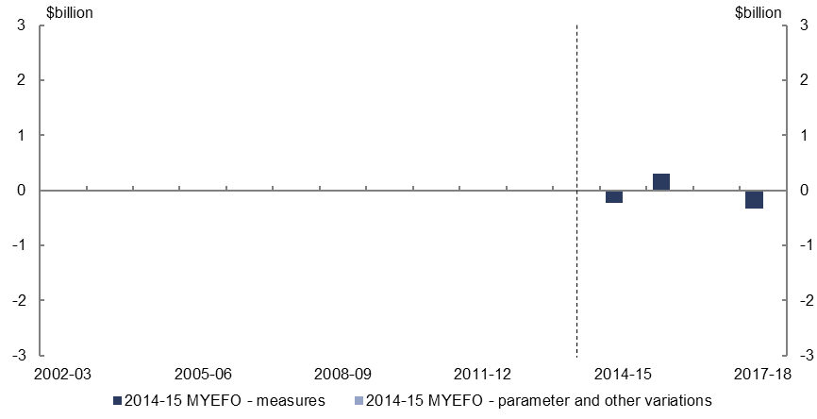
Figure 28: Expenses – Medicare Benefit Schedule – change from 2014-15 Budget to 2014-15 MYEFO estimates by measures and other variations
Changes to 2014-15 to 2017-18 estimates in MYEFO
Effect of measures | -0.231 billion | 0.304 billion | -0.029 billion | -0.336 billion
Effect of parameter and other variations | 0 billion | -0.006 billion | -0.007 billion | -0.023 billion
- Relative to the 2014-15 Budget, policy decisions are expected to decrease expenses on Medicare spending by $0.3 billion over the four the years to 2017-18, including:
  - the decision not to proceed with the 2014-15 Budget measure introducing patient contributions for GP, pathology and diagnostic imaging consultations;
  - introducing optional patient contributions together with reductions in Medicare Benefit Schedule rebates for GP consultations for non-concessional patients;
  - amending standard GP consultation lengths; and
  - extending the pause on indexation of some Medicare Benefit Schedule fees.

Expenses – assistance to the states and territories for public hospitals
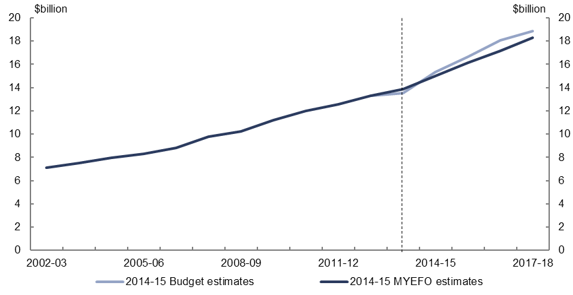
Figure 29: Expenses – assistance to the states and territories for public hospitals – change from 2014-15 Budget to 2014-15 MYEFO estimates
Historical data from 2002-03 to 2013-14 | 7.113 billion | 7.493 billion | 7.955 billion | 8.325 billion | 8.819 billion | 9.758 billion | 10.257 billion | 11.224 billion | 11.991 billion | 12.544 billion | 13.305 billion | 13.841 billion
2014-15 Budget estimates from 2014-15 to 2017-18 |  |  |  |  |  |  |  |  |  |  |  | 13.523 billion | 15.328 billion | 16.624 billion | 18.095 billion | 18.872 billion
Effect of 2014-15 MYEFO - measures |  |  |  |  |  |  |  |  |  |  |  |  | 0 billion | 0.002 billion | 0.005 billion | 0.008 billion
Effect 2014-15 MYEFO - parameter and other variations |  |  |  |  |  |  |  |  |  |  |  |  | -0.326 billion | -0.493 billion | -0.924 billion | -0.573 billion
2014-15 MYEFO estimates from 2014-15 to 2017-18 |  |  |  |  |  |  |  |  |  |  |  | 13.841 billion | 15.003 billion | 16.133 billion | 17.175 billion | 18.307 billion
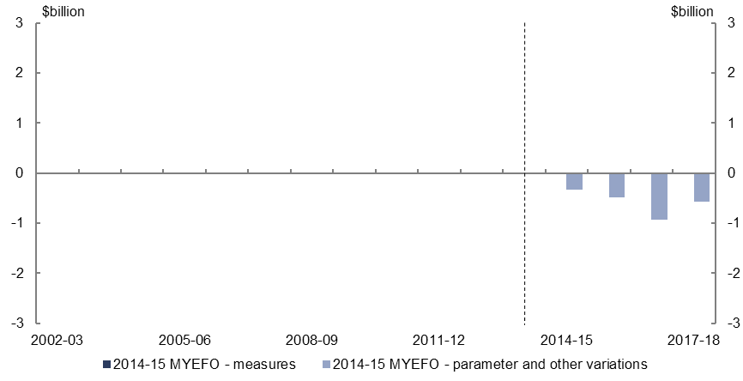
Figure 30: Expenses – assistance to the states and territories for public hospitals – change from 2014-15 Budget to 2014-15 MYEFO estimates by measures and other variations
Changes to 2014-15 to 2017-18 estimates in MYEFO
Effect of measures | 0 billion | 0.002 billion | 0.005 billion | 0.008 billion
Effect of parameter and other variations | -0.326 billion | -0.493 billion | -0.924 billion | -0.573 billion
- Parameter and other variations are expected to decrease expenses on assistance to the states and territories for public hospitals by $2.3 billion over the four years to 2017-18, relative to the 2014-15 Budget, largely reflecting lower expected projections for the national efficient price of hospital activities.

Expenses – private health insurance rebate
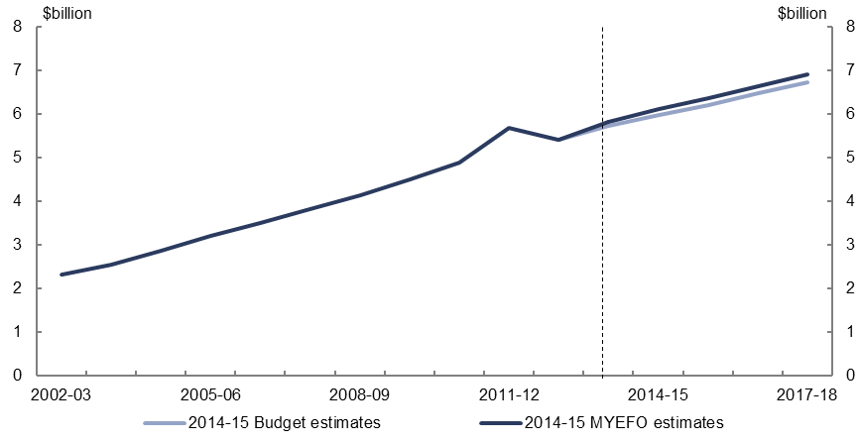
Figure 31: Expenses – private health insurance rebate – change from 2014-15 Budget to 2014-15 MYEFO estimates
Historical data from 2002-03 to 2013-14 | 2.327 billion | 2.547 billion | 2.86 billion | 3.215 billion | 3.501 billion | 3.812 billion | 4.14 billion | 4.493 billion | 4.89 billion | 5.678 billion | 5.408 billion | 5.827 billion
2014-15 Budget estimates from 2014-15 to 2017-18 |  |  |  |  |  |  |  |  |  |  |  | 5.721 billion | 5.989 billion | 6.209 billion | 6.471 billion | 6.737 billion
Effect of 2014-15 MYEFO - measures |  |  |  |  |  |  |  |  |  |  |  |  | 0 billion | 0 billion | 0 billion | 0 billion
Effect 2014-15 MYEFO - parameter and other variations |  |  |  |  |  |  |  |  |  |  |  |  | 0.13 billion | 0.15 billion | 0.161 billion | 0.167 billion
2014-15 MYEFO estimates from 2014-15 to 2017-18 |  |  |  |  |  |  |  |  |  |  |  | 5.827 billion | 6.119 billion | 6.359 billion | 6.632 billion | 6.904 billion
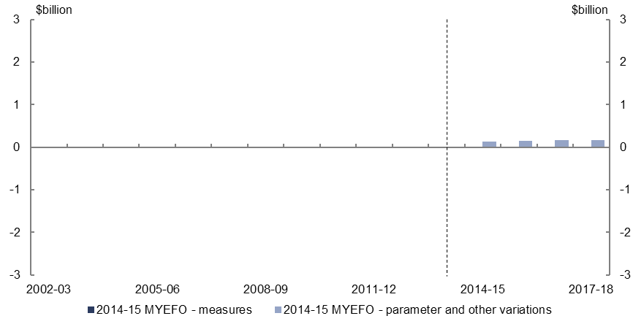
Figure 32: Expenses – private health insurance rebate – change from 2014-15 Budget to 2014-15 MYEFO estimates by measures and other variations
Changes to 2014-15 to 2017-18 estimates in MYEFO
Effect of measures | 0 billion | 0 billion | 0 billion | 0 billion
Effect of parameter and other variations | 0.13 billion | 0.15 billion | 0.161 billion | 0.167 billion
- Relative to the 2014-15 Budget, parameter and other variations are expected to increase spending on the private health insurance rebate by $0.6 billion over the four years to 2017-18. This increase is largely the result of stronger than expected growth in the number of people with health cover and a greater proportion of policy holders over 65, who attract a higher rebate.

Expenses – schools
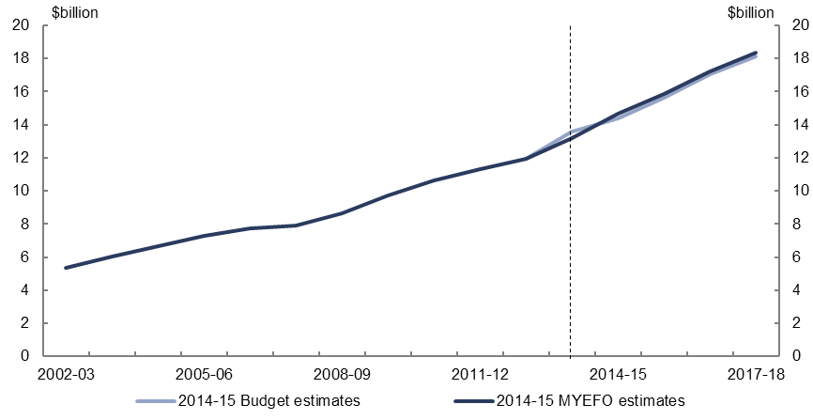
Figure 33: Expenses - schools – change from 2014-15 Budget to 2014-15 MYEFO estimates
Historical data from 2002-03 to 2013-14 | 5.331 billion | 6.012 billion | 6.672 billion | 7.289 billion | 7.745 billion | 7.914 billion | 8.66 billion | 9.75 billion | 10.636 billion | 11.335 billion | 11.925 billion | 13.188 billion
2014-15 Budget estimates from 2014-15 to 2017-18 |  |  |  |  |  |  |  |  |  |  |  | 13.567 billion | 14.374 billion | 15.646 billion | 17.032 billion | 18.149 billion
Effect of 2014-15 MYEFO - measures |  |  |  |  |  |  |  |  |  |  |  |  | 0.001 billion | 0.003 billion | 0.005 billion | 0.007 billion
Effect 2014-15 MYEFO - parameter and other variations |  |  |  |  |  |  |  |  |  |  |  |  | 0.313 billion | 0.204 billion | 0.183 billion | 0.175 billion
2014-15 MYEFO estimates from 2014-15 to 2017-18 |  |  |  |  |  |  |  |  |  |  |  | 13.188 billion | 14.688 billion | 15.853 billion | 17.22 billion | 18.331 billion
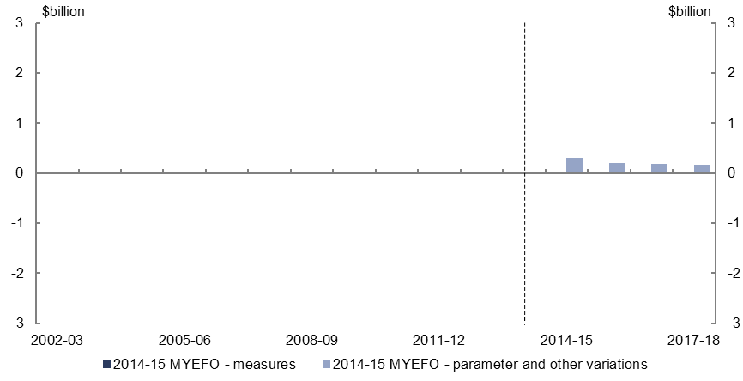
Figure 34: Expenses - schools – change from 2014-15 Budget to 2014-15 MYEFO estimates by measures and other variations
Changes to 2014-15 to 2017-18 estimates in MYEFO
Effect of measures | 0.001 billion | 0.003 billion | 0.005 billion | 0.007 billion
Effect of parameter and other variations | 0.313 billion | 0.204 billion | 0.183 billion | 0.175 billion
- Parameter and other variations are expected to increase spending on schools by $0.9 billion over the four years to 2017-18, relative to the 2014-15 Budget. This increase reflects higher expected enrolments in non-government schools and consequential changes in the Commonwealth share of base funding.

Expenses – higher education
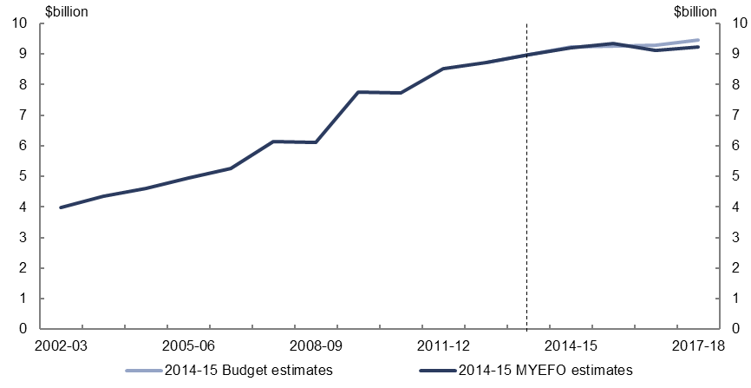
Figure 35: Expenses – higher education – change from 2014-15 Budget to 2014-15 MYEFO estimates
Historical data from 2002-03 to 2013-14 | 3.988 billion | 4.352 billion | 4.613 billion | 4.949 billion | 5.252 billion | 6.13 billion | 6.097 billion | 7.75 billion | 7.722 billion | 8.533 billion | 8.714 billion | 8.97 billion
2014-15 Budget estimates from 2014-15 to 2017-18 |  |  |  |  |  |  |  |  |  |  |  | 8.97 billion | 9.223 billion | 9.274 billion | 9.282 billion | 9.465 billion
Effect of 2014-15 MYEFO - measures |  |  |  |  |  |  |  |  |  |  |  |  | 0.015 billion | 0.013 billion | 0.014 billion | 0.001 billion
Effect 2014-15 MYEFO - parameter and other variations |  |  |  |  |  |  |  |  |  |  |  |  | -0.023 billion | 0.069 billion | -0.178 billion | -0.233 billion
2014-15 MYEFO estimates from 2014-15 to 2017-18 |  |  |  |  |  |  |  |  |  |  |  | 8.97 billion | 9.215 billion | 9.356 billion | 9.118 billion | 9.233 billion
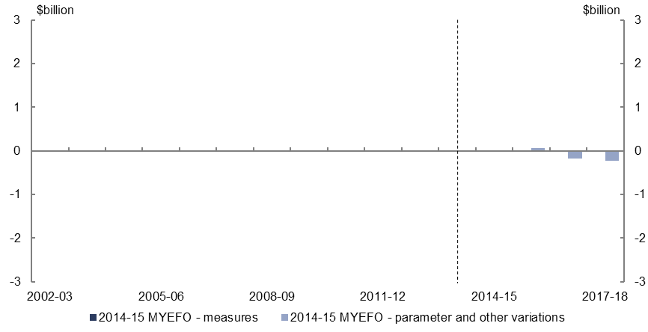
Figure 36: Expenses – higher education – change from 2014-15 Budget to 2014-15 MYEFO estimates by measures and other variations
Changes to 2014-15 to 2017-18 estimates in MYEFO
Effect of measures | 0.015 billion | 0.013 billion | 0.014 billion | 0.001 billion
Effect of parameter and other variations | -0.023 billion | 0.069 billion | -0.178 billion | -0.233 billion
- Parameter and other variations are expected to decrease expenses on higher education by $0.4 billion over the four years to 2017-18, relative to the 2014-15 Budget, reflecting a moderation in the expected rate of enrolments after a period of rapid growth following the introduction of the demand driven system in 2012.

Defence (expenses and net capital investment)
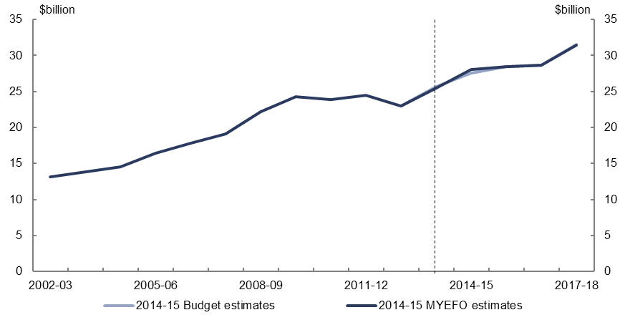
Figure 37: Defence (expenses and net capital investment) – change from 2014-15 Budget to 2014-15 MYEFO estimates
Historical data from 2002-03 to 2013-14 | 13.135 billion | 13.862 billion | 14.521 billion | 16.392 billion | 17.798 billion | 19.148 billion | 22.218 billion | 24.286 billion | 23.917 billion | 24.433 billion | 22.987 billion | 25.484 billion
2014-15 Budget estimates from 2014-15 to 2017-18 |  |  |  |  |  |  |  |  |  |  |  | 25.665 billion | 27.512 billion | 28.468 billion | 28.602 billion | 31.524 billion
Effect of 2014-15 MYEFO - measures |  |  |  |  |  |  |  |  |  |  |  |  | 0.429 billion | 0.031 billion | 0.006 billion | 0 billion
Effect 2014-15 MYEFO - parameter and other variations |  |  |  |  |  |  |  |  |  |  |  |  | 0.143 billion | -0.053 billion | 0.017 billion | -0.089 billion
2014-15 MYEFO estimates from 2014-15 to 2017-18 |  |  |  |  |  |  |  |  |  |  |  | 25.484 billion | 28.084 billion | 28.446 billion | 28.624 billion | 31.435 billion
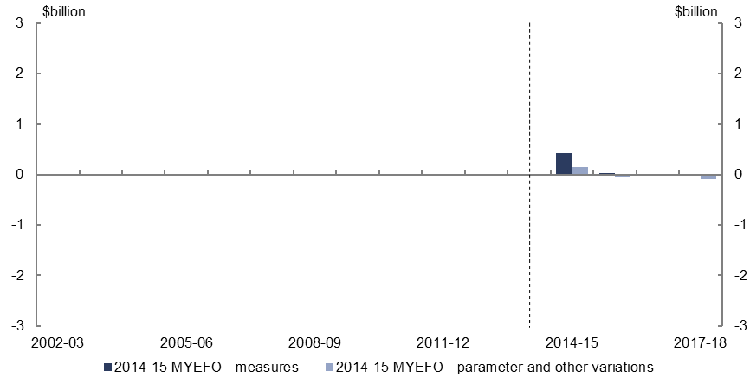
Figure 38: Defence (expenses and net capital investment) – change from 2014-15 Budget to 2014-15 MYEFO estimates by measures and other variations
Changes to 2014-15 to 2017-18 estimates in MYEFO
Effect of measures | 0.429 billion | 0.031 billion | 0.006 billion | 0 billion
Effect of parameter and other variations | 0.143 billion | -0.053 billion | 0.017 billion | -0.089 billion
- Relative to the 2014-15 Budget, policy decisions are expected to increase spending on defence by $0.5 billion over the four years to 2017-18, including the decision to commence Operation Okra, the Australian Defence Force’s contribution to the international effort to disrupt and degrade the Islamic State in Iraq and the Levant threat in Iraq.

Expenses – public debt interest
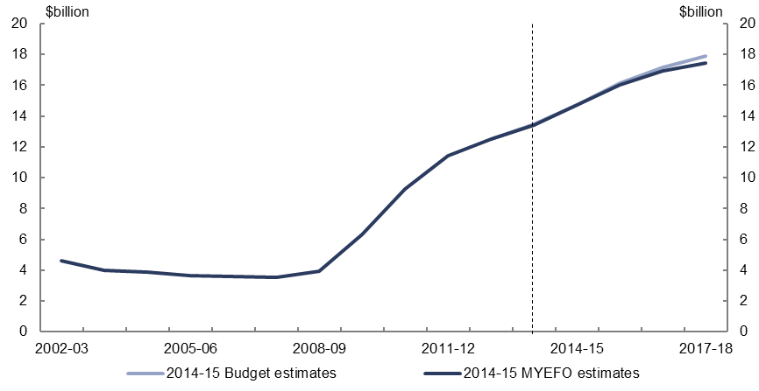
Figure 39: Expenses – public debt interest – change from 2014-15 Budget to 2014-15 MYEFO estimates
Historical data from 2002-03 to 2013-14 | 4.629 billion | 4.001 billion | 3.88 billion | 3.628 billion | 3.592 billion | 3.544 billion | 3.946 billion | 6.303 billion | 9.273 billion | 11.421 billion | 12.521 billion | 13.414 billion
2014-15 Budget estimates from 2014-15 to 2017-18 |  |  |  |  |  |  |  |  |  |  |  | 13.454 billion | 14.708 billion | 16.134 billion | 17.157 billion | 17.876 billion
Effect of 2014-15 MYEFO - measures |  |  |  |  |  |  |  |  |  |  |  |  | 0 billion | 0 billion | 0 billion | 0 billion
Effect 2014-15 MYEFO - parameter and other variations |  |  |  |  |  |  |  |  |  |  |  |  | 0.025 billion | -0.118 billion | -0.213 billion | -0.436 billion
2014-15 MYEFO estimates from 2014-15 to 2017-18 |  |  |  |  |  |  |  |  |  |  |  | 13.414 billion | 14.733 billion | 16.016 billion | 16.944 billion | 17.44 billion
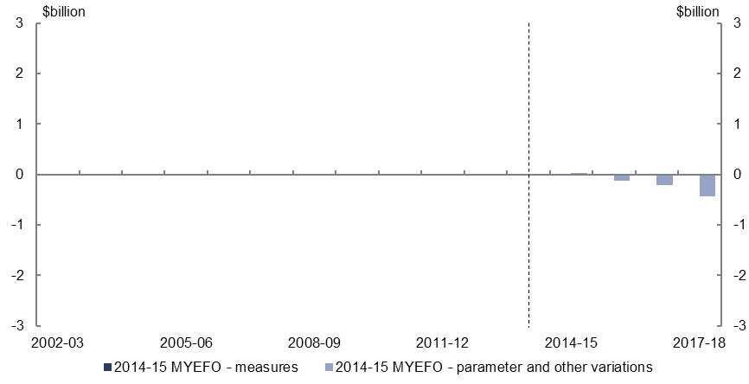
Figure 40: Expenses – public debt interest – change from 2014-15 Budget to 2014-15 MYEFO estimates by measures and other variations
Changes to 2014-15 to 2017-18 estimates in MYEFO
Effect of measures | 0 billion | 0 billion | 0 billion | 0 billion
Effect of parameter and other variations | 0.025 billion | -0.118 billion | -0.213 billion | -0.436 billion
- Relative to the 2014-15 Budget, public debt interest is expected to decrease by $0.7 billion over the four years to 2017-18 as a result of projected lower interest rates on government debt being partially offset by the deterioration in the headline cash balance.

Expenses – public sector superannuation
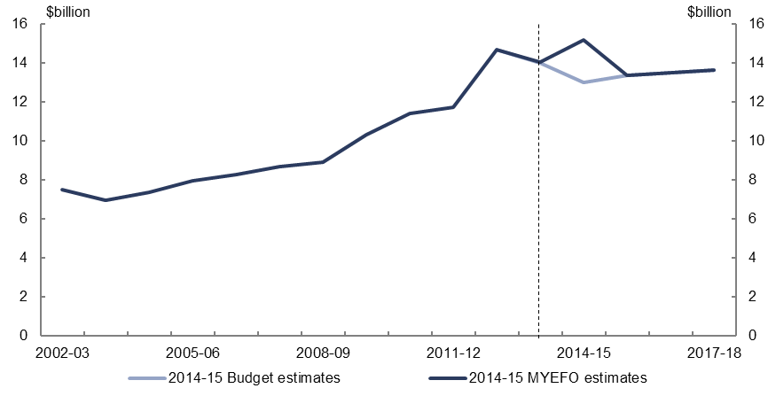
Figure 41: Expenses – public sector superannuation – change from 2014-15 Budget to 2014-15 MYEFO estimates
Historical data from 2002-03 to 2013-14 | 7.499 billion | 6.967 billion | 7.391 billion | 7.946 billion | 8.269 billion | 8.692 billion | 8.912 billion | 10.333 billion | 11.4 billion | 11.735 billion | 14.676 billion | 14.045 billion
2014-15 Budget estimates from 2014-15 to 2017-18 |  |  |  |  |  |  |  |  |  |  |  | 13.987 billion | 12.984 billion | 13.345 billion | 13.495 billion | 13.623 billion
Effect of 2014-15 MYEFO - measures |  |  |  |  |  |  |  |  |  |  |  |  | 0 billion | 0 billion | 0 billion | 0 billion
Effect 2014-15 MYEFO - parameter and other variations |  |  |  |  |  |  |  |  |  |  |  |  | 2.185 billion | 0.002 billion | 0.006 billion | -0.002 billion
2014-15 MYEFO estimates from 2014-15 to 2017-18 |  |  |  |  |  |  |  |  |  |  |  | 14.045 billion | 15.169 billion | 13.347 billion | 13.501 billion | 13.621 billion
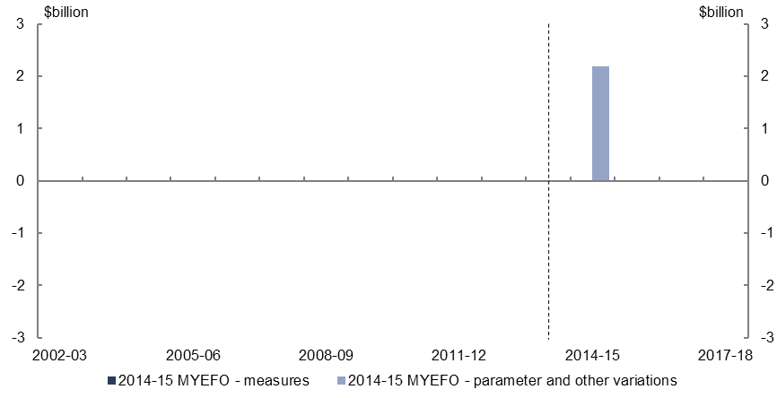
Figure 42: Expenses – public sector superannuation – change from 2014-15 Budget to 2014-15 MYEFO estimates by measures and other variations
Changes to 2014-15 to 2017-18 estimates in MYEFO
Effect of measures | 0 billion | 0 billion | 0 billion | 0 billion
Effect of parameter and other variations | 2.185 billion | 0.002 billion | 0.006 billion | -0.002 billion
- Parameter and other variations are expected to increase public sector superannuation expenses by $2.2 billion in 2014-15. This is due to the practice of changing the discount rate for the current year to the long-term government bond rate at MYEFO, from an actuarially based rate used at the Budget.

Expenses – Official Development Assistance
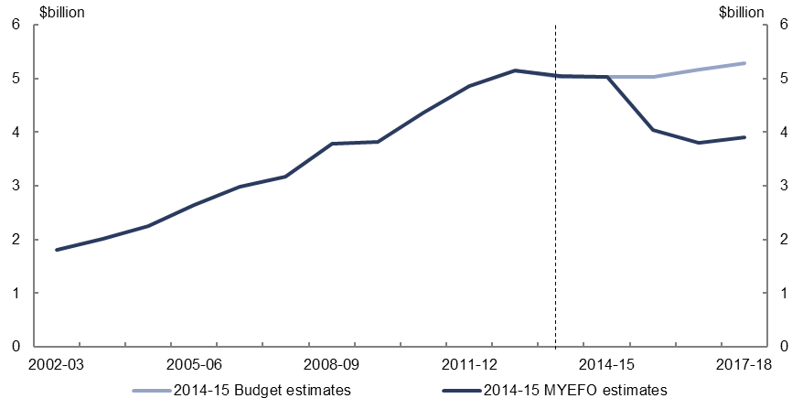
Figure 43: Expenses – Official Development Assistance – change from 2014-15 Budget to 2014-15 MYEFO estimates
Historical data from 2002-03 to 2013-14 | 1.816 billion | 2.019 billion | 2.251 billion | 2.641 billion | 2.99 billion | 3.172 billion | 3.79 billion | 3.821 billion | 4.362 billion | 4.864 billion | 5.149 billion | 5.045 billion
2014-15 Budget estimates from 2014-15 to 2017-18 |  |  |  |  |  |  |  |  |  |  |  | 5.032 billion | 5.032 billion | 5.034 billion | 5.16 billion | 5.289 billion
Effect of 2014-15 MYEFO - measures |  |  |  |  |  |  |  |  |  |  |  |  | 0 billion | -1 billion | -1.35 billion | -1.377 billion
Effect 2014-15 MYEFO - parameter and other variations |  |  |  |  |  |  |  |  |  |  |  |  | 0 billion | 0 billion | 0 billion | 0 billion
2014-15 MYEFO estimates from 2014-15 to 2017-18 |  |  |  |  |  |  |  |  |  |  |  | 5.045 billion | 5.032 billion | 4.034 billion | 3.81 billion | 3.912 billion
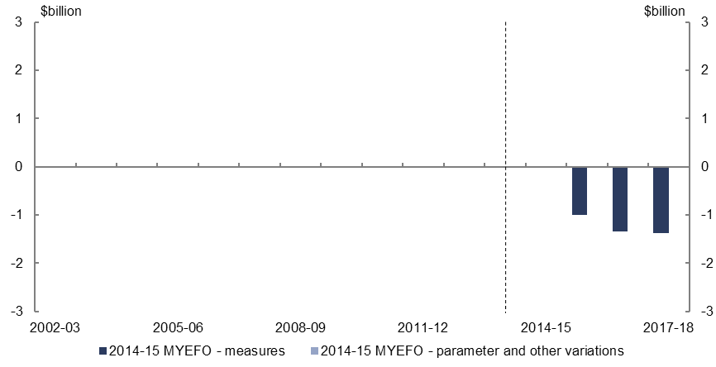
Figure 44: Expenses – Official Development Assistance – change from 2014-15 Budget to 2014-15 MYEFO estimates by measures and other variations
Changes to 2014-15 to 2017-18 estimates in MYEFO
Effect of measures | 0 billion | -1 billion | -1.35 billion | -1.377 billion
Effect of parameter and other variations | 0 billion | 0 billion | 0 billion | 0 billion
- Relative to the 2014-15 Budget, the policy decision to reduce funding for Official Development Assistance by $3.7 billion is expected to decrease expenses over the four years to 2017-18.

www.pbo.gov.au

The largest components of higher education spending are the Commonwealth Grants Scheme, Investment in Higher Education Research, and Higher Education Support programs. Higher education spending does not include the Higher Education Loan Programme.

