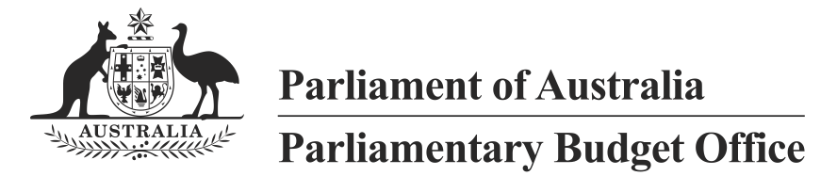
Projections of Government spending over the medium term
02/2014

© Commonwealth of Australia 2014
ISBN 978-0-9925131-2-2 (Online)
This work is licensed under the Creative Commons Attribution-NonCommercial-NoDerivs 3.0 Australia License.
The details of this licence are available on the Creative Commons website:
http://creativecommons.org/licenses/by-nc-nd/3.0/au/
Use of the Coat of Arms
The terms under which the Coat of Arms can be used are detailed on the following website:
www.itsanhonour.gov.au/coat-arms
Produced by: Parliamentary Budget Office
Design consultants: Wilton Hanford Hanover Pty Ltd
Assistant Parliamentary Budget Officer
Fiscal Policy Analysis Division
Parliamentary Budget Office
Parliament House
PO Box 6010
CANBERRA ACT 2600
Phone: (02) 6277 9500
Email: pbo@pbo.gov.au

Contents
Foreword iv
Overview 1
1 Projections of total Australian Government payments 4
2 Drivers of growth in government spending 7
Methodology 7
Composition of Australian government spending 8
Contributions to growth in government spending 12
2.1 Goods and Services Tax transfer to States 14
2.2 National Disability Insurance Scheme 15
2.3 Age Pension 16
2.4 Defence 17
2.5 Aged care 18
2.6 Medicare Benefits Schedule 19
2.7 Schools 20
2.8 Public hospitals 21
2.9 Disability Support Pension 22
2.10 Paid Parental Leave 23
2.11 Carer income support 24
2.12 Child care 25
2.13 Fuel Tax Credit Scheme 26
2.14 Government superannuation 27
2.15 Family Tax Benefit 28
2.16 Private Health Insurance Rebate 29
2.17 Higher education 30
2.18 Newstart 31
2.19 Public debt interest 32
2.20 Official Development Assistance 33
2.21 Pharmaceutical Benefits and Services 34
A Technical notes 35
B Data used in this report 38

Foreword
This report discusses the outlook for and drivers of Australian Government spending to help inform discussion about the sustainability of spending over the medium term.
As significant policies and budget measures increasingly impact beyond the short term this report looks at the medium term, which encompasses the Budget forward estimates and the period to 2024-25. Rather than an exhaustive analysis of all the components of government spending, it frames the discussion around the significant contributors to growth in total government spending, and examines trends in these programs over the medium term.
Estimates of spending up to 2017-18 used in this analysis are consistent with published 2014-15 Budget figures. Official estimates of spending on major programs beyond the forward estimates period are not published. Projected levels of spending on these programs beyond 2017-18 have been prepared by the PBO based on information provided by agencies and a range of models based on current policy settings. These estimates do not incorporate the impact of policy changes since the 2014-15 Budget although analysis of the potential impact of some significant yet to be legislated Budget savings measures is highlighted.
The data underlying this report are available from the PBO website.
I would like to thank the PBO staff involved in the preparation of this report. The report was prepared by Tim Pyne, Paul Gardiner, Nutan Singh, Holly Hart, Daniel Zeaiter and Anupam Sharma, with input from Tony McDonald. The report was prepared for publication by Louise Milligan and Helen Moorhouse.
I also wish to thank the external referees who provided helpful comments and suggestions on the report, namely the Grattan Institute and Mr Geoff Carmody, Director, Geoff Carmody & Associates, and a co-founder of Access Economics. The assistance of external reviewers does not imply any responsibility on their part for the content of the final report, which rests solely with the PBO.
Phil Bowen PSM FCPA
Parliamentary Budget Officer
22 August 2014

Overview
Comprehensive information on trends in and key drivers of government spending is important for an understanding of the level of sustainability of government spending and the future direction of fiscal policy.
This is the second PBO report on Australian Government spending.
The first report examined historical trends in government spending over the decade 2002-03 to 2012-13.
The real growth in Australian Government spending over the past decade (annual average 3.6 per cent) was significantly greater than real economic growth (annual average 3.0 per cent).
The strong growth in Australia’s national income (and nominal GDP, a key driver of revenue growth) from the historic surge in Australia’s terms of trade broadly offset this spending growth, with the ratio of Australian Government spending to nominal GDP being about the same in 2012-13 as it was in 2002-03.
This report discusses the outlook for and drivers of Australian Government spending over the medium term – the period 2012-13 to 2024-25.
The projected continuing decline in the terms of trade from its historical highs, and the depressing impact this will have on nominal GDP, mean that if government spending as a share of the economy is not to rise over the medium term, it will require real growth in spending to be significantly slower than growth in real GDP.
The Australian Government’s medium term projections are for a substantial slowing in the real growth in Australian Government spending compared with the past decade, with real spending growth (annual average growth 2.6 per cent) significantly lower than real economic growth (annual average 3.2 per cent) over the medium term.
Even with this reduction in the pace of spending growth, the projected ratio of Australian Government spending to nominal GDP over the medium term is, on average, about the same as in the past decade.
This report analyses what is driving the reduction in growth in Australian Government spending over the medium term by a detailed assessment of twenty-one programs that account for around three-quarters of projected government spending and nearly all (95 per cent) of the growth in total spending over the medium term.
Sheer arithmetic dictates that it is very difficult to reduce overall growth in Australian Government spending without reducing the pace of spending in these programs.
Based on current policy settings, the PBO’s medium term projections show that growth in spending on ten programs that grew rapidly over the past decade will be constrained to less than real GDP growth over the next decade. These programs are Family Tax Benefit, higher education, Medicare, public hospitals, Age Pension, Private Health Insurance Rebate, Disability Support Pension, government superannuation, public debt interest and Official Development Assistance.
However, there are a number of challenges to achieving these lower growth spending outcomes.
The sustained period of strong growth in Australian Government spending over the past decade can reasonably be expected to have lifted the Australian community’s expectations of continuing higher levels of government services and benefits over the medium term. Realising the projected slowing in the pace of growth of Australian Government spending implies successfully adjusting these expectations.
The PBO’s projections are based on current government policy and assume no new policy decisions in the future to expand or enhance Australian Government payments. However, this runs counter to experience over the past decade where there were significant discretionary increases in spending on a range of programs, including Age Pension, Family Tax Benefit, Disability Support Pension, carer income support, child care, Medicare and higher education.
Additionally, the projected slower spending growth over the medium term is dependent on 2014-15 Budget savings measures, most of which are yet to be legislated. Nearly all of the programs that are projected to grow at a slower pace over the medium term assume the implementation of savings measures that are yet to be legislated. Savings measures in these programs are projected to reduce spending over the medium term, with an impact of $19 billion or 0.7 per cent of GDP in 2024-25.
The slower growth in Australian Government spending over the medium term also reflects significantly reduced growth in Commonwealth funding for schools and hospitals from 2017-18. In practice, this may result in a shift in the funding responsibility for these programs from the Commonwealth to the States rather than an overall reduction in the growth of government spending in these areas. In particular, the expected growth in demand for hospital services over the medium term is likely to place increasing pressure on State budgets.
Programs projected to grow faster over the medium term than over the past decade include defence, GST transfers to States, the National Disability Insurance Scheme and the expanded Paid Parental Leave scheme. However, reducing spending in some of these programs would not result in a net saving to the budget, due to related, broadly offsetting revenue items and/or other spending offsets. In particular, the largest contribution to Australian Government spending over the medium term is GST transfers to the States, which in effect mirrors GST collections.
While the National Disability Insurance Scheme and expanded Paid Parental Leave scheme are significant contributors to spending growth over the medium term, together accounting for 19 per cent of the growth in total spending, the net impact of this spending on the budget is reduced by levies, contributions from State and Territory Governments, and reductions in other Australian Government programs.
The above challenges to achieving lower spending growth mean that actual spending outcomes could exceed the projections contained in this report which, given current revenue projections, could place fiscal sustainability at risk.
To the extent that the projected reduction in Australian Government spending growth is not achieved over the medium term, an even greater share of the burden of fiscal consolidation would need to fall on the revenue side of the budget. That said, the Australian Government’s medium term budget projections already assume a significant increase in revenue with tax receipts projected to rise from 21.4 per cent of GDP in 2012-13 to 23.9 per cent of GDP in 2019-20, and remaining at that level over the medium term.
Moreover, there are risks to the economic outlook over the medium term due to uncertainties in the international outlook and as the Australian economy transitions out of the resources investment boom to broader based growth in the non-resources sectors. These risks reinforce the need for fiscal consolidation in order to establish a fiscal buffer against the possibility of adverse economic shocks.

- Projections of total Australian Government payments
Based on current policy settings, the Budget papers show total Australian Government payments are projected to grow in real terms by 2.6 per cent annually over the medium term (2012-13 to 2024-25). This is slower than projected real GDP growth of 3.2 per cent annually over the same period, and significantly below the 3.6 per cent annual rate of growth in payments over the ten years to 2012-13 (see Figure 1.1).
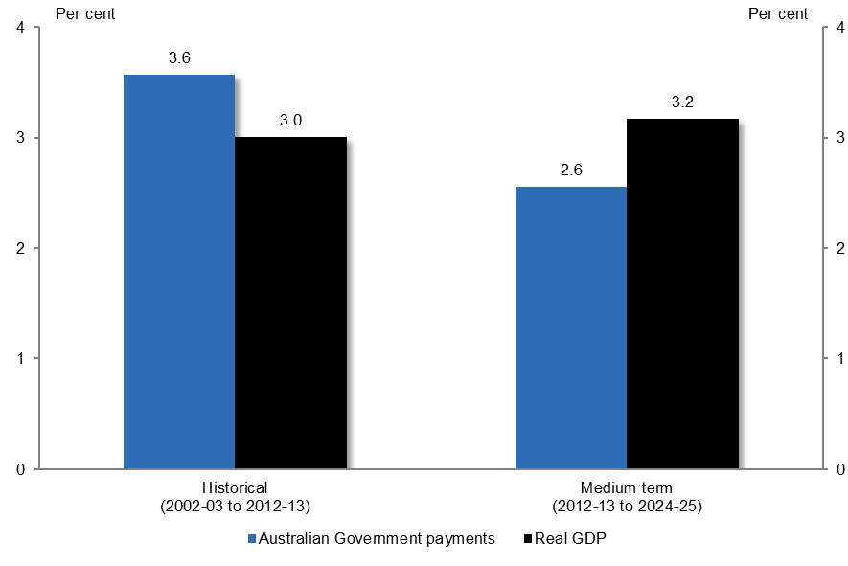
Figure 1.1: Annual real growth in total Australian Government payments and real GDP
Annual real growth | Historical | Medium term
Australian government payments | 3.6 per cent | 2.6 per cent
Real GDP | 3.0 per cent | 3.2 per cent
Source: Australian Government Budgets and Final Budget Outcomes and ABS Cat No. 5204
The projected reduction in the pace of Australian Government payments is even greater when GST transfers to the States are excluded – falling from annual growth of 3.9 per cent historically to 2.5 per cent over the medium term.
As GST transfers to the States in effect mirror GST collections they have no net impact on the Australian Government budget. While GST transfers grew significantly less than real GDP over the past decade, they are projected to grow in line with real GDP over the medium term.
The previous PBO report on historical expenditure trends discussed the reasons for comparing real growth in spending with real growth in GDP.
The terms of trade increased very strongly over the historical period and significantly boosted nominal GDP. This increase is expected to be temporary and the terms of trade are projected to decline over the medium term. Examining spending as a proportion of nominal GDP over the historical period when the terms of trade were rising has the effect of masking the underlying real growth in spending.
Annual real spending growth over the historical period of 3.6 per cent was stronger than the rate of growth in real GDP of 3.0 per cent. Despite this strong spending growth, the spending to GDP ratio fell slightly from 24.6 per cent in 2002-03 to 24.1 per cent in 2012-13 (see Figure 1.2).
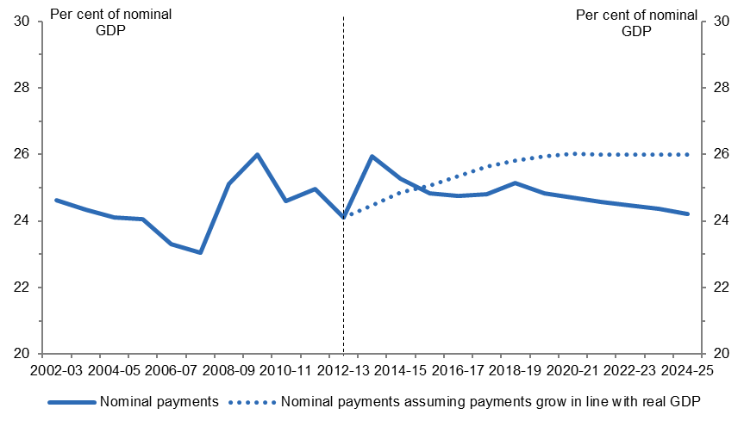
Figure 1.2: Nominal historical and projected Australian Government payments as a proportion of nominal GDP
Year | Payments as a proportion of nominal GDP | Payments grown in line with real GDP
2002-03 | 24.6 per cent
2003-04 | 24.3 per cent
2004-05 | 24.1 per cent
2005-06 | 24.1 per cent
2006-07 | 23.3 per cent
2007-08 | 23.1 per cent
2008-09 | 25.1 per cent
2009-10 | 26.0 per cent
2010-11 | 24.6 per cent
2011-12 | 25.0 per cent
2012-13 | 24.1 per cent | 24.1 per cent
2013-14 | 25.9 per cent | 24.5 per cent
2014-15 | 25.3 per cent | 24.9 per cent
2015-16 | 24.8 per cent | 25.1 per cent
2016-17 | 24.7 per cent | 25.3 per cent
2017-18 | 24.8 per cent | 25.6 per cent
2018-19 | 25.1 per cent | 25.8 per cent
2019-20 | 24.8 per cent | 25.9 per cent
2020-21 | 24.7 per cent | 26.0 per cent
2021-22 | 24.6 per cent | 26.0 per cent
2022-23 | 24.5 per cent | 26.0 per cent
2023-24 | 24.4 per cent | 26.0 per cent
2024-25 | 24.2 per cent | 26.0 per cent
Source: Australian Government Budgets and Final Budget Outcomes
As the temporary increase in the terms of trade reverses, growth in nominal GDP is expected to be weaker. In the absence of slower spending growth, the spending to GDP ratio would rise. By way of illustration, the dotted line in Figure 1.2 represents the ratio of spending to GDP that would result if real spending is projected to grow at the same rate as real GDP (3.2 per cent annual growth). In this illustrative example, the spending to GDP ratio rises over the period to 26 per cent, flattening towards the end of the medium term as the terms of trade is projected to stop declining.
Spending growth over the medium term is projected to grow at a real rate of 2.6 per cent in the 2014-15 Budget. This results in a gradual decline in spending as a proportion of GDP, with the ratio of Australian Government spending to GDP over the medium term, on average, about the same as the past decade.
To the extent that the projected reduction in Australian Government spending growth is not achieved over the medium term, an even greater share of the burden of fiscal consolidation would need to fall on the revenue side of the budget. That said, the Australian Government’s medium term budget projections already assume a significant increase in revenue with tax receipts projected to rise from 21.4 per cent of GDP in 2012-13 to 23.9 per cent of GDP in 2019-20, and remaining at that level over the medium term.
The projected growth in real GDP over the medium term is stronger than growth over the past decade. This strong projected real GDP growth reflects Treasury estimates that by 2015-16 the economy will be operating significantly below its potential. To close this gap, real GDP is projected to grow above trend growth for a period over the medium term as the economy moves back to its potential which is projected to occur by 2020-21.
Economic projections are based on judgements and assumptions which are subject to uncertainty. As the Budget papers note, there are risks to the economic outlook. Weaker real GDP growth than projected is a possibility given continued uncertainty around global growth following the financial crisis, the substantial slowing in growth in China following a period of rapid expansion, and the rise of geopolitical tensions.
These risks are in addition to the uncertainty about the Australian economy’s transition out of the resources investment boom, and rapidly rising terms of trade, to a more balanced growth path but with uncertainty about the prospects for a recovery in productivity growth.
Economic growth drives revenue growth and hence one side of the budget equation. Downside risks to the economic outlook imply downside risk to the revenue projections. This reinforces the need for fiscal consolidation in order to establish a fiscal buffer against the possibility of adverse economic shocks.
Australian Government payments in nominal terms are shown in Figure 1.3.
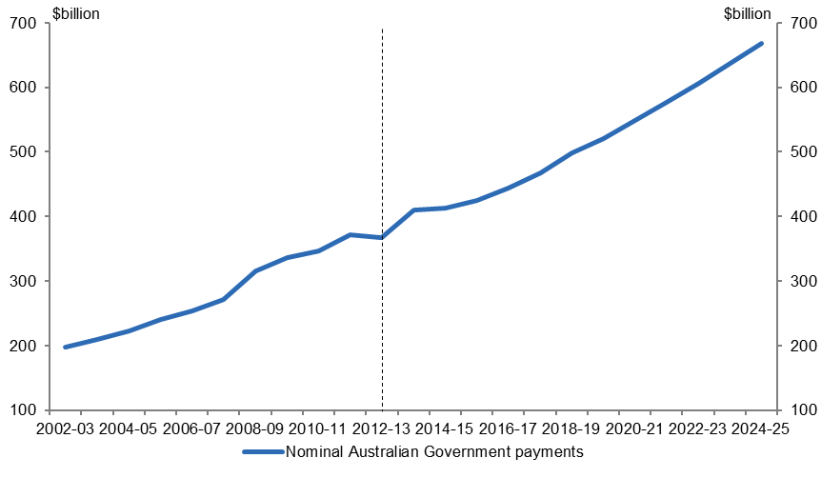
Figure 1.3: Nominal historical and projected Australian Government payments
Year | Nominal government payments ($ billion)
2002-03 | 197 billion
2003-04 | 210 billion
2004-05 | 222 billion
2005-06 | 240 billion
2006-07 | 253 billion
2007-08 | 272 billion
2008-09 | 316 billion
2009-10 | 222 billion
2010-11 | 346 billion
2011-12 | 371 billion
2012-13 | 367 billion
2013-14 | 411 billion
2014-15 | 412 billion
2015-16 | 424 billion
2016-17 | 444 billion
2017-18 | 467 billion
2018-19 | 498 billion
2019-20 | 520 billion
2020-21 | 548 billion
2021-22 | 576 billion
2022-23 | 606 billion
2023-24 | 637 billion
2024-25 | 668 billion
Source: Australian Government Budgets and Final Budget Outcomes
The key drivers of the projected growth in spending are discussed in the following section.

- Drivers of growth in government spending
This section examines the main programs driving growth in Australian Government spending over the medium term. The spending projections for each program are based on the announced policy settings contained in the 2014-15 Budget and make no allowance for new future spending initiatives in the respective programs.
Section 1 highlighted the strong spending growth that accompanied strong national income growth over the past decade. A by-product of this historical spending growth has been an increase in community expectations about what government can provide now and in the future.
Elevated community expectations are likely to put ongoing pressure on governments to increase discretionary spending on major programs over the medium term. It is difficult to see how governments could continue to meet these expectations while containing spending growth to the level currently projected.
Historical experience suggests that new spending initiatives are likely to be forthcoming over the next decade and affect the baseline projections presented. As such, actual spending outcomes over the medium term could exceed the projections contained in this section.

Methodology
Section 2 refers to spending on an accrual basis as detailed information on programs is only available in accrual terms. Total spending comprises expenses and net capital investment. As with Section 1, the ‘historical’ period of analysis commences in 2002-03 as there is greater data consistency from this year onwards and concludes in 2012-13, the last year for which actual spending data is available. The ‘medium term’ analysis commences from the last year of the historical period and concludes in 2024-25.
Estimates of spending up to 2017-18 are consistent with published 2014-15 Budget figures. Official estimates of spending on major programs beyond the forward estimates period are not published. Projected levels of spending on these programs beyond 2017-18 have been prepared by the PBO based on information provided by agencies and a range of models which take account of program indexation arrangements and demographic changes.
The impact of significant 2014-15 budget savings measures that are yet to be legislated is highlighted. This includes those measures currently before Parliament and those still to be introduced into the Parliament.
The tables and figures in this section only show the spending on particular programs – any associated revenue impacts are not included. This is particularly relevant for GST transfers to States, the National Disability Insurance Scheme (NDIS), the Paid Parental Leave (PPL) scheme and the Fuel Tax Credit Scheme. For example, the GST transfer to the States is equivalent to the GST revenue collected, meaning there is no net impact on the Commonwealth budget.
Spending projections for individual programs exclude departmental funding. The exceptions to this are the NDIS and defence where departmental costs are integrally linked to the programs.

Composition of Australian Government spending
Seventy-eight per cent of the projected $682 billion in government spending in 2024-25 is accounted for by twenty-one programs (see Figure 2.1 and Table 2.1).
Figure 2.1: Shares of projected government spending in 2024-25
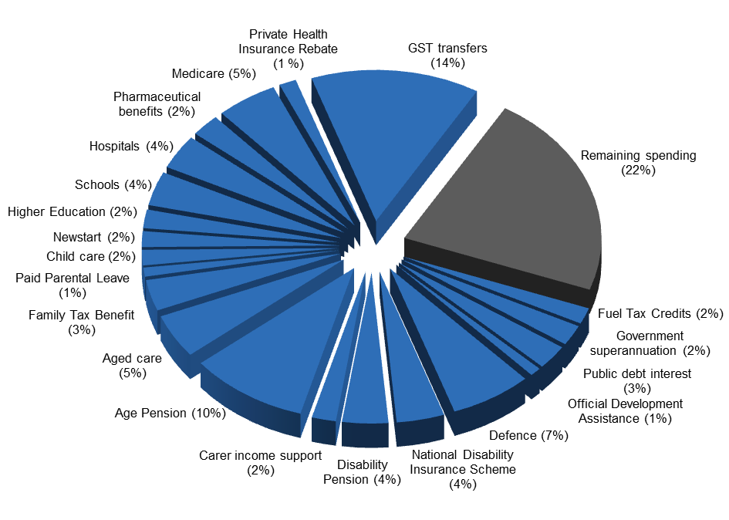  Driver | 2024-25  Share of total spending
GST transfers to States | 14 per cent
National Disability Insurance Scheme | 4 per cent
Age Pension | 10 per cent
Defence spending | 7 per cent
Aged care | 5 per cent
Medicare Benefits Schedule | 5 per cent
Schools | 4 per cent
Public Hospitals | 4 per cent
Paid Parental Leave | 1 per cent
Disability Support Pension | 4 per cent
Family Tax Benefit | 3 per cent
Child care | 2 per cent
Carer income support | 2 per cent
Fuel Tax Credit Scheme | 2 per cent
Pharmaceutical benefits and services | 2 per cent
Government superannuation | 2 per cent
Higher Education | 2 per cent
Private Health Insurance Rebate | 1 per cent
Newstart | 2 per cent
Public debt interest | 3 per cent
Official Development Assistance | 1 per cent
Remaining spending | 22 per cent
Source: Australian Government Budgets and PBO Analysis
In 2012-13 these same twenty-one programs accounted for 72 per cent of government spending. The increase in the major programs’ share of total spending from 2012-13 to 2024-25, has reduced the amount allocated to other spending areas (i.e. ‘remaining spending’).
Table 2.1: Real growth and contributions to growth in Australian Government spending
Driver | Nominal spending |  | Annual real growth |  | Contributions to growth ^{(a)} |  | Share of total growth | Share of total spending
 | 2012-13 | 2024-25 | 2002-03 | 2012-13 | 2002-03 | 2012-13 | 2012-13 | 2024-25
 |  |  | to | to | to | to | to
 |  |  | 2012-13 | 2024-25 | 2012-13 | 2024-25 | 2024-25
 | $b |  | % |  | Percentage points |  | % | %
GST transfers to States | 48 | 94 | 1.8 | 3.2 | 3.0 | 5.8 | 18 | 14
National Disability Insurance Scheme ^{(b)} | 0 | 26 | - | - | 0.0 | 5.1 | 16 | 4
Age pension | 36 | 68 | 4.5 | 2.8 | 4.9 | 3.7 | 12 | 10
Defence spending ^{(c)} | 23 | 47 | 2.1 | 3.6 | 1.6 | 3.2 | 10 | 7
Aged care | 13 | 32 | 6.8 | 5.4 | 2.3 | 2.9 | 9 | 5
Medicare Benefits Schedule | 19 | 34 | 5.8 | 2.7 | 3.0 | 1.8 | 6 | 5
Schools | 12 | 25 | 5.5 | 3.7 | 1.9 | 1.7 | 5 | 4
Public hospitals | 13 | 25 | 3.6 | 2.9 | 1.5 | 1.4 | 4 | 4
Disability Support Pension | 15 | 26 | 5.3 | 2.1 | 2.3 | 1.1 | 3 | 4
Paid Parental Leave ^{(d)} | 1 | 7 | - | 12.0 | 0.5 | 1.1 | 3 | 1
Carer income support | 6 | 14 | 10.2 | 4.0 | 1.5 | 1.0 | 3 | 2
Child care | 5 | 11 | 10.3 | 4.9 | 1.1 | 1.0 | 3 | 2
Fuel Tax Credits | 5 | 12 | 3.0 | 4.0 | 0.5 | 0.9 | 3 | 2
Government superannuation | 14 | 15 | 3.7 | -1.7 | 1.6 | -0.7 | -2 | 2
Family Tax Benefit | 19 | 23 | 3.3 | -1.0 | 2.0 | -0.6 | -2 | 3
Private Health Insurance rebate | 5 | 10 | 5.9 | 2.3 | 0.9 | 0.4 | 1 | 1
Higher education | 9 | 14 | 5.2 | 1.2 | 1.3 | 0.4 | 1 | 2
Newstart | 7 | 12 | 1.7 | 1.1 | 0.4 | 0.3 | 1 | 2
Public debt interest | 13 | 18 | 7.5 | 0.4 | 2.4 | 0.2 | 1 | 3
Official Development Assistance | 5 | 6 | 8.0 | -0.8 | 1.0 | -0.1 | 0 | 1
Pharmaceutical benefits and services | 9 | 13 | 2.4 | 0.3 | 0.7 | 0.1 | 0 | 2
Totals for above programs only | 278 | 531 | 4.1 | 3.0 | 34.5 | 30.6 | 95 | 78
Total ^{(e)} | 384 | 682 | 3.8 | 2.4 | 45.2 | 32.3 | 100 | 100
Real GDP |  |  | 3.0 | 3.2
- This is the percentage point contribution to total cumulative real growth over each period.
- This program commences in 2013-14 and consequently does not record an annual average growth rate over either of the periods of analysis.
- Defence spending comprises expenses and capital investment.
- This includes only the gross cost of the expanded Paid Parental Leave Scheme for 26 weeks at the income of the recipient capped at $100,000.
- Total government spending comprises expenses and net capital investment.
Source: Australian Government Budgets and PBO Analysis
Figure 2.2 shows historical real spending growth and projected medium-term spending growth of the twenty-one programs. The horizontal line in the figure indicates historical real GDP growth, with those programs above the line growing faster than real GDP historically and those programs below the line growing slower than real GDP historically. The vertical line in the figure indicates projected real GDP growth over the medium term, with those programs to the right of the line projected to grow faster than real GDP over the medium term and those programs to the left of the line projected to grow slower than real GDP over the medium term.
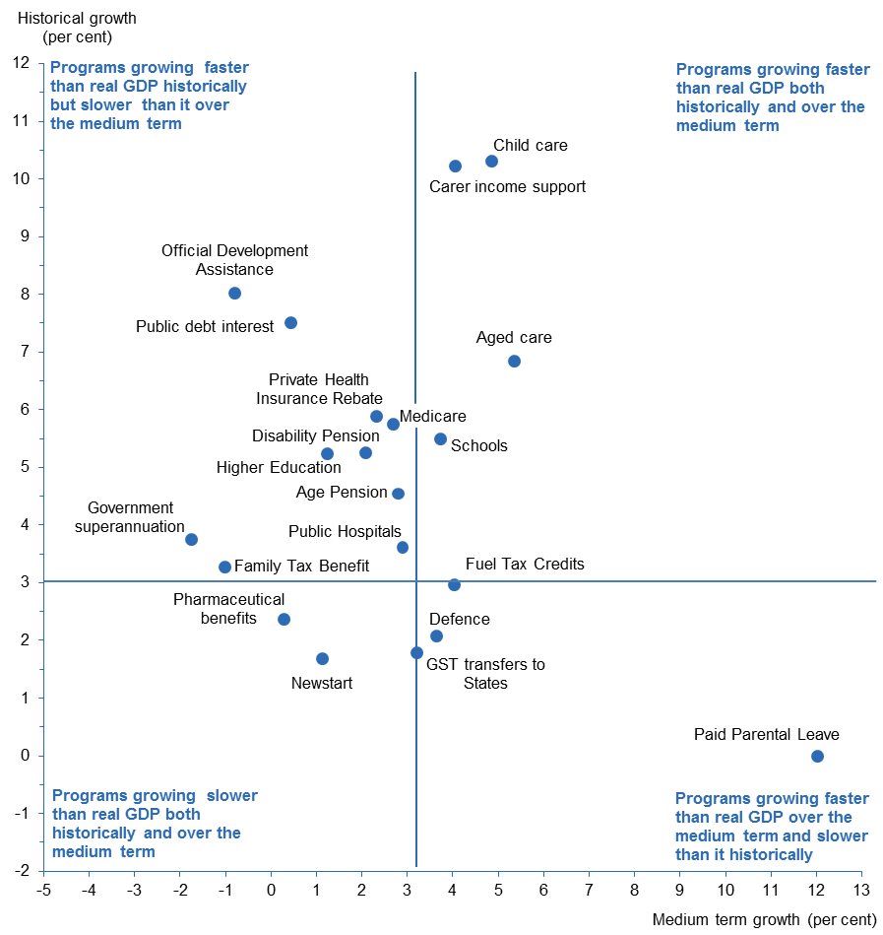
Figure 2.2: Annual real growth in spending programs and real GDP
Real GDP growth | 3.0 per cent historically | 3.2 per cent medium term
Programs growing faster than real GDP historically and slower than it over the medium term
Official Development Assistance | 8.0 per cent historically | -0.8 per cent medium term
Public debt interest | 7.5 per cent historically | 0.4 per cent medium term
Private Health Insurance Rebate | 5.9 per cent historically | 2.3 per cent medium term
Medicare | 5.8 per cent historically | 2.7 per cent medium term
Disability Pension | 5.3 per cent historically | 2.1 per cent medium term
Higher Education | 5.2 per cent historically | 1.2 per cent medium term
Age Pension | 4.5 per cent historically | 2.8 per cent medium term
Government superannuation | 3.7 per cent historically | -1.7 per cent medium term
Public Hospitals | 3.6 per cent historically | 2.9 per cent medium term
Family Tax Benefit | 3.3 per cent historically | -1.0 per cent medium term
Programs growing faster than real GDP both historically and over the medium term
Child care | 10.3 per cent historically | 4.9 per cent medium term
Carer income support | 10.2 per cent historically | 4.0 per cent medium term
Aged care | 6.8 per cent historically | 5.4 per cent medium term
Schools | 5.5 per cent historically | 3.7 per cent medium term
New programs and programs growing slower than real GDP historically and faster over the medium term
Fuel Tax Credits | 3.0 per cent historically | 4.0 per cent medium term
Defence | 2.1 per cent historically | 3.6 per cent medium term
GST transfers to States | 1.8 per cent historically | 3.2 per cent medium term
Paid Parental Leave | Not commenced | 12.0 per cent medium term
National Disability Insurance Scheme | Significant growth from 2013-14 commencement
Programs growing slower than real GDP both historically and over the medium term
Pharmaceutical benefits | 2.4 per cent historically | 0.3 per cent medium term
Newstart | 1.7 per cent historically | 1.1 per cent medium term
Source: Australian Government Budgets and PBO Analysis
A notable aspect of Figure 2.2 is the significant slowing in projected growth of most programs. There is a significant clustering of programs that grew more strongly than real GDP historically but are projected to slow below real GDP growth over the medium term (i.e. the top left hand quadrant of the figure). A number of other programs, while continuing to grow faster than GDP, are projected to slow significantly. These include child care and carer income support.
Overall, around three-quarters of the programs are expected to grow more slowly over the medium term. These programs include the Age Pension, Family Tax Benefit, higher education, Medicare and the Disability Support Pension, all of which are affected by 2014-15 Budget savings measures that are yet to be legislated.
As noted at the beginning of this section, the growth rates in Figure 2.2 assume no further new spending initiatives beyond that contained in the 2014-15 Budget. However, strong historical spending growth has raised community expectations about what government should provide and is likely to put ongoing pressure on governments to continue to take discrete decisions to increase spending on major programs over the medium term. This is supported by the experience over the past decade which suggests that containing spending growth to the rates currently projected will prove difficult for governments.
As historical examples, spending on the Age Pension was increased in 2007 (as part of the Simpler Superannuation changes), the 2008-09 Budget, the 2009-10 Budget, and late 2011 (as part of the carbon pricing compensation package). Similarly, spending on Medicare has been affected by a series of policy decisions over the past decade including the introduction of the Bulk Billing Incentive and Extended Medicare Safety Net in 2004, increasing the benefit for most services provided by a GP in 2005, and the inclusion of dental services items in 2007. Further, the More Help for Families package announced in the 2004-05 Budget, increased Family Tax Benefit Part A by $600 per year, reduced the taper rate on this payment, and relaxed the income test for Family Tax Benefit Part B. There were also discretionary increases in payment rates for the Disability Support Pension, Carer Income Support and child care, and an expansion in higher education spending over the past decade.

Contributions to growth in government spending
A program’s contribution to growth is dependent on both its size and rate of growth. Figure 2.3 shows the percentage point contributions of the main contributors to projected growth in total government spending over the medium term.
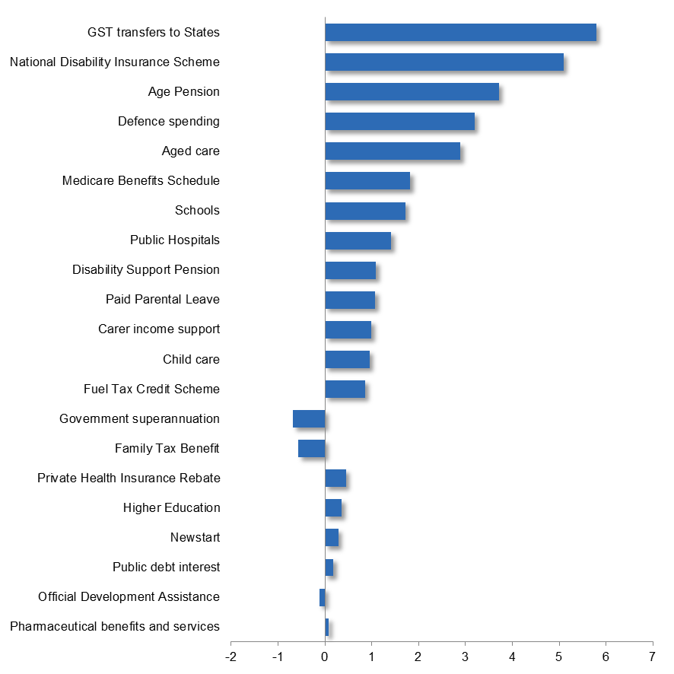
Figure 2.3: Contributions to projected real growth in government spending over the medium term
Driver | Contribution to medium term growth
GST transfers to States | 5.8 percentage points
National Disability Insurance Scheme | 5.1 percentage points
Age Pension | 3.7 percentage points
Defence spending | 3.3 percentage points
Aged care | 2.9 percentage points
Medicare Benefits Schedule | 1.8 percentage points
Schools | 1.7 percentage points
Public Hospitals | 1.4 percentage points
Disability Support Pension | 1.1 percentage points
Paid Parental Leave | 1.1 percentage points
Carer income support | 1.0 percentage points
Child care | 1.0 percentage points
Fuel Tax Credit Scheme | 0.9 percentage points
Government superannuation | -0.7 percentage points
Family Tax Benefit | -0.6 percentage points
Private Health Insurance Rebate | 0.4 percentage points
Higher Education | 0.4 percentage points
Newstart | 0.3 percentage points
Public debt interest | 0.2 percentage points
Official Development Assistance | -0.1 percentage points
Pharmaceutical benefits and services | 0.1 percentage points
Source: Australian Government Budgets and PBO Analysis
The twenty-one programs contribute 95 per cent of the projected growth in spending over the medium term.
GST transfers to the States, is the largest contributor to growth in total expenses over the medium term, accounting for 18 per cent of total growth. However, this expense is matched by GST revenue collected, meaning there is no net impact on the budget.
Two new programs, the National Disability Insurance Scheme and expanded Paid Parental Leave are projected to grow rapidly over the medium term and together account for 19 per cent of the growth in total spending. The net impact of this spending on the budget is reduced by levies, contributions from State and Territory Governments, and reductions in other Australian Government programs.
The Age Pension and defence are the second and third largest areas of spending respectively, together accounting for 17 per cent of total spending in 2024-25. The Age Pension is projected to account for 12 per cent of the growth in total spending over the medium term, largely driven by the ageing population. Defence is projected to account for 10 per cent of the growth in total spending over the medium term, reflecting long-term spending commitments to the enhancement of Australian Defence Force capabilities.
In contrast, Family Tax Benefit, is projected to detract 2 per cent from growth in total spending over the medium term. This primarily reflects significant 2014-15 Budget savings measures yet to be legislated.
The main contributors to growth in spending and their drivers are discussed in more detail below, including the impact of significant 2014-15 Budget savings measures associated with these programs that are yet to be legislated. Savings measures in these programs are projected to reduce spending over the medium term, with an impact of $19 billion or 0.7 per cent of GDP in 2024-25.

  - Goods and Services Tax transfer to States
The transfer of GST revenue to States is treated as an Australian Government expense. As the payment to the States is equivalent to the GST revenue collected, there is no net impact on the Commonwealth budget.
Growth in GST transfers is projected to accelerate from its historical real growth of 1.8 per cent annually to 3.2 per cent annually over the medium term. GST transfers are projected to account for 18 per cent of the growth in total spending over the medium term and 14 per cent of total spending in 2024-25.
The acceleration in growth over the medium term is driven by the continuation of the assumption in the 2014-15 Budget of a projected increase in growth in the consumption of goods and services subject to the tax.
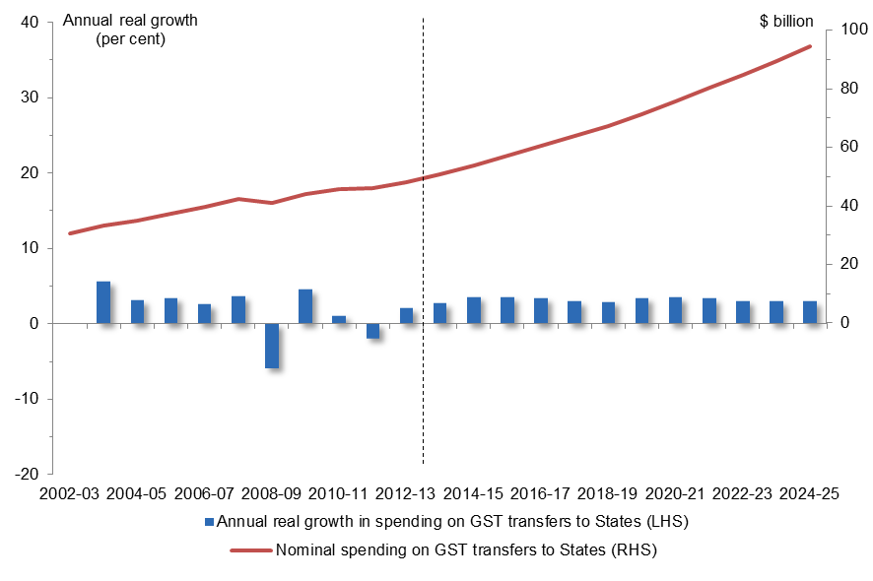
Figure 2.1.1: Nominal spending on Goods and Services Tax transfers to States and annual real growth
Year | Nominal dollars | Annual real growth
2002-03 | 31 billion
2003-04 | 33 billion | 5.6 per cent
2004-05 | 35 billion | 3.1 per cent
2005-06 | 37 billion | 3.5 per cent
2006-07 | 40 billion | 2.6 per cent
2007-08 | 42 billion | 3.7 per cent
2008-09 | 41 billion | -5.9 per cent
2009-10 | 44 billion | 4.5 per cent
2010-11 | 46 billion | 1.1 per cent
2011-12 | 46 billion | -1.9 per cent
2012-13 | 48 billion | 2.1 per cent
2013-14 | 51 billion | 2.7 per cent
2014-15 | 54 billion | 3.6 per cent
2015-16 | 57 billion | 3.6 per cent
2016-17 | 60 billion | 3.4 per cent
2017-18 | 64 billion | 3.0 per cent
2018-19 | 67 billion | 3.0 per cent
2019-20 | 71 billion | 3.4 per cent
2020-21 | 76 billion | 3.5 per cent
2021-22 | 80 billion | 3.4 per cent
2022-23 | 85 billion | 3.1 per cent
2023-24 | 89 billion | 3.0 per cent
2024-25 | 94 billion | 3.0 per cent
Source: Australian Government Budgets and PBO Analysis

  - National Disability Insurance Scheme
Spending on the National Disability Insurance Scheme (NDIS) is projected to grow rapidly over the medium term, including a significant ramping up over the period to 2020-21. The NDIS is projected to account for 16 per cent of the growth in total spending over the medium term and 4 per cent of total spending in 2024-25.
The NDIS will be fully established by 2021, and provide services to around 460,000 people with significant and permanent disabilities including for independent living, early intervention therapies, aids and equipment, help with household tasks, and assistance for carers.
Spending on the NDIS is partly offset by an increase in the Medicare Levy of 0.5 of a percentage point from 1 July 2014 (which is not included in these estimates). The spending shown in Figure 2.2.1 includes State contributions to the NDIS (which make up over 50 per cent of the total spending on the scheme in 2017-18) and funding provided through the existing National Disability Agreement.
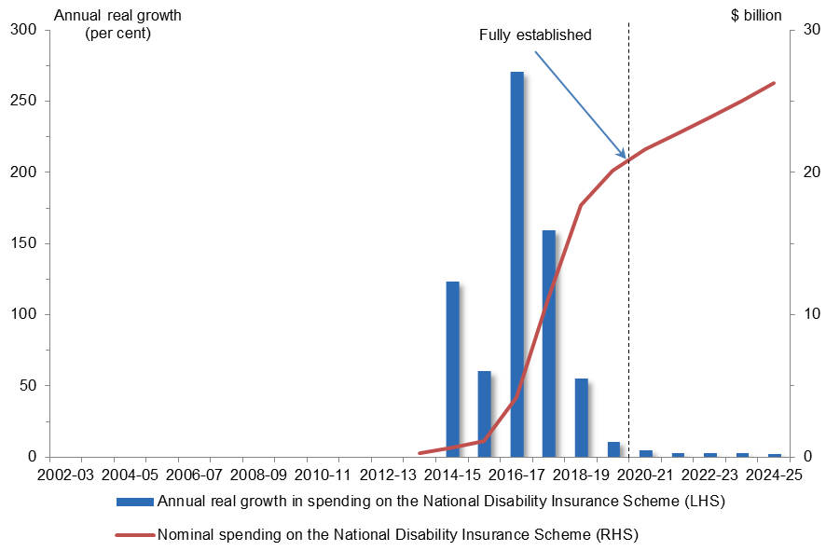
Figure 2.2.1: Nominal spending on the National Disability Insurance Scheme and annual real growth
Year | Nominal dollars | Annual real growth
2013-14 | 0.3 billion
2014-15 | 1 billion | 123 per cent
2015-16 | 1 billion | 60 per cent
2016-17 | 4 billion | 271 per cent
2017-18 | 11 billion | 160 per cent
2018-19 | 18 billion | 55 per cent
2019-20 | 20 billion | 11 per cent
2020-21 | 22 billion | 5 per cent
2021-22 | 23 billion | 3 per cent
2022-23 | 24 billion | 2 per cent
2023-24 | 25 billion | 2 per cent
2024-25 | 26 billion | 2 per cent
Source: Australian Government Budgets and PBO Analysis
  - Age Pension
Growth in spending on the Age Pension is projected to slow from its historical real growth of 4.5 per cent annually to 2.8 per cent annually over the medium term. The Age Pension is projected to account for 12 per cent of the growth in total spending over the medium term and 10 per cent of total spending in 2024-25.
Relatively strong historical growth reflects increases to the single pension rate and Pension Supplement in the 2009-10 Budget and further increases provided as part of the carbon pricing package, including one-off payments. The eligibility criteria for the Age Pension were also relaxed as part of the 2007 Simpler Superannuation package. The slowing in growth over the medium term partly reflects the impact of the 2014-15 Budget measure to index the Age Pension to movements in the CPI from 1 September 2017. This change to indexation is a shift from the current practice of increasing the Age Pension based on the higher of benchmarking against Male Total Average Weekly Earnings (MTAWE), or indexation by CPI or the Pensioner and Beneficiary Cost of Living index.
The 2009-10 Budget measure to lift the qualifying age for the Age Pension to 67 by 2023 also contributes to the projected slowing in the rate of growth in Age Pension spending over the medium term. The measure to raise the pension age to 70 years takes effect outside of the medium-term period (commences 1 July 2025).
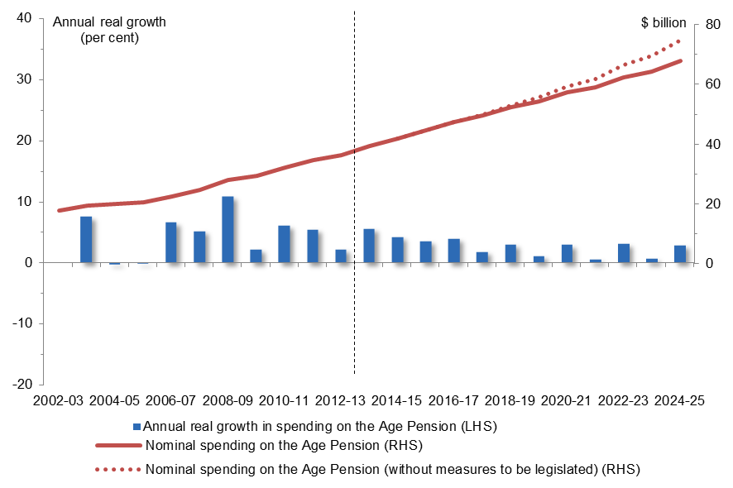
Figure 2.3.1: Nominal spending on the Age Pension and annual real growth
Year | Nominal dollars | Nominal dollar without measures | Annual real growth
2002-03 | 17.7 billion
2003-04 | 19.5 billion |  | 7.6 per cent
2004-05 | 20.0 billion |  | -0.2 per cent
2005-06 | 20.6 billion |  | -0.1 per cent
2006-07 | 22.6 billion |  | 6.6 per cent
2007-08 | 24.6 billion |  | 5.2 per cent
2008-09 | 28.1 billion |  | 10.9 per cent
2009-10 | 29.4 billion |  | 2.2 per cent
2010-11 | 32.2 billion |  | 6.1 per cent
2011-12 | 34.7 billion |  | 5.5 per cent
2012-13 | 36.3 billion |  | 2.2 per cent
2013-14 | 39.4 billion |  | 5.6 per cent
2014-15 | 42.0 billion | 42.0 billion | 4.3 per cent
2015-16 | 44.5 billion | 44.5 billion | 3.6 per cent
2016-17 | 47.5 billion | 47.5 billion | 4.0 per cent
2017-18 | 49.6 billion | 49.8 billion | 1.9 per cent
2018-19 | 52.4 billion | 53.0 billion | 3.0 per cent
2019-20 | 54.3 billion | 55.7 billion | 1.1 per cent
2020-21 | 57.3 billion | 59.2 billion | 2.9 per cent
2021-22 | 59.0 billion | 61.9 billion | 0.6 per cent
2022-23 | 62.4 billion | 66.5 billion | 3.1 per cent
2023-24 | 64.4 billion | 69.9 billion | 0.7 per cent
2024-25 | 67.9 billion | 74.8 billion | 2.9 per cent
Source: Australian Government Budgets and PBO Analysis
Figure 2.3.1 shows projected spending on the Age Pension, with and without the impact of the 2014-15 Budget measures which are yet to be legislated. In 2024-25 savings measures relating to the Age Pension are projected to reduce spending by $6.9 billion.
  - Defence
Growth in spending on defence, including net capital investment, is projected to accelerate from its historical real growth of 2.1 per cent annually to 3.6 per cent annually over the medium term. Defence is projected to account for 10 per cent of the growth in total spending over the medium term and 7 per cent of total spending in 2024-25.
Strong historical growth reflects the long-term funding commitments made in the Defence White Papers released in 2000 and 2009, and in the 2006-07 Budget, supplemented by funding for specific capabilities including the C17 heavy airlift aircraft and the F/A-18F Super Hornet aircraft. From 2010-11 growth slowed due to savings decisions taken in the 2009-10, 2011-12 and 2012-13 Budgets which largely involved the deferral of capital acquisitions and the associated operating and maintenance costs.
Spending growth in the medium term has been projected by the PBO reflecting the long term funding commitments made in the 2009 Defence White Paper as amended by deferral decisions, and adjustments made in the 2014-15 Budget to smooth the funding profile over the medium term.
Figure 2.4.1: Nominal spending on defence and annual real growth
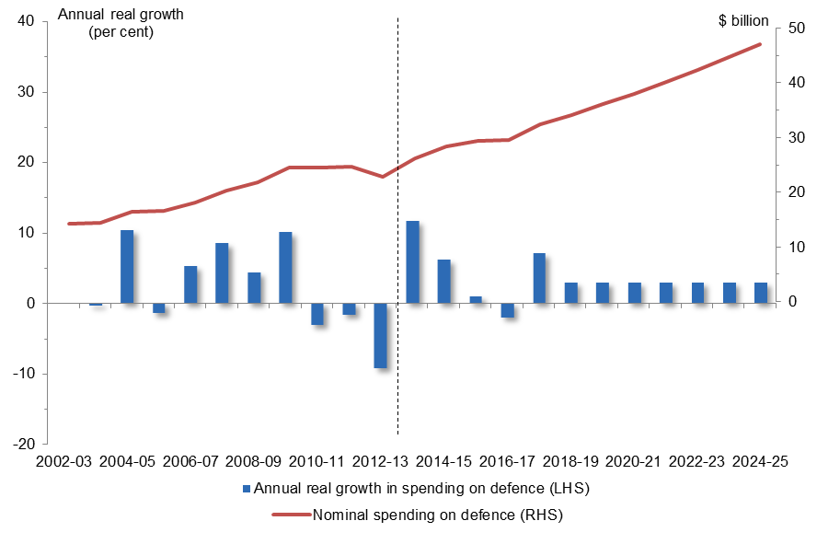  Year | Nominal dollars | Annual real growth
2002-03 | 14 billion
2003-04 | 15 billion | 1.0 per cent
2004-05 | 16 billion | 8.8 per cent
2005-06 | 16 billion | -7.5 per cent
2006-07 | 18 billion | 12 per cent
2007-08 | 20 billion | 8.5 per cent
2008-09 | 22 billion | 4.4 per cent
2009-10 | 24 billion | 10.0 per cent
2010-11 | 24 billion | -4.0 per cent
2011-12 | 25 billion | -.8 per cent
2012-13 | 23 billion | -10.3 per cent
2013-14 | 28 billion | 13 per cent
2014-15 | 28 billion | 6.1 per cent
2015-16 | 29 billion | 0.9 per cent
2016-17 | 30 billion | -1.8 per cent
2017-18 | 32 billion | 6.8 per cent
2018-19 | 35 billion | 4.6 per cent
2019-20 | 36 billion | 1.8 per cent
2020-21 | 38 billion | 3.4 per cent
2021-22 | 40 billion | 2.5 per cent
2022-23 | 43 billion | 3.5 per cent
2023-24 | 45 billion | 2.3 per cent
2024-25 | 47 billion | 2.5 per cent
Source: Australian Government Budgets and PBO Analysis
  - Aged care
Growth in spending on aged care is projected to slow from its historical real growth of 6.8 per cent annually to 5.4 per cent annually over the medium term. Aged care is projected to account for 9 per cent of the growth in total spending over the medium term and 5 per cent of total spending in 2024-25, an increase from its share of 3 per cent of total spending in 2012-13.
Strong historical growth reflects the Commonwealth assuming greater responsibility for funding aged care from the States, and spending in the 2004-05 Budget to improve the quality and availability of aged care services. Continued strong growth over the medium term is driven by projected increases in the number of aged care places funded by the Commonwealth and the ageing population, partly offset by the 2014-15 Budget measure to reduce spending on the Commonwealth Home Support Programme by $2 billion over six years from 2018-19.
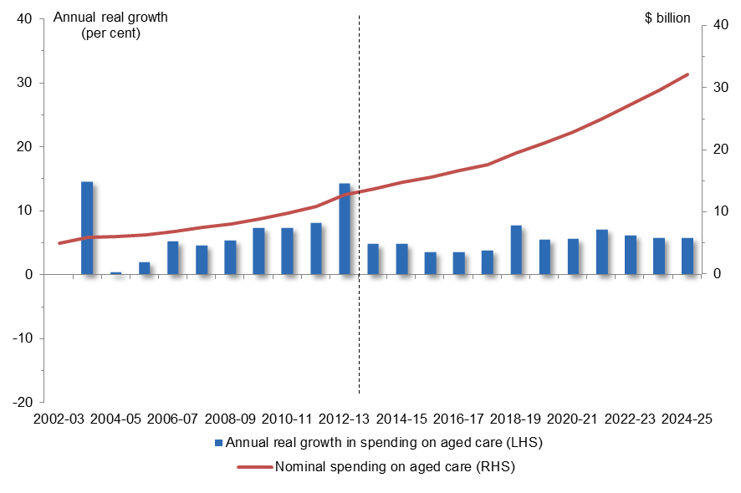
Figure 2.5.1: Nominal spending on aged care and annual real growth
Year | Nominal dollars | Annual real growth
2002-03 | 5 billion
2003-04 | 6 billion | 14.5 per cent
2004-05 | 6 billion | 0.4 per cent
2005-06 | 6 billion | 2.0 per cent
2006-07 | 7 billion | 5.2 per cent
2007-08 | 7 billion | 4.6 per cent
2008-09 | 8 billion | 5.4 per cent
2009-10 | 9 billion | 7.3 per cent
2010-11 | 10 billion | 7.4 per cent
2011-12 | 11 billion | 8.1 per cent
2012-13 | 13 billion | 14.3 per cent
2013-14 | 14 billion | 4.8 per cent
2014-15 | 15 billion | 4.8 per cent
2015-16 | 16 billion | 3.6 per cent
2016-17 | 17 billion | 3.6 per cent
2017-18 | 18 billion | 3.8 per cent
2018-19 | 20 billion | 7.7 per cent
2019-20 | 21 billion | 5.5 per cent
2020-21 | 23 billion | 5.6 per cent
2021-22 | 25 billion | 7.1 per cent
2022-23 | 27 billion | 6.2 per cent
2023-24 | 30 billion | 5.8 per cent
2024-25 | 32 billion | 5.7 per cent
Source: Australian Government Budgets and PBO Analysis
  - Medicare Benefits Schedule
Growth in spending on the Medicare Benefits Schedule (Medicare) is projected to slow from its historical real growth of 5.8 per cent annually to 2.7 per cent annually over the medium term. Medicare is projected to account for 6 per cent of the growth in total spending over the medium term and 5 per cent of total spending in 2024-25.
Strong historical growth reflects the introduction of a number of polices affecting Medicare including the Bulk Billing Incentive and Extended Medicare Safety Net in 2004, increasing the benefit for most services provided by a GP in 2005, and the inclusion of dental services items in 2007.
The slowing in growth over the medium term reflects 2014-15 Budget measures to reduce Medicare rebates for visits to general practitioners, out-of-hospital pathology services and diagnostic imaging by $5 and allowing the providers of these services to collect a patient contribution fee of $7, pausing indexation for non-GP Medicare fee subsidies, and changes to safety net thresholds and out-of-pocket cost caps.
Growth over the latter part of the medium term is relatively stronger than at the beginning of the period, driven by the lapsing of pauses to the indexation of some Medicare items combined with a projected increase in the average cost of Medicare items claimed.
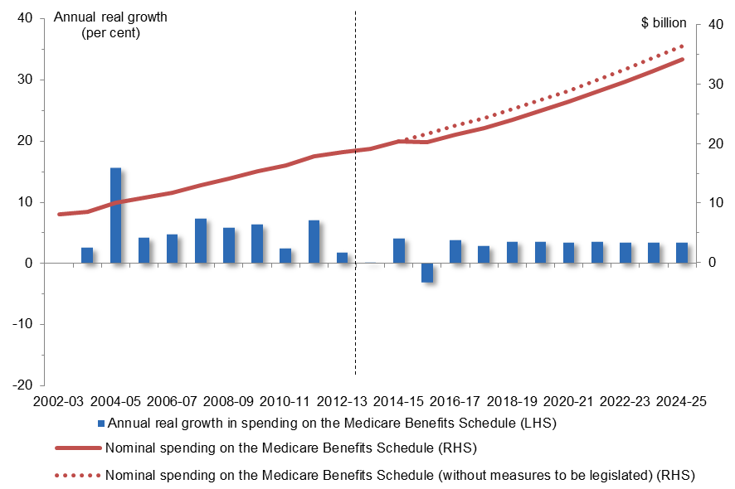
Figure 2.6.1: Nominal spending on the Medicare Benefits Schedule and annual real growth
Year | Nominal dollars | Nominal dollars without measures | Annual real growth
2002-03 | 8.1 billion
2003-04 | 8.5 billion |  | 2.6 per cent
2004-05 | 10.1 billion |  | 15.6 per cent
2005-06 | 10.8 billion |  | 4.2 per cent
2006-07 | 11.7 billion |  | 4.7 per cent
2007-08 | 13.0 billion |  | 7.4 per cent
2008-09 | 14.1 billion |  | 5.8 per cent
2009-10 | 15.4 billion |  | 6.3 per cent
2010-11 | 16.3 billion |  | 2.5 per cent
2011-12 | 17.8 billion |  | 7.1 per cent
2012-13 | 18.6 billion |  | 1.8 per cent
2013-14 | 19.1 billion |  | 0.0 per cent
2014-15 | 20.3 billion | 20.4 billion | 4.1 per cent
2015-16 | 20.2 billion | 21.7 billion | -3.1 per cent
2016-17 | 21.5 billion | 23.1 billion | 3.9 per cent
2017-18 | 22.6 billion | 24.3 billion | 2.9 per cent
2018-19 | 24.1 billion | 25.8 billion | 3.6 per cent
2019-20 | 25.5 billion | 27.3 billion | 3.6 per cent
2020-21 | 27.1 billion | 29.0 billion | 3.5 per cent
2021-22 | 28.8 billion | 30.7 billion | 3.6 per cent
2022-23 | 30.5 billion | 32.6 billion | 3.5 per cent
2023-24 | 32.4 billion | 34.5 billion | 3.5 per cent
2024-25 | 34.3 billion | 36.5 billion | 3.4 per cent
Source: Australian Government Budgets and PBO Analysis
Figure 2.6.1 shows projected spending on Medicare, with and without the impact of the 2014-15 Budget measures which are yet to be legislated. In 2024-25 savings measures relating to Medicare are projected to reduce spending by $2.2 billion.
  - Schools
Funding to States for schools includes spending on the government, Catholic and independent sectors.
Growth in funding for schools is projected to slow from its historical real growth of 5.5 per cent annually to 3.7 per cent annually over the medium term. Spending on schools is projected to account for 5 per cent of the growth in total spending over the medium term and 4 per cent of total spending in 2024-25.
Growth over the beginning of the medium term is in line with historical growth as school reform funding is maintained.
Growth slows over the second half of the medium term largely driven by the 2014-15 Budget measure to index funding to schools by movements in the CPI with allowance for changes in enrolments from 1 January 2018. This compares with existing indexation which is based on the cost of delivering education services. The slowing in spending growth over the second half of the medium term represents a partial shift in funding responsibility to the States.
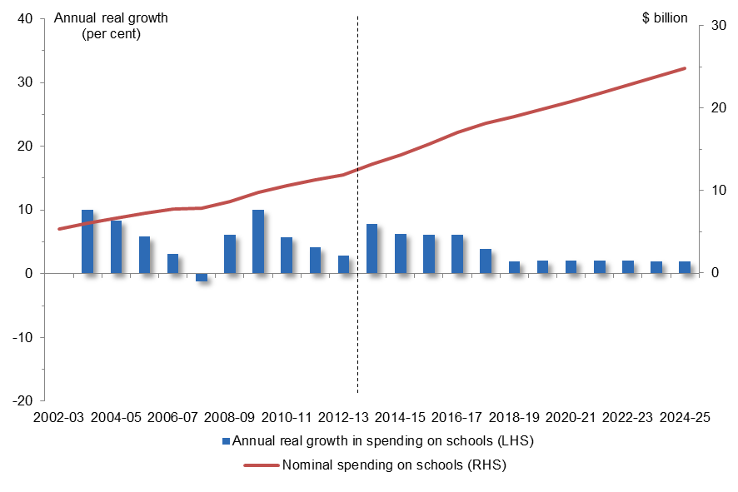
Figure 2.7.1: Nominal spending on schools and annual real growth
Year | Nominal dollars | Annual real growth
2002-03 | 5 billion
2003-04 | 6 billion | 10.1 per cent
2004-05 | 7 billion | 8.4 per cent
2005-06 | 7 billion | 5.8 per cent
2006-07 | 8 billion | 3.2 per cent
2007-08 | 8 billion | -1.2 per cent
2008-09 | 9 billion | 6.1 per cent
2009-10 | 10 billion | 10.0 per cent
2010-11 | 11 billion | 5.8 per cent
2011-12 | 11 billion | 4.2 per cent
2012-13 | 12 billion | 2.9 per cent
2013-14 | 13 billion | 7.9 per cent
2014-15 | 14 billion | 6.4 per cent
2015-16 | 16 billion | 6.2 per cent
2016-17 | 17 billion | 6.2 per cent
2017-18 | 18 billion | 4.0 per cent
2018-19 | 19 billion | 2.0 per cent
2019-20 | 20 billion | 2.1 per cent
2020-21 | 21 billion | 2.1 per cent
2021-22 | 22 billion | 2.1 per cent
2022-23 | 23 billion | 2.1 per cent
2023-24 | 24 billion | 2.0 per cent
2024-25 | 25 billion | 1.9 per cent
Source: Australian Government Budgets and PBO Analysis

  - Public hospitals
Growth in spending on public hospitals is projected to slow from its historical real growth of 3.6 per cent annually to 2.9 per cent annually over the medium term. Public hospital funding is projected to account for 4 per cent of the growth in total spending over the medium term and 4 per cent of total spending in 2024-25.
Strong growth over the beginning of the medium term reflects the maintenance of previous public hospital funding arrangements.
The sharp slowing in growth over the second half of the medium term reflects the 2014-15 Budget measure to index public hospitals funding by CPI increases and population from 1 July 2017, rather than funding based on 50 per cent of the efficient growth of public hospital services and the $16.4 billion funding guarantee that previously applied between 2014-15 and 2019-20.
The slowing in spending growth over the second half of the medium term represents a shift in funding responsibility to the States. States have been assuming a greater responsibility for public hospital funding, with their contribution rising from 51 per cent in 2001-02 to 58 per cent in 2011-12. The expected growth in demand for hospital services over the medium term will place increasing pressure on state budgets.
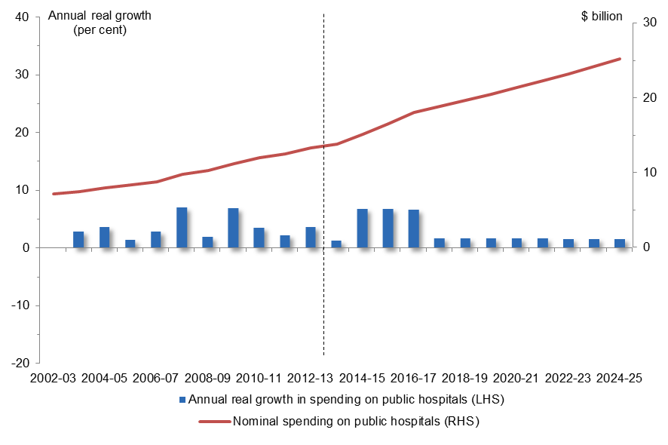
Figure 2.8.1: Nominal spending on public hospitals and annual real growth
Year | Nominal dollars | Annual real growth
2002-03 | 7 billion
2003-04 | 7 billion | 2.9 per cent
2004-05 | 8 billion | 3.7 per cent
2005-06 | 8 billion | 1.4 per cent
2006-07 | 9 billion | 2.9 per cent
2007-08 | 10 billion | 7.0 per cent
2008-09 | 10 billion | 1.9 per cent
2009-10 | 11 billion | 6.9 per cent
2010-11 | 12 billion | 3.6 per cent
2011-12 | 13 billion | 2.3 per cent
2012-13 | 13 billion | 3.7 per cent
2013-14 | 14 billion | 1.3 per cent
2014-15 | 15 billion | 6.8 per cent
2015-16 | 17 billion | 6.8 per cent
2016-17 | 18 billion | 6.7 per cent
2017-18 | 19 billion | 1.8 per cent
2018-19 | 20 billion | 1.7 per cent
2019-20 | 21 billion | 1.7 per cent
2020-21 | 21 billion | 1.7 per cent
2021-22 | 22 billion | 1.7 per cent
2022-23 | 23 billion | 1.7 per cent
2023-24 | 24 billion | 1.6 per cent
2024-25 | 25 billion | 1.6 per cent
Source: Australian Government Budgets and PBO Analysis
  - Disability Support Pension
Growth in spending on the Disability Support Pension (DSP) is projected to slow from its historical real growth of 5.3 per cent annually to 2.1 per cent annually over the medium term. The DSP is projected to account for 3 per cent of the growth in total spending over the medium term and 4 per cent of total spending in 2024-25.
The slowing in growth over the medium term reflects 2014-15 Budget measures to tighten eligibility and income test criteria for the DSP, and index payment rates to movements in the CPI. The change to indexation is a shift from the current practice of increasing the DSP based on the higher of benchmarking against MTAWE, or indexation by CPI or the Pensioner and Beneficiary Cost of Living index. These measures build on the 2011-12 Budget measures to tighten the eligibility assessment criteria for the DSP which also have an impact over the medium term.
Slower growth over the medium term is expected to be partly offset by the increase in the eligibility age for the Age Pension from 65 years to 67 years from 2017-18, which results in a projected increase in the flow of people to the DSP within this age cohort.
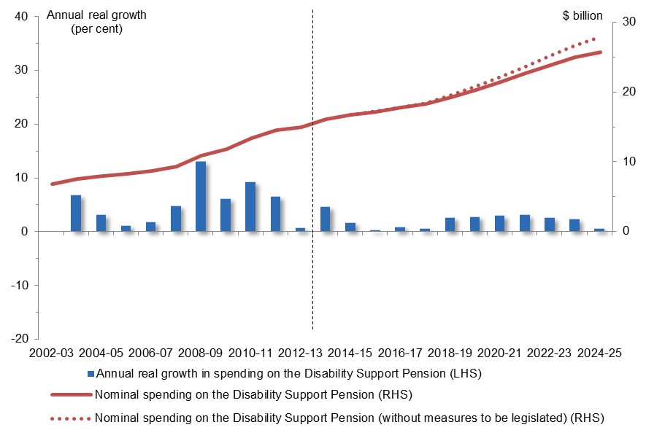
Figure 2.9.1: Nominal spending on the Disability Support Pension and annual real growth
Year | Nominal dollars | Nominal dollars without measures | Annual real growth
2002-03 | 6.9 billion
2003-04 | 7.5 billion |  | 6.8 per cent
2004-05 | 7.9 billion |  | 3.1 per cent
2005-06 | 8.3 billion |  | 1.1 per cent
2006-07 | 8.7 billion |  | 1.8 per cent
2007-08 | 9.4 billion |  | 4.8 per cent
2008-09 | 10.9 billion |  | 13.0 per cent
2009-10 | 11.9 billion |  | 6.2 per cent
2010-11 | 13.4 billion |  | 9.2 per cent
2011-12 | 14.6 billion |  | 6.5 per cent
2012-13 | 15.0 billion |  | 0.7 per cent
2013-14 | 16.1 billion |  | 4.6 per cent
2014-15 | 16.7 billion | 16.7 billion | 1.6 per cent
2015-16 | 17.2 billion | 17.2 billion | 0.3 per cent
2016-17 | 17.8 billion | 17.8 billion | 0.9 per cent
2017-18 | 18.3 billion | 18.5 billion | 0.6 per cent
2018-19 | 19.3 billion | 19.6 billion | 2.7 per cent
2019-20 | 20.3 billion | 20.8 billion | 2.8 per cent
2020-21 | 21.5 billion | 22.2 billion | 3.0 per cent
2021-22 | 22.7 billion | 23.7 billion | 3.1 per cent
2022-23 | 23.8 billion | 25.2 billion | 2.6 per cent
2023-24 | 25.0 billion | 26.7 billion | 2.3 per cent
2024-25 | 25.8 billion | 28.0 billion | 0.6 per cent
Source: Australian Government Budgets and PBO Analysis
Figure 2.9.1 shows projected spending on the DSP, with and without the impact of the 2014-15 Budget measures which are yet to be legislated. In 2024-25 savings measures relating to the DSP are projected to reduce spending by $2.2 billion.
  - Paid Parental Leave
The 2014-15 Budget includes a provision for an expanded Paid Parental Leave scheme in the contingency reserve rather than as a specific budget measure.
Figure 2.9.1 provides a PBO estimate of projected spending on the expanded scheme which includes leave for up to 26 weeks at the wage of the recipient capped at $100,000. This is an increase on the existing scheme which commenced from January 2011 providing 18 weeks of leave at the National Minimum Wage.
Spending on the paid parental leave scheme is projected to grow in real terms by 12.0 per cent annually over the medium term. The scheme is projected to account for 3 per cent of the growth in total spending over the medium term and 1 per cent of total spending in 2024-25.
Spending on the scheme is offset by a levy of 1.5 per cent on taxable company income above $5 million, and offsets from the abolition of the existing Paid Parental Leave scheme and the other existing State and Commonwealth maternity leave schemes (which are not included in these estimates).
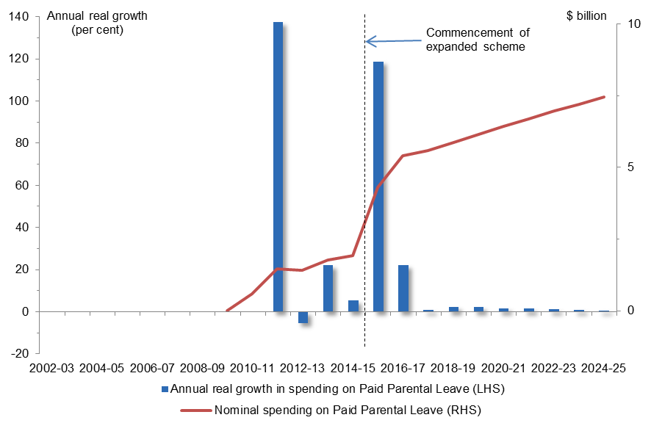
Figure 2.10.1: Nominal spending on Paid Parental Leave schemes and annual real growth
Year | Nominal dollars | Annual real growth
2010-11 | 1 billion
2011-12 | 1 billion | 137.4 per cent
2012-13 | 1 billion | -5.4 per cent
2013-14 | 2 billion | 22.2 per cent
2014-15 | 2 billion | 5.5 per cent
2015-16 | 4 billion | 118.1 per cent
2016-17 | 5 billion | 22.2 per cent
2017-18 | 6 billion | 1.0 per cent
2018-19 | 6 billion | 2.4 per cent
2019-20 | 6 billion | 2.4 per cent
2020-21 | 6 billion | 1.8 per cent
2021-22 | 7 billion | 1.7 per cent
2022-23 | 7 billion | 1.3 per cent
2023-24 | 7 billion | 1.1 per cent
2024-25 | 7 billion | 0.8 per cent
Source: Australian Government Budgets and PBO analysis
  - Carer income support
Carer income support, which includes the Carer Payment, allowances and supplements, is projected to slow from its historical real growth of 10.2 per cent annually to 4.0 per cent annually over the medium term. Carer income support is projected to account for 3 per cent of the growth in total spending over the medium term and 2 per cent of total spending in 2024-25.
Strong historical growth in carer income support partly reflects the payment of carer bonuses each year from 2003-04 to 2007-08, the introduction of the Carer Supplement in June 2009, and commencement of the Child Disability Assistance Payment in July 2007.
The slowing in growth over the medium term reflects the 2014-15 Budget measure to index the carer payment and associated allowances to movements in the CPI from 1 September 2017. This change to indexation is a shift from the current practice of increasing carer income support based on the higher of benchmarking against MTAWE, or indexation by CPI or the Pensioner and Beneficiary Cost of Living index.
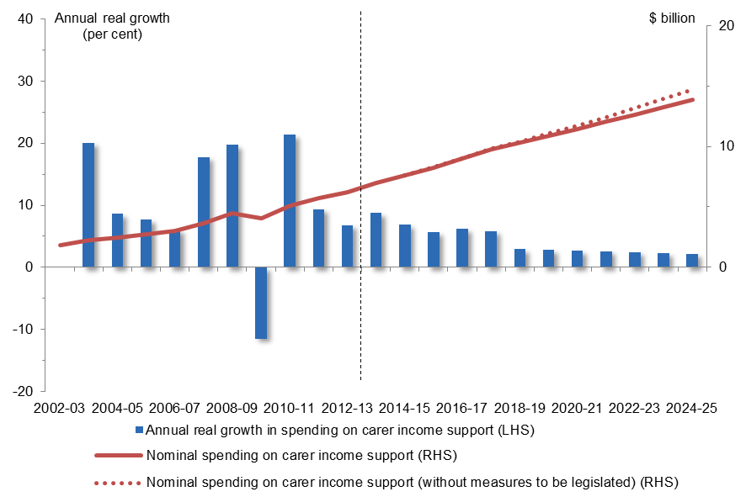
Figure 2.11.1: Nominal spending on carer income support and annual real growth
Year | Nominal dollars | Nominal dollars without measures | Annual real growth
2002-03 | 1.8 billion
2003-04 | 2.2 billion |  | 20.1 per cent
2004-05 | 2.5 billion |  | 8.6 per cent
2005-06 | 2.7 billion |  | 7.8 per cent
2006-07 | 3.0 billion |  | 6.1 per cent
2007-08 | 3.6 billion |  | 17.8 per cent
2008-09 | 4.5 billion |  | 19.8 per cent
2009-10 | 4.1 billion |  | -11.4 per cent
2010-11 | 5.1 billion |  | 21.5 per cent
2011-12 | 5.7 billion |  | 9.4 per cent
2012-13 | 6.2 billion |  | 6.9 per cent
2013-14 | 7.0 billion |  | 8.8 per cent
2014-15 | 7.6 billion | 7.6 billion | 6.9 per cent
2015-16 | 8.3 billion | 8.3 billion | 5.7 per cent
2016-17 | 9.0 billion | 9.0 billion | 6.2 per cent
2017-18 | 9.8 billion | 9.8 billion | 5.9 per cent
2018-19 | 10.3 billion | 10.4 billion | 2.7 per cent
2019-20 | 10.8 billion | 11.0 billion | 2.5 per cent
2020-21 | 11.3 billion | 11.6 billion | 2.3 per cent
2021-22 | 11.9 billion | 12.2 billion | 2.2 per cent
2022-23 | 12.4 billion | 12.9 billion | 2.0 per cent
2023-24 | 13.0 billion | 13.6 billion | 1.9 per cent
2024-25 | 13.5 billion | 14.4 billion | 1.7 per cent
Source: Australian Government Budgets and PBO Analysis
Figure 2.11.1 shows projected spending on carer income support, with and without the impact of the 2014-15 Budget measures which are yet to be legislated. In 2024-25 savings measures relating to carer income support are projected to reduce spending by $0.8 billion.
  - Child care
Child care spending comprises the Child Care Benefit, which is provided as an annual lump sum payment or as reduced child care fees, and the Child Care Rebate, which is provided as a fortnightly, quarterly or annual payment of 50 per cent of the out-of-pocket cost of child care.
Growth in spending on child care is projected to slow significantly from its historical real growth of 10.3 per cent annually to 4.9 per cent annually over the medium term. Child care is projected to account for 3 per cent of the growth in total spending over the medium term and 2 per cent of total spending in 2024-25.
Continued strong growth over the beginning of the medium term reflects the combination of increases in recipient numbers and child care costs, partly offset by measures in the 2013-14 and 2014-15 Budget to pause indexation of the maximum upper limit for the child care rebate.
Growth over the latter part of the medium term is slower reflecting reduced projected growth in recipient numbers and child care costs over the period.
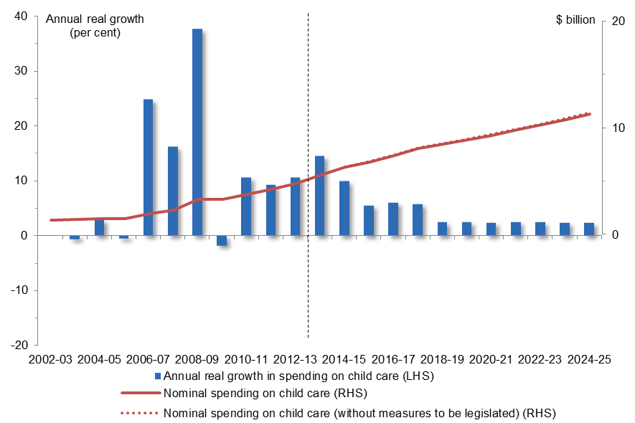
Figure 2.12.1: Nominal spending on child care and annual real growth
Year | Nominal dollars | Nominal dollars without measures | Annual real growth
2002-03 | 1.4 billion
2003-04 | 1.4 billion |  | -0.7 per cent
2004-05 | 1.5 billion |  | 2.9 per cent
2005-06 | 1.5 billion |  | -0.6 per cent
2006-07 | 1.9 billion |  | 24.8 per cent
2007-08 | 2.3 billion |  | 16.2 per cent
2008-09 | 3.3 billion |  | 37.7 per cent
2009-10 | 3.3 billion |  | -1.8 per cent
2010-11 | 3.8 billion |  | 10.7 per cent
2011-12 | 4.2 billion |  | 9.3 per cent
2012-13 | 4.8 billion |  | 10.6 per cent
2013-14 | 5.6 billion |  | 14.5 per cent
2014-15 | 6.3 billion | 6.3 billion | 9.9 per cent
2015-16 | 6.8 billion | 6.9 billion | 5.5 per cent
2016-17 | 7.4 billion | 7.5 billion | 6.1 per cent
2017-18 | 8.0 billion | 8.1 billion | 5.8 per cent
2018-19 | 8.4 billion | 8.5 billion | 2.4 per cent
2019-20 | 8.9 billion | 9.0 billion | 2.5 per cent
2020-21 | 9.3 billion | 9.4 billion | 2.4 per cent
2021-22 | 9.8 billion | 9.9 billion | 2.5 per cent
2022-23 | 10.3 billion | 10.4 billion | 2.4 per cent
2023-24 | 10.8 billion | 10.9 billion | 2.4 per cent
2024-25 | 11.3 billion | 11.4 billion | 2.3 per cent
Source: Australian Government Budgets and PBO Analysis
Figure 2.12.1 shows projected spending on child care, with and without the impact of the 2014-15 Budget measures which are yet to be legislated. In 2024-25 savings measures relating to child care are projected to reduce spending by around $0.1 billion.
  - Fuel Tax Credit Scheme
Growth in spending on the Fuel Tax Credit Scheme is projected to increase from its historical real growth of 3.0 per cent annually to 4.0 per cent annually over the medium term. The Fuel Tax Credit Scheme is projected to account for 3 per cent of the growth in total spending over the medium term and 2 per cent of total spending in 2024-25.
The acceleration in growth over the medium term primarily reflects the 2014-15 Budget measure to reintroduce indexation of fuel excise duties on diesel, petrol and other fuel products to movements in the CPI. A higher excise rate results in an increase in Fuel Tax Credits claimed by eligible businesses. However this is more than offset by the increased excise revenue from the reintroduction of indexation. Growth over the medium term also reflects increases in Fuel Tax Credit claims commensurate with projected higher diesel consumption, particularly in the mining industry.
Figure 2.13.1: Nominal spending on the Fuel Tax Credit Scheme and annual real growth
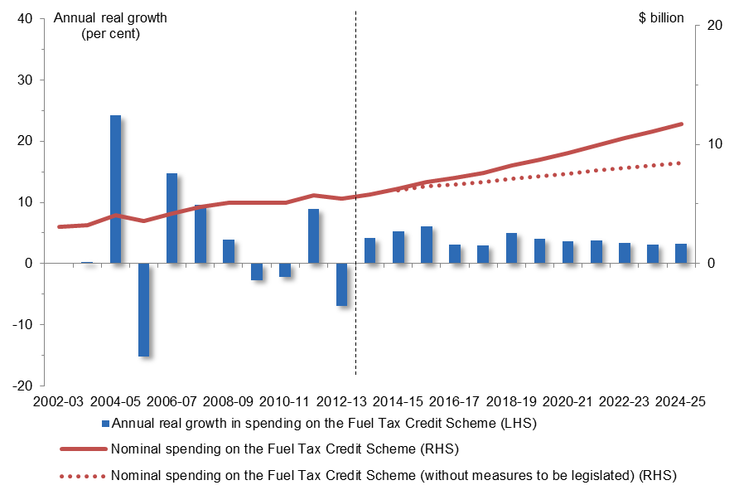  Year | Nominal dollars | Nominal dollars without measures | Annual real growth
2002-03 | 3.1 billion
2003-04 | 3.2 billion |  | 0.4 per cent
2004-05 | 4.1 billion |  | 24.2 per cent
2005-06 | 3.5 billion |  | -15.1 per cent
2006-07 | 4.2 billion |  | 14.9 per cent
2007-08 | 4.8 billion |  | 9.7 per cent
2008-09 | 5.1 billion |  | 3.9 per cent
2009-10 | 5.1 billion |  | -2.6 per cent
2010-11 | 5.1 billion |  | -2.2 per cent
2011-12 | 5.7 billion |  | 9.0 per cent
2012-13 | 5.4 billion |  | -6.9 per cent
2013-14 | 5.8 billion |  | 4.2 per cent
2014-15 | 6.3 billion | 6.2 billion | 5.4 per cent
2015-16 | 6.8 billion | 6.5 billion | 6.2 per cent
2016-17 | 7.2 billion | 6.7 billion | 3.1 per cent
2017-18 | 7.6 billion | 6.8 billion | 3.0 per cent
2018-19 | 8.2 billion | 7.1 billion | 5.1 per cent
2019-20 | 8.8 billion | 7.4 billion | 4.1 per cent
2020-21 | 9.3 billion | 7.6 billion | 3.7 per cent
2021-22 | 9.9 billion | 7.8 billion | 3.9 per cent
2022-23 | 10.5 billion | 8.0 billion | 3.5 per cent
2023-24 | 11.1 billion | 8.3 billion | 3.1 per cent
2024-25 | 11.5 billion | 8.5 billion | 3.3 per cent
Source: Australian Government Budgets and PBO Analysis
Figure 2.13.1 shows projected spending on the Fuel Tax Credit Scheme, with and without the impact of the 2014-15 Budget measure which is yet to be legislated. In 2024-25 the reintroduction of fuel excise indexation is projected to increase spending by $3.3 billion. However this increase in expenses is more than offset by the associated increase in revenue of $7.1 billion in 2024-25.
  - Government superannuation
Following historical annual real growth of 3.7 per cent, spending on government superannuation expenses, including for benefits and nominal interest, is projected to contract by 1.7 per cent annually over the medium term. Government superannuation is projected to detract 2 per cent from real growth in total spending over the medium term and account for 2 per cent of total spending in 2024-25.
The growth profile reflects the manner in which government superannuation benefits are currently valued. Government superannuation benefits expenses are the increase in Commonwealth superannuation liabilities for civilian employees and military personnel in unfunded schemes over a given financial year. These expenses are valued using a different discount rate for actuals and the first year of the budget estimates, compared with the remainder of the medium term, and these changes in the discount rate have the largest impact on superannuation benefit expenses. The Budget papers use a long-term discount rate to avoid the volatility that would occur by using current market yields on government bonds which continually change.
Actuals and expenses in the first year of the budget estimates are valued using a discount rate based on the long-term government bond rate at the end of the previous financial year in accordance with Australian Accounting Standards. In 2012-13, a discount rate of 3.1 per cent was applied to value these expenses resulting in a substantial increase on the previous year. The lower estimated government superannuation expenses from 2014-15 onwards reflects the use of a discount rate of 6.0 per cent based on the expected return on government bonds over the medium term (consistent with Long Term Cost Reports for the civilian and military superannuation schemes).
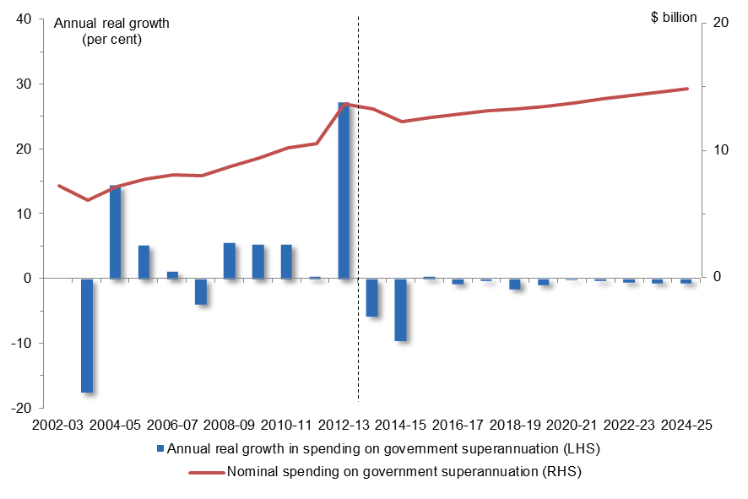
Figure 2.14.1: Nominal spending on government superannuation and annual real growth
Year | Nominal dollars | Annual real growth
2002-03 | 7 billion
2003-04 | 6 billion | -17.5 per cent
2004-05 | 7 billion | 14.4 per cent
2005-06 | 8 billion | 5.2 per cent
2006-07 | 8 billion | 1.1 per cent
2007-08 | 9 billion | -3.9 per cent
2008-09 | 9 billion | 5.6 per cent
2009-10 | 10 billion | 5.4 per cent
2010-11 | 11 billion | 5.4 per cent
2011-12 | 14 billion | 0.4 per cent
2012-13 | 13 billion | 27.2 per cent
2013-14 | 12 billion | -5.7 per cent
2014-15 | 13 billion | -9.5 per cent
2015-16 | 13 billion | 0.4 per cent
2016-17 | 13 billion | -0.8 per cent
2017-18 | 13 billion | -0.3 per cent
2018-19 | 13 billion | -1.5 per cent
2019-20 | 14 billion | -0.9 per cent
2020-21 | 14 billion | -0.1 per cent
2021-22 | 14 billion | -0.3 per cent
2022-23 | 14 billion | -0.5 per cent
2023-24 | 15 billion | -0.6 per cent
2024-25 | 15 billion | -0.6 per cent
Source: Australian Government Budgets and PBO Analysis
  - Family Tax Benefit
Following historical annual real growth of 3.3 per cent, spending on Family Tax Benefit (FTB) is projected to contract in real terms by 1.0 per cent annually over the medium term. FTB is projected to detract 2 per cent from real growth in total spending over the medium term and account for 3 per cent of total spending in 2024-25, a decrease from its share of 5 per cent of total spending in 2012-13.
Over the beginning of the medium term spending on FTB falls largely due to 2014-15 Budget measures. These measures include limiting FTB-B to families with children under six years, pausing increases to the base FTB rate for two years, revising and ceasing indexation of FTB end-of-year supplements, and lowering the FTB-B primary income earner limit to $100,000 annually. Changes to the eligibility age for FTB-A in the 2012-13 Budget contribute further to the contraction in FTB spending over the beginning of the medium term.
The return to growth over the latter part of the medium term reflects the lapsing of pauses to indexation and eligibility thresholds and the projected return to increasing recipient numbers over the period consistent with demographic projections.
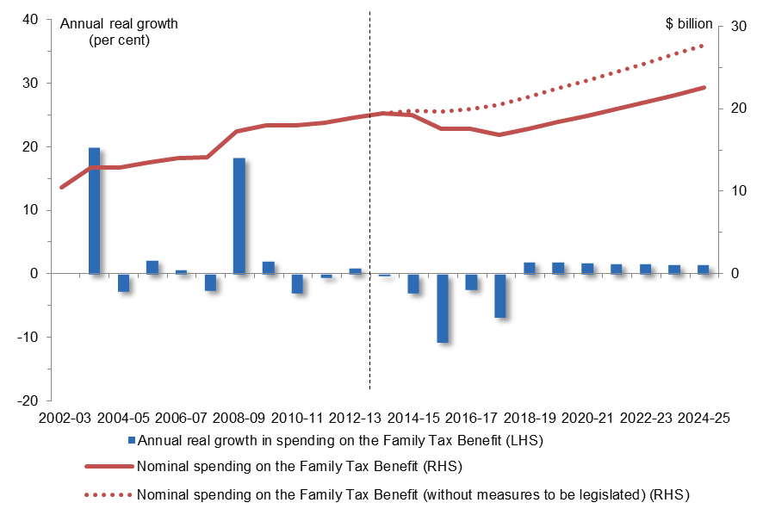
Figure 2.15.1: Nominal spending on the Family Tax Benefit and annual real growth
Year | Nominal dollars | Nominal dollars without measures | Annual real growth
2002-03 | 10.5 billion
2003-04 | 12.9 billion |  | 20.0 per cent
2004-05 | 12.8 billion |  | -2.7 per cent
2005-06 | 13.5 billion |  | 2.2 per cent
2006-07 | 14.0 billion |  | 0.8 per cent
2007-08 | 14.1 billion |  | -2.6 per cent
2008-09 | 17.3 billion |  | 18.3 per cent
2009-10 | 18.0 billion |  | 2.1 per cent
2010-11 | 18.0 billion |  | -3.0 per cent
2011-12 | 18.3 billion |  | -0.6 per cent
2012-13 | 18.9 billion |  | 1.0 per cent
2013-14 | 19.4 billion |  | -0.3 per cent
2014-15 | 19.2 billion | 19.8 billion | -3.0 per cent
2015-16 | 17.6 billion | 19.6 billion | -10.7 per cent
2016-17 | 17.6 billion | 20.0 billion | -2.4 per cent
2017-18 | 16.8 billion | 20.5 billion | -6.8 per cent
2018-19 | 17.6 billion | 21.5 billion | 1.9 per cent
2019-20 | 18.4 billion | 22.5 billion | 1.9 per cent
2020-21 | 19.2 billion | 23.5 billion | 1.8 per cent
2021-22 | 20.0 billion | 24.5 billion | 1.7 per cent
2022-23 | 20.8 billion | 25.6 billion | 1.6 per cent
2023-24 | 21.7 billion | 26.6 billion | 1.5 per cent
2024-25 | 22.5 billion | 27.7 billion | 1.5 per cent
Source: Australian Government Budget and PBO Analysis
Figure 2.15.1 shows projected spending on FTB, with and without the impact of the 2014-15 Budget measures which are yet to be legislated. In 2024-25 savings measures relating to FTB are projected to reduce spending by $5.2 billion.
  - Private Health Insurance Rebate
Growth in spending on the Private Health Insurance Rebate is projected to slow from its historical real growth rate of 5.9 per cent annually to 2.3 per cent annually over the medium term. The Private Health Insurance Rebate is projected to account for 1 per cent of the growth in total spending over the medium term and 1 per cent of total spending in 2024-25.
Slower growth over the medium term reflects 2014-15 Budget measures to pause indexation of the rebate for three years. Slower growth also reflects 2012-13 Budget measures to means test the rebate from 1 July 2013 and index contributions to the lower of either the CPI or commercial premium increases from 1 April 2013.
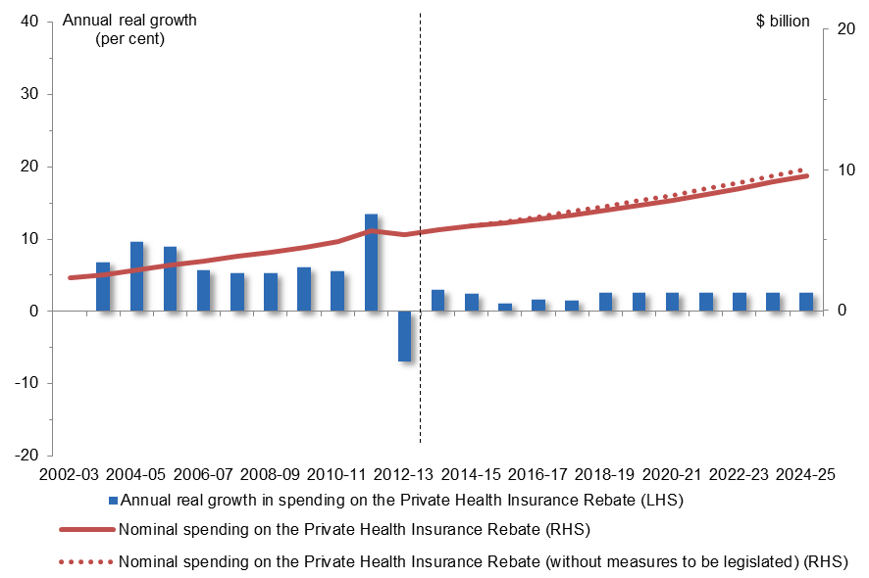
Figure 2.16.1: Nominal spending on the Private Health Insurance Rebate and annual real growth
Year | Nominal dollars | Nominal dollars without measures | Annual real growth
2002-03 | 2.3 billion
2003-04 | 2.5 billion |  | 6.9 per cent
2004-05 | 2.9 billion |  | 9.6 per cent
2005-06 | 3.2 billion |  | 8.9 per cent
2006-07 | 3.5 billion |  | 5.8 per cent
2007-08 | 3.8 billion |  | 5.4 per cent
2008-09 | 4.1 billion |  | 5.3 per cent
2009-10 | 4.5 billion |  | 6.1 per cent
2010-11 | 4.9 billion |  | 5.5 per cent
2011-12 | 5.7 billion |  | 13.5 per cent
2012-13 | 5.4 billion |  | -6.9 per cent
2013-14 | 5.7 billion |  | 2.9 per cent
2014-15 | 6.0 billion | 6.0 billion | 2.4 per cent
2015-16 | 6.2 billion | 6.3 billion | 1.2 per cent
2016-17 | 6.5 billion | 6.7 billion | 1.7 per cent
2017-18 | 6.7 billion | 7.0 billion | 1.6 per cent
2018-19 | 7.1 billion | 7.4 billion | 2.6 per cent
2019-20 | 7.5 billion | 7.8 billion | 2.6 per cent
2020-21 | 7.8 billion | 8.2 billion | 2.6 per cent
2021-22 | 8.2 billion | 8.6 billion | 2.6 per cent
2022-23 | 8.7 billion | 9.1 billion | 2.6 per cent
2023-24 | 9.1 billion | 9.6 billion | 2.6 per cent
2024-25 | 9.6 billion | 10.1 billion | 2.6 per cent
Source: Australian Government Budgets and PBO Analysis
Figure 2.16.1 shows projected spending on the Private Health Insurance Rebate, with and without the impact of the 2014-15 Budget measures which are yet to be legislated. In 2024-25 savings measures relating to the Private Health Insurance Rebate are projected to reduce spending by $0.5 billion.
  - Higher education
Growth in spending on higher education is projected to slow significantly from its historical real growth of 5.2 per cent annually to 1.2 per cent annually over the medium term. Higher education is projected to account for 1 per cent of the growth in total spending over the medium term and 2 per cent of total spending in 2024-25.
Growth over the beginning of the medium term is projected to slow significantly largely due to 2014-15 Budget measures to reduce subsidies under the Commonwealth Grants Scheme, cease reward funding for universities, change participation funding for students from low socio-economic backgrounds, and index funding for higher education providers to movements in the CPI rather than the Higher Education Grants Index.
The return to stronger growth over the latter part of the medium term is largely driven by projected increases in enrolments in the move to a demand driven enrolment model.
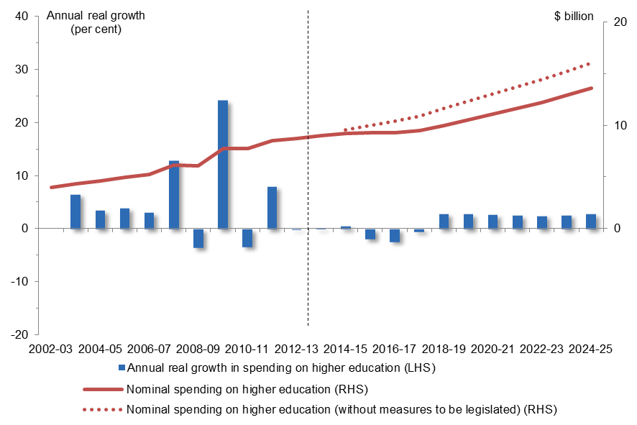
Figure 2.17.1: Nominal spending on higher education and annual real growth
Year | Nominal dollars | Nominal dollars without measures | Annual real growth
2002-03 | 4.0 billion
2003-04 | 4.4 billion |  | 6.6 per cent
2004-05 | 4.6 billion |  | 3.5 per cent
2005-06 | 4.9 billion |  | 3.9 per cent
2006-07 | 5.3 billion |  | 3.1 per cent
2007-08 | 6.1 billion |  | 12.9 per cent
2008-09 | 6.1 billion |  | -3.5 per cent
2009-10 | 7.8 billion |  | 24.2 per cent
2010-11 | 7.7 billion |  | -3.4 per cent
2011-12 | 8.5 billion |  | 8.0 per cent
2012-13 | 8.7 billion |  | -0.2 per cent
2013-14 | 9.0 billion |  | 0.2 per cent
2014-15 | 9.2 billion | 9.6 billion | 0.6 per cent
2015-16 | 9.3 billion | 10.0 billion | -1.9 per cent
2016-17 | 9.3 billion | 10.4 billion | -2.3 per cent
2017-18 | 9.5 billion | 10.9 billion | -0.5 per cent
2018-19 | 10.0 billion | 11.6 billion | 2.9 per cent
2019-20 | 10.5 billion | 12.3 billion | 2.8 per cent
2020-21 | 11.1 billion | 13.0 billion | 2.7 per cent
2021-22 | 11.6 billion | 13.7 billion | 2.6 per cent
2022-23 | 12.2 billion | 14.5 billion | 2.5 per cent
2023-24 | 12.9 billion | 15.3 billion | 2.7 per cent
2024-25 | 13.6 billion | 16.1 billion | 2.8 per cent
Source: Australian Government Budgets and PBO Analysis
Figure 2.17.1 shows projected spending on higher education, with and without the impact of the 2014-15 Budget measures which are yet to be legislated. In 2024-25 savings measures relating to the higher education are projected to reduce spending by $2.5 billion.
  - Newstart
Growth in spending on Newstart is projected to slow from its historical real growth of 1.7 per cent annually to 1.1 per cent annually over the medium term. Newstart is projected to account for 1 per cent of the growth in total spending over the medium term and 2 per cent of total spending in 2024-25.
The slowing in growth over the medium term reflects 2014-15 Budget measures to tighten access to Newstart for people under 30 years of age, increase the eligibility age for the payment from 22 years to 24 years, and maintain eligibility thresholds for three years.
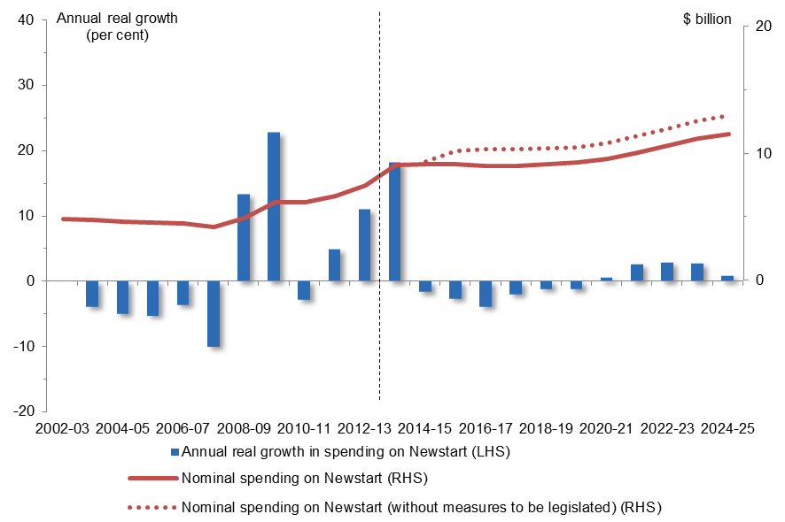
Figure 2.18.1: Nominal spending on Newstart and annual real growth
Year | Nominal dollars | Nominal dollars without measures | Annual real growth
2002-03 | 4.8 billion
2003-04 | 4.8 billion |  | -3.9 per cent
2004-05 | 4.6 billion |  | -5.0 per cent
2005-06 | 4.5 billion |  | -5.2 per cent
2006-07 | 4.5 billion |  | -3.6 per cent
2007-08 | 4.2 billion |  | -10.0 per cent
2008-09 | 4.9 billion |  | 13.1 per cent
2009-10 | 6.1 billion |  | 22.8 per cent
2010-11 | 6.1 billion |  | -2.8 per cent
2011-12 | 6.6 billion |  | 4.9 per cent
2012-13 | 7.5 billion |  | 11.0 per cent
2013-14 | 9.1 billion |  | 18.2 per cent
2014-15 | 9.1 billion | 9.4 billion | -1.7 per cent
2015-16 | 9.1 billion | 10.2 billion | -2.6 per cent
2016-17 | 9.0 billion | 10.3 billion | -3.9 per cent
2017-18 | 9.0 billion | 10.3 billion | -2.0 per cent
2018-19 | 9.1 billion | 10.4 billion | -1.2 per cent
2019-20 | 9.3 billion | 10.5 billion | -1.3 per cent
2020-21 | 9.5 billion | 10.8 billion | -0.6 per cent
2021-22 | 10.0 billion | 11.3 billion | 2.6 per cent
2022-23 | 10.6 billion | 11.9 billion | 2.9 per cent
2023-24 | 11.2 billion | 12.5 billion | 2.7 per cent
2024-25 | 11.5 billion | 13.0 billion | 0.9 per cent
Source: Australian Government Budget and PBO Analysis
Figure 2.18.1 shows projected spending on Newstart, with and without the impact of the 2014-15 Budget measures which are yet to be legislated. In 2024-25 savings measures relating to Newstart are projected to reduce spending by $1.4 billion.
  - Public debt interest
Public debt interest (PDI) expenses are paid by the Commonwealth on its borrowings primarily in the form of Commonwealth Government Securities (CGS) on issue.
Growth in PDI expenses is projected to slow from its historical real growth of 7.5 per cent annually to 0.4 per cent annually over the medium term. PDI is projected to account for 1 per cent of the growth in total spending over the medium term and 3 per cent of total spending in 2024-25.
PDI expenses are projected grow over the beginning of the medium term in line with projected budget deficits, and then contract over the latter part of the period as the stock and consequent cost of servicing CGS on issue decreases as the budget balance is projected to move to a surplus.
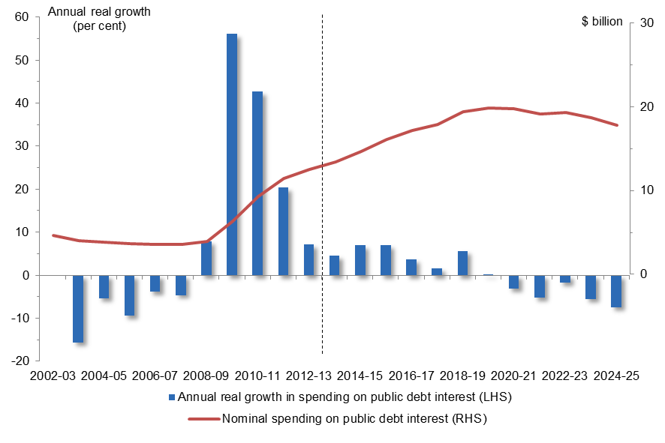
Figure 2.19.1: Nominal spending on public debt interest and annual real growth
Year | Nominal dollars | Annual real growth
2002-03 | 5 billion
2003-04 | 4 billion | -15.6 per cent
2004-05 | 4 billion | -5.3 per cent
2005-06 | 4 billion | -9.4 per cent
2006-07 | 4 billion | -3.8 per cent
2007-08 | 4 billion | -4.5 per cent
2008-09 | 4 billion | 8.0 per cent
2009-10 | 6 billion | 56.1 per cent
2010-11 | 9 billion | 42.7 per cent
2011-12 | 11 billion | 20.4 per cent
2012-13 | 13 billion | 7.2 per cent
2013-14 | 13 billion | 4.6 per cent
2014-15 | 15 billion | 7.0 per cent
2015-16 | 16 billion | 7.0 per cent
2016-17 | 17 billion | 3.8 per cent
2017-18 | 18 billion | 1.6 per cent
2018-19 | 19 billion | 5.7 per cent
2019-20 | 20 billion | 0.1 per cent
2020-21 | 20 billion | -3.1 per cent
2021-22 | 19 billion | -5.2 per cent
2022-23 | 19 billion | -1.7 per cent
2023-24 | 19 billion | -5.5 per cent
2024-25 | 18 billion | -7.4 per cent
Source: Australian Government Budgets and PBO Analysis
  - Official Development Assistance
Following historical annual real growth of 8.0 per cent, spending on Official Development Assistance or foreign aid is projected to contract by 0.8 per cent in real terms annually over the medium term. Official Development Assistance is not projected to account for any of the real growth in total spending over the medium term and is projected to account for 1 per cent of total spending in 2024-25.
Growth over the medium term reflects the 2014-15 Budget commitment to freeze foreign aid spending until 2016-17, and index it to movements in the CPI from 2016-17 rather than increasing toward the former foreign aid spending target of 0.5 per cent of Gross National Income.
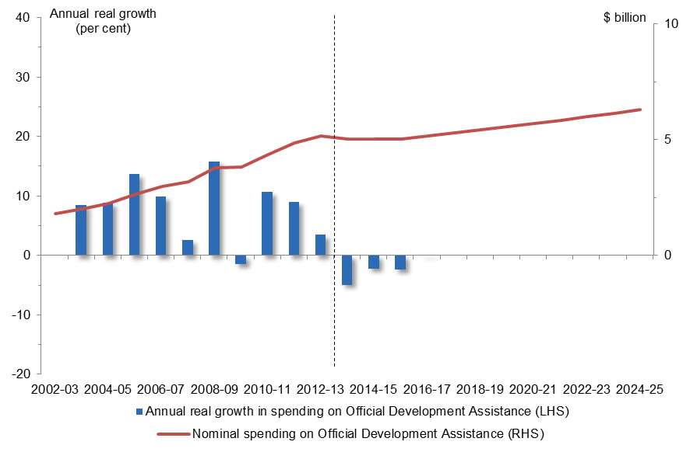
Figure 2.20.1: Nominal spending on Official Development Assistance and annual real growth
Year | Nominal dollars | Annual real growth
2002-03 | 2 billion
2003-04 | 2 billion | 8.6 per cent
2004-05 | 2 billion | 8.9 per cent
2005-06 | 3 billion | 13.7 per cent
2006-07 | 3 billion | 10.0 per cent
2007-08 | 3 billion | 2.6 per cent
2008-09 | 4 billion | 15.9 per cent
2009-10 | 4 billion | -1.5 per cent
2010-11 | 4 billion | 10.7 per cent
2011-12 | 5 billion | 9.0 per cent
2012-13 | 5 billion | 3.5 per cent
2013-14 | 5 billion | -4.9 per cent
2014-15 | 5 billion | -2.2 per cent
2015-16 | 5 billion | -2.4 per cent
2016-17 | 5 billion | 0.0 per cent
2017-18 | 5 billion | 0.0 per cent
2018-19 | 5 billion | 0.0 per cent
2019-20 | 6 billion | 0.0 per cent
2020-21 | 6 billion | 0.0 per cent
2021-22 | 6 billion | 0.0 per cent
2022-23 | 6 billion | 0.0 per cent
2023-24 | 6 billion | 0.0 per cent
2024-25 | 6 billion | 0.0 per cent
Source: Australian Government Budgets and PBO Analysis
  - Pharmaceutical Benefits and Services
Growth in spending on Pharmaceutical Benefits and Services (PBS) is projected to slow from its historical real growth of 2.4 per cent annually to 0.3 per cent annually over the medium term. The PBS is projected to account for a negligible share of the growth in total spending over the medium term and is projected to account for 2 per cent of total spending in 2024-25.
Slower growth over the medium term largely reflects 2014-15 Budget measures to decrease PBS rebates by $5, increase safety net thresholds and pause indexation of some subsidies.
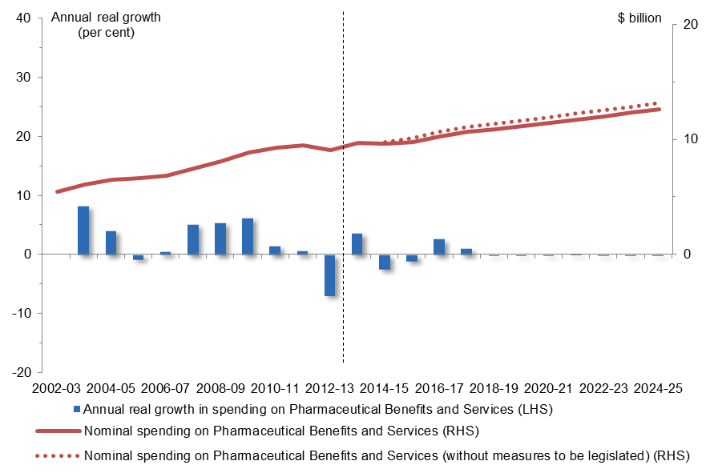
Figure 2.21.1: Nominal spending on Pharmaceutical Benefits and Services and annual real growth
Year | Nominal dollars | Nominal dollars without measures | Annual real growth
2002-03 | 5.5 billion
2003-04 | 6.1 billion |  | 8.3 per cent
2004-05 | 6.5 billion |  | 4.1 per cent
2005-06 | 6.6 billion |  | -0.7 per cent
2006-07 | 6.9 billion |  | 0.6 per cent
2007-08 | 7.5 billion |  | 5.1 per cent
2008-09 | 8.1 billion |  | 5.4 per cent
2009-10 | 8.8 billion |  | 6.3 per cent
2010-11 | 9.2 billion |  | 1.5 per cent
2011-12 | 9.5 billion |  | 0.7 per cent
2012-13 | 9.1 billion |  | -6.8 per cent
2013-14 | 9.7 billion |  | 3.7 per cent
2014-15 | 9.6 billion | 9.8 billion | -2.4 per cent
2015-16 | 9.8 billion | 10.1 billion | -1.0 per cent
2016-17 | 10.3 billion | 10.7 billion | 2.7 per cent
2017-18 | 10.7 billion | 11.1 billion | 1.1 per cent
2018-19 | 10.9 billion | 11.4 billion | -0.1 per cent
2019-20 | 11.2 billion | 11.7 billion | -0.1 per cent
2020-21 | 11.4 billion | 12.0 billion | -0.1 per cent
2021-22 | 11.7 billion | 12.2 billion | 0.0 per cent
2022-23 | 12.0 billion | 12.5 billion | -0.1 per cent
2023-24 | 12.3 billion | 12.8 billion | -0.1 per cent
2024-25 | 12.6 billion | 13.2 billion | -0.1 per cent
Source: Australian Government Budgets and PBO Analysis
Figure 2.21.1 shows projected spending on the PBS, with and without the impact of the 2014-15 Budget measures which are yet to be legislated. In 2024-25 savings measures relating to the PBS are projected to reduce spending by $0.5 billion.

- Technical notes

Real growth rates versus proportion of GDP
As noted in Section 1 and in Australian Government spending—Part 1: Historical trends from 2002-03 to 2012-13 (PBO 2013), this report compares real growth in spending with real growth in GDP.
The large increase in the terms of trade from 2001-02 to 2011-12 significantly boosted nominal GDP. This strong rise in the terms of trade is expected to be temporary. It has declined from its peak and is projected to continue to decline over the medium term. Therefore, examining spending as a ratio of nominal GDP over the period when the terms of trade rose strongly has the effect of masking underlying trends in spending.
Real spending has been deflated by the Consumer Price Index to 2012-13 dollars. This is the latest year for which actual spending data is available. Real government spending is compared with growth in real GDP to examine trends in spending over time.
The growth rates in Section 1 are compound annual average growth rates and cumulative contributions to growth.
The figures for each of the programs in Section 2 show annual real growth in spending to better illustrate year to year fluctuations in spending on each program. These figures also show spending in nominal dollars given the public debate is often framed in these terms.

Period of analysis
The period of analysis for this report is from 2002-03 to 2024-25.
The ‘historical’ period of analysis commences in 2002-03 as there is greater data consistency from this year onwards and concludes in 2012-13, the last year for which actual spending data is available.
The ‘medium term’ analysis commences from the last year of the historical period and concludes in 2024-25 which is the final year of the medium term projections period published in the Budget Papers.
Estimates of spending up to 2017-18 are consistent with published 2014-15 Budget figures.
Projected levels of spending on these programs beyond 2017-18 have been prepared by the PBO based on information provided by agencies and a range of models based on current policy settings.

Spending data
Twenty-one major programs
Rather than an exhaustive analysis of all the components of government spending, this report discusses twenty-one significant contributors to the growth in total government spending over the medium term.
Projections in this report are based on the Australian Government projection of total spending. Spending on other programs outside the twenty-one programs listed is not separately projected.
Cash versus accruals
Section 1 refers to total spending on a cash basis and is consistent with the projection of total payments to 2024-25 in the 2014-15 Budget papers.
Section 2 refers to spending on an accrual basis as detailed information on programs is only available in accrual terms. In most cases, over the medium term, the differences between cash and accrual aggregates will not be significant.
Spending, expenses and net capital investment
Total government spending on an accrual basis comprises expenses and net capital investment.
The analysis of major programs in this report is based on expenses only. The exception to this is defence, which has the largest proportion of net capital investment of all government spending areas (largely reflecting the acquisition of specialist military equipment). As such the analysis of total defence spending also includes net capital investment.
Associated revenue impacts
The tables and figures in the report only show the spending on particular programs – any associated revenue impacts are not included.
Commonwealth own-purpose expenses and funding to States
Program expenses discussed in this report reflect both direct Commonwealth spending on programs (own-purpose expenses), and funding provided to States and Territories for programs. For example, spending on public hospitals and schools largely comprise funding to States for these purposes.
Spending on some programs comprises a mix of own-purpose expenses and funding to States. Increased own-purpose spending in some areas discussed in this report may be partly offset by corresponding reductions in funding to States as the Commonwealth assumes a greater role as a direct funder of certain programs and services. For example, increased Australian Government spending on aged care as the Commonwealth assumes a greater role in funding places is partly offset by reduced payments to States for these services.
Departmental and administered spending
Spending projections for individual programs exclude departmental funding. The exceptions to this are the NDIS and defence where departmental costs are integrally linked to the programs.
GST
Medium-term growth in GST transfers to the States is driven by the continuation of the assumption in the 2014-15 Budget of a projected increase in growth in the consumption of goods and services subject to the tax.
National Disability Insurance Scheme
Spending on the NDIS includes State contributions (which make up over 50 per cent of the total spending on the scheme in 2017-18) and funding provided through the existing National Disability Agreement.
Spending on the NDIS includes departmental costs as they are integrally linked to the establishment of the scheme.
Defence
Spending growth in the medium term has been projected by the PBO reflecting the long term funding commitments made in the 2009 Defence White Paper as amended by deferral decisions, and adjustments made in the 2014-15 Budget to smooth the funding profile over the medium term.

Impact of measures yet to be legislated
2014-15 Budget savings measures that require legislation which have not yet been passed affect eleven of the programs discussed in this report. This includes those measures currently before Parliament and those still to be introduced into the Parliament.
The impact on government spending of the measures yet to be legislated is detailed at Attachment B.
Commitments relating to funding arrangements with States, in particular for schools and public hospitals, have not been included in the unlegislated savings measures. These are not subject to the same legislative requirements as the other eleven affected programs.
The public debt interest impact of the measures yet to be legislated is not included in the projections.

- Data used in this report
Table B.1: Nominal spending on programs discussed in this report
Nominal spending ($ b) | 2002-03 | 2003-04 | 2004-05 | 2005-06 | 2006-07 | 2007-08 | 2008-09 | 2009-10 | 2010-11 | 2011-12 | 2012-13 | 2013-14 | 2014-15 | 2015-16 | 2016-17 | 2017-18 | 2018-19 | 2019-20 | 2020-21 | 2021-22 | 2022-23 | 2023-24 | 2024-25
GST transfers to States | 30.7 | 33.2 | 35.1 | 37.4 | 39.6 | 42.4 | 41.2 | 44.0 | 45.9 | 46.0 | 48.1 | 50.7 | 53.7 | 57.0 | 60.4 | 63.8 | 67.3 | 71.4 | 75.8 | 80.3 | 84.8 | 89.5 | 94.4
National Disability Insurance Scheme | 0.0 | 0.0 | 0.0 | 0.0 | 0.0 | 0.0 | 0.0 | 0.0 | 0.0 | 0.0 | 0.0 | 0.3 | 0.7 | 1.1 | 4.2 | 11.2 | 17.7 | 20.1 | 21.6 | 22.7 | 23.9 | 25.1 | 26.3
Age Pension | 17.7 | 19.5 | 20.0 | 20.6 | 22.6 | 24.6 | 28.1 | 29.4 | 32.2 | 34.7 | 36.3 | 39.4 | 42.0 | 44.5 | 47.5 | 49.6 | 52.4 | 54.3 | 57.3 | 59.0 | 62.4 | 64.4 | 67.9
Defence spending | 14.2 | 14.7 | 16.4 | 15.6 | 18.0 | 20.2 | 21.8 | 24.5 | 24.2 | 24.6 | 22.6 | 26.2 | 28.4 | 29.4 | 29.6 | 32.4 | 34.2 | 36.0 | 38.0 | 40.1 | 42.3 | 44.6 | 47.1
Aged care | 5.0 | 5.9 | 6.1 | 6.4 | 6.9 | 7.5 | 8.1 | 8.9 | 9.9 | 10.9 | 12.8 | 13.8 | 14.7 | 15.6 | 16.6 | 17.7 | 19.5 | 21.1 | 22.8 | 25.1 | 27.3 | 29.6 | 32.1
Medicare Benefits Schedule | 8.1 | 8.5 | 10.1 | 10.8 | 11.7 | 13.0 | 14.1 | 15.4 | 16.3 | 17.8 | 18.6 | 19.1 | 20.3 | 20.2 | 21.5 | 22.6 | 24.1 | 25.5 | 27.1 | 28.8 | 30.5 | 32.4 | 34.3
Schools | 5.3 | 6.0 | 6.7 | 7.3 | 7.7 | 7.9 | 8.7 | 9.8 | 10.6 | 11.3 | 11.9 | 13.2 | 14.4 | 15.6 | 17.0 | 18.1 | 19.0 | 19.8 | 20.8 | 21.8 | 22.8 | 23.8 | 24.9
Public hospitals | 7.1 | 7.5 | 8.0 | 8.3 | 8.8 | 9.8 | 10.3 | 11.2 | 12.0 | 12.5 | 13.3 | 13.8 | 15.1 | 16.6 | 18.1 | 18.9 | 19.7 | 20.5 | 21.4 | 22.3 | 23.2 | 24.2 | 25.2
Disability Support Pension | 6.9 | 7.5 | 7.9 | 8.3 | 8.7 | 9.4 | 10.9 | 11.9 | 13.4 | 14.6 | 15.0 | 16.1 | 16.7 | 17.2 | 17.8 | 18.3 | 19.3 | 20.3 | 21.5 | 22.7 | 23.8 | 25.0 | 25.8
Paid Parental Leave | 0.0 | 0.0 | 0.0 | 0.0 | 0.0 | 0.0 | 0.0 | 0.0 | 0.6 | 1.5 | 1.4 | 1.8 | 1.9 | 4.3 | 5.4 | 5.6 | 5.9 | 6.2 | 6.4 | 6.7 | 7.0 | 7.2 | 7.5
Carer income support | 1.8 | 2.2 | 2.5 | 2.7 | 3.0 | 3.6 | 4.5 | 4.1 | 5.1 | 5.7 | 6.2 | 7.0 | 7.6 | 8.3 | 9.0 | 9.8 | 10.3 | 10.8 | 11.3 | 11.9 | 12.4 | 13.0 | 13.5
Child care | 1.4 | 1.4 | 1.5 | 1.5 | 1.9 | 2.3 | 3.3 | 3.3 | 3.8 | 4.2 | 4.8 | 5.6 | 6.3 | 6.8 | 7.4 | 8.0 | 8.4 | 8.9 | 9.3 | 9.8 | 10.3 | 10.8 | 11.3
Fuel Tax Credit Scheme | 3.1 | 3.2 | 4.1 | 3.5 | 4.2 | 4.8 | 5.1 | 5.1 | 5.1 | 5.7 | 5.4 | 5.8 | 6.3 | 6.8 | 7.2 | 7.6 | 8.2 | 8.8 | 9.3 | 9.9 | 10.5 | 11.1 | 11.8
Government superannuation | 7.2 | 6.1 | 7.1 | 7.8 | 8.1 | 8.0 | 8.7 | 9.4 | 10.2 | 10.5 | 13.7 | 13.2 | 12.3 | 12.6 | 12.8 | 13.1 | 13.2 | 13.4 | 13.8 | 14.1 | 14.3 | 14.6 | 14.9
Family Tax Benefit | 10.5 | 12.9 | 12.8 | 13.5 | 14.0 | 14.1 | 17.3 | 18.0 | 18.0 | 18.3 | 18.9 | 19.4 | 19.2 | 17.6 | 17.6 | 16.8 | 17.6 | 18.4 | 19.2 | 20.0 | 20.8 | 21.7 | 22.5
Private Health Insurance Rebate | 2.3 | 2.5 | 2.9 | 3.2 | 3.5 | 3.8 | 4.1 | 4.5 | 4.9 | 5.7 | 5.4 | 5.7 | 6.0 | 6.2 | 6.5 | 6.7 | 7.1 | 7.5 | 7.8 | 8.2 | 8.7 | 9.1 | 9.6
Higher education | 4.0 | 4.4 | 4.6 | 4.9 | 5.3 | 6.1 | 6.1 | 7.8 | 7.7 | 8.5 | 8.7 | 9.0 | 9.2 | 9.3 | 9.3 | 9.5 | 10.0 | 10.5 | 11.1 | 11.6 | 12.2 | 12.9 | 13.6
Newstart | 4.8 | 4.8 | 4.6 | 4.5 | 4.5 | 4.2 | 4.9 | 6.1 | 6.1 | 6.6 | 7.5 | 9.1 | 9.1 | 9.1 | 9.0 | 9.0 | 9.1 | 9.3 | 9.5 | 10.0 | 10.6 | 11.2 | 11.5
Public debt interest | 4.6 | 4.0 | 3.9 | 3.6 | 3.6 | 3.5 | 3.9 | 6.3 | 9.3 | 11.4 | 12.5 | 13.5 | 14.7 | 16.1 | 17.2 | 17.9 | 19.4 | 19.9 | 19.7 | 19.2 | 19.3 | 18.7 | 17.8
Official Development Assistance | 1.8 | 2.0 | 2.3 | 2.6 | 3.0 | 3.2 | 3.8 | 3.8 | 4.4 | 4.9 | 5.1 | 5.0 | 5.0 | 5.0 | 5.2 | 5.3 | 5.4 | 5.6 | 5.7 | 5.8 | 6.0 | 6.1 | 6.3
Pharmaceutical benefits and services | 5.5 | 6.1 | 6.5 | 6.6 | 6.9 | 7.5 | 8.1 | 8.8 | 9.2 | 9.5 | 9.1 | 9.7 | 9.6 | 9.8 | 10.3 | 10.7 | 10.9 | 11.2 | 11.4 | 11.7 | 12.0 | 12.3 | 12.6
Sub-total of above | 142.1 | 152.3 | 162.7 | 169.4 | 181.9 | 195.8 | 213.0 | 232.3 | 248.9 | 265.1 | 277.3 | 297.4 | 313.4 | 329.3 | 349.5 | 372.6 | 399.2 | 419.7 | 441.4 | 462.1 | 485.8 | 507.7 | 531.2
Total spending | 201.5 | 216.0 | 230.3 | 244.8 | 261.6 | 282.8 | 328.7 | 346.6 | 361.7 | 382.9 | 383.6 | 419.3 | 417.2 | 431.8 | 456.4 | 479.4 | 510.9 | 532.8 | 560.8 | 589.6 | 619.7 | 650.8 | 681.9
Source: Australian Government Budgets and PBO Analysis
Table B.2: Impact of 2014-15 Budget measures yet to be legislated on spending programs discussed in this report
Nominal ($ b) |  |  |  |  |  |  |  |  |  |  |  |  | 2014-15 | 2015-16 | 2016-17 | 2017-18 | 2018-19 | 2019-20 | 2020-21 | 2021-22 | 2022-23 | 2023-24 | 2024-25
Age Pension |  |  |  |  |  |  |  |  |  |  |  |  | 0.0 | 0.0 | 0.0 | -0.2 | -0.7 | -1.4 | -2.0 | -2.9 | -4.1 | -5.2 | -6.9
Medicare Benefits Schedule |  |  |  |  |  |  |  |  |  |  |  |  | -0.1 | -1.5 | -1.6 | -1.7 | -1.7 | -1.8 | -1.9 | -2.0 | -2.0 | -2.1 | -2.2
Disability Support Pension |  |  |  |  |  |  |  |  |  |  |  |  | 0.0 | 0.0 | 0.0 | -0.1 | -0.3 | -0.5 | -0.7 | -1.0 | -1.4 | -1.7 | -2.2
Carer income support |  |  |  |  |  |  |  |  |  |  |  |  | 0.0 | 0.0 | 0.0 | 0.0 | -0.1 | -0.2 | -0.3 | -0.4 | -0.5 | -0.7 | -0.8
Child care |  |  |  |  |  |  |  |  |  |  |  |  | 0.0 | 0.0 | -0.1 | -0.1 | -0.1 | -0.1 | -0.1 | -0.1 | -0.1 | -0.1 | -0.1
Fuel Tax Credit Scheme |  |  |  |  |  |  |  |  |  |  |  |  | 0.1 | 0.4 | 0.6 | 0.8 | 1.1 | 1.4 | 1.8 | 2.1 | 2.5 | 2.9 | 3.3
Family Tax Benefit |  |  |  |  |  |  |  |  |  |  |  |  | -0.5 | -2.0 | -2.3 | -3.7 | -3.9 | -4.1 | -4.3 | -4.5 | -4.7 | -5.0 | -5.2
Private Health Insurance Rebate |  |  |  |  |  |  |  |  |  |  |  |  | 0.0 | -0.1 | -0.2 | -0.3 | -0.3 | -0.3 | -0.4 | -0.4 | -0.4 | -0.5 | -0.5
Higher education |  |  |  |  |  |  |  |  |  |  |  |  | -0.4 | -0.7 | -1.1 | -1.4 | -1.7 | -1.8 | -2.0 | -2.1 | -2.2 | -2.3 | -2.5
Newstart |  |  |  |  |  |  |  |  |  |  |  |  | -0.2 | -1.1 | -1.3 | -1.3 | -1.3 | -1.2 | -1.3 | -1.3 | -1.3 | -1.4 | -1.4
Pharmaceutical benefits and services |  |  |  |  |  |  |  |  |  |  |  |  | -0.1 | -0.3 | -0.4 | -0.4 | -0.5 | -0.5 | -0.5 | -0.5 | -0.5 | -0.5 | -0.5
Total effect of measures |  |  |  |  |  |  |  |  |  |  |  |  | -1.3 | -5.4 | -6.5 | -8.4 | -9.4 | -10.6 | -11.5 | -13.0 | -14.9 | -16.6 | -19.0
Note: A negative sign before a number indicates a reduction in spending, while a positive number indicates an increase in spending.
Source: PBO Analysis

www.aph.gov.au/pbo

Parliamentary Budget Office, Australian Government spending—Part 1: Historical trends from 2002–03 to 2012–13.
This excludes the public debt interest impact of these measures.
Section 1 refers to spending on a cash basis and is consistent with the projection of total payments to 2024-25 in the 2014-15 Budget papers. The ‘historical’ period of analysis commences in 2002-03 as there is greater data consistency from this year onwards and concludes in 2012-13, the last year for which actual spending data is available. The ‘medium term’ analysis commences from the last year of the historical period and concludes in 2024-25.
Parliamentary Budget Office, Trends in Australian Government receipts: 1982–83 to 2012–13.
Parliamentary Budget Office, Australian Government spending—Part 1: Historical trends from 2002–03 to 2012–13.
The National Disability Insurance Scheme commences in 2013-14 and consequently does not record a growth rate over the two periods shown in this figure.
Under the previous National Health Reform Agreement, the Commonwealth guaranteed funding of an additional $16.4 billion in funding over the period 2014-15 to 2019-20 to the States and Territories for public hospitals. In the event the additional growth funding was less than $16.4 billion, the Commonwealth would have provided top-up funding of up to $16.4 billion to the States and Territories over that period.
The relatively small size of savings measures means that ‘Nominal spending on child care (without measures to be legislated)’ is almost the same as projected ‘Nominal spending on child care’.
Spending on Family Tax Benefit excludes the School Kids Bonus.

