National fiscal trends
Report no. 01/2015

© Commonwealth of Australia 2015
ISBN 978-0-9925131-5-3 (Online)
This work is licensed under the Creative Commons Attribution-NonCommercial-NoDerivs 3.0 Australia License.

The details of this licence are available on the Creative Commons website: http://creativecommons.org/licenses/by-nc-nd/3.0/au/
Use of the Coat of Arms
The terms under which the Coat of Arms can be used are detailed on the following website: www.itsanhonour.gov.au/coat-arms
Produced by: Parliamentary Budget Office
Designed by: Studio Tweed

Fiscal Policy Analysis Division
Parliamentary Budget Office
Parliament House
PO Box 6010
CANBERRA ACT 2600
Phone: (02) 6277 9500
Email: pbo@pbo.gov.au

Contents
Foreword v
Overview vi
1 National fiscal position 1
2 Revenue 10
3 Expenses 21
4 Net capital investment 36
5 Net debt and financing costs 45
List of tables
Table 1-1: Selected state fiscal aggregates and grants for capital purposes 3
Table 3-1: Real growth and contributions to growth in government expenses 27
Table 3-2: Health expenditure by jurisdiction 29
Table 3-3: Schools expenditure by jurisdiction 33
Table C-1: General government data by level of government (adjusted for inter-governmental flows and stocks) 70
Table C-2: General government data by level of government (as published) 71
List of figures
Figure 1-1: Fiscal balance across all levels of Government 1
Figure 1-2: Commonwealth net operating and fiscal balances 2
Figure 1-3: State net operating and fiscal balances 3
Figure 1-4: Fiscal and net operating balances for all states 4
Figure 1-5: Commonwealth revenue and spending and annual real growth 5
Figure 1-6: State revenue and spending and annual real growth 5
Figure 1-7: Average annual real growth in revenue and expenses from 2002–03 to 2012–13 6
Figure 1-8: Commonwealth and state net debt 9
Figure 2-1: Revenue for all levels of government as a proportion of nominal GDP 10
Figure 2-2: Commonwealth government revenue in 2012–13 11
Figure 2-3: Trends in major sources of Commonwealth government revenue 12
Figure 2-4: State own-source revenue in 2012–13 13
Figure 2-5: Trends in major sources of state own-source revenue 14
Figure 2-6: Conveyance stamp duty revenue for major states 15
Figure 2-7: Royalty revenue and commodity prices 16
Figure 2-8: Commonwealth transfer to states in 2012–13 17
Figure 2-9: Trends in the composition of Commonwealth transfers 18
Figure 2-10: GST transfers to the states 19
Figure 3-1: Expenses for all levels of government as a proportion of nominal GDP 21
Figure 3-2: Commonwealth and state expenses by function in 2012–13 22
Figure 3-3: Annual real growth in Commonwealth and state expenses 23
Figure 3-4: Contributions to cumulative real expenditure growth from 2002–03 to 2012–13 24
Figure 3-5: Trends in Commonwealth and state health expenditure 28
Figure 3-6: Nominal historical and projected spending on hospitals by level of government 30
Figure 3-7: Trends in Commonwealth and state education expenditure 33
Figure 3-8: Nominal historical and projected spending on schools by level of government 34
Figure 4-1: Net capital investment across all levels of government 36
Figure 4-2: General government gross fixed capital formation by function 37
Figure 4-3: Net capital investment by level of government 38
Figure 4-4: State net capital investment 39
Figure 4-5: Net capital investment across jurisdictions 40
Figure 4-6: Net capital investment for selected states 42
Figure 4-7: State own-purpose gross fixed capital formation and revenue from capital grants 43
Figure 4-8: Net capital investment across all levels of government by sector 44
Figure 5-1: Commonwealth and state net debt 46
Figure 5-2: Net debt by jurisdiction 47
Figure 5-3: Commonwealth and state general government net interest payments (excluding Queensland) 48
List of appendices
Appendix A – States analysis 50
Appendix B – Technical notes and sources 67
Appendix C – Data used in this report 70

Foreword
As debate and discussion increasingly focuses on the direction of Australian federalism and options for reform, this report provides an analysis of fiscal trends across all levels of government.
The report examines revenue, expenditure, net capital investment and the net debt position across all levels of Australian government.
The report focusses on the general government sector. The data underlying it are available from the PBO website. To allow for the most consistent comparison across jurisdictions data are sourced from the Australian Bureau of Statistics (ABS) from 2002–03 to 2012–13 (the most recent ABS observation). From 2013–14 to 2017–18 data are sourced from Commonwealth, state and territory budgets.
The data are largely based on the ABS Government Finance Statistics (GFS) series and budget data published by governments.
I would like to thank the PBO staff involved in the preparation of this report Tim Pyne, Paul Gardiner, Nutan Singh, Daniel Zeaiter, Holly Hart and Anupam Sharma. The report was prepared for publication by Louise Milligan and Helen Moorhouse.
I also wish to thank the external referees who provided helpful comments and suggestions on the report, namely the Grattan Institute; and Professor Miranda Stewart, Director, Tax and Transfers Policy Institute, Australian National University. The assistance of external reviewers does not imply any responsibility on their part for the content of the final report, which rests solely with the PBO.
Phil Bowen PSM FCPA
Parliamentary Budget Officer
29 April 2015

Overview
The Australian national fiscal position (Commonwealth and states and territories general government sector) deteriorated significantly over the past decade. The fiscal balance moved from a surplus of 0.9 per cent of GDP in 2002–03 to a deficit of 2.4 per cent of GDP in 2012–13. The deterioration of the national fiscal balance resulted in national net debt increasing from 2.1 per cent of GDP in 2002–03 to 12.4 per cent of GDP in 2012–13. The deterioration in the net debt position is even starker when considering that in 2007–08 Australia had negative net debt of 6.8 per cent of GDP.
The deterioration in the national fiscal balance from a surplus to deficit position and the consequent rise in national net debt were largely driven by the deterioration in the Commonwealth’s fiscal position. The Commonwealth’s fiscal balance moved into deficit in the middle of the past decade and while recovering somewhat has remained in deficit. The deterioration in the Commonwealth’s fiscal balance occurred as expenses growth significantly exceeded revenue growth over the past decade.
The fiscal balance of the states also deteriorated over the past decade largely due to expenses growth exceeding revenue growth (which reflected slower growth in GST transfers), together with strong growth in state funded net capital investment. The deterioration in the states’ fiscal balance was significantly smaller than the Commonwealth’s. As a consequence, states’ net debt experienced a more modest rise than the Commonwealth’s.
Looking ahead, the latest Commonwealth and state budget papers indicate that the national fiscal deficit is projected to improve over the forward estimates period to a deficit of 0.4 per cent of GDP in 2017–18. National net debt is projected to peak at 19.9 per cent of GDP in 2016–17 before falling to 19.5 per cent of GDP in 2017–18.
The projected improvement in the Commonwealth fiscal position reflects a combination of projected strong revenue growth and a significant slowing in expenses growth. The projected improvement in the states’ fiscal position reflects a combination of a projected significant slowing in expenses growth and a significant decline in state net capital investment.
The improvement in the budget position projected by the Commonwealth and states is subject to a number of uncertainties. In the case of the Commonwealth, the projected improvement in the fiscal balance is contingent on a projected strong recovery in economic growth and significantly reduced spending growth.
Since the 2014–15 MYEFO, more recent economic forecasts, such as contained in the RBA’s February Statement on Monetary Policy, point to a softening in the economic outlook.
In addition, the recent falls in mineral commodity prices, particularly iron ore prices, are expected to put further downward pressure on Commonwealth revenues. The projected reduction in Commonwealth spending growth is reliant on the Parliament passing significant savings measures that, to date, remain unlegislated, and the states assuming a greater proportion of funding for hospitals and, to a lesser extent, schools.
The states’ revenue outlook is also expected to be impacted by the recent fall in mineral commodity prices and hence state royalty revenue. The effect of the GST distribution arrangements, which take into account each state’s capacity to raise revenue, means the fall in royalty revenue will impact on all states. The upward pressure on state spending resulting from the reduction in growth in Commonwealth funding for hospitals and schools is yet to be fully incorporated into state budget forecasts.
The key revenue, expense and net capital investment trends underlying these aggregate national fiscal trends are set out below.
Revenue trends and outlook
Total national revenue declined over the past decade by around 2 percentage points of GDP from 35.0 per cent in 2002–03 to 33.2 per cent in 2012–13. This resulted mainly from a significant decline in Commonwealth revenue (excluding transfers) from 18.8 per cent of GDP to 17.5 per cent, through falls in personal income tax and excise and customs duties. Commonwealth revenue also exhibited significant volatility over the past decade reflecting the impact of tax cuts and volatility in income growth and asset prices.
In contrast, state own-source revenue over the past decade was relatively stable as a proportion of GDP. State property and payroll taxes were relatively stable, while rising royalty revenue was largely offset by declining conveyancing stamp duty.
Commonwealth transfers to the states, which are made up of general revenue assistance and specific purpose payments, comprise around 42 per cent of total state revenue. Commonwealth transfers declined as a per cent of GDP from 6.9 per cent in 2002–03 to 6.2 per cent in 2012–13 (reflecting a steady decline in general revenue assistance) with specific purpose payments rising as a share of total transfers, thereby reducing the proportion of flexible funding available to the states.
Commonwealth and state budget papers indicate that total national revenue is projected to increase over the forward estimates period, rising to 35.0 per cent of GDP by 2017–18. The projected recovery is largely driven by Commonwealth revenue, in particular by an increase in personal income tax due to bracket creep.
The projected recovery in national revenue is, however, not without uncertainty at both the Commonwealth and state levels. The recent falls in mineral commodity prices, particularly iron ore, is expected to put further downward pressure on Commonwealth and state revenues.
Commonwealth budget papers (2014-15 MYEFO) indicate that transfers are forecast to increase to 6.5 per cent of GDP by 2016–17 before dropping to 6.2 per cent in 2017–18 due to the impact of the proposed indexation changes for Commonwealth funding of hospitals and schools.
While consistent state hospital data beyond 2013–14 are not available, if demand for hospital services continues to grow as it has over the past decade, a greater share of the associated funding burden will fall on state governments over the medium term as a result of the new Commonwealth government indexation arrangements. This will intensify the recent trend which has seen state governments increase their share of total hospital funding. Adjusting to these new arrangements is likely to pose challenges to the management of state government budgets over the medium term.
In addition to the outlook for specific purpose payments, there is potential downside risk to the outlook for GST revenue and hence to general purpose transfers to the states. The projected increase in GST transfers as a proportion of GDP over the forward estimates period is conditional on no further increase in the proportion of household consumption that is exempt from GST. However, if consumption patterns continue as they have over the latter half of the past decade, whereby the proportion of household consumption that is exempt from GST has been increasing, this would flow through to GST revenue, and could potentially result in lower than projected GST transfers to the states.
Expenses trends and outlook
Over the past decade, national expenses increased by 1 percentage point, from 33.5 per cent of GDP to 34.5 per cent. Commonwealth own-purpose expenses rose from 18.1 per cent of GDP in 2002–03 to 18.9 per cent in 2012–13. Over the same period, state own-purpose expenses increased from 8.6 per cent of GDP to 9.4 per cent. At the same time Commonwealth transfers declined from 6.8 per cent of GDP to 6.2 per cent. Over the past decade, expenses growth exceeded revenue growth at all levels of government. According to Commonwealth and state budget papers this trend is forecast to reverse over the forward estimates period.
For the Commonwealth, the most significant contributors to expenses growth were social security and welfare, health and general public services which together contributed around two-thirds of the growth in Commonwealth own-purpose expenses over the period. State expenses growth was dominated by health (mainly hospitals), education (mainly schools) and transport and communications. These areas of spending contributed over 60 per cent of the growth in state expenses over the past decade.
Over the forward estimates period, the Commonwealth is projecting own-purpose expenses as a percentage of GDP to rise slightly driven mainly by social security and welfare spending. Commonwealth transfers are forecast to increase to 6.5 per cent of GDP by 2016–17 before dropping to 6.2 per cent in 2017–18. States are projecting own-purpose expenses as a percentage of GDP to fall, most significantly in Queensland, New South Wales and Victoria. This is despite state own-spending on hospitals, the largest area of state spending, growing by 5.5 per cent annually in real terms over the past decade.
Net capital investment trends and outlook
National total net capital investment grew significantly over the past decade rising from 0.5 per cent of GDP in 2002–03 to a peak of 2.3 per cent of GDP in 2009–10. States account for the vast majority of net capital investment through a combination of strong state funded investment and Commonwealth capital transfers, which increased temporarily as part of the fiscal stimulus. Since its peak, net capital investment eased back to 1.0 per cent of GDP in
2012–13, remaining 0.5 percentage points of GDP greater than in 2002–03.
Following very strong historical growth, the outlook for state net capital investment over the forward estimates period is subdued according to state budgets. State net capital investment (excluding local government) is projected to fall to 0.4 per cent of GDP by
2017–18, down by around 1 percentage point from its peak in 2009–10.

National fiscal position
Over the decade from 2002–03 to 2012–13, the fiscal position across all levels of Australian government changed markedly, transitioning from a surplus position of $7.4 billion in
2002–03 (0.9 per cent of GDP) to a deficit position of $36.5 billion in 2012–13 (2.4 per cent of GDP) (Figure 1-1). According to Commonwealth and state budget papers, the deficit across all levels of Government is projected to improve to $6.9 billion in 2017–18 (0.4 per cent of GDP).
Figure 1-1: Fiscal balance across all levels of Government
 | Per cent of GDP
2002-03 | 0.9
2003-04 | 1.1
2004-05 | 1.5
2005-06 | 1.9
2006-07 | 1.6
2007-08 | 1.2
2008-09 | -3.3
2009-10 | -5.6
2010-11 | -4.7
2011-12 | -4.2
2012-13 | -2.4
2013-14 | -3.3
2014-15 | -3.3
2015-16 | -2.0
2016-17 | -1.4
2017-18 | -0.4
Source: ABS and Commonwealth and state budget papers.
The change in the fiscal position across all levels of government has been driven primarily by the Commonwealth. In 2002–03 the Commonwealth had a fiscal surplus of 0.8 per cent of GDP, which improved to peak at 1.8 per cent of GDP in 2007–08. In 2009–10, the national fiscal position deteriorated sharply, with the Commonwealth fiscal deficit reaching 4.1 per cent of GDP, almost three-quarters of the national fiscal deficit of 5.6 per cent of GDP in that year. The deterioration in the Commonwealth’s fiscal position reflected a decline in revenue, particularly company tax and capital gains tax, together with marked increases in expenditure.
Similarly, the improvement in the fiscal balance across all levels of government from
2009–10 to the end of the forward estimates in 2017–18 is primarily driven by the Commonwealth, and largely reflects increasing personal income tax revenue and a projected decline in expenses growth.
Figure 1-2 shows the net operating balance and fiscal balance for the Commonwealth. The net operating balance measures the difference between revenue and recurrent expenses. It does not include net capital investment, which is accounted for in the fiscal balance.
Figure 1-2 highlights the minimal impact of net capital investment on the Commonwealth budget balance.
Figure 1-2: Commonwealth net operating and fiscal balances
  Per cent of GDP | Fiscal balance
  2002-03 | 0.9
  2003-04 | 0.9
  2004-05 | 1.5
  2005-06 | 2.0
  2006-07 | 1.9
  2007-08 | 2.1
  2008-09 | -1.9
  2009-10 | -3.6
  2010-11 | -3.3
  2011-12 | -2.6
  2012-13 | -1.4
  2013-14 | -2.5
  2014-15 | -2.3
  2015-16 | -1.5
  2016-17 | -0.9
  2017-18 | -0.1
   | Net operating balance
  2002-03 | 0.8
  2003-04 | 0.8
  2004-05 | 1.3
  2005-06 | 1.7
  2006-07 | 1.6
  2007-08 | 1.8
  2008-09 | -2.3
  2009-10 | -4.1
  2010-11 | -3.7
  2011-12 | -3.0
  2012-13 | -1.3
  2013-14 | -2.8
  2014-15 | -2.5
  2015-16 | -1.6
  2016-17 | -1.0
  2017-18 | -0.3
Source: ABS and Commonwealth and state budget papers.
The fiscal balance of the states also deteriorated over the past decade but by a smaller magnitude than the Commonwealth. Figure 1-3 shows that the states had small fiscal surpluses up to 2006–07 before moving into fiscal deficit which reached 1.2 per cent of GDP in 2009–10. The fiscal deficit has since improved and is projected to be 0.1 per cent of GDP in 2017–18.
The deterioration in the states’ position was largely due to expenses growth exceeding revenue growth (which reflected slower growth in GST transfers), together with strong growth in state funded net capital investment. The improvement in the fiscal balance since 2009–10 and continuing across the forward estimates is due to net capital investment coming off its peak, and significantly slower growth in expenses.
States’ aggregate operating balance deteriorated over the past decade but remained in surplus, although this position was supported by Commonwealth grants to the states for capital purposes relating to the fiscal stimulus and infrastructure. These grants are treated as recurrent revenue by the states but the associated spending on capital projects only affects their fiscal balance, not their net operating balance. The Commonwealth payments are tied to capital projects by agreements between the Commonwealth and the states. Between
2009–10 and 2011–12, these grants (which peaked at 1.4 per cent of GDP in 2009–10) masked the slowing in underlying state revenue which was not sufficient to cover recurrent expenses.
Table 1-1 shows the aggregate state net operating balance adjusted to exclude revenue from Commonwealth capital grants. After excluding the capital grants, the decline in the fiscal balance of 1.2 percentage points from 2002-03 to 2012-13 is due in equal parts to a decline in the net operating balance (driven by recurrent expenses exceeding revenue) and an increase in state funded net capital investment.
Table 1-1: Selected state fiscal aggregates and grants for capital purposes
 | 2002-03  (% of GDP) | 2012-13  (% of GDP) | Change from 2002-03 to 2012-13  (% of GDP)
Net operating balance | 0.7 | 0.1
Revenue from capital grants | 0.3 | 0.3
Net operating balance (excluding revenue from capital grants) | 0.4 | -0.2 | -0.6
Net capital investment | 0.4 | 1.1
Revenue from capital grants | 0.3 | 0.3
Net capital investment (excluding that financed from capital grants) | 0.1 | 0.8 | 0.6
Fiscal balance (net operating balance less net capital investment) | 0.2 | -1.0 | -1.2
Source: ABS and PBO analysis.
States were in a surplus or broadly balanced fiscal position in 2002–03. They moved into a fiscal deficit between 2007–08 and 2008–09 and since then the fiscal deficits have largely reflected the timing of major capital investments (Figure 1-3).
Figure 1-3: State net operating and fiscal balances
  Per cent of GDP | Fiscal balance
  2002-03 | 0.2
  2003-04 | 0.5
  2004-05 | 0.4
  2005-06 | 0.3
  2006-07 | 0.1
  2007-08 | -0.4
  2008-09 | -0.9
  2009-10 | -1.2
  2010-11 | -1.1
  2011-12 | -0.9
  2012-13 | -1.0
  2013-14 | -0.5
  2014-15 | -0.8
  2015-16 | -0.4
  2016-17 | -0.4
  2017-18 | -0.1
   | Net operating balance
  2002-03 | 0.7
  2003-04 | 0.9
  2004-05 | 0.9
  2005-06 | 1.0
  2006-07 | 1.1
  2007-08 | 0.6
  2008-09 | 0.4
  2009-10 | 0.6
  2010-11 | 0.5
  2011-12 | 0.5
  2012-13 | 0.1
  2013-14 | 0.5
  2014-15 | 0.2
  2015-16 | 0.6
  2016-17 | 0.8
  2017-18 | 0.8
Source: ABS and state budget papers.
In terms of the operating balance, New South Wales, Victoria and Western Australia achieved a surplus in 2012–13 and Queensland, South Australia and the Northern Territory are projecting surpluses during the forward estimates. Only Tasmania and the Australian Capital Territory are projecting to remain in deficit in 2017–18 (Figure 1-4).
Figure 1-4: Fiscal and net operating balances for all states
New South Wales | Victoria
Queensland | Western Australia
South Australia | Tasmania
Australian Capital Territory | Northern Territory
Source: ABS and state budget papers.

Trends in Commonwealth and state revenue and spending
Breaking down the total national fiscal position between Commonwealth and state and territory and local governments (hereafter referred to as ‘states’ unless otherwise noted) highlights some key differences in the profile of revenue and spending over the past decade (Figure 1-5 and Figure 1-6).
  Figure 1-5: Commonwealth revenue and spending and annual real growth
    Commonwealth
    Annual real growth | Revenue | Spending
    2002-03
    2003-04 | 5 | 5
    2004-05 | 6 | 4
    2005-06 | 4 | 3
    2006-07 | 4 | 4
    2007-08 | 6 | 5
    2008-09 | -5 | 13
    2009-10 | -4 | 3
    2010-11 | 3 | 2
    2011-12 | 7 | 3
    2012-13 | 4 | -3
    2013-14 | 1 | 6
    2014-15 | 1 | 0
    2015-16 | 4 | 1
    2016-17 | 5 | 2
    2017-18 | 5 | 2
    Commonwealth
    Nominal $billions | Revenue | Spending
    2002-03 | 207 | 200
    2003-04 | 222 | 215
    2004-05 | 242 | 230
    2005-06 | 261 | 244
    2006-07 | 278 | 261
    2007-08 | 304 | 282
    2008-09 | 299 | 328
    2009-10 | 293 | 346
    2010-11 | 310 | 362
    2011-12 | 339 | 384
    2012-13 | 362 | 382
    2013-14 | 374 | 418
    2014-15 | 386 | 426
    2015-16 | 412 | 439
    2016-17 | 441 | 459
    2017-18 | 473 | 478
  Figure 1-6: State revenue and spending and annual real growth
    State
    Annual real growth | Revenue | Spending
    2002-03
    2003-04 | 6.3 | 4.7
    2004-05 | 3.9 | 4.7
    2005-06 | 5.0 | 5.3
    2006-07 | 5.2 | 6.4
    2007-08 | 1.5 | 4.8
    2008-09 | 4.6 | 7.8
    2009-10 | 8.2 | 9.7
    2010-11 | 0.0 | -0.3
    2011-12 | 2.7 | 1.4
    2012-13 | -2.3 | -1.4
    2013-14 | 3.7 | 0.7
    2014-15 | 0.5 | 2.3
    2015-16 | 1.7 | -1.1
    2016-17 | 1.8 | 2.0
    2017-18 | 0.8 | -1.0
    State
    Nominal $billions | Revenue | Spending
    2002-03 | 129 | 128
    2003-04 | 141 | 137
    2004-05 | 150 | 147
    2005-06 | 163 | 159
    2006-07 | 176 | 175
    2007-08 | 185 | 189
    2008-09 | 199 | 210
    2009-10 | 220 | 236
    2010-11 | 227 | 243
    2011-12 | 239 | 252
    2012-13 | 238 | 254
    2013-14 | 254 | 263
    2014-15 | 261 | 275
    2015-16 | 272 | 278
    2016-17 | 284 | 291
    2017-18 | 293 | 295

Source: ABS and Commonwealth and state budget papers.
Over the period 2002–03 to 2007–08, Commonwealth revenue grew faster than expenses in real terms (Figure 1-5). A strong economy as well as the terms of trade boom, boosted revenue and resulted in the Commonwealth government being able to sustain high rates of spending growth and provide tax cuts, and still achieve surpluses.
With the onset of the global financial crisis there were sharp declines in Commonwealth government revenue for two years, and sharp increases in spending. While spending moderated and revenue began to recover from 2010–11, fiscal deficits are projected by the Commonwealth to persist over the forward estimates. The dip in Commonwealth spending in 2012–13 and the preceding and subsequent spikes in 2011–12 and 2013–14 respectively are largely associated with the bringing forward and deferral of Commonwealth payments across a range of areas into 2011–12 and 2013–14 respectively.
From 2013–14 to 2017–18, the Commonwealth is projecting revenue to recover, while spending growth is projected to moderate reflecting slower growth in major spending programs.
Similar to the Commonwealth government, state governments achieved fiscal surpluses during the first half of the decade (Figure 1-6). The deterioration in the overall state position was due to expenses growth exceeding revenue growth (which reflected slower growth in GST transfers), together with strong growth in state funded net capital investment. States in total transitioned from a surplus to a deficit position one year before the Commonwealth. However, if not for large falls in investment income (particularly in Queensland) driven by volatility in financial markets, states would have been in surplus in 2007–08 and moved to deficit at the same time as the Commonwealth.
From 2007–08 onwards there were large fluctuations in transfers for specific purposes from the Commonwealth to the states. State net capital investment grew strongly and peaked in 2009–10 driven in part by Commonwealth transfers in that year. The volatility in revenue at the end of the decade reflected the bring-forward of Commonwealth payments (primarily for infrastructure) to state governments from 2012–13 to 2011–12.
From 2013–14 onwards, states are projecting spending growth to slow reflecting the concerted fiscal consolidation taking place across most jurisdictions. This reflects decreases over the period in both recurrent expenditure (in part due to slower growth in employee expenses) and capital expenditure. This is despite state own-spending on hospitals, the largest area of state spending, growing by 5.5 per cent annually in real terms over the past decade.
Figure 1-7 shows the growth rate in government revenue, expenses and net capital investment for the Commonwealth and states.
Figure 1-7: Average annual real growth in revenue and expenses from 2002–03 to 2012–13
  2002-03 to 2012-13 | Annual real growth
  Commonwealth revenue | 2.9 per cent
  Commonwealth expenses | 3.9 per cent
  Commonwealth net capital investment | not available
  State revenue | 3.5 per cent
  State expenses | 3.9 per cent
  State net capital investment | 13.2 per cent
  2012-13 to 2017-18 | Annual real growth
  Commonwealth revenue | 2.9 per cent
  Commonwealth expenses | 3.9 per cent
  Commonwealth net capital investment | not available
  State revenue | 3.5 per cent
  State expenses | 3.9 per cent
  State net capital investment | 13.2 per cent
Source: ABS and Commonwealth and state budget papers.

Commonwealth revenue, expenses and net capital investment

Revenue
From 2002–03 to 2012–13, Commonwealth revenue grew broadly in line with real GDP growth of 3.0 per cent. Revenue fell sharply with the onset of the global financial crisis but has increased since 2010–11 reflecting the recovery from the crisis. Commonwealth budget papers indicate that revenue is projected to grow at 3.0 per cent annually in real terms from 2012–13 to 2017–18, largely driven by growth in personal income tax and capital gains tax collections.

Expenses
The historical growth in Commonwealth expenses has been driven primarily by social security and welfare expenses, which grew in real terms by 3.6 per cent annually over the past decade and accounted for more than one-fifth of the growth in total expenses across all levels of government. Health expenditure has also been a key driver of total Commonwealth expenditure, growing at 5.1 per cent annually in real terms over the past decade, and accounting for around 10 per cent of the growth in total expenses across all levels of government.
The Commonwealth is projecting growth in expenses to be lower over the forward estimates, in part reflecting the Commonwealth’s fiscal consolidation strategy. In particular, key social security and welfare payments such as Family Tax Benefit are projected to grow more slowly over the estimates period than over the past decade.

Net capital investment
Compared to the states, the Commonwealth undertakes relatively little net capital investment itself, with the majority relating to defence acquisitions. However, the Commonwealth provides grants for capital purposes to the states.

State revenue, expenses and net capital investment

Revenue
Over the past decade, state revenue including Commonwealth transfers fell slightly as a percentage of GDP. State own-source revenue was relatively stable. All major states experienced falls in conveyance stamp duty associated with the decreased value of transactions in the residential and non-residential property markets following the global financial crisis. This decline was more than offset by an increase in royalty revenue over the past decade, primarily in Western Australia (reflecting rapid rises in iron ore prices) and Queensland and New South Wales (reflecting increases in coal prices). Revenue from payroll and property taxes (primarily land tax and municipal rates but not conveyance stamp duty) remained relatively stable.
Commonwealth transfers (comprising specific purpose payments and GST transfers) declined over the period. Transfers peaked in 2009–10 as a result of additional specific purpose payments made to state governments as part of the fiscal stimulus under the Nation Building and Jobs Plan. Over the decade, GST payments to the states declined as a share of overall transfers.
From 2013–14 onwards, state budget papers show a slowing in revenue growth driven by slower growth in grant revenue from the Commonwealth and a relatively flat outlook for other state revenue heads.

Expenses
Growth in health and education expenditures was the key contributor to the growth in state government spending over the past decade (these two areas were also the largest in terms of Commonwealth transfers to the states). Together state expenditure in these two areas (including all expenditure funded from Commonwealth transfers) accounted for over one-fifth of the growth in total expenses across all levels of government over the past decade. Health, which is dominated by expenditure on hospitals, is the largest area accounting for 24 per cent of total expenses across all states in 2012–13.
Education, which consists largely of expenditure on schools, is the second largest area accounting for 22 per cent of total expenses across all states in 2012–13.
From 2013–14 to 2017–18 states are projecting expenses to grow by 0.7 per cent annually, driven by expenditure on hospitals, schools and public order and safety.

Net capital investment
The strong growth in state net capital investment over the past decade reflects a surge in capital expenditure on transport, health and education projects across most states during the middle of the decade (including investment funded by increased Commonwealth transfers as part of fiscal stimulus). Major capital projects in Queensland, Victoria, New South Wales and Western Australia have accounted for much of the growth. States are projecting the growth in state net capital investment to decline in real terms over the period 2013–14 to 2017–18 compared to the strong growth over the past decade, reflecting a subdued outlook for major infrastructure projects across most states.

Commonwealth and state net debt
Fiscal deficits require governments either to liquidate assets or borrow to fund spending. Both the Commonwealth and the states have in large part funded fiscal deficits through borrowing with a consequent significant impact on their balance sheet positions.
Net debt across all levels of government increased from 2.1 per cent of GDP in 2002–03 to 12.4 per cent of GDP in 2012–13 (Figure 1-8).
The deterioration in total national net debt has been largely driven by the Commonwealth’s fiscal balance position. Commonwealth net debt increased from 3.4 per cent of GDP in
2002–03 to 10.1 per cent in 2012–13.
The Commonwealth experienced a significant improvement in its net debt position over the first half of the decade due to successive fiscal surpluses and the sale of the third tranche of Telstra. This was reversed during the middle of the decade as the Commonwealth government borrowed to finance its recurrent expenditure.
Figure 1-8: Commonwealth and state net debt
   | Commonwealth net debt as a per cent of GDP
  2002-03 | 3.4
  2003-04 | 2.3
  2004-05 | 0.9
  2005-06 | -1.3
  2006-07 | -3.8
  2007-08 | -4.6
  2008-09 | -1.7
  2009-10 | 3.2
  2010-11 | 6.0
  2011-12 | 10.0
  2012-13 | 10.1
  2013-14 | 12.8
  2014-15 | 15.2
  2015-16 | 16.7
  2016-17 | 17.2
  2017-18 | 17.0
   | State net debt as a per cent of GDP
  2002-03 | -1.3
  2003-04 | -2.0
  2004-05 | -2.7
  2005-06 | -3.6
  2006-07 | -2.9
  2007-08 | -2.2
  2008-09 | -1.4
  2009-10 | -0.4
  2010-11 | 0.1
  2011-12 | 1.1
  2012-13 | 2.2
  2013-14 | 2.3
  2014-15 | 2.7
  2015-16 | 2.5
  2016-17 | 2.7
  2017-18 | 2.5
   | total net debt as a per cent of GDP
  2002-03 | 2.1
  2003-04 | 0.3
  2004-05 | -1.8
  2005-06 | -4.9
  2006-07 | -6.8
  2007-08 | -6.8
  2008-09 | -3.2
  2009-10 | 2.8
  2010-11 | 6.0
  2011-12 | 11.1
  2012-13 | 12.4
  2013-14 | 15.1
  2014-15 | 17.9
  2015-16 | 19.2
  2016-17 | 19.9
  2017-18 | 19.5
Source: ABS and Commonwealth and state budget papers.
In contrast, the increase in state net debt was primarily associated with borrowing to fund capital expenditure in the form of infrastructure projects. The small operating surpluses accumulated during the first half of the decade (which included capital grants from the Commonwealth) were insufficient to fund overall state investment, meaning that states incurred additional borrowing. As a result, states moved from a net asset position of 1.3 per cent of GDP in 2002–03 to a net debt position of 2.2 per cent of GDP in 2012–13.
State and Commonwealth projections for improvements in the fiscal balance over the forward estimates period contribute to projected national net debt peaking at 19.9 per cent of GDP in 2016–17 and then falling to 19.5 per cent of GDP by 2017–18.
The following chapters explore in more detail revenue, expenses, net capital investment and net debt, with a particular focus on state governments and their interaction with the Commonwealth.

Revenue
Revenue collected by all levels of government in Australia was 33.2 per cent of nominal GDP in 2012–13, down from 35.0 per cent in 2002–03. According to Commonwealth and state budget papers, this is projected to rise to 35.0 per cent by 2017–18 (Figure 2-1).
Figure 2-1: Revenue for all levels of government as a proportion of nominal GDP
  $ billions | Commonwealth (excluding transfers)
  2002-03 | 18.8
  2003-04 | 18.9
  2004-05 | 19.4
  2005-06 | 19.4
  2006-07 | 19.0
  2007-08 | 19.1
  2008-09 | 16.8
  2009-10 | 14.6
  2010-11 | 14.9
  2011-12 | 15.8
  2012-13 | 17.5
  2013-14 | 17.5
  2014-15 | 17.7
  2015-16 | 18.1
  2016-17 | 18.5
  2017-18 | 19.2
  $ billions | State (excluding transfers)
  2002-03 | 9.2
  2003-04 | 9.6
  2004-05 | 9.5
  2005-06 | 9.6
  2006-07 | 9.7
  2007-08 | 9.1
  2008-09 | 9.0
  2009-10 | 9.1
  2010-11 | 9.1
  2011-12 | 9.1
  2012-13 | 9.4
  2013-14 | 9.9
  2014-15 | 9.9
  2015-16 | 9.8
  2016-17 | 9.6
  2017-18 | 9.6
  $ billions | Transfers from Commonwealth to state
  2002-03 | 6.9
  2003-04 | 6.8
  2004-05 | 6.8
  2005-06 | 6.7
  2006-07 | 6.5
  2007-08 | 6.6
  2008-09 | 6.8
  2009-10 | 7.9
  2010-11 | 7.0
  2011-12 | 6.9
  2012-13 | 6.2
  2013-14 | 6.1
  2014-15 | 6.3
  2015-16 | 6.4
  2016-17 | 6.5
  2017-18 | 6.2
Source: ABS and Commonwealth and state government budget papers.
Commonwealth government revenue (excluding revenue transferred to the states) fell from 18.8 per cent of GDP in 2002–03 to 17.5 per cent in 2012–13. The Commonwealth projects this to increase to 19.2 per cent by 2017–18.
State government revenue is made up of own-source revenue and transfers from the Commonwealth government. As a proportion of GDP, transfers fell from 6.9 per cent in 2002–03 to 6.2 per cent in 2012–13. According to the Commonwealth budget papers, transfers to the states are projected to remain at this level in 2017–18. Transfers from the Commonwealth government are an important source of funding for state governments, accounting for 42 per cent of their total revenue on average between 2002–03 and 2012–13.
Over the past decade, state revenue (excluding Commonwealth transfers) remained fairly steady, increasing from 9.2 per cent of GDP in 2002–03 to 9.4 per cent in 2012–13. Over the forward estimates, state government budget papers project that own-source revenue will increase to 9.6 per cent of GDP in 2017–18.

Commonwealth government revenue

Composition of Commonwealth revenue
Commonwealth government revenue was $360.8 billion in 2012–13, or 23.7 per cent of GDP. The Commonwealth projects that this will increase to $473.2 billion in 2017–18, or 25.5 per cent of GDP. A breakdown of 2012–13 revenue is shown in Figure 2-2.
Figure 2-2: Commonwealth government revenue in 2012–13
 | $billions
Individuals' and other withholding taxes | 157
Company and resource rent taxes | 67
Sales taxes | 51
Excise and customs duties | 34
Non-tax revenue | 23
Superannuation fund taxes | 7
CGT | 7
Other taxes | 15
Source: ABS and Commonwealth budget papers.
Individuals’ and other withholding taxes are the largest source of revenue for the Commonwealth government, accounting for $156.8 billion or 43 per cent of total revenue in 2012–13 (Figure 2-2). The large majority of this revenue comprises personal income tax.
In 2012–13, company and resource rent taxes totalled $66.7 billion, or 18 per cent of total revenue. This component includes taxes on company profits ($64.8 billion) and resource rent taxes, such as the mineral resources and petroleum resource rent taxes ($1.9 billion).
Sales taxes totalled $51.5 billion or 14 per cent of total revenue in 2012–13, and are mostly comprised of the GST ($50.3 billion), which is transferred to the states in the form of General Revenue Assistance (see Sections 2.3.1 and 2.3.2).
Excise and customs duties totalled $33.9 billion in 2012–13, or 9 per cent of total Commonwealth revenue. This category includes petrol and diesel excises ($14.7 billion), customs and excise-equivalent duties ($8.2 billion), tobacco and other excises ($8.1 billion), and excises on alcoholic beverages ($2.9 billion).
Non-tax revenue was $23.5 billion or 6 per cent of total revenue in 2012–13. This primarily consists of sales of goods and services (such as fees for government and regulatory services), interest, and dividends.
Superannuation fund taxes totalled $7.3 billion in 2012–13, or 2 per cent of total Commonwealth revenue.
Capital gains tax (CGT) was $7.0 billion or 2 per cent of Commonwealth revenue in 2012–13. CGT is levied on the capital gains income of individuals, companies and superannuation funds.
The remaining 4 per cent of Commonwealth government revenue in 2012–13 was ‘other taxes’, totalling $15.3 billion. This category includes the former carbon pricing mechanism, agricultural levies, and financial institution supervisory levies.

Trends in Commonwealth revenue
Some Commonwealth taxes exhibit a significant degree of volatility (Figure 2-3). Personal income tax revenue has seen the largest fluctuations as a proportion of GDP over the past decade, with the overall decline reflecting decisions to reduce marginal tax rates and increase tax thresholds. Company tax and capital gains tax revenue have also been relatively volatile, reflecting changes in corporate profits and asset prices.
Figure 2-3: Trends in major sources of Commonwealth government revenue
  Individuals' and other withholding taxes | $billions
  2002-03 | 11.2
  2003-04 | 11.3
  2004-05 | 11.5
  2005-06 | 11.1
  2006-07 | 10.4
  2007-08 | 10.0
  2008-09 | 9.3
  2009-10 | 9.1
  2010-11 | 9.4
  2011-12 | 9.9
  2012-13 | 10.3
  2013-14 | 10.4
  2014-15 | 11.0
  2015-16 | 11.5
  2016-17 | 11.7
  2017-18 | 11.9
  Company and resource rent taxes | $billions
  2002-03 | 4.2
  2003-04 | 4.2
  2004-05 | 4.6
  2005-06 | 4.7
  2006-07 | 5.1
  2007-08 | 5.1
  2008-09 | 4.6
  2009-10 | 4.0
  2010-11 | 4.0
  2011-12 | 4.4
  2012-13 | 4.4
  2013-14 | 4.2
  2014-15 | 4.3
  2015-16 | 4.2
  2016-17 | 4.3
  2017-18 | 4.3
  Sales taxes | $billions
  2002-03 | 4.2
  2003-04 | 4.2
  2004-05 | 4.6
  2005-06 | 4.7
  2006-07 | 5.1
  2007-08 | 5.1
  2008-09 | 4.6
  2009-10 | 4.0
  2010-11 | 4.0
  2011-12 | 4.4
  2012-13 | 4.4
  2013-14 | 4.2
  2014-15 | 4.3
  2015-16 | 4.2
  2016-17 | 4.3
  2017-18 | 4.3
  Excise and customs duties | $billions
  2002-03 | 3.3
  2003-04 | 3.1
  2004-05 | 3.0
  2005-06 | 2.7
  2006-07 | 2.6
  2007-08 | 2.5
  2008-09 | 2.4
  2009-10 | 2.3
  2010-11 | 2.2
  2011-12 | 2.2
  2012-13 | 2.2
  2013-14 | 2.2
  2014-15 | 2.1
  2015-16 | 2.1
  2016-17 | 2.1
  2017-18 | 2.1
  Capital gains tax | $billions
  2002-03 | 0.5
  2003-04 | 0.5
  2004-05 | 0.7
  2005-06 | 1.1
  2006-07 | 1.3
  2007-08 | 1.6
  2008-09 | 1.1
  2009-10 | 0.6
  2010-11 | 0.5
  2011-12 | 0.4
  2012-13 | 0.5
  2013-14 | 0.5
  2014-15 | 0.6
  2015-16 | 0.7
  2016-17 | 0.8
  2017-18 | 0.8
Source: ABS, Commonwealth and state government budget papers.
The Commonwealth is projecting an increase in taxation revenue as a proportion of GDP over the forward estimates. This is largely driven by personal income tax revenue, as a result of bracket creep, as nominal wage increases move a higher proportion of individuals’ income into higher income tax brackets (which are not indexed to inflation). Over the medium term, the Commonwealth government’s budget projections assume taxation revenue reaches 23.9 per cent of GDP in 2020–21 and is capped at that level over the medium term.

State own-source revenue

Composition of state own-source revenue
State own-source revenue was $143.5 billion in 2012–13, or 9.4 per cent of GDP. According to state government budget papers, this is projected to increase to $177.5 billion in 2017–18, or 9.6 per cent of GDP. The composition of this revenue is shown in Figure 2-4.
Figure 2-4: State own-source revenue in 2012–13
 | $billions
Taxation revenue | 77
Sales of goods and services | 30
Interest and Dividends | 12
Royalties | 8
Other | 17
Source: ABS.
State government taxation revenue was $77.4 billion in 2012–13, accounting for over half of total own-source revenue. State governments are less dependent on taxation revenue than the Commonwealth government, which gathers over 90 per cent of its revenue from taxes. In 2012–13, state own-source revenue was largely made up of taxes on property such as land tax and municipal rates ($21.7 billion), payroll tax ($20.8 billion), conveyance stamp duty ($12.8 billion), motor vehicle taxes including stamp duty and registration fees ($8.5 billion), taxes on insurance ($5.5 billion) and taxes on gambling ($5.5 billion).
Revenue from the sale of goods and services is a significant source of revenue for state governments, raising over 20 per cent of total own-source revenue in 2012–13 ($29.7 billion). This compares to around 2 per cent for the Commonwealth government. Revenue from the sale of goods and services includes revenue from the rent of property, entry fees for national parks and museums, court fees, tolls from government operated roads, hospital charges, fees charged by TAFE colleges, public transport revenue and certain licence fees.
Interest and dividend revenue accounted for 8 per cent of state own-source revenue in
2012–13 ($11.5 billion). Dividends accounted for $6.3 billion of this, largely derived from state-owned corporations including electricity suppliers, water, port and transport authorities and investment corporations.
Royalty revenue accounted for 6 per cent of state own-source revenue in 2012–13 ($8.3 billion). Royalty revenue is primarily payments made by entities for the use of mineral resources, such as iron ore and coal. It is heavily concentrated in Western Australia, which collected over half of the total, with Queensland and New South Wales also generating significant royalty revenue. Other sources of revenue account for the remaining 12 per cent of total own-source revenue ($16.5 billion). This includes revenue from capital grants (which peaked under fiscal stimulus), unclaimed monies, TAB dividends, fines and penalties, mining exploration and production licence revenue, donations and gifts, and infrastructure contributions from property developers.

Trends in state own-source revenue
Over the past decade, state own-source revenue has been relatively stable, increasing from 9.2 per cent of GDP in 2002–03 to 9.4 per cent in 2012–13. However, there have been changes in the composition of the major components of this revenue (Figure 2-5). While payroll tax and taxes on property have remained relatively stable as a per cent of GDP, conveyance stamp duties, royalties and interest and dividend income have exhibited more volatility.
Figure 2-5: Trends in major sources of state own-source revenue
  Payroll tax | $billions
  2002-03 | 1.3
  2003-04 | 1.3
  2004-05 | 1.3
  2005-06 | 1.3
  2006-07 | 1.3
  2007-08 | 1.4
  2008-09 | 1.3
  2009-10 | 1.3
  2010-11 | 1.3
  2011-12 | 1.3
  2012-13 | 1.4
  Taxes on property | $billions
  2002-03 | 1.3
  2003-04 | 1.3
  2004-05 | 1.4
  2005-06 | 1.3
  2006-07 | 1.4
  2007-08 | 1.3
  2008-09 | 1.4
  2009-10 | 1.4
  2010-11 | 1.4
  2011-12 | 1.4
  2012-13 | 1.4
  Conveyance stamp duty | $billions
  2002-03 | 1.1
  2003-04 | 1.2
  2004-05 | 1.0
  2005-06 | 1.1
  2006-07 | 1.2
  2007-08 | 1.2
  2008-09 | 0.8
  2009-10 | 0.9
  2010-11 | 0.9
  2011-12 | 0.8
  2012-13 | 0.8
  Royalties | $billions
  2002-03 | 0.2
  2003-04 | 0.2
  2004-05 | 0.3
  2005-06 | 0.3
  2006-07 | 0.3
  2007-08 | 0.3
  2008-09 | 0.6
  2009-10 | 0.4
  2010-11 | 0.6
  2011-12 | 0.6
  2012-13 | 0.5
  Interest and dividends | $billions
  2002-03 | 0.6
  2003-04 | 0.9
  2004-05 | 0.9
  2005-06 | 1.0
  2006-07 | 0.9
  2007-08 | 0.5
  2008-09 | 0.6
  2009-10 | 0.6
  2010-11 | 0.7
  2011-12 | 0.7
  2012-13 | 0.8
Source: ABS.

Conveyance stamp duty
Conveyance stamp duty revenue fell from 1.1 per cent of GDP in 2002–03 to 0.8 per cent in 2012–13. There was a sharp decline in revenue in 2008–09 as a result of the decreased value of transactions in the residential and non-residential property markets following the global financial crisis.
This decline was reflected in broadly the same manner across all states (Figure 2-6). Prior to this, in New South Wales, there was a significant trend decline brought about by a lower volume of transactions and lower revenue due to the concessions for first home buyers. While there has been a pick-up in revenue in some states in 2012–13 (New South Wales and Western Australia), the inherent volatility in conveyance stamp duty can make it difficult to forecast future revenue streams with any certainty.
Figure 2-6: Conveyance stamp duty revenue for major states
  NSW | $billions
  2002-03 | 0.5
  2003-04 | 0.5
  2004-05 | 0.4
  2005-06 | 0.3
  2006-07 | 0.4
  2007-08 | 0.3
  2008-09 | 0.2
  2009-10 | 0.3
  2010-11 | 0.3
  2011-12 | 0.3
  2012-13 | 0.3
  Vic | $billions
  2002-03 | 0.3
  2003-04 | 0.3
  2004-05 | 0.3
  2005-06 | 0.3
  2006-07 | 0.3
  2007-08 | 0.3
  2008-09 | 0.2
  2009-10 | 0.3
  2010-11 | 0.3
  2011-12 | 0.2
  2012-13 | 0.2
  Qld | $billions
  2002-03 | 0.2
  2003-04 | 0.2
  2004-05 | 0.2
  2005-06 | 0.2
  2006-07 | 0.2
  2007-08 | 0.2
  2008-09 | 0.1
  2009-10 | 0.2
  2010-11 | 0.1
  2011-12 | 0.1
  2012-13 | 0.1
  WA | $billions
  2002-03 | 0.1
  2003-04 | 0.1
  2004-05 | 0.1
  2005-06 | 0.2
  2006-07 | 0.2
  2007-08 | 0.2
  2008-09 | 0.1
  2009-10 | 0.1
  2010-11 | 0.1
  2011-12 | 0.1
  2012-13 | 0.1
Source: ABS.

Royalties
The decline in conveyance stamp duty over the past decade was more than offset by an increase in royalty revenue over the same period, which grew from 0.2 per cent of GDP in 2002–03 to 0.5 per cent in 2012–13 as commodity prices and production increased.
While the decline in conveyance stamp duty revenue was felt across all states, the rise in royalty revenue was concentrated in Western Australia, Queensland and New South Wales. Western Australia was responsible for nearly two thirds of the overall growth in royalty revenue, with growth driven by a strong rise in iron ore prices. The spike in royalty revenue in 2008–09 was primarily the result of a surge in the price of coal, which resulted in increased royalties in Queensland and New South Wales in that year (Figure 2-7).
Figure 2-7: Royalty revenue and commodity prices
  WA royalties (% of GDP)
  2002-03 | 0.09
  2003-04 | 0.08
  2004-05 | 0.09
  2005-06 | 0.12
  2006-07 | 0.14
  2007-08 | 0.14
  2008-09 | 0.18
  2009-10 | 0.18
  2010-11 | 0.30
  2011-12 | 0.29
  2012-13 | 0.29
  2013-14 | 0.38
  2014-15 | 0.27
  2015-16 | 0.31
  2016-17 | 0.32
  2017-18 | 0.32
   | Iron ore price (AUD/t)
  2002-03 | 31.1
  2003-04 | 28.3
  2004-05 | 37.1
  2005-06 | 52.3
  2006-07 | 59.0
  2007-08 | 71.7
  2008-09 | 98.5
  2009-10 | 101.8
  2010-11 | 134.3
  2011-12 | 133.1
  2012-13 | 120.5
  2013-14 | 116.4
  2014-15 | 88.6
  2015-16 | 75.6
  2016-17 | 79.3
  2017-18 | 89.7
  Metallurgical coal price (AUD/t)
  2002-03 | 80.4
  2003-04 | 70.9
  2004-05 | 107.7
  2005-06 | 151.6
  2006-07 | 140.2
  2007-08 | 196.5
  2008-09 | 281.5
  2009-10 | 204.8
  2010-11 | 242.9
  2011-12 | 241.8
  2012-13 | 179.4
  2013-14 | 154.6
  2014-15 | 143.9
  2015-16 | 151.0
  2016-17 | 156.1
  2017-18 | 160.4
   | Thermal coal price (AUD/t)
  2002-03 | 45.8
  2003-04 | 37.6
  2004-05 | 59.9
  2005-06 | 70.4
  2006-07 | 66.9
  2007-08 | 61.9
  2008-09 | 167.2
  2009-10 | 79.6
  2010-11 | 99.3
  2011-12 | 126.0
  2012-13 | 112.0
  2013-14 | 103.4
  2014-15 | 97.6
  2015-16 | 90.3
  2016-17 | 85.0
  2017-18 | 84.2
   | QLD royalties (% of GDP)
  2002-03 | 0.09
  2003-04 | 0.07
  2004-05 | 0.11
  2005-06 | 0.15
  2006-07 | 0.13
  2007-08 | 0.12
  2008-09 | 0.27
  2009-10 | 0.16
  2010-11 | 0.19
  2011-12 | 0.19
  2012-13 | 0.14
  2013-14 | 0.15
  2014-15 | 0.15
  2015-16 | 0.19
  2016-17 | 0.21
  2017-18 | 0.22
   | NSW royalties (% of GDP)
  2002-03 | 0.03
  2003-04 | 0.03
  2004-05 | 0.04
  2005-06 | 0.05
  2006-07 | 0.04
  2007-08 | 0.05
  2008-09 | 0.10
  2009-10 | 0.08
  2010-11 | 0.09
  2011-12 | 0.10
  2012-13 | 0.09
  2013-14 | 0.08
  2014-15 | 0.08
  2015-16 | 0.09
  2016-17 | 0.09
  2017-18 | 0.10
Source: ABS, Department of Industry and Science, Commonwealth and state budget papers, and PBO analysis.
Both iron ore and coal prices have declined from their peaks, with Commonwealth and state governments forecasting subdued prices to 2017–18. There has been a substantial fall in the iron ore price recently, reflecting increasing global supply (primarily from Australia), and softening demand from China. As part of its latest Resources and Energy Quarterly (released in March 2015) the Australian Department of Industry and Science forecast an iron ore price of US$74 per tonne in 2014–15, falling to US$68 per tonne in 2017–18. The thermal coal price was forecast to fall from US$82 per tonne in 2014–15 to $64 per tonne in 2017–18. The metallurgical coal price was forecast to rise slightly to US$122 per tonne in 2017–18, from US$121 per tonne in 2014–15.
In recent budget updates, state governments have also revised down their commodity price forecasts. For example, in its mid-year budget update, the Western Australian government forecast a 2017–18 iron ore price of US$73 per tonne, down from the state budget forecast of US$105 per tonne.
While factoring in declining commodity prices, state government budget papers indicate that royalty revenue is projected to continue to increase, reaching 0.7 per cent of GDP by
2017–18. Western Australia’s royalty revenue is projected to increase from $4.4 billion in 2012–13 to $6 billion in 2017–18, representing an annual growth rate of 6.2 per cent. Queensland’s royalty revenue is projected to grow at 14 per cent annually over the same period, from $2.1 billion to $4.1 billion. These states’ projections primarily reflect forecast increases in production volumes. However, significant uncertainties around the outlook for commodity prices and the exchange rate reflect a key risk to state royalty revenue.

Interest and dividends
Income from interest and dividends experienced a sharp decline in 2007–08 largely as a result of falls in returns on assets invested by the Queensland government (from assets invested with the Queensland Investment Corporation) and the New South Wales government (from lower interest and managed fund earnings). This followed an increase in 2003–04 largely due to increased investment income for the Queensland government.

Commonwealth transfers to states
Revenue received by state governments from the Commonwealth government totalled $95.0 billion in 2012–13, or 6.2 per cent of GDP. The Commonwealth projects that this will increase to $115.8 billion in 2017–18, remaining at 6.2 per cent of GDP. A breakdown of 2012–13 transfers is shown in Figure 2-8.
Figure 2-8: Commonwealth transfer to states in 2012–13
 | $billions
GST | 48
Health | 17
Other | 7
Transport and communications | 4
Social security and welfare | 2
Housing and community amenities | 2
Education | 15
Source: ABS, Commonwealth budget papers and PBO analysis.
The payment of goods and services tax (GST) collections to the states is the largest component of revenue received by states from the Commonwealth government, accounting for just over half of total transfers ($48.1 billion) in 2012–13. Payments for health care and education purposes made up an additional third of total Commonwealth transfers. Together, these payments account for around 84 per cent of revenue received from the Commonwealth.

Trends in the composition of Commonwealth transfers
Revenue received by state governments is made up of general revenue assistance for use at the discretion of the recipient government and specific purpose payments which are to be used in specific sectors or to deliver programs agreed in partnership with the Commonwealth government. General revenue assistance mainly comprises the transfer of GST revenue to the states.
Commonwealth transfers to the states have averaged 6.8 per cent of GDP over the past decade (Figure 2-9). Commonwealth transfers reached a high of 7.9 per cent of GDP in 2009–10 as a result of additional specific purpose payments made to state governments under the Nation Building and Jobs Plan and the Nation Building Package. This included payments for the Building the Education Revolution program and additional money on road and rail projects and to support social housing. Commonwealth transfers reached a low of 6.2 per cent of GDP in 2012–13, partly reflecting the bringing forward of certain specific purpose payments to 2011–12.
Figure 2-9: Trends in the composition of Commonwealth transfers
  General revenue assistance | % of GDP
  2002-03 | 4.1
  2003-04 | 4.0
  2004-05 | 4.0
  2005-06 | 3.9
  2006-07 | 3.7
  2007-08 | 3.7
  2008-09 | 3.4
  2009-10 | 3.4
  2010-11 | 3.3
  2011-12 | 3.2
  2012-13 | 3.2
  2013-14 | 3.3
  2014-15 | 3.3
  2015-16 | 3.4
  2016-17 | 3.4
  2017-18 | 3.4
  Special purpose payments | % of GDP
  2002-03 | 2.8
  2003-04 | 2.8
  2004-05 | 2.8
  2005-06 | 2.8
  2006-07 | 2.8
  2007-08 | 2.9
  2008-09 | 3.4
  2009-10 | 4.4
  2010-11 | 3.7
  2011-12 | 3.8
  2012-13 | 3.0
  2013-14 | 2.8
  2014-15 | 3.0
  2015-16 | 3.0
  2016-17 | 3.1
  2017-18 | 2.8
Source: ABS, Commonwealth Grants Commission and Commonwealth budget papers.
Over the past decade, specific purpose payments have been increasing as a share of total transfers. General revenue assistance fell from 4.1 per cent of GDP in 2002–03 to 3.2 per cent in 2012–13. Conversely, specific purpose payments rose from 2.8 per cent of GDP to 3.0 per cent over the same period. Taken together, the reduction in general revenue assistance funding and the moderate increase in specific purpose funding have reduced the proportion of more flexible funding available to state governments.
Despite some scheduled increases in payments for schools and hospitals over the forward estimates, the Commonwealth is projecting that transfers will return to their 2012–13 level of 6.2 per cent of GDP in 2017-18.

Outlook for GST revenue
In addition to being the largest source of funding from the Commonwealth government, the GST is the single largest revenue stream for state governments, comprising around 20 per cent of total revenue in 2012–13. Given the importance of GST revenue to state governments, the outlook for GST collections will have a significant impact on their budget position over the forward estimates.
As shown in Figure 2-10, GST transfers to the states fell from 3.8 per cent of GDP in 2002–03 ($30.7 billion) to 3.2 per cent of GDP in 2013–14 ($51.1 billion). According to Commonwealth budget papers, GST transfers are projected to increase to 3.4 per cent of GDP by 2017–18 ($63.6 billion).
Figure 2-10: GST transfers to the states
 | % per cent of GDP
2002-03 | 3.8
2003-04 | 3.9
2004-05 | 3.8
2005-06 | 3.8
2006-07 | 3.6
2007-08 | 3.6
2008-09 | 3.3
2009-10 | 3.4
2010-11 | 3.3
2011-12 | 3.1
2012-13 | 3.2
2013-14 | 3.2
2014-15 | 3.3
2015-16 | 3.4
2016-17 | 3.4
2017-18 | 3.4
Source: Commonwealth budget papers.
The fall in GST as a proportion of GDP over the historical period was driven by a decline in consumption as a proportion of GDP (a rise in household saving). It was also driven by goods exempt from the GST (in particular, rent and other dwelling services, education and health) comprising an increasing share of total consumption. This increase was largely due to faster growth in the prices of these goods, relative to those subject to the GST .
The projected increase in GST transfers as a proportion of GDP over the forward estimates period is conditional on no further increase in the proportion of household consumption that is exempt from GST. However, if consumption patterns continue as they have over the latter half of the past decade, whereby the proportion of household consumption that is exempt from GST has been increasing, this would flow through to GST revenue, and could potentially result in lower than projected GST transfers to the states.

Expenses
Total expenses across all levels of government were $525.2 billion in 2012–13 (34.5 per cent of GDP), up from $268.5 billion (33.5 per cent of GDP) in 2002–03 (Figure 3-1). According to Commonwealth and state budget papers, total government expenses are projected to be $637.7 billion in 2017–18 (34.3 per cent of GDP).
Figure 3-1: Expenses for all levels of government as a proportion of nominal GDP
   | Commonwealth own-purpose
  2002-03 | 18.1
  2003-04 | 18.2
  2004-05 | 18.1
  2005-06 | 17.5
  2006-07 | 17.3
  2007-08 | 17.2
  2008-09 | 18.9
  2009-10 | 18.5
  2010-11 | 18.2
  2011-12 | 18.7
  2012-13 | 18.9
  2013-14 | 20.0
  2014-15 | 20.0
  2015-16 | 19.6
  2016-17 | 19.3
  2017-18 | 19.4
   | Transfers (GST and transfers for specific purposes)
  2002-03 | 6.8
  2003-04 | 6.6
  2004-05 | 6.7
  2005-06 | 6.6
  2006-07 | 6.3
  2007-08 | 6.4
  2008-09 | 6.8
  2009-10 | 7.6
  2010-11 | 7.1
  2011-12 | 6.6
  2012-13 | 6.2
  2013-14 | 6.1
  2014-15 | 6.3
  2015-16 | 6.4
  2016-17 | 6.5
  2017-18 | 6.2
   | State own-purpose
  2002-03 | 8.6
  2003-04 | 8.8
  2004-05 | 8.7
  2005-06 | 8.7
  2006-07 | 8.8
  2007-08 | 8.6
  2008-09 | 8.7
  2009-10 | 8.8
  2010-11 | 8.6
  2011-12 | 9.0
  2012-13 | 9.4
  2013-14 | 9.5
  2014-15 | 9.7
  2015-16 | 9.2
  2016-17 | 8.8
  2017-18 | 8.7
Source: ABS.
Over the past decade, Commonwealth own-purpose expenditure as a proportion of GDP ranged from 18.1 per cent in 2002–03 to 18.9 per cent in 2012–13. The Commonwealth projects own-purpose expenses to increase to 19.4 per cent of GDP by 2017–18.
In 2002–03, transfers to state governments were 6.8 per cent of GDP, falling to 6.2 per cent by 2012–13. Over the forward estimates, the Commonwealth projects transfers to increase and then return to 6.2 per cent of GDP in 2017–18.
State government own-purpose expenses (that is, excluding expenses funded by transfers from the Commonwealth) ranged from 8.6 per cent of GDP in 2002–03 to 9.4 per cent in 2012–13. According to state government budget papers, own-purpose expenses are projected to fall to 8.7 per cent of GDP by 2017–18.

Composition of expenses
In 2012–13, the largest category of expenditure across all levels of government was social security and welfare, which totalled $146.3 billion (9.6 per cent of GDP). The large majority of this expenditure ($129.5 billion) was at the Commonwealth level (Figure 3-2).
Figure 3-2: Commonwealth and state expenses by function in 2012–13
$ billions | Commonwealth own-purpose | Transfers for specific purposes | State
Recreation and culture | 3.6 | 0.0 | 9.4
Industry | 21.3 | 0.5 | 9.7
Defence | 20.7 | 0.0 | 0.0
Housing and community amenities | 6.1 | 2.0 | 13.8
Public order and safety | 3.7 | 0.2 | 21.7
Transport and communications | 2.0 | 3.6 | 24.0
General public services | 21.5 | 0.1 | 12.1
Other | 21.3 | 0.0 | 12.6
Education | 14.2 | 15.1 | 37.6
Health | 44.1 | 16.8 | 41.2
Social security and welfare | 129.5 | 2.3 | 14.6
Source: ABS.
The second-largest area of expenditure was health. Commonwealth government own-purpose expenditure on health totalled $44.1 billion (2.9 per cent of GDP) in 2012-13. This expenditure includes large Commonwealth programs such as Medicare and the Pharmaceutical Benefits Scheme. State health expenses are dominated by spending on hospitals, and accounted for $41.2 billion (2.7 per cent of GDP), or 40.3 per cent, of a total $102.1 billion (6.7 per cent of GDP) in health expenses across all levels of government in 2012–13. Transfers from the Commonwealth to state governments specifically for health purposes totalled $16.8 billion (1.1 per cent of GDP) or 16.5 per cent of total government health expenditure in 2012–13—the largest transfer of all the areas of expenditure.
Education was the third-largest area of expenditure. State government own-purpose expenditure on education was $37.6 billion (2.5 per cent of GDP) in 2012–13, representing 56.2 per cent of total education expenditure across all levels of governments. The transfer component of education expenses was $15.1 billion (1.0 per cent of GDP) or 22.6 per cent of total government education expenditure in 2012–13.
For states, the education function is dominated by expenditure on schools, while the majority of own-purpose Commonwealth education expenditure is on higher education and vocational education and training.
Commonwealth expenditure dominates in areas such as ‘other expenditure’ (primarily reflecting public debt interest expenditure), general public services (which includes public sector superannuation benefits expenses, foreign affairs, and foreign aid), and defence (in which other levels of government have no expenditure).
State governments are most prominent in areas such as transport and communications (which includes infrastructure spending), and public order and safety (which includes police and fire protection services).

Growth in expenses
From 2002–03 to 2012–13, total expenses for all levels of government grew by 4.1 per cent annually in real terms. Over the same period, own-purpose expenses for state governments grew by 4.7 per cent annually in real terms, while Commonwealth own-purpose expenditure grew by 4.3 per cent annually in real terms (see Figure 3-3). Transfers from the Commonwealth to state governments (including untied funding) grew by 2.8 per cent annually in real terms.
According to Commonwealth and state government budget papers, growth in expenses is projected to slow across all levels of government over the forward estimates. In real terms, Commonwealth own-purpose expenditure is projected to slow to 2.0 per cent annually, state government own-purpose expenditure to 0.1 per cent annually, and transfers to 1.7 per cent annually.
Figure 3-3: Annual real growth in Commonwealth and state expenses
  2002-03 to 2012-13 | Annual real growth
  Commonwealth own-purpose | 4.3
  Transfers (GST and transfers for specific purposes) | 2.8
  State own-purpose | 4.7
  2012-13 to 2017-18 | Annual real growth
  Commonwealth own-purpose | 2.0
  Transfers (GST and transfers for specific purposes) | 1.7
  State own-purpose | 0.1
Source: ABS and Commonwealth state government budget papers.

Total expenses across all levels of government grew by 49.1 per cent in real terms from
2002–03 to 2012-13. Figure 3-4 takes into account both the size and rate of growth for each function, with each bar representing the contribution of that function to total real expenses growth. This data, along with annual growth rates and nominal expenditure for each function, is shown in further detail in Table 3-1.
Figure 3-4: Contributions to cumulative real expenditure growth from 2002–03 to 2012–13
$ billions | Commonwealth own-purpose | Transfers for specific purposes | State
Recreation and culture | 0.5 | 0.0 | 1.4
Defence | 2.3 | 0.0 | 0.0
Industry | 4.3 | 0.1 | 0.4
Public order and safety | 0.7 | 0.1 | 4.1
Housing and community amenities | 2.9 | 0.3 | 1.8
Transport and communications | 0.3 | 1.1 | 3.9
Other | 4.4 | 0.0 | 2.2
General public services | 5.2 | 0.0 | 2.4
Education | 3.9 | 3.5 | 4.8
Health | 10.1 | 3.1 | 10.2
Social security and welfare | 22.1 | 0.0 | 3.7
Source: ABS and PBO analysis.
Commonwealth own-purpose expenditure over the past decade accounted for 57 per cent of total expenditure growth, while state own-purpose expenditure accounted for 30 per cent. The remaining 13 per cent of total expenditure growth came from growth in transfers from the Commonwealth to state governments.
Commonwealth own-purpose social security and welfare expenditure is the largest contributor to total expenses growth across all levels of government, accounting for 22.1 per cent of growth over the last decade. Commonwealth expenditure on this function grew by 3.6 per cent annually in real terms, while state government expenditure grew more strongly at 6.0 per cent annually in real terms. However, the large majority of expenses are at the Commonwealth level, as the federal government has primary responsibility for this function.
Because of its size, health is a significant driver of overall expenses growth, accounting for 23.4 per cent of total expenditure growth across all levels of government. Of this, own-purpose expenditure at both the Commonwealth and state levels each accounted for about 10 percentage points, while the transfer component contributed 3.1 percentage points. Health expenditure and its drivers are discussed in more detail in Section 3.3.
Education is the third-largest driver of expenses growth, accounting for 12.3 per cent of expenses growth across all levels of government over the past decade. Of this, growth due to Commonwealth expenditure was 3.9 percentage points, while state expenditure accounted for 4.8 percentage points, and the transfer component contributed 3.5 percentage points. Education expenditure and its drivers are discussed in more detail in Section 3.4.
General public services expenses accounted for 7.6 per cent of overall expenses growth across all levels of government. The majority of this growth (5.2 percentage points) was due to Commonwealth own-purpose expenditure. Commonwealth expenditure in this area includes government superannuation benefits, financial and fiscal affairs, and foreign affairs and economic aid.
The ‘other’ category of expenses includes interest paid on public debt, the nominal interest expense on unfunded superannuation liabilities, and natural disaster relief. Commonwealth own-purpose expenditure in this area grew by 4.6 per cent annually in real terms from
2002–03 to 2012–13, and state own-purpose expenditure grew by 3.6 per cent annually in real terms. The majority of this category’s contribution to overall expenditure growth occurred at the Commonwealth level (4.4 percentage points of a total 6.6 per cent overall contribution), partly reflecting the Commonwealth’s larger contribution to growth in national debt and hence increased public debt interest payments.
Over the past decade, transfers from the Commonwealth to the states for transport and communications have grown rapidly at 7.9 per cent annually in real terms. This is compared to 2.9 per cent annual growth in real terms for Commonwealth own-purpose transport and communications expenses, and 3.4 per cent growth in real terms at the state level. The large majority of this function’s contribution to overall expenditure growth (5.1 percentage points of a total 5.3 per cent overall contribution) is attributable to the transfer and state own-purpose components, reflecting the primary role that states have in providing infrastructure. The rapid growth in transfers from the Commonwealth to the states is due to the establishment of funding agreements between the Commonwealth and states, such as AusLink/Nation Building Program and the Building Australia Fund.
At the Commonwealth level, the fastest growing expense function from 2002–03 to 2012–13 was housing and community amenities, growing by 19.3 per cent annually in real terms. Despite this rapid growth, Commonwealth expenditure on this function contributed only 2.9 per cent of total expenses growth due to its relatively small size. This function includes environmental protection, and strong growth was driven by industry assistance provided under the Clean Energy Future package.
Expenditure on public order and safety was the third largest contributor to growth in state own-purpose expenses. This reflects the role of state governments as the primary funders of police, fire and protection services, prisons and corrective services. Over the decade, state own-purpose expenditure on public order and safety grew by 4 per cent annually in real terms, increasing from $11.1 billion in 2002–03 to $21.7 billion in 2012–13.
Expenditure on industry and economic affairs contributed 4.9 per cent to overall expenditure growth in real terms over the past decade. The majority of this contribution occurred at the Commonwealth level. This includes expenditure on immigration and industry assistance and development programs.
Defence expenditure occurs solely at the Commonwealth level. Over the period, it grew by 2.1 per cent annually in real terms, and accounted for 2.3 per cent of total expenses growth across all levels of government.
Transfers from the Commonwealth to the states for recreation and culture expenses totalled $29 million in 2002–03, and were $28 million in 2012–13. This results in a negative growth rate of 3 per cent annually in real terms. This function accounts for 1.9 per cent of overall government expenditure growth.
Given that health and education are two of the three largest areas of expenditure across all levels of government, and because they are key areas of shared responsibility between Commonwealth and state governments, they are discussed in further detail in the following sections.

Table 3-1: Real growth and contributions to growth in government expenses ^{(a)(b)}
Category | Nominal expenses ($b) |  | 2002-03 to 2012-13 |  |  | Share of total expenses 2012-13 (%)
Category |  |  | Annual real growth  (%) | Contribution to total growth (pp)^{(c)} | Share of total growth (%) | Share of total expenses 2012-13 (%)
Category | 2002-03 | 2012-13
Social security and welfare | 78 | 146 | 3.7 | 12.7 | 26 | 28
Commonwealth own-purpose | 70 | 129 | 3.6 | 10.9 | 22 | 25
State own-purpose | 6 | 15 | 6.0 | 1.8 | 4 | 3
Transfers to states | 2 | 2 | -0.2 | 0.0 | 0 | 0
Health | 47 | 102 | 5.2 | 11.5 | 23 | 19
Commonwealth own-purpose | 20 | 44 | 5.1 | 4.9 | 10 | 8
State own-purpose | 18 | 41 | 5.8 | 5.0 | 10 | 8
Transfers to states | 9 | 17 | 3.9 | 1.5 | 3 | 3
Education | 35 | 67 | 3.9 | 6.0 | 12 | 13
Commonwealth own-purpose | 6 | 14 | 6.8 | 1.9 | 4 | 3
State own-purpose | 22 | 38 | 2.5 | 2.4 | 5 | 7
Transfers to states | 7 | 15 | 5.2 | 1.7 | 3 | 3
General public services | 16 | 34 | 5.1 | 3.7 | 8 | 6
Commonwealth own-purpose | 10 | 21 | 5.6 | 2.5 | 5 | 4
State own-purpose | 6 | 12 | 4.2 | 1.2 | 2 | 2
Transfers to states | 0 | 0 | - | 0.0 | 0 | 0
Other | 17 | 34 | 4.2 | 3.2 | 7 | 6
Commonwealth own-purpose | 10 | 21 | 4.6 | 2.2 | 4 | 4
State own-purpose | 7 | 13 | 3.6 | 1.1 | 2 | 2
Transport and communications | 16 | 30 | 3.8 | 2.6 | 5 | 6
Commonwealth own-purpose | 1 | 2 | 2.9 | 0.1 | 0 | 0
State own-purpose | 13 | 24 | 3.4 | 1.9 | 4 | 5
Transfers to states | 1 | 4 | 7.9 | 0.5 | 1 | 1
Housing and community amenities | 10 | 22 | 5.3 | 2.5 | 5 | 4
Commonwealth own-purpose | 1 | 6 | 19.3 | 1.4 | 3 | 1
State own-purpose | 8 | 14 | 2.7 | 0.9 | 2 | 3
Transfers to states | 1 | 2 | 3.6 | 0.2 | 0 | 0
Public order and safety | 13 | 26 | 4.1 | 2.4 | 5 | 5
Commonwealth own-purpose | 2 | 4 | 4.2 | 0.4 | 1 | 1
State own-purpose | 11 | 22 | 4.0 | 2.0 | 4 | 4
Transfers to states | 0 | 0 | 10.3 | 0.0 | 0 | 0
Industry | 18 | 32 | 3.2 | 2.4 | 5 | 6
Commonwealth own-purpose | 11 | 21 | 4.4 | 2.1 | 4 | 4
State own-purpose | 7 | 10 | 0.8 | 0.2 | 0 | 2
Transfers to states | 0 | 0 | 6.7 | 0.1 | 0 | 0
Defence ^{(d)} | 13 | 21 | 2.1 | 1.1 | 2 | 4
Commonwealth own-purpose | 13 | 21 | 2.1 | 1.1 | 2 | 4
Recreation and culture | 7 | 13 | 2.9 | 0.9 | 2 | 2
Commonwealth own-purpose | 2 | 4 | 2.7 | 0.2 | 0 | 1
State own-purpose | 5 | 9 | 3.1 | 0.7 | 1 | 2
Transfers to states | 0 | 0 | -3.0 | 0.0 | 0 | 0
Total | 269 | 525 | 4.1 | 49.1 | 100 | 100
Commonwealth own-purpose | 145 | 288 | 4.3 | 27.9 | 57 | 55
State own-purpose | 69 | 143 | 4.7 | 14.9 | 30 | 27
Transfers to states | 55 | 94 | 2.8 | 6.4 | 13 | 18
- State own-purpose expenses in this table include local government.
- The transfer component shown for individual functions relates only to Commonwealth payments to state governments that can be attributed to specific expenditure functions (ie tied funding). It does not include untied funding (ie GST payments to the states), which cannot be attributed to specific functions and is included in the state component. This means that some state expenditure is funded by Commonwealth transfers. The transfer component also includes funding to states for capital purposes. This is discussed in more detail in Chapter 4.
- Total growth refers to expenses for all levels of government. PP refers percentage points.
- The Commonwealth has exclusive responsibility for defence expenditure.
Source: ABS, Commonwealth and state government budget papers, and PBO analysis.

Health expenses
Commonwealth own-purpose health expenditure grew by 5.1 per cent annually from
2002–03 to 2012–13, in real terms. State government own-purpose health expenditure grew by 5.8 per cent annually in real terms over the same period. The component of state expenditure that was funded through recurrent transfers from the Commonwealth government (that is, excluding transfers for capital purposes) grew more slowly, at 3.6 per cent annuallyin real terms. Figure 3-5 shows the trends in health expenses over the past decade.
Figure 3-5: Trends in Commonwealth and state health expenditure
  Annual real growth %
   | Commonwealth own-purpose |  | Recurrent transfers | State own-purpose
  2002-03 |  | - | - | -
  2003-04 |  | 8 | 0 | 7
  2004-05 |  | 11 | 6 | 8
  2005-06 |  | 2 | 1 | 7
  2006-07 |  | 3 | 4 | 7
  2007-08 |  | 6 | 10 | 6
  2008-09 |  | 7 | 10 | 3
  2009-10 |  | 6 | -7 | 11
  2010-11 |  | 3 | 8 | 2
  2011-12 |  | 8 | 5 | 3
  2012-13 |  | -4 | 1 | 4
  Nominal $ billions
   | Commonwealth own-purpose |  | Recurrent transfers | State own-purpose
  2002-03 | 20 | 9 |  | 18
  2003-04 | 23 | 9 |  | 20
  2004-05 | 26 | 10 |  | 22
  2005-06 | 27 | 10 |  | 24
  2006-07 | 29 | 11 |  | 27
  2007-08 | 32 | 12 |  | 29
  2008-09 | 35 | 14 |  | 31
  2009-10 | 38 | 13 |  | 35
  2010-11 | 41 | 15 |  | 37
  2011-12 | 45 | 16 |  | 39
  2012-13 | 44 | 16 |  | 42
Source: ABS and PBO analysis.
As shown in Table 3-2, Commonwealth government own-purpose per capita health expenditure has grown faster in real terms than real GDP per capita over the period. This growth is driven primarily by the Medical Benefits Schedule (Medicare), the Private Health Insurance Rebate, and Pharmaceutical Benefits and Services (PBS). These three programs together account for 10.2 per cent of the growth in total Commonwealth expenses over the past decade. In particular, Medicare was the key driver, growing by 5.8 per cent annually in real terms from 2002–03 to 2012–13, largely reflecting the introduction of new policy initiatives, in particular the listing of new items, the introduction of the Enhanced Medicare Safety Net and the removal of the gap payment for GP services.
Table 3-2: Health expenditure by jurisdiction
 | Health (real average annual per capita growth) (%) | GSP (real average annual per capita growth) (%) | Nominal health expenditure  per capita ($)
 | 2002–03 to 2012–13 | 2002–03 to 2012–13 | 2012–13
Northern Territory | 4.4 | 2.0 | 4,803
Australian Capital Territory | 5.5 | 1.3 | 3,223
South Australia | 4.7 | 1.4 | 3,079
Tasmania | 6.0 | 1.1 | 2,916
Western Australia | 3.8 | 2.4 | 2,764
Queensland | 5.5 | 1.7 | 2,666
Victoria | 2.2 | 1.0 | 2,301
New South Wales | 2.6 | 0.9 | 2,280
Commonwealth | 3.5 | 1.4 (GDP) | 1,908
Source: ABS and PBO analysis.
Annual real growth in state government per capita health expenditure has exceeded that of gross state product (GSP) per capita in all states (although there were wide variations), with Tasmania, Queensland and the Australian Capital Territory recording the strongest growth. The Northern Territory has consistently had the highest per capita health expenditure over the past decade, reflecting its higher than average costs to deliver services compared to other states. This is taken into account in the relatively high proportion of the GST which is distributed to the Northern Territory.
For state governments, the key driver of growth in health expenditure has been public hospitals, which are discussed in the following section.

Hospital expenses
Public hospitals are the largest area of health expenditure for states. In 2012–13, around 69 per cent of state health expenses (including those funded by Commonwealth transfers) were for public hospital services, with hospitals accounting for around 19 per cent of total state government expenses.
States have assumed greater responsibility for public hospital funding over the past decade, with their contribution rising from 58 per cent in 2002–03 to 63 per cent in
2012–13.
From 2002–03 to 2012–13, state own-purpose expenditure on public hospitals grew by 5.5 per cent annually in real terms. Public hospitals are funded in part through a Commonwealth payment to states, with this payment growing by 3.6 per cent annually in real terms (Figure 3-6).
Figure 3-6: Nominal historical and projected spending on hospitals by level of government
  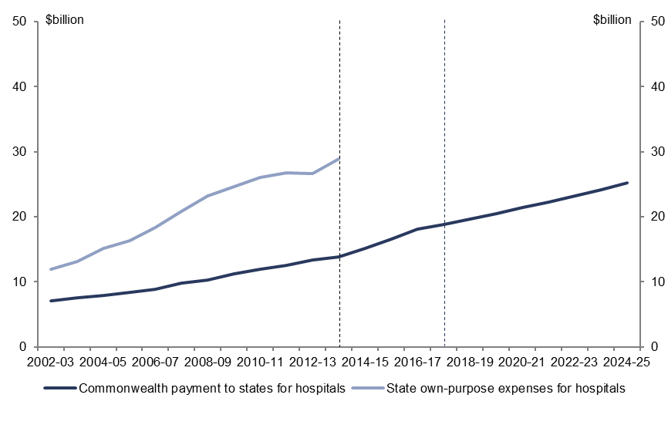  Nominal $ billions | State own-purpose expenses for hospitals
  2002-03 | 12
  2003-04 | 13
  2004-05 | 15
  2005-06 | 16
  2006-07 | 18
  2007-08 | 21
  2008-09 | 23
  2009-10 | 25
  2010-11 | 26
  2011-12 | 27
  2012-13 | 27
  2013-14 | 29
   | State own-purpose expenses for hospitals
  2002-03 | 7
  2003-04 | 7
  2004-05 | 8
  2005-06 | 8
  2006-07 | 9
  2007-08 | 10
  2008-09 | 10
  2009-10 | 11
  2010-11 | 12
  2011-12 | 13
  2012-13 | 13
  2013-14 | 14
  2014-15 | 15
  2015-16 | 17
  2016-17 | 18
  2017-18 | 19
  2018-19 | 20
  2019-20 | 21
  2020-21 | 21
  2021-22 | 22
  2022-23 | 23
  2023-24 | 24
  2024-25 | 25
Source: ABS, state government budget papers and PBO analysis.
The relatively strong historical growth in state government expenditure on hospitals over the past decade has been driven by a range of factors including new medical technology, the use of new diagnostic and treatment techniques, increasing community expectations for access to these services, and demographic factors.
The share of hospital expenditure has also been influenced by the changes to funding arrangements between the Commonwealth and states over the past decade. From 2002–03 to 2007–08, Commonwealth payments were delivered under Australian Health Care Agreements (AHCAs) that specified the level of funding to be provided to states.
Under these arrangements Commonwealth payments to states grew by 3.6 per cent annually in real terms while state own-purpose spending grew by 8.7 per cent in real terms.
From 2008–09 to 2011–12, Commonwealth funding to states for public hospitals was provided under National Healthcare Specific Purpose Payment arrangements. These were based on a health specific cost index, growth in population estimates weighted for hospital utilisation, and a technology factor. Over this period, growth in Commonwealth funding to states for hospitals increased to 4.3 per cent annually in real terms while state own-purpose spending slowed to 2.2 per cent annually in real terms.
From 2012–13 to 2016–17, Commonwealth funding to states for public hospitals is to be allocated under National Health Reform Agreement funding arrangements. States are to be funded based on 50 per cent of the efficient growth in the cost of public hospital services. Over the period, Commonwealth funding to states for hospitals is projected to grow by 5.4 per cent annually in real terms. Comparable estimates of state own-purpose spending on hospitals over the period are not available.
From 2017–18 to 2024–25, Commonwealth funding to states is projected to grow by 1.7 per cent annually in real terms. The sharp slowing in growth over the period reflects the 2014–15 Budget measure to index public hospitals funding by CPI increases and population growth from 1 July 2017.
While consistent state data beyond 2013–14 is not available, if demand for hospital services continues to grow as it has over the past decade, a greater share of the associated funding burden will fall on state governments over the medium term as a result of the new Commonwealth government indexation arrangements. This will intensify the recent trend which has seen state governments increase their share of total hospital funding.
Given that hospitals form such a significant share of state government expenditure, adjusting to these new arrangements is likely to pose challenges to the management of state government budgets over the medium term

Education expenses
Between 2002–03 and 2012–13, Commonwealth government own-purpose education expenses grew by 6.8 per cent annually in real terms. State government own-purpose education expenses grew by 2.5 per cent annually in real terms over the same period. The component of this spending that was funded through recurrent transfers from the Commonwealth government (that is, excluding transfers for capital purposes) grew more quickly, at 5.4 per cent annuallyin real terms.
Growth in Commonwealth own-purpose education expenditure is primarily driven by higher education. Over the period 2002–03 to 2012–13, Commonwealth spending on higher education grew by 5.2 per cent annually in real terms. This was partly driven by measures from 2003–04 to 2007–08 to increase Commonwealth funding per student by 2.5 per cent in 2005, 5.0 per cent in 2006, 7.5 per cent in 2007, and expand the number of Commonwealth supported places by linking these to population growth.
From 2007–08 to 2012–13, increases in student numbers were primarily driven by the progressive uncapping and eventual move to the current demand-driven enrolment model which has underpinned significant growth in higher education spending over the second half of the decade. Since the introduction of a demand driven system of funding for higher education enrolment between 2009 and 2013, the number of Commonwealth-subsidised undergraduate university places has increased by 22 per cent.
Within the education function, the largest area of expenditure for state governments is schools. Primary and secondary schools constituted around 76 per cent of state government education expenditure in 2012–13 (including expenditure funded by Commonwealth transfers). Schools are discussed in further detail in the following section.
As shown in Figure 3-7, the strongest growth in both state education expenses and recurrent transfers from the Commonwealth government (that is, excluding transfers for capital purposes) occurred in 2009–10. This was primarily a result of increased Commonwealth government payments to the states for the Building the Education Revolution program as part of the fiscal stimulus package and for digital education and a range of numeracy, literacy and quality improvement programs in schools.
Measures contained in the 2009–10 Commonwealth Budget also resulted in increased education transfers, including a more generous indexation arrangement for the government schools component of the National Schools Specific Purpose Payment (SPP), and increased funding for some National Partnership Payments (such as the Low Socio-economic Status School Communities payment).
Figure 3-7: Trends in Commonwealth and state education expenditure
  Annual real growth
   | Commonwealth own-purpose | Recurrent transfers | State own-purpose
  2002-03 | - | - | -
  2003-04 | 5 | 6 | 3
  2004-05 | -1 | 7 | 5
  2005-06 | 7 | 1 | 3
  2006-07 | -4 | 5 | 1
  2007-08 | 22 | 4 | 2
  2008-09 | 2 | 11 | 5
  2009-10 | 50 | 31 | 4
  2010-11 | 7 | -4 | 0
  2011-12 | -14 | -2 | 1
  2012-13 | 4 | 0 | 1
  Nominal $ billions
   | Commonwealth own-purpose | Recurrent transfers | State own-purpose
  2002-03 | 6 | 7 | 23
  2003-04 | 6 | 7 | 24
  2004-05 | 6 | 8 | 26
  2005-06 | 7 | 8 | 27
  2006-07 | 7 | 9 | 29
  2007-08 | 9 | 9 | 30
  2008-09 | 9 | 11 | 33
  2009-10 | 14 | 14 | 35
  2010-11 | 15 | 14 | 36
  2011-12 | 13 | 14 | 37
  2012-13 | 14 | 15 | 38
Source: ABS and PBO analysis.

School expenses
Schools are the largest area of education expenditure by states. In 2012–13, around 76 per cent of total spending on education by states (including those funded by Commonwealth transfers) was on schools. (Table 3-3). The Northern Territory has consistently had the highest per student schools expenditure from 2002–03 to 2012–13
Table 3-3: Schools expenditure by jurisdiction
 | Schools (real average annual per student growth) (%) | Nominal schools expenditure per student ($)
 | 2002–03 to 2012–13 | 2012–13
Northern Territory | 1.1 | 16,866
Western Australia | 2.6 | 12,392
Australian Capital Territory | 2.8 | 11,930
Tasmania | 0.8 | 10,603
Queensland | 1.2 | 9,997
South Australia | 0.9 | 9,690
New South Wales | 0.0 | 9,625
Victoria | 0.2 | 8,237
Source: ABS, Productivity Commission and PBO analysis.
Figure 3-8 shows historical and projected expenditure on schools by the Commonwealth and states. Commonwealth payments to states for schools grew by 5.5 per cent annually in real terms over the past decade. Around two-thirds of the payment to states is for non-government schools of which the Commonwealth is the primary funder.
Historically, Commonwealth funding for schools has been indexed by the Australian Government School Recurrent Cost (AGSRC) index taking into account changes in enrolments, capital requirements and the socio-economic status of the school. The index was used to calculate funding for government and independent schools throughout the decade while the arrangement was applicable for Catholic schools from 2005. The AGSRC index grew by 5.6 per cent annually in nominal terms between 2003 and 2012.
Figure 3-8: Nominal historical and projected spending on schools by level of government
  Nominal $billions | State own-purpose expenses for schools
  2002-03 | 17
  2003-04 | 18
  2004-05 | 19
  2005-06 | 20
  2006-07 | 21
  2007-08 | 22
  2008-09 | 25
  2009-10 | 29
  2010-11 | 28
  2011-12 | 27
  2012-13 | 28
  2013-14 | 28
  2014-15 | 28
  2015-16 | 29
  2016-17 | 30
  2017-18 | 31
  2018-19 | 33
  Nominal $billion | State own-purpose expenses for schools
  2002-03 | 5
  2003-04 | 6
  2004-05 | 7
  2005-06 | 7
  2006-07 | 8
  2007-08 | 8
  2008-09 | 9
  2009-10 | 10
  2010-11 | 11
  2011-12 | 11
  2012-13 | 12
  2013-14 | 13
  2014-15 | 14
  2015-16 | 16
  2016-17 | 17
  2017-18 | 18
  2018-19 | 19
  2019-20 | 20
  2020-21 | 21
  2021-22 | 22
  2022-23 | 23
  2023-24 | 24
  2024-25 | 25
Source: ABS, state government budget papers and PBO analysis.
State own-purpose expenses for schools grew by 2.2 per cent annually in real terms from 2002–03 to 2012–13. From 2013–14 to 2017–18 growth in state own-purpose expenses is projected to slow reflecting arrangements under the National Education Reform Agreement (NERA). Under these arrangements states generally agreed to increase base funding for schools by 3.0 per cent annually in nominal terms over the period with a smaller component of additional funding to account for socio-economic and other factors.
Commonwealth base funding is to increase by 4.7 per cent annually in nominal terms based on the Schooling Resource Standard (SRS) rather than AGSRC index.
As part of the 2014–15 Budget, the Commonwealth announced measures to index Commonwealth funding for schools to movements in the CPI with an allowance for changes in enrolments from 1 January 2018. From 2017–18 to 2024–25 Commonwealth funding to states is projected to grow by 2.0 per cent annually in real terms. This supersedes the NERA arrangements discussed above which were originally scheduled over six years to 2018.
The changes to the indexation arrangements for schools represent a partial shift in funding responsibility to the states, as the majority of Commonwealth funding for schools relates to non-government schools, for which the states do not have primary funding responsibility.

Net capital investment
Net capital investment across all levels of government increased from $4.2 billion (0.5 per cent of GDP) in 2002–03 to peak at $30.3 billion (2.3 per cent of GDP), largely due to the fiscal stimulus, before settling at $15.6 billion (1.0 per cent of GDP) in 2012–13. Over the decade net capital investment by all levels of government grew by 11.1 per cent annually in real terms (Figure 4-1). Funding included significant transfers to states discussed later in this chapter.
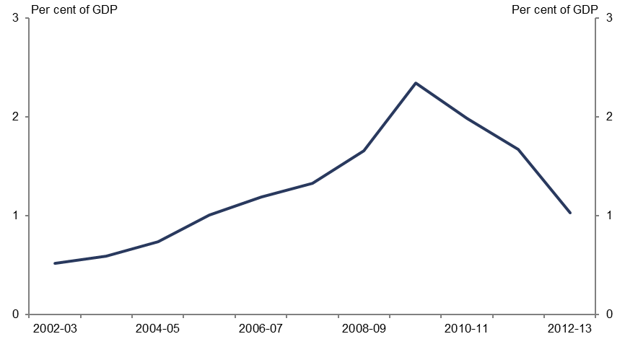
Figure 4-1: Net capital investment across all levels of government
 | % of GDP
2002-03 | 0.5
2003-04 | 0.6
2004-05 | 0.7
2005-06 | 1.0
2006-07 | 1.2
2007-08 | 1.3
2008-09 | 1.7
2009-10 | 2.3
2010-11 | 2.0
2011-12 | 1.7
2012-13 | 1.0
Source: ABS.

Net capital investment by function
There are four key areas (functions) of general government sector net capital investment in Australia—transport, education, defence and health.
Consistent data on net capital investment by function across all levels of government is not available. However, information on gross fixed capital formation, which is the largest component of net capital investment, is available. Gross fixed capital formation largely reflects capital purchases. Trends in gross fixed capital formation broadly follow net capital investment and provide an indication of the capital investment decisions of governments.
Figure 4-2 shows the largest areas of general government sector gross fixed capital formation across all levels of government.
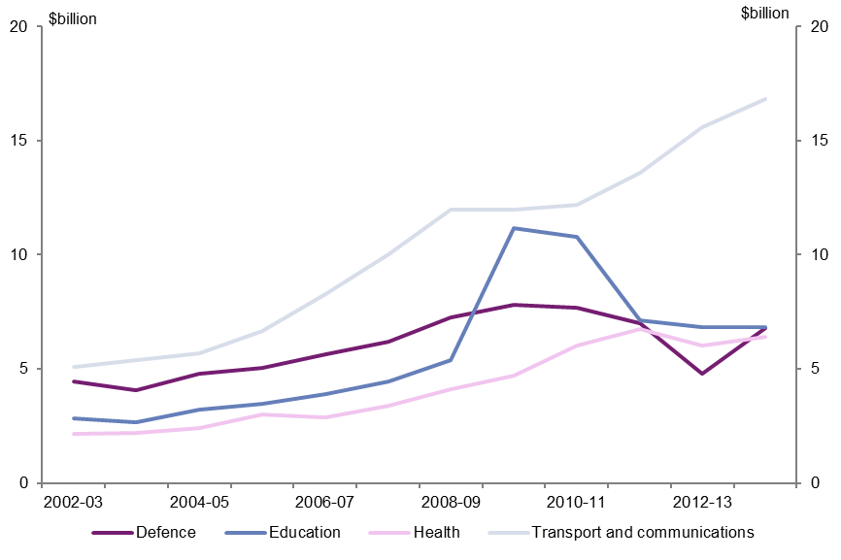
Figure 4-2: General government gross fixed capital formation by function
  Defence | $billions
  2002-03 | 4.5
  2003-04 | 4.1
  2004-05 | 4.8
  2005-06 | 5.0
  2006-07 | 5.7
  2007-08 | 6.2
  2008-09 | 7.3
  2009-10 | 7.8
  2010-11 | 7.7
  2011-12 | 7.0
  2012-13 | 4.8
  2013-14 | 6.8
  Education | $billions
  2002-03 | 2.8
  2003-04 | 2.7
  2004-05 | 3.2
  2005-06 | 3.5
  2006-07 | 3.9
  2007-08 | 4.5
  2008-09 | 5.4
  2009-10 | 11.2
  2010-11 | 10.8
  2011-12 | 7.1
  2012-13 | 6.8
  2013-14 | 6.8
  Health | $billions
  2002-03 | 2.1
  2003-04 | 2.2
  2004-05 | 2.4
  2005-06 | 3.0
  2006-07 | 2.9
  2007-08 | 3.4
  2008-09 | 4.1
  2009-10 | 4.7
  2010-11 | 6.0
  2011-12 | 6.8
  2012-13 | 6.0
  2013-14 | 6.4
  Transport and communications | $billions
  2002-03 | 5.1
  2003-04 | 5.4
  2004-05 | 5.7
  2005-06 | 6.6
  2006-07 | 8.3
  2007-08 | 10.0
  2008-09 | 12.0
  2009-10 | 12.0
  2010-11 | 12.2
  2011-12 | 13.6
  2012-13 | 15.6
  2013-14 | 16.8
Source: ABS.
Over the period from 2002–03 to 2013–14, transport and communications infrastructure was the largest and fastest growing area of general government investment. Primarily delivered by the states, investment in this area grew by 8.5 per cent annually in real terms, largely reflecting spending on road and rail projects.
Education (largely schools) was the second largest area of general government sector investment growing by 5.4 per cent annually in real terms. Investment in schools was boosted by stimulus spending under the Nation Building and Jobs Plan and the Nation Building Package from 2008–09 to 2011–12.
The Commonwealth general government sector accounts for all defence net capital investment. Defence gross fixed capital formation grew by 1.2 per cent annually in real terms from 2002–03 to 2013–14.
Health, which was a large and fast growing area, grew by 7.5 per cent annually in real terms from 2002–03 to 2013–14. Investment in this area largely related to spending on hospitals.

Investment by level of government
Over the past decade, states accounted for an average of 54 per cent of total net capital investment, while local government accounted for 26 per cent, and the Commonwealth, the remaining 20 per cent.
Figure 4-3 shows the composition of net capital investment by all levels of government in Australia from 2002–03 to 2012–13.
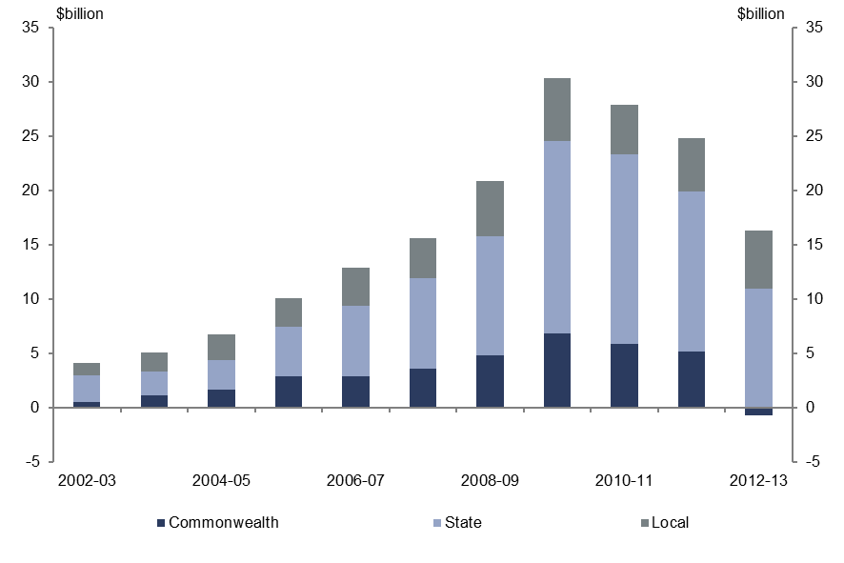
Figure 4-3: Net capital investment by level of government
  Commonwealth | $billions
  2002-03 | 0.6
  2003-04 | 1.1
  2004-05 | 1.7
  2005-06 | 2.9
  2006-07 | 2.9
  2007-08 | 3.6
  2008-09 | 4.8
  2009-10 | 6.9
  2010-11 | 5.9
  2011-12 | 5.2
  2012-13 | -0.7
  State | $billions
  2002-03 | 2.4
  2003-04 | 2.2
  2004-05 | 2.7
  2005-06 | 4.6
  2006-07 | 6.5
  2007-08 | 8.3
  2008-09 | 10.9
  2009-10 | 17.7
  2010-11 | 17.4
  2011-12 | 14.7
  2012-13 | 11.0
  Local | $billions
  2002-03 | 1.2
  2003-04 | 1.8
  2004-05 | 2.4
  2005-06 | 2.6
  2006-07 | 3.5
  2007-08 | 3.7
  2008-09 | 5.1
  2009-10 | 5.8
  2010-11 | 4.6
  2011-12 | 5.0
  2012-13 | 5.3
Source: ABS.

Commonwealth net capital investment
Apart from transfers to the states, Commonwealth net capital investment is relatively small and largely directed towards defence.
Commonwealth net capital investment totalled less than $1 billion in 2002–03 and recorded a net reduction in 2012–13. Over the decade, Commonwealth net capital investment peaked at $6.9 billion in 2009–10 reflecting the purchase of specialist military equipment including Bridging Air Combat Super Hornets, the Air Warfare destroyer and Multi Role Helicopter. The majority of Commonwealth net capital investment over the decade was on defence with the net reduction in 2012–13 resulting from the sale of spectrum licences that generated almost $1.5 billion.

State net capital investment
States account for the large majority of net capital investment in Australia. From 2002–03 to 2012–13, net capital investment by states grew by 13.4 per cent annually in real terms increasing from $2.4 billion in 2002–03 to $11.0 billion in 2012–13 (Figure 4-4). State net capital investment peaked at $17.7 billion in 2009-10.
By 2017–18 states are projecting net capital investment to fall to $8.8 billion, after strong historical growth in most jurisdictions (Figure 4-4). The increase in net capital investment in 2016–17 largely reflects the capitalisation of the finance lease for the new Royal Adelaide Hospital.
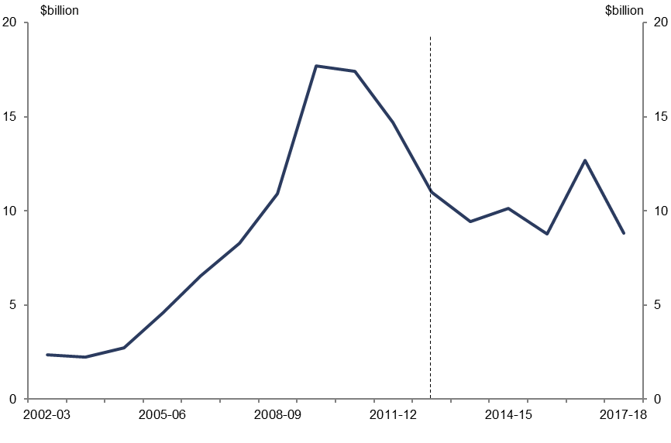
Figure 4-4: State net capital investment
State net capital investment | $billions
2002-03 | 2
2003-04 | 2
2004-05 | 3
2005-06 | 5
2006-07 | 7
2007-08 | 8
2008-09 | 11
2009-10 | 18
2010-11 | 17
2011-12 | 15
2012-13 | 11
2013-14 | 9
2014-15 | 10
2015-16 | 9
2016-17 | 13
2017-18 | 9
Source: ABS and state government financial statements and budget papers.

Local government net capital investment
Local government accounted for an average of 26 per cent of total general government net capital investment increasing from $1.2 billion in 2002–03 to $5.3 billion in 2012–13, growing by 12.8 per cent annually in real terms.
Local government net capital investment peaked at $5.8 billion in 2009–10. High levels of net capital investment over the latter part of the decade reflect natural disaster recovery works. Nearly all local government net capital investment relates to local roads, bridges, transport, waste and water management, parks, and other municipal services.

Net capital investment by jurisdiction
The profile of net capital investment has varied across governments over the decade to
2012–13. Figure 4-5 shows net capital investment for the Commonwealth and states (excluding local government) as a percentage of nominal gross state product (or nominal GDP for the Commonwealth).
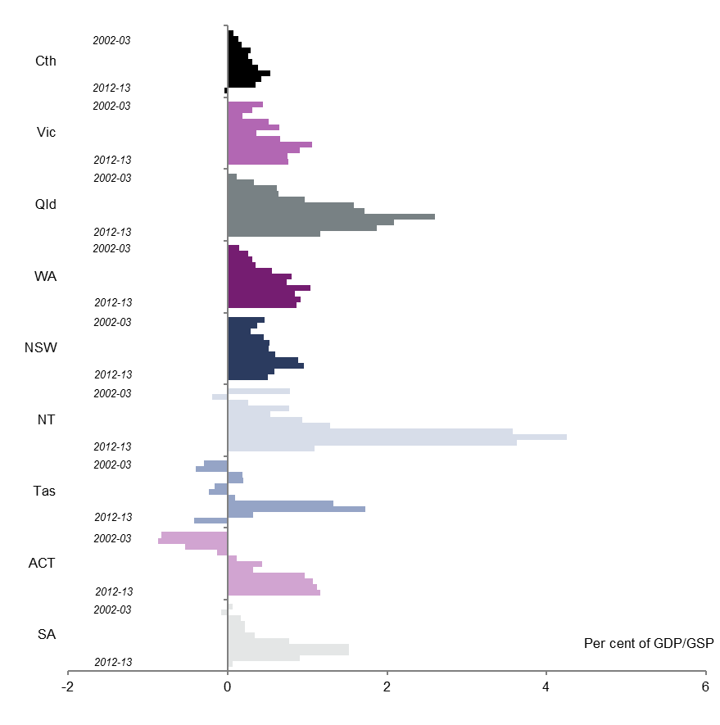
Figure 4-5: Net capital investment across jurisdictions
  % of GDP | Cth
  2002-03 | 0.1
  2003-04 | 0.1
  2004-05 | 0.2
  2005-06 | 0.3
  2006-07 | 0.3
  2007-08 | 0.3
  2008-09 | 0.4
  2009-10 | 0.5
  2010-11 | 0.4
  2011-12 | 0.3
  2012-13 | 0.0
  % of GDP | Vic
  2002-03 | 0.4
  2003-04 | 0.3
  2004-05 | 0.2
  2005-06 | 0.5
  2006-07 | 0.6
  2007-08 | 0.4
  2008-09 | 0.7
  2009-10 | 1.1
  2010-11 | 0.9
  2011-12 | 0.8
  2012-13 | 0.8
  % of GDP | Qld
  2002-03 | 0.1
  2003-04 | 0.3
  2004-05 | 0.6
  2005-06 | 0.6
  2006-07 | 1.0
  2007-08 | 1.6
  2008-09 | 1.7
  2009-10 | 2.6
  2010-11 | 2.1
  2011-12 | 1.9
  2012-13 | 1.2
  % of GDP | WA
  2002-03 | 0.1
  2003-04 | 0.3
  2004-05 | 0.3
  2005-06 | 0.3
  2006-07 | 0.6
  2007-08 | 0.8
  2008-09 | 0.7
  2009-10 | 1.0
  2010-11 | 0.8
  2011-12 | 0.9
  2012-13 | 0.9
  % of GDP | NT
  2002-03 | 0.8
  2003-04 | -0.2
  2004-05 | 0.3
  2005-06 | 0.8
  2006-07 | 0.5
  2007-08 | 0.9
  2008-09 | 1.3
  2009-10 | 3.6
  2010-11 | 4.3
  2011-12 | 3.6
  2012-13 | 1.1
  % of GDP | Tas
  2002-03 | -0.3
  2003-04 | -0.4
  2004-05 | 0.2
  2005-06 | 0.2
  2006-07 | -0.2
  2007-08 | -0.2
  2008-09 | 0.1
  2009-10 | 1.3
  2010-11 | 1.7
  2011-12 | 0.3
  2012-13 | -0.4
  % of GDP | ACT
  2002-03 | -0.8
  2003-04 | -0.9
  2004-05 | -0.5
  2005-06 | -0.1
  2006-07 | 0.1
  2007-08 | 0.4
  2008-09 | 0.3
  2009-10 | 1.0
  2010-11 | 1.1
  2011-12 | 1.1
  2012-13 | 1.2
  % of GDP | SA
  2002-03 | 0.1
  2003-04 | -0.1
  2004-05 | 0.2
  2005-06 | 0.2
  2006-07 | 0.2
  2007-08 | 0.3
  2008-09 | 0.8
  2009-10 | 1.5
  2010-11 | 1.5
  2011-12 | 0.9
  2012-13 | 0.1
Source: ABS.
The higher level net capital investment by the Northern Territory partly reflects the cost of delivering infrastructure with the peak in 2010–11 driven by the fiscal stimulus including significant grants for capital purposes from the Commonwealth. As part of the distribution of GST to states, adjustments are made to account for the higher cost of infrastructure in the Northern Territory.
The negative results recorded in the Australian Capital Territory for net capital investment early in the decade were largely due to the sale of land. Negative results in Tasmania over the decade largely reflect capital investment not keeping pace with depreciation.
Queensland, Western Australia, Victoria and New South Wales accounted for 71 per cent of total growth in net capital investment over the decade to 2012–13. Trends in these states are discussed below.

Queensland
Queensland was the largest contributor to growth in net capital investment from 2002–03 to 2012–13, accounting for 31 per cent of total growth. Over the period, net capital investment in Queensland grew by 32.3 per cent annually in real terms.
Net capital investment ramped up in Queensland over the first half of the decade to peak at $6.5 billion in 2009–10. This peak in investment was driven by state and Commonwealth fiscal stimulus and significant underlying growth in transport and health infrastructure investment. Over the decade, transport infrastructure investment grew by 16.2 per cent annually in real terms rising from $0.7 billion in 2002–03 to $4.2 billion in 2012–13, while health infrastructure investment grew by 16.7 per cent annually in real terms rising from $0.3 billion in 2002–03 to $1.5 billion in 2012–13.

Western Australia
Western Australia accounted for 19 per cent of total growth in net capital investment from 2002–03 to 2012–13. Over the period, net capital investment by the Western Australian government grew by 29.3 per cent annually in real terms.
Western Australian net capital investment increased from $123 million in 2002–03 to peak at $2.2 billion in 2011–12 before falling slightly to $2.1 billion in 2012–13. Over the decade, growth was largely attributable to investment in hospitals, road transport, and schools. Western Australia was the only state with a higher share of health infrastructure investment over the past decade than transport growing by 21.9 per cent annually in real terms.

Victoria
Victoria accounted for 14 per cent of total growth in net capital investment nationally. Over the period, Victorian government net capital investment grew by 8.2 per cent annually in real terms increasing from $0.9 billion in 2002–03 to $2.6 billion in 2012–13. Net capital investment in Victoria peaked at $3.1 billion in 2009-10 driven by investment in roads, public transport and health infrastructure.

New South Wales
New South Wales accounted for 7 per cent of total growth in government net capital investment from 2002–03 to 2012–13. Over the period, New South Wales net capital investment grew by 3.6 per cent annually in real terms increasing from $1.3 billion in 2002–03 to $2.4 billion in 2012–13. This growth was largely driven by road and transport projects with investment in this area growing by 10.3 per cent annually over the decade.
New South Wales net capital investment peaked at $4.3 billion in 2010–11 driven by increased spending on education and transport projects including significant investment as part of fiscal stimulus.
Figure 4-6 shows general government net capital investment for Western Australia, Queensland, Victoria and New South Wales (excluding local government).
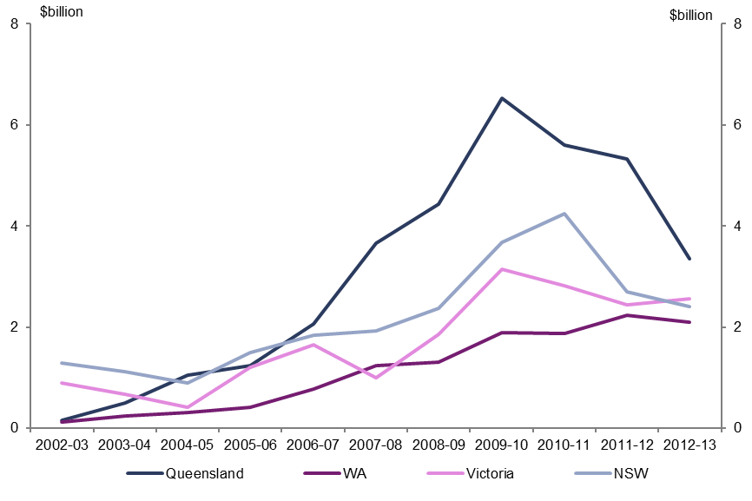
Figure 4-6: Net capital investment for selected states
  $ billions | NSW
  2002-03 | 1
  2003-04 | 1
  2004-05 | 1
  2005-06 | 1
  2006-07 | 2
  2007-08 | 2
  2008-09 | 2
  2009-10 | 4
  2010-11 | 4
  2011-12 | 3
  2012-13 | 2
  $ billions | Victoria
  2002-03 | 1
  2003-04 | 1
  2004-05 | 0
  2005-06 | 1
  2006-07 | 2
  2007-08 | 1
  2008-09 | 2
  2009-10 | 3
  2010-11 | 3
  2011-12 | 2
  2012-13 | 3
  $ billions | Queensland
  2002-03 | 0
  2003-04 | 1
  2004-05 | 1
  2005-06 | 1
  2006-07 | 2
  2007-08 | 4
  2008-09 | 4
  2009-10 | 7
  2010-11 | 6
  2011-12 | 5
  2012-13 | 3
  $ billions | WA
  2002-03 | 0
  2003-04 | 0
  2004-05 | 0
  2005-06 | 0
  2006-07 | 1
  2007-08 | 1
  2008-09 | 1
  2009-10 | 2
  2010-11 | 2
  2011-12 | 2
  2012-13 | 2
Source: ABS.
Summaries of trends for all states and territories are at Appendix A to this report.

Commonwealth transfers for capital purchases
As noted in previous chapters, the Commonwealth provides specific purpose payments to states to be spent on particular areas. These transfers are provided for both recurrent and capital purposes across a range of government functions.
Commonwealth grants to states for capital purposes totalled $7.5 billion in 2012–13. Over the past decade these grants grew by 8.3 per cent annually in real terms. This compares with state own-purpose net capital investment which grew by 14.5 per cent annually in real terms. Most Commonwealth transfers for capital purposes relate to transport, education, health and social housing.
The above areas of investment were affected by stimulus spending under the Nation Building and Jobs Plan and the Nation Building Package.
As part of fiscal stimulus measures, from 2008–09 to 2011–12, the Commonwealth government spent $33 billion on payments to states for capital purposes. In some instances these payments required a level of contribution from the recipients and also involve ongoing depreciation and maintenance costs. Most grants were for capital projects in schools, followed by transport and health. Fiscal stimulus also accounts for a large increase in housing transfers in 2009–10 reflecting payments under the Nation Building and Jobs Plan for social housing.
Figure 4-7 shows the contribution of Commonwealth grants for capital purposes in funding state general government net capital investment (excluding local government).
Figure 4-7: State own-purpose gross fixed capital formation and revenue from capital grants
$ billion | State own-purpose gross fixed capital formation | Revenue from capital grants
2002-03 | 5.5 | 2.5
2003-04 | 5.7 | 2.4
2004-05 | 6.2 | 2.9
2005-06 | 7.5 | 3.2
2006-07 | 9.3 | 3.9
2007-08 | 10.3 | 4.8
2008-09 | 11.2 | 7.3
2009-10 | 10.1 | 15.6
2010-11 | 14.0 | 11.9
2011-12 | 9.6 | 13.9
2012-13 | 19.3 | 4.5
Source: ABS and PBO analysis.

Public non-financial corporation net capital investment
The analysis in this report focusses on the general government sector. This sector primarily consists of government departments and agencies providing non-market public services which are funded mainly through taxes.
The general government sector does not include public non-financial corporations (PNFCs) which are government-owned entities providing services to consumers on a fee for service basis. These corporations are funded through a combination of revenue from the provision of goods and services and government grants.
Public non-financial corporations, particularly for states, typically have significant capital costs reflecting the goods and services they provide, such as electricity, water and transport. For example, within the electricity sector, PNFCs may be responsible for the generation, transmission and distribution of electricity.
Figure 4-8 shows general government and PNFC net capital investment across all levels of government.
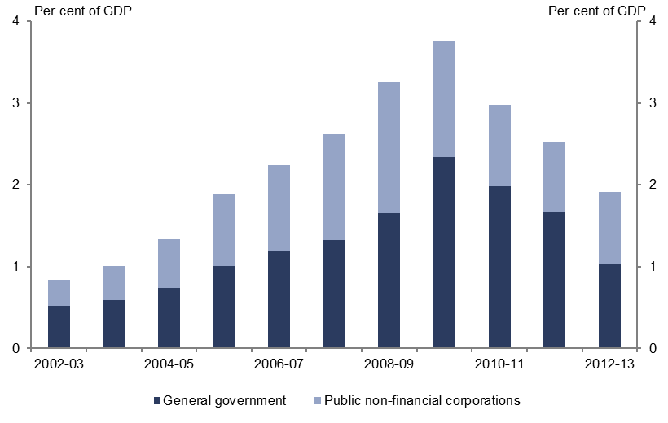
Figure 4-8: Net capital investment across all levels of government by sector
  % of GDP | General government
  2002-03 | 0.5
  2003-04 | 0.6
  2004-05 | 0.7
  2005-06 | 1.0
  2006-07 | 1.2
  2007-08 | 1.3
  2008-09 | 1.7
  2009-10 | 2.3
  2010-11 | 2.0
  2011-12 | 1.7
  2012-13 | 1.0
  % of GDP | Public non-financial corporations
  2002-03 | 0.3
  2003-04 | 0.4
  2004-05 | 0.6
  2005-06 | 0.9
  2006-07 | 1.1
  2007-08 | 1.3
  2008-09 | 1.6
  2009-10 | 1.4
  2010-11 | 1.0
  2011-12 | 0.9
  2012-13 | 0.9
Source: ABS.
Net capital investment by the PNFC sector across all levels of government increased from 0.3 per cent of GDP in 2002–03 to 0.9 per cent of GDP in 2012–13, growing by 14.9 per cent annually in real terms. Net capital investment by PNFCs peaked at 1.6 per cent of GDP in 2008–09 reflecting infrastructure investment in energy, water and transport projects in major states.

Net debt and financing costs
The balance sheet position of governments is a consequence of the accumulated revenue, expenses and net capital investment flows discussed in previous chapters.
As noted in Chapter 1, both the Commonwealth and states ran fiscal deficits over the second half of the past decade. Fiscal deficits for the Commonwealth stemmed from growth in recurrent expenditure exceeding revenue growth. For the states, the small operating surpluses accumulated during the first half of the decade (which included capital grants from the Commonwealth) were insufficient to fund overall state investment.
Fiscal deficits must be funded, requiring governments to liquidate assets or borrow. Both the Commonwealth and the states have in large part funded fiscal deficits through borrowing with a consequent impact on their net debt positions.
As Chapter 4 highlighted, investments in schools, health facilities and most roads are undertaken by the general government sector (predominately states). Where assets have a long effective life, they are commonly funded by debt which spreads the cost across the life of the asset. Such investments may provide an economic return to the extent that they improve the productive capacity of the economy such that the future economic benefits will outweigh the cost. These investments still need to be financed and their interest costs are met from recurrent budgets.

National net debt
Net debt across all levels of government increased from 2.1 per cent of GDP in 2002–03 to 12.4 per cent of GDP in 2012–13 (Figure 5-1). According to Commonwealth and state and territory budget papers, projected fiscal deficits result in projected total national net debt peaking at 19.9 per cent of GDP in 2016–17 before falling to 19.5 per cent of GDP in 2017–18.
Figure 5-1: Commonwealth and state net debt
  % of GDP | Commonwealth
  2002-03 | 3.4
  2003-04 | 2.3
  2004-05 | 0.9
  2005-06 | -1.3
  2006-07 | -3.8
  2007-08 | -4.6
  2008-09 | -1.7
  2009-10 | 3.2
  2010-11 | 6.0
  2011-12 | 10.0
  2012-13 | 10.1
  2013-14 | 12.8
  2014-15 | 15.2
  2015-16 | 16.7
  2016-17 | 17.2
  2017-18 | 17.0
  % of GDP | State
  2002-03 | -1.3
  2003-04 | -2.0
  2004-05 | -2.7
  2005-06 | -3.6
  2006-07 | -2.9
  2007-08 | -2.2
  2008-09 | -1.4
  2009-10 | -0.4
  2010-11 | 0.1
  2011-12 | 1.1
  2012-13 | 2.2
  2013-14 | 2.3
  2014-15 | 2.7
  2015-16 | 2.5
  2016-17 | 2.7
  2017-18 | 2.5
  % of GDP | Total
  2002-03 | 2.1
  2003-04 | 0.3
  2004-05 | -1.8
  2005-06 | -4.9
  2006-07 | -6.8
  2007-08 | -6.8
  2008-09 | -3.2
  2009-10 | 2.8
  2010-11 | 6.0
  2011-12 | 11.1
  2012-13 | 12.4
  2013-14 | 15.1
  2014-15 | 17.9
  2015-16 | 19.2
  2016-17 | 19.9
  2017-18 | 19.5
Source: ABS and Commonwealth and state budget papers.

Commonwealth net debt
Figure 5-1 underlines that the increase in total national net debt has been largely driven by the Commonwealth. The deterioration in the Commonwealth’s fiscal balance position has resulted in Commonwealth net debt increasing from 3.4 per cent of GDP in 2002–03 to 10.1 per cent in 2012–13.
Successive fiscal surpluses over the first half of the decade (combined with the third tranche Telstra sale) resulted in a significant improvement in the Commonwealth’s net debt position. This was reversed during the middle of the decade as the Commonwealth government borrowed to finance its recurrent expenditure.
The Commonwealth (2014-15 MYEFO) is projecting net debt to peak at 17.2 per cent of GDP in 2016–17 and then fall to 17.0 per cent of GDP by 2017–18, reflecting the forecast improvement in the fiscal balance.

State net debt
Compared to the Commonwealth, the increase in state net debt was modest. States moved from a net asset position of 1.3 per cent of GDP in 2002–03 to a net debt position of 2.2 per cent of GDP in 2012–13.
Like the Commonwealth, states also experienced a period of improvement in their net debt position at the beginning of the past decade.
However, unlike the Commonwealth, the states borrowed primarily to fund capital rather than recurrent expenditure, as infrastructure investment ramped up in the middle of the decade (see Chapter 4). The small operating surpluses accumulated during the first half of the decade (which included capital grants from the Commonwealth) were insufficient to fund overall state investment, meaning that states incurred additional borrowing.
According to state budgets, state net debt is projected to peak in 2014–15 at 2.7 per cent of GDP and then fall to 2.5 per cent in 2017–18 as most states adopt a strategy of fiscal consolidation.

Net debt by jurisdiction
All jurisdictions (with the exception of Tasmania and the Northern Territory) have experienced an increase in net debt over the past decade. Jurisdictions have generally followed the same pattern in terms of their net debt profile—a short period of balance sheet consolidation and then a rapid increase in net debt from the middle of the decade
(Figure 5-2).
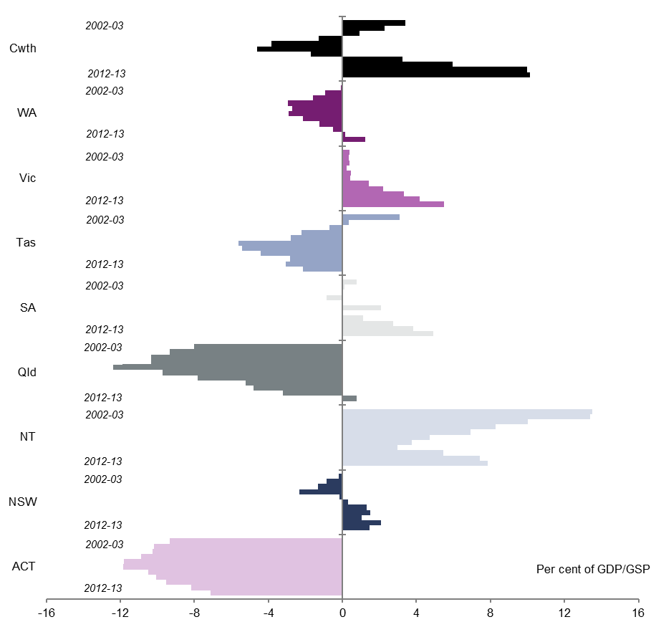
Figure 5-2: Net debt by jurisdiction
  % of GDP | Commonwealth
  2002-03 | 3.4
  2003-04 | 2.3
  2004-05 | 0.9
  2005-06 | -1.3
  2006-07 | -3.8
  2007-08 | -4.6
  2008-09 | -1.7
  2009-10 | 3.2
  2010-11 | 6.0
  2011-12 | 10.0
  2012-13 | 10.1
  % of GDP | Victoria
  2002-03 | 0.4
  2003-04 | 0.4
  2004-05 | 0.4
  2005-06 | 0.2
  2006-07 | 0.5
  2007-08 | 0.4
  2008-09 | 1.4
  2009-10 | 2.2
  2010-11 | 3.3
  2011-12 | 4.2
  2012-13 | 5.5
  % of GDP | Tas
  2002-03 | 3.1
  2003-04 | 0.3
  2004-05 | -0.7
  2005-06 | -2.2
  2006-07 | -2.8
  2007-08 | -5.6
  2008-09 | -5.4
  2009-10 | -4.4
  2010-11 | -2.8
  2011-12 | -3.0
  2012-13 | -2.1
  % of GDP | SA
  2002-03 | 0.8
  2003-04 | 0.1
  2004-05 | 0.0
  2005-06 | -0.9
  2006-07 | 0.0
  2007-08 | 2.1
  2008-09 | 0.0
  2009-10 | 1.1
  2010-11 | 2.7
  2011-12 | 3.8
  2012-13 | 4.9
  % of GDP | Qld
  2002-03 | -8.0
  2003-04 | -9.3
  2004-05 | -11.2
  2005-06 | -11.9
  2006-07 | -12.4
  2007-08 | -9.7
  2008-09 | -7.8
  2009-10 | -5.2
  2010-11 | -4.8
  2011-12 | -3.2
  2012-13 | 0.8
  % of GDP | NT
  2002-03 | 13.5
  2003-04 | 13.4
  2004-05 | 10.0
  2005-06 | 8.3
  2006-07 | 6.9
  2007-08 | 4.7
  2008-09 | 3.7
  2009-10 | 3.0
  2010-11 | 5.4
  2011-12 | 7.4
  2012-13 | 7.9
  % of GDP | NSW
  2002-03 | -0.2
  2003-04 | -0.9
  2004-05 | -1.3
  2005-06 | -2.3
  2006-07 | -0.2
  2007-08 | 0.3
  2008-09 | 1.3
  2009-10 | 1.5
  2010-11 | 1.0
  2011-12 | 2.1
  2012-13 | 1.5
  % of GDP | WA
  2002-03 | -0.1
  2003-04 | -0.9
  2004-05 | -1.6
  2005-06 | -2.9
  2006-07 | -2.7
  2007-08 | -2.9
  2008-09 | -2.1
  2009-10 | -1.3
  2010-11 | -0.5
  2011-12 | 0.2
  2012-13 | 1.2
Source: ABS.
The strongly negative net debt for Queensland and the Australian Capital Territory reflects these jurisdiction’s arrangements for funding their superannuation liabilities.
They both hold assets on their balance sheet dedicated to meeting long-term public sector superannuation liabilities. This can make it difficult to ascertain the underlying net debt position in these jurisdictions.

Net interest payments
The accumulation of debt will also have an impact on budgets through the cost of servicing outstanding debt. Net interest payments are the difference between interest paid and interest received. This measure primarily consists of interest paid on securities issued by government and provides an indication of the ongoing cost of increasing debt levels. In the context of tightening budgets, these debt servicing costs have the potential to ‘crowd out’ other recurrent expenditure.
Figure 5-3: Commonwealth and state general government net interest payments (excluding Queensland)
  Commonwealth | $billions
  2002-03 | 0.5
  2003-04 | 0.3
  2004-05 | 0.3
  2005-06 | 0.1
  2006-07 | 0.0
  2007-08 | -0.1
  2008-09 | 0.0
  2009-10 | 0.2
  2010-11 | 0.4
  2011-12 | 0.6
  2012-13 | 0.6
  2013-14 | 0.7
  2014-15 | 0.8
  2015-16 | 0.8
  2016-17 | 0.8
  2017-18 | 0.8
  State (excluding QLD) | $billions
  2002-03 | 0.1
  2003-04 | 0.0
  2004-05 | 0.0
  2005-06 | 0.0
  2006-07 | 0.0
  2007-08 | 0.1
  2008-09 | 0.1
  2009-10 | 0.1
  2010-11 | 0.1
  2011-12 | 0.2
  2012-13 | 0.2
  2013-14 | 0.2
  2014-15 | 0.2
  2015-16 | 0.2
  2016-17 | 0.2
  2017-18 | 0.2
Source: ABS and Commonwealth and state budget papers.
Total net interest payments across all levels of government were 0.5 per cent of GDP in 2002-03 (Figure 5-3). Reductions in Commonwealth net debt resulted in zero net interest payments in 2006-07 before increasing to 0.8 per cent of GDP by 2012-13. Commonwealth and state budget papers are projecting net interest payments to reach 1.0 of GDP by 2017-18 largely driven by the Commonwealth’s debt position.
To better highlight the underlying trends in net interest payments for the states, Queensland has been excluded. The superannuation funding arrangements for Queensland mask some of the underlying trend in net interest payments. Because the ABS classifies the Queensland government’s return on its investments to offset their superannuation liability as ‘interest income’, volatility in the value of the investment portfolio can significantly influence net interest payments.

– States analysis
This Appendix summarises key budget trends for states and territories. This analysis is based on ABS GFS and state and territory budget papers and financial statements.
Data on Commonwealth specific purpose transfers to states and territories has been sourced from final budget outcomes. General revenue assistance data which largely comprises the GST has been taken from Commonwealth Grants Commission data.

New South Wales
Figure A1‒1: NSW general government fiscal and  operating balances |  | Figure A1‒2: NSW general government net debt
  $ billion | Fiscal balance
  2002-03 | 0.5
  2003-04 | 0.0
  2004-05 | -0.2
  2005-06 | -0.6
  2006-07 | -1.0
  2007-08 | -1.6
  2008-09 | -2.8
  2009-10 | -2.6
  2010-11 | -2.9
  2011-12 | -2.0
  2012-13 | -2.2
  2013-14 | -1.2
  2014-15 | -3.2
  2015-16 | -2.0
  2016-17 | -1.7
  2017-18 | -1.0
  $billion | Operating balance
  2002-03 | 1.8
  2003-04 | 1.1
  2004-05 | 0.7
  2005-06 | 0.9
  2006-07 | 0.8
  2007-08 | 0.4
  2008-09 | -0.4
  2009-10 | 1.1
  2010-11 | 1.3
  2011-12 | 0.7
  2012-13 | 0.2
  2013-14 | 1.2
  2014-15 | 0.3
  2015-16 | 0.4
  2016-17 | 1.1
  2017-18 | 1.0
Source: ABS and NSW government financial statements.
Figure A1‒3: NSW general government annual average trends from 2002–03 to 2012–13
% Annual real growth
Specific purpose payments | 6.4
GST transfers | 4.0
Own-source revenue | 5.5
Total revenue | 5.3
Expenses | 5.8
Net capital investment | 6.4
Total spending | 5.8
Nominal GSP | 5.5
Real GSP | 2.1
Population growth | 1.1

Source: ABS, Commonwealth and NSW government financial statements and Commonwealth Grants Commission.
Figure A1‒4: Annual nominal growth in NSW government spending from 2002–03 to 2012–13 | Figure A1‒5: Contributions to total growth in NSW government spending from 2002–03 to 2012–13
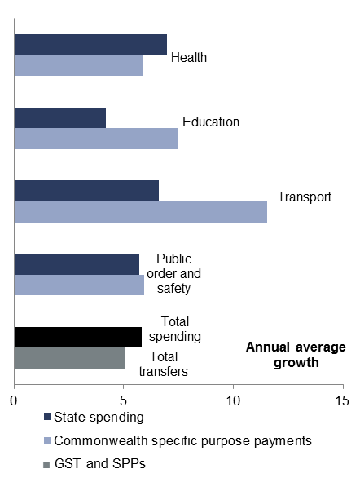 | 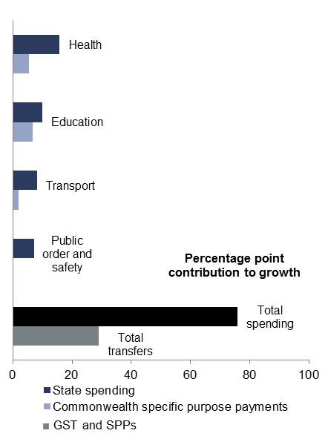
Source: ABS and Commonwealth and NSW government financial statements.
Figure A1‒6: NSW government revenue by source |  | Figure A1‒7: NSW tax and non-tax revenue by type
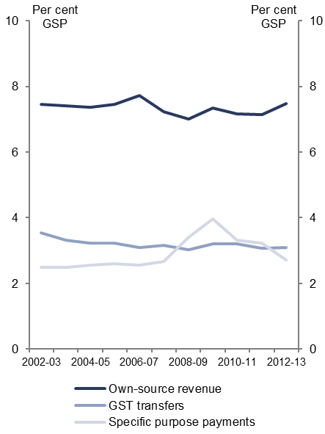 |  | 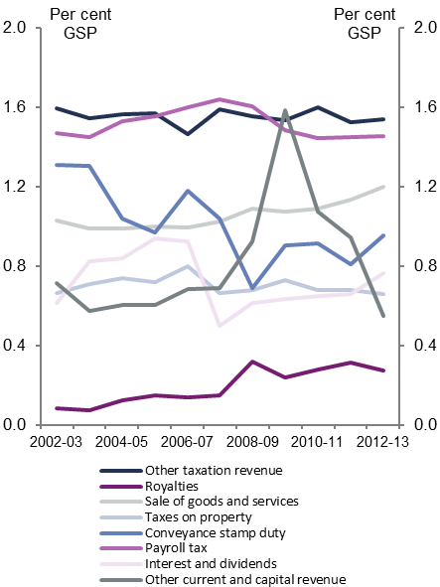
Source: ABS, Commonwealth and NSW government financial statements and Commonwealth Grants Commission.

Victoria
Figure A2‒1: Victorian general government fiscal and  operating balances | Figure A2‒2: Victorian general government net debt
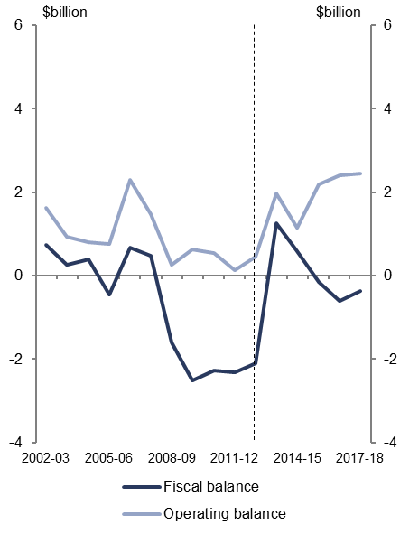 | 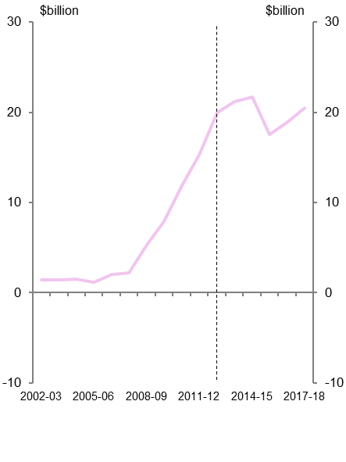
Source: ABS and Victorian government financial statements.
Figure A2‒3: Victorian general government annual average trends from 2002–03 to 2012–13
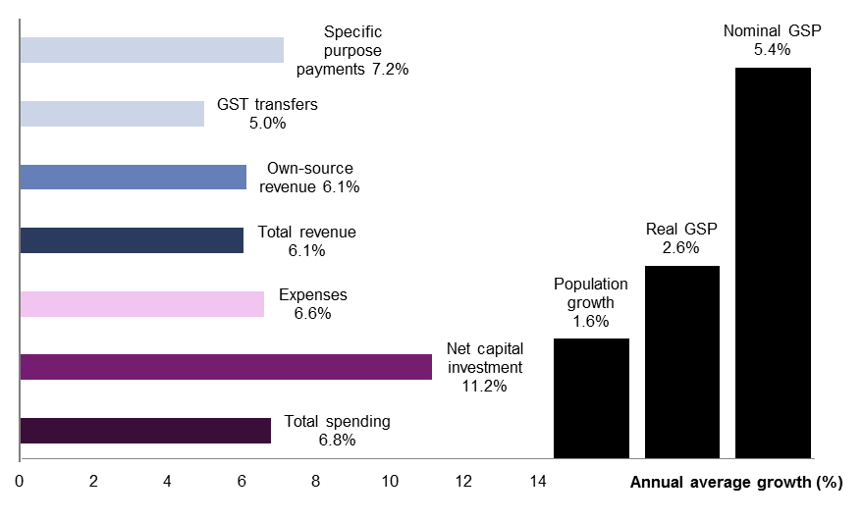
Source: ABS, Commonwealth and Victorian government financial statements and Commonwealth Grants Commission.
Figure A2‒4: Annual nominal growth in Victorian government spending from 2002–03 to 2012–13 | Figure A2‒5: Contributions to total growth in Victorian government spending from 2002–03 to 2012–13
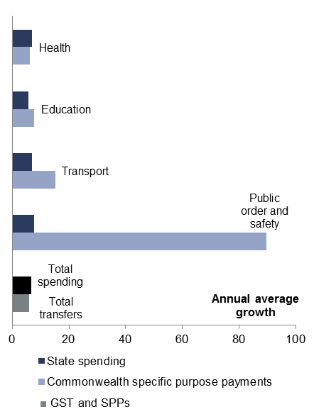 | 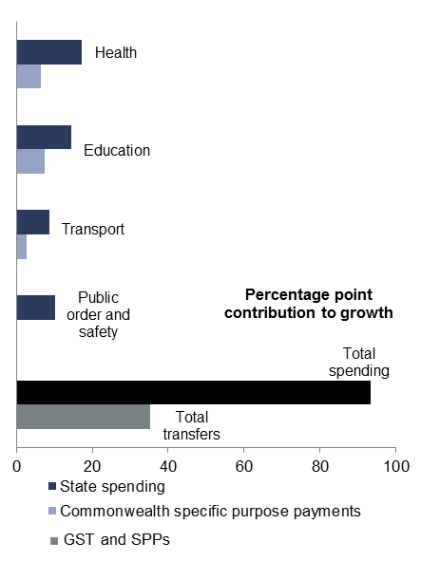
Source: ABS and Commonwealth and Victorian government financial statements.
Figure A2‒6: Victorian government revenue by source | Figure A2‒7: Victorian tax and non-tax revenue by type
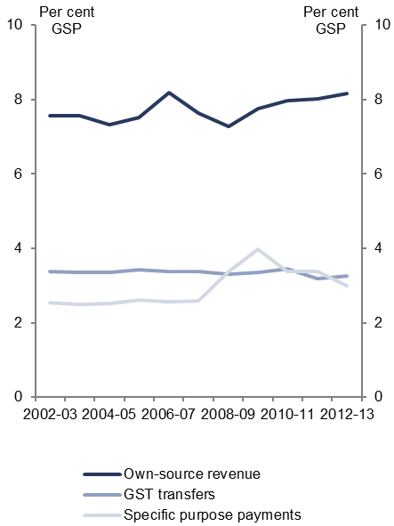 | 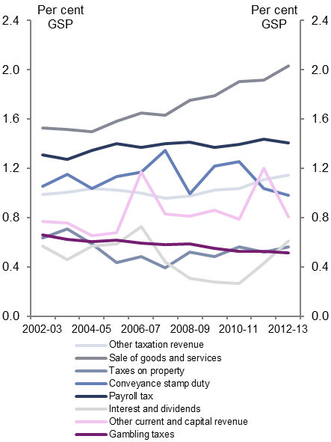
Source: ABS, Commonwealth and Victorian government financial statements and Commonwealth Grants Commission.

Queensland
Figure A3‒1: Queensland general government fiscal and operating balances | Figure A3‒2: Queensland general government net debt
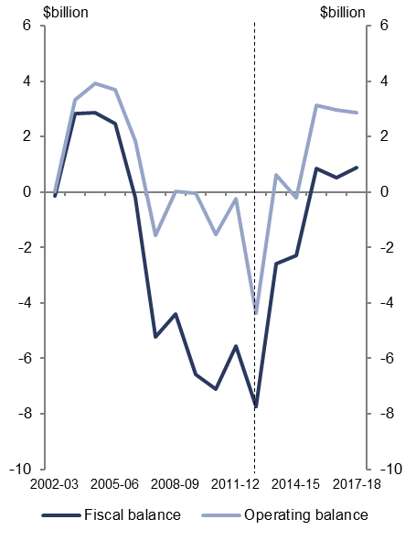 | 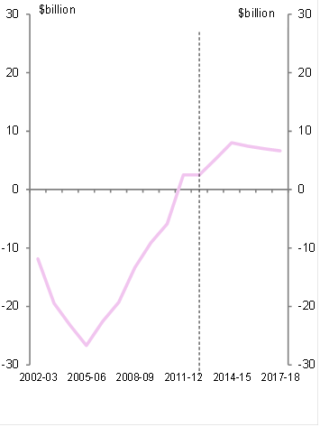
Source: ABS and Queensland government financial statements.
Figure A3‒3: Queensland general government annual average trends from 2002–03 to 2012–13
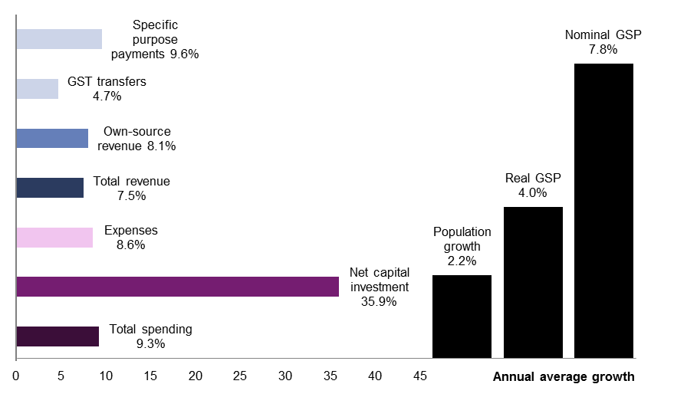
Source: ABS, Commonwealth and Queensland government financial statements and Commonwealth Grants Commission.
Figure A3‒4: Annual nominal growth in Queensland government spending from 2002–03 to 2012–13 | Figure A3‒5: Contributions to total growth in Queensland government spending from 2002–03 to 2012–13
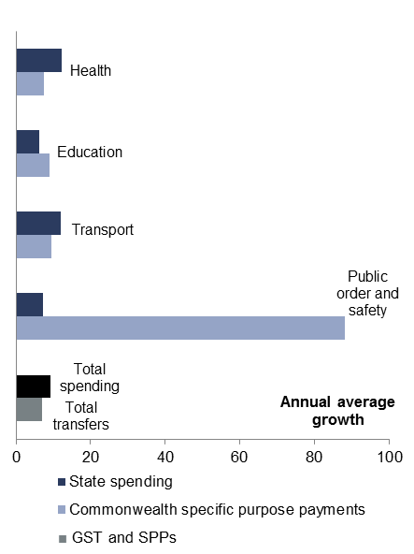 | 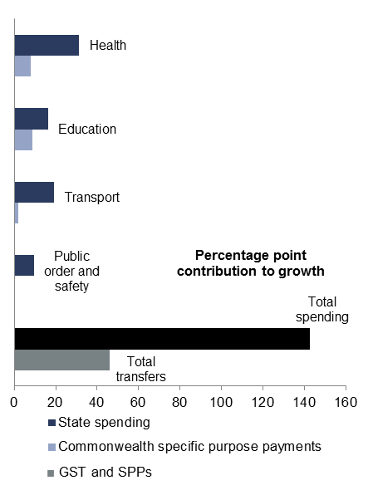
Source: ABS and Commonwealth and Queensland government financial statements.
Figure A3‒6: Queensland government revenue by source | Figure A3‒7: Queensland tax and non-tax revenue by type
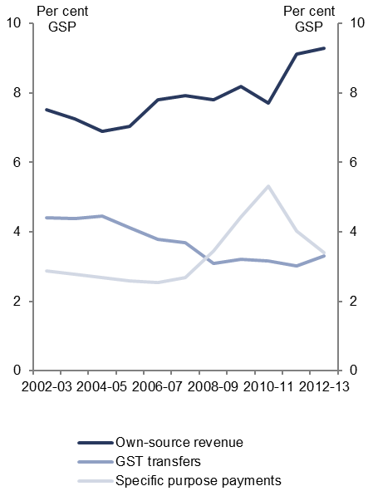 | 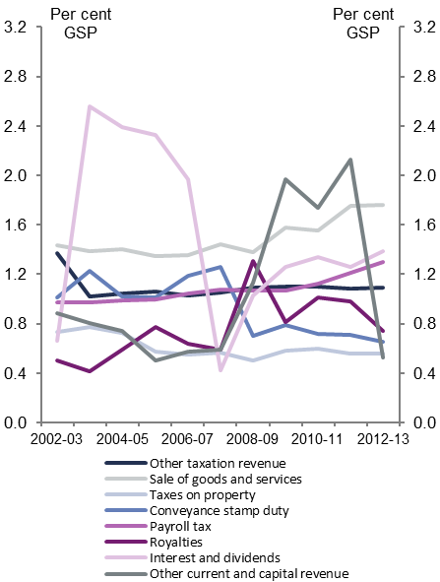
Source: ABS, Commonwealth and Queensland government financial statements and Commonwealth Grants Commission.

Western Australia
Figure A4‒1: WA general government fiscal and operating balances | Figure A4‒2: WA general government net debt
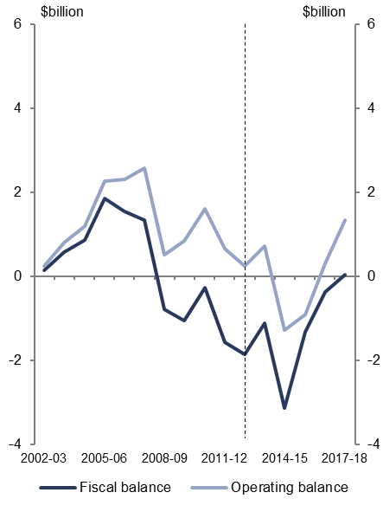 | 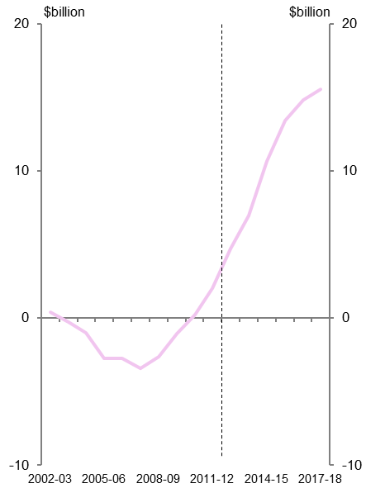
Source: ABS and WA government financial statements.
Figure A4‒3: WA general government annual average trends from 2002–03 to 2012–13
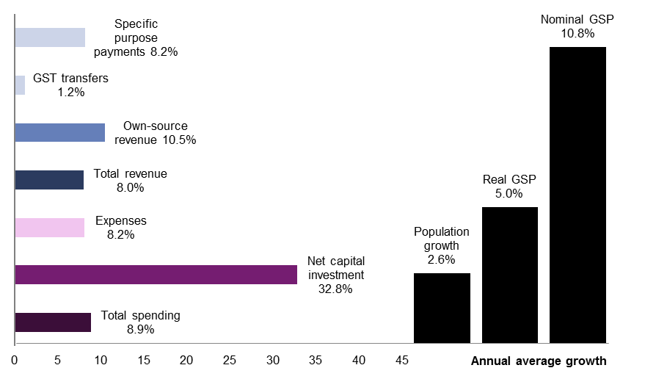
Source: ABS, Commonwealth and WA government financial statements and Commonwealth Grants Commission.
Figure A4‒4: Annual nominal growth in WA government spending from 2002–03 to 2012–13 | Figure A4‒5: Contributions to total growth in WA government spending from 2002–03 to 2012–13
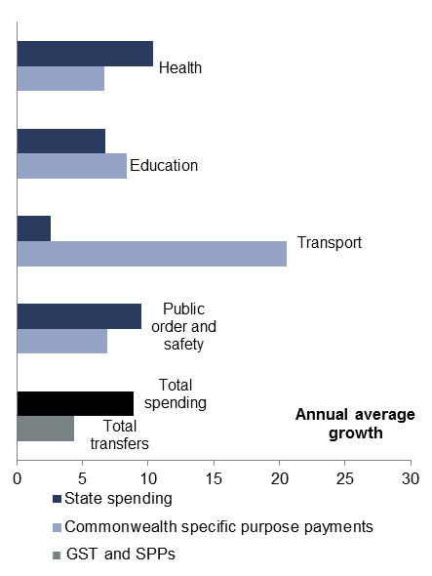 | 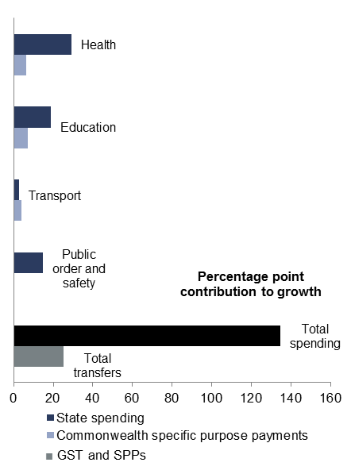
Source: ABS and Commonwealth and WA government financial statements.
Figure A4‒6: WA government revenue by source | Figure A4‒7: WA tax and non-tax revenue by type
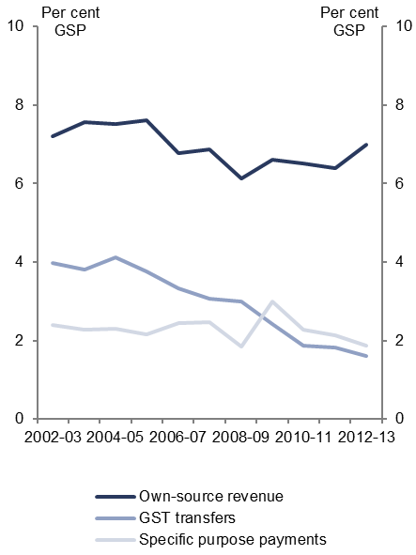 | 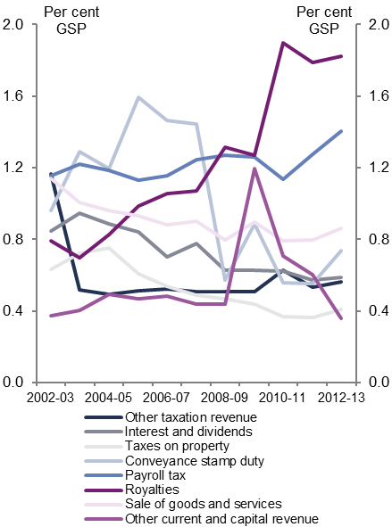
Source: ABS, Commonwealth and WA government financial statements and Commonwealth Grants Commission.

South Australia
Figure A5‒1: SA general government fiscal and operating balances | Figure A5‒2: SA general government net debt
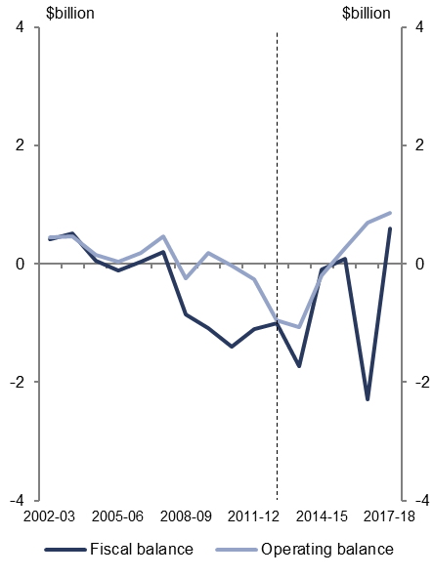 | 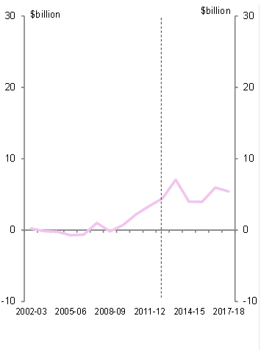
Source: ABS and SA government financial statements.
Figure A5‒3: SA general government annual average trends from 2002–03 to 2012–13
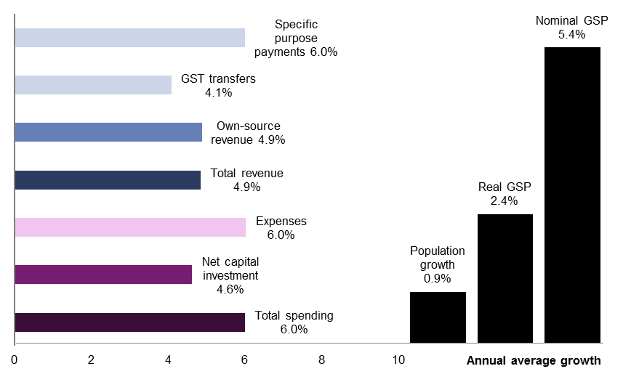
Source: ABS, Commonwealth and SA government financial statements and Commonwealth Grants Commission.
Figure A5‒4: Annual nominal growth in SA government spending from 2002–03 to 2012–13 | Figure A5‒5: Contributions to total growth in SA government spending from 2002–03 to 2012–13
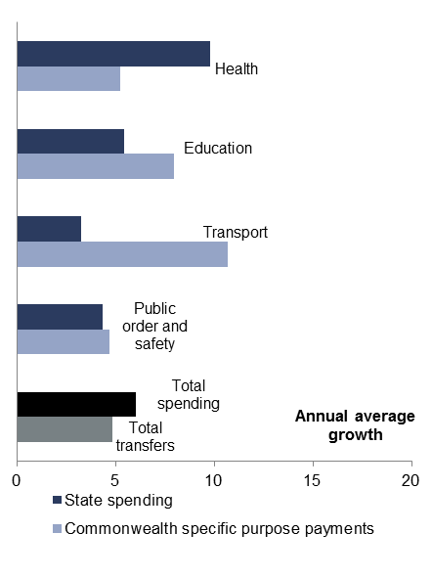 | 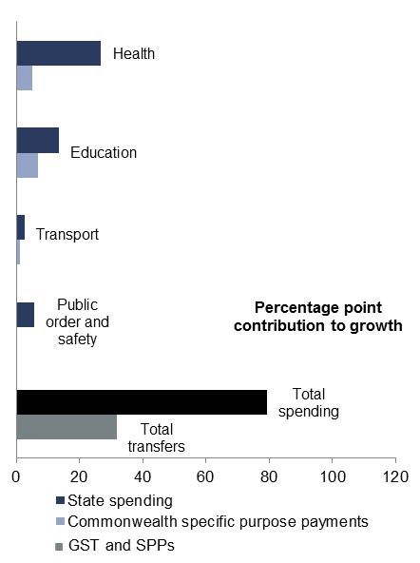
Source: ABS and Commonwealth and SA government financial statements.
Figure A5‒6: SA government revenue by source | Figure A5‒7: SA tax and non-tax revenue by type
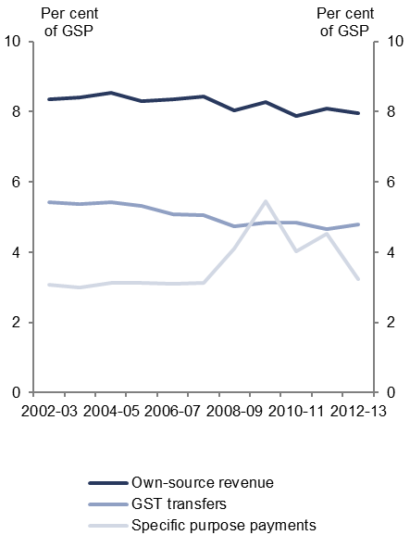 | 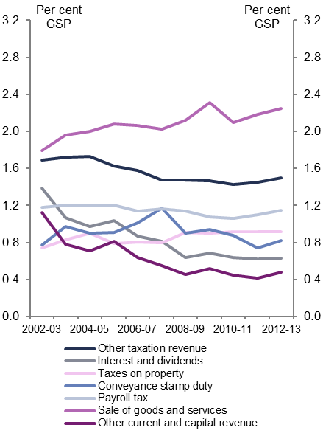
Source: ABS, Commonwealth and SA government financial statements and Commonwealth Grants Commission.

Tasmania
Figure A6‒1: Tasmanian general government fiscal and operating balances | Figure A6‒2: Tasmanian general government net debt
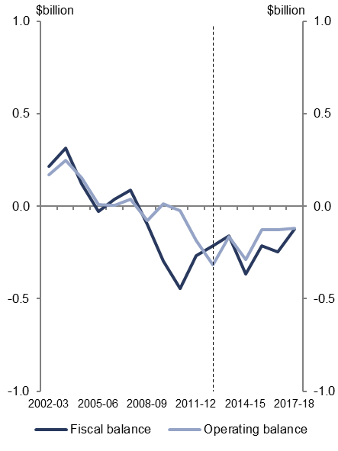 | 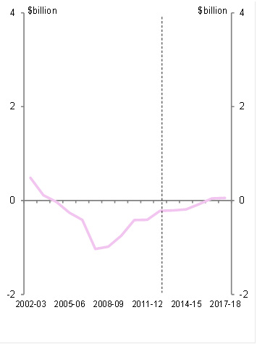
Source: ABS and Tasmanian government financial statements.
Figure A6‒3: Tasmanian general government annual average trends from 2002–03 to 2012–13
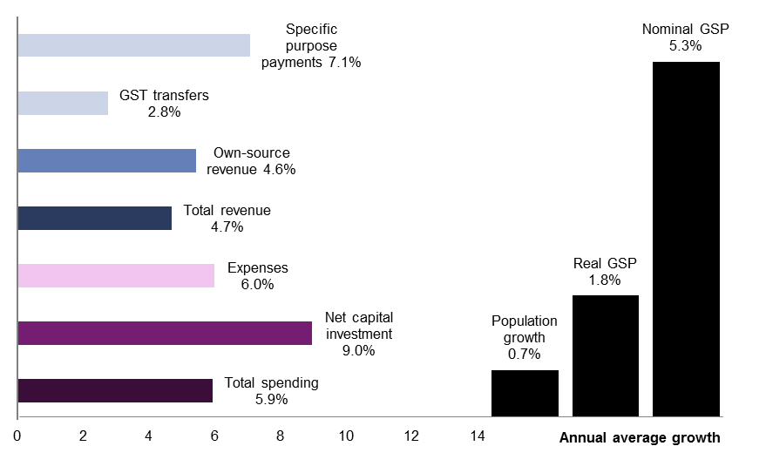
Source: ABS, Commonwealth and Tasmanian government financial statements and Commonwealth Grants Commission.
Figure A6‒4: Annual nominal growth in Tasmanian government spending from 2002–03 to 2012–13 | Figure A6‒5: Contributions to total growth in Tasmanian government spending from 2002–03 to 2012–13
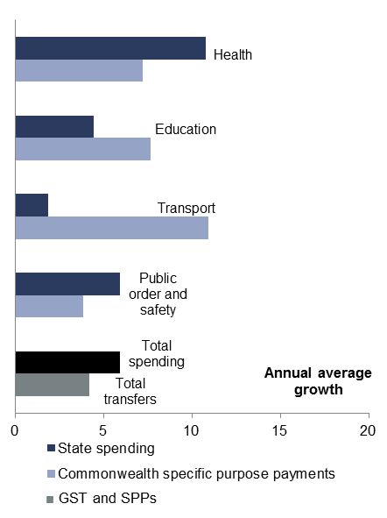 | 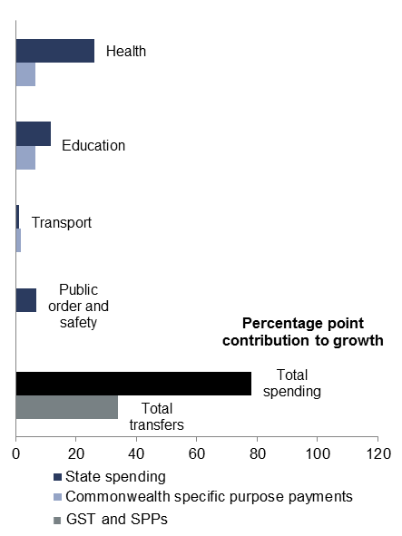
Source: ABS and Commonwealth and Tasmanian government financial statements.
Figure A6‒6: Tasmanian government revenue by source | Figure A6‒7: Tasmanian government tax and non-tax revenue by type
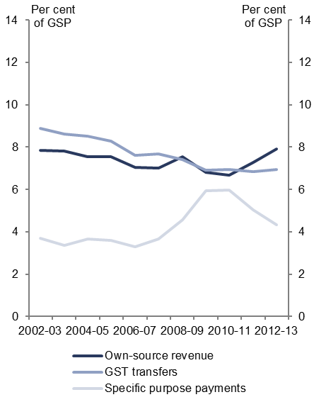 | 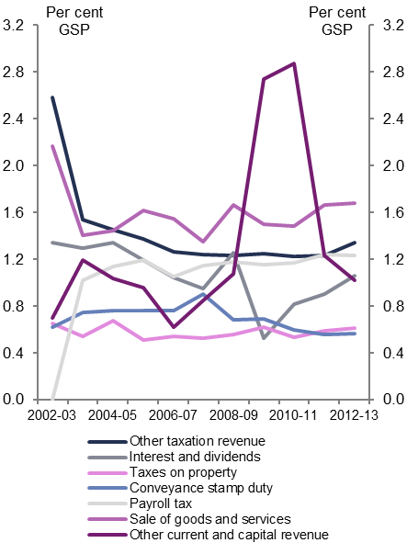
Source: ABS, Commonwealth and Tasmanian government financial statements and Commonwealth Grants Commission.

Australian Capital Territory
Figure A7‒1: ACT general government fiscal and operating balances | Figure A7‒2: ACT general government net debt
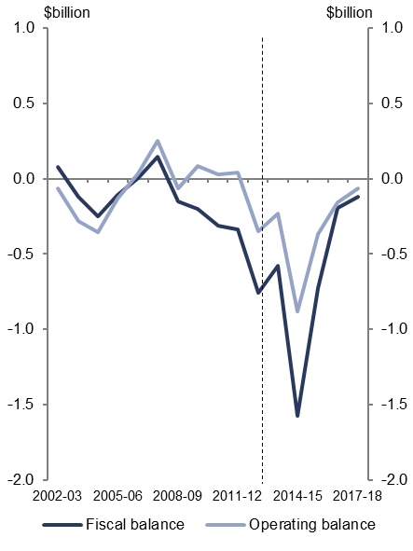 | 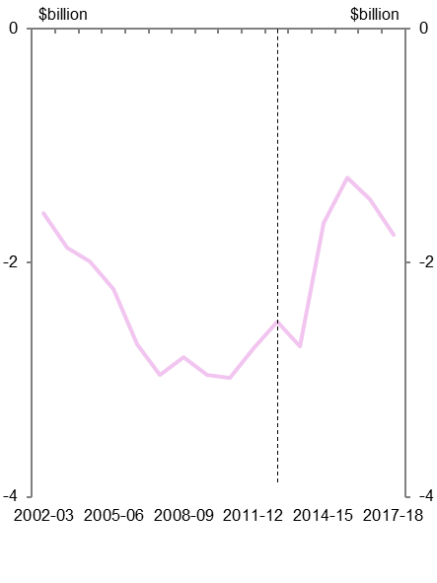
Source: ABS and ACT government financial statements.
Figure A7‒3: ACT general government annual average trends from 2002–03 to 2012–13
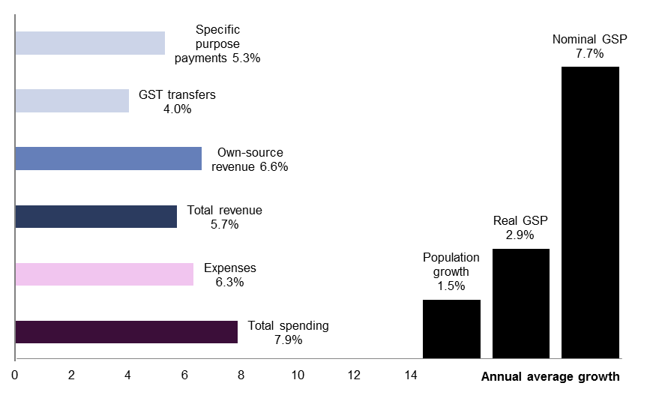
Source: ABS, Commonwealth and ACT government financial statements and Commonwealth Grants Commission.
Figure A7‒4: Annual nominal growth in ACT government spending from 2002–03 to 2012–13 | Figure A7‒5: Contributions to total growth in ACT government spending from 2002–03 to 2012–13
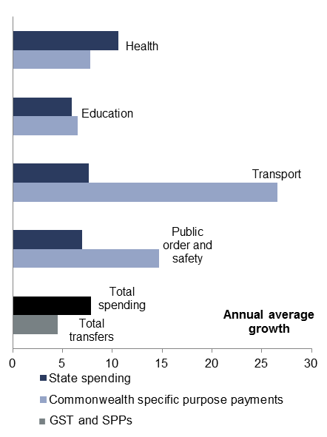 | 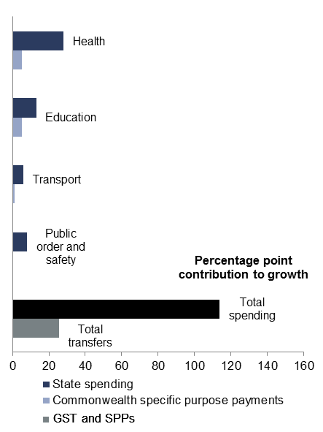
Source: ABS and Commonwealth and ACT government financial statements.
Figure A7‒6: ACT government revenue by source | Figure A7‒7: ACT government tax and non-tax revenue by type
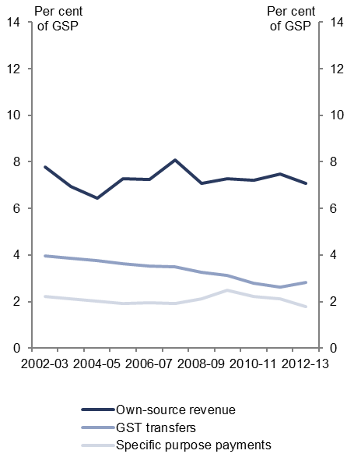 | 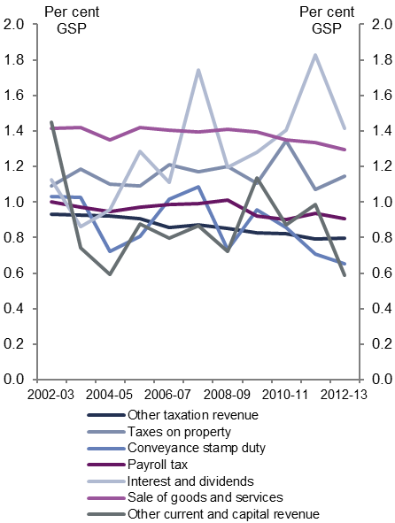
Source: ABS, Commonwealth and ACT government financial statements and Commonwealth Grants Commission.

Northern Territory
Figure A8‒1: NT general government fiscal and operating balances | Figure A8‒2: NT general government net debt
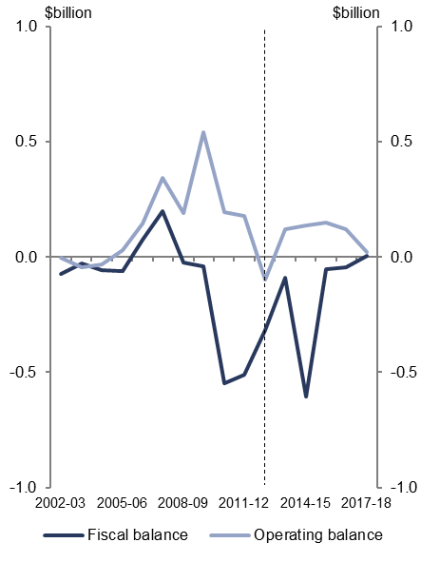 | 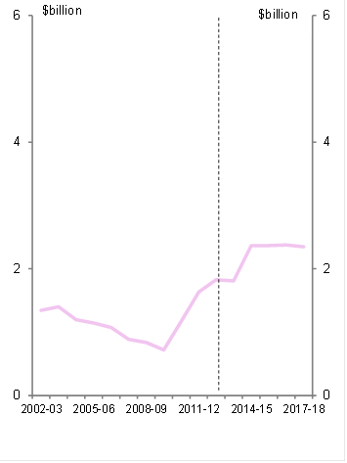
Source: ABS and NT government financial statements.
Figure A8‒3: NT general government annual average trends from 2002–03 to 2012–13
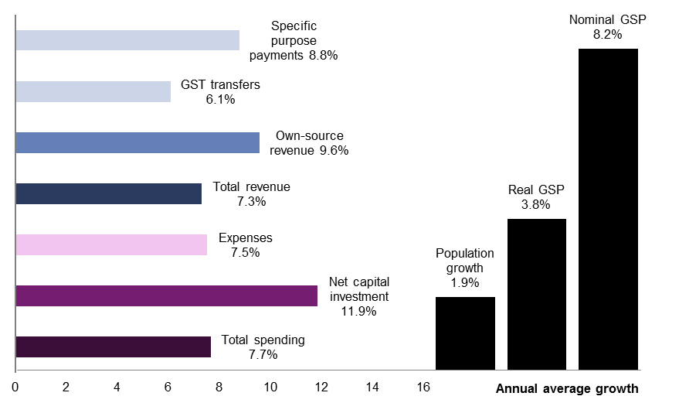
Source: ABS, Commonwealth and NT government financial statements and Commonwealth Grants Commission.
Figure A8‒4: Annual nominal growth in NT government spending from 2002–03 to 2012–13 | Figure A8‒5: Contributions to total growth in NT government spending from 2002–03 to 2012–13
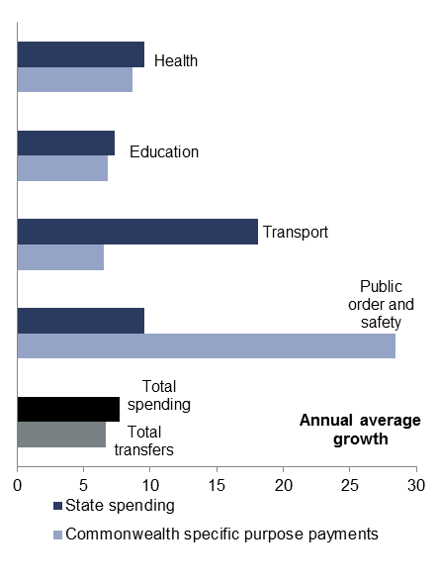 | 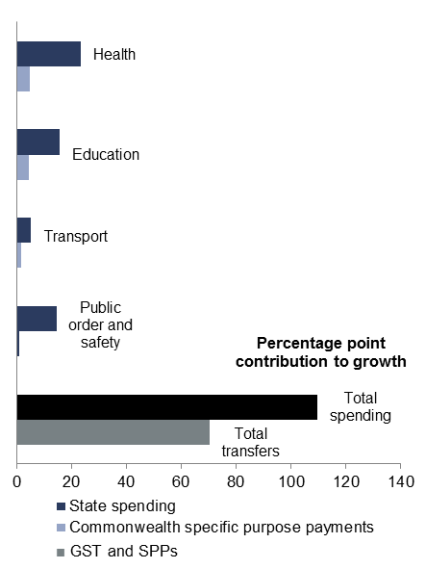
Source: ABS and Commonwealth and NT government financial statements.
Figure A8‒6: NT government revenue by source | Figure A8‒7: NT government tax and non-tax revenue by type
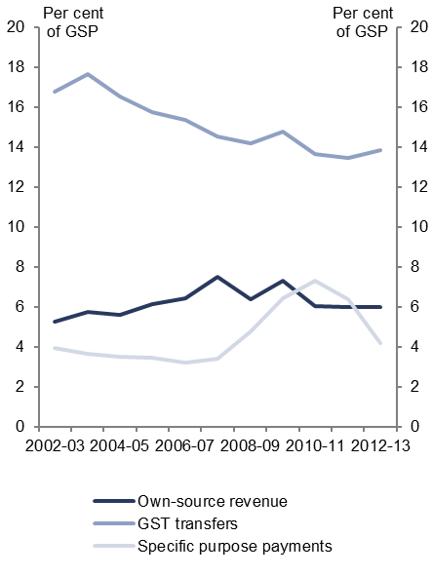 | 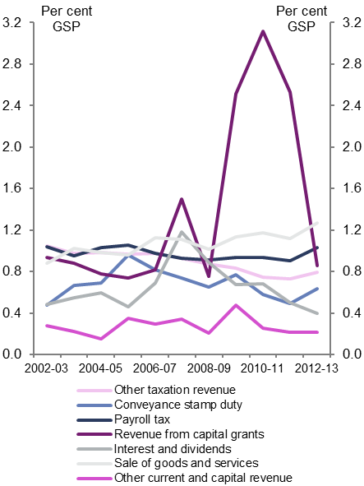
Source: ABS, Commonwealth and NT government financial statements and Commonwealth Grants Commission.

– Technical notes and sources
This report uses GFS data published by the ABS to discuss historical national fiscal trends from 2002–03 to 2012–13. Specifically, data has been sourced from:
- Cat. No. 5512.0 Government Finance Statistics, Australia (2011–12, 2012–13)
- Cat. No. 5506.0 Taxation Revenue, Australia (2011–12, 2012–13).
In most instances the ABS data used in this report is publicly available however, some unpublished information has been used to identify transfers between levels to better inform the analysis of budget trends nationally. This information is available from the ABS.

Estimates period data
The ABS collects data from all levels of government in Australia to prepare the historical GFS data it publishes. Under Uniform Presentation Framework arrangements the Commonwealth, states and territories also publish government finance data in a relatively comparable manner. The information published by governments extends over the forward estimates period although the level of detail provided varies across jurisdictions.
This report extends its analysis to the end of the forward estimates period in 2017–18. It uses ABS data over the period 2002–03 to 2012–13 to discuss historical trends and the latest available estimates period data published by governments to discuss the outlook for the national fiscal position, and for the Commonwealth and states and territories individually.
Local government data is not published over the forward estimates. As such local government revenue and expenses have been grown in line with the historical trend as a proportion of GDP, while net capital investment and net debt was grown by the nominal historical trend.

Economic parameters
Assumptions relating to the Consumer Price Index, nominal and real GDP are consistent with the 2014–15 Mid-Year Economic and Fiscal Outlook.
Historical data has been sourced from:
- Cat. No. 5206.0 Australian National Accounts: National Income, Expenditure and Product (September 2014)
- Cat. No. 6401.0 Consumer Price Index, Australia (September 2014).

Real growth rates
Real spending has been deflated by the Consumer Price Index to 2012-13 dollars. Real government spending is used to examine trends in spending over time.
The growth rates are compound annual average growth rates and cumulative contributions to growth.
In some instances annual real growth rates are also shown to better illustrate year to year fluctuations.

Transfers
Transfers between levels of government are sourced from unpublished ABS data. This is broadly consistent with publicly available Commonwealth Final Budget Outcome data on transfers to state and local governments.

Net capital investment
Net capital investment is the change in the balance sheet value of non-financial assets. It takes accounts of acquisitions and disposals of non-financial assets and depreciation in the value of these assets as they age.
Trends in gross fixed capital formation, which is largely the purchase of capital, broadly follow net capital investment. As the ABS does not published a break-down of net capital investment by function the measure of gross fixed capital formation has been used for some analysis in Chapter 4.

Sectors of government
This report focusses on the general government sector. This sector comprises government departments and agencies that provide non-market public services and are mainly funded through taxes.
Chapter 4 briefly examines public non-financial corporations (PNFCs), which are government-owned entities that provide goods and services to consumers on a commercial basis, which are funded largely by the sale of these goods and services.

Sources and references
Australian Bureau of Statistics (ABS), 2014, Australian National Accounts: National Income, Expenditure and Product, Cat. No. 5206.0
- ABS (a), 2014, Consumer Price Index, Australia, Cat. No. 6401.0
- ABS (b), 2013 to 2014, Government Finance Statistics, Australia 2011–12 and 2012–13, Cat. No. 5512.0
- ABS (c), 2013 to 2014, Taxation Revenue, Australia 2011–12 and 2012–13, Cat. No. 5506.0
- ABS (d), 2007 to 2013, Year Book Australia, Cat. No. 1301.0.
Commonwealth of Australia, 2002 to 2014, Budget Papers, Updates, and Final Budget Outcomes, 2002–03 to 2014–15, Canberra
- Commonwealth of Australia (a), 2002 to 2014, 2002–03 to 2012–13 Agency and Department Budget Estimates Statements and Additional Estimates Statements, various, Canberra
- Commonwealth of Australia (b), 2002 to 2014, 2002–03 to 2012–13 Agency and Department Annual Reports, various, Canberra
- Commonwealth of Australia, 2010, Intergenerational Report 2010: Australia to 2050: Future Challenges, Canberra.
Commonwealth of Australia, 2008, Nation Building: Rail, Road, Education & Research and Business, Canberra.
Commonwealth of Australia, 2011, Review of Funding for Schooling: Final Report, Canberra.
Australian Institute of Health and Welfare (AIHW), 2013, Health Expenditure 2011–12, Canberra.
Council of Australian Governments (COAG), 2008, 29 November 2008 Communique, Canberra
- COAG (a), 2012, National Education Agreement, Canberra
- COAG (b), 2011, National Health Reform Agreement, Canberra
- COAG (c), 2009, National Partnership Agreement on Hospital and Health Workforce Reform, Canberra
- COAG (d), 2009, National Partnership Agreement on the Nation Building and Jobs Plan, 5 February 2009, Canberra.
Department of Finance and Deregulation, 2010, Finance Circular No. 2010/02: Classification of Payments to the States and Territories and Commonwealth Own-Purpose Expenses, Financial Reporting Branch, Canberra.
The Treasury, 2009, Treasury Briefing Paper for the Senate Inquiry into the Economic Stimulus Package, Canberra.

– Data used in this report
Table C-1: General government data by level of government (adjusted for inter-governmental flows and stocks)
$ billion | 2002-03 | 2003-04 | 2004-05 | 2005-06 | 2006-07 | 2007-08 | 2008-09 | 2009-10 | 2010-11 | 2011-12 | 2012-13 | 2013-14 | 2014-15 | 2015-16 | 2016-17 | 2017-18
Revenue | 280.1 | 304.0 | 328.8 | 355.8 | 382.8 | 409.8 | 410.7 | 409.8 | 437.4 | 473.3 | 504.3 | 530.9 | 545.3 | 575.6 | 610.7 | 650.7
Commonwealth | 206.1 | 221.4 | 241.3 | 260.1 | 277.3 | 302.8 | 297.7 | 291.5 | 308.8 | 338.0 | 360.8 | 374.0 | 385.9 | 411.7 | 441.0 | 473.2
State | 58.4 | 66.0 | 69.5 | 75.8 | 83.5 | 84.0 | 88.4 | 92.4 | 101.6 | 106.8 | 112.5 | 125.6 | 127.1 | 130.0 | 133.4 | 140.0
Local | 15.6 | 16.6 | 17.9 | 19.9 | 22.0 | 23.1 | 24.6 | 25.9 | 27.0 | 28.5 | 31.0 | 31.3 | 32.3 | 33.9 | 35.6 | 37.4
Expenses | 268.5 | 289.1 | 308.2 | 327.1 | 352.4 | 379.6 | 431.3 | 451.9 | 475.9 | 510.7 | 525.2 | 563.5 | 578.9 | 590.6 | 611.9 | 637.7
Commonwealth | 199.3 | 213.7 | 228.1 | 240.8 | 257.0 | 278.0 | 322.3 | 337.9 | 355.5 | 377.4 | 382.0 | 413.8 | 422.9 | 436.5 | 456.1 | 475.3
State | 53.5 | 58.9 | 62.7 | 67.6 | 75.6 | 80.4 | 86.2 | 90.0 | 94.7 | 108.0 | 116.3 | 122.4 | 128.2 | 125.3 | 126.0 | 131.5
Local | 15.8 | 16.6 | 17.4 | 18.7 | 19.9 | 21.2 | 22.8 | 23.9 | 25.7 | 25.3 | 26.9 | 27.3 | 27.8 | 28.8 | 29.8 | 30.9
Net operating balance | 11.5 | 14.9 | 20.5 | 28.7 | 30.3 | 30.2 | -20.6 | -42.1 | -38.5 | -37.4 | -20.9 | -32.6 | -33.6 | -15.0 | -1.2 | 12.9
Commonwealth | 6.8 | 7.7 | 13.2 | 19.3 | 20.3 | 24.8 | -24.6 | -46.4 | -46.7 | -39.4 | -21.2 | -39.9 | -37.0 | -24.8 | -15.1 | -2.1
State | 4.9 | 7.2 | 6.8 | 8.2 | 7.9 | 3.6 | 2.2 | 2.4 | 6.9 | -1.2 | -3.9 | 3.2 | -1.2 | 4.7 | 8.1 | 8.6
Local | -0.2 | 0.1 | 0.6 | 1.2 | 2.1 | 1.8 | 1.8 | 1.9 | 1.3 | 3.2 | 4.2 | 4.1 | 4.6 | 5.2 | 5.8 | 6.5
Net capital investment | 4.2 | 5.1 | 6.8 | 10.1 | 12.9 | 15.6 | 20.9 | 30.3 | 27.9 | 24.9 | 15.6 | 19.6 | 19.7 | 18.4 | 23.0 | 19.8
Commonwealth | 0.6 | 1.1 | 1.7 | 2.9 | 2.9 | 3.6 | 4.8 | 6.9 | 5.9 | 5.2 | -0.7 | 3.9 | 2.8 | 2.4 | 2.7 | 2.9
State | 2.4 | 2.2 | 2.7 | 4.6 | 6.5 | 8.3 | 10.9 | 17.7 | 17.4 | 14.7 | 11.0 | 9.5 | 10.1 | 8.8 | 12.7 | 8.8
Local | 1.2 | 1.8 | 2.4 | 2.6 | 3.5 | 3.7 | 5.1 | 5.8 | 4.6 | 5.0 | 5.3 | 6.3 | 6.7 | 7.2 | 7.6 | 8.0
Fiscal balance | 7.4 | 9.8 | 13.7 | 18.6 | 17.4 | 14.6 | -41.5 | -72.4 | -66.4 | -62.2 | -36.5 | -52.2 | -53.3 | -33.3 | -24.2 | -6.9
Commonwealth | 6.2 | 6.6 | 11.6 | 16.5 | 17.4 | 21.1 | -29.5 | -53.3 | -52.6 | -44.6 | -20.5 | -43.7 | -39.8 | -27.2 | -17.8 | -5.0
State | 2.5 | 5.0 | 4.0 | 3.6 | 1.4 | -4.7 | -8.7 | -15.3 | -10.5 | -15.9 | -14.9 | -6.2 | -11.3 | -4.1 | -4.6 | -0.3
Local | -1.4 | -1.7 | -1.8 | -1.4 | -1.4 | -1.8 | -3.3 | -3.9 | -3.3 | -1.7 | -1.1 | -2.2 | -2.2 | -2.0 | -1.8 | -1.5
Net debt | 17.0 | 2.2 | -16.4 | -48.7 | -73.5 | -80.7 | -39.9 | 36.7 | 84.9 | 164.8 | 188.0 | 238.6 | 288.2 | 321.9 | 351.3 | 362.2
Commonwealth | 27.3 | 19.5 | 8.5 | -12.9 | -41.5 | -54.2 | -21.7 | 42.0 | 84.1 | 148.6 | 154.0 | 202.5 | 244.8 | 279.6 | 304.4 | 315.8
State | -7.7 | -14.1 | -21.4 | -31.4 | -27.2 | -21.5 | -11.7 | 0.5 | 10.9 | 26.6 | 41.6 | 46.2 | 54.2 | 53.9 | 59.1 | 59.4
Local | -2.6 | -3.2 | -3.6 | -4.4 | -4.8 | -5.0 | -6.5 | -5.7 | -10.0 | -10.4 | -7.7 | -10.1 | -10.8 | -11.5 | -12.2 | -12.9
Source: ABS Cat. No. 5512.0, and Commonwealth and state budget papers.
- Historical figures from 2002-03 to 2012-13 are based on data published by the ABS and derived from unpublished ABS data so that inter-sector flows and stocks have been removed.
- Commonwealth and state figures for 2013-14 are based on actuals in final budget outcomes. Commonwealth and state estimates period data from 2014-15 to 2017-18 are based on the latest available budget updates. Data from 2013-14 onwards has been adjusted so that inter-sector flows and stocks have been removed.
- Local government figures from 2002-03 to 2012-13 are sourced from data published by the ABS. From 2013-14 to 2017-18 local government revenue and expenses have been grown at trend as a percentage of GDP and net capital investment by the nominal trend over the decade.

Table C-2: General government data by level of government (as published)
$billion | 2002-03 | 2003-04 | 2004-05 | 2005-06 | 2006-07 | 2007-08 | 2008-09 | 2009-10 | 2010-11 | 2011-12 | 2012-13 | 2013-14 | 2014-15 | 2015-16 | 2016-17 | 2017-18
Commonwealth
Revenue | 206.8 | 222.2 | 242.2 | 261.0 | 278.2 | 303.7 | 298.6 | 292.6 | 310.0 | 339.1 | 361.8 | 374.0 | 385.9 | 411.7 | 441.0 | 473.2
Expenses | 199.9 | 214.3 | 228.8 | 241.5 | 257.7 | 278.8 | 323.1 | 338.9 | 356.5 | 378.5 | 383.0 | 413.8 | 422.9 | 436.5 | 456.1 | 475.3
Net operating balance | 7.0 | 7.9 | 13.4 | 19.5 | 20.5 | 24.9 | -24.5 | -46.3 | -46.5 | -39.4 | -21.1 | -39.9 | -37.0 | -24.8 | -15.1 | -2.1
Net capital investment | 0.6 | 1.1 | 1.7 | 2.9 | 2.9 | 3.6 | 4.8 | 6.9 | 5.9 | 5.2 | -0.7 | 3.9 | 2.8 | 2.4 | 2.7 | 2.9
Fiscal balance | 6.4 | 6.8 | 11.7 | 16.7 | 17.6 | 21.3 | -29.3 | -53.1 | -52.4 | -44.6 | -20.5 | -43.7 | -39.8 | -27.2 | -17.8 | -5.0
Net debt | 27.3 | 19.5 | 8.5 | -12.9 | -41.5 | -54.2 | -21.7 | 42.0 | 84.1 | 148.6 | 154.0 | 202.5 | 244.8 | 279.6 | 304.4 | 315.8
New South Wales
Revenue | 37.8 | 39.7 | 41.5 | 44.1 | 47.3 | 49.4 | 53.2 | 60.0 | 60.6 | 62.4 | 63.5 | 66.0 | 67.9 | 70.0 | 73.6 | 74.9
Expenses | 36.0 | 38.6 | 40.8 | 43.2 | 46.5 | 49.0 | 53.6 | 59.0 | 59.3 | 61.8 | 63.3 | 64.8 | 67.6 | 69.6 | 72.5 | 73.9
Net operating balance | 1.8 | 1.1 | 0.7 | 0.9 | 0.8 | 0.4 | -0.4 | 1.1 | 1.3 | 0.7 | 0.2 | 1.2 | 0.3 | 0.4 | 1.1 | 1.0
Net capital investment | 1.3 | 1.1 | 0.9 | 1.5 | 1.8 | 1.9 | 2.4 | 3.7 | 4.3 | 2.7 | 2.4 | 2.5 | 3.5 | 2.4 | 2.8 | 2.0
Fiscal balance | 0.5 | 0.0 | -0.2 | -0.6 | -1.0 | -1.6 | -2.8 | -2.6 | -2.9 | -2.0 | -2.2 | -1.2 | -3.2 | -2.0 | -1.7 | -1.0
Net debt | 2.0 | 0.1 | -1.3 | -4.6 | 2.9 | 4.4 | 8.0 | 9.2 | 7.8 | 13.2 | 10.9 | 6.9 | 9.3 | 10.5 | 11.5 | 10.7
Victoria
Revenue | 27.0 | 28.5 | 29.8 | 32.0 | 35.8 | 37.3 | 39.3 | 44.6 | 46.1 | 47.6 | 48.7 | 52.4 | 53.2 | 54.6 | 56.3 | 58.3
Expenses | 25.4 | 27.6 | 29.0 | 31.2 | 33.5 | 35.9 | 39.0 | 44.0 | 45.5 | 47.4 | 48.3 | 50.4 | 52.1 | 52.4 | 53.9 | 55.8
Net operating balance | 1.6 | 0.9 | 0.8 | 0.8 | 2.3 | 1.5 | 0.3 | 0.6 | 0.5 | 0.1 | 0.5 | 2.0 | 1.1 | 2.2 | 2.4 | 2.4
Net capital investment | 0.9 | 0.7 | 0.4 | 1.2 | 1.6 | 1.0 | 1.9 | 3.1 | 2.8 | 2.5 | 2.6 | 0.7 | 0.6 | 2.3 | 3.0 | 2.8
Fiscal balance | 0.7 | 0.3 | 0.4 | -0.5 | 0.7 | 0.5 | -1.6 | -2.5 | -2.3 | -2.3 | -2.1 | 1.3 | 0.6 | -0.1 | -0.6 | -0.4
Net debt | 1.3 | 1.4 | 1.5 | 1.2 | 2.0 | 2.2 | 5.3 | 7.9 | 11.9 | 15.3 | 19.9 | 21.2 | 21.7 | 17.5 | 18.9 | 20.4
Queensland
Revenue | 20.3 | 25.2 | 27.6 | 30.1 | 32.1 | 31.5 | 37.1 | 39.7 | 42.0 | 45.8 | 41.7 | 46.7 | 49.1 | 53.0 | 54.5 | 56.3
Expenses | 20.2 | 21.9 | 23.7 | 26.5 | 30.2 | 33.1 | 37.0 | 39.8 | 43.5 | 46.0 | 46.1 | 46.1 | 49.2 | 49.9 | 51.4 | 53.3
Net operating balance | 0.0 | 3.3 | 3.9 | 3.7 | 1.9 | -1.6 | 0.0 | 0.0 | -1.5 | -0.2 | -4.4 | 0.6 | -0.1 | 3.1 | 3.1 | 3.0
Net capital investment | 0.2 | 0.5 | 1.1 | 1.2 | 2.1 | 3.7 | 4.4 | 6.5 | 5.6 | 5.3 | 3.4 | 3.2 | 2.8 | 2.7 | 2.9 | 2.4
Fiscal balance | -0.1 | 2.8 | 2.9 | 2.5 | -0.2 | -5.2 | -4.4 | -6.6 | -7.1 | -5.6 | -7.7 | -2.6 | -2.8 | 0.3 | 0.2 | 0.6
Net debt | -11.8 | -14.9 | -19.4 | -23.2 | -26.7 | -22.6 | -19.3 | -13.3 | -9.1 | -5.9 | 2.5 | 5.2 | 8.0 | 7.4 | 7.0 | 6.6
Western Australia
Revenue | 11.8 | 12.8 | 14.2 | 16.2 | 17.5 | 19.3 | 19.4 | 21.9 | 23.7 | 25.1 | 25.5 | 28.0 | 27.1 | 28.0 | 30.1 | 31.7
Expenses | 11.5 | 11.9 | 13.0 | 13.9 | 15.1 | 16.7 | 18.9 | 21.1 | 22.1 | 24.4 | 25.2 | 27.2 | 28.4 | 29.0 | 29.8 | 30.4
Net operating balance | 0.3 | 0.8 | 1.2 | 2.3 | 2.3 | 2.6 | 0.5 | 0.8 | 1.6 | 0.6 | 0.2 | 0.7 | -1.3 | -0.9 | 0.3 | 1.3
Net capital investment | 0.1 | 0.2 | 0.3 | 0.4 | 0.8 | 1.2 | 1.3 | 1.9 | 1.9 | 2.2 | 2.1 | 1.8 | 1.9 | 0.4 | 0.7 | 1.3
Fiscal balance | 0.1 | 0.6 | 0.9 | 1.8 | 1.5 | 1.3 | -0.8 | -1.1 | -0.3 | -1.6 | -1.9 | -1.1 | -3.1 | -1.3 | -0.4 | 0.0
Net debt | 0.4 | -0.3 | -1.0 | -2.7 | -2.7 | -3.4 | -2.6 | -1.1 | 0.2 | 2.1 | 4.7 | 7.0 | 10.7 | 13.4 | 14.8 | 15.6
South Australia
Revenue | 9.3 | 10.0 | 10.6 | 11.0 | 11.7 | 12.9 | 13.5 | 15.5 | 15.0 | 15.9 | 15.0 | 15.3 | 16.5 | 17.2 | 17.9 | 18.6
Expenses | 8.9 | 9.5 | 10.4 | 11.0 | 11.5 | 12.4 | 13.8 | 15.4 | 15.1 | 16.2 | 16.0 | 16.4 | 16.6 | 16.9 | 17.2 | 17.7
Net operating balance | 0.4 | 0.5 | 0.2 | 0.0 | 0.2 | 0.5 | -0.2 | 0.2 | 0.0 | -0.3 | -0.9 | -1.1 | -0.2 | 0.3 | 0.7 | 0.9
Net capital investment | 0.0 | 0.0 | 0.1 | 0.1 | 0.2 | 0.3 | 0.6 | 1.3 | 1.4 | 0.8 | 0.1 | 0.7 | -0.1 | 0.2 | 3.0 | 0.3
Fiscal balance | 0.4 | 0.5 | 0.1 | -0.1 | 0.0 | 0.2 | -0.9 | -1.1 | -1.4 | -1.1 | -1.0 | -1.7 | -0.1 | 0.1 | -2.3 | 0.6
Net debt | 0.2 | -0.1 | -0.2 | -0.7 | -0.6 | 1.0 | -0.2 | 0.7 | 2.3 | 3.4 | 4.5 | 7.1 | 4.0 | 4.0 | 6.0 | 5.4
Tasmania
Revenue | 3.0 | 3.2 | 3.4 | 3.6 | 3.7 | 4.0 | 4.3 | 4.6 | 4.8 | 4.7 | 4.7 | 4.9 | 5.0 | 5.1 | 5.1 | 5.3
Expenses | 2.8 | 3.0 | 3.2 | 3.6 | 3.7 | 3.9 | 4.4 | 4.6 | 4.8 | 4.9 | 5.0 | 5.1 | 5.2 | 5.2 | 5.3 | 5.4
Net operating balance | 0.2 | 0.3 | 0.2 | 0.0 | 0.0 | 0.0 | -0.1 | 0.0 | 0.0 | -0.2 | -0.3 | -0.2 | -0.3 | -0.1 | -0.1 | -0.1
Net capital investment | 0.0 | -0.1 | 0.0 | 0.0 | 0.0 | -0.1 | 0.0 | 0.3 | 0.4 | 0.1 | -0.1 | 0.0 | 0.1 | 0.1 | 0.1 | 0.0
Fiscal balance | 0.2 | 0.3 | 0.1 | 0.0 | 0.0 | 0.1 | -0.1 | -0.3 | -0.4 | -0.3 | -0.2 | -0.2 | -0.4 | -0.2 | -0.2 | -0.1
Net debt | 0.5 | 0.1 | 0.0 | -0.3 | -0.4 | -1.0 | -1.0 | -0.7 | -0.4 | -0.4 | -0.2 | -0.2 | -0.2 | -0.1 | 0.0 | 0.1
Australian Capital Territory
Revenue | 2.4 | 2.4 | 2.4 | 2.7 | 2.9 | 3.4 | 3.3 | 3.8 | 3.9 | 4.1 | 4.1 | 4.3 | 4.4 | 4.7 | 4.9 | 5.2
Expenses | 2.4 | 2.6 | 2.7 | 2.8 | 2.9 | 3.1 | 3.4 | 3.7 | 3.9 | 4.1 | 4.5 | 4.6 | 5.3 | 5.1 | 5.1 | 5.2
Net operating balance | -0.1 | -0.3 | -0.4 | -0.1 | 0.0 | 0.3 | -0.1 | 0.1 | 0.0 | 0.0 | -0.3 | -0.2 | -0.9 | -0.4 | -0.2 | -0.1
Net capital investment | -0.1 | -0.2 | -0.1 | 0.0 | 0.0 | 0.1 | 0.1 | 0.3 | 0.3 | 0.4 | 0.4 | 0.3 | 0.7 | 0.4 | 0.0 | 0.1
Fiscal balance | 0.1 | -0.1 | -0.3 | -0.1 | 0.0 | 0.1 | -0.2 | -0.2 | -0.3 | -0.3 | -0.8 | -0.6 | -1.6 | -0.8 | -0.2 | -0.1
Net debt | -1.6 | -1.9 | -2.0 | -2.2 | -2.7 | -3.0 | -2.8 | -3.0 | -3.0 | -2.7 | -2.5 | -2.7 | -1.7 | -1.3 | -1.5 | -1.8
Northern Territory
Revenue | 2.4 | 2.6 | 2.7 | 3.0 | 3.3 | 3.9 | 4.2 | 4.7 | 4.7 | 4.9 | 4.8 | 5.2 | 5.5 | 5.6 | 5.7 | 5.6
Expenses | 2.4 | 2.6 | 2.7 | 3.0 | 3.1 | 3.5 | 4.0 | 4.1 | 4.5 | 4.7 | 4.9 | 5.0 | 5.4 | 5.4 | 5.6 | 5.6
Net operating balance | 0.0 | 0.0 | 0.0 | 0.0 | 0.1 | 0.3 | 0.2 | 0.5 | 0.2 | 0.2 | -0.1 | 0.1 | 0.1 | 0.1 | 0.1 | 0.0
Net capital investment | 0.1 | 0.0 | 0.0 | 0.1 | 0.1 | 0.1 | 0.2 | 0.6 | 0.7 | 0.7 | 0.2 | 0.2 | 0.7 | 0.2 | 0.2 | 0.0
Fiscal balance | -0.1 | 0.0 | -0.1 | -0.1 | 0.1 | 0.2 | 0.0 | 0.0 | -0.5 | -0.5 | -0.3 | -0.1 | -0.6 | -0.1 | 0.0 | 0.0
Net debt | 1.3 | 1.4 | 1.2 | 1.1 | 1.1 | 0.9 | 0.8 | 0.7 | 1.2 | 1.6 | 1.8 | 1.8 | 2.4 | 2.4 | 2.4 | 2.3
Source: ABS Cat. No. 5512.0, and Commonwealth and state budget papers.
- Figures do not include local government. Historical figures from 2002-03 to 2012-13 are sourced from data published by the ABS. Figures for 2013-14 are actuals as published by governments in final budget outcomes. Estimates period data from 2014-15 to 2017-18 are taken from the latest available Commonwealth and state budget updates.

Unless otherwise specified ‘states’ refers to states, territories and local governments. Data for local government are only available from 2002–03 to 2012–13. Trend estimates are used for key local government fiscal aggregates from 2013–14 to 2017–18.
Data in this report relates to the general government sector. From 2002–03 to 2012–13 data is sourced from the ABS. From 2013–14 to 2017–18 data is sourced from Commonwealth, state and territory budgets. Spending is the sum of expenses and net capital investment.
All growth rates quoted in this report refer to real compound annual average growth rates.
The Queensland government holds a large pool of investments on its balance sheet sufficient to fully meet its superannuation liabilities. Revenue can be significantly affected by volatility of returns generated on investments.
There is no average annual growth rate shown for net capital investment of the Commonwealth. Commonwealth government net capital investment fell from $0.74 billion in 2002–03 to -$0.67 billion in 2012–13. The net reduction in 2012-13 reflects the sale of spectrum licences in that year.
For a detailed discussion of historical trends in Commonwealth government receipts and spending see PBO reports Trends in Australian Government receipts: 1982–83 to 2012–13 and Australian Government spending—Part 1: Historical trends from 2002–03 to 2012–13.
Net debt is the sum of selected financial liabilities (deposits held, advances received, government securities, loans and other borrowings) less the sum of selected financial assets (cash and deposits, advances paid, and investments, loans and placements). It is a common measure of the strength of a government’s financial position.
Including own-source revenue and revenue transferred to state governments but excluding revenue derived from state governments.
Tobacco figures are not reported separately due to taxpayer confidentiality.
Capital gains tax would normally be included in the individual income tax, company tax and superannuation fund tax figures. For the purposes of this analysis it has been separately identified as its own head of revenue.
Figures do not add to the total due to rounding.
Trends in Australian Government receipts: 1982–83 to 2012–13, PBO, p. 51.
Taxes on property mainly comprise land taxes and municipal rates, but do not include conveyance stamp duty, which is discussed separately here.
Consistent data for all revenue heads is not available beyond 2012–13.
While all states exhibited a decline in conveyance stamp duty revenue in 2008–09, only the states with the largest conveyance stamp duty revenue have been included. Consistent data for conveyance stamp duty is not available beyond 2012–13.
Royalty revenue discussed here does not include royalties from off-shore activities which are collected by the Commonwealth on behalf of states. These royalties are fully provided to the states as part of general revenue assistance. States treat this revenue as a grant from the Commonwealth rather than royalties. Most of these royalties are collected by the Commonwealth on behalf of Western Australia.
2014-15 Mid-year Financial Projections Statement, The Government of Western Australia, p. 3
2014-15 Budget Paper No. 3, The Government of Western Australia, p. 7
See PBO report Trends in Australian Government receipts: 1982–83 to 2012–13.
The transfer component shown includes both tied funding (eg specific-purpose payments), and untied funding (eg GST payments to the states). There is no transfer component in the state government expenditure presented. All data in this section relates to the general government sector. The transfer component also includes funding to states for capital purposes.
The transfer component relates only to Commonwealth payments to state governments that can be attributed to specific expenditure functions (ie tied funding). It does not include untied funding (ie GST payments to the states), which cannot be attributed to specific functions and is included in the state component. This means that some state expenditure is funded by Commonwealth transfers. The transfer component also includes funding to states for capital purposes. This is discussed in more detail in Chapter 4.
The transfer component relates only to Commonwealth payments to state governments that can be attributed to specific expenditure functions (ie tied funding). It does not include untied funding (ie GST payments to the states), which cannot be attributed to specific functions and is included in the state component. This means that some state expenditure is funded by Commonwealth transfers. The transfer component also includes funding to states for capital purposes. This is discussed in more detail in Chapter 4.
General Revenue Assistance (that is, GST payments to the states) is normally included in this area of expenditure as a transfer from the Commonwealth to the states. However, because it is ultimately expended by the states and included in states’ expenses data, the transfer is omitted to avoid double-counting. Therefore, no transfer component is shown for this function.
The transfer component described here does not include funding to states for capital purposes. Apart from Figures 3–5 and 3–7, all other references to transfers in this chapter include transfers for both recurrent and capital purposes.
Projections of Government spending over the medium term, PBO, p. 9.
State figures include health expenditure funded by transfers from the Commonwealth (both tied and untied). The figures given for the Commonwealth are for own-purpose health expenditure only.
State only (ie excludes local government).
This report generally uses data based on GFS classifications. For consistency with this approach, public hospital expenditure in this chapter is based on the GFS acute care sub-function as published by the ABS, Commonwealth and states. The Australian Institute of Health and Welfare (AIHW) uses an alternative definition and notes that state spending on public hospitals rose from 51 per cent in 2001–02 to 58 per cent in 2011–12.
Comparable estimates of state spending on public hospitals are not available beyond 2013–14.
Australia’s health 2014, Australian Institute of Health and Welfare.
Schedule D - Intergovernmental Agreement on Federal Financial Relations. The health growth factor was a five year average of the AIHW health price index and the technology factor was derived by the Productivity Commission.
The transfer component described here does not include funding to states for capital purposes. Apart from Figures 3–5 and 3–7, all other references to transfers in this chapter include transfers for both recurrent and capital purposes.
Projections of Government spending over the medium term, PBO, p. 30.
Final Report, Review of the Demand Driven Funding System, p. 3.
Includes expenditure funded by transfers from the Commonwealth (both tied and untied).
This growth reflects arrangements under the NERA agreed to by five states which included nominal growth of 3 per cent annually for base funding from 2014–15 to 2018–19 with some variation at the beginning of the period and an additional funding component. Over the period, funding from the three states under Students First agreements is assumed to grow by 3 per cent annually in nominal terms with no additional funding component.
Gross fixed capital formation is expenditure on new capital plus additions and replacements of existing assets. It does not take into account asset disposals or depreciation.
Refers to state net capital investment only and does not include local government.
Net debt is the sum of selected financial liabilities (deposits held, advances received, government securities, loans and other borrowings) less the sum of selected financial assets (cash and deposits, advances paid, and investments, loans and placements). It is a common measure of the strength of a government’s financial position.
Data relates to states only (ie excludes local government).

