Trends in Australian Government receipts

1982–83 to 2012–13

01/2014

© Commonwealth of Australia 2014
ISBN 978-0-9874429-9-4 (Online)
This work is licensed under the Creative Commons Attribution-NonCommercial-NoDerivs 3.0 Australia License.
The details of this licence are available on the Creative Commons website:
http://creativecommons.org/licenses/by-nc-nd/3.0/au/
Use of the Coat of Arms
The terms under which the Coat of Arms can be used are detailed on the following website:
www.itsanhonour.gov.au/coat-arms
Produced by: Parliamentary Budget Office
Design consultants: Wilton Hanford Hanover Pty Ltd
Assistant Parliamentary Budget Officer
Revenue Analysis Branch
Parliamentary Budget Office
Parliament House
PO Box 6010
CANBERRA ACT 2600
Phone: (02) 6277 9500
Email:pbo@pbo.gov.au

Contents
Foreword v
Overview 1
1 Introduction 3
2 Overall trends in Australian Government receipts 5
Federal government receipts 5
Federal, state and local government tax receipts 6
Comparison of direct and indirect taxation 6
Components of federal government receipts 8
Summary 10
3 Taxes on capital 11
Company tax 11
Resource rent taxes 16
Superannuation fund taxes 17
Capital gains tax (CGT) 20
Summary 24
4 Taxes on labour 27
Personal income tax 27
Fringe benefits tax (FBT) 33
Summary 36
5 Taxes on consumption 37
Sales taxes 37
Excise 41
Import tariffs 45
Other consumption taxes 46
Summary 46
6 Other taxes and charges 47
Non-tax receipts 47
Other taxes 51
Summary 53
Technical notes 55
List of data sources and references 59
This page is intentionally left blank.

Foreword
This report examines trends in Australian Government receipts over the past three decades.
Understanding trends in, and key drivers of, Australian Government receipts helps put in perspective the current fiscal position of the Australian Government, and is an important element of understanding the sustainability of the fiscal position of the Australian Government over time.
The focus on fiscal sustainability continues the overarching theme of previous Parliamentary Budget Office (PBO) self-initiated reports, on the structural budget balance and historical expenditure trends.
Consistent with the PBO’s mandate, the report is factual in nature and does not include policy recommendations or conclusions. Rather, it is intended that the analysis and material in this report will be relevant to public policy debate.
There are several reasons for the extended time period of this report. It enables the analysis to look through factors that while temporary in nature can nevertheless persist for some time. The past three decades have also seen profound change in the structure of the Australian economy and the tax system, following the floating of the dollar in 1983. Finally, consistent historical time series data on individual taxes is available to the PBO, unlike for expenditure where the PBO needed to compile historical function and sub-function level data.
The report focuses on historical data, with the intention that it will continue to be a useful and relevant resource into the future, including as a foundation for future research by the PBO. The underlying data on which this report is based are available from the PBO website.
I would like to thank the PBO staff involved in the preparation of this PBO report. The report was prepared by a project team led by Tony McDonald with team members David Tellis, Holly Hart, Phillip Hawkins, Andrew Watterson and Gareth Wett. The report was prepared for publication by Louise Milligan.
I would also like to thank the external referees who provided comments and suggestions on the report: Professor Christopher Heady of the University of Kent, Ms Maryanne Mrakovcic of the NSW Treasury and Professor Miranda Stewart of the Melbourne Law School, University of Melbourne. The assistance of external reviewers does not imply any responsibility on their part for the content of the final report, which rests solely with the Parliamentary Budget Office.
Phil Bowen PSM FCPA
Parliamentary Budget Officer
15 April 2014

This page is intentionally left blank.

Overview
Australian Government receipts have averaged around 24.1 per cent of Gross domestic product (GDP) over the past 30 years, with fluctuations in individual years. Economic growth has been the main driver of receipts. Despite significant tax reform over the period, the net impact of policy decisions changing taxation rates and coverage had a much less significant impact on total receipts.
The mix of direct and indirect taxes collected by the federal government has remained relatively unchanged over this period. With direct taxes averaging 73.1 per cent of total receipts, Australia continues to rely more heavily on direct taxes than most other OECD countries, despite the introduction of the Goods and Services Tax (GST). The federal government continues to collect the bulk of tax receipts in Australia, with little change in the share of taxes collected by state, territory and local governments.
There have, however, been changes in the relative importance of certain tax categories, reflecting major tax reforms, changes to tax law and profound changes in the structure of the Australian economy. Receipts from taxes on capital and consumption have increased, while receipts from taxes on labour and other taxes and charges have declined.
Taxes on capital have grown modestly from 4.4 per cent of GDP in 1982–83 to 4.6 per cent of GDP in 2012–13, reflecting offsetting trends. Company tax receipts almost doubled as a proportion of total receipts, reflecting an increase in corporate profits as a share of GDP. However, this increase was mostly offset by a large fall in resource rent taxes over the period, reflecting a sharp decline in the contribution of offshore oil production to economic activity. The introduction of capital gains tax has increased the volatility of taxes on capital, with receipts moving in line with medium term trends in asset prices, particularly in share prices.
Taxes on consumption as a share of GDP increased substantially from 4.7 per cent in 1982–83 to peak at 7.1 per cent in 2002–03, reflecting a series of policy measures, including: the introduction of the GST; a series of increases in fuel tax excise in the 1980s; and increases in alcohol and tobacco excise associated with the introduction of the GST. However, over the past decade taxes on consumption have steadily declined to 5.4 per cent of GDP in 2012–13, reflecting a combination of policy (including tariff cuts and non-indexation of fuel tax excise) and economic developments (such as the shift in consumption patterns away from taxed items and the increase in the household saving ratio).
While still the largest source of receipts, taxes on labour have fallen from 12.2 per cent of GDP in 1982–83 to 10.9 per cent of GDP in 2012–13. This reflects a decline in personal income tax that has more than offset the impact of the introduction of new taxes on fringe benefits and superannuation contributions. The reduction in personal income tax reflects, in equal measure, a reduction in the wage share (the proportion of GDP received by labour) and the impact of tax cuts in excess of ‘bracket creep’ on the average personal income tax rate.
Other taxes and charges include sale of goods and services, interest and dividend receipts, and a range of other tax and non-tax receipts. They declined from 2.6 per cent of GDP in 1982–83 to 2.0 per cent of GDP in 2012–13. The main driver of this decline was that interest receipts fell by over 1 per cent of GDP, as the federal government ceased borrowing on behalf of the state and territory governments.

This page is intentionally left blank.

1 Introduction
This report examines trends in Australian Government receipts over three decades, from 1982–83 to 2012–13. A longer term analysis can help place developments in revenue in perspective, and help to identify trends that can be obscured by short-term fluctuations.
The past 30 years have been a period of significant and continual change in the Australian tax system. The period saw three major policy reviews of the tax system as a whole along with a number of other reviews and inquiries into individual aspects of the tax system, and almost continuous changes to the tax legislation.
As a result, the tax system today is in some ways unrecognisable from what it was 30 years ago. A number of important elements of the Australian tax system did not exist 30 years ago, including capital gains tax, tax on superannuation contributions and earnings, goods and services tax, fringe benefits tax, petroleum and minerals resource rent taxes, and dividend imputation. On the other hand, some key sources of revenue in 1982–83 are either no longer in existence (such as wholesale sales tax ) or have seen significant reductions in the statutory rates (particularly customs tariffs but also company and personal tax rates).
These changes in the tax system have occurred in the context of significant changes in the Australian and international economic landscape over the past three decades, including deregulation of financial, product and labour markets; shifts in demographic and consumption patterns in Australia and globally; asset and financial market shocks; technological developments, particularly in information and telecommunications technology; and a shift in global economic weight to the Asian region.
Despite these changes to the structure of Australia’s tax system and the broader economic context, Australian Government receipts have generally grown in line with GDP over the past 30 years. This highlights that the most important factor driving Australian Government receipts over time is growth in the value of economic activity in Australia.
This paper explores the factors underpinning these trends, with the objective of identifying the relative contribution of policy changes and economic developments to movements in Australian Government receipts. For ease of analysis, this report has grouped individual taxes into the categories typically used in public finance literature: taxes on capital, labour, and consumption, and other taxes and charges. The intention of the report is to provide an improved understanding of the current fiscal position and drivers of revenue, as well as forming a basis for identifying gaps in knowledge and/or data and areas for future research.
The remainder of this report is structured as follows. Chapter 2 presents a high level analysis of trends in Australian Government receipts, including aggregates, a brief comparison of the federal share of overall revenue, overall analysis of direct and indirect taxation, and a summary of movements in the components of receipts over time. Chapters 3 to 6 examine the individual components of federal government receipts, with receipts data grouped into taxes on capital (Chapter 3); taxes on labour (Chapter 4); taxes on consumption (Chapter 5); and other taxes and charges (Chapter 6).

2 Overall trends in Australian Government receipts
This chapter analyses the overall trends in Australian Government receipts. It discusses changes in federal government receipts since 1982–83; provides a comparison of federal, state and local government tax receipts; analyses Australia’s reliance on direct taxation relative to other OECD countries; and examines changes to the components of federal government tax receipts over time.

Federal government receipts
Since 1982–83, federal government receipts have increased from $45.5 billion to $351.1 billion in 2012–13. While there have been a number of significant changes to Australia’s tax system over this period, the most important factor driving this increase in receipts has been increases in the value of economic activity.
Taken as a proportion of GDP, receipts have fluctuated around their long-term average of 24.1 per cent since 1982–83, and have displayed no definitive upwards or downwards trend over the 30 year period (Figure 2.1). In 1982–83, receipts as a proportion of GDP were 24.0 per cent, 0.1 percentage points below the 30 year average. In 2012–13, receipts as a proportion of GDP were 23.1 per cent, 1.0 percentage point (around $15 billion) below the 30 year average.
Figure 2.1: Federal government receipts as a proportion of GDP
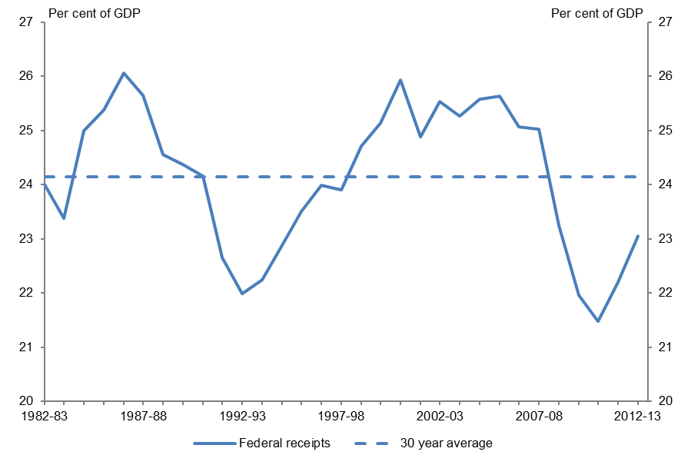
Sources: PBO based on data from the ABS and Treasury

Federal, state and local government tax receipts
The federal government collects the majority of taxation receipts in Australia, and federal government receipts are more volatile than state and local government receipts (Figure 2.2).
State taxes as a proportion of GDP were steadily increasing from 1982–83 (4.1 per cent of GDP) to 1999–00 (5.7 per cent of GDP). The abolition of a number of state taxes associated with the introduction of the Goods and Services Tax (GST) reduced state taxes to 4.6 per cent of GDP in
2000–01. Since then state taxes have gradually declined, reaching 4.0 per cent of GDP in 2012–13.
Local government tax receipts have not deviated significantly from 1 per cent of GDP since 1982–83.
Figure 2.2: Australia’s tax to GDP ratio by level of government
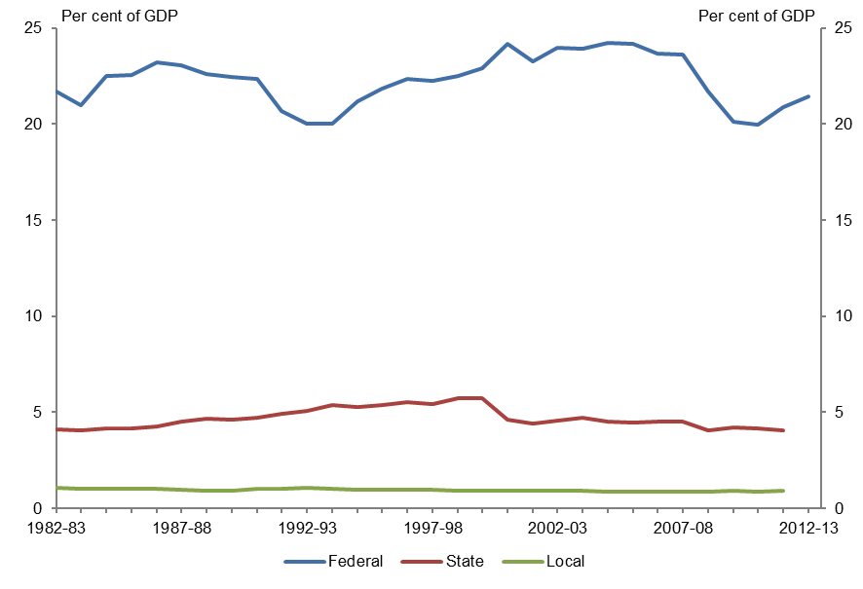
Sources: PBO based on data from the ABS, OECD and Treasury
Note: Excludes non-tax receipts. OECD data on state and local government tax receipts is not available for
2012–13. The GST is collected by the federal government and distributed to the state and territory governments. As such we have classified the GST as a federal tax.

Comparison of direct and indirect taxation
A common comparison of direct taxation between countries compares the proportion of direct taxes collected by all levels of government. Such comparisons have found that Australia’s reliance on direct taxes is similar to or slightly above the OECD average. However, international comparisons of direct taxation can be distorted by differing tax structures between countries. This is particularly relevant to Australia, as Australia does not collect social security contributions, whereas the majority of other OECD countries do. Rather, Australia requires compulsory contributions to be paid to superannuation accounts, which are not considered a tax. As social security contributions are considered a direct tax, international comparisons which incorporate social security contributions can distort the relativities between countries which do not utilise social security contributions, such as Australia.
A comparison of direct taxation excluding social security contributions indicates that Australia has a significantly higher reliance on direct taxation as a proportion of total taxes than the OECD average, and has done so since 1982–83 (Figure 2.3).
When state and local government tax receipts are excluded from the analysis, the proportion of direct taxes in Australia significantly increases from a 30 year average of 62.0 per cent to 73.1 per cent. This indicates that the federal government in Australia relies significantly more on direct taxes than state and local governments in Australia.
Figure 2.3: Direct taxes as a proportion of total taxes
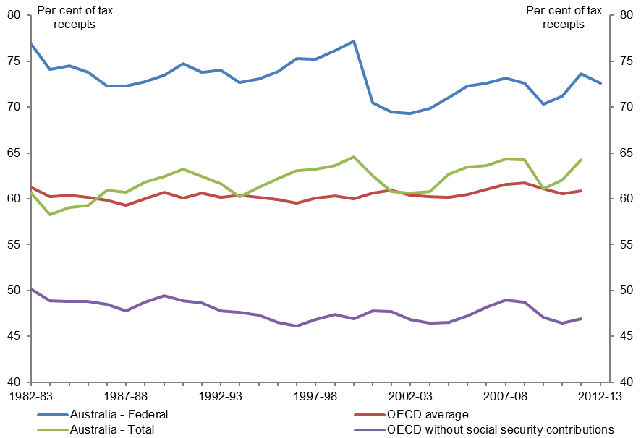
Sources: PBO based on data from the OECD and Treasury
Note: Excludes non-tax receipts. For Australia - Federal, direct taxes are given as a proportion of federal government tax receipts, and include personal income tax, company tax, fringe benefits tax, superannuation fund taxes and resource rent taxes. For Australia – Total and the OECD, direct taxes are given as a proportion of total government tax receipts and were calculated using the OECD’s Revenue Statistics – Comparative tables. For OECD average, direct taxes include taxes on income, profits and capital gains (category 1000), social security contributions (category 2000) and taxes on payroll and workforce (category 3000). For OECD without social security contributions and Australia – Total, direct taxes include taxes on income, profits and capital gains (category 1000) and taxes on payroll and workforce (category 3000). OECD data is not available for 2012–13. OECD averages are calculated as the unweighted means of the data values of all OECD countries for which data are available or can be estimated.
In 2012–13, direct taxes as a proportion of total taxes for the federal government had not changed significantly from the proportion in 1982–83, despite the introduction of the GST and associated personal income tax cuts. In 2012–13, direct taxes accounted for 72.6 per cent of total federal government receipts, 0.5 percentage points lower than the 30 year average of 73.1 per cent.

Components of federal government receipts
For the purposes of this report, the components of federal government receipts have been grouped into four categories: taxes on capital, taxes on labour, taxes on consumption and other taxes and charges. The revenue break down reported in government Budget documents cannot be strictly divided into these categories. Accordingly, the PBO has allocated the receipts data to the four categories, with the intention of providing a reasonable (yet imperfect) proxy for these categories.
Taxes on capital include company tax, resource rent taxes (including crude oil excise), taxes on superannuation earnings and capital gains tax; taxes on labour include personal income tax (excluding capital gains tax), fringe benefits tax and taxes on superannuation contributions; taxes on consumption include sales taxes, excise, import tariffs and other consumption taxes; and other taxes and charges include non-tax receipts and other taxes.
Figure 2.4: Major categories of federal government receipts as a proportion of total receipts
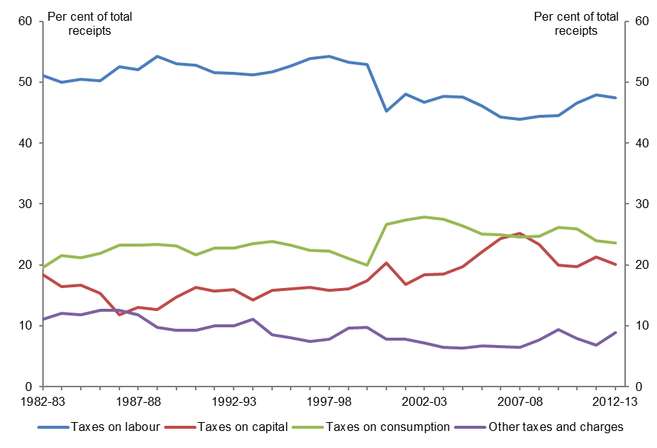
Source: PBO based on data from the Treasury
Taxes on capital were a slightly larger proportion of total tax receipts in 2012–13 than in 1982–83, increasing from 18.3 per cent of total receipts to 20.1 per cent (Figure 2.4 and Table 2.1). This has been driven by increases in company tax receipts which have almost doubled as a proportion of total receipts. This has occurred despite decreases to the company tax rate, and has been driven by base broadening measures and increasing company profits. Offsetting this, the contribution of resource rent taxes has fallen sharply since 1982–83, primarily reflecting reduced crude oil production.
Table 2.1: Components of federal government receipts
Component |  | 1982–83 |  |  |  | 2012–13
 |  | $bn | % GDP | % total |  | $bn | % GDP | % total
Taxes on capital |  | 8.3 | 4.4 | 18.3 |  | 70.4 | 4.6 | 20.1
Company tax |  | 4.8 | 2.5 | 10.6 |  | 66.9 | 4.4 | 19.1
Resource rent taxes |  | 3.5 | 1.8 | 7.7 |  | 2.3 | 0.1 | 0.6
Superannuation earnings tax |  | .. | .. | 0.1 |  | -2.0 | -0.1 | -0.6
Capital gains tax on individuals |  | - | - | - |  | 3.3 | 0.2 | 0.9
Taxes on labour |  | 23.2 | 12.2 | 51.0 |  | 166.6 | 10.9 | 47.5
Personal income tax |  | 23.2 | 12.2 | 51.0 |  | 153.0 | 10.0 | 43.6
Fringe benefits tax |  | - | - | - |  | 3.9 | 0.3 | 1.1
Superannuation contributions tax |  | - | - | - |  | 9.7 | 0.6 | 2.8
Taxes on consumption |  | 8.9 | 4.7 | 19.6 |  | 82.9 | 5.4 | 23.6
Sales taxes (GST and WST) |  | 3.5 | 1.8 | 7.7 |  | 48.6 | 3.2 | 13.8
Excise |  | 3.7 | 2.0 | 8.1 |  | 30.4 | 2.0 | 8.7
Import tariffs |  | 1.7 | 0.9 | 3.8 |  | 2.7 | 0.2 | 0.8
Other consumption taxes |  | - | - | - |  | 1.2 | 0.1 | 0.3
Other taxes and charges |  | 5.0 | 2.6 | 11.0 |  | 31.1 | 2.0 | 8.9
Non-tax receipts |  | 4.4 | 2.3 | 9.8 |  | 24.6 | 1.6 | 7.0
Other taxes |  | 0.6 | 0.3 | 1.3 |  | 6.5 | 0.4 | 1.9
Total receipts |  | 45.5 | 24.0 | 100.0 |  | 351.1 | 23.1 | 100.0
Sources: PBO based on data from the ABS and Treasury
Note: ‘..’ indicates the number is not zero but is rounded to zero. Components may not sum to totals due to rounding. Personal income tax excludes capital gains tax paid by individuals. Fringe benefits tax was introduced in 1986–87. Other consumption taxes include the luxury car tax and wine equalisation tax (WET), both of which did not exist in 1982–83.
Taxes on labour have remained the primary source of receipts for the federal government, although they have decreased from 51.0 per cent of total receipts in 1982–83 to 47.5 per cent in 2012–13. This has occurred despite the introduction of the fringe benefits tax and superannuation contributions tax, and has been driven by a decrease in the average tax rate and a decrease in the wage share of the economy.

Australia has increased its reliance on consumption taxes which have increased from 19.6 per cent of total receipts in 1982–83 to 23.6 per cent of total receipts in 2012–13. The introduction of the GST increased sales taxes from 9.3 per cent of total receipts in 1999–00, to a peak of 15.2 per cent in 2003–04. Since then reliance on consumption taxes has steadily declined, reflecting the impact of policy decisions and shifting consumption patterns on excise, tariff and GST receipts.
Other taxes and charges have declined from 11.0 per cent of total receipts in 1982–83 to 8.9 per cent of total receipts in 2012–13.

Summary
Federal government receipts have increased significantly since 1982–83, driven primarily by increasing economic activity. Taken as a proportion of GDP, receipts have fluctuated around the long-term average of 24.1 per cent, displaying no definitive upwards or downwards trend. In
2012–13, federal government receipts as a proportion of GDP were 1.0 percentage points ($15 billion) below the long-run average.
The federal government has been responsible for the majority of tax receipts in Australia over the past 30 years. State and local government tax receipts as a proportion of GDP have been relatively stable compared to federal government receipts.
Direct taxes as a proportion of total taxes for the federal government have not changed significantly since 1982–83, despite the introduction of the GST and associated personal income tax cuts. Further, the federal government has had a higher reliance on direct taxes than the state and local governments, as well as the OECD average, since 1982–83.
The federal government’s reliance on taxes on labour has decreased over the past three decades, largely reflecting decreases in personal income tax. This decrease has been offset by an increase in reliance on taxes on capital (driven by increased company tax receipts) and taxes on consumption (primarily as a result of the introduction of the GST).

3 Taxes on capital
This chapter explores trends in the federal government’s taxes on capital over the past three decades. Taxes on capital include company tax, resource rent taxes, superannuation earnings tax and capital gains tax (CGT). Taxes on capital have assumed greater importance over the past 30 years, rising from 4.4 per cent of GDP ($8.3 billion) in 1982–83 to 4.6 per cent of GDP ($70.4 billion) in 2012–13.

Company tax
Company tax receipts have grown strongly over the past 30 years, rising from 2.5 per cent of GDP ($4.8 billion) in 1982–83 to 4.4 per cent of GDP ($66.9 billion) in 2012–13 (Figure 3.1).
Figure 3.1: Company tax as a proportion of GDP
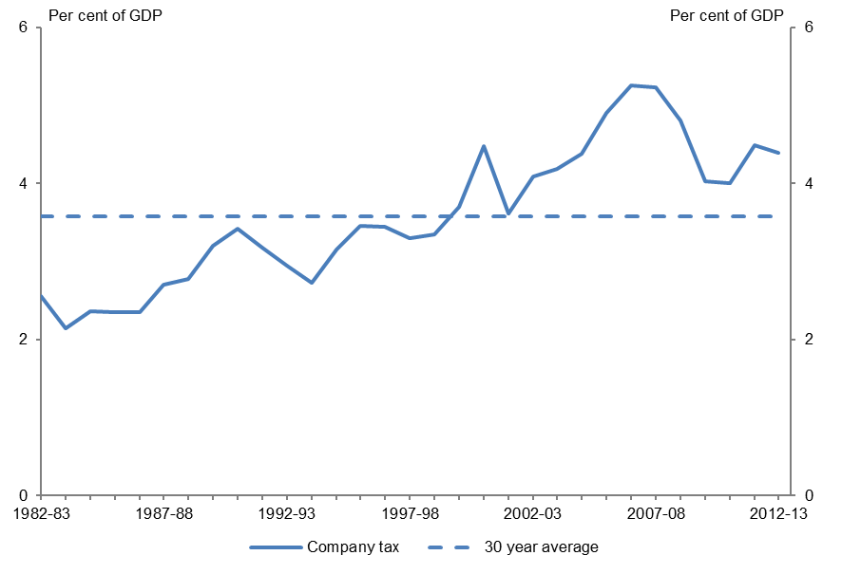
Sources: PBO based on data from the ABS and Treasury

Key policy developments
There have been a number of significant policy developments in the corporate tax system over the past 30 years, including several major policy reviews.
In particular, significant reductions in the statutory company tax rate over the past 30 years have been accompanied by measures designed to broaden the company tax base (such as reducing tax concessions) and improve the integrity of the system by removing opportunities for tax minimisation (Treasury 2013).
Measures to broaden the corporate tax base and improve compliance largely offset the impact of company tax rate reductions, so the proportion of company profits paid in income tax has not varied significantly over the past three decades (Figure 3.2).
Figure 3.2: Comparison of Australia’s statutory and effective company tax rate
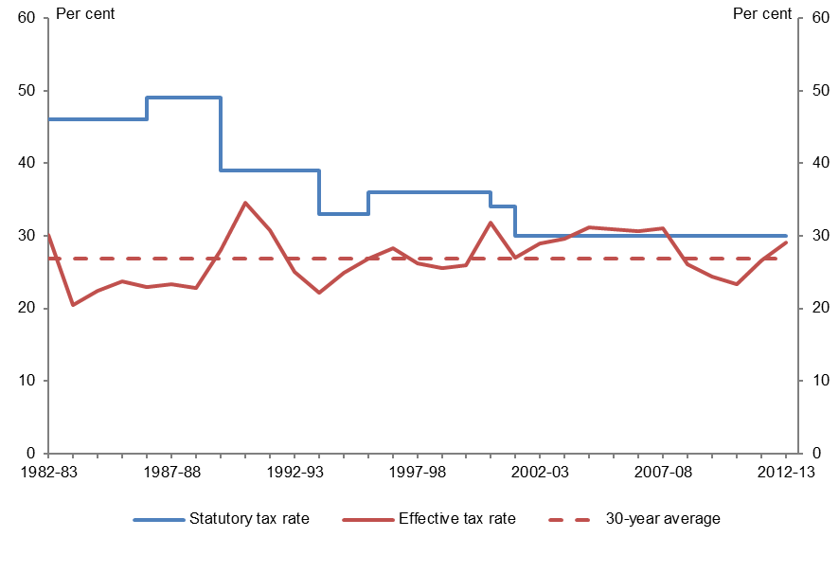
Sources: PBO based on data from the ABS and Treasury (2013)
Note: The effective company tax rate is the ratio of company tax receipts (excluding CGT) to net operating surplus (NOS). NOS has been calculated as gross operating surplus (for private companies) less consumption of fixed capital. CGT has been excluded from company tax because there is no simple way to include an appropriate measure of the income associated with CGT in NOS.
Australia has a long history of placing greater reliance on company tax than most other OECD countries (Smith 2009). This trend has become significantly more pronounced over the past three decades (Figure 3.3).

The direction of company tax policy in Australia over the past 30 years is broadly in line with that across the OECD, with considerable reductions in the statutory company tax rate being offset by a broadening of the corporate tax base (Treasury 2013). However, the net effect across the OECD has been a slight increase in company tax as a share of GDP rather than the significant increase in Australia, as explained below.
Figure 3.3: Company tax receipts as a proportion of GDP
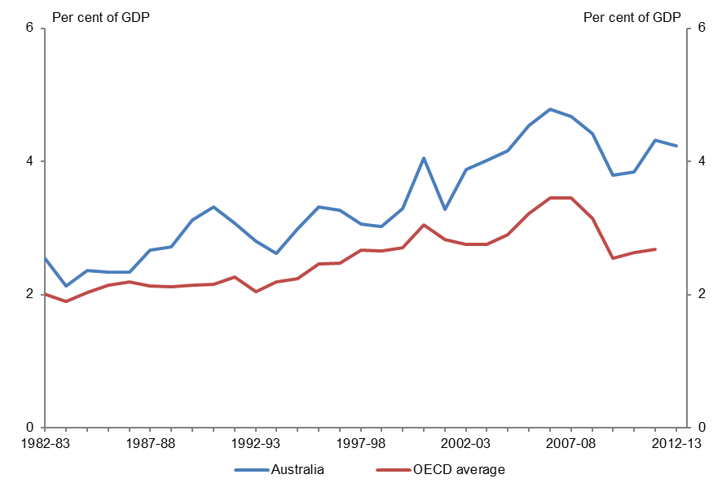
Sources: PBO based on data from the OECD, ABS and Treasury
Note: OECD figures are company taxes at the federal level only. Data for 2012–13 is not yet available. Figures for both the OECD and Australia exclude capital gains taxes. OECD figures are an unweighted average of all OECD countries for which data are available or can be estimated.

Trends in corporate tax receipts
The primary explanation for the growth in corporate tax receipts over the past 30 years is the growth of corporate income as a share of GDP.
Corporate gross operating surplus (a measure of corporate profitability) has grown from 15.2 per cent of GDP in 1982–83 to 22.8 per cent of GDP in 2012–13 (Figure 3.4).
There are two key factors underpinning this result. First, the profit share (the proportion of national income that is returned to capital) has risen over time. Second, the long run trend towards incorporation has resulted in more of the return to capital being recorded as corporate income.
Figure 3.4: Corporate Gross Operating Surplus (GOS) as a percentage of GDP
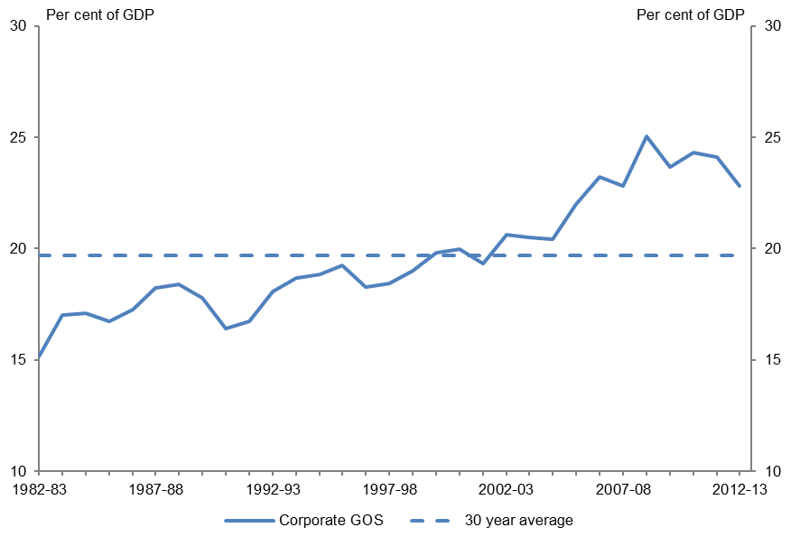
Source: PBO based on data from the ABS
Note: Corporate GOS is for private companies only and excludes public non-financial corporations.

Increase in profit share (capital)
Over the past 30 years, the profit share has risen over time, with a commensurate decline in the wage share (the proportion of national income received by labour).
The factors that have driven this result have varied over time.
A key objective of the Accord agreements between trade unions and the federal government in the 1980s was to reduce unemployment through wage restraint, thereby eliminating the ‘real wage overhang’ (Gregory 2004). The resultant wage restraint contributed to a steady increase in the profit share through the 1980s, partially reversing the decline in the 1970s.
Over the past decade, the surge in Australia’s terms of trade driven by increased demand for Australia’s principal mineral exports increased returns to Australia’s capital intensive mining sector. Among other things, this would be expected to result in an increase in the profit share (Henry 2006).
Over time, sustained increased demand for Australia’s principal mineral exports has translated into increased mining investment, increasing the capital intensive mining sector share of Australia’s production (Parkinson 2012). While this points to the profit share remaining elevated, the implications for corporate tax receipts, at least over the short term, are less clear cut (Parkinson 2011).

Trend towards incorporation
The long run trend towards incorporation by Australian business has also contributed to the increase in corporate tax receipts as a share of GDP (Figure 3.5), as more business profits are taxed as corporate rather than personal income.
Figure 3.5: Share of gross business profit (corporate and unincorporated businesses)
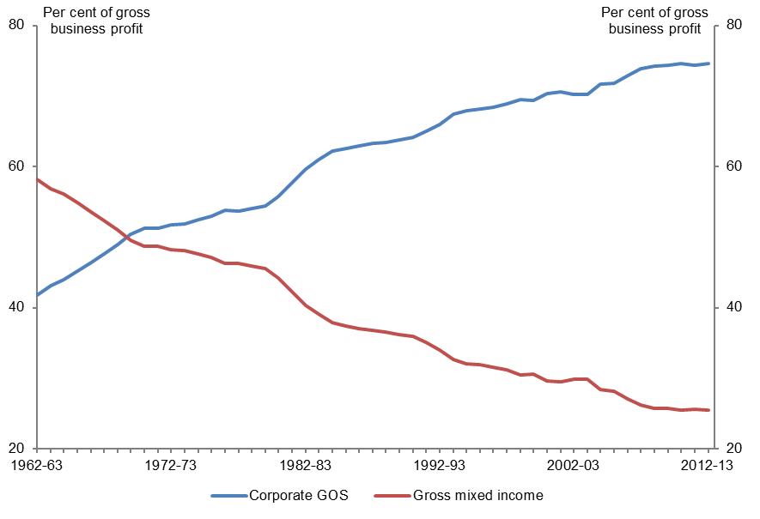
Source: PBO based on data from the ABS
Notes: Gross business profit represents the sum of corporate GOS and gross mixed income. Corporate GOS is for private companies only and excludes public non-financial corporations. Gross mixed income is a measure of the gross operating surplus for unincorporated enterprises and compensation accruing to the proprietors of these enterprises (Trewin 2000). The PBO has used a 5 year moving average to reflect the trend in the original series.

Resource rent taxes
Resource rent taxes, including crude oil excise, have fallen from 1.8 per cent of GDP in 1982–83 ($3.5 billion) to 0.1 per cent of GDP ($2.3 billion) in 2012–13 (Figure 3.6).
Figure 3.6: Resource rent taxes as a proportion of GDP
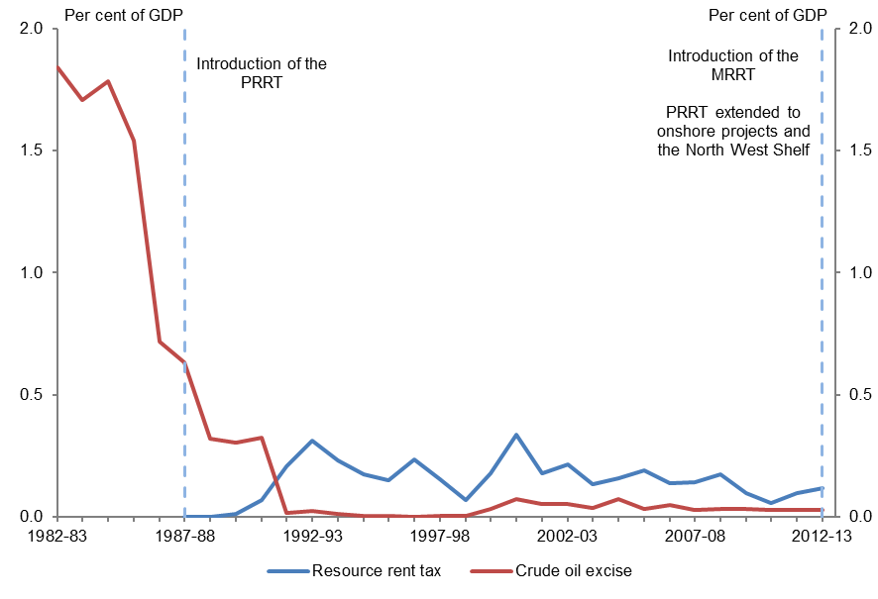
Sources: PBO based on data from the ABS, Bureau of Resources and Energy Economics (BREE) and Treasury
Note: Resource rent tax includes the Petroleum Resource Rent Tax (PRRT) and in 2012–13 the Minerals Resource Rent Tax (MRRT). Crude oil excise figures are not publicly available from 2007–08 onwards. The PBO has estimated these using Australian petroleum production statistics from BREE.

Key policy developments
Crude oil excise was placed on Australian offshore-oil production following the significant increase in oil prices in the mid-1970s, with the objective of redistributing to the community some of the gains producers received from increased world prices (Webb 2001).
As crude oil excise only applies to Australian production of crude oil, it can be thought of as a tax on capital in general, and a resource rent tax in particular, rather than a tax on consumption (Henry et al. 2009).
With the commencement of the Petroleum Resource Rent Tax (PRRT) in 1987–88, and the transfer of Bass Strait production to the PRRT regime in 1990–91, the crude oil excise regime has been of relatively limited application since that time.
In 2012–13, the PRRT was extended to onshore oil and gas projects and the North West Shelf and a Minerals Resource Rent Tax (MRRT) was applied to profits from the extraction of iron ore, coal and some coal seam gas in Australia.

Trends in resource rent tax receipts
Two key elements have driven resource rent receipts: the level of production covered by the tax and the price received.
The primary factor driving the decline in the federal government’s resource rent receipts over the past 30 years is the sharp reduction in oil production. In 1983–84 crude oil production in Australia was 162 million barrels, contributing 12.0 per cent of Australia’s GDP. By 2012–13 this had fallen to 86 million barrels, or 0.9 per cent of GDP.
Resource rent tax receipts have also fluctuated over time, reflecting the significant volatility of commodity prices, in particular the crude oil price.
Resource rent receipts in 2012–13 include MRRT net receipts of $0.2 billion (Australian Government 2013).

Superannuation fund taxes
Prior to 1988–89, superannuation funds were generally not subject to tax, with tax primarily applied on the benefits received by members. From 1988–89, superannuation funds have been subject to income tax on contributions received on behalf of members, and investment income (including capital gains), generally at the rate of 15 per cent.
Conceptually, this means that tax paid by superannuation funds is a combination of a tax on labour (in relation to contributions made in the current year) and a tax on capital (in relation to investment earnings). Accordingly, contributions tax has been included in the labour tax aggregates and earnings tax has been included in taxes on capital aggregates in this paper. However, this section encompasses analysis of both contributions and earnings taxes to provide a complete picture of trends in superannuation fund taxes.

Key policy developments
The main policy developments affecting superannuation funds relate to measures that substantially expanded the proportion of employees with superannuation coverage by requiring employers to make superannuation contributions on behalf of their employees.
From 1986, industrial awards required a 3.0 per cent employer superannuation contribution to be paid to an industry fund (APRA 2007). This was effectively extended to almost all employers with the introduction of the Superannuation Guarantee in 1992–93. Moreover, the superannuation contribution rate was increased to nine per cent, phased in over a decade.
In addition to the major taxation developments noted above, there have also been a number of other changes to the taxation arrangements for superannuation funds over recent decades. Most notably, from 1 July 2007, payments made from a taxed fund to individuals aged 60 and above became tax free, and earnings on assets supporting superannuation pensions for individuals aged 60 and above were generally exempted from tax.

Growth of the superannuation system
The proportion of employees with superannuation coverage in their main job has increased from 40 per cent in 1984–85 (prior to award superannuation), 72 per cent in 1991–92 (prior to the introduction of the Superannuation Guarantee) to 90 per cent in 2012–13 (Figure 3.7).
Over time, the effects of increasing superannuation coverage and the superannuation contribution rate have resulted in significant growth in the level of assets managed by superannuation funds. As the superannuation system has matured, superannuation assets have increased from around 17 per cent of GDP ($32 billion) in 1982–83 to 106 per cent of GDP ($1,619 billion) in 2012–13 (Figure 3.7).
Figure 3.7: Superannuation assets as a proportion of GDP, superannuation coverage and SG rate
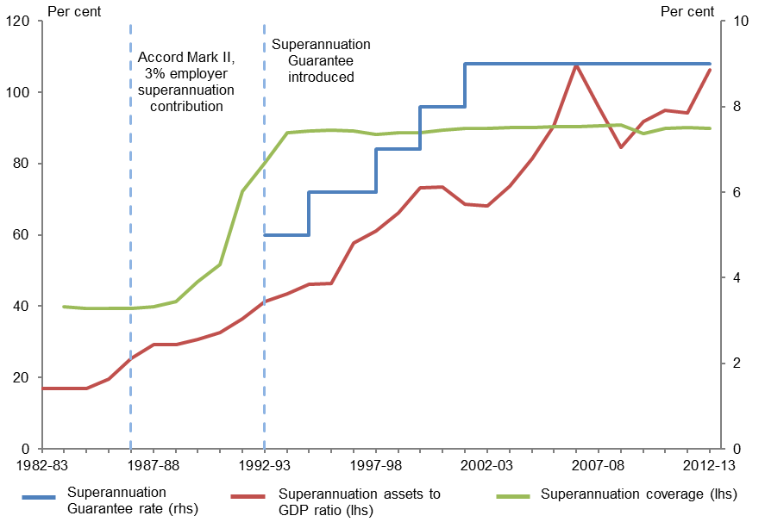
Sources: PBO based on data from the ABS, APRA and ATO
Note: The Superannuation Guarantee rate presented is the rate applying to employers with a national payroll in excess of $1 million. A lower rate applied to other employers until 1996–97. The Superannuation Guarantee rate was 4 per cent from 1 July 1992 to 31 December 1992, and 5 per cent from 1 January 1993 to 30 June 1993. The rate presented in the chart in 1992–93 is the average of these rates (4.5 per cent). Superannuation coverage indicates the proportion of employees with superannuation contributions paid into a superannuation scheme on their behalf by their employer in their main job.
Despite the significant level of assets managed by superannuation funds (106 per cent of GDP in 2012–13), superannuation fund tax receipts (at 0.5 per cent of GDP in 2012–13) are relatively small. This reflects the significant tax concessions for superannuation contributions and earnings.

Trends in superannuation tax receipts
Total superannuation fund taxes have grown steadily since 1988–89, reaching a peak of 1.0 per cent of GDP in 2007–08, before declining with the onset of the global financial crisis (GFC) to 0.5 per cent of GDP ($7.7 billion) in 2012–13 (Figure 3.8).
Figure 3.8: Superannuation fund taxes as a proportion of GDP
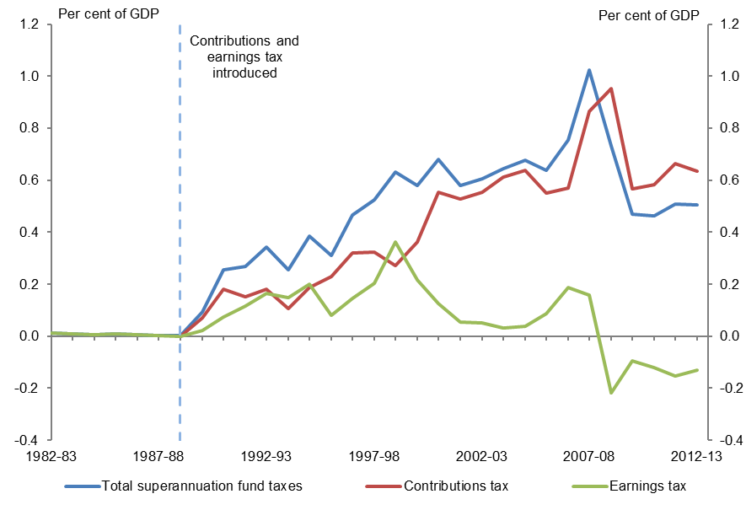
Source: PBO based on data from the ABS, ATO and Treasury
Note: Contributions tax has been estimated by the PBO and includes estimated tax on assessable contributions less death and disability insurance premiums, as well as superannuation surcharge receipts.
The growth in superannuation taxes primarily reflects increases in contributions over time as the superannuation system has matured. Contributions tax as a proportion of GDP steadily increased from 1988–89 to 2000–01. Since 2000–01, contributions tax has been relatively stable at around 0.6 per cent of GDP, except for a spike in 2007–08 and 2008–09, attributable to transitional arrangements for contribution limits.
Notwithstanding the considerable growth in superannuation assets over the period, earnings tax receipts have generally been lower and more volatile than contributions tax receipts. There are three factors underpinning this outcome.
First, investment earnings of superannuation funds include fully franked dividends paid by Australian companies. Superannuation funds receive franking credits on these dividends to reflect the tax already paid on this income at the company level. This reduces the effective tax rate on dividend income to the statutory rate of superannuation funds. As a result of franking credits becoming refundable in 2000–01, earnings tax receipts have been negative in some years (Figure 3.9).
Second, earnings tax receipts reflect the volatility of investment earnings. This is particularly evident in relation to the period since the onset of the GFC, where on average superannuation fund investment returns have generally been low or negative.
Third, a significant proportion of superannuation fund investment earnings are taxed at less than the standard 15 per cent rate. The discount on capital gains for assets held for a minimum of 12 months results in an effective tax rate on capital gains of 10 per cent for superannuation funds. In addition, earnings from assets supporting pension incomes are exempt from tax.
Figure 3.9: The effect of franking credits on earnings tax
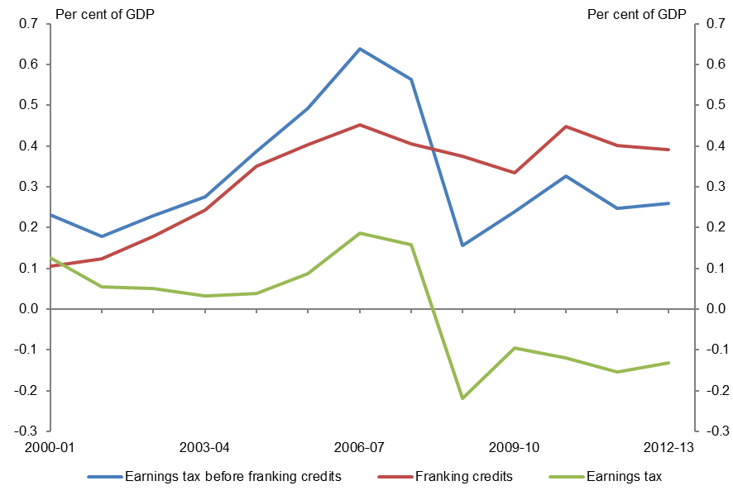
Source: PBO based on data from the ABS, ATO and Treasury
Note: Data for franking credits prior to 2000–01 is unavailable as some rebates related to dividend income were included in total rebates and credits and were not separately identified.

Capital gains tax (CGT)
In 2012–13, CGT receipts were $7.1 billion, which was 0.5 per cent of GDP.
CGT was introduced from 20 September 1985 and applies to most assets acquired on or after this date. CGT is generally levied on the gains made from the disposal of assets. Several types of assets are exempt from CGT, including the sole or principal place of residence (the family home).
The term CGT is somewhat of a misnomer, as it is not a separate tax but rather part of the income tax system. As such, CGT collections are included in company, superannuation fund and personal income tax receipts. For the purpose of this report, CGT has been excluded from personal income tax receipts and included in capital tax aggregates (along with CGT paid by companies and superannuation funds).

Key policy developments
The most significant change to the CGT system over the past 30 years occurred in 1999 with the implementation of the recommendations of the Review of Business Taxation (the Ralph Review).
Previously, CGT only applied to gains made on the disposal of an asset after taking into account the effect of inflation (that is, the real gain). From 1999, the indexation of the cost of the asset was replaced with a general discount that effectively halved the CGT rate for capital gains for individuals and reduced the CGT rate for superannuation funds to 10 per cent. The CGT discount does not apply to capital gains made by companies.

Trends in CGT receipts
A significant contributor to the increase in CGT receipts in the early part of the period of analysis is the maturing of the CGT system. As CGT is only applicable to assets acquired on or after 20 September 1985, the proportion of asset disposals that are subject to CGT has increased over time as assets are transferred between owners and become subject to CGT.
CGT receipts have exhibited a high degree of volatility more recently, rising from 0.5 per cent of GDP in 2003–04 to peak at 1.6 per cent of GDP in 2007–08 before falling to around 0.5 per cent of GDP in 2010–11 (Figure 3.10). The drivers of this volatility are explained in more detail below.
Figure 3.10: CGT receipts as a proportion of GDP
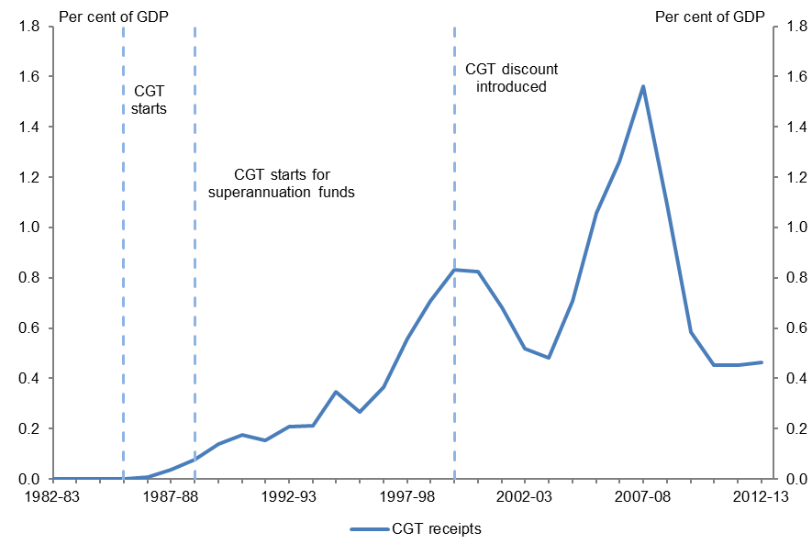
Sources: PBO based on data from the ABS and Treasury
Note: CGT became applicable to superannuation funds with the introduction of the 15 per cent tax on earnings implemented from 1 July 1988.

Distribution of CGT
The distribution of CGT has changed markedly over time (Figure 3.11). Before 2002–03, companies were responsible for the highest proportion of CGT receipts. However since then individuals have become the largest payers of CGT.
In 2012–13, almost half of CGT receipts came from individuals, around a third from companies and the remainder from superannuation funds.
In 2006–07, immediately prior to the onset of the GFC, superannuation funds accounted for the largest share of net capital gains by value (36 per cent), ahead of individuals (33 per cent) and companies (31 per cent). Despite this, CGT receipts from superannuation funds have generally been lower than those from companies and individuals, reflecting the lower tax rate applying to their capital gains.

Figure 3.11: Source of CGT receipts
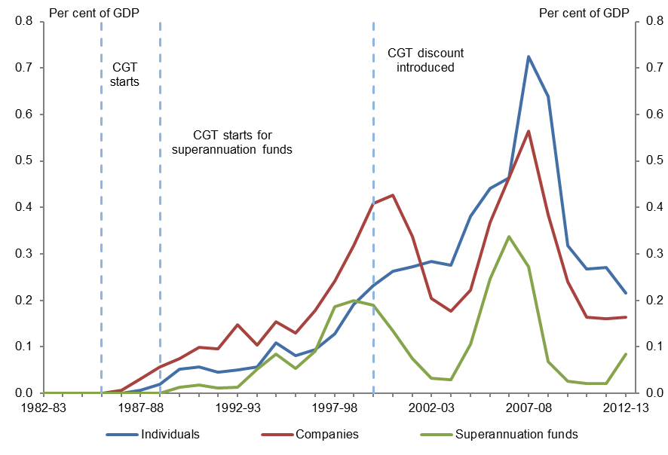
Sources: PBO based on data from the ABS and Treasury
Note: CGT became applicable to superannuation funds with the introduction of the 15 per cent tax on earnings implemented from 1 July 1988.

CGT receipts and asset price growth
As CGT is broadly levied on the profit from the disposal of an asset, CGT receipts are also closely related to asset price movements, including equity and property price movements.
The key factors determining CGT receipts are the pace of growth in the price of assets held by taxpayers, and the length of time these assets are held.
Figure 3.12 shows the composition of total capital gains by asset type over the period 2000–01 to 2010–11.
In 2010–11 (the latest year for which data is available) around 60 per cent of taxable capital gains were attributable to shares. This reliance on shares for capital gains was particularly strong for companies (with 60 per cent of total gains coming from shares) and superannuation funds (with 88 per cent of total gains coming from shares). Capital gains for individuals were more evenly spread between shares and property, with both accounting for around 40 per cent of total gains (ATO 2013).

Figure 3.12: Composition of total capital gains by asset type (income year basis)
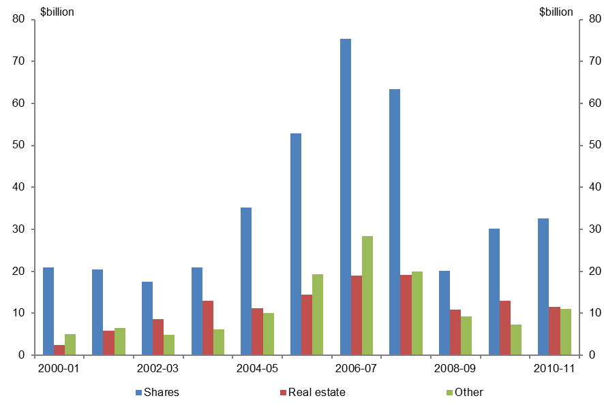
Source: PBO based on data from the ATO
Note: This data is sourced from the CGT schedule which is generally only required where a taxpayer’s current year capital gains or capital losses are greater than $10,000 and so does not include all capital gains. The data includes capital gains made by taxable entities only and does not account for capital losses. 2000–01 is the earliest year for which comparable data is available.
As the largest proportion of capital gains is attributable to shares, CGT receipts are highly dependent on equity prices. In turn, the volatility in equity prices is one of the key factors underpinning the volatility in CGT receipts (Figure 3.13).
In particular, the extremely strong growth in CGT receipts from 2003–04 to 2007–08 reflected sustained strong growth in equity prices. The subsequent sharp decline in equity prices following the GFC saw a fall in CGT receipts of over 1.0 per cent of GDP, or two thirds of CGT receipts.
Another factor that can influence CGT receipts over time is the level of utilisation of carried forward capital losses within the system. As capital losses can only be used to offset capital gains, any net capital loss is carried forward to offset future capital gains, thereby reducing the tax payable on subsequent capital gains of that taxpayer.
The level of unused capital losses grew sharply following the GFC, more than doubling from 8.8 per cent of GDP in 2007–08 to 20.8 per cent of GDP in 2008–09 (Clark & Hollis 2013).

Figure 3.13: CGT and growth in the All Ordinaries index
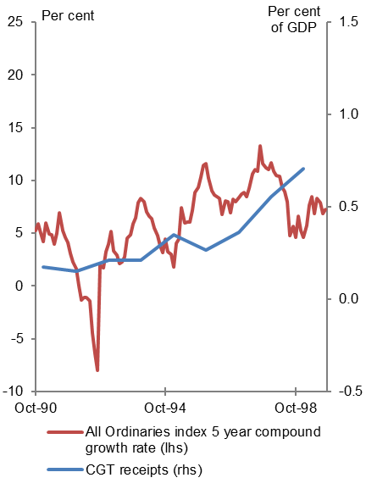 | 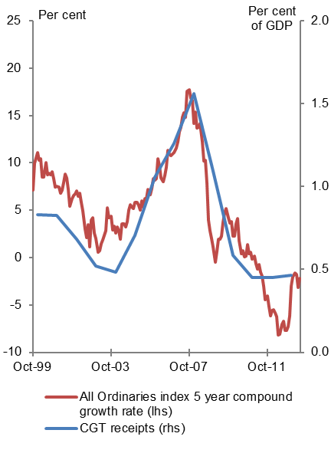
Sources: PBO based on data from the ABS, Parliamentary Library and Treasury
Note: Data begins five years after the introduction of CGT to allow for a five year asset holding period. Annual CGT receipts are allocated to the mid-point of each year. Two graphs are presented to allow for the changed relationship between equity price growth and CGT receipts following the introduction of the CGT discount.

Summary
Taxes on capital have increased as a proportion of GDP over the past three decades, primarily reflecting increased company tax receipts.
Overall, Australia’s historically high reliance on corporate tax compared with other OECD countries increased over the past 30 years.
The primary driver of increased company tax receipts is an increase in the corporate profit share, reflecting an increase in the profit share of national income, particularly as a result of the surge in Australia’s terms of trade from 2003–04.
Superannuation fund taxes are relatively small (0.5 per cent of GDP in 2012–13) relative to the assets under management (over 100 per cent on GDP in 2012–13), and are primarily attributable to taxes on contributions (classified as a tax on labour). Superannuation earnings tax receipts have been negative in recent years, reflecting the combined effect of low investment earnings in the wake of the global financial crisis, more concessional tax rates on capital gains and assets supporting pensions, and franking credits reducing the effective tax rate on dividend income to the statutory rate of superannuation funds.
With the introduction of the CGT, taxes on capital have become more volatile, reflecting medium term trends in asset prices, particularly share prices.
The growth in taxes on capital over the past three decades was constrained by a sharp reduction in resource rent taxes (including crude oil excise), reflecting a sharp reduction in oil production as a share of the economy over this period.

This page is left blank intentionally.

4 Taxes on labour
Taxes on labour for the purpose of this report include personal income tax (including the Medicare Levy but excluding CGT), superannuation contributions tax and fringe benefits tax. Taxes on labour decreased from 12.2 per cent of GDP ($23.2 billion) in 1982–83 to 10.9 per cent ($166.6 billion) in 2012–13.

Personal income tax
In 2012–13, personal income tax receipts (excluding CGT) as a proportion of GDP were 10.0 per cent ($153.0 billion).
Personal income tax as a proportion of GDP has fluctuated since 1982–83, but has generally trended downwards (Figure 4.1), decreasing from 12.2 per cent of GDP in 1982–83 to 10.0 per cent in 2012–13 (1.3 percentage points below its 30 year average of 11.3 per cent).
Figure 4.1: Personal income tax as a proportion of GDP
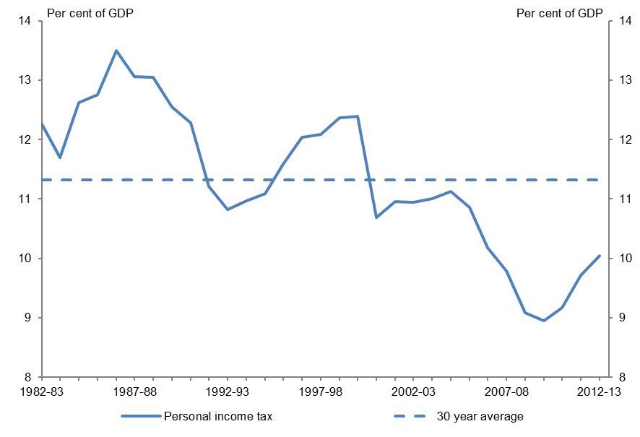
Sources: PBO based on data from the ABS and Treasury

Key policy developments
Personal income tax rates and thresholds have changed significantly since 1982–83 (Table 4.1). Marginal tax rates have generally decreased, and tax thresholds have increased. This trend has also been evident in other OECD countries (Torres et al. 2012). In Australia, changes to tax rates and thresholds have been particularly noticeable for higher incomes, with the top marginal tax threshold increasing from $35,788 (or $141,955 in 2012–13 dollars) to $180,000, and the top tax rate decreasing by 15 percentage points. On the other hand, some significant tax offsets have been targeted at lower income earners. In particular, the Low Income Tax Offset (LITO) increases the effective tax free threshold of lower income earners to $20,542.
Table 4.1: Personal income tax rates and thresholds
1982–83 |  |  | 1982–83 |  |  | 2012–13
Taxable Income  (1982-83 $) | Marginal tax rate  (%) |  | Taxable Income  (2012-13 $) | Marginal tax rate  (%) |  | Taxable income  (2012-13$) | Marginal tax rate  (%)
0 – 4,462 | 0 |  | 0 - 17,699 | 0 |  | 0 – 18,200 | 0
4,463 – 17,894 | 30.67 |  | 17,700 - 70,978 | 30.67 |  | 18,201 – 37,000 | 19
17,895 – 19,500 | 35.33 |  | 70,979 - 77,348 | 35.33 |  | 37,001 – 80,000 | 32.5
19,501 – 35,788 | 46 |  | 77,349 - 141,955 | 46 |  | 80,001 – 180,000 | 37
35,789 + | 60 |  | 141,956 + | 60 |  | 180,001 + | 45
Sources: PBO based on data from the ATO and the ABS
Note: The rates and thresholds presented in the table applied to resident taxpayers. Separate rates and thresholds applied to non-residents. The Medicare Levy is not included as different thresholds and rates apply in different circumstances. The table also excludes the effects of tax offsets, such as the low income tax offset. The 1982–83 thresholds in 2012–13 dollars have been indexed using Male Total Average Weekly Earnings (MTAWE).
There have also been a number of structural changes to the personal income tax system, including:
- The introduction of a 1 per cent Medicare Levy on 1 February 1984,
- The inclusion of capital gains in assessable income from 20 September 1985 (and the subsequent introduction of the 50 per cent CGT discount on 20 September 1999), and
- The provision of dividend imputation from 1986–87, providing a tax offset for the company tax paid on dividends distributed to resident individuals.

Trends in personal income tax
The decline in personal income tax receipts as a proportion of GDP over the past 30 years can be attributed almost equally to two key factors. First, the combined impact of reductions in marginal tax rates and increases in tax thresholds over the past three decades has resulted in a reduction in the average tax rate on personal income. Second, the share of national income received by labour (the wage share) has declined over time.

Reduction in the average tax rate on personal income
Personal income tax as a proportion of GDP has had a strong correlation with the average tax rate (Figure 4.2). Changes to the average tax rate primarily reflect changes to the tax rates and thresholds over the period.
Australia has a progressive personal income tax system, with higher marginal tax rates applying to higher incomes. In the absence of explicit government policy decisions, average tax rates and personal income tax collections increase as a result of bracket creep. Changes to the marginal tax rates and thresholds and the availability of tax offsets over the past 30 years have resulted in a 2.4 percentage point ($17.2 billion in 2012–13) reduction in the average tax rate, from 23.3 per cent in 1982–83 to 20.9 per cent in 2012–13, indicating that these tax cuts have more than offset bracket creep. These tax cuts have typically been linked to broader policy initiatives, including:
- Significant tax cuts delivered in the late 1980s and early 1990s in conjunction with the Prices and Income Accords (agreements between the Australian Council of Trade Unions and the federal government) encouraged wage growth restraint, partly in exchange for lower taxes.
- Tax cuts provided as compensation for the introduction of the GST in 2000–01 and the carbon pricing mechanism in 2012–13.
- Tax cuts delivered throughout the 2000s were intended to increase labour force participation and improve international competitiveness.
Figure 4.2: Comparison of personal income tax as a proportion of GDP and the average tax rate
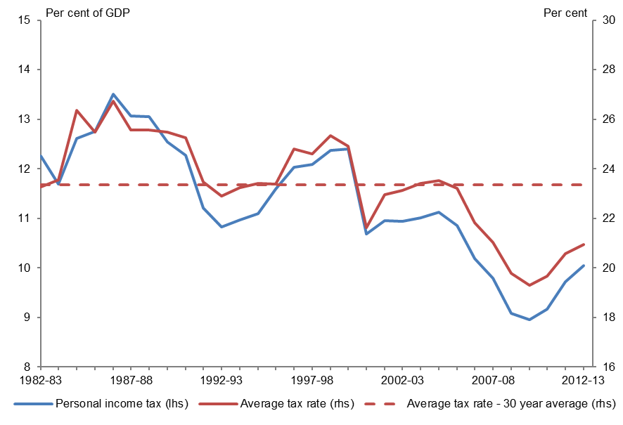
Sources: PBO based on data from the ABS, ATO and Treasury
Note: Taxable income has been derived from ATO data and adjusted for late lodging individuals. It excludes net capital gains.

Decrease in the wage share
Personal income tax receipts have also been affected by a decrease in the wage share over the past three decades, with a decrease in the amount of taxable income (excluding net capital gains) reported in personal income tax returns of 4.6 percentage points of GDP ($14.7 billion), from over 52 per cent of GDP in 1982–83 to 48 per cent of GDP in 2012–13 (Figure 4.3). Factors underpinning movements in the wage and profit shares of national income were discussed in Chapter 3.
Figure 4.3: Personal income tax and taxable income as a proportion of GDP
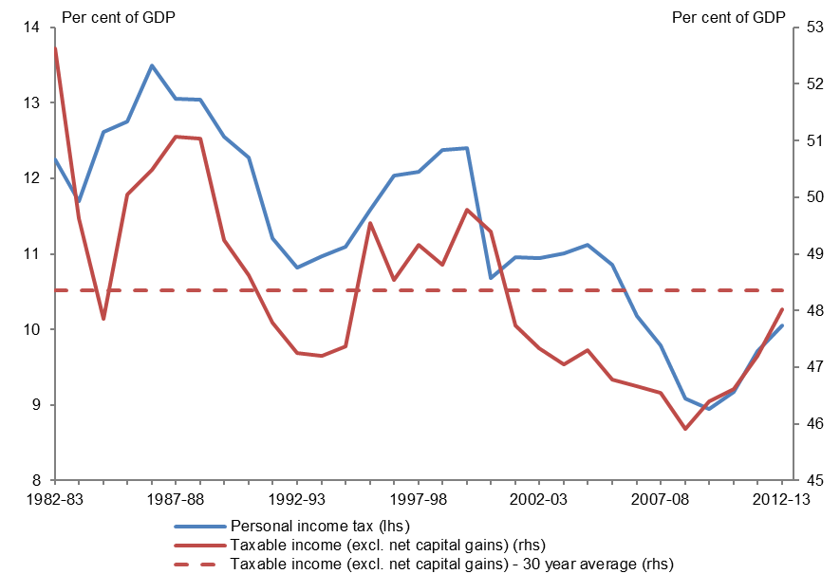
Sources: PBO based on data from the ABS, ATO and Treasury
Note: Taxable income has been derived from ATO data and adjusted for late lodging individuals. It excludes net capital gains.

Distribution of income tax cuts
There have also been significant changes in the distribution of personal income tax over the past three decades, reflecting changes in both rates and thresholds.
While the top marginal tax rate has decreased significantly since 1982–83, the marginal tax rate (inclusive of the Medicare Levy) faced by an individual on Male Total Average Weekly Earnings (MTAWE) has increased from 30.67 per cent in 1982–83 to 34 per cent in 2012–13 (Figure 4.4). The average tax rate for an individual earning MTAWE has decreased from 22.9 per cent to 21.9 per cent.
Figure 4.4: Marginal and average tax rates on Male Total Average Weekly Earnings
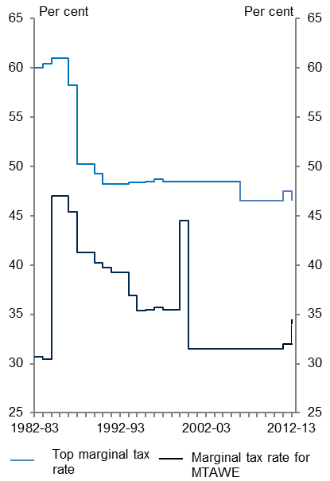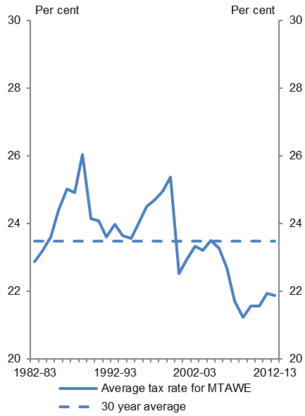
Sources: PBO based on data from the ABS and ATO
Note: The tax rates in this analysis include the Medicare Levy, the gun buy-back levy and the Flood Levy. The Medicare Levy surcharge is not included in the calculations.
The top marginal tax threshold as a proportion of MTAWE has significantly increased over the period, from around two times MTAWE in 1982–83 to 2.6 times in 2012–13 (Figure 4.5). This reflects changes in the top tax threshold in the 2000s, where the threshold increased from $60,000 in 2002–03 to $180,000 in 2008–09.
The proportion of persons filing a tax return subject to the top marginal tax rate has fluctuated throughout the period as a result of these changes and bracket creep (Figure 4.6). In 2012–13, this proportion was 2.5 per cent, significantly lower than the long-term average of 6.7 per cent and the high in 1999–00 of 14.3 per cent, but similar to the level in 1982–83 (2.0 per cent), when the top marginal tax rate was 60 per cent.
Figure 4.5: Top personal income tax threshold as a multiple of MTAWE | Figure 4.6: Proportion of tax filers subject to the top personal income tax rate
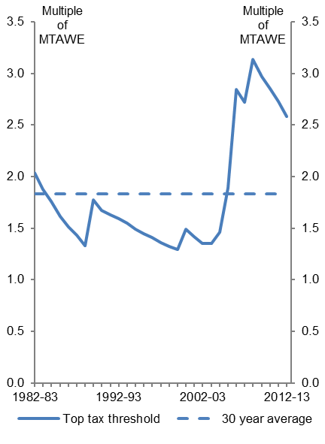 | 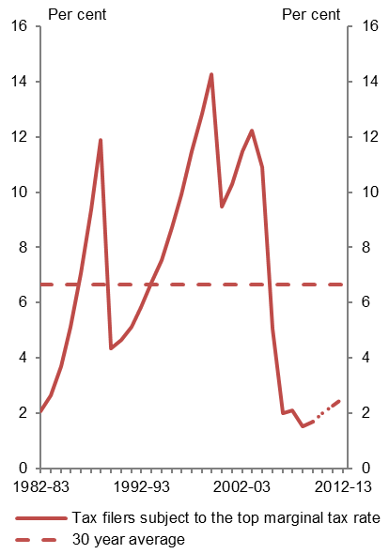
Sources: PBO based on data from the ABS and ATO
Note: Data on the number of individuals filing a tax return subject to the top marginal tax rate for 2011–12 and 2012–13 was estimated using the PBO’s personal income tax microsimulation model.

Fringe benefits tax (FBT)
In 2012–13, receipts from FBT were 0.26 per cent of GDP ($3.9 billion).
In 1987–88, the first full year of FBT receipts, FBT as a proportion of GDP was 0.27 per cent, similar to its 2012–13 level. However, FBT as a proportion of GDP increased to a high of 0.57 per cent in
1995–96, before gradually decreasing to its 2012–13 level (Figure 4.7).
Figure 4.7: FBT as a proportion of GDP
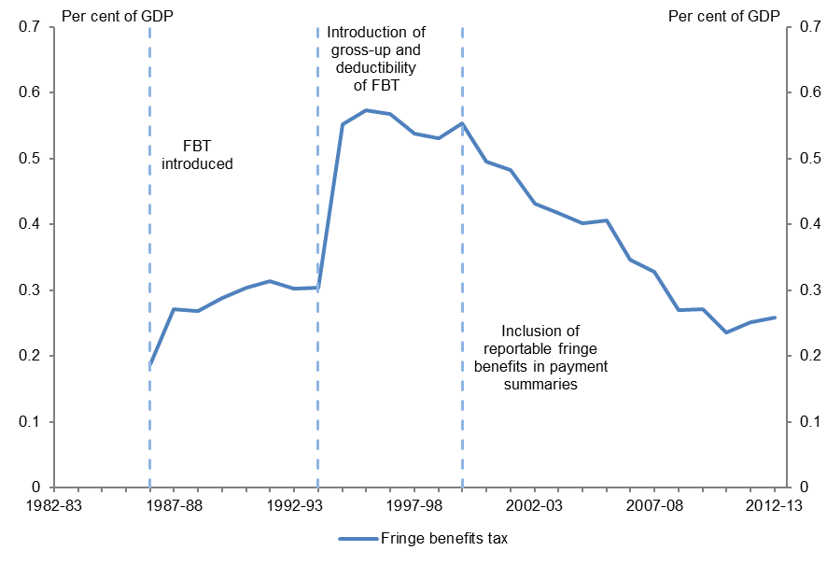
Sources: PBO based on data from the ABS and Treasury

Key policy developments
FBT in Australia is levied on employers, and separately taxes most non-cash remuneration to employees. Accordingly, given the link to employee remuneration, FBT is considered a tax on labour for the purposes of this report. The financial year for FBT runs from 1 April to 31 March.

The FBT rate
FBT was introduced in Australia in 1986–87, and the rate was initially set at 46 per cent to align with the company tax rate. In 1987–88, the rate was increased to 49 per cent, aligning with the top personal income tax rate. The FBT rate remained aligned with the top personal income tax rate until 1992–93, when the 1.25 per cent Medicare Levy was added to the rate, increasing it from 47 per cent to 48.25 per cent. In 1994–95 the FBT rate was increased to 48.4 per cent, accounting for an increase in the Medicare Levy to 1.4 per cent. In 1995–96, the FBT rate was increased to 48.475 per cent to reflect a higher 1.5 per cent Medicare Levy and 48.5 per cent for in 1996–97. The rate has since remained aligned with the top marginal personal income tax rate plus the Medicare Levy.

Administrative changes
FBT has experienced two significant administrative reforms since its introduction. These are the gross-up of the taxable value of fringe benefits and deductibility of FBT on 1 April 1994, and the inclusion of reportable fringe benefits in payment summaries from 1 April 1999.
Prior to 1 April 1994, the gap between the company tax rate and the FBT rate meant that the FBT system effectively created an incentive for corporate employers to compensate some employees via fringe benefits rather than salary and wages. From 1 April 1994 the taxable value of fringe benefits was grossed-up, and FBT was made a deductable expense for company tax purposes, removing this incentive. The gross-up factor is based on the FBT rate.
The second major administrative change to the FBT system was the introduction of reportable fringe benefits. Prior to 1999–00, fringe benefits received by an employee were not considered income for a number of means tested programs. From 1999–00, reportable fringe benefits were included in employees’ Pay-As-You-Go payment summaries and incorporated into the means tests for these programs, reducing the incentive for individuals to receive remuneration in the form of fringe benefits.

Trends in FBT
The reforms introduced on 1 April 1994 resulted in a significant increase in the FBT to GDP ratio from 0.30 per cent in 1993–94 to 0.55 per cent in 1994–95, as the taxable values of fringe benefits were almost doubled due to the gross-up factor. However, the deductibility of FBT has reduced taxable incomes for companies, resulting in a decrease in company tax receipts.
There has been a steady decline in FBT since the inclusion of fringe benefits in means tests under the reportable fringe benefits regime in 1999–00, from 0.55 per cent per cent of GDP in 1999–00 to 0.26 per cent in 2012–13. However the decline in fringe benefits tax receipts over this period is not reflected in the value of fringe benefits reported over this period, or in the proportion of individuals receiving fringe benefits (Figure 4.8).
While there are possible explanations for these apparently divergent trends, the detailed additional analysis required to resolve this question is beyond the scope of this report.
Figure 4.8: Take-up of fringe benefits over time
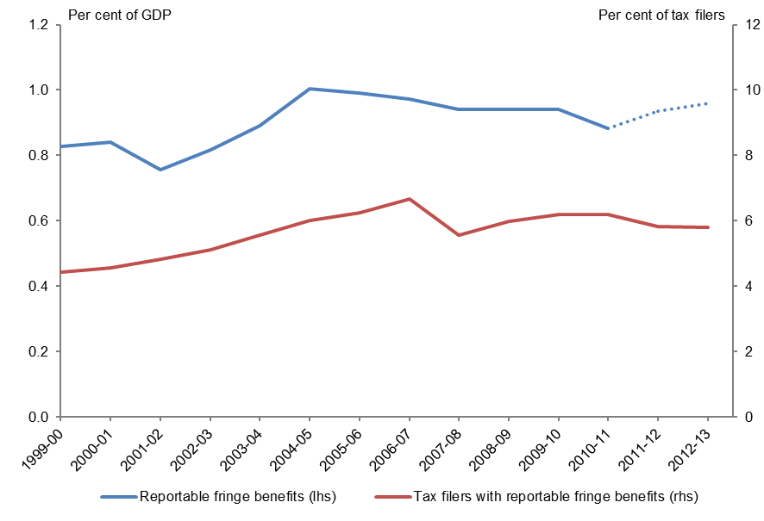
Source: PBO based on data from the ABS, ATO and Treasury
Note: Reportable fringe benefits for 2011–12 and 2012–13 were estimated using the PBO’s personal income tax microsimulation model.

Summary
Taxes on labour as a proportion of GDP have decreased since 1982–83, reflecting in approximately equal parts a reduction in the average tax rate on personal income (as threshold increases and tax rate cuts since 1982–83 have more than offset bracket creep) and a decrease in the wage share of the economy.
In 2012–13, FBT as a proportion of GDP was similar to the proportion when FBT was introduced. However, FBT as a proportion of GDP was more than double this level in the late 1990s, and has since been declining. This has occurred despite an increase in the number of individuals receiving, and value of, reportable fringe benefits since 1999–00. Further research is needed to determine the details of the drivers of the decrease in FBT as a proportion of GDP since 1999–00.

5 Taxes on consumption
The federal government applies a number of different indirect taxes, primarily targeted at consumers, including sales taxes, excise duties and import tariffs.
Taxes on consumption have assumed greater importance over the past 30 years, rising from 4.7 per cent of GDP ($8.9 billion) in 1982–83, peaking at 7.1 per cent of GDP ($56.9 billion) in
2002–03, before declining to 5.4 per cent of GDP ($82.9 billion) in 2012–13.
This chapter examines the factors underpinning this trend.

Sales taxes
For the purposes of this paper, sales taxes are defined as wholesale sales tax (WST) and the Goods and Services Tax (GST).
Sales taxes have increased in importance over the past three decades (Figure 5.1), rising from 1.8 per cent of GDP ($3.5 billion) in 1982–83 (WST) to 3.2 per cent of GDP ($48.6 billion) in 2012–13 (GST).
Figure 5.1: Sales taxes as a proportion of GDP
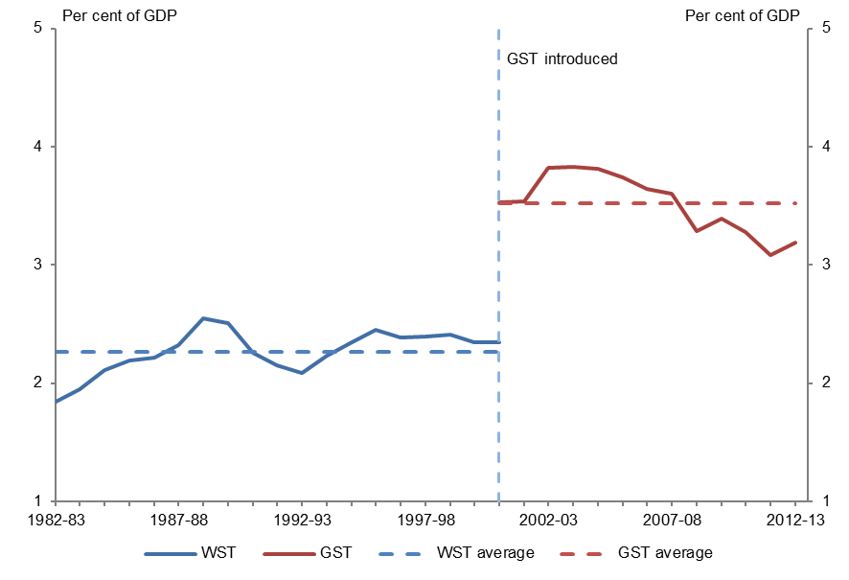
Sources: PBO based on data from the ABS and Treasury

Key policy developments
The main policy development in sales tax over the past three decades was the introduction of a 10 per cent GST on 1 July 2000 and the related repeal of the WST.
The GST was introduced in part to address the limitations of the WST, in particular the relatively narrow base, complexity and numerous tax rates of the WST (Australian Government 1998).
Prior to its abolition, the federal government periodically implemented measures to offset the impact of its declining tax base on WST receipts, primarily involving increases in wholesale tax rates (particularly in the 1982–83 and 1993–94 Budgets (Australian Government 1982 & 1993)).
The rate and base of the GST remain substantially the same as when it was introduced. Net GST revenue is distributed to the states and territories.

Trends in sales taxes
From 1982–83 to 1999–00 (prior to the introduction of the GST), the WST to GDP ratio was relatively steady (between 2.0 per cent and 2.5 per cent of GDP), as successive rate increases broadly offset the impact of the decline in the WST tax base.
The introduction of the GST immediately increased the sales tax to GDP ratio from 2.3 per cent in 1999–00 to 3.5 per cent in 2000–01, peaking at almost 3.8 per cent in 2003–04 as the system matured, an increase of around 1.3 per cent of GDP. However, subsequently around half of this increase has been unwound, as GST receipts have fallen to be around 3.2 per cent of GDP in 2012–13.
There are two key factors underpinning this decline: the decline in consumption as a share of GDP and a shift in the consumption patterns away from goods and services subject to GST.

Declining consumption, rising household saving
The GST was introduced at a time when consumption was a historically high share of GDP, and the household saving ratio was at historical lows (Figure 5.2).
The decline in Australia’s household saving ratio coincided with a period of strong growth in household wealth and indebtedness (Treasury 1999, Edey & Gower 2000).
Over the past decade consumption has fallen as a share of GDP, from being well above to well below its long run average, while the household saving ratio has reversed its long run decline, returning to just below its 1982–83 level. The reduction in the consumption share over the past decade reflects moderation of consumption from historically high levels at the time of the GST’s introduction as well as temporary factors in response to the global financial crisis (Freestone et al. 2011, Bishop & Cassidy 2012).
The fall in GST receipts over the past decade in part reflects an uncharacteristically high starting point which was not representative of longer term consumption and savings behaviour. The decline in the consumption share explains around half of the decline of GST/sales tax as a percentage of GDP over the past decade.
Figure 5.2: Household consumption and savings
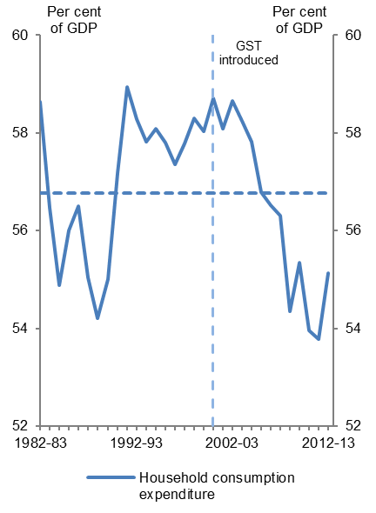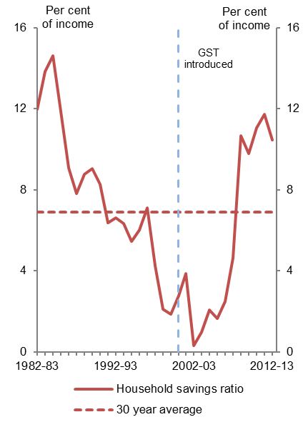
Source: PBO based on data from the ABS
Note: The household savings ratio represents household savings as a percentage of disposable income.

Changing consumption patterns
Another reason for the decline in GST receipts is that households now spend a lower proportion of their income on goods which are covered by the GST than they did when the GST was introduced.
The proportion of consumption subject to GST in Australia is around the OECD average but lower than in a number of comparable countries (Henry et al. 2009, OECD 2008 & 2012). This reflects policy decisions to exclude from Australia’s GST base a number of categories of goods and services, including health and education, rent and housing services, and other items such as fresh food.
This means that, in addition to the overall level of consumption, the level of GST receipts is also affected by the proportion of household consumption expenditure on items that are subject to GST.
The share of household consumption expenditure subject to GST has fallen significantly since the introduction of the GST, from around 61 per cent in 2000–01 to less than 56 per cent in 2012–13 (Figure 5.3). This reduction explains around half of the decline in GST/sales tax as a percentage of GDP over the past decade.
This reduction in the value of consumption subject to GST is not reflected in the volume of consumption subject to GST, which has remained relatively stable over the period (Figure 5.3). This means that the reduction in consumption subject to GST has been driven primarily by the price(s) of goods and services excluded from the GST rising faster than price(s) of goods and services subject to the GST.
Figure 5.3: Proportion of household expenditure subject to GST
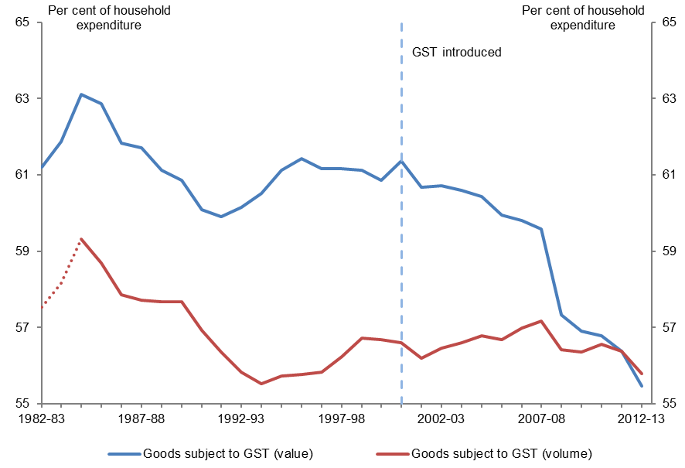
Source: PBO based on data from the ABS
Note: The volume of goods subject to GST prior to 1984–85 is not available. The PBO has estimated data prior to 1984–85 by assuming that the differential between value and volume measures were consistent with their
1984–85 level.
To understand what is underpinning this trend it is useful to examine the components of GST-excluded expenditure over the past 30 years (Figure 5.4).
There is a long run trend increase in the share of household expenditure on health and education. Similarly, the proportion of household expenditure spent on rent and housing services has also increased over time. This accelerated noticeably following the introduction of the GST.
On the other hand, the share of household spending on other items excluded from the GST declined over the first two decades (pre GST), before stabilising over the past decade (post GST).
The extent to which consumption trends of the past decade continue into the future (or indeed stabilise or reverse) will have important implications for GST revenue into the future.
Figure 5.4: Proportion of household expenditure GST excluded categories
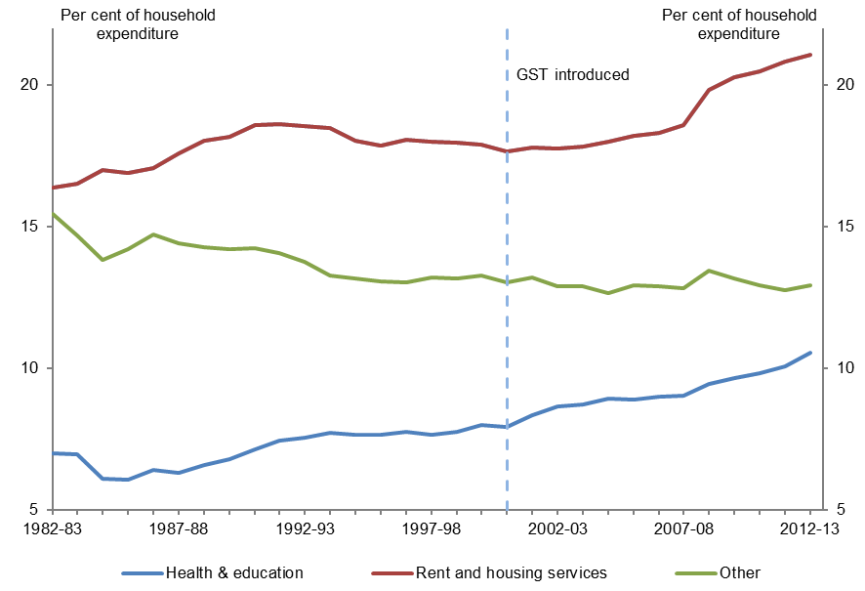
Source: PBO based on data from the ABS
Note: Other includes certain food and some financial services.

Excise
Excise is levied on certain goods produced in Australia, primarily fuel (petrol and diesel) and other petroleum products, tobacco and alcohol (excluding wine, which is instead subject to the Wine Equalisation Tax (WET). An excise-equivalent customs duty applies to imports of these goods to ensure they are treated consistently with locally produced goods. Refunds or credits generally apply where goods subject to excise are subsequently exported or used as an input to business production.
Overall, this means that while excise is notionally levied on the production of goods, it is best thought of as a consumption tax as it is effectively targeted at Australian consumption of goods.
An important exception to this is the crude oil excise placed on Australian production following the significant increase in oil prices in the mid-1970s that was subsequently replaced with the Petroleum Resource Rent Tax (PRRT) (Webb 2001, Trebeck et al. 2001). As such, for the purposes of this paper the crude oil excise is classified as a tax on capital rather than a tax on consumption, and is considered in the section on Resource Rent Taxes in Chapter 3.
Figure 5.5: Excise as a proportion of GDP
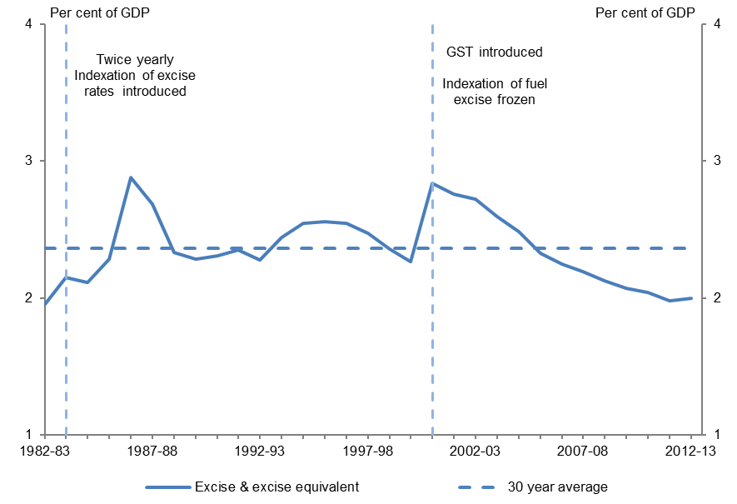
Source: PBO based on data from the Treasury
Note: Excludes excise on crude oil and LPG production which has been included in the section on resource taxation. Includes excise-equivalent customs duty.

Key policy developments
There have been a number of significant developments in excise over the past 30 years.
Excise in Australia is typically a fixed amount for the volume of production (consumption). This means that historically regular adjustments were made to the rate of excise in order to maintain the level of the tax in real terms (James 1996, Trebeck et al. 2001).
From August 1983, excise rates were indexed to inflation, with automatic increases twice a year to maintain the level of excise in real terms (Reinhardt & Steel 2006, James 1996, Henry et al. 2009).
From August 1988 the method of calculating beer excise was changed to a per litre of alcohol (on the volume of alcohol content which exceeds 1.15 per cent) basis. This change involved a reduction in excise on normal strength beer of around 50 per cent (RBA 1996).
There were significant increases in excise rates on fuel over and above indexation during the 1980s driven by the need to maintain revenue to offset falling receipts from excise on crude oil (Trebeck et al. 2001).
Tobacco excise was changed from a weight-based to a per stick rate for most tobacco products from 1 November 1999, leading to an increase in price for some tobacco products (Australian Government 2005). Tobacco excise rates were increased by 25 per cent from midnight on 29 April 2010.
Excise rates were adjusted in 2000 with the introduction of the GST to achieve a number of price increase targets in the transition to A New Tax System (Australian Government 1998).

In the case of petrol and diesel, the excise rate was cut by 6.656 cents to offset the price impact of the GST. The excise on petrol and diesel was cut by a further 1.5 cents per litre in March 2001 and indexation of fuel excise rates ceased as part of a package of decisions relating to fuel taxation (Trebeck et al. 2001).
The excise rate on alcohol products was increased to achieve a price increase for alcohol equal to the general estimated inflation impact of the GST package (Australian Government 1998).

Trends in excise receipts
Excise receipts (excluding crude oil) were 2.0 per cent of GDP ($30.4 billion) in 2012–13, the same as the 2.0 per cent of GDP ($3.7 billion) received in 1982–83 (Figure 5.5).
Despite this, excise receipts were far from stable over the past three decades, reaching a peak of 2.8 per cent of GDP in 2000–01, before steadily declining over the past decade.
This variation reflects the impact of policy changes (to both increase and decrease real excise rates on certain goods) and a shift in consumption away from goods subject to excise, with significant differences in the trends in excise receipts between fuel products (such as petrol and diesel) and alcohol and tobacco (Figure 5.6).
Figure 5.6: Fuel, alcohol and tobacco excise
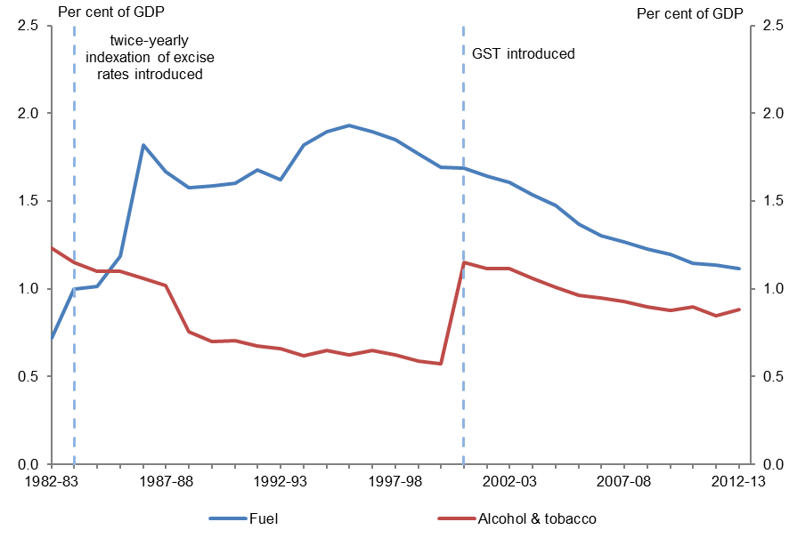
Source: PBO based on data from the Treasury and ABS
Note: The alcohol and tobacco data includes excise equivalent duty. The PBO has estimated tobacco receipts for 2012–13 as data are not publicly available.

Fuel Excise Trends
Many commentators have noted the impact of the decision to stop the indexation of fuel excise rates in 2001 on the real rate of fuel excise, and overall excise collections. Indeed, since this time excise on fuel has declined from 1.7 per cent of GDP in 2000–01 to just over 1 per cent in 2012–13. The Department of the Treasury (Treasury) has estimated that had the fuel excise rates in place in 2001 continued to be indexed fuel excise would be around $6.7 billion higher in 2013–14 (Clark & Hollis 2013).
However, in real terms the rate of fuel excise in 2012–13 was substantially higher than the rate prevailing in 1982–83 (Figure 5.7). This reflects the impact of a number of discretionary increases in fuel excise in the 1980s over and above the indexation to the Consumer Price Index (CPI) introduced to offset falls in crude oil excise receipts and to finance expenditure on roads (Trebeck et al. 2001).
Over time, without indexation or discretionary policy increases, the real rate of fuel excise will continue to decline in the future.
Figure 5.7: Fuel excise rate compared to CPI
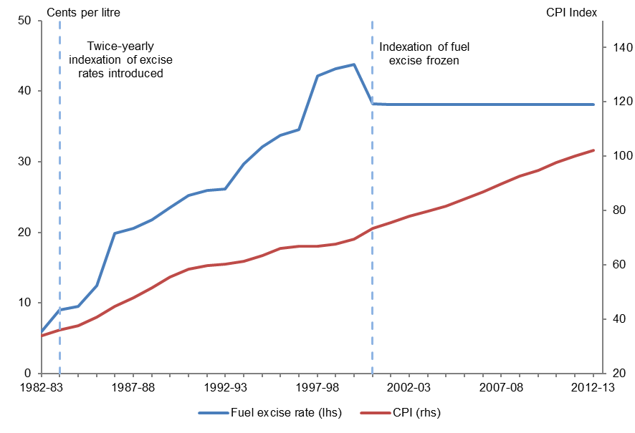
Source: PBO based on data from the ABS, James (1996), Webb (2001) and the Treasury
Note: The average annual excise rate for unleaded petrol has been used to calculate the excise rate series.

Trends in alcohol and tobacco excise
The long run trend decline in excise receipts from tobacco and alcohol reflects a long run shift in consumption away from these goods. In particular, household consumption of tobacco has fallen steadily over the past three decades, reflecting a decline in the proportion of the adult population who smoke (Scollo & Winstanley 2012). The decline in the level of alcohol consumption over this period is less stark than that of tobacco. There has been an increase in the share of alcohol consumption that is not subject to excise, primarily due to increased consumption of wine (Clark & Hollis 2013).
This long run trend was interrupted in 2000, as tobacco shifted to per stick excise in 1999 and alcohol excise rates increased in 2000 to avoid an effective tax cut on the abolition of the wholesale sales tax (which taxed alcohol at a higher rate than the GST). Together, this resulted in alcohol and tobacco excise increasing from 0.6 per cent of GDP in 1999–00 to 1.1 per cent of GDP in 2000–01. Subsequently, the long run decline in alcohol and tobacco excise resumed, declining to just over 0.9 per cent of GDP in 2012–13.

Import tariffs
Receipts from tariffs on imported goods have fallen steadily over the past three decades, from 0.9 per cent of GDP ($1.7 billion) in 1982–83 to 0.2 per cent of GDP ($2.7 billion) in 2012–13 (Figure 5.8).
The primary driver of this decline has been very substantial reductions in import tariffs over the period, with the majority of tariffs cut to around 5 per cent, with tariffs on textiles, clothing and footwear scheduled to be reduced to 5 per cent by 2015 (Garnaut 2002, Henry et al. 2009).
Figure 5.8: Import tariff receipts as a proportion of GDP
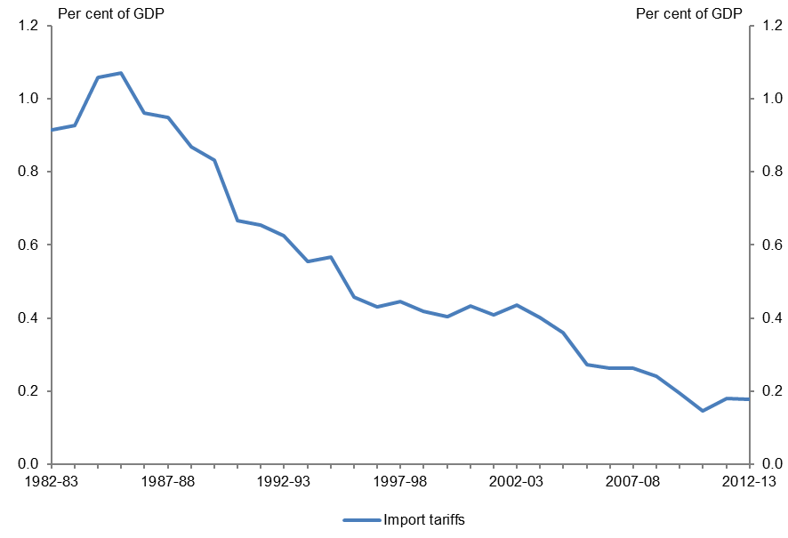
Sources: PBO based on data from the Treasury and ABS

Other consumption taxes
Other indirect taxes primarily targeted at consumers include the WET and the Luxury Car Tax.

Wine equalisation tax (WET)
The WET was introduced from 1 July 2000 to ensure consistency with the taxation arrangements that had applied under the former wholesale sales tax (Henry et al. 2009). The WET is a 29 per cent tax on the wholesale value of wine consumed in Australia, with producers entitled to a rebate of the WET on sales up to a maximum of $500,000 per year.
In 2000–01, the initial year of collections, WET receipts (net of the producer rebate) were 0.07 per cent of GDP ($0.5 billion), rising to peak at 0.08 per cent of GDP in 2001–02, steadily declining to be 0.05 per cent of GDP ($0.7 billion) in 2012–13.

Luxury car tax
The luxury car tax was introduced in 2000–01 to avoid an effective tax cut on higher priced cars on the abolition of wholesale sales tax (Henry et al. 2009).
Luxury car tax receipts were around 0.02 per cent of GDP in 2000–01 (its first year of operation), with receipts remaining relatively stable since then, fluctuating between 0.03 and 0.04 per cent of GDP.

Summary
Over the past 30 years, taxes on consumption have increased as a proportion of GDP, from 4.7 per cent of GDP in 1982–83, peaking at 7.1 per cent of GDP in 2002–03, before declining to 5.4 per cent of GDP in 2012–13.
The main reason for this increase was the introduction of the Goods and Services Tax (GST) in
2000–01, which increased sales tax receipts from 2.5 per cent (under the WST) in 1999–00, to a peak of 3.8 per cent of GDP in 2003–04.
Subsequently, about half of this increase in GST has been reversed, reflecting the decline in consumption as a share of GDP from its historically high level when the GST was introduced, and an increase in the proportion of household consumption on items excluded from the GST base.
Excise receipts in 2012–13 were the same as a proportion of GDP as they were in 1982–83. However, in between these two points excise receipts have fluctuated significantly as a proportion of GDP.
Fuel excise rose sharply through the 1980s, reflecting increases in excise rates in excess of inflation. Since the cessation of fuel excise indexation in 2001 the real value of fuel excise has declined. However, in real terms the fuel excise in 2012–13 remains above its level of 1982–83.
There has been a long run trend decline in excise from alcohol and tobacco. The only significant interruption to this trend was around the turn of the century, with the shift to per stick tobacco excise and increase in alcohol excise rates to avoid an effective tax cut on the abolition of wholesale sales tax.
There was a sharp reduction in tariff receipts on imported goods over the past three decades, reflecting very substantial reductions in import tariffs.

6 Other taxes and charges
Other taxes and charges include non-tax receipts and tax receipts not included in the classifications in previous chapters. Other taxes and charges decreased from 2.6 per cent of GDP ($5.0 billion) in 1982–83 to 2.0 per cent of GDP ($31.1 billion) in 2012–13.

Non-tax receipts
Non-tax receipts of the federal government comprise interest receipts, dividend receipts and receipts from the sale of goods and services and other non-tax receipts.

Trends in non-tax receipts
Non-tax receipts fell from 2.3 per cent of GDP ($4.4 billion) in 1982–83 to 1.6 per cent of GDP ($24.6 billion) in 2012–13 (Figure 6.1). There were significant fluctuations in non-tax receipts over the past three decades, ranging between a low of 1.3 per cent of GDP in 2011–12 to a peak of 2.9 per cent of GDP in 1986–87, with the long run average just below 2.0 per cent of GDP.
Figure 6.1: Non-tax receipts as a proportion of GDP
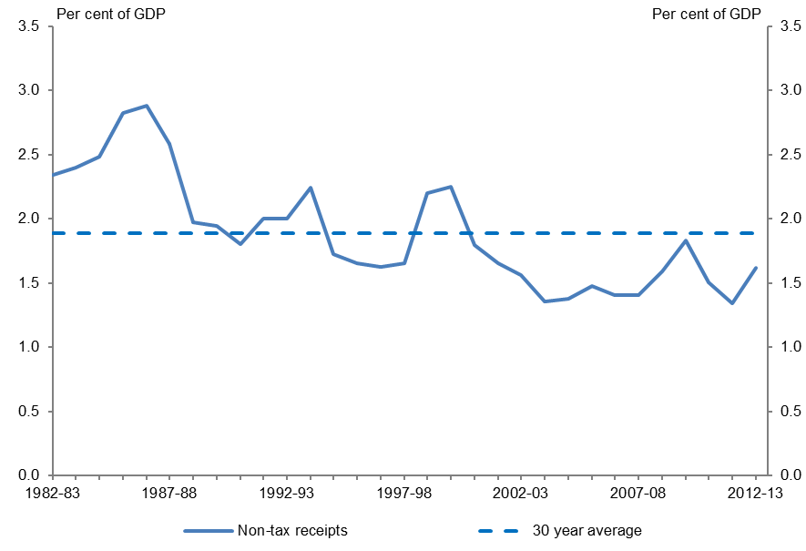
Sources: PBO based on data from the ABS and Treasury

Interest
The decline in non-tax receipts over the past three decades is more than explained by the reduction in interest receipts, from a peak of 1.4 per cent of GDP in 1982–83 to a low of 0.1 per cent in 1998–99, to be slightly above 0.2 per cent in 2012–13 (Figure 6.2).
Figure 6.2: Non-tax receipts by component as a proportion of GDP
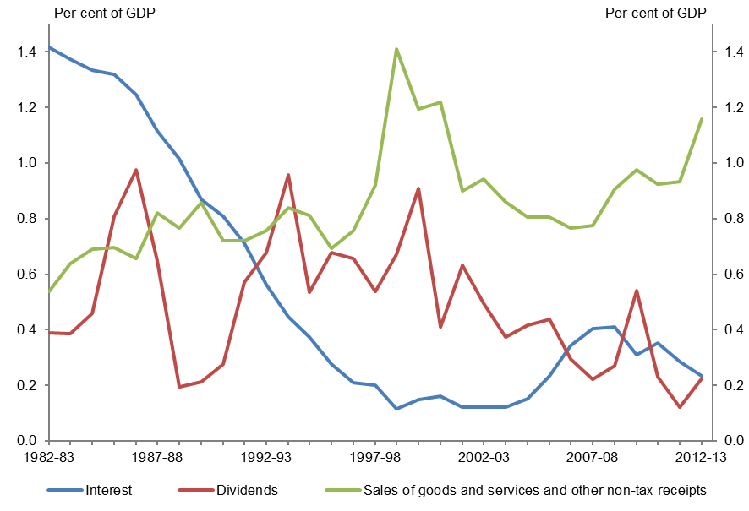
Sources: PBO based on data from the ABS and Treasury
Note: Sales of goods and services and other non-tax receipts data for the period 1982–83 to 1998–99 is based on unpublished ABS data. In 1999–2000, sales of goods and services and other non-tax receipts are calculated by subtracting interest receipts reported in the 2001–02 Budget papers and dividend receipts reported in unpublished ABS data from total non-tax receipts. This method is continued from 2000–01 onwards using interest and dividend receipts reported in Final Budget Outcomes.
A key factor contributing to the fall in interest receipts as a proportion of GDP was a decline in interest received from state governments by the federal government.
At the start of the period the federal government borrowed on behalf of the states, receiving interest payments from state governments to reimburse the additional public debt interest outlays incurred.
From 1986 new borrowings on behalf of the states ceased and from 1990 the states began making additional debt retirement payments to redeem outstanding debt upon maturity (AOFM 2013). This resulted in a steady reduction in interest receipts from the states, with a broadly commensurate reduction in the federal government’s public debt interest outlays.
An additional factor contributing to the decline in interest receipts over this period was the conversion in 1989–90 of debt owed to the federal government by Telecom (later Telstra) and Australia Post to equity as part of the corporatisation process (Australian Government 1989).

Interest receipts increased as a proportion of GDP from 2003–04 to 2008–09, as budget surpluses were placed on deposit with the Reserve Bank of Australia (RBA) to meet short-term liquidity needs. This reflected the decision to maintain the Commonwealth Government Securities market, including ensuring sufficient securities remained on issue to support the Treasury bond futures market
(Australian Government 2003).
Interest receipts have fallen somewhat since 2008–09, reflecting lower interest rates in Australia and globally in the wake of the global financial crisis (GFC) and an increasing proportion of Future Fund assets held in non-interest bearing securities (Future Fund 2009 to 2013).

Dividends
The federal government receives dividends from government business enterprises (such as Australia Post and Medibank Private), the RBA and equity investments of the Future Fund.
Dividends received by the federal government fell from 0.4 per cent of GDP ($0.7 billion) in
1982–83 to 0.2 per cent of GDP ($3.4 billion) in 2012–13. However there were very significant fluctuations in dividend receipts over this period, ranging between a low of 0.1 per cent of GDP in 2011–12 to a peak of 1.0 per cent of GDP in 1986–87 (Figure 6.3).
Figure 6.3: Dividend receipts as a proportion of GDP
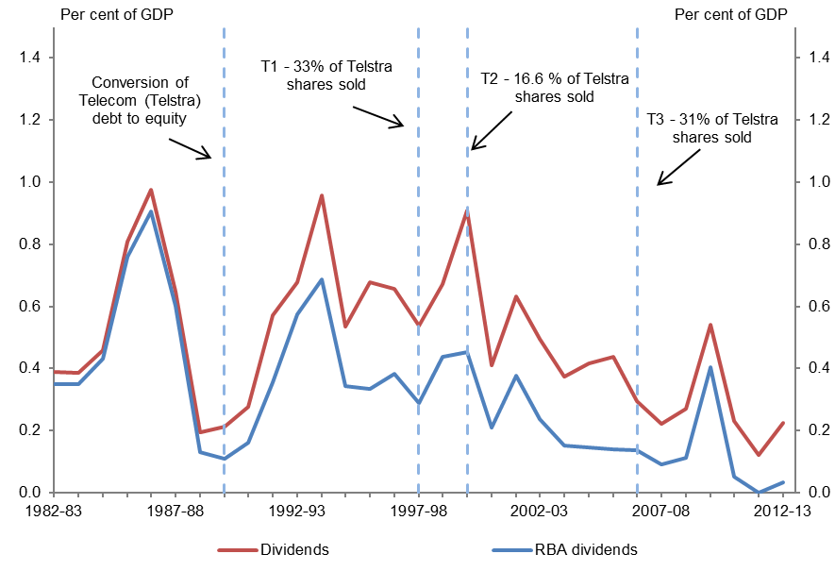
Sources: PBO based on data from the ABS, RBA and Treasury
Note: The federal government’s residual Telstra shareholding was transferred to the Future Fund in 2006–07. T3 sale proceeds were also transferred to the Future Fund in instalments.
The dominant factor behind the level of, and fluctuations in, federal government dividend receipts are the dividends received from the RBA. The high level of fluctuations of RBA dividends is largely attributable to gains (and losses) made on foreign currency operations.

The other major factor influencing the level of dividends received by the federal government was the corporatisation of Telecom in 1989–90 (with loans from the federal government converted to equity). This resulted in an increase in dividend receipts, offsetting the corresponding reduction in interest receipts from loans. These dividend receipts fell during the progressive privatisation of Telstra, again narrowing the gap between RBA dividends and total dividends, with this decline partially offset by dividends received by the Future Fund following its establishment.
While the federal government owned several other major government business enterprises in
1982–83 that have subsequently been privatised (including the Commonwealth Bank and Qantas), dividends from these investments were relatively low compared with those received from the RBA.

Sales of goods and services and other non-tax receipts
The sale of goods and services includes amounts such as fees for regulatory services. Significant receipts under this category include fees received by the Australian Securities and Investments Commission (ASIC) under the Corporations Act 2001, visa application fees and passport fees. This category also includes the fee paid by state governments to reimburse GST administration costs.
Other non-tax receipts is a residual classification, covering all items that are not classified as a tax or categorised as receipts from interest, dividends or the sale of goods and services, including receipts from the sale of non-financial assets. Significant receipts under this category include petroleum royalties, child support receipts, seigniorage from circulation coin production and receipts under the Risk Equalisation Trust Fund administered by the Private Health Insurance Administration Council.
Receipts from the sale of goods and services and other non-tax receipts grew from 0.5 per cent of GDP ($1.0 billion) in 1982–83 to 1.2 per cent of GDP ($17.6 billion) in 2012–13 (Figure 6.2).
Despite forming a relatively significant level of receipts there is only limited information on the components of this category, and the information that is available is spread across a number of publications of government agencies rather than consolidated in a single place. Moreover, the accounting rules that govern the classification of receipts as taxes, sales of goods and services or other non-tax receipts are complex. There have also been changes to these accounting rules over time, without a detailed explanation of the corresponding adjustments required to construct a consistent time series.
This highlights the need for further work to be done to present a detailed, consolidated picture of what comprises this category of federal government receipts and how it has changed over time.

While these factors preclude a comprehensive analysis of trends in this category at this time, preliminary analysis indicates the importance of a range of ‘one-off’ or temporary factors on growth in receipts from the sale of goods and services and other non-tax receipts over the past three decades, including:
- Proceeds from the auction of radiofrequency spectrum bands were a major contributor to the elevated levels of other non-tax receipts as a proportion of GDP in 1999–2000, 2000–01 and 2012–13.
- Fees received from financial institutions under the Guarantee Scheme for Large Deposits and Wholesale Funding implemented in the wake of the GFC were $1.3 billion in 2009–10, declining to $0.5 billion in 2012–13 as the scheme closed to new liabilities on 31 March 2010 and existing guaranteed liabilities were repaid.
- Changed arrangements for unclaimed company, bank account, life insurance and superannuation monies increased receipts in 2012–13 as additional account balances were transferred to ASIC and the Australian Tax Office (ATO). Receipts from unclaimed monies increased from $0.2 billion in 2011–12 to $2.1 billion in 2012–13.
Another factor driving the growth in receipts from the sale of goods and services more recently has been large increases in fees and charges for government services, including visa application and passport fees.

Other taxes
In 2012–13, other tax receipts were $6.5 billion, which was 0.4 per cent of GDP. A breakdown of the larger components of other taxes in 2012–13 is shown in Table 6.1.
Table 6.1: Significant components of other taxes in 2012-13
2012-13
$ million
Carbon pricing mechanism | 3,631
Passenger movement charge | 745
Agricultural levies | 463
Superannuation guarantee charge | 337
Financial institutions supervisory levies | 270
DEEWR levies | 173
Broadcasting licence fees ^{(a)} | 167
Import processing and depot charges | 150
Radiocommunications taxes ^{(a)} | 119
Other | 451
Total | 6,506
^{(a)} Amounts reported are on an accrual basis
Sources: PBO based on data from the ACMA, ATO, APRA, Customs, DEEWR and Treasury

Trends in other tax receipts
Other taxes fluctuated at around 0.4 per cent of GDP from 1982–83 to 1990–91. Following this, other taxes fell to around 0.2 per cent of GDP before increasing sharply following the commencement of the Carbon Pricing Mechanism (CPM) to be 0.4 per cent of GDP in 2012–13 (Figure 6.4).
The main reasons for the decline in other taxes from the 1980s to the 1990s were the move to self-government in the Australian Capital Territory (ACT) and the transfer of the debits tax to state governments. With the shift to self-government in the ACT in 1988–89, local taxes (such as payroll tax and stamp duty) that had previously been collected by the federal government were transferred to the ACT government. Following this, the federal government transferred the debits tax, a tax charged when money was withdrawn from a cheque account, to state governments in 1990–91. The debits tax and ACT taxes and charges each raised around 0.1 per cent of GDP per year immediately prior to their transfer to state governments.
The impact of these transfers on other tax receipts was temporarily offset in 1990–91 by the sharp increase in the wool tax rate to cover costs associated with the large wool stockpile prior to the collapse of the wool reserve price mechanism (Australian Government 1990 & 1991).
Figure 6.4: Other tax receipts as a proportion of GDP
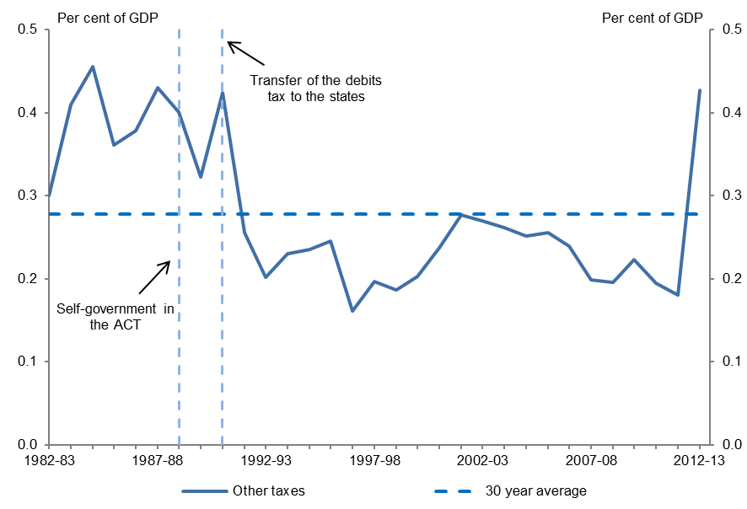
Sources: PBO based on data from the ABS and Treasury

Summary
The decline in non-tax receipts over the past three decades is more than explained by the reduction in interest receipts, as the federal government ceased borrowing on behalf of the states, with a corresponding reduction in the federal government’s public debt interest outlays. This decline was partially offset by increases in other components of non-tax receipts. Other taxes declined with the move to self-government in the ACT and the transfer of the debits tax to state governments, before increasing sharply in 2012–13 with the introduction of the CPM.
The primary source of federal government dividend receipts over the past 30 years has been the RBA. The high level of fluctuations of these dividends reflects the RBA’s foreign currency operations. The federal government also received significant dividends from Telstra in the period from its corporatisation to its privatisation, and more recently from equity investments of the Future Fund.
The main area of growth in other taxes and charges over the past 30 years has been in the sale of goods and services and other non-tax receipts. Despite making a significant contribution to federal government receipts, there is only limited information currently available about these receipts. Preliminary analysis indicates that this growth has been driven by a combination of a range of ‘one-off’ or temporary factors and large increases in fees and charges for government services, such as visa application and passport fees.
A more detailed breakdown and analysis of the components of other taxes and charges in the future would be helpful to provide a more comprehensive analysis of the total size of government claims on national income.

This page is intentionally left blank.

Technical notes

Receipts data
This report uses a cash accounting framework and reports on cash receipts. Cash receipts are accounted for at the time the payment is received by the relevant authority.
The alternative approach, accrual accounting, reports revenue when the taxpayer earns the income that is subject to tax (or, when revenue cannot be reliably measured this way, when a tax assessment is made). As accrual accounting was only introduced from the 1999–2000 Budget, accrual revenue data is not available over the whole period of analysis for this report.
Differences between cash and accrual accounting relate to timing differences between the recognition of accrual revenue and cash receipts and cases where revenue has been recognised but cash payment is no longer expected to be received.

Receipts as a proportion of GDP
This report uses receipts as a proportion of nominal GDP to analyse trends in taxation and non-taxation receipts. This metric is used as it provides a measure of the size of government receipts relative to the size of the economy, thereby allowing meaningful comparisons to be made across time about the proportion of total resources that have been available for government use.
As discussed in Australian Government spending Part 1: Historical trends from 2002–03 to 2012–13 (PBO 2013), concerns have been raised about the effectiveness of using the spending to nominal GDP ratio as a measure of government resource use. This is because recent large and temporary increases in the terms of trade significantly boosted nominal GDP, masking underlying growth in spending which would not be expected to automatically slow with any decline in the terms of trade in the future.
This temporary increase in the terms of trade does not disguise trends in receipts in the same way as expenses. As nominal GDP is a measure of both the total income generated by the economy and the total expenditure on goods and services in the economy, most revenue heads are fundamentally linked to the value of nominal GDP.
All else being equal, any change in the terms of trade would be expected to have a corresponding impact on taxation receipts. This means that an analysis of changes in the receipts to GDP ratio is able to identify structural changes in the level of taxation in the economy in a way that changes in the expenses to GDP ratio is not.

Period of analysis
The period of analysis for this report is from 1982–83 to 2012–13. It commences in 1982–83 to enable a relatively long period of analysis. This allows recent shorter term trends which may otherwise distort the analysis to be controlled for. It also allows for the incorporation of a number of significant tax reforms including the introduction of the capital gains tax (CGT) and the goods and services tax. The analysis concludes in 2012–13 as this is the latest year for which actual receipts data is available.

Data sources
Australian Government receipts data has been sourced from the Treasury and the Australian Bureau of Statistics (ABS). The underlying receipts data used in this publication is published as a separate Excel workbook accompanying this report.
For the purposes of this report, the components of Australian Government receipts have been grouped into four categories: taxes on capital, taxes on labour, taxes on consumption and other taxes and charges. The revenue break down reported in government Budget documents cannot be strictly divided into these categories. Accordingly, the PBO has allocated the revenue heads provided in the Budget to the four categories, with the intention of providing a reasonable (yet imperfect) proxy for these categories.

Taxes on capital
Taxes on capital include company tax receipts, resource rent tax receipts, excise on crude oil and LPG and superannuation fund earnings tax receipts.
As it applies to Australian production of crude oil and not imports, the PBO has classified crude oil excise as a tax on capital (in particular, a resource rent tax), rather than a tax on consumption.

Superannuation funds
In order to split superannuation fund taxes into taxes on capital and taxes on labour, the PBO has estimated earnings tax receipts (allocated to taxes on capital) and contributions tax receipts (allocated to taxes on labour). While this allocation has been reflected in the summary data reported in Chapter 2, both earnings taxes and contributions taxes are discussed in the taxes on capital chapter.

Capital gains tax (CGT)
CGT data is estimated based on income year data from Taxation Statistics with a timing assumption applied.
CGT receipts have not been removed from company tax or superannuation fund earnings tax receipts. However, CGT receipts have been removed from personal income tax as CGT is not a tax on labour (discussed further below).

Taxes on labour
Taxes on labour include personal income tax, fringe benefits tax receipts and superannuation contributions tax.

Personal income tax
The personal income tax chapter includes gross income tax withholding receipts, gross other individuals receipts and gross prescribed payments system receipts, less refunds. Gross income tax withholding receipts are largely collected through the Pay-As-You-Go withholding system for wage and salary income. This category also includes receipts from other withholding taxes such as interest, dividend and royalty withholding taxes on payments to non-residents. Gross other individuals receipts include Medicare levy receipts and all other income tax paid by individuals, including tax paid on profits from unincorporated business.
CGT receipts from individuals have been removed from the personal income tax data as capital gains tax is recognised as a tax on capital. However, some of the remaining components of personal income tax receipts which also represent taxes on capital (for example, interest, dividend and royalty withholding taxes) have not been removed from the personal income tax data due to data limitations.

Taxes on consumption
Taxes on consumption include sales tax receipts and excise and customs duty receipts.

Sales tax
Sales taxes include goods and services tax receipts and wholesale sales tax receipts.

Excise and customs duties
Excise duty includes excise on alcohol, tobacco, fuels and excise equivalent customs duties. Customs duties include only import tariffs.

Other taxes and charges
Other taxes and charges include non-tax receipts and other tax receipts not elsewhere classified (including the Carbon Pricing Mechanism).

Non-tax receipts
The breakdown of non-tax receipts for the period 1982–83 to 1998–99 is based on unpublished ABS data. Time-series data prior to 1998–99 may be affected by quality issues such as changes to accounting methodology, classification changes and data availability.
In 1999–2000, sales of goods and services and other non-tax receipts are calculated by subtracting interest receipts reported in the 2001–02 Budget papers and dividend receipts reported in unpublished ABS data from total non-tax receipts. This method is continued from 2000–01 onwards using interest and dividend receipts reported in Final Budget Outcomes.

Other data sources
International and sub-federal government comparisons utilise data from OECD Revenue Statistics – Comparative tables.
OECD data is on a calendar year basis for most countries and is only available until 2011. In this report, 2011 data for the OECD is mapped to 2011–12 Australian receipts data and so on for all other years.

List of data sources and references

Data sources
Australian Bureau of Statistics 1982 to 2013, Average Weekly Earnings, cat. no. 6302.0), ABS, Canberra.
Australian Bureau of Statistics 1993, 1995 and 1997 to 2012, Employee Earnings, Benefits and Trade Union Membership, cat. no. 6310.0, ABS, Canberra.
Australian Bureau of Statistics 2013a, Australian National Accounts: National Income, Expenditure and Product, cat. no. 5204.0, ABS, Canberra.
Australian Bureau of Statistics 2013b, Australian National Accounts: National Income, Expenditure and Product, cat. no. 5206.0, ABS, Canberra.
Australian Bureau of Statistics 2013c, Consumer Price Index, cat. no. 6401.0, ABS, Canberra.
Australian Communications and Media Authority 2013, Annual Report 2012–13, ACMA, Canberra.
Australian Customs and Border Protection Service 2013, Annual Report 2012–13, Customs, Canberra.
Australian Government 1982 to 2012, Budget Papers 1982–83 to 2012–13, Commonwealth of Australia, Canberra.
Australian Government 2013, Final Budget Outcome 2012–13, Commonwealth of Australia, Canberra.
Australian Parliamentary Library 2014, Stock Exchange Indexes, Parliament of Australia, Canberra.
Australian Prudential Regulation Authority 2004, Statistics - Superannuation Trends - September 2004, APRA Sydney.
Australian Prudential Regulation Authority 2007, APRA Insight - Celebrating 10 years of superannuation data collection 1996–2006, APRA, Sydney.
Australian Prudential Regulation Authority 2013, Annual Report 2012–13, APRA, Sydney.
Australian Prudential Regulation Authority 2014, Statistics - Annual Superannuation Bulletin - June 2013 (revised 5 February 2014), APRA, Sydney.
Australian Securities and Investments Commission 2013, Annual Report 2012–13, ASIC, Sydney.
Australian Taxation Office 2013, Annual Report 2012–13, ATO, Canberra.
Australian Taxation Office various years, Taxation Statistics 1982–83 to 2010–11, ATO, Canberra.
Department of Education, Employment and Workplace Relations 2013, Annual Report 2012–13, DEEWR, Canberra.
Organisation for Economic Co-operation and Development 2013, Revenue Statistics 1965–2012, OECD Publishing, France.
Reserve Bank of Australia 1998 to 2013, Annual Reports 1997–98 to 2012–13, RBA, Sydney.
Department of the Treasury 2009 to 2013, Annual Reports 2008–09 to 2012–13, Treasury, Canberra.

References
Trewin, D 2000, Australian System of National Accounts: Concepts, Sources and Methods, ABS, Canberra.
Australian Customs and Border Protection Service 2011, Minute Paper – Information sought by the Productivity Commission: Australian Customs and Border Protection Service's Responses, viewed 17 March 2014, http://www.customs.gov.au/webdata/resources/files/CBPResponsestoPC.pdf
Australian Government 1982 to 2013, Budget Papers 1982–83 to 2013–14, Commonwealth of Australia, Canberra.
Australian Government 1998, Tax reform: not a new tax, a new tax system, Commwealth of Australia, Canberra.
Australian Government 2006a, A plan to simplify and streamline superannuation, Commonwealth of Australia, Canberra.
Australian Government 2006b, International Comparison of Australia's Taxes, Commonwealth of Australia, Canberra.
Australian Office of Financial Management 2013, Annual Report 2012-13, AOFM, Canberra.
Australian Prudential Regulation Authority 2007, APRA Insight - Celebrating 10 years of superannuation data collection 1996-2006, APRA, Sydney.
Australian Taxation Office 2013, Taxation Statistics 2010-11, ATO, Canberra.
Bishop, J & Cassidy, N 2012, ‘Trends in National Saving and Investment’, Bulletin, Issue March Quarter, pp. 9-18.
Clark, J & Hollis, A 2013, ‘Tax-to-GDP: Past and prospective developments’, Economic Roundup, Issue 2, pp. 15-34.
Creedy, J & Gemmell, N 2007, ‘Tax Revenues and Fiscal Drag: An introduction’, The Australian Economic Review, vol. 40, no. 3, pp. 323-338.
Department of Immigration and Border Protection 2013, Previous versions of Visa Pricing Table and Form 990i, viewed 14 March 2014, https://www.immi.gov.au/fees-charges/990i-charges.htm
Department of the Treasury 1985, Reform of the Australian tax system: draft white paper, Australian Government Publishing Service, Canberra.
Department of the Treasury 1999, ‘The Measurement of Saving in Australia’, Economic Roundup, Issue Spring, pp. 21-50, viewed 19 March 2014, http://archive.treasury.gov.au/documents/195/PDF/round3.pdf
Department of the Treasury 2013, Risks to the Sustainability of Australia's Corporate Tax Base, Treasury, Canberra.
Edey, M & Gower, L 2000, National Saving: Trends and Policy, Reserve Bank of Australia, Sydney.
Freestone, O, Gaudry, D, Obeyesekere, A & Sedgwick, M 2011, ‘The rise in household saving and its implications for the Australian Economy’, Economic Roundup, Issue 2, pp. 61-79.
Future Fund 2009 to 2013, Annual Reports 2008-09 to 2012-13, Future Fund Board of Guardians, Melbourne.
Garnaut, R 2002, ‘Australia: a case study of unilateral trade liberalisation’, in: J Bhagwati (ed.), Going Alone: The Case for Relaxed Reciprocity in Freeing Trade, MIT Press, Cambridge.
Gregory, B 2004, ‘Where to now? Welfare and labour market regulation in Australia’, Australian Bulletin of Labour, vol. 30, no.1, pp. 33-45, viewed 24 March 2014, http://search.informit.com.au/fullText;dn=068861182793338;res=IELBUS
Henry, K 2006, ‘Implications of China’s re-emergence for the fiscal and economic outlook’, Address to the Australian Business Economist, Sydney, 16 May.
Henry, K, Harmer, J, Piggott, J, Ridout, H & Smith, G 2008, Architecture of Australia's Tax and Transfer System, Department of the Treasury, Canberra.
Henry, K, Harmer, J, Piggott, J, Ridout, H & Smith, G 2009, Australia's Future Tax System Review, Report to the Treasurer: Part 2, vols 1 & 2, Department of the Treasury, Canberra.
James, D 1996, 'Beer and Cigs Up!': A Recent History of Excise in Australia, PRS Publications Office, Canberra.
Organisation for Economic Co-operation and Development 2008, Consumption Tax Trends 2008:VAT/GST and Excise Rates, Trends and Administration Issues, OECD Publishing, viewed: 28 March 2014, http://www.keepeek.com/Digital-Asset-Management/oecd/taxation/consumption-tax-trends-2008_ctt-2008-en#page1
Organisation for Economic Co-operation and Development 2012, Consumption Tax Trends 2012: VAT/GST and Excise Rates, Trends and Asministration Issues, OECD Publishing, viewed 25 March 2014, http://www.keepeek.com/Digital-Asset-Management/oecd/taxation/consumption-tax-trends-2012_ctt-2012-en#page1
Organisation for Economic Co-operation and Development 2014, Economic Policy Reforms: Going for Growth Interim Report, OECD Publishing, viewed 28 March 2014, http://www.keepeek.com/Digital-Asset-Management/oecd/economics/economic-policy-reforms-2014_growth-2014-en#page1
Parkinson, M 2011, ‘Opportunities Challenges and Implications’, Aunnal post-Budget Address to the Australian Business Economists, Sydney, 17 March.
Parkinson, M 2012, ‘Challenges and opportunities for the Australian economy’, John Curtin Institute of Public Policy Breakfast Forum, Perth, 05 October.
Parliamentary Budget Office 2013, Australian Government spending Part 1: Historical trends from 2002-03 to 2012-13, PBO, Canberra.
Ralph, J, Allert, R & Joss, R 1999, Review of Business Taxation: A tax system redesigned, More certain, equitable and durable, Australian Government Publication Services, Canberra.
Reinhardt, S & Steel, L 2006, ‘A brief history of Australia's tax system’, Economic Roundup, Issue Winter, pp. 1-26.
Reserve Bank of Australia 1996, Notes on Occasional Paper No.8 Tables, RBA, Sydney.
Scollo, M & Winstanley, M 2012, Tobacco in Australia: Facts and Issues, 4th edn, Cancer Council Victoria, Melbourne.
Smith, G 2009, Australian Tax Reforms: Past and Future, University of Wellington, viewed 20 March 2014, http://www.victoria.ac.nz/sacl/centres-and-institutes/cagtr/pdf/smith.pdf
The Board of Taxation 2003, International Taxation: A Report to the Treasurer, vols. 1 & 2, Commonwealth of Australia, Canberra.
The Board of Taxation 2013, Post implementation review into certain aspects of the consolidation regime: a report to the Assistant Treasurer, Commonwealth of Australia, Canberra.
Torres, C, Mellbye, K & Brys, B 2012, ‘Trends in Personal Income Tax and Employee Social Security Contribution Schedules’, OECD Taxation Working Papers No. 12, OECD publishing, viewed 19 March 2014, http://www.oecd-ilibrary.org/taxation/trends-in-personal-income-tax-and-employee-social-security-contribution-schedules_5k95qw9633vf-en
Trebeck, D, Landels, J & Hughes, K 2001, Fuel Tax Inquiry: History of Fuel Taxation in Australia, viewed 26 March 2014, http://fueltaxinquiry.treasury.gov.au/content/backgnd/002.asp
Webb, R 2001, ‘Crude Oil Excise and Royalties’, Research Note, no. 29 (2000–01), Parliamentary Library, viewed 21 March 2014, http://www.aph.gov.au/binaries/library/pubs/rn/2000-01/01rn29.pdf

This analysis focuses on receipts rather than revenue due to a lack of historical revenue data. See Technical notes for details.
White Paper on Reform of the Australian Tax System (Treasury 1985), Tax reform: not a new tax, a new tax system (Australian Government 1998), and Australia’s Future Tax System Review (Henry et al 2009).
Including, for example, Review of Business Taxation (Ralph et al. 1999), Review of International Taxation Arrangements (The Board of Taxation 2003), Fuel Tax Inquiry (Trebeck et al. 2001), and A Plan to Simplify and Streamline Superannuation (Australian Government 2006a).
A search of the Austlii Numbered Acts database shows that the Australian Parliament passed around 1,350 tax acts between 1982 and 2013, which is about 25 per cent of the total number of acts passed in this period.
The components of cash receipts generally follow the revenue heads documented in the budget papers. See Technical notes for details, including for how and where revenue heads have been adjusted (aggregated or disaggregated) to assist the analysis in this paper. The underlying receipts data used in this publication is published in a separate Excel workbook accompanying this report.
Direct taxes are those directly paid by individuals and organisations, such as taxes on employee remuneration, payrolls and profits. Indirect taxes are those collected by an intermediary rather than the entity that bears the tax burden, such as the GST and excise.
See International Comparison of Australia’s Taxes (Australian Government 2006b), Architecture of Australia’s Tax and Transfer System (Henry et al. 2008), and Economic Policy Reforms: Going for growth Interim Report (OECD 2014).
A comparison of direct taxes excluding social security contributions does not remove all distortions from the analysis, as social security contributions in some OECD countries partly finance general government services. Further, in some countries the social security benefits received by individuals are only weakly related to individuals’ contributions.
The tax bases of labour, capital and consumption are often discussed in the literature on tax policy. See Architecture of Australia’s Tax and Transfer System (Henry et al. 2008) for the rationale of disaggregating receipts into these categories.
The PBO is aware that this disaggregation does not perfectly align with the four categories. A similar disaggregation of revenue heads into these categories can be found in Architecture of Australia’s Tax and Transfer System (Henry et al. 2008). Further research could focus on providing a more accurate disaggregation of government receipts into these categories.
It is acknowledged that defining taxes on capital in this way is likely to result in some misclassification, however data limitations prevent a further disaggregation at this time. Estimated capital gains tax receipts from individuals have been included in capital tax aggregates. Personal income tax includes other components that could be better characterised as taxes on capital, including tax on income from sole trader businesses, interest income and dividend income. Superannuation receipts attributable to the superannuation fund business by life assurance companies and registered organisations are included in company receipts. Capital gains tax has not been separated from company and superannuation tax receipts as they are already classified as taxes on capital.
Significant reviews include the White Paper on Reform of the Australian Tax System (Treasury 1985), Review of Business Taxation (Ralph et al. 1999), Australia's Future Tax System Review (Henry et al. 2009), and several reviews undertaken by the Board of Taxation including International Taxation Arrangements (The Board of Taxation 2003) and Certain Aspects of the Consolidation Regime - Post-Implementation Review (The Board of Taxation 2013).
For example, where increased capital investment results in increased depreciation expense (that is not included in GDP), corporate tax receipts may not rise in line with gross corporate profit.
The PRRT replaced the crude oil excise and federal and state royalty systems for offshore oil production except for the North West Shelf until 2012–13 (Trebeck et al. 2001).
The PBO has estimated these figures based on the Australian petroleum statistics from the Bureau of Resources and Energy Economics (BREE).
The superannuation tax rules are more complex than the broad framework described here. This paper does not provide a detailed description of these rules.
For assets purchased between 20 September 1985 and 20 September 1999, the taxpayer can choose between the indexation method (with indexation frozen at September 1999) and the discount.
It is acknowledged that this approach is likely to result in some misclassification. Estimated CGT receipts from individuals are classified as taxes on capital. Personal income tax includes other components that may be better characterised as taxes on capital, including tax on income from sole trader businesses, interest income and dividend income. Data limitations prevent a further disaggregation.
The Medicare Levy was pro-rated to 0.416 per cent in the introductory year of 1983–84 and subsequently increased to 1.25 per cent in 1986–87 (pro-rated in this year at 1.145 per cent), 1.4 per cent in 1993–94 and to 1.5 per cent in 1995–96. The Medicare Levy was also temporarily increased to 1.7 per cent in 1996–97 to include the 0.2 per cent gun buy-back levy.
CGT paid by individuals is covered in Chapter 3 and has been excluded from this analysis.
Franking credits became fully refundable from 1 July 2000.
The average tax rate is calculated by dividing personal income tax receipts by taxable income (excluding net capital gains) for individuals. Taxable income is the income on which the personal income tax rates and scales are applied. It is calculated by subtracting allowable deductions from assessable income. Net capital gains is equal to capital gains less any current and prior year capital losses.
Some individuals on lower incomes may have higher effective marginal tax rates due to the tapering of tax offsets, the phase-in of the Medicare Levy and interactions with the social security system.
Bracket creep (or fiscal drag) refers to the situation where wage growth pushes income into higher tax brackets, resulting in higher average tax rates and income tax collections (Creedy & Gemmell 2007).
See Australian Government Budget Papers 2003 to 2007.
The difference in the movement in the marginal and average tax rate faced by an individual on MTAWE reflects changes in tax rates below MTAWE and the impact of tax offsets.
FBT receipts in this paper are reported on the regular financial year basis of 1 July to 31 June.
The 1993–94 FBT rate was not adjusted to reflect the increase in the Medicare Levy to 1.4 per cent in 1993–94.
The 1995–96 FBT rate was a pro rata increase for the first year of the higher Medicare Levy reflecting the operation of the increased Medicare Levy only for the last nine months of that FBT year.
The FBT rate was not adjusted for the temporary gun buy-back levy in 1996–97 or the Flood Levy in 2011–12.
For an explanation of this refer to the Explanatory Memorandum to the Taxation Laws Amendment (Fringe Benefits Tax Measures) Bill 1992.
Since the introduction of the GST the gross-up factor differs depending on whether employers can obtain a GST credit for the fringe benefits provided.
For example, the Medicare Levy Surcharge, the Higher Education Contributions Scheme, and child support obligations
FBT is levied on the taxable value of fringe benefits, not the value of reportable fringe benefits. Certain reportable fringe benefits are exempt from FBT, and certain fringe benefits subject to FBT are not reportable fringe benefits.
For reasons explained in more detail below, crude oil excise receipts are not considered to be taxes on consumption, and are instead included in the analysis of taxes on capital in Chapter 3.
Other taxes that could also be described as sales taxes, such as the Wine Equalisation Tax (WET) and the Luxury Car Tax, are classified as ‘other consumption taxes’ for the purposes of this paper.
WST covered a relatively small share of household consumption, notably excluding the services sector.
In October 2005 the low-value threshold (under which imports are not liable for the GST and customs duty) was standardised to $1,000. Prior to October 2005 goods imported by post had a $1,000 threshold while goods imported by sea or air cargo had a threshold of $250 (Customs 2011).
The household saving ratio is the proportion of household saving to household disposable income.
The average rate of household expenditure over the past 30 years is inflated by the period of high consumption between 1990–91 and 2006–07. Since the commencement of the data series in 1959–60, consumption as a proportion of GDP has averaged around 56 per cent (about 1 percentage point above its 2012–13 level) and the household saving ratio averaged around 10 per cent (just below its 2012–13 level).
This analysis examines movements over the past three decades in the categories of goods and services that were excluded on the introduction of the GST.
Excise on fuel does not include the impact of fuel excise rebate schemes as these represent expenditure and are beyond the scope of this paper.
Excise receipts in this section are the sum of excise on domestic production and excise equivalent customs duty on imports.
Sales of goods and services refers to receipts from the direct provision of goods and services by the government. It includes: fees and charges for services rendered and sales of goods and services; fees from regulatory services; fees for work done acting as an agent; and operating lease rental income.
The classification of receipt of unclaimed monies depends on the role of the government agency to whom they are paid. Similarly, the classification of the Passenger Movement Charge has changed over time, from being a tax, to a ‘sale of goods and services’ and back to being a tax, depending on the relationship between the level of the charge and the value of the service provided.
Fees presented for the Guarantee for Large Deposits and Wholesale Funding are on an accrual basis.
For example, fees for an employer sponsored migration visa where the applicant has less than functional English lodged outside Australia have increased from $6,515 in November 2004 to $11,580 in June 2013 (Department of Immigration and Border Protection 2013).
This tax was subsequently abolished as part of the introduction of the GST.
Nominal GDP is as at the Mid-Year Economic and Fiscal Outlook 2013–14.
The tax bases of labour, capital and consumption are often discussed in the literature on tax policy. See Australia’s Future Tax System Review (Henry et al. 2008) for the rationale of disaggregating receipts into these categories.
For more information on the classification of taxes see Treasury’s Pocket Guide to the Australian Tax System, available at http://www.treasury.gov.au/Policy-Topics/Taxation/Pocket-Guide-to-the-Australian-Tax-System

