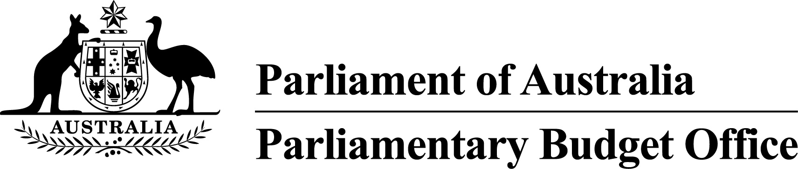
PBO Guidance 01/2018

Allowing minor parties to opt in to the PBO’s post-election report of election commitments
Section 64MA of the Parliamentary Service Act 1999 requires the Parliamentary Budget Officer to release a report within 30 days of the end of the caretaker period for a general election outlining the financial impact of all the election commitments that have a material impact on the Budget for all designated parliamentary parties – that is, parties with five or more members.
The Parliamentary Budget Office Review 2016–17 – Report of the Independent Review Panel recommended that the Parliamentary Budget Office (PBO) ‘should provide parliamentary political parties with fewer than five Members or Senators the option to have the financial impact of their election commitments included in the PBO’s post-election report of election commitments’ (Recommendation 13).
The PBO agrees with this recommendation and, following the release of a consultation paper and consideration of the submissions received, this guidance note outlines how we intend to implement the recommendation at the next general election given the resources currently available to the PBO. If any minor parties choose to opt in to the post-election report, we will release an addendum containing the financial implications of the election commitments of those minor parties as soon as possible after the release of the main report.
For the purposes of this guidance note, ‘minor parties’ refers to all independent parliamentarians and parliamentary political parties with fewer than five Members or Senators.

Notifying the PBO of a decision to opt in
The PBO notes that sufficient notice from minor parties of their intention to opt in to the post-election report will be required to allow us to plan for the production and release of the report. To allow us to plan for these processes, minor parties will be required to notify us of their intention to opt in to the post-election report no later than 14 days prior to polling day.
Ideally, parties seeking to opt in to the post-election report would submit their major polices to be costed by the PBO either before the caretaker period commences, where the requests can be on a confidential basis, or publicly during the caretaker period. The earlier a party engages with us on a policy costing request, the better placed we are to incorporate it into the post-election report if it is publicly announced as an election commitment.
Early engagement provides the opportunity for policy specifications to be clarified, if necessary, to cost the election commitment. Early engagement also gives the PBO time to develop the capability to cost more complex election commitments. If there is no engagement with the PBO prior to the making of election commitments, it may be difficult to include the costing of these commitments in the post-election report without substantially delaying the release of the report.

Providing the Parliamentary Budget Officer with a list of election commitments
Consistent with the requirements for designated parliamentary parties, any minor party wishing to opt in to the post-election report will be required to provide a final and complete list of election commitments to the Parliamentary Budget Officer by 5pm on the day before election polling day.
The Parliamentary Budget Officer will publicly release the list of election commitments provided by any minor parties at the same time as releasing the lists from the designated parliamentary parties.

Identifying election commitments that have a material impact on the Budget
If a minor party opts in to the post-election report and provides the Parliamentary Budget Officer with a list of election commitments, the Parliamentary Budget Officer will not make any judgements about whether the list includes all of the election commitments of that party that would have a material impact on the Budget.
The Parliamentary Budget Officer will, however, retain the option to amend the list of election commitments if the PBO is aware of a major publicly announced election commitment by a party that is omitted from their list, or a major election commitment on the list that was never publicly announced. In such a circumstance, the Parliamentary Budget Officer will provide the minor party with a statement explaining the reasons for any amendments.

Interactions between election commitments
The PBO will endeavour to calculate, document and include the financial impact of significant interactions between election commitments for minor parties in a similar manner to its treatment for major parties. Where the interactions are expected to be significant but cannot be confidently estimated, this will be clearly stated in the post-election report.
The combined impact of each minor party’s election commitments will be included in the post-election report, including in circumstances where the financial impact of interactions between election commitments is reported as unquantifiable.

Minor parties no longer represented in the Parliament following the election
If a minor party opts in to the post-election report and no longer has a representative in the Parliament following the election, their election commitments will be excluded from the post-election report on the basis that they will no longer have an ongoing role in budget-related deliberations.

Minor parties newly represented in the Parliament following the election
The PBO considered whether any federally registered non-parliamentary parties should be allowed to opt in to the post-election report given that they may ultimately win a seat at the election and have a role in budget-related deliberations. This would allow political parties that are newly represented in the Parliament to have the cost of their election commitments included in the report. We judged that this would likely prevent the post-election report from being prepared in a timely manner and so the option to be included in the post-election report will only be available for parties that have a representative in the Parliament immediately before the election.
Like all parliamentarians, however, newly elected parliamentarians will have the option to submit policy costing requests to the PBO outside of the caretaker period. This can include a costing of the full suite of their publicly announced election commitments. These can either be submitted on a confidential or non-confidential basis. Responses to these requests will be prepared as part of the PBO’s regular and ongoing policy costing work.

Timing of release of the post-election report
The PBO has a legislative requirement to release the post-election report relating to the financial implications of the election commitments of designated parliamentary parties within 30 days of the end of the caretaker period. If any minor parties choose to opt in to the post-election report, we will release an addendum containing the financial implications of the election commitments of those minor parties as soon as possible after the release of the main report.
Jenny Wilkinson
Parliamentary Budget Officer
Release date | 27 April 2018
Contact Officer(s) | Tim Pyne  First Assistant Parliamentary Budget Officer  Fiscal Policy Analysis Division  (02) 6277 9560

