1 July 2016

Mr Phil Bowen
Parliamentary Budget Officer
Parliament House
CANBERRA ACT 2600

Dear Mr Bowen

I formally request the following revenue proposals be costed by the Parliamentary Budget Office for public release.

- Australian Infrastructure Bank
- RenewAustralia Authority
- Putting a price back on pollution
- Closing the Emissions Reduction Fund and Wind Farm Commissioner
- Coal Export Levy
- Climate Finance for Developing Nations
- Negative Gearing and Capital Gains Discount
- Ending FEE-HELP to for-profit providers
- Paid Parental Leave
- Luxury Lifestyles Tax
- Not the time for Company Tax Cuts
- Restoring Family Tax Benefit Cuts
- Reversing Harsh Cuts

I appreciate you may require further information from us to complete the request. Should you require any further clarification, please contact Jay Tilley from my office on 0408 473 379

Yours sincerely
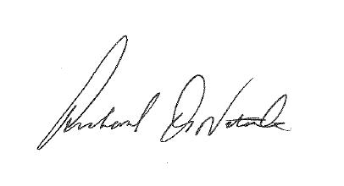
Senator Richard Di Natale

